MAESTRO
Ontologies & Knowledge Graphs for Manufacturing
A Beginner's Study Guide — Detailed Edition
From a single triple to a self-reasoning factory model
Every example drawn from the real MAESTRO v0.4 project files

Contents

How to use this guide
This guide builds up from absolute zero. If you have never heard of a knowledge graph or an ontology, begin at Part 1 and read straight through — each part assumes only what came before it. Every snippet of code and every example is taken verbatim from the real MAESTRO project files, so what you learn here maps directly onto files you can open, edit, and run.
The learning path: a single triple → a knowledge graph → an ontology → what MAESTRO is and the problem it solves → its seven layers (with real Turtle) → reasoning, the part that makes it intelligent (with the actual rules) → two fully worked real-world examples → a careful read of the two master schema diagrams → a glossary.
Convention used throughout: fixed-width text like core:Resource is real code or identifiers from the project. Indented grey blocks are real file excerpts or diagrams.

Part 1 — What is a Knowledge Graph?
Forget manufacturing for a moment. A knowledge graph is simply a way of writing down facts so that a computer understands the relationships between things, rather than just storing them in rows of a table.
Every fact is written as a tiny three-part sentence called a triple:
Subject → Predicate (the relationship) → Object
For example, three separate facts about a robot:
Robot1 → is a → Robot
Robot1 → is located in → Cell_A
Cell_A → is part of → Factory
Each “thing” (Robot1, Cell_A, Factory) is a node. Each relationship is an edge — an arrow connecting two nodes. String thousands of these together and you get a graph: a web of connected facts. That web is the knowledge graph.

Why a graph instead of a spreadsheet?
A spreadsheet is excellent at answering “give me all robots.” A graph is excellent at answering “which robots sit in cells that belong to factories that can build product X?” — questions that require hopping across many relationships. Graphs are built for connections, and manufacturing is full of connections.

How this looks in MAESTRO
In MAESTRO, triples are stored in text files ending in .ttl — the Turtle format, a clean way to write triples. Here is a single real line from the project:
skill-lib:MoveLinear a skill:MotionSkill .
Read it as the sentence: “MoveLinear is a MotionSkill.” The lone a is Turtle shorthand for “is a” (it declares the type of a thing). The whole MAESTRO project is one very large, very carefully organised pile of sentences exactly like this.
Key idea: a knowledge graph is just facts-as-triples. Nodes are things, edges are relationships. Everything else in this guide is built on this one idea.

Part 2 — What is an Ontology?
This is the single distinction beginners most often confuse, so it is worth slowing down.
A knowledge graph holds the actual facts about one specific factory: “Robot1 is in Cell_A.” These specific, real things are called instances (or individuals).
An ontology is the rulebook and vocabulary that sits above the facts. It defines three things:
- Classes — what categories of things are allowed to exist: there is such a thing as a Robot, a Skill, a Capability, a Product.
- Properties and hierarchies — how categories relate: a Robot is a kind of Resource; a Skill can be implemented by a ControlComponent.
- Rules / constraints — statements that must hold true: every Skill must be provided by some Resource.
Analogy. The ontology is the blueprint and the grammar; the knowledge graph is the actual building described using that grammar. Or: the ontology is an empty form with labelled fields and rules; the knowledge graph is the filled-in forms. The ontology defines the words; the knowledge graph speaks sentences with them.

You can see the split in the repository
Folder | Role | What it contains
ontologies/ | The ontology — vocabulary & rulebook | manufacturing-core.ttl defines the categories core:Resource, core:Skill, core:Capability, core:Product…
examples/ (the plant.ttl files) | The knowledge graph — real factory data | Statements like res:Robot1 a core:Resource that use the vocabulary to state facts
So when MAESTRO's core file declares that classes like core:Resource, core:Skill, core:Capability and core:Product exist, it is defining the vocabulary. When a specific factory file says res:Robot1 a core:Resource, it is using that vocabulary to state a fact. Ontology defines the words; the knowledge graph speaks with them.

Part 3 — What is MAESTRO, and Why Does it Exist?
MAESTRO stands for “Modular Ontology Stack for Future-Proof Manufacturing.” It is an ontology — a vocabulary plus a rulebook — for describing factories in a way that computers, robots, and AI can all understand together.

The problem it solves
Traditional manufacturing systems hard-wire function into the machine:
Machine → Function
Meaning: “this specific Siemens PLC does this specific job.” The trouble is, the moment you swap that controller for a Beckhoff one, add a ROS robot, or want an AI to plan production, everything breaks — because the knowledge was glued to one vendor's hardware.
MAESTRO flips the dependency into a clean chain. This is the heart of the entire project:
Capability (WHAT the plant can do — e.g. “transport a part”)
realized by Skill (HOW it does it — e.g. MoveLinear + VacuumPick)
executed by Control System (ROS / PLC / IEC 61499 — the software)
controlling Resource (the actual robot or machine)

Why this layering is so powerful
The project documentation calls out three concrete payoffs:
- Vendor swap. Replace a Beckhoff PLC with a Siemens one — the Skills it implements stay identical; only the core:ControlComponent individual changes. Nothing else in the model breaks.
- Multi-vendor cells. A ROS robot and an IEC 61499 controller can share a single skill:Transfer definition without either party knowing the other exists.
- AI orchestration. An LLM can reason over high-level Capabilities (intent) and let the graph find the concrete Skills and ControlComponents that realise them.
The browser analogy (from the docs). This is the same separation-of-concerns that lets a web browser run any JavaScript framework: declare the contract once, then plug in any implementation. MAESTRO declares “what a factory can do” once, independent of which brand of machine actually does it. That is what “future-proof” means here.
“Modular stack” means MAESTRO is split into many small ontology files — resource.ttl, skill.ttl, capability.ttl, process.ttl, product.ttl, and more — each aligned to an existing industry standard, so pieces can be used or replaced independently.
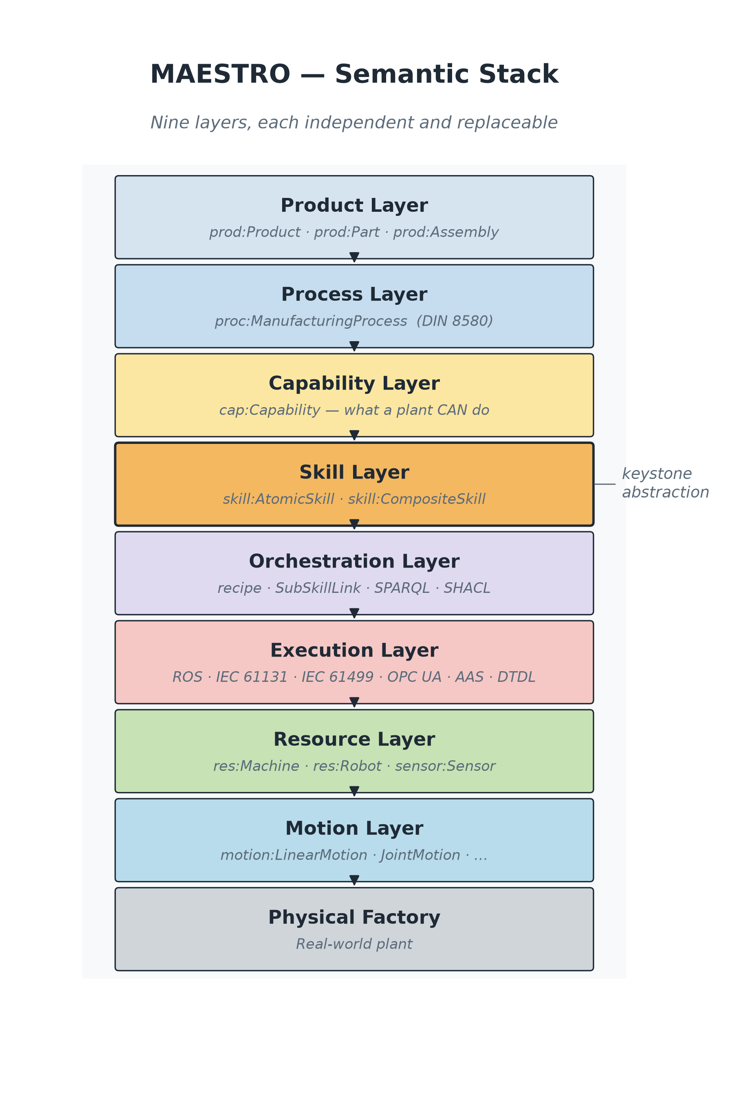
The MAESTRO semantic stack — nine layers, each independent and replaceable.

Part 4 — The Layers of MAESTRO (with real Turtle)
Recall the core chain: Product → Process → Capability → Skill → Control System → Resource → Motion. MAESTRO gives each link its own ontology file (its own vocabulary). The natural way to read a factory is top-down: start with what you want to make, and drill down until you reach the actual moving metal. All snippets below are real lines from the distribution-station example.
Layer | What it models | File
Product | What we want to make | logical/product.ttl
Process | Ordered manufacturing steps (the recipe) | logical/process.ttl
Capability | What the plant CAN do (abstract possibility) | logical/capability.ttl
Skill | HOW something is done — the keystone | logical/skill.ttl
Execution / Control | The software that actually runs a skill | execution/ros.ttl, iec61499.ttl, opcua.ttl
Resource | Physical machines, robots, sensors, actuators | physical/resource.ttl
Motion | Machine-independent movement semantics | physical/motion.ttl

Layer 1 — Resource (the physical things)
A Resource is any physical asset: a machine, robot, sensor, actuator, tool. The whole station is a core:Plant made of parts:
ex:DistributingStation1 a core:Plant ;
core:hasPart ex:FeederUnit1 , ex:TransferUnit1 .
The transfer arm is a resource with real attributes (manufacturer, model, a 0.5 kg payload limit):
ex:TransferArm1 a res:TransferArm ;
res:manufacturer "Festo" ;
res:payload [ unit:numericValue 0.5 ; unit:hasUnit unit:Kilogram ] .
Golden rule of this layer: resources do NOT contain manufacturing logic. The arm does not “know” it is distributing workpieces. It only provides skills — note the line core:provides ex:Type_skGoToLeft, .... A resource just advertises “here are the skills I can offer.” That advertisement is the hinge that lets you swap hardware later.

Layer 2 — Motion (machine-independent movement)
Below skills sits raw motion: pure geometry and physics, with no vendor and no controller. The arm's swing is described abstractly:
ex:ArmRotationalMotion a motion:RotationalMotion ;
motion:hasVelocity "1.5708"^^xsd:float ; # approx 90 deg per second
ex:hasDuration [ unit:numericValue 1.0 ; unit:hasUnit unit:Second ] .
This is just “a rotation, about 90° in 1 second.” Any arm from any vendor could perform it. Keeping motion separate means a skill can say “I need a rotation” without caring which robot supplies it.

Layer 3 — Skill (the keystone: HOW something is done)
This is the most important layer in MAESTRO. A Skill is a logical, reusable unit of doing. Crucially, a skill is not a robot or a PLC program — it is the abstract action. Execution technologies implement skills. Skills come in two kinds.

Atomic skills — one indivisible action
ex:Type_skGoToLeft a skill:MotionSkill ;
skill:requiresMotion ex:ArmRotationalMotion . # this skill USES that motion

ex:Type_skPick a skill:ManipulationSkill . # turn vacuum on, grip
ex:Type_skPlace a skill:ManipulationSkill . # turn vacuum off, release

Composite skills — built from smaller skills
ex:Type_skTransfer_adp a skill:TransferSkill ;
ex:hasSubSkill ex:Type_skGoToLeft , # go to magazine
ex:Type_skPick , # grab workpiece
ex:Type_skPlace , # release at other side
ex:Type_skGoToRight . # swing back
So “Transfer” = GoToLeft + Pick + Place + GoToRight, chained together. This nesting is exactly how complex factory behaviour is built from simple, reusable pieces — like functions calling smaller functions in code.

Layer 4 — Control / Execution (what actually runs the skill)
A skill is just an idea until some real software executes it. The distribution station uses IEC 61499 Function Blocks (a standard for distributed industrial control). Each skill is wired to the function block that implements it and the resource it drives:
ex:FBT_SkillGoToLeft a iec61499:BasicFB ;
iec61499:implementsSkill ex:Type_skGoToLeft ; # "I run this skill"
iec61499:controlsResource ex:TransferArm1 . # "by driving this arm"
This is the swappable layer. If you replaced these Festo function blocks with a ROS robot, you would change only these lines — Type_skGoToLeft and everything above it stays untouched. That is the vendor-independence payoff made concrete.

Layer 5 — Capability (WHAT the plant can do)
A Capability is a high-level possibility, deliberately abstract. The rule of thumb from the docs:
Good: TransportCapability (general — what kind of thing)
Bad: MoveCylinderLeftCapability (too specific — that's a skill detail)
Capabilities are the bridge between business intent and machinery. Processes ask for capabilities like cap:HandlingCapability, cap:PickPlaceCapability, and cap:TransportCapability. Nobody assigns these to the arm by hand — that link is inferred (see Part 5).

Layer 6 — Process (the manufacturing logic / recipe)
A Process is an ordered set of steps, each needing a capability. The “distribute a workpiece” process decomposes into five ordered sub-steps:
ex:DistributeWorkpieceProcess a proc:TransportProcess ;
proc:requiresCapability cap:HandlingCapability ,
cap:PickPlaceCapability ,
cap:TransportCapability ;
ex:hasSubProcess ex:LoadProcess , ex:PushProcess ,
ex:PickProcess , ex:RotateProcess , ex:PlaceProcess .

ex:LoadProcess proc:precedes ex:PushProcess . # ordering of the steps
The precedes property encodes the order: Load → Push → Pick → Rotate → Place. The process layer is the “what must happen, in what sequence” — independent of which machine does it.

Layer 7 — Product (the top: what we want to make)
At the very top: the product (or part) you want produced, and the process it needs.
ex:WorkpieceWP3 a prod:Part ;
prod:massKg 0.030 ;
prod:requiresProcess ex:DistributeWorkpieceProcess .
That single line — “WP3 requires the Distribute process” — is the seed of the whole reasoning chain. From it, MAESTRO can work all the way down to “…and therefore the Festo function block must fire the arm motor.”

The full chain, assembled
WorkpieceWP3 (product)
needs → DistributeWorkpieceProcess
needs → PickPlace, Transport, Handling capabilities
realized by → skTransfer (Pick + Place + GoToLeft + GoToRight)
implemented by → IEC 61499 Function Blocks
controlling → TransferArm1 + VacuumUnit1
performing → rotational + linear Motion
Each layer only talks to its neighbours through clean relationships. Swap anything at one layer and the rest survives. That separation is the entire point of MAESTRO.

Part 5 — Reasoning: How MAESTRO Figures Out Facts Nobody Typed
This is the part that turns MAESTRO from a tidy filing cabinet into something genuinely intelligent.

Asserted vs. inferred facts
Look back at plant.ttl. Nowhere did anyone write “the transfer arm can perform PickPlaceCapability,” and nowhere did anyone write “this plant can manufacture WP3.” Those facts are missing on purpose. In a knowledge graph there are two kinds of facts:
- Asserted facts — what a human typed in (“the vacuum unit provides skPick”; “WP3 requires the Distribute process”).
- Inferred facts — what a reasoner derives automatically by applying rules to the asserted facts.
A reasoner is a program that reads your triples, applies logical rules, and writes new triples that must be true as a consequence. You state the minimum; the machine works out the rest. MAESTRO uses several flavours of reasoning:
Reasoning kind | What it does | Example
OWL2-RL | Inheritance | If TransferArm is a kind of Robot, and Robot is a kind of Resource, the reasoner concludes TransferArm is a Resource — you never restate it.
SHACL | Validation (a checker, not an inventor) | Enforces rules like “every Skill must be provided by some Resource” and flags violations. Lives in constraints/.
SPARQL CONSTRUCT | Custom inference | Builds the capability chain. Lives in the rules/ folder — where the interesting work happens.

Rule 1 — which capabilities can each resource perform?
This is rules/capability-inference.rq. In plain English:
If a control component controls a resource, AND that component implements a skill, AND some capability is realized by that skill — then that resource can perform that capability.
Its logic, simplified to the heart:
Capability realizedBySkill Skill
Component implements Skill
Component controls Resource
---------------------------------- (therefore)
Resource canPerform Capability
Trace it: a function block (FBT_SkillVcmOn) implements skPick and controls VacuumUnit1. PickPlaceCapability is realized by a pick/place skill. So the reasoner writes a brand-new triple:
ex:VacuumUnit1 core:canPerform cap:PickPlaceCapability . # <-- INFERRED
Note on the real station. The station also ships a tailored variant, capability-inference-ds.rq, that matches capabilities to resources by skill category (e.g. anything providing a TransferSkill realises a transfer-type capability). It exists because the Festo function blocks implement station-specific skills rather than the shared library skills, so the generic rule would not catch them — a good lesson in how real ontologies get pragmatic patches.

Rule 2 — which products can the whole plant manufacture?
This is rules/manufacturing-ability.rq, and it builds on the output of Rule 1:
If a plant has a resource that can perform a capability, AND a product requires a process that requires that same capability — then the plant can manufacture that product.
Plant hasPart Resource
Resource canPerform Capability <- came from Rule 1!
Product requiresProcess Process
Process requiresCapability Capability
---------------------------------------- (therefore)
Plant canManufacture Product
So the reasoner chains the rules: Rule 1 establishes VacuumUnit1 canPerform PickPlaceCapability, then Rule 2 uses that to conclude DistributingStation1 canManufacture WorkpieceWP3 — again, a fact nobody wrote down.

Why this matters
- “Can my plant make this product?” is answered by inference, not by a human maintaining a checklist.
- “I swapped a vendor — what can the plant still do?” Re-run the reasoner; the capabilities recompute themselves.
- “Which resources give me pick-and-place?” Query the inferred canPerform facts.
It is also what makes the AI/LLM pipeline possible: a human says “make a WP3,” the LLM turns that into a query, the reasoner checks feasibility against the graph, and only then does anything reach the execution layer. The intelligence lives in the graph and the rules — not memorised in the LLM. That is the project's hard rule: “Do not use LLMs as knowledge storage.”
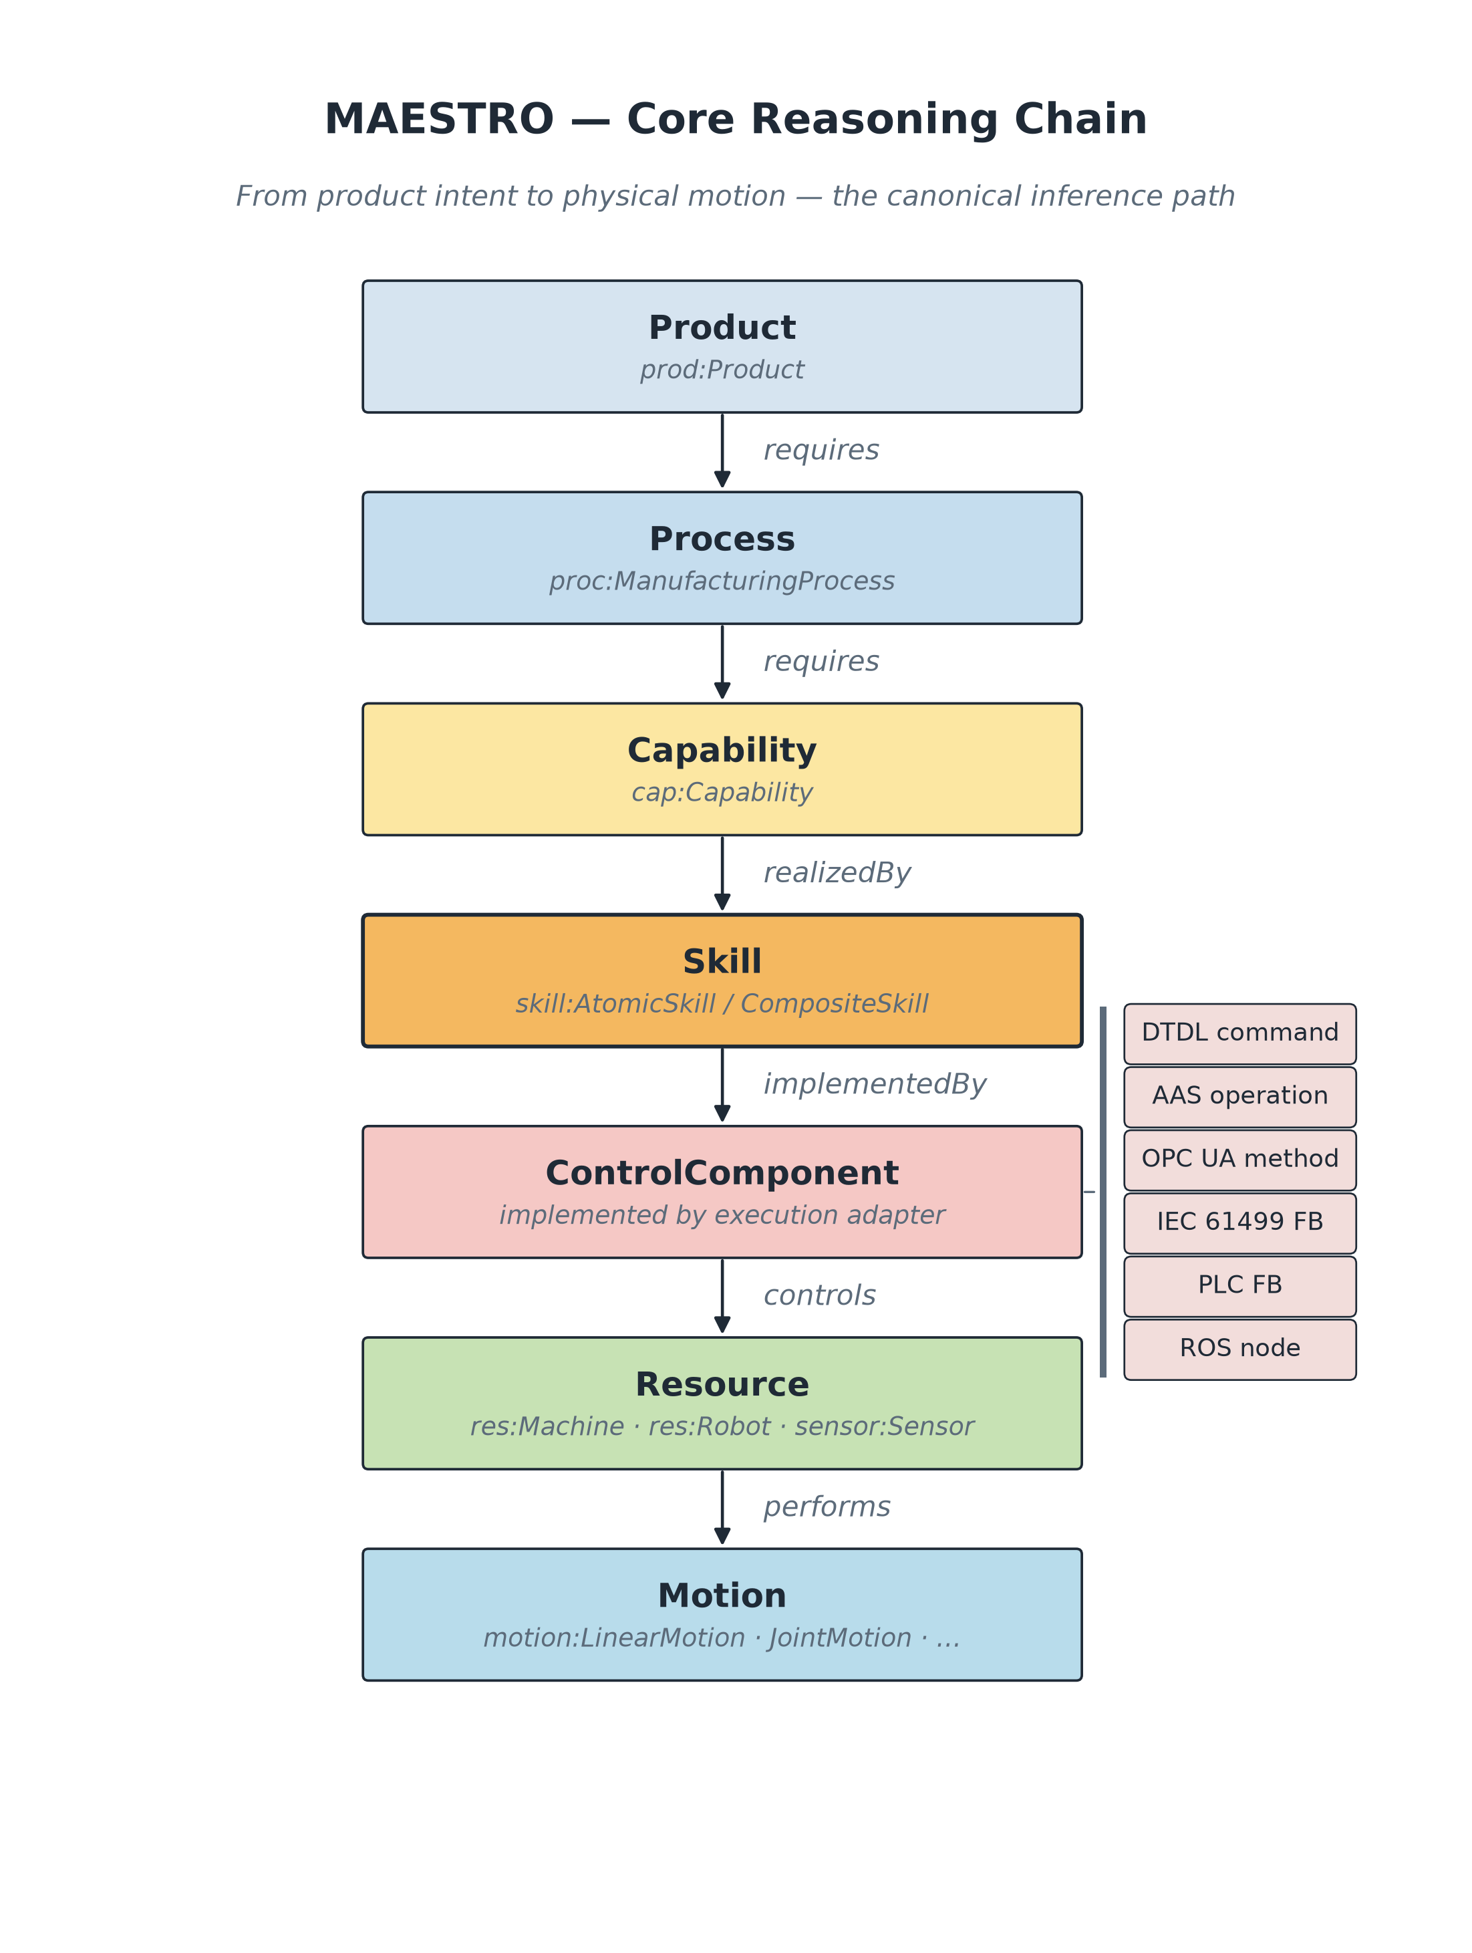
The core reasoning chain — Product down to Motion, with inference closing the gaps.

Part 6 — Worked Example A: The Distribution Station, End-to-End
We start at the top with a single goal — “produce one WorkpieceWP3” — and follow it down through every layer, let the reasoner fill the gaps, and end with metal moving. Every fact below is real.

The goal (one asserted fact)
ex:WorkpieceWP3 a prod:Part ;
prod:massKg 0.030 ;
prod:requiresProcess ex:DistributeWorkpieceProcess .

Going down: Product → Process
ex:DistributeWorkpieceProcess a proc:TransportProcess ;
proc:requiresCapability cap:HandlingCapability , cap:PickPlaceCapability , cap:TransportCapability ;
ex:hasSubProcess ex:LoadProcess, ex:PushProcess, ex:PickProcess, ex:RotateProcess, ex:PlaceProcess .
Five ordered steps, each declaring which capability it needs — but nothing about which machine:
Load (Handling) -> Push (Handling) -> Pick (PickPlace) -> Rotate (Transport) -> Place (PickPlace)

The bottom: what the hardware advertises
ex:VacuumUnit1 core:provides ex:Type_skPick , ex:Type_skPlace . # ManipulationSkills
ex:TransferArm1 core:provides ex:Type_skGoToLeft , ex:Type_skGoToRight . # MotionSkills
ex:FeederUnit1 core:provides ex:Type_skLoad_adp , ex:Type_skPush_adp . # HandlingSkills

ex:FBT_SkillVcmOn iec61499:implementsSkill ex:Type_skPick ;
iec61499:controlsResource ex:VacuumUnit1 .
At this point the top of the graph (“WP3 needs PickPlaceCapability”) and the bottom (“VacuumUnit1 provides skPick”) have no link between them. A human never connected them. The reasoner does.

Inference Rule 1 fires: resources gain capabilities
VacuumUnit1 canPerform PickPlaceCapability (from its ManipulationSkills) [INFERRED]
TransferArm1 canPerform TransportCapability (from its MotionSkills) [INFERRED]
FeederUnit1 canPerform HandlingCapability (from its HandlingSkills) [INFERRED]

Inference Rule 2 fires: the plant gains a product
The reasoner checks the three required capabilities against what the plant's parts can now do — all three are covered — and writes the final fact:
ex:DistributingStation1 core:canManufacture ex:WorkpieceWP3 . # <-- INFERRED
This is the answer to “can my factory make this part?” — computed, never stored. Delete the vacuum unit and re-run the reasoner: PickPlaceCapability vanishes, and this conclusion automatically disappears too. No human maintains it.

Back down to motion: the part actually moves
PickProcess needs PickPlaceCapability
-> realized by skill ex:Type_skPick
-> implemented by FB ex:FBT_SkillVcmOn
-> controls resource ex:VacuumUnit1
-> drives actuator ex:VacuumValve1 (IO_vcm_on -> open suction)

RotateProcess needs TransportCapability
-> skill ex:Type_skGoToRight -> FB ex:FBT_SkillGoToRight -> controls ex:TransferArm1
-> performs motion ex:ArmRotationalMotion (~90 deg in 1 second)
So the abstract intent “distribute WP3” has resolved, step by step, into open the vacuum valve and rotate the arm motor about 90° in one second — real I/O on real hardware.

Part 7 — Worked Example B: newsystem4 (the real testbed)
The plain distribution-station example is a clean teaching model. newsystem4 is the same Festo Distributing Station, but modelled from two real source artifacts rather than simplified — and it is the example built for an actual demonstration.
- The control layer comes from a real IEC 61499 / Schneider Electric project: a physical controller device EcoRT_0 (“Soft_dPAC”), runtime RES0, hosting application APP1.
- The physical layer comes from the actual Festo Didactic engineering documents and topology figures — real parts with part numbers, e.g. the DSNU-8-80 cylinder and DSR-16-180 rotary drive.
The physical job is the same: a feeder ejects a workpiece from a magazine; a transfer unit (a semi-rotary motor driving an arm with a vacuum suction cup) grips it, rotates 180°, and releases it downstream.

Topology (what's in the box)
DistributingStation1 (core:Plant)
+- FeederUnit1 feeds -> TransferUnit1
| +- Magazine1 (vertical FIFO, 8 workpieces)
| +- FeederPusher1 (driven by the cylinder)
| +- FeederCylinder1 DSNU-8-80 -> command: push
| +- 2 position sensors (SME-8) -> pos_e, pos_r
+- TransferUnit1
| +- TransferMotor1 DSR-16-180, 0-180 deg -> to_next, to_mgz
| +- TransferArm1 (driven by the motor)
| +- VacuumUnit1 valve + generator + filter + suction cup + sensor
| +- 2 limit switches (S-3-E) -> at_mgz, at_next
+- ControlConsole1 (the HMI button/light panel)

Skills → Function Blocks → Resources
Skill TYPE (logical) | Function block (real code) | Controls
Type_skMagazineEject | skMagazine_mo | FeederUnit1
Type_skMoveToMagazine | skSwivelArm_eo_Move_to_magazine | TransferMotor1
Type_skMoveToDownstream | skSwivelArm_eo_Move_to_downstream | TransferMotor1
Type_skGripWorkpiece | skSwivelArm_eo_Grip_workpiece | VacuumUnit1
Type_skReleaseWorkpiece | skSwivelArm_eo_Release_workpiece | VacuumUnit1
Type_skSwivelArmTransfer (composite) | skSwivelArm_mo_cmp1 (orchestrator) | TransferUnit1
Type_skButtonsLights | skButtonsLights | ControlConsole1
newsystem4 also models control-engineering realities the simple example skipped, without inventing new core concepts:
- Permit handshake (ex:permits, with Perm_L/Perm_R): enforces that the feeder and the transfer arm run in the correct sequence, not at once.
- Protocol adapters (ex:bridges): Magazine2Magasine and SwivelArm2Transfer translate internal signals to neighbour/downstream protocols.
- OPC UA interface: three registered skills are exposed to the network so external clients can call them.

The same generic rules still fire
FBT_skSwivelArm_mo_cmp1 implements Type_skSwivelArmTransfer
FBT_skSwivelArm_mo_cmp1 controls TransferUnit1
cap:PickPlaceCapability realizedBySkill Type_skSwivelArmTransfer
=> INFERRED: TransferUnit1 canPerform PickPlaceCapability
=> INFERRED: DistributingStation1 canManufacture WorkpieceWP
Full set of materialised conclusions: FeederUnit1 → HandlingCapability, TransferUnit1 → PickPlaceCapability, TransferMotor1 → TransportCapability, and the headline DistributingStation1 canManufacture WorkpieceWP.

The deeper lesson: one frozen core, everything else extends it
newsystem4 exists to prove one claim: MAESTRO is a single universal “frozen core,” and a real factory is just that core specialised down to specific hardware — not a separate model. Three tiers:
Tier | What it is | Stability
Frozen core (core:) | The ~12 universal classes and the spine relations (hasPart, provides, implements, controls, realizedBySkill, canPerform, canManufacture…). Imports nothing. | Invariant — changes only at a major version.
MAESTRO modules (res:, skill:, cap:, iec61499:…) | Domain/adapter vocabularies that couple to core ONLY via owl:imports + rdfs:subClassOf / rdfs:subPropertyOf. | Stable, versioned extensions; replaceable per concern.
Testbed (ex:) | The Festo-specific classes and all the individuals (FeederUnit1, IO_push…). | A concrete instantiation of the above.
The audit. Every example class rolls up to a frozen core class. A token audit of all 71 individuals returns zero terms that are not an instance of a MAESTRO core/module class. For instance FeederUnit1 -> ex:FeederUnit -> res:Machine -> core:Resource, and FBT_skMagazine_mo -> iec61499:CompositeFB -> core:ControlComponent.

Part 8 — Reading the Two Master Schema Diagrams

Shared conventions (apply to both figures)
- Box = a class (Figure 14) or an individual (Figure 15).
- Arrow = a relationship (an ontology property); the label is the property name.
- Coloured rounded outline = a cluster grouping one concern/layer.
- Gold box with a double border = a frozen core: class (Fig 14) or an individual typed by one (Fig 15) — the invariant spine.
- Orange “note” shapes («EXT») = external standards/artefacts MAESTRO bridges to but never absorbs.
- Solid arrow = an asserted triple; dashed/dotted = secondary/attribute relation; red dashed = an inferred triple.

Figure 14 — MAESTRO Core Schema (class level)
A class-level map of the whole ontology — what concepts MAESTRO defines and how they relate — organised into the seven manufacturing concerns of the 0.4 release.
Cluster (colour) | Module(s) | What it models
Product (purple) | product.ttl, dpp.ttl | ProductType / Instance / Variant / Feature / Requirement / Identifier / BOMNode / Material — what is to be produced, its identity and bill of materials.
Resources (teal) | resource.ttl, capability.ttl | AssemblyStation / Module / Machine and core:Capability — the physical assets and what they can do.
Skills (red) | core:Skill + skill.ttl | Atomic / Composite skills, reified orchestration (SubSkillLink, ControlFlow, DataBinding), typed parameters, pre/post-conditions, neutral SkillInterface / SkillService.
Recipe / Planning (blue) | recipe.ttl | Recipe / PlanStep — a neutral process plan whose steps are realised by skills.
Safety / Policy (black) | policy.ttl, safety.ttl, core: | Policy / Permission / Role / Mode / Evidence; Hazard / Risk / Mitigation; core:Constraint.
Invocation (orange) | communication.ttl | Endpoint / Protocol / Binding / OperationSignature / EventStream — the protocol-neutral way a skill is called.
Execution (violet) | runtime.ttl, prov.ttl, trace.ttl | SkillExecution / TimeInterval / Fault and core:State — the record of a skill actually running.
Only four classes carry the gold border because they belong to the frozen spine: core:Skill, core:Capability, core:Constraint, core:State. Everything else (prod: skill: recipe: com:…) is a module that extends them. The orange «EXT» notes name the external standards each cluster bridges (ECLASS/DPP, CAEX, ISA-88/95, OPC UA, REST, DTDL, AAS, QUDT, SOSA, PROV-O, SAREF4INMA, ODRL, CaSkMan) — always extensions, never copied into the core.
The spine running through it all: Product → requiresProcess → Process → requiresCapability → Capability → realizedBySkill → Skill, and on the execution side Skill ← implements ← ControlComponent → controls → Resource.
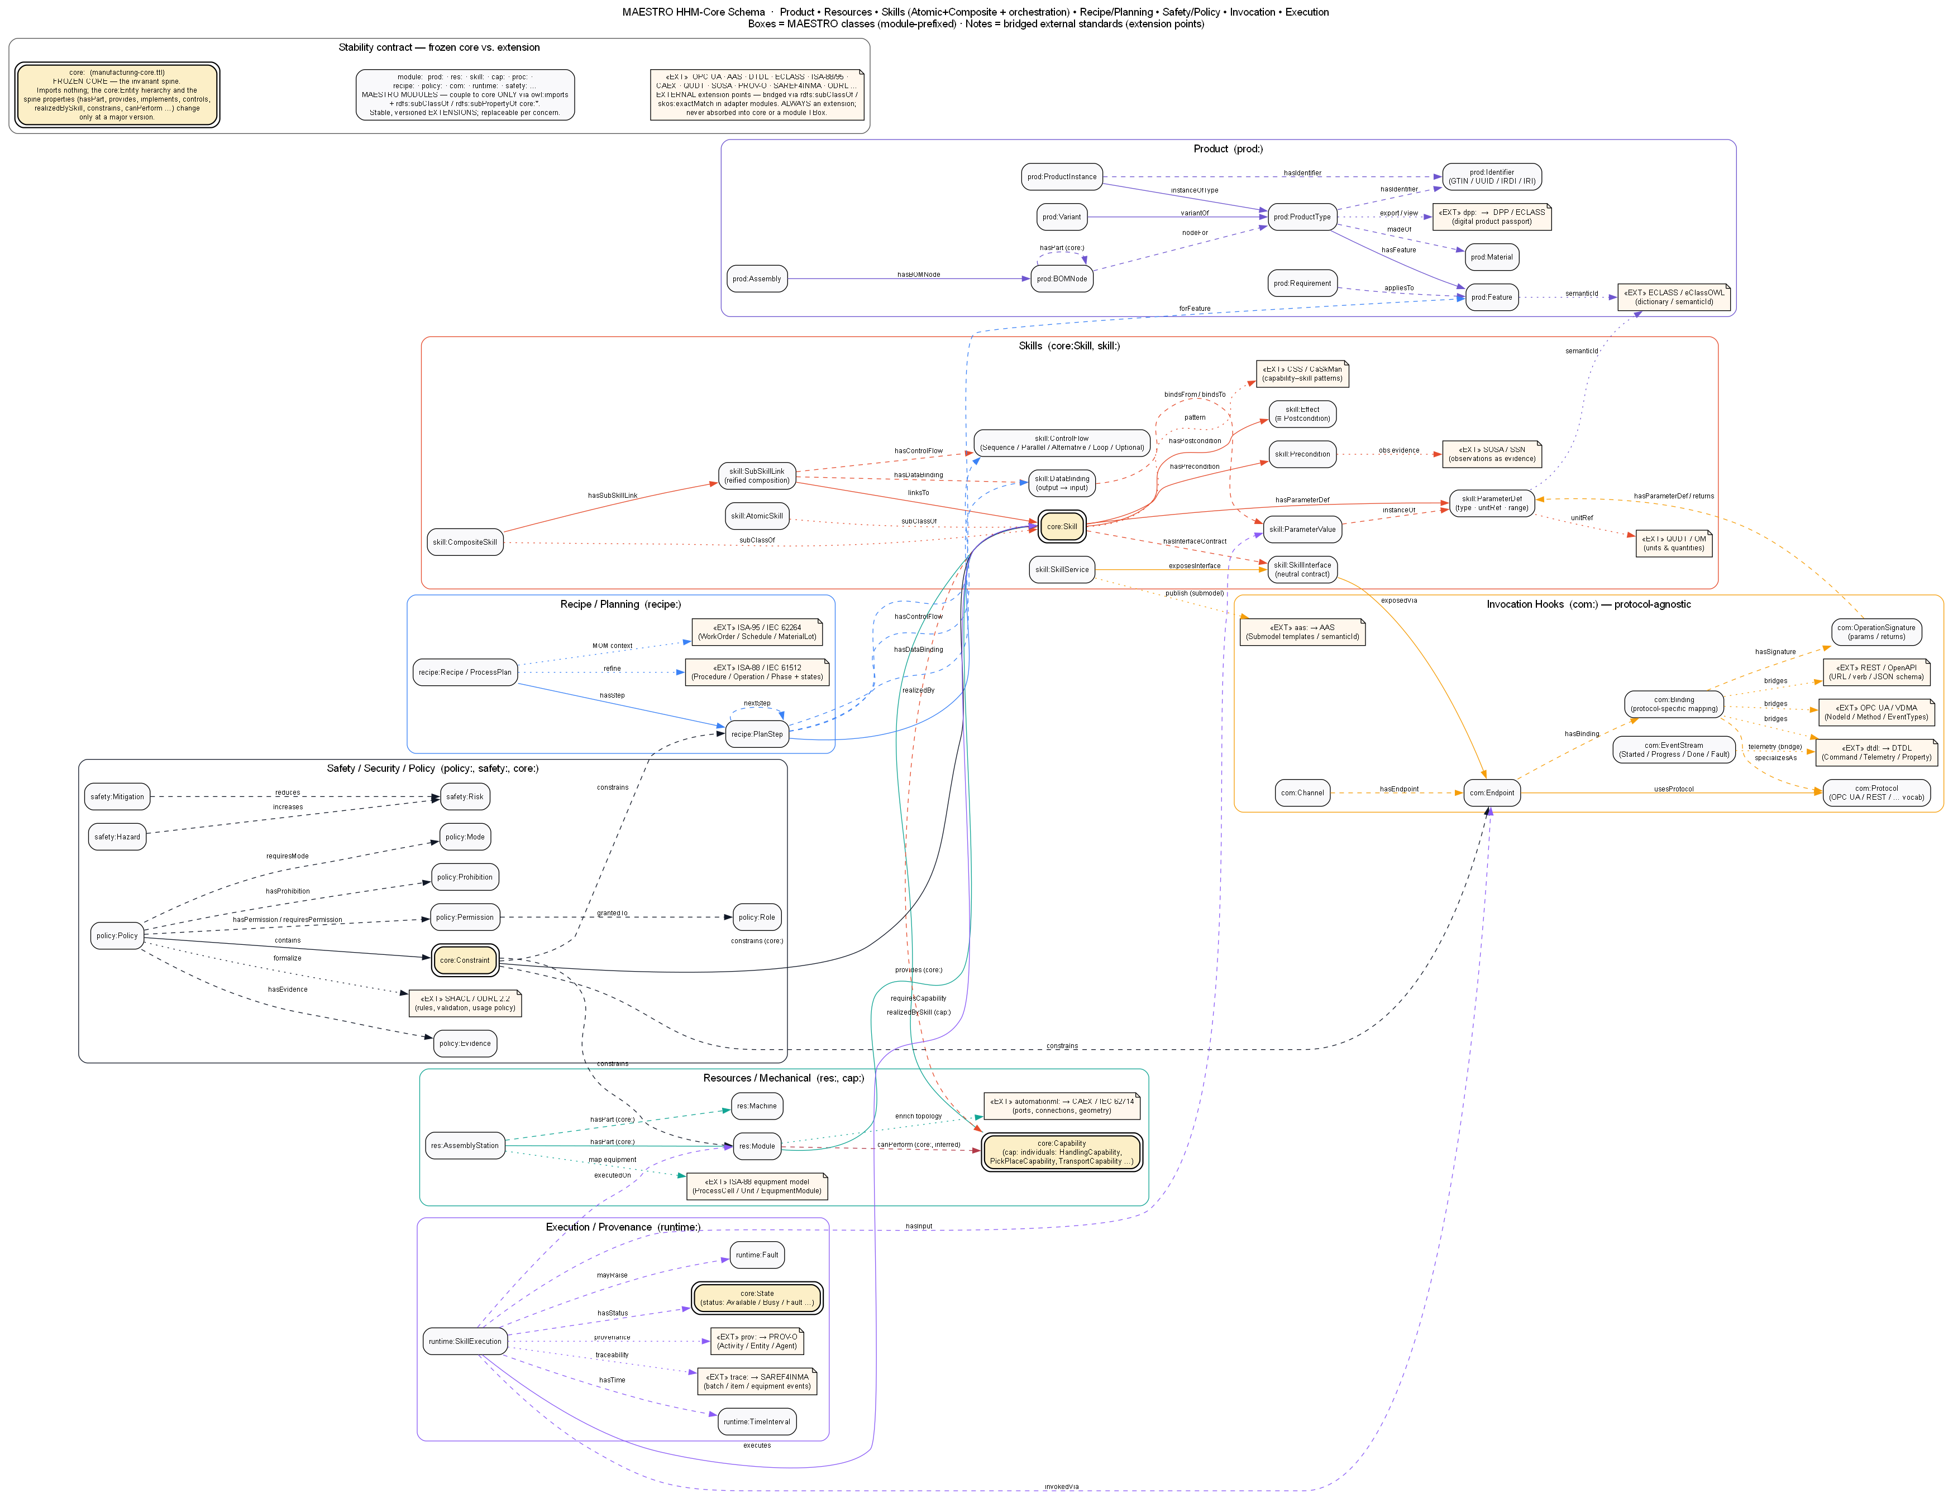
Figure 14 — MAESTRO HHM-Core Schema (the universal classes).

Figure 15 — newsystem4 Knowledge Graph (instance level)
Figure 14 “filled in” with the real testbed: every box is a concrete individual from the newsystem4 files, every arrow a real triple. It is grouped into six layers.
Cluster (colour) | Contents
Plant & Resources (teal) | DistributingStation1 and its parts (FeederUnit1, TransferUnit1, Magazine, cylinder, motor, arm, vacuum unit, console). Edges: hasPart, feeds, drivenBy.
Sensors & I/O (amber) | 6 sensors and 11 datapoints (ovals). Edges: createsSignal (sensor -> input), commandsActuator (output -> actuator).
Skill TYPES (red) | The 7 skills + 2 motion specs. Edges: provides (from resources), hasSubSkill, requiresMotion.
Capability / Process / Product (purple) | 3 capabilities, the 5-step DistributeWorkpieceProcess, and WorkpieceWP. Edges: realizedBySkill, hasSubProcess, precedes, requiresCapability, requiresProcess.
IEC 61499 Control (lavender) | FBTs with implementsSkill + controlsResource, the Soft_dPAC device / Runtime_RES0 / App_APP1, and FB instances wired by permits / bridges / instanceOfFBT.
OPC UA Interface (blue) | OpcUaDistributionInterface that exposes the registered skills Reg_Magazine / Reg_SwivelArm / Reg_ButtonsLights (each ofType a skill TYPE, partOf the application).
The payoff — the red dashed arrows. Four facts that are NOT asserted in the files; they are produced by the universal rules: FeederUnit1 canPerform HandlingCapability, TransferUnit1 canPerform PickPlaceCapability, TransferMotor1 canPerform TransportCapability, and the headline DistributingStation1 canManufacture WorkpieceWP. You can literally see the reasoning: solid arrows are asserted facts; red dashed arrows are the machine's conclusions stitched from them.
The gold boxes scattered across the clusters — DistributingStation1 (core:Plant), the three Reg_* skills (core:Skill), the three cap:* capabilities (core:Capability) — are where the universal frozen core shows through the Festo-specific names. That is the visual proof that the real testbed is nothing but MAESTRO's universal vocabulary, specialised to one machine.
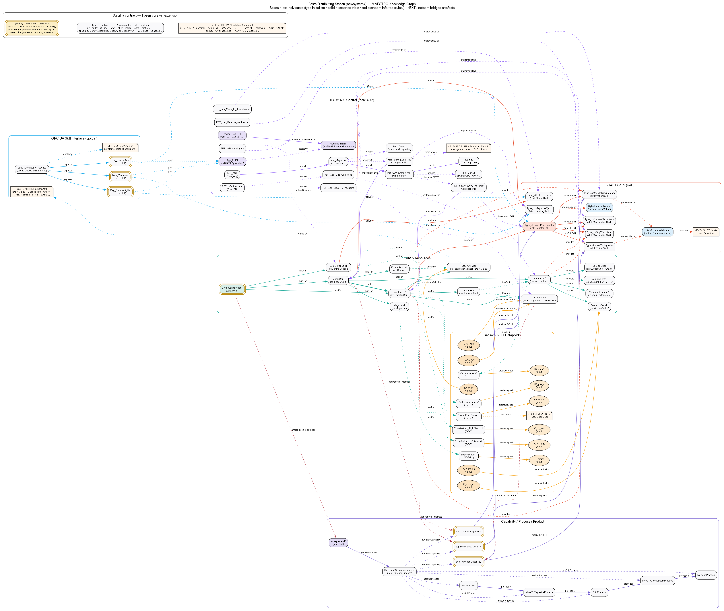
Figure 15 — Festo Distributing Station (newsystem4) knowledge graph (real individuals).

How the two figures relate
Figure 14 is the universal vocabulary; Figure 15 is that vocabulary filled in with the testbed. Every box in Figure 15 is an instance of a class in Figure 14 (directly, or via one or two subClassOf steps), and the same core relationships drive the reasoning in both:
Figure 14 (classes) Figure 15 (the station)
core:Resource <-type- FeederUnit1, TransferMotor1, sensors, ...
core:Plant <-type- DistributingStation1
core:Skill <-type- Type_skSwivelArmTransfer, Reg_Magazine, ...
core:Capability <-type- cap:PickPlaceCapability, ...
core:Process <-type- DistributeWorkpieceProcess, ...
core:Product <-type- WorkpieceWP
core:ControlComponent <-type- FBT_skMagazine_mo (Schneider Electric), ...
core:State <-type- IO_push, IO_vmon, ... (the 11 datapoints)

Quick Glossary
Term | Meaning
Triple | A fact written as Subject → Predicate → Object
Knowledge graph | A web of triples — the actual facts about a system
Ontology | The vocabulary + rules above the facts (classes, properties, constraints)
Class | A category of thing (Resource, Skill, Capability)
Individual / instance | A specific thing (TransferArm1, WorkpieceWP3)
.ttl (Turtle) | Text file format for writing triples
TBox / ABox | Vocabulary (classes & types) vs. the individuals/facts
Capability | What a plant CAN do (abstract possibility)
Skill | HOW something is done (logical, reusable; atomic or composite)
Resource | A physical asset (machine, robot, sensor, actuator)
ControlComponent | The software (PLC FB, ROS node…) that implements a skill
Reasoner | A program that derives new (inferred) triples from rules
Asserted vs inferred | Typed by a human vs. computed by the reasoner
Frozen core | The ~12 invariant core: classes every module extends
OWL2-RL | Reasoning profile used for class/property inheritance
SHACL | Validation language — checks the graph obeys constraints
SPARQL | Query / inference language for graphs (CONSTRUCT builds new triples)
«EXT» | An external standard MAESTRO bridges to, never absorbs
Source project: MAESTRO v0.4 — Modular Ontology Stack for Future-Proof Manufacturing (MIT License). All code excerpts are taken from the project's ontologies/, rules/, and examples/ folders.

