
MAESTRO
Modular Ontology Stack for Future-Proof Manufacturing
Technical Reference & Standards Alignment
Complete class and property specification for stakeholders
Ontology version 0.4.0 (OWL 2 RL)
Namespace: https://w3id.org/maestro#
Author: Melwin Xavier · Licence: MIT
Document generated 29 June 2026

Contents

1 Introduction
MAESTRO (Modular Ontology Stack for Future-Proof Manufacturing) is a unified, standards-aligned semantic framework for modelling manufacturing systems. It separates what a plant can do (capability) from how a plant does it (skill) and from what executes it (ROS, IEC 61131, IEC 61499, OPC UA, AAS), so that multi-vendor automation, digital twins and AI orchestration can share one knowledge graph.
This document is the full technical reference. It describes every module in the stack, the complete set of classes and properties each module defines, and — for every section — the industrial or web standard the module aligns to, why that standard was chosen, and how the alignment is implemented in the ontology.

1.1 How to read this document
Sections 2–5 give the architecture, the modular structure, the consolidated standards map, and the reasoning model. Sections 6 onward are the per-module reference: each begins with a short description, a Standard Alignment call-out (used / why / how), and then exhaustive tables of the module's classes, object properties and datatype properties with their definitions, super-classes, domains and ranges.

1.2 At a glance
Metric | Value
Ontology version | 0.4.0
Base namespace | https://w3id.org/maestro#
OWL profile | OWL 2 RL
Modules (.ttl) | 30 (+1 umbrella)
Classes defined | 205
Object properties | 146
Datatype properties | 51
Aligned standards | SSN/SOSA, QUDT, DIN 8580, VDI 2860/3682, ISA-88, ISA-95, PackML, AAS, OPC UA, IEC 61131-3, IEC 61499, ROS, DTDL, PROV-O, ODRL 2.2, SAREF4INMA, AutomationML/CAEX, IEC 61508, ISO 13849, ISO 9001, DPP/ECLASS

2 Master Architecture
MAESTRO is a nine-layer semantic stack. Each layer talks only to the layer immediately below it, and each layer is replaceable in isolation. The inversion at the heart of the design replaces the traditional Machine → Function coupling with a chain in which capability is realised by skill, executed by a control system, controlling a resource.
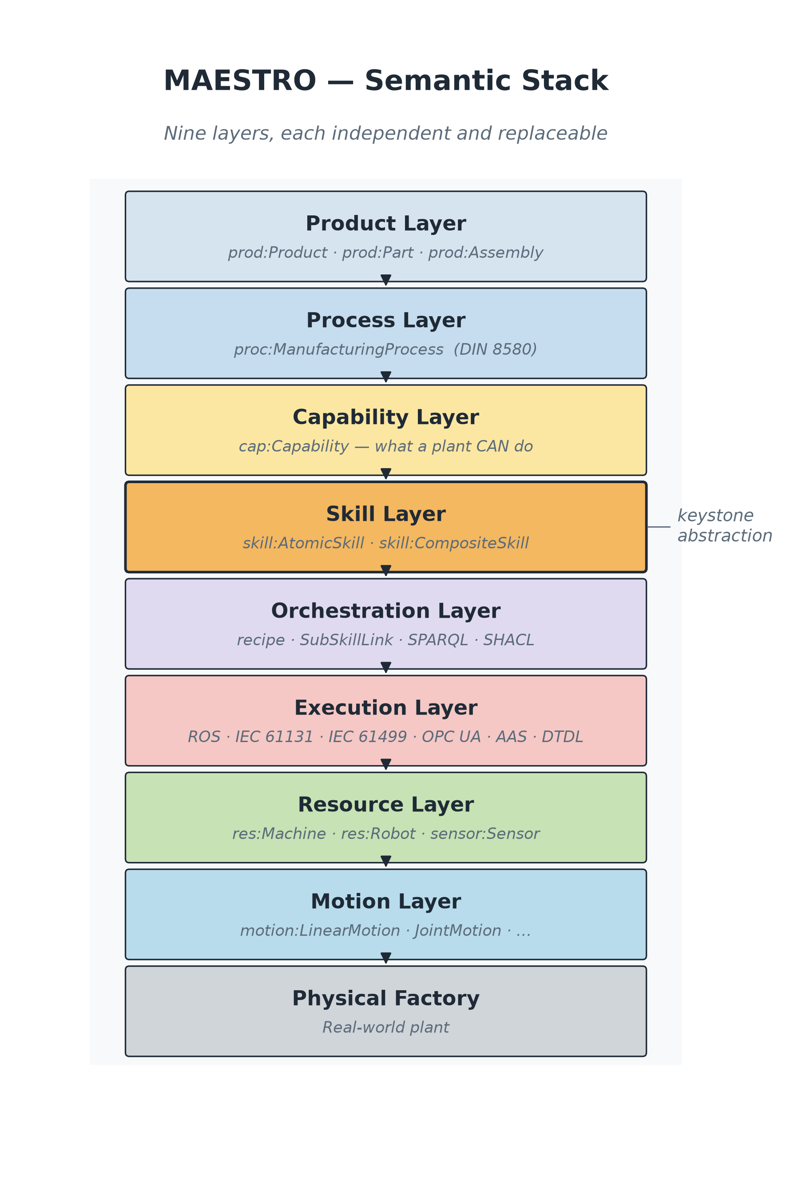
Figure 2.1 — The MAESTRO nine-layer semantic stack.

2.1 The nine layers
Layer | Owns
Product | What is being made (prod:Product, prod:Part, prod:Assembly).
Process | How it is made (DIN 8580 taxonomy, VDI 3682 sequencing).
Capability | What a plant can do (cap:Capability).
Skill | Logical executable behaviour (skill:AtomicSkill, skill:CompositeSkill).
Orchestration | SPARQL / SHACL / CONSTRUCT rules / LLM — the reasoning fabric.
Execution | The runtime: ROS, IEC 61131, IEC 61499, OPC UA, AAS.
Resource | Physical machines, robots, sensors, tools.
Motion | Geometric / kinematic primitives (motion:LinearMotion, …).
Physical Factory | The real-world plant.

2.2 Why three boundaries matter
- Capability ↔ Skill. Capabilities are what (vendor-neutral intent); skills are how (logical behaviour). Keeping them apart makes capability inference a graph-rule problem, not a code problem.
- Skill ↔ Execution. Skills are technology-neutral; ROS / PLCs / FBs are technology-specific. Crossing this boundary is what lets MAESTRO describe heterogeneous cells.
- Resource ↔ Motion. A robot is a resource; its movement is not. Splitting them makes the motion vocabulary reusable across robots, CNCs and AGVs.

3 Modular Ontology Stack
MAESTRO ships as 30 individual .ttl files plus one umbrella file (maestro.ttl). Loading the umbrella pulls in the whole stack via owl:imports; loading individual modules gives a tighter graph. The dependency rule is directed and acyclic: core imports nothing, every other module imports core, skill imports motion, capability imports skill, process imports capability, product imports process, and execution adapters import skill only. This is what makes incremental adoption possible.
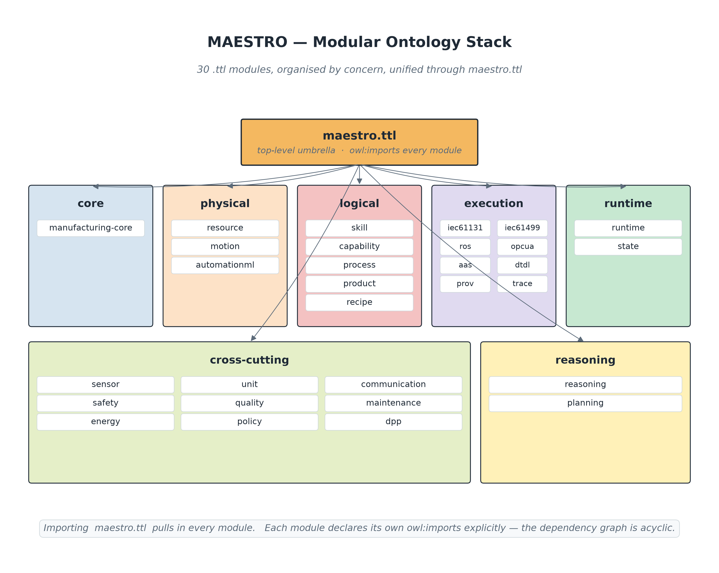
Figure 3.1 — The modular ontology stack and its package groups.
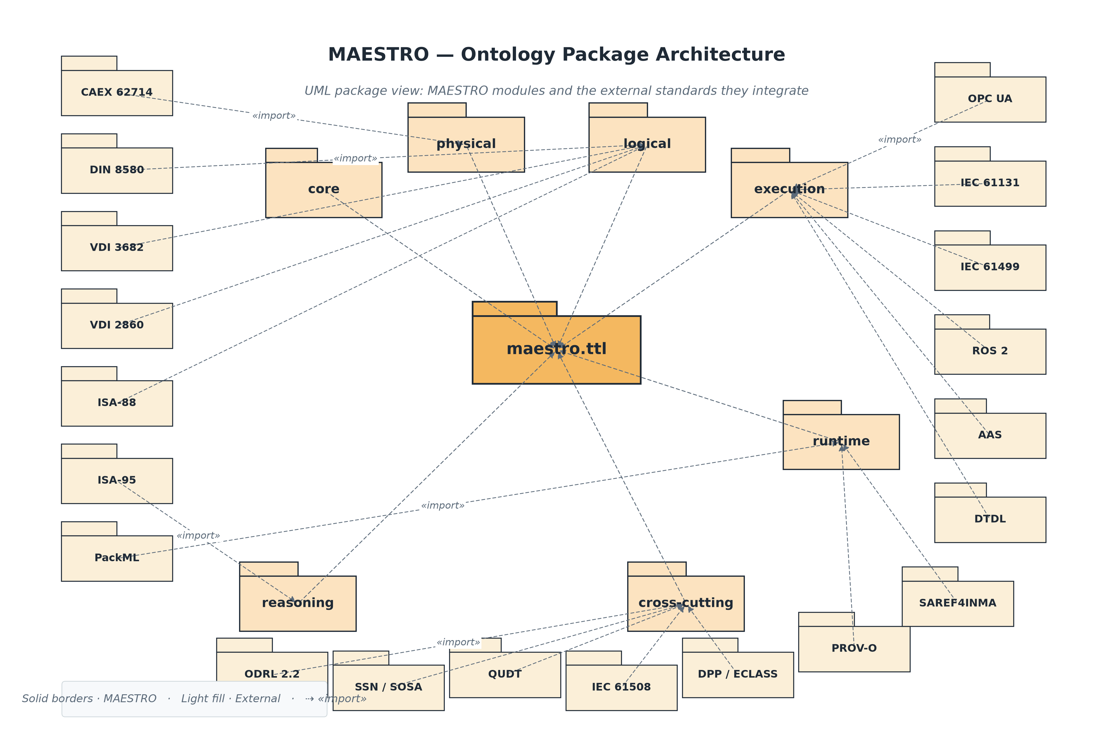
Figure 3.2 — Package architecture and import dependencies.

4 Standards Alignment — Consolidated Map
Alignment claims in MAESTRO are always backed by explicit bridge axioms. The convention is: rdfs:subClassOf when a MAESTRO class narrows an external class, owl:equivalentClass only when the semantics genuinely match, and skos:exactMatch / skos:closeMatch for concept schemes. MAESTRO does not import full upstream standard ontologies by default — upstream graphs are large, independently versioned and sometimes separately licensed — so it declares small bridge axioms and leaves full imports to deployment profiles. Reference copies of the freely-available upstream ontologies (PROV-O, ODRL 2.2, SAREF4INMA) are stored under references/ and are not loaded into the validated stack.
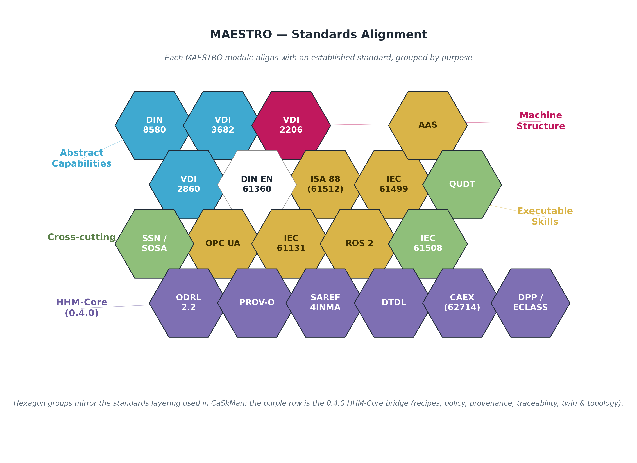
Figure 4.1 — The standards MAESTRO aligns to, by concern.
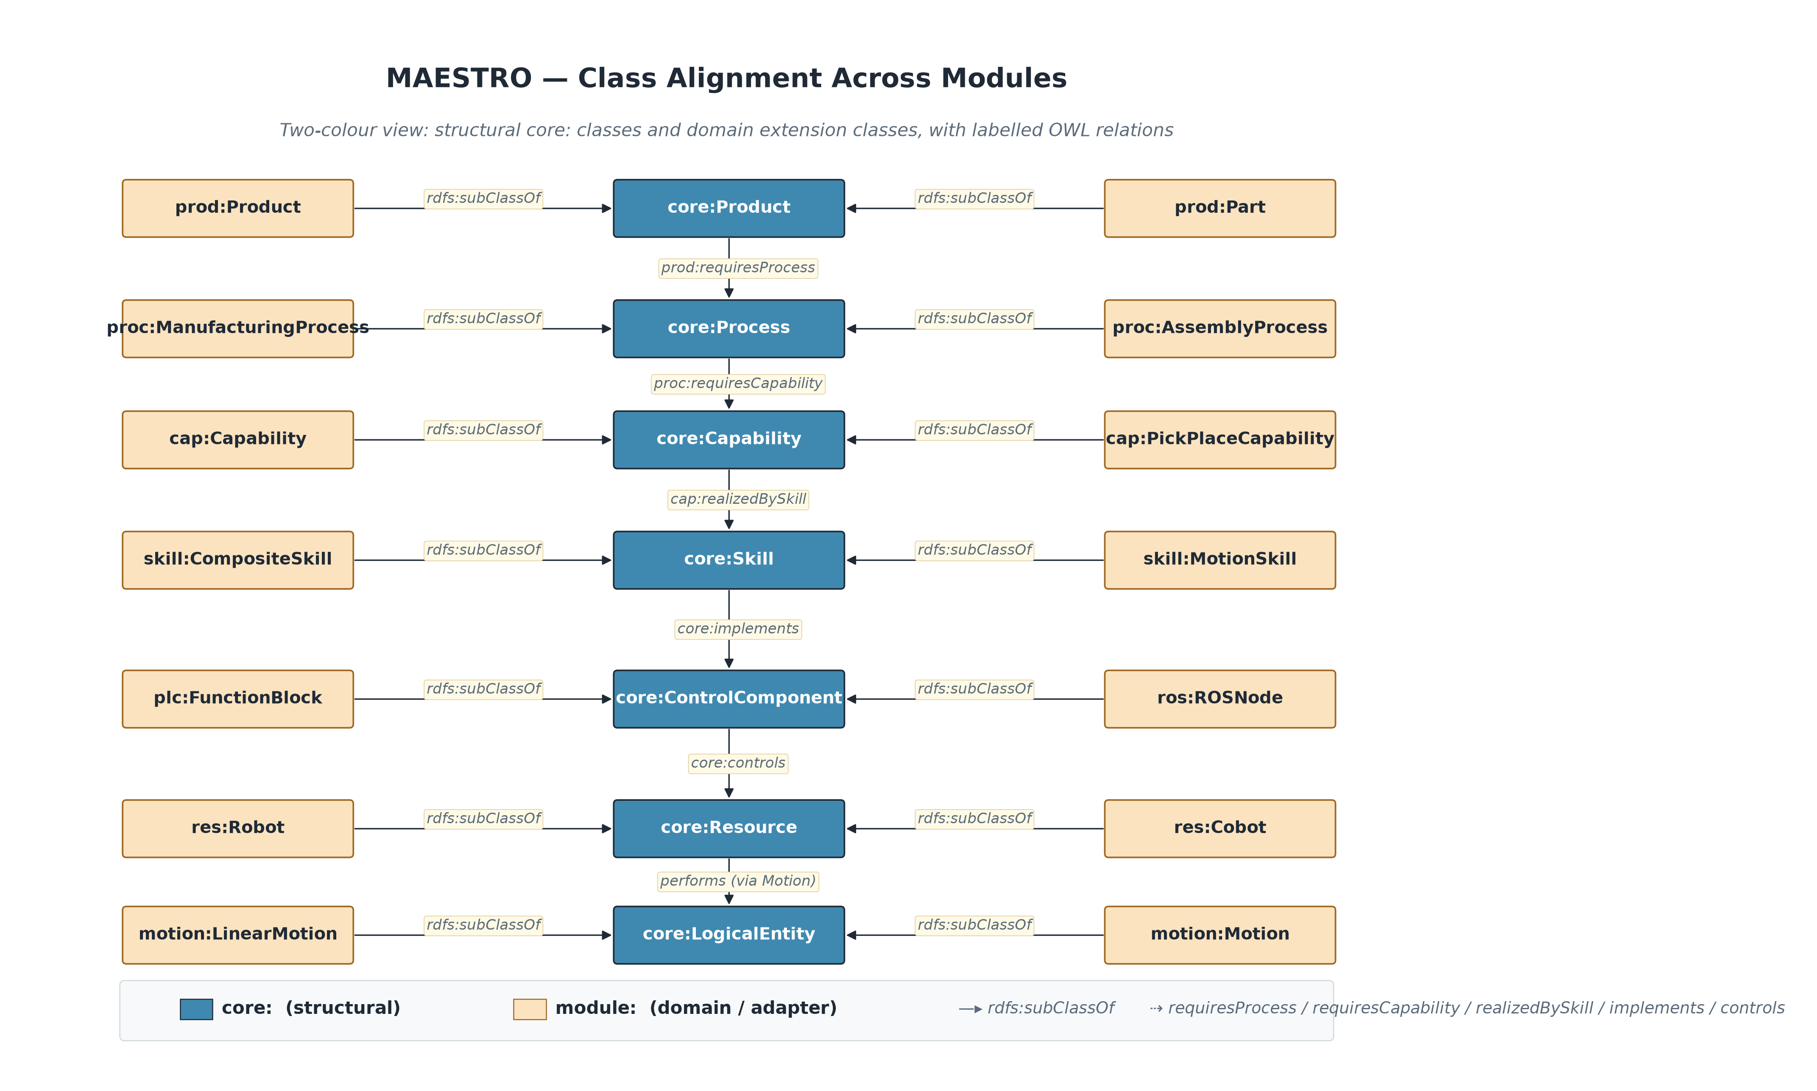
Figure 4.2 — Class-level alignment between MAESTRO and external standards.

4.1 Module-to-standard matrix
Module | Standard | Alignment mechanism
sensor | W3C SSN/SOSA | sensor:Sensor ⊑ sosa:Sensor; sensor:Observation ⊑ sosa:Observation
unit | QUDT | unit:Unit ⊑ qudt:Unit; unit:Quantity ⊑ qudt:Quantity
process | DIN 8580 / VDI 3682 | Local process families; sequencing via precedes/follows
skill | VDI 2860 | Local skill taxonomy; orchestration constructs MAESTRO-local
runtime / state | PackML (ISA-TR88) | SKOS state individuals aligned by label
planning | ISA-95 / IEC 62264 | Local planning classes; MOM context
recipe | ISA-88 / IEC 61512 | recipe:Recipe ⊑ isa88:Procedure; PlanStep ⊑ isa88:Phase
aas | AAS (IEC 63278) | Lightweight Shell/Submodel/Element bridge
opcua | OPC UA (IEC 62541) | OpcUaSkillInterface ⊑ skill:SkillInterface
policy | ODRL 2.2 | Policy/Permission/Prohibition ⊑ odrl:*
prov | W3C PROV-O | SkillExecution ⊑ prov:Activity; edges ⊑ prov:used / wasAssociatedWith
trace | ETSI SAREF4INMA | trace:Item ⊑ s4inma:Item; producedItem ⊑ prov:generated
dpp | DPP (ESPR) / ECLASS | prod:Feature skos:exactMatch eclass:<IRDI> (illustrative)
automationml | AutomationML / CAEX (IEC 62714) | Local mirrors; res:Module ⊑ aml:InternalElement
dtdl | DTDL (Azure Digital Twins) | dtdl:Interface ⊑ skill:SkillInterface; Command ⊑ com:OperationSignature
safety | IEC 61508 / ISO 13849 | SIL / PL levels; Hazard→Risk→Mitigation
quality | ISO 9001 | Local quality vocabulary
ros / iec61131 / iec61499 | ROS, IEC 61131-3, IEC 61499 | Native control-component classes; implements/controls ⊑ core:*

5 Reasoning Architecture
MAESTRO uses a layered reasoning model. OWL 2 RL / RDFS handles semantic inheritance (subclass, sub-property and inverse-property propagation); SHACL rejects malformed graphs before inference; SPARQL CONSTRUCT materialises the inferred core:canPerform and core:canManufacture relations; and SPARQL SELECT is the application and LLM query layer.
Layer | Technology | What it does
Semantic inheritance | OWL 2 RL / RDFS | Subclass, sub-property, inverse propagation
Validation | SHACL | Rejects malformed graphs before inference
Capability inference | SPARQL CONSTRUCT | Materialises core:canPerform
Manufacturing inference | SPARQL CONSTRUCT | Materialises core:canManufacture
Orchestration | SPARQL SELECT | Application and LLM query layer

5.1 The canonical reasoning chain
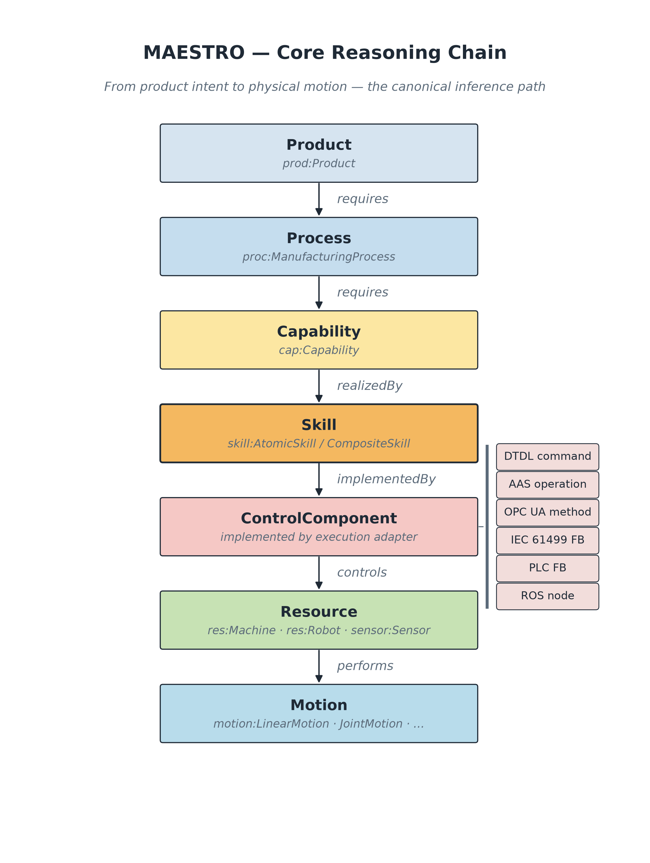
Figure 5.1 — Product → Process → Capability → Skill → ControlComponent → Resource → Plant.
Reading the chain: a Product requiresProcess a Process, which requiresCapability a Capability, which is realizedBySkill a Skill, which is implemented by a ControlComponent that controls a Resource — from which core:canPerform is inferred at the resource level and core:canManufacture at the plant level.

5.2 LLM + GraphDB pipeline
The LLM pipeline treats the graph as the source of truth: the LLM extracts intent and fills SPARQL templates, while deterministic graph queries and rule materialisation decide which resource can actually execute. The LLM never invents graph facts or writes into the runtime graph without provenance.
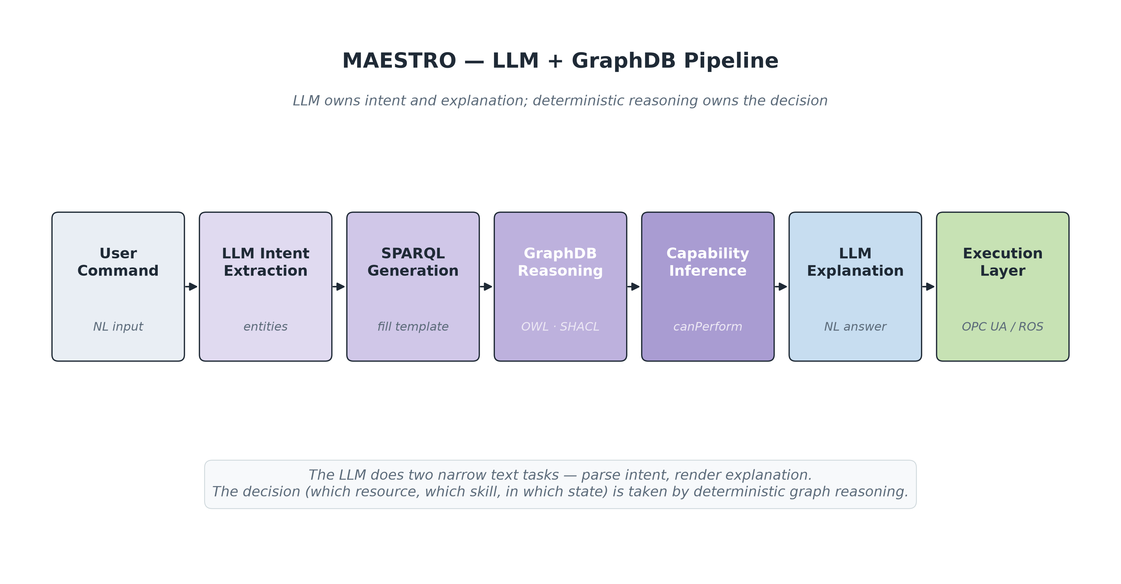
Figure 5.2 — The LLM + GraphDB orchestration pipeline.
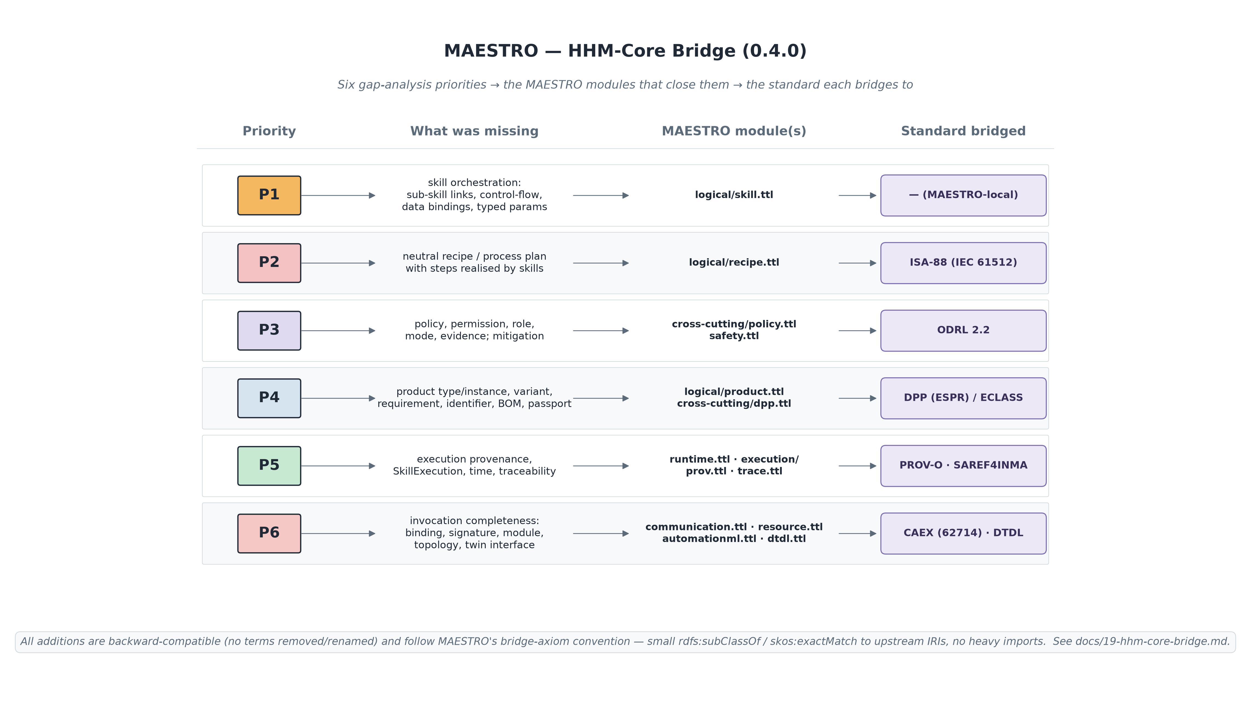
Figure 5.3 — The 0.4.0 HHM-Core bridge: new modules mapped to the standards they bridge.

6 Module Reference
Note on definitions: where a class or property carries no rdfs:comment in the source ontology, the definition shown here was supplied editorially from the repository documentation, the term’s class hierarchy and domain/range, and the standard the module aligns to. These editorial definitions describe intended meaning and are not axioms asserted in the .ttl files.
The remainder of the document is the exhaustive per-module reference. Modules are grouped as Core, Physical, Logical, Execution Adapters, Runtime, Cross-cutting and Reasoning. Within each table the first column is the term (local name), followed by its definition and structural facts (super-class, domain, range). A dash (—) indicates the value is not asserted in the ontology.

6.1 Core

Core Ontology (core:)
Module file: core/manufacturing-core.ttl
The root of the entire import graph. It imports nothing; every other module imports it. It carries only universal abstractions and the load-bearing relations that downstream modules specialise. core:Entity splits into core:PhysicalEntity (Resource, Plant) and core:LogicalEntity (Skill, Capability, Process, Product, State, Event, Constraint, ControlComponent), and the two branches are declared disjoint so boundary violations are caught early. It also fixes the relationship spine — implements, controls, deployedOn, realizedBySkill, hasPart/partOf, and the inferred canPerform / canManufacture / hasPlantCapability.
STANDARD ALIGNMENT
Standard used: OWL 2 RL and RDFS (W3C)
Why it is used: OWL 2 RL gives rule-based, decidable inference (subclass, sub-property, inverse propagation) that scales to a triple store, and RDFS supplies the labelling and subclass vocabulary. Choosing a profile (OWL 2 RL) rather than full OWL keeps reasoning tractable on a live graph.
How it is used: Classes are owl:Class, relations are owl:ObjectProperty / owl:DatatypeProperty, and the physical/logical split uses owl:disjointWith. Specialisation everywhere else is expressed as rdfs:subClassOf / rdfs:subPropertyOf pointing back at these core terms, which is what makes the capability-inference rules portable.

Defines 13 classes, 25 object properties, 3 datatype properties.
Classes
Class | Definition | Subclass of
core:Capability | A manufacturing possibility (what a plant CAN do). Realised by Skills. | core:LogicalEntity
core:Constraint | A restriction on Skills, Resources, or Processes. | core:LogicalEntity
core:ControlComponent | A software/hardware element that implements Skills and controls Resources (e.g. ROS node, PLC FB, IEC 61499 FB, OPC UA method). | core:LogicalEntity
core:Entity | The most general class. Anything modelled in MAESTRO is an Entity.
core:Event | A point-in-time occurrence in the manufacturing system. | core:LogicalEntity
core:LogicalEntity | An entity that exists only in the information model. | core:Entity
core:PhysicalEntity | An entity that has a physical realisation (mass, location). | core:Entity
core:Plant | An aggregation of Resources forming a manufacturing facility. | core:PhysicalEntity
core:Process | Manufacturing logic. Requires Capabilities to be executed. | core:LogicalEntity
core:Product | A product, part, or assembly that requires manufacturing Processes. | core:LogicalEntity
core:Resource | Any physical manufacturing asset (machine, robot, sensor, actuator, tool). | core:PhysicalEntity
core:Skill | A logical, executable behaviour. Implemented by ControlComponents; provided by Resources. | core:LogicalEntity
core:State | A discrete operational condition of a Resource or ControlComponent. | core:LogicalEntity

Object properties
Property | Definition | Domain | Range
core:canManufacture | Inferred relation: a Plant can manufacture a Product. Materialised by rules/manufacturing-ability.rq. | core:Plant | core:Product
core:canPerform | Inferred relation: a Resource is capable of performing a Capability. Materialised by rules/capability-inference.rq. | core:Resource | core:Capability
core:communicatesThrough | A ControlComponent communicates with a Resource through a communication channel. Range is com:Channel (kept open here to avoid pulling communication.ttl into core). | core:ControlComponent
core:composedOfSkill | A composite Skill is composed of another Skill. Transitive. | core:Skill | core:Skill
core:connectedTo | Physical or logical connectivity between two entities. Symmetric. | core:Entity | core:Entity
core:constrains | A Constraint reifies a restriction on a target — a Skill, recipe:PlanStep, res:Module or com:Endpoint. Range left open (union of targets) to keep OWL2-RL clean. New in 0.4.0 (HHM-Core Constraint→target edges). | core:Constraint
core:consumes | An Entity consumes an Event. | core:Entity | core:Event
core:controls | A ControlComponent controls a Resource. | core:ControlComponent | core:Resource
core:dependsOn | Generic dependency relation. | core:Entity | core:Entity
core:deployedOn | A logical ControlComponent is deployed on a physical controller or compute Resource. | core:ControlComponent | core:Resource
core:emits | An Entity emits an Event. | core:Entity | core:Event
core:executes | A ControlComponent executes a Process or Skill at runtime. Range is core:Skill or core:Process — left open via union (not asserted to keep OWL2-RL clean). | core:ControlComponent
core:hasPart | Mereological part-of relation. Transitive: Plant hasPart Cell, Cell hasPart Robot entails Plant hasPart Robot. | core:Entity | core:Entity
core:hasPlantCapability | Plant-level capability. Use this instead of core:canPerform on Plant individuals (canPerform is Resource-scoped). | core:Plant | core:Capability
core:hasState | Runtime operational State of an Entity. Use only inside a runtime named graph — see decisions/0002-runtime-graph-separation.md. | core:Entity | core:State
core:hosts | A physical Resource hosts a logical artefact (a ControlComponent, an IEC 61499 RuntimeResource, an OPC UA Server). | core:Resource | core:LogicalEntity
core:implementedBy | Inverse of core:implements. | core:Skill | core:ControlComponent
core:implements | A ControlComponent implements a Skill (concrete realisation). | core:ControlComponent | core:Skill
core:partOf | Inverse mereological relation. Transitive. | core:Entity | core:Entity
core:providedBy | Inverse of core:provides. | core:Skill | core:Resource
core:provides | A Resource provides a Skill (offers it for use). | core:Resource | core:Skill
core:realizedBySkill | A Capability is realized by a reusable Skill specification. | core:Capability | core:Skill
core:realizes | A Skill realises a Capability. | core:Skill | core:Capability
core:requiresCapability | A Process requires a Capability. | core:Process | core:Capability
core:requiresMotion | A Skill requires a technology-neutral motion specification. Range narrowed to motion:Motion in motion.ttl. | core:Skill | core:LogicalEntity

Datatype properties
Property | Definition | Domain | Range
core:description | A human-readable textual description of an entity. | core:Entity | xsd:string
core:identifier | Globally unique identifier (e.g. AAS shortId, OPC UA NodeId). Functional (each entity has at most one) and inverse-functional (each identifier names at most one entity). | core:Entity | xsd:string
core:version | A version string for an entity or artefact. | core:Entity | xsd:string

6.2 Physical Layer

Resource Ontology (res:)
Module file: physical/resource.ttl
Describes the physical asset hierarchy of a plant under core:Resource — machines (Robot, Cobot, TransferArm, AGV, CNC, Conveyor, AssemblyStation, LaserUnit), tools (Gripper, ToolChanger, VacuumUnit), actuators, controller devices (PLC, IndustrialPC) and, from 0.4.0, the reconfigurable plug-and-produce res:Module. The golden rule: resources carry no manufacturing semantics — they only provide skills, support motion and expose interfaces. There is no res:WeldRobot; there is a res:Robot that core:provides a welding skill, so re-tooling at runtime stays consistent.
STANDARD ALIGNMENT
Standard used: Asset hierarchy aligned to AutomationML / CAEX (IEC 62714) via res:Module
Why it is used: Naming assets by function (WeldRobot) breaks the instant a robot changes end-effector. Modelling capability separately and bridging res:Module to CAEX lets imported plant topology attach to the same asset that carries skills.
How it is used: res:Module is rdfs:subClassOf both core:Resource and aml:InternalElement, so a station doubles as the anchor for imported AutomationML topology. Datasheet properties (manufacturer, model, payload, reach) live here as unit-bearing unit:Quantity values; live state lives in runtime.ttl.

Defines 19 classes, 2 object properties, 5 datatype properties.
Classes
Class | Definition | Subclass of
res:Actuator | A powered component that produces motion or force (e.g. a servo motor). | core:Resource
res:AGV | Automated Guided Vehicle. | res:Machine
res:AssemblyStation | Workstation where assembly operations take place. | res:Machine
res:CNC | Computer Numerical Control machining centre. | res:Machine
res:Cobot | A collaborative robot designed for safe human interaction. | res:Robot
res:ControllerDevice | Physical controller or compute hardware that hosts logical ControlComponents. | core:Resource
res:Conveyor | Material handling conveyor. | res:Machine
res:Gripper | An end-effector tool that grasps and holds workpieces. | res:Tool
res:IndustrialPC | Industrial compute hardware that hosts logical ControlComponents. | res:ControllerDevice
res:LaserUnit | Laser machining / marking / welding unit. | res:Machine
res:Machine | A general manufacturing machine. | core:Resource
res:Module | A reconfigurable, plug-and-produce production module (MTP-style). As an AutomationML InternalElement it anchors imported plant topology, ports and connections. | core:Resource, aml:InternalElement
res:PLC | Programmable Logic Controller hardware. PLC programs and Function Blocks are logical ControlComponents deployed on this hardware. | res:ControllerDevice
res:Robot | An articulated, programmable, multi-axis machine. | res:Machine
res:ServoMotor | A servo-controlled actuator providing precise positioned motion. | res:Actuator
res:Tool | An attachable end-effector or working implement carried by a machine (gripper, tool changer, vacuum unit, …). | core:Resource
res:ToolChanger | A tool that automatically exchanges end-effectors, letting a robot re-tool at runtime. | res:Tool
res:TransferArm | A robotic arm specialised for transfer / pick-and-place tasks. | res:Robot
res:VacuumUnit | Vacuum end-effector for pick operations. | res:Tool

Object properties
Property | Definition | Domain | Range
res:payload | Maximum payload as an explicit quantity value. | res:Robot | unit:Quantity
res:reach | Robot reach as an explicit quantity value. | res:Robot | unit:Quantity

Datatype properties
Property | Definition | Domain | Range
res:manufacturer | The manufacturer (make) of a resource. Datasheet attribute. |  | xsd:string
res:model | The model designation of a resource. Datasheet attribute. |  | xsd:string
res:payloadKg | Maximum payload of a robot or handling resource, in kilograms. |  | xsd:float
res:reachMm | Robot reach in millimetres. |  | xsd:float
res:serialNumber | The unique serial number of an individual resource unit. |  | xsd:string

Motion Ontology (motion:)
Module file: physical/motion.ttl
Machine-independent geometric and kinematic primitives — LinearMotion, RotationalMotion, JointMotion, CartesianMotion, SynchronizedMotion, TrajectoryMotion, ForceControlledMotion — plus the abstract properties that parameterise them (velocity, acceleration, precision, coordinate frame, axes). The same motion:LinearMotion applies whether the actuator is a robot end-effector, a CNC tool head or an AGV.
STANDARD ALIGNMENT
Standard used: Deliberately standard-neutral abstract kinematics
Why it is used: If motion referenced a ROS PoseStamped or a PLC type, the whole stack would inherit that runtime dependency. Keeping motion abstract is what lets one motion vocabulary be reused across robots, CNCs and AGVs and mapped by any adapter.
How it is used: Motion declares only abstract geometric concepts; each execution adapter is responsible for mapping them into its protocol's runtime types. Skills point at motion specification individuals through skill:requiresMotion.

Defines 10 classes, 2 object properties, 4 datatype properties.
Classes
Class | Definition | Subclass of
motion:Axis | A controllable axis of movement of a machine or actuator. | core:LogicalEntity
motion:CartesianMotion | Motion specified in Cartesian/task space. | motion:Motion
motion:CoordinateFrame | A reference frame in which a motion or pose is expressed. | core:LogicalEntity
motion:ForceControlledMotion | Motion regulated by force/torque feedback. | motion:Motion
motion:JointMotion | Motion specified in joint space. | motion:Motion
motion:LinearMotion | Straight-line translational motion. | motion:Motion
motion:Motion | A geometric/kinematic movement abstraction. | core:LogicalEntity
motion:RotationalMotion | Motion about an axis of rotation. | motion:Motion
motion:SynchronizedMotion | Coordinated motion of multiple resources. | motion:Motion
motion:TrajectoryMotion | Motion defined by a parametric trajectory. | motion:Motion

Object properties
Property | Definition | Domain | Range
motion:hasCoordinateFrame | Relates a motion to the coordinate frame it is expressed in. |  | motion:CoordinateFrame
motion:requiresAxis | Relates a motion to an axis it requires. |  | motion:Axis

Datatype properties
Property | Definition | Domain | Range
motion:hasAcceleration | Acceleration of a motion (m/s² or rad/s²). |  | xsd:float
motion:hasPrecision | Repeatability / positioning precision in mm. |  | xsd:float
motion:hasVelocity | Linear velocity in m/s or angular velocity in rad/s, depending on motion subtype. |  | xsd:float
motion:numberOfAxes | The number of axes involved in a motion. |  | xsd:integer

AutomationML / Topology (aml:)
Module file: physical/automationml.ttl
A lightweight MAESTRO-local mirror of the CAEX object model used to represent reconfigurable plant topology: InternalElement (a component/module), ExternalInterface (a port) and InternalLink (a connection), wired with hasInterface and linksInterface.
STANDARD ALIGNMENT
Standard used: AutomationML / CAEX (IEC 62714)
Why it is used: CAEX is the dominant interchange format for plant topology, but it is defined as an XML Schema, not OWL, so it cannot be imported directly into the semantic stack.
How it is used: The three CAEX concepts are mirrored as MAESTRO-local owl:Classes; res:Module is declared rdfs:subClassOf aml:InternalElement so an imported topology snaps onto the same asset that provides skills.

Defines 3 classes, 2 object properties, 0 datatype properties.
Classes
Class | Definition | Subclass of
aml:ExternalInterface | A CAEX ExternalInterface — a port through which InternalElements connect. | core:LogicalEntity
aml:InternalElement | A CAEX InternalElement — a node in the plant topology hierarchy. | core:PhysicalEntity
aml:InternalLink | A CAEX InternalLink — a connection between two ExternalInterfaces. | core:LogicalEntity

Object properties
Property | Definition | Domain | Range
aml:hasInterface | An InternalElement exposes an ExternalInterface (port). | aml:InternalElement | aml:ExternalInterface
aml:linksInterface | An InternalLink connects two ExternalInterfaces. | aml:InternalLink | aml:ExternalInterface

6.3 Logical Layer

Skill Ontology (skill:)
Module file: logical/skill.ttl
The keystone of MAESTRO. Skills are reusable, technology-neutral behaviour specifications — not ROS nodes, PLC function blocks or OPC UA methods; execution technologies implement them. The taxonomy splits core:Skill into AtomicSkill (Motion, Manipulation, Handling, Inspection) and CompositeSkill (Assembly, Welding, Coordination, Process, Transfer). 0.4.0 reifies composition so control-flow and data-flow attach to each edge: SubSkillLink, ControlFlow (Sequence/Parallel/Alternative/Loop/Optional), DataBinding, typed ParameterDef/ParameterValue, Precondition/Effect, and a protocol-neutral SkillInterface/SkillService. Reusable skill individuals live in the separate skill-lib namespace.
STANDARD ALIGNMENT
Standard used: VDI 2860 skill taxonomy; orchestration constructs MAESTRO-local; SkillInterface protocol-neutral
Why it is used: Separating what a skill is from how it is executed is what lets a ROS robot and an IEC 61499 controller share one skill:Transfer definition. Reifying the composition edge is what lets a planner attach branching, looping and data wiring without leaving the semantic layer.
How it is used: Behaviour types are rdfs:subClassOf core:Skill. composedOfSkill stays as the plain shortcut; the reified SubSkillLink (hasSubSkillLink/linksTo) carries hasControlFlow and hasDataBinding. SkillInterface is the neutral contract that OPC UA, DTDL and AAS interfaces specialise.

Defines 26 classes, 18 object properties, 5 datatype properties.
Classes
Class | Definition | Subclass of
skill:Alternative | Exclusive choice (alt / branch). | skill:ControlFlow
skill:AssemblySkill | A composite skill that joins parts into an assembly. | skill:CompositeSkill
skill:AtomicSkill | An indivisible skill primitive. | core:Skill
skill:CompositeSkill | A skill built by composing other skills via skill:composedOfSkill. | core:Skill
skill:ControlFlow | Branching/looping/optional control between skill steps. Subclasses give the operator; the existing proc:precedes/follows/parallelWith cover the process-level ordering. | core:LogicalEntity
skill:CoordinationSkill | A composite skill that coordinates the actions of multiple resources or sub-skills. | skill:CompositeSkill
skill:DataBinding | Binds a producing skill's output parameter to a consuming skill's input parameter. Mirrors HHM-Core DataBinding. | core:LogicalEntity
skill:Effect | A postcondition/effect produced by a Skill, expressed over core:State via skill:refersToState. The plain skill:hasPostcondition (Skill→State) shortcut is retained. | core:LogicalEntity
skill:HandlingSkill | VDI 2860 handling skills (orient, position, deposit, secure). | skill:AtomicSkill
skill:InspectionSkill | An atomic skill that inspects or measures a workpiece. | skill:AtomicSkill
skill:Loop | A control-flow operator that repeats a sub-skill link or plan step. | skill:ControlFlow
skill:ManipulationSkill | Skills that change the spatial relation between a resource and a workpiece (grasp, pick, place, release). | skill:AtomicSkill
skill:MotionSkill | Skills that produce kinematic motion (move linear, move joint, …). | skill:AtomicSkill
skill:Optional | A control-flow operator marking a sub-skill link or plan step as optional. | skill:ControlFlow
skill:Parallel | A control-flow operator that executes branches concurrently. | skill:ControlFlow
skill:ParameterDef | Typed parameter definition of a Skill: a data type, an optional unit reference and an optional numeric range. Replaces the untyped skill:hasParameter target. | core:LogicalEntity
skill:ParameterValue | An instance-level value supplied for a ParameterDef (e.g. at a SkillExecution). | core:LogicalEntity
skill:Postcondition | Alias of skill:Effect using the HHM-Core name 'Postcondition'. The reified postcondition target of skill:hasPostcondition. | core:LogicalEntity
skill:Precondition | A condition that must hold before a Skill runs, expressed over core:State via skill:refersToState. The plain skill:hasPrecondition (Skill→State) shortcut is retained. | core:LogicalEntity
skill:ProcessSkill | A composite skill realising a manufacturing process step. | skill:CompositeSkill
skill:Sequence | A control-flow operator that executes branches in order. | skill:ControlFlow
skill:SkillInterface | A protocol-neutral contract through which a Skill is invoked. Protocol-specific interfaces (OPC UA, REST, DTDL, AAS) are subclasses. | core:LogicalEntity
skill:SkillService | A service abstraction (CSS Service) that exposes one or more SkillInterfaces. Mirrors HHM-Core SkillService. | core:LogicalEntity
skill:SubSkillLink | A reified composition link from a CompositeSkill to one constituent Skill, so that control-flow (skill:hasControlFlow) and data bindings (skill:hasDataBinding) can be attached per edge. Mirrors HHM-Core SubSkillLink. | core:LogicalEntity
skill:TransferSkill | A composite skill: pick at A, move to B, place at B. | skill:CompositeSkill
skill:WeldingSkill | A composite skill that performs welding. | skill:CompositeSkill

Object properties
Property | Definition | Domain | Range
skill:bindsFrom | Source (producing) parameter of a DataBinding. | skill:DataBinding | skill:ParameterDef
skill:bindsTo | Target (consuming) parameter of a DataBinding. | skill:DataBinding | skill:ParameterDef
skill:composedOfSkill | A composite Skill has another Skill as a constituent step. | core:Skill | core:Skill
skill:exposesInterface | A SkillService exposes a SkillInterface. | skill:SkillService | skill:SkillInterface
skill:hasControlFlow | Control-flow operator governing a SubSkillLink or a recipe:PlanStep. Domain kept general (core:LogicalEntity) so RDFS domain inference does not conflate PlanSteps with SubSkillLinks. | core:LogicalEntity | skill:ControlFlow
skill:hasDataBinding | Attaches a DataBinding to a SubSkillLink or recipe:PlanStep. | core:LogicalEntity | skill:DataBinding
skill:hasInterfaceContract | A Skill exposes a protocol-neutral SkillInterface contract. | core:Skill | skill:SkillInterface
skill:hasParameter | Relates a skill to a parameter (untyped shortcut; superseded by the typed ParameterDef). | core:Skill
skill:hasParameterDef | A Skill declares a typed ParameterDef. Typed successor of skill:hasParameter. | core:Skill | skill:ParameterDef
skill:hasPostcondition | A Skill's postcondition/effect. Target is either a core:State (shortcut form) or a reified skill:Postcondition / skill:Effect. | core:Skill | core:LogicalEntity
skill:hasPrecondition | A Skill's precondition. Target is either a core:State (shortcut form) or a reified skill:Precondition. | core:Skill | core:LogicalEntity
skill:hasSubSkillLink | A CompositeSkill carries reified SubSkillLinks to its constituents. | skill:CompositeSkill | skill:SubSkillLink
skill:instanceOf | Links a ParameterValue to the ParameterDef it instantiates. | skill:ParameterValue | skill:ParameterDef
skill:linksTo | The constituent Skill referenced by a SubSkillLink. | skill:SubSkillLink | core:Skill
skill:refersToState | Links a Precondition or Effect to the core:State it constrains/produces. | core:LogicalEntity | core:State
skill:requiresCapability | A Skill requires a Capability (HHM-Core Skill requiresCapability Capability). NOT a sub-property of the Process-level core:requiresCapability: that property's domain is core:Process, which is owl:disjointWith core:Skill, so sub-propertying would make a Skill an illegal Skill∩Process. | core:Skill | core:Capability
skill:requiresMotion | A Skill requires a reusable technology-neutral Motion specification. | core:Skill | motion:Motion
skill:unitRef | QUDT-aligned unit of the parameter, via unit:Unit. | skill:ParameterDef | unit:Unit

Datatype properties
Property | Definition | Domain | Range
skill:expectedDurationSeconds | Expected execution duration of a skill, in seconds (long-term deprecated in favour of unit-bearing quantity values). | core:Skill | xsd:float
skill:maxValue | Upper bound of a typed skill parameter. | skill:ParameterDef | xsd:double
skill:minValue | Lower bound of a typed skill parameter. | skill:ParameterDef | xsd:double
skill:paramType | Data type of the parameter, given as an XSD datatype IRI (e.g. xsd:double). | skill:ParameterDef | xsd:anyURI
skill:value | The supplied literal value of a ParameterValue. | skill:ParameterValue

Capability Ontology (cap:)
Module file: logical/capability.ttl
A capability is what a plant or resource can do, expressed at the level a production manager, MES, planner or LLM cares about. Capabilities are modelled as individuals of core:Capability organised with SKOS (skos:broader), each bound to the skills that realise it through cap:realizedBySkill. The granularity rule keeps names high-level (cap:TransportCapability, not cap:MoveCylinderLeftCapability).
STANDARD ALIGNMENT
Standard used: SKOS (W3C) concept scheme; vendor-neutral intent
Why it is used: Modelling capabilities as individuals (not classes-as-values, and not anonymous OWL restrictions) makes capability inference a straightforward SPARQL/rule problem and keeps the layer free of machine, vendor or axis detail.
How it is used: Each capability is a core:Capability and a skos:Concept; skos:broader builds the hierarchy and cap:realizedBySkill (a sub-property of core:realizedBySkill) binds it to skills.

Defines 0 classes, 1 object properties, 0 datatype properties.
Object properties
Property | Definition | Domain | Range
cap:realizedBySkill | A Capability specification is realized by a reusable Skill specification. | core:Capability | core:Skill

Process Ontology (proc:)
Module file: logical/process.ttl
The manufacturing-logic layer. The taxonomy follows the six DIN 8580 families — PrimaryShaping, Forming, Separating (with Machining), Joining (with Assembly), Coating, MaterialPropertyChange — plus auxiliary Handling, Transport and Inspection processes. Sequencing and the binding to capability close the reasoning chain: Product → requiresProcess → Process → requiresCapability → Capability.
STANDARD ALIGNMENT
Standard used: DIN 8580 (process taxonomy) + VDI 3682 (formalised process description)
Why it is used: DIN 8580 is the canonical classification of manufacturing processes, so aligning to it makes the taxonomy interoperable with existing process-planning practice; VDI 3682 supplies the sequencing semantics.
How it is used: Process families are rdfs:subClassOf proc:ManufacturingProcess; precedes/follows (and the symmetric parallelWith) express VDI 3682 sequencing; requiresCapability (sub-property of core:requiresCapability) links a process to the capability it needs.

Defines 12 classes, 5 object properties, 0 datatype properties.
Classes
Class | Definition | Subclass of
proc:AssemblyProcess | A joining process that assembles parts (DIN 8580 Group 4 sub-family). | proc:JoiningProcess
proc:Coating | DIN 8580 Group 5. | proc:ManufacturingProcess
proc:Forming | DIN 8580 Group 2 — bending, drawing, forging. | proc:ManufacturingProcess
proc:HandlingProcess | An auxiliary process that handles or moves material without changing it. | proc:ManufacturingProcess
proc:InspectionProcess | An auxiliary process that inspects or measures a product. | proc:ManufacturingProcess
proc:JoiningProcess | DIN 8580 Group 4 — welding, screwing, gluing. | proc:ManufacturingProcess
proc:MachiningProcess | A separating process that removes material by machining (DIN 8580 Group 3 sub-family). | proc:Separating
proc:ManufacturingProcess | The root class of manufacturing processes; specialised by the six DIN 8580 families. | core:Process
proc:MaterialPropertyChange | DIN 8580 Group 6 — heat treatment. | proc:ManufacturingProcess
proc:PrimaryShaping | DIN 8580 Group 1 — casting, sintering. | proc:ManufacturingProcess
proc:Separating | DIN 8580 Group 3 — cutting, machining. | proc:ManufacturingProcess
proc:TransportProcess | A handling process that transports material between locations. | proc:HandlingProcess

Object properties
Property | Definition | Domain | Range
proc:follows | Sequencing relation: this process follows another (inverse of precedes). | proc:ManufacturingProcess | proc:ManufacturingProcess
proc:parallelWith | Sequencing relation: this process runs in parallel with another (symmetric). | proc:ManufacturingProcess | proc:ManufacturingProcess
proc:precedes | Sequencing relation: this process precedes another (VDI 3682 sequencing). | proc:ManufacturingProcess | proc:ManufacturingProcess
proc:producesState | Relates a process to the state it produces. | proc:ManufacturingProcess | core:State
proc:requiresCapability | Relates a process to the capability it requires (sub-property of core:requiresCapability). | proc:ManufacturingProcess | core:Capability

Product Ontology (prod:)
Module file: logical/product.ttl
The demand side of the knowledge graph. A product states the processes it requires and lets capability/skill/control-component inference do the rest. 0.4.0 adds an explicit type/instance split (ProductType, ProductInstance, Variant), Requirement, multi-scheme Identifier (GTIN, UUID, IRDI, IRI), and a structured BOMNode. Features carry tolerances that will eventually drive process selection.
STANDARD ALIGNMENT
Standard used: Product identity with multi-scheme identifiers (GTIN/UUID/IRDI/IRI); Digital Product Passport linkage
Why it is used: A catalogue item, its configurations and a physically built unit are different things; conflating them breaks traceability. Scheme-qualified identifiers let the same product be referenced from GS1, IEC CDD/ECLASS and internal systems.
How it is used: prod:ProductType / Variant / ProductInstance are related by instanceOfType / variantOf; prod:Identifier carries scheme + value; prod:requiresProcess (a sub-property of the deprecated core:requires) links demand to the process taxonomy.

Defines 15 classes, 11 object properties, 6 datatype properties.
Classes
Class | Definition | Subclass of
prod:Assembly | A Product composed of multiple Parts and/or sub-Assemblies. | core:Product
prod:BOMNode | A node in a structured bill of materials: a referenced Product with quantity, position and reference designator. Adds structure that prod:Assembly + core:hasPart lack. | core:LogicalEntity
prod:Feature | A geometric or functional feature of a Product (hole, slot, surface). | core:LogicalEntity
prod:GTIN | A Global Trade Item Number identifier (GS1 scheme). | prod:Identifier
prod:Identifier | A scheme-qualified identifier of a product (GTIN, UUID, IRDI, IRI). | core:LogicalEntity
prod:IRDI | International Registration Data Identifier (e.g. ECLASS / IEC CDD). | prod:Identifier
prod:IRI | An Internationalized Resource Identifier used as a product identifier. | prod:Identifier
prod:Material | A material a product is made of. | core:LogicalEntity
prod:Part | An atomic manufactured item — not further decomposed in this model. | core:Product
prod:ProductInstance | A physically produced unit of a ProductType (what is built). Mirrors HHM-Core ProductInstance. | core:Product
prod:ProductType | A product design / catalogue type (what is specified). Mirrors HHM-Core ProductType. | core:Product
prod:Requirement | A requirement that applies to a product Feature (functional, dimensional, regulatory …). | core:LogicalEntity
prod:Tolerance | A dimensional, geometric, or surface tolerance specification. | core:LogicalEntity
prod:UUID | A universally unique identifier used as a product identifier. | prod:Identifier
prod:Variant | A configuration/variant of a ProductType (HHM-Core aligns variants to PRONTO). | prod:ProductType

Object properties
Property | Definition | Domain | Range
prod:appliesTo | A Requirement applies to a Feature. | prod:Requirement | prod:Feature
prod:hasBOMNode | An Assembly is structured by BOM nodes. | prod:Assembly | prod:BOMNode
prod:hasFeature | Relates a product to one of its features. | core:Product | prod:Feature
prod:hasIdentifier | A Product carries one or more scheme-qualified Identifiers. | core:Product | prod:Identifier
prod:hasTolerance | Relates a feature to a tolerance applied to it. | prod:Feature | prod:Tolerance
prod:instanceOfType | Links a produced ProductInstance to the ProductType it realises. | prod:ProductInstance | prod:ProductType
prod:madeOf | Relates a product to the material it is made of. | core:Product | prod:Material
prod:mass | Product mass as a unit-bearing quantity. | core:Product | unit:Quantity
prod:nodeFor | The Product referenced by a BOM node. | prod:BOMNode | core:Product
prod:requiresProcess | A Product requires a Manufacturing Process to be produced. | core:Product | proc:ManufacturingProcess
prod:variantOf | A Variant is a configuration of a base ProductType. | prod:Variant | prod:ProductType

Datatype properties
Property | Definition | Domain | Range
prod:massKg | Deprecated unit-suffixed datatype property. Use prod:mass with unit:Quantity instead. | core:Product | xsd:float
prod:position | Position / location of the node in the assembly. | prod:BOMNode | xsd:string
prod:quantity | Quantity of the referenced Product in this BOM node. | prod:BOMNode | xsd:decimal
prod:refDesignator | Reference designator (e.g. 'R1', 'C3'). | prod:BOMNode | xsd:string
prod:scheme | Identifier scheme name, e.g. 'GTIN', 'UUID', 'IRDI', 'IRI'. | prod:Identifier | xsd:string
prod:value | The identifier value within its scheme. | prod:Identifier | xsd:string

Recipe / Plan Ontology (recipe:)
Module file: logical/recipe.ttl
A neutral, technology-independent procedural plan that sits between the process taxonomy and ISA-95 work orders: an ordered container of PlanSteps, each realised by a MAESTRO skill, with control flow, data binding, sequencing (nextStep) and a link to the product feature it produces (forFeature).
STANDARD ALIGNMENT
Standard used: ISA-88 / IEC 61512 (batch / procedural control)
Why it is used: ISA-88's procedure→unit-procedure→operation→phase hierarchy is the established model for procedural control, so MAESTRO recipes map cleanly onto it for any tool that already speaks S88.
How it is used: recipe:Recipe ≡ isa88:Procedure, UnitProcedure ≡ isa88:UnitProcedure, Operation ≡ isa88:Operation, PlanStep ≡ isa88:Phase. ISA-88 has no single free OWL, so the isa88: namespace is an illustrative placeholder a deployment profile repoints at a chosen S88 vocabulary.

Defines 5 classes, 8 object properties, 0 datatype properties.
Classes
Class | Definition | Subclass of
recipe:Operation | ISA-88 Operation layer grouping Phases. | core:Process, isa88:Operation
recipe:PlanStep | A single step of a Recipe, realised by a Skill and carrying control-flow and data bindings. Subclass of ISA-88 Phase. | core:LogicalEntity, isa88:Phase
recipe:ProcessPlan | A process-plan flavour of Recipe (neutral, technology-independent). | recipe:Recipe
recipe:Recipe | An ordered container of PlanSteps. Subclass of core:Process and ISA-88 Procedure. | core:Process, isa88:Procedure
recipe:UnitProcedure | ISA-88 Unit Procedure layer between Recipe and Operation. | core:Process, isa88:UnitProcedure

Object properties
Property | Definition | Domain | Range
recipe:forFeature | The product Feature this PlanStep produces or operates on. | recipe:PlanStep | prod:Feature
recipe:hasContext | Anchors a Recipe in its ISA-95 / IEC 62264 MOM context (the OperationsDefinition / work order it refines). HHM-Core Recipe context ISA-95. | recipe:Recipe | plan:OperationsDefinition
recipe:hasControlFlow | Control-flow operator (sequence/parallel/alt/loop/optional) governing this PlanStep. | recipe:PlanStep | skill:ControlFlow
recipe:hasDataBinding | A data binding feeding outputs of one step into the inputs of this PlanStep. | recipe:PlanStep | skill:DataBinding
recipe:hasStep | A Recipe contains an ordered PlanStep. | recipe:Recipe | recipe:PlanStep
recipe:nextStep | The successor PlanStep in sequential flow. | recipe:PlanStep | recipe:PlanStep
recipe:realizedBy | A PlanStep is realised by a Skill (step-level realization, finer than the Capability-level core:realizedBySkill). | recipe:PlanStep | core:Skill
recipe:requiresOperation | A product Feature requires a PlanStep/operation to be produced (HHM-Core Feature requiresOperation PlanStep). Inverse of recipe:forFeature. | prod:Feature | recipe:PlanStep

6.4 Execution Adapters

ROS Adapter (ros:)
Module file: execution/ros.ttl
Maps Robot Operating System concepts to the skill layer: ROSNode, ROSTopic, ROSService, ROSAction, TFFrame and MoveItController, with publishes/subscribes/advertisesAction/advertisesService edges and a rosVersion tag (humble, iron, jazzy).
STANDARD ALIGNMENT
Standard used: ROS / ROS 2
Why it is used: ROS is the dominant robotics middleware; an adapter lets ROS-controlled robots participate in skill-based orchestration without the rest of the stack knowing ROS exists.
How it is used: ros:ROSNode is the native control component; ros:implementsSkill and ros:controlsResource are rdfs:subPropertyOf core:implements / core:controls, which is all the capability layer needs to unify ROS with other protocols.

Defines 7 classes, 6 object properties, 1 datatype properties.
Classes
Class | Definition | Subclass of
ros:MoveItController | A MoveIt motion-planner node. | ros:ROSNode
ros:ROSAction | A ROS action interface for long-running, goal-oriented tasks. | core:LogicalEntity
ros:ROSNode | A ROS / ROS 2 node; the native control component of the ROS adapter. | core:ControlComponent
ros:ROSParameter | A configuration parameter of a ROS node. | core:LogicalEntity
ros:ROSService | A ROS request/response service interface. | core:LogicalEntity
ros:ROSTopic | A ROS publish/subscribe message channel. | core:LogicalEntity
ros:TFFrame | A coordinate frame published on the ROS /tf tree. | core:LogicalEntity

Object properties
Property | Definition | Domain | Range
ros:advertisesAction | Relates a node to a ROS action it advertises. | ros:ROSNode | ros:ROSAction
ros:advertisesService | Relates a node to a ROS service it advertises. | ros:ROSNode | ros:ROSService
ros:controlsResource | Relates a ROS node to the resource it controls (sub-property of core:controls). | ros:ROSNode | core:Resource
ros:implementsSkill | Relates a ROS node to the skill it implements (sub-property of core:implements). | ros:ROSNode | core:Skill
ros:publishes | Relates a node to a topic it publishes to. | ros:ROSNode | ros:ROSTopic
ros:subscribes | Relates a node to a topic it subscribes to. | ros:ROSNode | ros:ROSTopic

Datatype properties
Property | Definition | Domain | Range
ros:rosVersion | ROS distribution / version (e.g. 'humble', 'iron', 'jazzy'). |  | xsd:string

IEC 61131-3 Adapter (plc:)
Module file: execution/iec61131.ttl
Models classical PLC programs: PLCProgram, FunctionBlock, Function, Task and Variable, with the five IEC 61131-3 languages pre-declared as individuals (Ladder, Structured Text, Function Block Diagram, Sequential Function Chart, Instruction List).
STANDARD ALIGNMENT
Standard used: IEC 61131-3 (PLC programming languages)
Why it is used: IEC 61131-3 is the installed base of industrial control; representing its program structure lets classical PLCs implement MAESTRO skills alongside newer technologies.
How it is used: plc:FunctionBlock and friends are the native control components; the bridging implementsSkill/controlsResource sub-properties of core:* connect them to skills and resources; the five languages ship as named individuals.

Defines 6 classes, 3 object properties, 1 datatype properties.
Classes
Class | Definition | Subclass of
plc:Function | An IEC 61131-3 pure function (no retained state). | core:ControlComponent
plc:FunctionBlock | An IEC 61131-3 Function Block (FB). | core:ControlComponent
plc:Language | An IEC 61131-3 programming language (Ladder, Structured Text, FBD, SFC, IL).
plc:PLCProgram | The top-level IEC 61131-3 program. | core:ControlComponent
plc:Task | A cyclic or event-driven task scheduling execution. | core:LogicalEntity
plc:Variable | An IEC 61131-3 variable (tag). | core:LogicalEntity

Object properties
Property | Definition | Domain | Range
plc:controlsResource | Relates a PLC artefact to the resource it controls (sub-property of core:controls). | plc:FunctionBlock | core:Resource
plc:implementsSkill | Relates a PLC artefact to the skill it implements (sub-property of core:implements). | plc:FunctionBlock | core:Skill
plc:writtenIn | Relates a program or function block to the IEC 61131-3 language it is written in. |  | plc:Language

Datatype properties
Property | Definition | Domain | Range
plc:cycleTimeMs | The cycle time of a task, in milliseconds. | plc:Task | xsd:float

IEC 61499 Adapter (iec61499:)
Module file: execution/iec61499.ttl
Models event-driven distributed automation: BasicFB (ECC-defined), CompositeFB (FB network), ServiceInterfaceFB, Application, Device and Resource, with emitsEvent / consumesEvent event semantics.
STANDARD ALIGNMENT
Standard used: IEC 61499 (distributed event-driven function blocks)
Why it is used: IEC 61499 is the standard for distributed, event-driven control where logic spans multiple devices — semantics that classical IEC 61131 cyclic scanning cannot express.
How it is used: The function-block and deployment classes are native; emitsEvent/consumesEvent capture the event flow; implementsSkill/controlsResource (sub-properties of core:*) tie the application back to skills and resources.

Defines 9 classes, 5 object properties, 0 datatype properties.
Classes
Class | Definition | Subclass of
iec61499:Application | A distributed IEC 61499 application spanning devices. | core:LogicalEntity
iec61499:BasicFB | A basic function block defined by an ECC (Execution Control Chart). | iec61499:FunctionBlock
iec61499:CompositeFB | A composite function block built from interconnected FBs. | iec61499:FunctionBlock
iec61499:Connection | A connection between function-block event or data ports. | core:LogicalEntity
iec61499:Device | A physical computing device that hosts IEC 61499 RuntimeResources. Subsumed under core:Resource (controller hardware) and aligned with res:ControllerDevice. | core:Resource
iec61499:ExecutionEvent | An IEC 61499 execution event (formerly iec61499:Event in 0.2.0). Renamed to avoid collision with core:Event. | core:Event
iec61499:FunctionBlock | IEC 61499 function block. Disjoint with plc:FunctionBlock (IEC 61131-3 FB) to prevent accidental dual-typing. | core:ControlComponent
iec61499:RuntimeResource | IEC 61499 runtime resource (formerly iec61499:Resource in 0.2.0). Renamed to avoid collision with core:Resource. | core:LogicalEntity
iec61499:ServiceInterfaceFB | A service-interface function block wrapping a non-IEC 61499 interface. | iec61499:FunctionBlock

Object properties
Property | Definition | Domain | Range
iec61499:consumesEvent | Relates a function block to an event it consumes. | iec61499:FunctionBlock | iec61499:ExecutionEvent
iec61499:controlsResource | Relates an IEC 61499 artefact to the resource it controls (sub-property of core:controls). | iec61499:FunctionBlock | core:Resource
iec61499:emitsEvent | Relates a function block to an event it emits. | iec61499:FunctionBlock | iec61499:ExecutionEvent
iec61499:hostsRuntimeResource | Relates a device to a runtime resource it hosts. | iec61499:Device | iec61499:RuntimeResource
iec61499:implementsSkill | Relates an IEC 61499 artefact to the skill it implements (sub-property of core:implements). | iec61499:FunctionBlock | core:Skill

OPC UA Adapter (opcua:)
Module file: execution/opcua.ttl
Exposes skills network-wide through opcua:OpcUaSkillInterface (nodeId, browseName, exposes), following the CaSkMan SkillInterface pattern. The inverse accessibleThrough lets a client ask how to invoke a given skill over the wire.
STANDARD ALIGNMENT
Standard used: OPC UA (IEC 62541) + CaSkMan SkillInterface pattern
Why it is used: OPC UA is the vendor-neutral industrial communication standard; exposing skills as OPC UA interfaces is what enables Manufacturing-as-a-Service — a remote API call can invoke a skill in someone else's factory.
How it is used: As of 0.4.0 opcua:OpcUaSkillInterface is rdfs:subClassOf the protocol-neutral skill:SkillInterface; opcua:exposes binds the interface to the skill and the inverse accessibleThrough answers the invocation query.

Defines 6 classes, 4 object properties, 2 datatype properties.
Classes
Class | Definition | Subclass of
opcua:OpcUaMethod | An OPC UA method node (a callable operation). | opcua:OpcUaNode
opcua:OpcUaNode | A generic OPC UA address-space node. | core:LogicalEntity
opcua:OpcUaObject | An OPC UA object node. | opcua:OpcUaNode
opcua:OpcUaServer | An OPC UA server exposing an address space. | core:ControlComponent
opcua:OpcUaSkillInterface | An OPC UA object that exposes a MAESTRO Skill to network clients. Mirrors the CaSkMan SkillInterface pattern; the OPC UA realisation of the protocol-neutral skill:SkillInterface. | opcua:OpcUaObject, skill:SkillInterface
opcua:OpcUaVariable | An OPC UA variable node holding a value. | opcua:OpcUaNode

Object properties
Property | Definition | Domain | Range
opcua:accessibleThrough | A Skill is accessible through an OPC UA SkillInterface (inverse of opcua:exposes). | core:Skill | opcua:OpcUaSkillInterface
opcua:exposes | An OPC UA SkillInterface exposes a Skill. | opcua:OpcUaSkillInterface | core:Skill
opcua:hostsInterface | Relates an OPC UA server to a skill interface it hosts. | opcua:OpcUaServer | opcua:OpcUaSkillInterface
opcua:implementsSkill | Relates an OPC UA artefact to the skill it implements (sub-property of core:implements). | opcua:OpcUaMethod | core:Skill

Datatype properties
Property | Definition | Domain | Range
opcua:browseName | The OPC UA BrowseName of a node. | opcua:OpcUaNode | xsd:string
opcua:nodeId | OPC UA NodeId (e.g. 'ns=2;s=Skill.Transfer.Start'). | opcua:OpcUaNode | xsd:string

Asset Administration Shell Adapter (aas:)
Module file: execution/aas.ttl
A lightweight AAS bridge: AssetAdministrationShell → hasSubmodel → Submodel → hasSubmodelElement → SubmodelElement (with Property and Operation subclasses), and representsAsset linking a shell to its Asset. Intentionally not yet the full AAS 3.0 Reference/Key model.
STANDARD ALIGNMENT
Standard used: Asset Administration Shell (IEC 63278 / IDTA)
Why it is used: AAS is the reference standard for Industry 4.0 digital twins; aligning to it lets MAESTRO assets present a standards-conformant twin envelope to AAS-aware tooling.
How it is used: The shell/submodel/element classes mirror the AAS metamodel; hardening to the full AAS 3.0 Reference/Key model is flagged as a dedicated future task before claiming strict conformance.

Defines 7 classes, 4 object properties, 2 datatype properties.
Classes
Class | Definition | Subclass of
aas:Asset | A physical or logical asset represented by an Administration Shell. | core:PhysicalEntity
aas:AssetAdministrationShell | The digital twin envelope of an Asset. | core:LogicalEntity
aas:Operation | An AAS submodel element representing a callable operation. | aas:SubmodelElement
aas:Property | An AAS submodel element holding a typed property value. | aas:SubmodelElement
aas:Reference | An AAS reference to another element or asset. | core:LogicalEntity
aas:Submodel | An AAS submodel grouping related submodel elements. | core:LogicalEntity
aas:SubmodelElement | A single element within an AAS submodel. | core:LogicalEntity

Object properties
Property | Definition | Domain | Range
aas:hasSubmodel | Relates an Administration Shell to one of its submodels. | aas:AssetAdministrationShell | aas:Submodel
aas:hasSubmodelElement | Relates a submodel to one of its elements. | aas:Submodel | aas:SubmodelElement
aas:publishesInterface | An AAS Submodel publishes a protocol-neutral skill:SkillInterface (HHM-Core SkillInterface published in AAS submodel). | aas:Submodel | skill:SkillInterface
aas:representsAsset | Relates an Administration Shell to the asset it represents. | aas:AssetAdministrationShell | aas:Asset

Datatype properties
Property | Definition | Domain | Range
aas:idShort | The short identifier (idShort) of an AAS element. |  | xsd:string
aas:semanticId | ECLASS / IEC CDD identifier (IRDI), e.g. '0173-1#02-AAO677#002'. The dictionary alignment that gives these IRDIs meaning is declared in cross-cutting/dpp.ttl via skos:exactMatch from product features/parameters to ECLASS concepts. |  | xsd:string

DTDL Adapter (dtdl:)
Module file: execution/dtdl.ttl
Mirrors the Azure Digital Twins Definition Language so a skill interface can be projected onto a twin: Interface, Command, Telemetry and Property, with hasCommand/hasTelemetry/hasProperty edges.
STANDARD ALIGNMENT
Standard used: DTDL (Azure Digital Twins Definition Language)
Why it is used: DTDL is the modelling language for Azure Digital Twins; supporting it lets MAESTRO skills surface in a cloud digital-twin platform.
How it is used: DTDL is JSON-LD (dtmi: identifiers), not OWL, so these are MAESTRO-local mirrors: dtdl:Interface rdfs:subClassOf skill:SkillInterface, dtdl:Command rdfs:subClassOf com:OperationSignature, dtdl:Telemetry rdfs:subClassOf com:EventStream.

Defines 4 classes, 3 object properties, 0 datatype properties.
Classes
Class | Definition | Subclass of
dtdl:Command | A DTDL Command — maps to a skill operation (an OperationSignature). | com:OperationSignature
dtdl:Interface | A DTDL Interface — the digital-twin realisation of a protocol-neutral skill:SkillInterface. | skill:SkillInterface
dtdl:Property | A DTDL Property — a readable/writable twin property. | core:LogicalEntity
dtdl:Telemetry | A DTDL Telemetry channel — maps to a com:EventStream. | com:EventStream

Object properties
Property | Definition | Domain | Range
dtdl:hasCommand | Relates a DTDL interface to a command it exposes. | dtdl:Interface | dtdl:Command
dtdl:hasProperty | Relates a DTDL interface to a property it exposes. | dtdl:Interface | dtdl:Property
dtdl:hasTelemetry | Relates a DTDL interface to a telemetry channel it exposes. | dtdl:Interface | dtdl:Telemetry

PROV-O Provenance Bridge (mprov:)
Module file: execution/prov.ttl
Turns every fired skill into a standards-aligned provenance record. A runtime:SkillExecution is declared a prov:Activity and its edges map onto standard PROV-O properties, with datatype aliases (startedAtTime/endedAtTime) carrying the activity timestamps.
STANDARD ALIGNMENT
Standard used: W3C PROV-O
Why it is used: PROV-O is the W3C standard for provenance; aligning to it means any PROV-aware tool can read MAESTRO execution lineage for free, with no MAESTRO-specific code.
How it is used: runtime:SkillExecution rdfs:subClassOf prov:Activity; executes/hasInput rdfs:subPropertyOf prov:used; executedOn → prov:wasAssociatedWith; mprov:startedAtTime/endedAtTime → prov:startedAtTime/endedAtTime. Object-property time (hasTime → TimeInterval) and datatype timestamps are kept separate so the property hierarchies stay legal. Full PROV-O is referenced, not imported.

Defines 0 classes, 0 object properties, 2 datatype properties.
Datatype properties
Property | Definition | Domain | Range
mprov:endedAtTime | End timestamp of a runtime:SkillExecution, mapped to prov:endedAtTime on the Activity. | runtime:SkillExecution | xsd:dateTime
mprov:startedAtTime | Start timestamp of a runtime:SkillExecution, mapped to prov:startedAtTime on the Activity. | runtime:SkillExecution | xsd:dateTime

SAREF4INMA Traceability Bridge (trace:)
Module file: execution/trace.ttl
Adds item/batch genealogy on top of the execution record: Item, Batch and TraceEvent, with producedItem (also a prov:generated edge), partOfBatch and usedEquipment.
STANDARD ALIGNMENT
Standard used: ETSI SAREF4INMA (SAREF for industry & manufacturing)
Why it is used: SAREF4INMA is the ETSI standard extension for manufacturing item/batch traceability; aligning to it gives standards-grade genealogy without inventing a bespoke vocabulary.
How it is used: trace:Item rdfs:subClassOf s4inma:Item, trace:Batch rdfs:subClassOf s4inma:Batch; trace:producedItem rdfs:subPropertyOf prov:generated ties traceability back into the PROV record. Full SAREF4INMA is referenced, not imported.

Defines 3 classes, 3 object properties, 0 datatype properties.
Classes
Class | Definition | Subclass of
trace:Batch | A production batch grouping items. Subclass of saref4inma:Batch. | core:LogicalEntity, s4inma:Batch
trace:Item | A produced item / unit. Subclass of saref4inma:Item. | core:PhysicalEntity, s4inma:Item
trace:TraceEvent | A traceability event emitted during execution (genealogy record). | core:Event

Object properties
Property | Definition | Domain | Range
trace:partOfBatch | An Item belongs to a production Batch. | trace:Item | trace:Batch
trace:producedItem | The Item produced by a SkillExecution (HHM-Core SkillExecution traceability). Also a PROV generation edge. | runtime:SkillExecution | trace:Item
trace:usedEquipment | Equipment (Resource) used by a SkillExecution, for genealogy. | runtime:SkillExecution | core:Resource

6.5 Runtime Layer

Runtime Ontology (runtime:)
Module file: runtime/runtime.ttl
The live-operational-state layer. State values (Available, Busy, Fault, …) are canonical individuals of core:State rather than classes, so instance data points straight at them via core:hasState. 0.4.0 adds the execution record: SkillExecution and TimeInterval, with executes/executedOn/invokedVia/hasInput/hasStatus/hasTime.
STANDARD ALIGNMENT
Standard used: PackML (ISA-TR88.00.02) state model, plus W3C PROV via the prov bridge
Why it is used: PackML is the established packaging-machine state model; reusing its state names by label keeps runtime status interoperable, while modelling states as individuals keeps instance data simple.
How it is used: States are core:State + skos:Concept individuals aligned to PackML by label; SkillExecution/TimeInterval provide the lineage record that execution/prov.ttl and execution/trace.ttl then align to PROV-O and SAREF4INMA.

Defines 5 classes, 9 object properties, 4 datatype properties.
Classes
Class | Definition | Subclass of
runtime:RuntimeEvent | An event occurring during plant operation. | core:Event
runtime:SkillExecution | A record of one execution of a Skill on a Resource: its inputs, status, invocation endpoint, faults and time interval. Mirrors HHM-Core SkillExecution; aligned to prov:Activity in execution/prov.ttl. | core:LogicalEntity
runtime:Snapshot | Marker class for a runtime snapshot ontology / named graph. New in 0.3.0. | core:LogicalEntity
runtime:StateTransition | A runtime event recording a change from one state to another. | runtime:RuntimeEvent
runtime:TimeInterval | A start/end time interval. Complements the instant-only runtime:timestamp. | core:LogicalEntity

Object properties
Property | Definition | Domain | Range
runtime:enteredState | The state entered by a state transition. | runtime:StateTransition | core:State
runtime:executedOn | The Resource the Skill ran on. | runtime:SkillExecution | core:Resource
runtime:executes | The Skill that this execution ran. | runtime:SkillExecution | core:Skill
runtime:fromState | The state left by a state transition. | runtime:StateTransition | core:State
runtime:hasInput | A ParameterValue supplied to this execution. | runtime:SkillExecution | skill:ParameterValue
runtime:hasStatus | The execution status, drawn from the runtime state vocabulary (Executing/Held/Aborted/…). | runtime:SkillExecution | core:State
runtime:hasTime | The time interval over which the execution ran. | runtime:SkillExecution | runtime:TimeInterval
runtime:invokedVia | The communication Endpoint through which the execution was invoked. | runtime:SkillExecution | com:Endpoint
runtime:mayRaise | A fault state (e.g. runtime:Fault) raised during the execution. | runtime:SkillExecution | core:State

Datatype properties
Property | Definition | Domain | Range
runtime:endTime | The end timestamp of a time interval or execution. | runtime:TimeInterval | xsd:dateTime
runtime:snapshotTaken | Wall-clock timestamp at which the snapshot was captured. | runtime:Snapshot | xsd:dateTime
runtime:startTime | The start timestamp of a time interval or execution. | runtime:TimeInterval | xsd:dateTime
runtime:timestamp | The timestamp at which a runtime event occurred. | runtime:RuntimeEvent | xsd:dateTime

State Ontology (state:)
Module file: runtime/state.ttl
The runtime state and event vocabulary: state classes plus state-transition events (enteredState, fromState, timestamp) so state changes are first-class, queryable events rather than overwritten attributes.
STANDARD ALIGNMENT
Standard used: PackML-aligned state vocabulary
Why it is used: Treating transitions as events (not just a current-state attribute) is what later enables historical state validity and audit over time.
How it is used: StateTransition is rdfs:subClassOf a runtime event; the current core:hasState relation is a current-state shortcut, with interval-based occurrences flagged as future work.

Defines 4 classes, 4 object properties, 1 datatype properties.
Classes
Class | Definition | Subclass of
state:FinalState | A terminal state of a state machine. | core:State
state:InitialState | The starting state of a state machine. | core:State
state:StateMachine | A state machine describing the lifecycle of a resource or component. | core:LogicalEntity
state:Transition | A transition between two states in a state machine. | core:LogicalEntity

Object properties
Property | Definition | Domain | Range
state:hasStateMachine | Relates an entity to its state machine. |  | state:StateMachine
state:hasTransition | Relates a state machine to one of its transitions. | state:StateMachine | state:Transition
state:source | The source state of a transition. | state:Transition | core:State
state:target | The target state of a transition. | state:Transition | core:State

Datatype properties
Property | Definition | Domain | Range
state:guardExpression | A guard condition that must hold for a transition to fire. | state:Transition | xsd:string

6.6 Cross-cutting Concerns

Sensor Ontology (sensor:)
Module file: cross-cutting/sensor.ttl
Sensing and observation classes (Sensor, VisionSensor, Observation, …). Since 0.3.0 the duplicate shadow properties were removed in favour of the upstream SOSA properties (sosa:observes, sosa:madeObservation, sosa:hasSimpleResult, sosa:resultTime).
STANDARD ALIGNMENT
Standard used: W3C SSN/SOSA
Why it is used: SSN/SOSA is the W3C standard for sensors and observations; aligning avoids re-inventing sensing vocabulary and keeps observation data interoperable.
How it is used: sensor:Sensor rdfs:subClassOf sosa:Sensor and sensor:Observation rdfs:subClassOf sosa:Observation; sensors are also core:Resource subclasses so they appear in the asset graph.

Defines 4 classes, 1 object properties, 0 datatype properties.
Classes
Class | Definition | Subclass of
sensor:FeatureOfInterest | The real-world feature a sensor observes (aligned with sosa:FeatureOfInterest). | core:LogicalEntity, sosa:FeatureOfInterest
sensor:ObservableProperty | A property that can be observed (aligned with sosa:ObservableProperty). | core:LogicalEntity, sosa:ObservableProperty
sensor:Observation | A sensor observation. Subclass of core:Event so it joins the MAESTRO eventing model. | core:Event, sosa:Observation
sensor:Sensor | Physical sensor. Subclass of both core:Resource and sosa:Sensor so SOSA-native graphs federate cleanly. | core:Resource, sosa:Sensor

Object properties
Property | Definition | Domain | Range
sensor:hasObservationEvidence | A Skill is supported by a SOSA Observation as evidence (HHM-Core Skill->Observation obs-evidence edge). | core:Skill | sosa:Observation

Unit Ontology (unit:)
Module file: cross-cutting/unit.ttl
Physical units and quantities (unit:Unit, unit:Quantity) that let measured properties carry an explicit unit instead of a bare number — the target of unit-bearing properties like res:payload, res:reach and prod:mass.
STANDARD ALIGNMENT
Standard used: QUDT (Quantities, Units, Dimensions, Types)
Why it is used: QUDT is the de-facto standard for units on the semantic web; bare xsd:float values are ambiguous and error-prone, so unit-bearing quantities are preferred.
How it is used: unit:Unit rdfs:subClassOf qudt:Unit and unit:Quantity rdfs:subClassOf qudt:Quantity; deprecated bare-float properties (payloadKg, reachMm, massKg) are superseded by unit:Quantity-valued ones.

Defines 2 classes, 1 object properties, 2 datatype properties.
Classes
Class | Definition | Subclass of
unit:Quantity | A quantity value paired with a unit (subclass of qudt:Quantity). | core:LogicalEntity, qudt:Quantity
unit:Unit | A unit of measure (subclass of qudt:Unit). | core:LogicalEntity, qudt:Unit

Object properties
Property | Definition | Domain | Range
unit:hasUnit | Relates a quantity to its unit. |  | unit:Unit

Datatype properties
Property | Definition | Domain | Range
unit:numericValue | The numeric magnitude of a quantity. |  | xsd:double
unit:symbol | The display symbol of a unit (e.g. mm, kg). | unit:Unit | xsd:string

Communication Ontology (com:)
Module file: cross-cutting/communication.ttl
Industrial communication protocols and endpoints (OPC UA, DDS, MQTT, Profinet, EtherCAT, …). 0.4.0 adds a neutral Binding indirection plus OperationSignature and EventStream so invocation contracts are protocol-agnostic.
STANDARD ALIGNMENT
Standard used: Industrial protocol families; MAESTRO-neutral Binding (HHM-Core P6)
Why it is used: Skills must be invokable over many wire protocols; a neutral binding layer means a skill's invocation contract does not hard-code any single protocol.
How it is used: com:Binding is the protocol-agnostic indirection; com:OperationSignature and com:EventStream are the neutral contracts that protocol-specific interfaces (DTDL Command/Telemetry, OPC UA) specialise.

Defines 6 classes, 9 object properties, 2 datatype properties.
Classes
Class | Definition | Subclass of
com:Binding | A neutral protocol-mapping indirection between an Endpoint/interface and a concrete protocol (OPC UA, REST, DTDL, …). Mirrors HHM-Core Binding. | core:LogicalEntity
com:Channel | A bidirectional communication channel using a Protocol. | core:LogicalEntity
com:Endpoint | A network endpoint at which a service is reachable. | core:LogicalEntity
com:EventStream | A skill-level event/telemetry stream contract (maps to DTDL Telemetry, OPC UA events). | core:LogicalEntity
com:OperationSignature | The parameter/return schema of an invocable operation. Mirrors HHM-Core OperationSignature. | core:LogicalEntity
com:Protocol | A communication protocol (e.g. OPC UA, MQTT, DDS, Profinet, EtherCAT). | core:LogicalEntity

Object properties
Property | Definition | Domain | Range
com:bindsEndpoint | Relates a binding to the endpoint it binds. | com:Binding | com:Endpoint
com:hasEndpoint | Relates an entity to a communication endpoint. | com:Channel | com:Endpoint
com:usesProtocol | Relates a Channel or an Endpoint to the Protocol it uses (HHM-Core Endpoint usesProtocol Protocol). Domain kept general so both Channel and Endpoint may use it. | core:LogicalEntity | com:Protocol
com:exposedVia | A protocol-neutral skill:SkillInterface is exposed to clients via a communication Endpoint (HHM-Core SkillInterface exposedVia Endpoint). Declared here so skill.ttl need not depend on communication.ttl. | skill:SkillInterface | com:Endpoint
com:hasBinding | An Endpoint is realised by a protocol Binding. | com:Endpoint | com:Binding
com:hasParameterDef | An input parameter of an operation signature (reuses skill:ParameterDef). | com:OperationSignature | skill:ParameterDef
com:hasSignature | The OperationSignature exposed by a Binding. | com:Binding | com:OperationSignature
com:returns | A return value of an operation signature. | com:OperationSignature | skill:ParameterDef
com:specializesAs | The concrete Protocol a Binding specialises to. | com:Binding | com:Protocol

Datatype properties
Property | Definition | Domain | Range
com:address | URI/URL of the endpoint (e.g. 'opc.tcp://plc1:4840'). | com:Endpoint | xsd:string
com:port | The network port of an endpoint. | com:Endpoint | xsd:integer

Safety Ontology (safety:)
Module file: cross-cutting/safety.ttl
Functional-safety vocabulary: Hazard, Risk and (from 0.4.0) reified Mitigation with increases/reduces relations, plus SIL/PL safety-integrity levels. Together with res:Cobot it describes the human-robot collaboration safety envelope.
STANDARD ALIGNMENT
Standard used: IEC 61508 (SIL) + ISO 13849 (PL)
Why it is used: IEC 61508 and ISO 13849 are the functional-safety standards for industrial machinery; aligning lets safety-integrity levels be stated and reasoned about consistently.
How it is used: Hazard→Risk and Mitigation→Risk relations are modelled explicitly; safety:Mitigation reuses the additive core:constrains property, so safety constraints and access-control constraints share one constraint vocabulary.

Defines 7 classes, 5 object properties, 0 datatype properties.
Classes
Class | Definition | Subclass of
safety:EmergencyStop | An emergency-stop safety function. | safety:SafetyFunction
safety:Hazard | A potential source of harm. | core:LogicalEntity
safety:Mitigation | A reified mitigation measure that reduces a Risk. Promotes the safety:mitigates relation to a first-class object, mirroring HHM-Core Mitigation. | core:LogicalEntity
safety:PerformanceLevel | ISO 13849 Performance Level (PL a … PL e).
safety:Risk | The risk associated with a hazard (combination of severity and probability). | core:LogicalEntity
safety:SafetyFunction | A function intended to maintain or achieve a safe state (IEC 61508). | core:LogicalEntity
safety:SafetyIntegrityLevel | IEC 61508 SIL (SIL1 … SIL4).

Object properties
Property | Definition | Domain | Range
safety:increases | A Hazard increases a Risk (HHM-Core Hazard→Risk edge). | safety:Hazard | safety:Risk
safety:reduces | A Mitigation reduces a Risk (HHM-Core Mitigation→Risk edge). | safety:Mitigation | safety:Risk
safety:hasPerformanceLevel | Relates a safety function to its ISO 13849 Performance Level (PL). | safety:SafetyFunction | safety:PerformanceLevel
safety:hasSIL | Relates a safety function to its IEC 61508 Safety Integrity Level (SIL). | safety:SafetyFunction | safety:SafetyIntegrityLevel
safety:mitigates | Relates a mitigation or safety function to the hazard or risk it mitigates. | safety:SafetyFunction | safety:Hazard

Quality Ontology (quality:)
Module file: cross-cutting/quality.ttl
Quality-management vocabulary for inspections, characteristics and results, feeding the runtime quality filters used during skill selection.
STANDARD ALIGNMENT
Standard used: ISO 9001 (quality management)
Why it is used: ISO 9001 is the baseline quality-management standard; aligning keeps quality concepts recognisable to existing QMS practice.
How it is used: Quality classes and properties attach to products and executions and are queried as constraints in the LLM/SPARQL filtering stage.

Defines 5 classes, 2 object properties, 1 datatype properties.
Classes
Class | Definition | Subclass of
qa:Defect | A defect found in a product. | core:LogicalEntity
qa:InspectionResult | The result of a quality inspection. | core:LogicalEntity
qa:KPI | Key performance indicator (OEE, FPY, scrap rate, …). | core:LogicalEntity
qa:NonConformance | A non-conformance against a quality requirement. | core:Event
qa:QualityCheck | A quality inspection or check activity. | core:LogicalEntity

Object properties
Property | Definition | Domain | Range
qa:detected | Relates an inspection to a defect it detected. | qa:QualityCheck | qa:Defect
qa:hasResult | Relates a quality check to its result. | qa:QualityCheck | qa:InspectionResult

Datatype properties
Property | Definition | Domain | Range
qa:kpiValue | The value of a quality KPI. | qa:KPI | xsd:double

Maintenance Ontology (maint:)
Module file: cross-cutting/maintenance.ttl
Maintenance events, schedules and predictive analytics, including a dedicated Predictive action class and metrics such as remainingUsefulLifeHours and mtbfHours.
STANDARD ALIGNMENT
Standard used: Predictive-maintenance metrics (RUL, MTBF)
Why it is used: Carrying RUL and MTBF on resources is what makes predictive maintenance a graph query rather than a separate system.
How it is used: Maintenance classes carry the datatype metrics; the maint:Predictive action class distinguishes predictive from corrective/preventive work.

Defines 6 classes, 0 object properties, 4 datatype properties.
Classes
Class | Definition | Subclass of
maint:Corrective | Corrective maintenance, performed after a failure. | maint:MaintenanceAction
maint:FaultDiagnosis | A fault-diagnosis activity. | core:LogicalEntity
maint:Inspection | A maintenance inspection activity. | maint:MaintenanceAction
maint:MaintenanceAction | The root class of maintenance actions. | core:Event
maint:Predictive | Maintenance triggered by predictive analytics over sensor data. | maint:MaintenanceAction
maint:Preventive | Preventive maintenance, performed on a schedule. | maint:MaintenanceAction

Datatype properties
Property | Definition | Domain | Range
maint:performedAt | The timestamp at which maintenance was performed. | maint:MaintenanceAction | xsd:dateTime
maint:remainingUsefulLifeHours | Estimated remaining useful life of a resource, in hours. | core:Resource | xsd:double
maint:scheduledFor | The scheduled date or time for a maintenance action. | maint:MaintenanceAction | xsd:dateTime
maint:mtbfHours | Mean time between failures, in hours. | core:Resource | xsd:double

Energy Ontology (energy:)
Module file: cross-cutting/energy.ttl
Energy-aware manufacturing: power, consumption and carbon footprint per resource and process — powerWatts, energyKwh and carbon intensity by energy source.
STANDARD ALIGNMENT
Standard used: Energy / carbon accounting metrics
Why it is used: Exposing power, energy and carbon intensity in the same graph supports energy-aware scheduling and sustainability reporting (an Industry 5.0 concern).
How it is used: Energy classes carry powerWatts/energyKwh datatype properties and relate consumption to the resource or process and its energy source.

Defines 3 classes, 1 object properties, 3 datatype properties.
Classes
Class | Definition | Subclass of
energy:EnergyConsumer | A resource or process that consumes energy. | core:Resource
energy:EnergyMeasurement | A measurement of energy or power. | core:Event
energy:EnergySource | A source of energy, with an associated carbon intensity. | core:LogicalEntity

Object properties
Property | Definition | Domain | Range
energy:suppliedBy | Relates an energy consumer to its energy source. | energy:EnergyConsumer | energy:EnergySource

Datatype properties
Property | Definition | Domain | Range
energy:carbonGCO2eqPerKwh | Grams CO2-equivalent emitted per kWh produced. | energy:EnergySource | xsd:double
energy:energyKwh | Energy consumed, in kilowatt-hours. | energy:EnergyMeasurement | xsd:double
energy:powerWatts | Instantaneous power draw, in watts. | energy:EnergyConsumer | xsd:double

Policy / Access Control Ontology (policy:)
Module file: cross-cutting/policy.ttl
The governance cluster: who may run what, in which operating mode, backed by what evidence. Policy, Permission and Prohibition are bridged to ODRL; Role (RBAC), Mode (Auto/Manual/Maintenance) and Evidence are MAESTRO-local. A policy describes governance; SHACL shapes enforce it.
STANDARD ALIGNMENT
Standard used: ODRL 2.2 (W3C Open Digital Rights Language)
Why it is used: ODRL is the W3C standard for expressing permissions and prohibitions; reusing it means access policies are expressed in a recognised rights vocabulary rather than an ad-hoc one.
How it is used: policy:Policy/Permission/Prohibition rdfs:subClassOf odrl:Policy/Permission/Prohibition; grantedTo binds a permission to a Role, requiresMode to an operating Mode; policy:contains reuses core:Constraint so access and safety constraints share one vocabulary. Full ODRL is referenced, not imported.

Defines 6 classes, 7 object properties, 0 datatype properties.
Classes
Class | Definition | Subclass of
policy:Evidence | An audit/observation reference backing a policy decision. MAESTRO-local. | core:LogicalEntity
policy:Mode | An operating mode (auto / manual / maintenance) that a policy can require. MAESTRO-local. | core:LogicalEntity
policy:Permission | The ability to perform an action over a target. Subclass of odrl:Permission. | core:LogicalEntity, odrl:Permission
policy:Policy | A non-empty group of Permissions/Prohibitions governing skills, steps, modules or endpoints. Subclass of odrl:Policy. | core:LogicalEntity, odrl:Policy
policy:Prohibition | The inability to perform an action over a target. Subclass of odrl:Prohibition. | core:LogicalEntity, odrl:Prohibition
policy:Role | An actor role to which permissions are granted (RBAC). MAESTRO-local. | core:LogicalEntity

Object properties
Property | Definition | Domain | Range
policy:contains | A Policy contains a Constraint (HHM-Core Policy contains Constraint). | policy:Policy | core:Constraint
policy:grantedTo | A Permission is granted to a Role (HHM-Core Permission grantedTo Role). | policy:Permission | policy:Role
policy:hasEvidence | A Policy is backed by Evidence (HHM-Core Policy hasEvidence Evidence). | policy:Policy | policy:Evidence
policy:hasPermission | Relates a policy to a permission it contains. | policy:Policy | policy:Permission
policy:hasProhibition | Relates a policy to a prohibition it contains. | policy:Policy | policy:Prohibition
policy:requiresMode | A Policy gates on an operating Mode (HHM-Core Policy requiresMode Mode). | policy:Policy | policy:Mode
policy:requiresPermission | A Policy requires a Permission to apply (HHM-Core Policy requiresPermission Permission). | policy:Policy | policy:Permission

Digital Product Passport Ontology (dpp:)
Module file: cross-cutting/dpp.ttl
A Digital Product Passport view over products (dpp:ProductPassport, describes, hasIdentifier) and the ECLASS dictionary alignment used for semantic identifiers.
STANDARD ALIGNMENT
Standard used: EU Digital Product Passport (ESPR) / ECLASS
Why it is used: The EU ESPR mandates Digital Product Passports, and ECLASS/IEC CDD are the standard product-classification dictionaries; aligning prepares MAESTRO products for regulatory passport requirements.
How it is used: dpp:ProductPassport is MAESTRO-local; prod:Feature skos:exactMatch eclass:<IRDI> (illustrative). The ECLASS dictionary is registration-gated, so a deployment profile points the alignment at eClassOWL or IEC CDD.

Defines 1 classes, 2 object properties, 0 datatype properties.
Classes
Class | Definition | Subclass of
dpp:ProductPassport | A Digital Product Passport: the lifecycle/sustainability dossier of a product. | core:LogicalEntity

Object properties
Property | Definition | Domain | Range
dpp:describes | A ProductPassport describes a Product. | dpp:ProductPassport | core:Product
dpp:hasIdentifier | The scheme-qualified Identifier(s) the passport carries (reuses prod:Identifier). | dpp:ProductPassport | prod:Identifier

6.7 Reasoning Layer

Reasoning Ontology (reasoning:)
Module file: reasoning/reasoning.ttl
The thin vocabulary that scaffolds the inference layer — markers and metadata for the rule/validation machinery that materialises canPerform and canManufacture.
STANDARD ALIGNMENT
Standard used: OWL 2 RL + SHACL + SPARQL (W3C)
Why it is used: A layered reasoning model — OWL/RDFS for inheritance, SHACL for validation, SPARQL CONSTRUCT for inference, SPARQL SELECT for queries — keeps each concern testable and tractable on a live store.
How it is used: Executable rules live in rules/*.rq (capability-inference, manufacturing-ability) and SHACL shapes under constraints/; this module holds the supporting vocabulary.

Defines 2 classes, 0 object properties, 1 datatype properties.
Classes
Class | Definition | Subclass of
reas:ReasoningLayer | A layer in the MAESTRO reasoning model (inheritance, validation, inference or query). | core:LogicalEntity
reas:ReasoningModel | The overall layered reasoning model. | core:LogicalEntity

Datatype properties
Property | Definition | Domain | Range
reas:technology | The technology implementing a reasoning layer (e.g. OWL 2 RL, SHACL, SPARQL). | reas:ReasoningLayer | xsd:string

Planning Ontology (plan:)
Module file: reasoning/planning.ttl
The production-planning and work-order context — operations definitions and planning classes that anchor recipes in their manufacturing-operations context (recipe:hasContext → plan:OperationsDefinition).
STANDARD ALIGNMENT
Standard used: ISA-95 / IEC 62264 (Manufacturing Operations Management)
Why it is used: ISA-95 is the standard for the enterprise/control integration and work-order context; aligning lets MAESTRO recipes sit beneath ISA-95 operations definitions.
How it is used: Planning classes mirror the ISA-95 MOM context; recipe:hasContext binds a recipe to a plan:OperationsDefinition. Formal class-level mappings are noted as future work.

Defines 9 classes, 3 object properties, 2 datatype properties.
Classes
Class | Definition | Subclass of
plan:Area | An ISA-95 area within a site. | core:LogicalEntity
plan:Enterprise | An ISA-95 enterprise (top of the role-based equipment hierarchy). | core:LogicalEntity
plan:OperationsDefinition | An ISA-95 operations definition providing manufacturing-operations context for a recipe. | core:LogicalEntity
plan:ProductionOrder | An ISA-95 production order. | core:LogicalEntity
plan:ProductionSchedule | An ISA-95 production schedule grouping production orders. | core:LogicalEntity
plan:Site | An ISA-95 site within an enterprise. | core:LogicalEntity
plan:WorkCenter | An ISA-95 work center (a grouping of work units). | core:LogicalEntity
plan:WorkOrder | A work order dispatched to the shop floor. | core:LogicalEntity
plan:WorkUnit | An ISA-95 work unit (the lowest equipment-hierarchy level). | core:LogicalEntity

Object properties
Property | Definition | Domain | Range
plan:assignedTo | Relates a work order to the resource or work unit it is assigned to. | plan:WorkOrder | plan:WorkCenter
plan:partOfArea | Relates a work center to the area it belongs to. | plan:WorkCenter | plan:Area
plan:partOfSite | Relates an area to the site it belongs to. | plan:Area | plan:Site

Datatype properties
Property | Definition | Domain | Range
plan:dueDate | The due date of a production or work order. | plan:ProductionOrder | xsd:dateTime
plan:quantity | The quantity associated with a production or work order. | plan:ProductionOrder | xsd:integer

7 Appendix — Design Principles & Deployment

7.1 Design principles
The rules below decide whether MAESTRO survives contact with a real plant.
- Keep ontology modular. One concern, one .ttl; cross-module coupling only through owl:imports and rdfs:subPropertyOf core:*.
- Separate logical and physical layers. A core:Resource is physical; a core:Skill is logical. Never put behaviour into a resource class.
- Separate capability and execution. A cap:Capability is what; a ros:ROSNode (or plc:FunctionBlock) is how.
- Align with standards. Reuse SSN/SOSA, QUDT, DIN 8580, VDI 2860/3682, PackML, ISA-95 rather than re-inventing vocabulary.
- Use semantic reasoning. OWL 2 RL for inheritance, SHACL for validation, SPARQL CONSTRUCT for inference, SPARQL SELECT for queries.
- Use named graphs. Design-time, run-time and inference results each live in their own graph.
- Use skills as the abstraction. Skills are the keystone; everything else clips onto them.

7.2 GraphDB organisation
Each module is stored in its own named graph. This gives lifecycle separation (rarely-changing design-time graphs versus second-by-second runtime graphs), bounded reasoning scope (run OWL 2 RL over just the graph that changed), and graph-level access control (a read-only consumer can see graph/capability without graph/iec61499).

7.3 Validation
Running python tests/validate_repo.py parses the ontology, executes the SPARQL CONSTRUCT rules, materialises the inferences and checks the core expected results; the SHACL shapes under constraints/ are enforced over the worked examples with RDFS inference. The 0.4.0 release reports “MAESTRO validation passed”.

