MAESTRO Worked Example
Festo Distributing Station
newsystem4
Technical Documentation — Mechatronic Topology, Skill / IEC 61499 Control Layer, and Semantic Reasoning Model
Example package: examples/distribution-station-newsystem4/
Control source: IEC 61499 / 4diac project ~/Documents/newsystem4/IEC61499 (Soft_dPAC “EcoRT_0” / RES0 / APP1)
Physical source: Festo Didactic manual 648811, 01_Distributing_GRAFCET, Changer / Function drawings + stakeholder topology figures
Model version: plant 0.2.0 · product 0.1.0 · runtime 0.1.0
Date: 29 June 2026
This document is a stand-alone companion to the MAESTRO framework specification. Read the MAESTRO document for the ontology stack and design rationale; read this document for how one real station — the Festo Distributing Station, as built in newsystem4 — is captured end-to-end in that model.

Contents
1. System Overview
2. Plant Topology
3. Sensors and I/O Datapoints
4. Motion Specifications
5. Skill Layer
6. IEC 61499 Control Layer
7. Product and Process
8. Runtime State and the Reasoning Chain
9. Relationship to the MAESTRO Core
10. Example Package Manifest

1. System Overview
The Distributing Station is the entry point of a Festo MPS production line. It combines workpiece buffering with pick-and-place manipulation: raw cylindrical workpieces are stored in a gravity-fed magazine, separated one at a time, and transferred to the next station. The newsystem4 example models a concrete instance of this station — its physical parts, its sensors and I/O, the IEC 61499 control application that runs it, and the semantic layer that lets an orchestrator reason about what the station can do.
The station is built from two cooperating mechatronic units plus an operator console:
- Feeder Unit — a vertical FIFO magazine and a double-acting pneumatic cylinder/pusher that ejects the bottom workpiece onto the pickup position.
- Transfer Unit — a semi-rotary swivel drive whose arm carries a vacuum suction end-effector; it grips the workpiece at the magazine, rotates 180°, and releases it at the downstream station.
- Control Console — the operator HMI (START / STOP / RESET, AUTO/MAN key switch, emergency stop, indicator lamps). Retained from the control project; not drawn in the material-flow figure.
Why this example exists. The Distributing Station is the smallest MPS station that still exercises every modelling concern MAESTRO targets: a decomposable physical plant, real sensors and datapoints, a layered skill / function-block control stack, a product that demands a process, a live availability snapshot, and a reasoning chain that answers one question — “can this station make this workpiece right now?”

1.1 What this document covers
The sections that follow walk through the three TTL files that constitute the newsystem4 knowledge box, plus the function-block control layer they are grounded in:
File | Lifecycle / owner | Contents
plant.ttl | Rare (re-commissioning) — mechatronics designer | Physical topology, sensors & I/O datapoints, motion specs, skill TYPES, IEC 61499 FB layer, device/runtime/application, registered skills, OPC UA interface
product.ttl | Per product family — process engineer | The workpiece and the five-step distribute process it requires
runtime.ttl | Every few seconds — PLC / OPC UA bridge | Availability snapshot (loaded into a separate named graph)
A fourth artifact, unified-kg/distribution-station-kg.ttl, merges the MAESTRO modules used by this station with all three files into one self-contained graph (no owl:imports) for single-file loading into GraphDB.

2. Plant Topology
The plant is declared as a core:Plant decomposed with core:hasPart into the feeder unit, the transfer unit, and the control console. Each unit is further decomposed into actuators, tools, an end-effector, and sensors. The functional names below match the stakeholder topology figure exactly; the real Festo part numbers are retained as attributes.
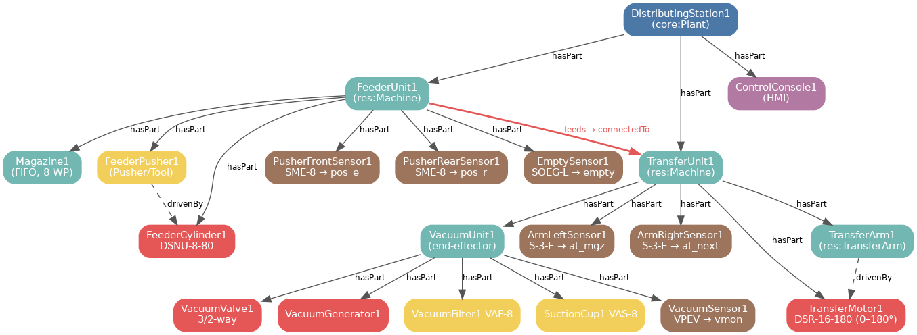
Figure 1 — newsystem4 plant topology. DistributingStation1 (core:Plant) decomposes via core:hasPart into the Feeder, Transfer, and Console units. The material-flow link FeederUnit1 ex:feeds TransferUnit1 lifts to core:connectedTo by sub-property inference. Colours: plant (dark blue), machines (teal), actuators (red), tools (yellow), sensors (brown), HMI (purple).

2.1 Topology tree
DistributingStation1 (core:Plant)
├── FeederUnit1 feeds → TransferUnit1
│ ├── Magazine1 (vertical FIFO, 8 WP; EmptySensor → empty)
│ ├── FeederPusher1 (Pusher; drivenBy FeederCylinder1)
│ ├── FeederCylinder1 (DSNU-8-80) ← push
│ ├── PusherFrontSensor1 (SME-8) → pos_e
│ ├── PusherRearSensor1 (SME-8) → pos_r
│ └── EmptySensor1 (SOEG-L) → empty
├── TransferUnit1
│ ├── TransferMotor1 (DSR-16-180, 0–180°) ← to_next, to_mgz
│ ├── TransferArm1 (drivenBy TransferMotor1; carries VacuumUnit1)
│ ├── VacuumUnit1
│ │ ├── VacuumValve1 (3/2-way) ← vcm_on, vcm_off
│ │ ├── VacuumGenerator1 / VacuumFilter1 (VAF-8) / SuctionCup1 (VAS-8)
│ │ └── VacuumSensor1 (VPEV) → vmon
│ ├── TransferArm_LeftSensor1 (S-3-E) → at_mgz
│ └── TransferArm_RightSensor1 (S-3-E) → at_next
└── ControlConsole1 (HMI — retained; not in the figure)

2.2 Local class extensions (Festo MPS mechatronics)
plant.ttl extends the generic MAESTRO resource taxonomy (res:Machine / res:Actuator / res:Tool, sensor:Sensor) with classes specific to this station. Because each is a sub-class of a MAESTRO class, OWL2-RL automatically lifts every instance to core:Resource — so the generic shapes and reasoning rules apply unchanged.
Local class | rdfs:subClassOf | Represents
ex:FeederUnit | res:Machine | Stack-magazine feeder module
ex:TransferUnit | res:Machine | Swivel-arm changer module
ex:Magazine | res:Machine | Vertical gravity-fed FIFO barrel (8 WP)
ex:PneumaticCylinder | res:Actuator | Double-acting linear actuator
ex:RotaryDrive | res:Actuator | Semi-rotary 0–180° swivel drive
ex:VacuumGenerator | res:Actuator | Venturi vacuum generator
ex:VacuumValve | res:Actuator | 3/2-way solenoid (vacuum on/off)
ex:Pusher | res:Tool | Slider on the cylinder rod
ex:VacuumFilter / ex:SuctionCup | res:Tool | In-line filter (VAF-8) / suction cup (VAS-8)
ex:ControlConsole | res:Machine | Operator HMI panel (Bedienpult)
ex:MagneticProximitySensor | sensor:Sensor | Festo SME-8 magneto-inductive switch
ex:ThroughBeamSensor | sensor:Sensor | Festo SOEG-L fibre-optic light barrier
ex:LimitSwitch | sensor:Sensor | Festo S-3-E mechanical micro switch
ex:VacuumSwitch | sensor:Sensor | Festo VPEV vacuum-pressure switch

2.3 Real Festo components
Each physical individual carries a Festo order number and model from manual 648811, so the semantic model stays traceable to procurement and spares:
Component (instance) | Festo model | Order no.
FeederCylinder1 | DSNU-8-80 (double-acting) | 019181
TransferMotor1 | DSR-16-180 (semi-rotary) | 011910
VacuumValve1 | 3/2-way solenoid | 161417
VacuumGenerator1 | ~50 l/min @ 6 bar | 185865
VacuumFilter1 | VAF-8 | 015889
SuctionCup1 | VAS-8 | 036135
PusherFront / RearSensor1 | SME-8 | 150857
EmptySensor1 | SOEG-L + SOEZ-SE | 165327
TransferArm Left / RightSensor1 | S-3-E | 007347
VacuumSensor1 | VPEV | 152629
Sub-property lift. The single asserted edge ex:FeederUnit1 ex:feeds ex:TransferUnit1 is automatically materialised as ex:FeederUnit1 core:connectedTo ex:TransferUnit1, because ex:feeds rdfs:subPropertyOf core:connectedTo. The same pattern lifts ex:drivenBy to core:dependsOn.

3. Sensors and I/O Datapoints
Six sensors observe the station. Each is SOSA-aligned via sosa:observes and produces exactly one I/O datapoint through the local ex:createsSignal property. Datapoints are modelled as ex:IOSignal (a sub-class of core:State), so skills can reference them through standard pre/post-condition properties and the State shapes police them.
Datapoint | Dir. | Source / target | Meaning
pos_e | input | PusherFrontSensor1 (SME-8) | Feeder pusher fully extended
pos_r | input | PusherRearSensor1 (SME-8) | Feeder pusher fully retracted
empty | input | EmptySensor1 (SOEG-L) | Magazine empty
at_mgz | input | ArmLeftSensor1 (S-3-E) | Arm at magazine position
at_next | input | ArmRightSensor1 (S-3-E) | Arm at downstream position
vmon | input | VacuumSensor1 (VPEV) | Vacuum confirms workpiece held
push | output | → FeederCylinder1 | Eject a workpiece from the magazine
to_mgz | output | → TransferMotor1 | Rotate arm toward the magazine
to_next | output | → TransferMotor1 | Rotate arm toward downstream
vcm_on | output | → VacuumValve1 | Open vacuum valve (suction ON)
vcm_off | output | → VacuumValve1 | Close valve / blow-off (suction OFF)
Output datapoints point back at the actuator they drive via ex:commandsActuator. This lets a downstream query answer “which physical actuator moves if I set vcm_on?” in a single hop: ex:IO_vcm_on ex:commandsActuator ex:VacuumValve1.

4. Motion Specifications
Motion is held separately from skill so one motion spec can be reused by several skills and so motion planners can reason over geometry without pulling in the skill graph. Two motions are defined; both carry the controller timeout budget of PT = 4000 ms per phase (from the magazine and swivel-arm ECC controllers).
Motion | Type | Velocity | Stroke / range | Duration
ex:CylinderLinearMotion | LinearMotion | 0.05 m·s⁻¹ | 80 mm (DSNU-8-80) | 4.0 s
ex:ArmRotationalMotion | RotationalMotion | ≈ π/4 rad·s⁻¹ | 0–180° (DSR-16-180) | 4.0 s

5. Skill Layer
A skill is an encapsulated machine capability invoked as a high-level service. In MAESTRO each skill TYPE lives in the TBox (a reusable specification) and is paired 1:1 with an IEC 61499 Function Block Type that implements it. The newsystem4 station defines seven skill TYPES: one feeder handling skill, four elementary transfer-arm operations, one composite transfer skill, and one HMI skill.
Skill TYPE | Semantic class | Function Block Type | Controls resource
ex:Type_skMagazineEject | HandlingSkill | skMagazine_mo | FeederUnit1
ex:Type_skMoveToMagazine | MotionSkill | skSwivelArm_eo_Move_to_magazine | TransferMotor1
ex:Type_skMoveToDownstream | MotionSkill | skSwivelArm_eo_Move_to_downstream | TransferMotor1
ex:Type_skGripWorkpiece | ManipulationSkill | skSwivelArm_eo_Grip_workpiece | VacuumUnit1
ex:Type_skReleaseWorkpiece | ManipulationSkill | skSwivelArm_eo_Release_workpiece | VacuumUnit1
ex:Type_skSwivelArmTransfer (composite) | TransferSkill | skSwivelArm_mo_cmp1 | TransferUnit1
ex:Type_skButtonsLights | AtomicSkill | skButtonsLights | ControlConsole1
The composite ex:Type_skSwivelArmTransfer references its four sub-skills with ex:hasSubSkill (a sub-property of skill:composedOfSkill) and declares its I/O signature with ex:controlsIO / ex:receivesIO. Each skill TYPE also points at the motion it needs (skill:requiresMotion) and an expectedDurationSeconds for planner-side scheduling.
Capability bridge. The station links the standard MAESTRO capabilities to its local skill TYPES so the inference rule can fire: cap:HandlingCapability cap:realizedBySkill ex:Type_skMagazineEject; cap:PickPlaceCapability cap:realizedBySkill ex:Type_skSwivelArmTransfer; cap:TransportCapability cap:realizedBySkill ex:Type_skMoveToMagazine, ex:Type_skMoveToDownstream.

6. IEC 61499 Control Layer
The control logic is an event-driven IEC 61499 application built in 4diac / EcoStruxure Automation Expert. The standard replaces vendor-specific, scan-based PLC code with portable, distributable function blocks — the technical basis for plug-and-produce. The model captures the control project at three levels: function-block types (the library), running instances (APP1), and the device/runtime that hosts them.

6.1 Skill function blocks
Every skill TYPE is paired with one FB type via iec61499:implementsSkill; the FB declares the resource it drives via iec61499:controlsResource. These two properties are the hinge the capability rule traverses (Section 8).
- skMagazine_mo (CompositeFB) — magazine skill. Internal logic FB SkillMagazineController_b_a: ECC states INIT, WAIT, stEJECT, stRETRACT, SUCCESS, ERROR, SUSPEND, STOP, plus TIMEOUT_EJECT / TIMEOUT_RETRACT. Eject precondition: OK_L ∧ OK_R ∧ ¬empty ∧ pos_e.
- skSwivelArm_mo_cmp1 (CompositeFB) — the composite transfer skill. Contains the four elementary-operation FBs, the orchestrator, the output bus, and RegisterSkill2.
- Four elementary-operation FBs: Move_to_magazine, Move_to_downstream (drive TransferMotor1) and Grip_workpiece, Release_workpiece (drive VacuumUnit1).
- skButtonsLights (CompositeFB) — HMI skill driving ControlConsole1.

6.2 Orchestration, permits, bus and adapters
The SkillSwivelArm1_Controller_Orchestrator (a BasicFB) sequences the four elementary operations through STEP1..STEP5, advancing on STATE feedback (=5 means DONE) and LET_L/LET_R permits. The four FB outputs are merged into one through SwivelArmBus_4_1 (4× B_MERGE4). Two further mechanisms make the chain deterministic and reusable:
- Permit handshake (modelled by ex:permits) — Perm_L / Perm_R links enforce sequential ordering between the feeder and the transfer arm. The True_Adp and True_Adp_rev adapters grant permanent permission at the two ends of the chain.
- Protocol adapters (modelled by ex:bridges) — Magazine2Magasine and SwivelArm2Transfer translate the internal adapter signals to the neighbour / downstream protocols, decoupling the skill FBs from the wiring.

6.3 Device, runtime and application
From System.sys and the deployment, the running system is:
Device Soft_dPAC "EcoRT_0" (Schneider Electric)
└── Runtime RES0 (EMB_RES_ECO)
└── Application APP1
Magazine → SwivelArm_Cmp1 → (FB2 right-permit)
Conv1 (Magazine2Magasine), Conv2 (SwivelArm2Transfer)
FB1 left true-permit, FB5 SwivelArm bus, Model (logger)
FB instances point to their type with ex:instanceOfFBT and to the runtime with ex:hostedOn. APP1 initialises the magazine first, then the swivel arm, sequenced by the permit handshaking, with the protocol adapters feeding the Model logger for monitoring.

6.4 Registered skills and OPC UA
At runtime the RegisterSkill2 FBs register three application-level skills to the GraphDB skill registry; each carries ex:ofType back to its TYPE (separating specification from the fireable instance). These are the skills exposed to the network through the OPC UA interface ex:OpcUaDistributionInterface (node ns=2;s=Skill.SwivelArm, browse name DistributingStationSkill):
Registered skill | ofType | Description
ex:Reg_Magazine (skMagazine_mo) | Type_skMagazineEject | Separates and ejects the bottom workpiece from the stack magazine
ex:Reg_SwivelArm (skSwivelArm_mo_cmp1) | Type_skSwivelArmTransfer | Picks the workpiece at the magazine, rotates 180°, releases it downstream
ex:Reg_ButtonsLights (skButtonsLights) | Type_skButtonsLights | Operator HMI: buttons and indicator lamps
The OPC UA interface exposes the registered instances, not the abstract TYPES, because clients orchestrate concrete skills. This gives the skill its functional duality: callable as an OPC UA service at the supervisory level and as an event-driven FB at the control level.

7. Product and Process
The demand side is small by design. A single workpiece declares the process it needs; the process declares the capabilities it requires. Capabilities — not skills — are what the product asks for; this is the abstraction barrier between demand and supply.
ex:WorkpieceWP a prod:Part ;
prod:massKg 0.030 ;
prod:requiresProcess ex:DistributeWorkpieceProcess .

ex:DistributeWorkpieceProcess a proc:TransportProcess ;
proc:requiresCapability cap:HandlingCapability ,
cap:PickPlaceCapability ,
cap:TransportCapability ;
ex:hasSubProcess Push, MoveToMagazine, Grip, MoveToDownstream, Release .
The five sub-processes are chained with proc:precedes so a planner can resolve them topologically. They map one-to-one onto the orchestrator's STEP sequence and onto the station's skills:
Figure 2 — The five-step distribute cycle. Each process step requires one capability and is realised by one skill, in the order enforced by proc:precedes and the SwivelArm orchestrator.
# | Process step | Requires capability | Realised by skill
1 | Push / eject from magazine | HandlingCapability | skMagazineEject
2 | Move arm to magazine | TransportCapability | skMoveToMagazine
3 | Grip with vacuum | PickPlaceCapability | skGripWorkpiece
4 | Move arm to downstream | TransportCapability | skMoveToDownstream
5 | Release downstream | PickPlaceCapability | skReleaseWorkpiece

8. Runtime State and the Reasoning Chain

8.1 Runtime snapshot
runtime.ttl is loaded into its own named graph so the OPC UA bridge can drop and re-post it every few seconds without touching the design-time topology. It asserts core:hasState runtime:Available for the station and its units. The orchestrator's policy is simple: never consider a resource whose state is anything other than runtime:Available.

8.2 The reasoning chain
The whole point of the model is to derive two facts no one asserted directly: which capabilities each resource canPerform, and whether the plant canManufacture the workpiece. Two rules do this over the OWL2-RL-materialised graph.
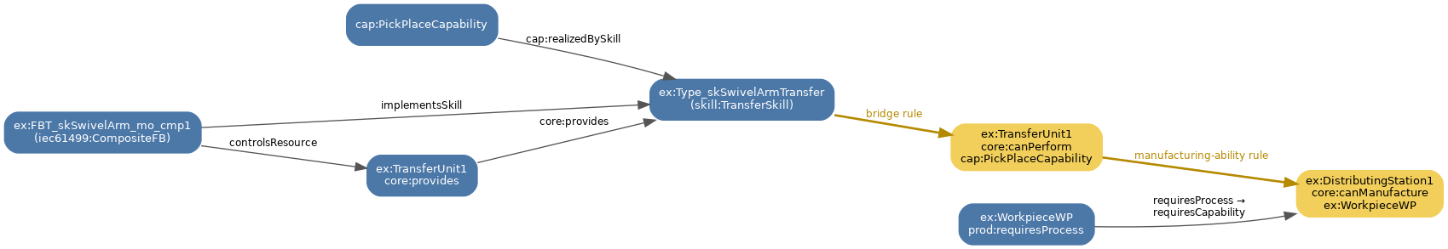
Figure 3 — The capability-inference chain for the transfer skill. Blue nodes are explicit triples; amber nodes are derived by the bridge rule and the manufacturing-ability rule. The chain joins capability, skill class, resource, and function block, then lifts to canPerform and canManufacture.

Rule 1 — capability inference (bridge)
A resource can perform a capability if it provides a skill TYPE whose semantic class matches a skill that the capability is realised by, and a function block implements that skill on that resource. For the transfer skill this yields:
ex:TransferUnit1 core:provides ex:Type_skSwivelArmTransfer .
ex:Type_skSwivelArmTransfer a skill:TransferSkill .
cap:PickPlaceCapability cap:realizedBySkill ex:Type_skSwivelArmTransfer .
ex:FBT_skSwivelArm_mo_cmp1 iec61499:implementsSkill ex:Type_skSwivelArmTransfer ;
iec61499:controlsResource ex:TransferUnit1 .
⇒ INFERRED: ex:TransferUnit1 core:canPerform cap:PickPlaceCapability

Rule 2 — manufacturing ability
If a plant has (transitively) a resource that can perform every capability the product's process requires, the plant can manufacture the product:
ex:DistributingStation1 a core:Plant ; core:hasPart+ ?resource .
?resource core:canPerform ?capability .
ex:WorkpieceWP prod:requiresProcess ?process .
?process proc:requiresCapability ?capability .
⇒ INFERRED: ex:DistributingStation1 core:canManufacture ex:WorkpieceWP
One question, one triple. Everything in this model — the topology, the sensors, the skill / FB layer, the capability bridge — exists to support a single derived assertion: ex:DistributingStation1 core:canManufacture ex:WorkpieceWP. An orchestrator queries the materialised store and gets the answer in one SELECT, without knowing which triple was asserted, OWL-inferred, or rule-derived.

8.3 Loading and running
The knowledge box is reproducible from the repository with the OWL2-RL ruleset and the two rule files:
from pathlib import Path
import rdflib

g = rdflib.Graph()
for path in Path('ontologies').glob('**/*.ttl'):
g.parse(path, format='turtle')
g.parse('examples/distribution-station-newsystem4/plant.ttl', format='turtle')
g.parse('examples/distribution-station-newsystem4/product.ttl', format='turtle')

for triple in g.query(Path('rules/capability-inference.rq').read_text()):
g.add(triple)
for row in g.query(Path('queries/01-resources-with-capability.rq').read_text()):
print(row)
Alternatively, load the single self-contained file unified-kg/distribution-station-kg.ttl into a GraphDB repository created with the OWL2-RL ruleset, then run rules/capability-inference.rq and rules/manufacturing-ability.rq as SPARQL INSERTs. The repository-level regression check runs the same core path via python tests/validate_repo.py.

9. Relationship to the MAESTRO Core
Purpose. This section shows, in detail, how the newsystem4 station relates to the universal MAESTRO core ontology — material for both the technical documentation and the “MAESTRO-on-our-testbed” demonstration. Every statement is taken from the actual example files (plant.ttl / product.ttl / runtime.ttl) and the loaded MAESTRO ontology modules, and is reproducible with the scripts in Section 9.6.

9.1 One frozen core, everything else extends it
MAESTRO is a modular, universal manufacturing ontology, layered so that exactly one tier is invariant and everything domain-specific is an extension of it:
Tier | What it is | Stability
Frozen core — core: (manufacturing-core.ttl) | The universal abstractions (the core:Entity taxonomy) and the spine relations (hasPart, provides, implements, controls, realizedBySkill, requiresCapability, composedOfSkill, hasState, canPerform, canManufacture, …). Imports nothing. | Invariant — changes only at a major version
MAESTRO modules — res:, skill:, cap:, proc:, prod:, iec61499:, opcua:, motion:, sensor:, runtime: | Domain / adapter vocabularies that couple to core only via owl:imports + rdfs:subClassOf / rdfs:subPropertyOf core:*. | Stable, versioned extensions
Example / testbed — ex: (this station) | The Festo-specific classes (ex:FeederUnit, ex:IOSignal, …) and all the A-Box individuals (FeederUnit1, IO_push, …). | A concrete instantiation
The key idea. The newsystem4 example is not a separate model — it is the universal core, specialised down to the Festo testbed. No element introduces a new top-level concept; each one specialises a core class or sub-properties a core relation.

9.2 Class alignment — every example class is a kind of a core class
Running the rdfs:subClassOf closure over the example plus the ontology shows that every domain class used in the station resolves to a frozen core: class (zero classes without a core ancestor). Figure 7 shows the bridge directly; each Festo individual (left) is — through rdf:type / rdfs:subClassOf — an instance of a frozen core class (right).
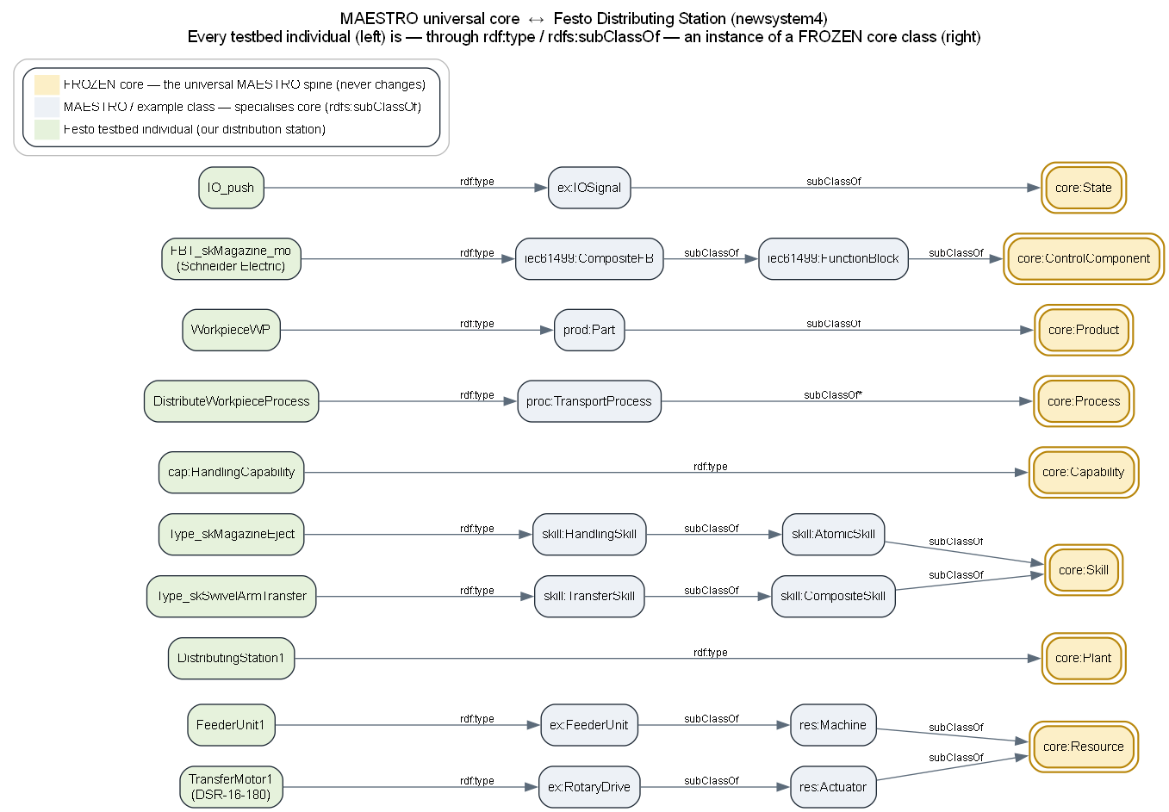
Figure 7 — MAESTRO universal core ↔ Festo testbed bridge. Green = Festo testbed individual; grey = MAESTRO/example class that specialises core; gold = the frozen core spine class it ultimately resolves to.
Grouped by the core class they specialise:
core:Resource (physical manufacturing assets)
├── res:Machine ← FeederUnit1, TransferUnit1, Magazine1, ControlConsole1
│ └── res:Robot ← res:TransferArm ← TransferArm1
├── res:Actuator ← FeederCylinder1 (DSNU-8-80), TransferMotor1 (DSR-16-180),
│ VacuumValve1, VacuumGenerator1
├── res:Tool ← FeederPusher1, VacuumFilter1 (VAF-8), SuctionCup1 (VAS-8),
│ VacuumUnit1
├── sensor:Sensor ← SME-8 ×2, SOEG-L, S-3-E ×2, VPEV (⊑ core:Resource + sosa:Sensor)
└── res:ControllerDevice ← res:PLC ← Device_EcoRT_0 (Soft_dPAC)

core:Plant ← DistributingStation1 (the whole station)

core:Skill
├── skill:AtomicSkill
│ ├── skill:HandlingSkill ← Type_skMagazineEject
│ ├── skill:MotionSkill ← Type_skMoveToMagazine, Type_skMoveToDownstream
│ └── skill:ManipulationSkill ← Type_skGripWorkpiece, Type_skReleaseWorkpiece
├── skill:CompositeSkill
│ └── skill:TransferSkill ← Type_skSwivelArmTransfer
└── (registered runtime skills) ← Reg_Magazine, Reg_SwivelArm (+4 sub), Reg_ButtonsLights

core:Capability ← cap:HandlingCapability, cap:PickPlaceCapability, cap:TransportCapability

core:Process ← proc:ManufacturingProcess
├── proc:HandlingProcess ← Push, Grip, Release
└── proc:TransportProcess ← DistributeWorkpiece, MoveToMagazine, MoveToDownstream

core:Product ← prod:Part ← WorkpieceWP

core:ControlComponent
└── iec61499:FunctionBlock
├── iec61499:CompositeFB ← skMagazine_mo, skSwivelArm_mo_cmp1, 4 eo-FBTs,
│ skButtonsLights, FB instances
├── iec61499:BasicFB ← SkillMagazineController_b_a, ...Orchestrator, B_MERGE4
├── ex:ProtocolAdapterFB ← Magazine2Magasine, SwivelArm2Transfer (+ instances)
└── ex:PermitAdapterFB ← True_Adp, True_Adp_rev (+ instances)

core:State ← ex:IOSignal ← the 11 datapoints (pos_e, pos_r, empty, at_mgz,
at_next, vmon, push, to_mgz, to_next, vcm_on, vcm_off)

core:LogicalEntity ← motion (Cylinder/ArmMotion), iec61499:Application (App_APP1),
iec61499:RuntimeResource (Runtime_RES0),
opcua:OpcUaSkillInterface (OpcUaDistributionInterface),
sensor:ObservableProperty (the 4 observed properties)
Result. The example exercises 8 of the ~12 core classes — Plant, Resource, Skill, Capability, Process, Product, State, ControlComponent (plus LogicalEntity). A class-token audit of all 71 individuals returns zero terms that are not an instance of a MAESTRO core / module class.

9.3 Property alignment — every relation is (or specialises) a core spine relation
The edges in the example are either core spine properties used directly, rdfs:subPropertyOf a core spine property, or module / local object properties that range over core classes.

9.3.1 Core spine properties used directly
core:hasPart / core:partOf, core:provides, core:hasState, core:identifier, core:description.

9.3.2 Module / example properties that sub-property a core property
Property (example / module) | rdfs:subPropertyOf
cap:realizedBySkill | core:realizedBySkill
proc:requiresCapability | core:requiresCapability
skill:composedOfSkill | core:composedOfSkill
skill:requiresMotion | core:requiresMotion
iec61499:implementsSkill | core:implements
iec61499:controlsResource | core:controls
iec61499:hostsRuntimeResource | core:hosts
ex:feeds | core:connectedTo
ex:permits | core:connectedTo
ex:bridges | core:connectedTo
ex:drivenBy | core:dependsOn
ex:hostedOn | core:dependsOn
ex:hasSubProcess | core:hasPart
ex:hasSubSkill | core:composedOfSkill

9.3.3 Example properties that specialise a skill-module relation
Property | rdfs:subPropertyOf | Operates over
ex:controlsIO | skill:hasPostcondition | core:Skill → core:State (ex:IOSignal)
ex:receivesIO | skill:hasPrecondition | core:Skill → core:State (ex:IOSignal)

9.3.4 Local object properties over core / module classes
ex:createsSignal (core:Resource → ex:IOSignal ⊑ core:State), ex:commandsActuator (ex:IOSignal → res:Actuator ⊑ core:Resource), ex:instanceOfFBT (FB → FB), ex:ofType (registered core:Skill → skill TYPE), opcua:exposes (interface → core:Skill), proc:precedes, prod:requiresProcess (core:Product → core:Process).

9.3.5 Inferred core relations
Materialised by the universal rules: core:canPerform (core:Resource → core:Capability) and core:canManufacture (core:Plant → core:Product).

9.4 The demonstration: universal core reasoning runs on the testbed
The decisive point for “how MAESTRO can be used with our testbed” is that MAESTRO's domain-agnostic inference rules (rules/capability-inference.rq, rules/manufacturing-ability.rq — written for no specific plant) operate purely on the core spine, and therefore fire unchanged on the Festo data. The whole reasoning chain stays at the core level:
iec61499:implementsSkill ⊑ core:implements
FBT_skSwivelArm_mo_cmp1 implements Type_skSwivelArmTransfer
iec61499:controlsResource ⊑ core:controls
FBT_skSwivelArm_mo_cmp1 controls TransferUnit1
cap:realizedBySkill ⊑ core:realizedBySkill
cap:PickPlaceCapability realizedBySkill Type_skSwivelArmTransfer
⇒ (rule) TransferUnit1 core:canPerform cap:PickPlaceCapability

core:hasPart + prod:requiresProcess + proc:requiresCapability
⇒ (rule) DistributingStation1 core:canManufacture WorkpieceWP
Materialised conclusions (verified by running the two rules over the example):
- FeederUnit1 core:canPerform cap:HandlingCapability
- TransferUnit1 core:canPerform cap:PickPlaceCapability
- TransferMotor1 core:canPerform cap:TransportCapability
- DistributingStation1 core:canManufacture WorkpieceWP
In other words. We described the testbed in MAESTRO's universal vocabulary, and the core's own reasoning told us what the station can do — without any plant-specific logic.

9.5 Figures
Three repository figures document the alignment described above:
Figure | Shows
16-core-to-festo-bridge.png | Core ↔ testbed alignment: each Festo individual specialises a frozen core: class via rdf:type / rdfs:subClassOf (embedded as Figure 7 above).
15-distribution-newsystem4-schema.png | The full example instance graph, clustered by layer; individuals typed by a frozen core: class carry a gold double border.
14-maestro-core-schema.png | The universal MAESTRO / HHM-Core schema the example instantiates (frozen core marked; extension modules and «EXT» external bridges distinguished).
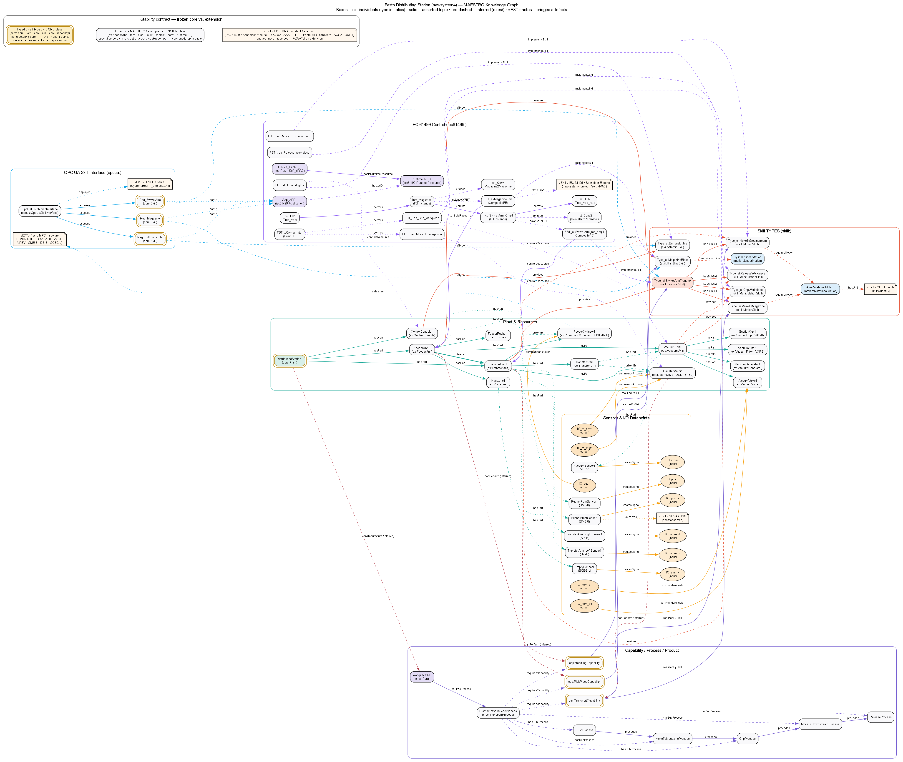
Figure 8 — newsystem4 full instance graph, clustered by layer. Individuals typed by a frozen core: class carry a gold double border.
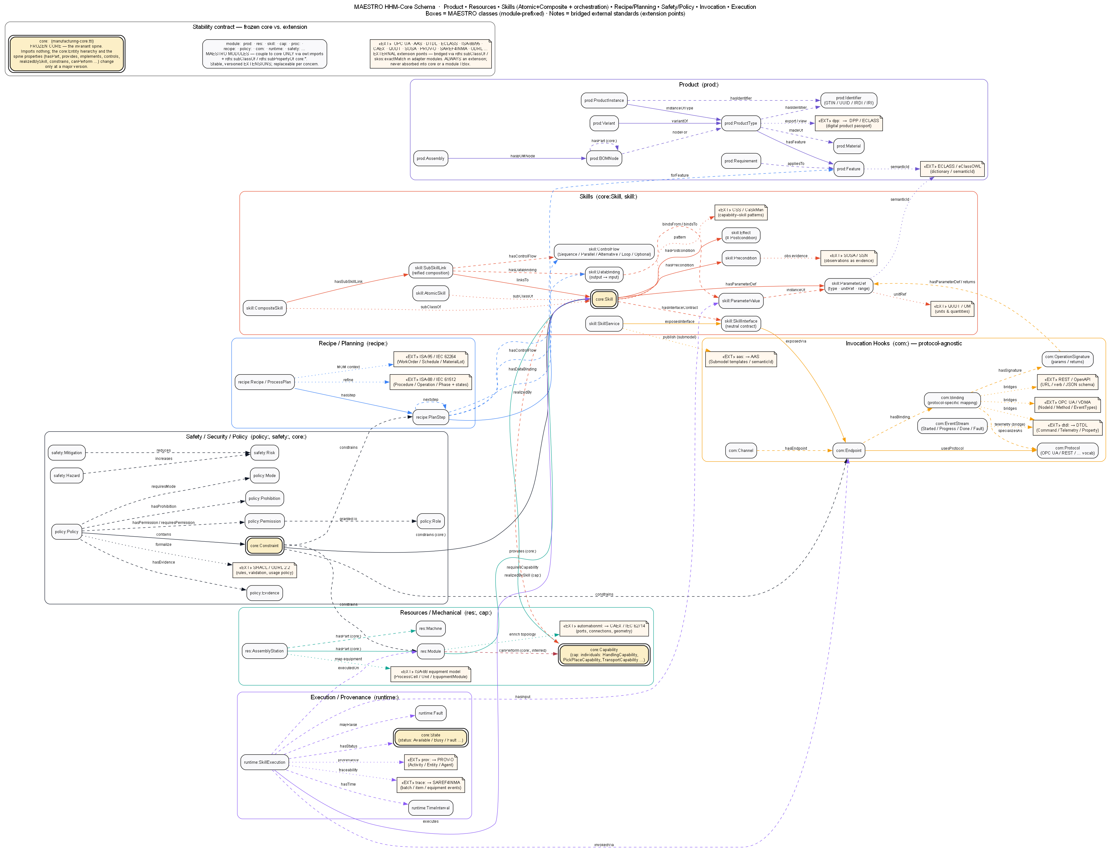
Figure 9 — The universal MAESTRO / HHM-Core schema that the example instantiates. Frozen core is marked; extension modules and external bridges are distinguished.
See also docs/18-design-principles.md (the frozen-core-vs-extension stability contract) and docs/05-core-ontology.md (the core class taxonomy and relationship spine).

9.6 Reproducibility
Prove every example class rolls up to a core class:
from pathlib import Path
import rdflib
from rdflib.namespace import RDF, RDFS, OWL

g = rdflib.Graph()
for p in Path('ontologies').glob('**/*.ttl'):
g.parse(p, format='turtle')
for f in ['plant.ttl', 'product.ttl', 'runtime.ttl']:
g.parse(f'examples/distribution-station-newsystem4/{f}', format='turtle')

CORE = 'https://w3id.org/maestro/core#'
def core_ancestor(cls):
seen, stack = set(), [cls]
while stack:
c = stack.pop()
if str(c).startswith(CORE): return c
for sup in g.objects(c, RDFS.subClassOf):
if sup not in seen: seen.add(sup); stack.append(sup)
return None

EX = 'https://w3id.org/maestro/examples/distribution-station-newsystem4#'
for cls in {t for s, p, t in g.triples((None, RDF.type, None))
if str(s).startswith(EX) and t not in (OWL.Class, OWL.NamedIndividual)}:
print(cls, '->', core_ancestor(cls)) # every line ends in a core: class
Run the universal rules and see the testbed conclusions:
for rule in ['rules/capability-inference.rq', 'rules/manufacturing-ability.rq']:
for triple in g.query(Path(rule).read_text(encoding='utf-8')):
g.add(triple)

CORE_NS = rdflib.Namespace(CORE)
EX_NS = rdflib.Namespace(EX)
print(list(g.triples((None, CORE_NS.canPerform, None))))
print(list(g.triples((EX_NS.DistributingStation1, CORE_NS.canManufacture, None))))
Repository validation (python tests/validate_repo.py) parses the example, enforces the SHACL shapes and re-derives these inferences as part of the regular test suite — so the alignment described here is continuously checked, not a one-off claim.

10. Example Package Manifest
All files referenced in this document live under examples/distribution-station-newsystem4/:
Resource | Role
plant.ttl | Design-time topology, sensors/IO, motion, skill TYPES, IEC 61499 FB layer, device/app, OPC UA
product.ttl | Workpiece + five-step distribute process
runtime.ttl | Availability snapshot (separate named graph)
unified-kg/distribution-station-kg.ttl | Self-contained T-Box + A-Box in one file for single-file GraphDB loading
README.md | Quick-reference: topology, skill→FBT table, reasoning chain, run instructions
Companion document. This file documents the newsystem4 station only. For the MAESTRO ontology stack, the nine semantic layers, standard alignment, the reasoning architecture, and design principles, share it alongside the MAESTRO framework specification.

