MAESTRO — Festo Distributing Station Explainer
  - A walk-through of the TTL model, the reasoning chain, and the live GraphDB session
Melwin Xavier
2026-05-26
Table of Contents

MAESTRO — Festo Distributing Station

A walk-through of the TTL model, the reasoning chain, and the live GraphDB session
Author: Melwin Xavier Repository: maestro-ds on the local GraphDB instance Branch: usecase_festo Date: 2026-05-26

1. Why this document exists
The Festo Distributing Station (DS) is the smallest MPS station that still contains every modelling concern MAESTRO is designed to capture:
- a physical plant decomposed into machines, actuators, sensors, and an end-effector,
- logical skills registered at runtime to a 4DIAC / Schneider EAE application (Comp_Skill_Adp),
- product / process demand that needs to be matched against the plant's abilities,
- a runtime snapshot (which resource is Available right now), and
- a reasoning chain that turns all of the above into the single answer the orchestrator cares about: "can this plant manufacture this workpiece right now?".
This file explains every TTL block in the examples/distribution-station/ folder, links each block to the ontology module it depends on, and shows the live GraphDB session in which the three TTL files were loaded, the OWL2-RL ruleset was activated, and the two SPARQL-CONSTRUCT inference rules (capability-inference.rq, manufacturing-ability.rq) were materialised. It closes with a worked example of a single SPARQL SELECT that simultaneously joins explicit triples, OWL/RDFS-inferred triples, and custom-rule-derived triples — the headline property of the architecture.

2. The figures referenced in this document
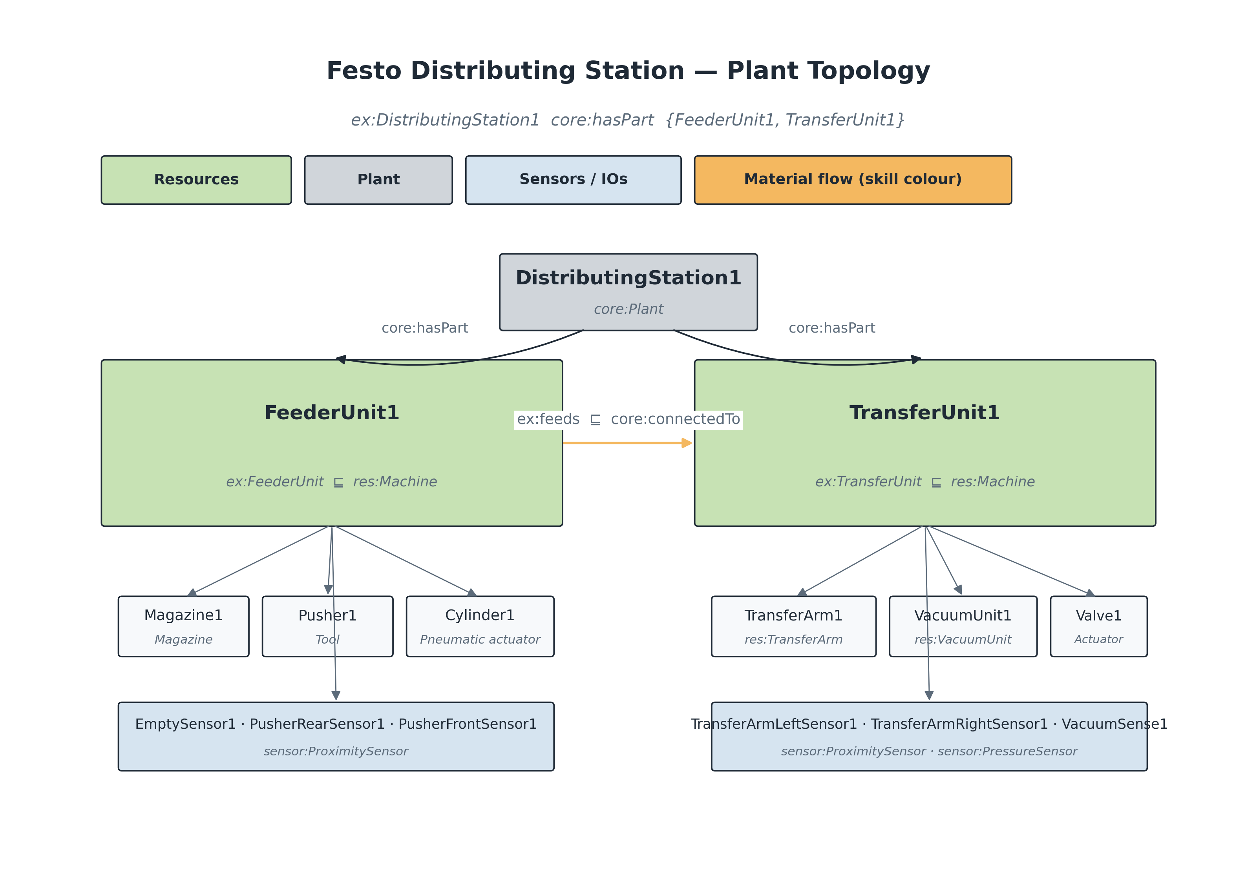 Figure 1 — Festo Distributing Station plant topology. ex:DistributingStation1 (a core:Plant) is decomposed via core:hasPart into the FeederUnit and the TransferUnit, each further decomposed into actuators, end-effectors and sensors. The material-flow link ex:feeds lifts to core:connectedTo through subproperty inference.
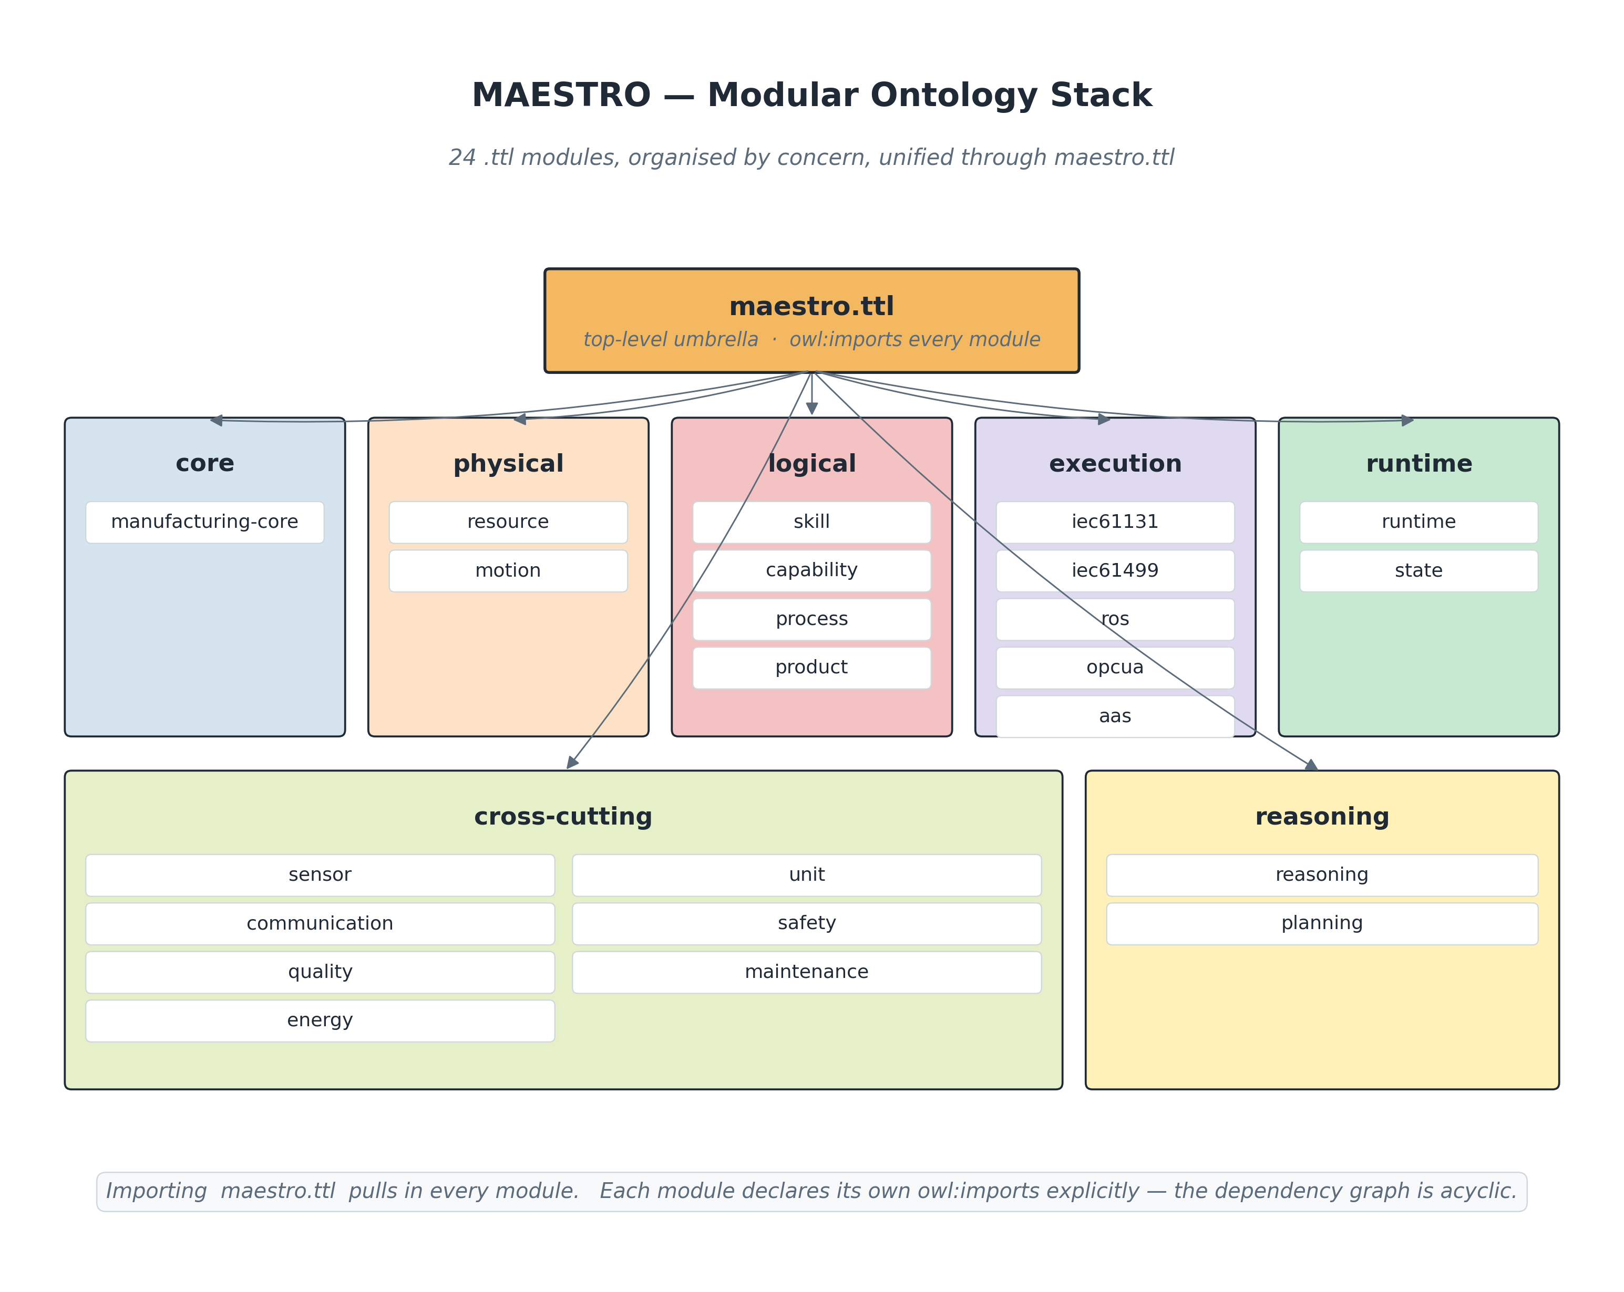 Figure 2 — Modular ontology stack. Importing <https://w3id.org/maestro> pulls in every module the Distribution Station TTL relies on (core, resource, motion, skill, capability, process, product, IEC 61499, OPC UA, sensor, unit, runtime, reasoning).
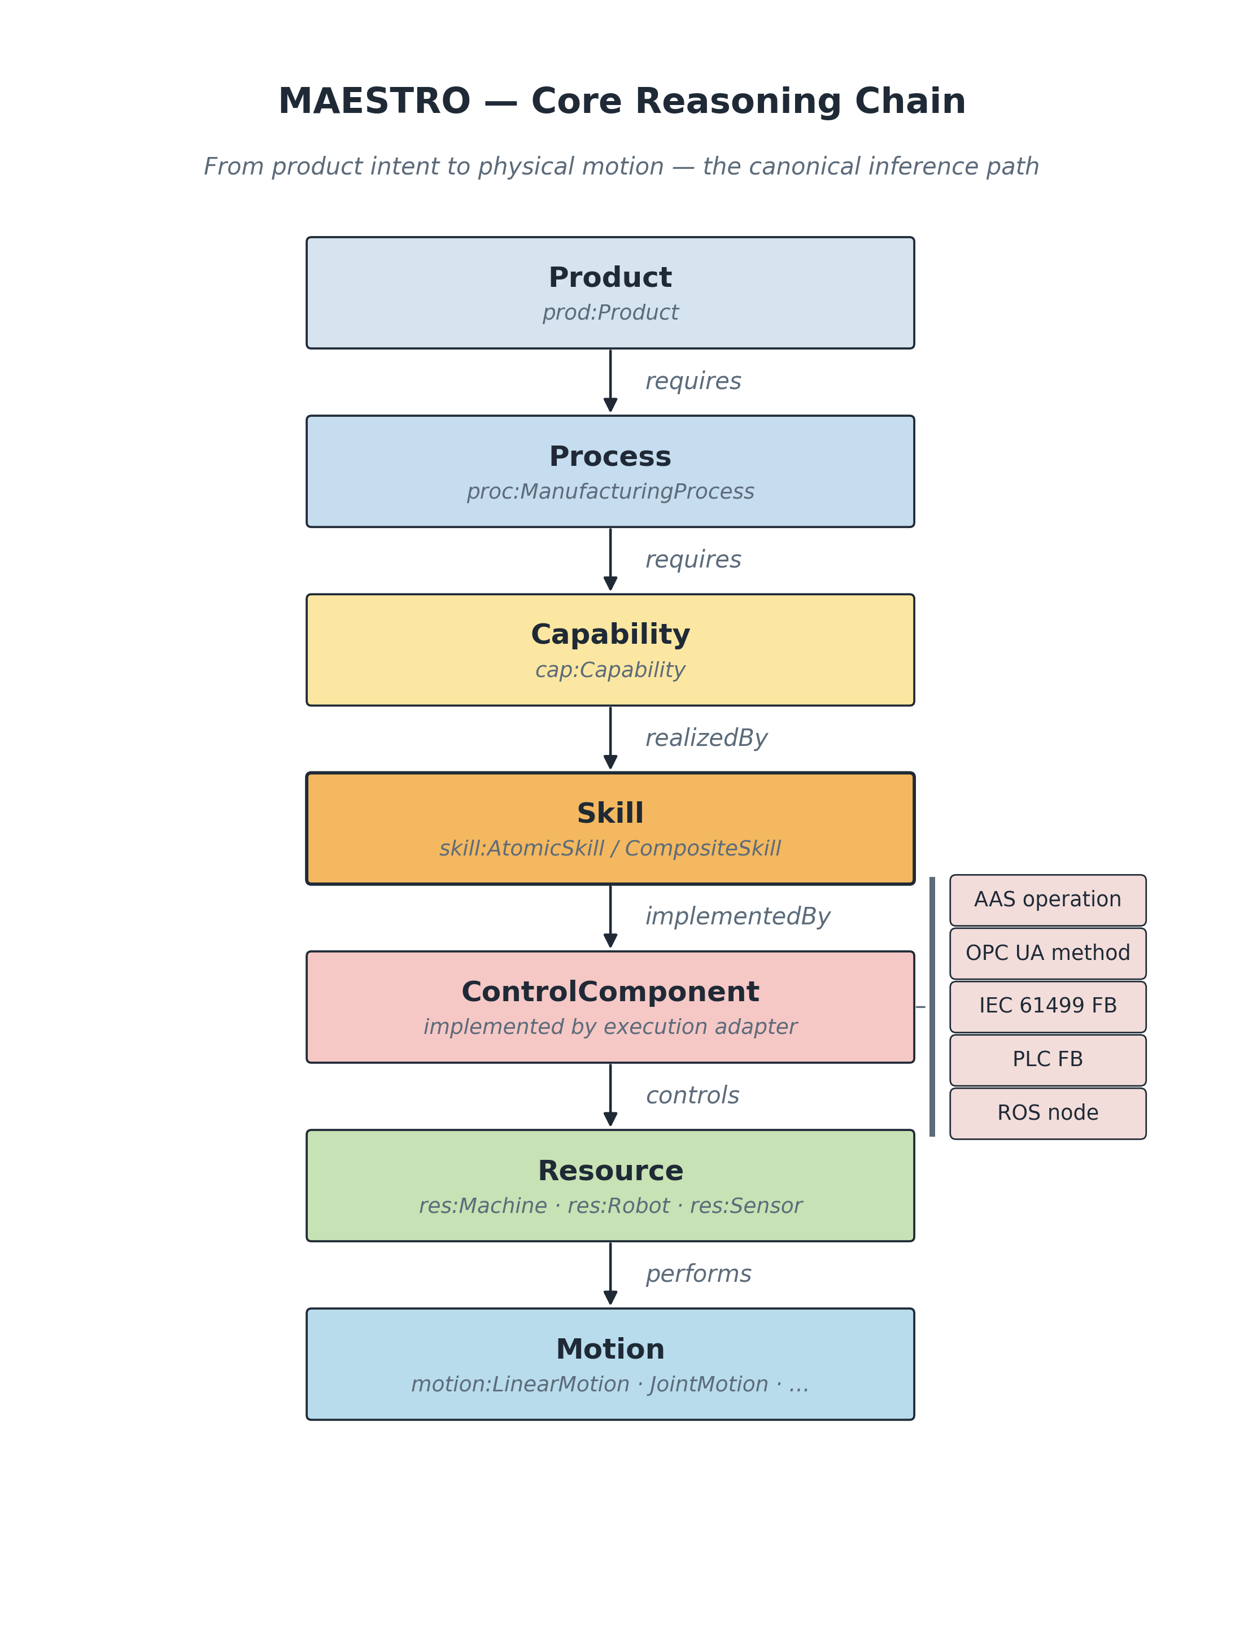 Figure 3 — Canonical MAESTRO reasoning chain. The plant.ttl, product.ttl and runtime.ttl files together populate every node of this chain for the Distributing Station.
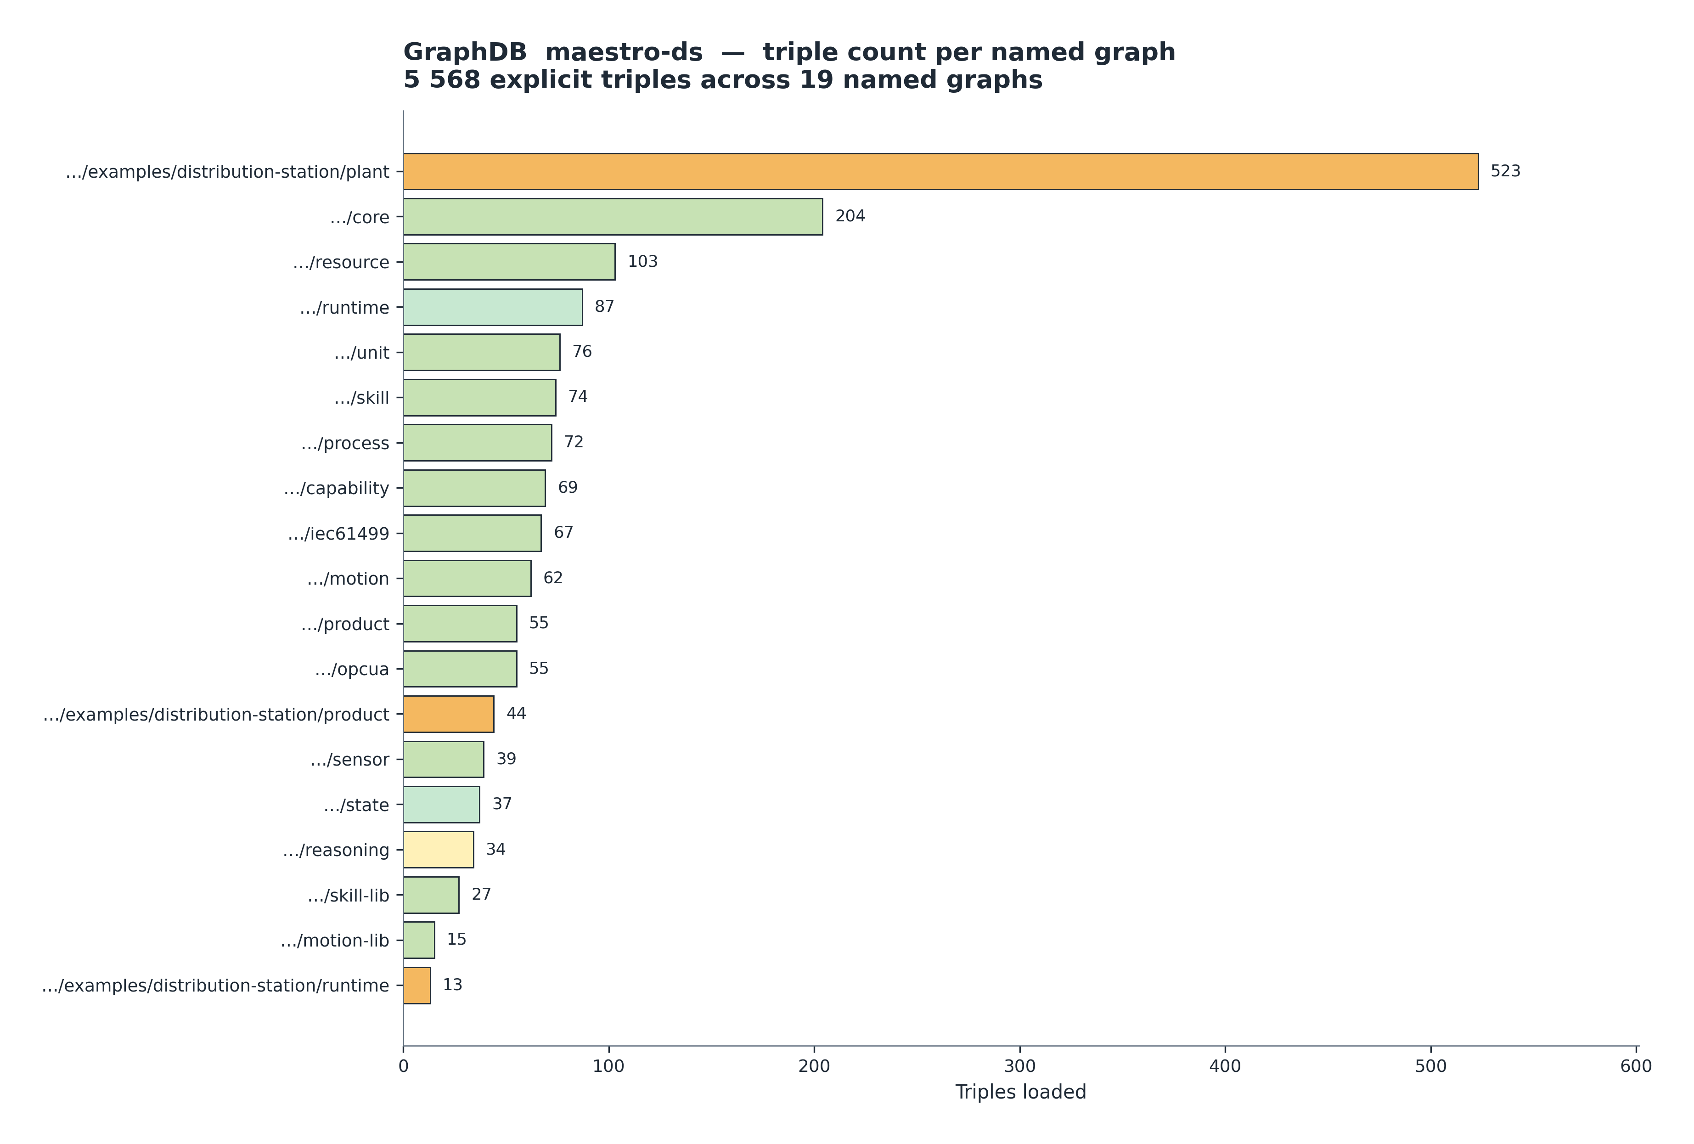 Figure 4 — Triple distribution across the 19 named graphs of the maestro-ds repository (5 568 explicit triples total). The Distribution-Station example graphs are highlighted in amber, the runtime/state graphs in green, the reasoning graph in yellow.
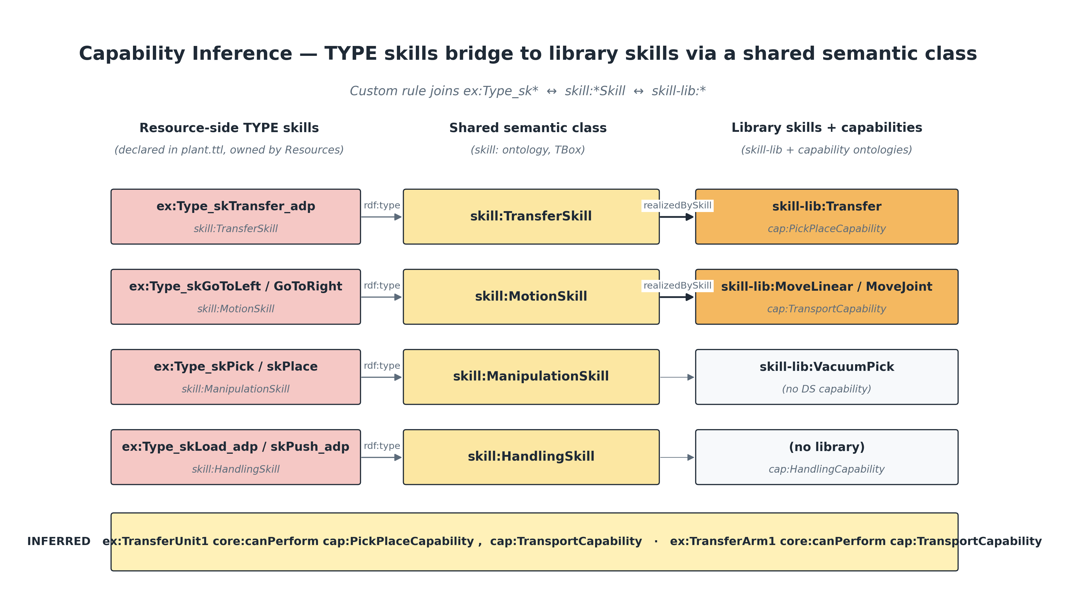 Figure 5 — Custom capability-inference bridge rule. Resource-side TYPE skills (left, in plant.ttl) and library-side skill-lib skills (right, in capability.ttl) are joined through their shared semantic class (skill:TransferSkill, skill:MotionSkill, …). The bridge produces three core:canPerform triples — shown at the bottom — without modifying any of the underlying ontologies.
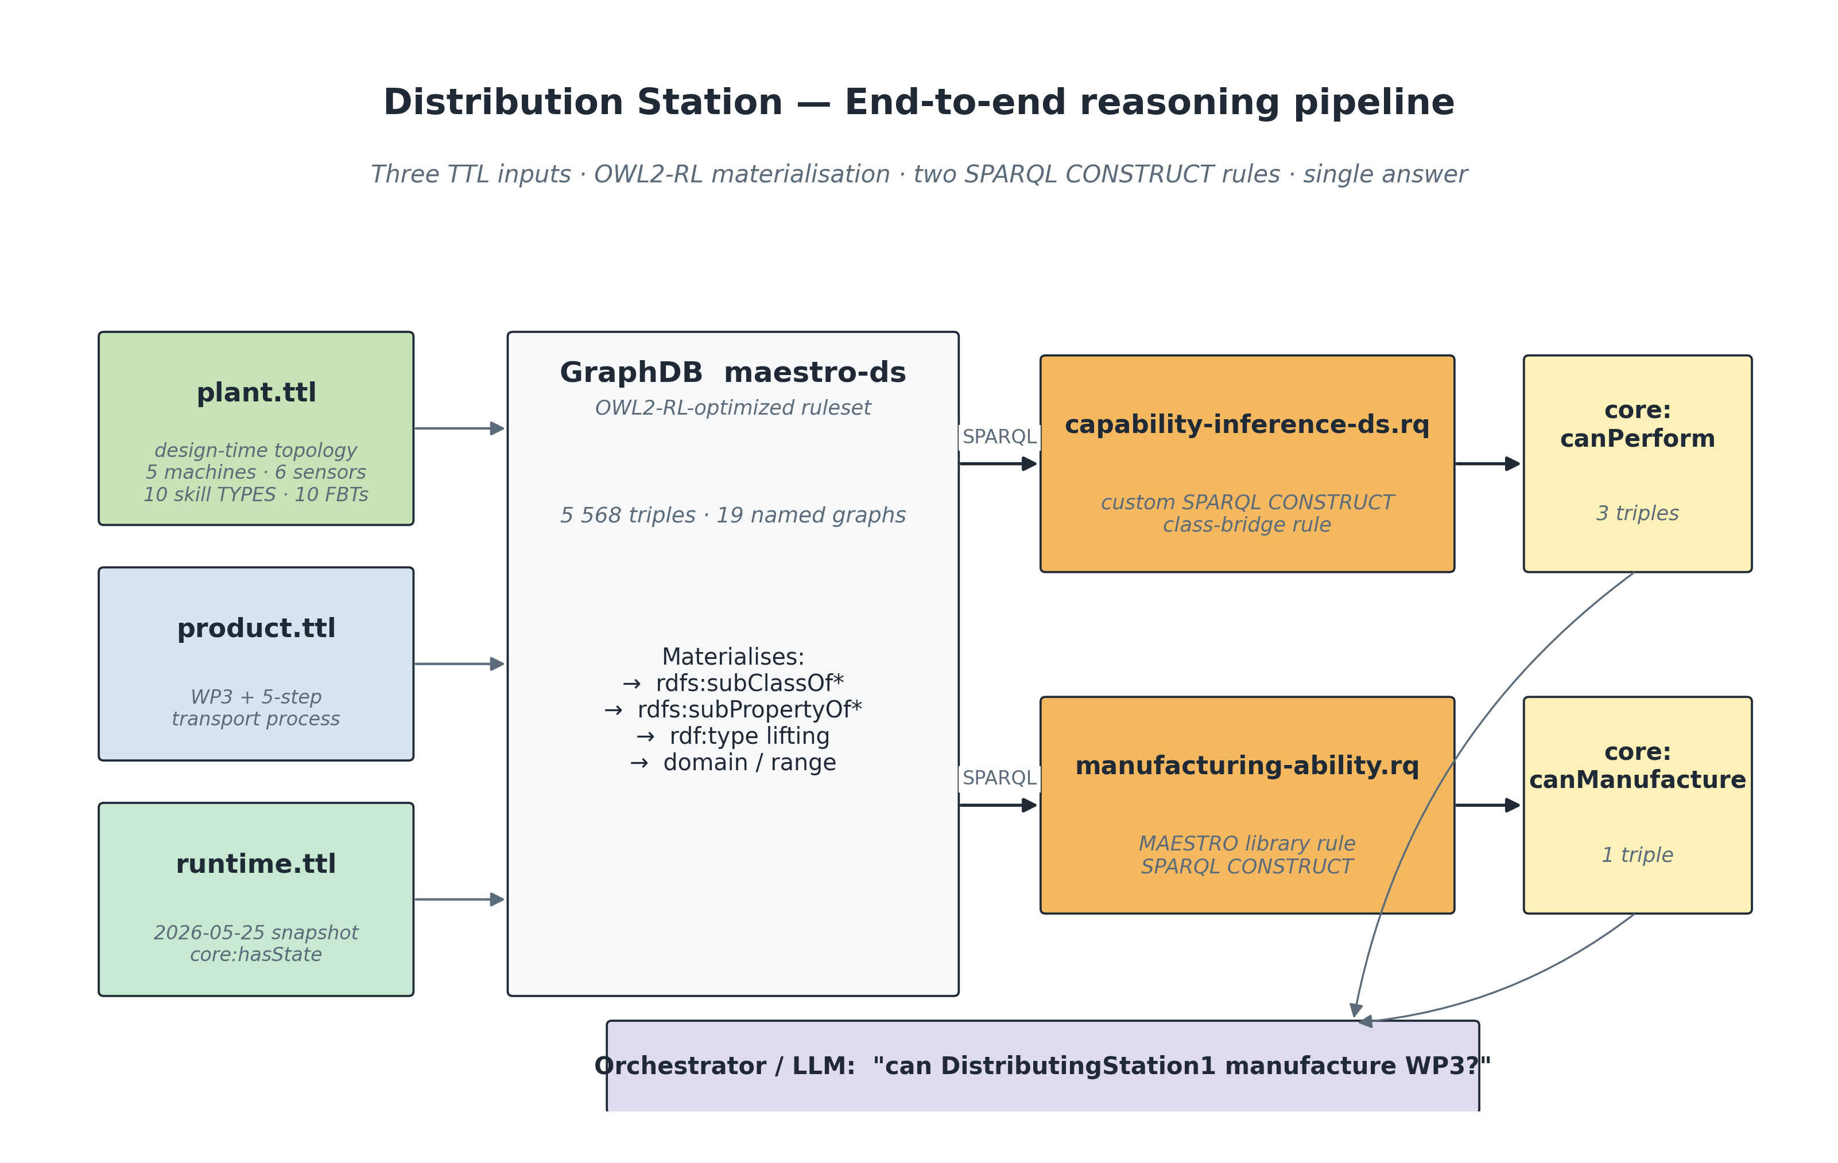 Figure 6 — End-to-end reasoning pipeline. Three TTL inputs are loaded into the maestro-ds repository; the OWL2-RL ruleset materialises subClassOf / subPropertyOf / type-lifting; two SPARQL CONSTRUCT rules then produce core:canPerform and core:canManufacture into a dedicated …/reasoning/inferred named graph; the orchestrator or LLM queries the materialised store with a single SELECT.
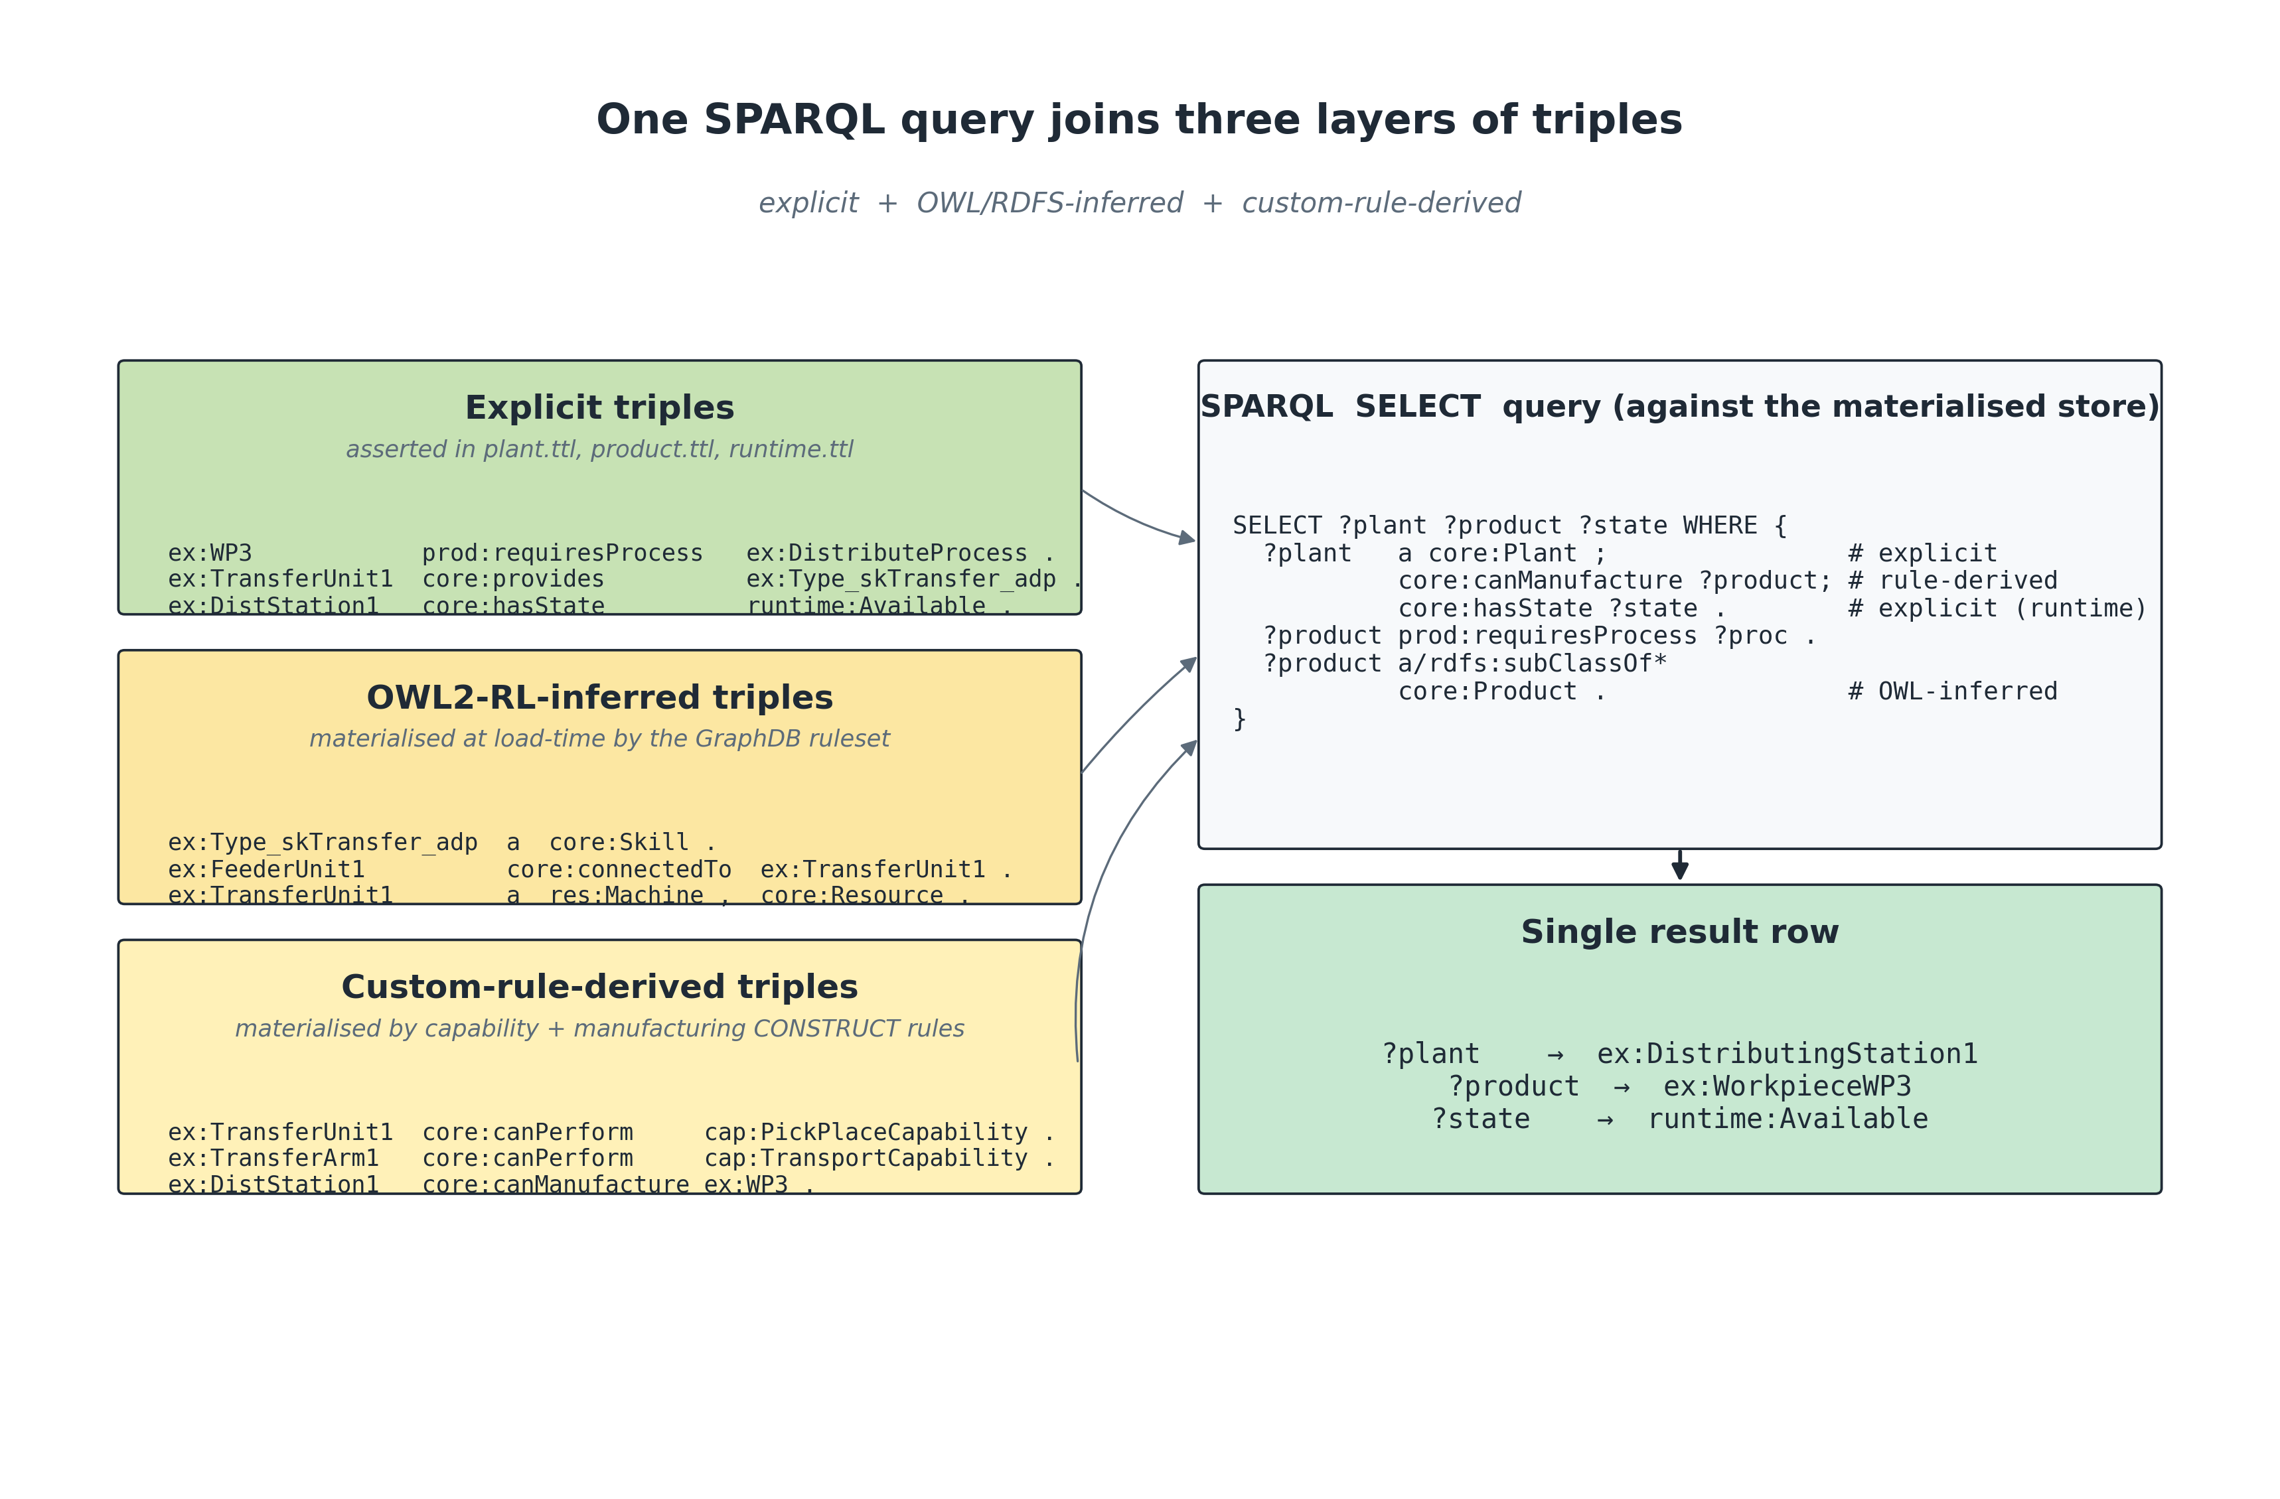 Figure 7 — One SPARQL query, three layers of triples. The same SELECT simultaneously joins explicit triples (asserted in the source TTL), OWL2-RL-inferred triples (materialised by the ruleset at load time), and custom-rule-derived triples (materialised by the two SPARQL CONSTRUCT rules). The query is layer-agnostic — the orchestrator does not need to know which triple came from where.

3. Folder layout
examples/distribution-station/
├── plant.ttl # design-time topology + skill TYPES + IEC 61499 FBTs + OPC UA interface
├── product.ttl # WorkpieceWP3 and the 5-step transport process it requires
└── runtime.ttl # snapshot of which resources are Available right now
These three files are intentionally split because they have different lifecycles:
File | Changes | Owner | Named graph
plant.ttl | Rarely (per re-commissioning) | Mechatronics designer | …/examples/distribution-station/plant
product.ttl | Per product family | Process engineer | …/examples/distribution-station/product
runtime.ttl | Every few seconds | PLC / OPC UA bridge | …/examples/distribution-station/runtime
Keeping them in separate named graphs lets GraphDB cache the design-time graphs aggressively and re-derive only the runtime portion when state changes.

4. plant.ttl — design-time topology
The plant file declares the Distributing Station and everything inside it. It mirrors the layout in the EAE project FESTO_DS_skills_reg / Comp_Skill_Adp:
DistributingStation
├── FeederUnit (Magazine + Pusher + Cylinder + 2 sensors)
│ └── feeds → TransferUnit
└── TransferUnit (TransferArm + VacuumUnit + 2 arm sensors)

4.1 Local class extensions (Festo-specific mechatronics)
plant.ttl extends the generic res:Machine / res:Actuator / res:Tool taxonomy with classes that are specific to the MPS Distributing Station:
Class | rdfs:subClassOf | Why it's defined
ex:FeederUnit | res:Machine | The feeder is a self-contained MPS module — modelled as a Machine so it can be hot-swapped against any other MAESTRO machine
ex:TransferUnit | res:Machine | Same reasoning, distinct module
ex:Magazine | res:Machine | Passive FIFO buffer, but still a Resource so it can carry a runtime state
ex:PneumaticCylinder | res:Actuator | The thing that physically moves the pusher
ex:VacuumValve | res:Actuator | Solenoid switching the vacuum supply
ex:Pusher | res:Tool | Passive slider — owns no actuator, only carries ex:drivenBy
Reasoning consequence. Because ex:FeederUnit rdfs:subClassOf res:Machine and res:Machine rdfs:subClassOf core:Resource, OWL2-RL automatically materialises ex:FeederUnit1 a core:Resource. We verified this with the live query:
SELECT ?t WHERE { ex:Type_skTransfer_adp a ?t }
which returns owl:Thing, core:Entity, core:LogicalEntity, core:Skill, skill:CompositeSkill, skill:TransferSkill — only the last two are asserted; everything above is OWL-inferred.

4.2 Local property extensions
plant.ttl introduces seven object properties and one datatype property. Every one is declared as a rdfs:subPropertyOf an existing MAESTRO property so the reasoning chain keeps working:
Property | rdfs:subPropertyOf | Used to express
ex:feeds | core:connectedTo | Material-flow link feeder → transfer
ex:drivenBy | core:dependsOn | A passive mechanical element is moved by an Actuator
ex:createsSignal | — | A sensor produces an ex:IOSignal
ex:commandsActuator | — | An IO datapoint drives an Actuator
ex:receivesIO | skill:hasPrecondition | The IO that a skill TYPE depends on
ex:controlsIO | skill:hasPostcondition | The IO that a skill TYPE manages
ex:hasSubSkill | skill:composedOfSkill | A composite skill TYPE points at its sub-skills
ex:ofType | — | An ABox skill instance is an instance of a reusable skill TYPE
Reasoning consequence. Because ex:feeds rdfs:subPropertyOf core:connectedTo, the asserted triple ex:FeederUnit1 ex:feeds ex:TransferUnit1 is automatically lifted to ex:FeederUnit1 core:connectedTo ex:TransferUnit1. Verified with SELECT ?o WHERE { ex:FeederUnit1 core:connectedTo ?o } → ex:TransferUnit1.

4.3 Plant individual
ex:DistributingStation1 a core:Plant ;
core:identifier "plant-distributing-station-001" ;
core:hasPart ex:FeederUnit1 , ex:TransferUnit1 .
core:Plant is the entry point used by the manufacturing-ability rule (Section 7.2). Anything not reachable from a core:Plant instance via core:hasPart will never be considered by the manufacturing-ability inference.

4.4 Mechatronic individuals
Each individual carries:
- a Festo-specific class (ex:FeederUnit, ex:Magazine, ex:Pusher, …),
- a core:identifier (used by external systems such as the AAS bridge),
- res:manufacturer / res:model strings,
- a core:hasPart decomposition (Magazine, Pusher, Cylinder, sensors),
- a core:provides list of reusable skill TYPES the resource exposes.
ex:TransferUnit1 a ex:TransferUnit ;
core:hasPart ex:TransferArm1 , ex:VacuumUnit1 ,
ex:TransferArmRightSensor1 , ex:TransferArmLeftSensor1 ;
core:provides ex:Type_skGoToLeft , ex:Type_skGoToRight , ex:Type_skGoToRight2x ,
ex:Type_skPick , ex:Type_skPlace ,
ex:Type_skTransfer_adp , ex:Type_skTransferSlow_adp .
core:provides is the single declaration the capability-inference rule needs to start fanning out. A resource that does not core:provides any skill cannot be inferred to perform any capability.

4.5 Sensors and I/O signals
The six sensors are typed against the sensor ontology (sensor:ProximitySensor, sensor:PressureSensor) and aligned to SOSA via sosa:observes. Each sensor produces one ex:IOSignal through the local ex:createsSignal property. The signals (IO_empty, IO_pos_r, IO_pos_e, IO_at_next, IO_at_mgz, IO_vmon, …) are typed as ex:IOSignal rdfs:subClassOf core:State so the same SHACL shapes that police generic State graphs also police the I/O graph.
The actuator command lines (IO_retract, IO_to_next, IO_to_mgz, IO_vcm_on, IO_vcm_off, …) point back to the actuators they drive via ex:commandsActuator. This is what lets a downstream LLM-explanation rule answer "which physical actuator will move if I send command IO_vcm_on?" in a single SPARQL hop.

4.6 Motion specifications
Four motion:Motion individuals capture the kinematics:
Motion | Type | Velocity | Used by
ex:ArmRotationalMotion | motion:RotationalMotion | π/2 rad·s⁻¹ (90° in 1 s) | skGoToLeft, skGoToRight
ex:ArmRotationalMotionSlow | motion:RotationalMotion | π/4 rad·s⁻¹ (90° in 2 s) | skGoToRight2x
ex:PusherLinearMotion | motion:LinearMotion | 0.05 m·s⁻¹ (~50 mm in 1.2 s) | skLoad_adp, skPush_adp
ex:PusherLinearMotionSlow | motion:LinearMotion | 0.025 m·s⁻¹ (~50 mm in 2.4 s) | skPushSlow_adp
Motion is held separate from skill so that a single motion spec can be reused by multiple skills, and so that motion planners can reason over geometry without dragging in the entire skill graph.

4.7 Skill TYPES (the reusable specifications)
Skill TYPES live in the TBox and mirror the FBT library in IEC 61499. Each one carries:
- a semantic class (skill:MotionSkill, skill:ManipulationSkill, skill:HandlingSkill, skill:TransferSkill),
- a skill:requiresMotion pointer (where applicable),
- a skill:expectedDurationSeconds for planner-side scheduling,
- a controlsIO / receivesIO signature.
ex:Type_skTransfer_adp a skill:TransferSkill ;
ex:hasSubSkill ex:Type_skGoToLeft ,
ex:Type_skPick ,
ex:Type_skPlace ,
ex:Type_skGoToRight ;
ex:controlsIO ex:IO_WPtype , ex:IO_at_mgz , ex:IO_at_next , ex:IO_vmon ;
ex:receivesIO ex:IO_to_mgz , ex:IO_to_next , ex:IO_vm_off , ex:IO_vm_on .
There are 10 TYPES in total: three motion TYPES, two manipulation TYPES, three handling TYPES, two composite transfer TYPES.

4.8 IEC 61499 layer
Every skill TYPE is paired with exactly one function block type:
ex:FBT_TransferUnit a iec61499:CompositeFB ;
iec61499:implementsSkill ex:Type_skTransfer_adp ;
iec61499:controlsResource ex:TransferUnit1 .
iec61499:implementsSkill is declared rdfs:subPropertyOf core:implements, and iec61499:controlsResource is rdfs:subPropertyOf core:controls. That's exactly what the capability-inference.rq rule needs (Section 7.1) — it traverses the ?implements / ?controls chain by property-subsumption, not by literal match, which means a future adapter (ROS, IEC 61131, AAS) can plug in without changing the rule.

4.9 Application + registered skill instances (ABox)
ex:App_Comp_Skill_Adp is the IEC 61499 application that registers six application-level skills to GraphDB at runtime. Each registered skill (ex:LoadWP, ex:PushWP, ex:cmpTrans, ex:cmpTransSlow, …) carries ex:ofType back to its TYPE — this distinguishes "specification" (TBox) from "instance the orchestrator can fire" (ABox). The composite ones (ex:cmpTrans, ex:cmpTransSlow) own their own sub-instances (cmpTrans_GTL2, cmpTrans_Pick2, …) so the runtime can address each child move individually.

4.10 OPC UA interface
ex:OpcUaDistributionInterface a opcua:OpcUaSkillInterface ;
opcua:nodeId "ns=2;s=Skill.CmpTrans" ;
opcua:browseName "DistributingStationSkill" ;
opcua:exposes ex:cmpTrans , ex:cmpTransSlow ,
ex:LoadWP , ex:LoadWP_toslow ,
ex:PushWP , ex:PushWPslow .
The interface exposes the registered skill instances rather than the abstract TYPES, because clients orchestrate concrete skills, not specifications. This mirrors the CaSkMan pattern.

5. product.ttl — demand side
The product file declares what the plant has to manufacture and which steps that requires. It is intentionally tiny — fewer than 80 lines.

5.1 The five-step transport process
ex:DistributeWorkpieceProcess a proc:TransportProcess ;
proc:requiresCapability cap:HandlingCapability ,
cap:PickPlaceCapability ,
cap:TransportCapability ;
ex:hasSubProcess ex:LoadProcess , ex:PushProcess ,
ex:PickProcess , ex:RotateProcess , ex:PlaceProcess .
The five sub-processes are chained with proc:precedes so a planner can resolve them topologically:
Load → Push → Pick → Rotate → Place
Each sub-process declares which capability it requires (cap:HandlingCapability, cap:PickPlaceCapability, or cap:TransportCapability). Capabilities, not skills, are what the product requests — this is the abstraction barrier between demand and supply.

5.2 The product itself
ex:WorkpieceWP3 a prod:Part ;
prod:massKg 0.030 ;
prod:requiresProcess ex:DistributeWorkpieceProcess .
WP3 is the Festo cylindrical blank. The only thing the model needs to know about it for reasoning is prod:requiresProcess. Mass is included for future weight-aware planning.

6. runtime.ttl — the live snapshot
<…/runtime> a owl:Ontology , runtime:Snapshot ;
runtime:snapshotTaken "2026-05-25T08:00:00Z"^^xsd:dateTime .
ex:DistributingStation1 core:hasState runtime:Available .
ex:FeederUnit1 core:hasState runtime:Available .
ex:TransferUnit1 core:hasState runtime:Available .
ex:TransferArm1 core:hasState runtime:Available .
ex:VacuumUnit1 core:hasState runtime:Available .
ex:Magazine1 core:hasState runtime:Available .
This file is loaded into its own named graph so the OPC UA bridge can DROP and re-POST it every few seconds without touching the design-time topology. The orchestrator's policy is simple: never consider a resource whose core:hasState is anything other than runtime:Available.

7. The live GraphDB session

7.1 Step 1 — create the repository
The GraphDB instance is reachable at http://localhost:7200. I created a fresh repository called maestro-ds with the OWL2-RL-optimized ruleset (so OWL/RDFS inheritance fires automatically) and SHACL validation disabled (we run SHACL out-of-band):
curl -X POST 'http://localhost:7200/rest/repositories' \
-H 'Content-Type: multipart/form-data' \
-F "config=@.tmp/maestro-ds-config.ttl"
# HTTP 201
Repo config (excerpt):
[] a rep:Repository ;
rep:repositoryID "maestro-ds" ;
rep:repositoryTitle "MAESTRO — Festo Distributing Station (OWL2-RL + custom rules)" ;
rep:repositoryImpl [
rep:repositoryType "graphdb:SailRepository" ;
sr:sailImpl [
sail:sailType "graphdb:Sail" ;
graphdb:ruleset "owl2-rl-optimized" ;
graphdb:enable-context-index "true" ;
graphdb:disable-sameAs "true" ;
…
]
] .
Listing repositories after creation:
["Test", "test-repo", "maestro-ds"]

7.2 Step 2 — load 19 TTL modules into 19 named graphs
A small bash script uploaded every module into its corresponding named graph:
upload () {
curl -X POST "${REPO}/statements?context=%3C${graph}%3E" \
-H 'Content-Type: text/turtle' --data-binary "@${file}"
}
upload ontologies/core/manufacturing-core.ttl https://w3id.org/maestro/core
upload ontologies/physical/resource.ttl https://w3id.org/maestro/resource
upload ontologies/physical/motion.ttl https://w3id.org/maestro/motion
upload ontologies/logical/skill.ttl https://w3id.org/maestro/skill
upload ontologies/logical/capability.ttl https://w3id.org/maestro/capability
upload ontologies/logical/process.ttl https://w3id.org/maestro/process
upload ontologies/logical/product.ttl https://w3id.org/maestro/product
upload ontologies/lib/skill-lib.ttl https://w3id.org/maestro/skill-lib
upload ontologies/lib/motion-lib.ttl https://w3id.org/maestro/motion-lib
upload ontologies/execution/iec61499.ttl https://w3id.org/maestro/iec61499
upload ontologies/execution/opcua.ttl https://w3id.org/maestro/opcua
upload ontologies/cross-cutting/sensor.ttl https://w3id.org/maestro/sensor
upload ontologies/cross-cutting/unit.ttl https://w3id.org/maestro/unit
upload ontologies/runtime/runtime.ttl https://w3id.org/maestro/runtime
upload ontologies/runtime/state.ttl https://w3id.org/maestro/state
upload ontologies/reasoning/reasoning.ttl https://w3id.org/maestro/reasoning
upload examples/distribution-station/plant.ttl …/examples/distribution-station/plant
upload examples/distribution-station/product.ttl …/examples/distribution-station/product
upload examples/distribution-station/runtime.ttl …/examples/distribution-station/runtime
All 19 calls returned HTTP 204 (no-content success). Triple counts after load:
SELECT ?g (COUNT(*) AS ?n) WHERE { GRAPH ?g { ?s ?p ?o } } GROUP BY ?g ORDER BY DESC(?n)
Named graph | Triples
…/examples/distribution-station/plant | 523
…/core | 204
…/resource | 103
…/runtime | 87
…/unit | 76
…/skill | 74
…/process | 72
…/capability | 69
…/iec61499 | 67
…/motion | 62
…/product | 55
…/opcua | 55
…/examples/distribution-station/product | 44
…/sensor | 39
…/state | 37
…/reasoning | 34
…/skill-lib | 27
…/motion-lib | 15
…/examples/distribution-station/runtime | 13
Total | 5 568

7.3 Step 3 — capability inference
Two rules fire in sequence:

7.3.1 Bridge rule (custom, MAESTRO-DS specific)
The library shipped with MAESTRO (rules/capability-inference.rq) chains Capability → realizedBy → Skill → implementedBy → ControlComponent → controls → Resource. For the Distribution Station that chain breaks at the second hop, because the example's resources core:provides station-specific skill TYPES (ex:Type_skTransfer_adp, ex:Type_skGoToLeft, …), while the capabilities point at library skills (skill-lib:Transfer, skill-lib:MoveLinear). We close the gap with a small custom rule that joins the two ends through their shared semantic class (skill:TransferSkill, skill:MotionSkill, …):
# rules/capability-inference-ds.rq — custom DS bridge rule
PREFIX core: <https://w3id.org/maestro/core#>
PREFIX cap: <https://w3id.org/maestro/capability#>
PREFIX skill: <https://w3id.org/maestro/skill#>
INSERT {
GRAPH <https://w3id.org/maestro/reasoning/inferred> {
?resource core:canPerform ?capability .
}
}
WHERE {
VALUES ?skillClass {
skill:MotionSkill skill:ManipulationSkill skill:HandlingSkill
skill:TransferSkill skill:AssemblySkill skill:ProcessSkill
}
?resource core:provides ?typeSkill .
?typeSkill a ?skillClass .
?libSkill a ?skillClass .
?capability cap:realizedBySkill ?libSkill .
}
Read this rule as a sentence: "A resource can perform a capability if it provides any skill type whose semantic class is also the class of a library skill that the capability is realized by."
Materialised triples (verified live):
Resource | core:canPerform
ex:TransferArm1 | cap:TransportCapability
ex:TransferUnit1 | cap:PickPlaceCapability
ex:TransferUnit1 | cap:TransportCapability
Each triple is written into the dedicated named graph <https://w3id.org/maestro/reasoning/inferred> so we can DROP and re-derive on demand without touching the source TTL.

7.3.2 Manufacturing-ability inference (library rule)
# rules/manufacturing-ability.rq
PREFIX core: <https://w3id.org/maestro/core#>
PREFIX proc: <https://w3id.org/maestro/process#>
PREFIX prod: <https://w3id.org/maestro/product#>
PREFIX rdfs: <http://www.w3.org/2000/01/rdf-schema#>
INSERT {
GRAPH <https://w3id.org/maestro/reasoning/inferred> {
?plant core:canManufacture ?product .
}
}
WHERE {
?plant a core:Plant ;
core:hasPart+ ?resource .
?resource a/rdfs:subClassOf* core:Resource ;
core:canPerform ?capability .
?product a/rdfs:subClassOf* core:Product ;
prod:requiresProcess ?process .
?process a/rdfs:subClassOf* proc:ManufacturingProcess ;
proc:requiresCapability ?capability .
}
The core:hasPart+ (transitive) is the small generalisation that makes the rule reach TransferUnit1 and TransferArm1 even though they are nested inside DistributingStation1.
Materialised triple:
ex:DistributingStation1 core:canManufacture ex:WorkpieceWP3 .
That single triple is the entire output of the reasoning pipeline. Everything else — the 5 568 explicit triples, the OWL2-RL forward chain, the three core:canPerform triples — exists only to support this one assertion.

8. The three layers of triples, queried together
The headline property of the architecture is that SPARQL queries cannot tell the difference between explicit, OWL-inferred, and custom-rule-derived triples — they all live in the same graph and the same query touches all three.
Layer | How it's produced | Example triple
Explicit | Asserted in a TTL file | ex:WorkpieceWP3 prod:requiresProcess ex:DistributeWorkpieceProcess .
OWL/RDFS-inferred | Materialised at load-time by the owl2-rl-optimized ruleset | ex:Type_skTransfer_adp a core:Skill . (asserted as skill:TransferSkill, lifted to core:Skill via subClassOf*)
Custom-rule-derived | Materialised by INSERT { … } WHERE { … } into <…/reasoning/inferred> | ex:TransferUnit1 core:canPerform cap:PickPlaceCapability .
The single SPARQL query below touches all three layers plus the runtime snapshot:
PREFIX core: <https://w3id.org/maestro/core#>
PREFIX cap: <https://w3id.org/maestro/capability#>
PREFIX prod: <https://w3id.org/maestro/product#>
SELECT ?plant ?product ?state WHERE {
?plant a core:Plant ; # EXPLICIT
core:canManufacture ?product ; # CUSTOM-RULE-DERIVED
core:hasState ?state . # EXPLICIT (runtime graph)
?product prod:requiresProcess ?proc . # EXPLICIT (product graph)
}
Live result:
?plant | ?product | ?state
ex:DistributingStation1 | ex:WorkpieceWP3 | runtime:Available
A second sanity-check query — joining the OWL-inferred skill:TransferSkill class with the custom-rule-derived core:canPerform:
PREFIX core: <https://w3id.org/maestro/core#>
PREFIX skill: <https://w3id.org/maestro/skill#>
PREFIX iec61499: <https://w3id.org/maestro/iec61499#>
SELECT ?resource ?cap ?typeSkill ?fbt WHERE {
?resource core:canPerform ?cap . # custom rule
?resource core:provides ?typeSkill . # explicit
?typeSkill a skill:TransferSkill . # explicit
?fbt iec61499:implementsSkill ?typeSkill. # explicit
}
Returns four bindings: TransferUnit1 × {PickPlaceCapability, TransportCapability} × {Type_skTransfer_adp/FBT_TransferUnit, Type_skTransferSlow_adp/FBT_TransferUnitSlow}.
The fact that none of the SPARQL above declares anything about which layer produced which triple is the whole point: inference is materialised into the same store, so the orchestrator, the LLM-explanation pipeline, and any downstream tool all use the same surface API.

9. Why this matters for the Distribution Station specifically
- Hot-swap proof. Because capabilities are realised through skill class membership rather than IRI equality, a future feeder unit that exposes a different Type_skLoad_xyz will still be recognised as having cap:HandlingCapability the moment it declares itself a skill:HandlingSkill. No rule rewrites.
- Standard-aligned. Sensors are SOSA-typed, units carry quantity-value pairs, motion is QUDT-compatible, IEC 61499 FBT identifiers are first-class IRIs. A reviewer can audit each layer against its own standard without having to read the others.
- Runtime-safe. Resources whose core:hasState ≠ runtime:Available cannot satisfy the manufacturing-ability rule, because the rule joins on ?resource core:canPerform … AND the orchestrator's policy filters out unavailable resources before that join. The "Available" check is a query-time policy, not a rule-time one — so it can be tightened (e.g. excluding Degraded) without re-running materialisation.
- LLM-ready. The same graph that supports orchestration powers the natural-language explanation layer. Asking the LLM "why can the station make WP3?" boils down to a fixed SPARQL CONSTRUCT chasing five edges, all of which are already in the store.

10. Reproducing the session
Everything in this document is reproducible from the repository:
# 1. Create the repo
curl -X POST 'http://localhost:7200/rest/repositories' \
-H 'Content-Type: multipart/form-data' \
-F "config=@.tmp/maestro-ds-config.ttl"
# 2. Load the 19 modules
bash .tmp/upload.sh
# 3. Materialise the inferences
curl -X POST 'http://localhost:7200/repositories/maestro-ds/statements' \
-H 'Content-Type: application/sparql-update' \
--data-binary "@rules/capability-inference-ds.rq"
curl -X POST 'http://localhost:7200/repositories/maestro-ds/statements' \
-H 'Content-Type: application/sparql-update' \
--data-binary "@.tmp/manufacturing-insert.rq"
# 4. Verify
curl -G 'http://localhost:7200/repositories/maestro-ds' \
--data-urlencode 'query=SELECT * WHERE { ?p core:canManufacture ?prod }'
# → ex:DistributingStation1 core:canManufacture ex:WorkpieceWP3
The custom bridge rule and the repo-config TTL are committed alongside this document (see rules/capability-inference-ds.rq and .tmp/maestro-ds-config.ttl).

11. References
- README §18 — Reasoning architecture
- README §19 — Core reasoning model
- README §21 — GraphDB organization
- docs/14-reasoning.md — full reasoning chain
- docs/15-graphdb-organization.md — named-graph layout
- decisions/0002-runtime-graph-separation.md — runtime / design-time graph split
- Schneider EAE project FESTO_DS_skills_reg / Comp_Skill_Adp — the IEC 61499 source this example mirrors

