

MAESTRO
Modular Ontology Stack for Future-Proof Manufacturing
Technical Overview & Module Reference

Version 0.3.0
Author: Melwin Xavier
Date: 2026-06-15
Audience: stakeholder handover

Contents
Right-click and choose “Update Field” to build the table of contents.

1. Executive summary
MAESTRO is a modular, standards-aligned ontology for Industry 4.0/5.0 manufacturing. It describes a manufacturing system as a knowledge graph (RDF/OWL) so that software — including reasoners and AI agents — can answer questions such as “can this plant make this product?” and “which resources and skills are needed?” without any vendor-specific glue code.
Its central idea is an inversion of the traditional Machine → Function model. Instead of hard-coding what a machine does, MAESTRO separates four concerns: a Capability (what is possible, vendor-neutral), a Skill (the logical behaviour that realises it), an Execution adapter (the technology that implements the skill — ROS, PLC, IEC 61499, OPC UA), and a Resource (the physical asset). Because these are decoupled, you can swap a robot, change a controller, or expose a skill as a service without rewriting the model.
This document describes MAESTRO version 0.3.0: its nine-layer architecture, each of the 24 ontology modules with its current classes and fields, the reasoning pipeline, a worked example, and the planned future work for validation and extension.

2. Architecture overview — the nine-layer stack
MAESTRO is organised as a nine-layer semantic stack. Each layer talks only to the layer immediately below it, and each layer is replaceable in isolation. From top to bottom: Product (what is made), Process (how), Capability (what the plant can do), Skill (logical behaviour), Orchestration (the SPARQL/SHACL/LLM reasoning fabric), Execution (ROS, PLC, IEC 61499, OPC UA, AAS), Resource (physical machines), Motion (kinematic primitives), and the Physical Factory itself.
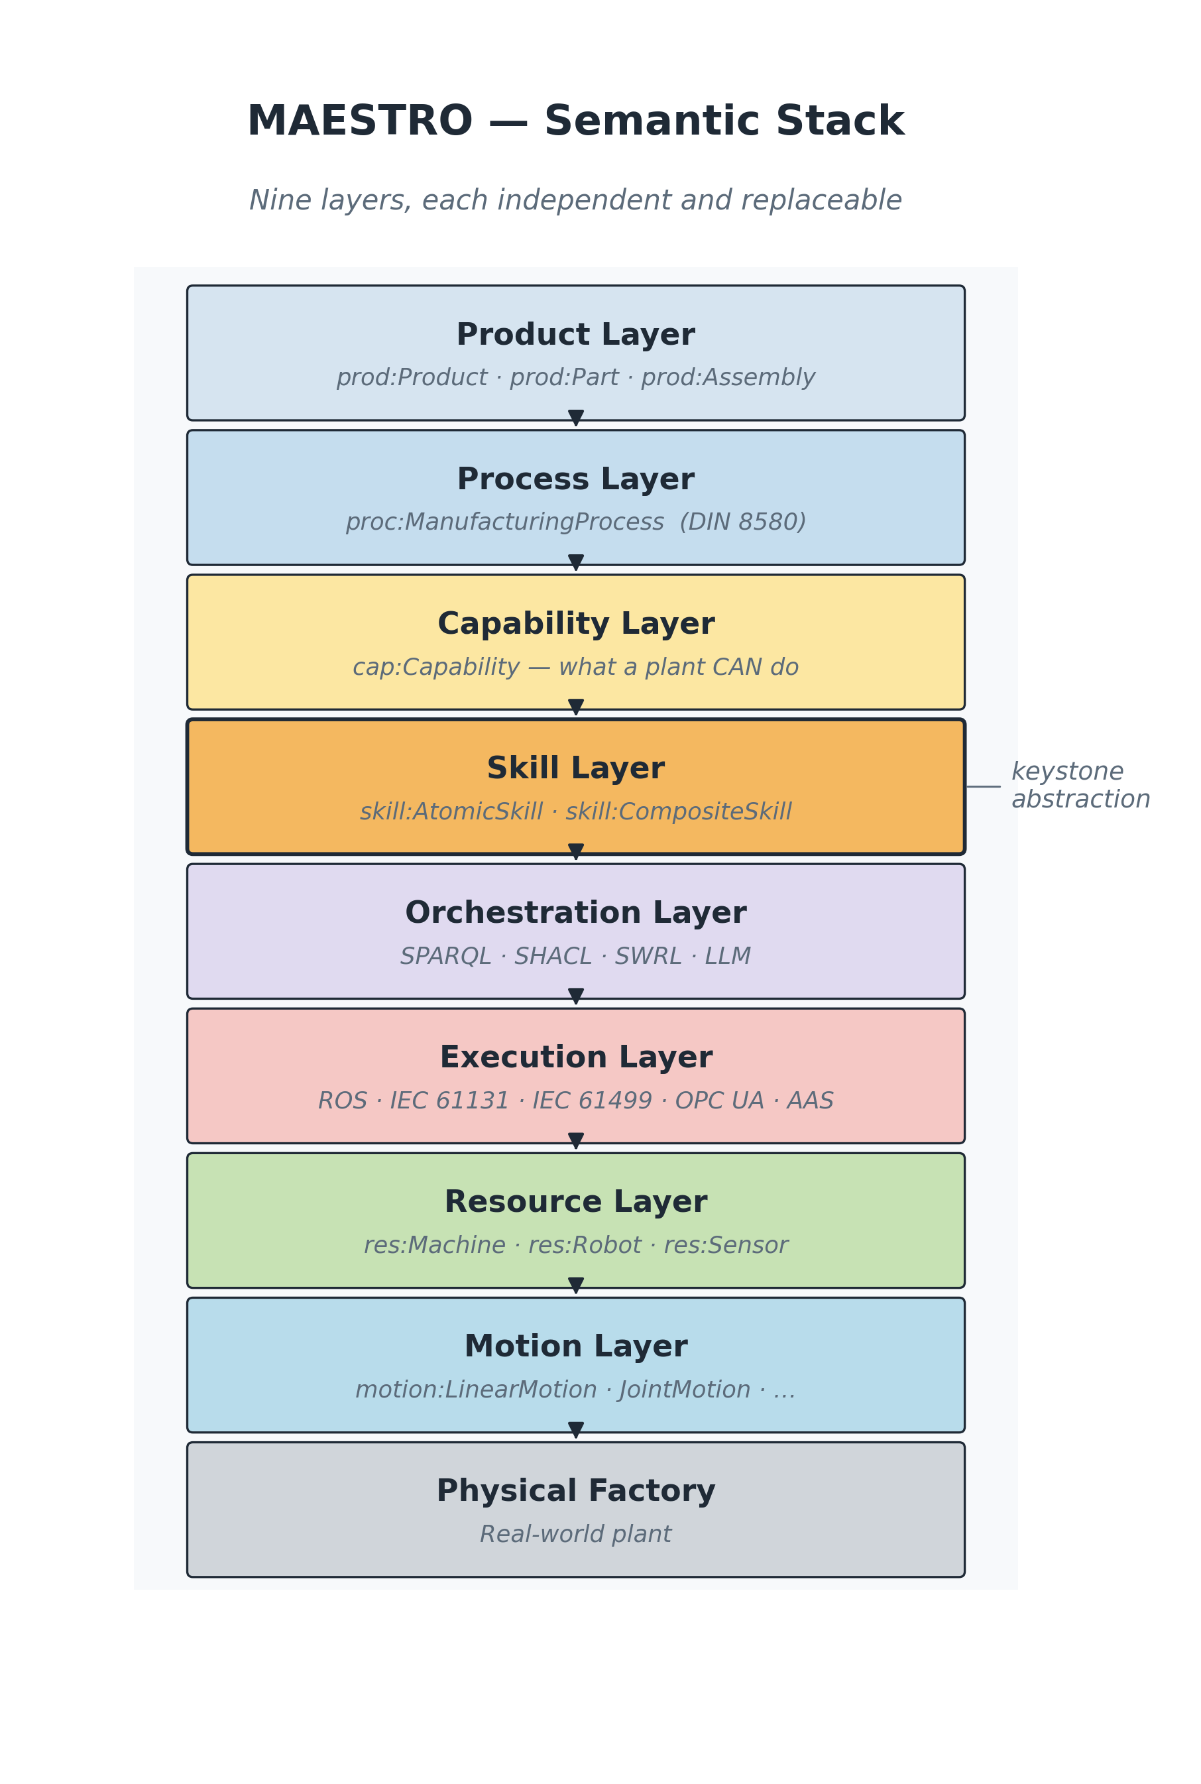
Figure 1 — The nine-layer semantic stack.
Three boundaries do most of the work and are the reason the stack stays future-proof:
- Capability ↔ Skill — separates what is possible (vendor-neutral intent) from how it is achieved (logical behaviour).
- Skill ↔ Execution — separates technology-neutral behaviour from technology-specific implementation (ROS / PLC / IEC 61499 / OPC UA).
- Resource ↔ Motion — separates the physical asset from the geometric and kinematic semantics of how it moves.

3. The modular stack and import graph
The vocabulary is split into 24 small TTL modules grouped by concern and tied together by a single umbrella file, maestro.ttl, which imports them all. Every module imports only what it needs (most depend just on core), which keeps the stack easy to extend: a new concern is a new file plus one owl:imports line. All modules share the permanent namespace base https://w3id.org/maestro/ and carry version 0.3.0.
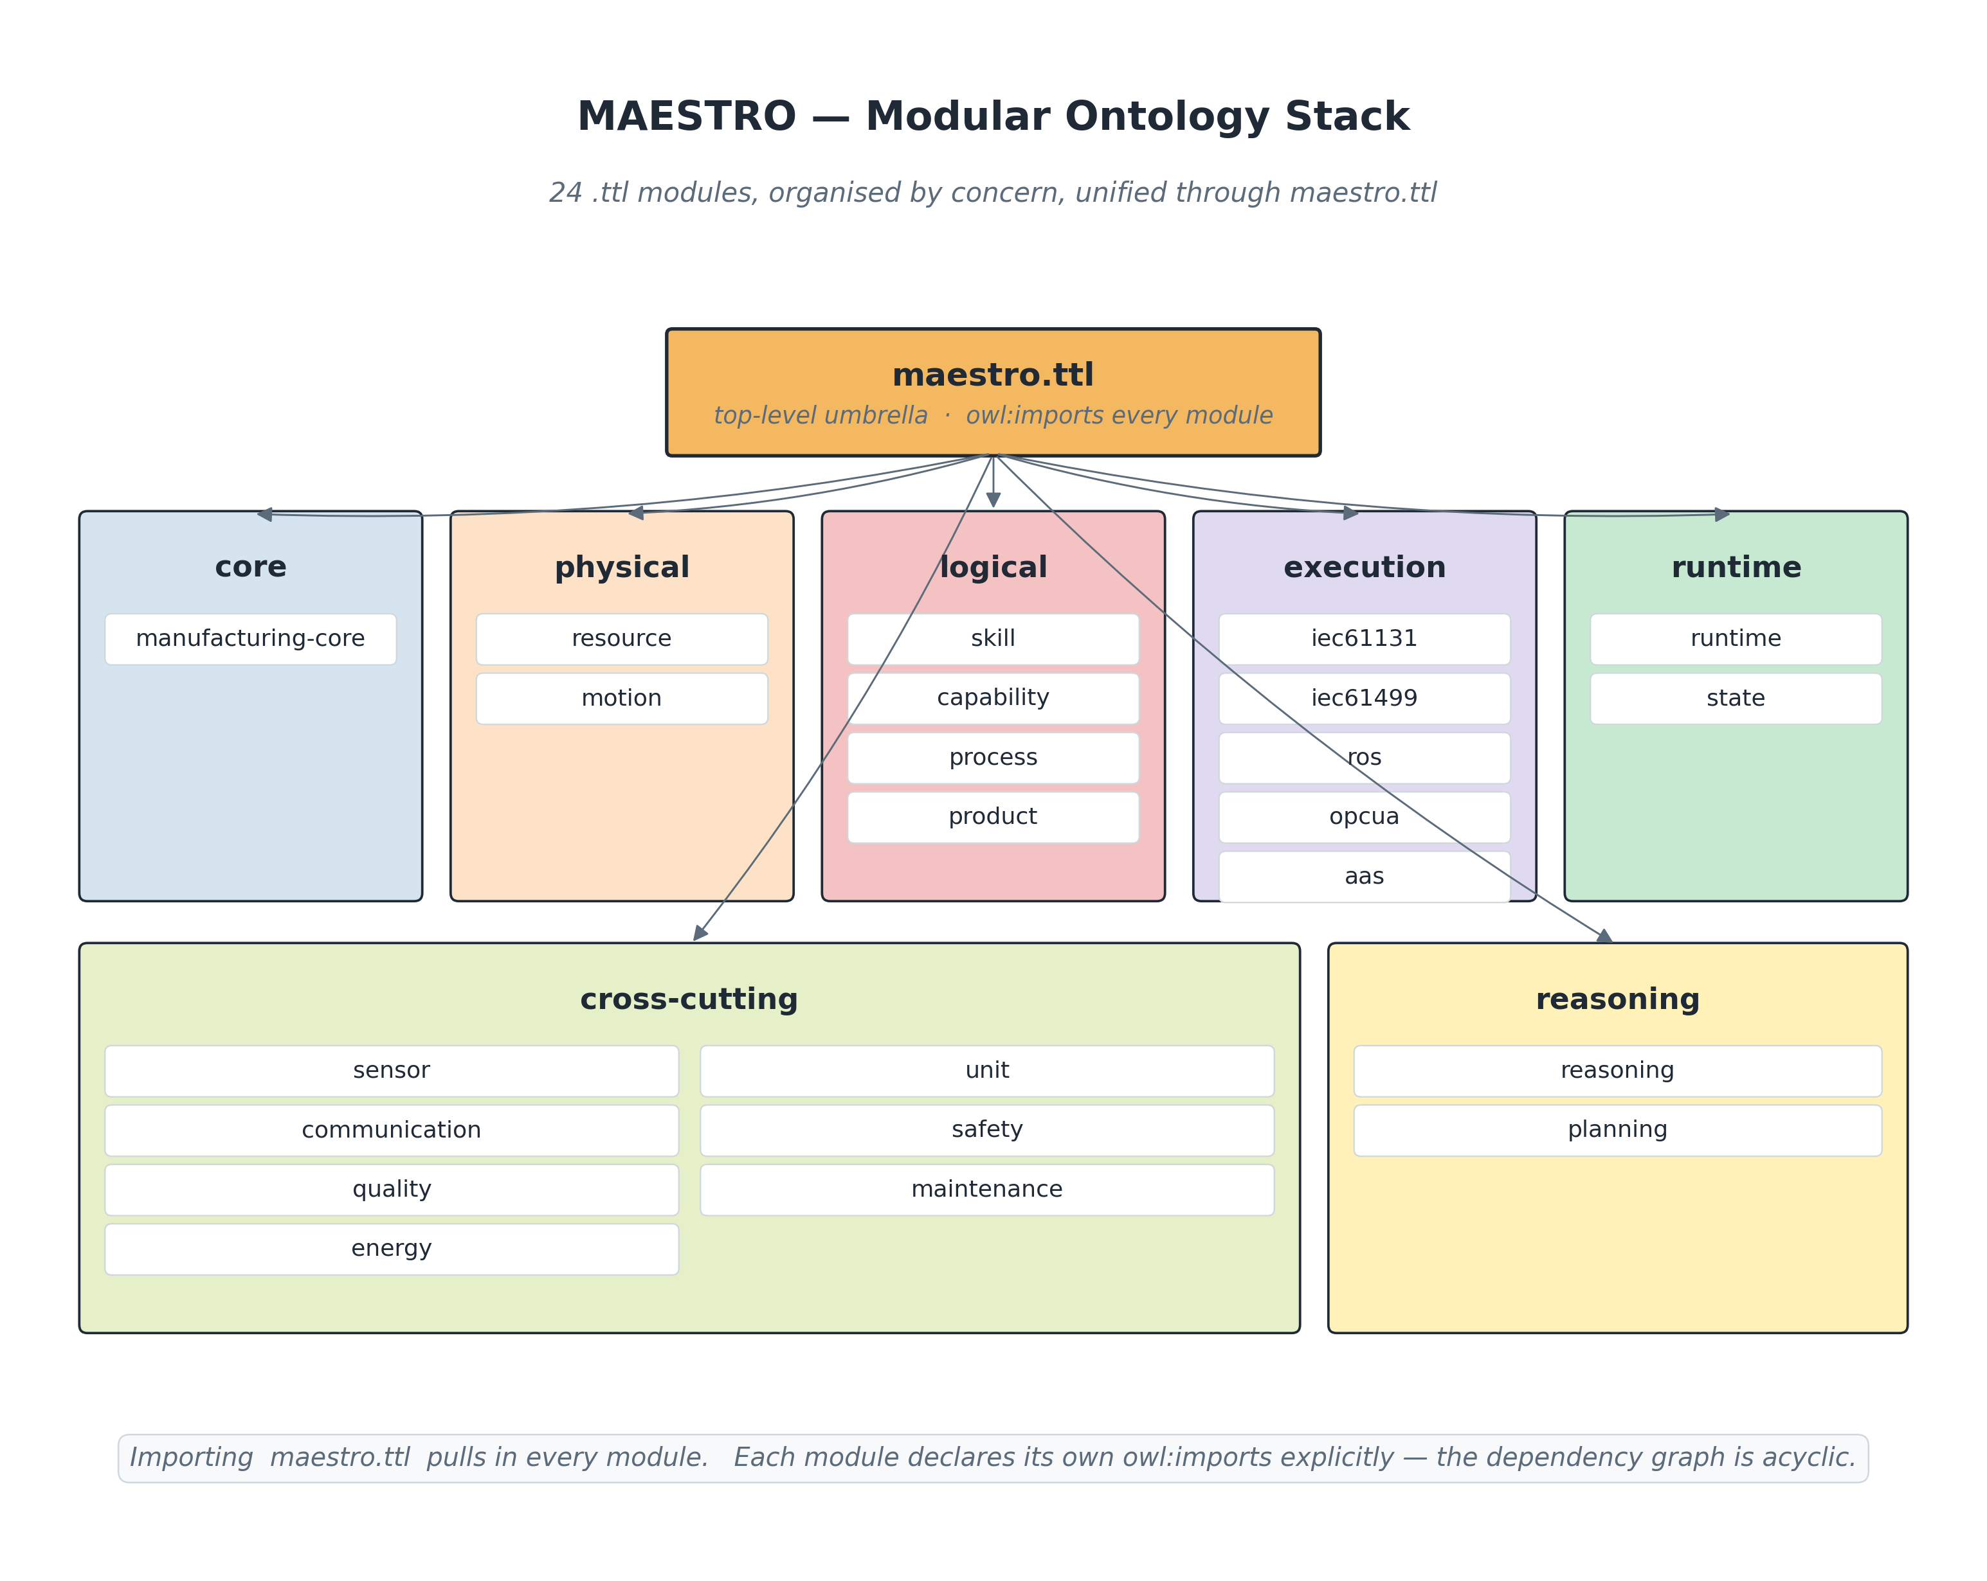
Figure 2 — The 24 modules and the umbrella import graph.

4. Module-by-module reference
Each module below lists its purpose, its namespace prefix and IRI, and the classes, properties and notable individuals it currently defines. Tables are generated directly from the TTL source, so they reflect the live ontology.

4.1 Core
The single root every other module builds on.

Manufacturing Core (core:)
File: ontologies/core/manufacturing-core.ttl Namespace: https://w3id.org/maestro/core#
The root abstractions of the whole stack. Everything is an Entity, split into PhysicalEntity and LogicalEntity. The five manufacturing pillars — Resource, Skill, Capability, Process, Product — and the universal relations that bind them (provides, realizes, requiresCapability, implements, controls) live here.
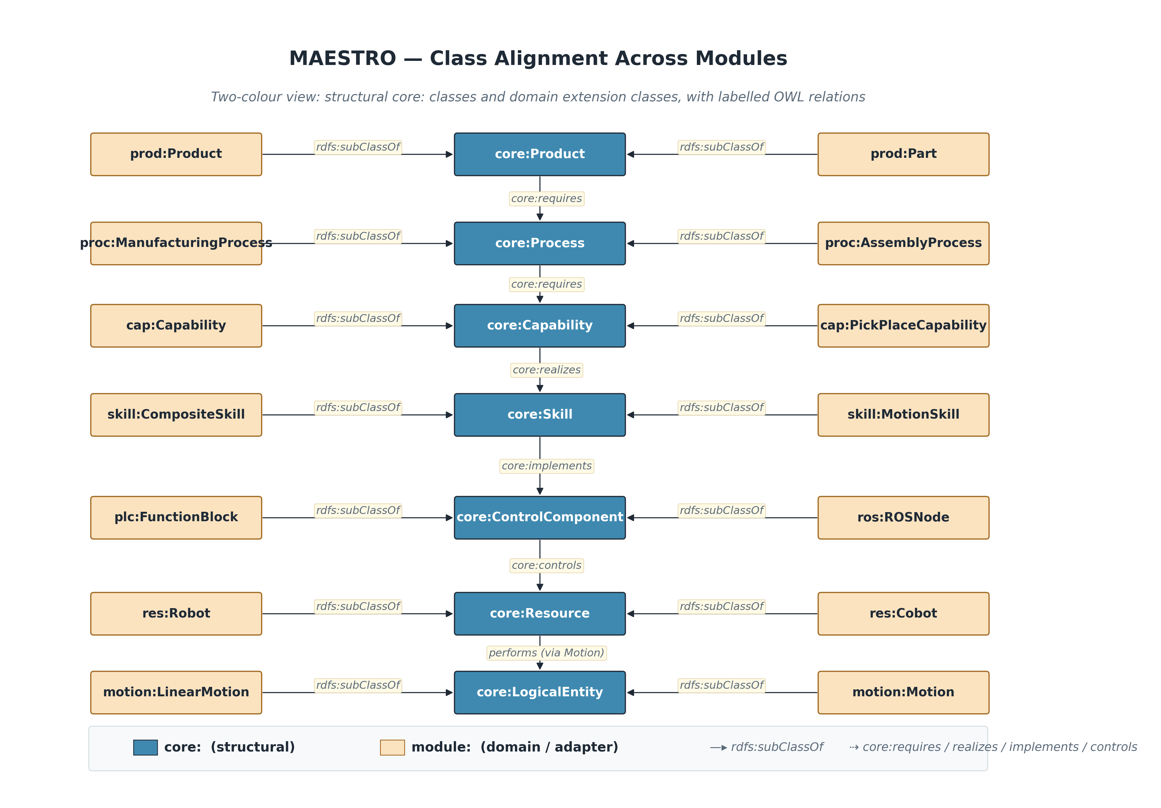
Figure — Manufacturing Core (10-class-alignment.png).
Classes
Class | Subclass of | Description
core:Capability | core:LogicalEntity | A manufacturing possibility (what a plant CAN do). Realised by Skills.
core:Constraint | core:LogicalEntity | A restriction on Skills, Resources, or Processes.
core:ControlComponent | core:LogicalEntity | A software/hardware element that implements Skills and controls Resources (e.g. ROS node, PLC FB, IEC 61499 FB, OPC UA method).
core:Entity | — | The most general class. Anything modelled in MAESTRO is an Entity.
core:Event | core:LogicalEntity | A point-in-time occurrence in the manufacturing system.
core:LogicalEntity | core:Entity | An entity that exists only in the information model.
core:PhysicalEntity | core:Entity | An entity that has a physical realisation (mass, location).
core:Plant | core:PhysicalEntity | An aggregation of Resources forming a manufacturing facility.
core:Process | core:LogicalEntity | Manufacturing logic. Requires Capabilities to be executed.
core:Product | core:LogicalEntity | A product, part, or assembly that requires manufacturing Processes.
core:Resource | core:PhysicalEntity | Any physical manufacturing asset (machine, robot, sensor, actuator, tool).
core:Skill | core:LogicalEntity | A logical, executable behaviour. Implemented by ControlComponents; provided by Resources.
core:State | core:LogicalEntity | A discrete operational condition of a Resource or ControlComponent.
Properties
Property | Kind | Domain → Range | Description
core:canManufacture | Object | core:Plant → core:Product | Inferred relation: a Plant can manufacture a Product. Materialised by rules/manufacturing-ability.rq.
core:canPerform | Object | core:Resource → core:Capability | Inferred relation: a Resource is capable of performing a Capability. Materialised by rules/capability-inference.rq.
core:communicatesThrough | Object | core:ControlComponent → — | A ControlComponent communicates with a Resource through a communication channel. Range is com:Channel (kept open here to avoid pulling communication.ttl into core).
core:composedOfSkill | Object | core:Skill → core:Skill | A composite Skill is composed of another Skill. Transitive.
core:connectedTo | Object | core:Entity → core:Entity | Physical or logical connectivity between two entities. Symmetric.
core:consumes | Object | core:Entity → core:Event | An Entity consumes an Event.
core:controls | Object | core:ControlComponent → core:Resource | A ControlComponent controls a Resource.
core:dependsOn | Object | core:Entity → core:Entity | Generic dependency relation.
core:deployedOn | Object | core:ControlComponent → core:Resource | A logical ControlComponent is deployed on a physical controller or compute Resource.
core:description | Data | core:Entity → xsd:string
core:emits | Object | core:Entity → core:Event | An Entity emits an Event.
core:executes | Object | core:ControlComponent → — | A ControlComponent executes a Process or Skill at runtime. Range is core:Skill or core:Process — left open via union (not asserted to keep OWL2-RL clean).
core:hasPart | Object | core:Entity → core:Entity | Mereological part-of relation. Transitive: Plant hasPart Cell, Cell hasPart Robot entails Plant hasPart Robot.
core:hasPlantCapability | Object | core:Plant → core:Capability | Plant-level capability. Use this instead of core:canPerform on Plant individuals (canPerform is Resource-scoped).
core:hasState | Object | core:Entity → core:State | Runtime operational State of an Entity. Use only inside a runtime named graph — see decisions/0002-runtime-graph-separation.md.
core:hosts | Object | core:Resource → core:LogicalEntity | A physical Resource hosts a logical artefact (a ControlComponent, an IEC 61499 RuntimeResource, an OPC UA Server).
core:identifier | Data | core:Entity → xsd:string | Globally unique identifier (e.g. AAS shortId, OPC UA NodeId). Functional (each entity has at most one) and inverse-functional (each identifier names at most one entity).
core:implementedBy | Object | core:Skill → core:ControlComponent | Inverse of core:implements.
core:implements | Object | core:ControlComponent → core:Skill | A ControlComponent implements a Skill (concrete realisation).
core:partOf | Object | core:Entity → core:Entity | Inverse mereological relation. Transitive.
core:providedBy | Object | core:Skill → core:Resource | Inverse of core:provides.
core:provides | Object | core:Resource → core:Skill | A Resource provides a Skill (offers it for use).
core:realizedBySkill | Object | core:Capability → core:Skill | A Capability is realized by a reusable Skill specification.
core:realizes | Object | core:Skill → core:Capability | A Skill realises a Capability.
core:requiresCapability | Object | core:Process → core:Capability | A Process requires a Capability.
core:requiresMotion | Object | core:Skill → core:LogicalEntity | A Skill requires a technology-neutral motion specification. Range narrowed to motion:Motion in motion.ttl.
core:version | Data | core:Entity → xsd:string

4.2 Physical layer
What physically exists on the shop floor and how it moves.

Resource (res:)
File: ontologies/physical/resource.ttl Namespace: https://w3id.org/maestro/resource#
Physical manufacturing assets: machines, robots and cobots, conveyors, CNC and laser units, tools and grippers, actuators, and the controller hardware (PLC, industrial PC) that hosts control components.
Classes
Class | Subclass of | Description
res:Actuator | core:Resource
res:AGV | res:Machine | Automated Guided Vehicle.
res:AssemblyStation | res:Machine | Workstation where assembly operations take place.
res:CNC | res:Machine | Computer Numerical Control machining centre.
res:Cobot | res:Robot | A collaborative robot designed for safe human interaction.
res:ControllerDevice | core:Resource | Physical controller or compute hardware that hosts logical ControlComponents.
res:Conveyor | res:Machine | Material handling conveyor.
res:Gripper | res:Tool
res:IndustrialPC | res:ControllerDevice | Industrial compute hardware that hosts logical ControlComponents.
res:LaserUnit | res:Machine | Laser machining / marking / welding unit.
res:Machine | core:Resource | A general manufacturing machine.
res:PLC | res:ControllerDevice | Programmable Logic Controller hardware. PLC programs and Function Blocks are logical ControlComponents deployed on this hardware.
res:Robot | res:Machine | An articulated, programmable, multi-axis machine.
res:ServoMotor | res:Actuator
res:Tool | core:Resource
res:ToolChanger | res:Tool
res:TransferArm | res:Robot | A robotic arm specialised for transfer / pick-and-place tasks.
res:VacuumUnit | res:Tool | Vacuum end-effector for pick operations.
Properties
Property | Kind | Domain → Range | Description
res:manufacturer | Data | — → xsd:string
res:model | Data | — → xsd:string
res:payload | Object | res:Robot → unit:Quantity | Maximum payload as an explicit quantity value.
res:payloadKg | Data | — → xsd:float | Maximum payload of a robot or handling resource, in kilograms.
res:reach | Object | res:Robot → unit:Quantity | Robot reach as an explicit quantity value.
res:reachMm | Data | — → xsd:float | Robot reach in millimetres.
res:serialNumber | Data | — → xsd:string

Motion (motion:)
File: ontologies/physical/motion.ttl Namespace: https://w3id.org/maestro/motion#
Technology-neutral geometric and kinematic primitives — linear, rotational, joint, Cartesian, synchronized, trajectory and force-controlled motion — kept separate from the resources that execute them.
Classes
Class | Subclass of | Description
motion:Axis | core:LogicalEntity
motion:CartesianMotion | motion:Motion | Motion specified in Cartesian/task space.
motion:CoordinateFrame | core:LogicalEntity
motion:ForceControlledMotion | motion:Motion | Motion regulated by force/torque feedback.
motion:JointMotion | motion:Motion | Motion specified in joint space.
motion:LinearMotion | motion:Motion
motion:Motion | core:LogicalEntity | A geometric/kinematic movement abstraction.
motion:RotationalMotion | motion:Motion
motion:SynchronizedMotion | motion:Motion | Coordinated motion of multiple resources.
motion:TrajectoryMotion | motion:Motion | Motion defined by a parametric trajectory.
Properties
Property | Kind | Domain → Range | Description
motion:hasAcceleration | Data | — → xsd:float
motion:hasCoordinateFrame | Object | — → motion:CoordinateFrame
motion:hasPrecision | Data | — → xsd:float | Repeatability / positioning precision in mm.
motion:hasVelocity | Data | — → xsd:float | Linear velocity in m/s or angular velocity in rad/s, depending on motion subtype.
motion:numberOfAxes | Data | — → xsd:integer
motion:requiresAxis | Object | — → motion:Axis

4.3 Logical layer
The vendor-neutral semantics: what is made, how, and what it takes.

Skill (skill:)
File: ontologies/logical/skill.ttl Namespace: https://w3id.org/maestro/skill#
The keystone of the stack. A Skill is reusable logical behaviour — it is NOT a ROS node, a PLC function block or an OPC UA method; execution technologies implement skills. Atomic skills are primitives; composite skills are built from other skills via composedOfSkill.
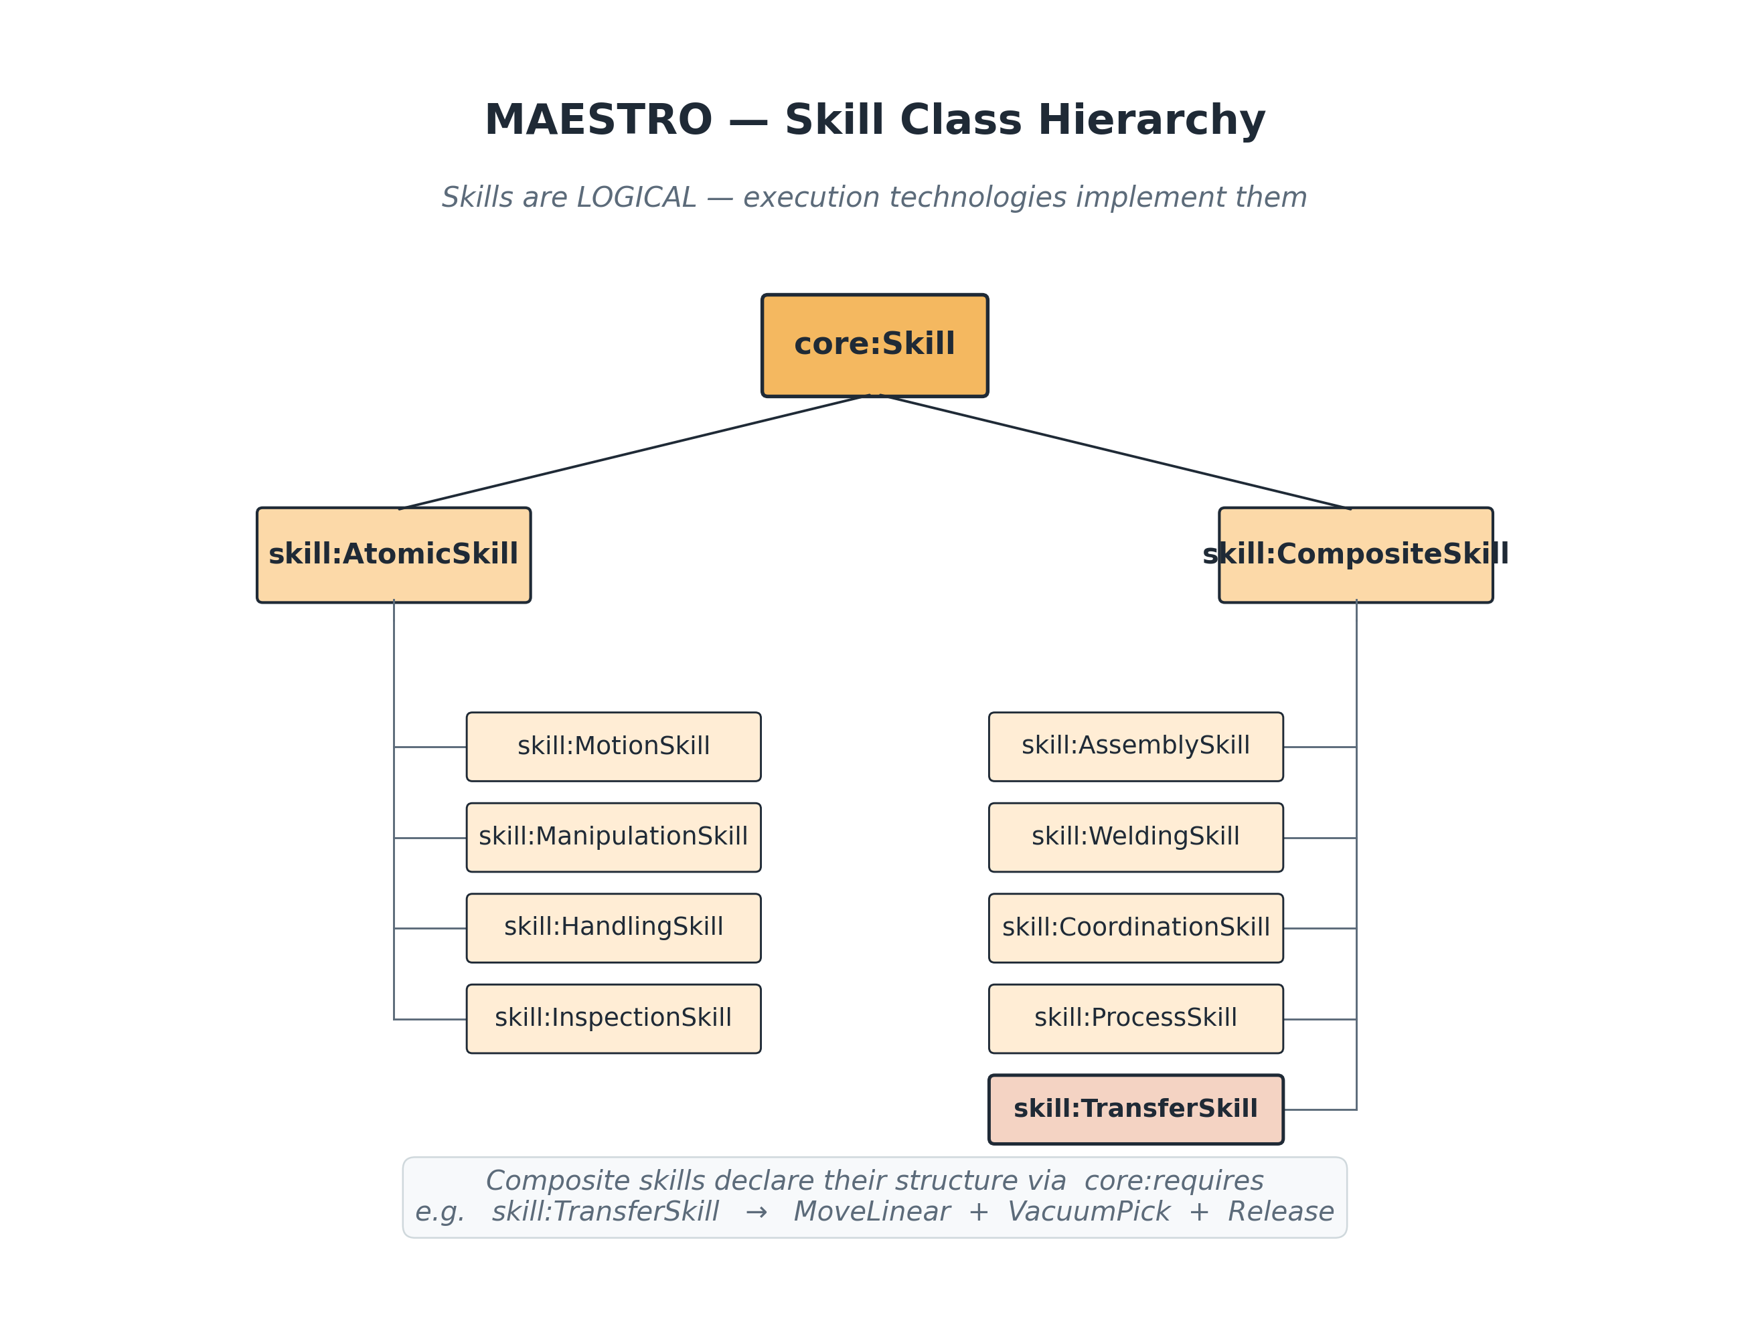
Figure — Skill (03-skill-hierarchy.png).
Classes
Class | Subclass of | Description
skill:AssemblySkill | skill:CompositeSkill
skill:AtomicSkill | core:Skill | An indivisible skill primitive.
skill:CompositeSkill | core:Skill | A skill built by composing other skills via skill:composedOfSkill.
skill:CoordinationSkill | skill:CompositeSkill
skill:HandlingSkill | skill:AtomicSkill | VDI 2860 handling skills (orient, position, deposit, secure).
skill:InspectionSkill | skill:AtomicSkill
skill:ManipulationSkill | skill:AtomicSkill | Skills that change the spatial relation between a resource and a workpiece (grasp, pick, place, release).
skill:MotionSkill | skill:AtomicSkill | Skills that produce kinematic motion (move linear, move joint, …).
skill:ProcessSkill | skill:CompositeSkill
skill:TransferSkill | skill:CompositeSkill | A composite skill: pick at A, move to B, place at B.
skill:WeldingSkill | skill:CompositeSkill
Properties
Property | Kind | Domain → Range | Description
skill:composedOfSkill | Object | core:Skill → core:Skill | A composite Skill has another Skill as a constituent step.
skill:expectedDurationSeconds | Data | core:Skill → xsd:float
skill:hasParameter | Object | core:Skill → —
skill:hasPostcondition | Object | core:Skill → core:State
skill:hasPrecondition | Object | core:Skill → core:State
skill:requiresMotion | Object | core:Skill → motion:Motion | A Skill requires a reusable technology-neutral Motion specification.

Capability (cap:)
File: ontologies/logical/capability.ttl Namespace: https://w3id.org/maestro/capability#
What a plant can do, expressed vendor-neutrally (TransportCapability, not MoveLeftCapability). Capabilities are organised as a SKOS concept scheme and are realised by one or more Skills.
Properties
Property | Kind | Domain → Range | Description
cap:realizedBySkill | Object | core:Capability → core:Skill | A Capability specification is realized by a reusable Skill specification.
Individuals
Individual | Type | Description
cap:AssemblyCapability | core:Capability, skos:Concept | Ability to combine parts into an assembly.
cap:CapabilityScheme | skos:ConceptScheme | SKOS organization for reusable manufacturing capability specifications.
cap:HandlingCapability | core:Capability, skos:Concept | Handling capability
cap:InspectionCapability | core:Capability, skos:Concept | Inspection capability
cap:MachiningCapability | core:Capability, skos:Concept | Machining capability
cap:PackagingCapability | core:Capability, skos:Concept | Packaging capability
cap:PickPlaceCapability | core:Capability, skos:Concept | Pick a part at location A and place it at location B.
cap:TestingCapability | core:Capability, skos:Concept | Testing capability
cap:TransportCapability | core:Capability, skos:Concept | Ability to transport material between locations.
cap:WeldingCapability | core:Capability, skos:Concept | Welding capability

Process (proc:)
File: ontologies/logical/process.ttl Namespace: https://w3id.org/maestro/process#
The manufacturing process taxonomy aligned to DIN 8580 (primary shaping, forming, separating, joining, coating, property change) plus handling/transport/inspection, with sequencing relations (precedes, follows, parallelWith).
Classes
Class | Subclass of | Description
proc:AssemblyProcess | proc:JoiningProcess
proc:Coating | proc:ManufacturingProcess | DIN 8580 Group 5.
proc:Forming | proc:ManufacturingProcess | DIN 8580 Group 2 — bending, drawing, forging.
proc:HandlingProcess | proc:ManufacturingProcess
proc:InspectionProcess | proc:ManufacturingProcess
proc:JoiningProcess | proc:ManufacturingProcess | DIN 8580 Group 4 — welding, screwing, gluing.
proc:MachiningProcess | proc:Separating
proc:ManufacturingProcess | core:Process
proc:MaterialPropertyChange | proc:ManufacturingProcess | DIN 8580 Group 6 — heat treatment.
proc:PrimaryShaping | proc:ManufacturingProcess | DIN 8580 Group 1 — casting, sintering.
proc:Separating | proc:ManufacturingProcess | DIN 8580 Group 3 — cutting, machining.
proc:TransportProcess | proc:HandlingProcess
Properties
Property | Kind | Domain → Range | Description
proc:follows | Object | proc:ManufacturingProcess → proc:ManufacturingProcess
proc:parallelWith | Object | proc:ManufacturingProcess → proc:ManufacturingProcess
proc:precedes | Object | proc:ManufacturingProcess → proc:ManufacturingProcess
proc:producesState | Object | proc:ManufacturingProcess → core:State
proc:requiresCapability | Object | proc:ManufacturingProcess → core:Capability

Product (prod:)
File: ontologies/logical/product.ttl Namespace: https://w3id.org/maestro/product#
Products, parts and assemblies, plus the features, tolerances and materials that drive which processes a product requires.
Classes
Class | Subclass of | Description
prod:Assembly | core:Product | A Product composed of multiple Parts and/or sub-Assemblies.
prod:Feature | core:LogicalEntity | A geometric or functional feature of a Product (hole, slot, surface).
prod:Material | core:LogicalEntity
prod:Part | core:Product | An atomic manufactured item — not further decomposed in this model.
prod:Tolerance | core:LogicalEntity | A dimensional, geometric, or surface tolerance specification.
Properties
Property | Kind | Domain → Range | Description
prod:hasFeature | Object | core:Product → prod:Feature
prod:hasTolerance | Object | prod:Feature → prod:Tolerance
prod:madeOf | Object | core:Product → prod:Material
prod:mass | Object | core:Product → unit:Quantity | Product mass as a unit-bearing quantity.
prod:massKg | Data | core:Product → xsd:float | Deprecated unit-suffixed datatype property. Use prod:mass with unit:Quantity instead.
prod:requiresProcess | Object | core:Product → proc:ManufacturingProcess | A Product requires a Manufacturing Process to be produced.

4.4 Execution adapters
Technology-specific bindings that implement logical skills.

ROS / ROS 2 (ros:)
File: ontologies/execution/ros.ttl Namespace: https://w3id.org/maestro/ros#
ROS nodes, topics, services, actions, parameters, TF frames and MoveIt controllers. ROS nodes implement skills and control resources.
Classes
Class | Subclass of | Description
ros:MoveItController | ros:ROSNode
ros:ROSAction | core:LogicalEntity
ros:ROSNode | core:ControlComponent
ros:ROSParameter | core:LogicalEntity
ros:ROSService | core:LogicalEntity
ros:ROSTopic | core:LogicalEntity
ros:TFFrame | core:LogicalEntity | A coordinate frame published on the ROS /tf tree.
Properties
Property | Kind | Domain → Range | Description
ros:advertisesAction | Object | ros:ROSNode → ros:ROSAction
ros:advertisesService | Object | ros:ROSNode → ros:ROSService
ros:controlsResource | Object | ros:ROSNode → core:Resource
ros:implementsSkill | Object | ros:ROSNode → core:Skill
ros:publishes | Object | ros:ROSNode → ros:ROSTopic
ros:rosVersion | Data | — → xsd:string | ROS distribution / version (e.g. 'humble', 'iron', 'jazzy').
ros:subscribes | Object | ros:ROSNode → ros:ROSTopic

IEC 61131-3 (PLC) (plc:)
File: ontologies/execution/iec61131.ttl Namespace: https://w3id.org/maestro/iec61131#
Classic PLC world: programs, tasks, function blocks, functions and variables, with the five IEC 61131-3 languages (LD, ST, FBD, SFC, IL) as individuals.
Classes
Class | Subclass of | Description
plc:Function | core:ControlComponent
plc:FunctionBlock | core:ControlComponent | An IEC 61131-3 Function Block (FB).
plc:Language | —
plc:PLCProgram | core:ControlComponent
plc:Task | core:LogicalEntity
plc:Variable | core:LogicalEntity
Properties
Property | Kind | Domain → Range | Description
plc:controlsResource | Object | plc:FunctionBlock → core:Resource
plc:cycleTimeMs | Data | plc:Task → xsd:float
plc:implementsSkill | Object | plc:FunctionBlock → core:Skill
plc:writtenIn | Object | — → plc:Language
Individuals
Individual | Type | Description
plc:FunctionBlockDiagram | plc:Language
plc:InstructionList | plc:Language
plc:LadderLogic | plc:Language
plc:SequentialFunctionChart | plc:Language
plc:StructuredText | plc:Language

IEC 61499 (iec61499:)
File: ontologies/execution/iec61499.ttl Namespace: https://w3id.org/maestro/iec61499#
Event-driven distributed control: basic, composite and service-interface function blocks, applications, runtime resources and devices. Kept disjoint from IEC 61131 function blocks.
Classes
Class | Subclass of | Description
iec61499:Application | core:LogicalEntity
iec61499:BasicFB | iec61499:FunctionBlock | A basic function block defined by an ECC (Execution Control Chart).
iec61499:CompositeFB | iec61499:FunctionBlock | A composite function block built from interconnected FBs.
iec61499:Connection | core:LogicalEntity
iec61499:Device | core:Resource | A physical computing device that hosts IEC 61499 RuntimeResources. Subsumed under core:Resource (controller hardware) and aligned with res:ControllerDevice.
iec61499:ExecutionEvent | core:Event | An IEC 61499 execution event (formerly iec61499:Event in 0.2.0). Renamed to avoid collision with core:Event.
iec61499:FunctionBlock | core:ControlComponent | IEC 61499 function block. Disjoint with plc:FunctionBlock (IEC 61131-3 FB) to prevent accidental dual-typing.
iec61499:RuntimeResource | core:LogicalEntity | IEC 61499 runtime resource (formerly iec61499:Resource in 0.2.0). Renamed to avoid collision with core:Resource.
iec61499:ServiceInterfaceFB | iec61499:FunctionBlock
Properties
Property | Kind | Domain → Range | Description
iec61499:consumesEvent | Object | iec61499:FunctionBlock → iec61499:ExecutionEvent
iec61499:controlsResource | Object | iec61499:FunctionBlock → core:Resource
iec61499:emitsEvent | Object | iec61499:FunctionBlock → iec61499:ExecutionEvent
iec61499:hostsRuntimeResource | Object | iec61499:Device → iec61499:RuntimeResource
iec61499:implementsSkill | Object | iec61499:FunctionBlock → core:Skill

OPC UA (opcua:)
File: ontologies/execution/opcua.ttl Namespace: https://w3id.org/maestro/opcua#
OPC UA servers, nodes, objects, variables and methods, plus a SkillInterface pattern that exposes a MAESTRO Skill over the network.
Classes
Class | Subclass of | Description
opcua:OpcUaMethod | opcua:OpcUaNode
opcua:OpcUaNode | core:LogicalEntity
opcua:OpcUaObject | opcua:OpcUaNode
opcua:OpcUaServer | core:ControlComponent
opcua:OpcUaSkillInterface | opcua:OpcUaObject | An OPC UA object that exposes a MAESTRO Skill to network clients. Mirrors the CaSkMan SkillInterface pattern.
opcua:OpcUaVariable | opcua:OpcUaNode
Properties
Property | Kind | Domain → Range | Description
opcua:accessibleThrough | Object | core:Skill → opcua:OpcUaSkillInterface | A Skill is accessible through an OPC UA SkillInterface (inverse of opcua:exposes).
opcua:browseName | Data | opcua:OpcUaNode → xsd:string
opcua:exposes | Object | opcua:OpcUaSkillInterface → core:Skill | An OPC UA SkillInterface exposes a Skill.
opcua:hostsInterface | Object | opcua:OpcUaServer → opcua:OpcUaSkillInterface
opcua:implementsSkill | Object | opcua:OpcUaMethod → core:Skill
opcua:nodeId | Data | opcua:OpcUaNode → xsd:string | OPC UA NodeId (e.g. 'ns=2;s=Skill.Transfer.Start').

Asset Administration Shell (aas:)
File: ontologies/execution/aas.ttl Namespace: https://w3id.org/maestro/aas#
The Industry 4.0 digital-twin envelope: administration shells, assets, submodels and submodel elements (properties, operations).
Classes
Class | Subclass of | Description
aas:Asset | core:PhysicalEntity
aas:AssetAdministrationShell | core:LogicalEntity | The digital twin envelope of an Asset.
aas:Operation | aas:SubmodelElement
aas:Property | aas:SubmodelElement
aas:Reference | core:LogicalEntity
aas:Submodel | core:LogicalEntity
aas:SubmodelElement | core:LogicalEntity
Properties
Property | Kind | Domain → Range | Description
aas:hasSubmodel | Object | aas:AssetAdministrationShell → aas:Submodel
aas:hasSubmodelElement | Object | aas:Submodel → aas:SubmodelElement
aas:idShort | Data | — → xsd:string
aas:representsAsset | Object | aas:AssetAdministrationShell → aas:Asset
aas:semanticId | Data | — → xsd:string | ECLASS / IEC CDD identifier.

4.5 Runtime layer
Live operational state, kept apart from design-time models.

Runtime (runtime:)
File: ontologies/runtime/runtime.ttl Namespace: https://w3id.org/maestro/runtime#
Live behaviour: runtime events, state transitions and snapshots, with PackML-aligned operational states (Available, Busy, Executing, Held, Fault, …) as individuals.
Classes
Class | Subclass of | Description
runtime:RuntimeEvent | core:Event
runtime:Snapshot | core:LogicalEntity | Marker class for a runtime snapshot ontology / named graph. New in 0.3.0.
runtime:StateTransition | runtime:RuntimeEvent
Properties
Property | Kind | Domain → Range | Description
runtime:enteredState | Object | runtime:StateTransition → core:State
runtime:fromState | Object | runtime:StateTransition → core:State
runtime:snapshotTaken | Data | runtime:Snapshot → xsd:dateTime | Wall-clock timestamp at which the snapshot was captured.
runtime:timestamp | Data | runtime:RuntimeEvent → xsd:dateTime
Individuals
Individual | Type | Description
runtime:Aborted | core:State, skos:Concept | Aborted
runtime:Alarm | core:State, skos:Concept | Alarm
runtime:Available | core:State, skos:Concept | Resource is ready to accept work.
runtime:Busy | core:State, skos:Concept | Resource is currently executing a skill.
runtime:Executing | core:State, skos:Concept | PackML 'Execute' substate.
runtime:Fault | core:State, skos:Concept | Resource is in a faulted or error state.
runtime:HealthState | core:State, skos:Concept | Diagnostic health indicator such as healthy, degraded, or failed.
runtime:Held | core:State, skos:Concept | PackML 'Held' state: execution paused.
runtime:Idle | core:State, skos:Concept | Idle
runtime:StateScheme | skos:ConceptScheme

State machine (state:)
File: ontologies/runtime/state.ttl Namespace: https://w3id.org/maestro/state#
A generic state-machine vocabulary — state machines, transitions, guards, initial and final states — reused across resources and control components.
Classes
Class | Subclass of | Description
state:FinalState | core:State
state:InitialState | core:State
state:StateMachine | core:LogicalEntity
state:Transition | core:LogicalEntity
Properties
Property | Kind | Domain → Range | Description
state:guardExpression | Data | state:Transition → xsd:string
state:hasStateMachine | Object | — → state:StateMachine
state:hasTransition | Object | state:StateMachine → state:Transition
state:source | Object | state:Transition → core:State
state:target | Object | state:Transition → core:State

4.6 Cross-cutting concerns
Orthogonal aspects that apply across every layer.

Units & quantities (unit:)
File: ontologies/cross-cutting/unit.ttl Namespace: https://w3id.org/maestro/unit#
QUDT-aligned units and unit-bearing quantities, so physical values carry explicit units instead of bare floats.
Classes
Class | Subclass of | Description
unit:Quantity | core:LogicalEntity, qudt:Quantity
unit:Unit | core:LogicalEntity, qudt:Unit
Properties
Property | Kind | Domain → Range | Description
unit:hasUnit | Object | — → unit:Unit
unit:numericValue | Data | — → xsd:double
unit:symbol | Data | unit:Unit → xsd:string
Individuals
Individual | Type | Description
unit:Degree | unit:Unit
unit:DegreeCelsius | unit:Unit
unit:Joule | unit:Unit
unit:Kelvin | unit:Unit
unit:Kilogram | unit:Unit
unit:Metre | unit:Unit
unit:MetrePerSecond | unit:Unit
unit:Millimetre | unit:Unit
unit:Newton | unit:Unit
unit:Pascal | unit:Unit
unit:Radian | unit:Unit
unit:Second | unit:Unit
unit:Watt | unit:Unit

Sensors (sensor:)
File: ontologies/cross-cutting/sensor.ttl Namespace: https://w3id.org/maestro/sensor#
W3C SOSA/SSN-aligned sensors and observations, with industrial sensor types (temperature, pressure, vibration, force, torque, proximity, vision).
Classes
Class | Subclass of | Description
sensor:FeatureOfInterest | core:LogicalEntity, sosa:FeatureOfInterest
sensor:ObservableProperty | core:LogicalEntity, sosa:ObservableProperty
sensor:Observation | core:Event, sosa:Observation | A sensor observation. Subclass of core:Event so it joins the MAESTRO eventing model.
sensor:Sensor | core:Resource, sosa:Sensor | Physical sensor. Subclass of both core:Resource and sosa:Sensor so SOSA-native graphs federate cleanly.

Communication (com:)
File: ontologies/cross-cutting/communication.ttl Namespace: https://w3id.org/maestro/communication#
Protocols, channels and endpoints — OPC UA, DDS, MQTT, PROFINET, EtherCAT, Modbus, HTTP — that connect control components.
Classes
Class | Subclass of | Description
com:Channel | core:LogicalEntity | A bidirectional communication channel using a Protocol.
com:Endpoint | core:LogicalEntity
com:Protocol | core:LogicalEntity
Properties
Property | Kind | Domain → Range | Description
com:address | Data | com:Endpoint → xsd:string | URI/URL of the endpoint (e.g. 'opc.tcp://plc1:4840').
com:hasEndpoint | Object | com:Channel → com:Endpoint
com:port | Data | com:Endpoint → xsd:integer
com:usesProtocol | Object | com:Channel → com:Protocol
Individuals
Individual | Type | Description
com:DdsProtocol | com:Protocol
com:EthercatProtocol | com:Protocol
com:HttpProtocol | com:Protocol
com:ModbusProtocol | com:Protocol
com:MqttProtocol | com:Protocol
com:OpcUaProtocol | com:Protocol
com:ProfinetProtocol | com:Protocol

Safety (safety:)
File: ontologies/cross-cutting/safety.ttl Namespace: https://w3id.org/maestro/safety#
Functional safety: safety functions, hazards and risks, with IEC 61508 SIL and ISO 13849 Performance Level individuals, and emergency stop.
Classes
Class | Subclass of | Description
safety:EmergencyStop | safety:SafetyFunction
safety:Hazard | core:LogicalEntity
safety:PerformanceLevel | — | ISO 13849 Performance Level (PL a … PL e).
safety:Risk | core:LogicalEntity
safety:SafetyFunction | core:LogicalEntity | A function intended to maintain or achieve a safe state (IEC 61508).
safety:SafetyIntegrityLevel | — | IEC 61508 SIL (SIL1 … SIL4).
Properties
Property | Kind | Domain → Range | Description
safety:hasPerformanceLevel | Object | safety:SafetyFunction → safety:PerformanceLevel
safety:hasSIL | Object | safety:SafetyFunction → safety:SafetyIntegrityLevel
safety:mitigates | Object | safety:SafetyFunction → safety:Hazard
Individuals
Individual | Type | Description
safety:PLa | safety:PerformanceLevel
safety:PLb | safety:PerformanceLevel
safety:PLc | safety:PerformanceLevel
safety:PLd | safety:PerformanceLevel
safety:PLe | safety:PerformanceLevel
safety:SIL1 | safety:SafetyIntegrityLevel
safety:SIL2 | safety:SafetyIntegrityLevel
safety:SIL3 | safety:SafetyIntegrityLevel
safety:SIL4 | safety:SafetyIntegrityLevel

Quality (qa:)
File: ontologies/cross-cutting/quality.ttl Namespace: https://w3id.org/maestro/quality#
Quality checks, defects, non-conformances, inspection results (Pass/Fail/Rework) and KPIs (OEE, FPY, scrap rate).
Classes
Class | Subclass of | Description
qa:Defect | core:LogicalEntity
qa:InspectionResult | core:LogicalEntity
qa:KPI | core:LogicalEntity | Key performance indicator (OEE, FPY, scrap rate, …).
qa:NonConformance | core:Event
qa:QualityCheck | core:LogicalEntity
Properties
Property | Kind | Domain → Range | Description
qa:detected | Object | qa:QualityCheck → qa:Defect
qa:hasResult | Object | qa:QualityCheck → qa:InspectionResult
qa:kpiValue | Data | qa:KPI → xsd:double
Individuals
Individual | Type | Description
qa:Fail | qa:InspectionResult
qa:Pass | qa:InspectionResult
qa:Rework | qa:InspectionResult

Maintenance (maint:)
File: ontologies/cross-cutting/maintenance.ttl Namespace: https://w3id.org/maestro/maintenance#
Preventive, corrective, predictive and inspection maintenance actions, plus fault diagnosis and reliability metrics (RUL, MTBF).
Classes
Class | Subclass of | Description
maint:Corrective | maint:MaintenanceAction
maint:FaultDiagnosis | core:LogicalEntity
maint:Inspection | maint:MaintenanceAction
maint:MaintenanceAction | core:Event
maint:Predictive | maint:MaintenanceAction | Maintenance triggered by predictive analytics over sensor data.
maint:Preventive | maint:MaintenanceAction
Properties
Property | Kind | Domain → Range | Description
maint:mtbfHours | Data | core:Resource → xsd:double | Mean time between failures, in hours.
maint:performedAt | Data | maint:MaintenanceAction → xsd:dateTime
maint:remainingUsefulLifeHours | Data | core:Resource → xsd:double
maint:scheduledFor | Data | maint:MaintenanceAction → xsd:dateTime

Energy (energy:)
File: ontologies/cross-cutting/energy.ttl Namespace: https://w3id.org/maestro/energy#
Energy consumers, measurements and sources, with power, energy and carbon-intensity fields for energy-aware manufacturing.
Classes
Class | Subclass of | Description
energy:EnergyConsumer | core:Resource
energy:EnergyMeasurement | core:Event
energy:EnergySource | core:LogicalEntity
Properties
Property | Kind | Domain → Range | Description
energy:carbonGCO2eqPerKwh | Data | energy:EnergySource → xsd:double | Grams CO2-equivalent emitted per kWh produced.
energy:energyKwh | Data | energy:EnergyMeasurement → xsd:double
energy:powerWatts | Data | energy:EnergyConsumer → xsd:double
energy:suppliedBy | Object | energy:EnergyConsumer → energy:EnergySource
Individuals
Individual | Type | Description
energy:CompressedAir | energy:EnergySource
energy:ElectricalGrid | energy:EnergySource
energy:Solar | energy:EnergySource
energy:Wind | energy:EnergySource

4.7 Reasoning & planning
How the graph is reasoned over, and where it sits in the enterprise.

Reasoning (reas:)
File: ontologies/reasoning/reasoning.ttl Namespace: https://w3id.org/maestro/reasoning#
Documents the layered reasoning stack (semantic inheritance via OWL2-RL, validation via SHACL, capability inference and orchestration via SPARQL, explanation via LLM) and the canonical reasoning chain.
Classes
Class | Subclass of | Description
reas:ReasoningLayer | core:LogicalEntity
reas:ReasoningModel | core:LogicalEntity
Properties
Property | Kind | Domain → Range | Description
reas:technology | Data | reas:ReasoningLayer → xsd:string
Individuals
Individual | Type | Description
reas:CapabilityInference | reas:ReasoningLayer
reas:CoreReasoningChain | reas:ReasoningModel | Product →’ requires →’ Process →’ requires →’ Capability →’ realizedBy →’ Skill →’ implementedBy →’ ControlComponent →’ controls →’ Resource →’ performs →’ Motion.
reas:Explanation | reas:ReasoningLayer
reas:Orchestration | reas:ReasoningLayer
reas:SemanticInheritance | reas:ReasoningLayer
reas:Validation | reas:ReasoningLayer

Planning (ISA-95) (plan:)
File: ontologies/reasoning/planning.ttl Namespace: https://w3id.org/maestro/planning#
ISA-95 enterprise hierarchy (enterprise, site, area, work centre, work unit) and production planning objects (orders, schedules, work orders).
Classes
Class | Subclass of | Description
plan:Area | core:LogicalEntity
plan:Enterprise | core:LogicalEntity
plan:OperationsDefinition | core:LogicalEntity
plan:ProductionOrder | core:LogicalEntity
plan:ProductionSchedule | core:LogicalEntity
plan:Site | core:LogicalEntity
plan:WorkCenter | core:LogicalEntity
plan:WorkOrder | core:LogicalEntity
plan:WorkUnit | core:LogicalEntity
Properties
Property | Kind | Domain → Range | Description
plan:assignedTo | Object | plan:WorkOrder → plan:WorkCenter
plan:dueDate | Data | plan:ProductionOrder → xsd:dateTime
plan:partOfArea | Object | plan:WorkCenter → plan:Area
plan:partOfSite | Object | plan:Area → plan:Site
plan:quantity | Data | plan:ProductionOrder → xsd:integer

4.8 Reusable libraries
Canonical instance data with stable, citable IRIs.

Skill library (skill-lib:)
File: ontologies/lib/skill-lib.ttl Namespace: https://w3id.org/maestro/skill-lib#
Reusable skill individuals (MoveLinear, MoveJoint, VacuumPick, Release, Transfer) separated from the skill: vocabulary so application data can cite stable IRIs.
Individuals
Individual | Type | Description
skill-lib:MoveJoint | skill:MotionSkill | Move the controlled point through configured joint space waypoints.
skill-lib:MoveLinear | skill:MotionSkill | Move the controlled point along a straight line at constant velocity.
skill-lib:Release | skill:ManipulationSkill | Release a held part by deactivating the holding mechanism (e.g. vacuum off, gripper open).
skill-lib:Transfer | skill:TransferSkill | Composite pick-and-place skill — moves a part from A to B.
skill-lib:VacuumPick | skill:ManipulationSkill | Activate vacuum, lower onto part, lift.

Motion library (motion-lib:)
File: ontologies/lib/motion-lib.ttl Namespace: https://w3id.org/maestro/motion-lib#
Canonical reusable motion specifications (linear, joint, Cartesian) that skills point at via requiresMotion.
Individuals
Individual | Type | Description
motion-lib:CartesianMotionSpec | motion:CartesianMotion | Canonical reusable specification for Cartesian motion requirements.
motion-lib:JointMotionSpec | motion:JointMotion | Canonical reusable specification for joint-space motion requirements.
motion-lib:LinearMotionSpec | motion:LinearMotion | Canonical reusable specification for linear motion requirements.

5. Reasoning and the LLM pipeline
MAESTRO reasons over the graph in layers: OWL2-RL handles semantic inheritance, SHACL validates the data, SPARQL CONSTRUCT rules infer capabilities, and SPARQL queries drive orchestration. The canonical reasoning chain threads the whole stack together:
Product → Process → Capability → Skill → ControlComponent → Resource → Motion
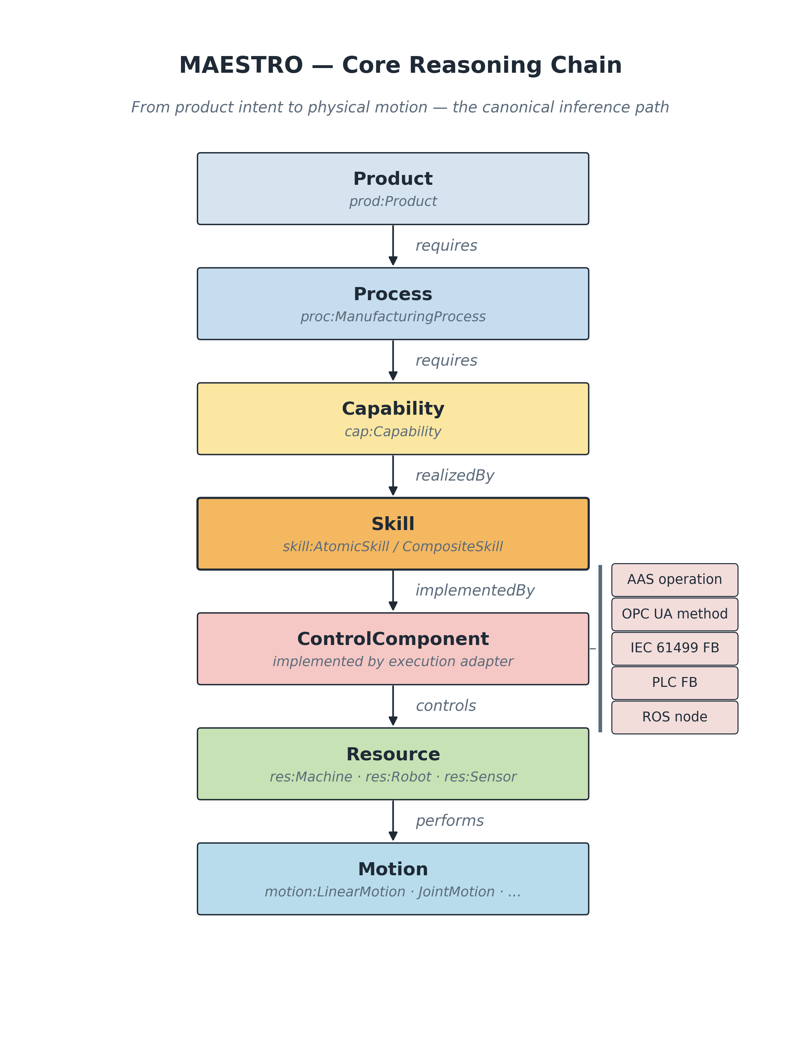
Figure 3 — The core reasoning chain.
On top of this, a Large Language Model translates a natural-language question into SPARQL, runs it against the graph database, and explains the deterministic result. The LLM never stores facts — it only translates intent and narrates answers; all knowledge lives in the graph.
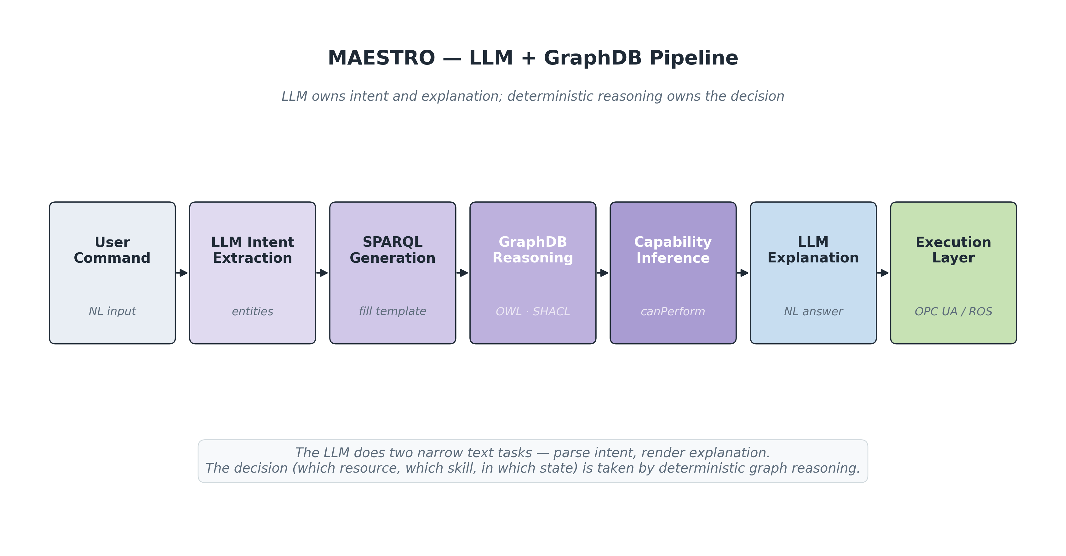
Figure 4 — The LLM + graph-database reasoning pipeline.

6. Standards alignment
MAESTRO does not reinvent existing standards; it federates with them so models stay interoperable and vendor-independent.
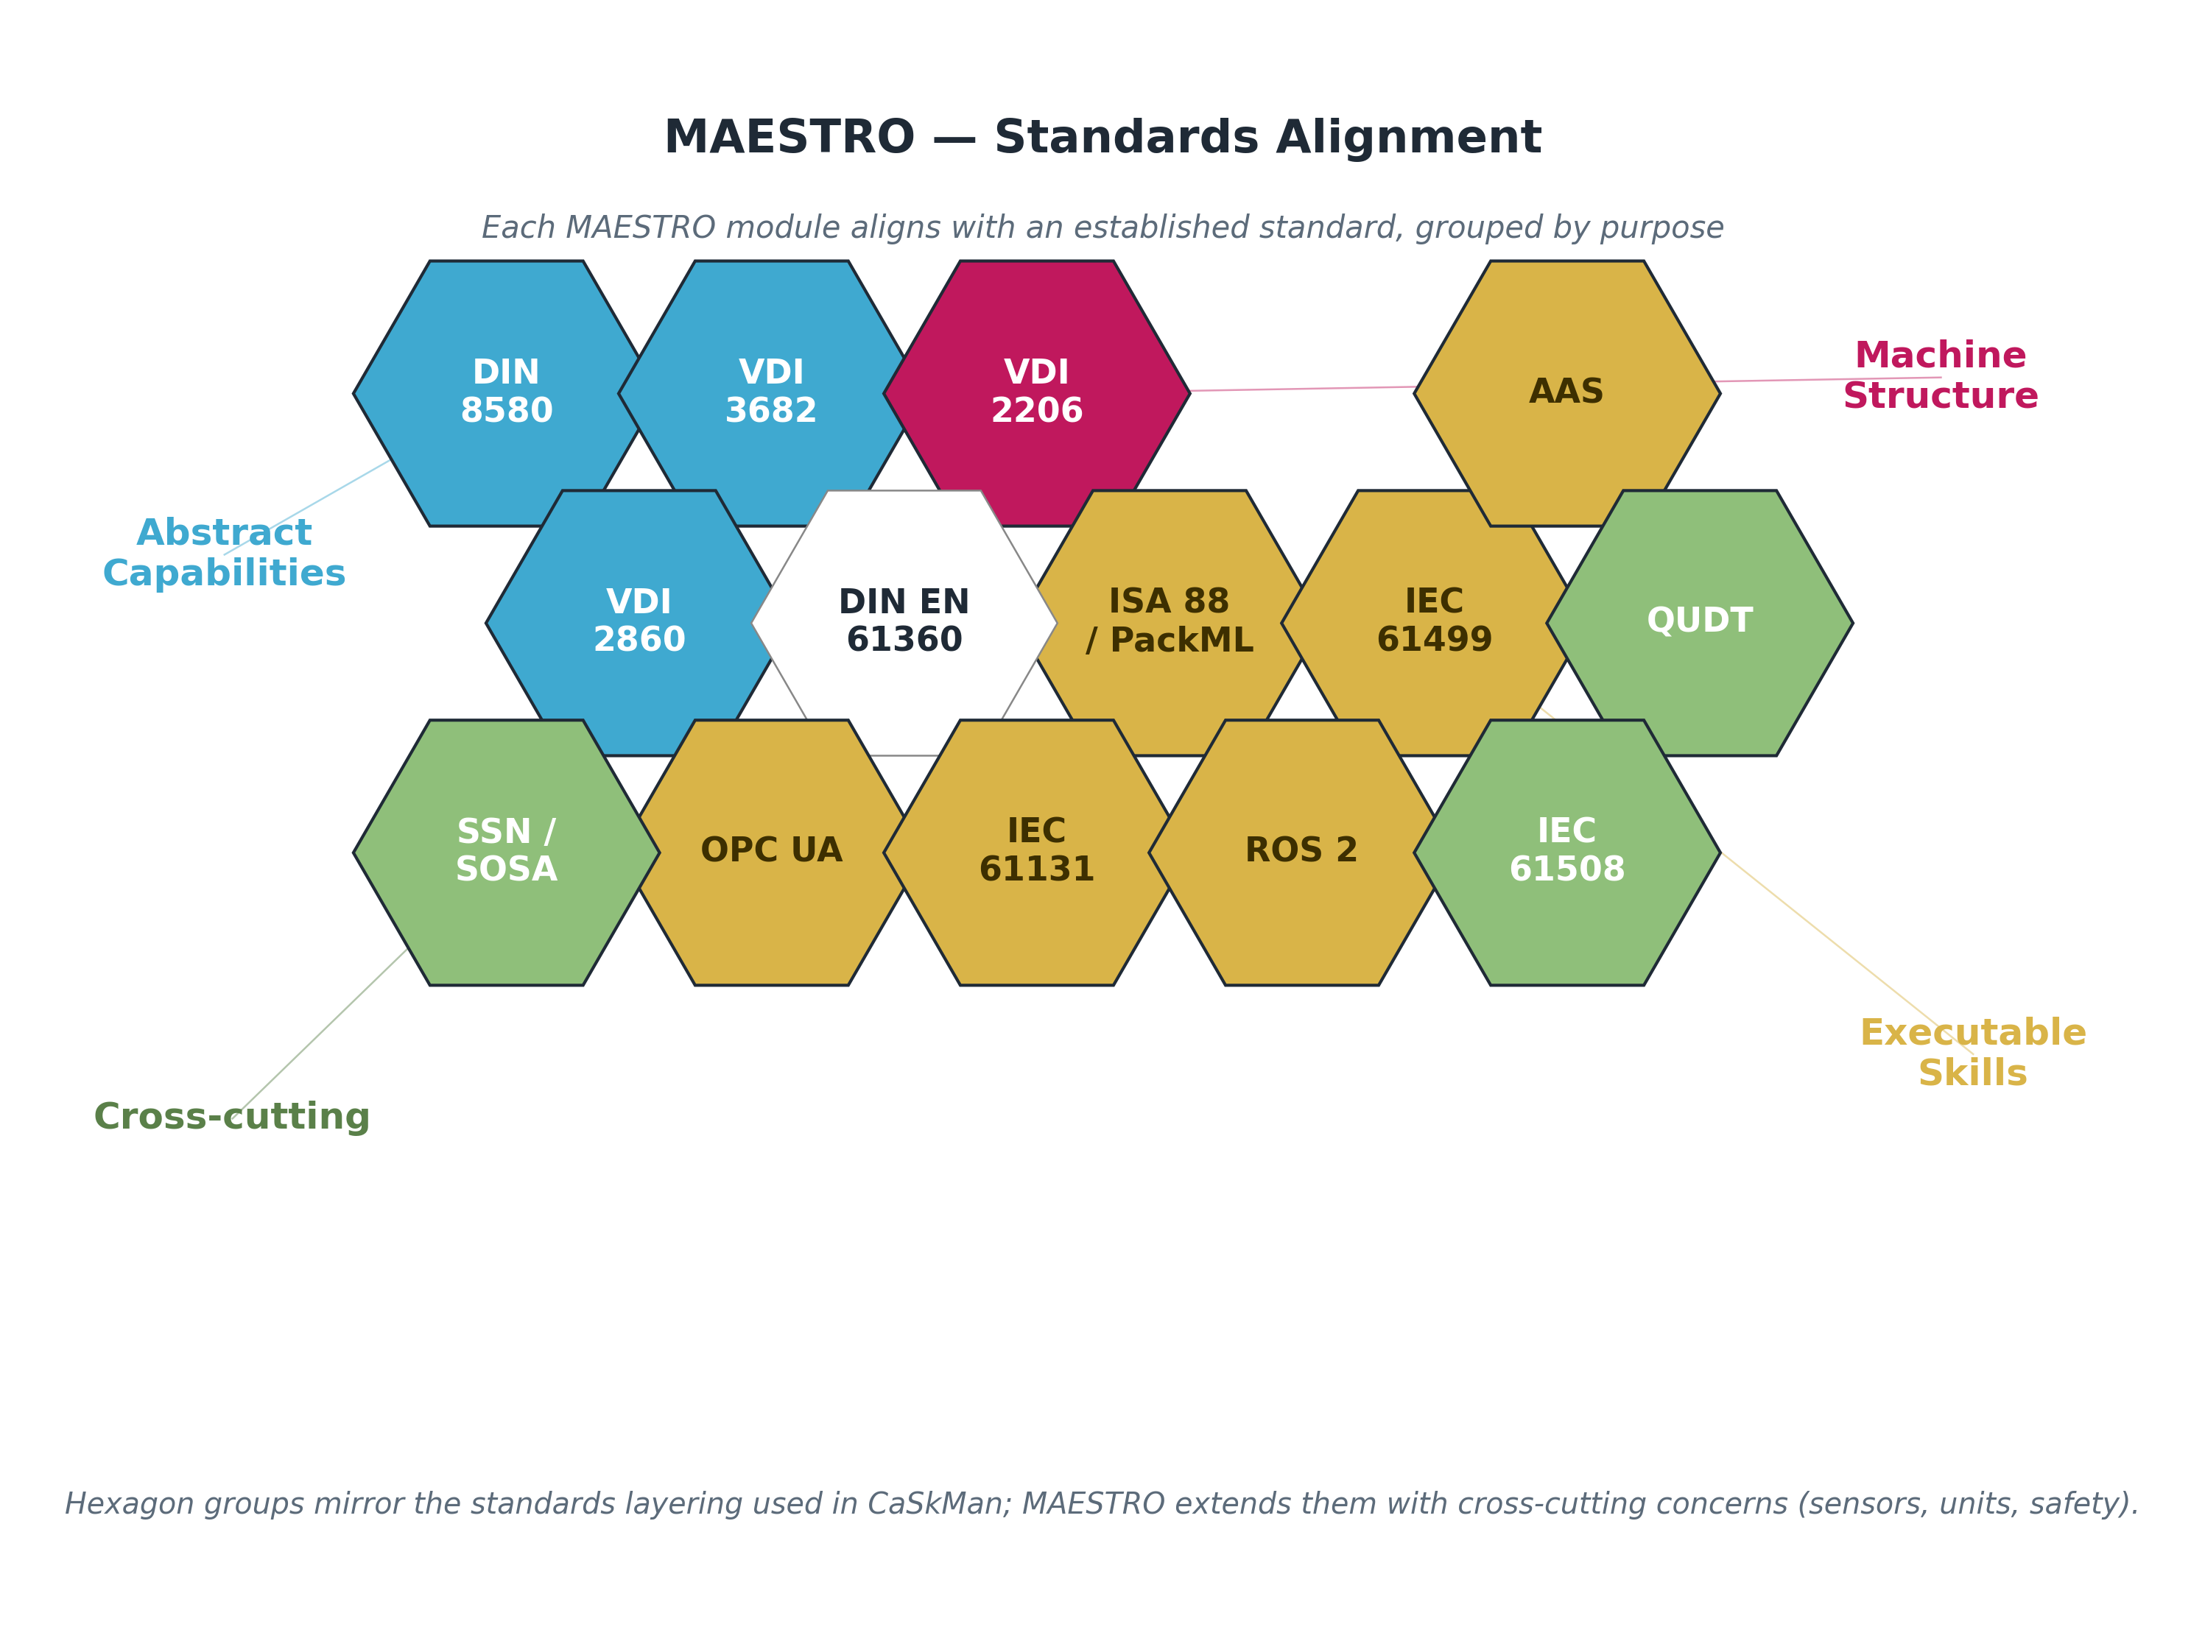
Figure 5 — External standards MAESTRO aligns with.
Standard | Role in MAESTRO | Module(s)
DIN 8580 | Manufacturing process taxonomy | process
VDI 2860 | Handling skill categories | skill
VDI 3682 | Process sequencing | process
IEC 61131-3 | Classic PLC programming model | iec61131
IEC 61499 | Event-driven distributed control | iec61499
OPC UA | Interoperable skill interfaces | opcua
Asset Administration Shell | Digital-twin envelope | aas
ISA-95 | Enterprise / planning hierarchy | planning
PackML | Operational state model | runtime
IEC 61508 / ISO 13849 | Functional safety (SIL / PL) | safety
QUDT | Units and quantities | unit
W3C SOSA / SSN | Sensors and observations | sensor
W3C SKOS | Capability & state concept schemes | capability, runtime

7. Worked example — the Distribution Station
The Festo MPS Distributing Station is modelled end-to-end as the reference example. Its plant topology, skill bridge and reasoning pipeline are all expressed with the same modules described above.
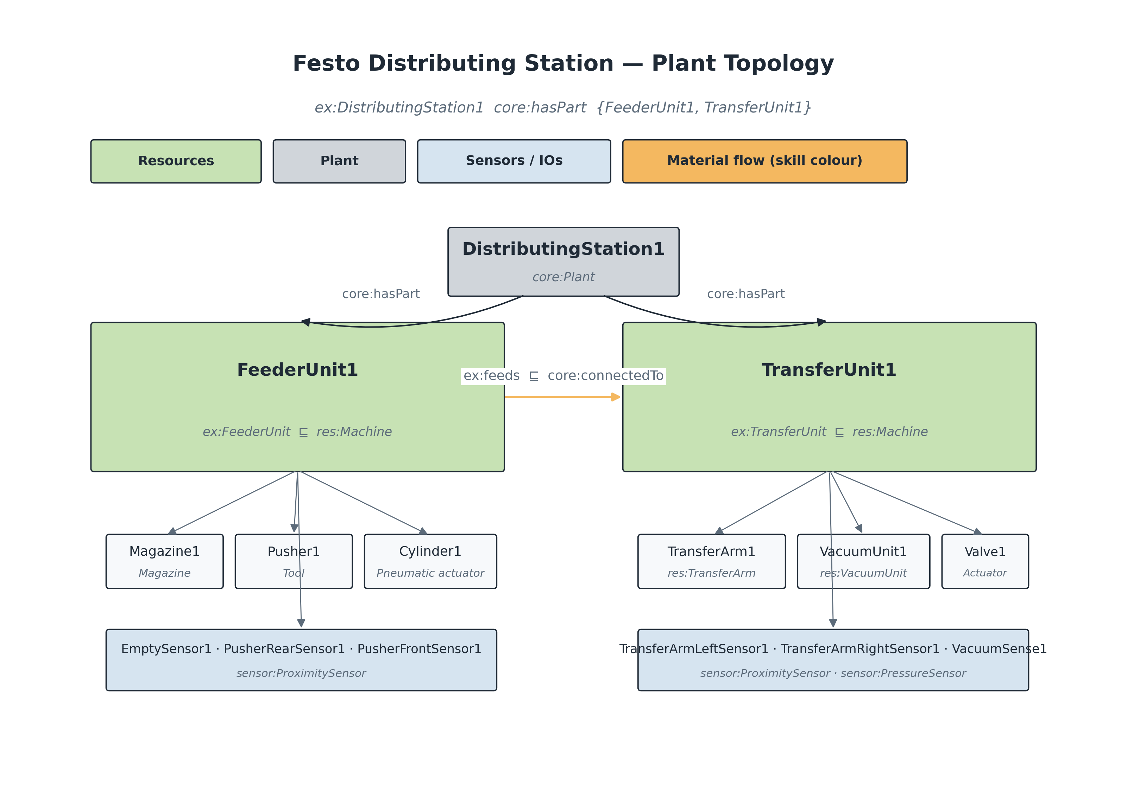
Figure 6 — Distribution Station plant topology.
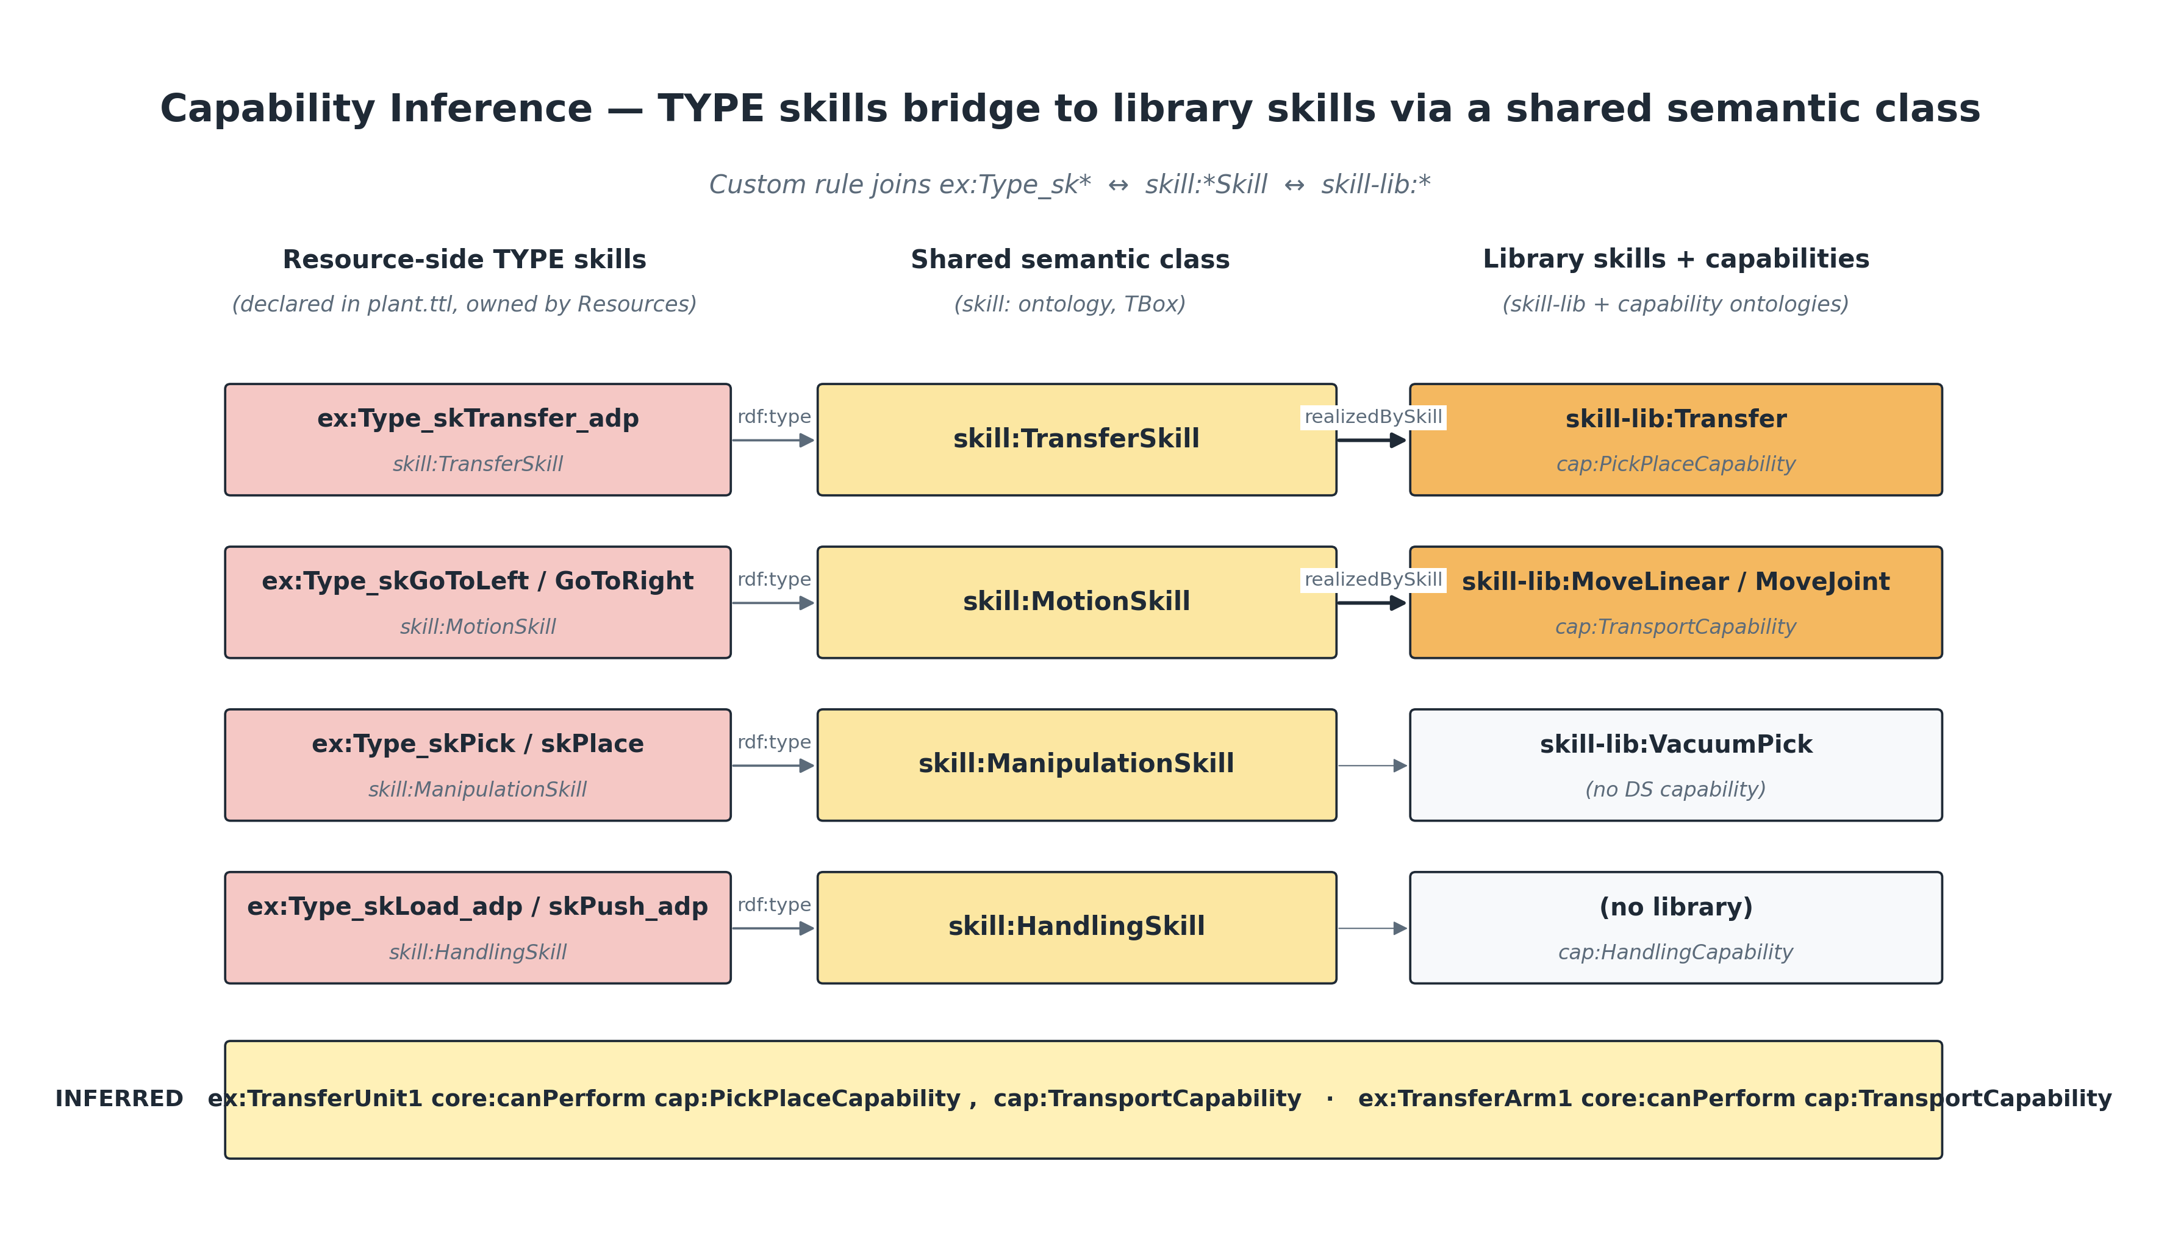
Figure 7 — Bridging resource-side skill types to library skills.
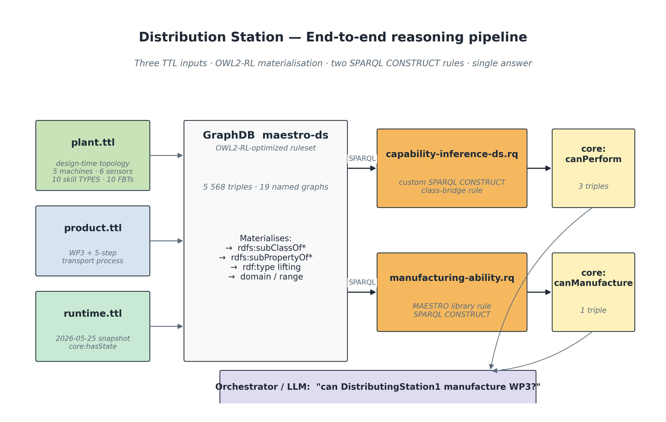
Figure 8 — Distribution Station reasoning pipeline.
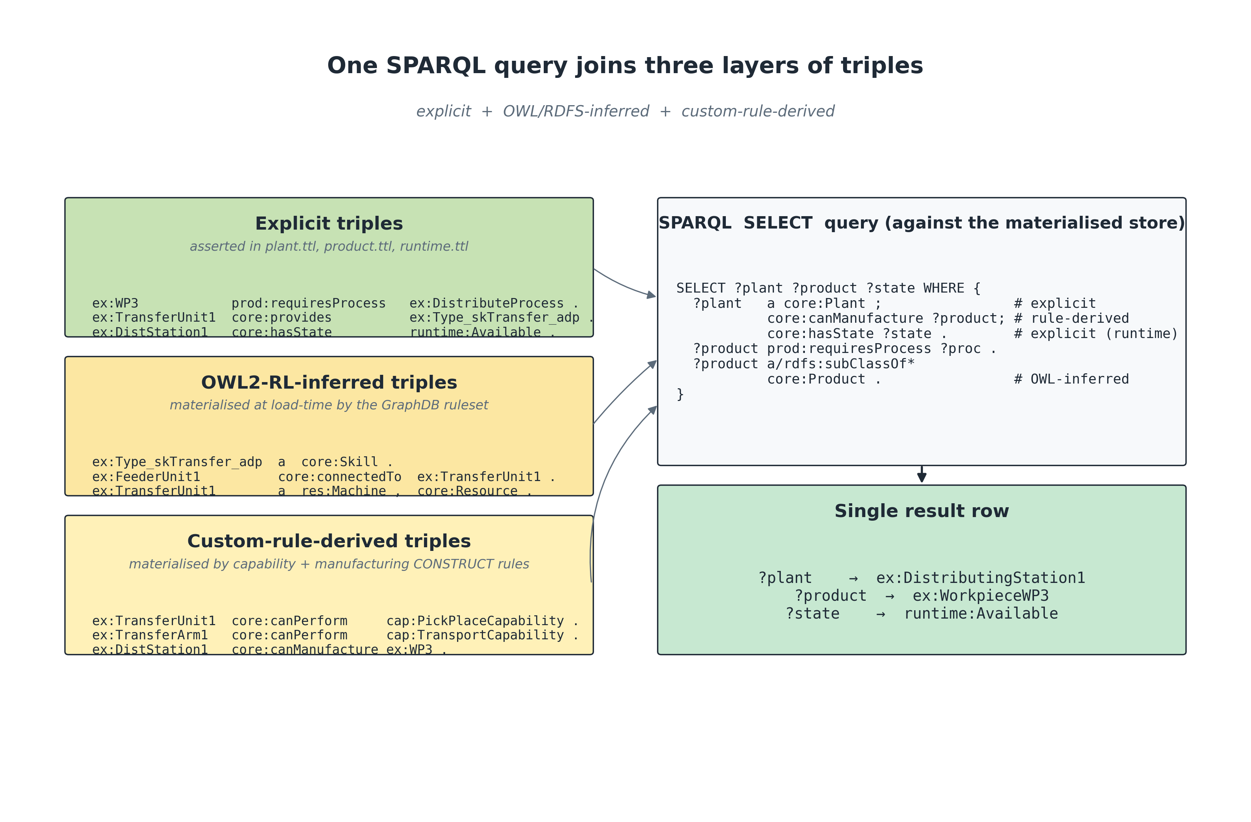
Figure 9 — The three-layer (design / reasoning / runtime) view.
Verified result: ex:DistributingStation1 core:canManufacture ex:WorkpieceWP3
This conclusion is inferred — not asserted — from a live GraphDB session of roughly 5,500 triples using OWL2-RL plus two SPARQL CONSTRUCT rules.

8. Future works

8.1 Validation roadmap (Festo MPS stations)
The framework is being validated against Festo MPS reference stations in three milestones. Milestone numbers (M1/M2/M3) are independent of the code release version.
Milestone | Station | Focus | Query class enabled
M1 (v0.1) | Distributing Station | Base stack: 16 modules, plant + product + runtime; largely complete. | Basic feasibility — canManufacture, canPerform
M2 (v0.2) | Distributing Station | Constant-speed motion sub-classes for timing; safety (SIL) instances. | Time-aware — cycle-time, scheduling, SIL filtering
M3 (v0.3) | Drilling Station | Second station for portability; AAS digital twin; machine operations. | Gap identification — find missing capabilities
Each milestone closes with new example files, new SPARQL queries, and a git tag (v0.1-roadmap-m1 … v0.3-roadmap-m3). Open questions for review include whether security belongs in M2 or M3, whether the Drilling Station is a physical or model-only target, and confirming the M1/M2/M3 naming alongside semantic version tags.

8.2 Industry 5.0 extensions
MAESTRO is designed so the next generation of manufacturing concepts can be added as new modules rather than patches. The current stack already accommodates:
Extension | How MAESTRO supports it today
Autonomous factories | The machine-readable reasoning chain lets a planner traverse it without human guidance.
AI manufacturing agents | Agents talk to SPARQL, not directly to PLCs; intent extraction is separated from deterministic reasoning.
Self-reconfiguration | Skills are not bound to resources; swapping an end-effector re-fires capability inference.
Manufacturing-as-a-Service | OPC UA SkillInterfaces expose skills network-wide for remote invocation.
Semantic digital twins | aas + runtime cover the AAS envelope plus live behaviour.
Predictive maintenance | maintenance carries RUL, MTBF and a dedicated Predictive action class.
Energy-aware manufacturing | energy exposes power, energy and carbon intensity by source.
Human-robot collaboration | Cobot + safety (SIL/PL) describe the safety envelope; runtime states make it explicit.

9. Glossary — namespace prefixes
Prefix | Namespace IRI | Module
core: | https://w3id.org/maestro/core# | manufacturing-core.ttl
res: | https://w3id.org/maestro/resource# | resource.ttl
motion: | https://w3id.org/maestro/motion# | motion.ttl
skill: | https://w3id.org/maestro/skill# | skill.ttl
cap: | https://w3id.org/maestro/capability# | capability.ttl
proc: | https://w3id.org/maestro/process# | process.ttl
prod: | https://w3id.org/maestro/product# | product.ttl
plc: | https://w3id.org/maestro/iec61131# | iec61131.ttl
iec61499: | https://w3id.org/maestro/iec61499# | iec61499.ttl
ros: | https://w3id.org/maestro/ros# | ros.ttl
opcua: | https://w3id.org/maestro/opcua# | opcua.ttl
aas: | https://w3id.org/maestro/aas# | aas.ttl
runtime: | https://w3id.org/maestro/runtime# | runtime.ttl
state: | https://w3id.org/maestro/state# | state.ttl
sensor: | https://w3id.org/maestro/sensor# | sensor.ttl
unit: | https://w3id.org/maestro/unit# | unit.ttl
com: | https://w3id.org/maestro/communication# | communication.ttl
safety: | https://w3id.org/maestro/safety# | safety.ttl
qa: | https://w3id.org/maestro/quality# | quality.ttl
maint: | https://w3id.org/maestro/maintenance# | maintenance.ttl
energy: | https://w3id.org/maestro/energy# | energy.ttl
reas: | https://w3id.org/maestro/reasoning# | reasoning.ttl
plan: | https://w3id.org/maestro/planning# | planning.ttl
skill-lib: | https://w3id.org/maestro/skill-lib# | skill-lib.ttl
motion-lib: | https://w3id.org/maestro/motion-lib# | motion-lib.ttl

