Assignment 13.4
P.Induvardhan
2303A52030
Batch: 44
Task 1: Refactoring Data Transformation Logic
Code:
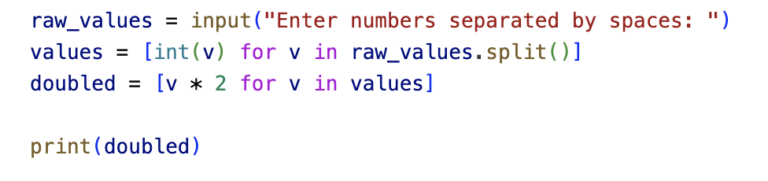
Input:

Output:


Task 2: Improving Text Processing Code Readability
Code:
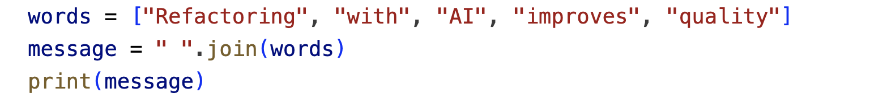

Output:

Task 3: Safer access to Configuration Data
Code:
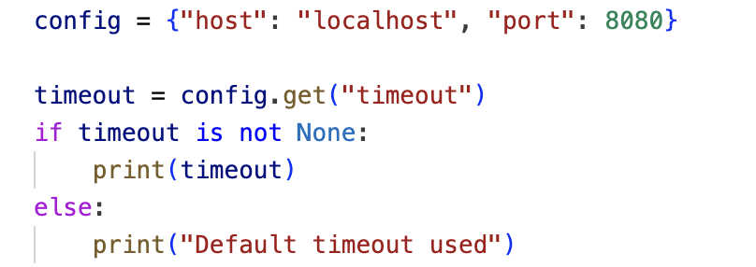

Output:

Task 4: Refactoring Conditional Logic for Scalability
Code:
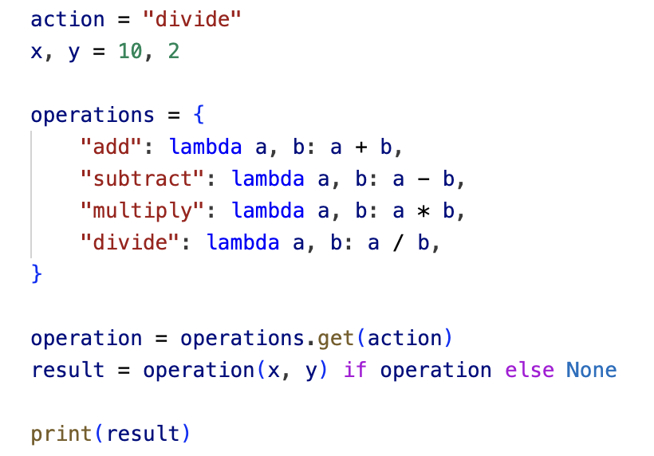

Output:


Task 5: Simplifying Search Logic in Collections
Code:
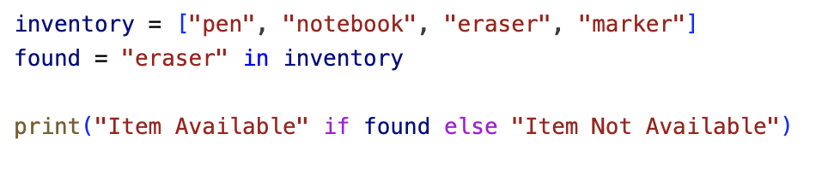

Output:


