ASSIGNMENT- 11.1
P. Induvardhan Reddy
2303A52030
Batch: 44

Task Description #1 – Stack Implementation
Task: Use AI to generate a Stack class with push, pop, peek, and is_empty Methods
Code:
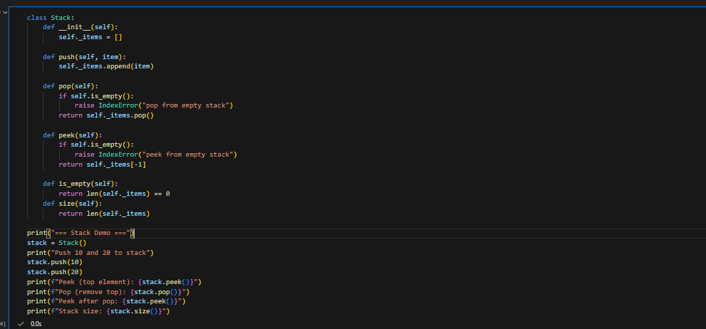

Output:
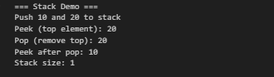
Task Description #2 – Queue Implementation
Task: Use AI to implement a Queue using Python lists.
Code:
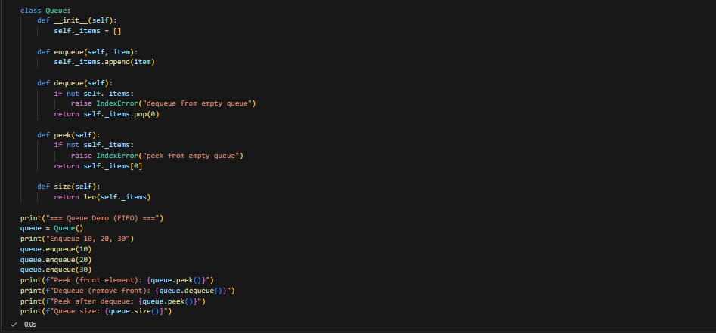
Output:
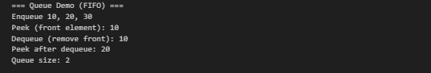
Task 3 – Linked List
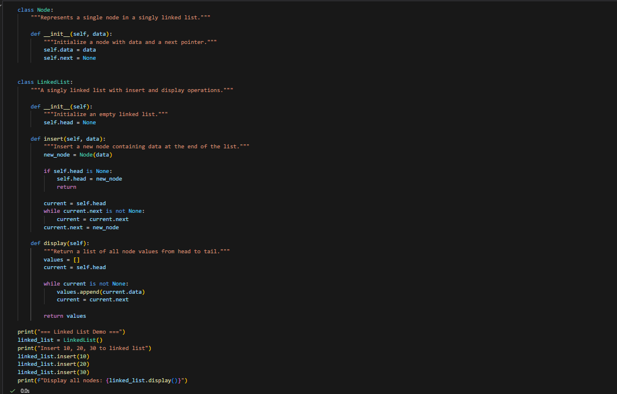
Output:
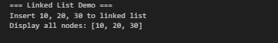
Task 4 – Binary Search Tree (BST)
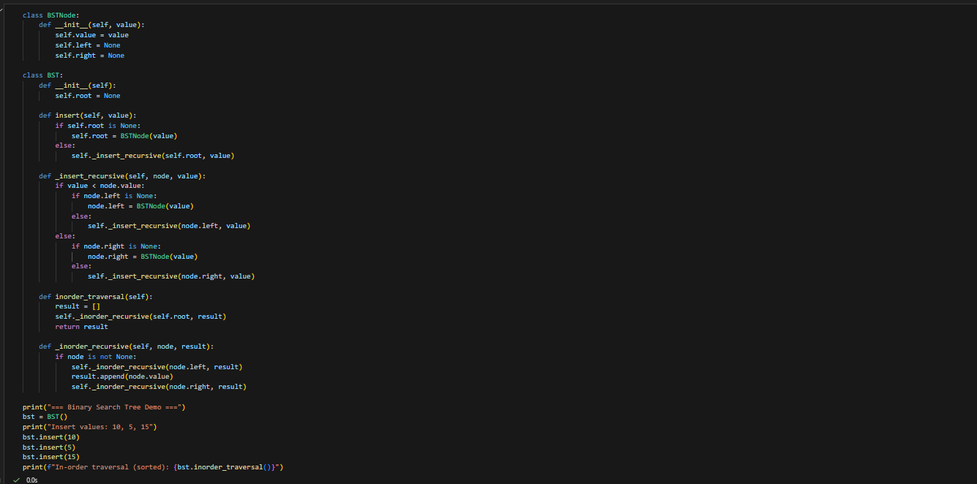
Output:
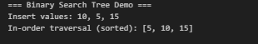

Task 5 – Hash Table
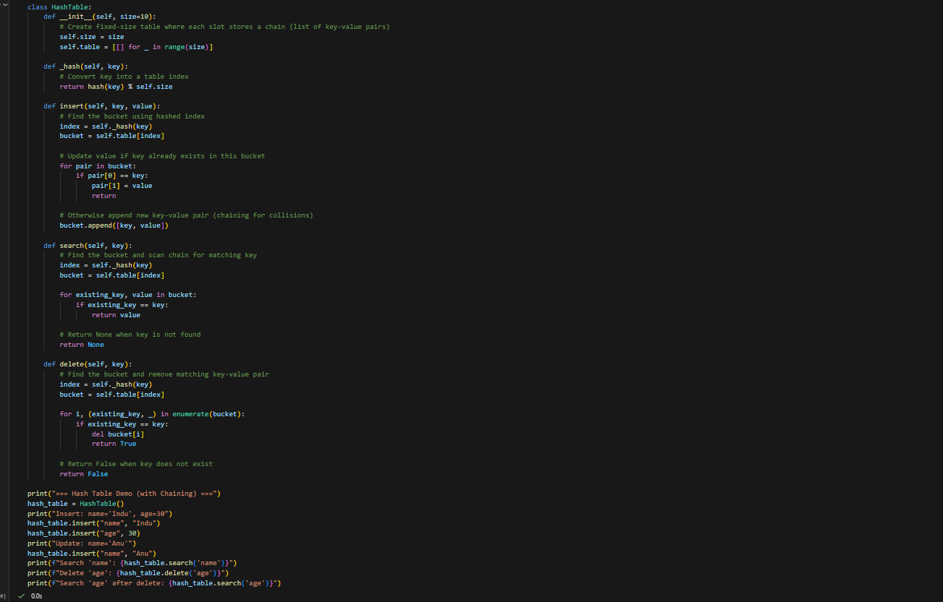
Output:
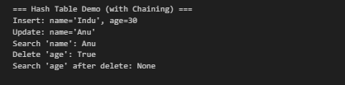

Task 6 – Graph Representation
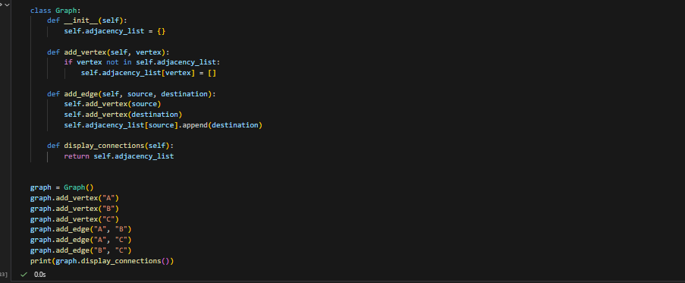
Output:
Task 7 – Priority Queue
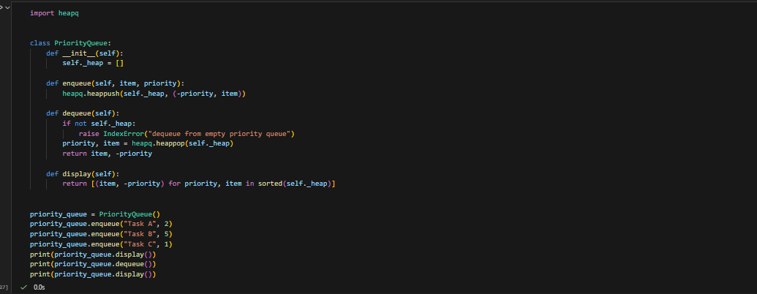
Output:
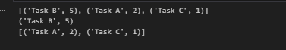

Task 8 – Deque
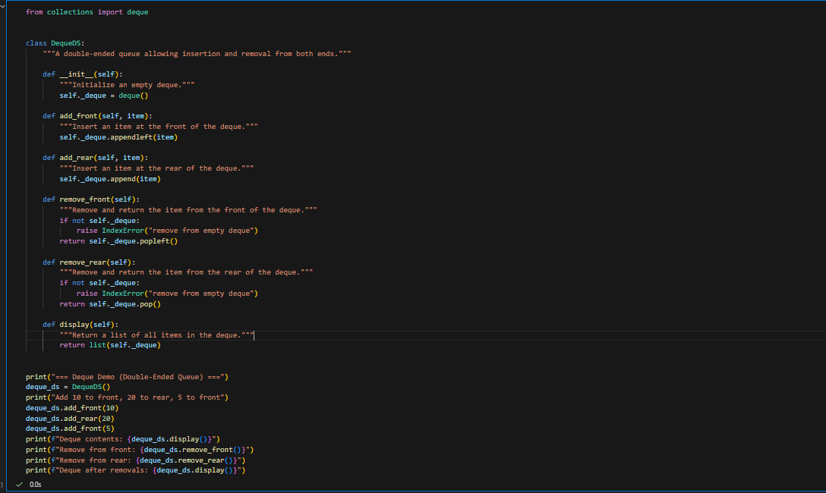
Output:
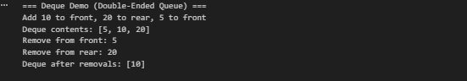
Task 9: Real-Time Application Challenge – Choose the
Right Data Structure
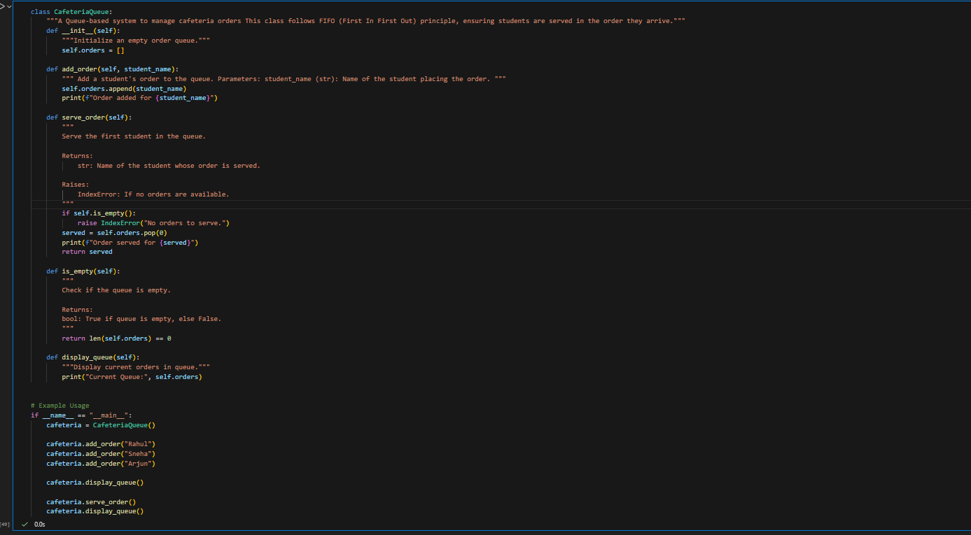
Output:
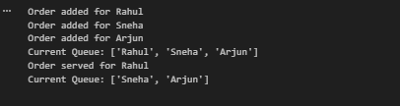

Task 10: Smart E-Commerce Platform – Data Structure
Challenge
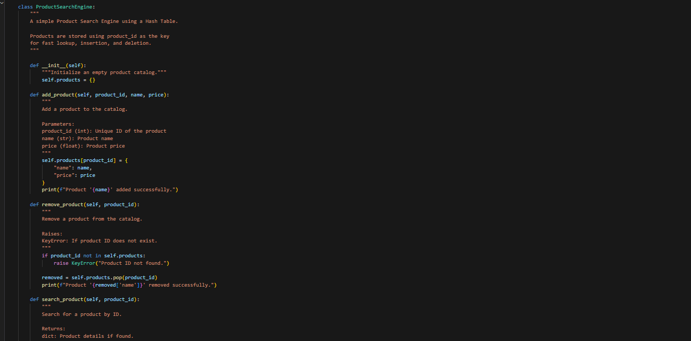
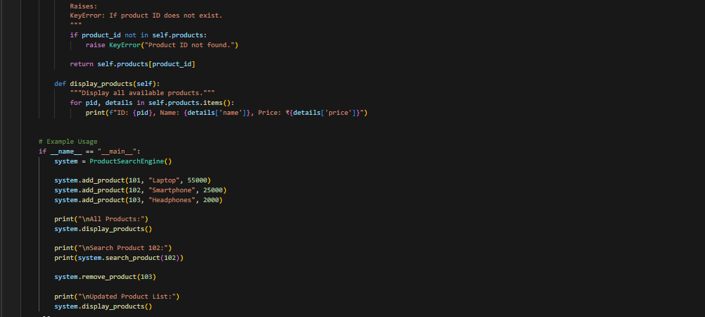
Output:
