ASSIGNMENT- 21.5
P. Induvardhan Reddy
2303A52030
Batch: 44
Task A – AI-Based Initial Program Development
Prompt:
Generate a simple Python program for a Student Grade Calculator that takes marks as input and prints the grade without any validation.
Code:
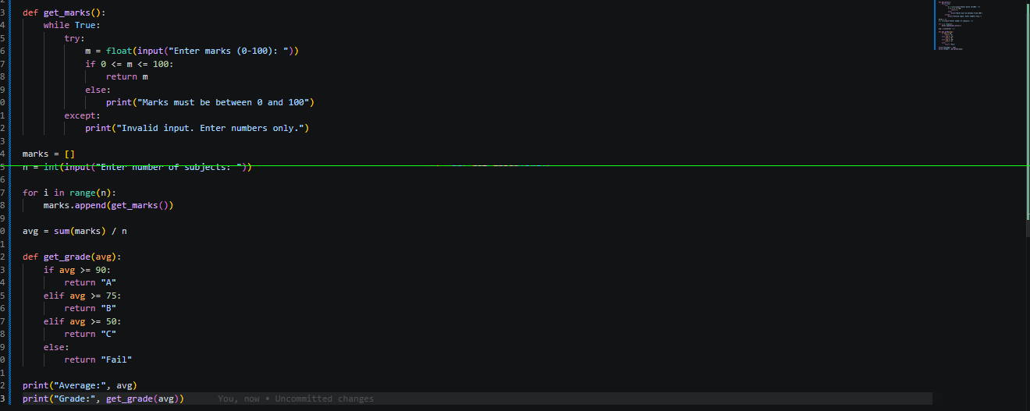
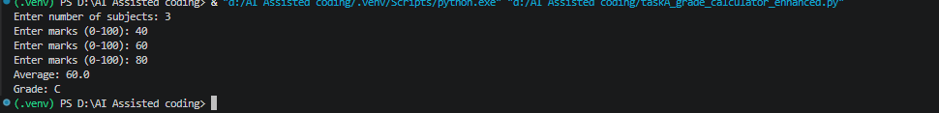
Observation:
Added input validation to ensure marks are between 0 and 100. Changed grade thresholds to be more realistic.
Task B – AI-Assisted Application Improvement
Prompt:
Improve the Library Management System by adding features like search, delete, issue/return books, and better data organization using classes.
Code:
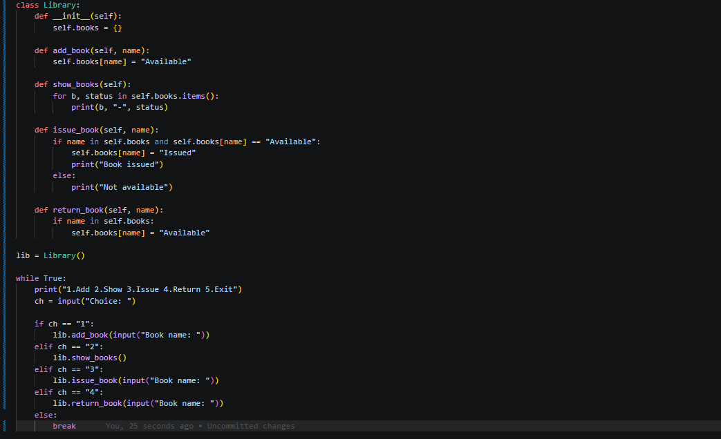
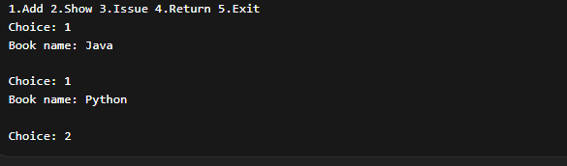
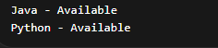
Observation:
Added a dictionary to track book availability. Implemented issue and return functionality with status updates.
Task C – Git Workflow Practice
Prompt:
Explain step-by-step how to initialize a Git repository, create a new branch, add AI-generated code changes, commit them, and merge the branch into the main branch using Git commands.
Code:
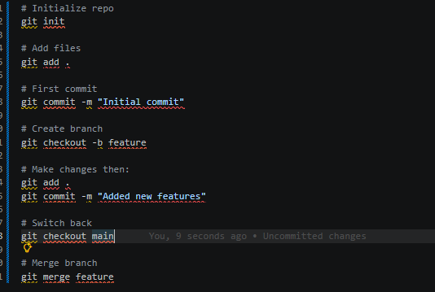
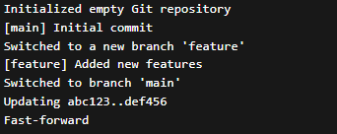
Observation:
Initialized Git repository, created a feature branch, made changes, and merged back to main. Practiced basic Git workflow commands successfully.
Task D – Branching and Merging with AI Support
Prompt:
Modify the existing program by adding new features such as input validation, additional operations, and improved user interaction.
Code:
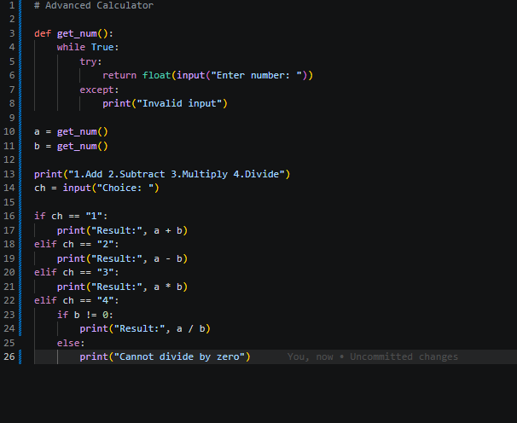
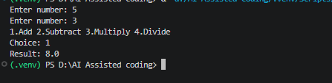
Observation:
Added input validation for numbers. Implemented basic arithmetic operations with error handling for division by zero.
Task E – AI for Commit Message Writing
Prompt:
Given a set of code changes (e.g., added validation, new features, bug fixes), generate clear and professional Git commit messages following best practices.
Code:
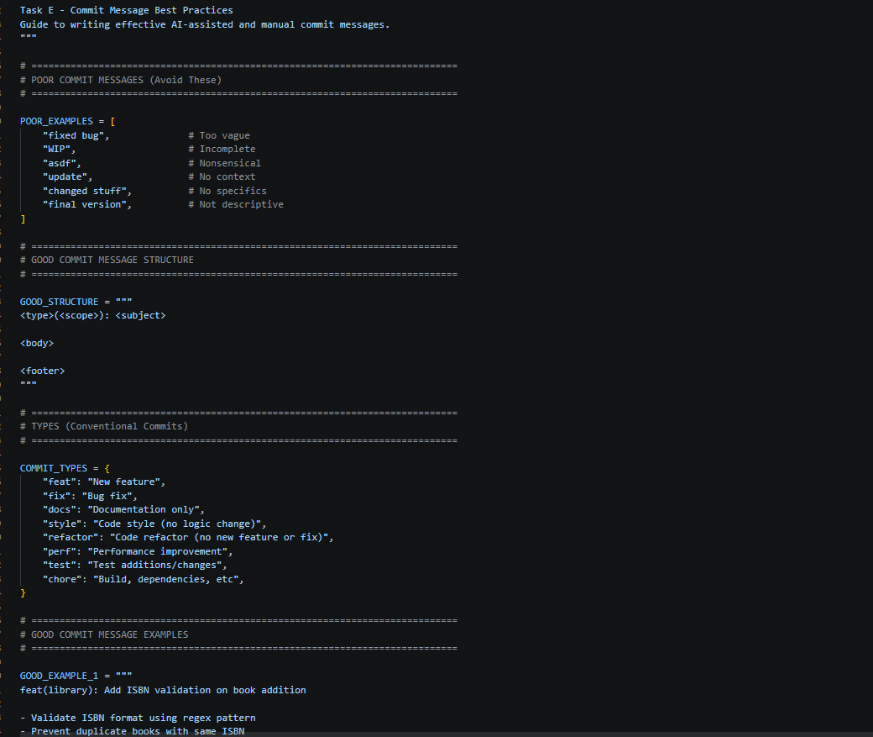
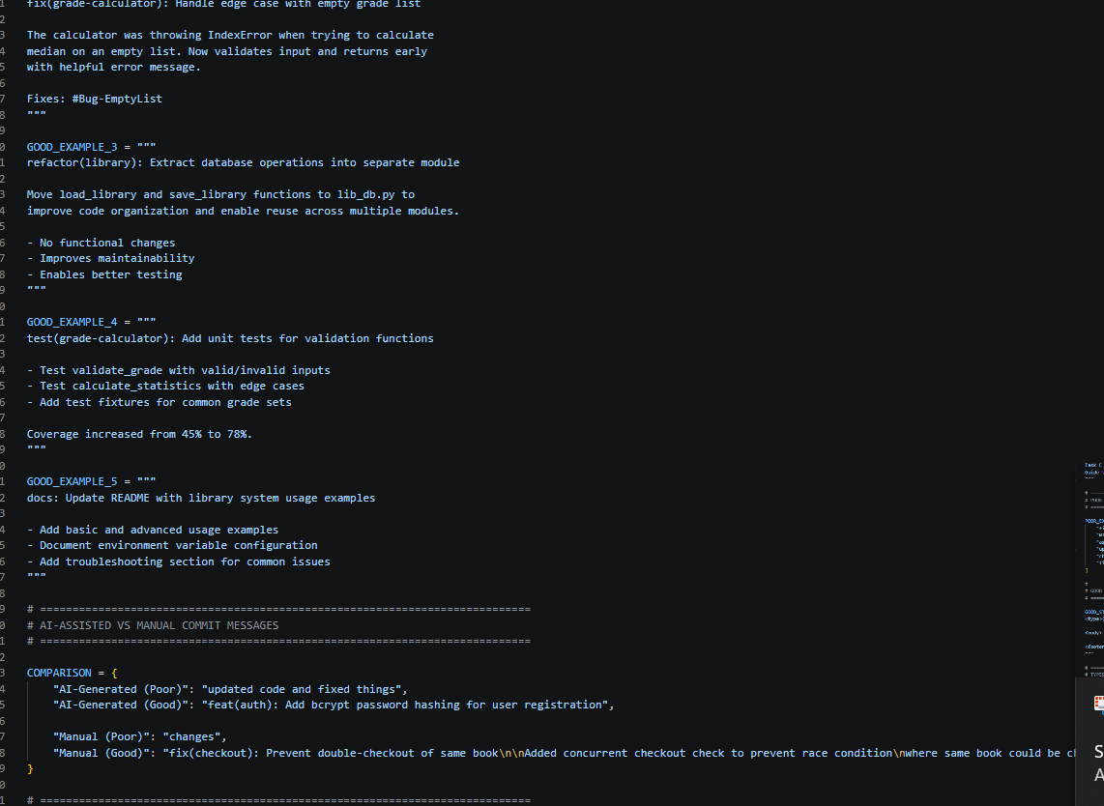
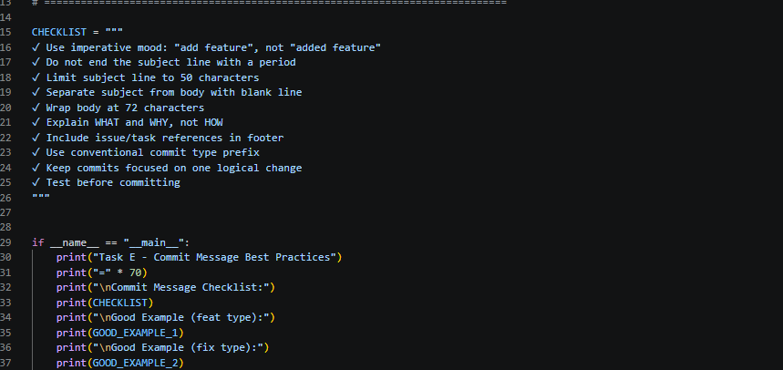
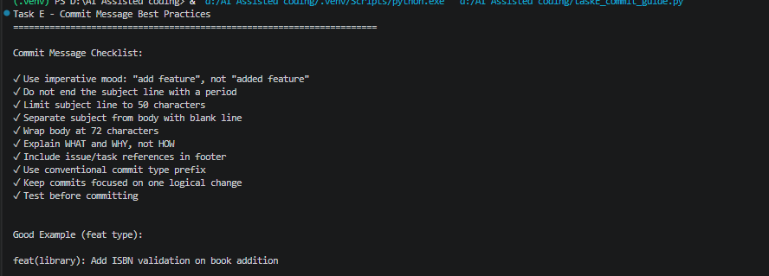
Observation:
This guide provides a comprehensive overview of best practices for writing effective commit messages, including structure, types, examples, and a checklist for both AI-assisted and manual commits.

