Assignment 17.1
P. Induvardhan Reddy
2303A52030
Batch: 44
Task 1: Customer Data Cleaning
Prompt:
Create a pandas script to clean customer data: fill missing values (age, income, city), remove duplicates, lowercase city names, and encode gender and city.
Code:
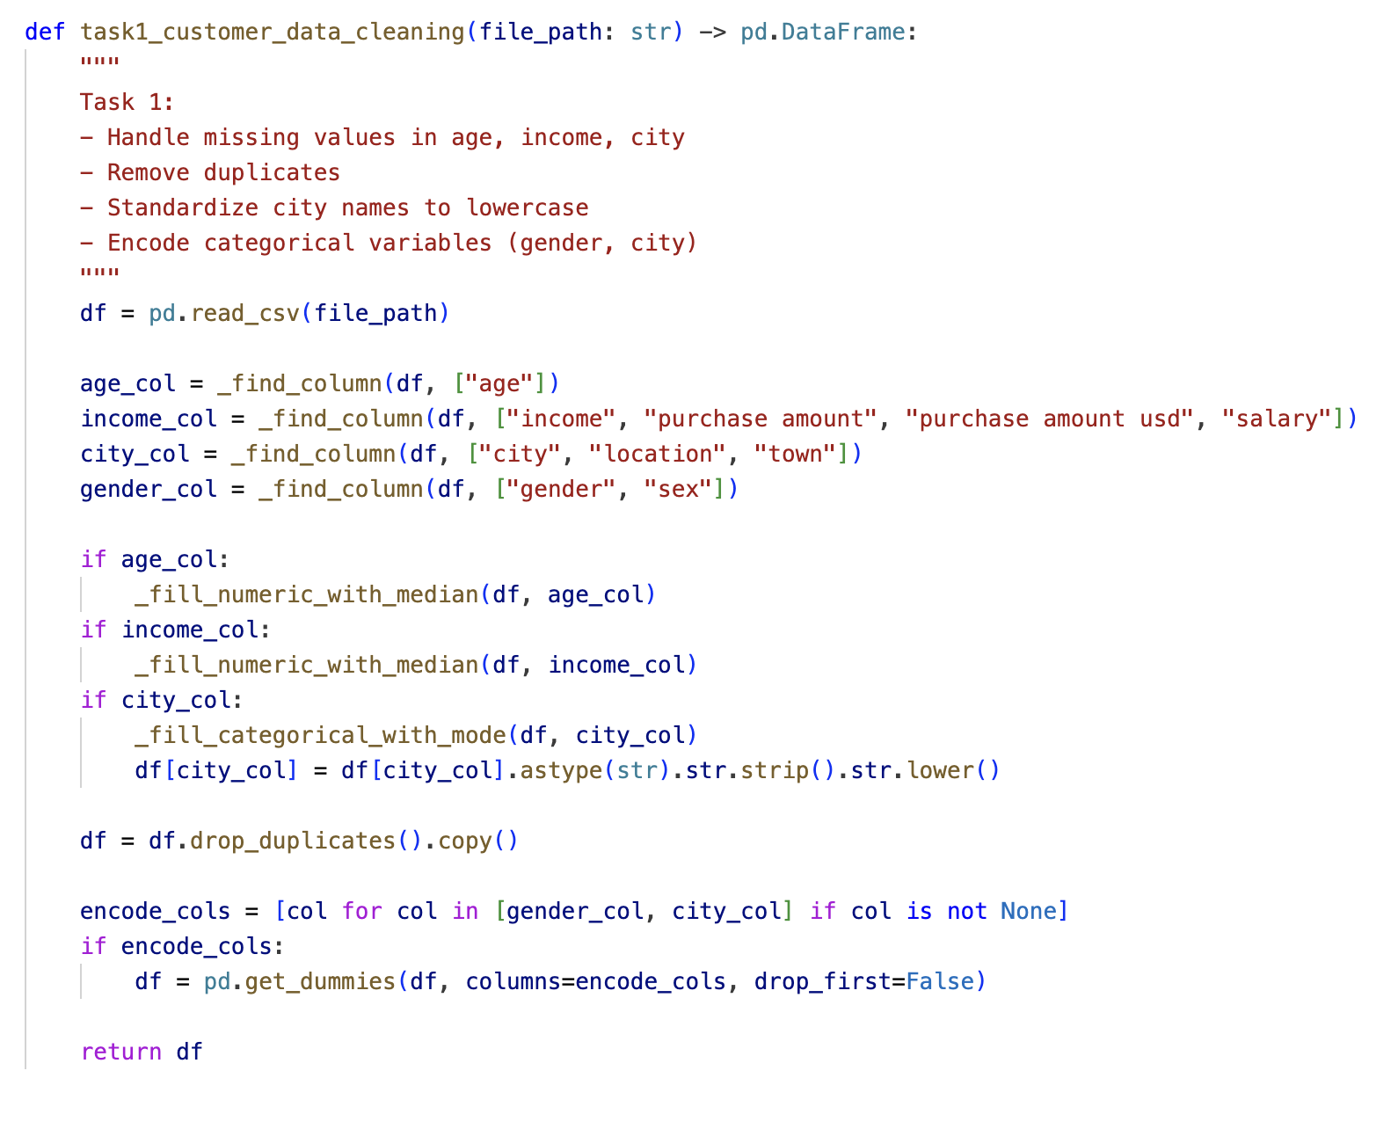
Output:
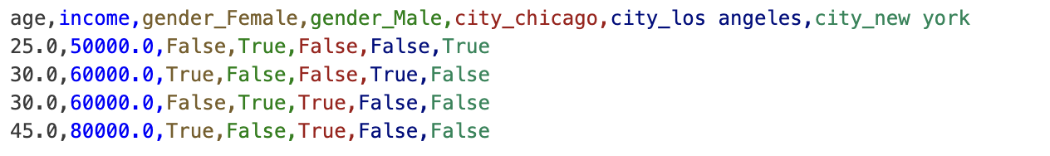
Observation:
Missing values were filled (age and income became numeric values, city gaps were filled), duplicate rows were removed, and city/gender were encoded into separate indicator columns.
Observation: the output is analysis-ready with no raw text categories left for gender/city.
Task 2: Sales Data Preprocessing
Prompt:
Create a pandas script to preprocess sales data: convert dates, extract month/year/day, normalize sales, and remove outliers.
Code:
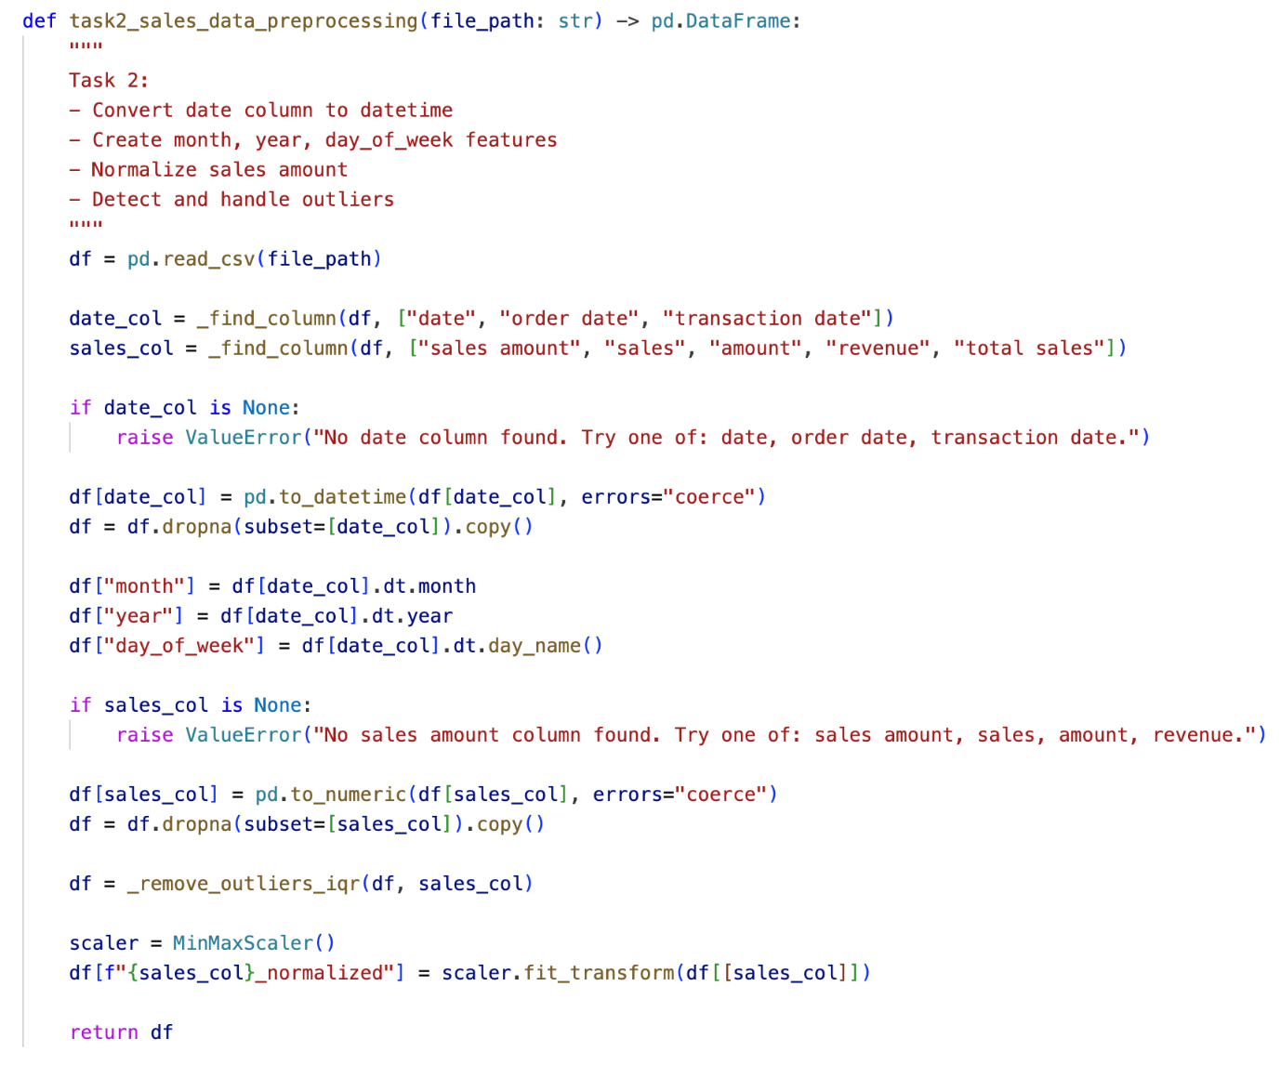
Output:
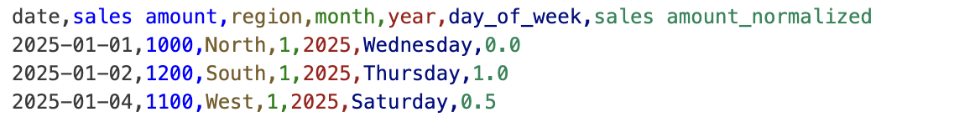
Observation:
Date values were converted and expanded into month, year, and day of week, invalid dates were dropped, extreme sales outliers were removed, and sales were min-max normalized.
Observation: normalization worked as expected (values scaled between 0 and 1), and the high outlier row was excluded.

Task 3: Healthcare Data Preparation
Prompt:
Create a pandas and sklearn script to preprocess healthcare data: fill missing values, encode categories, scale features, and split into train/test sets.
Code: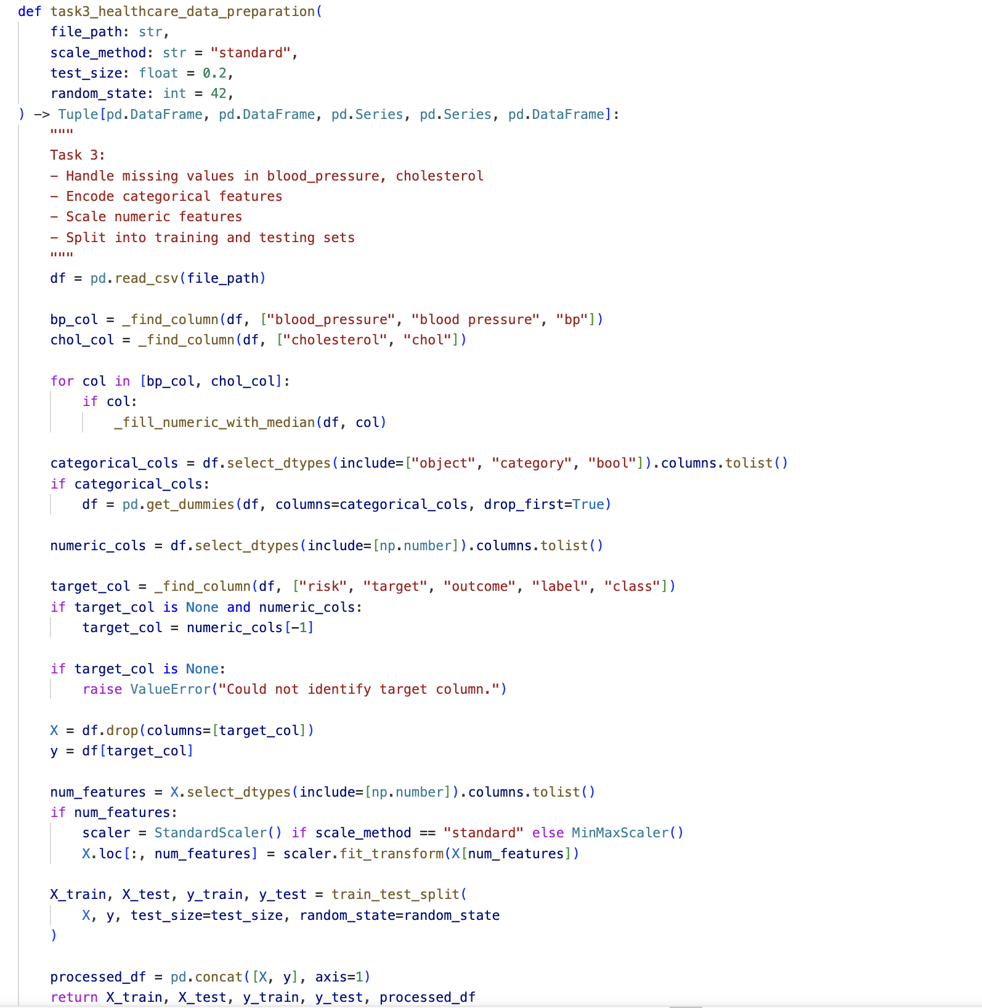

Output:
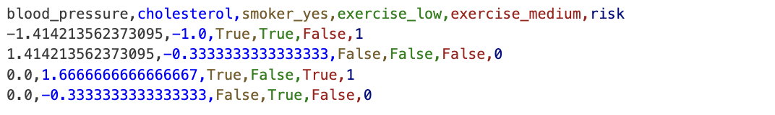

Observation:
Missing blood pressure and cholesterol values were imputed, categorical variables were encoded, and numeric features were scaled (standard scaling).
Observation: scaled features are centred and comparable in magnitude, making the dataset suitable for ML training/testing workflows.

Task 4: Employee Salary Data Preprocessing
Prompt:
Create a pandas and sklearn script to clean salary data: handle missing values, remove outliers, lowercase department names, and encode department and location.
Code:
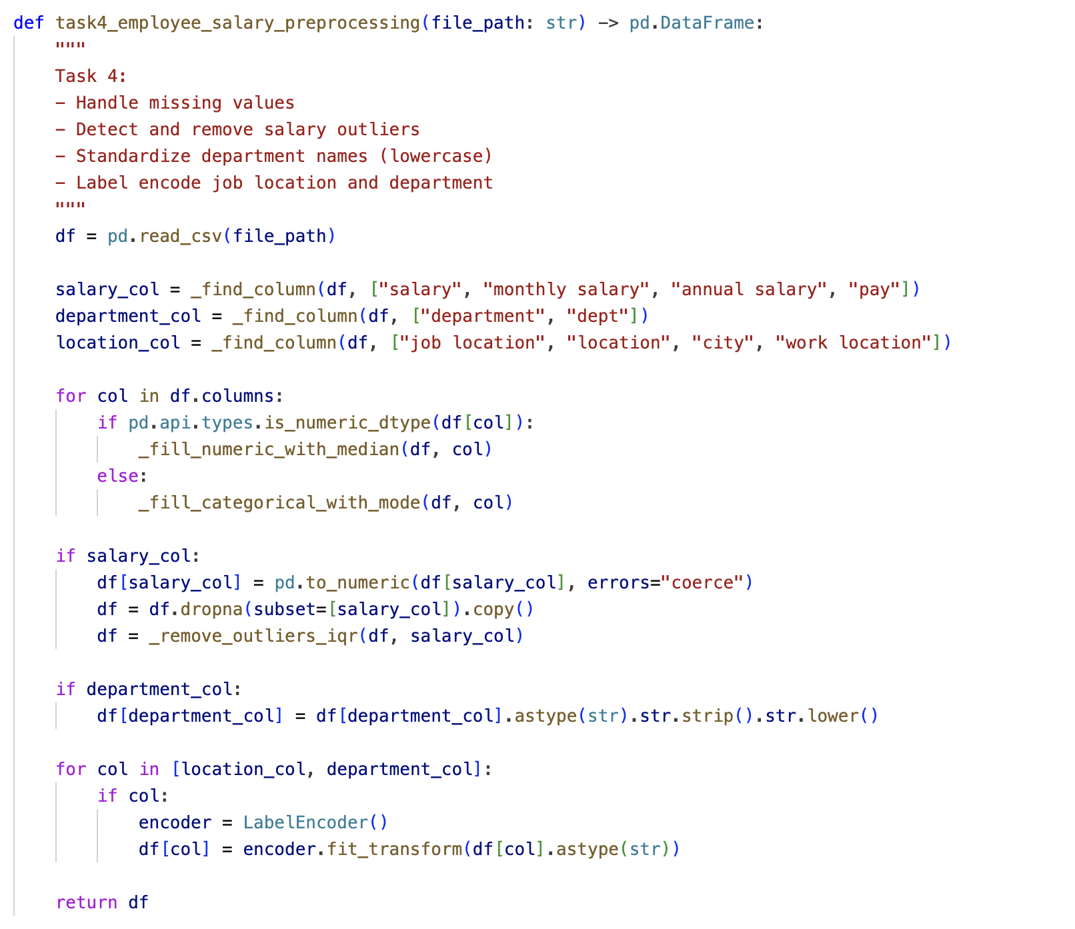

Output:
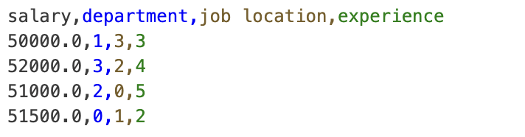

Observation:
Missing values were handled, salary outliers were removed, department text was standardized to lowercase before encoding, and department/location were label-encoded.
Observation: the extreme salary value was removed, and categorical HR fields were converted to numeric format for analytics models.

