Assignment 19.1
K. Shiva Teja
2303A52480
Batch: 44
Task 1: Python to Java Conversion
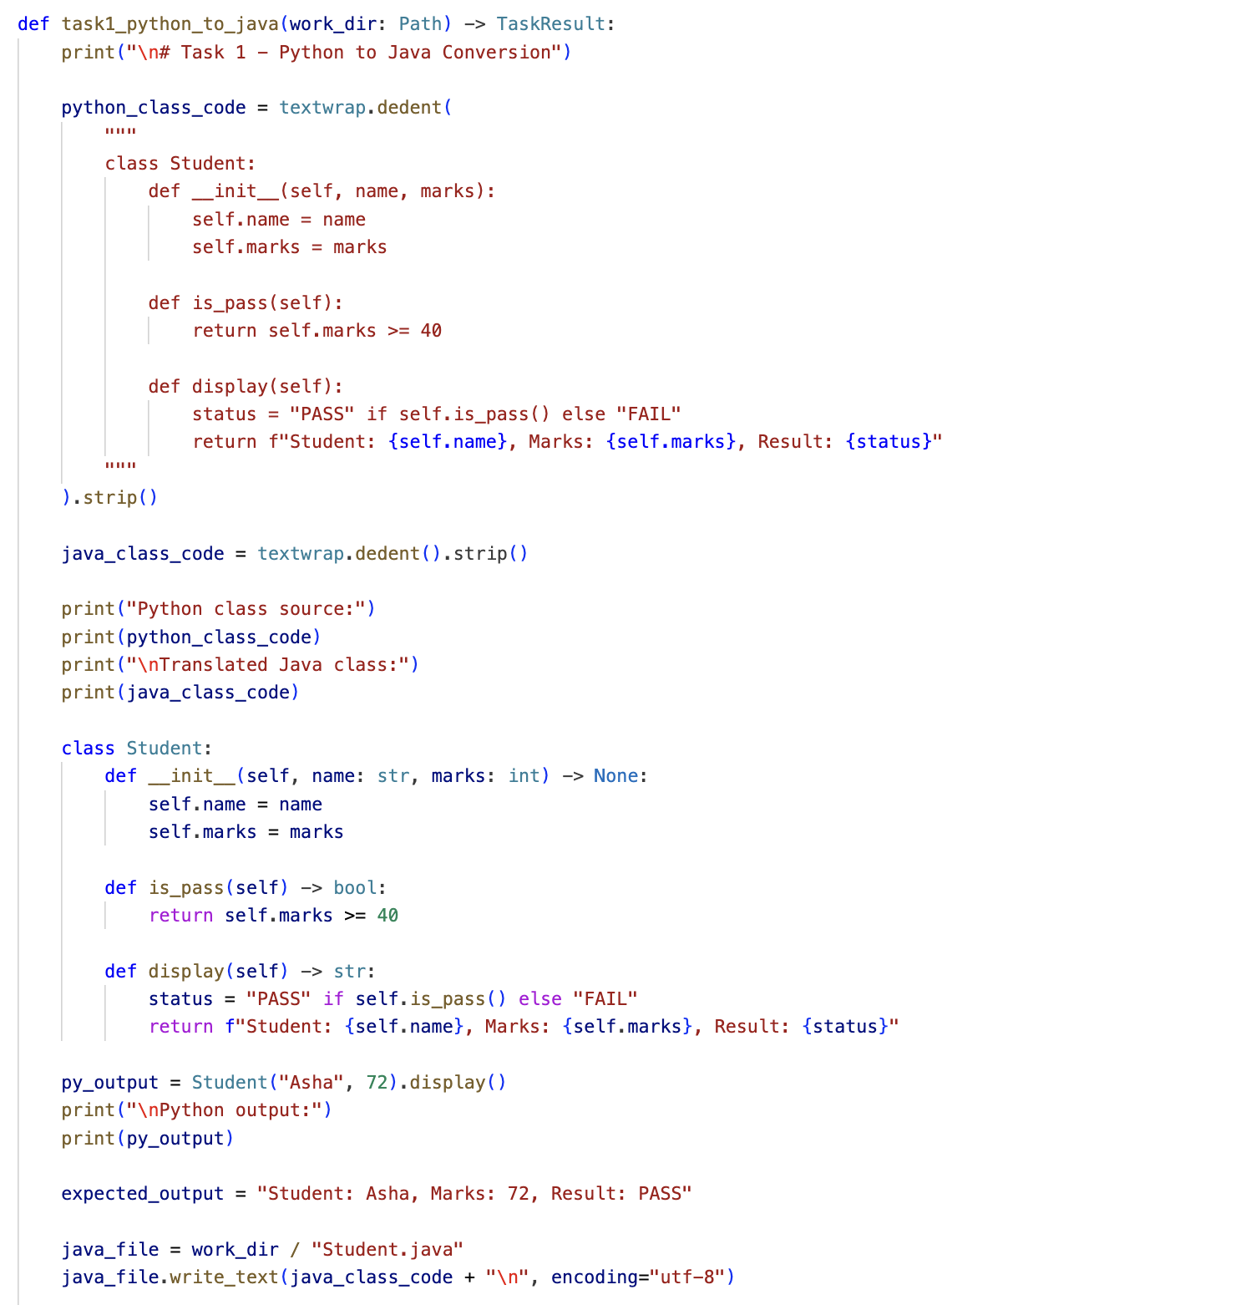
Output:

Observation:
- Task 1 - Python to Java Conversion
The translated Java class preserves class structure, attributes, constructor, and method behaviour from Python. Output logic is equivalent, and expected result is correct. Full Java runtime verification is pending on your machine due to missing Java installation.

Task 2: C++ to Python Function Conversion
Code:
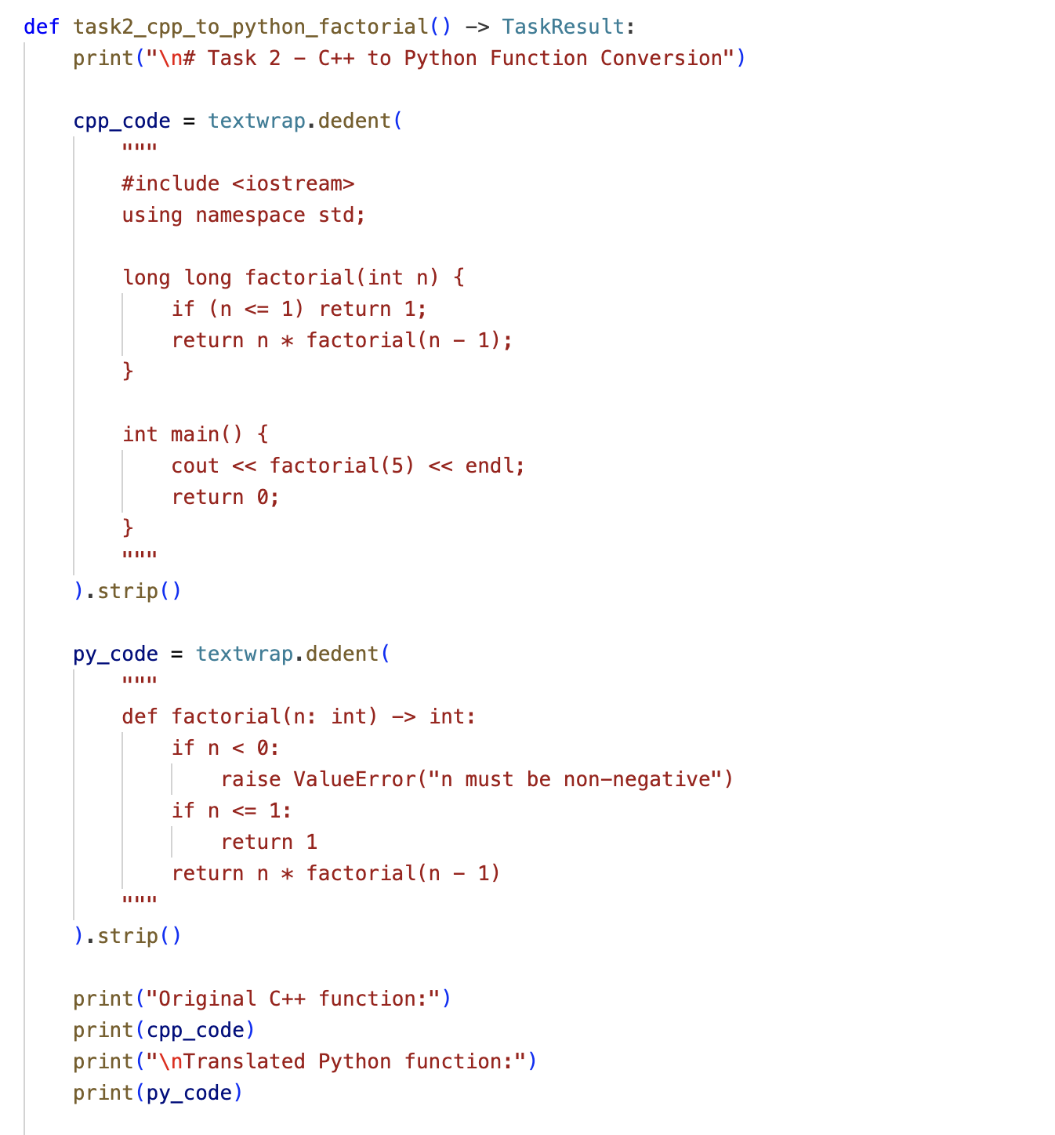

Output:
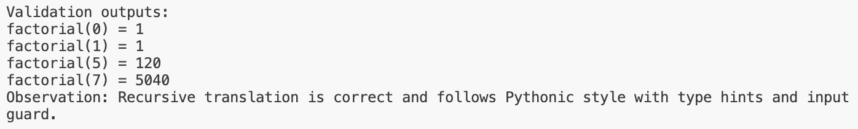
Observation:
The recursive factorial translation is functionally correct and follows Python conventions (type hints, clear base case, input validation for negatives). Sample tests confirm correct outputs.

Task 3: SQL to Pandas Query
Code:
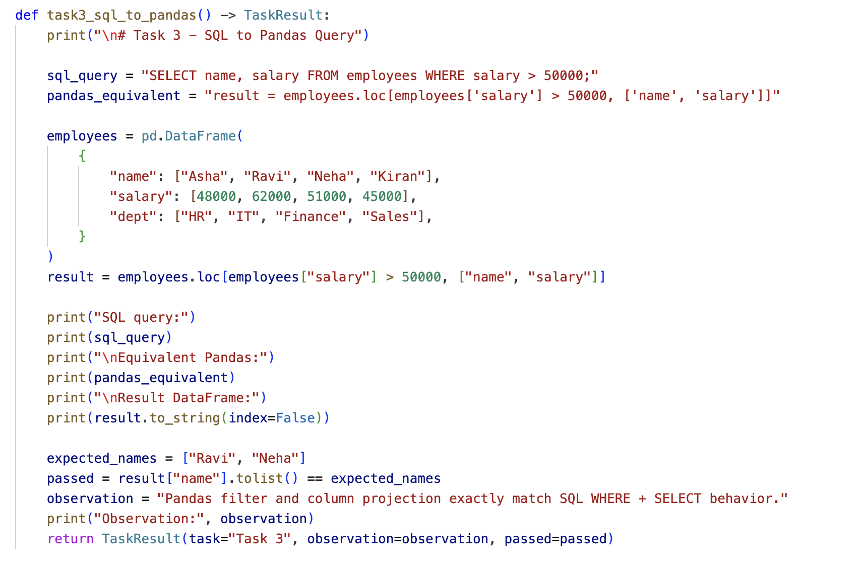
Output:
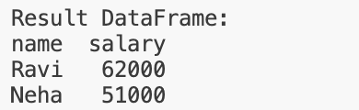

Observation:
The Pandas expression correctly replicates SQL semantics: row filtering with a condition and selecting only required columns. Retrieved records match the expected subset exactly.

Task 4: Real-Time Application: Multi-Language Snippet
Code:
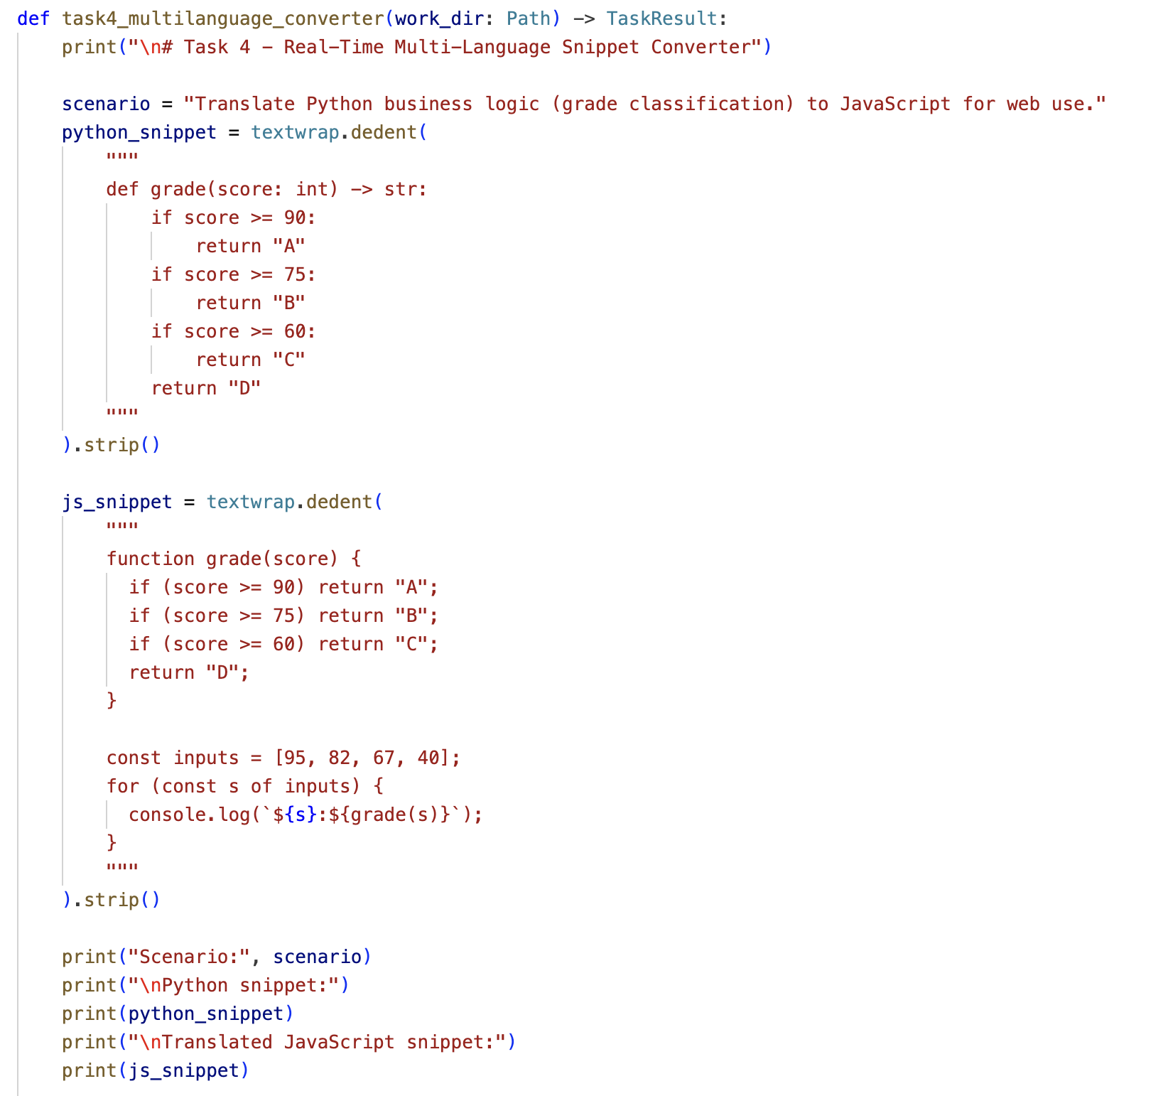

Output:
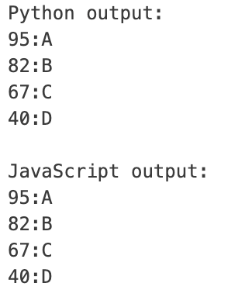

Observation:
Both Python and JavaScript implementations produce identical outputs for the same inputs. Main translation differences were syntax, string formatting style, and language runtime/tooling, not business logic.

