Assignment-8.1
P. Induvardhan Reddy
2303A52030
Batch-44
Task 1: Apply AI to generate at least 3 assert test cases for
is_strong_password(password) and implement the validator
function.
Code:
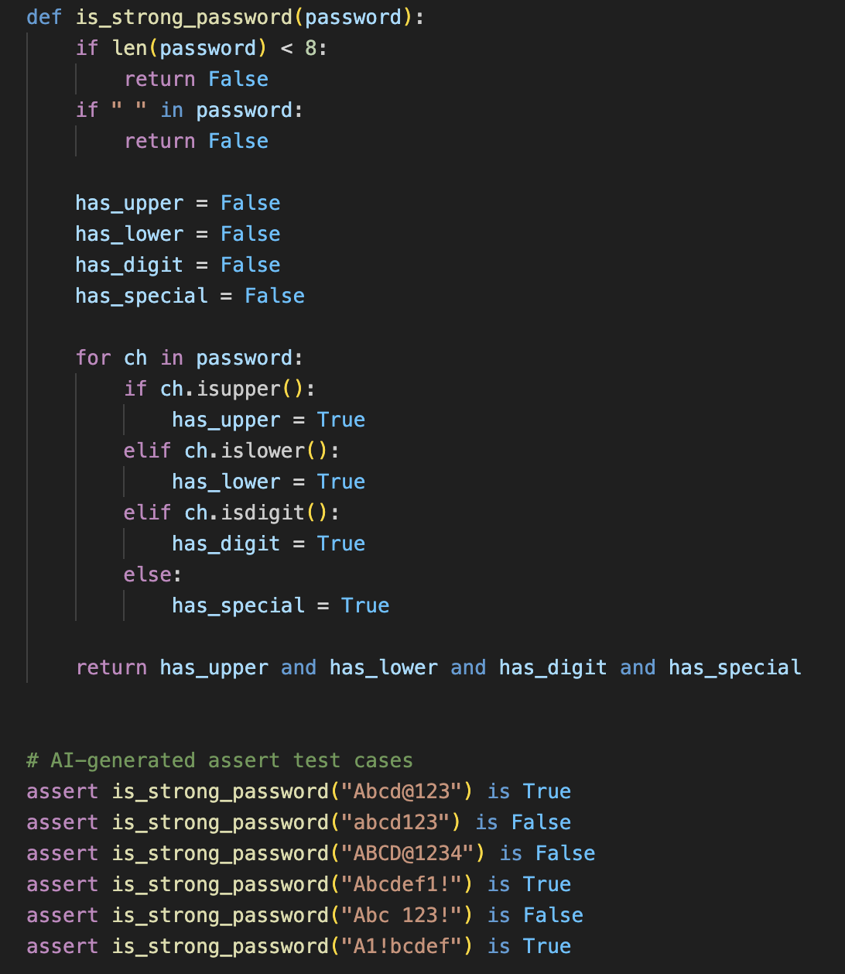
Task 2: Use AI to generate at least 3 assert test cases for a
classify_number(n) function. Implement using loops.
Code:
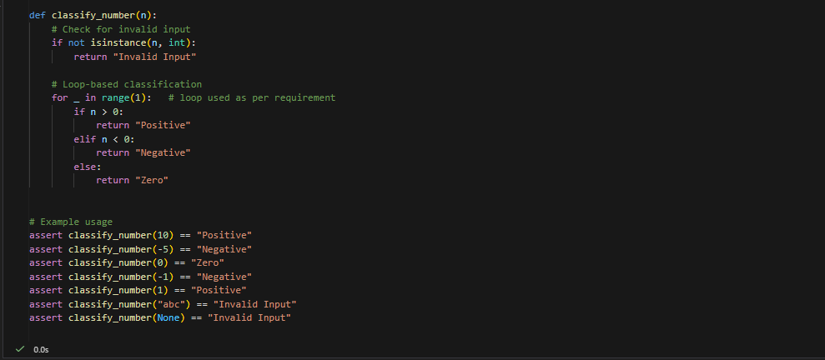

Task 3: Use AI to generate at least 3 assert test cases for
is_anagram(str1, str2) and implement the function.
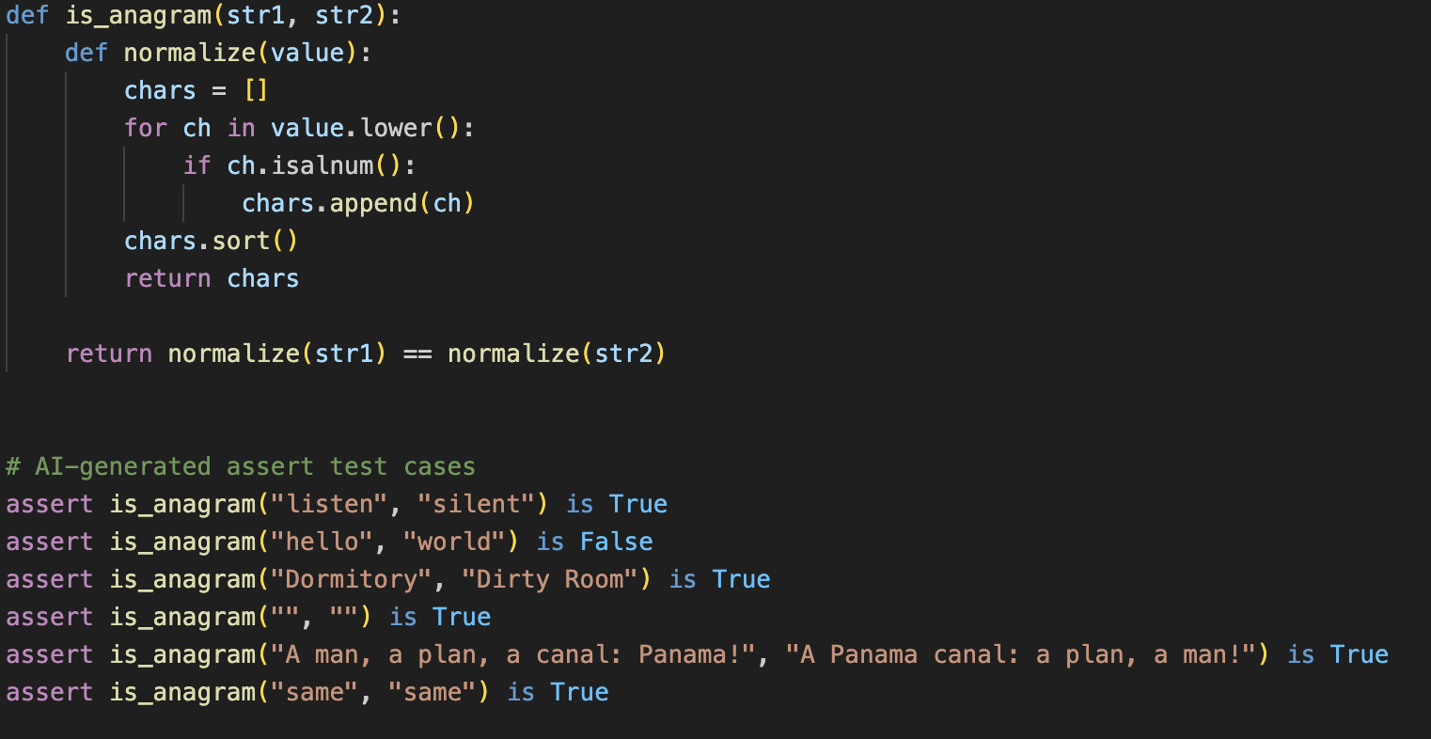

Task 4: Task: Ask AI to generate at least 3 assert-based tests for an
Inventory class with stock management.

Code:
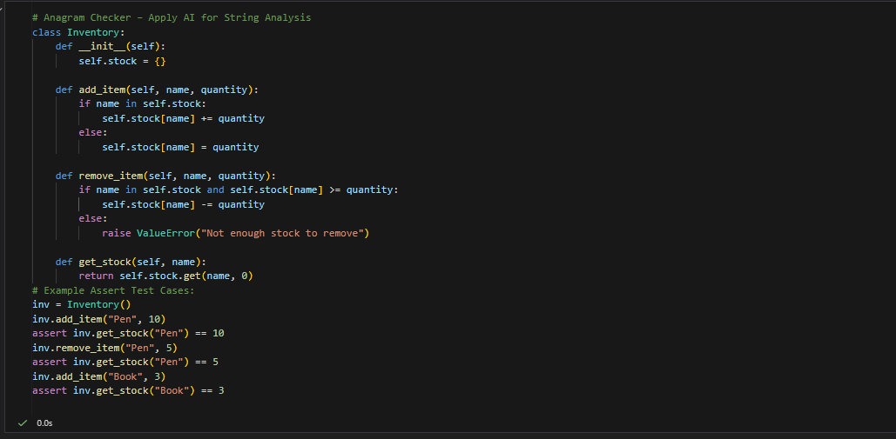

Task 5: Use AI to generate at least 3 assert test cases for
validate_and_format_date(date_str) to check and convert
dates.
Code:
