Assignment-7.1
P. Induvardhan Reddy
2303A52030
Batch – 44

Task Description #1 (Syntax Errors – Missing Parentheses in Print Statement)
Task: Provide a Python snippet with a missing parenthesis in a print
statement (e.g., print "Hello"). Use AI to detect and fix the syntax error.
# Bug: Missing parentheses in print statement
def greet():
print "Hello, AI Debugging Lab!"
greet()

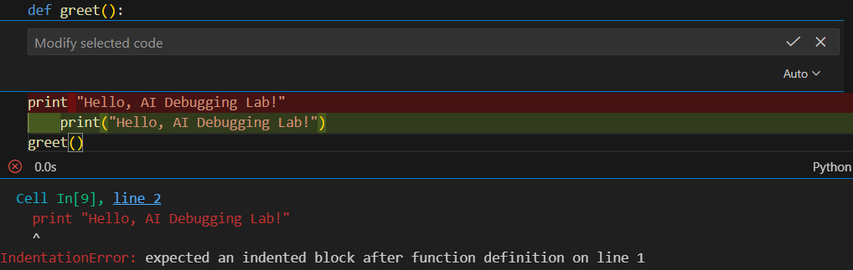
• Corrected code with proper syntax and AI explanation.
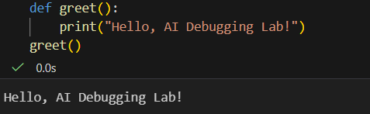

Task Description #2 (Incorrect condition in an If Statement)
Task: Supply a function where an if-condition mistakenly uses =
instead of ==. Let AI identify and fix the issue.
# Bug: Using assignment (=) instead of comparison (==)
def check_number(n):
if n = 10:
return "Ten"
else:
return "Not Ten"
#Output
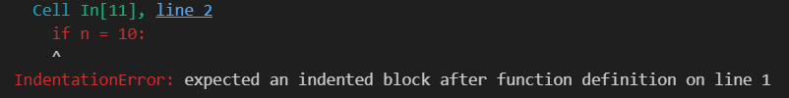
Corrected code using == with explanation and successful test execution
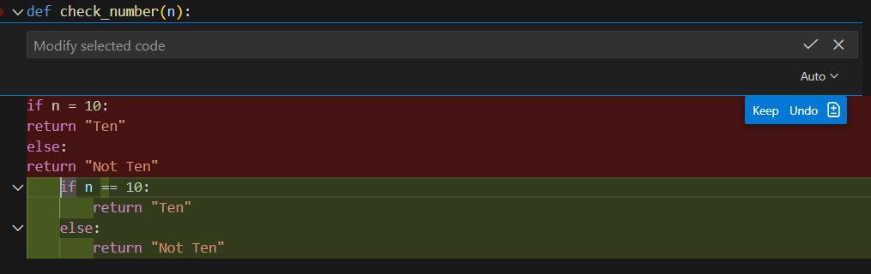
#output:
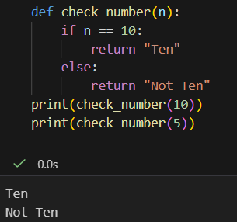

Task Description #3 (Runtime Error – File Not Found)
Task: Provide code that attempts to open a non-existent file and crashes. Use AI to apply safe error handling.
# Bug: Program crashes if file is missing
def read_file(filename):
with open(filename, 'r') as f:
return f.read()
print(read_file("nonexistent.txt"))
#Output :
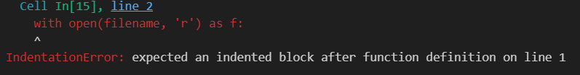
Safe file handling with exception management.
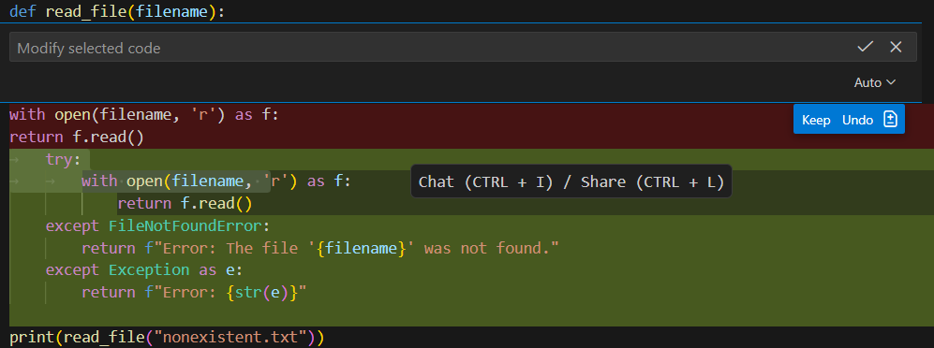
#Output :
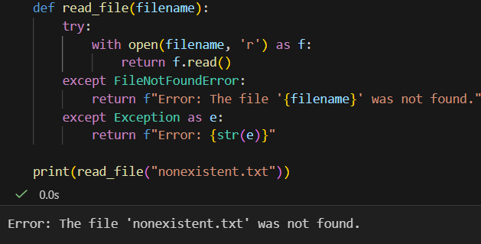

Task Description #4 (Calling a Non-Existent Method)
Task: Give a class where a non-existent method is called (e.g., obj.undefined_method()). Use AI to debug and fix.
# Bug: Calling an undefined method
class Car:
def start(self):
return "Car started"
my_car = Car()
print(my_car.drive()) # drive() is not defined
#Output :
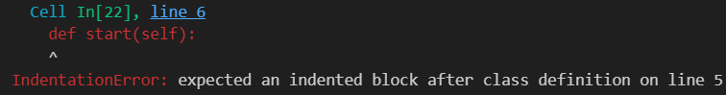
Corrected class with clear AI explanation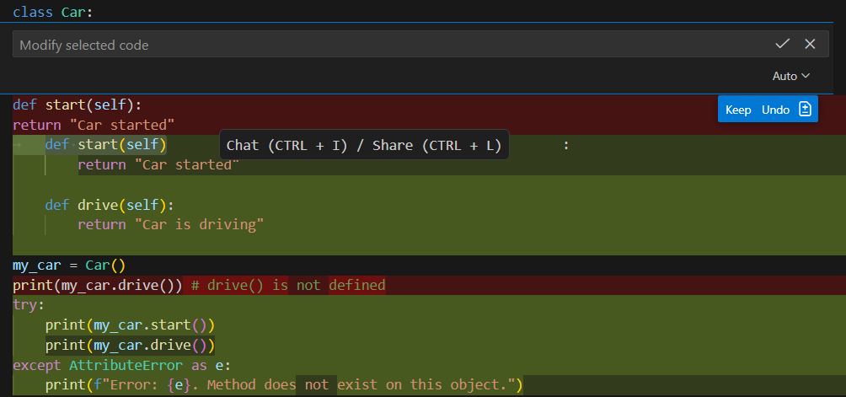#Output : 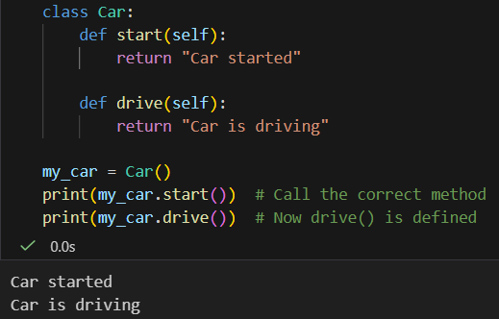
Task Description #5 (TypeError – Mixing Strings and Integers in Addition)
Task: Provide code that adds an integer and string ("5" + 2) causing a TypeError. Use AI to resolve the bug.
# Bug: TypeError due to mixing string and integer
def add_five(value):
return value + 5
print(add_five("10"))
#Output :
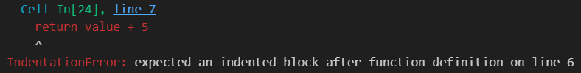
Corrected code that runs successfully for multiple inputs.
