ASSIGNMENT- 12.4
P. Induvardhan Reddy
2303A52030
Batch : 44

Task 1: Bubble Sort for Ranking Exam Scores
Scenario: You are working on a college result processing system where a small
list of student scores needs to be sorted after every internal assessment.
Code:
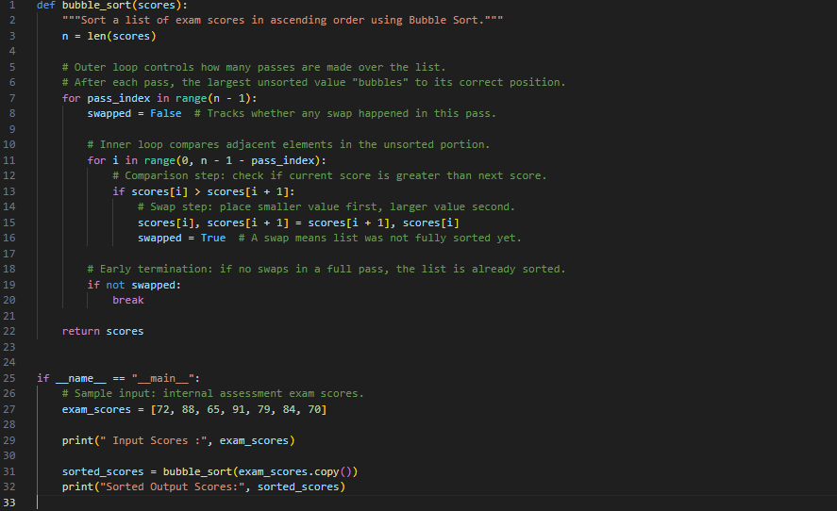
Output:

Task 2: Improving Sorting for Nearly Sorted Attendance Records
Scenario : You are maintaining an attendance system where student roll numbers
are already almost sorted, with only a few late updates.
Code:
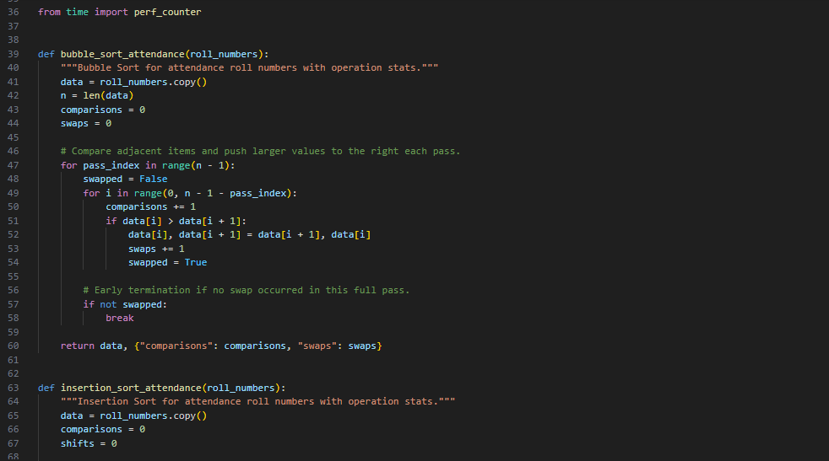
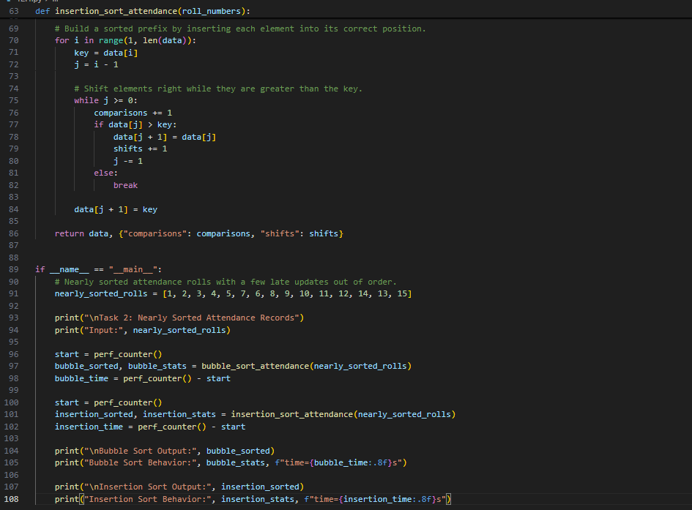
Output:

Task 3: Searching Student Records in a Database
Scenario: You are developing a student information portal where users search for student records by roll number.
Code:
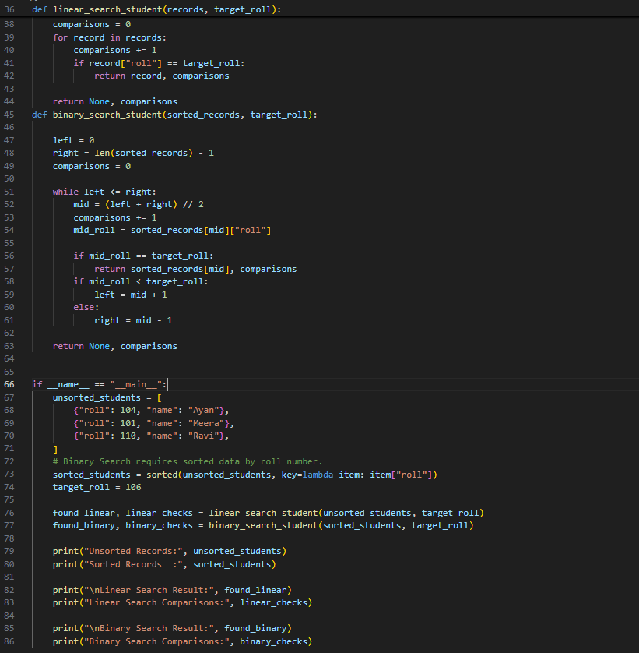
Output:
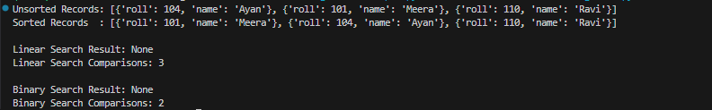

Task 4: Choosing Between Quick Sort and Merge Sort for Data Processing
Scenario: You are part of a data analytics team that needs to sort large datasets received from different sources (random order, already sorted, and reverse sorted).

Code:
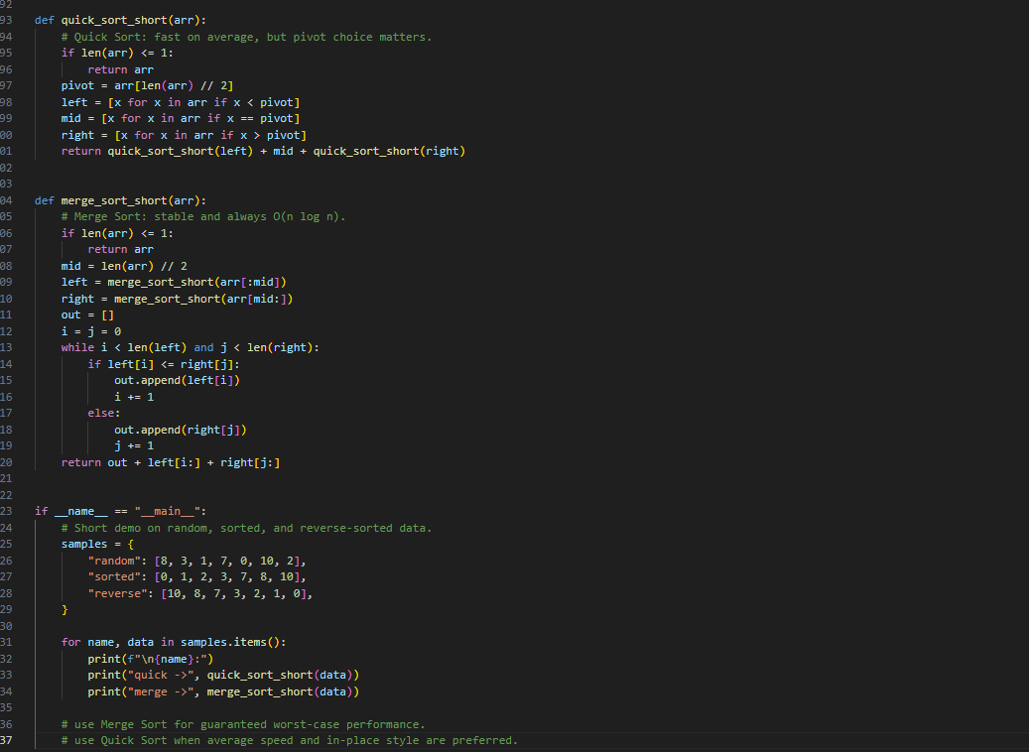
Output:
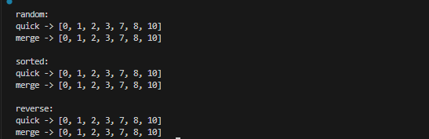

Task 5: Optimizing a Duplicate Detection Algorithm
Scenario: You are building a data validation module that must detect duplicate user IDs in a large dataset before importing it into a system
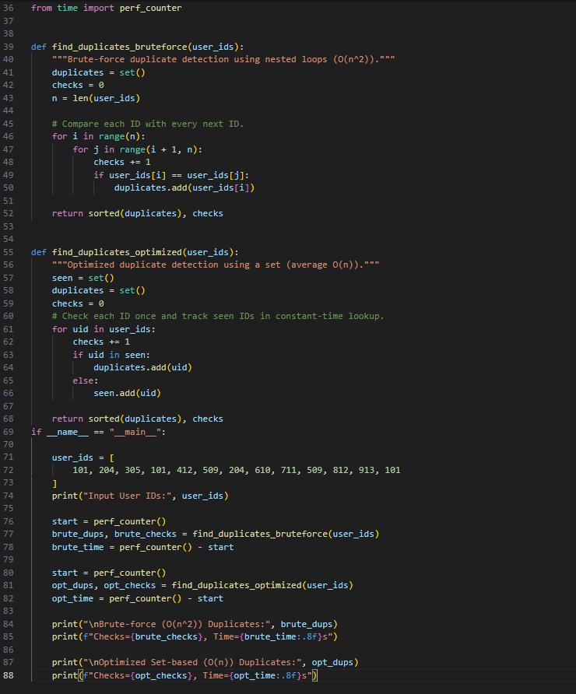
Output:
