SMARTPOS
Advanced Offline-First POS System
Complete System Design, Implementation, Deployment & Service Specification
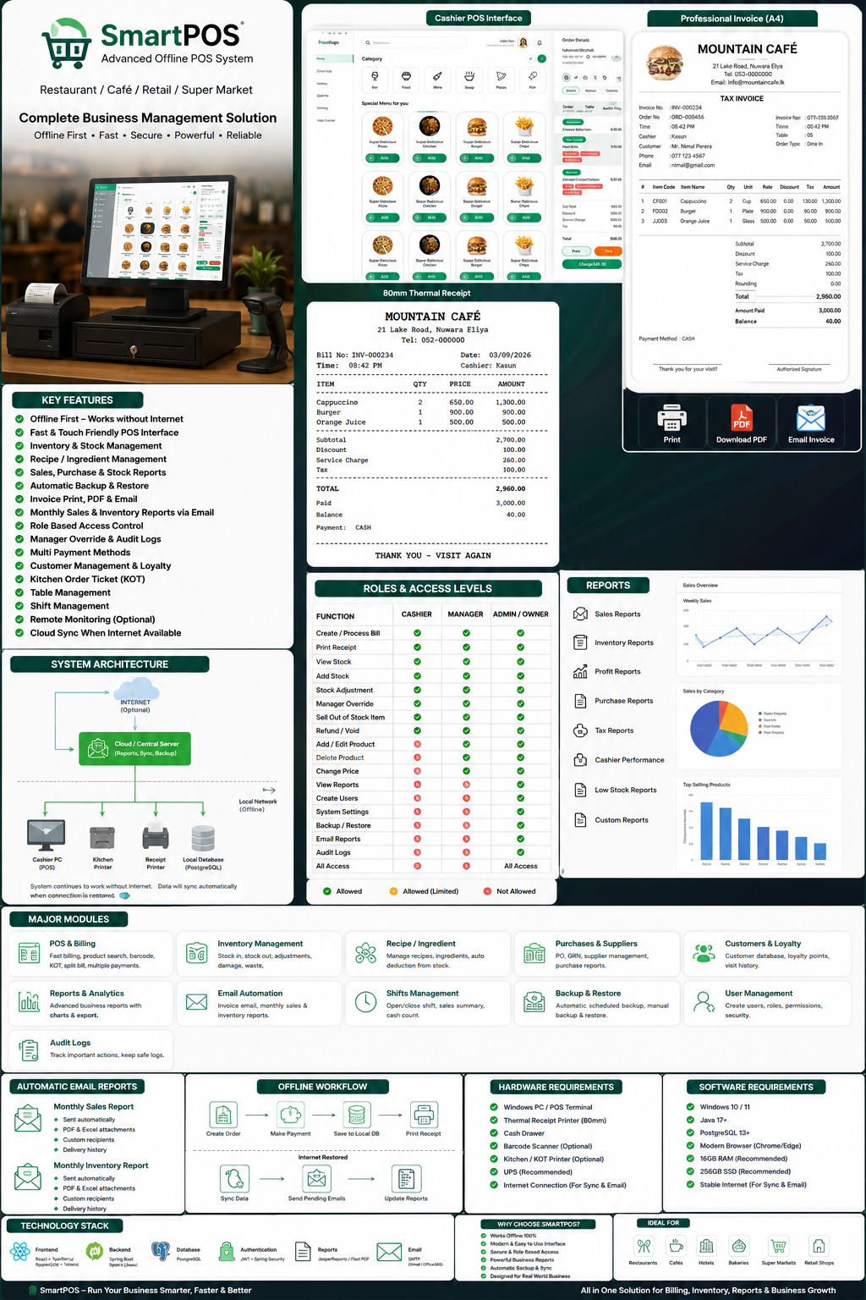
DOCUMENT PURPOSE
A professional blueprint for building, installing, operating, supporting, and extending an offline-first POS platform for cafés, restaurants, small hotels, bakeries, mini marts, supermarkets, and retail shops.

Prepared as a complete technical and operational reference
Version 1.0 | September 2026

1. Executive Overview
SmartPOS is designed as a complete business operations platform, not only a billing screen. The system combines point-of-sale billing, inventory control, receipt and invoice generation, staff access control, restaurant workflows, purchasing, customer management, business reports, automated emails, local backup, cloud synchronization, device monitoring, and audit logs in one structured solution.
The central design principle is offline-first reliability. The cashier must be able to continue selling even when the internet connection is unavailable. Core operations therefore execute against a local application service and local PostgreSQL database. Internet connectivity is treated as an optional enhancement used for email delivery, remote dashboards, cloud synchronization, remote monitoring, and off-site reporting.
CORE PRODUCT PROMISE
Internet down? Keep selling. Every completed transaction is saved locally, stock is updated, receipts continue printing, and pending cloud/email work is synchronized automatically when connectivity returns.

1.1 Target Businesses
Business Type | Typical Use
Café / Coffee Shop | Fast touch billing, dine-in/takeaway, recipe inventory, receipt printing, shift reports.
Restaurant | Table orders, KOT/kitchen printing, split payments, recipes, inventory and manager approvals.
Small Hotel | Reception/front-desk billing, restaurant POS, customer records and consolidated reports.
Bakery | Prepared item sales, ingredient usage, daily production and stock control.
Mini Mart / Retail Shop | Barcode billing, inventory, suppliers, purchase receiving, discounts and stock warnings.
Supermarket - Future Expansion | Multiple terminals, branch synchronization, centralized reporting and device management.

1.2 Design Objectives
- Fast checkout experience optimized for 1366×768 and 1920×1080 Windows POS terminals.
- Offline operation for login, product search, billing, local payments, stock deduction, receipt printing and local reports.
- Strict role-based access for Cashier, Manager and Admin/Owner users.
- Professional A4 invoice, PDF download, email invoice and 80mm thermal receipt output.
- Automatic monthly sales and inventory reports with PDF/Excel attachments.
- Complete inventory traceability through stock movement history instead of silent quantity changes.
- Manager override workflows for stock shortages, negative stock, refunds and voids.
- Automated local backups and optional off-site/cloud synchronization.
- Auditability: every sensitive action records who, when, where, why and what changed.
- Architecture suitable for future multi-branch and remote device monitoring.

2. Complete System Overview
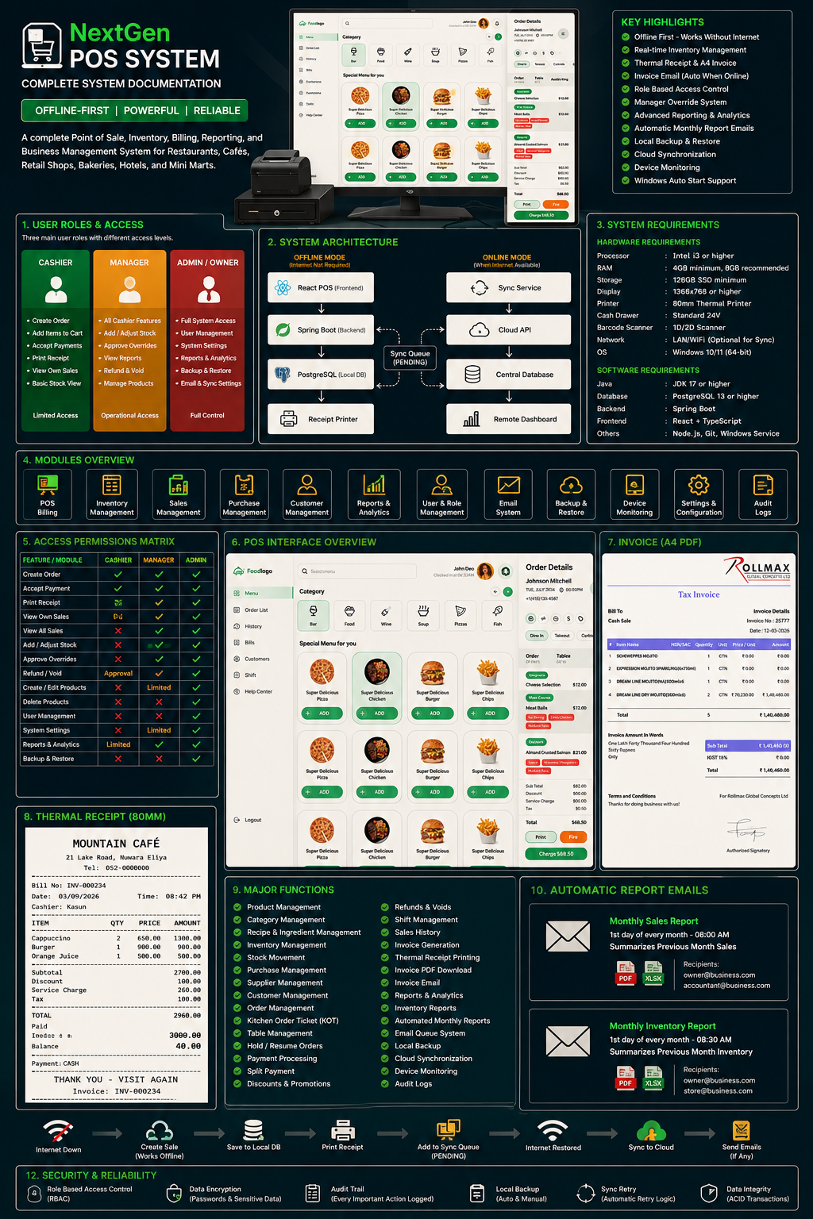
Figure 1 - AI-generated overview of the SmartPOS product, roles, architecture, modules, invoice, receipt and reporting features.

3. High-Level Architecture
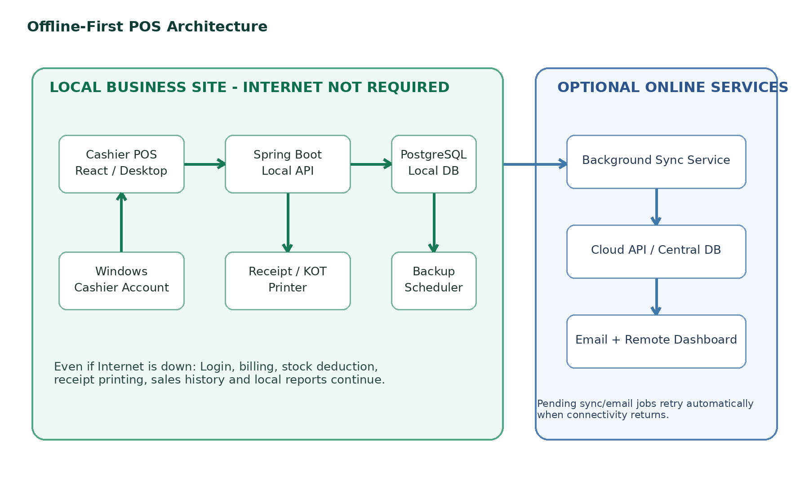
The local business site is the authoritative execution environment for checkout. The cloud layer is deliberately decoupled from checkout so that cloud or ISP failures never prevent normal cash sales. A synchronization queue records work that must be sent later.
Windows Cashier PC / Local Network
│
├── React / Desktop POS UI
│ ↓
├── Spring Boot Local API
│ ↓
├── PostgreSQL Local Database
│ ├── Sales / Inventory / Users / Orders
│ ├── Email Queue
│ └── Sync Queue
│
├── 80mm Receipt Printer / KOT Printer
└── Backup Scheduler
│
Internet available?
│
├── NO → keep operating locally
└── YES → sync cloud data, send queued email,
update remote dashboard/monitoring

4. Hardware Requirements
Component | Minimum / Prototype | Recommended Commercial Setup | Purpose
Cashier Computer | Intel i3, 4GB RAM, 128GB SSD | Intel i3/i5, 8GB RAM, 256GB+ SSD | Runs Windows, local POS, backend and local database.
Display | 1366×768 monitor | 15–22 inch Full HD / touch POS display | Fast cashier interaction and menu selection.
Thermal Printer | 80mm USB printer | 80mm USB/LAN ESC/POS printer | Customer receipt printing.
Cash Drawer | Optional | 24V drawer connected to printer | Cash handling and controlled opening.
Barcode Scanner | Optional for café | 1D/2D USB scanner for retail | Fast product lookup in retail use.
Kitchen Printer | Optional | LAN/USB thermal printer | KOT printing in restaurant/kitchen.
Router | Basic LAN/Wi-Fi router | Business router with guest isolation | Local network, internet and optional cloud sync.
UPS | Recommended | 650VA or higher | Protects POS from short power failures and unsafe shutdowns.
Backup Storage | External USB optional | External SSD/NAS + cloud copy | Secondary backup location.
Network Cabling | Cat5e acceptable | Cat6 structured cabling | Reliable wired connection for printers/terminals.

4.1 Windows Account Model
For a dedicated POS terminal, create a restricted Windows user account named Cashier and retain a separate Windows Administrator account for installation and maintenance. The Windows account protects the computer; the POS employee login records which person is performing business actions.
PC Power On
↓
Windows starts
↓
Cashier Windows account login
↓
PostgreSQL service + POS backend start automatically
↓
POS application auto-opens in full-screen / kiosk-style mode
↓
Employee ID + PIN
↓
Cashier / Manager / Admin interface according to role

5. Software Requirements & Technology Stack
Layer | Recommended Technology | Responsibility
Operating System | Windows 10/11 Pro 64-bit | Cashier workstation, local services, printer drivers and auto-start.
Frontend | React + TypeScript + Vite + Tailwind CSS | Touch-friendly POS, admin dashboards, reports and settings.
Backend | Spring Boot / Java 17+ | REST API, RBAC, business rules, scheduler, reports, email and sync.
Database | PostgreSQL 13+ | Local authoritative storage for business data.
Authentication | Spring Security + JWT/local session design | Login, role permissions, protected backend endpoints.
PDF/Reports | Java PDF library + Excel/CSV export library | Invoices and downloadable business reports.
Email | SMTP | Invoice delivery and scheduled monthly reports.
Monitoring Agent | Python or lightweight Windows service - optional | CPU/RAM/disk/service status and heartbeat.
Version Control | Git + GitHub/GitLab | Source control and release management.
Packaging | Windows Service + desktop wrapper/PWA/kiosk | Commercial deployment experience.

5.1 Suggested Local Installation Layout
C:\SmartPOS\
├── app\ # POS desktop/web shell
├── backend\ # smartpos-backend.jar
├── config\ # local configuration
├── logs\ # application logs
├── backups\ # database backups
├── reports\ # generated PDF/Excel reports
├── print\ # print templates / temporary files
└── sync\ # queue/support files if required
Windows Services
├── PostgreSQL
└── SmartPOS Backend

6. User Roles and Access Control
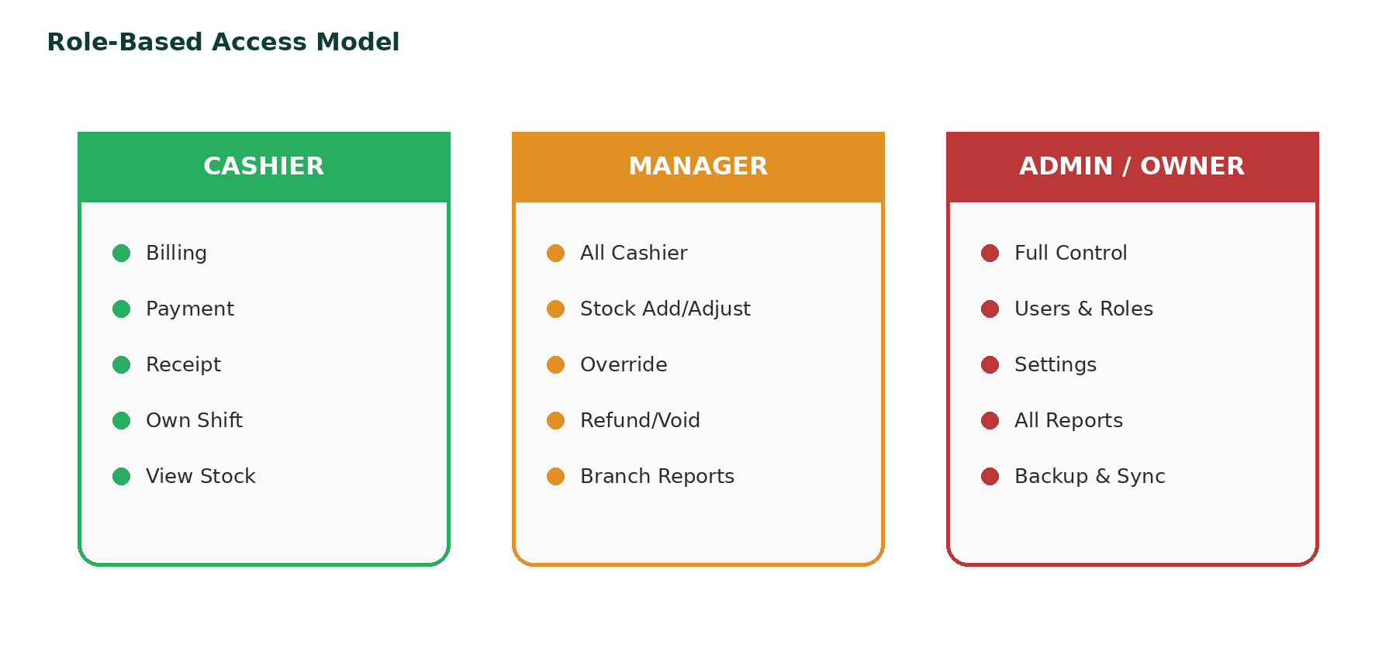
Role-based access control (RBAC) must be enforced in the backend. Hiding a button in the frontend is not sufficient security. Every sensitive API operation checks the authenticated user role and required permission.
Feature / Module | Cashier | Manager | Admin / Owner
Create / Process Bill | ✓ | ✓ | ✓
Accept Payment | ✓ | ✓ | ✓
Print / Email Invoice | ✓ | ✓ | ✓
View Current Stock | ✓ | ✓ | ✓
Add Stock | — | ✓ | ✓
Manual Stock Adjustment | — | ✓ | ✓
Manager Stock Override | Request only | ✓ | ✓
Negative Stock Approval | — | ✓ | ✓
Refund / Void | Request/limited | ✓ | ✓
Create Product | — | ✓ | ✓
Edit Product | — | ✓ | ✓
Delete / Permanently Remove Product | — | — | ✓
Change Selling Price | — | Limited/approved | ✓
View Own Shift Sales | ✓ | ✓ | ✓
View Branch Reports | Limited | ✓ | ✓
View Profit / Cost Reports | — | Optional | ✓
Create Cashier User | — | — | ✓
Create Manager User | — | — | ✓
Create Admin User | — | — | ✓ / protected
Business Settings | — | — | ✓
Tax / Email / Sync Settings | — | — | ✓
Backup / Restore | — | — | ✓
Audit Log | Own actions only | Branch view | Full view
Device Monitoring | — | Limited | ✓

6.1 Cashier Role
- Create orders and bills
- Search/select products or scan barcode
- Change quantity/remove item before payment
- Take cash/card/other configured payments
- Print thermal receipt
- Download or email completed invoice
- View current stock availability
- Open/close own shift
- View own/current-shift sales
- Request manager approval when required

6.2 Manager Role
- All Cashier capabilities
- Receive stock and perform stock adjustments
- Approve out-of-stock or negative-stock transactions
- Approve refund/void operations
- Create/edit products depending on policy
- View branch inventory, purchases and sales reports
- Close cashier shifts and investigate discrepancies
- Review operational audit records

6.3 Admin / Owner Role
- Full system access
- User and role management
- Product/category/price/cost management
- All inventory and supplier/purchase management
- All financial and profitability reports
- Business, tax, printer, email and sync settings
- Backup and restore control
- Automated report scheduling
- Device monitoring and audit log access

7. Cashier POS Interface Design
The cashier UI should use the supplied visual direction: a light, modern restaurant POS with a narrow navigation sidebar, large category/product grid, and a persistent order summary panel. It should be optimized for both mouse and touch input and support keyboard shortcuts for high-speed billing.
Area | Content / Behavior
Left Navigation | Logo, Menu, New Order, Order List, History, Bills, Customers, Shift, Help, Logout.
Top Header | Search, barcode input, cashier name, shift start time, online/offline status, notifications.
Category Strip | Large icon cards: Coffee, Food, Juice, Pizza, Bar, Dessert, etc.
Product Grid | Image, name, price, stock/availability state, Add button. Disabled items visibly marked.
Order Panel | Customer, order type, table, cart lines, modifiers, notes, discounts and totals.
Checkout Actions | Hold, KOT/Fire, Print, Charge/Pay.
Offline Indicator | Clear amber status with pending sync count but no interruption to checkout.

8. Cashier Transaction Workflow
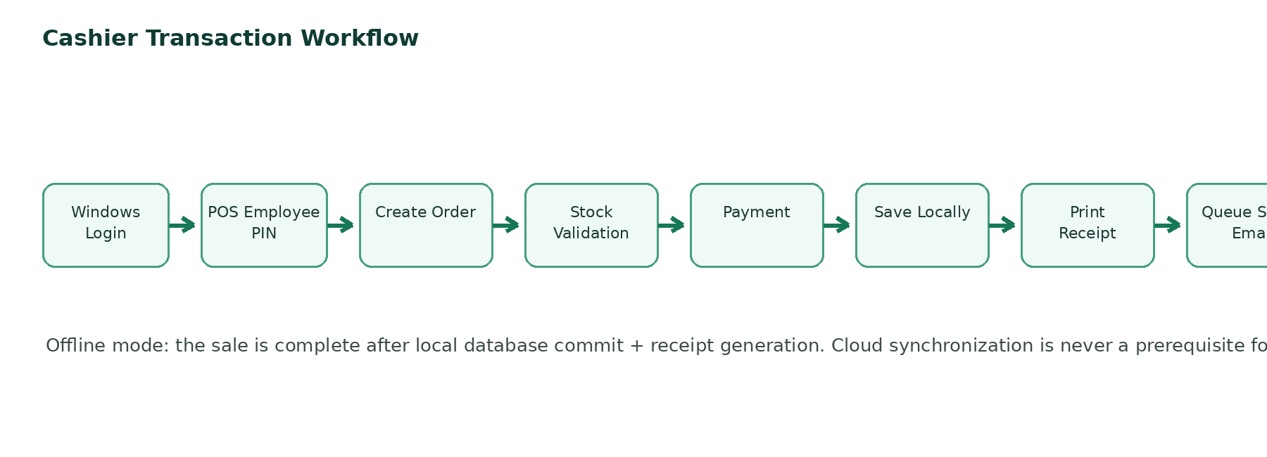
- Cashier signs into Windows and the POS auto-starts.
- Employee authenticates with Employee ID and PIN/password.
- Cashier creates a new order and selects dine-in, takeaway, delivery or configured order type.
- Products are added from menu cards, search or barcode scanner.
- POS validates product availability and recipe/ingredient constraints.
- If stock is insufficient, Cashier must reduce quantity/remove item or request Manager Override.
- Cashier confirms payment method and received amount.
- Backend commits sale, payment and inventory movement in one reliable local database transaction.
- Invoice number is generated and 80mm receipt becomes available immediately.
- Optional email and cloud sync are queued if online connectivity is unavailable.
- POS returns to a clean new-order state.

9. Offline-First Operation and Synchronization
The local database remains the primary source for active checkout. Internet-dependent operations must use queues rather than blocking the business process.
Function | Internet Available | Internet Unavailable
Employee Login | Works | Works using locally authorized account data
Product/Menu Load | Local | Local
Billing | Works | Works
Cash Payment | Works | Works
Stock Deduction | Local + sync | Local; sync queued
Receipt Print | Works | Works
Local Sales History | Works | Works
PDF Invoice | Works | Works
Invoice Email | Send immediately | Queue as PENDING
Monthly Email Reports | Send | Generate/queue and retry
Cloud Dashboard | Updates | Temporarily stale/offline
Remote Monitoring | Updates | Shows last-seen/offline until reconnect
Cloud Sync | Immediate/background | Queue and retry later

9.1 Synchronization Queue
Field | Meaning
id / UUID | Globally unique sync event.
entity_type | SALE, PRODUCT, STOCK_MOVEMENT, USER, etc.
entity_id | Record being synchronized.
operation_type | CREATE, UPDATE, DELETE/DEACTIVATE or domain event.
payload | Serialized data required for cloud sync.
created_at | When queued.
retry_count | Number of delivery attempts.
last_attempt | Last synchronization attempt.
sync_status | PENDING, SYNCING, SYNCED, FAILED.
synced_at | Successful completion timestamp.

TRANSACTION SAFETY
A successful local sale must never be rolled back merely because cloud synchronization or email delivery failed. Checkout reliability and local data integrity take priority.

10. Product, Category and Menu Management
Product Field | Description
UUID / Item Code / Barcode | Stable identifiers for local/cloud synchronization and scanning.
Name / Description / Category | Display and classification.
Product Type | RETAIL_ITEM, PREPARED_MENU_ITEM, SERVICE, INGREDIENT.
Selling Price / Cost Price | Revenue and profitability reporting.
Tax / Unit | Tax calculation and unit of measure.
Current Stock / Min Stock | Availability and reorder alerts.
Track Inventory | Allows service/non-stock items.
Allow Discount | Controls cashier discount availability.
Image | Touch-friendly product card.
Active | Soft deactivate without deleting historical references.

11. Inventory Management
Inventory is controlled through immutable stock movement records. The current quantity is a result of purchases, sales, adjustments, returns, waste, damages and recipe consumption. Never change a quantity silently without recording a movement and responsible user.
Movement Type | Example | Effect
PURCHASE | Supplier delivery +24 Coca Cola | Increase stock
SALE | 2 burgers sold | Reduce stock
RECIPE_USAGE | Cappuccino consumes milk/beans | Reduce ingredients
RETURN_IN | Customer/supplier-approved return to stock | Increase stock
RETURN_OUT | Return to supplier | Reduce stock
DAMAGE | Broken bottle | Reduce stock
WASTE | Expired ingredient | Reduce stock
ADJUSTMENT | Physical stock count correction | Increase/decrease with reason
OVERRIDE_SALE | Manager-approved sale below zero | May create negative stock warning

11.1 Manager Override for Insufficient Stock
Cashier selects Burger x 2
Available stock = 1
↓
INSUFFICIENT STOCK
[Change Qty] [Remove] [Request Manager Override]
↓
Manager Employee ID + PIN + Reason
↓
Backend verifies MANAGER / ADMIN permission
↓
Sale allowed only when approved
↓
Audit log + negative stock warning generated
The override record must include product, quantity requested, system stock before/after, Cashier, approving Manager/Admin, timestamp, terminal and reason.

12. Recipe / Ingredient Inventory
For restaurants and cafés, prepared menu items should optionally consume ingredients using a recipe/BOM model. This is a second-stage capability and can be disabled for simple shops.
Menu Item | Ingredient | Quantity per Sale
Cappuccino | Coffee Beans | 18 g
Cappuccino | Milk | 200 ml
Cappuccino | Sugar | 5 g

When one Cappuccino is sold, the backend records corresponding ingredient stock movements. If required ingredients are unavailable, the product can automatically be marked unavailable unless a Manager override policy permits otherwise.

13. Purchasing and Suppliers
- Supplier master data: name, contact person, phone, email, address and tax details.
- Purchase document: supplier invoice/GRN number, items, quantity, cost, tax and total.
- Completing a purchase creates stock movement records and updates cost data according to the chosen valuation rule.
- Managers/Admins can review purchase history, outstanding deliveries and supplier performance.

14. Payments, Discounts and Shift Control
Capability | Behavior
Cash | Amount received + automatic balance/change calculation.
Card | Record card payment reference; integration can be added later.
Bank Transfer / Wallet | Optional configured payment type with reference.
Split Payment | Multiple payment methods against one invoice.
Item Discount | Role/rule limited; audit amount and approving user.
Bill Discount | Permission controlled with maximum threshold.
Shift Opening | Cashier records opening cash amount.
Shift Closing | Expected vs actual cash, variance and manager review.

15. Restaurant Order Management
Restaurant mode extends basic POS with table and kitchen workflows while sharing the same sale, inventory and payment engine.
- Dine-in, takeaway, delivery and optional curbside order types.
- Table selection and table status.
- Hold/resume orders without payment.
- KOT / kitchen printer tickets.
- Kitchen notes and item modifiers.
- Order states: NEW → SENT_TO_KITCHEN → PREPARING → READY → SERVED → PAID → COMPLETED.
- Split bill and multi-payment support.

16. Invoice and Receipt System

16.1 Professional A4 Invoice / PDF
Section | Required Content
Header | Logo, business name, address, phone, email, website, tax registration number.
Invoice Identity | Invoice number, order number, date/time, Cashier, customer and order type.
Item Table | Item code, item name, quantity, unit, rate, discount, tax and amount.
Summary | Subtotal, discount, service charge, tax, rounding, total, paid and balance.
Footer | Payment method, terms, thank-you text and system-generated/authorized statement.
Actions | Print, Download PDF, Email Invoice, Reprint according to role.

16.2 80mm Thermal Receipt
MOUNTAIN CAFÉ
21 Lake Road, Nuwara Eliya
Tel: 052-0000000
----------------------------------------
Bill No: INV-000234 Date: 03/09/2026
Time: 08:42 PM Cashier: Kasun
----------------------------------------
ITEM QTY PRICE AMOUNT
Cappuccino 2 650.00 1300.00
Burger 1 900.00 900.00
Orange Juice 1 500.00 500.00
----------------------------------------
Subtotal 2700.00
Discount 100.00
Service Charge 260.00
Tax 100.00
TOTAL 2960.00
Paid 3000.00
Balance 40.00
Payment: CASH
----------------------------------------
THANK YOU - VISIT AGAIN
Invoice: INV-000234
Receipt printing must operate entirely on the local Windows PC. Recommended implementation includes a dedicated 80mm print stylesheet and an ESC/POS-capable printing architecture for commercial deployments.

17. Invoice Email and Email Queue
- After payment, generate and store invoice data locally.
- Customer may choose Email Invoice and enter/select an email address.
- If online, backend generates the PDF and sends through SMTP.
- If offline, store an email_queue record with PENDING status.
- Background service retries when connectivity returns.
- Record recipient, invoice, timestamps, status, retry count and error in email history.
IMPORTANT
Email failure must never cause the completed sale to fail. The invoice remains printable/downloadable locally and the email can be delivered later.

18. Reports and Analytics
Report Group | Reports
Sales | Daily, weekly, monthly, yearly, custom range, product, category, hourly, Cashier, payment type, discount, refund, tax, service charge.
Inventory | Current inventory, valuation, low stock, out of stock, negative stock, movement, adjustment, purchases, damage/waste, ingredient usage.
Profit | Gross revenue, COGS, gross profit, margin, product profitability, category profitability.
Operations | Cashier performance, shift closing, refunds/voids, manager overrides, audit activity.

Report pages must be driven by backend/database results and include date filters, search, sorting, charts, detail tables, totals and export actions. Avoid static/demo-only charts.

18.1 Report Output Actions
- View in web UI
- Print
- Download PDF
- Export CSV
- Export Excel
- Email report

19. Automated Monthly Reports

19.1 Monthly Sales Report Email
Default schedule example: first day of each month at 08:00, summarizing the previous calendar month. Admin configures recipients and can enable/disable the schedule.
- Revenue
- Orders
- Average order value
- Cash/card/other payment totals
- Discounts
- Refunds
- Tax/service charge
- Top products/categories
- PDF and Excel attachments
- Delivery history and retry state

19.2 Monthly Inventory Report Email
- Closing inventory and valuation
- Low/out-of-stock/negative-stock items
- Stock purchased and consumed
- Adjustments, damage and waste
- Fast-moving and slow-moving products
- PDF and Excel attachments

20. Customer Management and Loyalty
Field / Feature | Purpose
Customer ID / Name | Customer identity.
Phone / Email / Address | Lookup, invoice delivery and contact.
Loyalty Points | Optional reward program.
Total Purchases / Visit Count | Customer analytics.
Last Visit | Engagement and retention.
Search | Phone, name or email.

21. Refunds, Voids and Financial Record Integrity
Financial transactions should not be hard-deleted. A refund or void is a controlled business event tied to the original sale. Manager/Admin approval and a reason are mandatory for sensitive corrections.
Cashier requests refund
↓
Manager/Admin authorization
↓
Reason required
↓
Refund record created
↓
Stock returned/adjusted when applicable
↓
Audit event written
↓
Original transaction retained with status
COMPLETED / PARTIALLY_REFUNDED / REFUNDED / VOIDED

22. Backup and Restore
Local automated backup protects the business against database corruption, accidental loss and hardware failure. Backups should be scheduled daily and periodically tested by restoration into a safe test database.
Requirement | Recommended Behavior
Default Schedule | Daily at 11:59 PM or after business closing.
Location | C:\SmartPOS\Backups\ plus optional secondary/cloud copy.
File Naming | smartpos_YYYY-MM-DD_HHMMSS.backup
Retention | Configurable; e.g., daily + weekly/monthly retention.
Admin Actions | Backup Now, View Backups, Test Backup, Restore Backup.
Security | Restrict restore to Admin; encrypt off-site backup where applicable.
Dashboard | Last backup, status, size, location, next backup.

23. Device Monitoring and Remote Support
Remote monitoring is optional and should never be required for checkout. A lightweight Windows agent can send health data when internet is available.
Metric | Purpose
Terminal ID / Device Name | Identify each POS workstation.
Last Seen / Online Status | Detect offline devices.
CPU / RAM / Disk | Predict performance or disk-full problems.
POS Service / DB Service | Detect service failure.
Application Version | Identify outdated installations.
Last Backup | Confirm protection status.
Pending Sync Count | Detect long-running synchronization problems.

24. Security and Reliability
- Secure password and PIN hashing; never store plain-text credentials.
- Backend RBAC and permission validation for every protected action.
- Account active/inactive status and login attempt protection.
- Audit trail for sensitive business operations.
- Database transactions for sale + payment + stock changes.
- Unique invoice/transaction IDs to prevent duplicate synchronization.
- Input validation and global exception handling.
- Environment variables or secure configuration for email/database secrets.
- Restricted Windows Cashier account and protected Administrator account.
- Regular backup and restore tests.
- Optional encrypted cloud communication using HTTPS/TLS.

25. Core Database Design
Domain | Tables / Entities
Identity & Access | users, roles, permissions, user_roles
Business Configuration | business_settings, tax_settings, printer_settings
Products | categories, products, ingredients, recipes, recipe_items
Inventory | inventory, stock_movements
Purchasing | suppliers, purchases, purchase_items
Customers | customers, loyalty_transactions
Orders & Sales | orders, order_items, order_item_modifiers, sales, sale_items, payments
Refunds | refunds, refund_items
Cashier Operations | cashier_shifts
Documents | invoices
Email | email_queue, email_history
Reports | report_schedules, report_history
Sync | sync_queue, sync_history
Devices | devices, device_health
Backup | backups
Governance | audit_logs

26. Major API Groups
API Group | Examples
Auth | POST /auth/login, /auth/logout, /auth/refresh
POS | GET /pos/menu, POST /orders, POST /sales/checkout
Products | GET/POST/PUT /products, categories
Inventory | GET /inventory, POST /stock/receive, /stock/adjust
Overrides | POST /manager/authorize, /overrides/stock
Payments | POST /payments, split payment endpoints
Invoices | GET /invoices/{id}, /pdf, /print-data, POST /email
Reports | GET /reports/sales, /inventory, /profit
Users | Admin user/role management
Backups | POST /backups, /restore
Sync | POST /sync/batch, GET /sync/status
Devices | POST /devices/heartbeat, GET /devices/status

27. Installation and Deployment Procedure
- Prepare Windows PC and apply operating system updates.
- Create separate Windows Administrator and restricted Cashier accounts.
- Install required runtime components and printer drivers.
- Install PostgreSQL and create the SmartPOS local database/user.
- Install the SmartPOS backend as an automatic Windows service.
- Install/configure the POS frontend or desktop wrapper.
- Configure business information, tax, receipt printer and invoice settings.
- Create Admin/Owner, Manager and Cashier POS accounts.
- Configure categories, menu/products, prices and opening stock.
- Configure thermal receipt printer and optional KOT printer/cash drawer/scanner.
- Configure local automated backups and test a manual restore.
- Configure SMTP, monthly report recipients and sync credentials if online features are used.
- Configure auto-start or kiosk/full-screen behavior for the Cashier Windows account.
- Run end-to-end sale tests while online.
- Disconnect the internet and repeat billing, receipt printing, stock update and local report tests.
- Reconnect the internet and confirm queued email/sync jobs complete.
- Train Admin/Manager/Cashier staff and hand over operating procedures.

28. Network Design for Small Businesses
Internet / ISP
↓
Business Router
├── POS LAN / Wi-Fi (protected)
│ ├── Cashier POS
│ ├── Manager PC
│ ├── Receipt/Kitchen Printer
│ └── Optional local server
│
└── Guest Wi-Fi (isolated from POS devices)
Where supported by the router, separate POS/operations and guest traffic using guest isolation or VLANs. The POS should continue functioning on the local network even when the ISP connection is down.

29. Testing and Acceptance Checklist
Test Area | Acceptance Criteria
Authentication | Cashier/Manager/Admin login and denied unauthorized actions.
Checkout | New order, quantity, discounts, payment, change calculation and sale completion.
Offline Mode | Disconnect internet and complete multiple sales.
Inventory | Stock deduction, low stock, stock receiving, adjustment and override.
Receipt | 80mm print, reprint and print preview.
Invoice | A4 invoice, PDF download and data accuracy.
Email | Immediate online email and queued offline email retry.
Refund/Void | Manager approval, reason, stock effect and audit log.
Reports | Daily/monthly sales, inventory, profit and export.
Automated Reports | Scheduled monthly sales/inventory generation and delivery.
Backup | Automatic backup, manual backup and restoration test.
Sync | Pending queue, reconnect and duplicate-safe processing.
Device Monitoring | Heartbeat, last-seen and offline status where enabled.
Windows Startup | Services auto-start and POS launches after Cashier login.

30. Commercial Service Delivery Model
A complete POS service can be sold as a managed business solution rather than only software. The customer receives a functioning cashier environment, configured hardware, POS software, local database, receipt printing, business setup, staff training and ongoing support.
Service Stage | Deliverables
Site Survey | Business type, counters, network, product volume, printer/scanner/KOT requirements and workflow.
Hardware Supply | POS PC/terminal, printer, drawer, scanner, router, UPS and cabling as required.
Software Deployment | Windows configuration, database, POS app, users, taxes, menu/products and opening stock.
Integration | Printer, cash drawer, barcode, network and optional email/cloud services.
Testing | Online/offline checkout, receipt, backup, email queue, reporting and permissions.
Training | Admin/Owner, Manager and Cashier role-specific training.
Handover | Credentials policy, backup procedures, support contacts and acceptance checklist.
Ongoing Support | Remote support, updates, backup monitoring, device monitoring and periodic review.

31. Recommended Development Roadmap
Phase | Scope
1 | Architecture, database, authentication and RBAC.
2 | Products, categories, inventory and stock movements.
3 | Cashier POS UI, cart and order handling.
4 | Payments, sales and local/offline transaction persistence.
5 | Invoice, thermal receipt, printing and PDF.
6 | Customers and invoice email queue.
7 | Manager overrides, refunds, voids and audit logs.
8 | Reports, charts and PDF/Excel/CSV exports.
9 | Automated monthly sales and inventory report emails.
10 | Backup and restore.
11 | Cloud synchronization queue and retries.
12 | Remote device monitoring.
13 | Windows auto-start/service deployment and production hardening.

32. Definition of Done
- Every visible button performs a real backed operation; no fake placeholder interactions.
- Cashier can complete a sale without internet connectivity.
- Role restrictions are validated by the backend.
- Stock movement history explains every inventory change.
- A4 invoice/PDF and 80mm receipt are generated from actual transactions.
- Emails queue while offline and deliver after connectivity returns.
- Monthly reports are generated from the database and can be viewed/exported/emailed.
- Backup can be created and restored successfully.
- System has meaningful audit logs and error handling.
- Windows deployment behaves as a usable commercial cashier system, not a developer demo.

Appendix A - Master AI Development Prompt
The following prompt can be supplied to a capable coding AI to build the application phase-by-phase. It is intentionally explicit so that the generated project is treated as a complete commercial system rather than a UI-only demo.
MASTER DEVELOPMENT PROMPT

Build a complete, production-style, offline-first Point of Sale (POS), Inventory, Billing, Reporting, and Business Management System for small cafés, restaurants, hotels, bakeries, mini marts, and retail shops.

This must NOT be a UI-only prototype.

Build a fully functional application with frontend, backend, database, authentication, role-based authorization, inventory logic, POS billing, invoice generation, thermal receipt printing, PDF invoice download, invoice email delivery, automated monthly report emails, offline operation, online synchronization, automatic local backups, audit logs, reports, settings, error handling, and realistic sample data.

The application will mainly run on Windows cashier PCs.

1. TECHNOLOGY STACK
Frontend: React, TypeScript, Vite, Tailwind CSS, reusable components, responsive and touch-screen friendly design, keyboard shortcuts.
Backend: Spring Boot, REST API, Spring Security, JWT/local authentication, RBAC, scheduled jobs, validation, global exception handling, audit logging.
Database: PostgreSQL as the primary local business database.
Windows deployment: backend runs automatically as a Windows service, PostgreSQL starts with Windows, POS can auto-open after Cashier Windows login, and the design can later be packaged as a desktop/kiosk application.
Cloud: optional remote/cloud synchronization; the local POS must never require internet for normal billing.
Email: SMTP with environment variables; never hardcode secrets.

2. OFFLINE-FIRST ARCHITECTURE
The POS must continue operating when internet is unavailable.
Cashier → Local React/Desktop POS → Local Spring Boot Backend → Local PostgreSQL → Receipt Printer.
Internet is NOT required for local login, product loading/search, orders, cash sales, saving sales, stock updates, receipt printing, local sales history or local inventory.
When online, a background sync service communicates with a cloud API/central database.
Maintain a synchronization queue with: id, entity_type, entity_id, operation_type, payload, created_at, retry_count, last_attempt, sync_status, synced_at. Statuses: PENDING, SYNCING, SYNCED, FAILED.
Never delete or roll back a successful local transaction because cloud synchronization failed. Show ONLINE/OFFLINE status and pending sync count. Automatically retry pending work after reconnection. Use conflict-safe UUIDs.

3. USER ROLES
Implement CASHIER, MANAGER, ADMIN/OWNER. Windows user and POS employee accounts are separate. A Windows PC may use a restricted account named Cashier. Inside the POS, staff login using Employee ID plus PIN/password.

4. CASHIER PERMISSIONS
Cashier can login/logout, open POS, view/search/filter products, scan barcode, add to order, change quantity, remove item before payment, add notes/customer, select dine-in/takeaway/delivery, use table selection, apply allowed promotions, view available stock, create bill, accept cash/card/split payments according to policy, calculate change, complete transaction, print/reprint within permissions, email/download invoice, view own/current-shift sales, and open/close shift.
Cashier cannot create/delete products, change prices/costs, manually add/reduce stock, delete historical sales, create system users, change system settings, access sensitive profit reports, freely refund/void, or sell unavailable products without manager approval.

5. MANAGER PERMISSIONS
Manager has Cashier permissions plus stock receiving/adjustment, stock movement view, stock override, negative stock approval, refund/void approval, invoice reprint, branch sales/inventory reports, low-stock report, product creation/editing according to policy, cashier performance, shift close, supplier/purchase view, and operational audit view. Manager cannot delete critical audit logs, create Admin users or modify protected system-wide settings unless explicitly permitted.

6. ADMIN/OWNER PERMISSIONS
Admin has complete management access: Dashboard, POS, Products, Categories, Inventory, Recipes/Ingredients, Purchases, Suppliers, Sales, Orders, Invoices, Customers, Staff, User Roles, Reports, Email Reports, Backups, Devices, Audit Logs, Business Settings, Tax, Printer, Email, Sync and System Settings. Admin can manage all products, prices, costs, stock, suppliers, users, permissions, reports, backup/restore, email recipients, tax/service charge, invoice/receipt format, business identity, low-stock thresholds, automation, sync and devices.

7. MANAGER OVERRIDE
If Burger stock is zero and Cashier selects it, show OUT OF STOCK with Remove Product and Request Manager Override. Override modal requires Manager Employee ID, Manager PIN and reason. Backend must verify active MANAGER/ADMIN authorization. Audit product, system stock before/after, quantity sold, Cashier, approving user, reason, timestamp and terminal. Negative stock must be visibly marked in inventory.

8. PRODUCT MANAGEMENT
Fields: UUID, item code, barcode, name, description, category, image, selling price, cost price, tax, unit, current stock, minimum stock threshold, reorder quantity, product type, active, allow discount, track inventory, timestamps. Product types: RETAIL_ITEM, PREPARED_MENU_ITEM, SERVICE, INGREDIENT.

9. RECIPE / INGREDIENT INVENTORY
Optional BOM/recipe system. Example Cappuccino consumes Coffee Beans 18g, Milk 200ml, Sugar 5g. A sale deducts ingredients. If ingredients are unavailable, mark item unavailable unless manager override policy permits.

10. INVENTORY
Support current/available/reserved/minimum stock, stock status, additions, reductions, purchases, returns, damages, waste, manual corrections, sale deductions, recipe deductions, negative stock, stock history and valuation. Every change creates a stock movement with previous quantity, movement, new quantity, reason, user and time. Never silently change stock.

11. LOW STOCK
Each item has a minimum level. Dashboard shows Out of Stock, Low Stock, Negative Stock and Healthy Stock. Manager/Admin can open detailed reports.

12. POS UI
Build a premium modern POS inspired by the supplied restaurant POS reference: left sidebar, central product/menu grid, right order panel. Left navigation: Menu, New Order, Order List, History, Bills, Customers, Shift, Help, Logout. Header: search/barcode, cashier, clocked-in time, online/offline indicator, notifications. Category cards and attractive product cards with image, name, price, availability, stock indicator and Add button. Order panel: customer, order type, table, order number, cashier, cart lines, modifiers, notes, discounts, subtotal, service charge, tax, rounding, total. Actions: Hold, Print, Fire/KOT, Charge. Use white/light gray/soft mint/green, rounded cards, subtle shadows, clean typography and touch-friendly spacing. Do not make it look like a generic student CRUD project.

13. PAYMENT SCREEN
Charge opens a polished modal showing grand total and payment methods Cash, Card, Bank Transfer, Digital Wallet and Split Payment. Cash input calculates change. Complete Payment must save sale/payment, reduce stock, generate invoice number and receipt, create audit event, enqueue cloud sync and show success.

14. ORDER HOLDING
Hold an unpaid order, serve another customer, resume later with all items, quantities, modifiers, customer, table, discounts and notes intact.

15. RESTAURANT FEATURES
Dine-in, takeaway, delivery, table management, KOT/kitchen printing, order status, kitchen notes, special instructions, hold/resume, split bills, multiple payments, tips and service charge. Order lifecycle: NEW → SENT_TO_KITCHEN → PREPARING → READY → SERVED → PAID → COMPLETED.

16. PROFESSIONAL INVOICE
Generate A4/A5/PDF invoice with logo, business identity, tax data, invoice/order number, date/time, cashier, customer, table/order type, item table (#, item code, item name, qty, unit, rate, discount, tax, amount), subtotal, discount, service charge, tax, rounding, total, paid, balance, payment method, terms and system-generated statement. Actions: PRINT, DOWNLOAD PDF, EMAIL INVOICE, REPRINT.

17. EMAIL INVOICE
After payment, allow customer email input/selection. Generate PDF and email as attachment. Store email history. If offline, save Email Status=PENDING and show that it will send automatically when internet returns. Background service retries later.

18. 80MM THERMAL RECEIPT
Generate a professional 80mm receipt with business name/address/phone, bill number, date/time, cashier, item lines, subtotal, discount, service charge, tax, total, paid, balance, payment method and thank-you footer. Provide Print, Reprint, Print Preview. Use print CSS specifically for 80mm and support ESC/POS/Windows configured printers. Receipt must work offline.

19. SALES HISTORY
Search/filter by invoice, product, customer, cashier, payment type, date/date range, order type and status. Transaction detail actions: view, print, PDF, email, refund, void and reprint according to permissions.

20. REFUNDS/VOIDS
Cashier cannot delete financial records. Cashier requests → Manager authentication → reason required → refund/void created → stock adjustment if applicable → audit record. Keep original sale. Statuses: COMPLETED, PARTIALLY_REFUNDED, REFUNDED, VOIDED.

21. ADMIN DASHBOARD
Cards: Today Revenue, Orders, Average Order Value, Cash Sales, Card Sales, Stock Value, Low Stock, Out of Stock. Charts: sales by day/month, revenue trend, category sales, top products, payment methods, hourly sales, profit trend. Widgets: recent transactions, low stock, top products, cashier performance, backup status, sync status and warnings.

22. REPORTING
Web UI reports must be real database-driven reports. Sales: daily, weekly, monthly, yearly, custom date, product, category, hourly, cashier, branch, payment, discount, refund, tax, service charge. Inventory: current inventory, valuation, low/out/negative stock, movement, adjustment, purchase, waste/damage, ingredient usage. Profit: gross revenue, COGS, gross profit, margin, product/category profitability. Filters: date, category, product, cashier, supplier, payment type. Actions: VIEW, PRINT, PDF, CSV, EXCEL, EMAIL.

23. REPORT DETAIL VIEW
Report title, business name, generated date, selected filters, summary cards, charts, detailed table, pagination, search, sort, totals and exports.

24. AUTOMATIC MONTHLY SALES EMAIL
Admin Settings → Reports → Automated Reports. Enable Monthly Sales Report. Configure recipients and schedule, default first day of month at 08:00 for previous calendar month. Include revenue, orders, average order, payment totals, discounts, refunds and other relevant summaries. Attach PDF and Excel. Store delivery history.

25. AUTOMATIC MONTHLY INVENTORY EMAIL
Include closing inventory, valuation, low/out/negative stock, purchases, consumption, adjustments, damage, waste, fast/slow movers. Attach PDF and Excel. Configure recipients/schedule/format/enable.

26. FAILED EMAIL HANDLING
If automatic email fails due to internet, set PENDING and retry later. Track generated_at, recipient, report, delivery_status, retry_count, last_attempt and error. Never lose a generated report.

27. SHIFT MANAGEMENT
Start Shift with opening cash. Track cash/card sales, refunds and discounts. End Shift with expected cash, actual cash and difference. Generate Z Report/End-of-Day Report. Manager approval for significant discrepancies.

28. CUSTOMER MANAGEMENT
Customer ID, name, phone, email, address, loyalty points, total purchases, visit count, last visit. Search by phone/name/email. Use saved email for invoice delivery.

29. SUPPLIERS/PURCHASES
Supplier master data. Purchase entry with supplier, invoice/GRN, products, quantity, cost, tax and total. Completing purchase increases stock and creates stock movements.

30. USER MANAGEMENT
Admin can create/edit/deactivate users, reset PIN/password and assign roles. Store hashed passwords/PINs only.

31. AUDIT LOG
Record LOGIN, LOGOUT, SALE, REFUND, VOID, PRICE_CHANGE, STOCK_ADD, STOCK_ADJUSTMENT, NEGATIVE_STOCK_OVERRIDE, USER_CREATED, ROLE_CHANGED, BACKUP_CREATED, BACKUP_RESTORED, SETTINGS_CHANGED, INVOICE_REPRINTED. Fields: timestamp, user, role, terminal, action, entity, old/new values, reason and device/IP. Cashier/Manager cannot edit audit logs.

32. BACKUP
Automatic local PostgreSQL backup. Default C:\\SmartPOS\\Backups\\ and daily schedule. Admin: Backup Now, View Backups, Test Backup, Restore Backup. Dashboard shows last backup, status, size, location, next backup. Support optional encrypted off-site backup.

33. DEVICE HEALTH
Optional Windows agent sends device name, terminal ID, last seen, online/offline, POS service, database service, CPU, RAM, disk, Windows version, app version, last backup and pending sync count.

34. BUSINESS SETTINGS
Business name, logo, address, phone, email, website, currency LKR/Rs., tax number, invoice prefix, receipt footer, tax %, service charge %, default printer, receipt size, timezone, date format, low-stock rules, allow negative stock, manager override required, email config.

35. KEYBOARD SHORTCUTS
F1 Search, F2 Quantity, F3 Item Discount, F4 Remove, F5 Refresh, F6 Customer, F7 Hold, F8 Additional Charges, F9 Bill Discount, F10 Loyalty, F11 Payment, F12 Remarks, Ctrl+N New Order, Ctrl+P Print, Esc Close dialog.

36. RESPONSIVE BEHAVIOR
Primary: 1366×768 and 1920×1080 Windows cashier terminals. Admin dashboard usable on laptop/tablet/mobile. Cashier UI prioritizes desktop/touch terminal.

37. DESIGN SYSTEM
Premium business identity with Emerald Green primary, white/light gray background, mint, charcoal, semantic success/warning/error/info colors, professional typography, rounded cards, soft shadows, clear hierarchy, elegant tables, loading skeletons, toasts and confirmation dialogs. Avoid excessive gradients and generic Bootstrap look.

38. SECURITY
Authentication, backend RBAC, hashing, account status, login protection, validation, secure session handling and audit logs. Frontend-only hiding is never sufficient.

39. DATABASE
Create proper entities/tables: users, roles, permissions, user_roles, business_settings, categories, products, ingredients, recipes, recipe_items, inventory, stock_movements, suppliers, purchases, purchase_items, customers, orders, order_items, order_item_modifiers, sales, sale_items, payments, refunds, refund_items, cashier_shifts, invoices, email_queue, email_history, report_schedules, report_history, sync_queue, sync_history, devices, device_health, backups, audit_logs. Use PK/FK/indexes/unique constraints/timestamps and UUIDs where needed.

40. ERROR HANDLING
Professional messages: Internet unavailable → continue offline; Printer unavailable → sale saved, retry print; Email unavailable → queued; Insufficient stock → show available/requested; Database problems must never silently discard a transaction.

41. SAMPLE DATA
Seed categories Coffee, Tea, Juice, Food, Burger, Pizza, Dessert and products such as Cappuccino, Latte, Espresso, Americano, Chicken Burger, Beef Burger, Margherita Pizza, Chicken Pizza, Orange Juice, Mango Juice, French Fries, Chocolate Cake. Create development Admin, Manager, Cashier accounts clearly marked for replacement.

42. REQUIRED PAGES
Login; Cashier: POS, Orders, Held Orders, Sales History, Bills, Customers, Shift; Manager: Dashboard, POS, Inventory, Products, Purchases, Suppliers, Sales, Reports, Cashier Performance, Stock Warnings; Admin: Executive Dashboard, Products, Categories, Inventory, Ingredients, Recipes, Purchases, Suppliers, Sales, Invoices, Customers, Users, Roles, Reports, Email Reports, Backups, Devices, Audit Logs, Business, Tax, Printer, Email and Sync Settings.

43. FUNCTIONAL RULES
Never implement fake buttons. ADD must add to cart; CHARGE creates payment; PRINT generates printable output; DOWNLOAD PDF generates file; EMAIL invokes backend email workflow; EXPORT creates selected report; ADD STOCK changes DB and creates movement; REFUND follows authorization; BACKUP NOW runs backup. Charts and invoices must use real backend data.

44. PRINTING
Separate layouts for 80mm thermal receipt, A4 professional invoice, KOT, shift closing report and business reports. Print layouts exclude unnecessary UI.

45. QUALITY
Treat as commercial software, not a university demonstration. Code must be modular, maintainable, secure, documented and scalable. Use Controller, Service, Repository, DTO, Entity, Mapper, Security and Validation layers. Use reusable React components/services.

46. PROJECT DELIVERY
For every phase provide exact file location, complete code, required dependency, database migration/schema, environment variables, run command, testing instructions and expected result. Do not skip code with “same as above” or “rest omitted”.

47. BUILD ORDER
Phase 1 architecture/database/auth/RBAC; Phase 2 products/categories/inventory; Phase 3 cashier POS/cart/orders; Phase 4 payments/sales/offline persistence; Phase 5 invoice/receipt/printing/PDF; Phase 6 customer/email; Phase 7 overrides/refunds/void/audit; Phase 8 reports/exports; Phase 9 automated monthly reports; Phase 10 backup/restore; Phase 11 cloud sync; Phase 12 device monitoring; Phase 13 Windows startup/service deployment/production hardening.

48. EXPECTED FINAL CASHIER WORKFLOW
Windows Power On → Cashier Windows Login → Local DB starts → Backend starts → POS auto-opens → Employee PIN → POS Menu → Create Order → Payment → Local Transaction Save → Inventory Update → Receipt Print → Invoice Generated → Optional Email → Background Cloud Sync.
If Internet is down: Billing, Inventory, Receipt, Local Reports, Cash Payment, Invoice and Database all work. Cloud Sync/Email are queued, remote monitoring is temporarily offline. When internet returns, automatically sync, send pending email/reports and update monitoring with no cashier intervention.

49. UX EXPECTATION
The finished product should feel like a premium restaurant POS + professional ERP inventory application + modern SaaS analytics dashboard + commercial invoicing system. A cashier should understand the interface quickly. The owner should be able to operate the business without database access. Prioritize reliability, speed, offline availability, security and ease of use.

Start by showing the COMPLETE PROJECT ARCHITECTURE and folder structure, database relationship design, API plan and page/navigation design. Then begin PHASE 1 implementation.

Appendix B - Recommended Project Folder Structure
smartpos/
├── frontend/
│ ├── src/components/
│ ├── src/features/auth/
│ ├── src/features/pos/
│ ├── src/features/inventory/
│ ├── src/features/reports/
│ ├── src/features/settings/
│ └── src/services/
├── backend/
│ └── src/main/java/com/company/smartpos/
│ ├── controller/
│ ├── service/
│ ├── repository/
│ ├── entity/
│ ├── dto/
│ ├── mapper/
│ ├── security/
│ ├── scheduler/
│ ├── sync/
│ ├── reporting/
│ └── config/
├── database/
│ ├── migrations/
│ └── seed/
├── monitoring-agent/
├── deployment/windows/
├── docs/
└── tests/

Appendix C - Final Handover Checklist
Item | Completed
Hardware installed and tested | ☐
Windows Admin/Cashier accounts configured | ☐
POS backend/database auto-start | ☐
Business details/tax/receipt settings configured | ☐
Products/categories/opening stock imported | ☐
Cashier/Manager/Admin accounts created | ☐
Receipt/KOT printers tested | ☐
Online sale tested | ☐
Offline sale tested | ☐
Reconnect synchronization tested | ☐
Invoice PDF/download/email tested | ☐
Monthly report schedule configured | ☐
Backup created and restore tested | ☐
Role permissions verified | ☐
Staff training completed | ☐
Support process handed over | ☐

END STATE
A successfully deployed SmartPOS installation should allow a cashier to power on the Windows terminal, log in, open the POS automatically, sell and print receipts without internet, and require no technical intervention for normal operation. Managers control operational exceptions, while the Admin/Owner manages business configuration, users, reporting, backups and system-wide settings.

