Policeman low poly character creation part 2 - RIGGING – notes: -

After finishing part 1 you should now have a policeman character who looks a bit like this: -

Next – Rigging him with an armature skeleton so he can be posed in order to make animations.

Press “1” on numpad to go to exact front view

Make sure the “Policeman” object is selected not the Hat.

Shift + A and Add an “Armature” single bone object >>

Use the “in front” bone setting to make it show in front of body: -

Go to Edit Mode, Move it up, then grab the end bulb and shrink it to a small “root” bone

Use Extrude to grow new bones, using Z to lock to Z-axis and make a spine: -

Just do one big bone for controlling the head: -

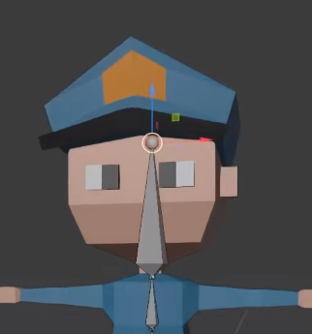

Rename the bones – root / spine1 / spine2 / head

[click on bone in edit mode and press F2]

Extrude a shoulder bone from the start of the Head bone, like so: -

Make sure to return to front view for this: -

Extrude bone to elbow, bone to wrist, and one final bone in the hand

Go to an above view, and make sure to flex the elbow slightly –

So it doesn’t “lock” out when being posed.

Rename the bones and include “.L” at end of all, this will allow us to magically mirror to his right side later

Shoulder.L / UpperArm.L / LowerArm.L / Hand.L

Extrude a bone straight down from the root bone, but then move it using g to start from the hip area

This bone should reach from the hip right to the centre of your knee joint

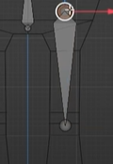

Put in lower leg and foot like this and make sure to put a little bend in the knee: -

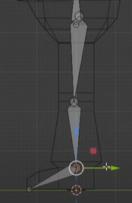

Rename – UpperLeg.L, LowerLeg.L, Foot.L

We are now almost ready to mirror to the right side, but finally we need to “inverse kinematics” to the legs so that they pose more naturally especially as we run / walk animate.

And even before that, go to front view, select all Armature – press Shift+N and select “recalculate roll” >> This makes animation smarter later, especially in terms of symmetry and pasting animations from left to right.

Now let’s place the IK bones – extrude from knee and heel as follows (note in side view 3 on numpad after 1 front view): -

We’re are going to use the knee spur bone as a “pole” bone – this will be used to keep the knee pointing in a natural way during animations.

Select it and press “Alt + P” and select “Clear Parent”

Now move it to approx. this location slight above the knee:-

Also, with this bone selected turn off the “deform” option here: -

The Ankle bone can stay where it is, but do also “Clear Parent” on it and untick “Deform” option.

Rename the knee pole bone: “IKLegPole.L” (F2) and the ankle bone “IKTarget.L”

Click the lower leg bone, and press control tab and switch into “Pose Mode”

Click on “Bone constraints” tab and “Add a bone constraint”

And select the “Inverse Kinematics” type

Target should be set to “Armature” you can do this by using the dropper and clicking on the upper leg bone.

Bone: IKTarget.L

Similar for Pole Target: -

At this moment the footbone should have been flipped out to the side.

Fix this by changing the “pole angle” – set it to 90 degrees

[ed – I needed **minus 90** in my worked along example]

The leg is actually not attached / related to the spine at present, we need to fix this so that, for example crouching down with the spine affects the legs.

So go back to Edit mode – select the upper leg bone first, then shift select the root bone and press “Ctrl + P” but select “keep offset”

You’ll see a dotted line appear showing they are now connected

Now return to the lower leg and Pose Mode – and set parameter “chain length” to 2 – this means only lower leg and upper leg affected by the IK constraint

At this point, the skeleton is not connected to the body but you can start to play a bit in pose mode – drop the spine and see the legs crouch. Grab the ankle target and move it and see the leg bend naturally – one problem is the foot is not right yet, we’ll fix that next.

(when you crouch, the foot drops)

Select the Foot bone

Disable “inherit rotation” here in “Relations” section: -

But not quite there, with the foot bone selected, add a bone constraint and select “Copy Rotation” this time.

Select the target bone in this constraint: -

This will rotate it right on top of the target bone, to fix change target and owner to “local space”.

To get proper rotation / roll behaviour – select the Y and Z axis in the invert row: -

Finally all done! We can now mirror / symmetrise to get all his right hand side for free!

Select the Armature in object mode, tab into edit mode, A to select all the bones

And now for some blender magic – press F3 and type symmetrise and select the symmetry option and hey presto the skeleton is automatically completed!

Now the next step is to finally link the actual character model and the armature, do this as follows:-

Return to Object mode, select the character **first**, then shift select the Armature [order is essential]

Press CTRL+P and select “armature deform – with automatic weights”

Can now in “Pose Mode” start to move the skeleton and see the whole character begin to move!

But HAT and the EYES will not move – this can be fixed..

If you experiment with posing, to get back to the original t-pose you can use the following two shortcuts – 1 : ALT + R and 2: ALT + G resets all the rotations and moves in the pose

You will probably see if you move the leg forward that the characters belt is deforming way too much, this can be lessened using the “Weight Painting” technique.

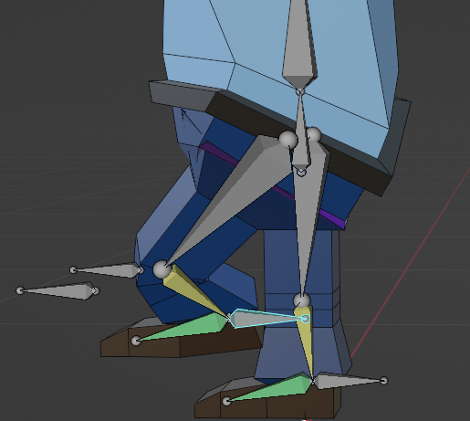

Go back to Object mode, select the character, then go to edit mode and vertex select mode.

Each vertex has a “weight” association with each bone in the armature, this came from the “automatic weights” option we took earlier.

[Actually vertex weights associated with which bone can be seen in Item tab on top right]

You can in theory just change the weighting here but it would be laborious and tricky to do each vertex in turn instead we use weight painting technique.

Select the Armature first then shift select the character and choose “Weight painting” mode.

Selecting bones in turn shows you the weight or influence on areas of the model. The lighter the colour the stronger the effect.

Select the upper leg bone with “Shift + Select”. Slight the weight in the paint brush down to zero – and paint all around the waist / belt

Fixing the Eyes to the head: -

Go into Edit mode on the character – Press “L” whilst hovering over the eye – the whole eye should select

This unlinks the eye from any bone.

Now to weight 100% to head bone –

Do “Select Active Group” >> Head

And “Assign to Active Group”

And finally we need the Hat to follow the head also – as this is a completely separate object we use a slightly different technique: -

In object mode, select the Hat object, then go to “Object Constraints” properties tab: -

Add a “Child Of” constraint

Set Target to Armature and Target Bone = Head

Hat will come off and go to weird angle – fix as follows: -

Click on “Set Inverse” to bring it back

AND THAT’S IT!! – Next stop – RIGGED ANIMATION!