Build a retro rocket in Blender
  - Student modelling lab
Build your own playful rocket with a rounded cream body, red swept fins, a recessed porthole and a metal engine. Keep every main part editable, then light and render your finished model.
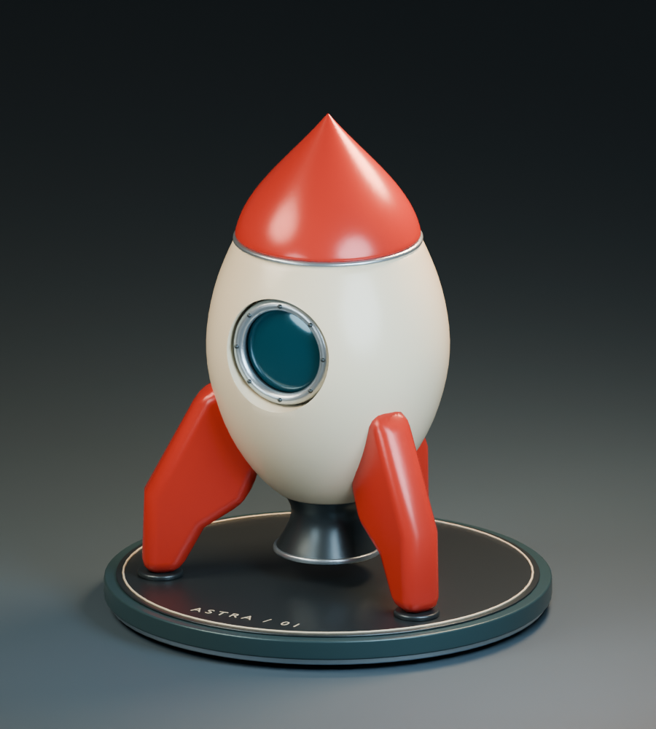
Your reference model. Aim for a similar silhouette; your colour choices and details can be your own.

What you will learn
Turn a circle into a curved body with extrusion and scaling; make a solid fin from an outline; duplicate parts around a centre; cut a recess with a Boolean; use modifiers, materials and area lights.

Before you begin
You already know how to select, orbit and navigate. This lab uses Blender 5.0 terminology and keyboard shortcuts with the standard Blender keymap. No add-ons or Python are needed.
Allow about three 60–75 minute club sessions, with extra time for finishing. Work at your own pace and save at every checkpoint.
Name __________________________ Rocket name __________________________

  - LAB 01

Set up your modelling scene
Start in a fresh file. All dimensions are Blender units. The rocket stands along Z; its porthole faces front, toward negative Y.
1. Save a new file. Choose File > New > General. Save any earlier work first. Use File > Save As and name this file YourName_RetroRocket.blend.
2. Clear the starter objects. In Object Mode, select the default cube, camera and light, then press X and confirm. We will create our own camera and lights later.
3. Reset the centre. Press Shift+S and choose Cursor to World Origin. Keep the 3D cursor here while building. Use the default Median Point pivot.
4. Make parts easy to find. Rename the starting Collection to Rocket in the Outliner. Add new objects in Object Mode so they remain separate. Press F2 after adding each object to name it.

How to read the instructions
A sequence such as E, Z, 0.16, Enter means press each key in order. A plus sign means hold keys together, such as Shift+A. Press Enter after each numeric transform. Decimal points use a dot.
Command | What it does
Tab | Switch between Object Mode and Edit Mode
Shift+A | Add a new object or mesh
G / R / S | Move / rotate / scale; follow with X, Y or Z
E / F | Extrude selected geometry / fill a boundary
N | Open the sidebar for exact coordinates
F3 | Search for an operation or modifier
Ctrl+Z / Ctrl+S | Undo / save the file

Two habits that prevent surprises
Check the mode in the top left before each step. Edit Mode changes the vertices inside one object; Object Mode moves or adds whole objects.
After scaling a whole object, use Ctrl+A > Scale in Object Mode before adding Bevel or Solidify. This keeps modifier widths predictable. Leave modifiers unapplied so you can adjust them later.
Checkpoint The scene is empty, the cursor is at the origin and your own file is saved. You are ready to build, not just watch.

  - LAB 02

Extrude the rounded body
A stack of circular rings controls the silhouette. Wider middle rings make the rocket look plump and playful.
1. Start the first ring. In Object Mode add Mesh > Circle with Shift+A. Immediately press F9: set Vertices to 48, Radius to 1 and Fill Type to Nothing. Click away, press F2 and name it Fuselage.
2. Make the bottom cap. Press Tab for Edit Mode; press A, then S, 0.53, Enter. Move it with G, Z, 1.30, Enter. Press F to fill the circle. Keep the face selected.
3. Build upward. For each row below, extrude with E, Z, the rise value, Enter; then S, the scale factor, Enter. Do not select the whole mesh between rows. Only the new top face stays selected.
Ring | Rise along Z | Scale factor | Target height | Target radius
2 | 0.04 | 1.0377 | 1.34 | 0.55
3 | 0.16 | 1.3818 | 1.50 | 0.76
4 | 0.50 | 1.4737 | 2.00 | 1.12
5 | 0.65 | 1.1786 | 2.65 | 1.32
6 | 0.50 | 1.0152 | 3.15 | 1.34
7 | 0.58 | 0.9104 | 3.73 | 1.22
8 | 0.42 | 0.8402 | 4.15 | 1.025
9 | 0.04 | 0.9951 | 4.19 | 1.02

4. Smooth the shape. Press A, then Shift+N to recalculate normals outward. Return to Object Mode with Tab. In Modifier Properties, choose Add Modifier and search Subdivision Surface. Use Catmull-Clark, Viewport 1 and Render 2. Right-click the body and choose Shade Smooth.
The top and bottom caps are large faces called n-gons. They work here because the visible silhouette comes from the surrounding rings and the end caps are covered by other parts. Keep the body closed for the later Boolean.
Checkpoint In front view the middle is broad, the tail narrows, and the top is gently rounded. The body is about 2.7 units wide and runs from Z 1.3 to 4.2.

Pause and explain
Why are the last two rings so close together? They help the upper edge hold its shape when subdivision smooths the mesh. Save your file.

  - LAB 03

Build the red nose
Use the same ring method for a short, curved nose that ends in a point. Keep it as its own object.
1. Add the base. Return to Object Mode. Add a new Circle with 48 vertices, radius 1 and no fill. Name it Nose. In Edit Mode select all, scale by 1.015, move along Z by 4.19, then press F to fill.
2. Shape the nose. Keep the top face selected. Work through this table using E, Z, rise, Enter followed by S, factor, Enter, exactly as for the body.
Ring | Rise along Z | Scale factor | Target height | Target radius
2 | 0.04 | 1.0049 | 4.23 | 1.02
3 | 0.22 | 0.9412 | 4.45 | 0.96
4 | 0.25 | 0.8438 | 4.70 | 0.81
5 | 0.26 | 0.7284 | 4.96 | 0.59
6 | 0.27 | 0.5593 | 5.23 | 0.33
7 | 0.25 | 0.3030 | 5.48 | 0.10
8 | 0.12 | 0.05 | 5.60 | 0.005

3. Finish the surface. Select all and press Shift+N. Return to Object Mode. Add Subdivision Surface with Viewport 1 and Render 2, then Shade Smooth. Leave the tiny top ring in place; subdivision makes it appear pointed.
4. Add the seam ring. In Object Mode add Mesh > Torus. Immediately use F9: Major Segments 64, Minor Segments 12, Major Radius 1.025 and Minor Radius 0.025. Leave rotation at zero. Set its Location Z to 4.19 in the N sidebar. Name it Nose_Seam and Shade Smooth.
Checkpoint The seam ring covers the join, with no visible gap between nose and body. Orbit around the back as well as checking the front.

Make a design choice later
Once your whole rocket works, try changing the nose height. In Edit Mode select its vertices and scale along Z around an appropriate pivot, or move individual rings with X-Ray enabled. Keep the base aligned with the body.
For now, keep the guide dimensions so the later measurements fit. Save your file before starting the fins.

  - LAB 04

Draw one chunky fin
Build an eight-point outline in the XZ plane, then give it thickness. The numbered diagram shows the order of the vertices.
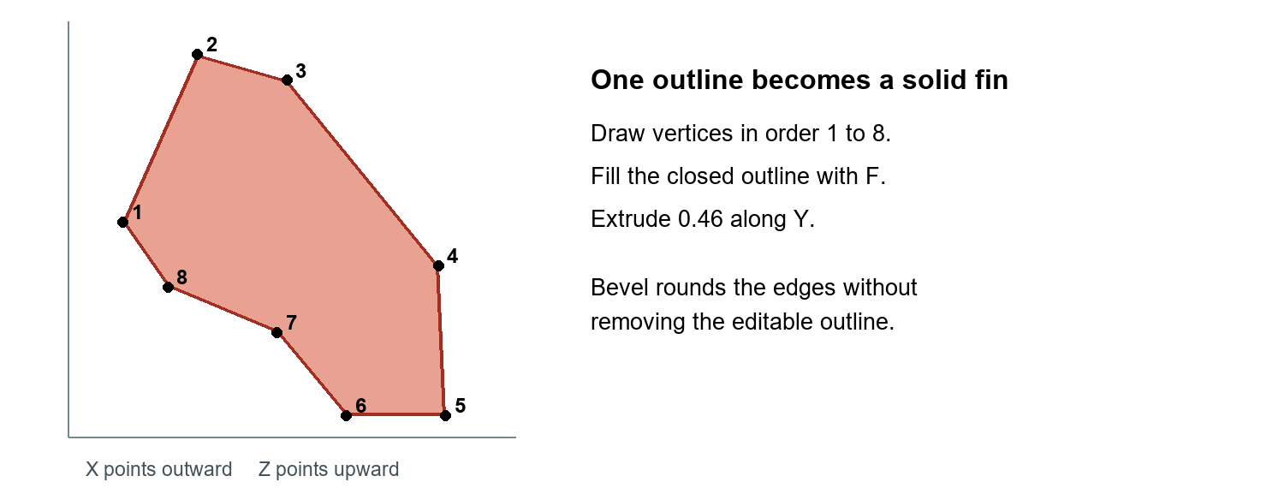
Fin outline viewed from the front before rotation. Its Y thickness is added after the face is filled.
1. Make one vertex. Add a Plane in Object Mode and name it Fin_01. Enter Edit Mode, select all, then press M > At Center. In the N sidebar Item tab, set this vertex to X 0.72, Y -0.23, Z 1.62.
2. Trace the outline. For each next vertex, press E then right-click to cancel only its movement. A new vertex still exists. With just that vertex selected, enter its X and Z below in the N sidebar; Y stays -0.23. Do not press E twice for one row.
Vertex | X | Z | Vertex | X | Z
1 start | 0.72 | 1.62 | 5 | 2.02 | 0.43
2 | 1.02 | 2.65 | 6 | 1.62 | 0.43
3 | 1.38 | 2.49 | 7 | 1.34 | 0.94
4 | 1.99 | 1.35 | 8 | 0.90 | 1.22

3. Fill and thicken. After vertex 8, press A then F to close and fill the outline. Press E, Y, 0.46, Enter. Select all and press Shift+N. Return to Object Mode.
4. Round the edges. Add a Bevel modifier: Amount 0.16, Segments 3, Limit Method Angle. Then add Weighted Normal and enable Keep Sharp. Right-click > Shade Smooth. Keep both modifiers.
Checkpoint You have one thick, swept fin. Orbit to confirm it is a solid slab, not a flat face. Its lower edge reaches Z 0.43. Save.

  - LAB 05

Arrange the fins and build the base
All three fins use the world centre as their origin, so they rotate neatly around the body.
1. Space the fins. Select Fin_01 in Object Mode. Press R, Z, 90, Enter. Duplicate with Shift+D, then right-click to cancel movement; press R, Z, 120, Enter and name it Fin_02. Repeat once from Fin_02, name it Fin_03. Keep exactly three fins.
2. Make the engine. In Object Mode add Mesh > Cone. Immediately press F9: Vertices 64, Radius 1 = 0.60, Radius 2 = 0.36, Depth 0.65. Set Location to (0, 0, 0.975). Name it Engine_Nozzle. The wide opening is at the bottom.
3. Open the nozzle. Enter Edit Mode, switch to Face Select and deselect all. Orbit underneath and select only the large bottom circular face, with X-Ray off. Press X > Only Faces. The top face must remain. Return to Object Mode.
4. Give it a wall. Add Solidify with Thickness 0.06, Offset -1 and Fill Rim enabled. Add Bevel after it: Amount 0.02, Segments 3. Shade Smooth. Add a separate Torus at (0, 0, 0.65), Major Radius 0.57, Minor Radius 0.025; name it Engine_Lip.
5. Add the platform. Add a Cylinder with 64 vertices, Radius 2.43, Depth 0.30 and Location (0, 0, 0.23). Name it Platform. Add Bevel with Amount 0.06, Segments 3, then Shade Smooth.
6. Add the feet. Add three separate Cylinders using the values below. Each has 32 vertices, Radius 0.25 and Depth 0.065. Name them Foot_01 to Foot_03. Add Bevel 0.02, Segments 3 to each.
Part | Location X | Location Y | Location Z
Foot_01 | 0 | 1.82 | 0.412
Foot_02 | -1.576 | -0.91 | 0.412
Foot_03 | 1.576 | -0.91 | 0.412

Checkpoint The platform top is at Z 0.38. Each foot touches it and supports a fin. The nozzle hangs above the platform with a clear gap. Inspect from the back to find the third fin.
If the fins rotate in place, their origins were moved. With the cursor still at world zero, use Object > Set Origin > Origin to 3D Cursor, then set Z rotations to 90, 210 and 330 degrees. Save.

  - LAB 06

Cut a real porthole recess
The cutter removes a pocket from the body. Keep the cutter as an editable helper; hide it instead of deleting it.
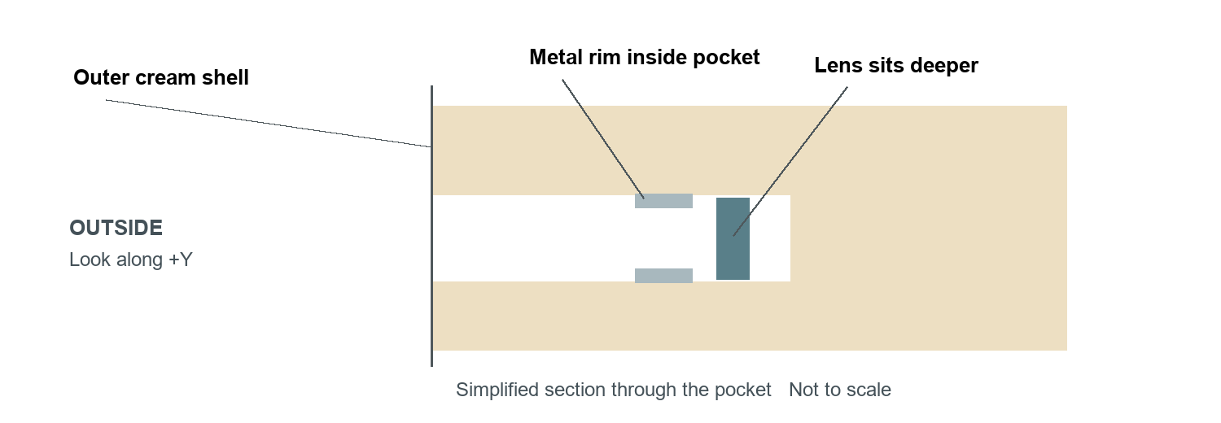
A recessed porthole has a visible shell edge in front of its rim and lens. This is a pocket, not a hole through the whole rocket.
1. Create the cutter. In Object Mode add a Cylinder. In F9 set Vertices 96, Radius 0.625 and Depth 2. Name it Porthole_Cutter. In the N sidebar set Location (0, -1.85, 3.18) and Rotation (90°, 0°, 0°). It points along Y into the front of the body.
2. Subtract the pocket. Select Fuselage. Add a Boolean modifier below Subdivision Surface. Set Operation to Difference, Solver to Exact, and use the Object eyedropper to choose Porthole_Cutter from the viewport or Outliner.
3. Hide the helper correctly. Select the cutter and press H to hide it in the viewport. In the Outliner filter menu, enable the camera restriction column, then turn off the cutter’s camera icon to hide it in renders too. Keep the cutter object in the file.
4. Soften the opening. Select Fuselage again. Add Bevel below the Boolean: Amount 0.025, Segments 3, Limit Method Angle. The stack order must be Subdivision Surface, Boolean, Bevel.
Checkpoint Orbit around the front: the pocket has cream side walls and a back surface. It stops inside the body. It does not appear on the back of the rocket.

If the recess does not appear
Check the Boolean is on Fuselage, not on the cutter; it uses Difference; and its Object field names Porthole_Cutter. Confirm the cutter dimensions and that it intersects the front of the body. Press Alt+H to reveal hidden objects if you need to adjust it, then hide it again.
Keep both meshes closed. If the result looks broken, select each mesh in Edit Mode, press A then Shift+N, and return to Object Mode. Save.

  - LAB 07

Fit the rim and lens inside
Add the porthole pieces in Object Mode. The front of the rocket is negative Y, so a more negative Y value sits farther toward the viewer.
1. Make the metal rim. Add a Torus. In F9 set Major Segments 64, Minor Segments 12, Major Radius 0.53 and Minor Radius 0.065. Name it Porthole_Rim. Set Location (0, -1.045, 3.18) and Rotation (90°, 0°, 0°). Shade Smooth.
2. Add a dark seal. Add another Torus with Major Radius 0.535 and Minor Radius 0.066. Name it Porthole_Seal. Use Location (0, -1.015, 3.18), Rotation (90°, 0°, 0°), then Shade Smooth.
3. Add the blue lens. Add a UV Sphere with Radius 1, Segments 48 and Rings 24. Name it Porthole_Lens. Set Location (0, -0.965, 3.18), Rotation (0°, 0°, 0°) and Scale (0.48, 0.065, 0.48). Apply Scale with Ctrl+A > Scale, then Shade Smooth.
4. Darken the pocket behind it. Add a Cylinder with Radius 0.608, Depth 0.025 and 64 vertices. Name it Porthole_Back. Set Location (0, -0.884, 3.18) and Rotation (90°, 0°, 0°). This disk will use the dark seal material.
Checkpoint The rim fits within the opening and the lens is slightly behind the rim. Viewed at an angle, you can see a cream inset edge. The lens should not bulge beyond the body.

Optional rivets
Add a small UV Sphere of radius 0.026 at each location below. Use 12 segments and 8 rings. Name them Rivet_01 to Rivet_08 and use a dark metal material. All have Y = -1.11.
Rivet | X | Z | Rivet | X | Z
1 | 0 | 3.71 | 5 | 0 | 2.65
2 | 0.375 | 3.555 | 6 | -0.375 | 2.805
3 | 0.53 | 3.18 | 7 | -0.53 | 3.18
4 | 0.375 | 2.805 | 8 | -0.375 | 3.555

Do not join the lens, rim and body. Separate objects make later changes much easier. Save your file.

  - LAB 08

Add colour and brushed metal
Materials describe how surfaces reflect light. Use Material Preview while choosing colours; the final render will use your own studio lights.
1. Create your first material. Select Fuselage, open Material Properties and click New. Rename it Ivory_Enamel. In the Principled BSDF settings, enter the values below. Hex colours go in the colour picker’s Hex field; use alpha FF if shown.
2. Reuse materials. Create the remaining materials on one object each. For other objects that need the same surface, choose that existing material from the material dropdown instead of making another copy.
Material | Hex colour | Metallic | Roughness | Assign to
Ivory_Enamel | EADBC0 | 0 | 0.27 | Fuselage
Red_Enamel | C63728 | 0.12 | 0.26 | Nose and fins
Brushed_Metal | BAC5CA | 0.86 | 0.30 | Rim, seam, engine lip
Dark_Metal | 414C50 | 0.75 | 0.34 | Nozzle and rivets
Dark_Seal | 20282B | 0 | 0.50 | Seal, backing and feet
Blue_Lens | 075269 | 0.48 | 0.13 | Lens
Teal_Platform | 355158 | 0.35 | 0.32 | Platform

3. Give the lens a polished finish. On Blue_Lens, expand Coat and set Weight to 0.6. Leave Transmission Weight at 0. This is a stylised opaque blue lens; it does not need realistic transparent glass to look good.

Optional fine brushing
4. Add texture to Brushed_Metal. Select the rim and open the Shading workspace. In the Shader Editor add Texture Coordinate, Vector Math set to Multiply, Noise Texture and Bump nodes. Keep the existing Principled BSDF connected to Material Output.
5. Connect the nodes. Connect Generated to Multiply’s first Vector input. Set its second Vector to (1, 1, 0.035). Connect Multiply’s Vector output to Noise Vector; set Noise Scale 150 and Detail 2. Connect Noise Fac to Bump Height, then Bump Normal to Principled Normal.
6. Keep it subtle. Set Bump Strength to 0.11 and Distance to 0.018. This is a lightweight procedural approximation of brushing, with no image textures required.
Checkpoint Cream, red and metal are clearly distinct. If the metal looks scratched or lumpy, reduce Bump Strength. Save.

  - LAB 09

Build a small studio
A large floor and three soft lights give the model readable edges, gentle shadows and attractive reflections.
1. Add the floor. In Object Mode add a Plane at the origin. Set its Dimensions X and Y to 200 in the N sidebar, then apply Scale. Name it Studio_Floor. Give it a new material: Hex 3C4D57, Metallic 0, Roughness 0.62.
2. Add the camera. Add a Camera. Name it Camera_Hero. Enter Location (8, -15, 8) and Rotation (72.84°, 0°, 28.07°). In Camera Data Properties choose Orthographic and set Orthographic Scale to 7.9. This frames the model around Z 2.75.
3. Check the frame. Use View > Cameras > Active Camera, or Numpad 0. In Output Properties set resolution to 900 × 1000 at 100%. The nose and platform should fit with clear space around them.
4. Add three Area lights. Use Shift+A > Light > Area for each. Enter the values below in the N sidebar and Light Data Properties. Rotation values are degrees in XYZ order. Set Shape to Disk. Leave light colours white initially.
Light | Location XYZ | Rotation XYZ | Power | Size
Key | -5, -6, 9 | 52.47, 0, -39.81 | 1050 W | 5
Fill | 5, -3, 5 | 71.07, 0, 59.04 | 750 W | 4
Rim | 2, 4, 8 | 41.81, 0, 153.43 | 1400 W | 3

5. Set up a quick render. In Render Properties choose Cycles, set Render Max Samples to 32 and enable Denoise. In Color Management use AgX. CPU rendering is fine; use a configured GPU if your teacher has set one up.
6. Render and save the picture. Press F12. When the render is finished, use Image > Save As in the render window and save a PNG named YourName_Rocket_Hero.png. Saving the .blend alone does not save this picture.
Checkpoint You can see the cream body, red fins and metal rim without large black areas or blown-out highlights. The cutter is invisible. Save the .blend again.
Optional: tint the key slightly warm and the fill slightly cool. Change one light at a time, then compare renders. Larger lights soften shadows and broaden reflections.

  - LAB 10

Inspect and improve your rocket
A good model works from more than one viewpoint. Use the same checks a modeller would use before handing work to someone else.
1. Save two more views. Duplicate Camera_Hero twice. For Camera_Front set Location (0, -16, 6.8) and Rotation (75.80°, 0°, 0°). For Camera_Rear set Location (-10, 13, 7.4) and Rotation (74.17°, 0°, -142.43°). Keep Orthographic Scale 7.9.
2. Choose the camera to render. Select the camera you want in the Outliner, then use View > Cameras > Set Active Object as Camera, or Ctrl+Numpad 0 with the mouse over the viewport. Press F12 and save each PNG with Front or Rear in the name.

Final inspection checklist
[ ] There are exactly three separately editable fins, evenly spaced around the body.
[ ] The nose meets the body; no cracks are visible from the back.
[ ] The rim and lens are inside a genuine recess, with no stray cutter in the render.
[ ] The fins and feet touch the platform; the nozzle has space below it.
[ ] Objects have meaningful names and useful modifiers are still editable.
[ ] The whole rocket fits in all three images, with readable lighting.

Fix a problem before you finish
What you see | What to check
A cylinder covers the porthole | Turn off the cutter’s render camera icon, not just its viewport eye.
A very wide or uneven bevel | Apply object Scale; check the bevel amount and modifier order.
Fins overlap or spin in place | Set fin origins to the world-centred cursor; check Z rotations 90, 210, 330.
Dark or broken mesh patches | In Edit Mode select all and use Shift+N. Check for duplicate vertices or extra extrusions.
A flat or invisible recess | Boolean belongs on Fuselage; Difference uses the correct intersecting cutter.
A camera points away | Use XYZ Euler rotation, enter degrees, and check the active camera.

Checkpoint Save your final .blend and three PNGs. Show a partner one change you made after inspecting a render.

  - LAB 11

Make it your own
Complete the main build first. Then choose one or two extensions and explain how your changes affect the design.
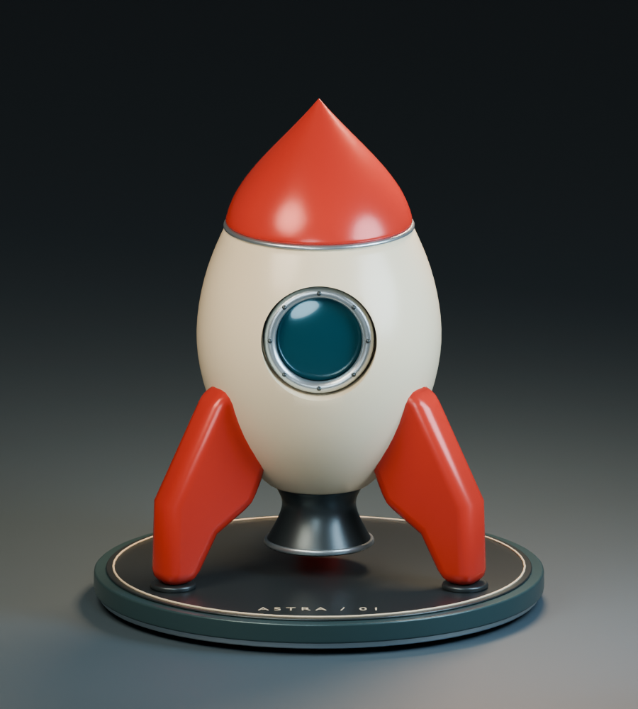
Front reference. Compare the width of the body, the short nose and the wide stance of the fins.

Choose a challenge
A. Change the personality. Try a taller nose, a wider body or shorter fins. Keep a saved copy before experimenting. Adjust connected parts so the nose seam and porthole still fit.
B. Add a platform inlay. Add a Torus at (0, 0, 0.385), Major Radius 2.22 and Minor Radius 0.012. Use ivory or metal. Keep it separate from the platform.
C. Invent a colour scheme. Keep the body and fins visually distinct. Render your original and new palette under the same lighting so the comparison is fair.
D. Make a maintenance hatch. Try a second small recess on the back using a new cutter. Keep enough body between the two pockets and name the new helper clearly.

Explain your modelling choices
Which operation added thickness to your fin? __________________________________
Why did you hide the Boolean cutter instead of deleting it? _______________________
What does Subdivision Surface change? _______________________________________
Which change made your rocket feel more playful, and why? ______________________

  - LAB 12

Teacher notes
Start after your introduction to selection and navigation. Students model from scratch. Keep Retro_Rocket.blend and retro_rocket.py as teacher references, separate from students’ files.

Suggested session plan
Session | Student work | Teaching focus
1 60–75 min | Labs 1–4: setup, body, nose and one fin | Model together through the first two body extrusions. Check mode, selection and scale factors before students continue.
2 60–75 min | Labs 5–7: fins, base and recessed porthole | Demonstrate origin versus geometry, then the Boolean stack. Check cutter viewport and render visibility separately.
3 60–75 min | Labs 8–11: materials, lighting, inspection and personalisation | Render small previews early. Ask students to identify one defect, fix it and explain the improvement.

Support and stretch
For students who need support, omit rivets and procedural brushing, and demonstrate the single-vertex fin outline together. Pause at each checkpoint. If a pupil loses the selected top face during extrusion, help them reselect only that face before continuing.
For faster students, ask them to alter the silhouette while keeping the nose join, platform contact and porthole fit correct. Ask why the model uses a separate nose and three separate fins rather than one joined mesh.

What to look for
A successful submission includes a saved .blend, three PNG views, the named main parts, three fins at 120° spacing, a real recessed porthole, and retained modifiers. Assess whether students can explain extrusion, subdivision, bevel and Boolean, as well as the finished appearance.
Expected answers: extrusion adds fin thickness; a live Boolean still needs its cutter; subdivision adds geometry and smooths the control mesh. A wider body, shorter nose and thicker rounded fins tend to give this design a playful silhouette.

Reference and lesson preparation
The dimensions follow the classroom rocket reference. The nozzle and platform are deliberately simpler than the reference render. Preview the lesson on your classroom Blender version; labels can vary between versions and keymaps.
Useful official Blender Manual topics: Mesh Primitives; Boolean Modifier; Bevel Modifier; Introduction to Modifiers. Search these titles in the manual if a menu label differs.
docs.blender.org/manual/en/latest/modeling/meshes/primitives.html
docs.blender.org/manual/en/4.4/modeling/modifiers/generate/bevel.html
docs.blender.org/manual/en/latest/modeling/modifiers/introduction.html

