Guidelines to Install & Run Prodigy via Docker
- I’m getting started with Docker and Prodigy for the first time → go to 1)
- I have already installed Docker (for Windows: and ‘make’ via chotolatey) and just want to install the latest Prodigy container → skip to 3)
- I have already installed the latest Prodigy container and just want to run it→ skip to 4)
- I’ve got an error! Skip to Some Common Errors
1) Install Docker Desktop:
- Linux: https://docs.docker.com/desktop/install/linux-install/
- Mac: https://docs.docker.com/desktop/install/mac-install/
Note: there are two docker versions, depending on whether your mac has an Apple silicon processor or an Intel processor. You can see the information about your processor by clicking on the Apple logo in the top-left corner of your screen, select “About this Mac” and look for the “Processor” or “Chip” information. If you can see Apple M1, M2 or M3 anywhere, you have an Apple Silicon Processor, otherwise an Intel processor
- Windows: https://docs.docker.com/desktop/install/windows-install/
Verify your installation by opening a terminal (or PowerShell in case of Windows) and running the following two command:
docker --version; docker compose version
This should output something like:
Docker version 25.0.5, build 5dc9bcc
Docker Compose version v2.24.6-desktop.1
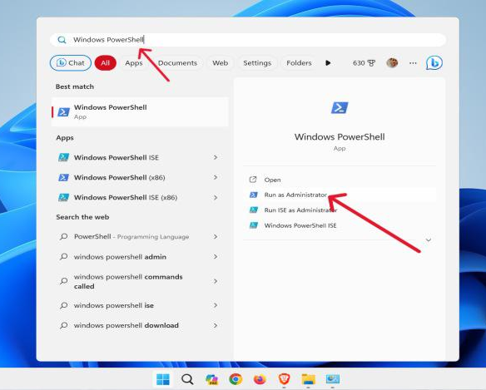
2) For Windows users only: Additionally, install Make. A convenient way to do so is via the packet manager Chocolately.
Open the PowerShell as Administrator
(right click on PowerShell > Run as Administrator,
s. screenshot)

Run the following in PowerShell to install Chocolately:
Set-ExecutionPolicy Bypass -Scope Process -Force; [System.Net.ServicePointManager]::SecurityProtocol = [System.Net.ServicePointManager]::SecurityProtocol -bor 3072; iex ((New-Object System.Net.WebClient).DownloadString('https://community.chocolatey.org/install.ps1'))
Close PowerShell and open it again as Administrator (s. instruction above). Then install Make via the following command in the PowerShell:
choco install make -y
3) Install container: Unzip PsychNER_prodigy.zip and open a terminal within the folder PsychNER. Run the following command to install the container:
make build
4) Run container: Everything is now installed. Run one of the following command to start Prodigy in the container, depending on the dataset you will work with:
make start-50
make start-100
make start-ben
make start-julia
make start-bernard
make start-pia
5) Navigate to http://localhost:8080 in your web browser and start annotating given the guidelines. Additionally,

- Make sure to press the save button within Prodigy regularly!
- You only have to annotate the token level task when you see the abstract for the first time (the other two times, you don’t have to mark anything in the abstract).

6) If you want to export the data, run the following command:
make db-export
This will save a .jsonl file, named with current date and time, in the export folder.
7) When you finish your session, press the save button, open the terminal and run the following command to shut down the docker container:
make stop

Some common errors
- Cannot connect to the Docker daemon ... Is the docker daemon running?
Solution: Open the Docker Desktop app which will automatically restart docker.

- Bind for 0.0.0.0:8080 failed: port is already allocated
Solution: There is already another Prodigy Container running. Please navigate into the corresponding prodigy folder and run the command make stop.

If you can remember where/how you started this still running Container, you can still stop it with the following: Find the number of the docker container, by opening a Terminal or PowerShell and running docker ps. This will report something like this:
Copy the container id (e.g. 4980a71810a) and run docker stop <your_id> (e.g. docker stop 4980a71810a).

