Guidelines to Install & Run Prodigy via Docker as of 04.04.2024
1) Install Docker Desktop:
- Linux: https://docs.docker.com/desktop/install/linux-install/
- Mac: https://docs.docker.com/desktop/install/mac-install/
Note: there are two docker versions, depending on whether your mac has an Apple silicon processor or an Intel processor. You can see the information about your processor by clicking on the Apple logo in the top-left corner of your screen, select “About this Mac” and look for the “Processor” or “Chip” information. If you can see Apple M1, M2 or M3 anywhere, you have an Apple Silicon Processor, otherwise an Intel processor
- Windows: https://docs.docker.com/desktop/install/windows-install/
Verify your installation by opening a terminal (or PowerShell in case of Windows) and running the following two command:
docker --version; docker compose version
This should output something like:
Docker version 25.0.5, build 5dc9bcc
Docker Compose version v2.24.6-desktop.1
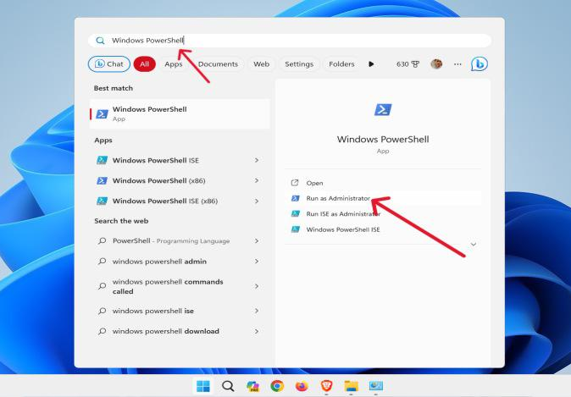
2) For Windows users only: Additionally, install Make. A convenient way to do so is via the packet manager Chocolately.
Open the PowerShell as Administrator (right click on PowerShell > Run as Administrator)

Run the following in PowerShell to install Chocolately:
Set-ExecutionPolicy Bypass -Scope Process -Force; [System.Net.ServicePointManager]::SecurityProtocol = [System.Net.ServicePointManager]::SecurityProtocol -bor 3072; iex ((New-Object System.Net.WebClient).DownloadString('https://community.chocolatey.org/install.ps1'))
Close PowerShell and open it again as Administrator (s. instruction above). Then install Make via the following command in the PowerShell:
choco install make -y

3) Unzip PsychNER_prodigy.zip and open a terminal within the folder PsychNER. Run the following command to start the docker container:
make start
4) Navigate to http://localhost:8080 in your web browser and start annotating given the guidelines below. Make sure to press the save button regularly.

5) If you want to export the data, run the following command:
make db-export
This will save a .jsonl file, named with current date and time, in the export folder.
6) When you finish your session, press the save button, open the terminal and run the following command to shut down the docker container:
make stop
Some common errors:
- Cannot connect to the Docker daemon ... Is the docker daemon running?
Solution: Open the Docker Desktop app which will automatically restart docker.

