**TEXT SUMMARIZATION**

Summarization is of two types:

# **EXTRACTIVE SUMMARIZATION:**

As the word suggests, we find important sentences from a text and put them together to give us the summary.

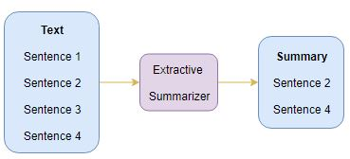

# **ABSTRACTIVE SUMMARIZATION**

Here, we form new sentences for our summary.

