AI Usage DISCLOSURE FORM

1. Team Details
Team Name: SRMIST_Puchkaz_______________
Project / Product Name: __Smart Guided Troubleshooting Engine (Theme 2)__________________
Organization / Institution (if any): SRMIST KTR_________________
Submission Date: _30/09/2026______________________

2. AI Usage Declaration
Did your team use any Artificial Intelligence (AI) in developing this project? Yes / No
_____Yes__________________________

3. Purpose of AI Usage ( Brief Details)
Idea generation / brainstorming _________ No_________
Code generation or assistance _______ Yes _________
UI / UX design ___________ No_____
Content creation ________ No________
Data analysis ______ Yes _________
Testing / debugging ______ Yes (Generating Pytest edge-case suites and debugging concurrency locks)________
Other ____________ N/A____________

4. Feature Origin Classification ( Please add/delete based on the number of the feature)
1. Feature Name - Stage 0 Enrichment & Zero-Hallucination Gate
2. Self-Generated/AI-Generated/Both: Both (AI-Assisted)
3. Description: Used Google Gemini / AI Assistant to generate and optimize strict Regular Expressions (_DEVICE_RE and _SYMPTOM_RE) to parse messy user inputs. Prompted AI to generate extreme edge-case unit tests (e.g., handling chaotic inputs like "aaaaaaarrrgghh"). We manually integrated and modified the validation logic to trigger the unclassified_issue fallback.
1. Feature Name - Semantic Deeplink Mapping (TF-IDF Penalty Logic)
2. Self-Generated/AI-Generated/Both: Both (AI-Assisted)
3. Description: Used AI to debug semantic collisions in our TF-IDF matrix (e.g., distinguishing between "Backup" and "Auto-Sync" which share similar keywords). Prompted AI to help formulate a dual-layer multiplier (0.5x penalty / 1.5x boost) based on strict action verb matching. Output was manually adapted to fit our specific device catalog schema.
1. Feature Name - Concurrency Locks & Deployment Setup
2. Self-Generated/AI-Generated/Both ________ AI-Generated___________
3. Description ( include AI tools/platform Used, prompt used , Output Summary, Modification) __________________ Description: Tool Used: Google Gemini. Prompt used: "Create a Dockerfile and docker-compose.yml for this FastAPI app, and make my semantic cache thread-safe." Output Summary: Generated the Docker deployment files and Python threading.Lock mechanisms. Modification: Minor path adjustments for deployment; used as generated to ensure the Semantic Cache remained memory-safe during high-concurrency testing.

5. Ethical & Compliance Confirmation
AI usage complies with guidelines and policies. Yes
No proprietary or copyrighted data misused. I Agree

6. Declaration & Sign-Off
Name of Team Representative: PRISHA AGARWAL
Role: Team Leader
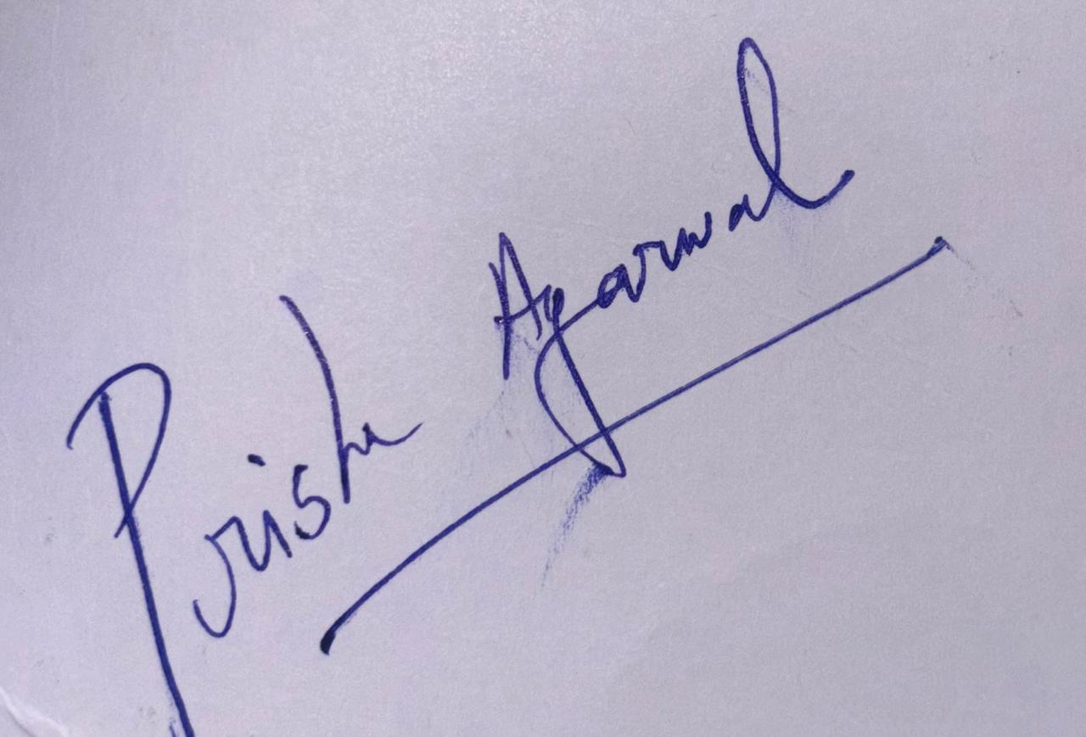
Signature:

Date: 30/09/2026

