# Combine and align images

## Take advantage of the new feature where images can now be aligned left, right, and center when combined into one

## Learn the difference between using green check mark to save changes and the Save icon

The Image combiner tool was available before but it wasn’t possible to align added images differently, there was only center alignment.

Use the Image combiner tool (located in the Tools submenu on the left) and add images to the frame by clicking the Add button or drag and dropping them into the frame.

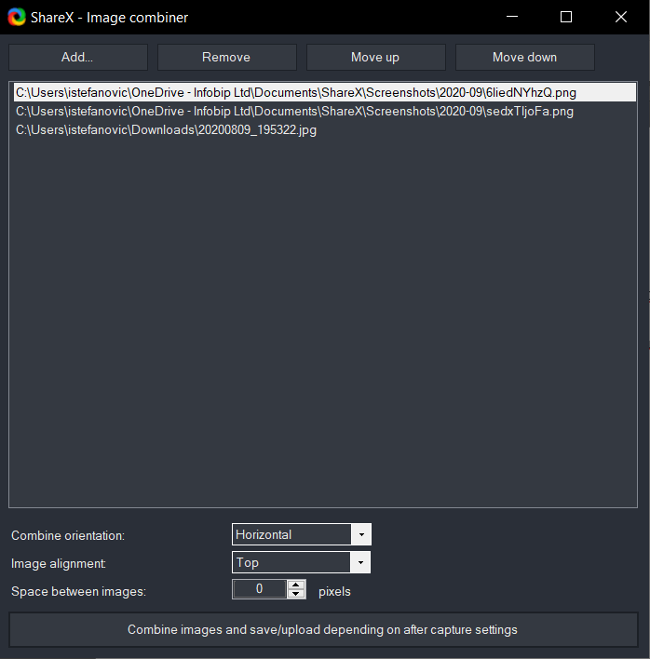

Use the *Move up* and *Move down* buttons to arrange the order of the images. It is also possible to move them up and down in the frame itself by drag and dropping them inside of it.

From the *Combine orientation* dropdown list select whether the images will be arranged vertically or horizontally.

The *Image alignment* dropdown list enables top, right or left alignment, depending on the wanted output.

The *Space between images* is calculated in pixels and can be entered either by using up and down arrow buttons, or manually (typing it in the box).

After arranging the images and the wanted output, click the bottom button – *Combine images and save/upload depending on after capture settings*. The application will display the combined images as one.

Depending on the personal settings, the image will either get saved automatically or will require confirmation that the output is ok. If it requires confirmation, click either the green check mark or the Save icon in the heading bar to save the changes.

## Checking after capture settings

If not sure where the settings for the required action after image capture are, follow these instructions.

1. Select the *After capture tasks* menu item on the left

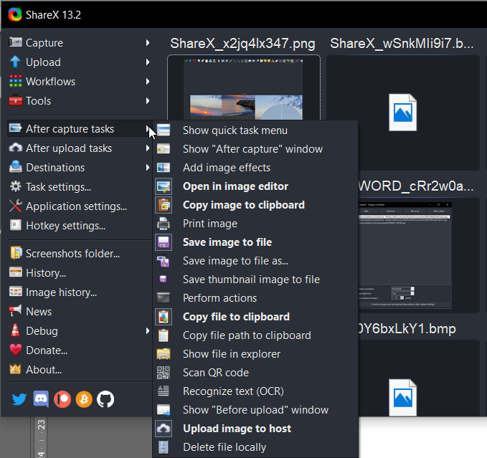

1. Check which of the available actions are bold. Those are currently turned on.
2. If *Open in image editor* is bold, that means the image will first open in the editor and will not be automatically saved, but will require confirmation that you want to save it. To save it, you can either confirm by clicking the green check mark or click the Save or Save as icons.

The difference between the green check mark and Save icons is that the check mark signifies all the selected After capture tasks (items in bold in the menu) will be run after you click it. Save icons will only perform the selected save function.

If we take the image above as an example, clicking the green check mark will run the following tasks:

* Open in image editor
* Copy image to clipboard
* Save image to file
* Copy file to clipboard
* Upload image to host

Depending on the actions you want to perform after capturing/creating an image, select or unselect menu items as often as required.