Пример

LDAP required.

Domain: LSBT.com  
ADDC: 172.20.142.106  
ADDC Full Name: SERVER.LSBT.com  
Computer account: WKRKM-VS

Liferay settings:

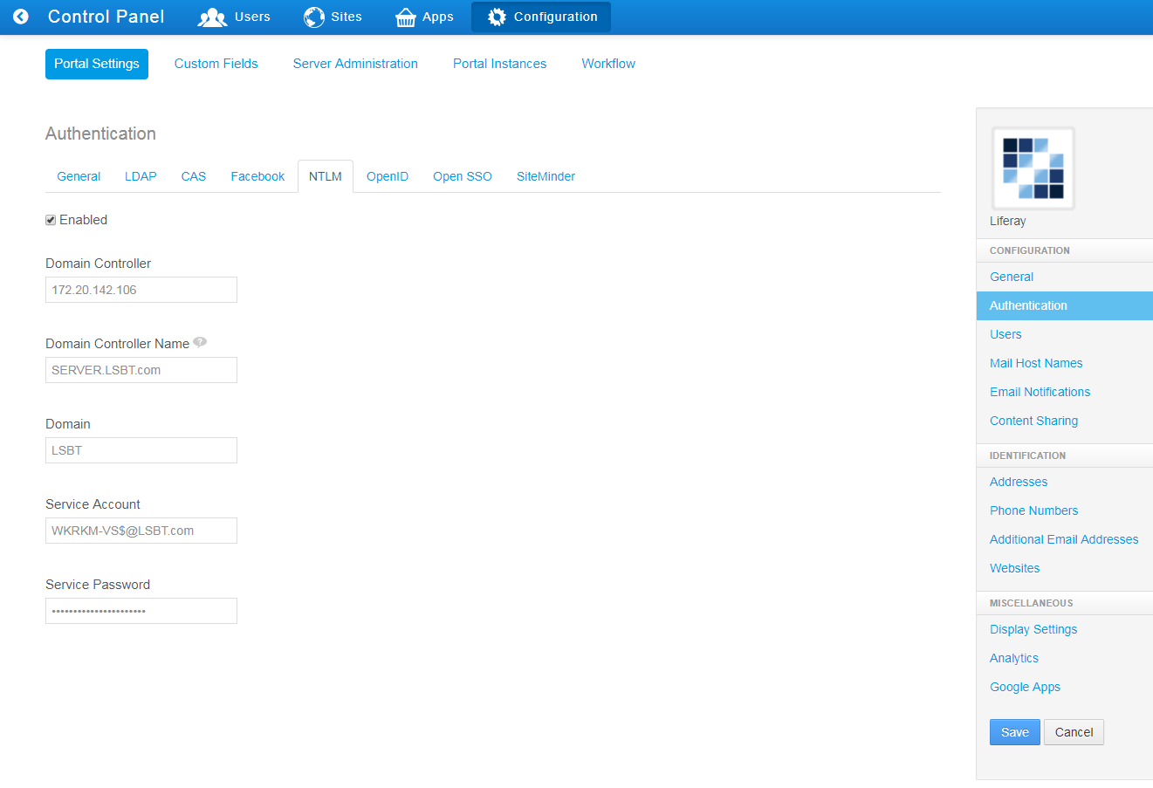

Computer account settings:  
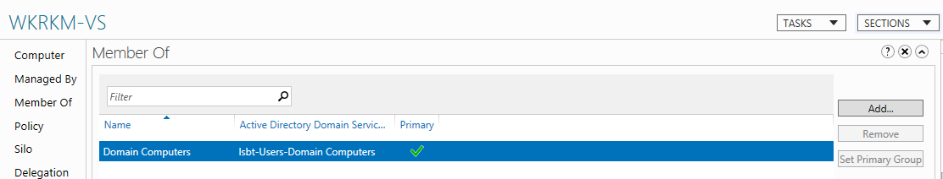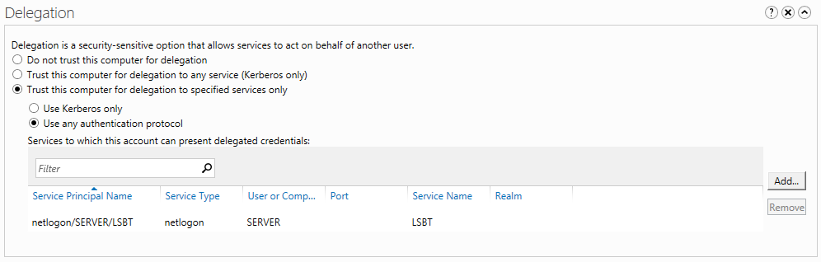

Two ways to set account password:  
1. You can use “ADSI Edit. Find computer account -> right-click -> Reset Password.  
2. Use next VBScript:  
Dim objComputer  
Set objComputer = GetObject("WinNT://LSBT/WKRKM-VS$")  
objComputer.SetPassword "1"  
Wscript.Quit