Лабораторно-практическая работа No 1

«Аффинный шифр»

1-2. m=256, k=(5,23).

def reverse(num):  
 a = 0  
 for i in range(1, 257):  
 if num \* i % 256 == 1:  
 a = i  
 break  
 return a  
  
  
def encrypt():  
 filename = input("Enter filename: ")  
 with open(filename, 'rb+') as fh:  
 content = bytearray(fh.read())  
 for i, byte in enumerate(content):  
 content[i] = (5 \* byte + 23) % 256  
 fh.seek(0)  
 fh.write(content)  
  
  
def decrypt():  
 filename = input("Enter filename: ")  
 with open(filename, 'rb+') as fh:  
 content = bytearray(fh.read())  
 for i, byte in enumerate(content):  
 content[i] = (reverse(5) \* (byte - 23)) % 256  
 fh.seek(0)  
 fh.write(content)  
  
  
option = input("Select action:\n1. Encrypt\n2. Decrypt\nAnykey. Exit\n")  
  
if int(option) == 1:  
 encrypt()  
elif int(option) == 2:  
 decrypt()  
else:  
 exit(0)

До

После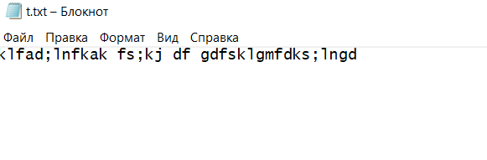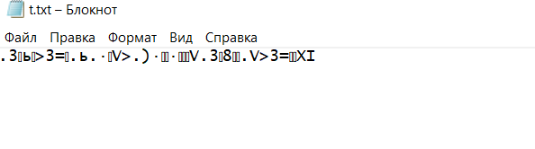

До

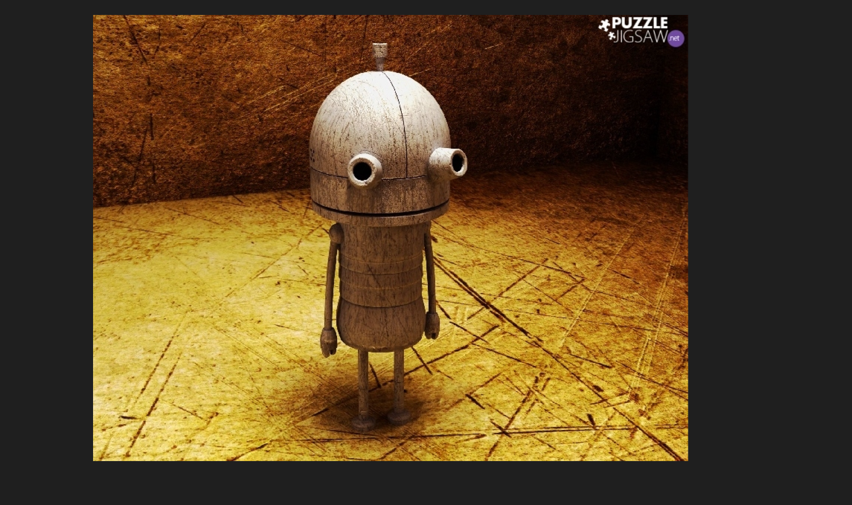

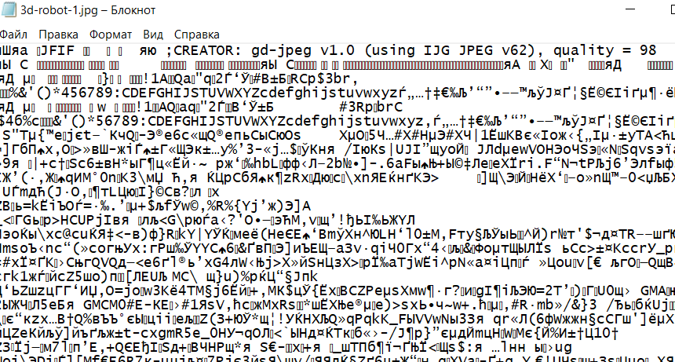

После

