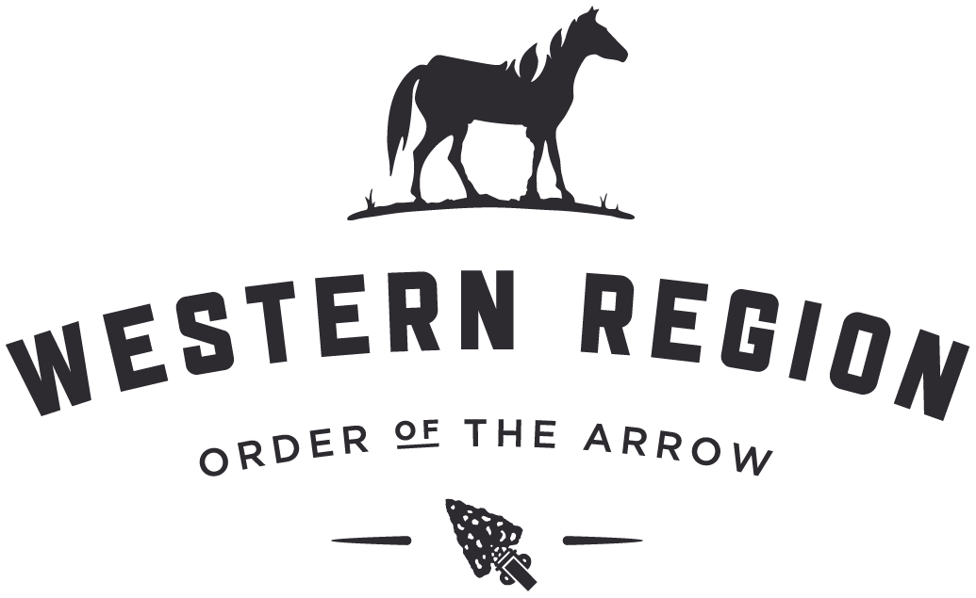

The Western Region Order of the Arrow Committee feels so strongly that the OA High Adventure program leaves a lasting impression and energizes the arrowmen that participate they would like to offer each and every Lodge in the Western Region a $300 scholarship that can be used to cover participation fees for any one of the following four Order of the Arrow High Adventure programs in the summer of 2017:

1. OA Trail Crew at Philmont Scout Ranch
2. Wilderness Voyage at the Charles L Sommers Canoe Base
3. Canadian Odyssey at the Charles L Sommers Canoe Base
4. Summit Experience at the Summit Bechtel Reserve

Please Note:

* **Participants will need to provide your own transportation.**
* **Scholarship money cannot be used for OA Ocean Adventure.**
* **The Western Region will not register on your behalf. You must follow the normal application process.**

Details on program, fees and registration can be found online at: http://www.adventure.oa-bsa.org

The openings are filling up fast, so do not get left behind on this once in a lifetime opportunity.

Lodges must submit the first and last name of the individual selected to receive the scholarship to highadventure@western.oa-bsa.org.