**MIGHTY TOT PHYSICAL ACTIVITY CALCULATOR**

**USER MANUAL**

**1. PRE-REQUISITES FOR THOSE RUNNING FROM PYTHON SOURCE CODE**

This section is for those who intend to run from the Python source code. If you will use the compiled executable, then you may jump ahead to Section 2. Before proceeding, we strongly recommend using a virtual environment manager for python, e.g. Anaconda.

You must be running Python 3. You must have the following libraries installed:

* pillow version 9.2.0 or higher
* numpy version 1.23.3 or higher
* pytz version 2022.1 or higher
* tkinter version 8.6 or higher (usually built into Python)
* datetime (is already built into Python)
* time (is already built into Python)

**2. PREPARING THE INPUT FILE**

The file name can only be made up of letters, numbers and/or the underscore ‘_’ character. Do not use any other characters. Do not use spaces. As long as these rules are followed, the file name can be any length or combination.

The input file has to be in a .tsv file format (tab separated values). It is a text file with 4 columns of data, separated by tabs. Each line ends with a ‘\n’ newline character. The first column is time (in seconds) for the corresponding acceleration data point contained in the rest of the row. This is Unix epoch time, for example, 1722003627.95000 below indicates 14 hours, 20 minutes, 27.95000 seconds, on the 26th of July, 2024. The second, third, and fourth columns x, y, and z acceleration in that order. The units for the acceleration are m/s2. The data must be at a sampling rate of 20 Hz, i.e., at 0.050 second intervals. The number of decimal places can vary based on your source data and there is no upper or lower limit on the number of decimal places on the data.

Below is what a .tsv file looks like when opened in a text editor.

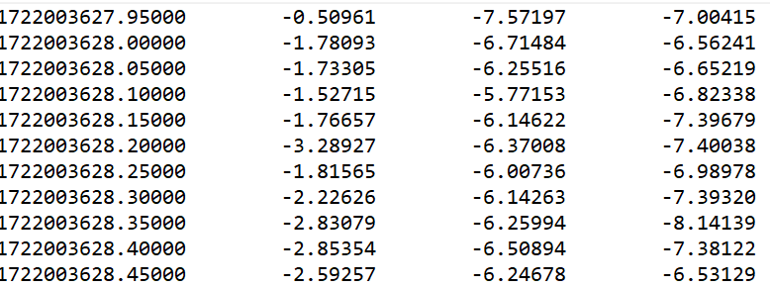

Place the .tsv file within the data directory.

**3. OVERVIEW**

The general process involves clicking the “load” button to load an input file, filling out all the input parameters, and then clicking the “calculate” button. If everything goes well, the output files will be generated and saved.

The console window at the bottom will provide messages related to the file input and processing. New messages appear at the bottom of the console window. You can scroll up the console window to see older messages.

These instructions are applicable to Mac OS, Windows, and Linux Operating Systems.

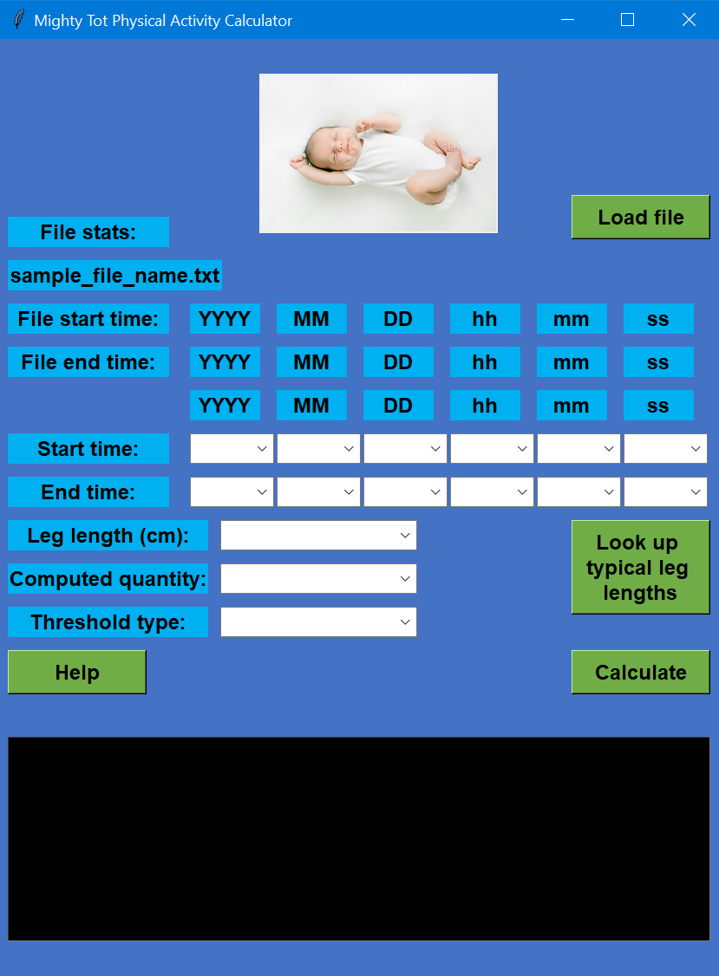

**4. LOADING AN INPUT FILE**

Click on “Load file” to load a .tsv file. This will open a dialog box to select the file.

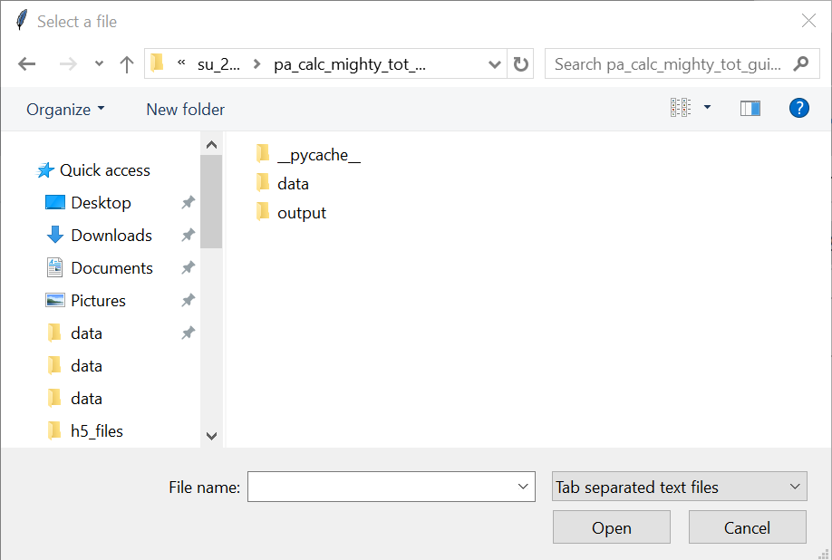

Navigate to the “data” directory where you saved your input file or files already. You may need to select the “Tab separated text files” file type before the file is visible for you to select.

Select the input file that you want to process and click the “Open” button. In this case we have selected the “ABC267_6019821_R_CALIBRATED.tsv” file.

Please note that it may take a several minutes to load the file if it the file contains several days of data.

After the file has been loaded, information about the file will be displayed under the “File stats” section. This will be the file name, the start time of the recording from the data, and the end time of the recording from the data. The time format is YYYY-MM-DD hh:mm:ss (year, month, day, hours, minutes, seconds). The hour is in the 24-hour format. So 14 hours means 2 PM. This is the format followed throughout.

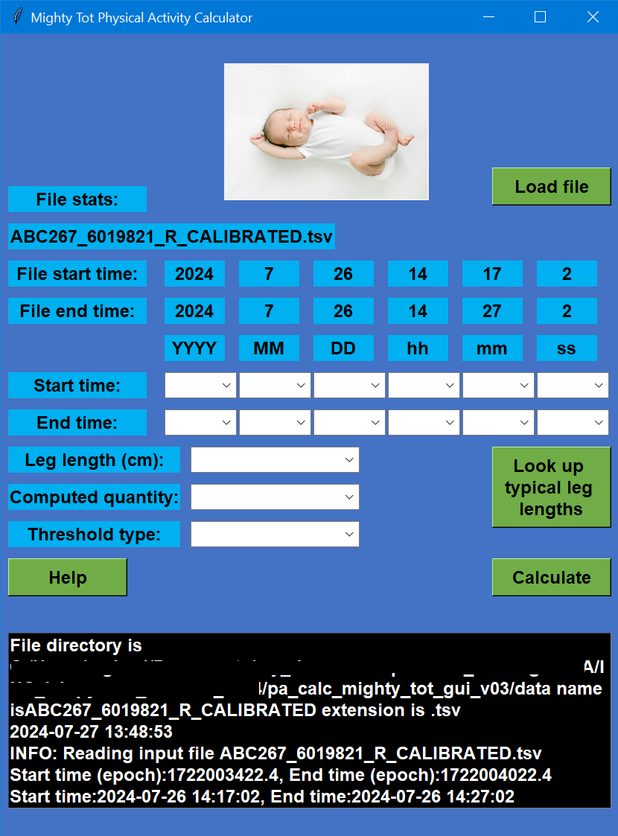

In this case, the file recording started on 26 July 2024 at 14:17:02 hours and ended on 26 July 2024 at 14:27:02 hours. The console window will show some additional information about the file load process.

**5. ENTERING START AND END TIME**

Mighty Tot allows you to process a subset of the data. For example, a sensor may have been recording for 7 days, but only 6 days out of those may be relevant. In this example, we will process the middle 8 minutes out of the 10 minutes of the recording. That is, out of the 14:17:02 - 14:27:02 time duration, we will process only from 14:18:02 to14:26:02.

Enter the desired start and end date processing time using the drop-down lists. The start time must always be greater than or equal to the file start time. Similarly, the end time must always be less than or equal to the file start time. So in this case the start time is 2024-7-26 14:18:02. The end time is 2024-7-26 14:26:02.

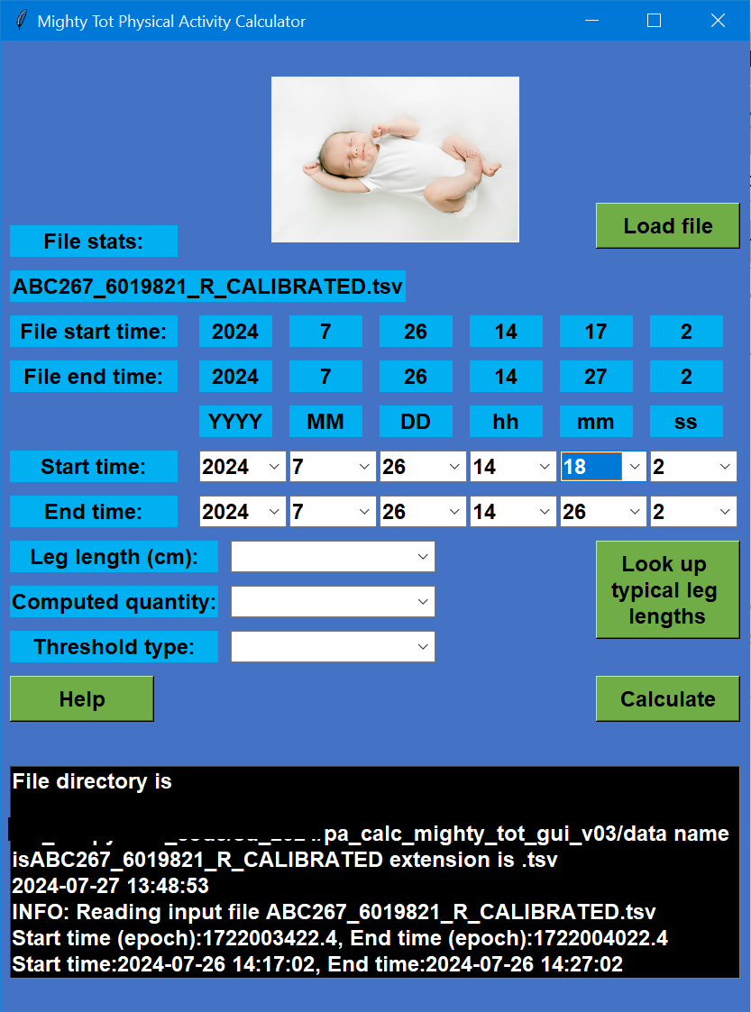

Alternatively, if the entire data file needs to be processed, then for the start time, use the file start time, and for the end time, use the file end time.

**6. ENTERING THE CALCULATION PARAMETERS**

Enter the leg length of the infant in cm, to the nearest 0.5 cm. The leg length is the sum of the thigh length and shank length which are defined as follows:

* Thigh length: greater trochanter to knee joint line
* Shank length: knee joint line to lateral malleolus

If you don’t know the leg length, click the “Look up” button to see an approximation by age group. For example, a 6-8 month-old infant will have a leg length of 25.6 cm.

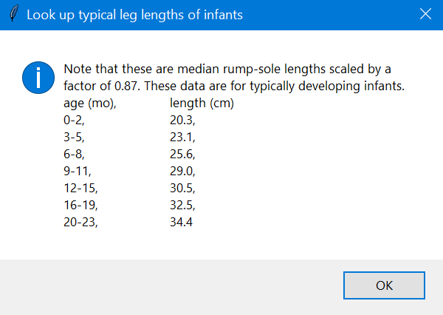

Enter the computed quantity to use for classifying physical activity (acceleration or jerk). If not sure, use acceleration as that is the typical measure used for measuring physical activity.

Enter the threshold type to use for classifying physical activity: TP (True Positive) or PAP (Predicted Activity Proportion) method.

* Use TP if you want a detailed description across time of when the infant was in different categories of physical activity (e.g., sedentary from 9:00-9:05, light activity from 9:05-9:10, etc.).
* Use PAP if you want to describe the overall activity profile of an infant (e.g., sedentary for 60 % of the time, light activity for 10 % of the time, moderate-to-vigorous for 30 % of the time).

**7. COMPUTE PHYSICAL ACTIVITY**

After entering all the parameters, click the “calculate” button. Keep an eye on the console window for information and any error messages.

Please note that it may take a several minutes to process the file if it is several days long.

Once completed, messages on the console will indicate that processing is done. You can scroll up the console window to see older messages.

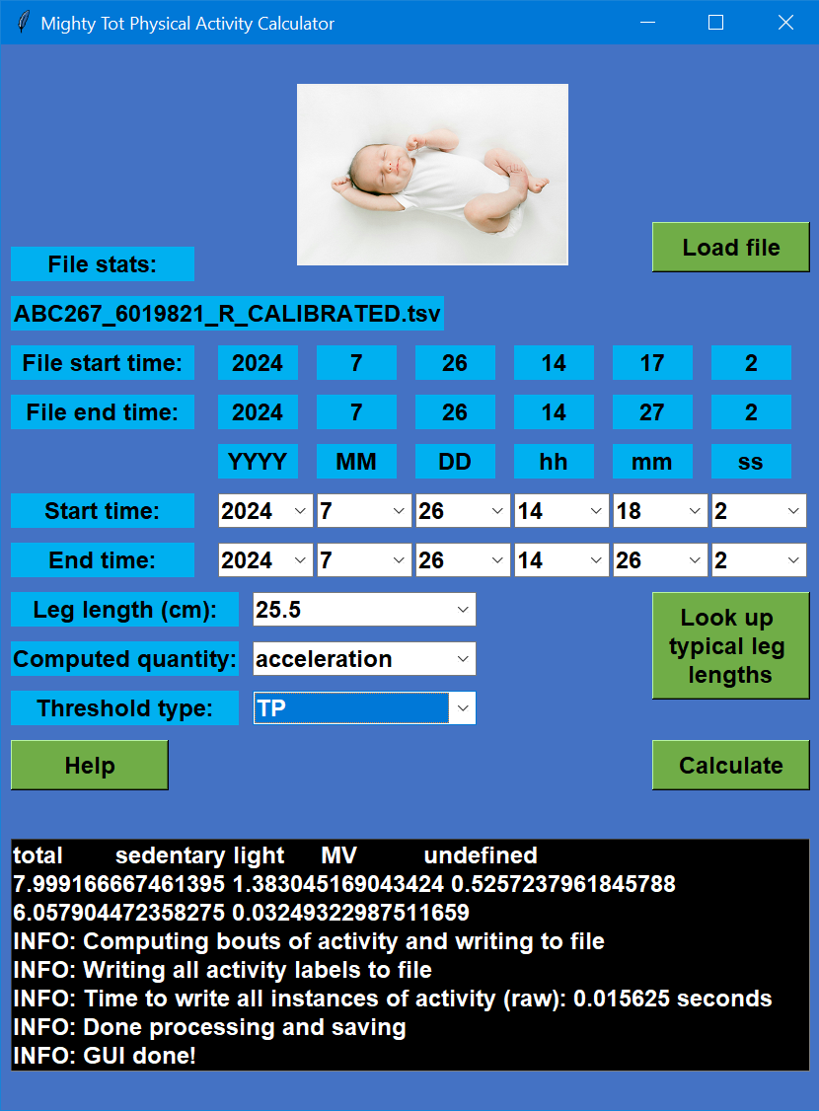

**8. OUTPUT FILE: SUMMARY**

This file name will be of the format XXXXXX_SUMMARY.txt.

If you want to describe the overall activity profile of an infant, then use this file. These results are best obtained using the PAP method for acceleration.

This file contains the overall summary of physical activity in terms of 3 different measures: counts (instances) recorded, in terms of percentage time spent, and in terms of actual time spent in minutes.

For each measure, values will be listed for the total, sedentary, light, and moderate-to-vigorous (MV) activity. There is also a fifth label called “undefined” which can be ignored. These are points are the start of the file within the first 2 seconds which cannot be processed.

For the example file below, for a total of 8.00 minutes, 1.38 minutes were spent sedentary, 0.53 minutes were spent in light activity, and 6.06 minutes were spent in moderate-to-vigorous (MV) activity. Other than these, 0.03 minutes were undefined.

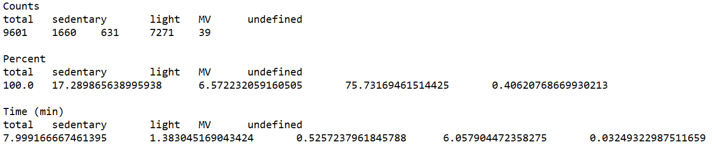

**9. OUTPUT FILE: BOUTS**

This file name will be of the format XXXXXX_BOUTS.txt.

If you want a detailed description across time of when the infant was in different categories of physical activity, then use this file. These results are best obtained using the TP method for acceleration.

This file list bouts of activity as they occur over time. There are 4 columns of data, separated by commas: start time of a bout (Unix epoch time), end time of a bout (Unix epoch time), duration of a bout, and classification of a bout. The unit for time is seconds. The first line contains the headings, and the rest contain the data.

Classification of bouts is as below:

* Sedentary: 0.0
* Light activity: 3.0
* Moderate-to-vigorous (MV) activity: 6.0
* Undefined (could not be computed): 999.0

For the example file below, for the first 1.9 seconds the bout is undefined. After that is a 16.8 second sedentary bout. This is followed by 0.4 second light activity bout, then a 1.9 second MV activity, and so on.

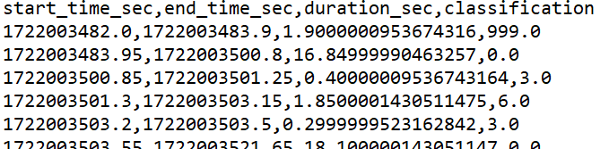

The undefined bout is made up of instances at the start of the file within the first 2 seconds which cannot be processed. Undefined bouts do not occur after the first 2 seconds.

**10. OUTPUT FILE: RAW**

This file name will be of the format XXXXXX_RAW.TXT

If you want a detailed description across time of when the infant was in different categories of physical activity, and you want to perform your own grouping or analysis (beyond what the BOUTS file provides), then use this file. Alternatively, if you can want a different analysis/grouping of overall time spent (e.g., day-by-day or hour-by-hour), beyond what the SUMMARY file provides, then use this file. These results are applicable to both the TP and PAP

This file lists instantaneous levels of activity as they occur over time. There are 2 columns of data, separated by commas: Unix epoch time (in seconds) at each instance, and classification at each instance.

Classification of instances is as below:

* Sedentary: 0.0
* Light activity: 3.0
* Moderate-to-vigorous (MV) activity: 6.0
* Undefined (could not be computed): 999.0

For the example file below each instance is 0.050 s apart indicating a sampling rate of 20 Hz same as the input file. There are 2 instances of sedentary activity, followed by 9 instances of light activity, then 6 instances of MV activity, and so on.

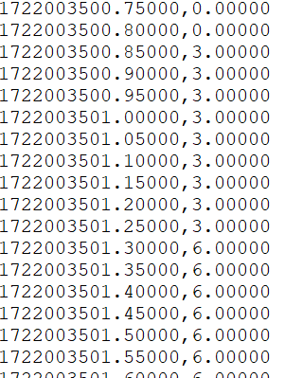

In this file, undefined instances occur at the start of the file within the first 2 seconds, which cannot be processed. Undefined instances do not occur after the first 2 seconds.

**11. OUTPUT FILE: LOG**

This file name will be of the format XXXXXX_LOG.TXT

If you want to check for any error messages or if you want to check the input and parameters used when processing the file, then use this file.

This file is a record of all of the messages generated in the console window. Some of the useful information that is available includes:

* Date and time of analysis
* Name of the input file
* Start and end times of the input file
* Start and end times for processing as entered by the user
* Computed quantity (acceleration or jerk) as selected by the user
* Optimization type (TP or PAP) as selected by the user
* Leg length as selected by the user
* Error messages

**12. REFERENCES AND CONTACT INFO**

Leg length estimates are based on anthropometric measurements Snyder et al. [1] and scaled based on models by Ghazi [2].

For more information about the derivation of and different types of calculations and outputs see: Ghazi et al. [3].

Image credit for infant photo: Morgan [4]

For more information or technical assistance, contact Beth A. Smith [bsmith@chla.usc.edu](mailto:bsmith@chla.usc.edu) and Mustafa Ghazi mghazi@chla.usc.edu

1. Richard G. Snyder, Lawrence W. Schneider, Clyde L. Owings, Herbert M. Reynolds, D. Henry Golomb, and M. Anthony Schork. Anthropometry of Infants, Children, and Youths to Age 18 for Product Safety Design. Technical Report UM-HSRI-77-17, *Highway Safety Research Institute, Ann Arbor, MI, USA*, 1977.
2. Mustafa A, Ghazi. MOVIT: Monocular Vision-Based Tracking. PhD Dissertation, *University of Oklahoma*, 2018.
3. Mustafa A. Ghazi, Judy Zhou, Kathryn L. Havens, and Beth A. Smith. Accelerometer Thresholds for Estimating Physical Activity Intensity Levels in Infants: A Preliminary Study. *Sensors*, 24(14):4436, 2024.
4. Goda Morgan. Baby Lying Down and Sleeping. *Pexels.* URL: <https://www.pexels.com/photo/baby-lying-down-and-sleeping-18649618/>. Accessed May 2024