Social laughter and smiles in preschool children

Caspar Addyman

Goldsmiths, University of London

Charlotte Fogelquist, Lenka Levakova, Sarah Rees

Birkbeck, University of London

Author Note

The authors would like to thank parents and children who took part in this study and the owners of the preschool for allowing us to conduct research on their premises.

Abstract

Surprisingly little research has investigated social laughter in preschool children. We studied children’s responses to amusing video clips in the presence or absence of peers. The sample consisted of 9 boys and 11 girls aged 2-4 who watched three cartoons under three different conditions, either individually, in pairs or in groups of 6-8. The social conditions showed significantly higher the numbers of laughs and smiles than individual viewing. Children laughed eight times as much and smiled almost three times as much in company. No differences were found between pairs and groups and no association was found between subjective funniness ratings and group size. This suggests that presence of even a single social partner can change behaviour in response to humorous material and that it is the sociability of the situation, rather than its humour, that elicits laughter.

(137 words)

*Keywords:* preschoolers, laughter, smiles, humour, peer groups

Laughter is a universal aspect of human life occurring in almost all individuals and across all cultures (Martin, 2007; Provine, 2001). Beginning at a very young age, laughter is a distinctive pattern of vocalisation that is instantly recognisable. Despite variations in cultural norms and across generations, the actual sounds of laughter are difficult to tell apart from one culture to the next (Gervais & Wilson, 2005). Laughter is also a highly social phenomenon (Addyman & Addyman, 2013; Provine, 1993). Surprisingly little experimental research has investigated social laughter in young children and its relation to humour. The current study sought to do so by having preschoolers watch humourous videos on their own or in company of their peers.

Laughter and smiling are instinctive and spontaneous behaviours that begins at very young age (Caron, 2002; Provine, 1996). Most smiles in one to five-month-old infants happen in response to the human face or voice, suggesting it is primarily a socially behaviour (Sroufe & Waters, 1976). After crying, laughter is one of the earliest social vocalisations produced by human babies and babies start to laugh in response to other people’s actions at around the age of four months(Martin, 2007). Most laughter in babies and young children is elicited through tactile stimulation as well as incongruous sights and sounds, so long as such incongruities are experienced a secure or playful setting (Rothbart, 1973). Congenitally deaf and blind children emit appropriate laughter in social situations despite never having perceived laughter in others suggesting this laughter is innate (Provine, 2001).

Comparative and phylogenetic studies support the notion that laughter and smiling are evolved instincts. Many primate species display a relaxed open-mouth “play face” during social play frequently accompanied by a pant-like vocalisation both of which bear resemblance to human laughter (Caron, 2002; Provine, 2001). Many primate species also display a silent bared-teeth expression which, although believed to have originally been a sign of aggression, has evolved to function as a sign of non-hostility, appeasement and friendliness, this expression being analogous to the human smile (Caron, 2002). Laughter even seems to be a signal for social play in rats (Knutson, Burgdorf, & Panksepp, 1998).

Noting that not all laughs are alike, Giles & Oxford (1970) proposed seven mutually exclusive categories of laughter. The most common types were humorous laughter, described as a behavioural response to amusing stimuli, and social laughter, described as a behavioural response allowing integration within a given social group. Social laughter occurs either as a direct response to other group members laughing or as a result of group expectations of laughter and, as such, serves to reduce social and cognitive discord, thereby promoting acceptance and loyalty within the group. Chapman & Wright (1976) points out that laugher, as distinct from smiling, in response to amusing stimuli, is relatively uncommon in the absence of another person to share the humour. Humour is not an easy thing to define or classify. It is difficult to pinpoint exactly what makes something funny (P. E. McGhee, 1979). Sometimes humour is even defined in terms of ability to provoke laughter and sometimes the terms laughter and humour get interchangeably (Devereux & Ginsburg, 2001). Studies have shown observed young childrens laughter to be correlated with subjective ratings of funniness (Antony J Chapman, 1983). But people often smile and laugh in the absence of humour, and people may feel amused without smiling or laughing, particularly when alone (Weisfeld, 1993).

Evidence for the sociality of laughter and smiling comes from a study by Provine and Fischer (1989) in which students were asked to keep laughter diaries in which they recorded all instances of laughing, smiling and talking in a given week. Results revealed that laughter was over 30 times, and smiling over six times, more likely to occur in social than in solitary situations. Provine (2001) proposes that laughter, rather like mutual grooming in primate troops, serves a nonlinguistic function in creating social bonds, reinforcing friendships, and drawing people into the fold. During conversation, laughter seems to be synchronised into the speech stream in an orderly manner, a phenomenon known as the *punctuation effect*. Through covertly observing human interaction in a variety of everyday settings such as shopping malls, restaurants or bars, Provine (1993) recorded the amount of laughter in natural interactions. Rather than the expected results of the audience laughing more than the speaker, the opposite was true, laughter amongst the speakers being on average 46% higher than that of the audience. It was further noted that most of the speaker’s pre-laughter comments were not in the least humorous, leading Provine (2004) to suggest that the essential ingredient for laughter, rather than being a joke, is the presence of another person.

Darwin and others thought smiling and laughter were manifestations of degrees of intense happiness (Darwin, 1872; Ekman & Friesen, 1984). But several studies support the contrasting hypothesis that smiling is primarily a social indication of friendliness. Kraut and Johnson (1979) observed people in a bowling alley. They found smiles were more likely interacting with others than when scoring a strike. Fernández-Dols and Ruiz-Belda (1995) observed 22 gold medal winners at the presentation ceremony of the Barcelona Olympic Games. Medalists smiled most during face to face encounters associated with the actual presentation of their medals, but only sporadically during other times of the presentation ceremony.

A number of studies have linked humorous laughter to social group size. Morrison (1940) found a high positive correlation between audience size and the number of laughs elicited during a theatre performance. Young and Frye (1966) found that undergraduates laughed more in response to joke in groups than when alone but humour ratings did not differ. Fridlund (1991) had participants watch an enjoyable video in four conditions of varying sociality: alone; alone but believing a friend close by was otherwise engaged; alone but believing a friend close was watching the same videotape in a separate room; and with a friend present at the viewing. Smiling, assessed by electromyography activity of the underlying muscles of the cheek, was found to increase as a function of the degree of sociality of the viewing process, but was not associated with subjective ratings of emotion felt, leading to the conclusion that smiling is less dependent on emotion than on social context. In a similar study, Devereux and Ginsburg (2001) found laughter was more frequent and lasted longer when participants watched videos in pairs rather than when watching alone. No differences in subjective ratings of amusement or happiness felt, or funniness of video clip, were found, supporting the notion that laugher is a function of the sociality of a situation regardless of internal emotional state.

Classic observational studies of preschool children find laughter to be primarily social (Brackett, 1933; Kenderdine, 1931). Sherman (1975) coded videos of 596 formal lessons in a prechool. He found that glee, defined as joyful screaming, laughing and intense physical acts was highly contagious spreading a chain reaction. Jones and Raag (1989) observed infant play sessions and found that infants were not inclined to smile until turning around and making eye contact with their mothers. To investigate the extent to which laughter and smiling are socially facilitated, Chapman (1973) had 7-8 year olds listen to humorous material through headphones under three conditions: alone; with a non-listening companion; and with a companion listening to the same material. Results revealed that total time engaged in overt laughing and smiling was higher in children accompanied by a listening companion than in those accompanied by a non-listening companion, and higher in children accompanied by a non-listening companion than in those listening alone. Children who laughed and smiled the most also gave the highest subjective ratings of funniness. A subsequent study, also with 7-8 year olds, included a social exclusion condition (A. J. Chapman, 1975). Participant listened to humorous material with two confederates. Results revealed that the more the confederates made eye contact with each other, and therefore not with the participant, the less the participant laughed or smiled. This effect occurred independent of whether the participants believed they were listening to the same humorous material as the confederates. This supports the idea that it is the sharing of a social situation per se, rather than the sharing of humorous stimuli, that is the crucial factor in eliciting laughter and smiling in children.

A subsequent literature review has reveal very little experimental research that investigates the social facilitative aspects of laughter in preschool children. The aim of the current study was to investigate the effect of group size on overt laughter and smiles in a younger sample of pre-schoolers watching humorous videos. We predict that smiling and laughter will increase in the more social conditions. Additionally, we predict that this will not affect subjective ratings of funniness.

**Method**

**Participants**

Participants were 20 children (11 female) who attended a private preschool in Twickenham. Participants’ ages ranged from 2 years 7 months to 4 years 1 month (mean age 3 years 3 months). The majority were from a white British background. All parents provided written consent to the children taking part and verbal consent was also obtained from the children prior to testing sessions. Ethical approval was obtained from the ethics committee at Birkbeck, University of London.

***Materials***

Threevideo clips from the Bernard Bear cartoon series were used as humorous material. The Bernard Bear series was chosen as it contains plenty of slapstick and incongruous humour which previous research has shown particularly appeals to children of preschool age (Rothbart, 1973). Each video consisted of two episodes and had a total running time of between 6 minutes 35 seconds and 7 minutes 43 seconds in length (*see online materials for episode list)*. Video clips were presented using a Lenovo ThinkPad 2.0 laptop connected to 56cm Samsung Syncmaster flat television screen positioned on a table at a height of approximately 55cm and at a distance form participants of approximately 1.5 metres. Participants were recorded via a built in camera on the laptop as well as via a compact HD JVC camcorder placed on a tripod positioned just behind and to the right of the television screen. A Blue Snowball microphone was connected to the laptop and positioned on a shelf to the right of participants.

Subjective funniness ratings were taken using a printed visual scale containing simple cartoon-like pictures of a happy face meaning "very funny", a neutral face meaning "quite funny" and a sad face meaning "not funny" (see online materials, Addyman, Fogelquist, Levakova, & Rees, 2017).

**Design**

The experiment used a mixed design. The experimental independent variable was viewing condition as a within subjects factor at three levels. Children watched 3 videos in conditions individually, in pairs or in groups of 6 or 8. A second independent variable viewing order children were divided into three streams A, B and C, tested in different orders over several sessions (see Table 1). The dependent variables were the number of laughs and smiles elicited by the video clip in each child in each viewing condition. An additional dependent variable was the child’s subjective funniness ratings.

Table 1: Order of presentation. Sessions took place on separate days over several weeks.

|  |  |  |  |  |
| --- | --- | --- | --- | --- |
| ORDER | GROUP SIZE | Session 1  (Video 1) | Session 2  (Video 2) | Session 3  (Video 3) |
| A | 6 (3m, 3f) | Individually | Pairs | Group |
| B | 8 (4m, 4f) | Pairs | Group | Individually |
| C | 6 (2m, 4f) | Group | Individually | Pairs |

**Procedure**

The study took place over several sessions over a six-week period supervised by two researchers, one of whom worked at the preschool and was well known to all the children. Video and recording equipment were set up in an area of the preschool separated from the main area by 1.2-metre-high privacy screens. In the individual viewing condition, a researcher invited one child to come to watch a short video clip and made the child comfortable on cushions on the floor at approximately 1.5 metres from the television screen. Throughout the viewing of the video clip, both researchers were positioned just outside of the privacy screen, slightly behind and to the left of the child. This allowed the researchers to supervise and provide any necessary reassurance to the child, whilst remaining separate from the viewing process. Care was taken by the researchers throughout to maintain a neutral expression and not to be perceived as participating in the watching of the video clip. This procedure was then repeated for the next child until all children had been tested. In the pairs viewing condition, the same procedure as above was followed, except that children were seated side by side on floor cushions. In the group viewing condition, again, the same procedure was followed, except that children were seated in a semi-circle on floor cushions.

In all viewing conditions, once the video clip had ended, the researcher who worked at the preschool asked each child how funny they thought the video clip was, using the visual scale described above. Regardless of viewing condition, children were always asked individually. Finally, the child was invited to choose a sticker as a reward for taking part.

**Video Coding**

Smiles and laughter were coded offline from the video recordings of the children. Video presention software (Camcasia Studio 8) was used to allow the researchers to watch the recordings of participants simultaneously with the video clip being viewed. Laughs and smiles were operationalised based on the definitions of Chapman (1975). A laugh was defined as audible inarticulate vocal sound and/or visible shaking of the shoulders or torso, whilst a smile was defined as an upwards stretching of the corners of the mouth unaccompanied by vocal sound.

Three researchers each independently coded two thirds of videos across all viewing conditions ensuring each video was coded twice. A 10-second timer was set to start 20 seconds after commencement of the video clip and to end once six minutes had elapsed. In each 10-second interval, the researchers noted the number of laughs and number of smiles per child on a coding sheet (*see online materials*). Once coding had been completed, researchers compared their respective totals. In cases where there were minor discrepancies in totals, the mean number of laughs and mean number of smiles per child per viewing condition were calculated and recorded on a master table of data. In a small number of cases where discrepancies were larger, the video clip was re-watched and a consensus reached. To further minimise bias or error, a colleague who was naïve to the study analysed 15% of the recordings in the manner described above. A percentage of similarity between researcher coding and naïve coding was calculated by dividing the number of agreements between the researchers and naïve coder by the number of agreements plus number of disagreements between the researchers and naïve coder. The similarly percentage was found to be 86%.

# **Results**

To investigate the social role of laughter and smiles in preschool children watching funny videos, we initially looked at laughter, smiles and funniness ratings separately. All analysis was performed using the R statistics language, version 3.4.2 with ANOVA performed using CRAN package ez, version 4.4.0. The data, the analysis scripts and the code to generate all figures are provided in the online materials (Addyman et al., 2017)

.

Laughter

Descriptive statistics showed a greater number of laughs in the group viewing condition (mean 8.20, SD 8.14) and in the pair viewing condition (mean 7.60, SD 6.68) than in the individual viewing condition (mean 0.93, SD 2.36). To test the experimental hypothesis a mixed 3x3 ANOVA was conducted with group size as the within subject variables (group, pairs, individual) and viewing order as between subjects variable (orders A, B or C). Mauchly’s test of Sphericity was passed with p=.761, therefore homogeneity of variance could be assumed.

Results showed a highly significant main effect of viewing condition for laughs, F (2, 34) = 12.93, *p* < .001 with a generalized eta squared (GES) = .25. There was no main effect of viewing order F(2, 17) = 0.44, p=.65, GES = .03 and no interaction F(4,34) = 1.85, p=.14, GES = .09. The difference in laughter between viewing conditions was compared with a set of Bonferroni corrected two-tailed, pairwise t-tests. These showed that children laughed significantly more in pairs than alone t(19) = 4.77, p < .001 and in groups than alone t(19) = 4.15, p < .001. But amount of laughter per child did not differ between pairs and groups t(19) = 0.33, p < .74. These results support the hypothesis that the amount of laughter is determined by presence of a social partner and are shown in the left-hand panel of Figure 1.

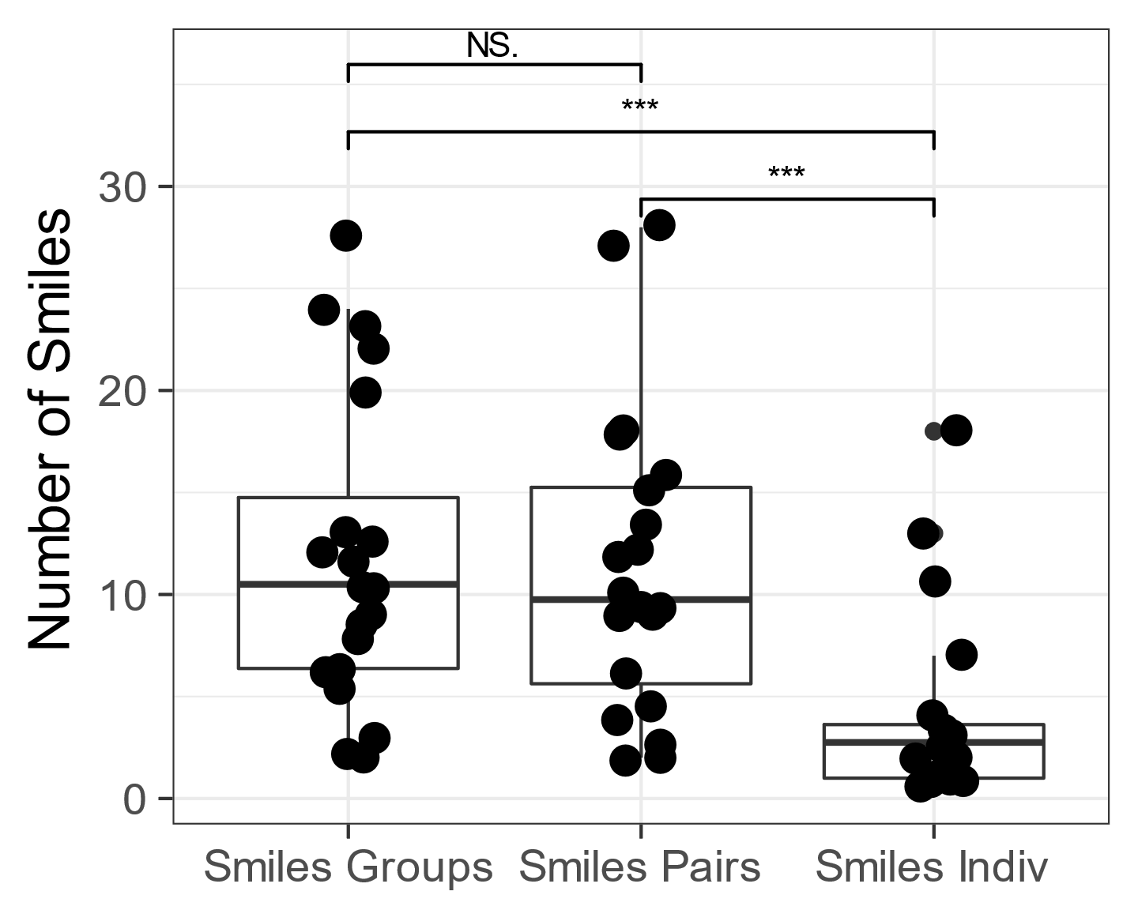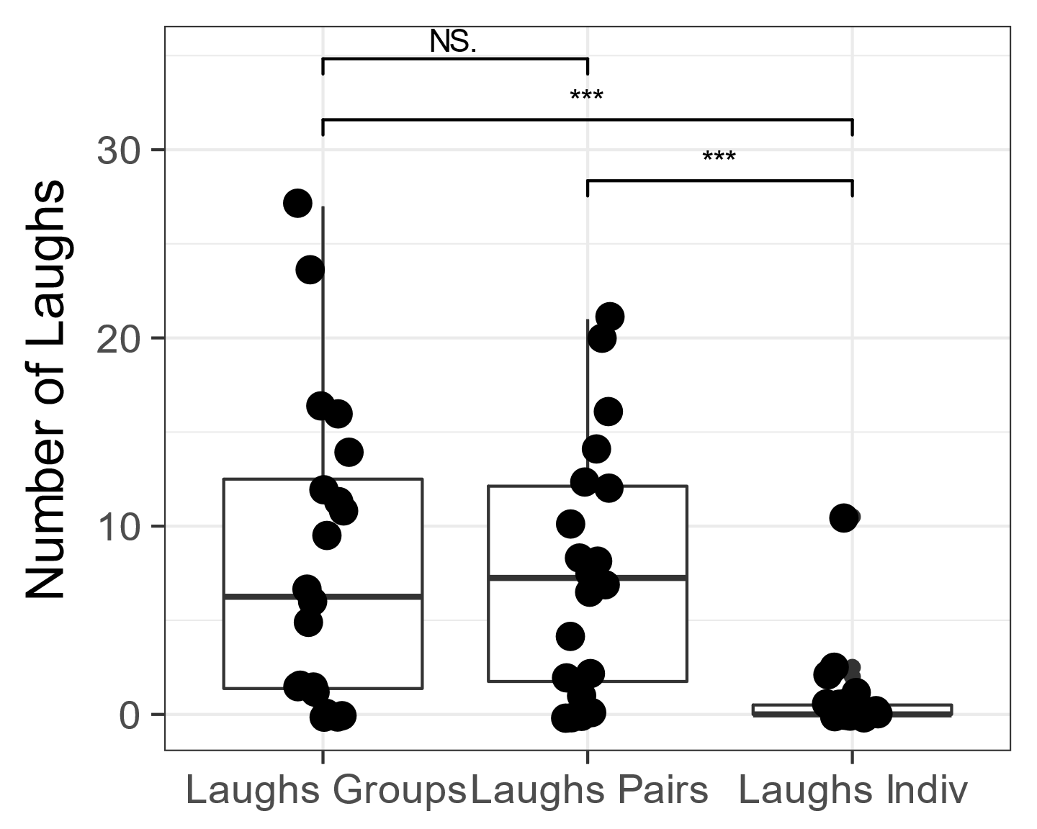

*Figure 1: Tukey box plots of the number of laughs (left) and smiles (right) by condition. Each dot represents one child in one condition and the superimposed box plots show the median and inter-quartile range. Horizontal bars above the plot indicate significance levels of the paired-sample t-test planned comparison.*

Smiles

Descriptive statistics showed a greater number of smiles in the group viewing condition (mean 11.85, SD 7.61) and in the pair viewing condition (mean 11.38, SD 7.45) than in the individual viewing condition (mean 4.10, SD 4.61). The same 3x3 ANOVA as above was carried out. Mauchly’s test of Sphericity indicated that the significance value for viewing condition was .06, therefore homogeneity of variance could be assumed.

Results showed a highly significant main effect of viewing condition for smiles, F (2, 34) = 16.31, *p* < .001, GES = .26. There was no main effect of viewing order F(2, 17) = 1.43, p=.26, GES = .10 and no interaction F(4,34) = 1.90, p=.13, GES = .07. As before, group viewing conditions were compared with pair-wise t-tests. These showed that children smiles significantly more in pairs than alone t(19) = 3.92, p < .001 and in groups than when alone t(19) = 4.70, p < .001. But amount of laughter per child did not differ between pairs and groups t(19) = 0.39, p < .70. Again, these results support the hypothesis that the amount of smiling is determined by presence of a social partner and are shown in the right-hand panel of Figure 1.

Subjective funniness ratings

To investigate the association between children's subjective funniness ratings and viewing condition, totals of "not funny", "quite funny" and "very funny" ratings were calculated for each viewing condition. A Pearson's Chi Square test of association showed that there were no significant differences in subjective funniness ratings between the group, pair and individual viewing conditions, χ2 = 2.033, d.f=4, *p* = .73. Despite laughing and smiling more when watching in pairs and groups children did not rate these conditions as more funny. A similar analysis revealed that all videos were considered equally funny, χ2 = 2.27, d.f=4, *p* = .69. These ratings are summarised in table 2 and 3 respectively.

*Tables 2 & 3: Children’s funniness ratings for each video according to size of group watching (left) and based on content (right).*

|  |  |  |  |
| --- | --- | --- | --- |
| Funniness  Rating | Group Size | | |
| Group | Pair | Indiv |
| Not Funny | 4 | 2 | 3 |
| Quite Funny | 3 | 6 | 6 |
| Very Funny | 13 | 12 | 11 |
| Total | 20 | 20 | 20 |

|  |  |  |  |
| --- | --- | --- | --- |
| Funniness  Rating | Video | | |
| 1 | 2 | 3 |
| Not Funny | 3 | 3 | 3 |
| Quite Funny | 3 | 7 | 5 |
| Very Funny | 14 | 10 | 12 |
| Total | 20 | 20 | 20 |

Finally, we wanted to see if subjective funniness ratings would predict the number of laughs and smiles. For each video we grouped the data according to whether each child had said the video was Not Funny, Quite Funny or Very Funny. We then calculated the mean numbers of laughs and smiles for each of these groups. A one-way ANOVA showed no relationship between number of laughs and funniness, F(2,31)= 0.21, p =.81, GES = .01. A similar one-way ANOVA showed no relationship between number of smiles and subjective funniness F(2,31)= 0.48, p =.63, GES = .03. The data are shown in Figure 2.

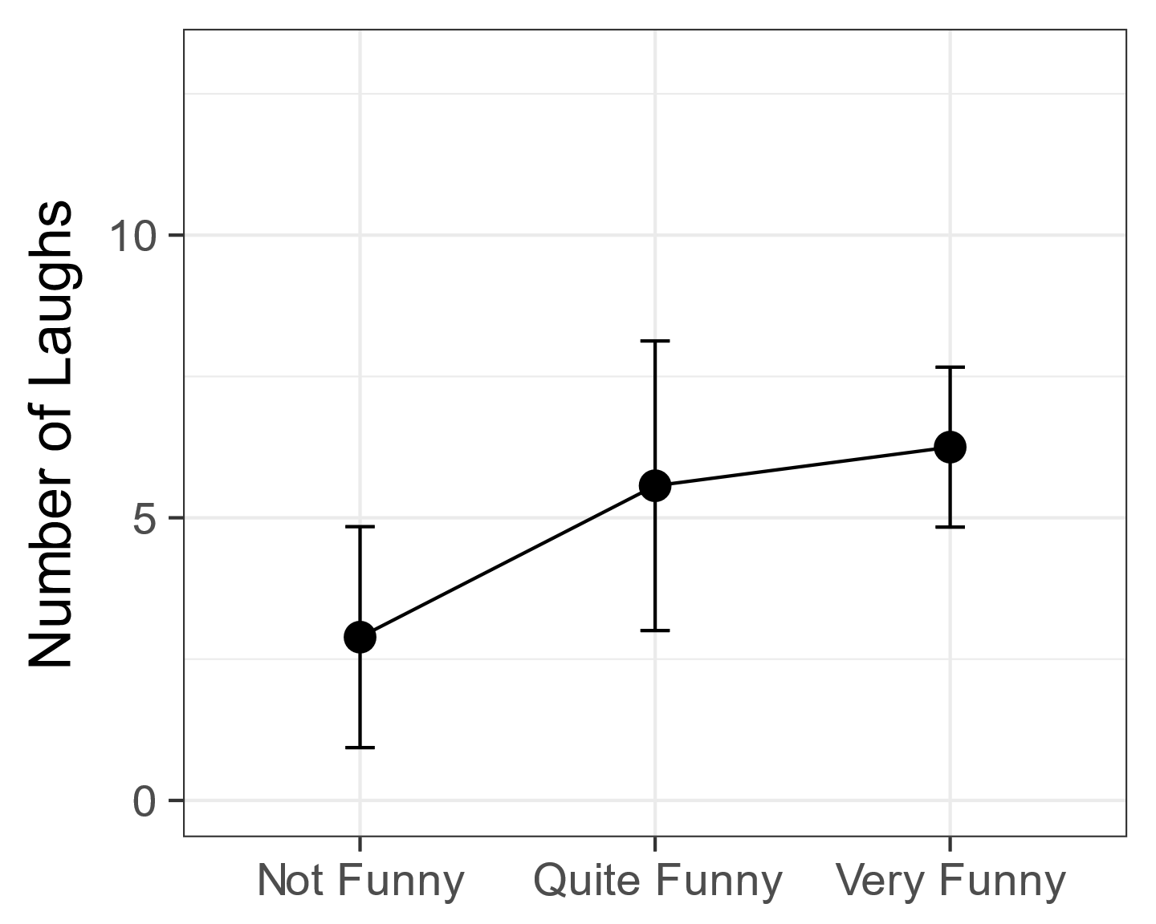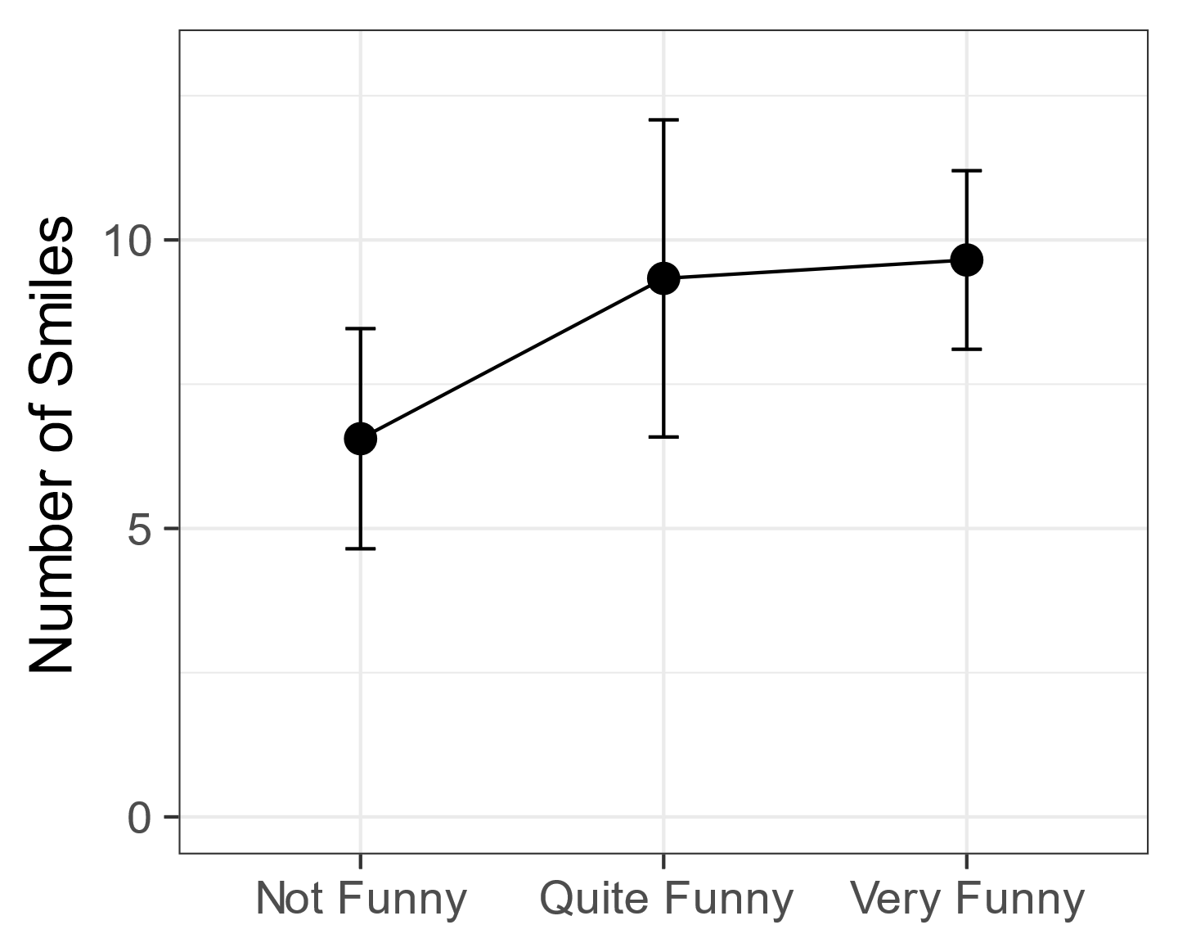

*Figure 2: How laughs (left) and smiles (right) relate to subjective funniness. Error bars represent 1 standard error.*

**Discussion**

The principal aim of this experiment was to investigate the influence of social peers on pre-schoolers responses to humorous materials. In line with our predictions we found that presence of a social partner significantly increased smiling and laughter. When watching a funny cartoon, children laughed eight times as much in company as when on their own while smiles increased by a factor of around 2.8. The amount of laughter or smiling did not differ between pairs or group conditions. This suggests that the presence of a single social partner can be sufficient to increase overt laughter and smiles. When children’s funniness ratings were taken into account, we found that the greater laughter and smiles in groups and pairs was not associated higher ratings of funniness. Finally, there was no association between individual funniness ratings and the amount of laughter and smiles produced.

Chapman (1973) found that 7-8 year olds laughed and smiled more in pairs than individually. Ours findings extend that result looking at a much younger age group (2-4 year olds) and by including a group condition. It goes beyond the observational work on social laughter in adults (Kraut & Johnson, 1979; Fernández-Dols & Ruiz-Belda 1995) and links to the related work on social laughter with adults (Fridlund 1991; Young & Frye, 1966; Devereux & Ginsburg, 2001). Our results provide a demonstration of clear social role of overt laughter and smiles from a much younger age than shown in previous research.

The lack of difference in amount of laughing and smiling between the pair and group conditions was unexpected and interesting. Mehu & Dunbar (2008) carried out naturalistic observations in public areas of people interacting in small groups in which group size, composition, in terms of sex and age of individuals, and social context of interactions were taken into account. Their results revealed group size to have the largest overall effect on the amount laughter and smiling, with rates increasing as a function of group size. Whereas group size had no influence in our experiment and the lack of difference between the pair and group conditions goes against a pure social contagion explanation. If children laughed and smiled increase in response to the smiles and laughs of others we would expect higher scores in the group condition. This is at odds with the contagious properties of laughter in preschool children reported by Brackett (1933) and Sherman (1975), as well as with the experimental research using laugh boxes by Provine (1992) which found that laughter itself elicited laughter.

Nonstatistical observations of our video data indicated that, in the pair viewing condition, the laughter of one child did sometimes set the other off laughing, and that in the group viewing condition, this happened in a kind of chain reaction. Incongruous events (for example, Bernard Bear getting stuck in a bin) elicited high levels of laughter but rather than all children bursting into laughter simultaneously, it was often the initial laughter of one particularly gregarious child that quickly spread. These nonstatistical observations correspond with the previous research. It could be that our study was underpowered to be able to detect these contagion effects. Further research could explicitly set out to look for them. Likewise, nonstatistical observation also indicated that children in pairs or in a group frequently made eye contact with each other whilst laughing. In cases where a child laughed or smiled in the individual condition, they would sometimes try to catch the eye of the researchers, presumably in an attempt to share the joke. As mentioned previously, great care was taken to minimise social interaction between researchers and participants during the viewing process. These nonstatistical observations correspond with previous observations of Jones (1989) that infants engaged in play tend only to smile when turning to make eye contact with carers, as well as with previous observations of Kraut & Johnson (1979) and Fernandez Dols & Ruiz-Belda (1995) that most adult smiling occurred during face to face contact. Attempts to share the joke illustrate the social function of laughter and smiling and while beyond the scope of the current experiment could be included in any follow up studies.

In Chapman’s (1973) study, children who laughed and smiled the most also gave the highest subjective ratings of funniness. We did not find this. The videos were rated very funny by a majority of children in all viewing conditions and the chi-squared tests found no association between the funniness of videos and the viewing conditions. Likewise, despite the apparent trends seen in figure 2, the statistical analysis revealed that there was no more laughter and smiles in cases where children rate more funny. One possible explanation for this is that these very young children did not fully understand what they were being asked. McGhee (1977) suggests that the typical use of five- or seven-point funniness rating scales, whilst appropriate for older children, may not be appropriate for younger children. In the current study, a three-point funniness rating scale was used. While it was the view of the researcher who knew the children that most could easily do this task. But some children’s responses were often quite arbitrary, therefore calling into question the validity of relying on subjective ratings in children so young. Future work should include a control task with non-funny stimuli to ensure children can answer this question. A larger sample might allow age to be included as a co-variate.

Chapman (1976) emphasised that the unassuming nature of young children make them ideal participants for investigating spontaneous behaviours such as laughter. One of the main strengths of the current experiment was its high ecological validity. It was conducted during children’s normal day-to-day preschool activities and took place in a screened-off corner of the main room of the preschool. One downside was inevitably some background noise from other activities but it is not believed children were unduly affected by this. The upside was the children remained in a familiar setting and so no children felt anxious and this also helped keep them naïve to the fact they were being observed or evaluated, thereby maintaining ecological validity. Throughout the experiment the researchers stood just outside of the privacy screens slightly behind the children which meant that children in the individual viewing condition were not alone in the strictest sense but this was required due to the children’s young age and preschool regulations that require adult supervision at all times. The fact that a strong effect was still found suggests children acted as if watching alone. Finally, all the children in this study were well known to each other having attended the same preschool for an extended period increasing any likely social effects.

In measuring overt responses, questions arise as to how to establish definitive operational definitions of smiling and laughter and whether to treat smiling and laughing as separate behavioural responses or as different continuums of a single behavioural response. In coding smiles and laughs in the current experiment, it was noted that often a smile would become a laugh, and often a laugh would end with a smile. Most inconsistencies between coders concerned laughs being termed smiles and vice versa. Although any inconsistencies were revisited and a consensus reached, the measures of laughter and smiling in the current experiment did not account for different intensities of laughter in terms of volume or duration, or for different intensities of smiling. It is clear that better operational definitions could be established and future work could address this. But for the purposes of the current study, the measures adopted were considered sufficient to clearly demonstrate that laughter and smiling is highly influenced by social circumstances.

Giles and Oxford (1970) proposed that social laugher and humorous laughter are mutually exclusive. The findings of the current experiment suggest that the two types of laughter are frequently interlinked and that laughter and smiling have a strongly social role even in a humorous setting. An earlier study of pre-schoolers measured laughter in response to a humorous recording either alone or after observing a laughing or non-laughing peer (Brown, Wheeler, & Cash, 1980). That study found a mixed pattern of results that laughing increased across conditions but that smiling was least after encountering a non-smiling peer. This lead those authors to favour an imitation learning account of their results (Bandura, 1978). But in our study the mere presence of another was sufficient to increase overt laughter and smiling, the social facilitation (Zajonc 1965) is a better starting point.

Certainly more research is needed to understand how social and emotional factors interact with learning in pre-schoolers. Many researchers now recognise that emotion is an indivisible part of preschool experience. Social and Emotional Learning (SEL) has become a well-known acronym with early years literature (Morris, Millenky, Raver, & Jones, 2013; Williams, Sheridan, & Sandberg, 2014). But while that literature addresses aggression and warmth, it rarely directly considers laughter, mirth or glee. Rana Esseily and colleagues recently demonstrated that laughter aided observational learning in 18 month old infants (Esseily, Rat-Fischer, Somogyi, O’Regan, & Fagard, 2016). This suggests there is potential to recruit young children’s natural mirth and glee and the social setting of the preschool to enhance learning. Humour in social settings could have a pedagogical role in preschool. For example, it would be interesting to investigate if the observational learning benefit of laughter found by Esseily et al.(2016) translated to greater comprehension and learning from videos in a setting like that of the current experiment.

Finally, the primarily social aspect of laughter and smiles found in the present study does not diminish pre-schoolers appreciation and understanding of humour. Extensive work by Elena Hoicka and colleagues have investigated humour production and understanding in preschool children. They have shown that infants and pre-schoolers can understand and produce humour (Hoicka & Akhtar, 2012; Hoicka & Gattis, 2008). They have also showed that pre-schooler can tell jokes from pretending and apply contextual cues to understand humour (Hoicka & Akhtar, 2011; Hoicka & Butcher, 2016). The children in the present study found the cartoons funny in all view conditions but their laughing was strongly modulated by social setting. Indexing young children’s humour understanding with laughter is not straightforward. But the cognitive skills children require for understanding humour make it a fascinating lens onto preschool developmental.

In conclusion, the present study has demonstrated that social presence of peers makes a large difference to pre-schoolers overt laughter and smiling. But that increased ostensive signals of humour appreciation do not change the perceived funniness of humorous material. Given the importance of social laughter and smiling in establishing social bonds and value of humour within the context of cognitive development is it hoped that the current experiment will form the basis for further investigation into the social nature of laughter and smiling in preschool children.

.

References

Addyman, C., & Addyman, I. (2013). The science of baby laughter. *Comedy Studies*, *4*(2013), 143–153. https://doi.org/10.1386/cost.4.2.143

Addyman, C., Fogelquist, C., Levakova, L., & Rees, S. (2017). Social laughter in preschool children: Dataset, analysis scripts and supporting materials. FigShare. https://doi.org/10.6084/m9.figshare.5549356

Bandura, A. (1978). Social Learning Theory of Aggression. *Journal of Communication*, *28*(3), 12–29. https://doi.org/10.1111/j.1460-2466.1978.tb01621.x

Brackett, C. W. (1933). Laughing and Crying of Preschool Children. *The Journal of Experimental Education*, *2*(2), 119–126. https://doi.org/10.1080/00220973.1933.11009932

Brown, G. E., Wheeler, K. J., & Cash, M. (1980). The effects of a laughing versus a nonlaughing model on humor responses in preschool children. *Journal of Experimental Child Psychology*, *29*(2), 334–339. https://doi.org/10.1016/0022-0965(80)90024-7

Caron, J. E. (2002). From ethology to aesthetics: Evolution as a theoretical paradigm for research on laughter, humor, and other comic phenomena. *Humor - International Journal of Humor Research*, *15*(3), 245–281. https://doi.org/10.1515/humr.2002.015

Chapman, A. J. (1973). Social facilitation of laughter in children. *Journal of Experimental Social Psychology*, *9*(6), 528–541.

Chapman, A. J. (1975). Humorous laughter in children. *Journal of Personality and Social Psychology*, *31*(1), 42–49.

Chapman, A. J. (1983). Humor and laughter in social interaction and some implications for humor research. In J. H. Goldstein & P. E. McGhee (Eds.), *Handbook of humor research* (pp. 135–158). New York: Springer Verlag.

Chapman, A. J., & Wright, D. S. (1976). Social enhancement of laughter: An experimental analysis of some companion variables. *Journal of Experimental Child Psychology*, *21*(2), 201–218.

Darwin, C. (1872). *The expression of emotion in man and animals*. London: John Murray.

Devereux, P. G., & Ginsburg, G. P. (2001). Sociality Effects on the Production of Laughter. *The Journal of General Psychology*, *128*(2), 227–240. https://doi.org/10.1080/00221300109598910

Ekman, P., & Friesen, W. V. (1984). *Unmasking the face : a guide to recognizing emotions from facial clues* (Reprint editio.). Palo Alto Ca.: Consulting Psychologists Press.

Esseily, R., Rat-Fischer, L., Somogyi, E., O’Regan, K. J., & Fagard, J. (2016). Humour production may enhance observational learning of a new tool-use action in 18-month-old infants. *Cognition & Emotion*, *9931*(May), 1–9. https://doi.org/10.1080/02699931.2015.1036840

Fernández-Dols, J.-M., & Ruiz-Belda, M.-A. (1995). Are smiles a sign of happiness? Gold medal winners at the Olympic Games. *Journal of Personality and Social Psychology*, *69*(6), 1113.

Fridlund, A. J. (1991). Sociality of solitary smiling: Potentiation by an implicit audience. *Journal of Personality and Social Psychology*, *60*(2), 229–240. https://doi.org/10.1037/0022-3514.60.2.229

Gervais, M., & Wilson, D. S. S. (2005). The evolution and functions of laughter and humor: a synthetic approach. *The Quarterly Review of Biology*, *80*(4), 395–430. https://doi.org/10.1086/498281

Giles, H., & Oxford, G. S. (1970). Towards a multidimensional theory of laughter causation and its social implications. *Bulletin of the British Psychological Society*, *23*(79), 97–105.

Hoicka, E., & Akhtar, N. (2011). Preschoolers joke with jokers, but correct foreigners. *Developmental Science*, *14*(4), 848–858. https://doi.org/10.1111/j.1467-7687.2010.01033.x

Hoicka, E., & Akhtar, N. (2012). Early humour production. *British Journal of Developmental Psychology*, *30*(4), 586–603. https://doi.org/10.1111/j.2044-835X.2011.02075.x

Hoicka, E., & Butcher, J. (2016). Parents Produce Explicit Cues That Help Toddlers Distinguish Joking and Pretending. *Cognitive Science*, *40*(4), 941–971. https://doi.org/10.1111/cogs.12264

Hoicka, E., & Gattis, M. (2008). Do the wrong thing: How toddlers tell a joke from a mistake. *Cognitive Development*, *23*(1), 180–190. https://doi.org/10.1016/j.cogdev.2007.06.001

Jones, S. S., & Raag, T. (1989). Smile production in older infants: The importance of a social recipient for the facial signal. *Child Development*, 811–818.

Kenderdine, M. (1931). Laughter in the pre-school child. *Child Development*, *2*(3), 228–230.

Knutson, B., Burgdorf, J., & Panksepp, J. (1998). Anticipation of play elicits high frequency ultrasonic vocalizations in young rats. *Journal of Comparative Psychology*, *112*(1), 65–73.

Kraut, R. E., & Johnston, R. E. (1979). Social and emotional messages of smiling: An ethological approach. *Journal of Personality and Social Psychology*, *37*(9), 1539.

Martin, R. A. (2007). *The psychology of humor : an integrative approach*. Amsterdam: Elsevier Academic Press.

McGhee, P. (1977). Children’s humour: a review of current research trends. In A. Chapman & H. Foot (Eds.), *It’s a Funny Thing, Humour.* Oxford: Pergamon Press.

McGhee, P. E. (1979). *Humor, its origin and development*. San Francisco: W.H. Freeman and Company. Retrieved from http://www.worldcat.org/title/humor-its-origin-and-development/oclc/5101611

Morris, P., Millenky, M., Raver, C. C., & Jones, S. M. (2013). Does a Preschool Social and Emotional Learning Intervention Pay Off for Classroom Instruction and Children’s Behavior and Academic Skills? Evidence From the Foundations of Learning Project. *Early Education and Development*, *24*(7), 1020–1042. https://doi.org/10.1080/10409289.2013.825187

Morrison, J. (1940). A note concerning investigations on the constancy of audience laughter. *Sociometry*, *3*(2), 179–185.

Provine, R. R. (1993). Laughter Punctuates Speech: Linguistic, Social and Gender Contexts of Laughter. *Ethology*, *95*(4), 291–298. https://doi.org/10.1111/j.1439-0310.1993.tb00478.x

Provine, R. R. (1996). Laughter mechanisms The study of laughter provides a novel approach to the and evolution of vocal production , perception and social behavior. *American Scientist*, *84*(1), 38–45.

Provine, R. R. (2001). *Laughter : a scientific investigation*. New York ;;London : Penguin.

Provine, R. R. (2004). Laughing, tickling, and the evolution of speech and self. *Current Directions in Psychological Science*, *13*(6), 215–218. https://doi.org/10.1111/j.0963-7214.2004.00311.x

Provine, R. R., & Fischer, K. R. (2010). Laughing, Smiling, and Talking: Relation to Sleeping and Social Context in Humans. *Ethology*, *83*(4), 295–305. https://doi.org/10.1111/j.1439-0310.1989.tb00536.x

Rothbart, M. K. (1973). Laughter in young children. *Psychological Bulletin*, *80*(3), 247–256. https://doi.org/10.1037/h0034846

Sherman, L. W. (1975). An ecological study of glee in small groups of preschool children. *Child Development*, *46*(1), 53–61. Retrieved from http://www.ncbi.nlm.nih.gov/pubmed/1132281

Sroufe, L. A., & Waters, E. (1976). The ontogenesis of smiling and laughter: a perspective on the organization of development in infancy. *Psychological Review*, *83*(3), 173–189. https://doi.org/10.1037/0033-295X.83.3.173

Weisfeld, G. E. (1993). The adaptive value of humor and laughter. *Ethology and Sociobiology*, *14*(2), 141–169.

Williams, P., Sheridan, S., & Sandberg, A. (2014). Preschool - an arena for children’s learning of social and cognitive knowledge. *Early Years*, *34*(3), 226–240. https://doi.org/10.1080/09575146.2013.872605

Young, R. D., & Frye, M. (1966). Some are Laughing; Some are Not—Why? *Psychological Reports*, *18*(3), 747–754. https://doi.org/10.2466/pr0.1966.18.3.747