Social facilitation of laughter and smiles in preschool children

Caspar Addyman

Goldsmiths, University of London

Charlotte Fogelquist, Lenka Levakova, Sarah Rees

Birkbeck, University of London

Author Note

The authors would like to thank parents and children who took part in this study and the owners of the preschool for allowing us to conduct research on their premises.

Abstract

Surprisingly little research has investigated the social dimension of laughter in preschool children. This experiment studied children’s responses to amusing video clips in the presence or absence of peers. The sample consisted of 9 boys and 11 girls aged 31-49 months (mean 39.8, SD 4.2) who watched three cartoons under three different conditions: individually, in pairs, or in groups of 6 or 8. The social viewing conditions showed significantly higher numbers of laughs and smiles than the individual viewing condition. On average children laughed eight times more in company as on their own, and smiled almost three times as much. No differences were found between pairs and groups, and no association was found between subjective funniness ratings and group size. This suggests that the presence of even a single social partner can change behaviour in response to humorous material. It supports the idea that laughter and smiles are primarily flexible social signals rather than reflexive responses to humour.

(158 words)

*Keywords:* preschoolers, laughter, smiles, humour, peer groups

Laughter is a universal aspect of human life occurring in almost all individuals and across all cultures (Martin, 2007; Provine, 2001). Laughter is a distinctive pattern of vocalisation that is instantly recognisable and emerges by four months (Sroufe & Waters, 1976). Despite variations in cultural norms and across generations, the actual sounds of laughter are difficult to tell apart from one culture to the next (Gervais & Wilson, 2005). Laughter is also a highly social phenomenon (Addyman & Addyman, 2013; Chapman, 1973; Provine, 1993). Surprisingly little experimental research has investigated the social dimensions of laughter in young children and how this relates to their responses to humour. The current study sought to do so by adapting the methods of Chapman (1973) to measure smiling and laughter in preschoolers watching humorous videos on their own or in the company of their peers.

Noting that not all laughs are alike, Giles & Oxford (1970) proposed seven mutually exclusive categories of laughter. The most common types were humorous laughter, described as a behavioural response to amusing stimuli, and social laughter, described as a behavioural response allowing integration within a given social group. Social laughter occurs either as a direct response to other group members laughing or as a result of group expectations of laughter and, as such, serves to reduce social and cognitive discord, thereby promoting acceptance and loyalty within the group. Chapman & Wright (1976) point out that laughter, as distinct from smiling, in response to amusing stimuli, is relatively uncommon in the absence of another person to share the humour. Humour is not an easy thing to define or classify. It is difficult to pinpoint exactly what makes something funny (P. E. McGhee, 1979). Sometimes humour is defined in terms of ability to provoke laughter and sometimes the terms laughter and humour are used interchangeably (Devereux & Ginsburg, 2001). Studies have shown observed young children’s laughter to be correlated with subjective ratings of funniness (Chapman, 1983). However, people often smile and laugh in the absence of humour, and people may feel amused without smiling or laughing, particularly when alone (Weisfeld, 1993).

Darwin and others thought smiling and laughter were manifestations of degrees of intense happiness (Darwin, 1872; Ekman & Friesen, 1984). However, several studies support the contrasting hypothesis that smiling is primarily a social indication of friendliness. Kraut and Johnson (1979) observed people in a bowling alley. They found smiles were more likely when interacting with others than when scoring a strike. Fernández-Dols and Ruiz-Belda (1995) observed 22 gold medal winners at the presentation ceremony of the Barcelona Olympic Games. Medalists smiled most during face-to-face encounters associated with the actual presentation of their medals, but only sporadically during other times of the presentation ceremony.

Comparative and phylogenetic studies support the notion that laughter and smiling are evolved instincts with a social purpose. Many primate species display a relaxed open-mouth “play face” during social play, frequently accompanied by a pant-like vocalisation, both of which bear resemblance to human laughter (Caron, 2002; Provine, 2001). Many primate species also display a silent bared-teeth expression analogous to the human smile which, although believed to have originally been a sign of aggression, has evolved to function as a sign of non-hostility, appeasement and friendliness (Caron, 2002). Laughter even seems to be a signal for social play in rats that can be evoked by tickling (Knutson, Burgdorf, & Panksepp, 1998). More recently, Davila Ross, Owren, and Zimmermann (2009) tickled infants from all five great apes species and found that acoustic similarities in their laughter matched the known genetic similarities of the species. In other work (Davila-Ross, Allcock, Thomas, & Bard, 2011) found that chimpanzees changed the form of their laughs and laughed more in social than solitary play situations. This supported similar field observations by Matsusaka (2004).

In humans, laughter and smiling are instinctive and spontaneous behaviours that begin at a very young age (Caron, 2002; Provine, 1996). Most smiles in 1-5-month-old infants happen in response to the human face or voice, suggesting it is primarily a social behaviour (Sroufe & Waters, 1976). After crying, laughter is one of the earliest social vocalisations produced by human babies, and babies start to laugh in response to other people’s actions at around the age of 4 months(Martin, 2007). Most laughter in babies and young children is elicited through tactile stimulation as well as incongruous sights and sounds, so long as such incongruities are experienced in a secure or playful setting (Rothbart, 1973). Congenitally deaf and blind children emit appropriate laughter in social situations despite never having perceived laughter in others, suggesting this laughter is innate (Provine, 2001).

Infant smiles and laughter may communicate wellbeing. In Gartstein and Rothbart's (2003) Infant Behavioural Questionnaire-Revised (IBQ-R) questions about smiles and laughter are combined into a single subscale that contributes to an overall score for positive affect. However the story is complex, Mireault, Sparrow, Poutre, Perdue and Macke (2012) found that direct measures of smiling and laughter at 6 months did not correlate with this IBQ-R score. But the IBQ-R measure did predict greater attachment at a year, suggesting that ‘less good-humored infants elicit greater parental engagement’ (Mireault et al. 2012: 797). This suggests it is important to distinguish trait measures of ‘good humour’ from state measures of laughter and smiling in response to humorous material or social cues. Extensive work by Elena Hoicka and colleagues has investigated humour production and understanding in preschool children. They have shown that infants and preschoolers can understand and produce humour (Hoicka & Akhtar, 2012; Hoicka & Gattis, 2008). They have also shown that preschoolers can tell jokes from pretending, and apply contextual cues to understand humour (Hoicka & Akhtar, 2011; Hoicka & Butcher, 2016).

Evidence for the sociality of laughter and smiling comes from a study by Provine and Fischer (1989) in which students were asked to keep laughter diaries in which they recorded all instances of laughing, smiling and talking in a given week. Results revealed that laughter was over 30 times, and smiling over six times, more likely to occur in social than in solitary situations. Provine (2001) proposes that laughter, rather like mutual grooming in primate troops, serves a nonlinguistic function in creating social bonds, reinforcing friendships, and drawing people into the fold. During conversation, laughter seems to be synchronised into the speech stream in an orderly manner, a phenomenon known as the *punctuation effect*. Through covertly observing human interaction in a variety of everyday settings such as shopping malls, restaurants or bars, Provine (1993) recorded the amount of laughter in natural interactions. Rather than the expected results of the audience laughing more than the speaker, the opposite was true, laughter amongst the speakers being on average 46% higher than that of the audience. It was further noted that most of the speaker’s pre-laughter comments were not in the least humorous, leading Provine (2004) to suggest that the essential ingredient for laughter, rather than being a joke, is the presence of another person. Interestingly, Dezecache and Dunbar (2012) found that laughter subgroups remained small (around 3-4 people) even as social groups became much larger.

A number of studies have linked humorous laughter to social group size. Morrison (1940) found a high positive correlation between audience size and the number of laughs elicited during a theatre performance. Young and Frye (1966) found that undergraduates laughed more in response to a joke in groups than when alone, but humour ratings did not differ. Fridlund (1991) had participants watch an enjoyable video in four conditions of varying sociality: alone; alone but believing a friend close by was otherwise engaged; alone but believing a friend close by was watching the same videotape in a separate room; and with a friend present at the viewing. Smiling, assessed by electromyography activity of the underlying muscles of the cheek, was found to increase as a function of the degree of sociality of the viewing process, but was not associated with subjective ratings of emotion felt, leading to the conclusion that smiling is less dependent on emotion than on social context. In a similar study, Devereux and Ginsburg (2001) found laughter was more frequent and lasted longer when participants watched videos in pairs than when watching alone. No differences in subjective ratings of amusement or happiness felt, or funniness of video clip, were found, supporting the notion that laugher is a function of the sociality of a situation regardless of internal emotional state.

Classic observational studies of preschool children find laughter to be primarily social (Brackett, 1933; Kenderdine, 1931). Sherman (1975) coded videos of 596 formal lessons in a preschool. He found that glee, defined as joyful screaming, laughing and intense physical acts was highly contagious, spreading in a chain reaction. Jones and Raag (1989) observed infant play sessions and found that infants were not inclined to smile until turning around to make eye contact with their mothers. To investigate the extent to which laughter and smiling are socially facilitated, Chapman (1973) had 7-8 year-olds listen to humorous material through headphones under three conditions: alone; with a non-listening companion; and with a companion listening to the same material. Results revealed that total time engaged in overt laughing and smiling was higher in children accompanied by a listening companion than in those accompanied by a non-listening companion, and higher in children accompanied by a non-listening companion than in those listening alone. Children who laughed and smiled the most also gave the highest subjective ratings of funniness. A subsequent study, also with 7-8 year-olds, included a social exclusion condition (A. J. Chapman, 1975). Participants listened to humorous material with two confederates. Results revealed that the more the confederates made eye contact with each other, and therefore not with the participant, the less the participant laughed or smiled. This effect occurred independently of whether the participants believed they were listening to the same humorous material as the confederates. This supports the idea that it is the sharing of a social situation per se, rather than the sharing of humorous stimuli, that is the crucial factor in eliciting laughter and smiling in children.

A subsequent literature review revealed very little experimental research that had investigated the social facilitative aspects of laughter in preschool children. One aim is to investigate Chapman’s (1973) findings in a much younger sample. A second aim was to see if group size changes this social effect. In the present study preschool children watched humorous videos alone or in pairs or in groups of six or eight. It was predicted that incidents of smiling and laughter would increase in the social condition, with the effect being greater in the larger group. It was predicted that this would not affect subjective ratings of funniness. Finally, in a social context it is useful to distinguish a non-vocal cue like smiling from laughter (Haakana, 2010), therefore we treat smiling and laughter as separate variables.

**Method**

**Participants**

Participants were 20 children (11 female) who attended a private preschool in Twickenham. Participants’ ages ranged from 2 years 7 months to 4 years 1 month (mean 39.8 months, SD 4.2 months). All children were British born and included 19 who were white and 1 who was mixed raced. All parents provided written consent to the children taking part and verbal consent was also obtained from the children prior to testing sessions. Ethical approval was obtained from the ethics committee at Birkbeck, University of London.

**Materials**

Video clips from the Bernard Bear cartoon series were used as humorous material. The Bernard Bear series was chosen as it contains no dialog but relies on slapstick and incongruous humour which previous research has shown particularly appeals to children of preschool age (Rothbart, 1973). Each video consisted of two episodes and had a total running time of between 6 minutes 35 seconds and 7 minutes 43 seconds (*see online materials for episode list)*. Video clips were presented using a Lenovo ThinkPad 2.0 laptop connected to a 56cm Samsung Syncmaster flat television screen positioned on a table at a height of approximately 55cm and at a distance from participants of approximately 1.5 metres. Participants were recorded via a built-in camera on the laptop as well as via a compact HD JVC camcorder placed on a tripod positioned just behind and to the right of the television screen. A Blue Snowball microphone was connected to the laptop and positioned on a shelf to the right of participants.

Subjective funniness ratings were taken using a printed visual scale containing simple cartoon-like pictures of a happy face meaning "very funny", a neutral face meaning "quite funny" and a sad face meaning "not funny" (*see online materials, Addyman, Fogelquist, Levakova, & Rees, 2017*).

**Design**

The experiment used a 3x3 mixed design. The experimental independent variable was group size as a within subjects factor, a second independent variable counterbalanced presentation order. Children were randomly assigned to three view orders A, B and C, and watched three videos individually, in pairs, or in groups of 6 or 8 on separate occasions (see Table 1 and Appendix 2). The two main dependent variables were the number of laughs and smiles elicited by the video clip in each child in each viewing condition. An additional dependent variable was the children’s subjective funniness ratings.

Table 1: .Viewings of the funny video took place in three experimental conditions (individual, pairs or groups) that took place in three separate session with viewing order counterbalanced as shown..

|  |  |  |  |  |
| --- | --- | --- | --- | --- |
| VIEWING ORDER | GROUP SIZE | Session 1  Week 1-2 Video1 | Session 2  Week 3-4 Video 2 | Session 3  Week 5-6  Video 3 |
| A | 6 (3m, 3f) | Individually | Pairs | Group |
| B | 8 (4m, 4f) | Pairs | Group | Individually |
| C | 6 (2m, 4f) | Group | Individually | Pairs |

**Procedure**

The study took place over several sessions over a six-week period supervised by two researchers, one of whom worked at the preschool and was well known to all the children. Video and recording equipment were set up in an area of the preschool separated from the main area by 1.2-metre-high privacy screens. In the individual viewing condition, a researcher invited one child to come to watch a short video clip and made the child comfortable on cushions on the floor at approximately 1.5 metres from the television screen. Throughout the viewing of the video clip, both researchers were positioned just outside of the privacy screen, slightly behind and to the left of the child. This allowed the researchers to supervise and provide any necessary reassurance to the child, whilst remaining separate from the viewing process. Care was taken by the researchers throughout to maintain a neutral expression and not to be perceived as participating in the watching of the video clip. This procedure was then repeated for the next child until all children had been tested. In the pairs viewing condition, the same procedure as above was followed, except that children were seated side by side on floor cushions. In the group viewing condition, again, the same procedure was followed, except that children were seated in a semi-circle on floor cushions.

In all viewing conditions, once the video clip had ended, the researcher who worked at the preschool asked each child how funny they thought the video clip was, using the visual scale described above. Regardless of viewing condition, children were always asked individually. Finally, the child was invited to choose a sticker as a reward for taking part.

**Video Coding**

Smiles and laughter were coded offline from the video recordings of the children. Video presentation software (Camcasia Studio 8) was used to allow the researchers to watch the recordings of participants simultaneously with the video clip being viewed. Laughs and smiles were operationalised based on the definitions of Chapman (1975). A laugh was defined as an audible inarticulate vocal sound and/or visible shaking of the shoulders or torso, whilst a smile was defined as an upwards stretching of the corners of the mouth unaccompanied by vocal sound.

The three researchers each independently coded two thirds of videos across all viewing conditions, ensuring each video was coded twice. A 10-second timer was set to start 20 seconds after commencement of the video clip and to end once six minutes had elapsed. In each 10-second interval, the researchers noted the number of laughs and number of smiles per child on a coding sheet (*see online materials*). Once coding had been completed, the researchers compared their respective totals. The pairwise correlations in scores between coders were all greater than 95%. In cases where there were minor discrepancies in totals, the mean number of laughs and mean number of smiles per child per viewing condition were calculated and recorded on a master table of data. A minor discrepancy was a scoring difference between coders of 3 or fewer laughs or smiles per child per video. In a small number of cases where discrepancies were larger, the video clip was re-watched and a consensus reached. To further minimise bias or error, a colleague who was naïve to the study analysed 15% of the recordings in the manner described above. A percentage of similarity between researcher coding and naïve coding was calculated by dividing the number of agreements between the researchers and naïve coder by the number of agreements plus number of disagreements between the researchers and naïve coder. The similarity percentage was found to be 86%.

# **Results**

To investigate the social role of laughter and smiles in preschool children watching funny videos, laughter, smiles and funniness ratings were looked at separately. All analysis was performed using the R statistics language, version 3.4.2 with ANOVA performed using CRAN package ez, version 4.4.0 (Lawrence, 2016) and power calculations using package pwr, version 1.2.1 (Champely, 2017). The data, the analysis scripts and the code to generate all figures are provided in the online materials (Addyman et al., 2017). Table 2 shows the descriptive statistics and Table 3 the pairwise correlations for all the main experimental variables.

Power

The F-scores reported in Chapman (1973) show large effect sizes of the group size variable for both laughter (ηp² = .43) and smiling (ηp² = .57). Using the smaller value we calculate that the necessary sample size to detect a similar effect with alpha level of .05 and power of .80 with our 3x3 repeated measures design would be 17. Our actual sample size of 20 participants gives a predicted power of .90. (See online materials for full calculations).

Laughter

Descriptive statistics showed a greater number of laughs in the group viewing condition (mean 8.20, SD 8.14) and in the pair viewing condition (mean 7.60, SD 6.68) than in the individual viewing condition (mean 0.93, SD 2.36). To test the experimental hypothesis, a mixed 3x3 ANOVA was conducted with group size as the within-subjects variable (group, pairs, individual) and viewing order as the between-subjects variable (orders A, B or C). Mauchly’s test of Sphericity was passed with W= .996, p=.761, therefore homogeneity of variance could be assumed.

Results showed a highly significant main effect of viewing condition for laughs, F (2, 34) = 12.93, *p* < .001 with a generalized eta squared, ges = .25. There was no main effect of viewing order F(2, 17) = 0.44, p=.65, ges = .03 and no interaction F(4,34) = 1.85, p=.14, ges = .09. The difference in laughter between viewing conditions was compared with a set of Bonferroni corrected two-tailed, pairwise t-tests. These showed that children laughed significantly more in pairs than alone t(19) = 4.77, p < .001, and in groups than alone t(19) = 4.15, p < .001. However, the amount of laughter per child did not differ between pairs and groups t(19) = 0.33, p < .74. These results support the hypothesis that the amount of laughter is determined by the presence of a social partner and are shown in the left-hand panel of Figure 1.

Table 2: .Descriptive Statistics

|  |  |  |  |  |  |  |  |  |  |  |
| --- | --- | --- | --- | --- | --- | --- | --- | --- | --- | --- |
| *Variable* | *N* | *Mean* | *SD* | *SE* | *Median* | *Min* | *Max* | *Range* | *Skewness* | *Kurtosis* |
| AGE MONTHS | 20 | 39.8 | 4.21 | 0.94 | 40 | 31 | 49 | 18 | -0.2 | -0.12 |
| Laughs Groups | 20 | 8.2 | 8.14 | 1.82 | 6.25 | 0 | 27 | 27 | 0.75 | -0.53 |
| Laughs Pairs | 20 | 7.6 | 6.68 | 1.49 | 7.25 | 0 | 21 | 21 | 0.49 | -0.96 |
| Laughs Indiv | 20 | 0.92 | 2.36 | 0.53 | 0 | 0 | 10.5 | 10.5 | 3.33 | 10.62 |
| Smiles Groups | 20 | 11.85 | 7.61 | 1.7 | 10.5 | 2 | 27.5 | 25.5 | 0.6 | -0.9 |
| Smiles Pairs | 20 | 11.38 | 7.45 | 1.66 | 9.75 | 2 | 28 | 26 | 0.71 | -0.26 |
| Smiles Indiv | 20 | 4.1 | 4.61 | 1.03 | 2.75 | 0.5 | 18 | 17.5 | 1.76 | 2.1 |

Table 3: Pairwise Pearson correlations between child age and laughter and smile totals per condition.

|  |  |  |  |  |  |  |
| --- | --- | --- | --- | --- | --- | --- |
|  | *Laughs Groups* | *Laughs Pairs* | *Laughs Indiv* | *Smiles Groups* | *Smiles Pairs* | *Smiles Indiv* |
| *AGE MONTHS* | 0.163 *(.492)* | -0.010 *(.968)* | -0.206 *(.385)* | 0.088 *(.713)* | 0.300 *(.198)* | 0.063 *(.791)* |
| *Laughs Groups* |  | 0.431 *(.058)* | 0.268 *(.253)* | **0.586** *(.007)*** | **0.615* *(.004)*** | 0.007 *(.977)* |
| *Laughs Pairs* |  |  | 0.347 *(.133)* | 0.361 *(.118)* | **0.529* *(.016)*** | -0.108 *(.651)* |
| *Laughs Indiv* |  |  |  | 0.145 *(.541)* | -0.098 *(.681)* | 0.021 *(.929)* |
| *Smiles Groups* |  |  |  |  | **0.733*** *(<.001)*** | 0.353 *(.127)* |
| *Smiles Pairs* |  |  |  |  |  | 0.140 *(.556)* |
| *\* p<.05, ** p<.01, *** p<.001.* | | | | | | |

Smiles

Descriptive statistics showed a greater number of smiles in the group viewing condition (mean 11.85, SD 7.61) and in the pair viewing condition (mean 11.38, SD 7.45) than in the individual viewing condition (mean 4.10, SD 4.61). The same 3x3 ANOVA as above was carried out. Mauchly’s test of Sphericity was passed with W = .703, *p* = .06, therefore homogeneity of variance could be assumed.

Results showed a highly significant main effect of viewing condition for smiles, *F*(2, 34) = 16.31, *p* < .001, ges = .26. There was no main effect of viewing order *F*(2, 17) = 1.43, *p* = .26, ges = .10, and no interaction F(4,34) = 1.90, p=.13, ges = .07. As before, group viewing conditions were compared with pair-wise t-tests. These showed that children smiled significantly more in pairs than alone t(19) = 3.92, p < .001, and in groups than when alone t(19) = 4.70, p < .001. However, the amount of laughter per child did not differ between pairs and groups t(19) = 0.39, p < .70. Again, these results support the hypothesis that the amount of smiling is determined by the presence of a social partner and are shown in the right-hand panel of Figure 1.

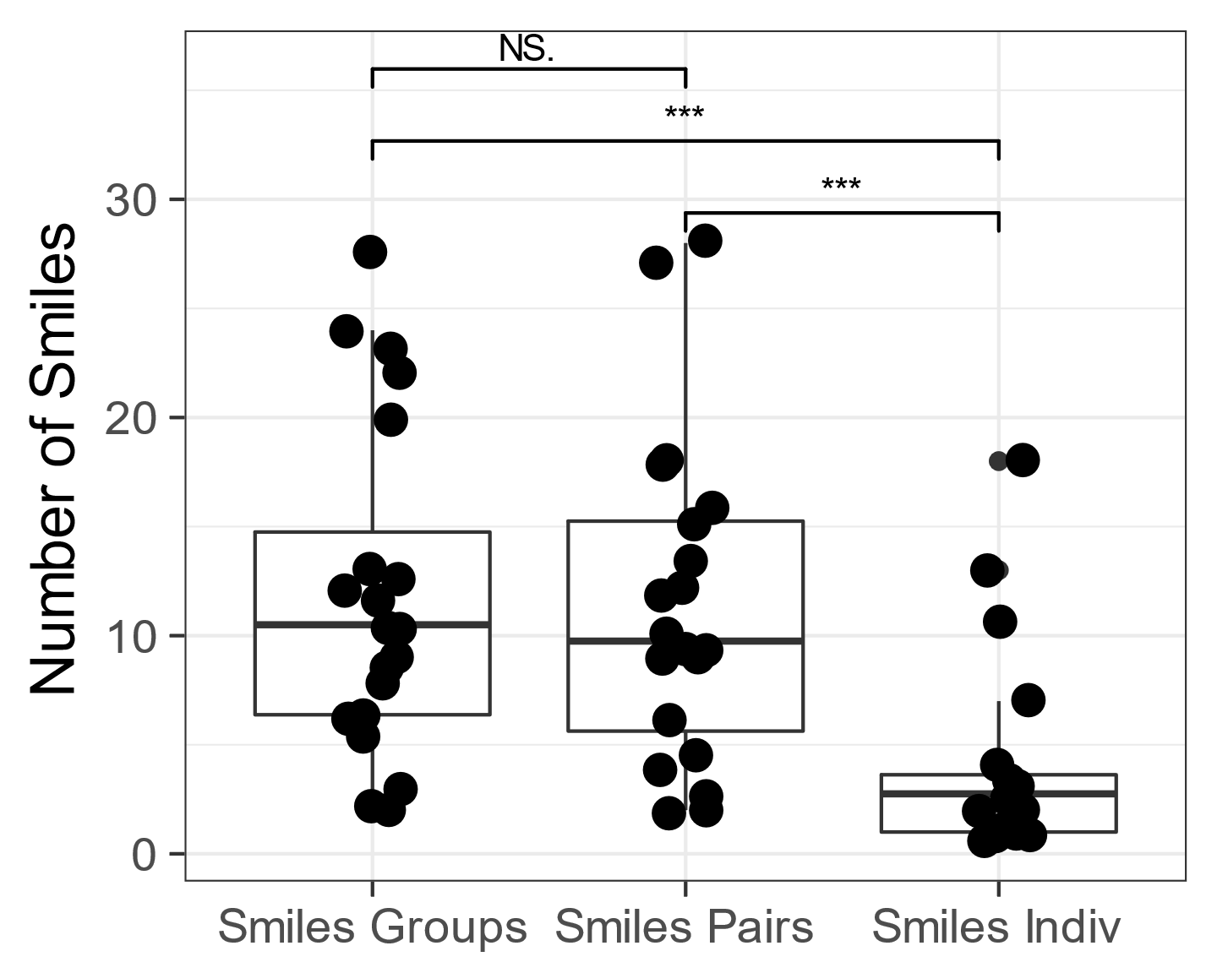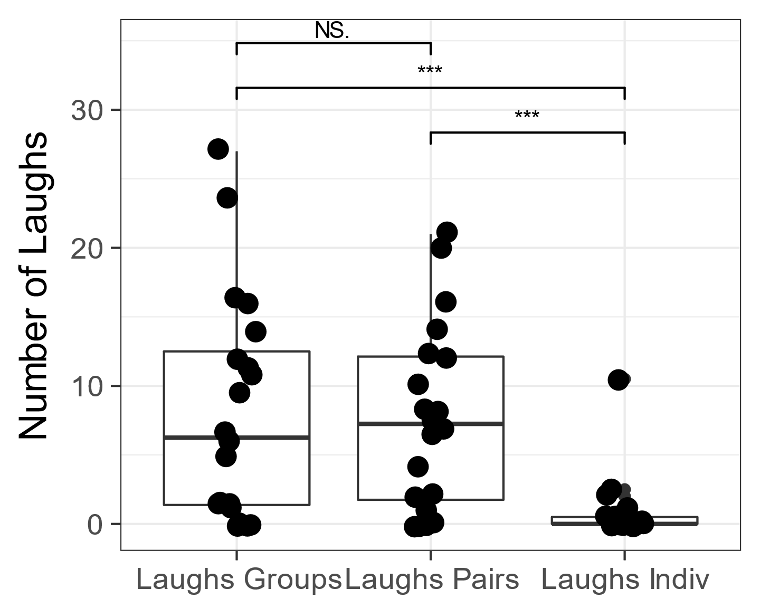

*Figure 1: Tukey box plots of the number of laughs (left) and smiles (right) by condition. Each dot represents one child in one condition and the superimposed box plots show the median and inter-quartile range. Horizontal bars above the plot indicate significance levels of the paired-sample t-test planned comparison.*

Subjective funniness ratings

To investigate the association between children's subjective funniness ratings and viewing condition, totals of "not funny", "quite funny" and "very funny" ratings were calculated for each viewing condition. A Pearson's Chi-Square test of association showed that there were no significant differences in subjective funniness ratings between the group, pair and individual viewing conditions, χ2 = 2.033, d.f=4, *p* = .73. Despite laughing and smiling more when watching in pairs and groups, children did not rate the videos in these conditions as more funny. A similar analysis revealed that all videos were considered equally funny, χ2 = 2.27, d.f=4, *p* = .69. These ratings are summarised in table 2 and 3 respectively.

*Tables 4 & 5: Children’s funniness ratings for each video according to size of group watching (left) and based on content (right).*

|  |  |  |  |
| --- | --- | --- | --- |
| Funniness  Rating | Group Size | | |
| Group | Pair | Indiv |
| Not Funny | 4 | 2 | 3 |
| Quite Funny | 3 | 6 | 6 |
| Very Funny | 13 | 12 | 11 |
| Total | 20 | 20 | 20 |

|  |  |  |  |
| --- | --- | --- | --- |
| Funniness  Rating | Video | | |
| 1 | 2 | 3 |
| Not Funny | 3 | 3 | 3 |
| Quite Funny | 3 | 7 | 5 |
| Very Funny | 14 | 10 | 12 |
| Total | 20 | 20 | 20 |

Finally, it was investigated whether subjective funniness ratings would predict the number of laughs and smiles. For each video the data were grouped according to whether each child had said the video was Not Funny, Quite Funny or Very Funny. The mean numbers of laughs and smiles for each of these groups were then calculated. A one-way ANOVA showed no relationship between number of laughs and funniness, F(2,31)= 0.21, p =.81, ges = .01. A similar one-way ANOVA showed no relationship between number of smiles and subjective funniness F(2,31)= 0.48, p =.63, ges = .03. The data are shown in Figure 2.

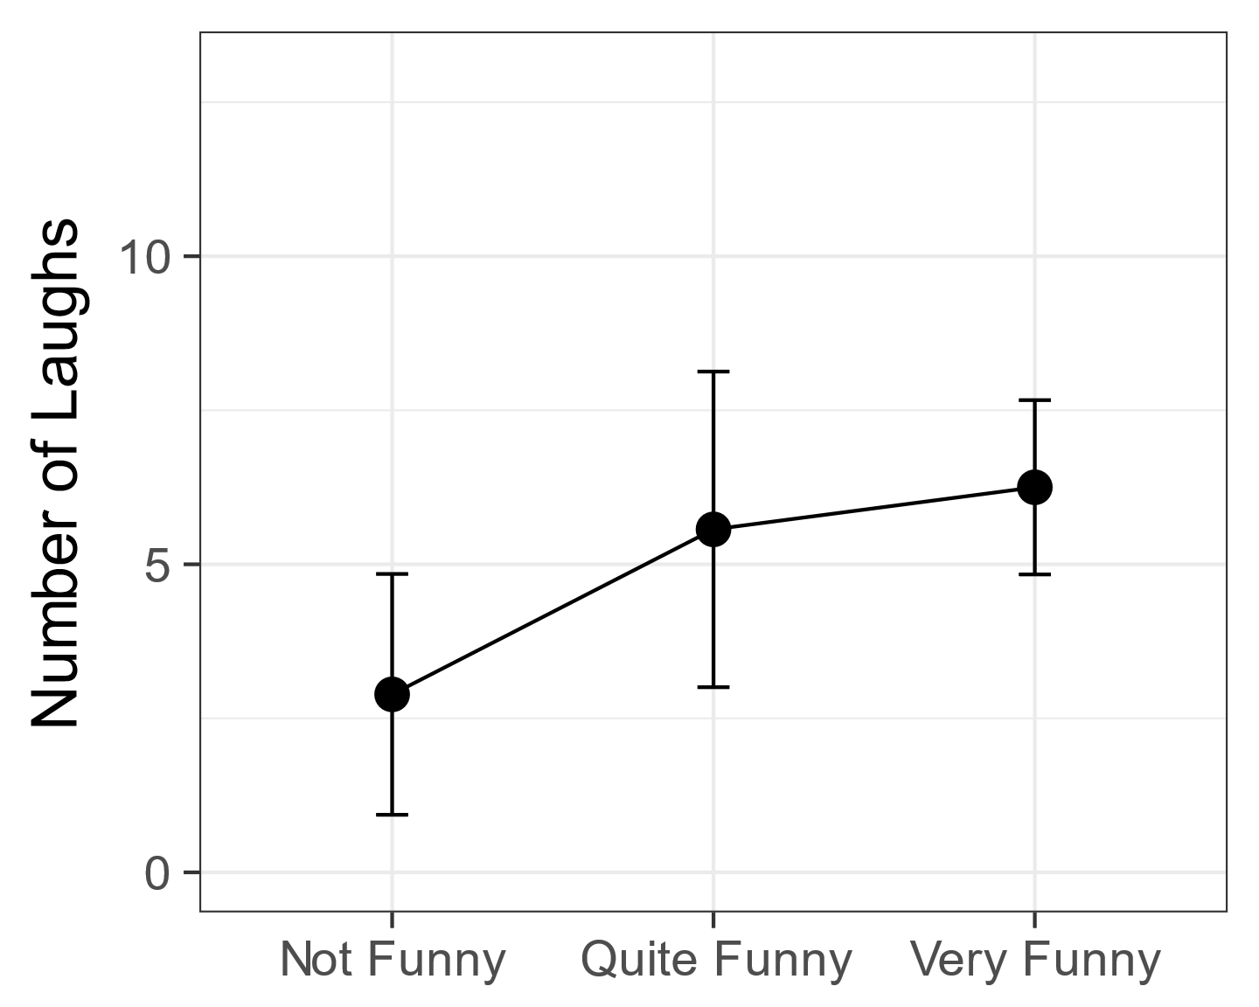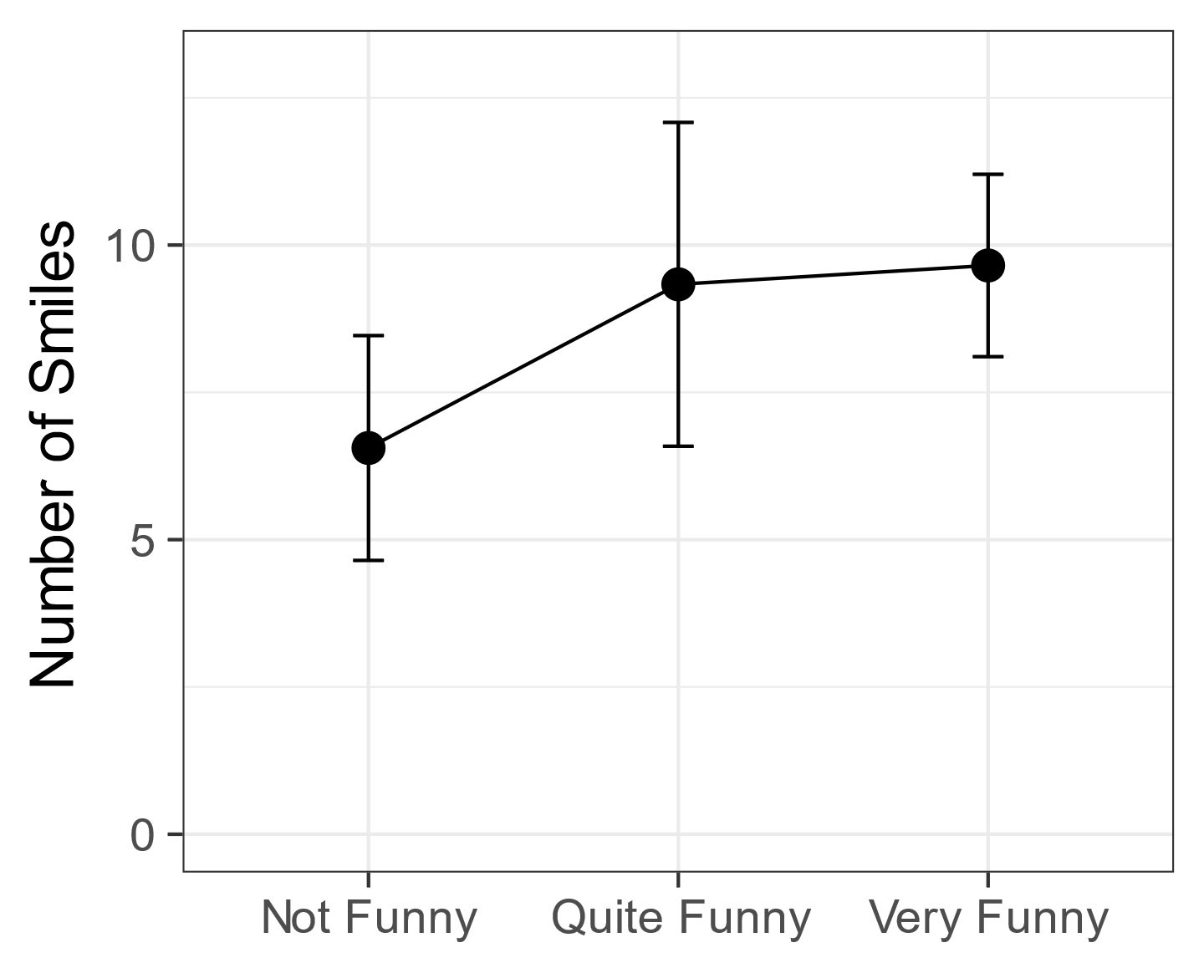

*Figure 2: How laughs (left) and smiles (right) relate to subjective funniness. Error bars represent +/- 1 standard error.*

**Discussion**

This experiment investigated the influence of social peers on preschoolers’ responses to humorous materials. In line with predictions, we found that the presence of a social partner significantly increased smiling and laughter. When watching a funny cartoon, on average children laughed eight times more in company than when on their own, while smiles increased by a factor of around 2.8. The amount of laughter or smiling did not differ between pair or group conditions. This suggests that the presence of a single social partner can be sufficient to increase overt laughter and smiles. When children’s funniness ratings were taken into account, it was found that the greater amount of laughter and smiles in groups and pairs was not associated with higher ratings of funniness. Finally, there was no association between individual funniness ratings and the amount of laughter and smiles produced.

Chapman (1973) found that 7-8 year-olds laughed and smiled more in pairs than individually. The findings of the current study extend that result by looking at a much younger age group (mean age 3 years 4 months) and by including a group condition. Our experimental approach goes beyond the observational work on social laughter in adults (Kraut & Johnson, 1979; Fernández-Dols & Ruiz-Belda 1995) and links to the related work on social laughter with adults (Fridlund 1991; Young & Frye, 1966; Devereux & Ginsburg, 2001). The results of the present study provide a demonstration of the clear social role of overt laughter and smiles from a much younger age than shown in previous research. Furthermore, age was not correlated with any of the experimental measures suggesting this effect is already well established at this age. A challenge for future research would be to extend this method to younger ages.

The lack of difference in the amount of laughing and smiling between the pair and group conditions was unexpected. Mehu and Dunbar (2008) carried out naturalistic observations in public areas of people interacting in small groups in which group size, composition, in terms of sex and age of individuals, and social context of interactions were taken into account. Their results revealed group size to have the largest overall effect on the amount of laughter and smiling, with rates increasing as a function of group size. Group size had no influence in the current experiment, and the lack of difference between the pair and group conditions goes against a pure social contagion explanation. If children’s laughter and smiles increased in response to the smiles and laughs of others, higher scores would be expected in the group condition. This is at odds with the contagious properties of laughter in preschool children reported by Brackett (1933) and Sherman (1975), as well as with the experimental research using laugh boxes by Provine (1992) which found that laughter itself elicited laughter. One difference between this study and previous work is the relatively passive and non-social nature of the task. Children were watching a video rather than interacting with each other.

Nonstatistical observations of our video data indicated that in the pair viewing condition, the laughter of one child did sometimes set the other off laughing, and that in the group viewing condition, this happened in a kind of chain reaction. Incongruous events (for example, Bernard Bear getting stuck in a bin) elicited high levels of laughter but rather than all children bursting into laughter simultaneously, it was often the initial laughter of one particularly gregarious child that quickly spread. Likewise, observations indicated that children in pairs or groups frequently made eye contact with each other whilst laughing. In the individual condition, smiling children would sometimes try to catch the eye of the researchers, presumably to share the joke. These nonstatistical observations correspond with previous research. Jones (1989) found that infants engaged in play tend only to smile when turning to make eye contact with carers while Kraut & Johnson (1979) and Fernandez Dols & Ruiz-Belda (1995) found that most adult smiling occurs during face-to-face contact

Should laughter and smiling be treated as a single construct? This is both a theoretical and methodological question. When assessing temperament it is reasonable to combine them as indicators for positive affect as in the IBQ-R (Gartstein & Rothbart, 2003). In social and communicative setting it is worth keeping the distinction (Haakana, 2010) but this requires clear operational definitions and measures. In the current experiment, it was noted that often a smile would become a laugh, and often a laugh would end with a smile and most inconsistencies between coders concerned laughs being termed smiles and vice versa. With our 10 second blocked counting, consensus was high between our coders and our results do show a stronger effect in the laughter compared to the smiles. But our method does not allow us to account for different intensities of laughter in terms of volume or duration, or for different intensities of smiling. Likewise analyses of eye contact, laughter initiation, contagion were not possible in the current study which relied on a single microphone and single camera angle in a noisy environment. Future studies should use multiple cameras and individual lapel microphones to record data for richer time-series analyses. Future work should also include temperament measures.

In Chapman’s (1973) study, children who laughed and smiled the most also gave the highest subjective ratings of funniness. This was not found in the current study. The videos were rated Very Funny by most children in all viewing conditions and the Chi-Squared tests found no association between funniness of videos and viewing conditions. Likewise, despite the apparent trends seen in figure 2, the statistical analysis revealed that there were no more laughter and smiles in cases rated funnier by children. One explanation may be that these very young children did not fully understand what they were being asked. McGhee (1977) suggests that the typical use of five- or seven-point funniness rating scales, whilst appropriate for older children, may not be appropriate for younger children. In the current study, a three-point funniness rating scale was used. Whilst it was the view of the researcher who knew the children that most could easily do this task, children’s responses were often quite arbitrary, therefore calling into question the validity of relying on subjective ratings in children so young. Future work should include a control task with non-funny stimuli to ensure children can answer this question.

Chapman (1976) emphasised that the unassuming nature of young children make them ideal participants for investigating spontaneous behaviours such as laughter. One of the main strengths of the current experiment was its high ecological validity. It was conducted during children’s normal day-to-day preschool activities and took place in a screened-off corner of the main room of the preschool. One downside was inevitably some background noise from other activities, but it is not believed the children were unduly affected by this. The upside was that the children remained in a familiar setting and so no children felt anxious, and this also helped keep them naïve to the fact they were being observed or evaluated, thereby maintaining ecological validity. Throughout the experiment, the researchers stood just outside of the privacy screens and slightly behind the children, which meant that children in the individual viewing condition were not alone in the strictest sense. This was required due to the children’s young age and preschool regulations that require adult supervision at all times. The fact that a strong effect was still found suggests the children acted as if watching alone. Finally, all the children in this study were well known to each other, having attended the same preschool for an extended period, increasing any likely social effects.

Giles and Oxford (1970) proposed that social laughter and humorous laughter are mutually exclusive. The findings of the current experiment suggest that the two types of laughter are frequently interlinked and that laughter and smiling have a strongly social role even in a humorous setting. An earlier study of preschoolers measured laughter in response to a humorous recording either alone or after observing a laughing or non-laughing peer (Brown, Wheeler, & Cash, 1980). That study found a mixed pattern of results in that laughing increased across conditions, but smiling occurred least after encountering a non-smiling peer. This led those authors to favour an imitation learning account of their results (Bandura, 1978). In the present study, however, the mere presence of another was sufficient to increase overt laughter and smiling, therefore the social facilitation explanation (Zajonc 1965) is perhaps a better starting point.

Certainly, more research is needed to understand how social and emotional factors interact with learning in preschoolers. Many researchers now recognise that emotion is an indivisible part of the preschool experience. Social and Emotional Learning (SEL) has become a well-known acronym with early years literature (Morris, Millenky, Raver, & Jones, 2013; Williams, Sheridan, & Sandberg, 2014). Whilst that literature addresses aggression and warmth, it rarely directly considers laughter, mirth or glee. Rana Esseily and colleagues recently demonstrated that laughter aided observational learning in 18 month old infants (Esseily, Rat-Fischer, Somogyi, O’Regan, & Fagard, 2016). This suggests there is potential to recruit young children’s natural mirth and glee and the social setting of the preschool to enhance learning. Humour in social settings could have a pedagogical role in preschool. For example, it would be interesting to investigate whether the observational learning benefit of laughter found by Esseily et al.(2016) translated to greater comprehension and learning from videos in a setting like that of the current experiment.

Finally, the primarily social aspect of laughter and smiles found in the present study does not diminish preschoolers’ appreciation and understanding of humour (Hoicka & Akhtar, 2012; Hoicka & Butcher, 2016) The children in the present study found the cartoons funny in all viewing conditions but their laughter and smiles were strongly modulated by social setting. Our study shows that indexing young children’s understanding of humour with laughter is not straightforward, but the cognitive skills children require for understanding humour make it a fascinating lens onto preschool development.

In conclusion, the present study has demonstrated that social presence of peers makes a large difference to preschoolers’ overt laughter and smiling, but that increased ostensive signals of humour appreciation do not change the perceived funniness of humorous material. Given the importance of social laughter and smiling in establishing social bonds and the value of humour within the context of cognitive development, it is hoped that the current experiment will form the basis for further investigation into the social nature of laughter and smiling in preschool children.

References

Addyman, C., & Addyman, I. (2013). The science of baby laughter. *Comedy Studies*, *4*(2013), 143–153. https://doi.org/10.1386/cost.4.2.143

Addyman, C., Fogelquist, C., Levakova, L., & Rees, S. (2017). Social laughter in preschool children: Dataset, analysis scripts and supporting materials. FigShare. https://doi.org/10.6084/m9.figshare.5549356

Bandura, A. (1978). Social Learning Theory of Aggression. *Journal of Communication*, *28*(3), 12–29. https://doi.org/10.1111/j.1460-2466.1978.tb01621.x

Brackett, C. W. (1933). Laughing and Crying of Preschool Children. *The Journal of Experimental Education*, *2*(2), 119–126. https://doi.org/10.1080/00220973.1933.11009932

Brown, G. E., Wheeler, K. J., & Cash, M. (1980). The effects of a laughing versus a nonlaughing model on humor responses in preschool children. *Journal of Experimental Child Psychology*, *29*(2), 334–339. https://doi.org/10.1016/0022-0965(80)90024-7

Caron, J. E. (2002). From ethology to aesthetics: Evolution as a theoretical paradigm for research on laughter, humor, and other comic phenomena. *Humor - International Journal of Humor Research*, *15*(3), 245–281. https://doi.org/10.1515/humr.2002.015

Champely, S. (2017). pwr: Basic Functions for Power Analysis. Retrieved from https://cran.r-project.org/package=pwr

Chapman, A. J. (1973). Social facilitation of laughter in children. *Journal of Experimental Social Psychology*, *9*(6), 528–541.

Chapman, A. J. (1975). Humorous laughter in children. *Journal of Personality and Social Psychology*, *31*(1), 42–49.

Chapman, A. J. (1983). Humor and laughter in social interaction and some implications for humor research. In J. H. Goldstein & P. E. McGhee (Eds.), *Handbook of humor research* (pp. 135–158). New York: Springer Verlag.

Chapman, A. J., & Wright, D. S. (1976). Social enhancement of laughter: An experimental analysis of some companion variables. *Journal of Experimental Child Psychology*, *21*(2), 201–218.

Darwin, C. (1872). *The expression of emotion in man and animals*. London: John Murray.

Davila-Ross, M., Allcock, B., Thomas, C., & Bard, K. A. (2011). Aping expressions? chimpanzees produce distinct laugh types when responding to laughter of others. *Emotion*, *11*(5), 1013–1020. https://doi.org/10.1037/a0022594

Davila Ross, M., J Owren, M., & Zimmermann, E. (2009). Reconstructing the Evolution of Laughter in Great Apes and Humans. *Current Biology*, *19*(13), 1106–1111. https://doi.org/10.1016/j.cub.2009.05.028

Devereux, P. G., & Ginsburg, G. P. (2001). Sociality Effects on the Production of Laughter. *The Journal of General Psychology*, *128*(2), 227–240. https://doi.org/10.1080/00221300109598910

Dezecache, G., & Dunbar, R. I. M. (2012). Sharing the joke: The size of natural laughter groups. *Evolution and Human Behavior*, *33*(6), 775–779. https://doi.org/10.1016/j.evolhumbehav.2012.07.002

Ekman, P., & Friesen, W. V. (1984). *Unmasking the face : a guide to recognizing emotions from facial clues* (Reprint ed). Palo Alto Ca.: Consulting Psychologists Press.

Esseily, R., Rat-Fischer, L., Somogyi, E., O’Regan, K. J., & Fagard, J. (2016). Humour production may enhance observational learning of a new tool-use action in 18-month-old infants. *Cognition & Emotion*, *9931*(May), 1–9. https://doi.org/10.1080/02699931.2015.1036840

Fernández-Dols, J.-M., & Ruiz-Belda, M.-A. (1995). Are smiles a sign of happiness? Gold medal winners at the Olympic Games. *Journal of Personality and Social Psychology*, *69*(6), 1113.

Fridlund, A. J. (1991). Sociality of solitary smiling: Potentiation by an implicit audience. *Journal of Personality and Social Psychology*, *60*(2), 229–240. https://doi.org/10.1037/0022-3514.60.2.229

Gartstein, M. A., & Rothbart, M. K. (2003). Studying infant temperament via the Revised Infant Behavior Questionnaire. *Infant Behavior and Development*, *26*(1), 64–86. https://doi.org/10.1016/S0163-6383(02)00169-8

Gervais, M., & Wilson, D. S. S. (2005). The evolution and functions of laughter and humor: a synthetic approach. *The Quarterly Review of Biology*, *80*(4), 395–430. https://doi.org/10.1086/498281

Giles, H., & Oxford, G. S. (1970). Towards a multidimensional theory of laughter causation and its social implications. *Bulletin of the British Psychological Society*, *23*(79), 97–105.

Haakana, M. (2010). Laughter and smiling: Notes on co-occurrences. *Journal of Pragmatics*. https://doi.org/10.1016/j.pragma.2010.01.010

Hoicka, E., & Akhtar, N. (2011). Preschoolers joke with jokers, but correct foreigners. *Developmental Science*, *14*(4), 848–858. https://doi.org/10.1111/j.1467-7687.2010.01033.x

Hoicka, E., & Akhtar, N. (2012). Early humour production. *British Journal of Developmental Psychology*, *30*(4), 586–603. https://doi.org/10.1111/j.2044-835X.2011.02075.x

Hoicka, E., & Butcher, J. (2016). Parents Produce Explicit Cues That Help Toddlers Distinguish Joking and Pretending. *Cognitive Science*, *40*(4), 941–971. https://doi.org/10.1111/cogs.12264

Hoicka, E., & Gattis, M. (2008). Do the wrong thing: How toddlers tell a joke from a mistake. *Cognitive Development*, *23*(1), 180–190. https://doi.org/10.1016/j.cogdev.2007.06.001

Jones, S. S., & Raag, T. (1989). Smile production in older infants: The importance of a social recipient for the facial signal. *Child Development*, 811–818.

Kenderdine, M. (1931). Laughter in the pre-school child. *Child Development*, *2*(3), 228–230.

Knutson, B., Burgdorf, J., & Panksepp, J. (1998). Anticipation of play elicits high frequency ultrasonic vocalizations in young rats. *Journal of Comparative Psychology*, *112*(1), 65–73.

Kraut, R. E., & Johnston, R. E. (1979). Social and emotional messages of smiling: An ethological approach. *Journal of Personality and Social Psychology*, *37*(9), 1539.

Lawrence, M. A. (2016). ez: Easy Analysis and Visualization of Factorial Experiments. Retrieved from https://cran.r-project.org/package=ez

Martin, R. A. (2007). *The psychology of humor : an integrative approach*. Amsterdam: Elsevier Academic Press.

Matsusaka, T. (2004). When does play panting occur during social play in wild chimpanzees? *Primates*, *45*(4), 221–229. https://doi.org/10.1007/s10329-004-0090-z

McGhee, P. (1977). Children’s humour: a review of current research trends. In A. Chapman & H. Foot (Eds.), *It’s a Funny Thing, Humour.* Oxford: Pergamon Press.

McGhee, P. E. (1979). *Humor, its origin and development*. San Francisco: W.H. Freeman and Company. Retrieved from http://www.worldcat.org/title/humor-its-origin-and-development/oclc/5101611

Mehu, M., & Dunbar, R. (2008). Naturalistic observations of smiling and laughter in human group interactions. *Behaviour*, *145*(12), 1747–1780. https://doi.org/10.1163/156853908786279619

Mireault, G., Sparrow, J., Poutre, M., Perdue, B., & Macke, L. (2012). Infant humor perception from 3- to 6-months and attachment at one year. *Infant Behavior and Development*, *35*(4), 797–802. https://doi.org/10.1016/j.infbeh.2012.07.018

Morris, P., Millenky, M., Raver, C. C., & Jones, S. M. (2013). Does a Preschool Social and Emotional Learning Intervention Pay Off for Classroom Instruction and Children’s Behavior and Academic Skills? Evidence From the Foundations of Learning Project. *Early Education and Development*, *24*(7), 1020–1042. https://doi.org/10.1080/10409289.2013.825187

Morrison, J. (1940). A note concerning investigations on the constancy of audience laughter. *Sociometry*, *3*(2), 179–185.

Provine, R. R. (1993). Laughter Punctuates Speech: Linguistic, Social and Gender Contexts of Laughter. *Ethology*, *95*(4), 291–298. https://doi.org/10.1111/j.1439-0310.1993.tb00478.x

Provine, R. R. (1996). Laughter mechanisms The study of laughter provides a novel approach to the and evolution of vocal production , perception and social behavior. *American Scientist*, *84*(1), 38–45.

Provine, R. R. (2001). *Laughter : a scientific investigation*. London: Penguin.

Provine, R. R. (2004). Laughing, tickling, and the evolution of speech and self. *Current Directions in Psychological Science*, *13*(6), 215–218. https://doi.org/10.1111/j.0963-7214.2004.00311.x

Provine, R. R., & Fischer, K. R. (1989). Laughing, Smiling, and Talking: Relation to Sleeping and Social Context in Humans. *Ethology*, *83*(4), 295–305. https://doi.org/10.1111/j.1439-0310.1989.tb00536.x

Rothbart, M. K. (1973). Laughter in young children. *Psychological Bulletin*, *80*(3), 247–256. https://doi.org/10.1037/h0034846

Sherman, L. W. (1975). An ecological study of glee in small groups of preschool children. *Child Development*, *46*(1), 53–61. Retrieved from http://www.ncbi.nlm.nih.gov/pubmed/1132281

Sroufe, L. A., & Waters, E. (1976). The ontogenesis of smiling and laughter: a perspective on the organization of development in infancy. *Psychological Review*, *83*(3), 173–189. https://doi.org/10.1037/0033-295X.83.3.173

Weisfeld, G. E. (1993). The adaptive value of humor and laughter. *Ethology and Sociobiology*, *14*(2), 141–169.

Williams, P., Sheridan, S., & Sandberg, A. (2014). Preschool - an arena for children’s learning of social and cognitive knowledge. *Early Years*, *34*(3), 226–240. https://doi.org/10.1080/09575146.2013.872605

Young, R. D., & Frye, M. (1966). Some are Laughing; Some are Not—Why? *Psychological Reports*, *18*(3), 747–754. https://doi.org/10.2466/pr0.1966.18.3.747