We varied the number of hidden units to see if we could get the initial learning and subsequent forgetting rebound of the subchunks of klmn. We were not able to do so.

Giroux & Rey, SRN Model

Hiddens: 5

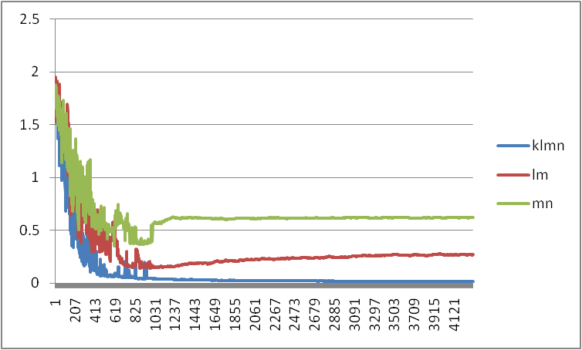

Hiddens: 6

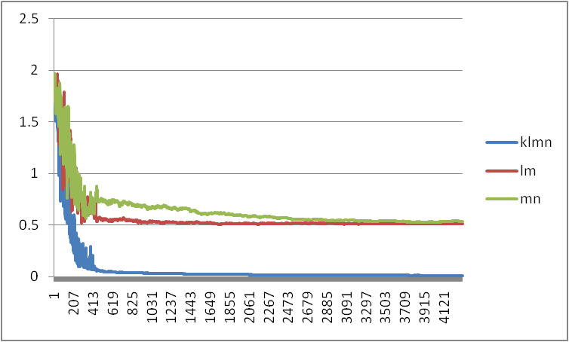

Hiddens: 7

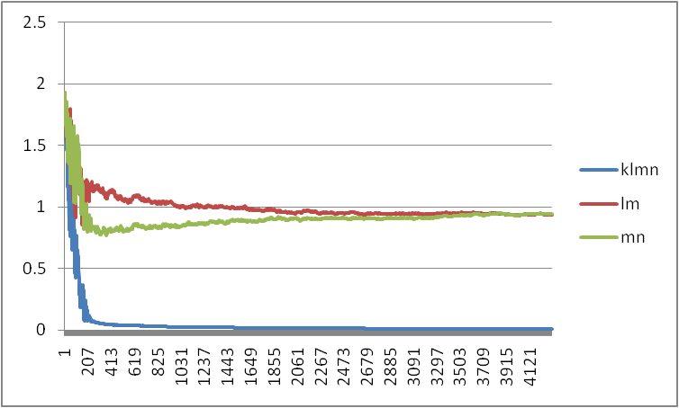

Hiddens: 8

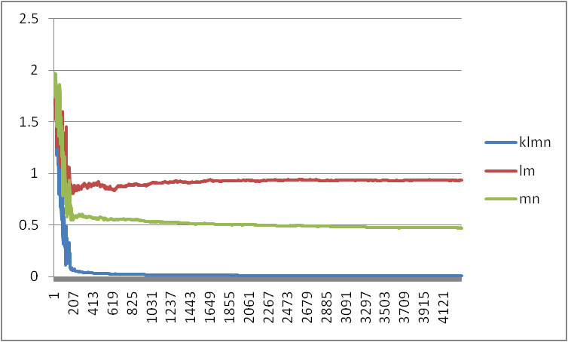

Hiddens: 9

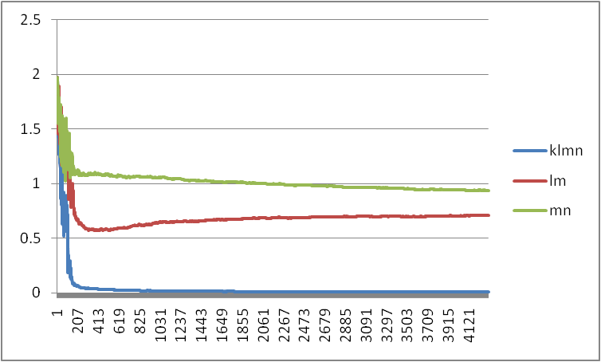

Hiddens: 12

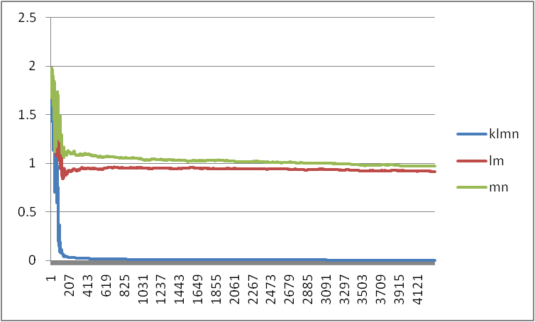

Hiddens: 15

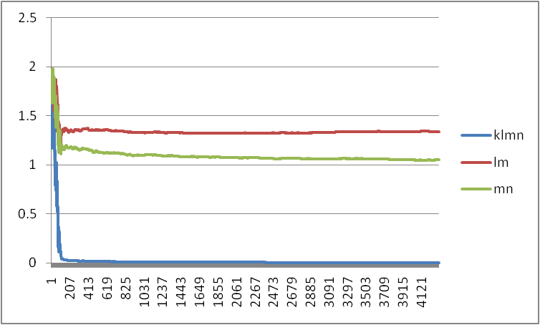

Hiddens: 18

