Consider the normal situation shown below. The upper black normal gaussian (NG1) is supposed to represent the normal activation spike for an event to which the person/infant is paying a normal amount of attention. NG1 fades to NG2 in a given amount of time TN. This means that both the curve NG2 and Δnormal correspond to TN.

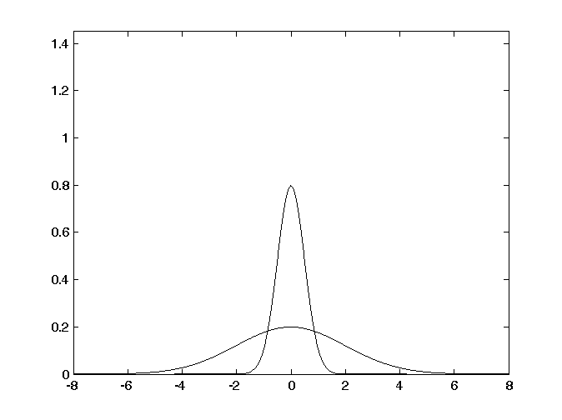

Δnormal

NG2

NG1

It seems to me that one of the, if not *the* key questions is: Do people/infants habituate to Δnormal or do they habituate to the lower black normal gaussian (NG2), or something else altogether? In other words, is the perception of time a function of

i) Δnormal ? or

ii) the shape (i.e., amplitude and variance) of NG2? or

iii) the ratio σ(NG1)/σ(NG2)?

iv) etc.

The two choices potentially imply two different models. Assume you hear a very loud sound, or are attending very closely to the sound. That gives the following graphs:

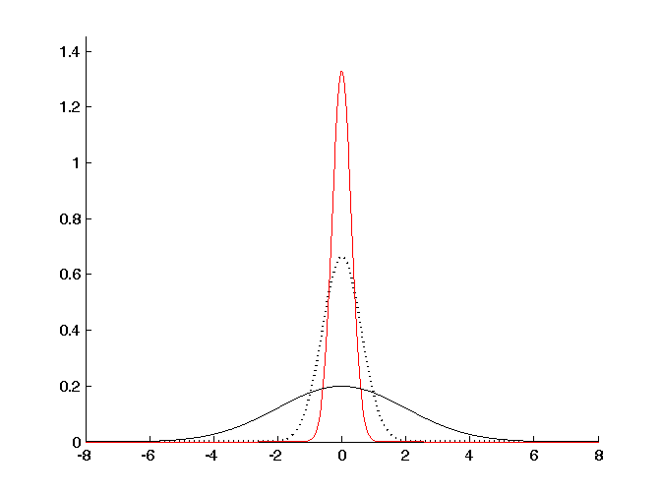

Δnormal

The picture above is the Staddon view, more or less, where Δ represents the amount of activation. Our view, of course, is that Δ is the spread of activation (i.e., σ of the activation curve).

In a lengthy discussion with Elizabeth last night, she gave some very good arguments for the measure not being based on the time it takes for the fading gaussing to reach NG2, but rather the amount of time that the curve takes to decrease in activation by an amount Δnormal . And, in this case, increased attention would cause the curve to squash-and-spread more slowly.

So, the alternate views are:

i) the “absolute” view in which the activation curves always squash-and-spread at the same rate, the only difference with increase attention being that the initial curve is higher than normal and, therefore, it takes longer to get to NG2. Thus you report: “10 seconds” when it was, in fact, 13 seconds;

ii) the “relative” view where, within reason, the height of the initial curve is not important, but that as soon as its activation has decreased by Δnormal, you report “10 sec.”, but in this version, increased attention is causing the curve to fall more slowly. As in view 1), you would report “10 s.” when, in fact, 13 s. had passed. (I think this view needs to be amended a bit more, which I discuss at the end of this little document.)

I defended the first view, which has been our idea all along, but she made some very good arguments for the second view. In particular, she said that the “absolute” view requires all of the learning exemplars to be approximately the same in terms of their loudness. In other words, the curve NG1 must be pretty much identical for all of the training exemplars. But we know this can’t be the case. On the other hand, if you take the “relative” view, this problem goes away. The calibration with movement is made on the basis of Δ, regardless of where NG1 starts. And then, you simply need to say that when you are attending more than normal to a stimulus, the activation squashes down more slowly.

Now, clearly, this latter view can’t be right *stricto sensu* because if the NG1 is low, or quite flat, then you might never reach Δ, for example. So, I think that probably the correct way to look at Δ is as a percentage change in activation with respect to the original (%Δ). Or alternately,a percentage change in the spread of the original curve (i.e., σ). That has the following advantages:

i) it would allow you to train on lots of different starting curves, which is almost certainly right;

ii) it would be a very different proposition from the Staddon one. For the moment, our major difference with Staddon et al. is that we use uncertainty (σ) and not activation level as our measure of time. That’s nice, of course, but using a %Δ measure really is different and, the more I think about it, I think it is the more attractive alternative.

Let’s talk about this.

Here’s how we are viewing the problem now:

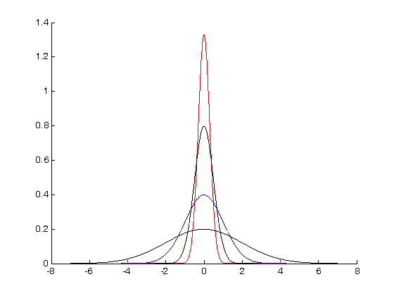

Δnormal

Δhigh attention

Δdistracted