I have used the old model, but slightly simplified:



where

Ai(t) is the activation in the ith column at time step *t*

βr, βl are rates of activation spreading from the (i-1)st column to the ith column (βr), and from the (i+1)st column to the ith column (βl)

βm  determines the rate of decay of the activation of the *ith* column.

Assumptions

i) *initially only a single column is activated,* to a greater or lesser extent, depending on stimulus intensity

ii) the values of βr, βl and βm are the “normal” values of these parameters and the “normal” input stimulus intensity is 1.

We look at four things:

I) the model makes predictions about time estimates when the initial stimulus intensity is varied.

II) Weber’s law. We adopt a measure, which we call, *F*, that characterizes both the height and the spread of the Gaussian and shows that this measure is very close to linear with time.

III) we show that any activation profile can be uniquely “backed up” to discover the intensity of the initial stimulus

IV) the model makes predictions about time estimates if increased/decreased focus of attention to the initial stimulus is parameterized by varying βm, the rate of activation decay in a column.

The "F" measure

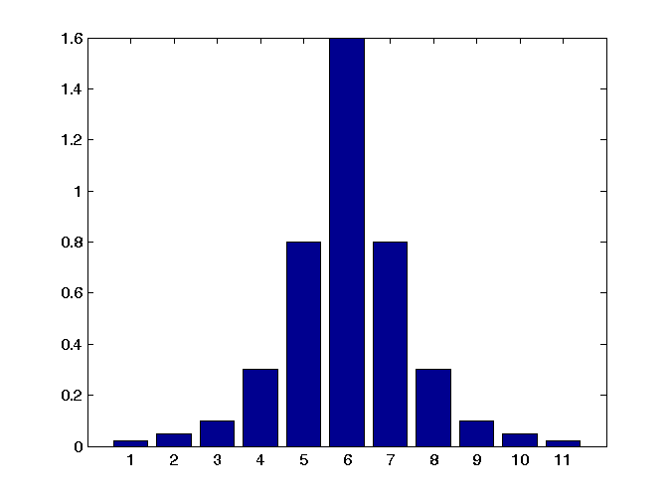

**spread = σ**

**Amplitude = a**

Spreading activation, as defined by the following formula:



decays and spreads exponentially. A reasonable characterization of an activation profile that would take into consideration both its height and its spread would be, for example, the height of the profile at time *t* divided by the spread of the profile at time *t*. Thus, tall, narrow Gaussians would have a high value; low, flat, spread-out Gaussians would get a low value.

Since spread in both directions is exponential, we “linearize” this with the log function. Thus, our measure that we use to characterize the Gaussian is:



I. Predictions when the initial stimulus intensity is varied

Below we compare three stimulus intensities:

i) the normal intensity (1.0), in the top graph

ii) a more intense stimulus (2.0), in the second graph

iii) and a less intense initial stimulus (0.5).

10 s.

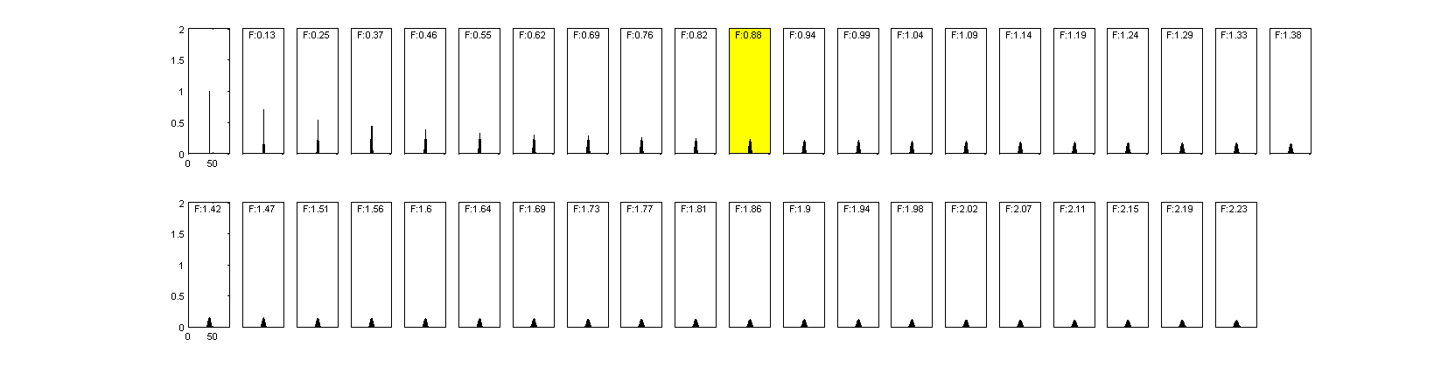



15 s.

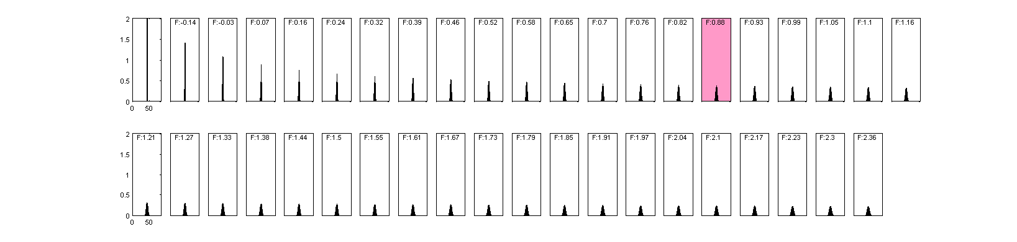

7 s.

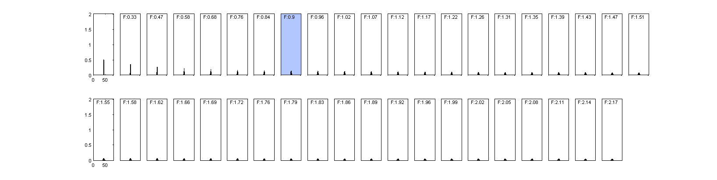

The predictions of the model are clear. As the intensity of a stimulus that occurred in the past increases with respect to its normal intensity, when asked how long ago the stimulus occurred, people will report that it occurred more recently than it did, in fact, occur. In other words, longer intervals are perceived as being shorter than they were. Similarly, as the intensity of a stimulus that occurred in the past decreases with respect to its normal intensity, intervals with respect to the stimulus are judged to be longer than they actually were. In other words, when the stimulus is more intense, when 15 seconds have passed, participants will report 10 seconds. When the stimulus is less intense, when 7 seconds have passed, participants will report 10 seconds.

II. Weber’s Law.

The growth in activation spread of the fading Gaussians, as defined by



where

*a* is the amplitude of the Gaussian and

σ is its standard deviation

is approximately linear. The red dashed curve is a best-linear approximation of the growth of *F*.

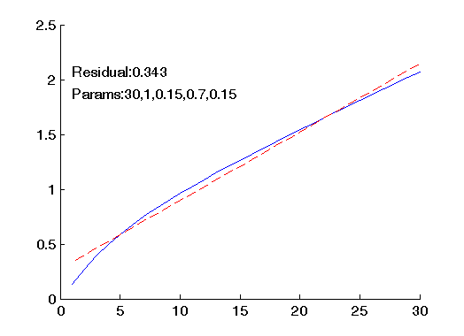 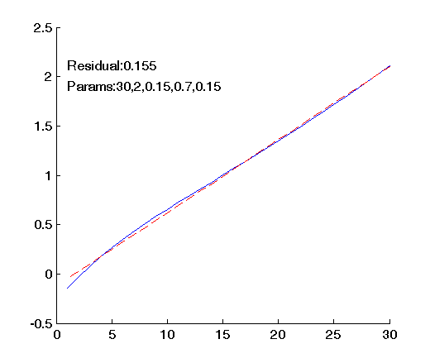

Evolution of *F* over 30 time steps with a starting activation of 1.0 (left panel) and 2.0 (right panel).

.

III. Discovering the intensity of the original stimulus.

In addition, given any activation profile generated from an initial stimulus, the original stimulus can be found based *only* on the activation profile at time *t*. We assume that βr, βl, and βm are known.

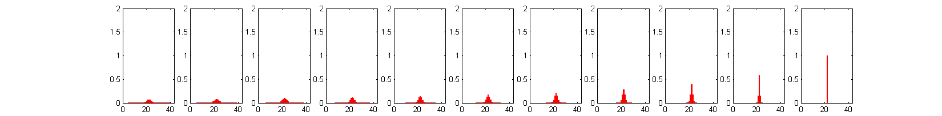

Starting from any activation profile generated by a stimulus (the panel at the far left), that particular activation profile can be “backed up” to discover the activation of the original stimulus. In this case, the profile on the far left could only have been generated by an initial stimulus of activation 1.0.

IV. Predictions about time estimates under increased/decreased focus of attention to the initial stimulus

We examine what happens if focus of attention is parameterized by varying βm, the rate of activation decay in an activation column.

If we assume that increased attention decreases the activation decay rate (and decreased focus of attention increases activation decay rate), we should see effects similar to those produced by stronger/weaker initial stimuli.

To simulate increased focus of attention, we decreased the activation decay rate by 4%. To simulate decreased focus of attention, we increased activation decay rate by 4%.

15 s.

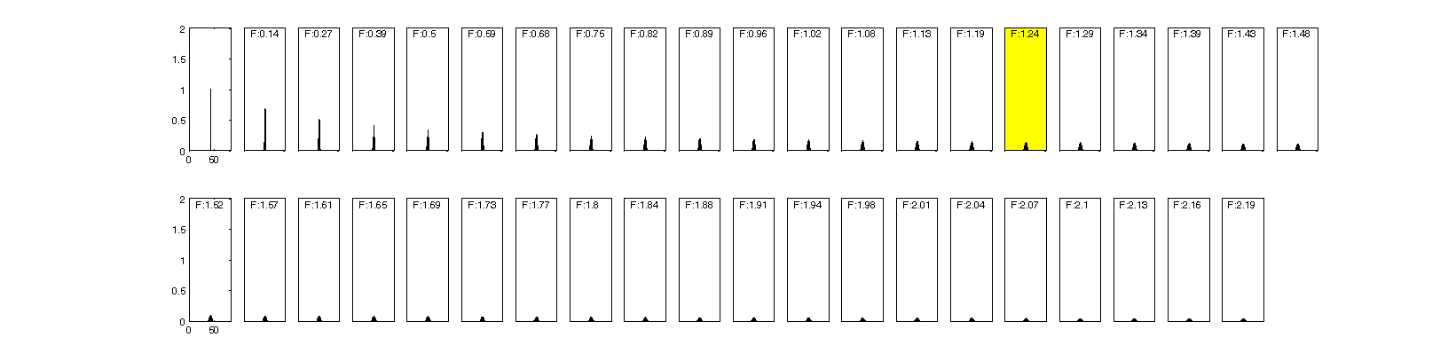

18 s.

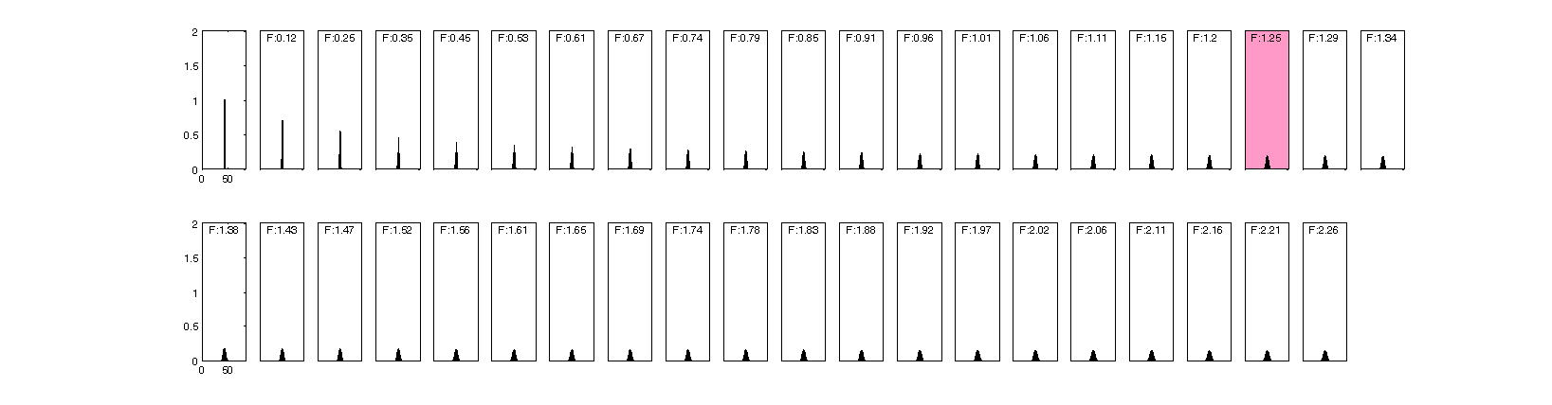

13 s.

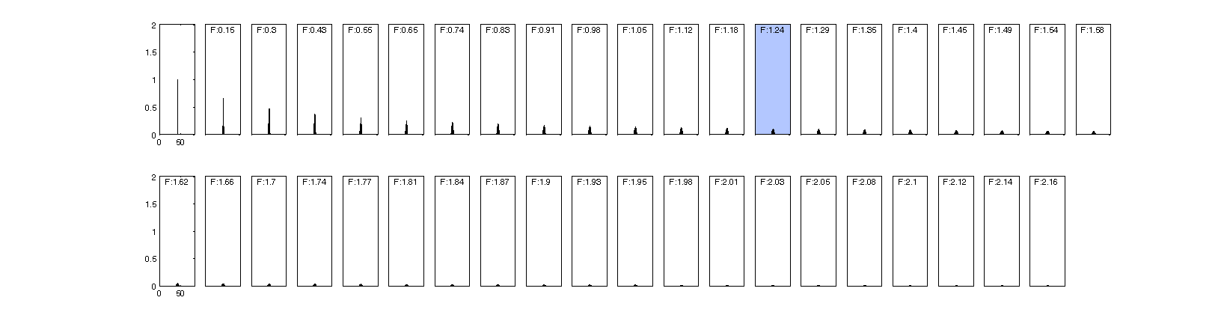



The three figures represent: i) normal focus of attention, ii) higher focus of attention, iii) lower focus of attention.

The predictions, like those for increased stimulus intensity, are clear. Increased focus of attention will cause participants to report a shorter time interval than actually occurred (in this case, the passage of 18 s. will be reported as 15 s). Decreased focus of attention will cause participants to report a longer time than actually occurred (in our example, the passage of 13 s. will be perceived as 15 s).