**Digit Recoginition system**

**Problem statement:**

<https://www.kaggle.com/c/digit-recognizer>

**Solution:**

refer digit_CNN.ipynb (attached)

**Explanation:**

Cell[1]: importing of necessary pakages

Cell[2]: reading input files train.csv and test.csv and labeling the data

Cell[3]: Normalizing the obtained data to the RGB colour code

Cell[4]: Reshaping the data to the 28X28 pixel format

Cell[5]: catogerizing the Y_train data to 10base and renaming the X_test data.

Cell[6]: Convolution Neural Network model (sequential model) setup .

Cell[7]: Compiling the defined CNN model to the required optimization

Cell[8]: Training the neural network with the input train data and setting the no.of epochs to 2.

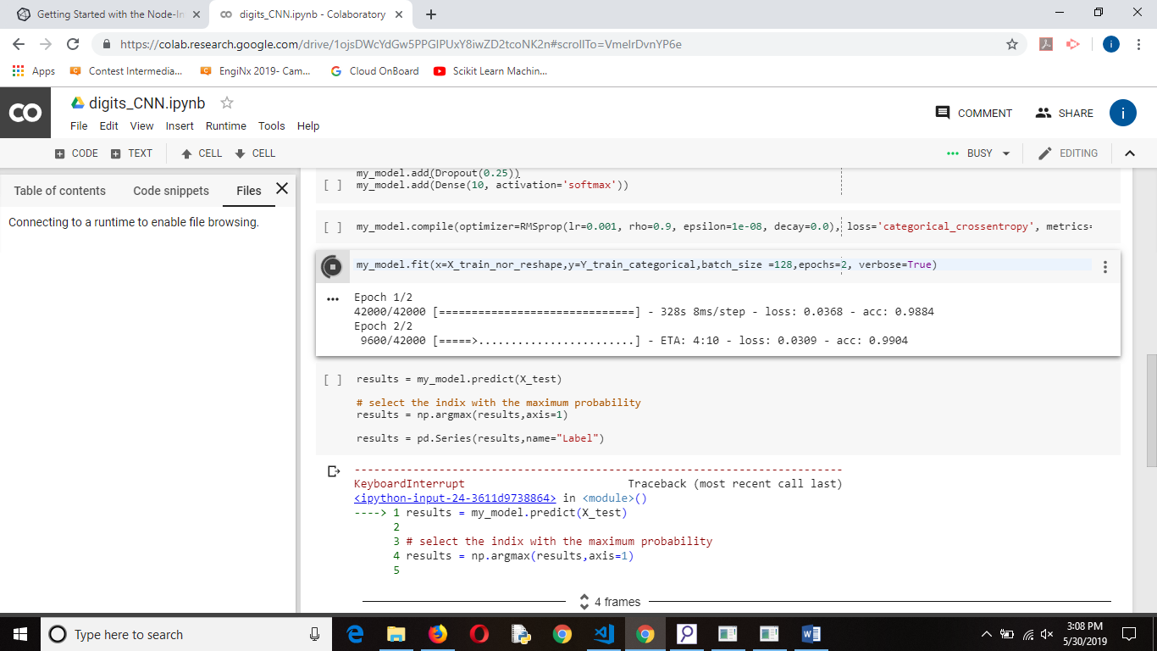

Cell[9]: Predicting the result in series .

Cell[10]: creating the separate CSV file to record the output (My_submission.csv).

**Support used:**

* Python 3
* Google co-labs (processing)/Anacoda python IDE.