Prepared by Noa Vidal April 4, 20XX

Q1

Performance
Report
Consolidated Messenger

www.consolidatedmessenger.com 918-555-0133 noa@consolidatedmessenger.com

Students Information:
Name:
أحمد علي أحمد مخلوف
أحمد عادل رسمي حماد
أحمد أيمن عبدالمنعم محمد
عمر محمد عبد الفتاح محمد
----------------------------------------------------------
Index
- (Introduction to parallel programming,Lecture2Slide25)
- (Fundamental of openmp with omp.h,Lecture2Slide30)
(CreatingThreads to solve PILecture2Slide42)
- (SerialPI Program vs Parallel,Lecture2Slide48)
(SimpleParallel pi program ,Lecture2Slide52)
- (Applying SPMD design pattern on PI Problem,Lecture2Slide53)
- (ChallengingwithFalsesharing,Lecture2Slide56)
- (ApplyingbasicSync,Lecture2Slide60)
  - barrier,Lecture2Slide60
  - critical,Lecture2Slide63
  - Atomic,Lecture2Slide64
- (Using a critical section to remove the impact of false sharing,Lecture2Slide69)
- (Using an atomic section to remove the impact of false sharing,Lecture2Slide72)
- (Basic loop worksharing constructs,Lecture2Slide74)
- (Applying most important methods of schedule clause,Lecture2Slide76)
- (Working nestedloops,Lecture2Slide81)
- (Reduction,Lecture2Slide82)
- (Introductiontompi,Lecture3Slide90)
- (Dealingwithmpidatatypes,Lecture3Slide93)
- (BasicMPIoperations,Lecture3Slide255toSlide264)

- (Introduction to parallel programming,Lecture2Slide25)

- OpenMP is one of the most widely used parallel programming models today.Our First challenge is how to create helloWorld using openmp.So Let’s start!
- In the first, We would use ubuntu to compile openmp code.First,open ubuntu and these are our essential commands
  - mkdir--> creating folder, directory
  - nano --> open your cpp file and use your ubuntu editor
  - touch --> create your cpp file
  - g++ -o name.exe name.cpp -Wall -Fopenmp -->compiling our openmp constructs correctly.
  - ls --> see all directories
  - cd --> go to relative or absolute path

- Afterwards,We would create our first simple program to say hello-world using multi-threading constructs as following picture

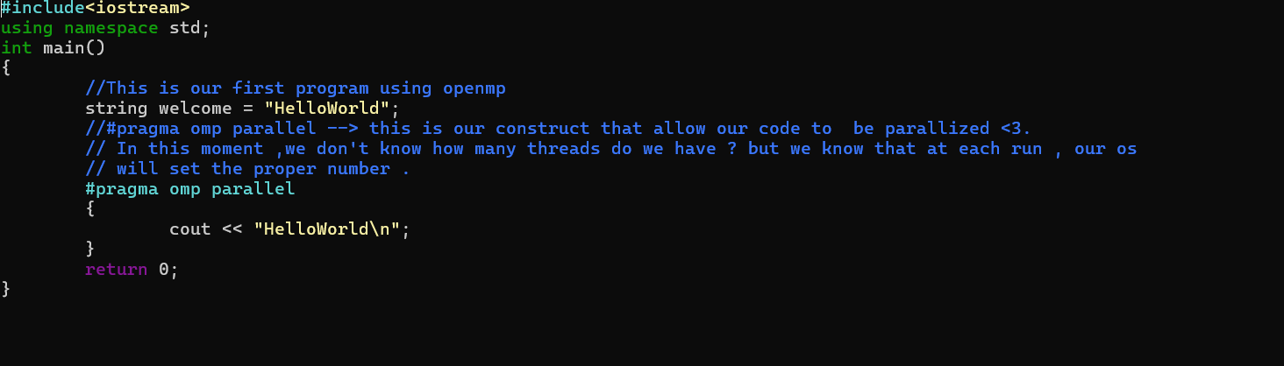

- Here we define a simple parallel program , which it outputs helloworld based on default number of threads as seen in this picture.
- 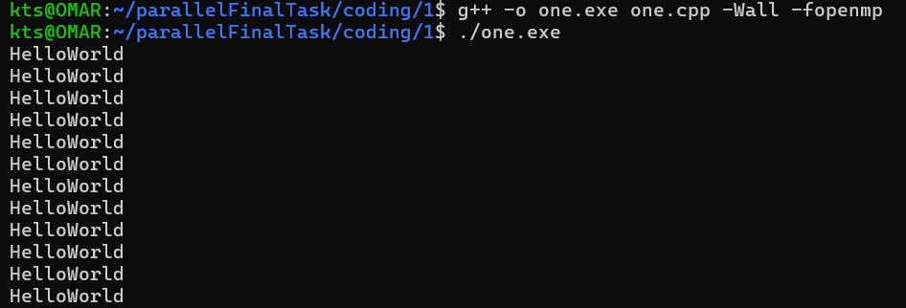

- (Fundamental of openmp with omp.h,Lecture2Slide30)

- As we see in introduction , to deal up with threads , you should define #pragma omp parallel
- Let’s figure out our Most important methods and fields:
- omp_get_thread_num(); --> It used to get the number of threads that works between our omp parallel
- omp_set_num_threads();--> It used to set how many thread do we need to run our code at each one
- omp_get_num_threads(); --> It used to know the id or rank of thread while runtime
See our picture
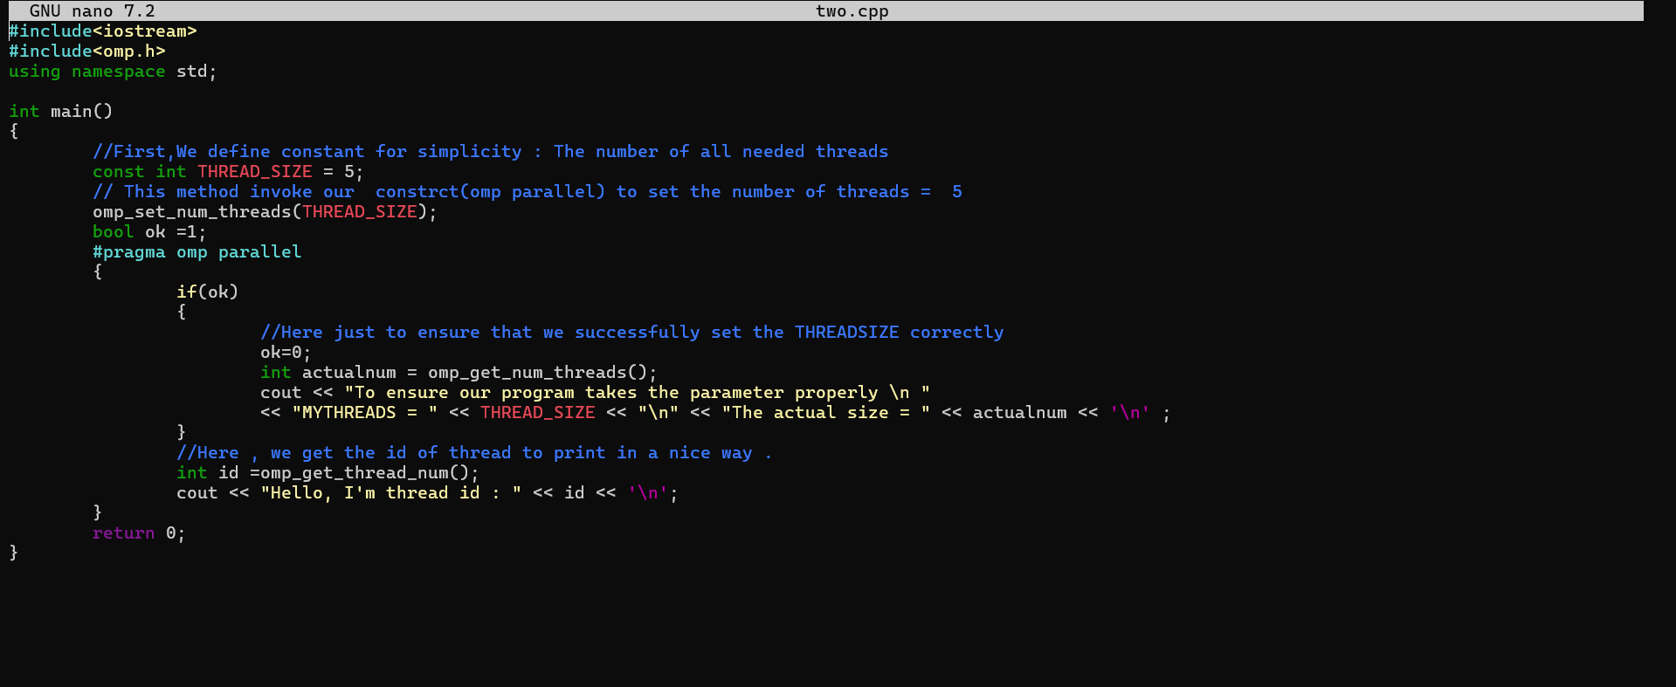

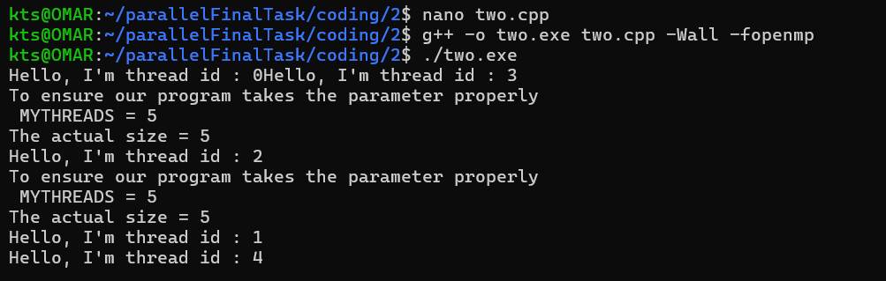

- Although we achieved the purpose , there are a lot of problems like (race condition on bool ok , false sharing cache , etc)

- (SerialPI Program vs Parallel,Lecture2Slide48)

- In our section , we would like to discuss an important mathematical issue which is PI value .To calulate our PI , we need to integrate the following equation : 4.0/(1+x^2) dx
- This integral leads to calculate approximately the sum of rectangles under the curve which is :
  - Summation I=0toN (F(xi)deltax , where F(xi)=width , deltax =height
- Let’s see our picture :
- 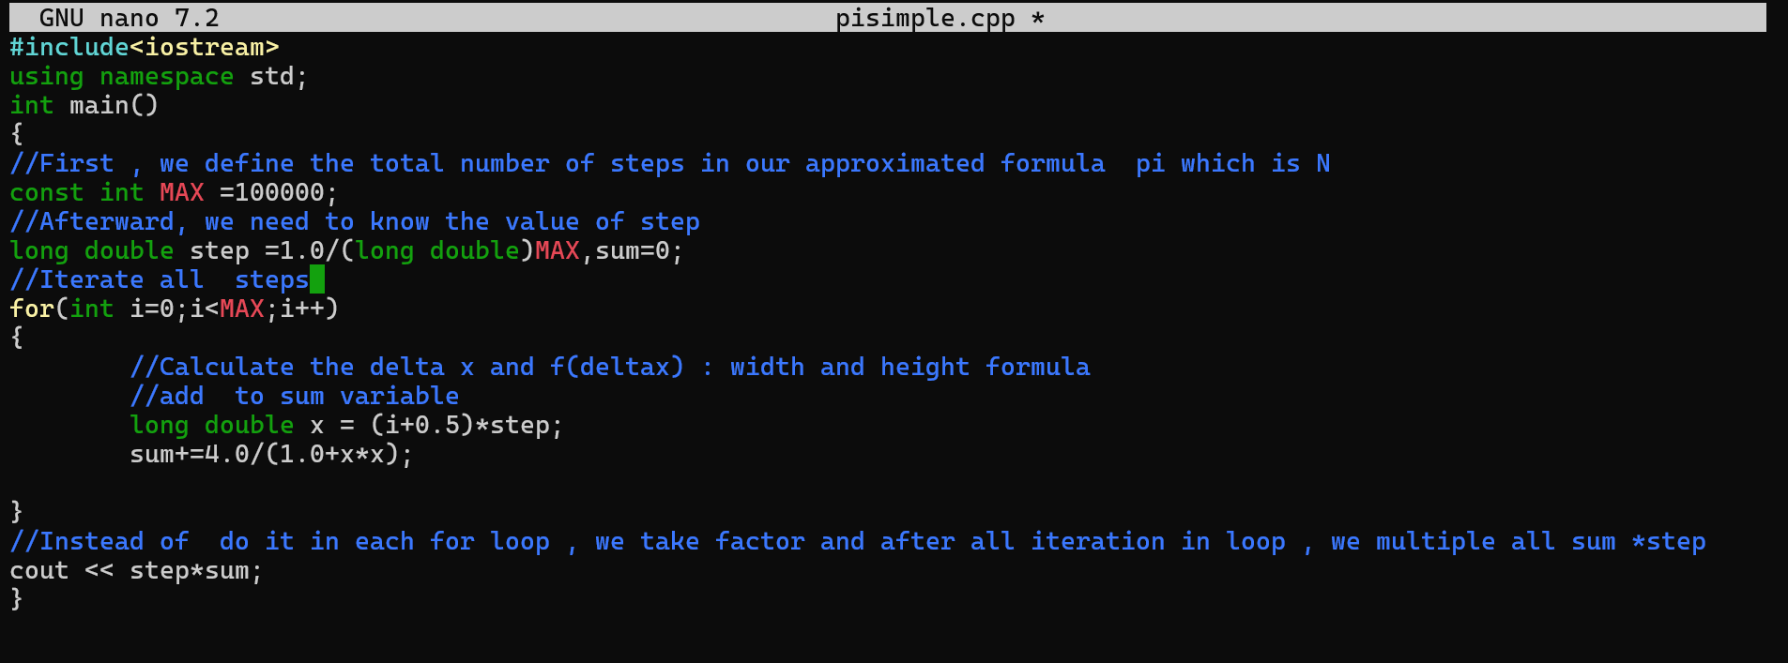
- 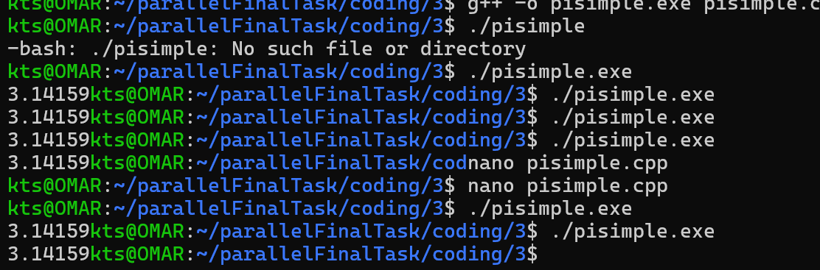
- As we see , we delighted to see our PI’s value is correct.But or challenge is “HOW TO MAKE PI PROGRAM AS PARALLEL VERSION”.Let’s code it together.

Executive summary
Consolidated Messenger closed Q1 2025 with record-breaking revenue growth, driven by expanded e-commerce partnerships and streamlined delivery operations. Revenue increased by 12% quarter-over-quarter, reaching $45 million. Operational efficiency improvements resulted in a 15% reduction in delivery times, enhancing customer satisfaction.

Financial overview
Q1 revenue totaled $45 million, a 12% increase from the previous quarter. Net profit margins rose to 18%, attributed to cost optimization initiatives and increased delivery volume. Operating expenses were effectively managed, ensuring sustainable growth.

Operational performance
Consolidated Messenger achieved a 15% reduction in delivery times by optimizing route planning and expanding its network of regional fulfillment centers. Customer satisfaction scores improved by 10%, reflecting the positive impact of these operational changes.

Market analysis
The e-commerce industry experienced continued growth, with increased demand for last-mile delivery services. Competitors such as Express Shippers Ltd. and Platoterra Container Shipping expanded their footprints, but Consolidated Messenger maintained its market leadership by offering superior delivery speed and reliability.

Challenges and risks
Rising fuel costs posed a potential challenge to maintaining profitability. However, the implementation of fleet optimization measures helped mitigate these costs. Labor shortages also presented a risk, but an enhanced recruitment strategy ensured operational continuity.

Strategic initiatives and progress
Key initiatives included the deployment of AI-powered route optimization and the expansion of same-day delivery services. These initiatives contributed to the company’s improved operational efficiency and customer satisfaction.

Recommendations and action plan
To sustain growth in the next quarter, Consolidated Messenger plans to invest in further automation of delivery processes. Additionally, strengthening partnerships with e-commerce platforms will expand the customer base and revenue streams.

