PRACTICAL 1

<!DOCTYPE html>
<html lang="en">
<head>
<meta charset="UTF-8">
<meta name="viewport" content="width=device-width, initial-scale=1.0">
<title>Headings and Anchor</title>
</head>
<body>
<h1>First Line</h1>
<h6>Second Line</h6>
<a href="https://www.google.com">Click Here</a>
</body>
</html>
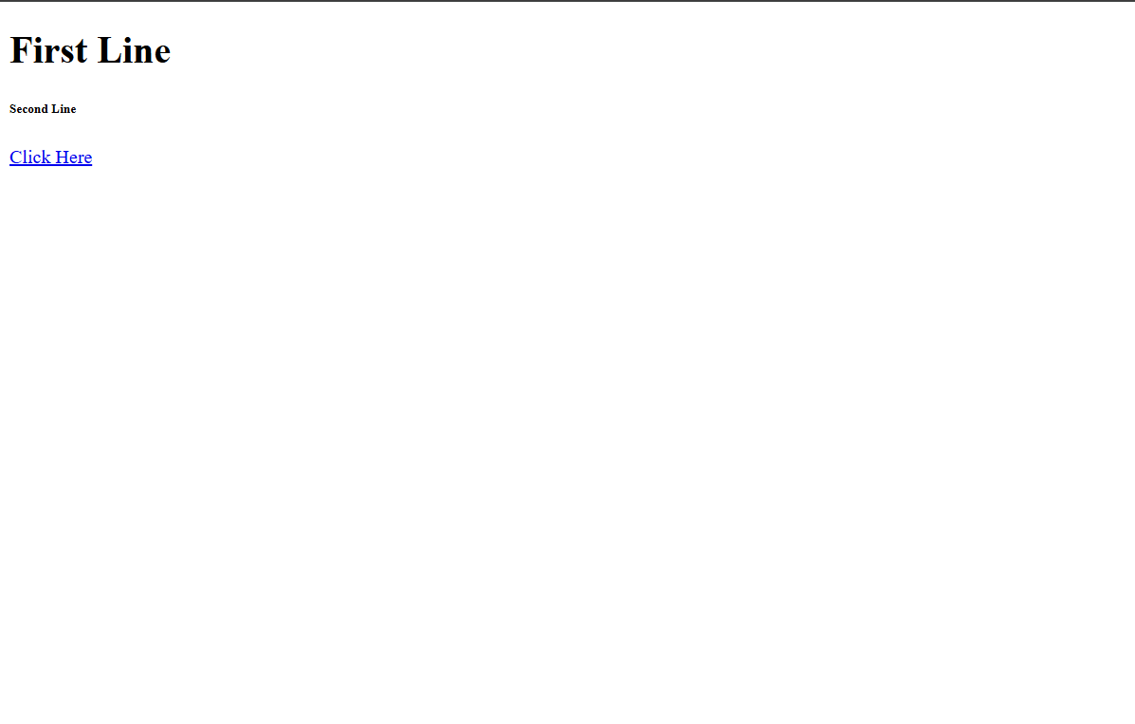

<!DOCTYPE html>
<html lang="en">
<head>
<meta charset="UTF-8">
<meta name="viewport" content="width=device-width, initial-scale=1.0">
<title>Testing Tags</title>
<style>
td, th {
text-align: center;
}
#tt {
border-collapse: collapse;
}
</style>
</head>
<body>
<h1>Testing Tags</h1>
<p>This is a paragraph to test the HTML structure.</p>
<ul>
<li>Fruits</li>
<ol>
<li>Apple</li>
<li>Banana</li>
<li>Mango</li>
</ol>
<li>Cars</li>
<ol>
<li>BMW</li>
<li>Audi</li>
<li>Mercedes</li>
</ol>
</ul>
<table id="tt", border="1", cellpadding="10", align="center",>
<tr>
<th>Time</th>
<th>Monday</th>
<th>Tuesday</th>
<th>Wednesday</th>
<th>Thursday</th>
<th>Friday</th>
<th>Saturday</th>
</tr>
<tr>
<td>8:45-9:45</td>
<td rowspan="2">NL(3) | LL(2) |<br> FSDL(1)</td>
<td rowspan="2">SDL(3) | LL(1) |<br> FSDL(2)</td>
<td>OS</td>
<td>EM-IV(T)</td>
<td>MES</td>
<td>R</td>
</tr>
<tr>
<td>9:45-10:45</td>
<td>EM-IV</td>
<td>EM-IV</td>
<td>CN</td>
<td>R</td>
</tr>
<tr>
<td>10:45-11:00</td>
<td colspan="6", bgcolor="yellow">Break</td>
</tr>
<tr>
<td>11:00-12:00</td>
<td rowspan="2">FSDL</td>
<td>CN</td>
<td rowspan="2">FSDL(3) | LL(1) |<br> SDL(2)</td>
<td>OS</td>
<td>OS</td>
<td>&nbsp;</td>
</tr>
<tr>
<td>12:00-1:00</td>
<td>SE</td>
<td>SE</td>
<td>SE</td>
<td>&nbsp;</td>
</tr>
<tr>
<td>1:00-1:30</td>
<td colspan="6", bgcolor="yellow">Break</td>
</tr>
<tr>
<td>1:30-2:30</td>
<td rowspan="3" bgcolor="#0099ff">MP-1B</td>
<td>EM-IV</td>
<td>E&S</td>
<td>CN</td>
<td rowspan="2">LL(3) | NL(2) |<br> SDL(1)</td>
<td>&nbsp;</td>
</tr>
<tr>
<td>2:30-3:30</td>
<td>E&S</td>
<td rowspan="2", bgcolor="#66ff66">TT</td>
<td>MES</td>
<td>&nbsp;</td>
</tr>
<tr>
<td>3:30-4:30</td>
<td>MES</td>
<td>R</td>
<td>R</td>
<td>&nbsp;</td>
</tr>
</table>
</body>
</html>

