**Overview:**

This document gives overall idea and steps to be followed to access Automation Anywhere 2019 community edition from individual machine.

**Automation Anywhere Community Edition:**

Instantly start your RPA journey with the FREE Community Edition, the only platform that gives you a complete Digital Workforce Platform package, all on the web:

* Robotic Process Automation (RPA) to automate your business processes
* IQ Bot – an AI-powered solution for intelligent document processing
* Operational and business analytics that show the performance of your bots

With Community Edition, you will enjoy the benefits of our latest Enterprise A2019 platform for free**:

* Experience the purely web-based interface that delivers instant-on ease of use with drag-and-drop simplicity for all users
* Build bots at any skill level with no-code, low-code, and bring-your-own-code options
* Start developing bots instantly with step-by-step in-product learning
* Leverage the cloud to access state-of-the art enterprise-class technology, no matter the size of your business and with none of the barriers

From small businesses* and developers to small teams and students, Community Edition provides everyone with [free access to RPA courses](https://university.automationanywhere.com/) on Automation Anywhere University and support from the world’s largest RPA community, [A-People](https://apeople.automationanywhere.com/s/?language=en_US).

**Steps to access AA community edition:**

1. Open <https://www.automationanywhere.com/products/enterprise/community-edition>
2. Enter required details in form and click on **‘Get Free Community Edition’** button.

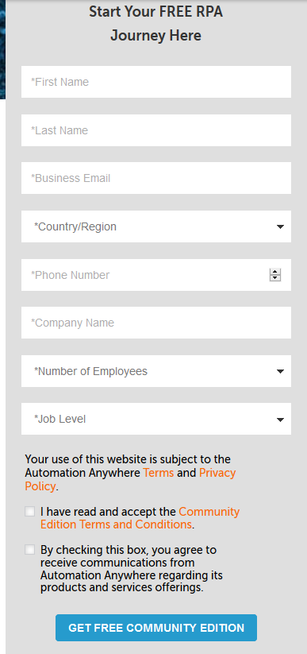

1. After submitting the request, you should be able to see below screen.

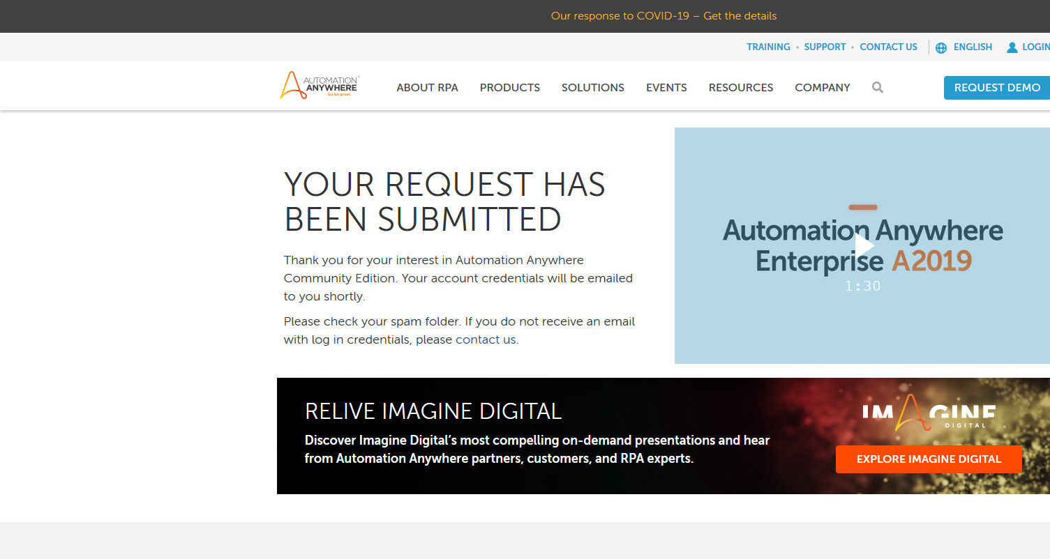

1. You will receive welcome email from Automation Anywhere for credentials and instructions as below. (I have removed username and password fields)

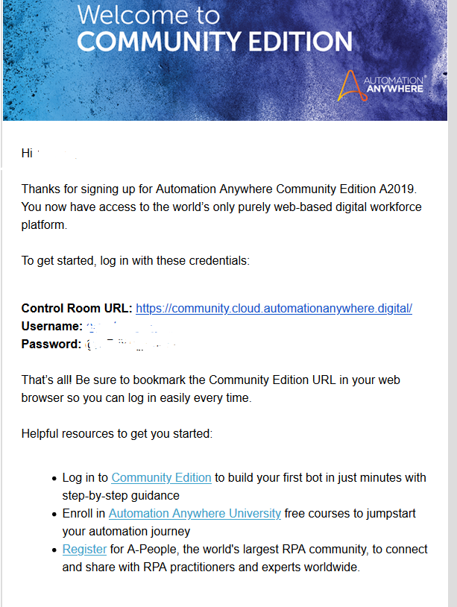

1. Access control room url mentioned email with your credentials.

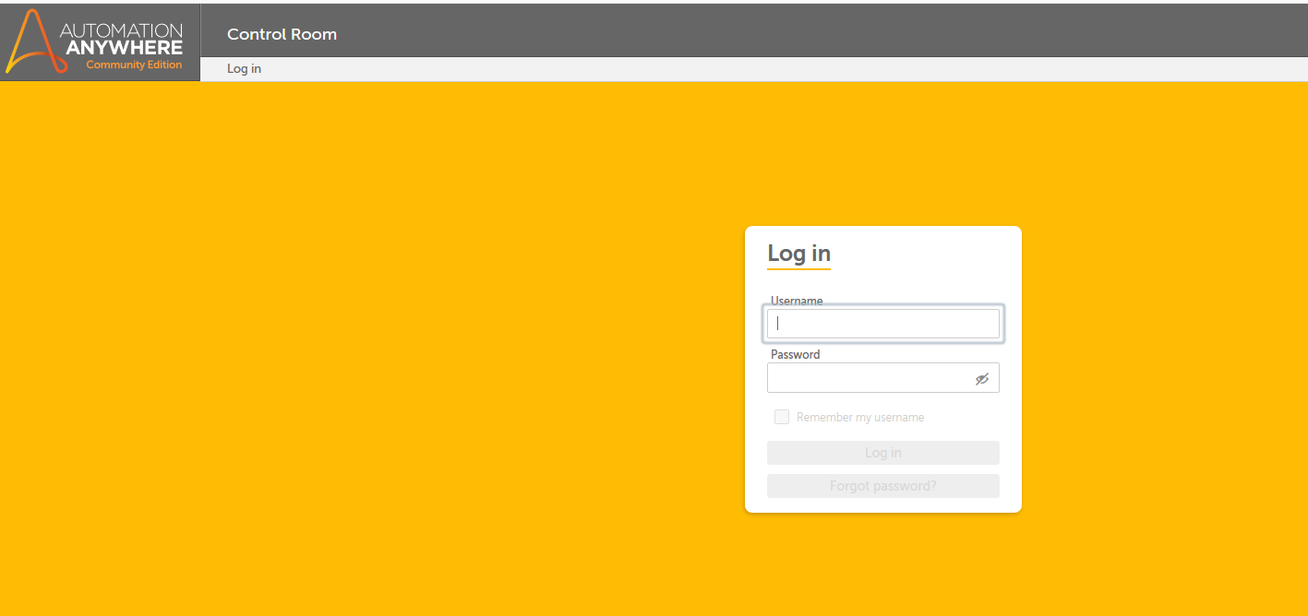

1. After successful login you should be able to see below screen

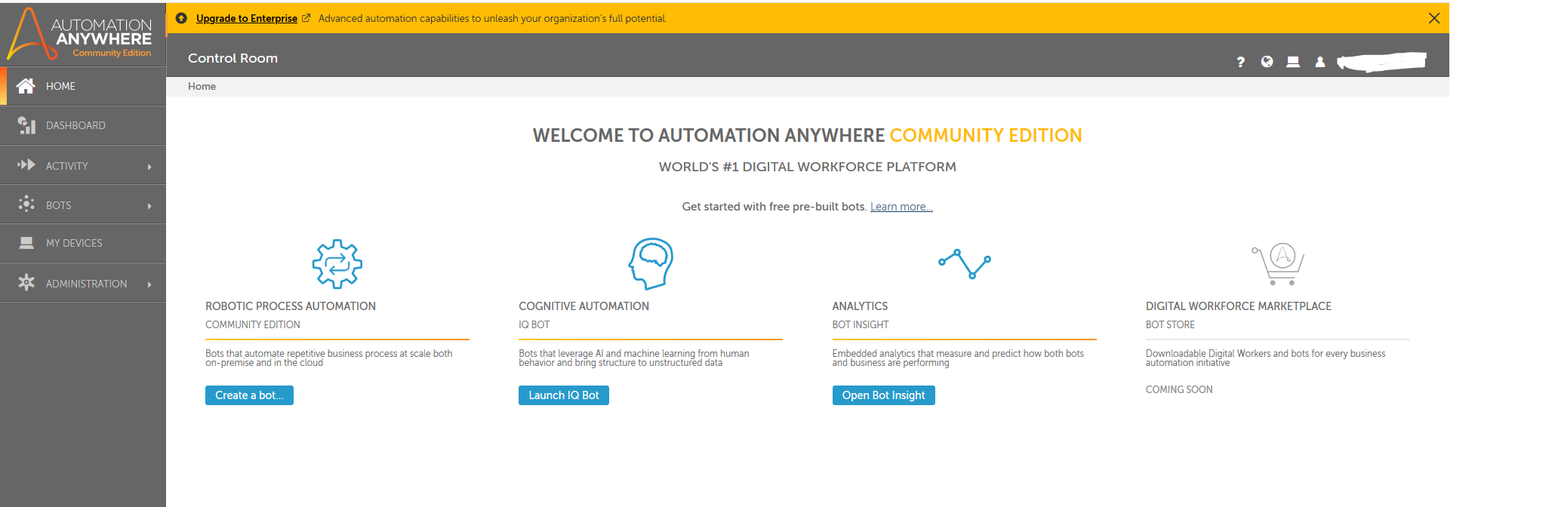

1. You can start creating BOTs by clicking **‘Create a bot’** button.