My Understanding of the Small Language Model Assignment
Everything I built is in this repository: the tokenizer, the model, the training code, the tests, the release folder and this report.

What this project was
In this assignment I built a small language model, a tiny relative of ChatGPT, completely from scratch. It learns from TinyStories, a collection of very simple stories written for young children, and then writes new stories on its own.
The main parts are the tokenizer (which turns text into numbers), the Transformer (the model itself), the training script, and the code that generates text. I was allowed to use PyTorch for the basic maths, but not ready-made tokenizers or ready-made Transformer models.

The short result
- My model has 22,696,448 learned numbers (parameters), about 22.7 million.
- It trained for about 7 minutes on my laptop's NVIDIA RTX 5060 GPU, using fp16 (half precision), the same setting a free Colab or Kaggle T4 GPU uses.
- Its final score on stories it never trained on (validation loss) is 1.7151. The stretch target was 2.0 or lower, and lower is better, so I beat it.
- It writes stories that read well sentence by sentence, but the plots are simple and it repeats itself when a story is forced to be long.
- Anyone can run it on a normal laptop with one command, no GPU needed. I checked this in a brand new Python environment.
The rest of this document explains what I understood at each step, what I measured, and what went wrong along the way.

How I worked
Where I did what. I wrote and tested all the code on my own Windows laptop in a Python virtual environment. The laptop has an AMD Ryzen 7 260 processor, 15 GB of memory and an NVIDIA RTX 5060 Laptop GPU with 8 GB. The GPU supports bf16, a newer number format, but I deliberately did not use it, because the free T4 GPUs on Colab and Kaggle do not support it well. Everything uses fp16 with a gradient scaler, or plain fp32, so the same code runs on those free GPUs too. I also added a small notebook (notebooks/colab_kaggle.ipynb) that only runs commands; all the real code lives in .py files, as the assignment requires.
Tests first. For every piece I wrote a pytest test before moving on. The tests check things I can predict in advance, such as shapes, a hand-worked answer, or that the model cannot see the future. By the end I had 48 passing tests (two of them need a GPU and are skipped on a computer without one).
The data. I used TinyStories V2 (GPT-4). The training file is about 2.2 GB and the validation file about 22 MB. Stories are separated by the text <|endoftext|>. I did all my early debugging on the small validation file and only moved to the big file once everything worked.

Key numbers in one table
What | My result
Vocabulary size | 10,000 tokens (256 bytes + <|endoftext|> + 9,743 merges)
Tokenizer training | full 2.2 GB file, 2.5 minutes with 12 processes, peak memory 1.2 GB
Longest token | " accomplishment" (15 bytes)
Compression | 4.12 bytes per token (4.14 on 10 random stories)
Training tokens in the file | 541,229,347
Validation tokens in the file | 5,465,883
Model size | 22,696,448 parameters
Model shape | 4 layers, 512 wide, 16 heads, feed-forward size 1,344
Best learning rate in pilots | 3e-3
torch.compile speed-up | 1.23× (84 → 69 ms per step)
Main run | 5,000 steps, about 41 million tokens, 422 seconds of training
Final validation loss | 1.7151
Perplexity | 5.56
Speed on my laptop CPU | about 26 tokens per second for 256 tokens
Size of the saved model | about 91 MB

What I understood, step by step

1. The tokenizer: turning text into numbers
A model can only work with numbers, so text has to be cut into pieces and every piece gets a number. If each letter is a piece, sentences become very long. If each word is a piece, the list of words is huge and any new word breaks everything.
BPE (byte pair encoding) sits in the middle. I start with 256 pieces, one for every possible byte, plus the special end-of-story token. Then I repeat one simple step: find the two neighbouring pieces that appear together most often and glue them into one new piece. After 9,743 rounds I had 10,000 pieces. The very first merges were " t", "he", " a", " s" and " w", and soon whole words like " the" and " and" became single pieces.
Three things I learned here. First, I must split the text at the end-of-story marker before counting, or the tokenizer learns pieces of the marker itself and pieces that join two stories. Second, recounting every pair after every merge is far too slow, so after each merge I only fix the counts for the words that actually contained that pair. Third, splitting 2.2 GB of text into words is slow in one Python process, so I cut the file into chunks (always at an end-of-story marker) and counted them in 12 processes at the same time. That let me use the whole training file instead of only a quarter of it.
I checked my code with the small example from the assignment (low, lower, widest, newest). It gave the expected first merges: s t, e st, o w, l ow, w est, n e. The first one is a tie between (s, t) and (e, s), and the rule is to pick the bigger pair, which is (s, t).

2. Using the tokenizer and preparing the data
Encoding replays the learned merges, in the order they were learned, on any new text. Decoding does the reverse. The best test is that encoding and then decoding gives back exactly the same text, including Hindi, emoji and an empty string. That worked. The end-of-story marker always becomes exactly one number.
I then turned both story files into long lists of numbers. The training file became 541,229,347 tokens and the validation file 5,465,883. I stored them as 2-byte numbers (uint16), because my largest ID is 9,999 and uint16 goes up to 65,535. The training file took 130 seconds to encode with 12 processes.

3. The building blocks of the model
- Position (RoPE). The model reads all the words at once, so by itself it does not know their order. RoPE gives each word a position by rotating pairs of its numbers by an angle that depends on where the word is. The nice result is that the match between two words then depends only on how far apart they are.
- Attention. Each word looks back at the earlier words and decides which ones matter for predicting the next word. A mask stops it from looking at future words, otherwise it could just copy the answer. I first wrote this the slow, plain way and checked that it matched PyTorch's fast version to 0.00001.
- Feed-forward layer (SwiGLU). After attention mixes information between words, this layer works on each word separately. It uses three weight matrices and the SiLU function, which is the design most modern models use.

4. The full model
A block is attention plus feed-forward, each one added back to its input (so the original information is never lost), with a normalising step (RMSNorm) before each. I stacked 4 blocks. At the start there is a table that turns each token number into 512 numbers, and at the end a layer that gives a score for each of the 10,000 possible next tokens.
Two checks mattered most. The model must not see the future: when I changed the later tokens, the earlier outputs stayed exactly the same, bit for bit. And before any training the loss should be about 9.21, because guessing evenly between 10,000 tokens gives exactly ln(10,000). It was.

5. Setting up training
This part had many small pieces, and a mistake in any of them can stay hidden because the loss still goes down a little. So I tested each one:
- the loss against a hand calculation
- the optimizer, so every weight is in exactly one group (weight decay only on the big weight matrices)
- the learning rate, which climbs for the first 5% of steps and then falls along a cosine curve
- gradient clipping, which stops one huge update from wrecking the model
- mixed precision (fp16), which is faster but needs care
- batches, where the target is the input shifted by one token
- saving and loading, so a stopped run can continue exactly where it stopped
One detail I learned: with fp16 the loss is multiplied by a big number (65,536 at the start) so that small gradients do not round to zero. The gradients must be divided back down (unscaled) before clipping, otherwise the clipping works on numbers that are 65,536 times too big. My test checks that the gradient size reported during fp16 training equals the real fp32 gradient size.

The tests and checks, in detail
A test is only useful if it would fail when the code is wrong. This table lists what my tests prove for each part.
Part | What the tests check
Tokenizer training | The hand-worked example gives s t, e st, o w, l ow, w est, n e. No learned token contains bytes from two stories or from the end-of-story marker (I confirmed the test fails if the split is removed). The vocabulary has exactly the size asked for, with no repeated IDs. Parallel and single-process training give the same result.
Tokenizer use | "the cat ate" gives 9, 7, 1, 5, 10, 3. Encode then decode returns the same text for English, Hindi, emoji, spaces and an empty string. The end-of-story marker is always one ID; the longer special token wins when two overlap. Reading a file in small pieces gives the same IDs as reading it whole.
Attention | My slow version matches PyTorch's within 0.00001 for 3-D and 4-D inputs. Changing later keys never changes earlier outputs.
RoPE | Matches a slow version that builds the full rotation matrix. Keeps the length of vectors. Position 0 is unchanged. Dot products depend only on the distance.
Full model | Output shape is (2, 17, 10000). The model cannot see the future. The starting loss is close to 9.21. The parameter count matches my hand count.
Loss and optimizer | The loss matches a hand calculation. Every parameter is in exactly one group, and the no-decay group is exactly the RMSNorm weights.
Learning rate | The schedule matches values I worked out by hand at several steps, and LambdaLR follows it.
Clipping | After clipping, the total gradient size is at most 1.0.
Batches | Targets are the inputs shifted by one, and no slice runs past the end of the data.
Checkpoints | Save, train 5 steps, reload, train the same 5 steps: losses match within 0.001, on CPU and on the GPU in fp16.
fp16 | The fp16 loss is within 0.01 of the fp32 loss, and gradients are unscaled before clipping (GPU only).
Generation | Greedy decoding gives the same output every time; top-p keeps the smallest set that reaches p; the same seed gives the same story; generation stops at the end-of-story token.

Three checks before the real run
A training script that is slightly wrong can waste a whole day, so I ran three checks with the real model first.
1. Learning one batch. I trained on the same single batch again and again. A working model should memorise it. The loss went from 9.38 to 0.0020 in 100 steps and 0.0008 after 300. At the same time the loss on the validation stories rose to 8.51, which is expected, because the model was learning one batch by heart. This also shows that the validation data really is separate from the training data.
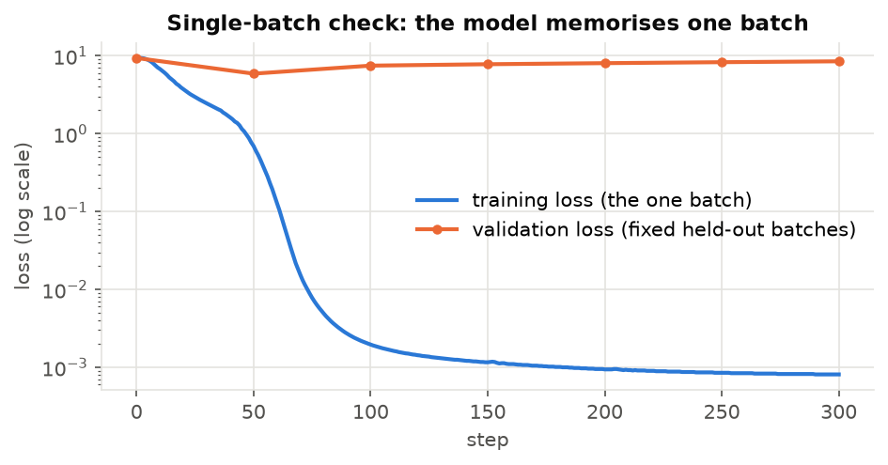
The model memorises one batch (log scale).
2. Stopping and resuming. I trained 600 steps without stopping, and separately stopped a run at step 300 and resumed it from the saved checkpoint. The checkpoint also stores the random number generators, so the resumed run picks exactly the same batches. At step 600 the validation loss was 2.38087 for the uninterrupted run and 2.38134 for the resumed one, and the learning rate was identical at every step. The tiny differences were already there before the stop, so they come from the GPU, not from resuming.
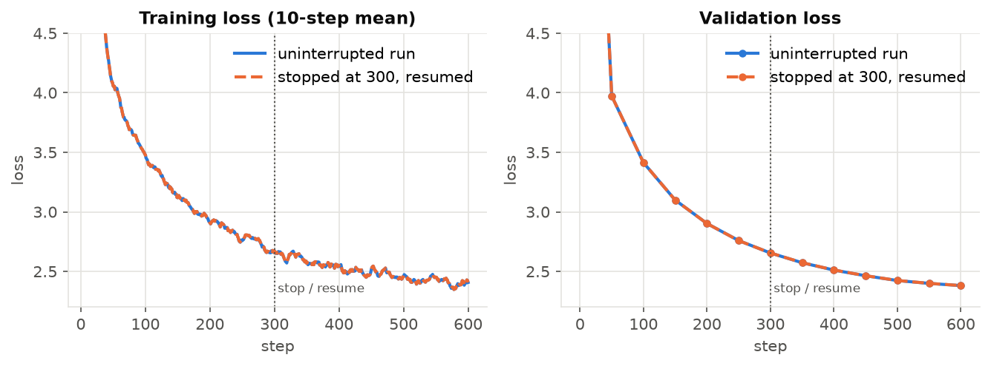
The resumed run (dashed) lies on top of the uninterrupted run.
3. Gradient size. In the first 100 steps of the main run the gradient norm stayed between 0.40 and 1.82. It rose while the learning rate was warming up and then settled at about 0.5. It was never invalid (NaN) and did not keep growing. Over the whole run the fp16 gradient scaler never had to skip a step.
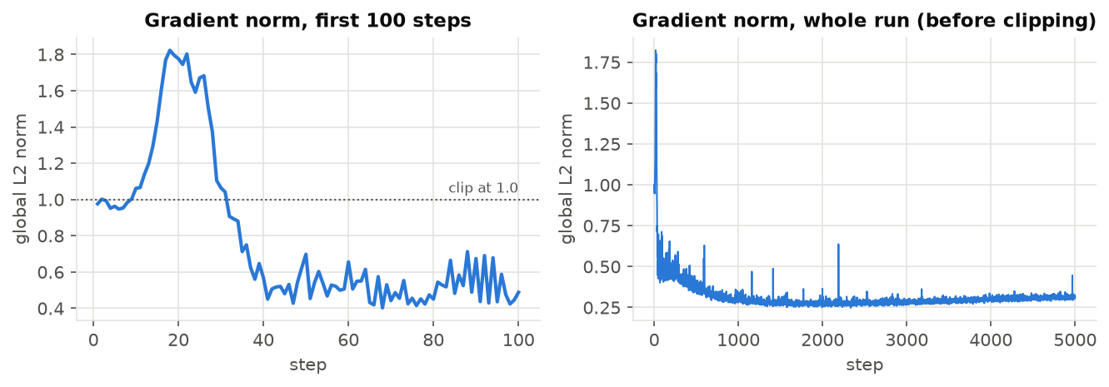
Gradient norm before clipping.

Finding a good learning rate
The learning rate is the size of each step the model takes while learning. Too small and it learns very slowly; too big and it jumps around and breaks. A tiny warm-up experiment showed this clearly. Minimising the average square of 100 numbers, a rate of 1 made slow progress, 10 worked well, 100 made the numbers flip sign every step without the loss changing at all, and 1,000 made the loss explode to about 10²⁴ in 10 steps.
For the real model I ran seven short tests of 300 steps each. To make sure at least one would break, I went beyond the 1e-4 to 1e-2 range the assignment asked for.
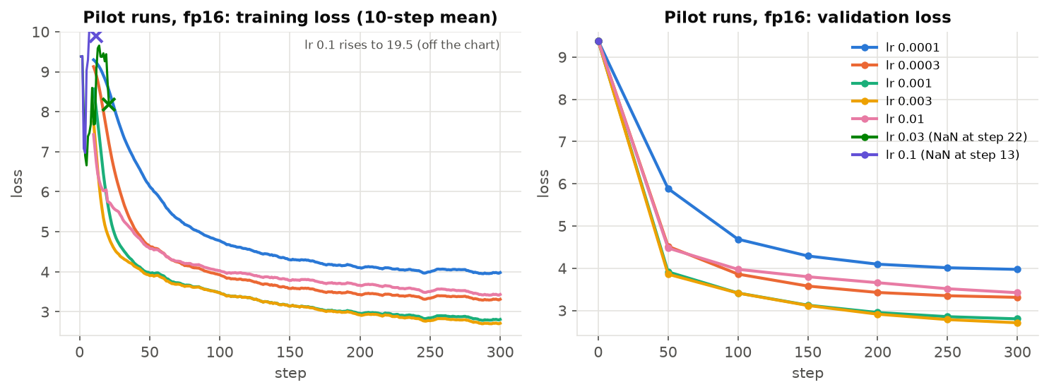
My 300-step pilot runs, batch 32, context 256, fp16.
Peak learning rate | Validation loss after 300 steps (fp16) | Largest gradient norm | Same run in fp32
0.0001 | 3.972 | 1.8 | -
0.0003 | 3.310 | 1.9 | -
0.001 | 2.801 | 1.9 | -
0.003 | 2.708 | 2.9 | -
0.01 | 3.420 | 47.3 | 3.439
0.03 | NaN at step 22 | inf | 3.765
0.1 | NaN at step 13 | inf | 4.125

The best rate was 3e-3, with 1e-3 close behind (0.09 apart). At 1e-2 training was already shaky: the gradient norm jumped to 47 and the loss ended much worse. 3e-2 and 1e-1 broke completely, and the loss turned into NaN (not a number).
I wanted to know whether the NaN was caused by fp16 or by the rate itself, so I ran the broken rates again in fp32. In fp32 there was no NaN, but the loss still shot up (to 21.7 for 1e-1, much worse than a random guess) and then crawled back to a poor value. So the rate really is too high in both formats. fp16 just turns the blow-up into NaN, because its largest number is 65,504 and the activations go past it once the weights get large.
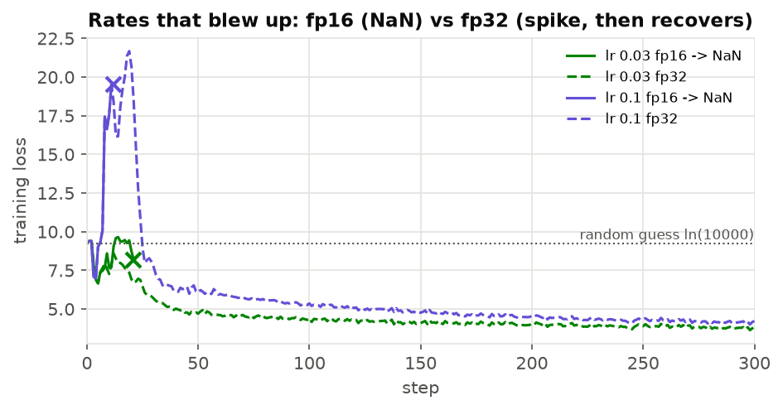
The same high learning rates in fp16 (solid, ending in NaN) and fp32 (dashed).

The main training run
I trained for 5,000 steps with the rate 3e-3. Each step used 32 pieces of text of 256 tokens, so the model saw 40,960,000 tokens in total. That is only about 7.6% of all the training text, so it never saw the same text twice. The learning rate climbed for the first 250 steps and then came down in a smooth curve, ending exactly at its lowest value (3e-4) on the last step. I used torch.compile, which made each step about 1.23 times faster.
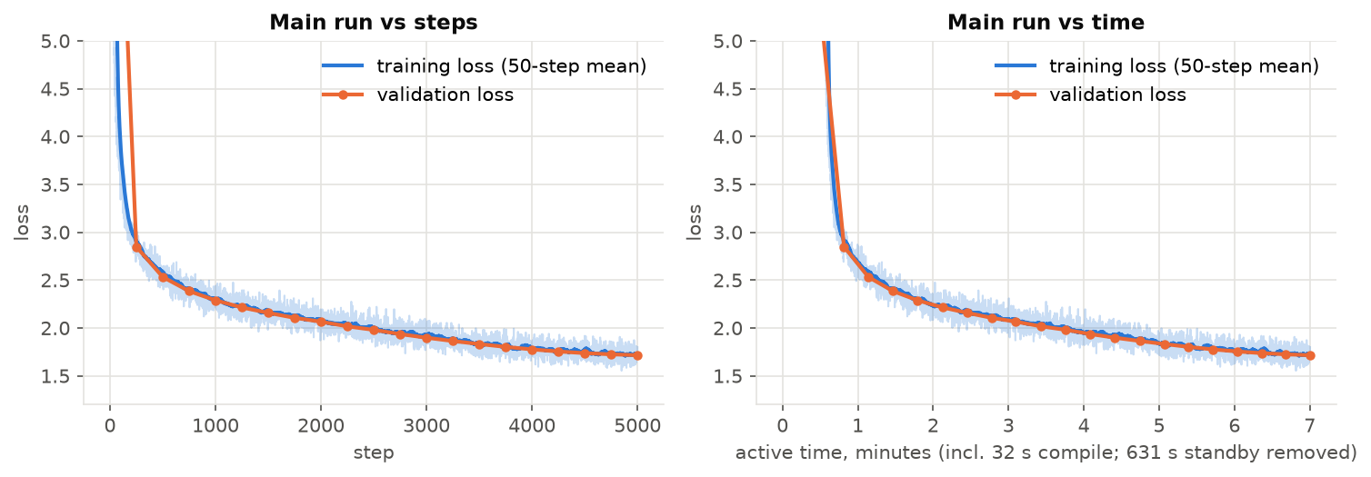
Main run against steps and against time.
The final validation loss was 1.7151, which is a perplexity of 5.56. Perplexity roughly means how many tokens the model is unsure between at each step, so it is about as unsure as choosing between 5 or 6 options. The training loss at the end (1.725) was almost the same as the validation loss, so the model was not just memorising.
The training itself took 422 seconds (7 minutes), including about 30 seconds for torch.compile to prepare the model. My log first said 1,053 seconds. When I looked, one single step had taken 631 seconds. The Windows event log showed that the laptop had gone into standby because I had left it idle, and woke up 11 minutes later. Training simply continued, and the loss was not affected.

Writing stories
To write a story the model predicts one token, adds it to the text, and repeats. Two settings control it. Temperature controls how adventurous it is (low is safe, high is random). Top-p keeps only the most likely tokens that together cover a chosen share of the probability.
Left alone, the model ends its stories after 141 to 227 tokens (median 170 over 20 tries). The assignment asked for stories of at least 256 tokens, so for those I blocked the end-of-story token until 256 tokens were written. To be honest, this forces the model to keep going past where it wanted to stop.

The stories I got
All stories start from "Once upon a time". Here are pieces of the real output, with what I noticed. The full texts are in report/stories.txt.
Temperature 0.7, top-p 0.9, seed 1 (256 tokens). It begins: "Once upon a time, in a small house, there lived a little girl named Mia. Mia loved to play outside in her big yard. She liked to run, jump, and laugh with her friends. One day, Mia found a ..." The first part is a clear little story about a mysterious box with a magic toy, and the name Mia stays consistent. After its natural ending at 220 tokens it adds two "The moral of the story is..." lines, and one of them makes no sense.
Temperature 0.7, top-p 0.9, seed 2 (256 tokens). It begins: "Once upon a time, there was a little girl named Lily. She had a toy that she loved to play with. One day, she went to the park with her mom. At the park, Lily saw a big, yummy cake. She ..." Lily finds a cake at the park and shares it. Each sentence is fine, but the facts drift: she "gave the cake to her mom" after eating it, and her mom says "I'm glad you ate the cake". After the natural end at 125 tokens it repeats the moral three times.
Temperature 1.0, top-p 0.95, seed 1 (256 tokens). It begins: "Once upon a time, in a modest little town, there lived a funny man named Tom. He loved to drive his truck around his town. One day, he saw a man selling ice cream in the house. He had a dog ..." More unusual words ("a modest little town", "a funny man named Tom") and a more varied plot, but also odd details such as "a man selling ice cream in the house" and a dog that appears from nowhere. It ends with "The End." and then a repeated moral.
The story from my release test. With temperature 0.8, top-p 0.9 and seed 42 the model wrote a 148-token story about a boy named Tim and a red ball that starts to talk, and it ended by itself. This is the story the fresh-environment test printed, word for word the same both times.
What I learned from reading them. Lower temperature gives safer but more repetitive text. Higher temperature gives more variety but more mistakes. The model is good at the shape of a children's story (a name, a small problem, a happy ending, a moral) and weak at keeping the facts consistent. For 22.7 million parameters and 7 minutes of training, that seems normal to me, but I did not test a bigger model.

Packaging it so anyone can use it
The release folder holds only four files: the weights (model.pt, about 91 MB, no optimizer state), config.json with the model settings, and the tokenizer files vocab.json and merges.txt. inference.py rebuilds the model from config.json, loads the weights so they work on a CPU even though they were trained on a GPU, and prints the story followed by one line with the number of tokens and the speed. It only imports my model, tokenizer and generation code, nothing from the training code.
For the acceptance test I copied exactly the files that git would commit into a brand new folder, made a fresh Python environment, installed only requirements.txt and ran the one command from the README:
python inference.py --model-dir release --prompt "Once upon a time" --max-new-tokens 256 --temperature 0.8 --top-p 0.9 --seed 42 --device cpu
It worked and printed the same story as my development setup. Two small problems came up. The first try failed because Windows cannot install PyTorch in a folder whose path is too long; a shorter folder fixed it, so the problem was the computer, not the code. PyTorch also printed a warning that numpy was missing, so I added numpy to requirements.txt to keep the output clean.

My answers to the assignment questions

The four warm-up questions
- What is chr(0)? It is the null character. repr shows it as '\x00', but print shows nothing, so 'a' + chr(0) + 'b' prints like "ab" although it has 3 characters.
- Why UTF-8? "hello" is 5 bytes in UTF-8, 10 in UTF-16 and 20 in UTF-32 (12 and 24 with the byte-order mark). The others waste space on zeros, and UTF-8 always starts from the same 256 bytes, so no text is ever unknown. It is not always the smallest: "नमस्ते" is 18 bytes in UTF-8 and 12 in UTF-16.
- Why is decoding one byte at a time wrong? Many characters use several bytes, and one byte from the middle of a character means nothing alone. "héllo" breaks, because é is the two bytes C3 A9 and C3 alone gives "unexpected end of data".
- An invalid two-byte sequence: C3 28. The first byte says one more byte must follow that starts with the bits 10, but 28 starts with 00.

Q1. Where does the BPE training time go?
On the small validation file, mostly in merging: 40.4 seconds out of 49.4 in a profiled run, against 8.9 seconds for splitting into words. Inside merging almost all the time is spent finding the most common pair with max() (39.0 seconds), not in updating the counts. But splitting grows with the size of the file. On the first 200 MB of the training file the two were already close (74.7 versus 82.7 seconds), so on the full file splitting would win. That is why I split the file into chunks and counted them in parallel. The profiler itself slows things down: the same validation run took 23 seconds without it.

Q2. Why store token IDs as uint16?
My IDs are at most 9,999 and uint16 goes up to 65,535, so 2 bytes per token is enough. The training file became 1.08 GB instead of 2.2 GB (int32) or 4.3 GB (int64). It would stop being enough if the vocabulary grew past 65,536 tokens.

Q3. Why does attention divide by the square root of d_k?
With 32 numbers per head, the scores had a spread of 5.92 without dividing and 1.05 after. Without dividing, softmax gave on average 84% of the attention to a single word; with it, 38%. When softmax nearly picks one word, very little learning signal passes back through it. Dividing keeps the scores in a healthy range.

Q4. Why does RoPE only care about distance?
I put the same query and key at many positions. Whenever the two positions were 3 apart the answer was -3.4828, at positions as different as (3, 0) and (250, 247). Positions 5 apart always gave -1.4415, and equal positions gave the plain unrotated value -2.0532. Rotating both vectors by angles that depend on their positions leaves only the difference between the angles.

Q5. How many parameters does my model have?
22,696,448. The embedding table and the output layer hold 5,120,000 each, so together they are 45% of the model. Each of the 4 layers holds 3,113,984. My count by hand matched the count from the code.

Q6. How much work is one forward pass?
About 9.53 billion operations for 256 tokens. The feed-forward layers do the most (44%), then the output layer (27.5%), then the attention projections (22.5%). The attention scores themselves are only 5.6%.

Q7. What changes for a GPT-2 sized model?
About 291.6 billion operations. Attention scores become a much bigger share inside a layer (from 7.8% to 18.2%), because they grow with the square of the text length. The feed-forward share goes down a little. The output layer stays at about 27%, because the vocabulary grows 5 times while the width grows only 1.5 times.

Q8. How much memory does training need?
In 32-bit numbers: 90.8 MB for the weights, 90.8 MB for the gradients and 181.6 MB for the optimizer, about 363 MB without activations. AdamW keeps two extra numbers for every weight (an average of the gradient and an average of its square), which is why it needs twice the memory of the weights.

Q9. The learning rate that broke versus the best one
The best was 3e-3 and the first one that broke (NaN) was 3e-2, ten times bigger. 1e-2, only about three times bigger than the best, was already unstable. So yes, the best rate sits just below where training starts to break. The fp32 re-runs showed the breaking is real and not only an fp16 effect.

Q10. How good are the stories?
Sentence by sentence they are good: correct grammar, steady character names and proper quotes. Two things changed the quality. The first is length: when I forced long stories, they repeated morals. The second is temperature and top-p: at 0.7 the text was safe but generic, at 1.0 odd details appeared. Keeping facts straight (who ate the cake) is the weakest part. I think that comes from the small model and short training.

Q11. How fast is it on a CPU, and what would a cache save?
About 26 tokens per second (25.3 to 26.3) for 256 tokens on my AMD Ryzen 7 260 laptop with 15 GB RAM. Without a cache every new token makes the model read the whole text again: 33,658 token positions for 256 new tokens instead of 259, so about 99% of the work is repeated. From timing single forward passes (9.4 ms for 1 token, 57.3 ms for 256) I estimate 9.2 seconds without a cache and about 2.4 with one, roughly 4 times faster. It is not 99% faster because each step still has a fixed cost. This is an estimate; I did not build the cache.

Mistakes I made and what each one taught me
The assignment asks me to separate real mistakes from the normal limits of a small model. These are the real mistakes I found and fixed.
- A test that could not fail. My first test for "no token crosses two stories" failed for the wrong reason (both stories shared the space character). When I fixed that, it passed, but then I removed the end-of-story split on purpose and it still passed. I rewrote it so that it fails on broken code. Lesson: check that a test can fail.
- Resuming crashed on the GPU. Loading a checkpoint straight onto the GPU also moved the saved random number states there, and PyTorch only accepts them on the CPU. The fp16 resume test caught it before any real run. Lesson: test the same path the real run uses.
- torch.compile did not work at first. On Windows it needs an extra package (triton-windows). Colab and Kaggle run Linux and do not need it.
- My timings were wrong twice. The main run looked like it took 17.5 minutes, and a profiling run looked very slow, because the laptop went to sleep while idle. I found it in the Windows event log and now report only the real training time. Lesson: when a number looks odd, find out why before reporting it.
- The fresh install failed once. Windows could not install PyTorch in a folder with a very long path. A short folder fixed it.

What I could not check, and what I would try next
These are limits of my setup and results, not bugs.
- The pilot runs were only 300 steps, so 3e-3 and 1e-3 (0.09 apart) might rank differently in a 5,000-step run.
- The validation loss comes from 50 fixed batches (409,600 tokens, about 7.5% of the validation file), so it is a close but not exact estimate of the loss on the whole file.
- The stories needed the end-of-story token blocked to reach 256 tokens.
- GPU runs are not bit-for-bit repeatable, so two identical runs differ slightly (in the 3rd or 4th decimal of the loss).
- The cache speed-up is an estimate from timings, not a measurement.
As agreed, I did not do the optional extras: the Docker image, the architecture experiment, the KV cache, weight sharing and GPT-2 initialisation.

What I take away
The biggest lesson for me is that the model itself is not the hardest part. Most of the real work was checking that every small piece is correct, because many mistakes do not crash anything; they only make the results quietly worse. Writing a test for each piece, making sure each test can fail, and measuring before guessing saved me several times.

Words I had to learn
Word | What it means in simple terms
Token | One piece of text that has its own number, such as a word or part of a word
Vocabulary | The full list of tokens the model knows (10,000 for mine)
BPE | The method that builds the vocabulary by gluing together the most common neighbouring pieces
Parameter | One number the model learns. Mine has about 22.7 million
Attention | The step where each word looks at earlier words and decides which matter
RoPE | A way to tell the model the position of each word by rotating its numbers
Feed-forward layer | The step that processes each word on its own after attention
Loss | A score for how wrong the model's guesses are. Lower is better
Validation loss | The loss on stories the model never trained on, so it shows real learning
Perplexity | The loss turned into "how many options the model is unsure between"
Learning rate | The size of each learning step
Optimizer (AdamW) | The part that changes the weights a little after each step
Gradient | The direction and size in which each weight should change
Gradient clipping | Capping the gradient so one huge step cannot damage the model
fp16 and fp32 | Smaller and larger number formats. fp16 is faster and uses less memory but overflows more easily
Gradient scaler | Multiplies the loss before the backward pass so small fp16 gradients do not become zero, then divides them back
torch.compile | A PyTorch tool that turns the model into faster GPU code
Checkpoint | A saved copy of the training state so a stopped run can continue
Temperature | A setting that makes the generated text safer (low) or more random (high)
Top-p | A setting that only allows the most likely tokens that together add up to a chosen share
KV cache | Remembering past work while generating, so the model does not read everything again for each new word

All the code, tests, the model files and the instructions to run it are in the repository; the one command to run it is in the README.

