Small Language Model from Scratch: Writeup
TinyStories V2 (GPT-4). Model: 22,696,448 parameters, 4 layers, d_model 512, 16 heads, d_ff 1,344, RoPE, SwiGLU, RMSNorm, 10,000-token byte-level BPE. Trained on one NVIDIA RTX 5060 Laptop GPU in fp16 (autocast + GradScaler, no bf16, so the same code runs on a Colab/Kaggle T4). Final validation loss 1.7151, perplexity 5.56. All 48 pytest tests pass. Every number below comes from the scripts in scripts/ and the logs in runs/.

Part 1-2: Tokenizer
Warm-ups. (1) chr(0) is the NUL character: repr shows '\x00' (so 'a'+chr(0)+'b' is shown as 'a\x00b') while print writes an invisible control character, so the string looks like 'ab' although its length is 3. (2) UTF-8 is the most compact for our text and needs only 256 base symbols: "hello" is 5 bytes in UTF-8 vs 10/20 in UTF-16/32 (12/24 with BOM). It is not always the smallest: "नमस्ते" is 18 bytes in UTF-8 vs 12 in UTF-16. (3) Multi-byte characters cannot be decoded byte by byte: 'héllo' is b'h\xc3\xa9llo' and bytes([0xc3]).decode() raises "unexpected end of data". (4) b'\xc3\x28' is invalid: 0xC3 starts a 2-byte character, so the next byte must look like 10xxxxxx, but 0x28 is 00101000.
Training. I trained on the full 2.23 GB training file (no need to cut to a quarter): pre-tokenisation in 12 processes (chunks cut at <|endoftext|>) took 64.8 s and the 9,743 merges 87.0 s, 2.5 min in total, peak memory 1,198 MB (all processes). Longest token: " accomplishment" (15 bytes). It makes sense: a long, fairly common word in moral-of-the-story sentences, with its leading space. The vocabulary is exactly 10,000 (256 bytes + <|endoftext|> + 9,743 merges). Tests: the low/lower/widest/newest example gives s t, e st, o w, l ow, w est, n e; no token mixes two stories; "the cat ate" encodes to [9, 7, 1, 5, 10, 3]; English/Hindi/emoji/empty strings round-trip; encode_iterable equals encode.
Q1 (cProfile). On the validation file (single process) merging takes 40.4 s of the profiled 49.4 s, pre-tokenisation 8.9 s. Almost all merge time is the max() that finds the best pair (39.0 s), not the incremental updates (_merge_word 0.24 s). But pre-tokenisation grows with the file size while merging grows with the number of unique pre-tokens: on the first 200 MB they are already close (74.7 s vs 82.7 s), so on the full 2.2 GB file a single process would spend most of its time splitting. That is why I parallelised pre-tokenisation.
Encoding. Compression on 10 random validation stories: 4.14 bytes/token (4.12 on the whole training file). Speed: 3.49 MB/s in one process; the training file (541,229,347 tokens) took 130 s with 12 processes; validation has 5,465,883 tokens. Q2. IDs go up to 9,999 and uint16 holds 0-65,535, so 2 bytes per token is enough: train.npy is 1.08 GB instead of 2.2 GB (int32) or 4.3 GB (int64), and the memory-mapped batches read half as much. It stops being enough when the vocabulary passes 65,536 tokens (e.g. a 100k-token tokenizer needs uint32).

Part 3-4: Model
Tests: my hand-written softmax(QKᵀ/√d_k)V with a -inf causal mask matches F.scaled_dot_product_attention to 1e-5 for 3-D and 4-D inputs; RoPE matches a slow version that builds the full rotation matrix; all pieces keep their input shape with extra batch dims; logits are (2, 17, 10000); changing tokens after position t leaves outputs up to t bit-identical; the loss at initialisation is ln(10,000) ≈ 9.21 (nearly uniform predictions); the parameter count equals my hand count.
Q3. With d_k = 32 and unit-variance q, k, the raw scores have std 5.92 (≈√32) vs 1.05 after dividing. Without the division the softmax is nearly one-hot (mean largest weight 0.84, entropy 0.43 nats out of 2.08); with it, attention stays spread out (0.38, 1.67 nats). A saturated softmax also has tiny gradients: the mean p(1-p) was 0.029 vs 0.094.
Q4. Same q and k (d_head 32) placed at different positions: the dot product is -3.4828 for (i, j) = (3,0), (10,7), (100,97) and (250,247); -1.4415 for both pairs with i-j = 5; -2.0532 (the unrotated value) when i = j; and -3.2514 for i-j = -3. RoPE rotates q by angle iθ and k by jθ per pair, and the dot product of two rotated vectors only sees the difference (i-j)θ.
Q5. Embedding 5,120,000; per layer 3,113,984 = attention 1,048,576 (4·512²) + SwiGLU 2,064,384 (3·512·1344) + 2 RMSNorm 1,024; 4 layers 12,455,936; final norm 512; output layer 5,120,000. Total 22,696,448, equal to sum(p.numel()). Embedding + output = 45.1% of the model.
Matmul (one forward pass, T tokens) | FLOPs, ours (T=256) | FLOPs, GPT-2 small (T=1024)
q, k, v, o projections, per layer: 4·2·T·d² | 536,870,912 | 4,831,838,208
QKᵀ scores, per layer: 2·T²·d | 67,108,864 | 1,610,612,736
attention × V, per layer: 2·T²·d | 67,108,864 | 1,610,612,736
feed-forward, per layer: 3·2·T·d·d_ff | 1,056,964,608 | 9,663,676,416
output layer: 2·T·d·V | 2,621,440,000 | 79,047,426,048
total (×4 layers / ×12 layers + output) | 9.53 G | 291.6 G
share: FFN / output / projections / attention | 44.4% / 27.5% / 22.5% / 5.6% | 39.8% / 27.1% / 19.9% / 13.3%

Q6. The feed-forward layers do the most work (44%), then the output layer (27.5%); the attention score/value products are only 5.6%. Q7. GPT-2 small (12 layers, d 768, 12 heads, V 50,257, T 1,024; I used a SwiGLU FFN with d_ff 2,048, which costs the same as GPT-2's 2·768·3,072 GELU MLP) needs 291.6 GFLOPs. Attention scores grow with T², so inside a layer their share rises from 7.8% to 18.2%, while the FFN share falls. The output layer stays at about 27% because the vocabulary grew 5× while the model width grew only 1.5×.

Part 5: Training setup
Learning-rate warm-up (SGD on mean(w²), w = 5·N(0,1) 10×10). The gradient is w/50, so each step multiplies w by (1 − lr/50). lr 1: ×0.98, loss falls slowly (26.3 → 18.3). lr 10: ×0.8, loss ×0.64 per step (26.3 → 0.47). lr 100: ×(−1), w just flips sign, loss stays exactly 26.27. lr 1000: ×(−19), loss ×361 per step, 2.7e24 after 10 steps.
Tests: loss = hand-computed −log softmax; the two AdamW groups (weight matrices with decay 0.1, RMSNorm weights without) hold every parameter exactly once; the schedule matches hand values (e.g. 5.5e-4 half way through the cosine); after clipping the norm is ≤ 1.0; targets = inputs shifted by one and no slice runs past the end; save → 5 steps → reload → same 5 steps gives losses within 1e-3 (CPU fp32 and GPU fp16); the fp16 loss is within 0.01 of fp32, and the gradient norm train_step reports equals the fp32 norm (within 2%) although the loss was scaled by 65,536, which proves scaler.unscale_ runs before clipping. torch.compile: 84.1 → 68.5 ms per step (1.23× faster, 300 timed steps, fp16) after ~29 s of compilation.
Q8. fp32 parameters 90.8 MB + gradients 90.8 MB + AdamW state 181.6 MB = 363.1 MB before activations. AdamW keeps two running averages per weight (first moment m and second moment v), each the same size as the weights, so its state is twice the weights.

Part 6: Training script checks and learning rate
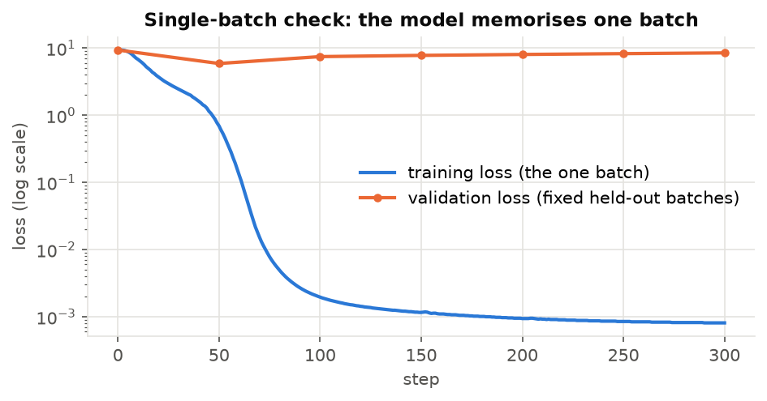
Single batch: training loss 9.38 → 0.0008 in 300 steps while held-out loss rises to 8.51.
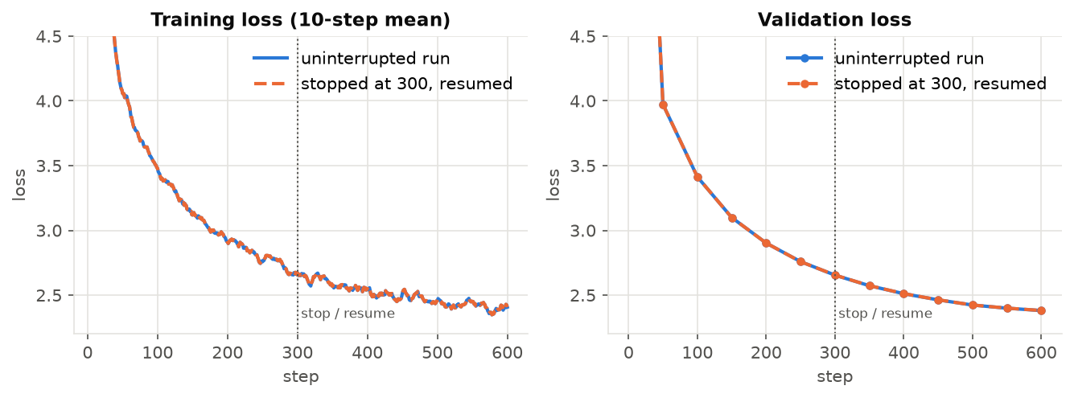
Stopped at step 300 and resumed: at step 600 validation loss is 2.38087 (uninterrupted) vs 2.38134 (resumed); the learning rate and batches are identical (the checkpoint stores model, optimizer, scheduler, scaler and RNG states).
The curves overlap with no jump. The small differences (largest single-step training-loss gap 0.008) already exist before step 300 (2.76333 vs 2.76421), so they come from non-deterministic GPU kernels, not from resuming. Gradient norm: in the first 100 steps of the main run it stayed between 0.40 and 1.82 (peak during warm-up, then ~0.4-0.7), never NaN and not growing; after step 1,000 it stays in 0.25-0.64. GradScaler skipped 0 steps.
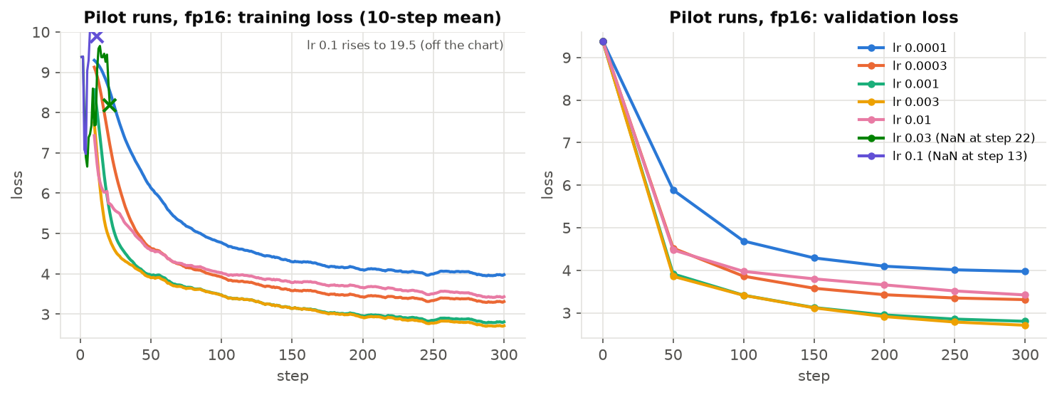
Seven 300-step pilots (batch 32, context 256, 5% warm-up, cosine to 10% of the peak), fp16.
Peak lr | Val. loss at 300 (fp16) | Max grad norm | Same run in fp32
0.0001 | 3.972 | 1.8 | -
0.0003 | 3.310 | 1.9 | -
0.001 | 2.801 | 1.9 | -
0.003 | 2.708 | 2.9 | -
0.01 | 3.420 | 47.3 | 3.439
0.03 | NaN at step 22 | inf | 3.765
0.1 | NaN at step 13 | inf | 4.125

I spaced rates evenly on a log scale (×3 or ×3.3 apart) to cover 1e-4 to 1e-2 as asked, and added 3e-2 and 1e-1 because 1e-2 was unstable but did not blow up. Choice: 3e-3 (lowest pilot loss). Q9. The first rate that blew up (3e-2, NaN at step 22) is 10× my best rate; 1e-2, only 3.3× above it, already had gradient-norm spikes up to 47 and a much worse loss. So the best rate does sit just below the region where training breaks, roughly one ×3 step below the first unstable rate. I re-ran the broken rates in fp32: there they spike (1e-1 reaches a loss of 21.7, far above the 9.2 of a random guess) but do not turn into NaN and recover to a poor loss. So the instability is real; the NaN itself is the fp16 range (max 65,504) overflowing once the weights grow, with the GradScaler unable to help because the inf appears in the forward pass.

Part 7: Main run and stories
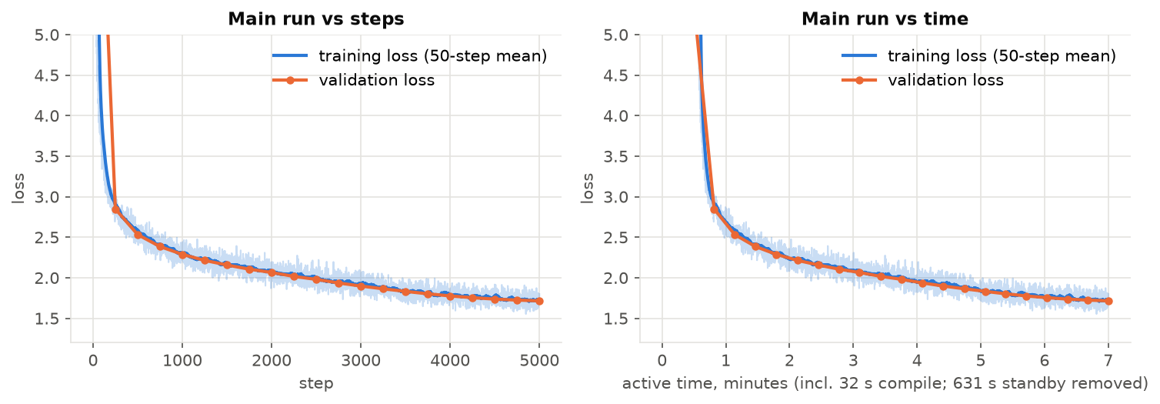
Main run: 5,000 steps × 32 × 256 = 40,960,000 tokens, peak lr 3e-3, 250 warm-up steps, cosine to 3e-4 exactly at the last step.
Final validation loss 1.7151, perplexity 5.56 (50 fixed validation batches = 409,600 held-out tokens; mean training loss over the last 100 steps 1.725, so no overfitting: the model saw only 7.6% of the training tokens once). Training took 422 s (7.0 min) including 32 s of compilation. The raw log says 1,053 s because Windows put the laptop into Modern Standby for 631 s during one step (confirmed in the Windows event log); the run continued correctly afterwards.
Stories (prompt "Once upon a time"; full texts in report/stories.txt). Left alone the model ends its stories after a median of 170 tokens (141-227 over 20 seeds), so for the required ≥256-token stories <|endoftext|> was blocked until 256 tokens (--min-new-tokens).
- T=0.7, top-p=0.9, seed 1 (would stop at 220): Once upon a time, in a small house, there lived a little girl named Mia. Mia loved to play outside in her big yard. She liked to run, jump, and laugh with her friends. One day, Mia found a mysterious box in her yard. It was a new toy with a big button on it. ...
- T=0.7, top-p=0.9, seed 2 (would stop at 125): Once upon a time, there was a little girl named Lily. She had a toy that she loved to play with. One day, she went to the park with her mom. At the park, Lily saw a big, yummy cake. She wanted to eat it all by herself. She asked her mom, "Can I have a bite of ...
- T=1.0, top-p=0.95, seed 1 (would stop at 190): Once upon a time, in a modest little town, there lived a funny man named Tom. He loved to drive his truck around his town. One day, he saw a man selling ice cream in the house. He had a dog named Spot. Spot was very nice and happy. Tom wanted to drive the ...
Q10. Sentence-level fluency is very good: correct grammar, punctuation and dialogue, and character names stay consistent. Two things change the quality. (1) Length: once the story is forced past its natural ending, the model repeats "The moral of the story is..." lines (seeds 1 and 2 at T=0.7) because a TinyStories story usually ends there. (2) Temperature/top-p: at 0.7/0.9 the plots are safe but generic (Lily, a toy, a park); at 1.0/0.95 there is more variety but also more slips ("a man selling ice cream in the house"). World logic is the weakest part at every setting ("Lily gave the cake to her mom" right after eating it).

Part 8: Packaging
release/ holds model.pt (weights only, 90.8 MB), config.json, vocab.json and merges.txt. inference.py imports only model/ and tokenizer/, rebuilds the model from config.json, loads the weights with map_location, and prints the story and a tokens/s line. Acceptance test: I copied exactly the files git would commit into a new folder, created a fresh venv, installed only requirements.txt (torch, regex, einops, numpy) and ran the README command on the CPU. It printed the same story as my development environment, and two runs with --seed 42 were identical.
Q11. On an AMD Ryzen 7 260 laptop CPU (8 cores, PyTorch used 8 threads, 15 GB RAM, Windows 11) generating 256 tokens runs at 25.3-26.3 tokens/s (30-34 tokens/s for the natural 148-token story). Without a cache, step k re-runs the model over all min(4+k, 256) tokens: 33,658 token positions for 256 new tokens instead of 259, so 99.2% of the work is repeated. I measured a forward pass at 9.4 ms for 1 token and 57.3 ms for 256 tokens; summing these predicts 9.2 s without a cache (measured ~9.8 s) and about 2.4 s with one, roughly 3.8× faster (~75% of the time saved). It is not 99% because each step still has a fixed cost (reading all weights, the 10,000-way output layer, Python overhead). This is an estimate; I did not build the cache.

Bugs I found vs. limits of the model
Bugs (fixed): (1) my first story-boundary test passed even without splitting on <|endoftext|>, which I found by running the training without the split; I rewrote it. (2) Resuming on the GPU crashed because map_location='cuda' moved the saved RNG states to the GPU (torch.set_rng_state needs a CPU tensor); the fp16 resume test caught it. (3) torch.compile failed on Windows without Triton; fixed with triton-windows (Colab/Kaggle on Linux need nothing). Not bugs: the NaNs at lr ≥ 3e-2 (fp16 overflow after real divergence, see Q9); the 631 s gap in the main-run log (laptop standby); repeated morals, generic plots and logic slips (limits of a 22.7M model trained on 41M tokens for 7 minutes).

