**Database Management Systems Laboratory**

**Assignment A6**

**Date of Submission: 15-09-2020**

**Title: CURSORS**

Roll number: 31301

Name: Aboli Marathe

Class: TE-3

Batch: K-3

PICT, Pune

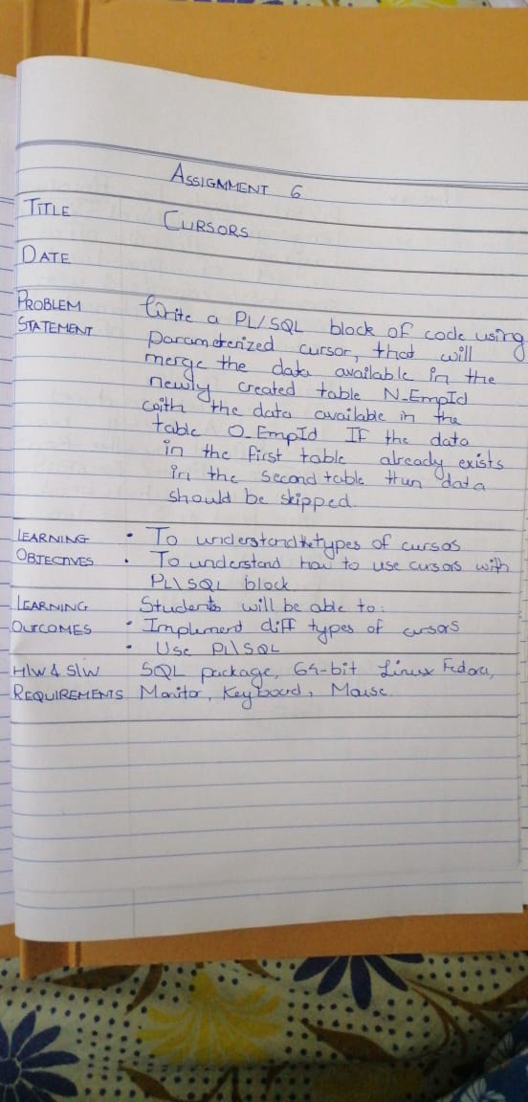

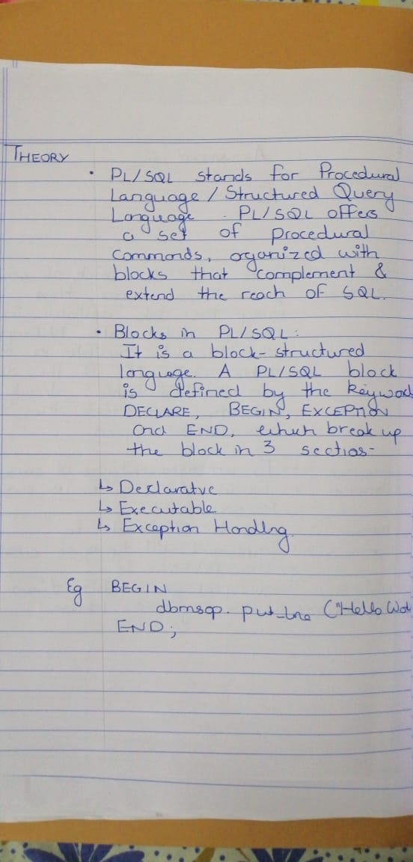

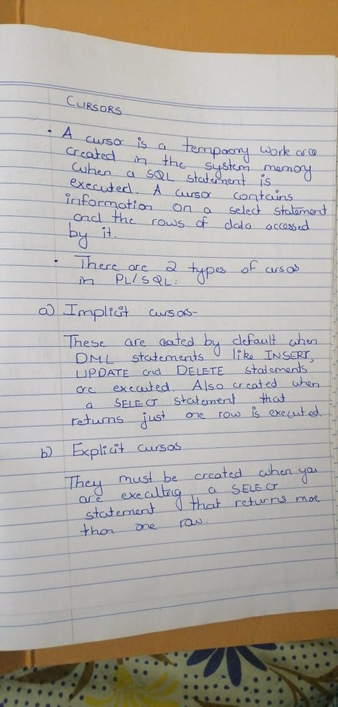

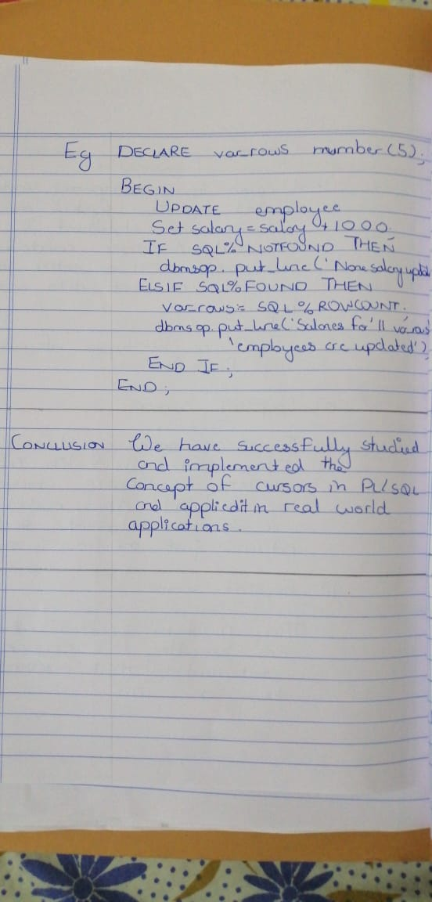

CODE AND OUTPUTS

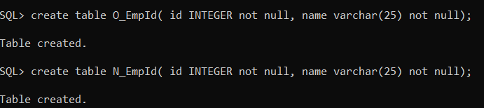

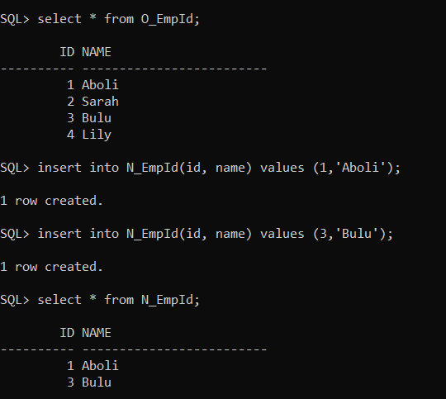

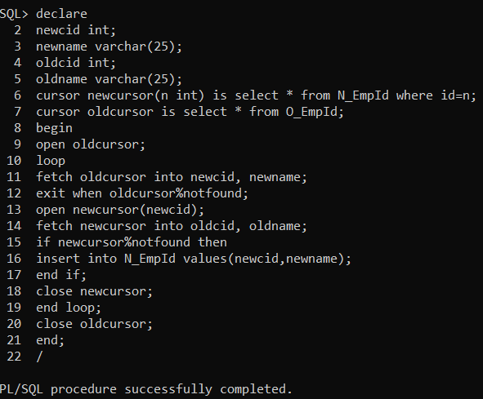

Alternate Code using MySQL procedures.

create procedure cur_merge2()

begin

declare oldemp_id int;

declare oldemp_name varchar(15);

declare newemp_id int;

declare newemp_name varchar(15);

declare common int;

declare finished integer default 0;

declare oldcursor cursor for select * from O_EmpId;

declare newcursor cursor for select * from N_EmpId where id = common;

declare continue handler for not found set finished =1;

open oldcursor;

for_loop : loop

set finished=0;

fetch oldcursor into oldemp_id , oldemp_name;

set common = oldemp_id;

if finished = 1 then

leave for_loop;

end if;

open newcursor;

fetch newcursor into newemp_id , newemp_name;

if finished = 1 then

insert into N_EmpId values (oldemp_id, oldemp_name);

end if;

close newcursor;

end loop for_loop;

close oldcursor;

end;

