SE Lab – 05
SRN: PES2UG24CS462
Name: PES2UG24CS462
Class: 5H

Screenshots of the three Report Txt files I got after running each tool:

Before fixing the faults:

Pylint_report.txt

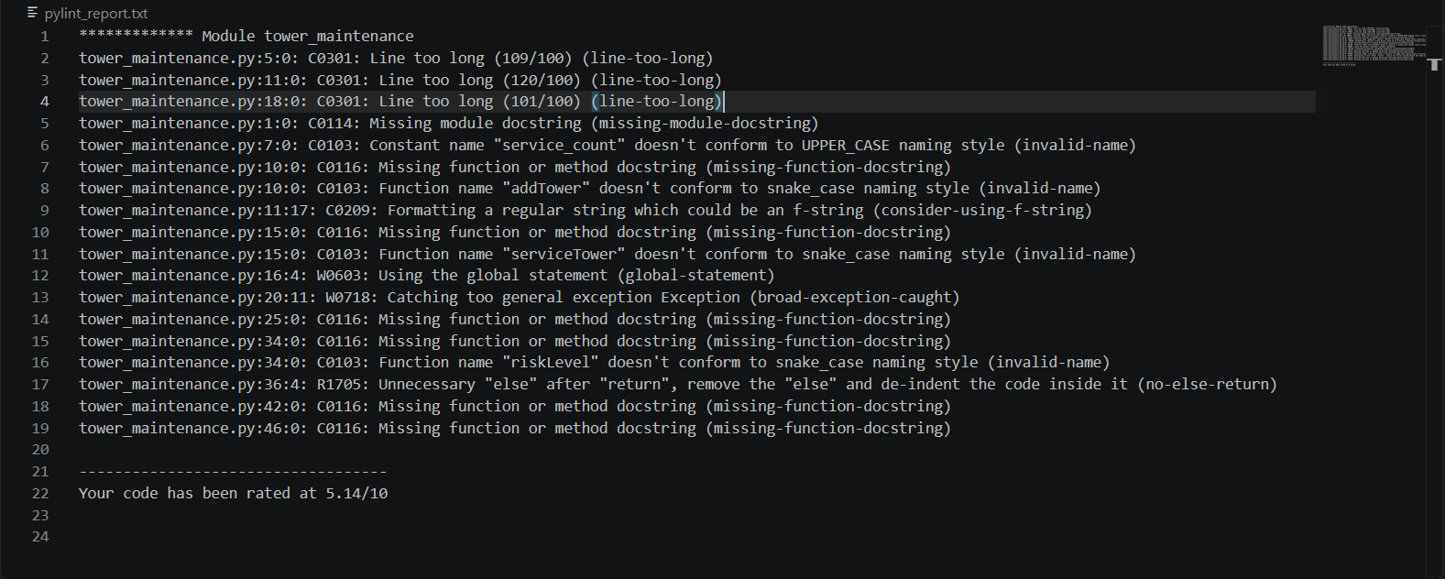

Bandit_report.txt
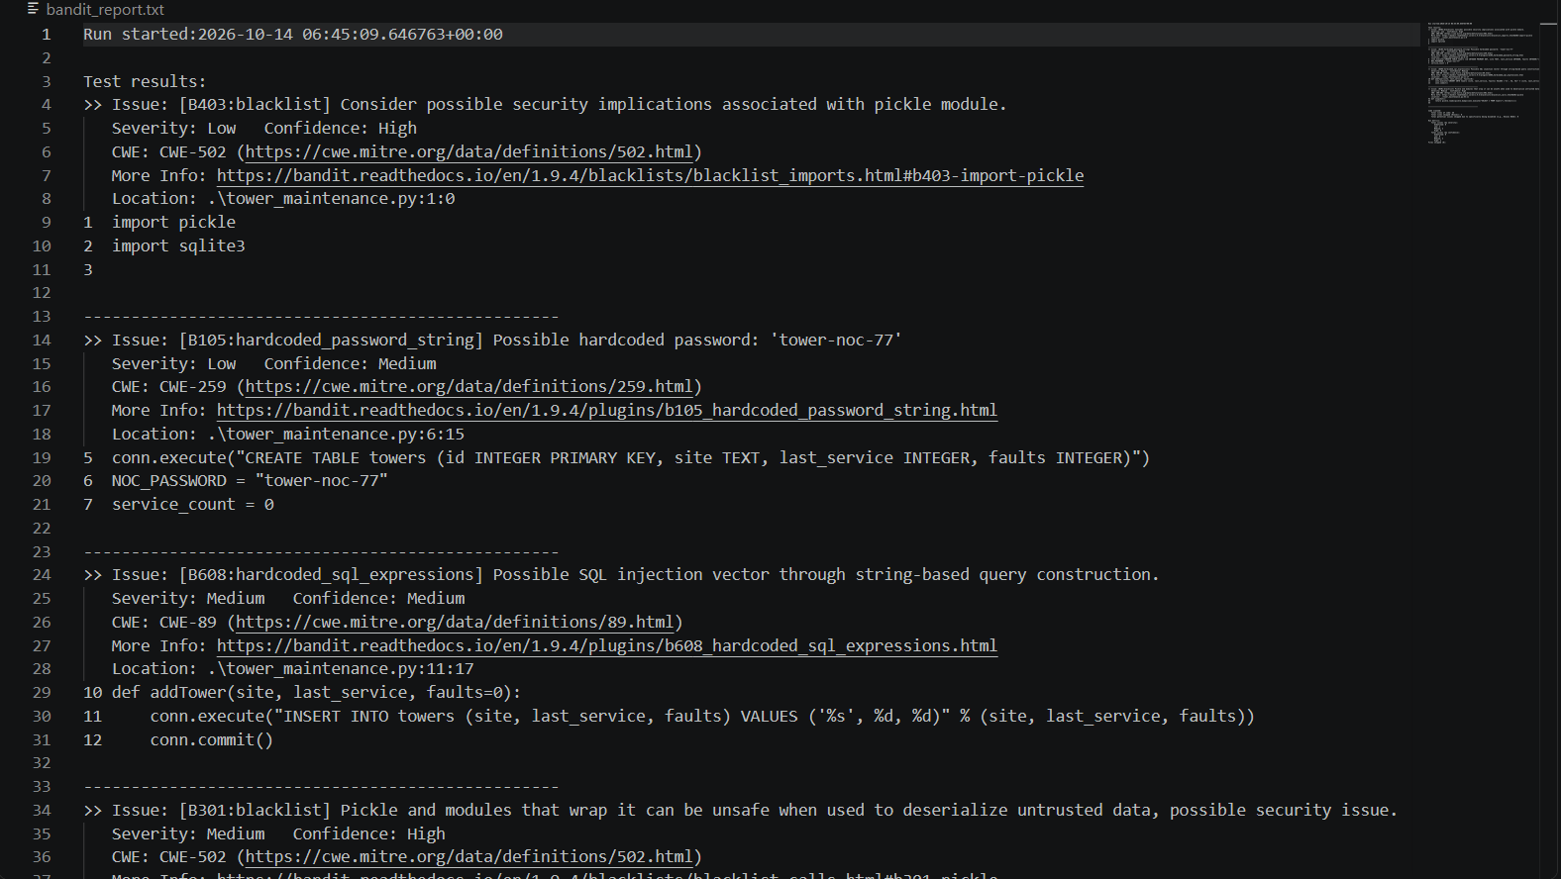
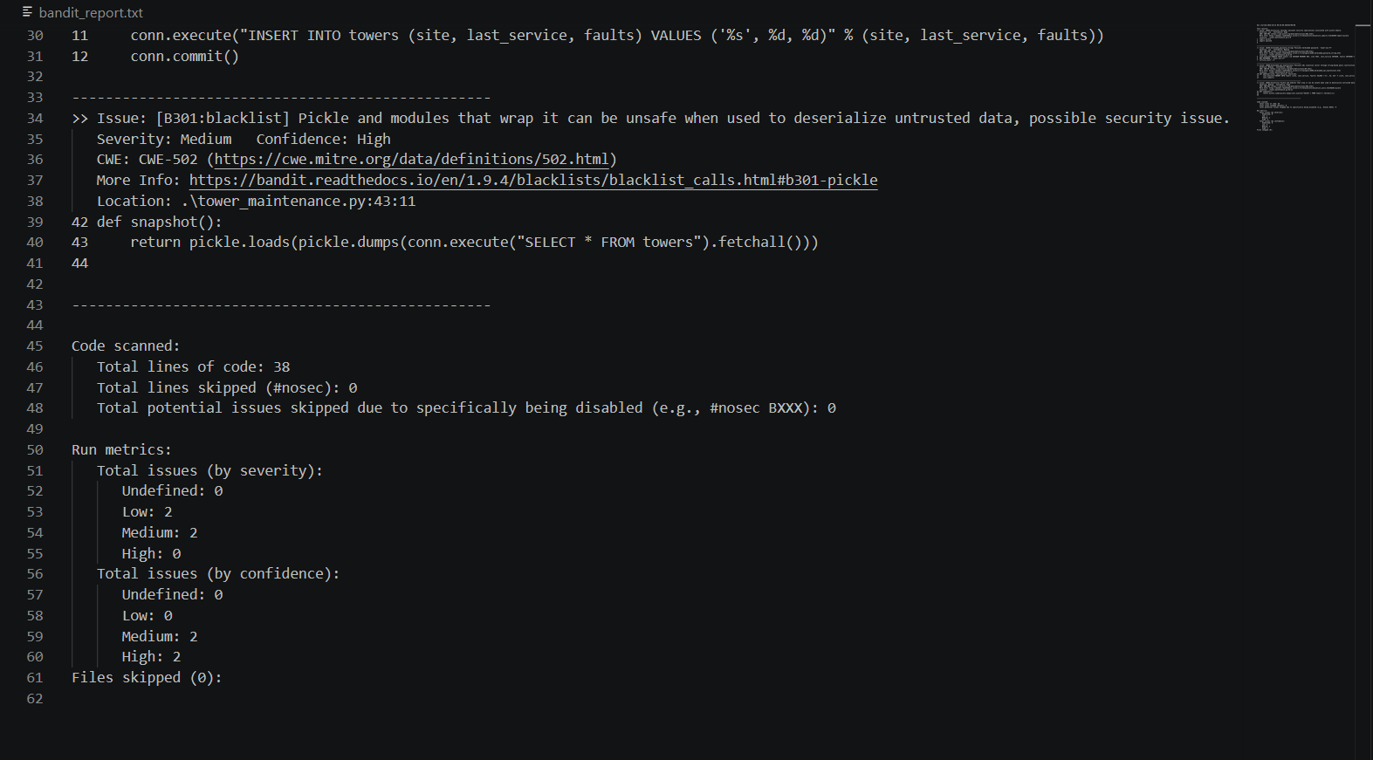

Flake8_report.txt
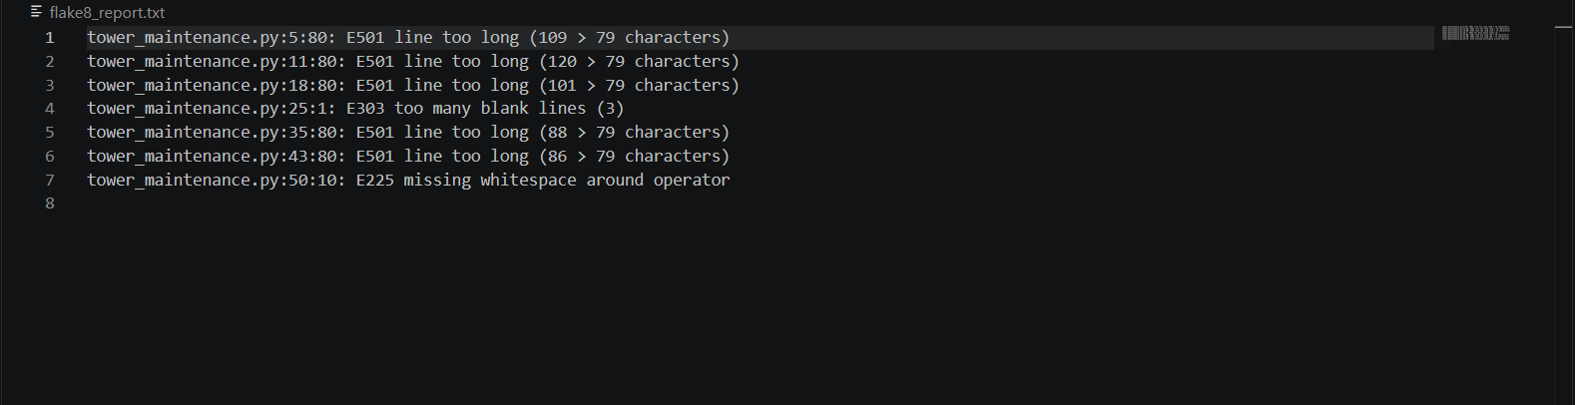

Summary of the code file faults-
Lines 1, 6, 7: flagged import, hard-coded password, and constant naming.
Lines 5, 11, 18, 35, 43: lines exceed the configured length.
Line 11: SQL string formatting flagged by Bandit.
Lines 10, 15, 25, 34, 42, 46: missing function docstrings; lines 10, 15, and 34 also have naming-style warnings.
Lines 16, 20, 36: global statement, broad exception, and unnecessary else.
Line 25: excess blank lines flagged by Flake8.
Line 43: pickle usage flagged by Bandit.
Line 50: missing whitespace around an operator.

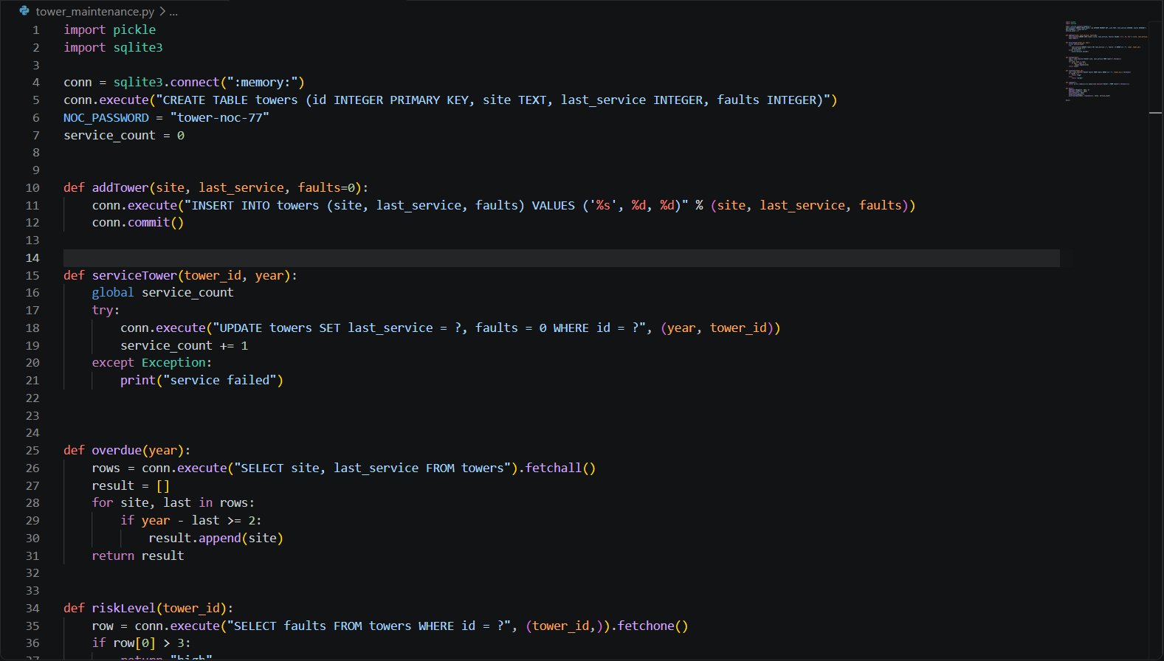
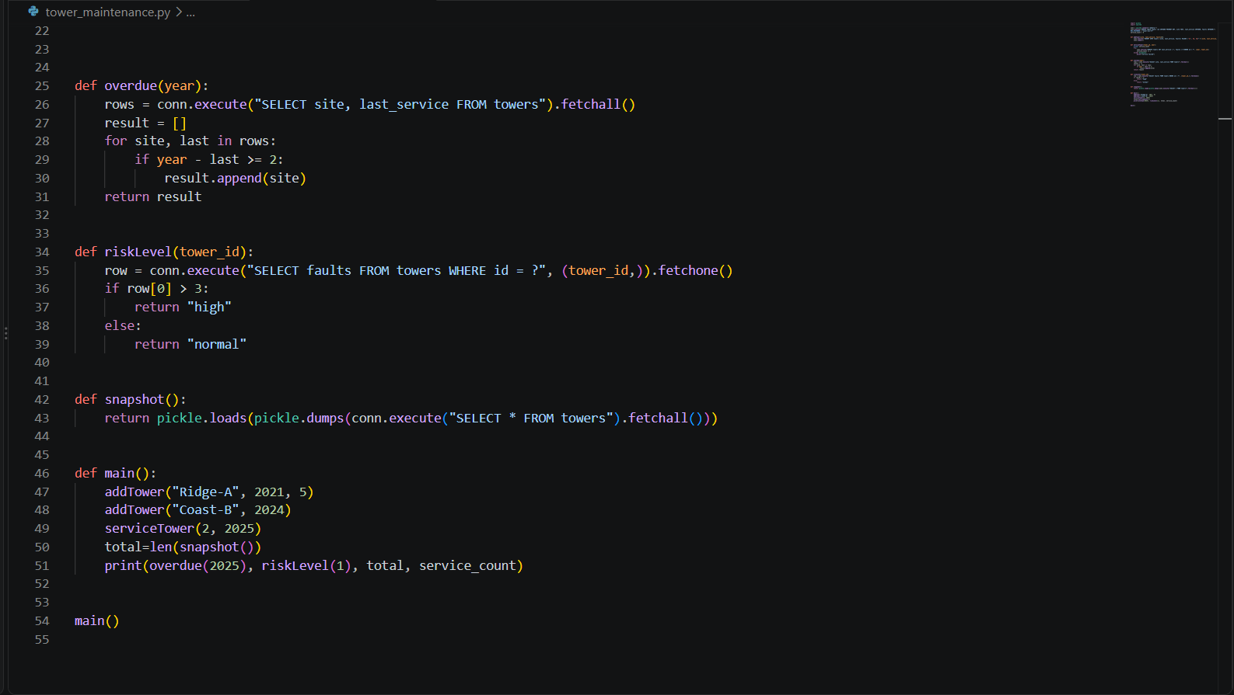

Report Files of tools after Code is fixed:

Pylint_report_after.txt
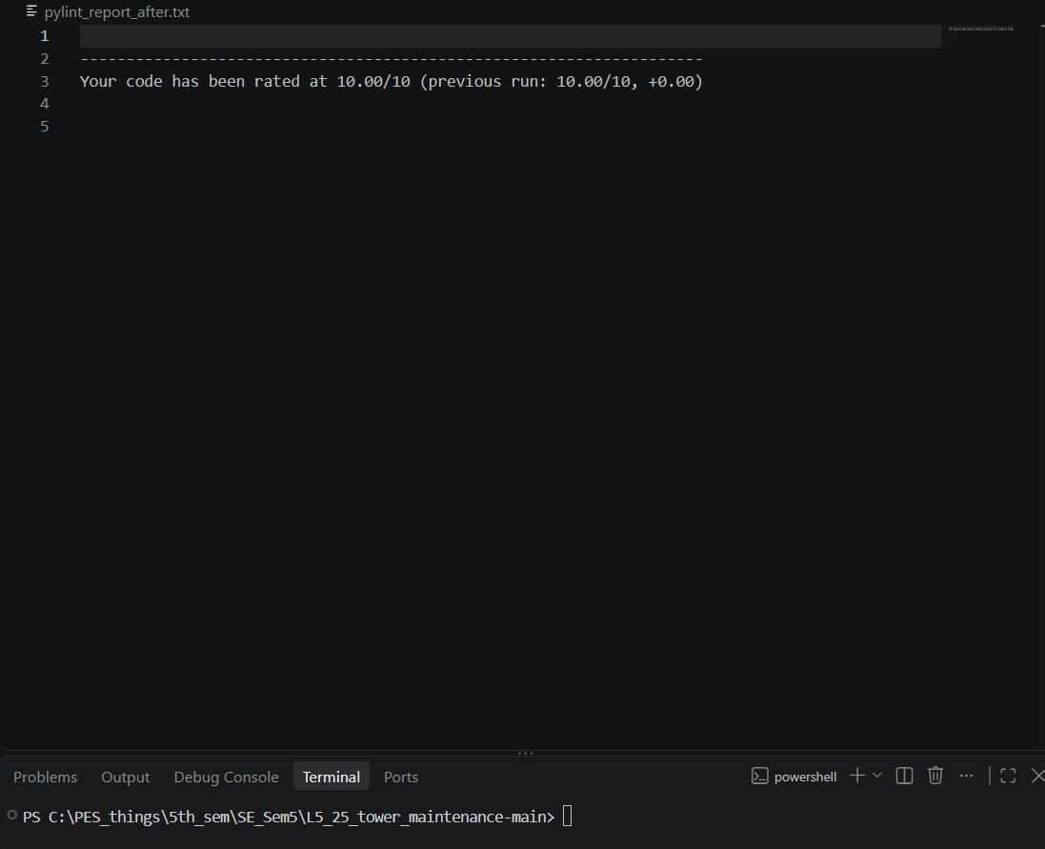

Bandit_report_after.txt
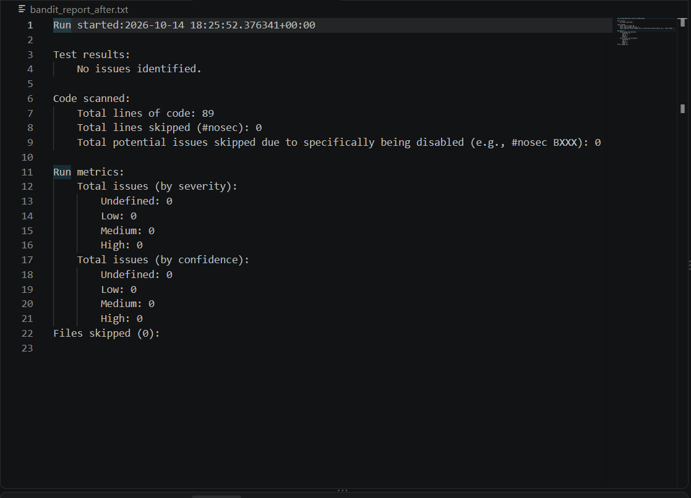

Flake8_report_after.txt
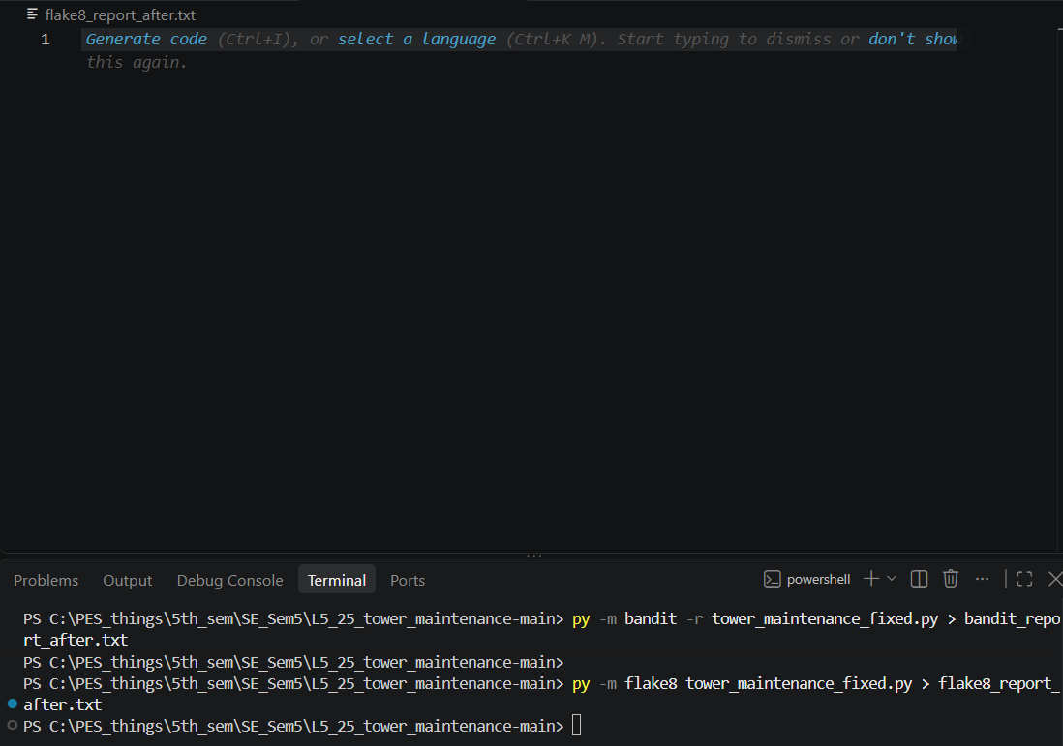

As u can see I have run the tool on the fixed python file but the report still turns out to be empty as there is no faults being detected

And pylint has rated the code a 10/10 after fixing which is a massive improvement from the previous 5.14/10

And here are the screenshots of the fixed code:

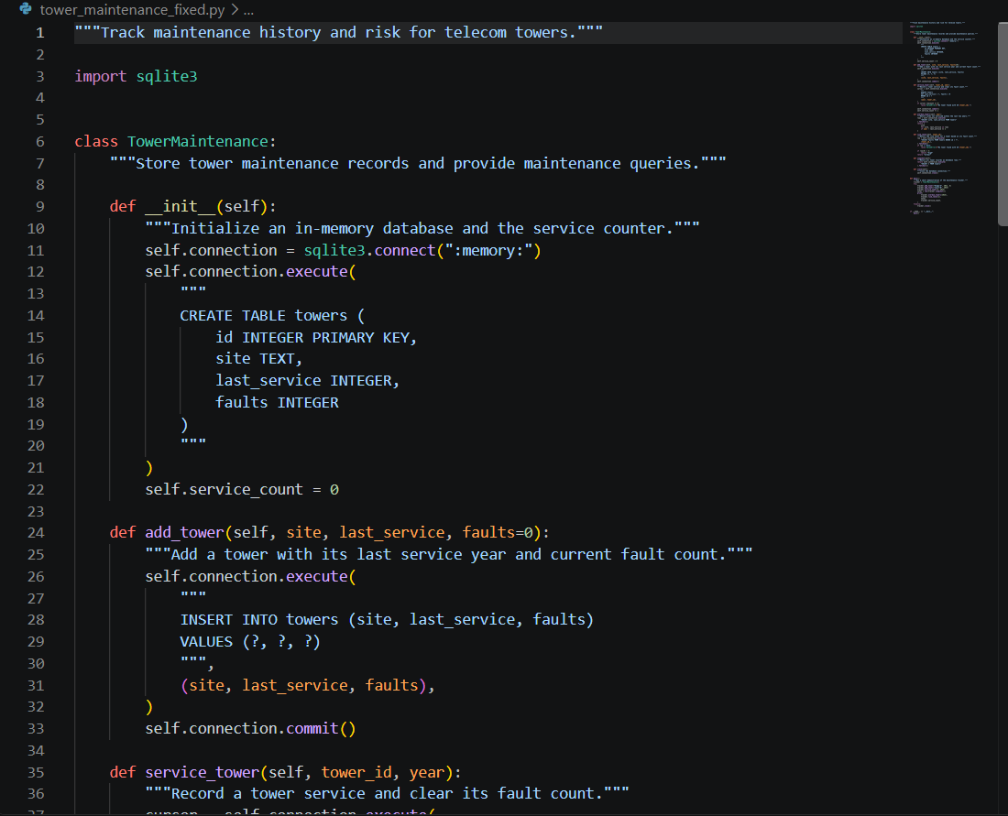
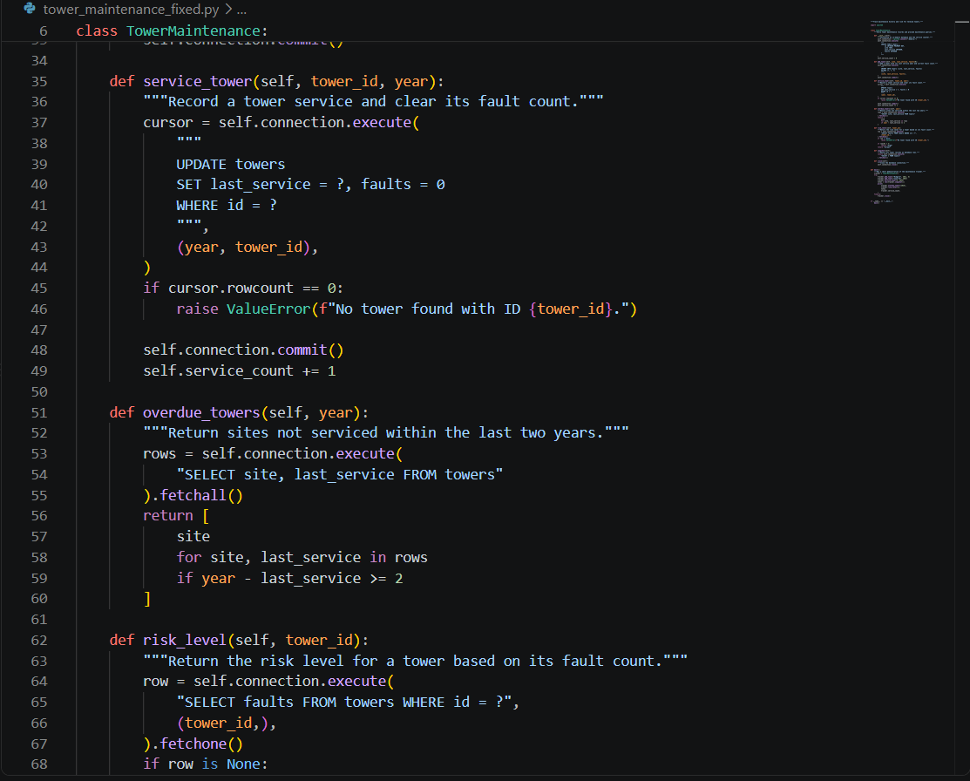
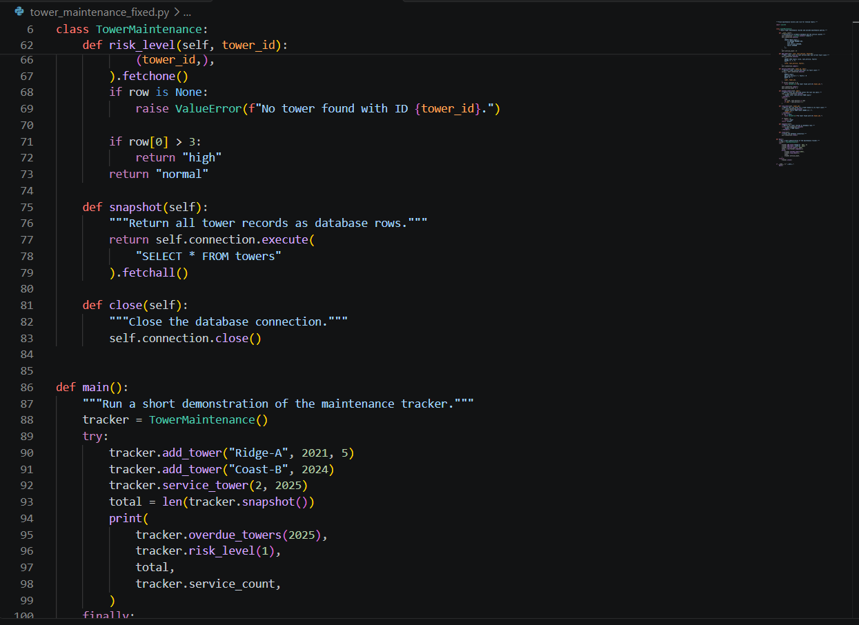
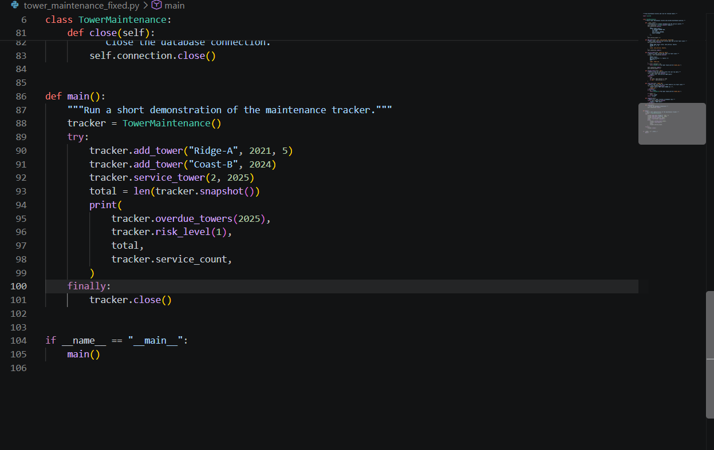

So as u can see even tough there is an increase in the number of lines of the code file the code is neat and tidy, by keeping the Max characters per line fault in bay.

Reflections.md
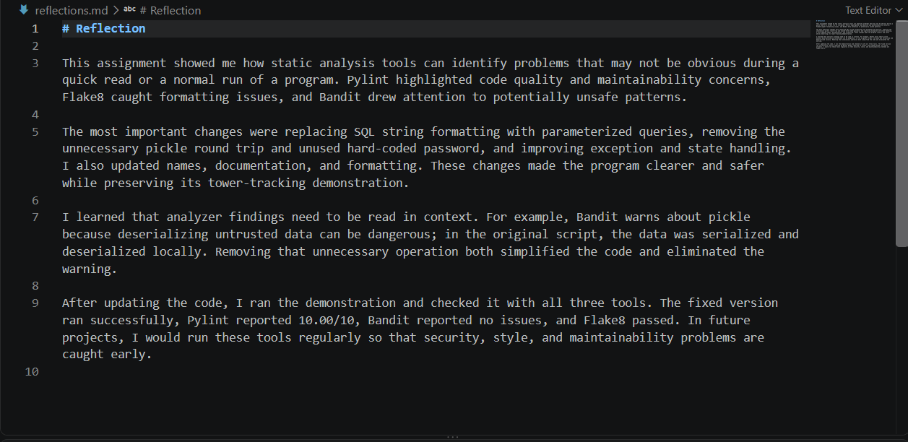

Even after searching for the reflection questions in the repo as well as the handbook I didn’t find any as the the handbook pointed to the repo and vice versa, so I have just added a reflections.md file summarising what we did in this lab

Thank You

