Tour and Travel Agency
Operations System
Requirements Specification
Software Modeling & Design · Version 1.0
Functional Requirements | 52 (FR-01 – FR-52)
Non-Functional Requirements | 16 (NFR-01 – NFR-16)
Use Cases | 44 (UC-01 – UC-44) + 4 reporting UCs
Activity Diagrams | 30 (AC-01 – AC-30)
Sequence Diagrams | 30 (SD-01 – SD-30)
Collaboration Diagrams | 30 (CC-01 – CC-30)
State Machine Diagrams | 6
BPMN Process Diagrams | 3 (BPMN-01 – BPMN-03)
Design Patterns | 5

1. Executive Summary
The Tour and Travel Agency Operations System is a software modeling and design project that produces a comprehensive system specification for a mid-sized travel agency. The system centralizes and supports all core agency operations in a single, role-aware platform, replacing disconnected manual processes with structured workflows across customer management, bookings, travel packages, partner coordination, staff administration, financial management, and reporting.
The project has progressed through business domain research, requirements development (52 functional and 16 non-functional requirements), use case specification (44 use cases across 8 domains), and a full suite of UML and BPMN modeling artifacts. This document assembles all project deliverables into one structured specification aligned with the course requirements template.

2. Product / Service Description

2.1 Product Context
The system is a standalone internal platform designed exclusively for one travel agency. It does not interface with public booking marketplaces or act as a multi-tenant platform. The system covers eight functional domains: User & Access Management, Travel Package Management, Booking & Reservation, Scheduling & Operations, Partner Management, Financial Management, Customer Experience & Loyalty, and Reporting & Analytics.

External integration points are limited to optional future modules such as payment gateways and government travel advisory feeds, governed by the extensibility constraint in NFR-16. The system's primary interfaces are its internal actors: Customer, Travel Agent, Operations Staff, HR Staff, Finance Staff, Administrator, and Manager/Owner.

2.2 User Characteristics
User Type | Role Summary | Technical Profile | Primary System Functions
Customer | End consumer who books travel services | General public; minimal technical background; may be first-time users | Browse packages, submit bookings, manage profile, upload documents, track status
Travel Agent | Sales-facing staff who process bookings | Office staff; familiar with booking tools; trained on agency workflows | Process bookings, issue itineraries, manage cancellations, communicate with customers
Operations Staff | Manages packages, schedules, and partners | Experienced staff; manages complex operational records | Create/edit packages, manage schedules, assign guides, maintain partner records
HR Staff | Manages employee records and attendance | Administrative background; HR system experience | Maintain employee records, log attendance, process leave requests
Finance Staff | Handles payments, receipts, and reporting | Finance background; familiar with payment and reconciliation workflows | Record payments, generate receipts, reconcile records, manage refunds and reports
Administrator | System-level control and account management | High technical competence; manages all accounts and access | Create/disable accounts, assign roles, view audit logs, administer system
Manager / Owner | Strategic oversight and reporting | Business-oriented; comfortable with dashboards and reports | View operations dashboard, access financial reports, review performance data

2.3 Assumptions
- The system is deployed within a single travel agency with one headquarters and one optional branch.
- All system users are employees or registered customers of the agency; no public API is exposed.
- Users have access to a device with an internet connection sufficient for normal web application interaction.
- Supplier records are entered and maintained manually by staff; no live supplier API integration is assumed in the initial release.
- All financial figures are recorded in a single base currency; multi-currency conversion is out of scope for this version.
- The system will be administered by at least one designated Administrator responsible for account management and access control.

2.4 Constraints and Dependencies
- The system must comply with applicable data privacy legislation (e.g. GDPR or equivalent) as specified in NFR-13.
- Customer document uploads are constrained to PDF, JPEG, and PNG formats with a maximum file size of 10 MB per document (NFR-15).
- Financial records must be retained for a minimum of 7 years; customer travel documents for a minimum of 2 years post-trip (NFR-14).
- Audit log entries are immutable; no user including administrators may edit or delete them (NFR-05).
- New integration modules must be addable without modifying existing core system components (NFR-16).
- The system must achieve at least 99% uptime during business hours (NFR-06).

3. Requirements

3.1 Functional Requirements
The system has 52 functional requirements across 8 domains. Priority definitions: High = core operational function; Medium = important supporting feature; Low = enhancement or optional feature.

Req # | Requirement | Priority | Domain
1. User & Access Management
FR-01 | The system shall allow all user types to log in securely using their credentials, with role-based routing to the appropriate system area upon authentication. | High | User &
FR-02 | The system shall lock a user account after three consecutive failed login attempts and notify the affected user. | High | User &
FR-03 | The system shall allow customers to manage their own profile including contact details and traveler information, and allow administrators to view customer account details for support and oversight purposes. | High | User &
FR-04 | The system shall allow administrators to create, edit, disable, and reactivate user accounts and log all such actions. | High | User &
FR-05 | The system shall allow HR staff to maintain employee records including roles, contact information, and employment status, and to manage attendance entries and leave requests. | High | User &
FR-06 | The system shall allow users to reset their password through a verified recovery process. | Medium | User &
FR-07 | The system shall manage user sessions including logout, automatic timeout after inactivity, and prevention of unauthorized session reuse. | Medium | User &
2. Travel Package Management
FR-08 | The system shall allow staff to create, update, archive, and publish travel packages, storing details such as destination, duration, itinerary, capacity, price, and inclusions. | High | Travel Package
FR-09 | The system shall allow staff to define seasonal pricing rules or discounts linked to specific packages and date ranges. | Medium | Travel Package
FR-10 | The system shall allow staff to create and manage promotional campaigns and promo codes, including validity periods and discount amounts, which the system applies automatically at booking. | Medium | Travel Package
FR-11 | The system shall allow staff to define and maintain a required travel document checklist for each package. | Medium | Travel Package
FR-12 | The system shall allow customers to submit package customization requests, which staff can review and respond to manually. | Medium | Travel Package
FR-13 | The system shall restrict customer-facing package browsing to published packages only, while allowing authorized staff to view and edit packages in any lifecycle state. | Medium | Travel Package
FR-14 | The system shall allow staff to duplicate an existing package as a template for creating new ones. | Low | Travel Package
3. Booking & Reservation
FR-15 | The system shall allow customers to submit a booking request for a selected package, including traveler details, and shall validate customer travel eligibility before submission is accepted. | High | Booking &
FR-16 | The system shall route confirmed booking requests to a review queue, generate a unique booking reference, and allow staff to approve, reject, or place the booking on hold. | High | Booking &
FR-17 | The system shall automatically update remaining package capacity and notify the customer when a booking status changes. | High | Booking &
FR-18 | The system shall allow staff to issue digital itineraries or travel summaries for confirmed bookings. | Medium | Booking &
FR-19 | The system shall allow customers to view the current status of their bookings from their account. | Medium | Booking &
FR-20 | The system shall allow customers to submit cancellation requests subject to policy rules, and require staff to record the cancellation outcome and any associated refund status. | Medium | Booking &
FR-21 | The system shall allow staff to add notes or special requests to a booking and maintain a history of all major actions performed on that booking. | Medium | Booking &
FR-22 | The system shall allow staff to modify booking details such as traveler information or travel dates after initial confirmation, subject to availability and policy rules. | Medium | Booking &
FR-23 | The system shall validate traveler documents against the package checklist requirements before finalizing a booking. | Medium | Booking &
FR-24 | The system shall allow customers to upload required travel documents against their booking, and shall store those documents for staff review and eligibility verification. | Medium | Booking &
FR-25 | The system shall allow customers to join a waitlist for a fully booked package, and shall automatically notify the next eligible customer on the waitlist when a confirmed booking is cancelled and capacity becomes available. | Medium | Booking &
4. Scheduling & Operations
FR-26 | The system shall allow staff to create and maintain travel schedules including departure dates, return dates, and trip status, linked to their corresponding packages. | High | Scheduling &
FR-27 | The system shall allow staff to assign guides or coordinators to specific trips from a list of available personnel, and record that assignment against the trip. | Medium | Scheduling &
FR-28 | The system shall allow staff to mark a trip as completed, triggering archival of operational data including schedules, assignments, and booking records for historical reporting. | Low | Scheduling &
FR-29 | The system shall distribute required trip-related documents to assigned internal personnel upon trip confirmation or schedule finalization. | Medium | Scheduling &
FR-30 | The system shall track trip status across its full lifecycle including scheduled, in progress, completed, and archived states, and restrict operations based on current status. | Medium | Scheduling &
5. Partner Management
FR-31 | The system shall allow staff to create, edit, and deactivate business partner records, including partner name, type, contact information, and service category. | Medium | Partner Management
FR-32 | The system shall allow staff to link one or more business partners to a travel package, specifying the service role of each partner, and to update or remove those links as needed. | Medium | Partner Management
FR-33 | The system shall maintain a categorized directory of business partners filterable by type and status, available to authorized staff for operational reference. | Medium | Partner Management
FR-34 | The system shall allow staff to record notes or feedback against a business partner record for internal reference. | Low | Partner Management
6. Financial Management
FR-35 | The system shall allow finance staff to record incoming and outgoing payments and update payment status as unpaid, partial, paid, refunded, or cancelled. | High | Financial Management
FR-36 | The system shall generate receipts automatically upon payment completion and allow authorized finance staff to manually generate or reissue receipts when necessary. | Medium | Financial Management
FR-37 | The system shall allow finance staff to verify and reconcile payment records, identifying and resolving discrepancies between recorded and expected amounts. | Medium | Financial Management
FR-38 | The system shall allow finance staff to record and track refunds and financial adjustments linked to specific bookings, separate from the cancellation workflow. | Medium | Financial Management
FR-39 | The system shall allow finance staff to record agency expenses and generate financial reports including revenue, expense, and profit summaries for specified periods, accessible to managers and owners. | High | Financial Management
FR-40 | The system shall allow finance staff to set and track payment due dates for bookings with partial or pending payment status, flag overdue payments for follow-up, and support the definition of installment schedules with individual due dates for bookings under a payment plan. | Medium | Financial Management
7. Customer Experience & Loyalty
FR-41 | The system shall allow customers to browse and search travel packages by destination, date, budget, or category, and display current availability alongside search results. | High | Customer Experience
FR-42 | The system shall display a calendar view of available departure dates and remaining capacity for each package, accessible to customers during browsing and booking. | Medium | Customer Experience
FR-43 | The system shall allow customers to save packages to a favourites list for later review. | Low | Customer Experience
FR-44 | The system shall notify customers of promotional campaigns, loyalty rewards, and referral benefits relevant to their account. | Medium | Customer Experience
FR-45 | The system shall record loyalty points earned per booking and allow customers to view and apply available rewards at the time of booking. | Low | Customer Experience
FR-46 | The system shall track customer referrals, link them to associated accounts, and apply any referral benefits upon qualifying booking completion. | Low | Customer Experience
FR-47 | The system shall maintain a record of notifications and communications sent to each customer, accessible from their account and by authorized staff. | Medium | Customer Experience
8. Reporting & Analytics
FR-48 | The system shall provide managers and owners with an operations dashboard displaying summaries of active bookings, cancellations, package performance, and sales figures. | Medium | Reporting &
FR-49 | The system shall provide role-specific reporting views, giving finance staff access to financial summaries, HR staff access to workforce and attendance reports, and managers access to full operational overviews. | Medium | Reporting &
FR-50 | The system shall allow authorized staff to export reports in a standard format for external business review purposes. | Low | Reporting &
FR-51 | The system shall log all significant system actions including administrative changes, booking modifications, payment updates, and access events, and make those logs accessible to administrators. | High | Reporting &
FR-52 | The system shall notify relevant staff members of events requiring their attention, including pending booking reviews, overdue payments, assigned trips, and account changes, routing notifications based on staff role. | Medium | Reporting &

3.2 Non-Functional Requirements
The system has 16 non-functional requirements across 6 categories. Each includes a concrete acceptance metric for verification.

ID | Requirement | Category | Acceptance Metric
Performance
NFR-01 | The system shall support a minimum of 500 concurrent users under normal operating conditions, and shall remain stable under peak loads of up to 1,000 concurrent users without exceeding the response time threshold defined in NFR-02. | Performance | Load test at 500 and 1,000 concurrent users; response time must remain within 2 seconds.
NFR-02 | The system shall respond to common user actions within 2 seconds under normal load conditions. | Performance | 95% of requests must complete within 2 seconds under normal load.
Security
NFR-03 | The system shall protect authentication credentials, sensitive customer data, and financial records through industry-standard encryption for data in transit and at rest. | Security | Security audit; all transmissions use TLS; stored sensitive data encrypted at rest.
NFR-04 | The system shall enforce role-based access control, ensuring that each user type can only access the functions and data appropriate to their assigned role. | Security | Access testing per role; unauthorized attempts must return access denied.
NFR-05 | Audit log entries shall not be editable or deletable by any user, including administrators, ensuring a tamper-proof record of all significant system actions. | Security | Attempt edit/delete on log entries across all roles; all attempts must fail.
Availability & Reliability
NFR-06 | The system shall maintain at least 99% availability during business hours, with planned maintenance scheduled outside of peak operational periods. | Availability & Reliability | Uptime monitoring; max allowable downtime during business hours is 1.68 hours per week.
NFR-07 | The system shall maintain consistency across all interrelated records including booking status, payment status, package capacity, traveler information, and financial adjustments. | Availability & Reliability | No booking confirmation may exist without a matching capacity and payment record update.
NFR-08 | The system shall perform automated backups of all operational data at least once every 24 hours, and shall be capable of restoring to the most recent backup state within 4 hours. | Availability & Reliability | Backup logs and recovery drill; restoration must complete within 4 hours.
Usability
NFR-09 | A first-time user shall be able to complete a standard booking workflow without formal training and within 10 minutes of their first interaction with the system. | Usability | Usability testing; 80% of first-time users must complete the booking workflow within 10 minutes unaided.
NFR-10 | The system shall display a confirmation or error message within 2 seconds of every user-initiated action, covering success, failure, and validation states. | Usability | Every action must produce a visible feedback message within 2 seconds.
NFR-11 | All system modules shall use the same navigation structure, button placement conventions, and terminology, ensuring a consistent interface experience. | Usability | UI review against interface style guide; deviations constitute a defect.
NFR-12 | The system shall support display of interface content in the user's preferred language or detected device language, with English as the default language. | Usability | Switch device language; interface must reflect the selected language within one page load.
Compliance & Legal
NFR-13 | The system shall comply with applicable legal and regulatory requirements including GDPR or equivalent data privacy legislation, financial record-keeping regulations, and consumer protection laws. | Compliance & Legal | Compliance review; data handling practices must be documented and auditable.
NFR-14 | The system shall retain booking records and financial data for a minimum of 7 years, and uploaded customer documents for a minimum of 2 years following trip completion. | Compliance & Legal | Data retention audit; records must remain retrievable for the defined minimum periods.
Constraints & Extensibility
NFR-15 | The system shall enforce file size and format constraints on customer document uploads, accepting only PDF, JPEG, and PNG formats with a maximum file size of 10 MB per uploaded document. | Constraints & Extensibility | Files exceeding 10 MB or outside accepted formats must be rejected with a clear error message.
NFR-16 | New integration modules shall be addable to the system without modifying existing core system components, supporting future integration with external services. | Constraints & Extensibility | Architectural review; new module must not require changes to existing core modules.

4. User Scenarios / Use Cases

The system has 44 use cases organized across the same 8 domains as the functional requirements. Each use case corresponds to one or more functional requirements, is assigned a primary actor, and is documented with a full use case table including trigger, preconditions, main success scenario, alternative flows, and postconditions. The index below provides the complete mapping. Full use case tables are held in Specifications/Use_Case_Specifications.docx.

Naming convention: FR-## → UC-## → AC-## (Activity) → SD-## (Sequence) → CC-## (Collaboration).

UC ID | Use Case Name | Related Requirements | Primary Actor
1. User & Access Management
UC-01 | Log In | FR-01, FR-02, FR-07 | Any User
UC-02 | Register Customer Account | FR-01 | Customer
UC-03 | Reset Password | FR-06 | Any User
UC-04 | Manage Customer Profile | FR-03 | Customer
UC-05 | Administer User Accounts | FR-04 | Administrator
UC-06 | Manage Employee Records | FR-05 | HR Staff
UC-07 | Manage Attendance & Leave | FR-05 | HR Staff
2. Travel Package Management
UC-08 | Create & Publish Travel Package | FR-08 | Operations Staff
UC-09 | Update & Archive Travel Package | FR-08, FR-13 | Operations Staff
UC-10 | Define Seasonal Pricing & Discounts | FR-09 | Operations Staff
UC-11 | Manage Promotional Campaigns & Promo Codes | FR-10 | Operations Staff
UC-12 | Define Package Document Checklist | FR-11 | Operations Staff
UC-13 | Submit & Review Package Customization Request | FR-12 | Customer / Operations Staff
UC-14 | Duplicate Package as Template | FR-14 | Operations Staff
3. Booking & Reservation
UC-15 | Submit Booking Request | FR-15, FR-23 | Customer
UC-16 | Review & Process Booking | FR-16, FR-17 | Travel Agent
UC-17 | Issue Digital Itinerary | FR-18 | Travel Agent
UC-18 | View Booking Status | FR-19 | Customer
UC-19 | Submit & Process Cancellation | FR-20 | Customer / Travel Agent
UC-20 | Add Notes & Booking History | FR-21 | Travel Agent
UC-21 | Modify Booking Details | FR-22 | Travel Agent
UC-22 | Upload & Verify Travel Documents | FR-24 | Customer / Travel Agent
UC-23 | Join & Manage Waitlist | FR-25 | Customer / Travel Agent
4. Scheduling & Operations
UC-24 | Create & Manage Travel Schedule | FR-26 | Operations Staff
UC-25 | Assign Guide or Coordinator | FR-27 | Operations Staff
UC-26 | Close & Archive Completed Trip | FR-28 | Operations Staff
UC-27 | Distribute Trip Documents | FR-29 | Operations Staff
UC-28 | Track Trip Lifecycle Status | FR-30 | Operations Staff
5. Partner Management
UC-29 | Manage Business Partner Records | FR-31 | Operations Staff
UC-30 | Link Partners to Travel Package | FR-32 | Operations Staff
UC-31 | Browse Partner Directory | FR-33 | Operations Staff
UC-32 | Record Partner Feedback & Notes | FR-34 | Operations Staff
6. Financial Management
UC-33 | Record & Update Payment | FR-35 | Finance Staff
UC-34 | Generate & Reissue Receipt | FR-36 | Finance Staff
UC-35 | Reconcile Payment Records | FR-37 | Finance Staff
UC-36 | Record Refund & Adjustment | FR-38 | Finance Staff
UC-37 | Generate Financial Report | FR-39 | Finance Staff / Manager
UC-38 | Manage Payment Plans & Overdue Flags | FR-40 | Finance Staff
7. Customer Experience & Loyalty
UC-39 | Search & Browse Travel Packages | FR-41, FR-13 | Customer
UC-40 | View Departure Calendar | FR-42 | Customer
UC-41 | Save Package to Favourites | FR-43 | Customer
UC-42 | Receive Promotional Notifications | FR-44 | Customer
UC-43 | Manage Loyalty Points & Rewards | FR-45 | Customer
UC-44 | Track & Apply Referral Benefits | FR-46 | Customer
8. Reporting & Analytics
UC-45 | View Operations Dashboard | FR-48 | Manager / Owner
UC-46 | Access Role-Specific Reports | FR-49 | Finance Staff / HR Staff / Manager
UC-47 | Export Reports | FR-50 | Authorized Staff
UC-48 | Browse Audit Log | FR-51 | Administrator

1. User & Access Management
This domain covers authentication, session management, account administration, and employee record handling. Primary actors are Customer, Administrator, and HR Staff.

UC-01 — Log In
Use Case ID | UC-01
Use Case Name | Log In
Primary Actor | Any User (Customer, Travel Agent, Operations Staff, HR Staff, Finance Staff, Administrator, Manager/Owner)
Secondary Actors | Administrator — notified when an account is locked; can reactivate the account via UC-05.
Trigger | User navigates to the login screen and submits credentials.
Preconditions | A user account exists and is not currently authenticated.
Main Success Scenario | - User enters username and password.  - System validates credentials against stored records.  - System determines the user role.  - System creates a session and routes user to their role-specific area.  - System logs the access event in the audit log.
Alternative Flows | - Credentials invalid — system returns error message and increments failure counter.  - Three consecutive failures — account locked, user notified, Administrator alerted.  - Account already locked — user directed to reset password or contact Administrator.  - Session already active — existing session terminated before new one is created.
Postconditions | A valid session is opened with correct role permissions, or the account is locked after repeated failures.
Related FRs | FR-01, FR-02, FR-07

UC-02 — Register Customer Account
Use Case ID | UC-02
Use Case Name | Register Customer Account
Primary Actor | Customer
Secondary Actors | None.
Trigger | Customer selects the register option from the login or home screen.
Preconditions | Customer does not already have an account and is not currently logged in.
Main Success Scenario | - Customer enters registration details including name, email, and password.  - System validates completeness and checks email uniqueness.  - System creates account with customer role.  - System sends confirmation notification to the provided email.  - System redirects customer to initial profile setup.
Alternative Flows | - Required fields missing — validation error returned, form not submitted.  - Email already registered — registration rejected, customer directed to log in or reset password.
Postconditions | A new customer account is stored and ready for use.
Related FRs | FR-01

UC-03 — Reset Password
Use Case ID | UC-03
Use Case Name | Reset Password
Primary Actor | Any User
Secondary Actors | None.
Trigger | User selects the forgot password or reset password option.
Preconditions | User has an existing account registered in the system.
Main Success Scenario | - User enters their registered email address.  - System verifies the email exists in the system.  - System generates a time-limited reset token and sends it to the email.  - User opens the reset link and enters a new password.  - System validates the new password and updates credentials.  - System invalidates the reset token and logs the action.
Alternative Flows | - Email not recognized — process silently completes with no token sent for security reasons.  - Reset token expired — user must restart the process.  - New password does not meet requirements — validation error returned, password not updated.
Postconditions | User credentials are updated and the user can log in with the new password.
Related FRs | FR-06

UC-04 — Manage Customer Profile
Use Case ID | UC-04
Use Case Name | Manage Customer Profile
Primary Actor | Customer
Secondary Actors | Administrator — view-only access to customer profile for support and oversight purposes.
Trigger | Customer opens the profile section of their account.
Preconditions | Customer is logged in.
Main Success Scenario | - Customer opens profile page.  - Customer edits contact details or traveler information.  - System validates submitted data.  - System saves changes and confirms success.  - System logs the action in the audit log.
Alternative Flows | - Invalid or incomplete data submitted — validation error returned, changes not saved.  - Administrator views profile — read-only access granted, no modifications permitted.
Postconditions | Customer profile is updated and available for use in future bookings.
Related FRs | FR-03

UC-05 — Manage User Accounts
Use Case ID | UC-05
Use Case Name | Manage User Accounts
Primary Actor | Administrator
Secondary Actors | Any User — receives notification when their account status is changed.
Trigger | Administrator opens the user account management area.
Preconditions | Administrator is logged in with account management permissions.
Main Success Scenario | - Administrator selects a user account or creates a new one.  - Administrator performs create, edit, disable, or reactivate action.  - System validates the action and applies the change.  - System logs the action in the audit log.  - System notifies the affected user of the account change.
Alternative Flows | - Administrator attempts to disable their own account — action blocked by system.  - Reactivating a locked account — account restored and failure counter reset.  - Invalid data submitted — validation error returned, change not applied.
Postconditions | The selected user account lifecycle state is updated and logged.
Related FRs | FR-04

UC-06 — Manage Employee Records and Attendance
Use Case ID | UC-06
Use Case Name | Manage Employee Records and Attendance
Primary Actor | HR Staff
Secondary Actors | Employee — receives notification of leave request outcome.
Trigger | HR Staff opens the employee records or attendance module.
Preconditions | HR Staff is logged in with HR module access.
Main Success Scenario | - HR Staff selects employee records or attendance management.  - HR Staff updates employee contact details, role, or employment status.  - HR Staff logs attendance entries or reviews pending leave requests.  - HR Staff approves or rejects leave requests.  - System saves all changes and logs the action.  - System notifies the affected employee of leave request outcome.
Alternative Flows | - Leave request conflicts with existing approved leave — flagged for HR Staff review before decision.  - Invalid employee record data submitted — validation error returned, changes not saved.  - Employee record not found — error returned.
Postconditions | Employee records and attendance information are updated and stored.
Related FRs | FR-05

2. Travel Package Management
This domain covers the creation, configuration, publication, and customization of travel packages. Primary actors are Operations Staff and Customer.

UC-07 — Manage Travel Packages
Use Case ID | UC-07
Use Case Name | Manage Travel Packages
Primary Actor | Operations Staff
Secondary Actors | Manager/Owner — can view packages in any lifecycle state for oversight purposes.
Trigger | Operations Staff opens the package management module.
Preconditions | Operations Staff is logged in with package management permissions.
Main Success Scenario | - Staff selects create, update, archive, publish, or duplicate.  - Staff enters or updates package details including destination, duration, capacity, price, itinerary, and inclusions.  - System validates required fields.  - System applies the selected action and updates the package catalog state.  - System logs the action in the audit log.  - Published packages become visible to customers; draft and archived packages remain staff-only.
Alternative Flows | - Required fields missing — validation error returned, package not saved.  - Attempt to publish package with no linked schedule — rejected until a schedule is created via UC-21.  - Staff duplicates existing package — new draft created with copied details ready for editing.  - Staff archives a published package — package removed from customer view immediately.
Postconditions | Package lifecycle state is updated in the catalog and reflected across the system.
Related FRs | FR-08, FR-13, FR-14

UC-08 — Configure Seasonal Pricing
Use Case ID | UC-08
Use Case Name | Configure Seasonal Pricing
Primary Actor | Operations Staff
Secondary Actors | Manager/Owner — can view pricing rules for oversight.
Trigger | Operations Staff opens the pricing configuration for an existing package.
Preconditions | A travel package exists in the system.
Main Success Scenario | - Staff opens the pricing configuration for a selected package.  - Staff defines a date range and associated pricing rule or discount.  - System validates the date range for conflicts with existing rules.  - System links the pricing rule to the package and saves.  - System confirms the rule is active for the defined period.
Alternative Flows | - Overlapping date ranges for the same package — conflict flagged, rule not saved until resolved.  - Invalid discount value entered — validation error returned.  - Date range in the past — system warns staff before saving.
Postconditions | Seasonal pricing rule is stored and linked to the package for the defined period.
Related FRs | FR-09

UC-09 — Manage Promotional Campaigns
Use Case ID | UC-09
Use Case Name | Manage Promotional Campaigns
Primary Actor | Operations Staff
Secondary Actors | Customer — receives promotional notifications via UC-39. Finance Staff — monitors campaign impact on revenue reporting.
Trigger | Operations Staff opens the promotional campaign management module.
Preconditions | Operations Staff is logged in with campaign management permissions.
Main Success Scenario | - Staff creates a new campaign or opens an existing one.  - Staff defines campaign name, validity period, and associated discount.  - Staff generates one or more promo codes linked to the campaign.  - System validates code uniqueness.  - System stores the campaign and activates codes for the defined validity period.  - When a customer enters a valid code at booking, system applies the discount automatically.
Alternative Flows | - Duplicate promo code detected — rejected, staff prompted to use a unique code.  - Expired code entered by customer at booking — rejected with clear error message.  - Campaign deactivated mid-booking — code rejected at booking submission.
Postconditions | Campaign is stored and active. Promo codes are available for customer use within the validity period.

UC-10 — Define Document Checklist
Use Case ID | UC-10
Use Case Name | Define Document Checklist
Primary Actor | Operations Staff
Secondary Actors | Customer — checklist used to validate document uploads in UC-16. Travel Agent — references checklist when reviewing booking eligibility.
Trigger | Operations Staff opens the checklist configuration for an existing package.
Preconditions | A travel package exists in the system.
Main Success Scenario | - Staff opens the document checklist configuration for a selected package.  - Staff adds required document types such as passport, visa, or travel insurance.  - System links the checklist to the package record.  - System saves the checklist and makes it available for booking validation.
Alternative Flows | - Package not found — error returned.  - Duplicate checklist item added — system prevents duplication.  - Checklist updated after bookings already confirmed — system flags affected bookings for staff review.
Postconditions | Document checklist is stored and linked to the package for use in booking validation.
Related FRs | FR-11

UC-11 — Submit Customization Request
Use Case ID | UC-11
Use Case Name | Submit Customization Request
Primary Actor | Customer
Secondary Actors | Travel Agent — reviews the request and determines feasibility, then communicates outcome to the customer.
Trigger | Customer selects the customization request option on a package page.
Preconditions | Customer is logged in and a published package exists.
Main Success Scenario | - Customer submits customization details describing their requirements.  - System records the request and assigns it to an available Travel Agent.  - Travel Agent reviews the request and assesses feasibility.  - Travel Agent accepts or rejects the request.  - System notifies the customer of the outcome.  - System logs the request and outcome.
Alternative Flows | - No agent available — request queued until an agent is assigned.  - Request rejected — customer notified with reason, original standard package remains available for booking.  - Customer cancels request before agent review — request marked withdrawn.
Postconditions | Customization request is resolved and outcome communicated to the customer.
Related FRs | FR-12

3. Booking & Reservation
This domain covers the full booking lifecycle from package selection through confirmation, modification, and cancellation. Primary actors are Customer and Travel Agent, with Finance Staff involved in payment and refund steps.

UC-12 — Submit Booking Request
Use Case ID | UC-12
Use Case Name | Submit Booking Request
Primary Actor | Customer
Secondary Actors | Travel Agent — reviews booking and approves, rejects, or places on hold. Finance Staff — payment status updated following booking confirmation.
Trigger | Customer selects the book option on an available package.
Preconditions | Customer is logged in, the package is published and has available capacity.
Main Success Scenario | - Customer selects a package and enters traveler details.  - System validates customer travel eligibility for the selected package.  - Customer submits the booking request.  - System generates a unique booking reference.  - System routes the request to the booking review queue.  - System assigns the booking to an available Travel Agent.  - Travel Agent reviews and approves the booking.  - System updates remaining package capacity.  - System notifies customer of booking confirmation.
Alternative Flows | - Eligibility check fails — booking rejected before submission, customer informed of reason.  - Package at full capacity — customer offered waitlist option via UC-17.  - Travel Agent places booking on hold — customer notified, booking remains pending.  - Travel Agent rejects booking — customer notified with reason, capacity unchanged.  - Promo code entered — system validates and applies discount before submission.
Postconditions | Booking request is created with a reference number and assigned status reflecting the agent review outcome.
Related FRs | FR-15, FR-16, FR-17, FR-23

UC-13 — View Package Availability
Use Case ID | UC-13
Use Case Name | View Package Availability
Primary Actor | Customer
Secondary Actors | None.
Trigger | Customer opens a package details page or browses available departure dates.
Preconditions | A published package with at least one linked schedule exists.
Main Success Scenario | - Customer opens a package page.  - System retrieves available departure dates from the linked schedule.  - System checks current remaining capacity for each date.  - System displays availability calendar with remaining spots per departure date.
Alternative Flows | - No available dates — package shown as fully booked, waitlist option offered.  - Package unpublished since customer last viewed — page unavailable, customer redirected to browse.
Postconditions | Current package availability is displayed to the customer.
Related FRs | FR-41, FR-42

UC-14 — View Booking Status
Use Case ID | UC-14
Use Case Name | View Booking Status
Primary Actor | Customer
Secondary Actors | None.
Trigger | Customer opens the bookings section of their account.
Preconditions | Customer is logged in.
Main Success Scenario | - Customer opens the booking status page.  - System retrieves all bookings linked to the customer account.  - System displays current status and action history for each booking.
Alternative Flows | - No bookings found — empty state displayed with prompt to browse packages.
Postconditions | Customer can see the current status and history of all their bookings.
Related FRs | FR-19

UC-15 — Issue Digital Itinerary
Use Case ID | UC-15
Use Case Name | Issue Digital Itinerary
Primary Actor | Travel Agent
Secondary Actors | Customer — receives the generated itinerary.
Trigger | Travel Agent selects the issue itinerary option for a confirmed booking.
Preconditions | The booking is confirmed and customer contact details are complete.
Main Success Scenario | - Travel Agent opens a confirmed booking and initiates itinerary generation.  - System retrieves full booking details.  - System compiles booking details into a formatted itinerary document.  - System delivers the itinerary to the customer.  - System logs the delivery action.
Alternative Flows | - Booking not yet confirmed — itinerary generation blocked until booking is approved.  - Customer contact details incomplete — delivery fails, Travel Agent notified to update profile.
Postconditions | Customer receives a digital itinerary for their confirmed booking.
Related FRs | FR-18

UC-16 — Upload Travel Documents
Use Case ID | UC-16
Use Case Name | Upload Travel Documents
Primary Actor | Customer
Secondary Actors | Travel Agent — reviews uploaded documents against the package checklist. Operations Staff — can access documents for trip preparation.
Trigger | Customer opens their booking and selects the document upload option.
Preconditions | Customer is logged in, a booking exists, and the package has a document checklist.
Main Success Scenario | - Customer opens their booking and selects documents to upload.  - System validates file format and size against constraints.  - System stores the uploaded documents against the booking.  - System marks corresponding checklist items as submitted.  - System notifies the assigned Travel Agent that documents are ready for review.
Alternative Flows | - File format not accepted — upload rejected with clear error message.  - File exceeds 10MB size limit — upload rejected with clear error message.  - Checklist item already submitted — customer prompted to confirm replacement.  - No checklist defined for package — upload still permitted for general reference.
Postconditions | Uploaded documents are stored against the booking and checklist items updated accordingly.
Related FRs | FR-23, FR-24

UC-17 — Join Waitlist
Use Case ID | UC-17
Use Case Name | Join Waitlist
Primary Actor | Customer
Secondary Actors | Travel Agent — notified when a waitlist position triggers a new booking opportunity.
Trigger | Customer attempts to book a fully booked package and selects the join waitlist option.
Preconditions | Customer is logged in and the selected package has no remaining capacity.
Main Success Scenario | - Customer selects the join waitlist option on a fully booked package.  - System records the customer's waitlist position with timestamp.  - System confirms the waitlist registration to the customer.  - When a confirmed booking is cancelled and capacity is released, system identifies the next eligible waitlisted customer.  - System notifies the customer and holds capacity briefly for their response.  - Customer responds and proceeds to booking via UC-12.
Alternative Flows | - Customer already on waitlist for same package — duplicate prevented, existing position confirmed.  - Customer does not respond within the hold period — capacity released to next waitlisted customer.  - Waitlist empty when cancellation occurs — capacity restored to available pool without notification.
Postconditions | Customer is registered on the waitlist and will be notified when capacity becomes available.
Related FRs | FR-25

UC-18 — Modify Booking
Use Case ID | UC-18
Use Case Name | Modify Booking
Primary Actor | Travel Agent
Secondary Actors | Customer — notified of modifications made to their booking. Finance Staff — notified if modification affects payment amount.
Trigger | Travel Agent opens a confirmed booking and initiates a modification.
Preconditions | Travel Agent is logged in, the booking is confirmed, and the trip has not yet started.
Main Success Scenario | - Travel Agent opens a confirmed booking.  - Travel Agent edits traveler details or requests a travel date change.  - System checks availability for the new dates if applicable.  - System saves the changes and logs the action in the audit log.  - System notifies the customer of the modification.  - System notifies Finance Staff if the modification affects the payment amount.
Alternative Flows | - Requested new dates unavailable — agent informed, modification not saved.  - Trip already in progress or completed — modification blocked, agent notified.  - Payment already processed and modification affects price — Finance Staff notified to handle adjustment via UC-32.
Postconditions | Booking details are updated, logged, and communicated to the customer.
Related FRs | FR-22

UC-19 — Add Booking Notes and View Audit Trail
Use Case ID | UC-19
Use Case Name | Add Booking Notes and View Audit Trail
Primary Actor | Travel Agent
Secondary Actors | Administrator — can view the full booking audit trail for oversight purposes.
Trigger | Travel Agent opens a booking record to add a note or review the action history.
Preconditions | Travel Agent is logged in and the booking exists.
Main Success Scenario | - Travel Agent opens a booking record.  - Travel Agent adds a note with type and content.  - System saves the note against the booking with timestamp and author.  - Travel Agent or Administrator opens the booking audit trail.  - System retrieves and displays the full history of actions performed on the booking.  - System logs the note addition.
Alternative Flows | - Note submitted empty — validation error returned, note not saved.  - Audit trail empty — booking too new, only creation event shown.  - Administrator accesses audit trail — read-only access, no modifications permitted.
Postconditions | Booking notes are saved and the audit trail reflects all actions performed on the booking.
Related FRs | FR-21

UC-20 — Submit and Process Cancellation Request
Use Case ID | UC-20
Use Case Name | Submit and Process Cancellation Request
Primary Actor | Customer
Secondary Actors | Travel Agent — reviews and processes the cancellation request. Finance Staff — handles refund if applicable.
Trigger | Customer selects the cancel option on an active booking.
Preconditions | Customer is logged in and has a booking eligible for cancellation.
Main Success Scenario | - Customer submits a cancellation request with reason.  - System validates the request against the cancellation policy.  - Travel Agent reviews and approves or rejects the cancellation.  - System records the cancellation outcome.  - System cancels the booking and releases the package capacity slot.  - System updates refund status and notifies Finance Staff if a refund applies.  - System notifies the customer of the outcome.  - If a waitlist exists for the package, system triggers notification to next waitlisted customer via UC-17.
Alternative Flows | - Cancellation policy prohibits cancellation or refund — agent records outcome accordingly, customer informed.  - Agent rejects cancellation — booking remains active, customer notified with reason.  - Trip already completed — cancellation blocked, customer directed to contact agency directly.
Postconditions | Cancellation is resolved and reflected in booking, capacity, and refund records.
Related FRs | FR-20

4. Scheduling & Operations
This domain covers trip scheduling, guide and coordinator assignment, document distribution, and trip lifecycle management. Primary actor is Operations Staff.

UC-21 — Maintain Travel Schedules
Use Case ID | UC-21
Use Case Name | Maintain Travel Schedules
Primary Actor | Operations Staff
Secondary Actors | Manager/Owner — can view schedules for oversight. Travel Agent — references schedules when handling booking queries.
Trigger | Operations Staff opens the schedule management module for a package.
Preconditions | Operations Staff is logged in and the related package exists.
Main Success Scenario | - Staff opens the schedule module for a selected package.  - Staff creates or updates a schedule entry with departure date, return date, and capacity.  - System links the schedule to the package and updates available capacity.  - System logs the action.  - Schedule becomes available for customer availability checks and bookings.
Alternative Flows | - Schedule dates conflict with existing schedule for same package — conflict flagged, not saved until resolved.  - Package not yet published — schedule created but not visible to customers until package is published.  - Schedule removed — linked bookings flagged for staff review.
Postconditions | Travel schedule is updated and linked to the package, available for booking and availability checks.
Related FRs | FR-26, FR-30

UC-22 — Assign Guide or Coordinator
Use Case ID | UC-22
Use Case Name | Assign Guide or Coordinator
Primary Actor | Operations Staff
Secondary Actors | Employee — receives notification of trip assignment. Manager/Owner — can view assignments for oversight.
Trigger | Operations Staff opens the trip assignment screen for a scheduled trip.
Preconditions | Operations Staff is logged in, a trip schedule exists, and employee records are available.
Main Success Scenario | - Staff opens the trip assignment screen for a selected schedule.  - Staff selects an employee to assign as guide or coordinator.  - System checks for scheduling conflicts for the selected employee.  - System records the assignment against the trip.  - System notifies the assigned employee.  - System logs the assignment action.
Alternative Flows | - Selected employee has a scheduling conflict — assignment blocked, staff prompted to select an alternative.  - No available employees — staff notified, assignment left pending.  - Assignment updated — previous assignee notified of removal, new assignee notified of assignment.
Postconditions | Trip is assigned to a guide or coordinator and the assignment is recorded.
Related FRs | FR-27

UC-23 — Distribute Trip Documents
Use Case ID | UC-23
Use Case Name | Distribute Trip Documents
Primary Actor | Operations Staff
Secondary Actors | Employee — receives distributed trip documents. Travel Agent — receives relevant booking summaries.
Trigger | Trip is confirmed or schedule is finalized, triggering automatic document distribution.
Preconditions | A trip schedule is finalized and personnel assignments exist.
Main Success Scenario | - Trip confirmation or schedule finalization triggers distribution.  - System identifies all assigned personnel for the trip.  - System distributes relevant documents to each assigned person based on their role.  - System confirms delivery and logs the distribution action.
Alternative Flows | - No personnel assigned yet — distribution held until assignments completed via UC-22.  - Document delivery fails for a recipient — staff notified, manual redistribution required.
Postconditions | Required trip documents are distributed to all assigned personnel and delivery is logged.
Related FRs | FR-29

UC-24 — Track and Update Trip Status
Use Case ID | UC-24
Use Case Name | Track and Update Trip Status
Primary Actor | Operations Staff
Secondary Actors | Manager/Owner — monitors trip status via operations dashboard. Travel Agent — references trip status when handling customer queries.
Trigger | Operations Staff opens a trip record to update its current lifecycle status.
Preconditions | Operations Staff is logged in and a trip record exists.
Main Success Scenario | - Staff opens a trip record.  - Staff updates the trip status to reflect the current lifecycle stage.  - System enforces status-based restrictions on invalid operations.  - System logs the status change.
Alternative Flows | - Attempt to revert to an earlier status — blocked, status progression is forward only.  - Trip marked as in progress — new bookings automatically blocked for that schedule.  - Trip marked as completed — closure workflow triggered via UC-25.
Postconditions | Trip status is updated and system restrictions are applied based on the new status.
Related FRs | FR-30

UC-25 — Close and Archive Trip
Use Case ID | UC-25
Use Case Name | Close and Archive Trip
Primary Actor | Operations Staff
Secondary Actors | Manager/Owner — accesses archived data via reporting. Finance Staff — references archived financial records.
Trigger | Operations Staff initiates trip closure for a completed trip.
Preconditions | The trip is marked as completed and all bookings are resolved.
Main Success Scenario | - Staff initiates closure for a completed trip.  - System closes the schedule and prevents further modifications.  - System archives booking records, assignments, and operational data.  - System triggers document distribution to internal personnel via UC-23.  - System updates reporting data to reflect the closed trip.  - System logs the archival action.
Alternative Flows | - Active unresolved bookings still exist — closure blocked until all bookings are resolved.  - Trip already archived — no further action permitted.
Postconditions | Trip is closed and all operational data is archived and available for historical reporting.
Related FRs | FR-28

5. Partner Management
This domain covers the management of business partner records, package-partner links, and partner notes. Primary actor is Operations Staff.

UC-26 — Manage Business Partners
Use Case ID | UC-26
Use Case Name | Manage Business Partners
Primary Actor | Operations Staff
Secondary Actors | Manager/Owner — can view the partner directory for oversight.
Trigger | Operations Staff opens the partner management module.
Preconditions | Operations Staff is logged in with partner management permissions.
Main Success Scenario | - Staff opens the partner management module.  - Staff creates a new partner record or selects an existing one.  - Staff enters or updates partner name, type, contact information, and service category.  - System validates the data and checks for duplicates.  - System saves the record and updates the partner directory.  - System logs the action.
Alternative Flows | - Duplicate partner record detected — staff warned before saving.  - Deactivating a partner linked to an active package — system flags affected packages for review before deactivation proceeds.  - Required fields missing — validation error returned, record not saved.
Postconditions | Partner record is created or updated and reflected in the partner directory.
Related FRs | FR-31, FR-33

UC-27 — Link Partners to Packages
Use Case ID | UC-27
Use Case Name | Link Partners to Packages
Primary Actor | Operations Staff
Secondary Actors | Travel Agent — references partner links when preparing itineraries and handling customer queries.
Trigger | Operations Staff selects a package and initiates partner linking.
Preconditions | Both the package and the partner exist in the system and the partner is active.
Main Success Scenario | - Staff selects a package to link partners to.  - Staff selects one or more active partners and specifies each partner's service role.  - System validates uniqueness of each link.  - System saves the links and makes them visible in the package record.  - System logs the action.
Alternative Flows | - Partner already linked to same package in the same role — duplicate rejected.  - Partner is inactive — link blocked until partner is reactivated via UC-26.  - Link removed — package record updated, affected itineraries flagged for review.
Postconditions | Selected partners are linked to the package with defined service roles.
Related FRs | FR-32

UC-28 — Record Partner Notes
Use Case ID | UC-28
Use Case Name | Record Partner Notes
Primary Actor | Operations Staff
Secondary Actors | Manager/Owner — can view partner notes for oversight.
Trigger | Operations Staff opens a partner record and selects the add note option.
Preconditions | Operations Staff is logged in and the partner record exists.
Main Success Scenario | - Staff opens a partner record.  - Staff enters a note with relevant feedback or operational observations.  - System saves the note against the partner record with timestamp and author.  - System confirms the note has been saved.
Alternative Flows | - Note submitted empty — validation error returned, note not saved.  - Partner record deactivated — notes still accessible in read-only mode.
Postconditions | Note is saved against the partner record and available for internal reference.
Related FRs | FR-34

UC-28b — Search and Filter Partner Directory
Use Case ID | UC-28b
Use Case Name | Search and Filter Partner Directory
Primary Actor | Operations Staff
Secondary Actors | Travel Agent — searches directory when preparing packages or itineraries.
Trigger | Operations Staff or Travel Agent opens the partner directory and applies search filters.
Preconditions | User is logged in and partner records exist in the system.
Main Success Scenario | - User opens the partner directory.  - User applies filters such as partner type, service category, or active/inactive status.  - System queries the directory and returns matching results.  - User selects a partner to view the full record or proceed to link them to a package via UC-27.
Alternative Flows | - No results match filters — empty state displayed, user prompted to adjust filters.  - Search returns large result set — user refines filters to narrow results.
Postconditions | Matching partner records are displayed and available for further action.
Related FRs | FR-33

6. Financial Management
This domain covers payment recording, receipt generation, reconciliation, refund tracking, expense management, and installment handling. Primary actor is Finance Staff.

UC-29 — Record Payment Status
Use Case ID | UC-29
Use Case Name | Record Payment Status
Primary Actor | Finance Staff
Secondary Actors | Travel Agent — notified when payment status affects booking. Customer — notified of payment updates. Manager/Owner — monitors payment statuses via dashboard.
Trigger | Finance Staff opens a booking payment record to record or update payment.
Preconditions | Finance Staff is logged in and a booking payment record exists.
Main Success Scenario | - Finance Staff opens the payment record for a selected booking.  - Finance Staff records payment amount, type, and date.  - Finance Staff updates the payment status.  - System updates the booking record to reflect the new payment status.  - System flags the payment as overdue if applicable.  - System notifies the customer and Travel Agent of the status update.
Alternative Flows | - Payment recorded exceeds expected amount — discrepancy flagged for reconciliation via UC-31.  - Booking already cancelled — payment recording blocked, Finance Staff directed to refund workflow via UC-32.  - Payment marked partial — system checks due date and flags if overdue.
Postconditions | Payment status is recorded and reflected across booking and financial records.
Related FRs | FR-35, FR-40

UC-30 — Generate Receipt
Use Case ID | UC-30
Use Case Name | Generate Receipt
Primary Actor | Finance Staff
Secondary Actors | Customer — receives the generated or reissued receipt.
Trigger | Payment is marked as completed triggering automatic generation, or Finance Staff manually requests generation or reissue.
Preconditions | A payment record exists and is eligible for receipt generation.
Main Success Scenario | - Payment is marked as completed.  - System automatically generates a receipt for the transaction.  - System delivers the receipt to the customer.  - Finance Staff can manually trigger generation or reissue if required.  - System logs the receipt generation action.
Alternative Flows | - Payment not yet completed — automatic receipt generation blocked.  - Customer contact details missing — receipt generated but delivery fails, Finance Staff notified.  - Reissue requested — new receipt generated with reissue flag, original retained in records.

UC-31 — Reconcile Payment Records
Use Case ID | UC-31
Use Case Name | Reconcile Payment Records
Primary Actor | Finance Staff
Secondary Actors | Manager/Owner — notified of unresolved discrepancies requiring escalation. Administrator — can access reconciliation logs for audit.
Trigger | Finance Staff opens the reconciliation module to review payment records.
Preconditions | Finance Staff is logged in and payment records exist for review.
Main Success Scenario | - Finance Staff opens the reconciliation module.  - Finance Staff reviews the payment log for the selected period.  - System identifies potential discrepancies or Finance Staff detects them manually.  - Finance Staff applies corrections where needed.  - System marks the record as reconciled.  - System logs the reconciliation action.
Alternative Flows | - Discrepancy cannot be resolved at staff level — escalated to Manager/Owner for review.  - No discrepancies found — records marked as reconciled with no changes.  - Correction applied creates new discrepancy — flagged for further review.
Postconditions | Payment records are reconciled or explicitly flagged for further action.
Related FRs | FR-37

UC-32 — Track Refunds and Financial Adjustments
Use Case ID | UC-32
Use Case Name | Track Refunds and Financial Adjustments
Primary Actor | Finance Staff
Secondary Actors | Customer — notified of refund status. Travel Agent — notified when refund is linked to their booking.
Trigger | A cancellation is approved or a financial adjustment event occurs requiring refund recording.
Preconditions | Finance Staff is logged in and a qualifying booking or payment record exists.
Main Success Scenario | - Finance Staff opens the refund management module.  - Finance Staff records refund amount, reason, and links it to a specific booking.  - System updates the financial records to reflect the adjustment.  - System notifies the customer of the refund status.  - System notifies the Travel Agent linked to the booking.  - System logs the refund action.
Alternative Flows | - Refund amount exceeds original payment — flagged for Manager/Owner approval before processing.  - Booking not found — error returned, no refund recorded.  - Adjustment submitted without a linked booking — blocked, all adjustments must reference a booking.
Postconditions | Refund or financial adjustment is fully recorded and reflected in financial and booking records.

UC-33 — Manage Agency Expenses and Financial Reports
Use Case ID | UC-33
Use Case Name | Manage Agency Expenses and Financial Reports
Primary Actor | Finance Staff
Secondary Actors | Manager/Owner — primary consumer of generated reports. Administrator — access to financial logs for audit.
Trigger | Finance Staff opens the expense management module or initiates report generation.
Preconditions | Finance Staff is logged in with financial management permissions.
Main Success Scenario | - Finance Staff records expense entries against relevant categories.  - Finance Staff selects report type and period for generation.  - System compiles revenue, expense, and profit data for the selected period.  - System generates the financial report.  - Report is made accessible to Manager/Owner.  - System logs the report generation action.
Alternative Flows | - Report period contains no data — empty report generated with notice.  - Expense entry missing required category — validation error, entry not saved.  - Report exported — export captured via UC-41.
Postconditions | Expense records are stored and financial report is available for management review.
Related FRs | FR-39

UC-34 — Manage Payment Due Dates and Installments
Use Case ID | UC-34
Use Case Name | Manage Payment Due Dates and Installments
Primary Actor | Finance Staff
Secondary Actors | Customer — notified of upcoming or overdue payments. Travel Agent — notified when overdue payment affects their booking.
Trigger | Finance Staff opens a booking payment record to set a due date or define an installment schedule.
Preconditions | Finance Staff is logged in and a booking with partial or pending payment exists.
Main Success Scenario | - Finance Staff opens the payment record for a selected booking.  - Finance Staff sets a payment due date or defines an installment schedule with individual due dates.  - System saves the schedule and monitors payment statuses against due dates.  - System automatically flags overdue payments.  - System notifies the customer of upcoming payment due dates.  - System notifies Finance Staff and Travel Agent when a payment becomes overdue.
Alternative Flows | - Due date passes without payment — booking flagged as overdue, Finance Staff and Travel Agent notified.  - Specific installment missed — that installment flagged as overdue without cancelling remaining schedule.  - Due date modified after customer notification — audit log updated, customer notified of change.
Postconditions | Payment due dates and installment schedule are recorded and actively monitored
Related FRs | FR-40

7. Customer Experience & Loyalty
This domain covers package discovery, loyalty and referral programs, favourites, and customer notifications. Primary actor is Customer.

UC-35 — Browse and Search Packages
Use Case ID | UC-35
Use Case Name | Browse and Search Packages
Primary Actor | Customer
Secondary Actors | None.
Trigger | Customer opens the package discovery area or applies search filters.
Preconditions | Published packages exist in the system.
Main Success Scenario | - Customer enters search terms or applies filters such as destination, date, budget, or category.  - System queries the published package catalog using the applied filters.  - System returns matching results with current availability indicators.  - Customer selects a package to view full details and availability calendar.
Alternative Flows | - No packages match filters — empty state returned, customer prompted to adjust filters.  - Package becomes unavailable between search and selection — waitlist option offered via UC-17.  - Customer not logged in — browsing permitted but booking requires login.
Postconditions | Customer sees filtered package results with availability information.
Related FRs | FR-41, FR-42

UC-36 — Save Favourite Packages
Use Case ID | UC-36
Use Case Name | Save Favourite Packages
Primary Actor | Customer
Secondary Actors | None.
Trigger | Customer selects the save or favourite option on a package page.
Preconditions | Customer is logged in and viewing a published package.
Main Success Scenario | - Customer selects the save to favourites option on a package.  - System stores the package reference against the customer profile.  - System confirms the package has been saved.  - Customer can return to their favourites list at any time to review or proceed to booking.
Alternative Flows | - Package already in favourites — duplicate prevented, customer notified.  - Package archived after being saved — shown in favourites list with unavailable status.  - Customer not logged in — prompted to log in before saving.
Postconditions | Package is saved to the customer favourites list and available for later review.
Related FRs | FR-43

UC-37 — Manage Loyalty Program
Use Case ID | UC-37
Use Case Name | Manage Loyalty Program
Primary Actor | Customer
Secondary Actors | Finance Staff — loyalty points linked to payment completion. Travel Agent — references loyalty status when handling bookings.
Trigger | Booking is confirmed and payment completed, triggering loyalty point crediting. Or customer opens the loyalty section to view or apply rewards.
Preconditions | Customer is logged in and has at least one completed booking.
Main Success Scenario | - Booking is confirmed and payment completed.  - System checks customer eligibility for loyalty points.  - System credits loyalty points to the customer account.  - Customer opens loyalty section and views current points balance.  - Customer applies available rewards when submitting a new booking.  - System validates eligibility and applies the reward at booking.
Alternative Flows | - Customer attempts to apply rewards with insufficient points — application blocked, current balance shown.  - Booking cancelled after points credited — points reversed or held subject to cancellation policy.  - Points expired — balance updated, customer notified.
Postconditions | Loyalty points are credited, visible to the customer, and applicable to future bookings.
Related FRs | FR-45

UC-38 — Track Customer Referrals
Use Case ID | UC-38
Use Case Name | Track Customer Referrals
Primary Actor | Customer
Secondary Actors | Finance Staff — applies referral benefits linked to qualifying bookings.
Trigger | Existing customer shares a referral identifier with a new customer, or a referred customer completes a qualifying booking.
Preconditions | Customer is logged in and has an active account with referral capability.
Main Success Scenario | - Existing customer shares their referral identifier with a new customer.  - New customer registers using the referral identifier.  - System links the referral to both customer accounts.  - New customer completes a qualifying booking.  - System automatically applies referral benefit to the referring customer.  - System notifies the referring customer of the applied benefit.
Alternative Flows | - Referred customer does not complete a qualifying booking — no benefit applied, referral recorded but inactive.  - Referral identifier not recognized — registration proceeds without referral link.  - Customer attempts self-referral — blocked by system.
Postconditions | Referral is tracked and benefit applied to the referring customer upon qualifying booking completion.
Related FRs | FR-46

UC-39 — Send Customer Notifications
Use Case ID | UC-39
Use Case Name | Send Customer Notifications
Primary Actor | System (triggered automatically)
Secondary Actors | Customer — receives notifications. Operations Staff — manages promotional triggers. Finance Staff — triggers payment-related notifications.
Trigger | A qualifying system event occurs such as a new promotional campaign, loyalty point credit, referral benefit, or booking status change.
Preconditions | Customer account exists and a triggering event has occurred.
Main Success Scenario | - Triggering event occurs in the system.  - System identifies the relevant customer and notification type.  - System generates and sends the notification to the customer.  - System records the notification against the customer account.  - Notification is accessible from the customer account and by authorized staff.
Alternative Flows | - Customer notification preferences set to off — notification suppressed but still recorded in communication history.  - Delivery failure — system retries and logs failure if unresolved.  - Staff views communication history — read-only access, no modifications permitted.
Postconditions | Notification is delivered and recorded against the customer account.
Related FRs | FR-44, FR-47

8. Reporting & Analytics
This domain covers operations dashboards, report generation and export, audit log access, and internal staff notifications. Primary actors are Manager/Owner, Finance Staff, and Administrator.

UC-40 — View Operations Dashboard
Use Case ID | UC-40
Use Case Name | View Operations Dashboard
Primary Actor | Manager/Owner
Secondary Actors | Administrator — access to system-wide overview. Finance Staff — access to financial summary portion of dashboard.
Trigger | Manager/Owner opens the operations dashboard.
Preconditions | User is logged in with dashboard access permissions.
Main Success Scenario | - Manager/Owner opens the operations dashboard.  - System compiles current data across bookings, cancellations, packages, and financials.  - System displays role-appropriate summary to the user.  - Manager/Owner applies filters by period or category to refine the view.  - System updates displayed data based on applied filters.
Alternative Flows | - No data available for selected period — empty dashboard with notice displayed.  - Finance Staff accesses dashboard — financial summary shown, operational booking details restricted.  - Administrator accesses dashboard — system-wide summary including access and audit data shown.
Postconditions | User sees a current role-appropriate operational overview.
Related FRs | FR-48, FR-49

UC-41 — Generate and Export Reports
Use Case ID | UC-41
Use Case Name | Generate and Export Reports
Primary Actor | Finance Staff
Secondary Actors | Manager/Owner — approves and accesses exported reports. Administrator — accesses exported reports for audit.
Trigger | Finance Staff initiates report generation for a selected type and period.
Preconditions | Finance Staff is logged in and financial data exists for the selected period.
Main Success Scenario | - Finance Staff selects report type and period.  - System generates the report compiling relevant data.  - Finance Staff reviews the report content.  - Manager/Owner approves the report.  - System exports the report in standard format.  - System archives a copy of the exported report.  - System logs the export action in the audit log.
Alternative Flows | - Report period contains no data — empty report generated with notice, export still permitted.  - Export format not supported — error returned, staff prompted to select valid format.  - Report rejected by Manager/Owner — returned to Finance Staff for revision.
Postconditions | Report is generated, approved, exported, and archived with the action logged.
Related FRs | FR-50

UC-42 — Access and Review Audit Logs
Use Case ID | UC-42
Use Case Name | Access and Review Audit Logs
Primary Actor | Administrator
Secondary Actors | Manager/Owner — can request audit log summaries for oversight.
Trigger | Administrator opens the audit log module.
Preconditions | Administrator is logged in with audit log access permissions.
Main Success Scenario | - Administrator opens the audit log module.  - Administrator applies filters by event type, user, or date range.  - System returns matching log entries.  - Administrator reviews entries.  - System prevents any edit or delete action on log entries regardless of role.
Alternative Flows | - No log entries match filters — empty result, administrator prompted to adjust filters.  - Manager/Owner requests audit summary — Administrator generates filtered summary report without sharing raw log access.  - Attempt to edit or delete log entry by any user — blocked by system.
Postconditions | Administrator has reviewed the audit log and no entries have been modified.
Related FRs | FR-51

UC-43 — Receive Staff Notifications
Use Case ID | UC-43
Use Case Name | Receive Staff Notifications
Primary Actor | System (triggered automatically)
Secondary Actors | Travel Agent — notified of pending booking reviews. Finance Staff — notified of overdue payments. Operations Staff — notified of trip assignments and schedule changes. Administrator — notified of account lockouts and system events.
Trigger | A qualifying internal event occurs such as a new booking in the review queue, an overdue payment, a trip assignment, or an account lockout.
Preconditions | A triggering event has occurred and relevant staff accounts are active.
Main Success Scenario | - Triggering event occurs in the system.  - System identifies the relevant staff role and recipients.  - System generates and delivers notification to the appropriate staff member.  - System logs the notification.
Alternative Flows | - Staff member account inactive — notification held until account is reactivated.  - Multiple staff members share the same role — notification delivered to all relevant members.  - Notification delivery fails — system retries and logs failure if unresolved.
Postconditions | Relevant staff members are notified of events requiring their attention.
Related FRs | FR-52

5. Diagrams

5.1 Use Case Diagram
The diagram below shows all 8 actors and all 48 use cases organised into domain bands within the system boundary. Left-side actors (Customer, Supplier) are external parties; right-side actors (Travel Agent, Operations Staff, HR Staff, Finance Staff, Administrator, Manager/Owner) are internal staff roles. Association lines connect each actor to the use cases they participate in.

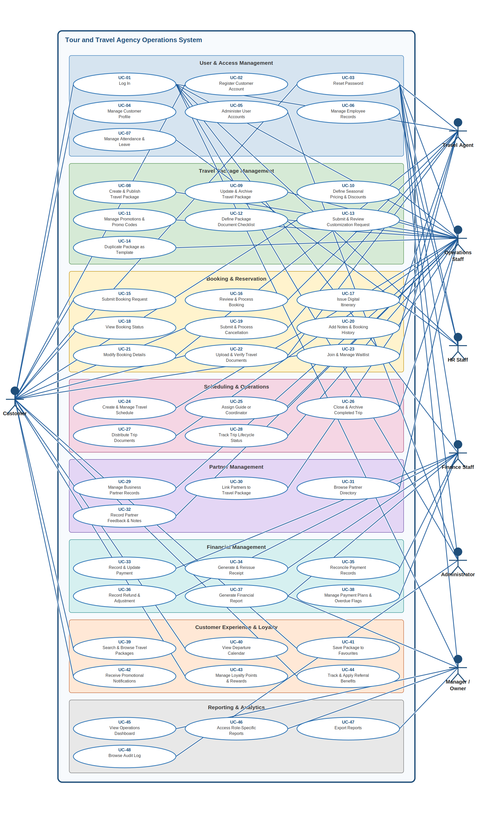
Prepared by: Dion Hasanbashaj

5.2 Activity Diagrams (AC-01 – AC-30)
Thirty activity diagrams, one per use case (AC-01 corresponds to UC-01, etc.). Each diagram uses vertical swim lanes to partition responsibility across the actors and system components involved. Activities flow top-to-bottom within each lane with decision diamonds, alternative branches, and cross-lane handoffs where applicable. Colour coding: green outcomes for success paths, pink/red for errors or rejections, blue for primary actor activities, and amber or grey for system operations.

AC-01: Log In
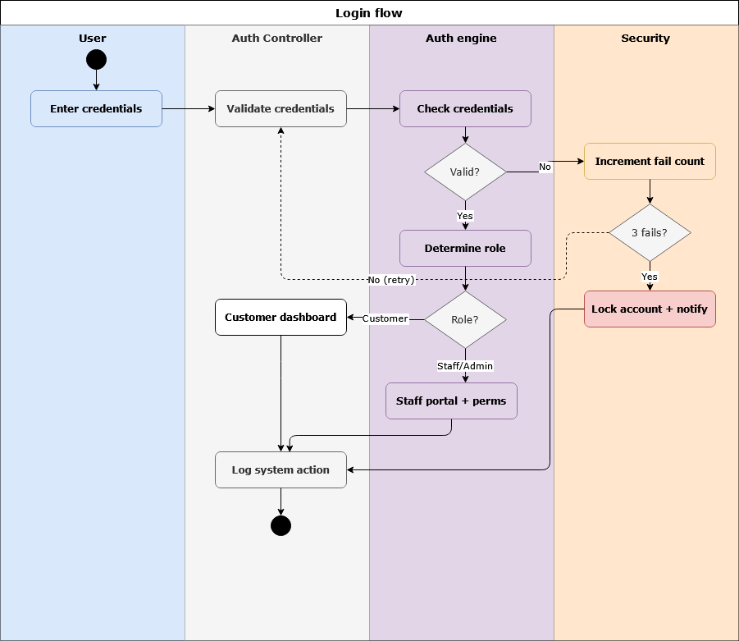
Prepared by: Isuf Celhaka & Dion Hasanbashaj

AC-02: Register Customer Account
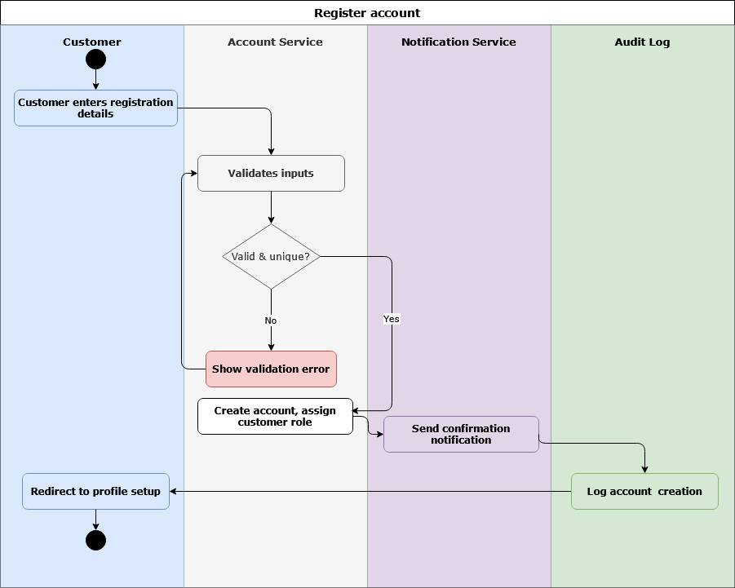
Prepared by: Isuf Celhaka

AC-03: Reset Password
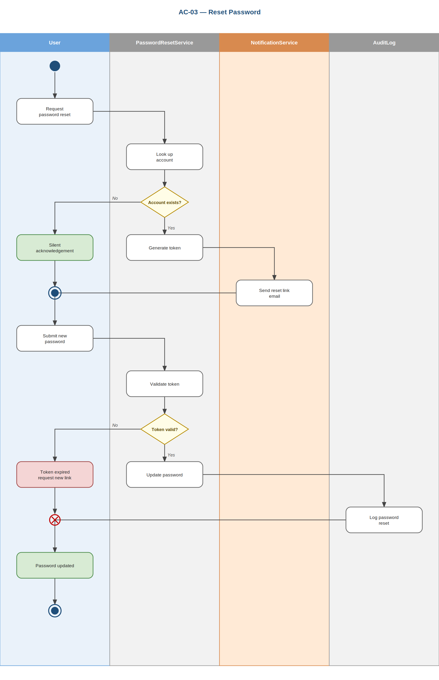
Prepared by: Isuf Celhaka

AC-04: Manage Customer Profile
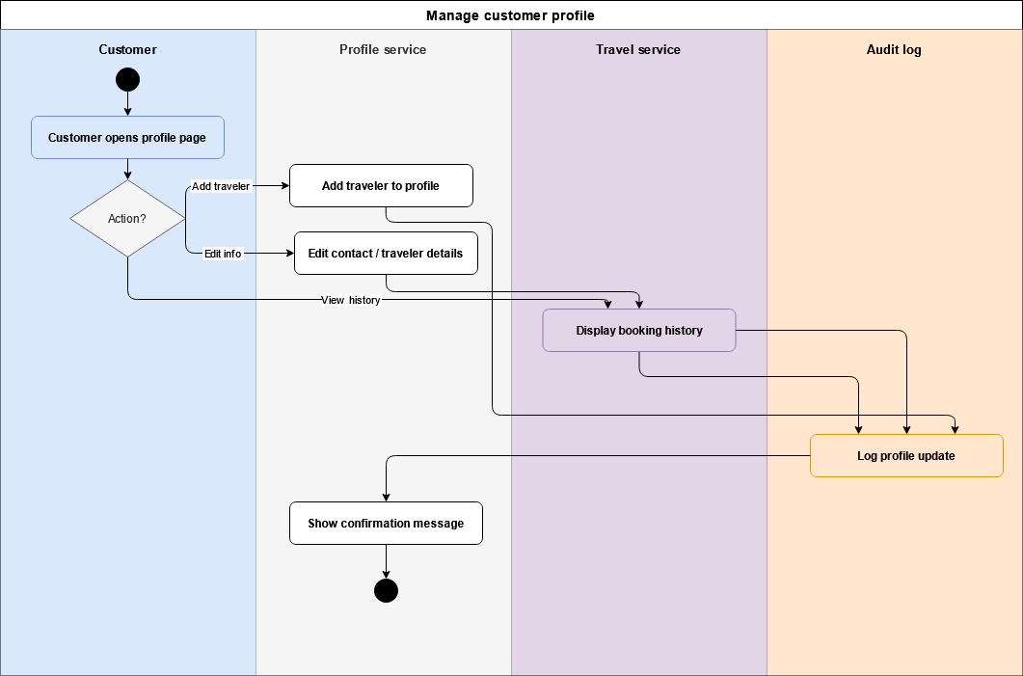
Prepared by: Isuf Celhaka

AC-05: Administer User Accounts
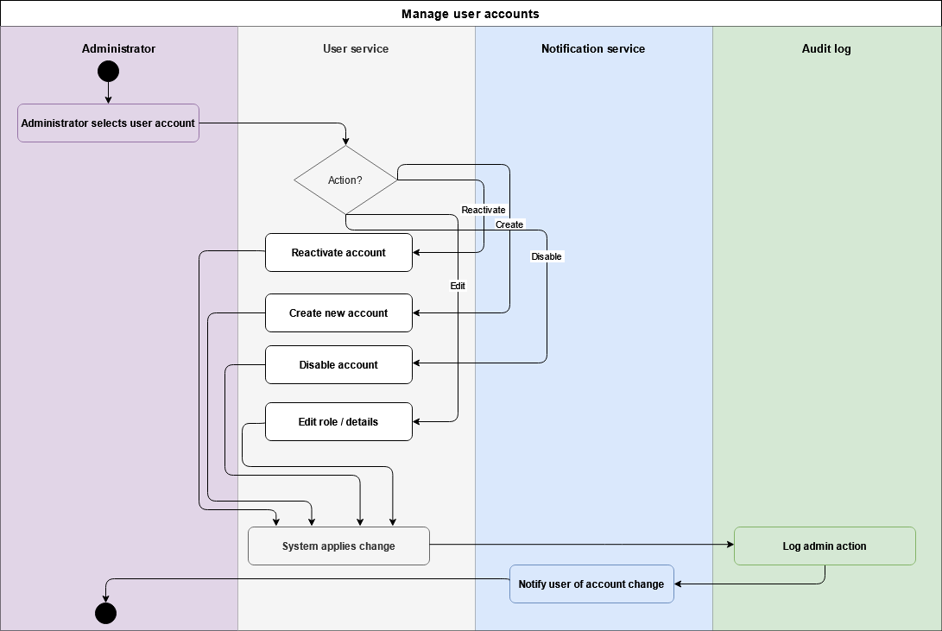
Prepared by: Isuf Celhaka

AC-06: Manage Employee Records
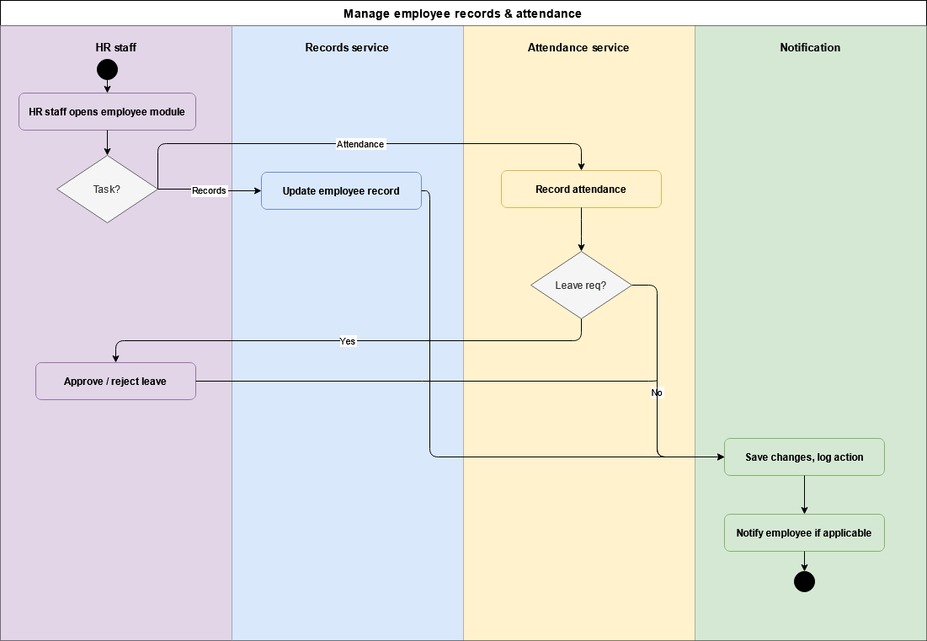
Prepared by: Isuf Celhaka

AC-07: Manage Attendance & Leave
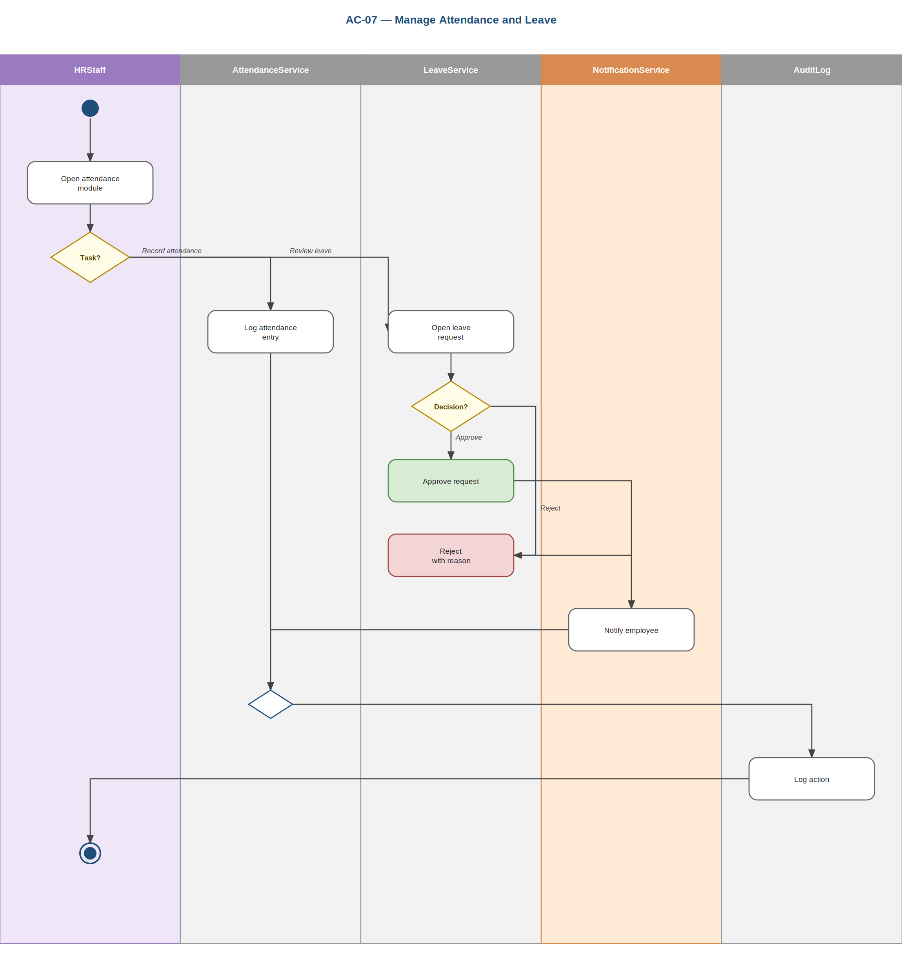
Prepared by: Isuf Celhaka

AC-08: Create & Publish Travel Package
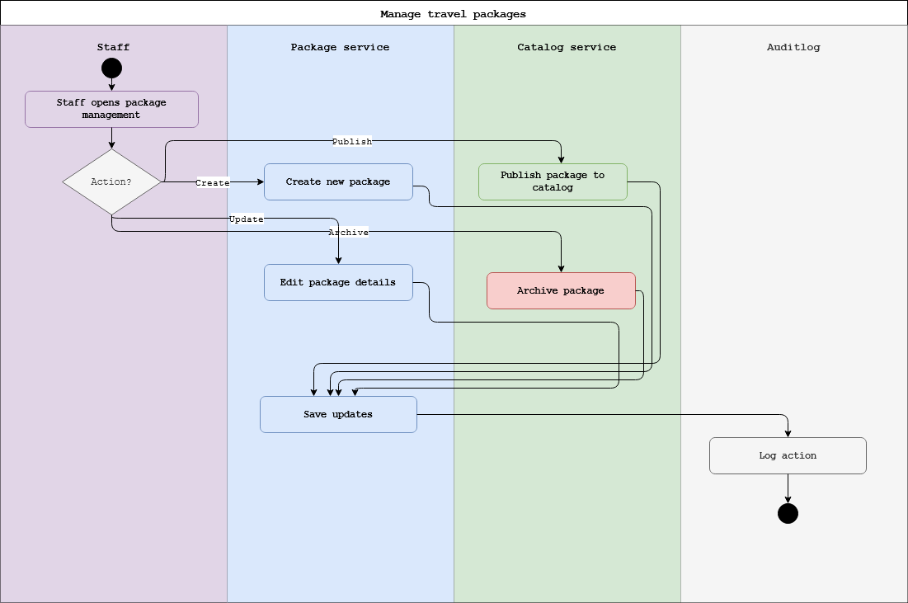
Prepared by: Amanda Shirka & Dion Hasanbashaj

AC-09: Update & Archive Travel Package
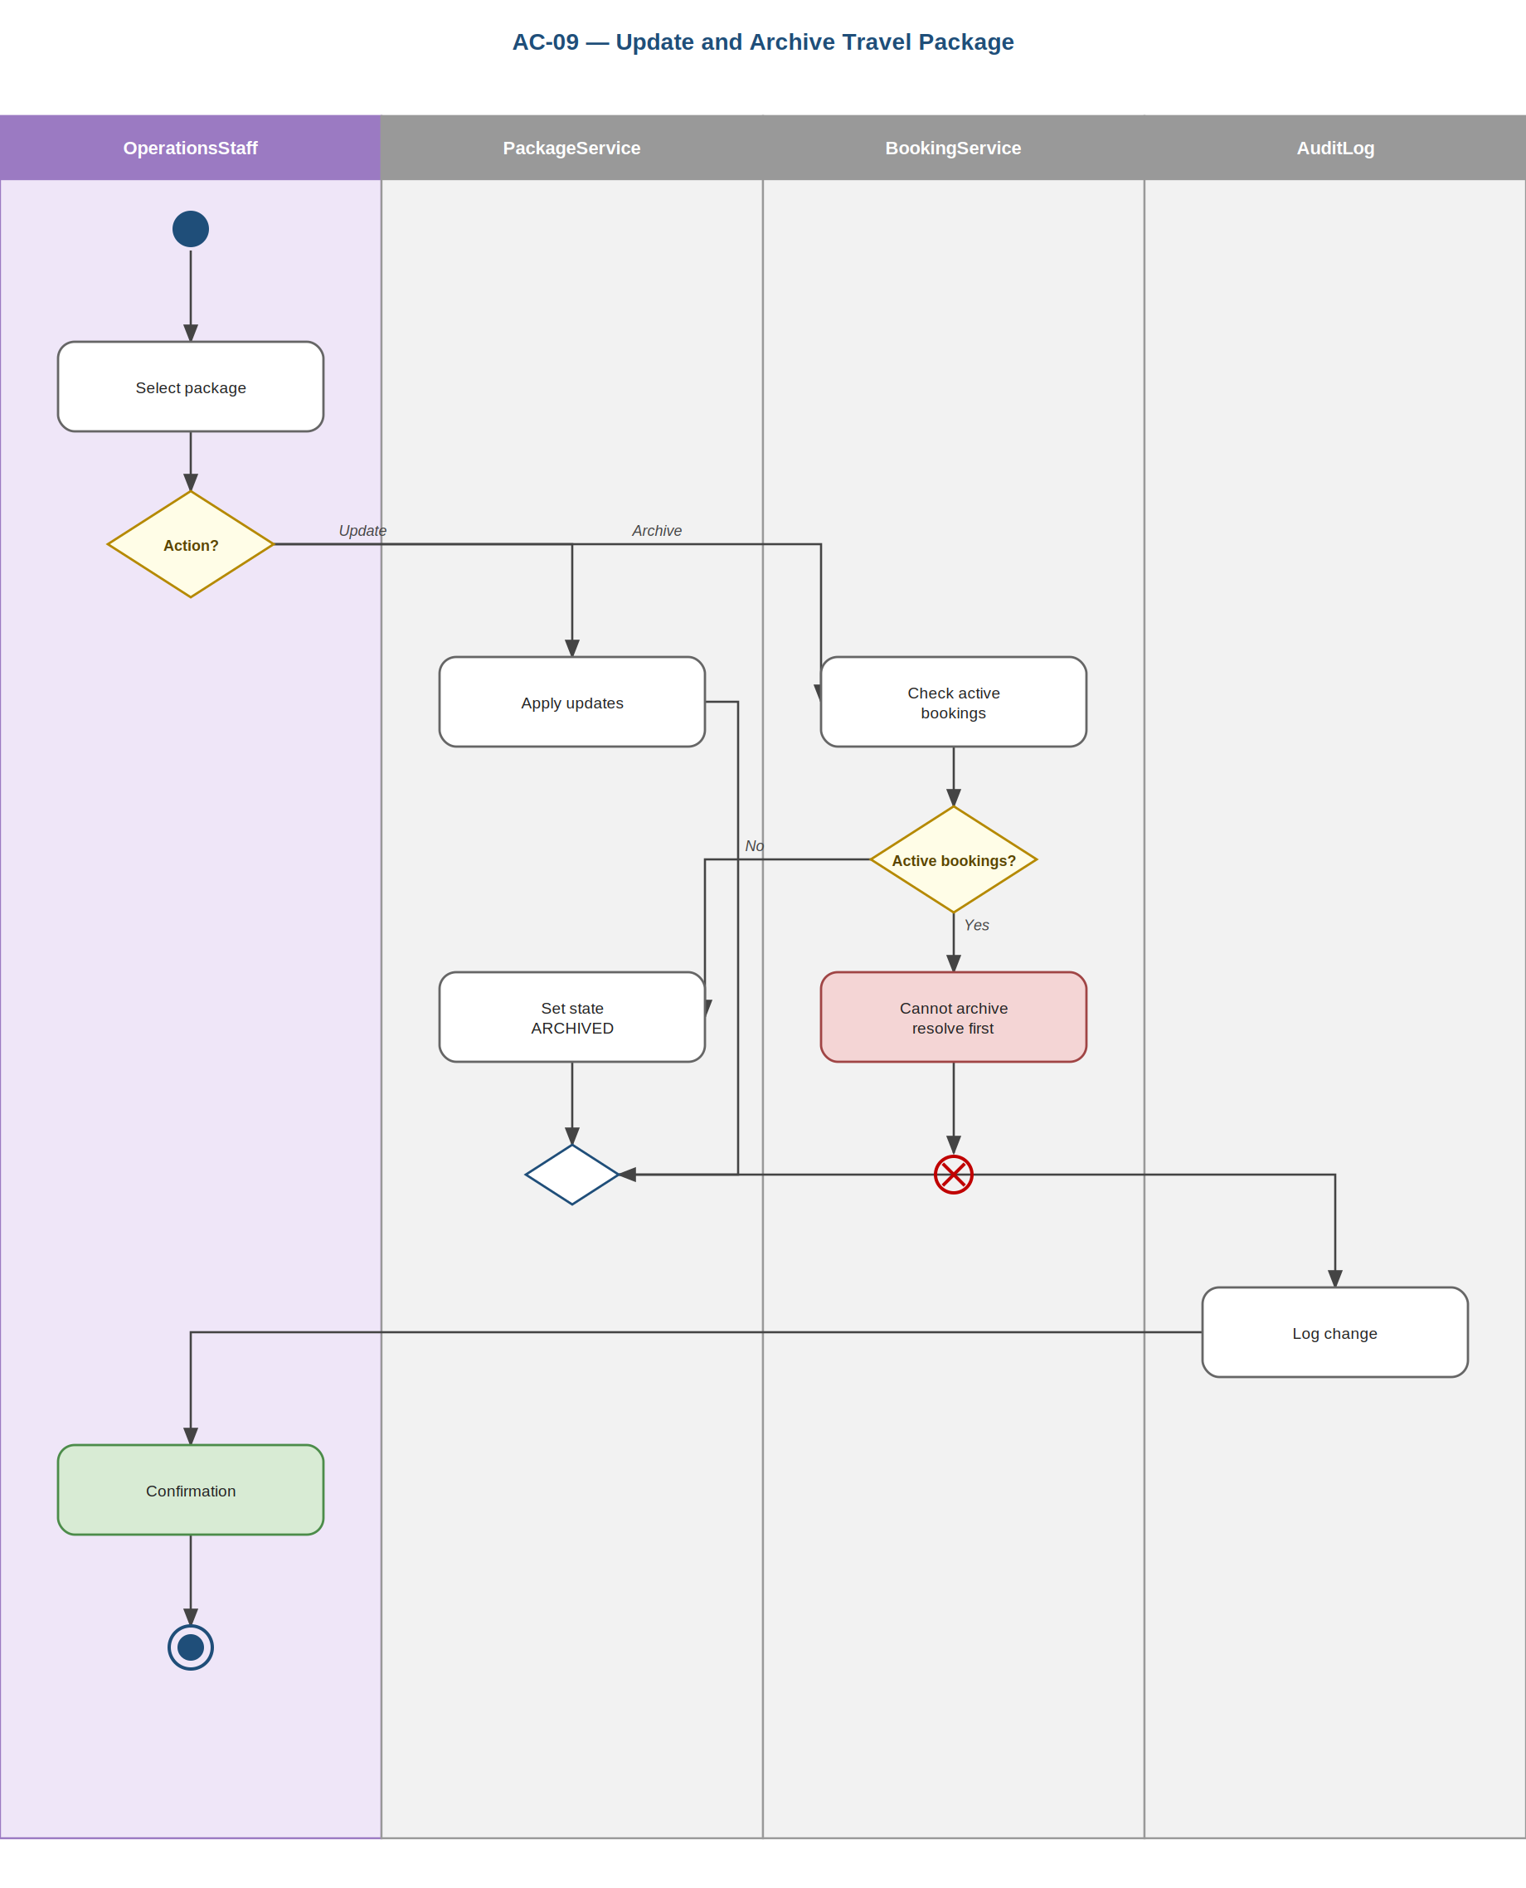
Prepared by: Amanda Shirka

AC-10: Define Seasonal Pricing & Discounts
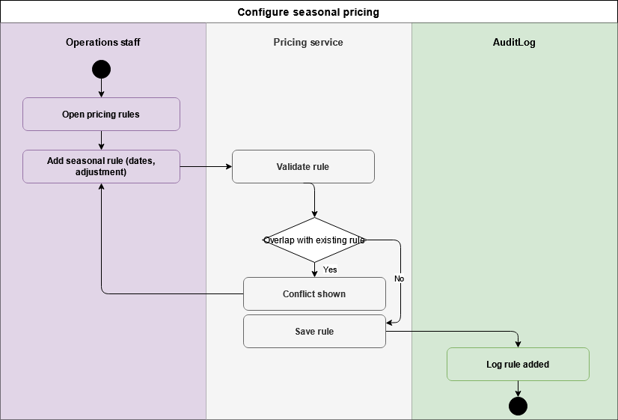
Prepared by: Amanda Shirka

AC-11: Manage Promotional Campaigns & Promo Codes
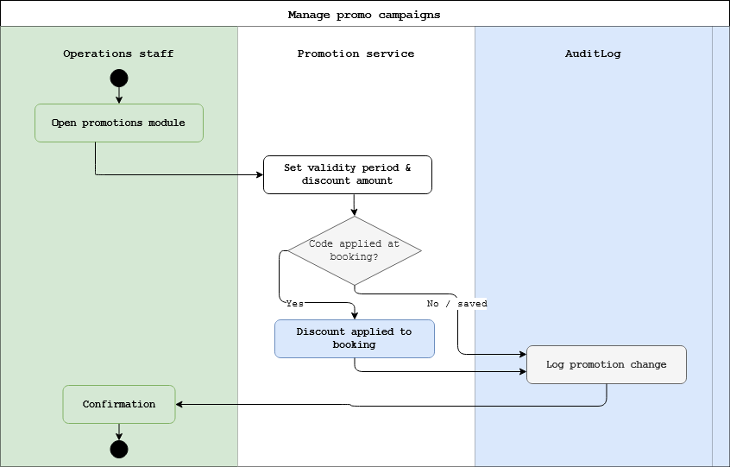
Prepared by: Amanda Shirka

AC-12: Define Package Document Checklist
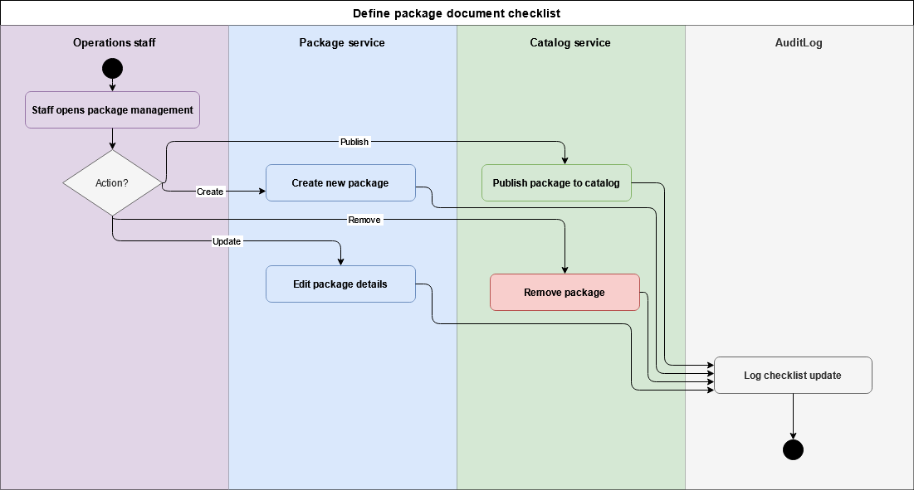
Prepared by: Amanda Shirka

AC-13: Submit & Review Package Customization Request
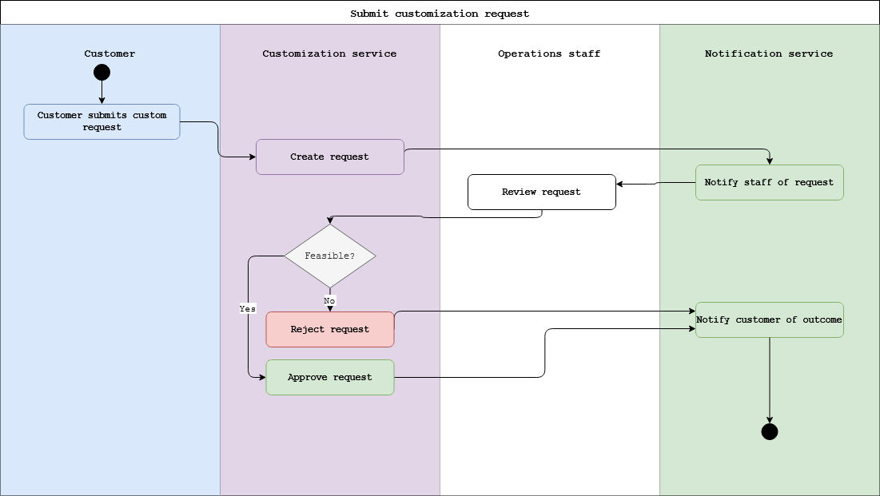
Prepared by: Amanda Shirka

AC-14: Duplicate Package as Template
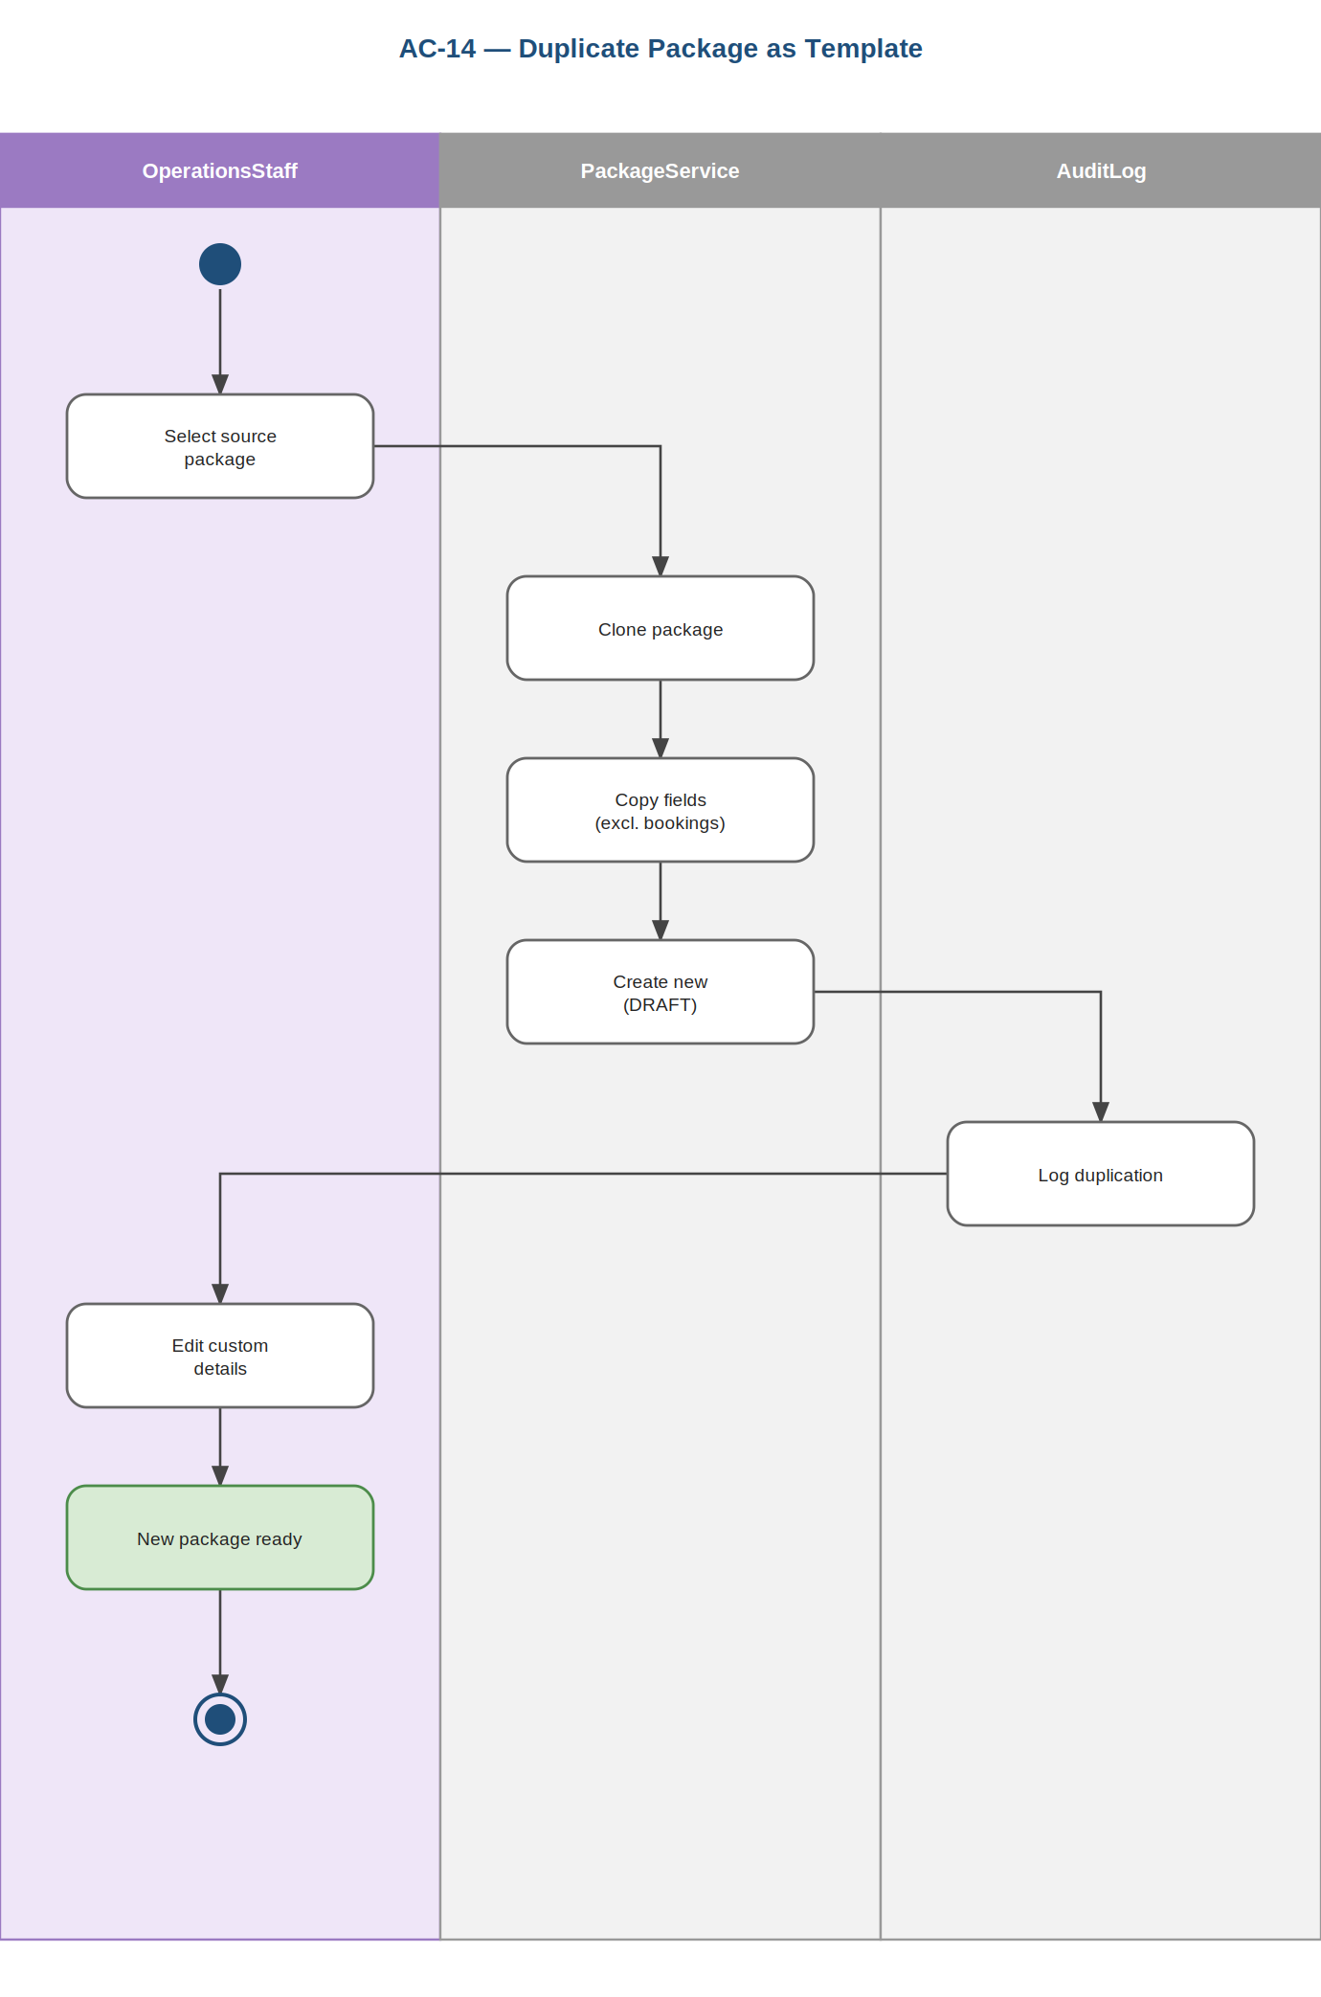
Prepared by: Amanda Shirka

AC-15: Submit Booking Request
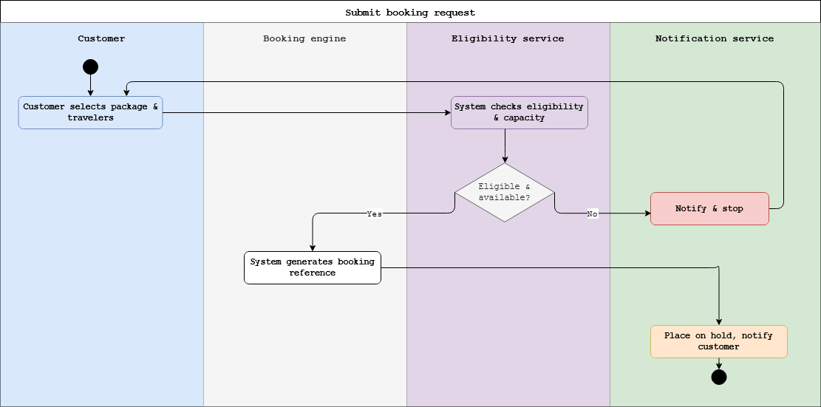
Prepared by: Alba Gjergji & Ana Gjergji

AC-16: Review & Process Booking
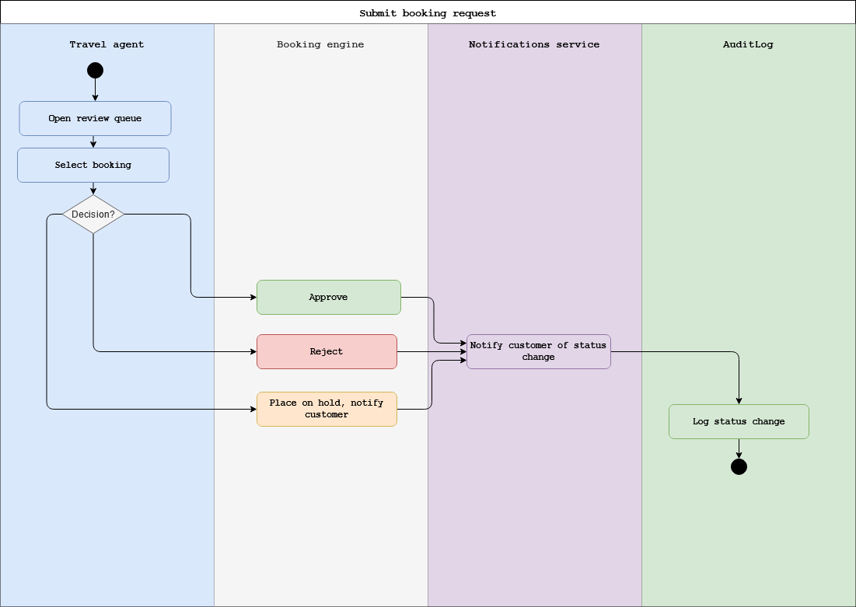
Prepared by: Alba Gjergji, Ana Gjergji & Dion Hasanbashaj

AC-17: Issue Digital Itinerary
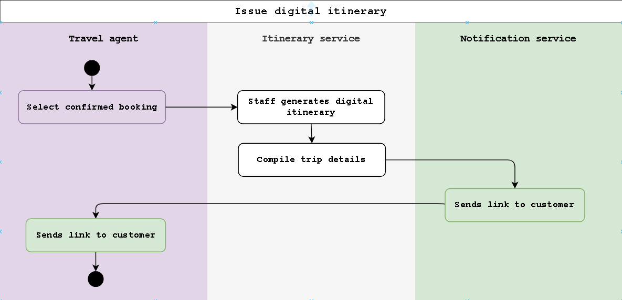
Prepared by: Alba Gjergji & Ana Gjergji

AC-18: View Booking Status
AC-19: Submit & Process Cancellation
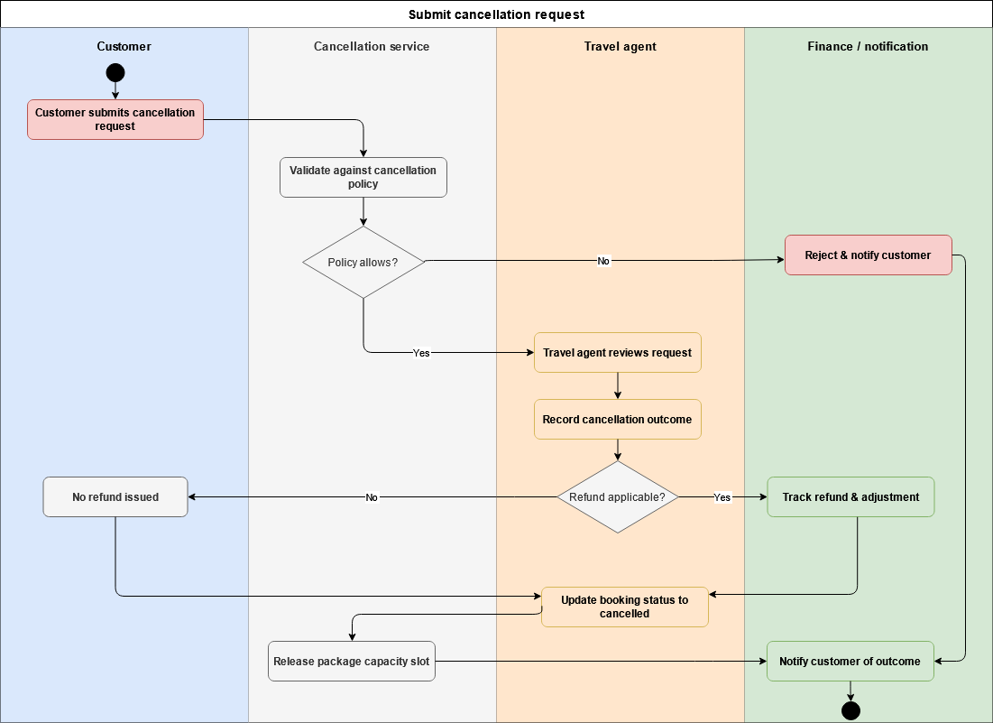
Prepared by: Alba Gjergji & Ana Gjergji

AC-20: Add Notes & Booking History
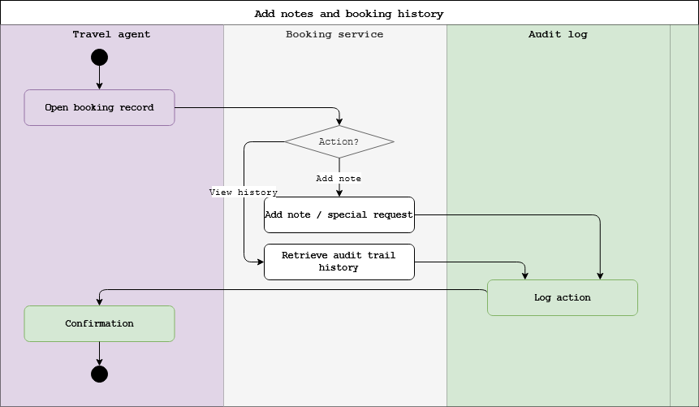
Prepared by: Alba Gjergji & Ana Gjergji

AC-21: Modify Booking Details
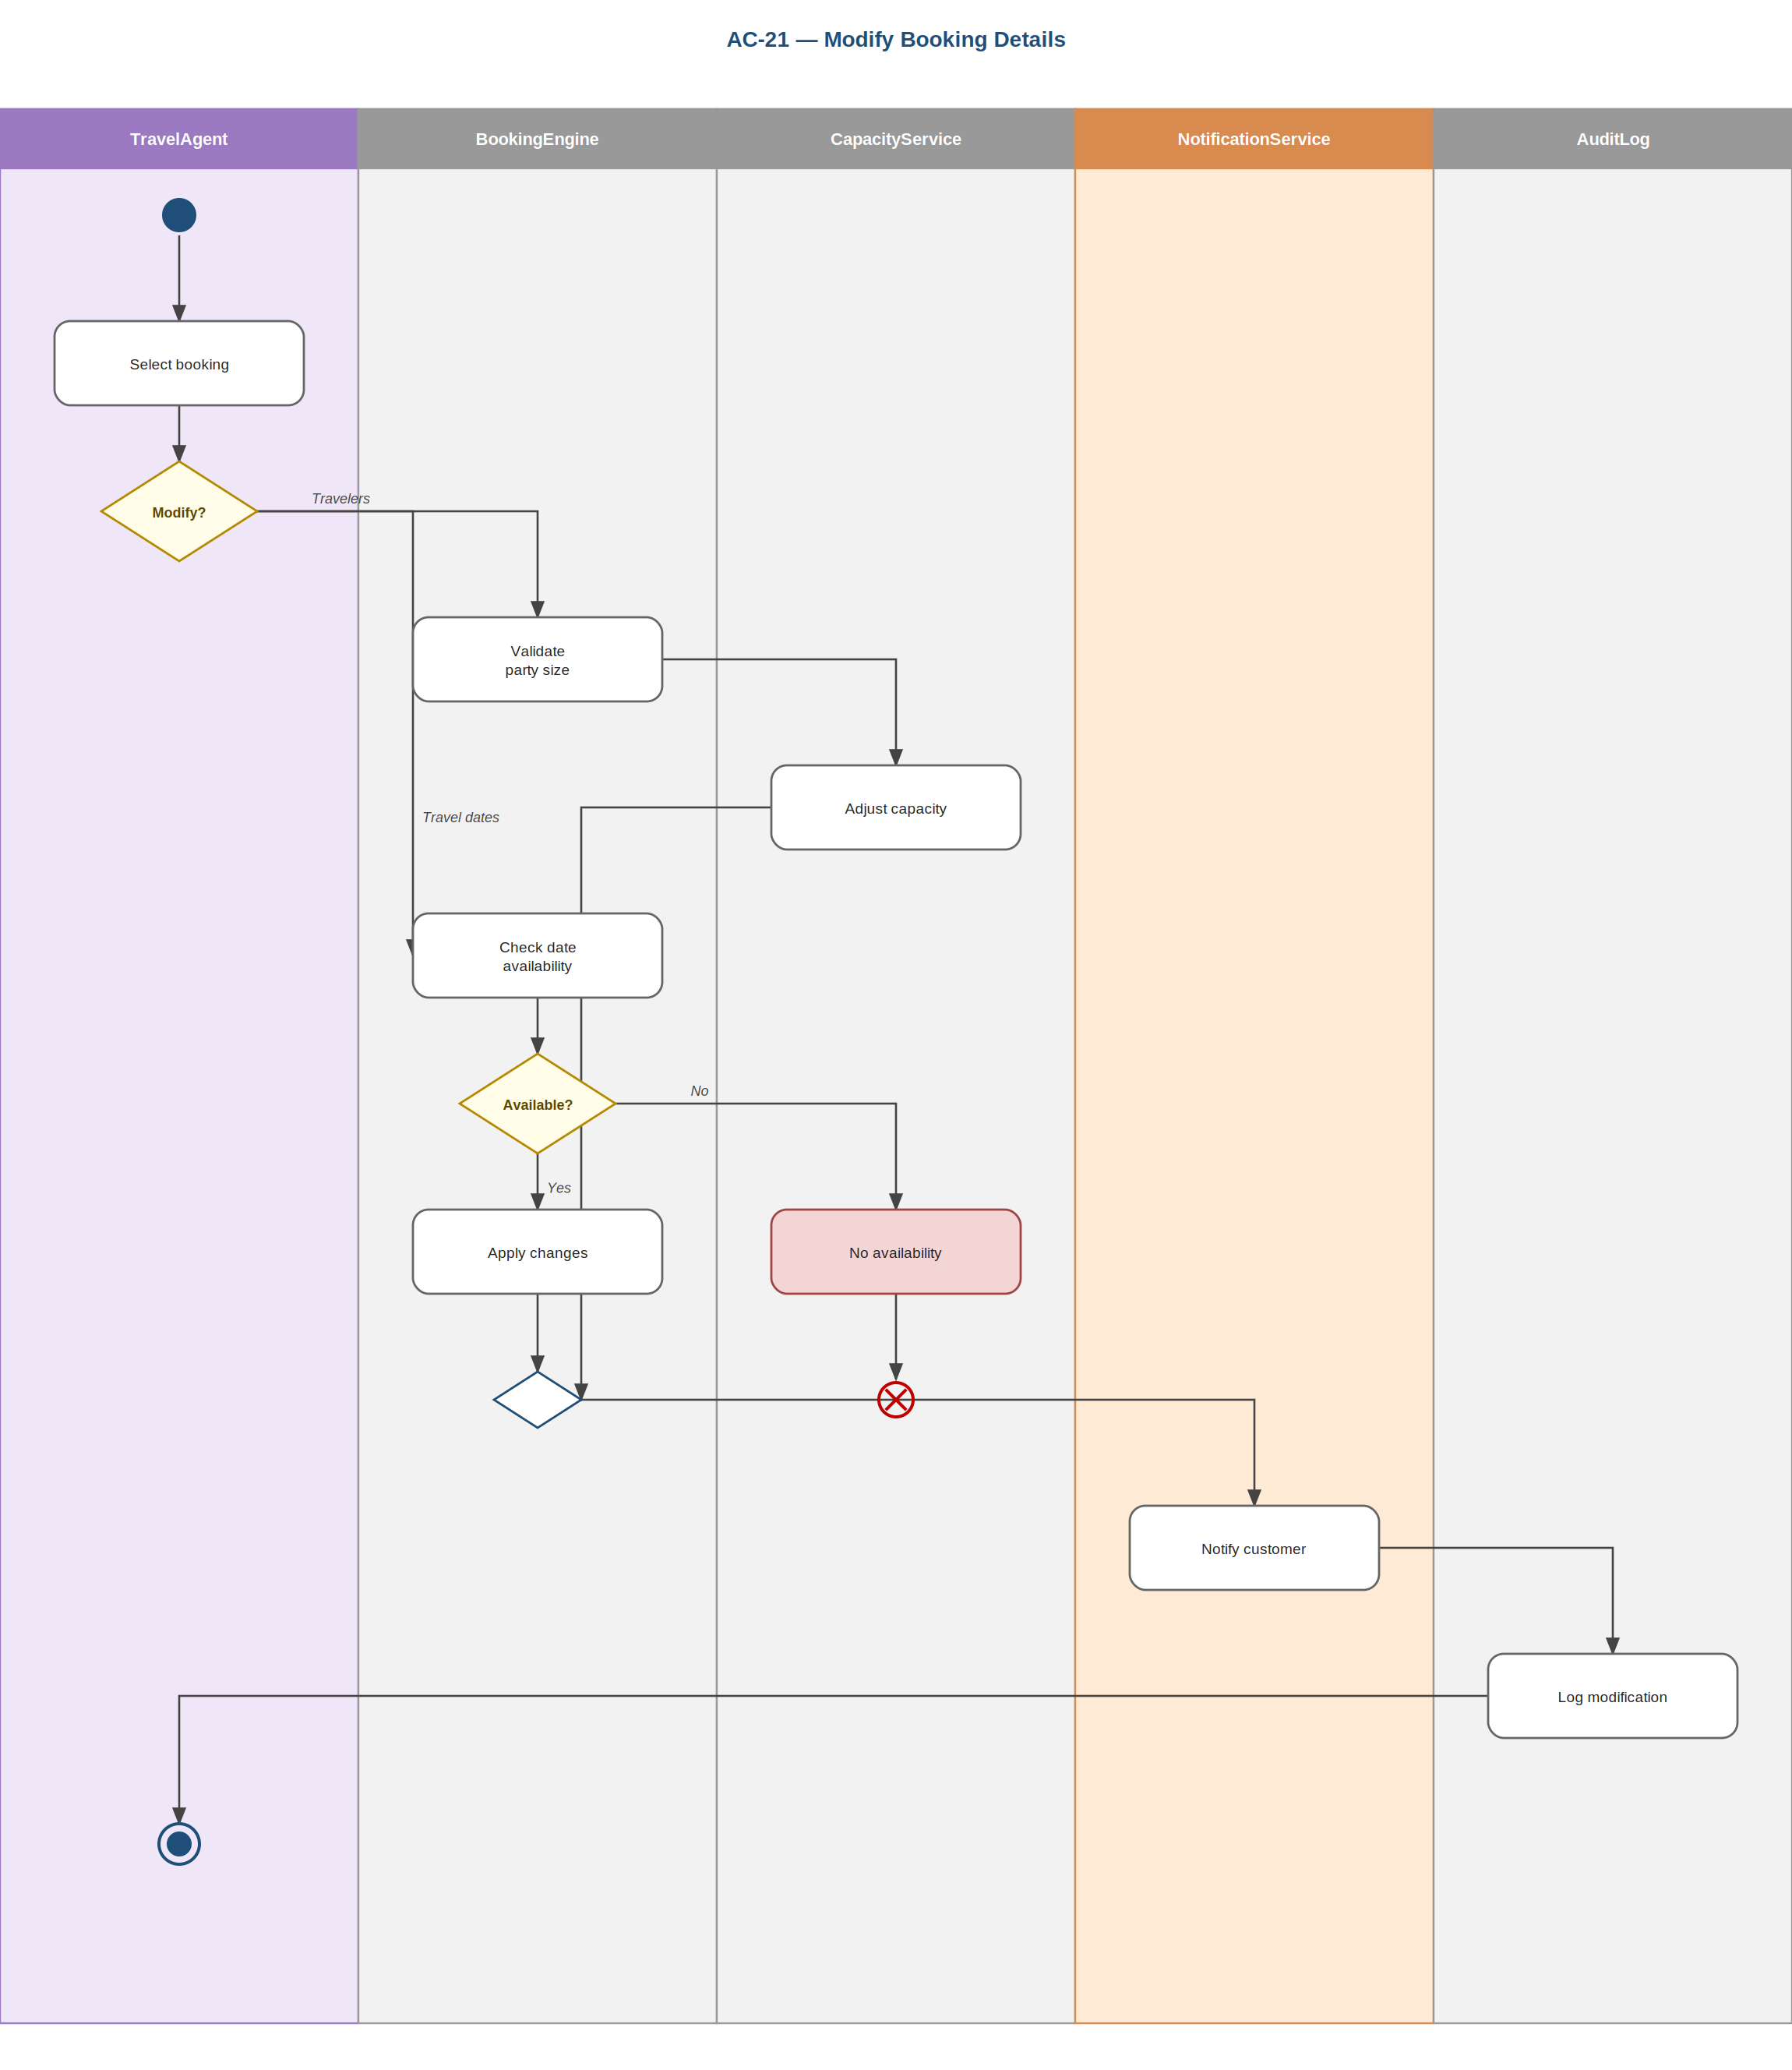
Prepared by: Alba Gjergji & Ana Gjergji

AC-22: Upload & Verify Travel Documents
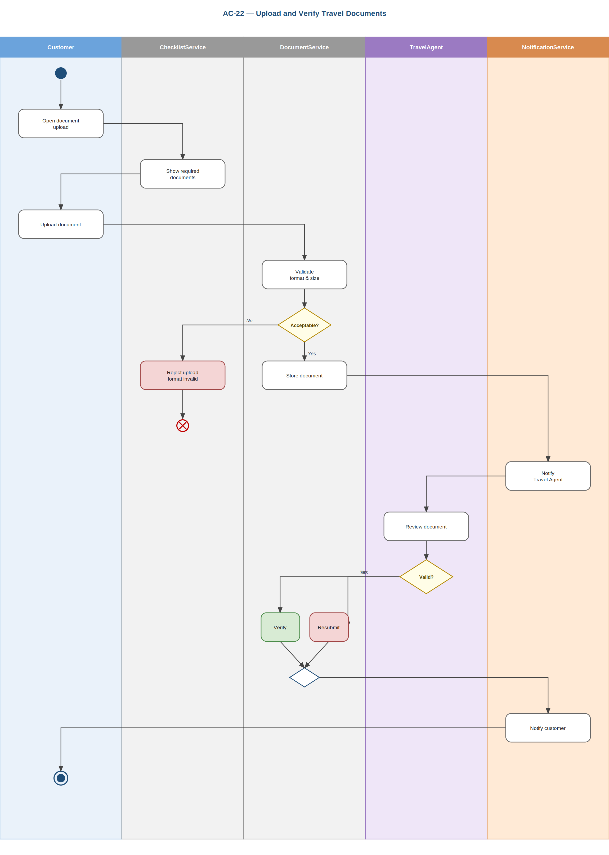
Prepared by: Alba Gjergji & Ana Gjergji

AC-23: Join & Manage Waitlist
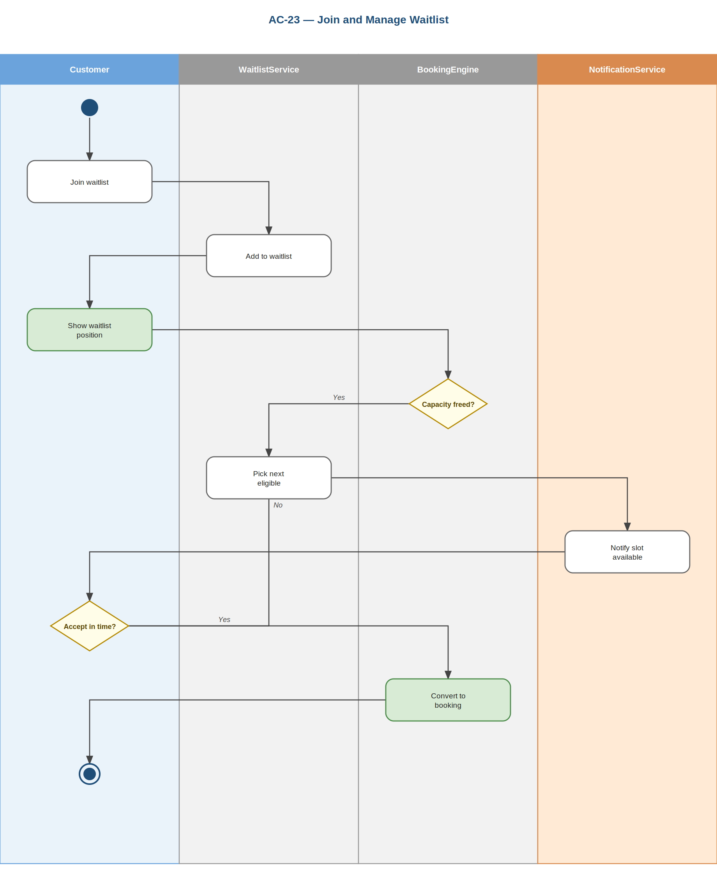
Prepared by: Alba Gjergji & Ana Gjergji

AC-24: Create & Manage Travel Schedule
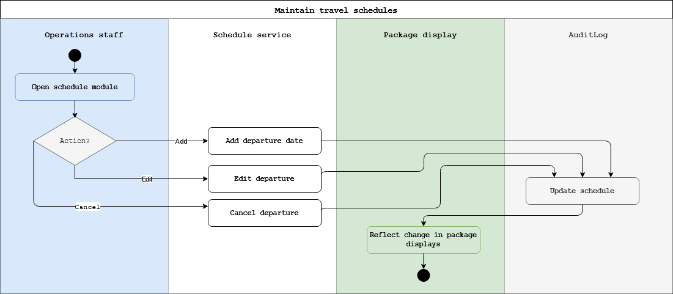
Prepared by: Gledis Ruci & Dion Hasanbashaj

AC-25: Assign Guide or Coordinator
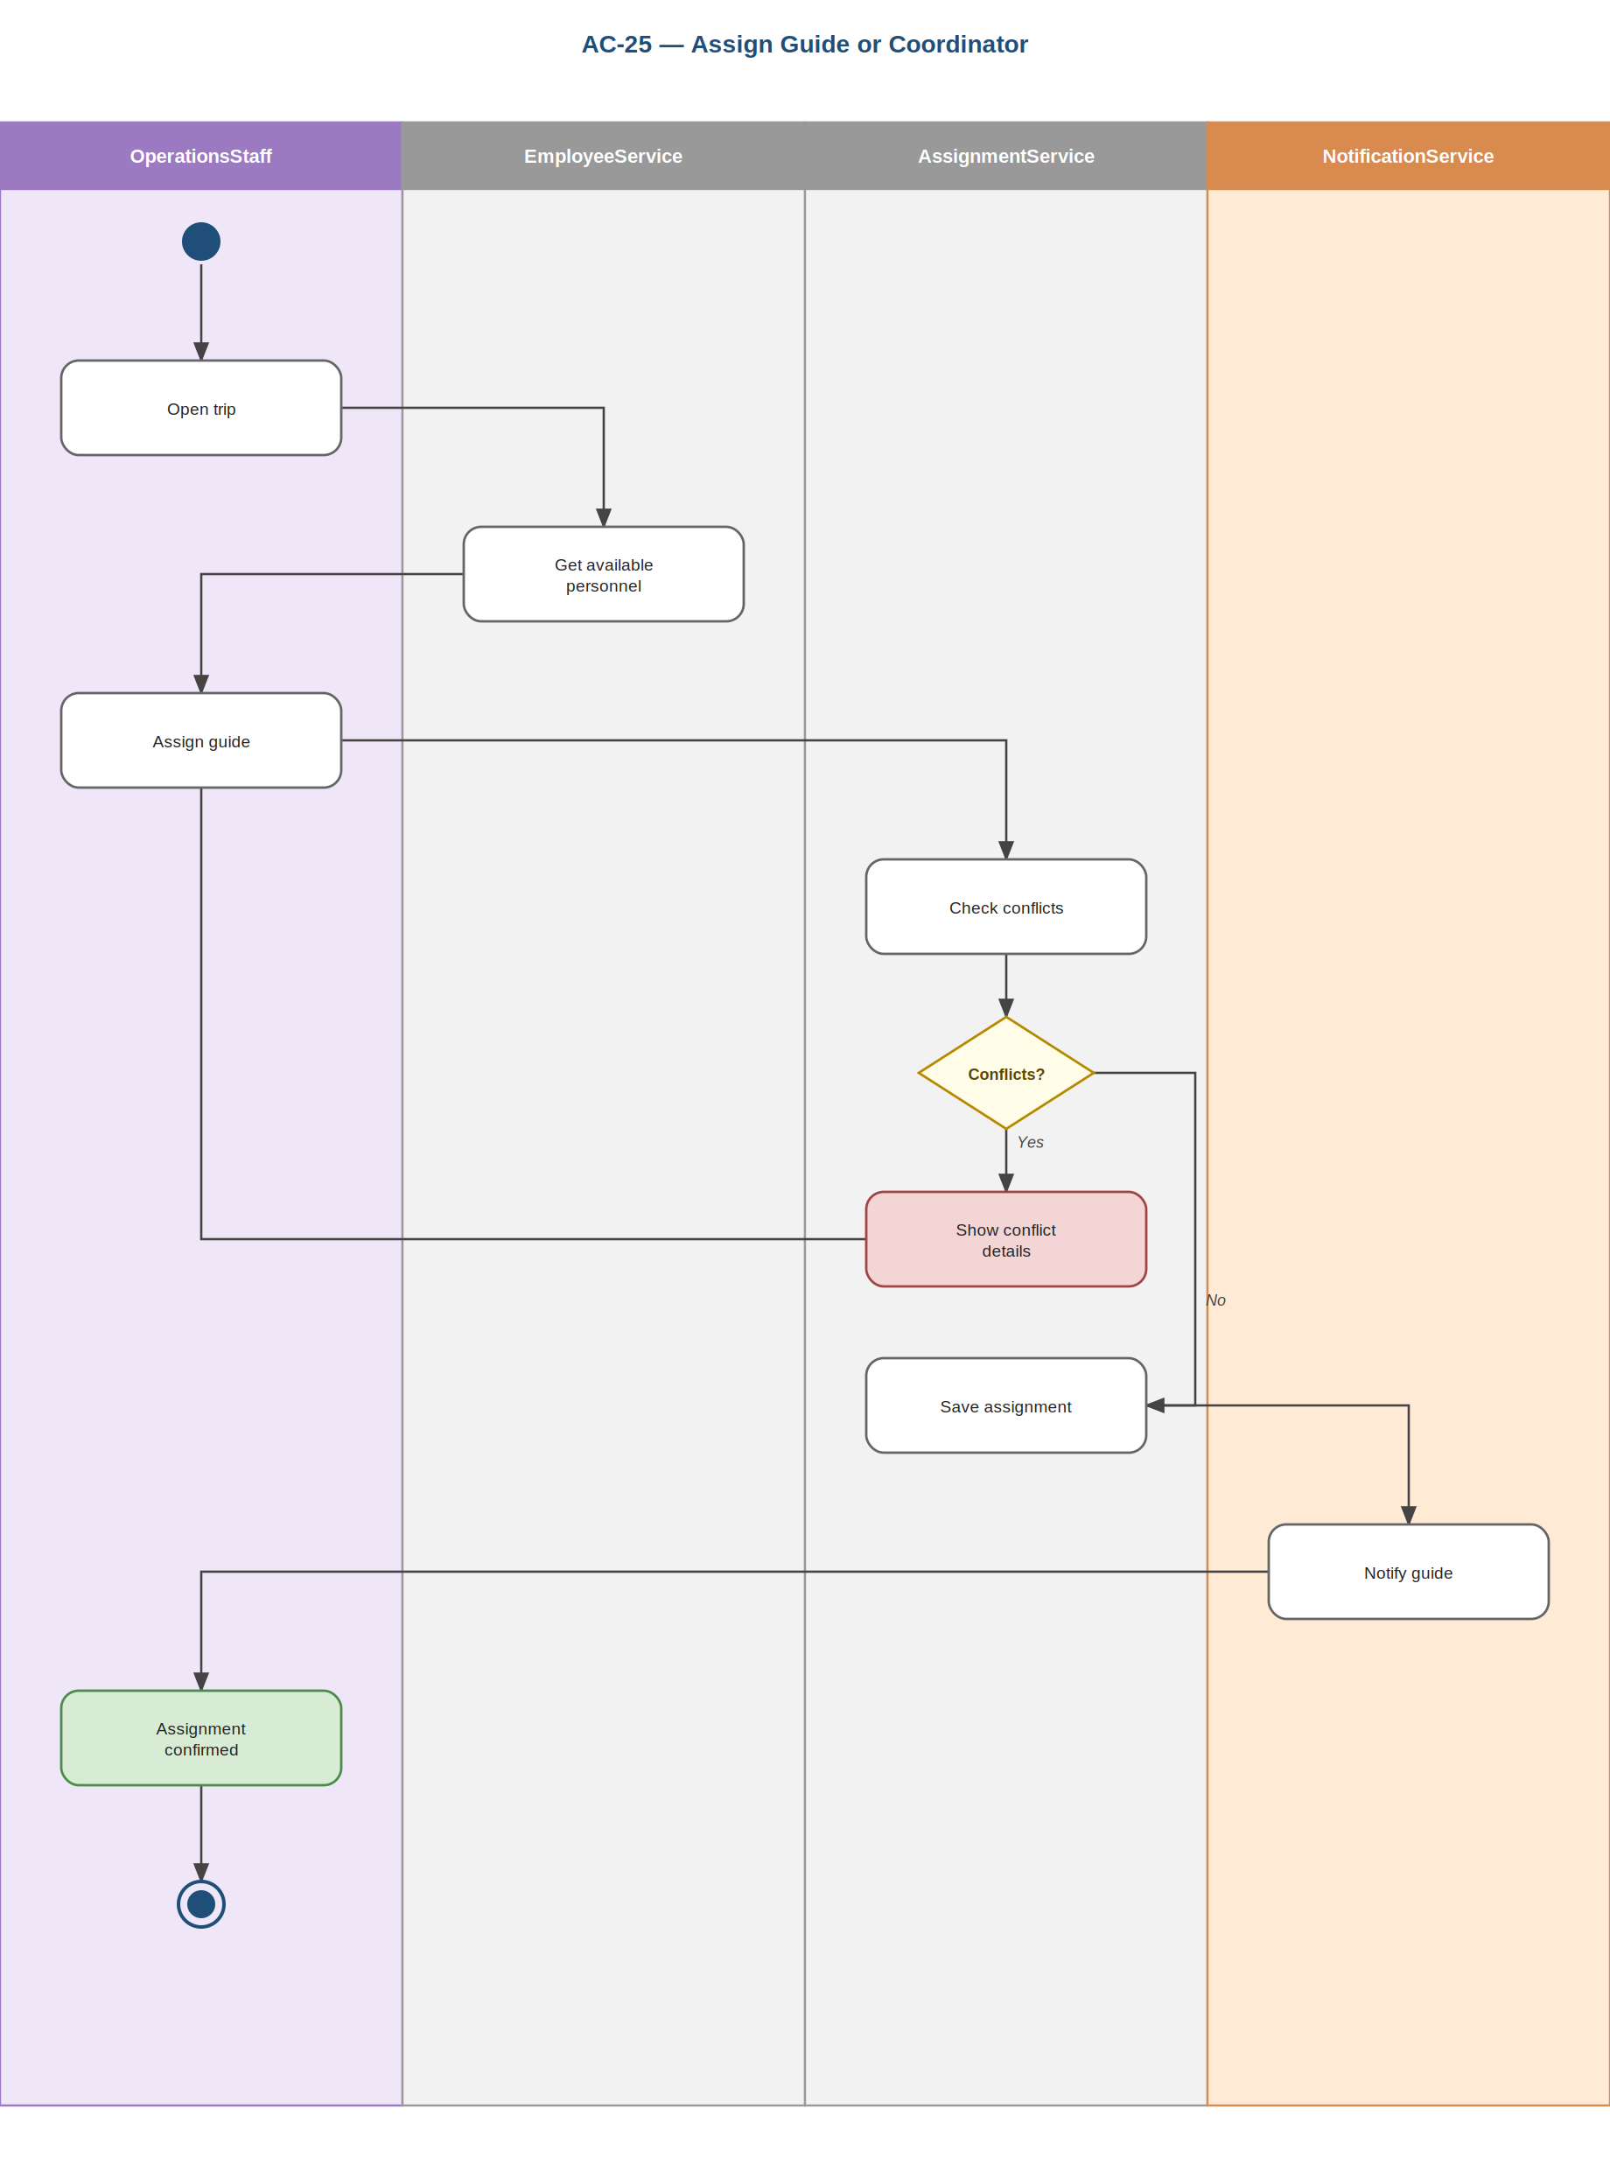
Prepared by: Gledis Ruci

AC-26: Close & Archive Completed Trip
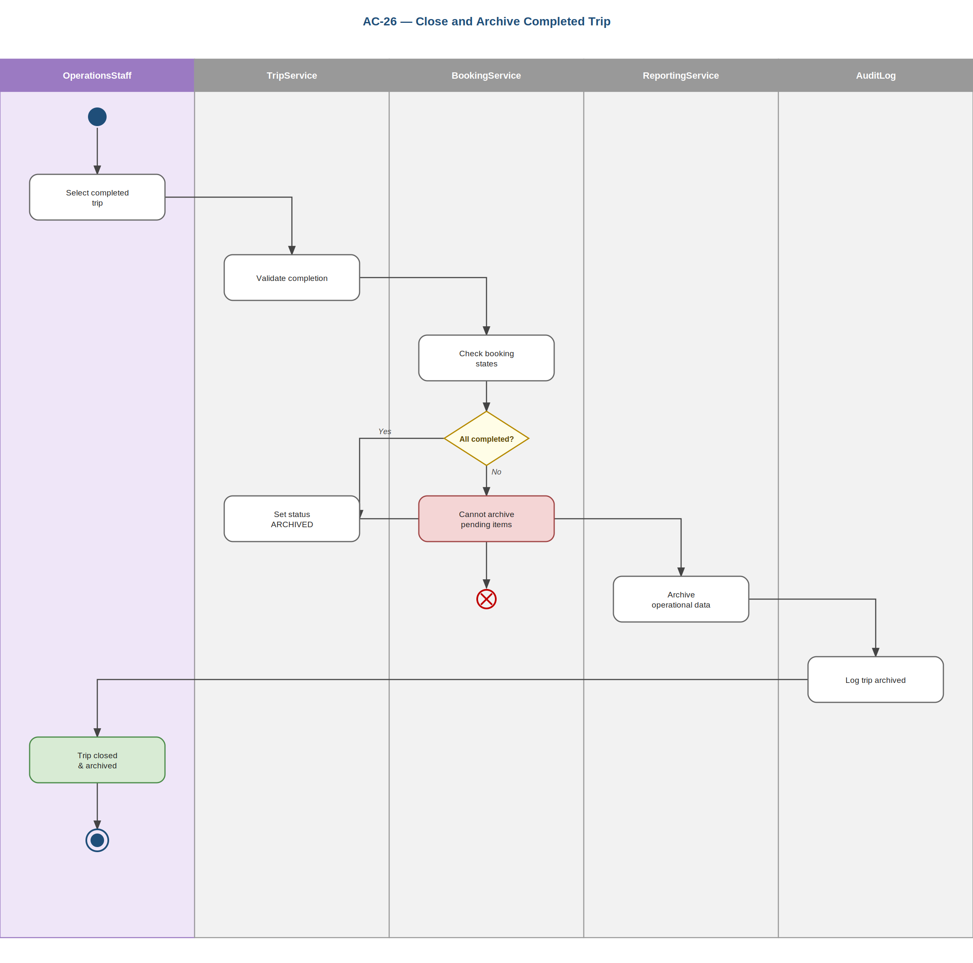
Prepared by: Gledis Ruci

AC-27: Distribute Trip Documents
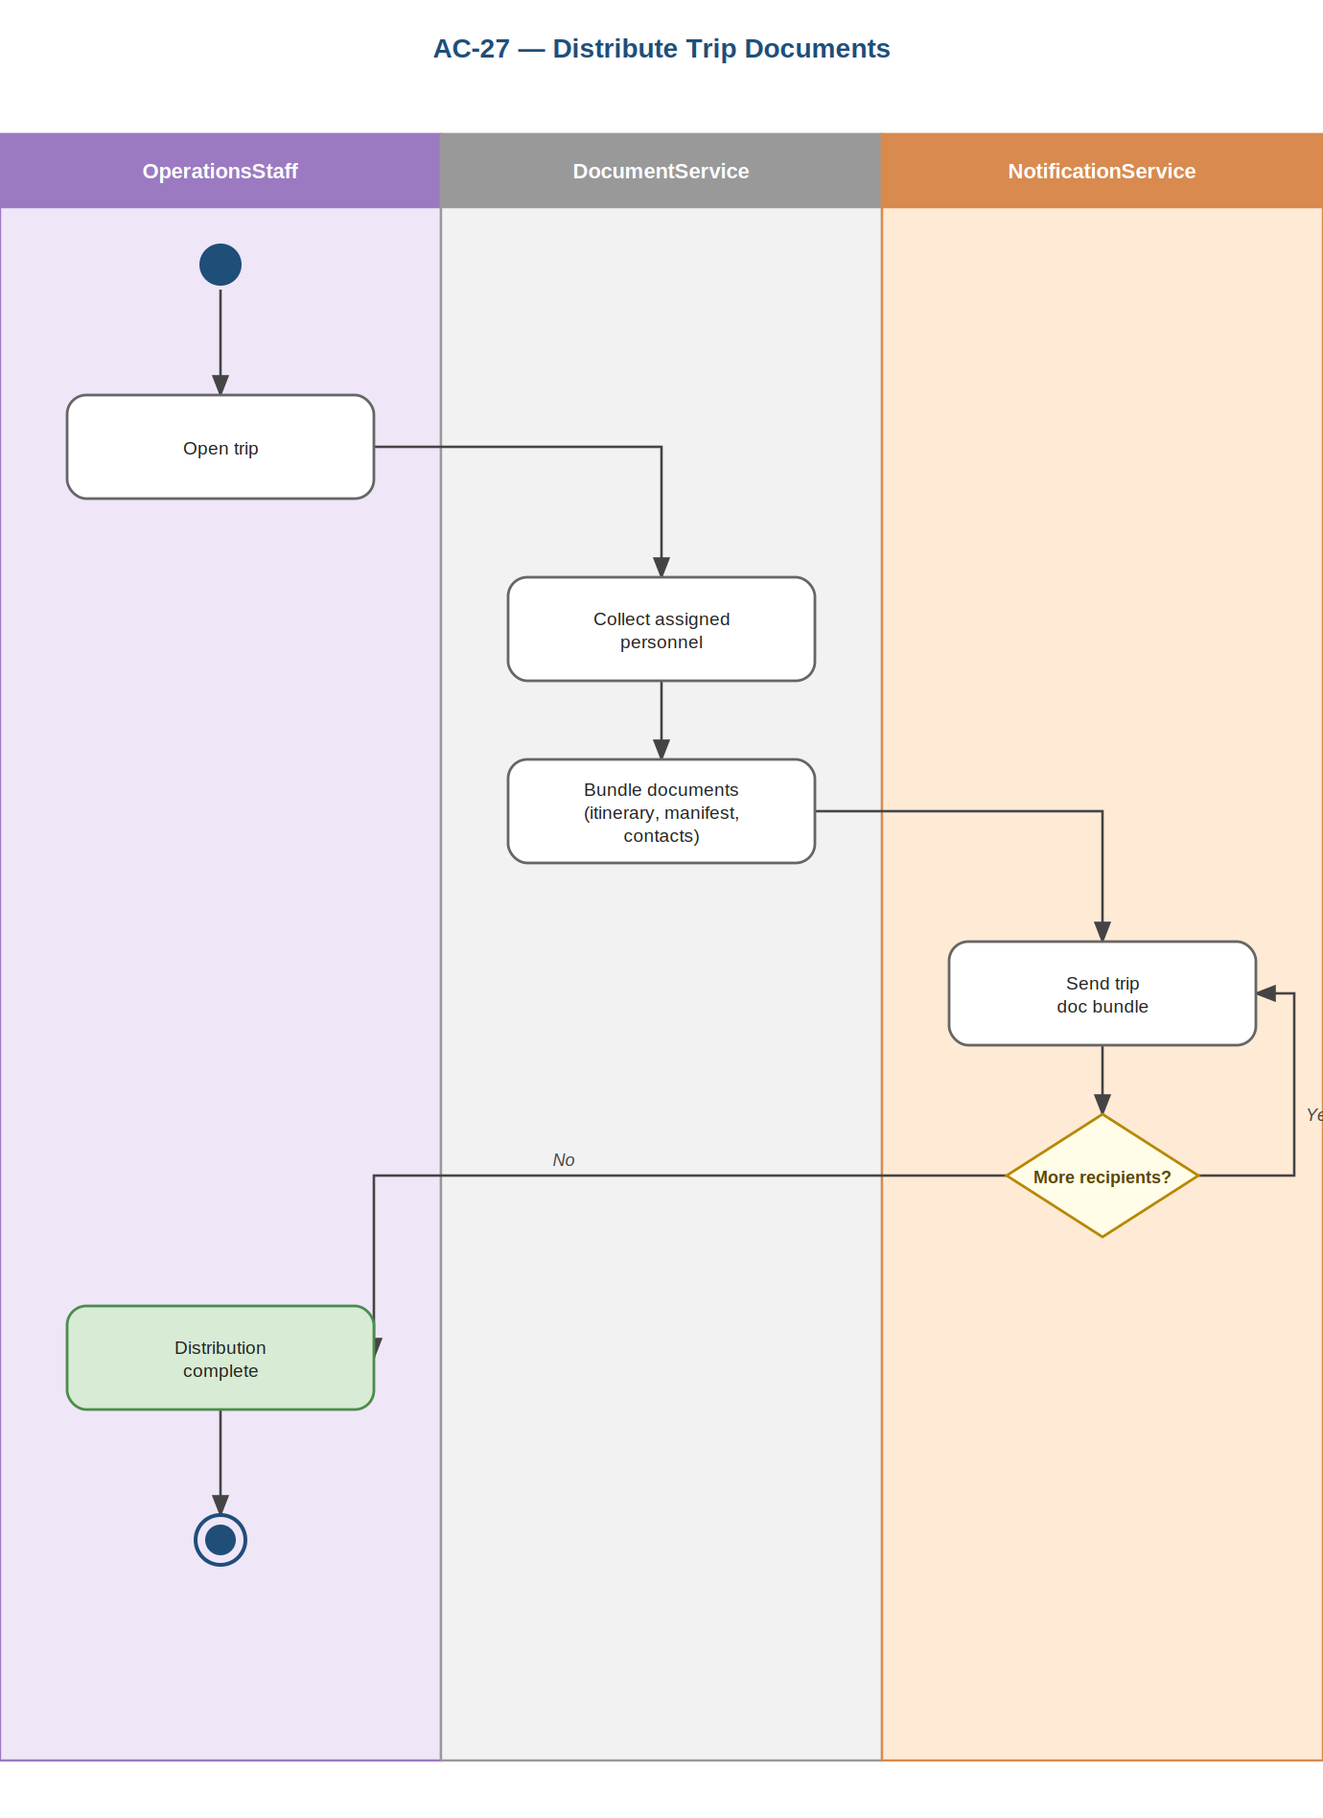
Prepared by: Gledis Ruci

AC-28: Track Trip Lifecycle Status
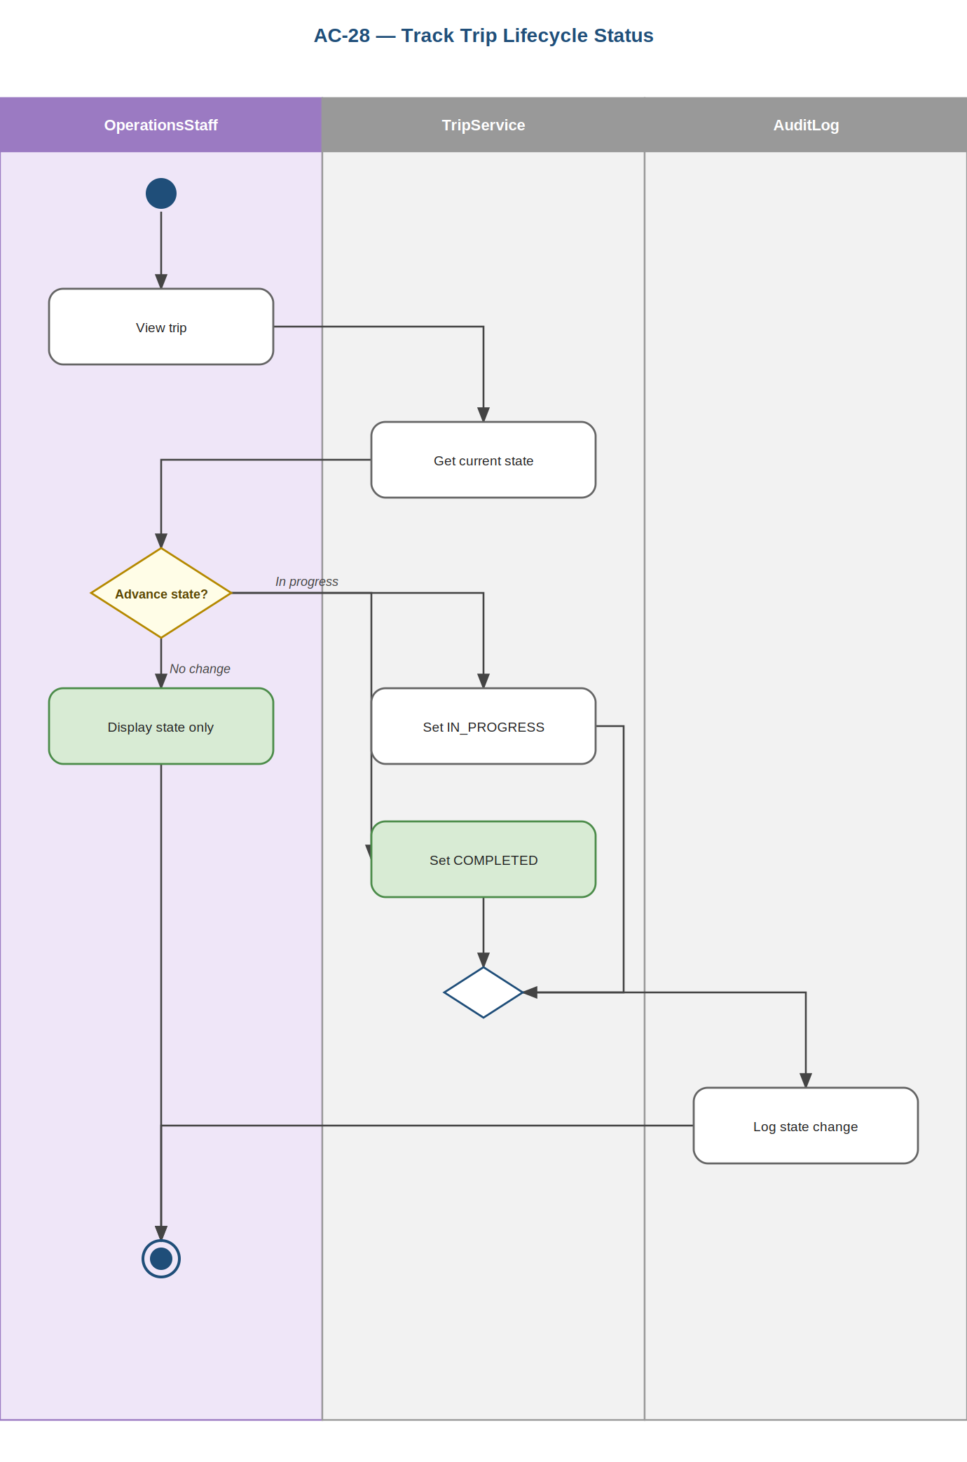
Prepared by: Gledis Ruci

AC-29: Manage Business Partner Records
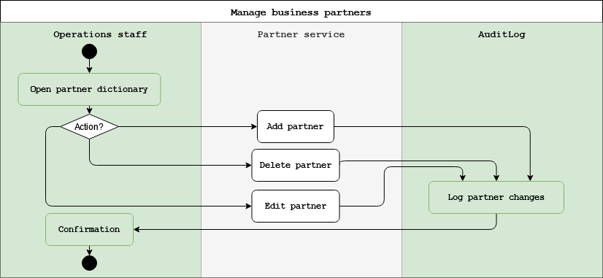
Prepared by: Henri Aliaj & Dion Hasanbashaj

AC-30: Link Partners to Travel Package
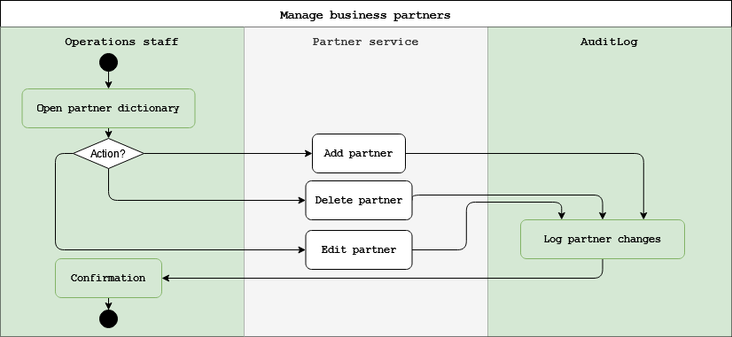
Prepared by: Henri Aliaj

5.1 Entity Relationship Diagram
The ERD models the agency's data entities, their attributes, and the relationships between them. It is generated from the same unified domain model as the class diagram, so the two are fully consistent: every entity, attribute, and relationship corresponds one-to-one across both. The model spans 30 entities covering identity and access, packages and catalog, pre-booking sales, bookings, payments, cancellation, operations, and supporting records, and includes the Waitlist entity for capacity-constrained departures. Crow's-foot notation indicates cardinality and PK/FK markers identify keys.

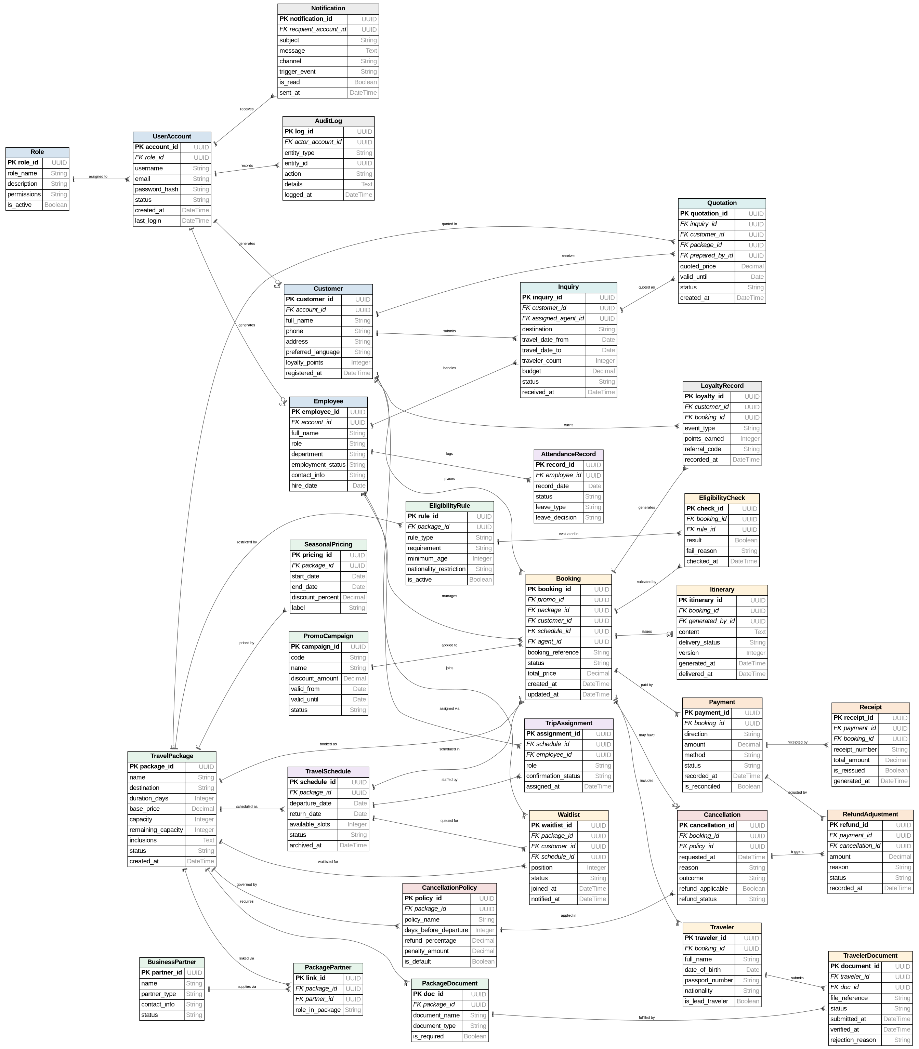
Prepared by: Dion Hasanbashaj

5.4 Class Diagram
The class diagram models the system's domain classes, their attributes, methods, and relationships. It is generated from the same unified model as the ERD, guaranteeing consistency between the two: the 30 classes and their attributes match the ERD entities exactly, with the Waitlist class included. PK/FK annotations are reserved for the ERD; here each class shows its attributes and the operations it provides, and the association multiplicities mirror the ERD cardinalities.

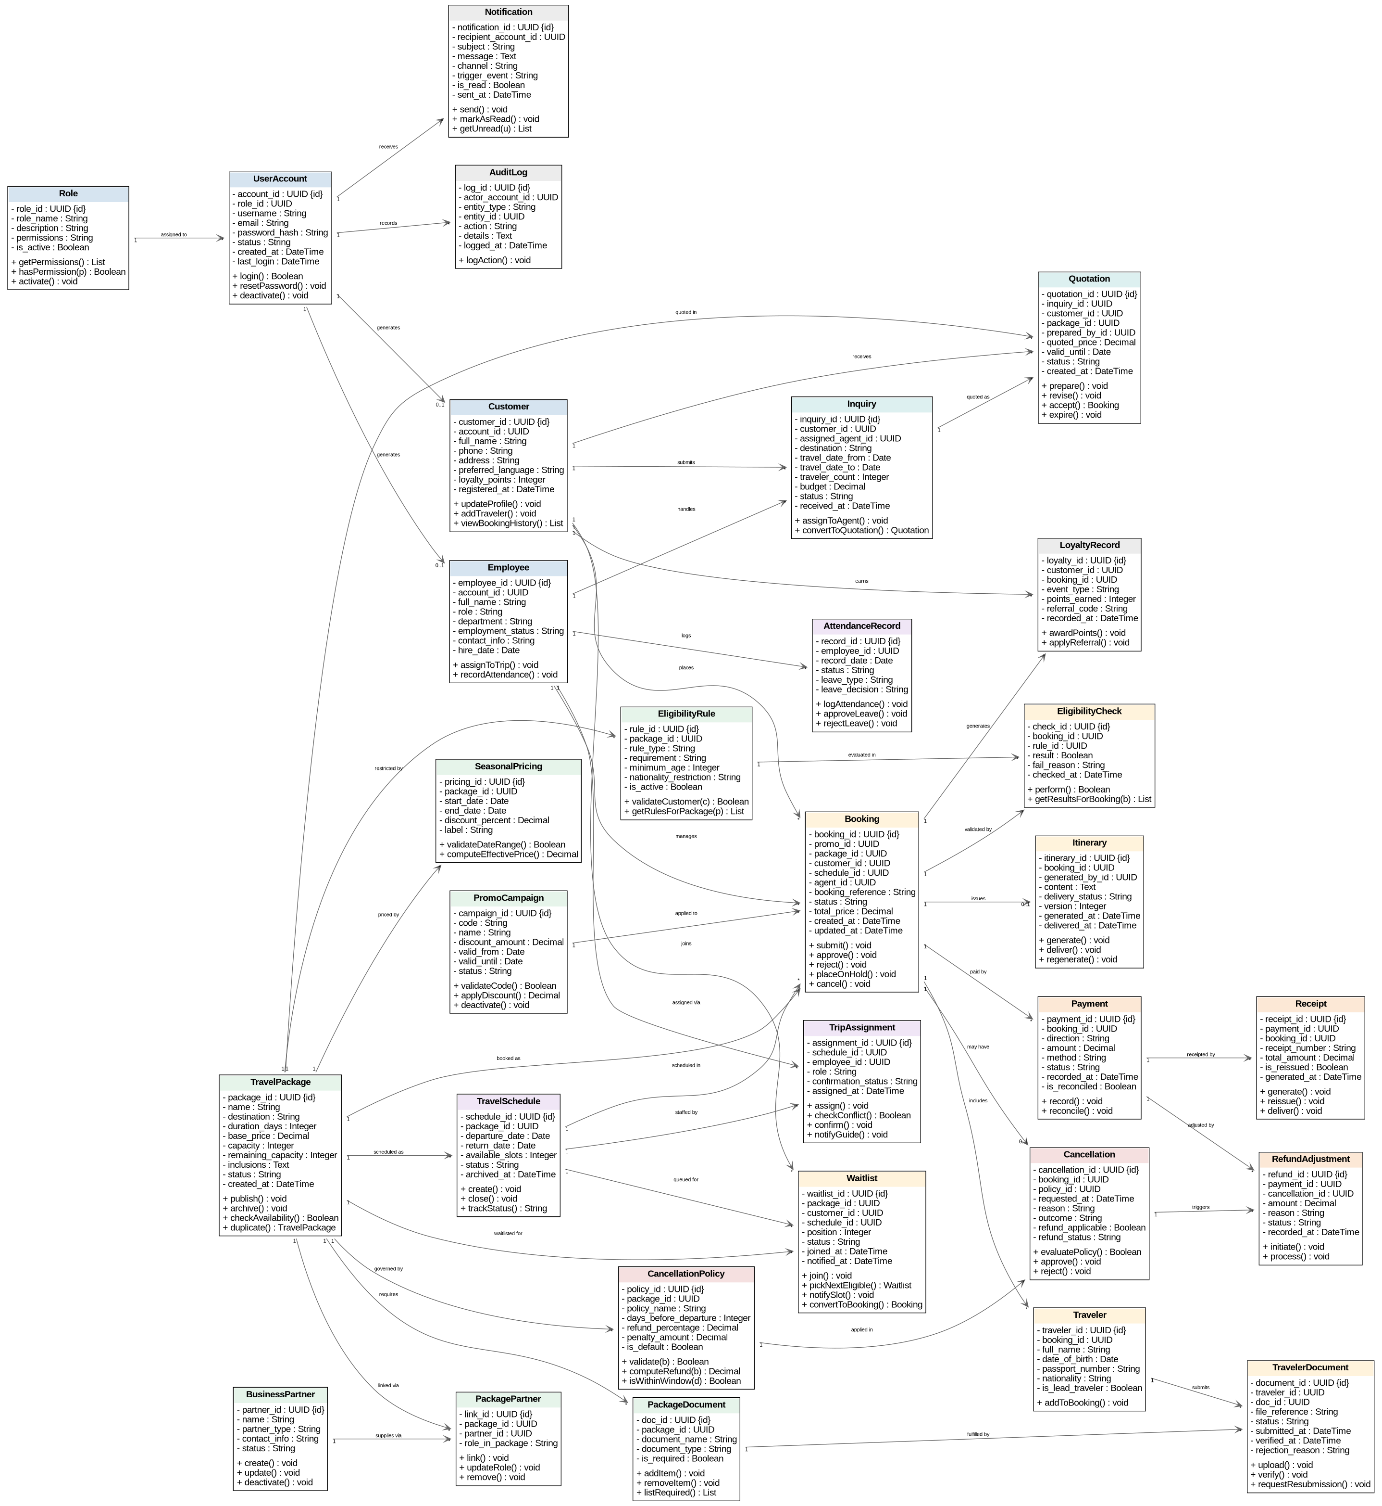
Prepared by: Dion Hasanbashaj

5.5 State Machine Diagrams
State machine diagrams model the lifecycle states and transitions of the system's key stateful entities, including Booking, TravelPackage, TripSchedule, PaymentRecord, and Customer Account.

SMD-01
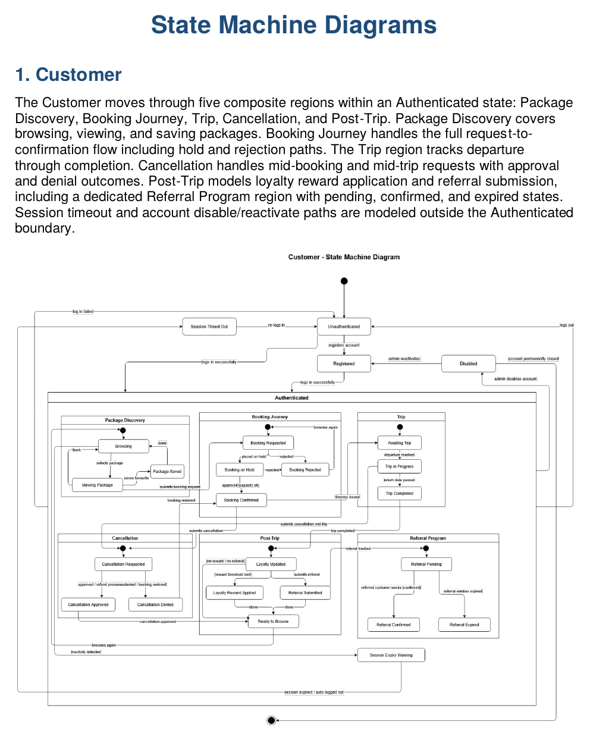
Prepared by: Dion Hasanbashaj

SMD-02
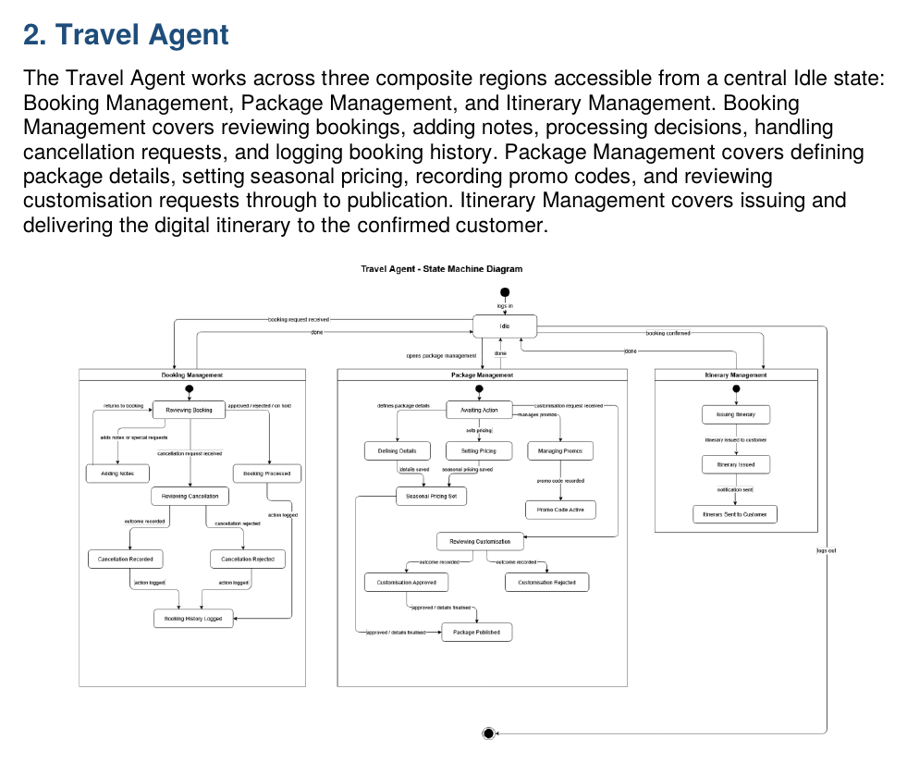
Prepared by: Dion Hasanbashaj

SMD-03
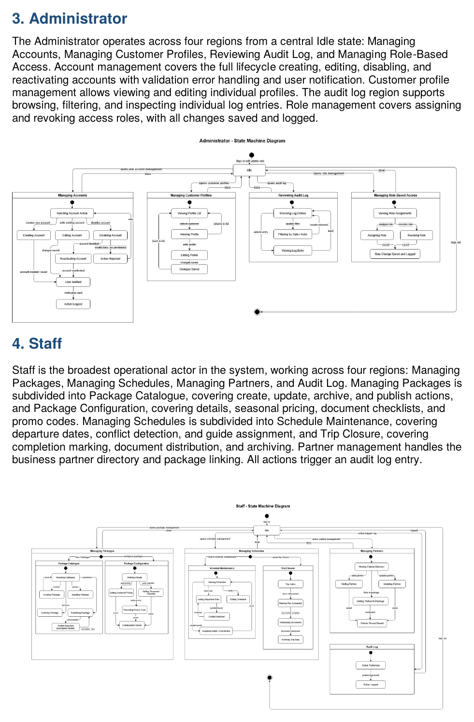
Prepared by: Dion Hasanbashaj

SMD-04
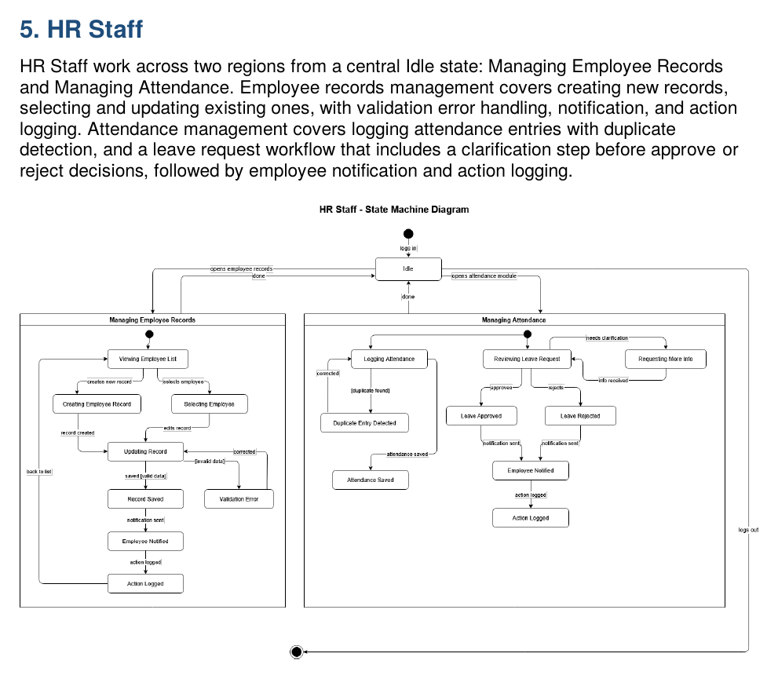
Prepared by: Dion Hasanbashaj

SMD-05
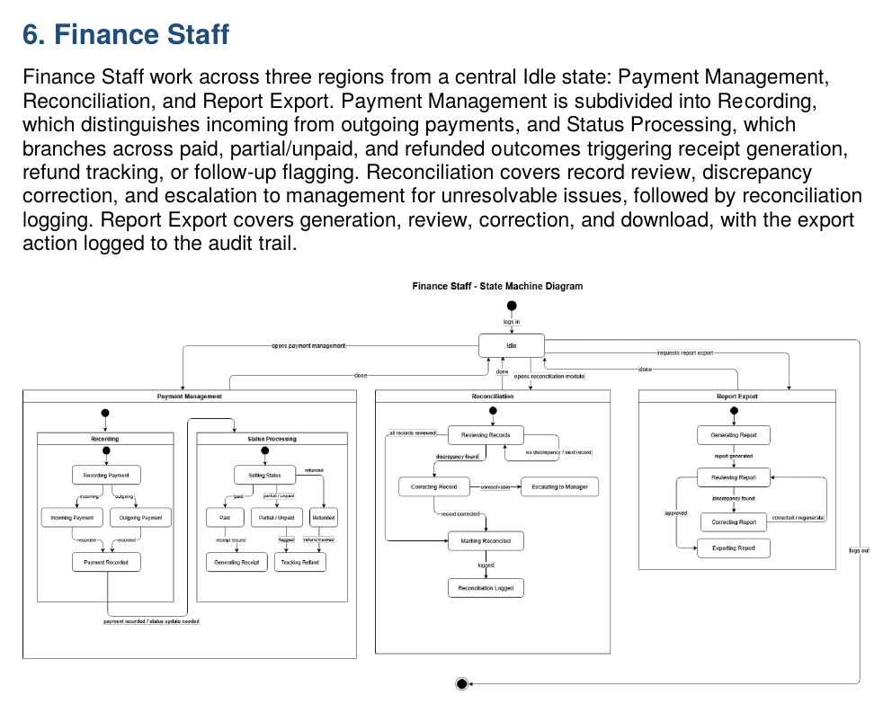
Prepared by: Dion Hasanbashaj

SMD-06
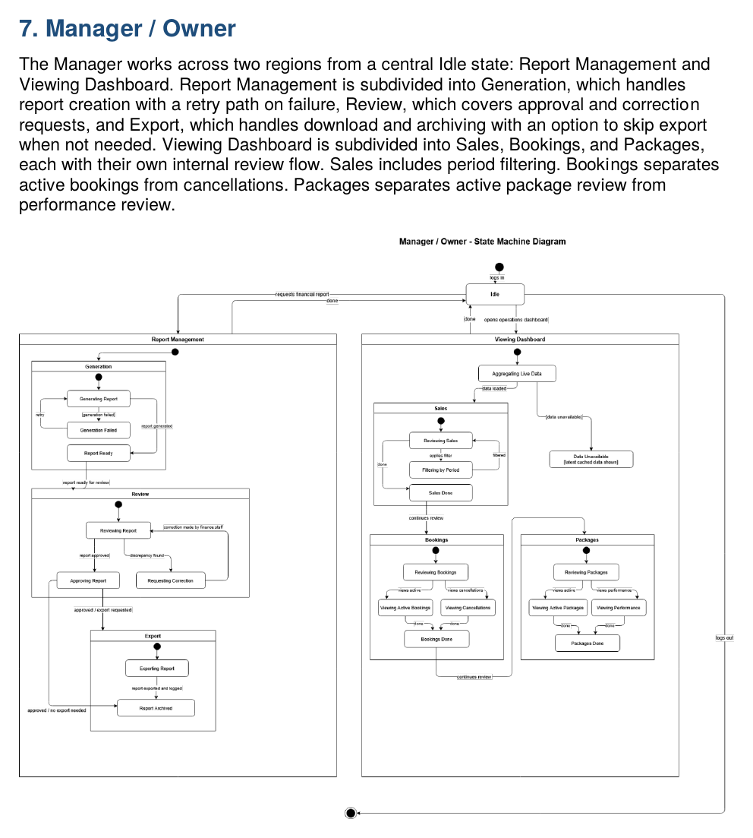
Prepared by: Dion Hasanbashaj

5.6 Sequence Diagrams (SD-01 – SD-30)
Thirty sequence diagrams, each derived from the corresponding activity diagram. Sequence diagrams show the temporal ordering of messages between objects and actors. Guard conditions in alt fragments use separate individual guard boxes per the established convention.

SD-01: Log In
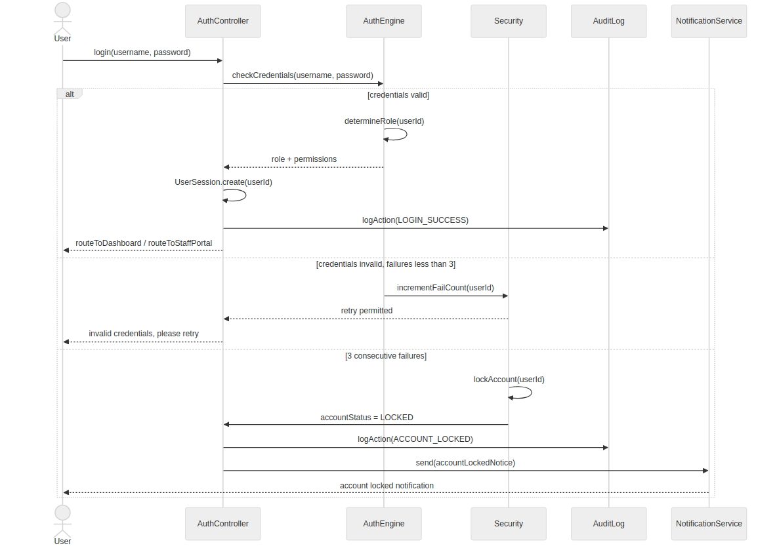
Prepared by: Isuf Celhaka

SD-02: Register Customer Account
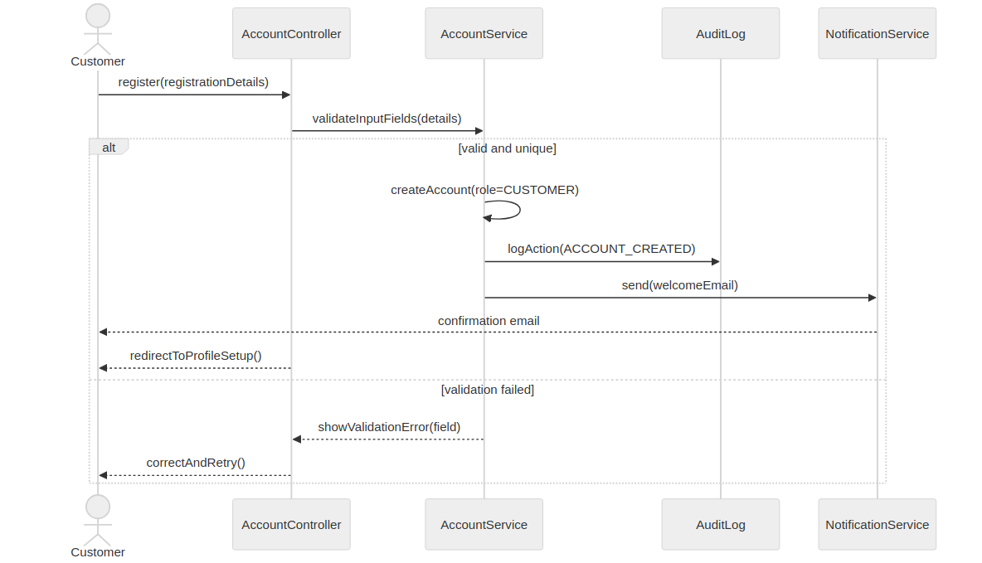
Prepared by: Isuf Celhaka

SD-03: Reset Password
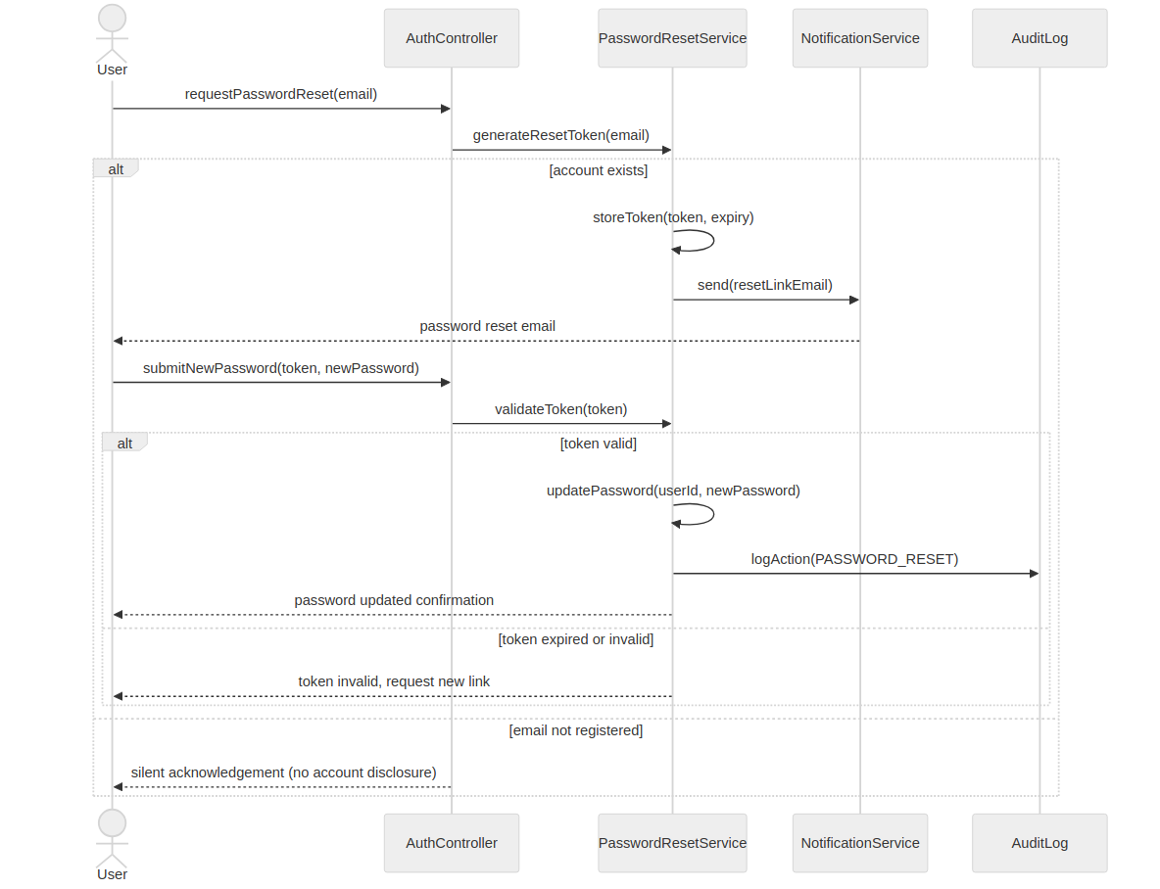
Prepared by: Isuf Celhaka

SD-04: Manage Customer Profile
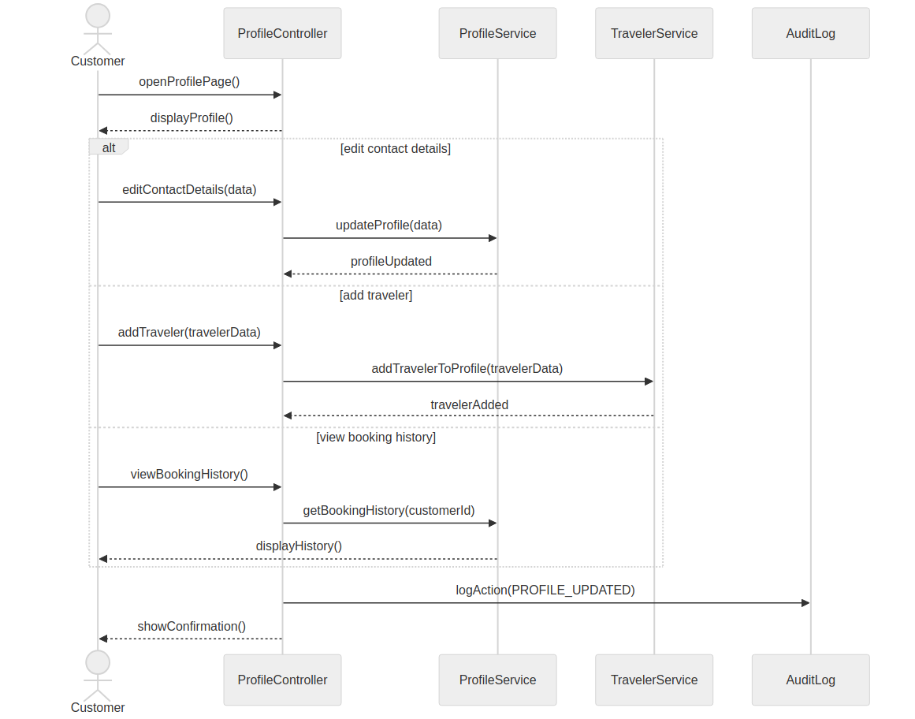
Prepared by: Isuf Celhaka

SD-05: Administer User Accounts
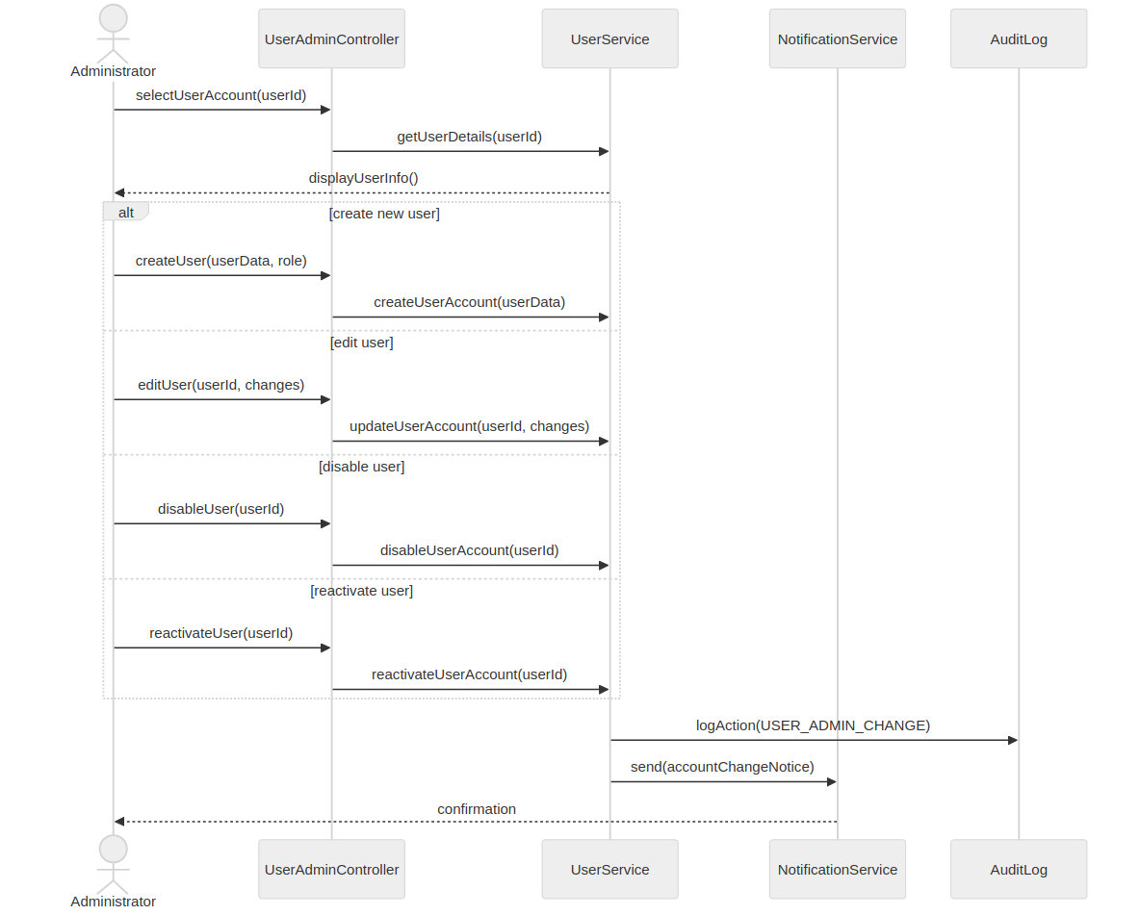
Prepared by: Isuf Celhaka

SD-06: Manage Employee Records
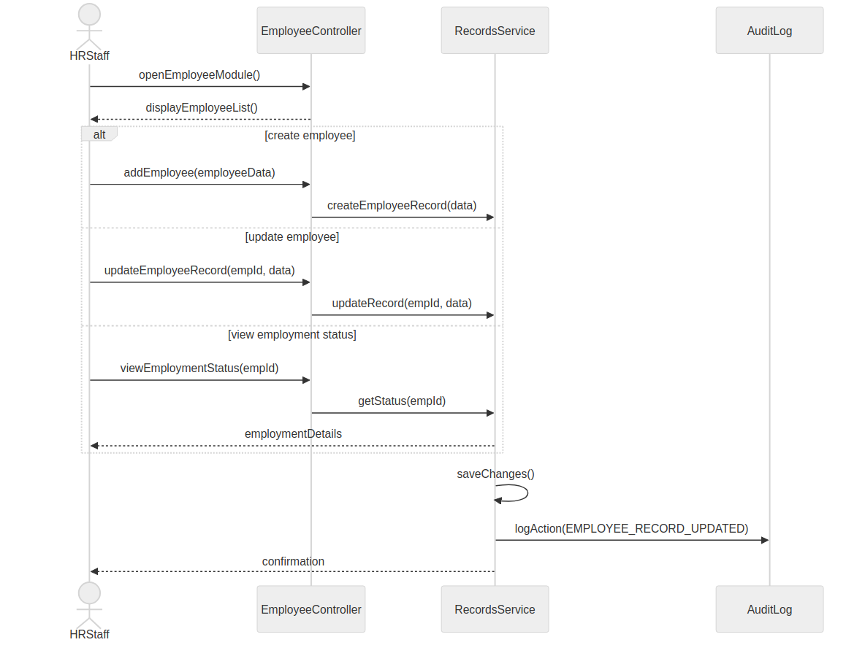
Prepared by: Isuf Celhaka

SD-07: Manage Attendance & Leave
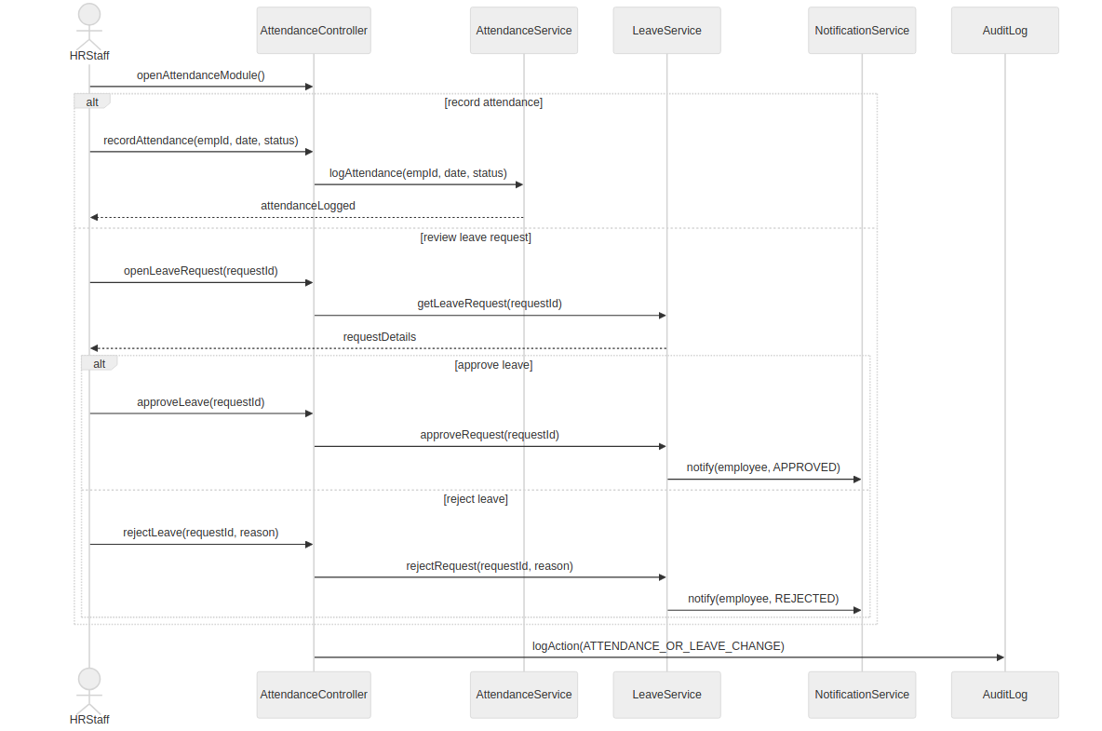
Prepared by: Isuf Celhaka

SD-08: Create & Publish Travel Package
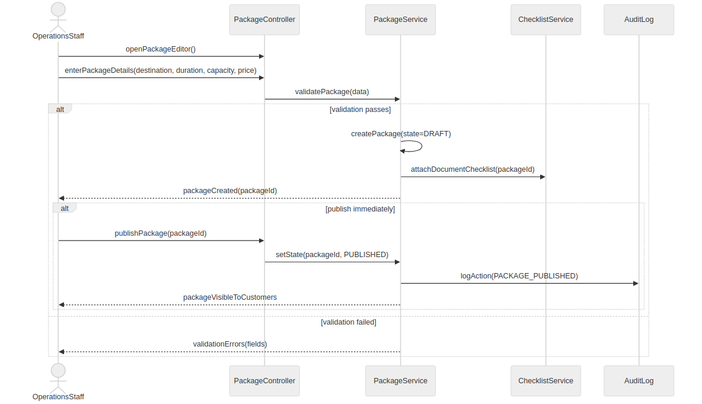
Prepared by: Amanda Shirka

SD-09: Update & Archive Travel Package
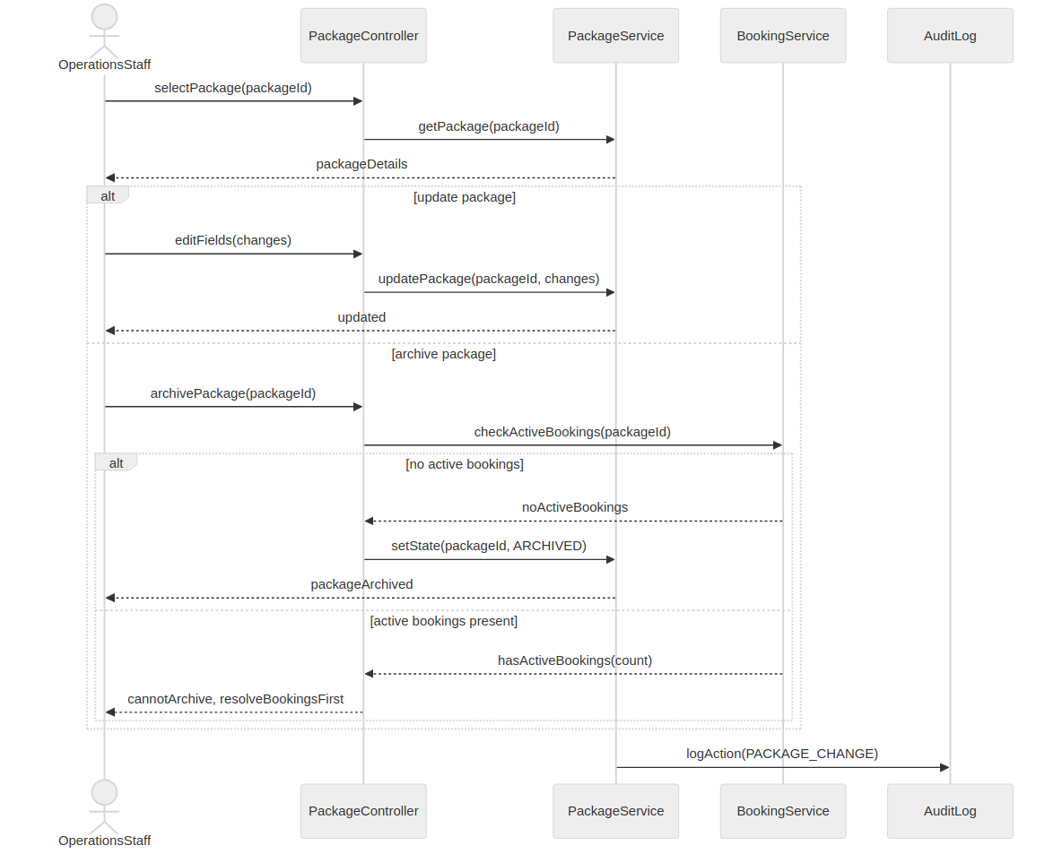
Prepared by: Amanda Shirka

SD-10: Define Seasonal Pricing & Discounts
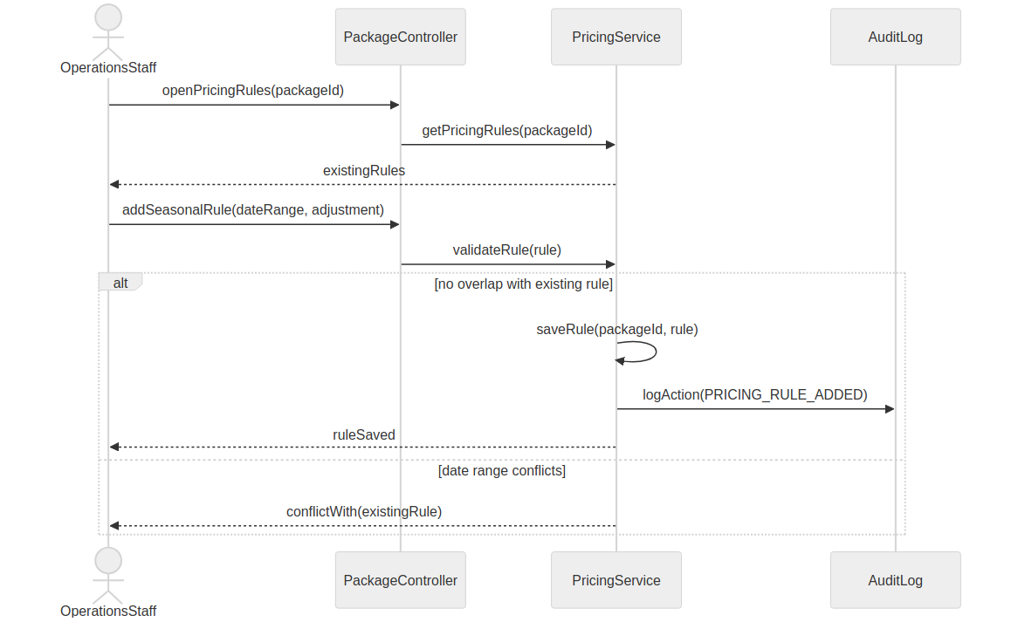
Prepared by: Amanda Shirka

SD-11: Manage Promotional Campaigns & Promo Codes
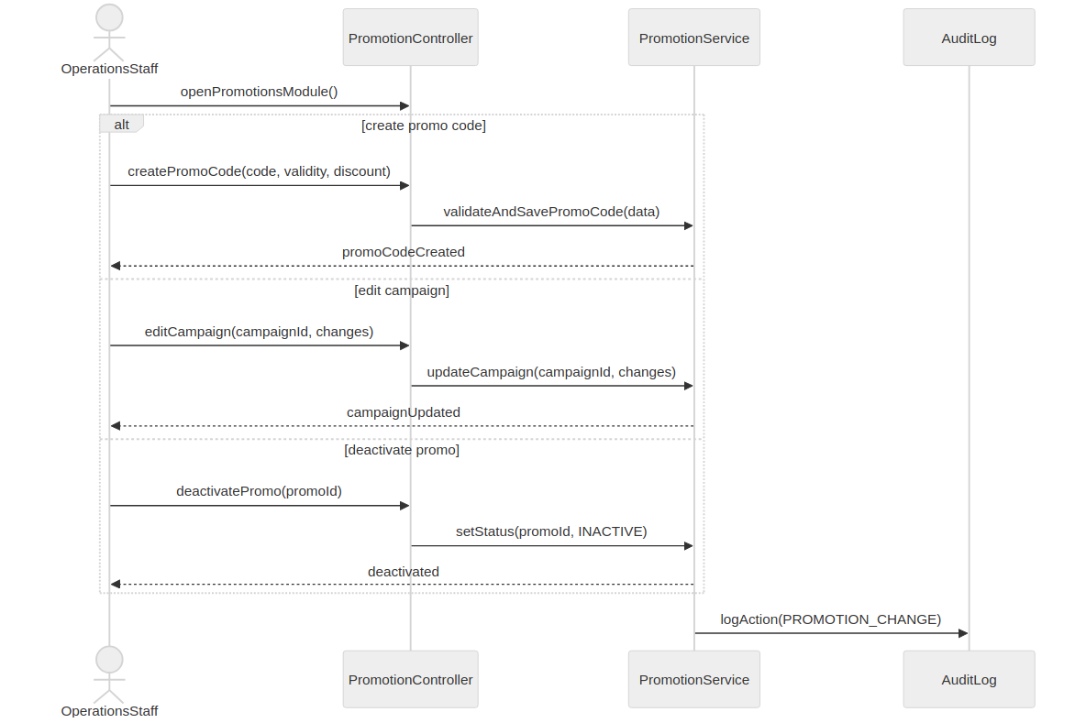
Prepared by: Amanda Shirka

SD-12: Define Package Document Checklist
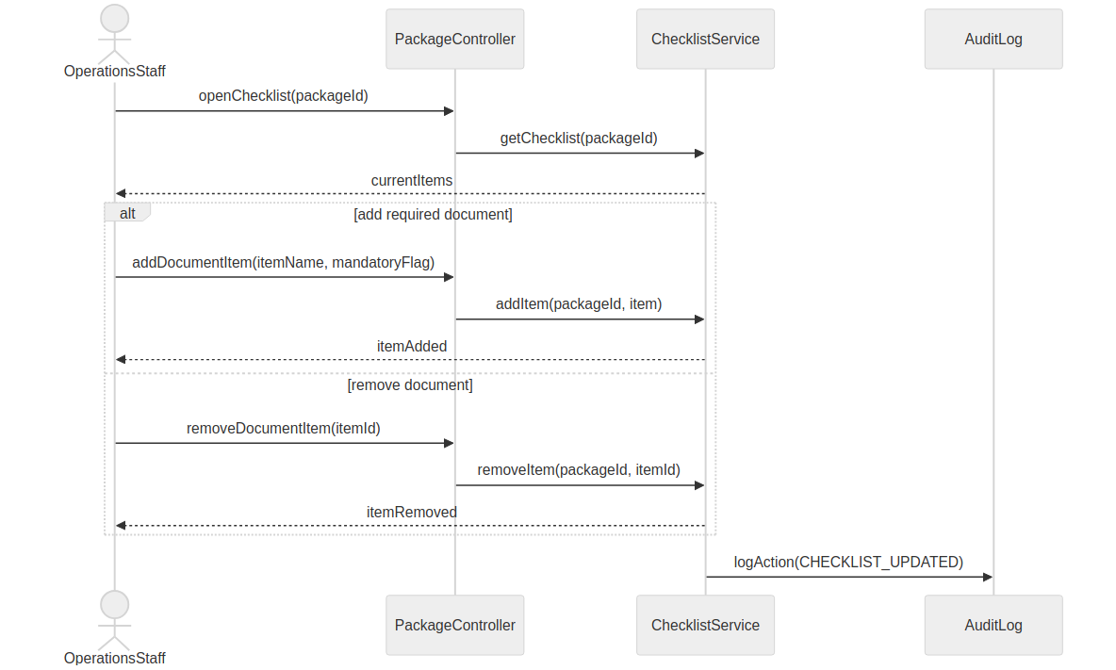
Prepared by: Amanda Shirka

SD-13: Submit & Review Package Customization Request
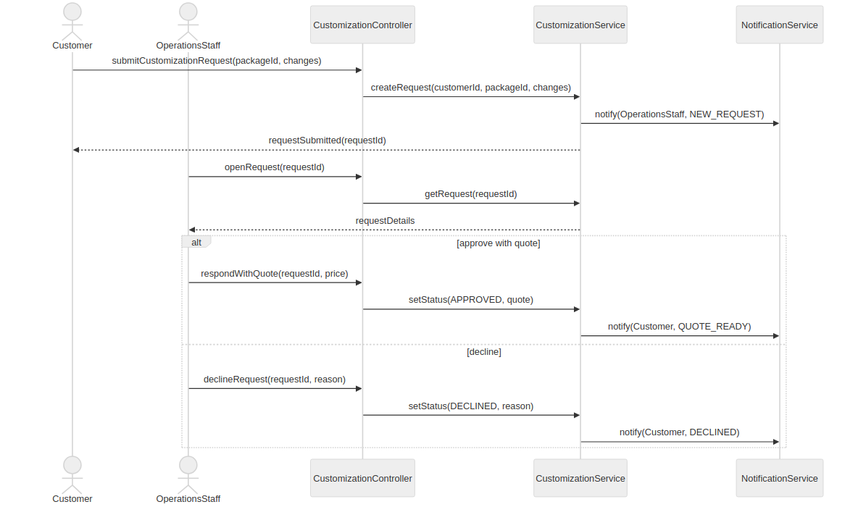
Prepared by: Amanda Shirka

SD-14: Duplicate Package as Template
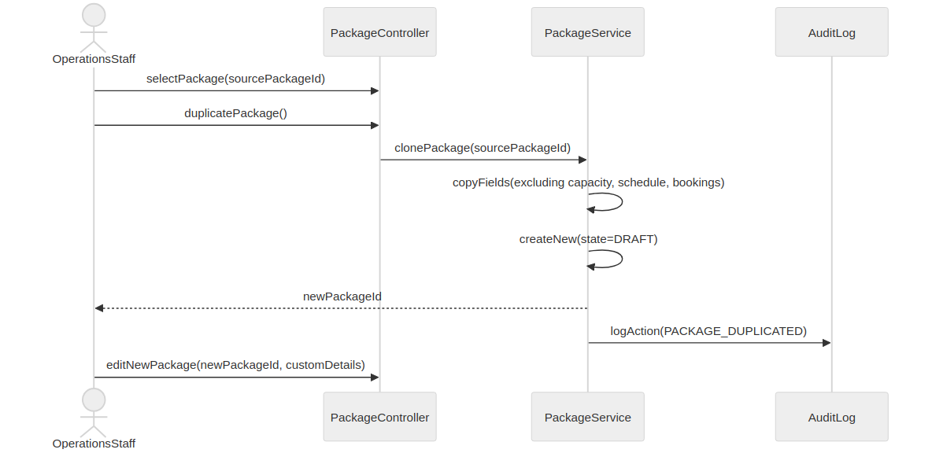
Prepared by: Amanda Shirka

SD-15: Submit Booking Request
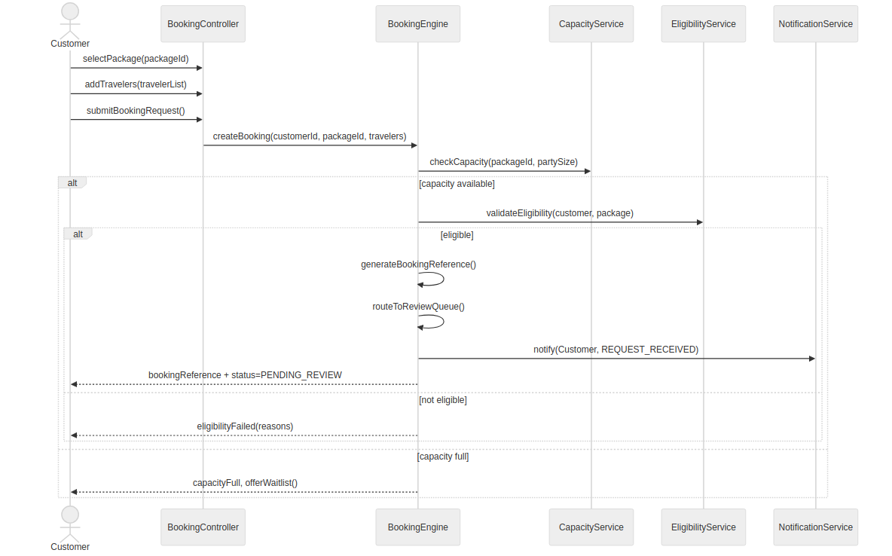
Prepared by: Alba Gjergji & Ana Gjergji

SD-16: Review & Process Booking
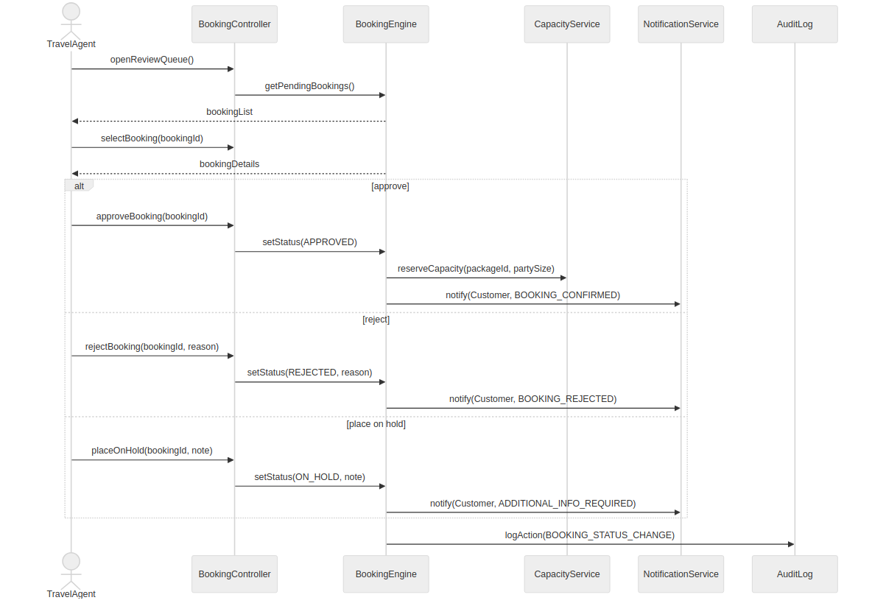
Prepared by: Alba Gjergji & Ana Gjergji

SD-17: Issue Digital Itinerary
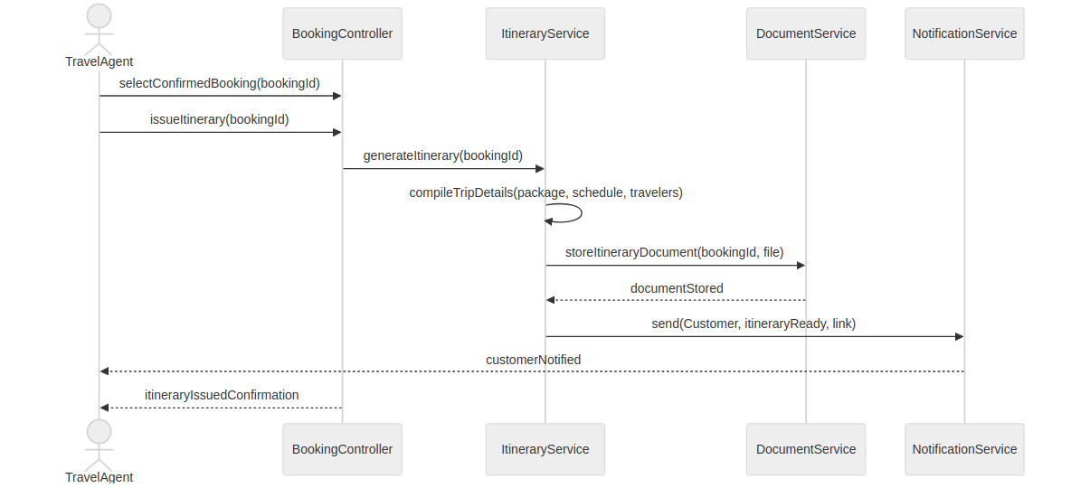
Prepared by: Alba Gjergji & Ana Gjergji

SD-18: View Booking Status
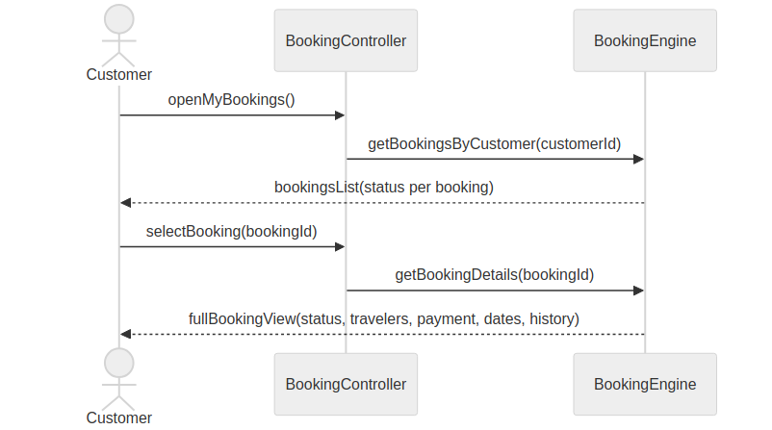
Prepared by: Alba Gjergji & Ana Gjergji

SD-19: Submit & Process Cancellation
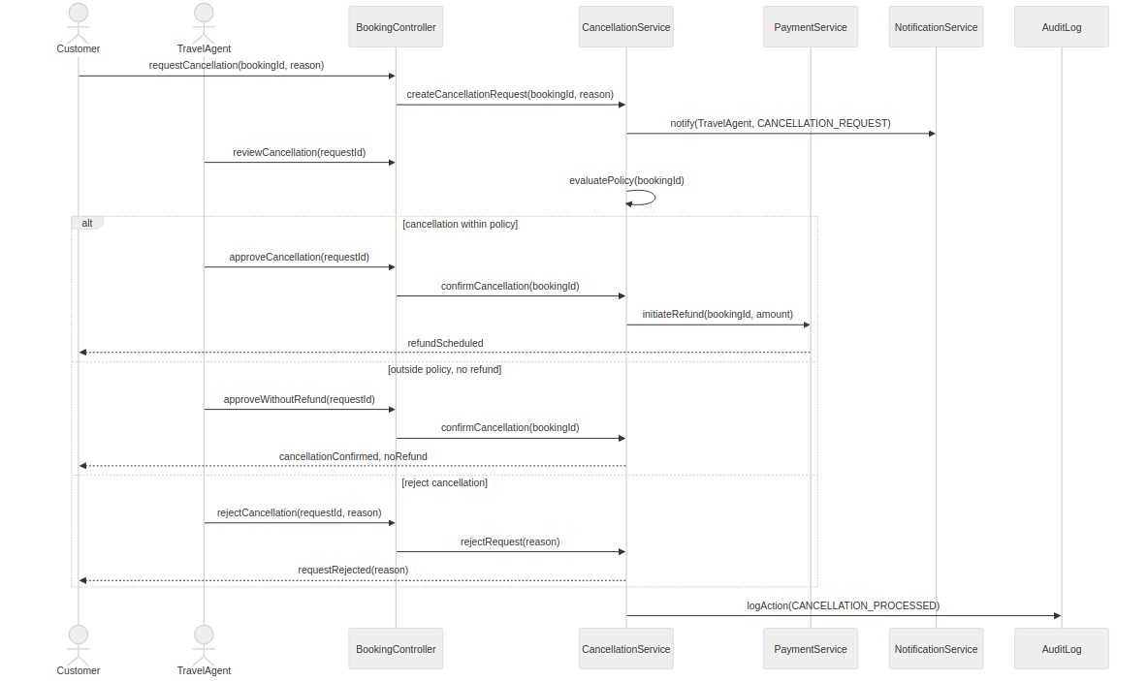
Prepared by: Alba Gjergji & Ana Gjergji

SD-20: Add Notes & Booking History
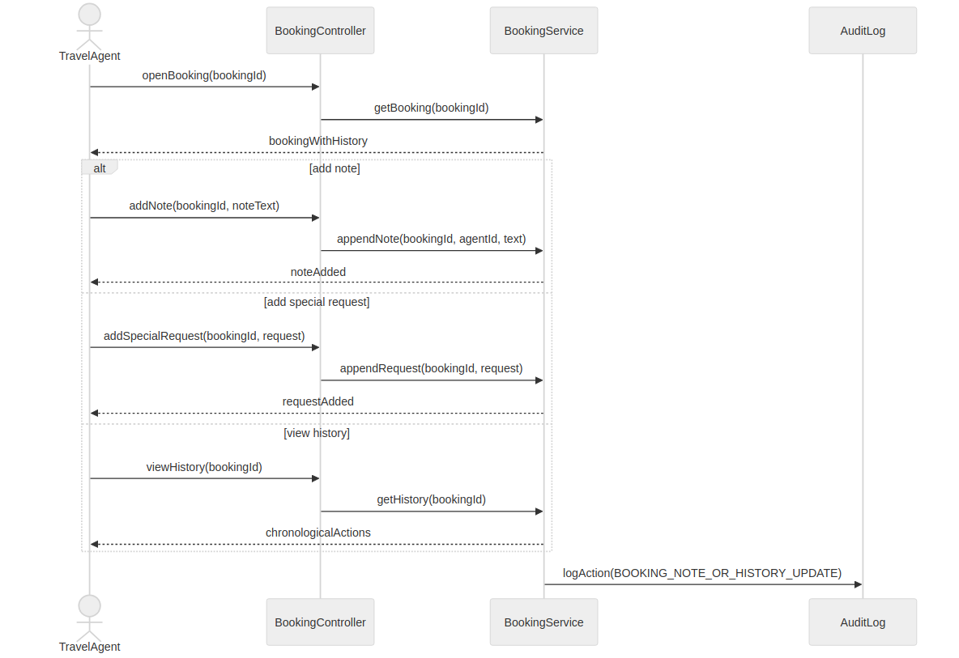
Prepared by: Alba Gjergji & Ana Gjergji

SD-21: Modify Booking Details
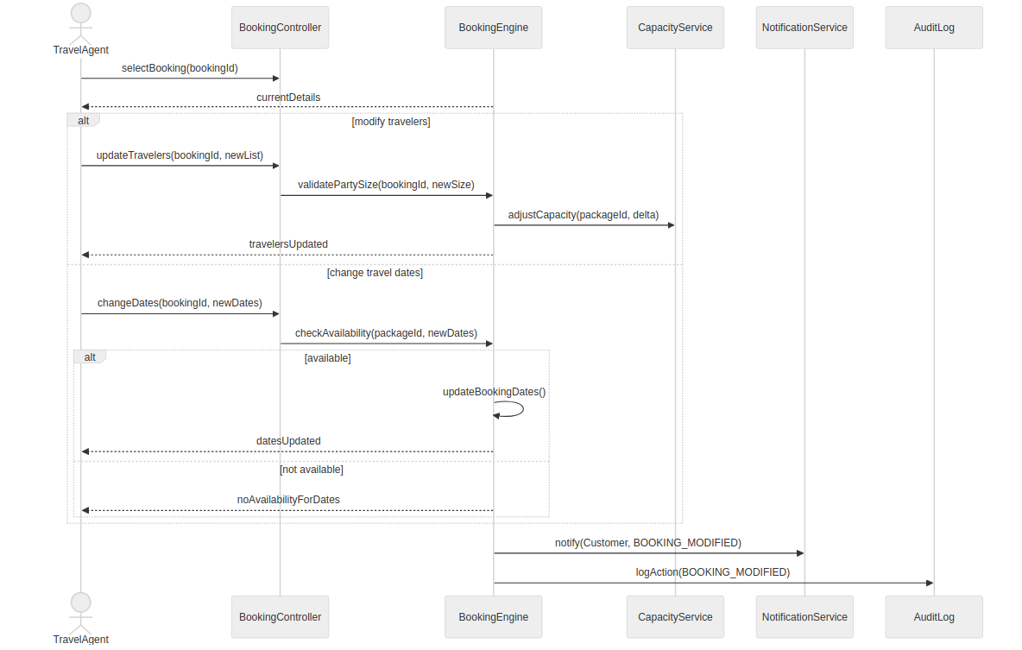
Prepared by: Alba Gjergji & Ana Gjergji

SD-22: Upload & Verify Travel Documents
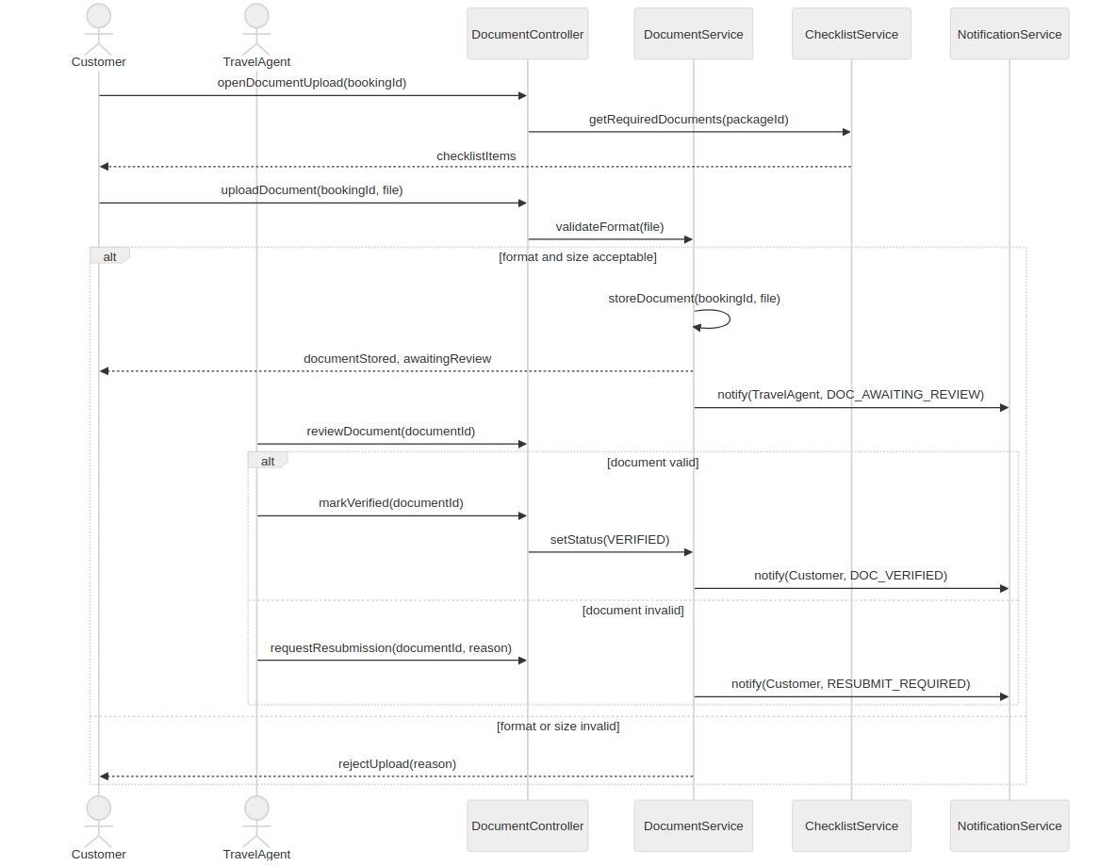
Prepared by: Alba Gjergji & Ana Gjergji

SD-23: Join & Manage Waitlist
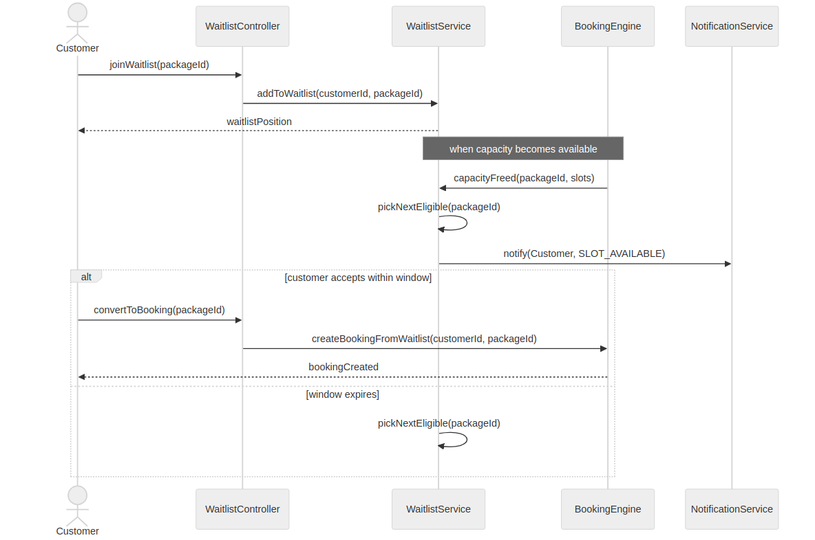
Prepared by: Alba Gjergji & Ana Gjergji

SD-24: Create & Manage Travel Schedule
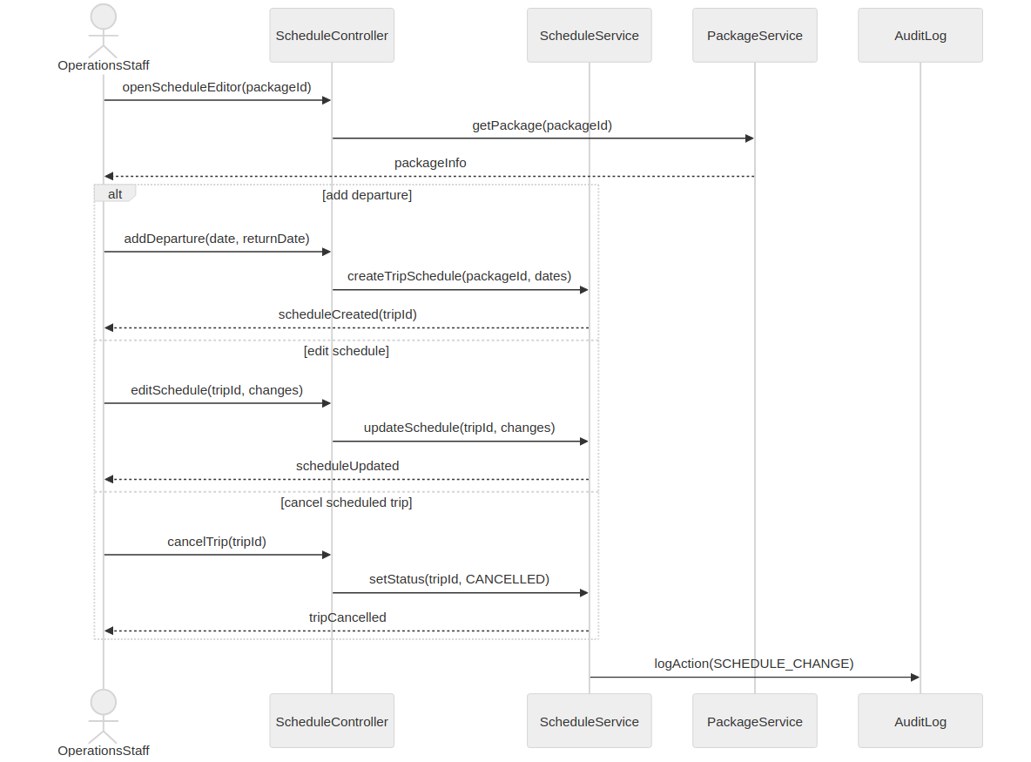
Prepared by: Gledis Ruci

SD-25: Assign Guide or Coordinator
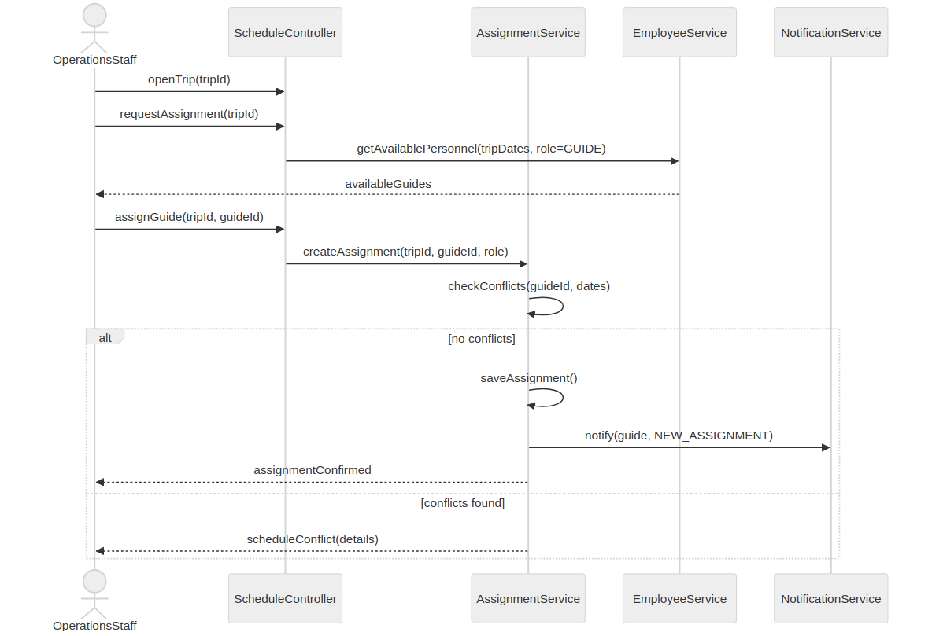
Prepared by: Gledis Ruci

SD-26: Close & Archive Completed Trip
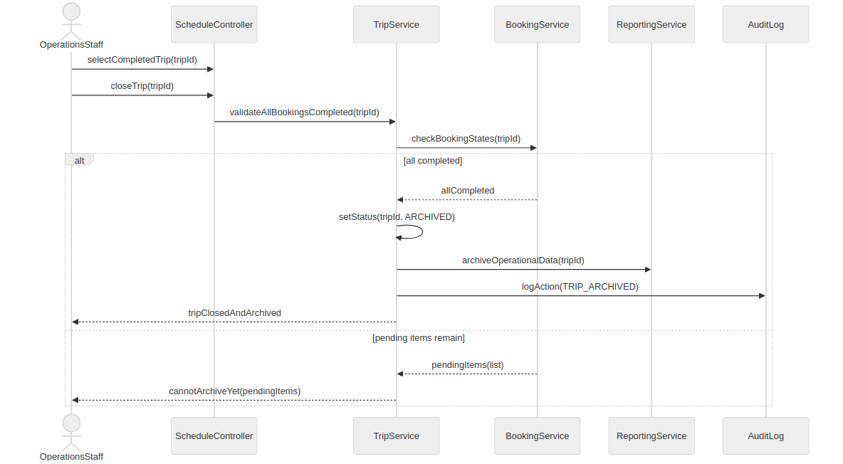
Prepared by: Gledis Ruci

SD-27: Distribute Trip Documents
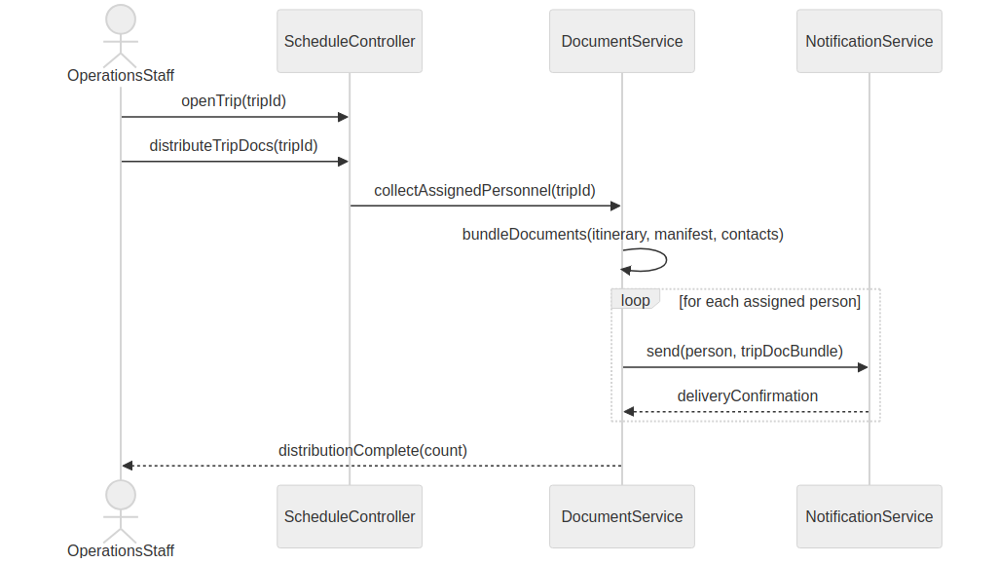
Prepared by: Gledis Ruci

SD-28: Track Trip Lifecycle Status
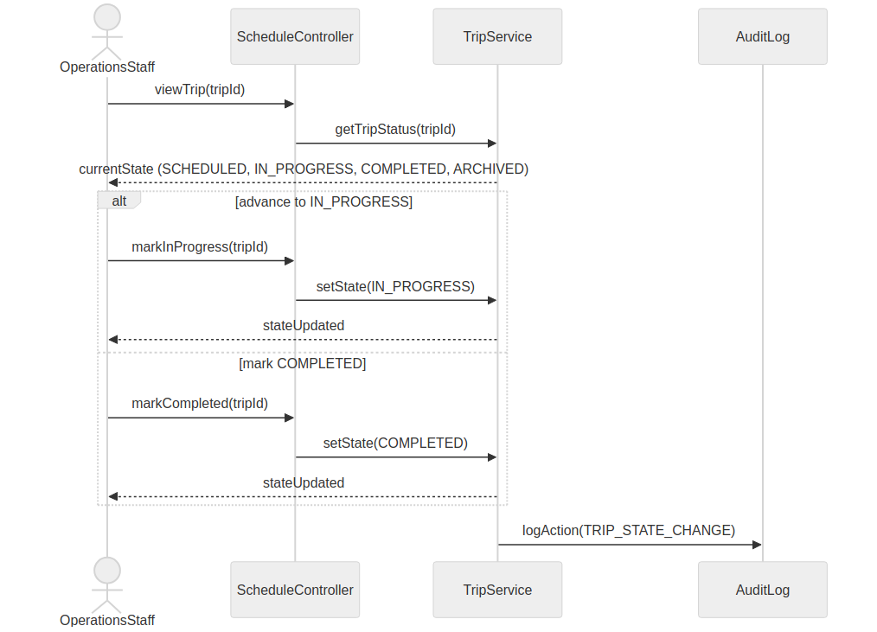
Prepared by: Gledis Ruci

SD-29: Manage Business Partner Records
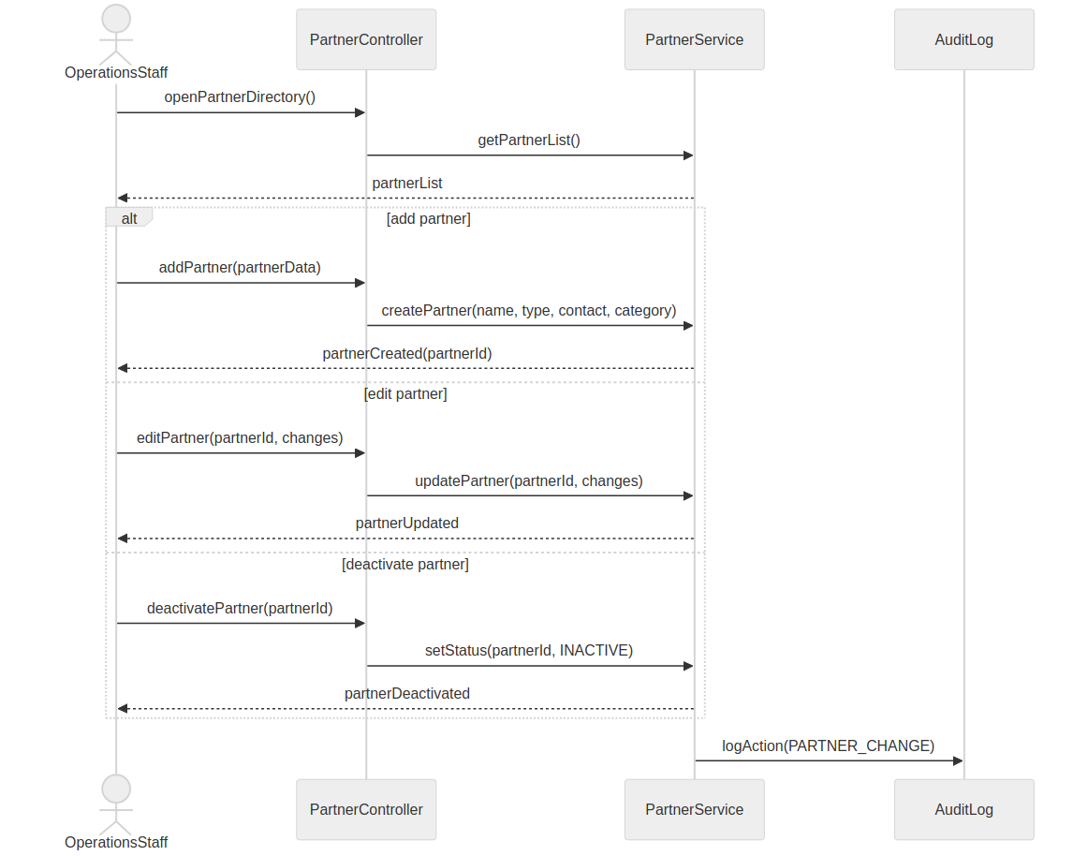
Prepared by: Henri Aliaj

SD-30: Link Partners to Travel Package
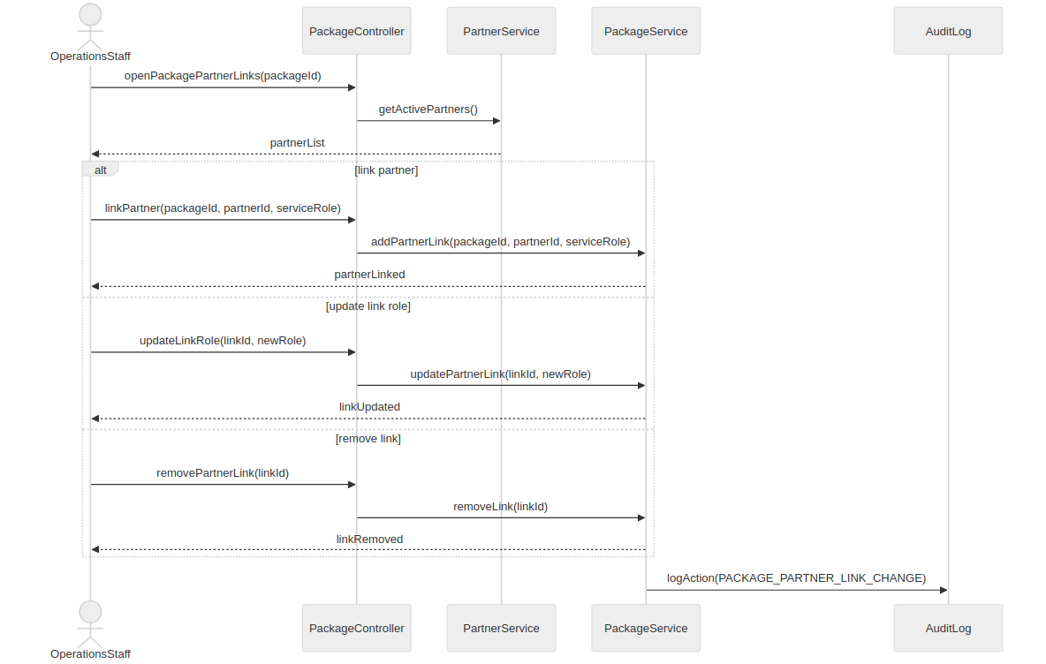
Prepared by: Henri Aliaj

5.7 Collaboration Diagrams (CC-01 – CC-30)
Thirty collaboration diagrams, each derived from the corresponding sequence diagram. Collaboration diagrams emphasize structural object relationships over temporal ordering. Each uses a non-linear layout (triangle, diamond, L-shape, or grid) to prevent label overlap. The source document's cover page is omitted here.

CC-01: Log In
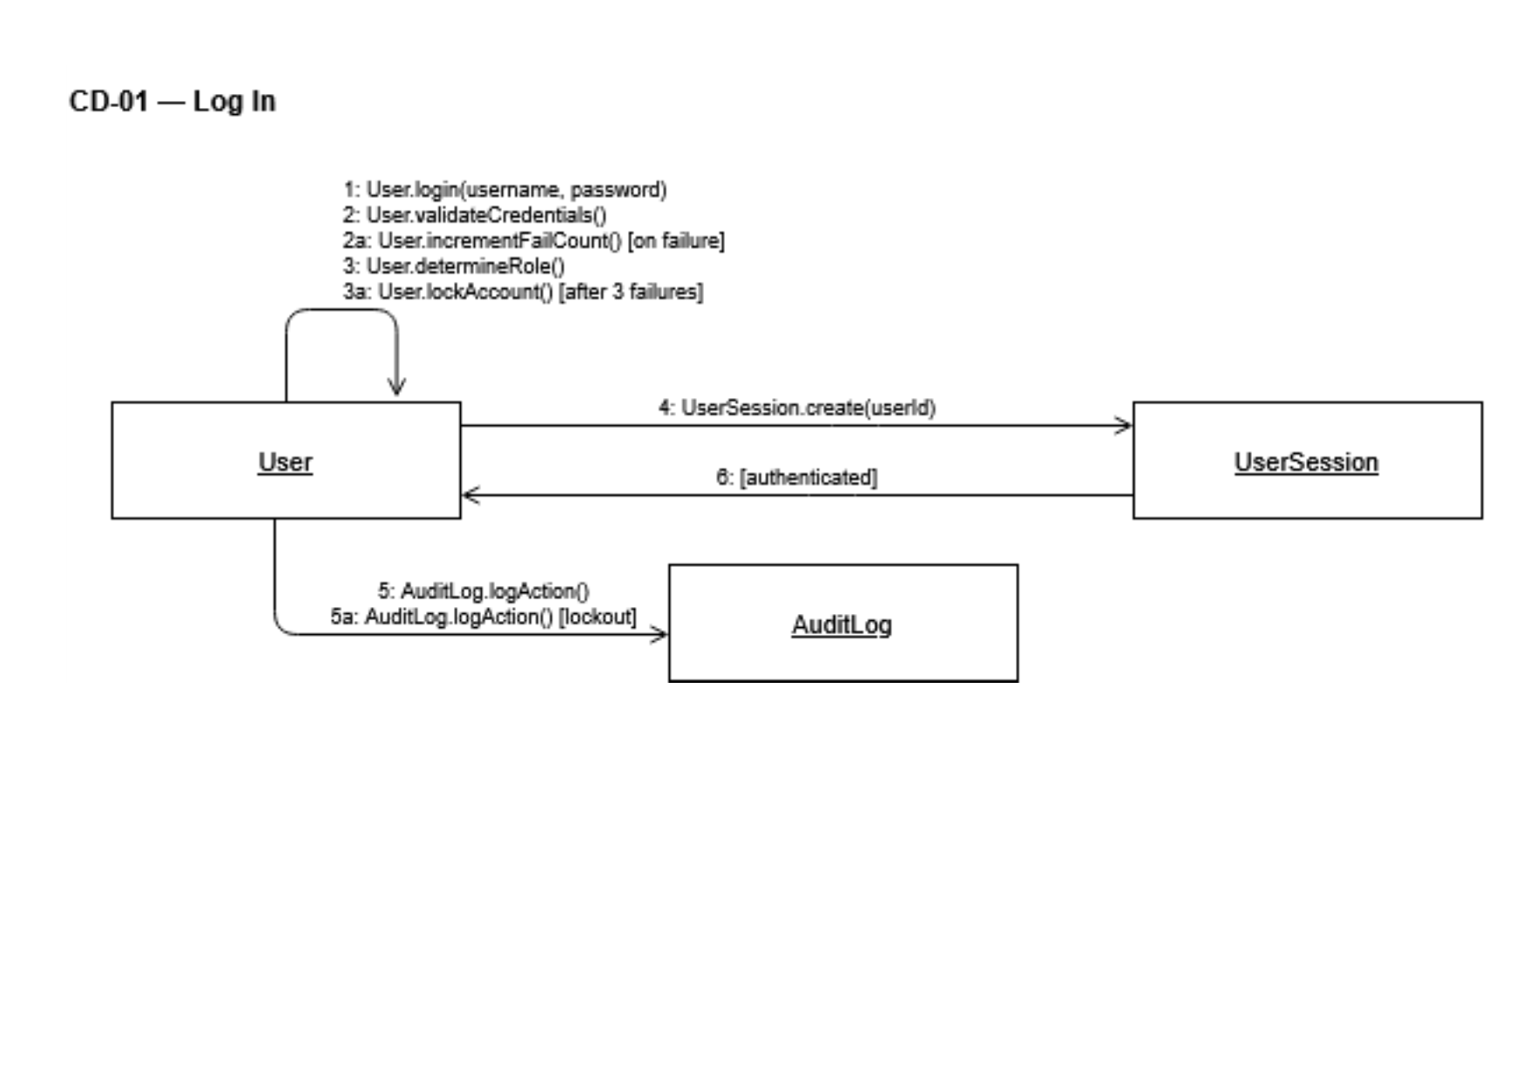
Prepared by: Isuf Celhaka

CC-02: Register Customer Account
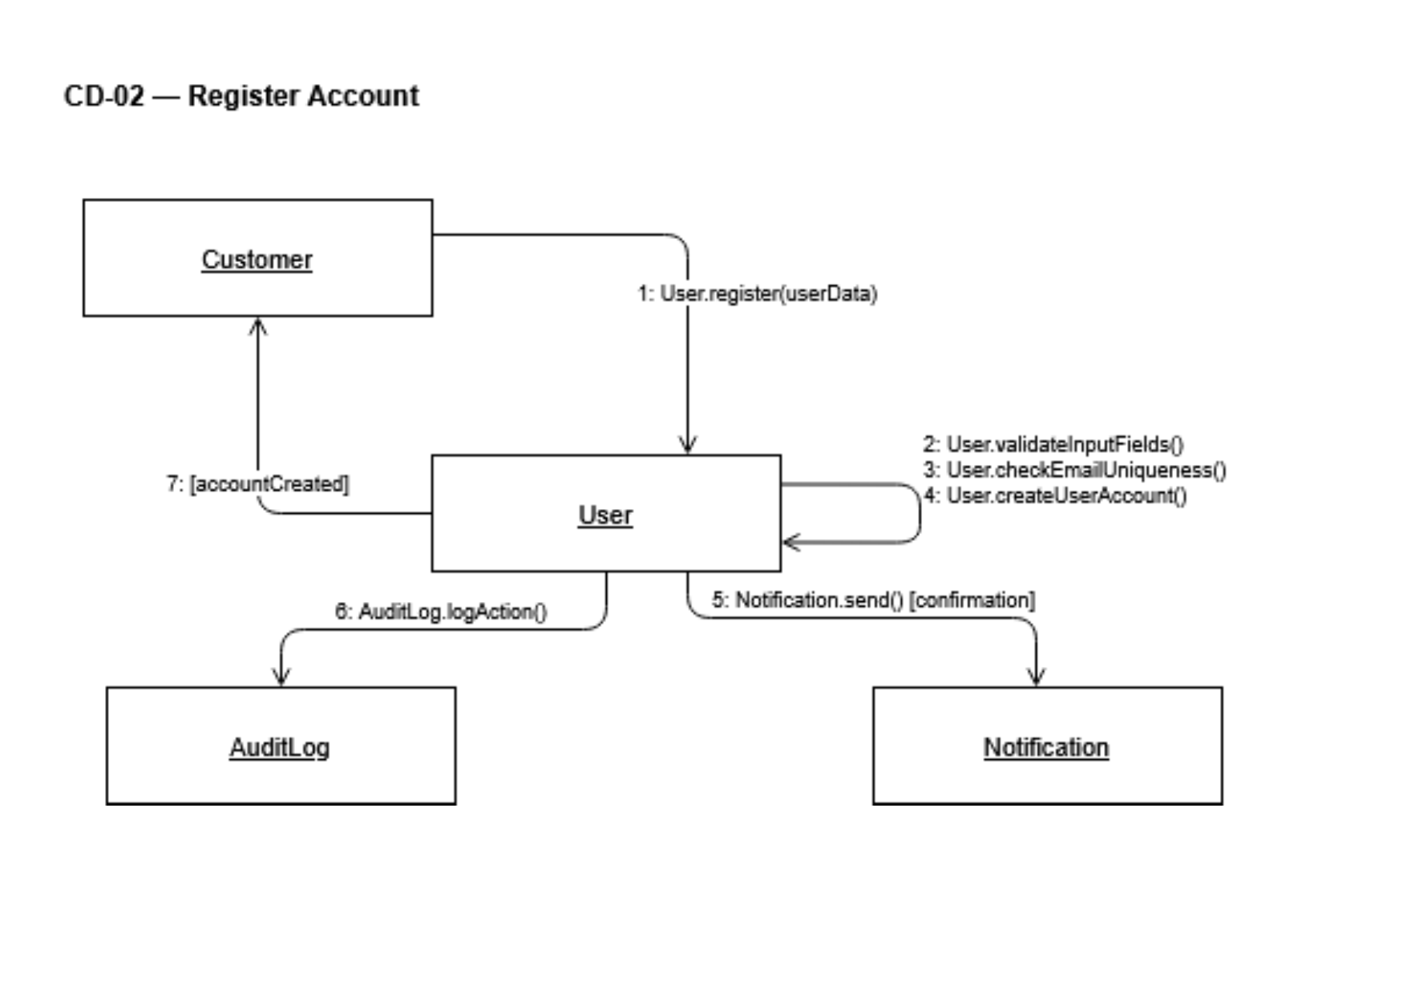
Prepared by: Isuf Celhaka
CC-03: Reset Password
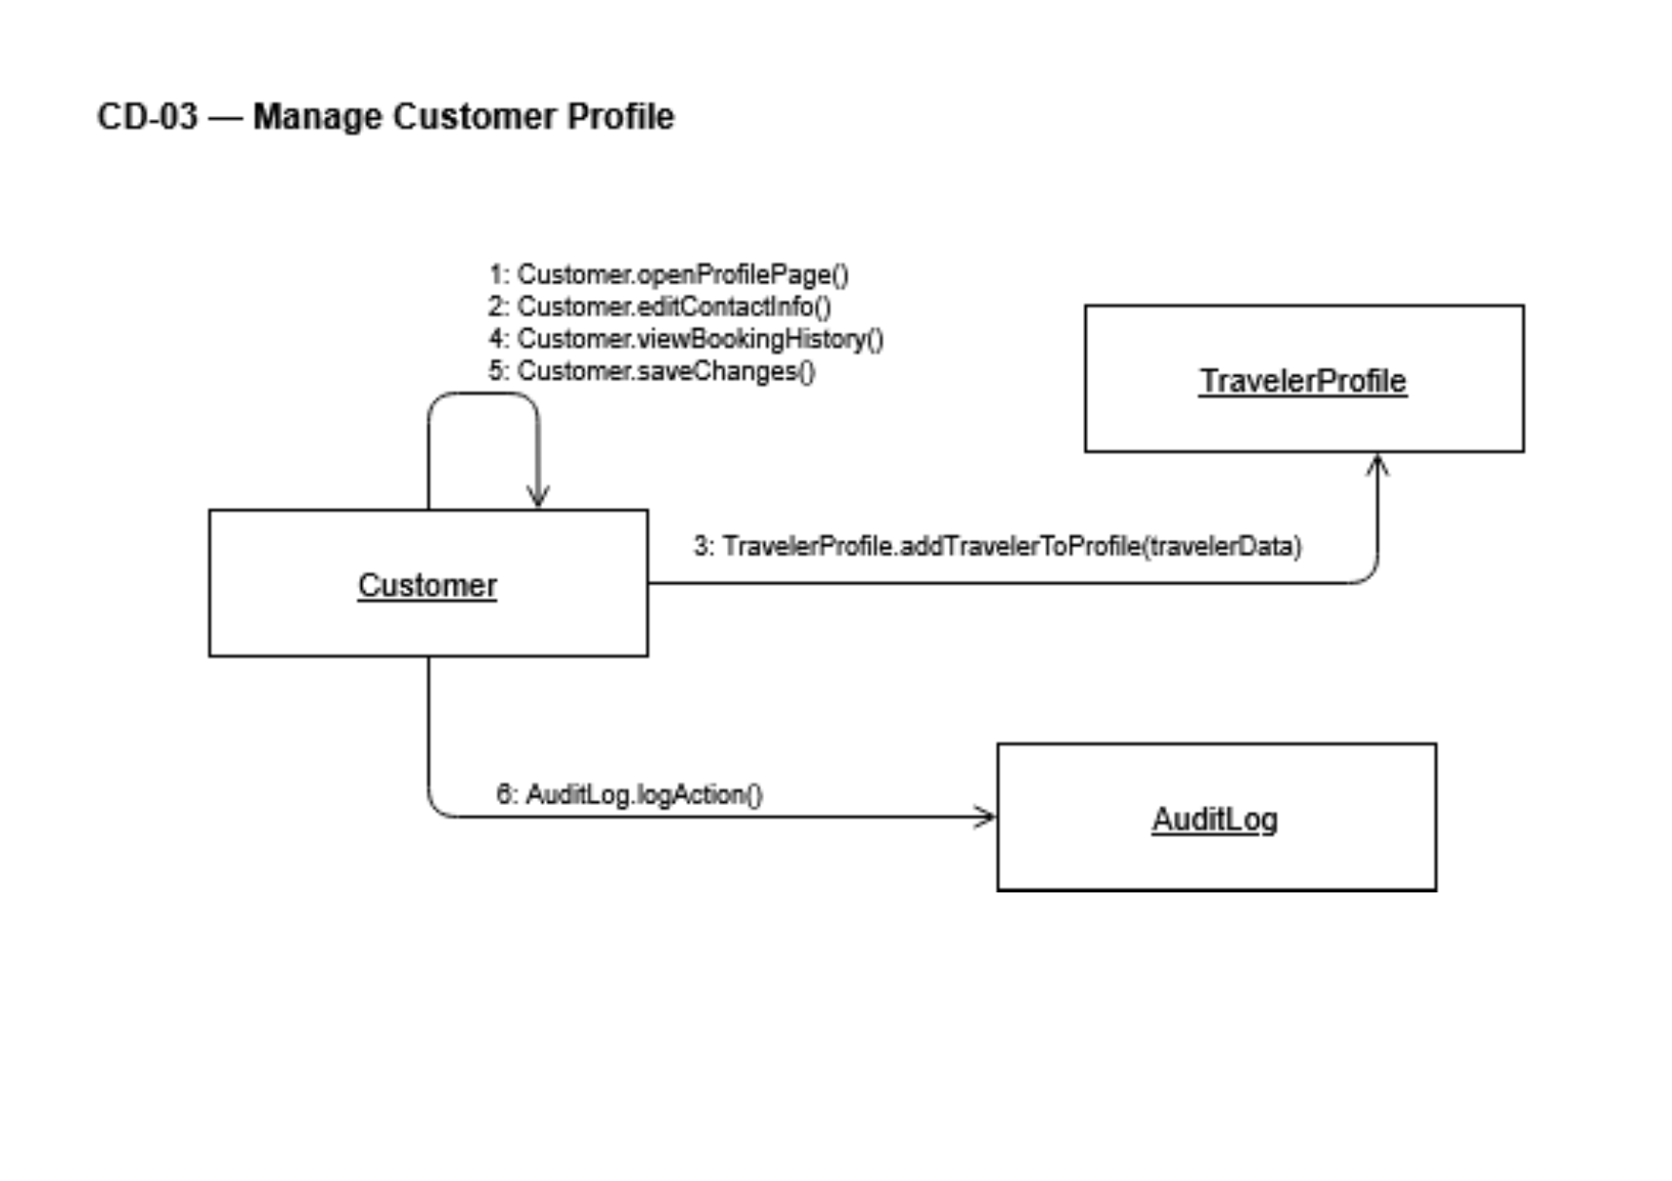
Prepared by: Isuf Celhaka

CC-04: Manage Customer Profile
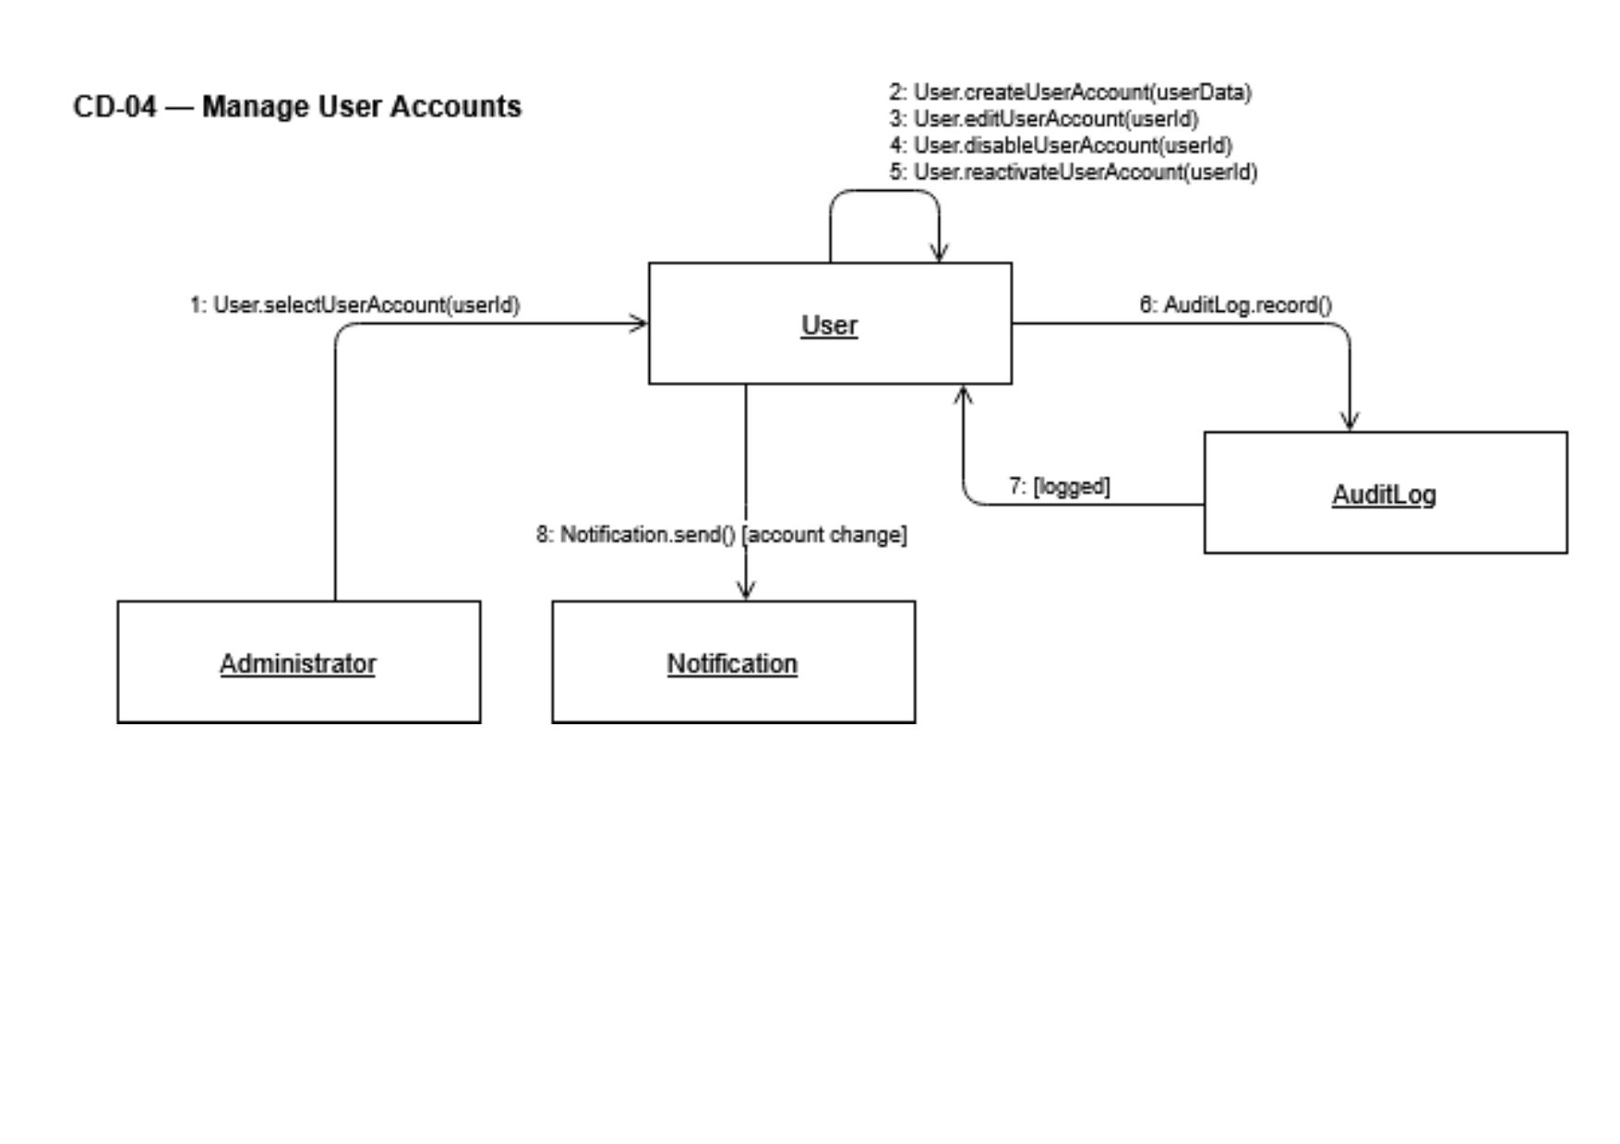
Prepared by: Isuf Celhaka
CC-05: Administer User Accounts
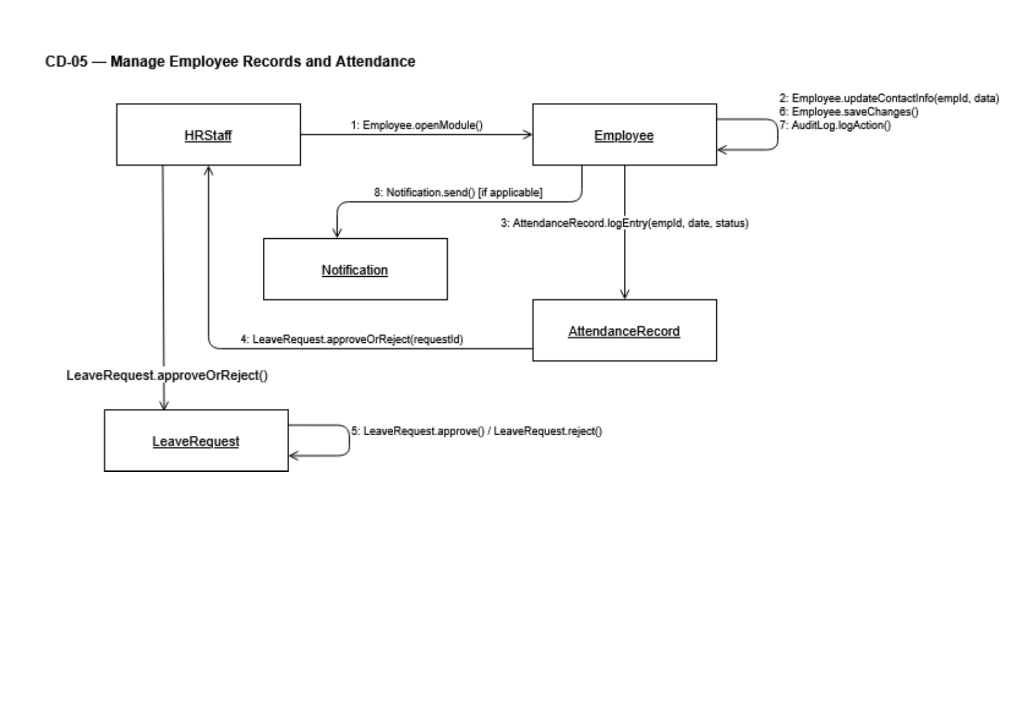
Prepared by: Isuf Celhaka

CC-06: Manage Employee Records
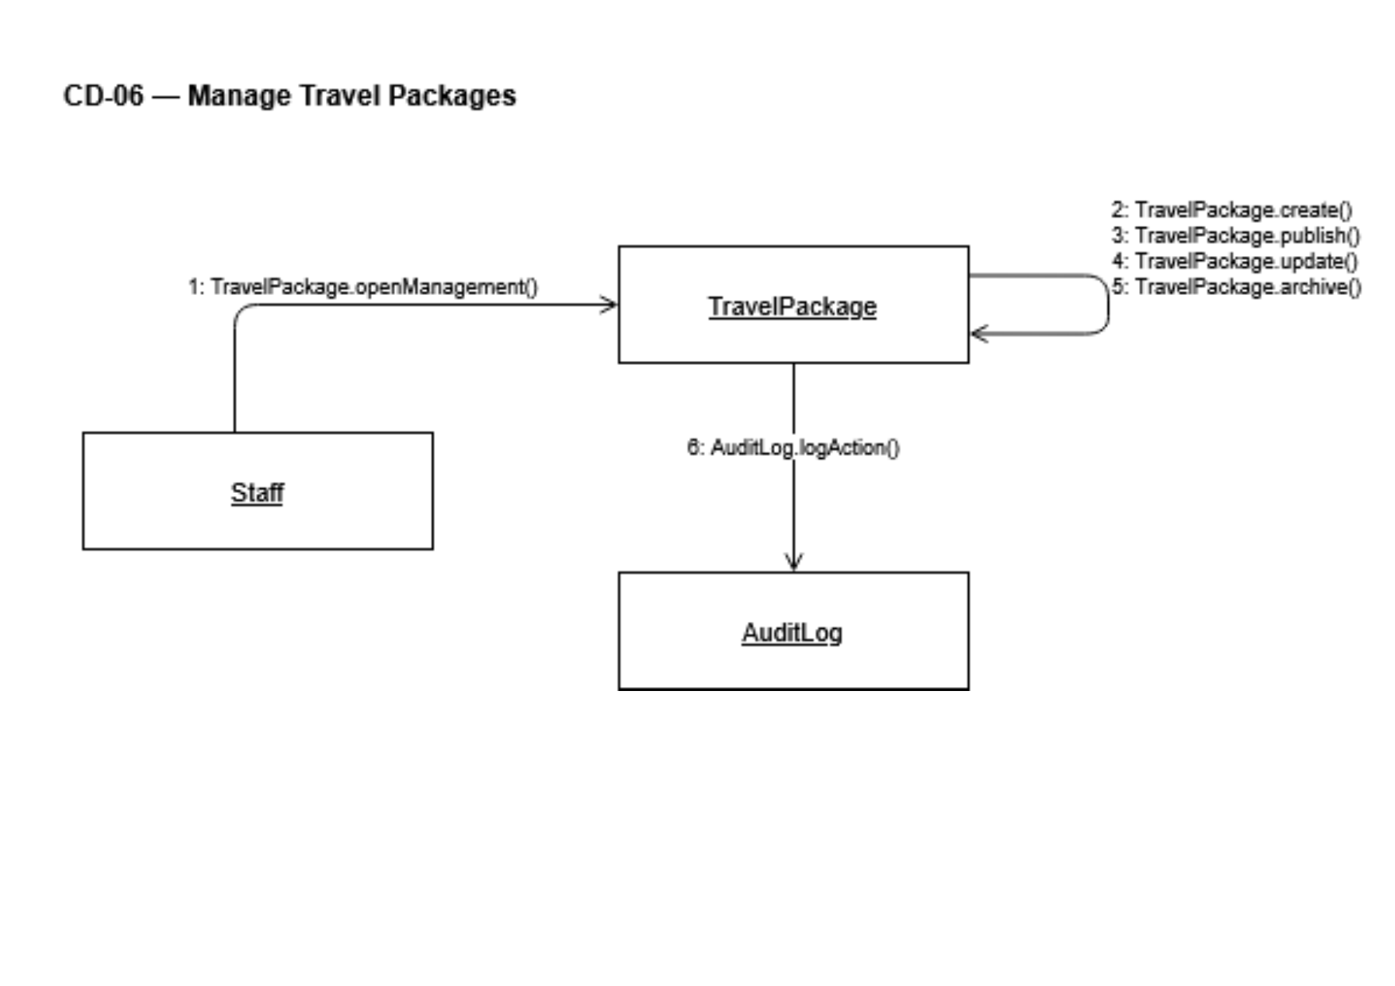
Prepared by: Isuf Celhaka

CC-07: Manage Attendance & Leave
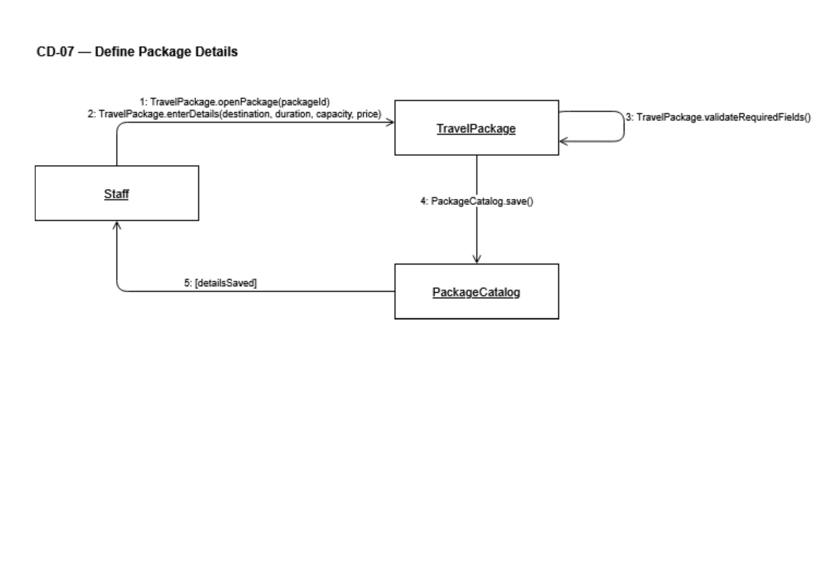
Prepared by: Isuf Celhaka

CC-08: Create & Publish Travel Package
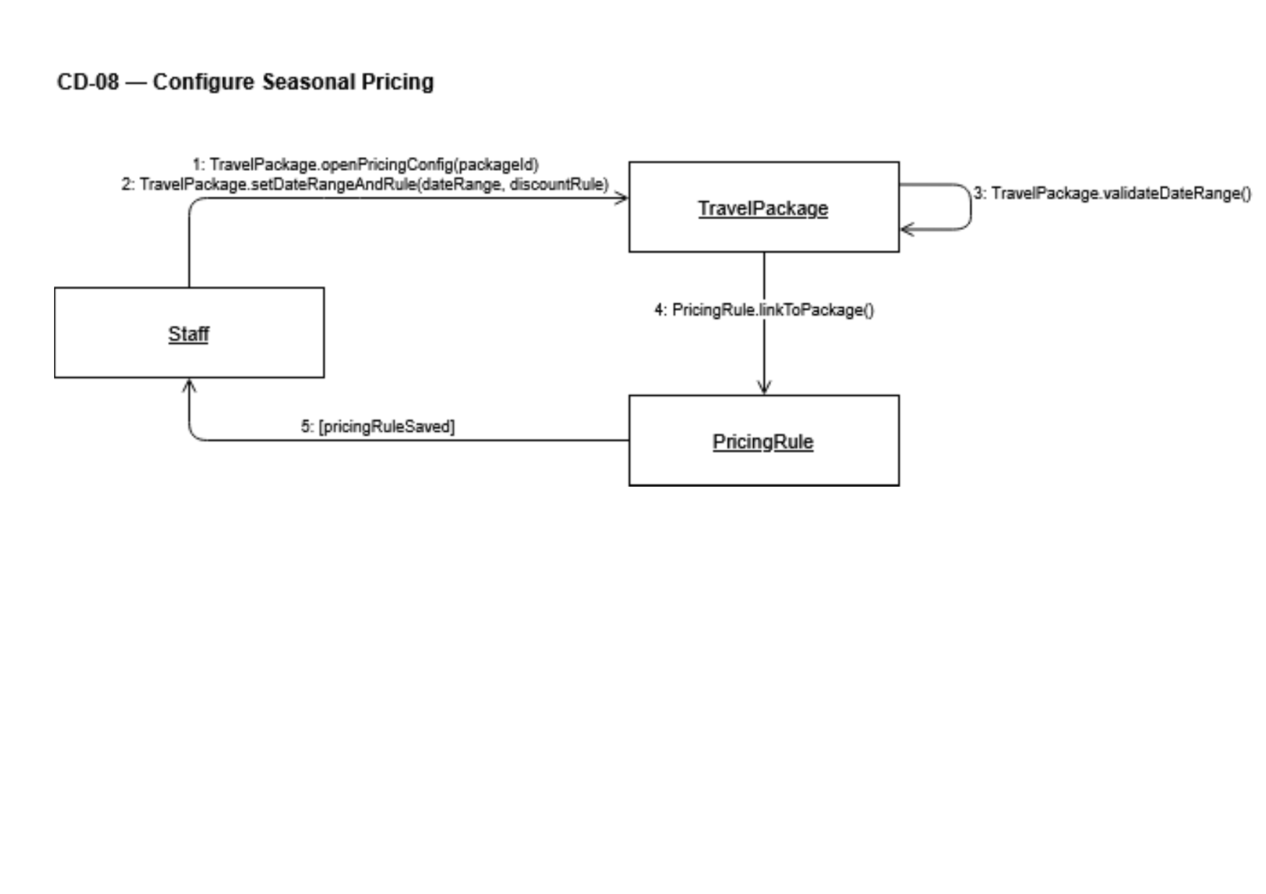
Prepared by: Amanda Shirka
CC-09: Update & Archive Travel Package
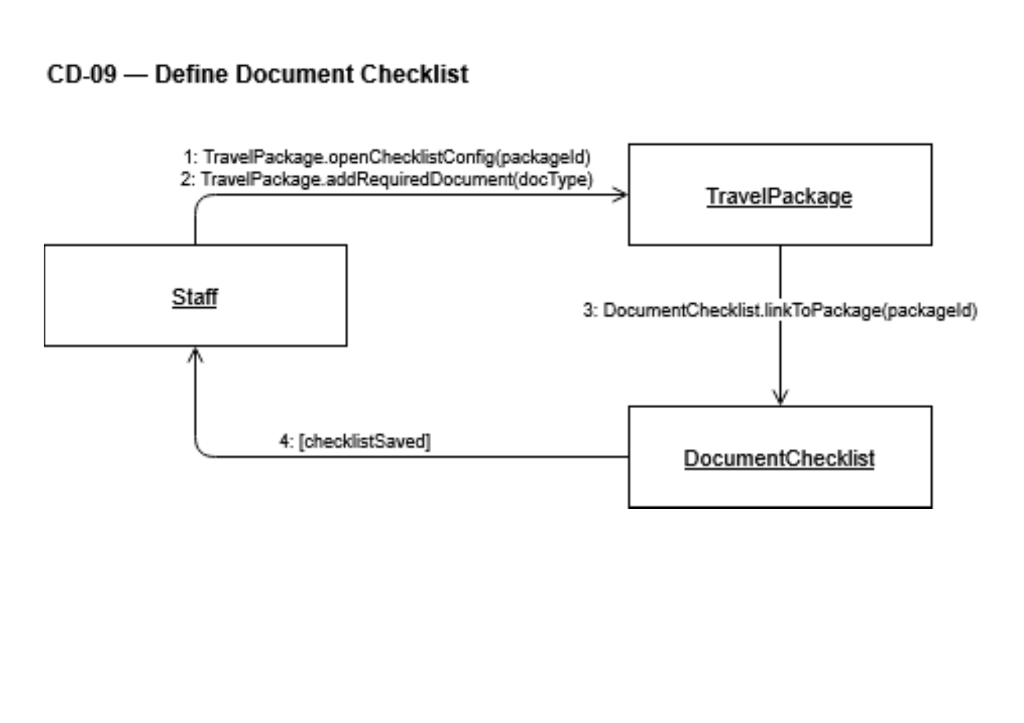
Prepared by: Amanda Shirka

CC-10: Define Seasonal Pricing & Discounts
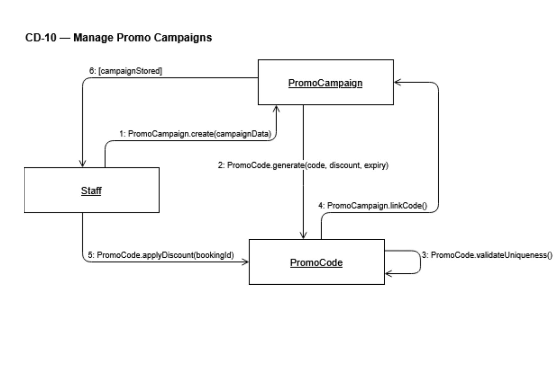
Prepared by: Amanda Shirka
CC-11: Manage Promotional Campaigns & Promo Codes

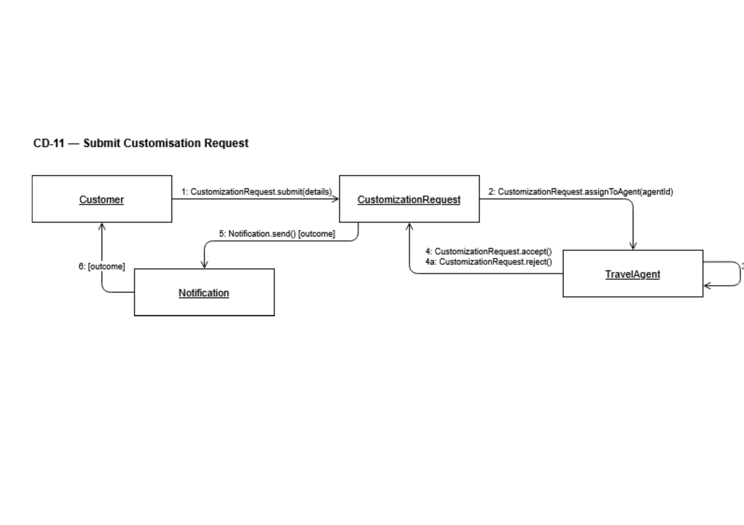
Prepared by: Amanda Shirka

CC-12: Define Package Document Checklist

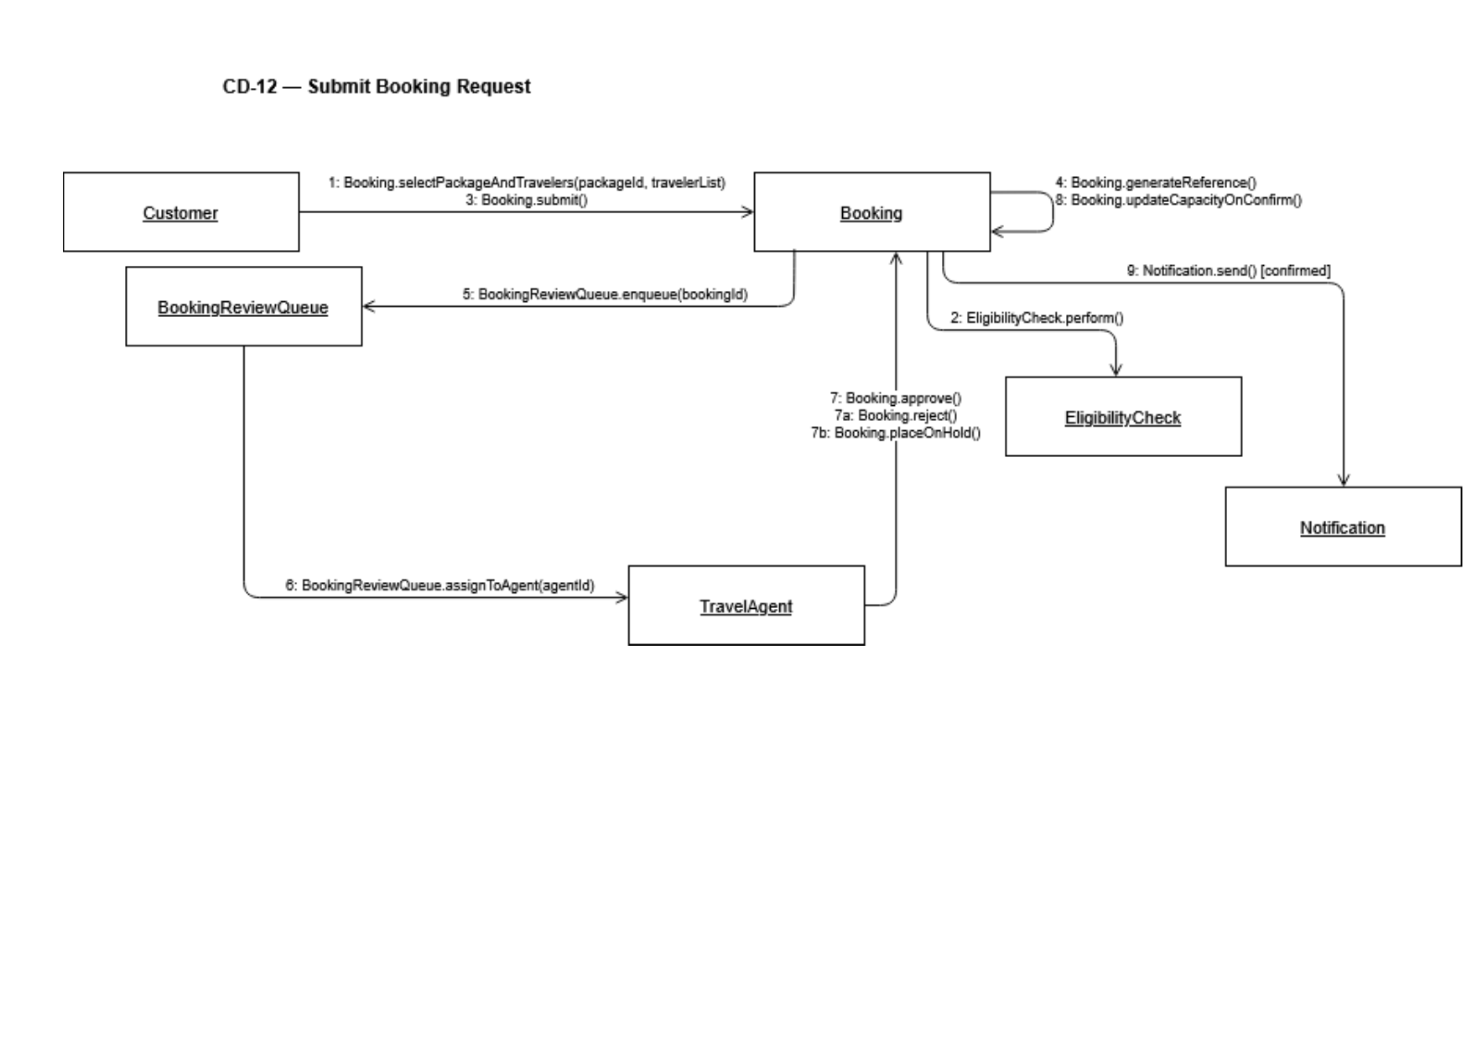
Prepared by: Amanda Shirka

CC-13: Submit & Review Package Customization Request
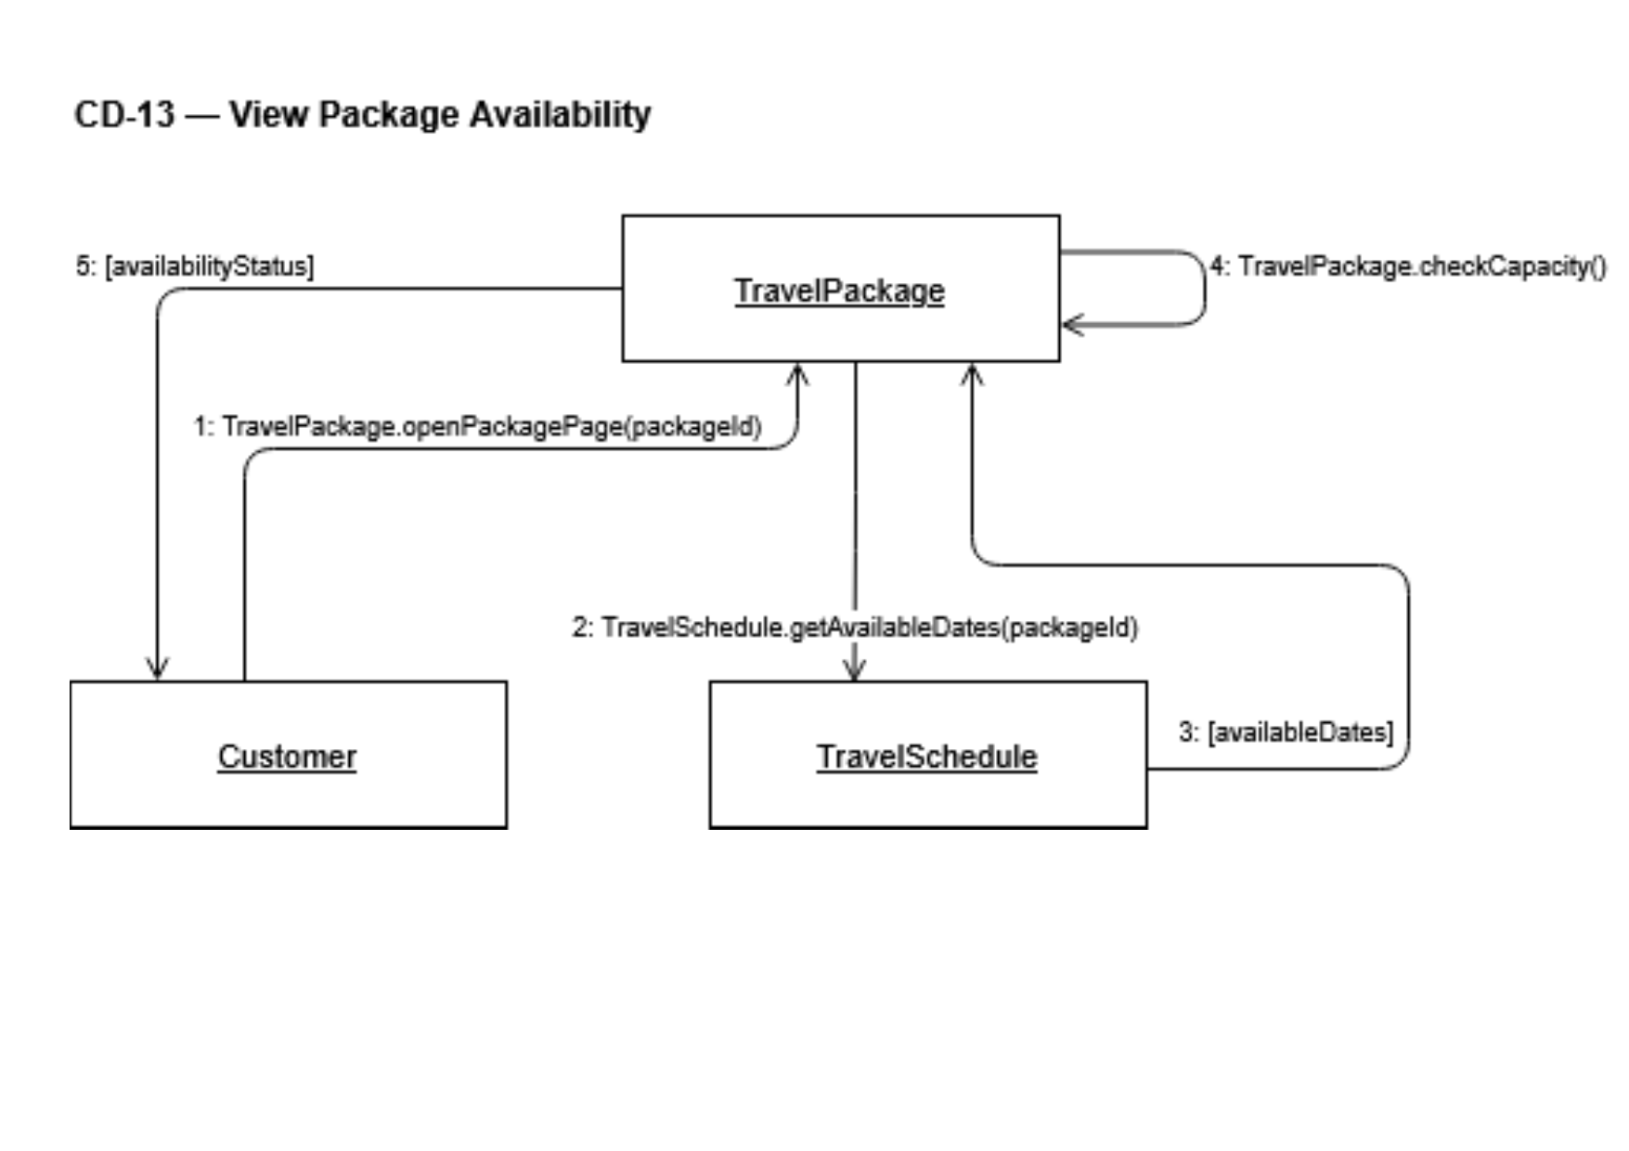
Prepared by: Amanda Shirka

CC-14: Duplicate Package as Template

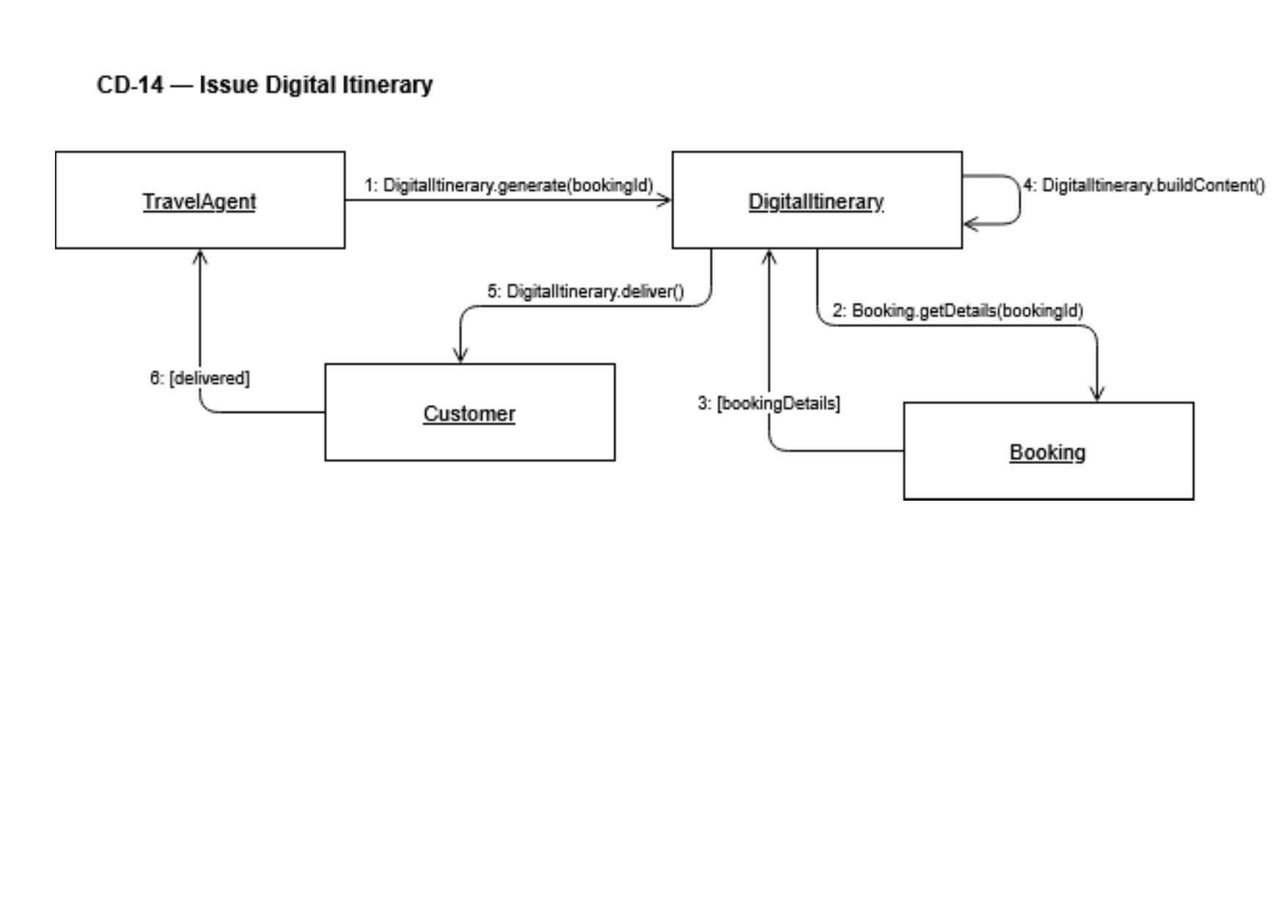
Prepared by: Amanda Shirka

CC-15: Submit Booking Request

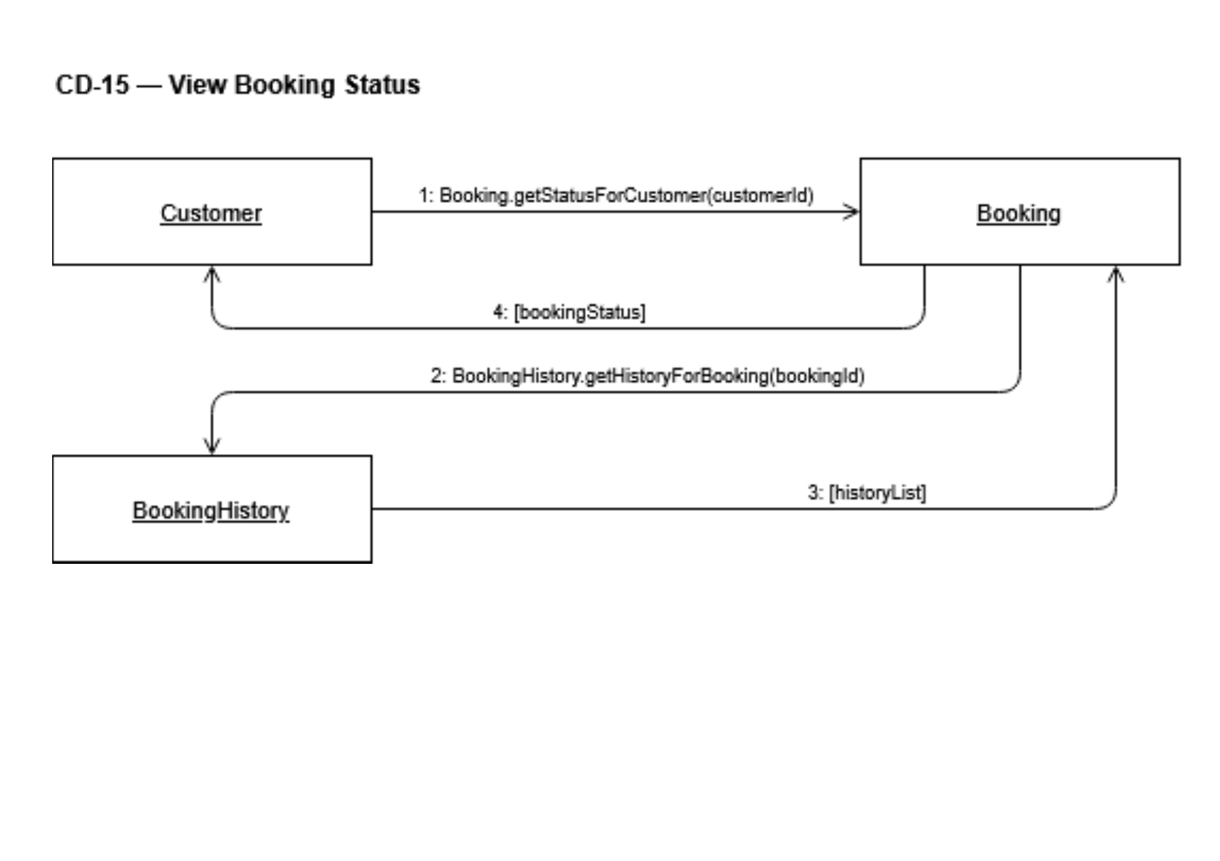
Prepared by: Alba Gjergji & Ana Gjergji

CC-16: Review & Process Booking
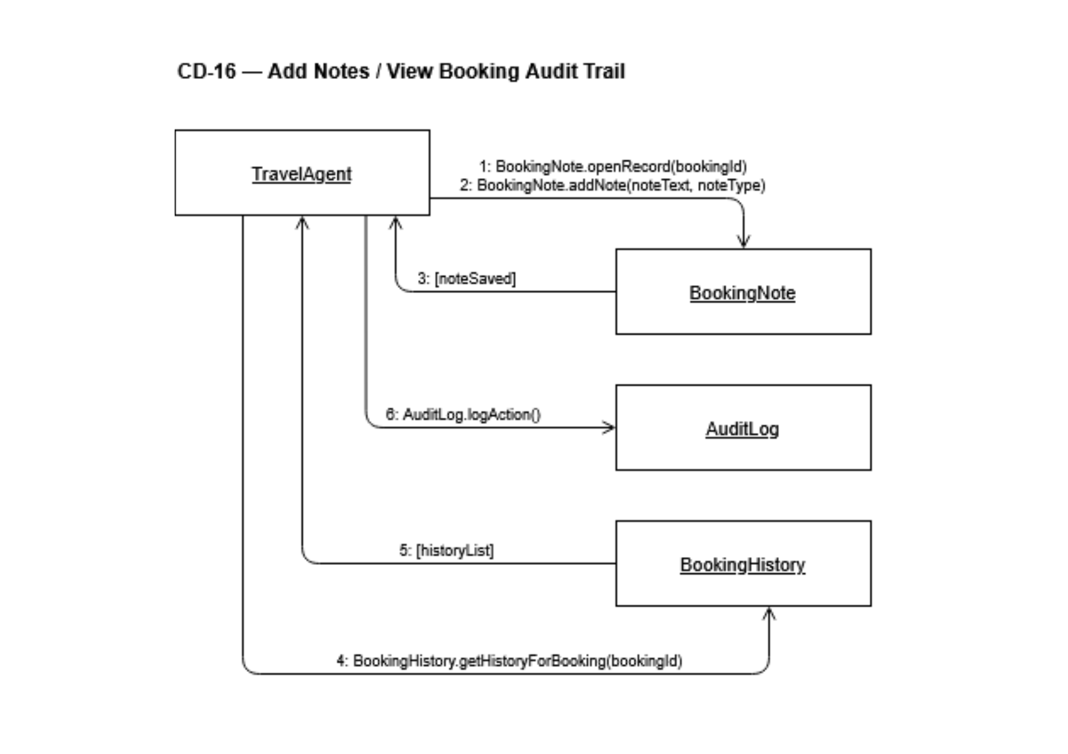
Prepared by: Alba Gjergji & Ana Gjergji
CC-17: Issue Digital Itinerary
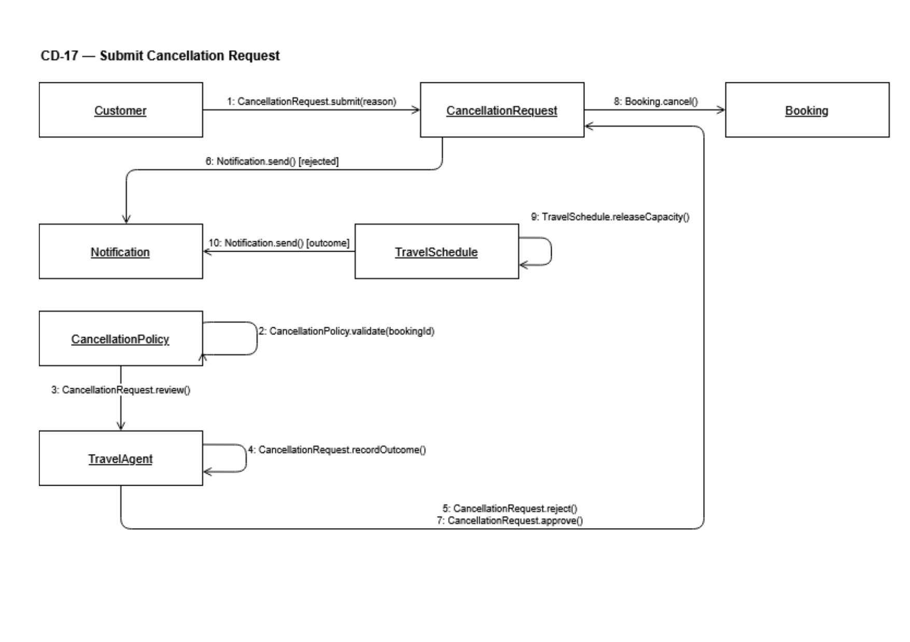
Prepared by: Alba Gjergji & Ana Gjergji

CC-18: View Booking Status
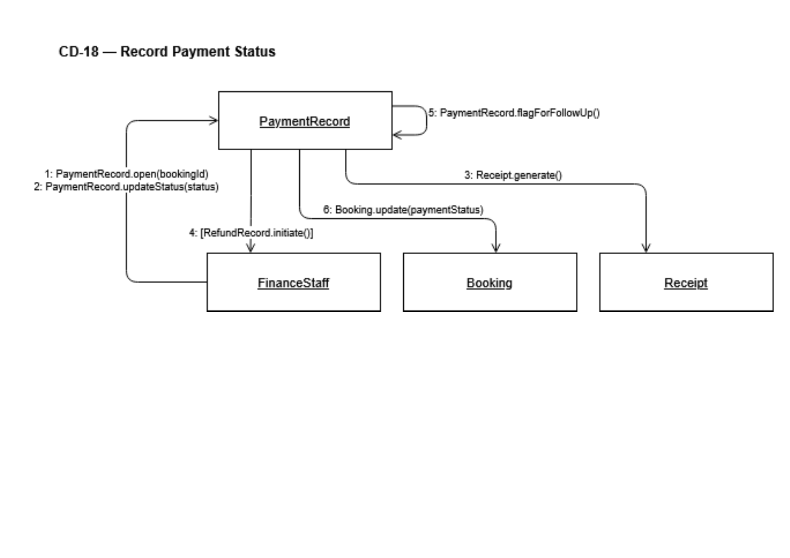
Prepared by: Alba Gjergji & Ana Gjergji
CC-19: Submit & Process Cancellation

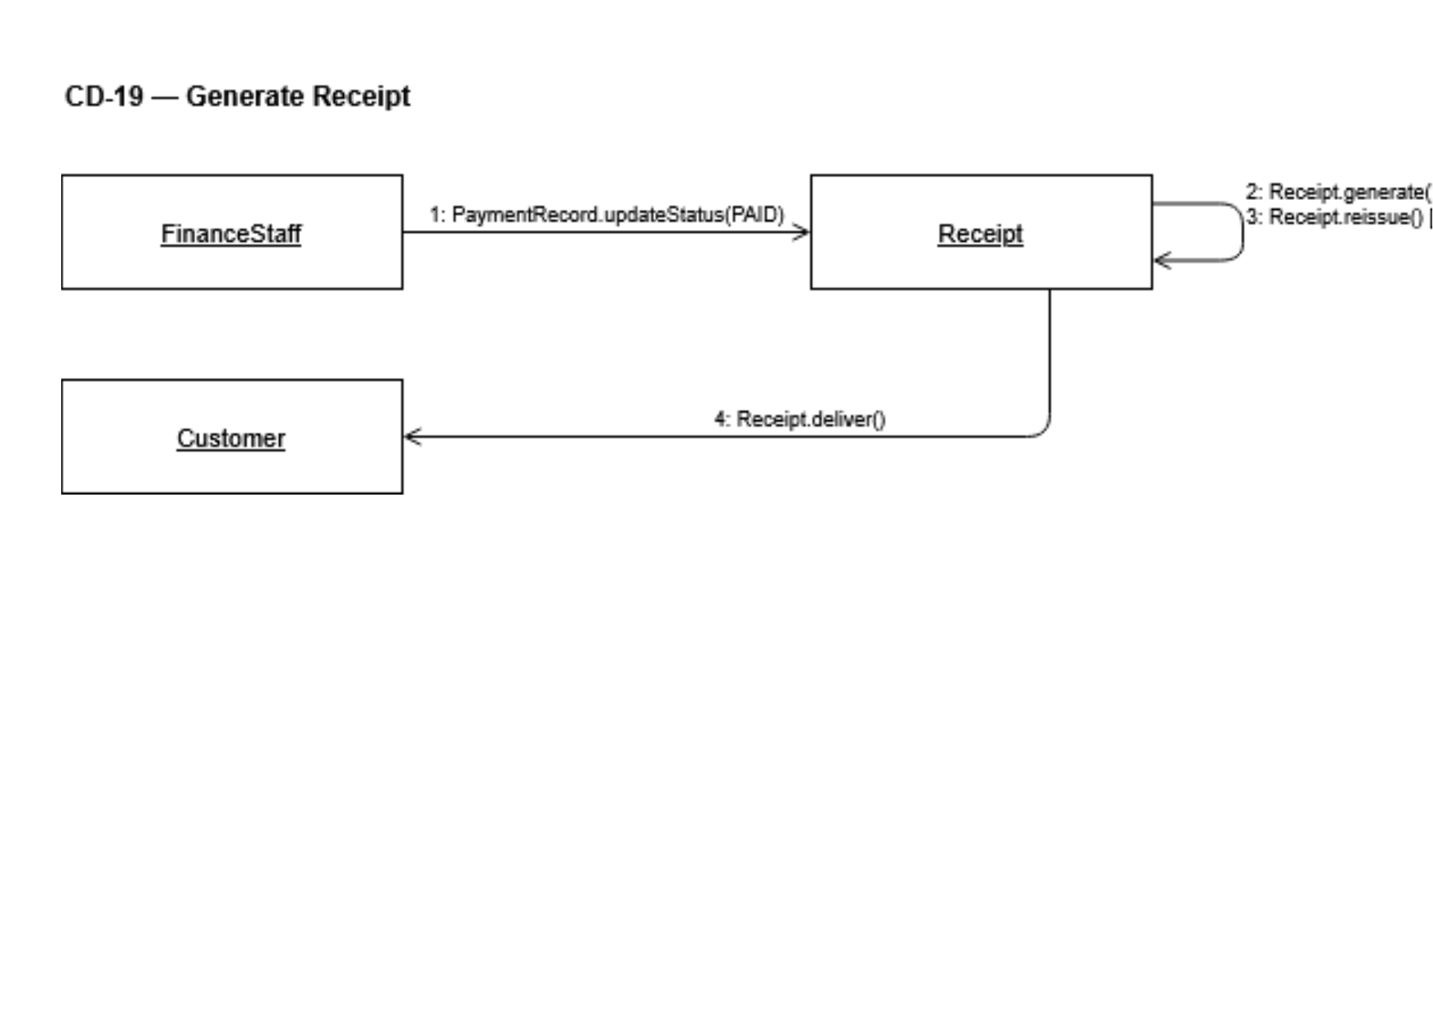
Prepared by: Alba Gjergji & Ana Gjergji

CC-20: Add Notes & Booking History
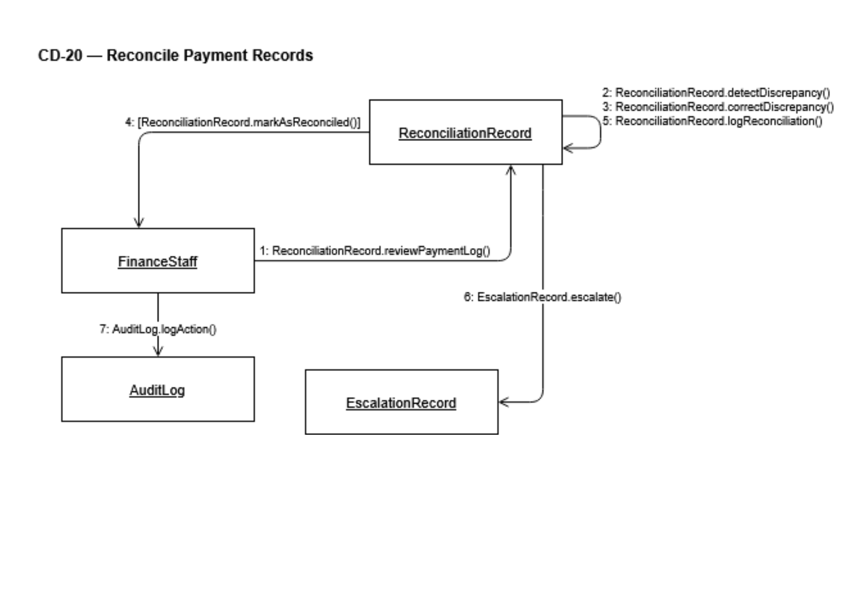
Prepared by: Alba Gjergji & Ana Gjergji
CC-21: Modify Booking Details

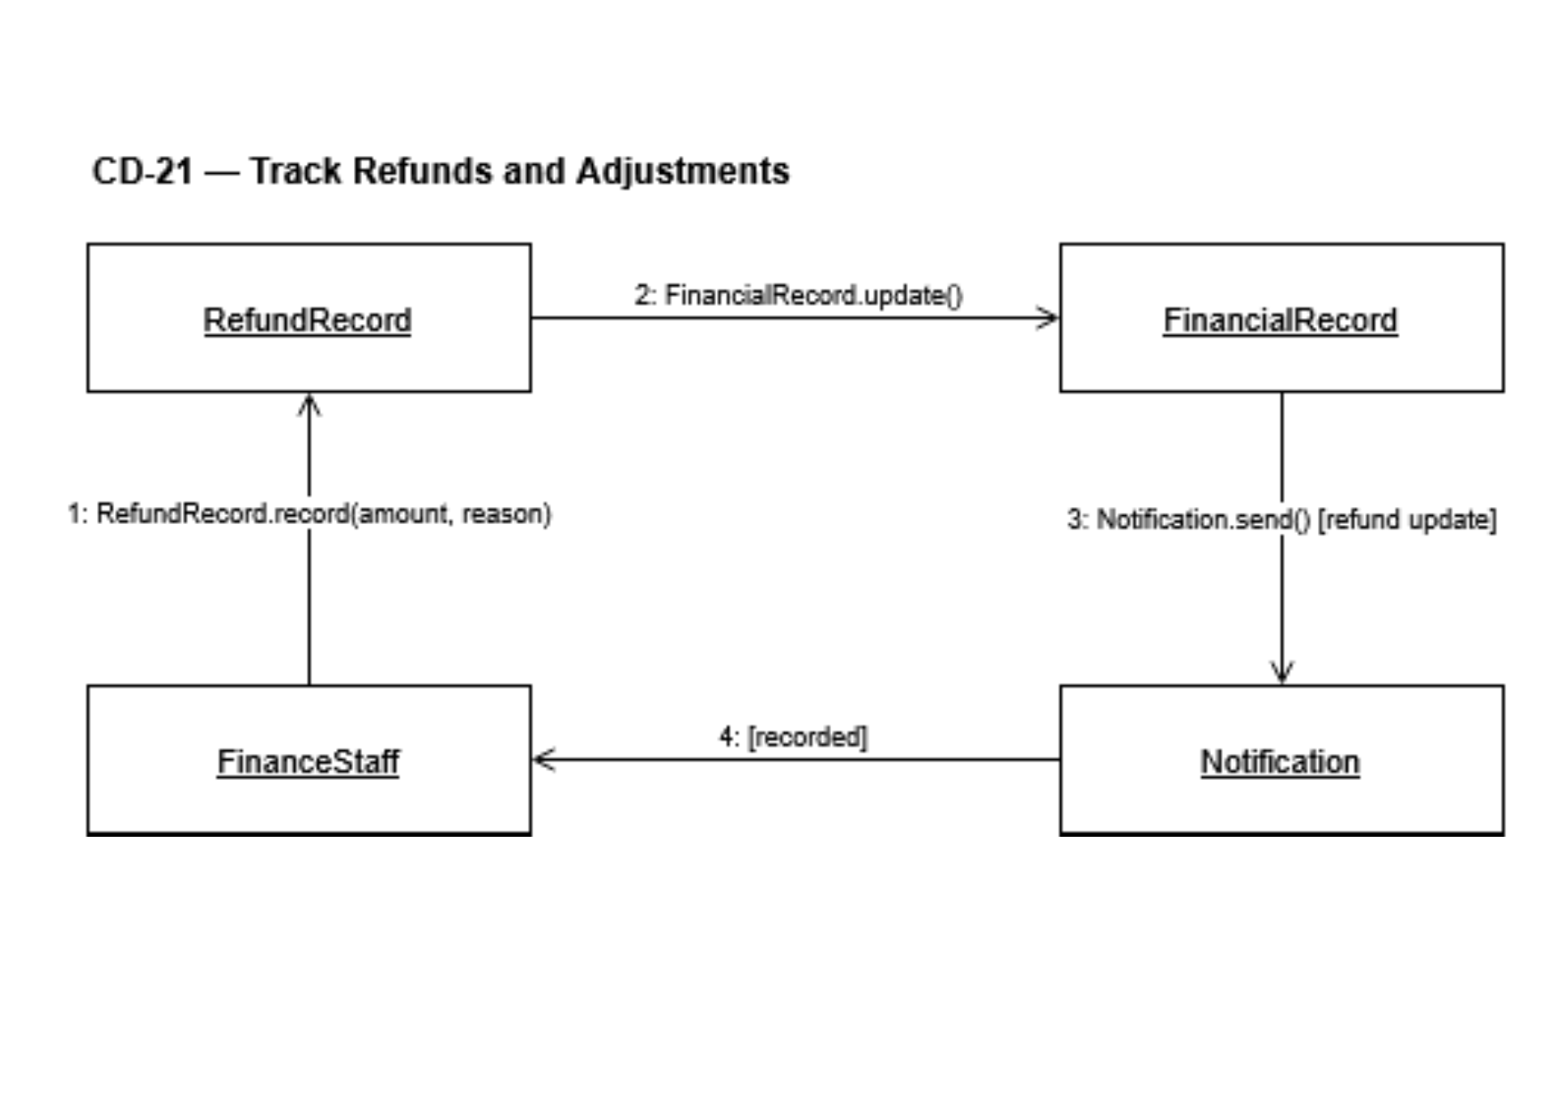
Prepared by: Alba Gjergji & Ana Gjergji

CC-22: Upload & Verify Travel Documents
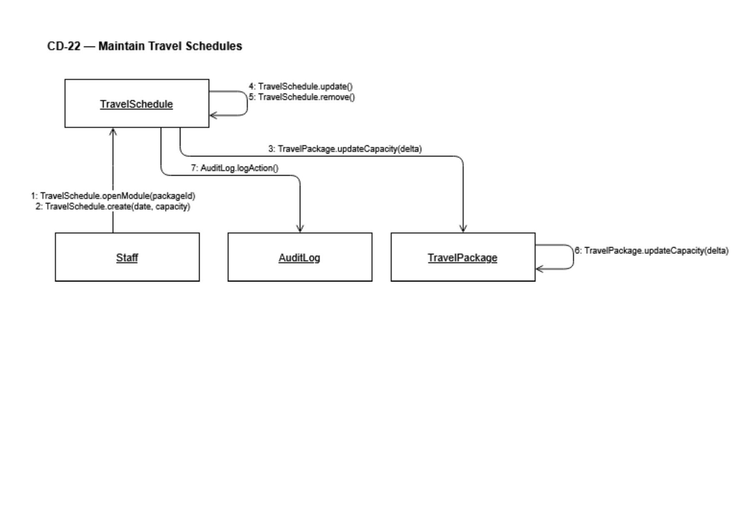
Prepared by: Alba Gjergji & Ana Gjergji
CC-23: Join & Manage Waitlist
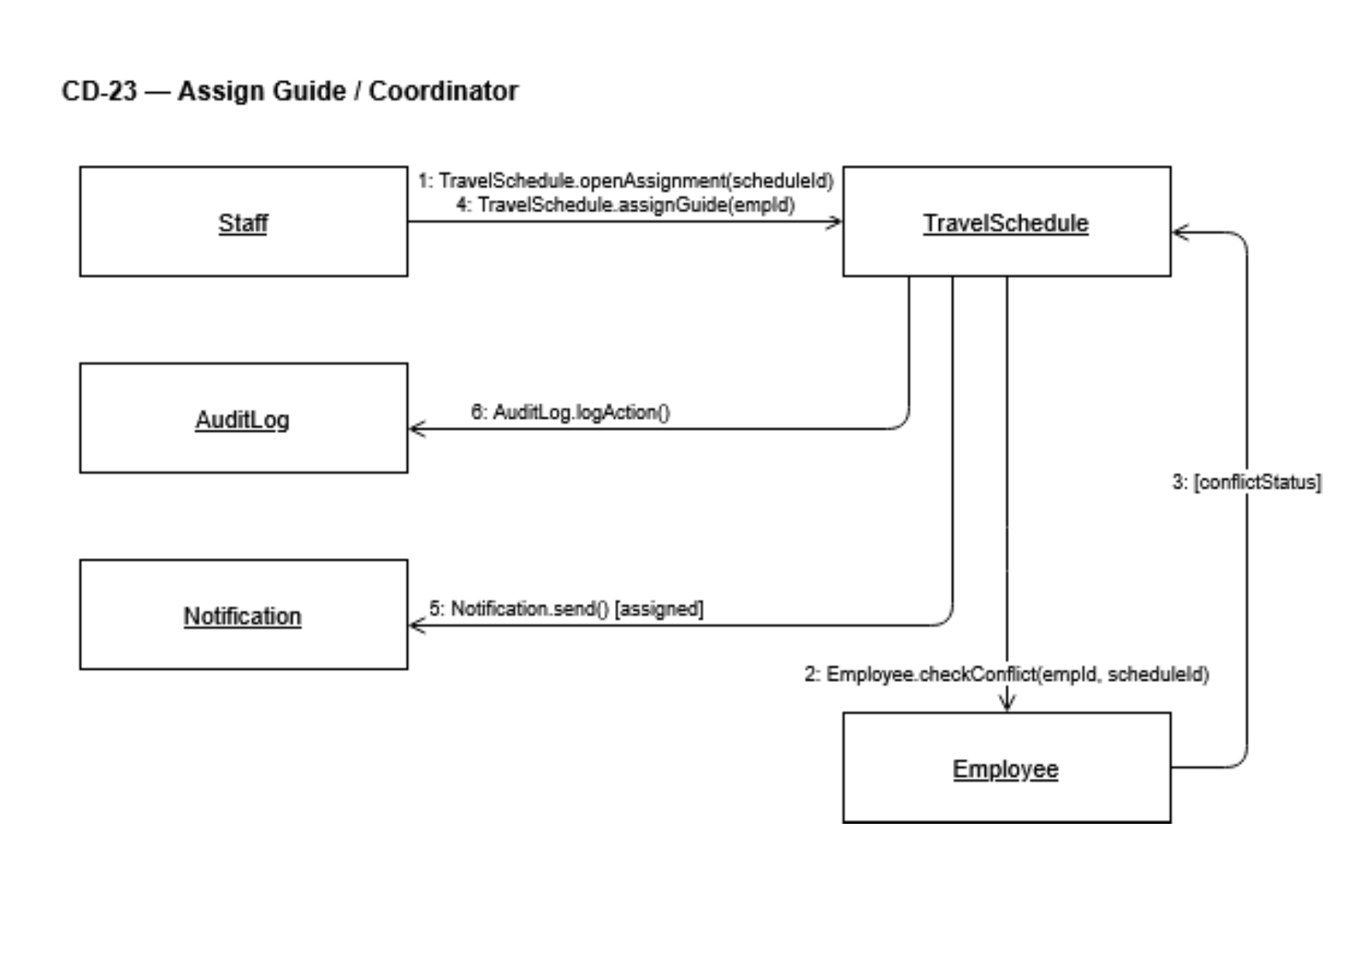
Prepared by: Alba Gjergji & Ana Gjergji

CC-24: Create & Manage Travel Schedule
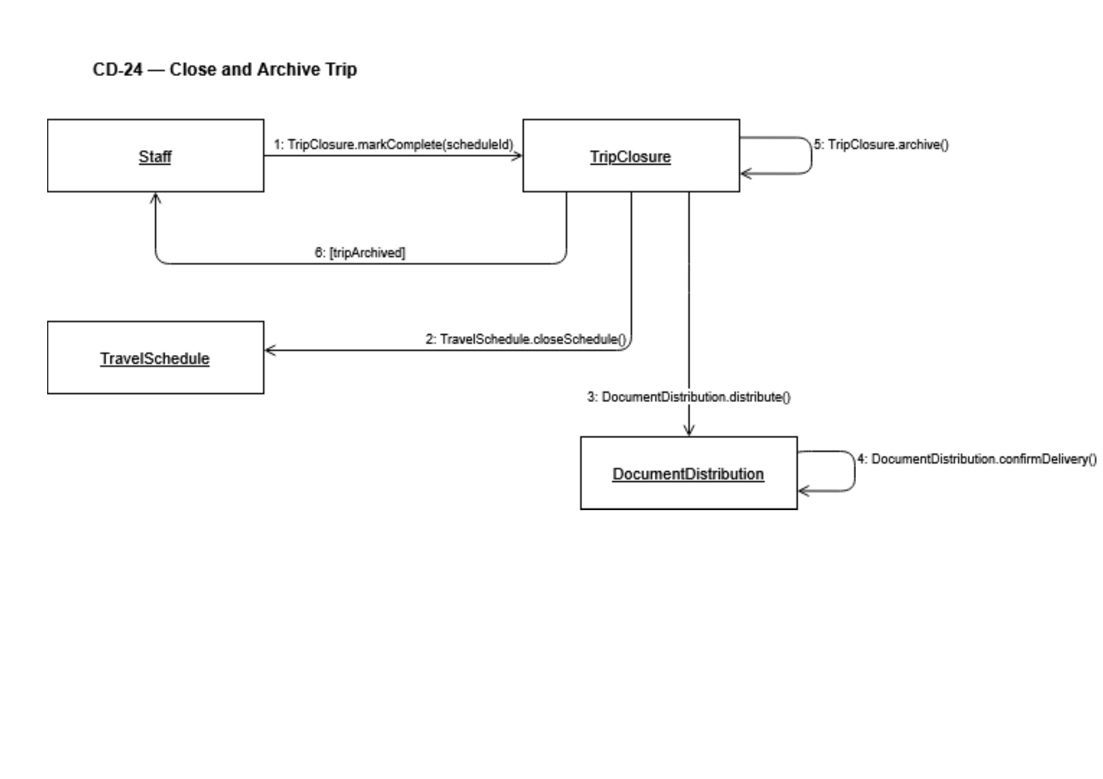
Prepared by: Gledis Ruci
CC-25: Assign Guide or Coordinator
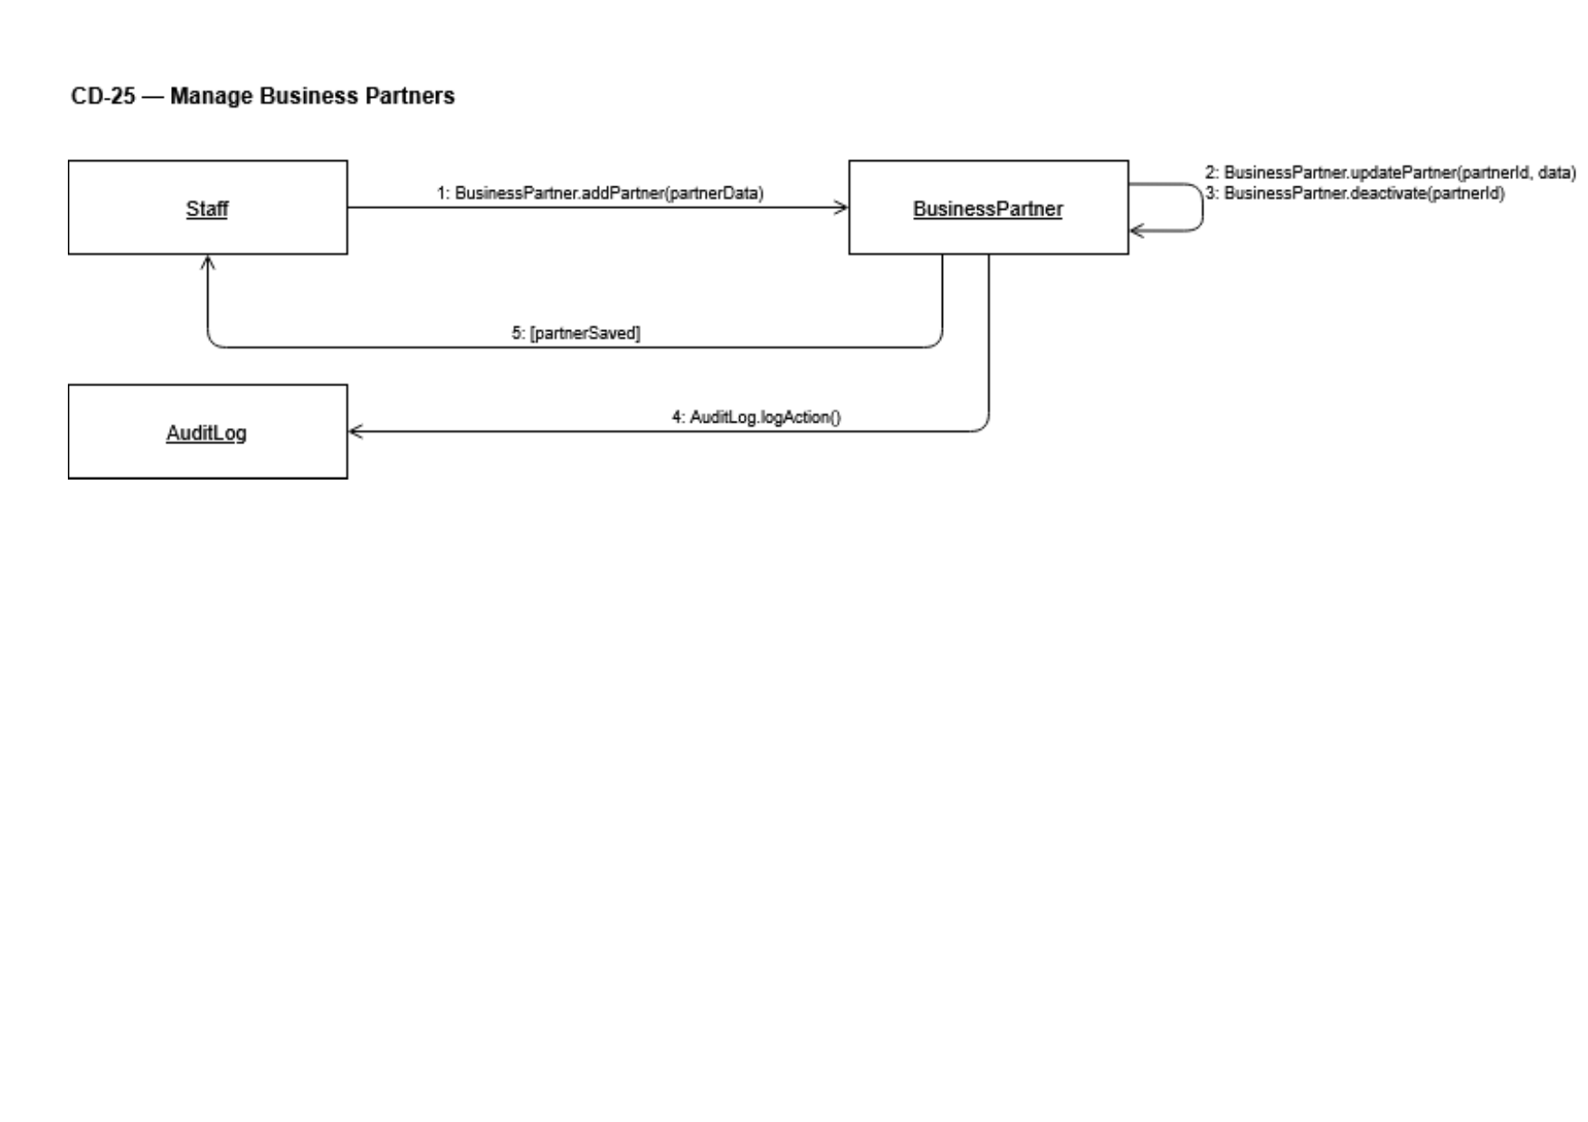
Prepared by: Gledis Ruci

CC-26: Close & Archive Completed Trip
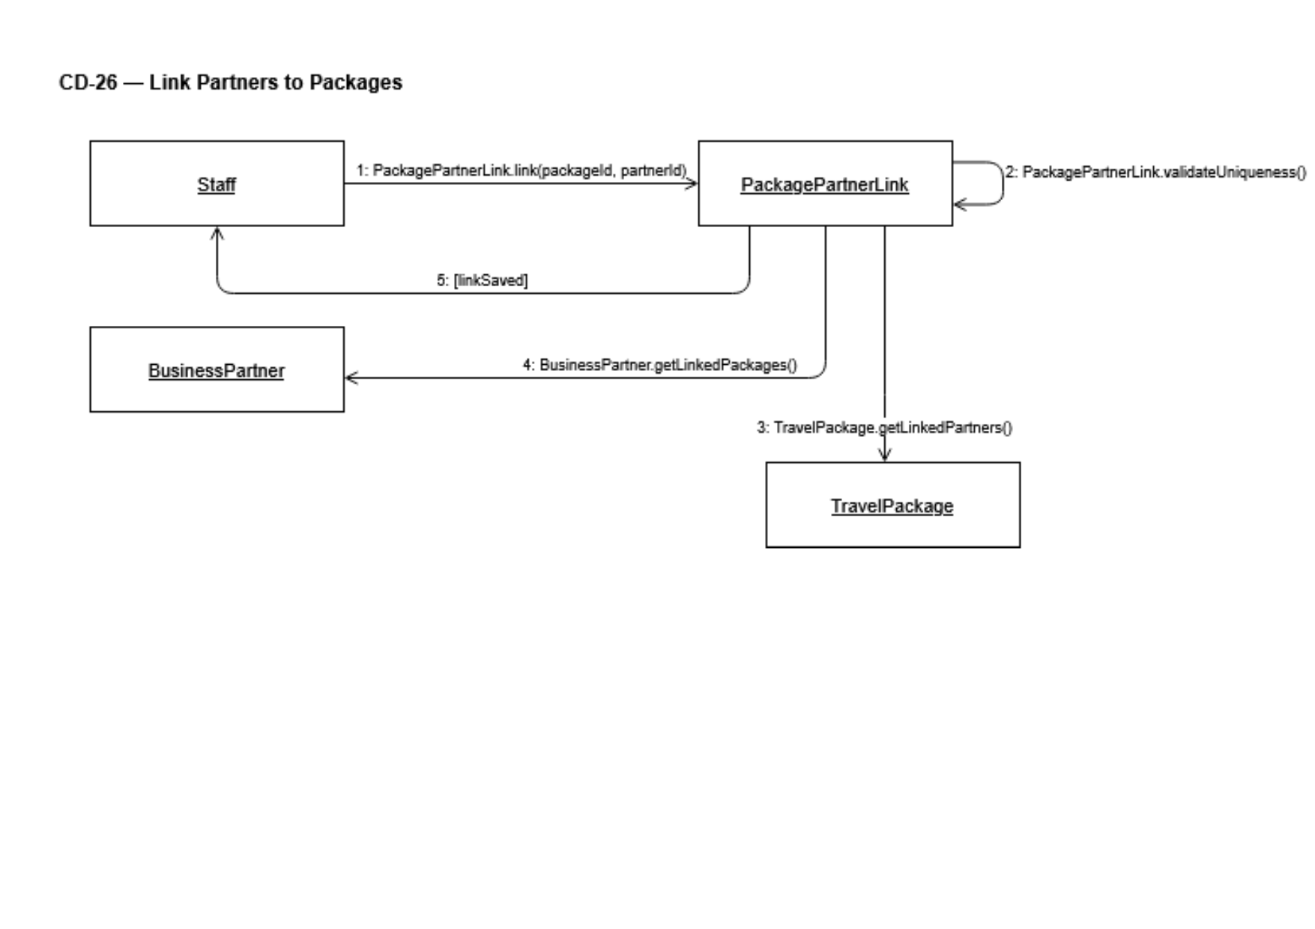
Prepared by: Gledis Ruci

CC-27: Distribute Trip Documents
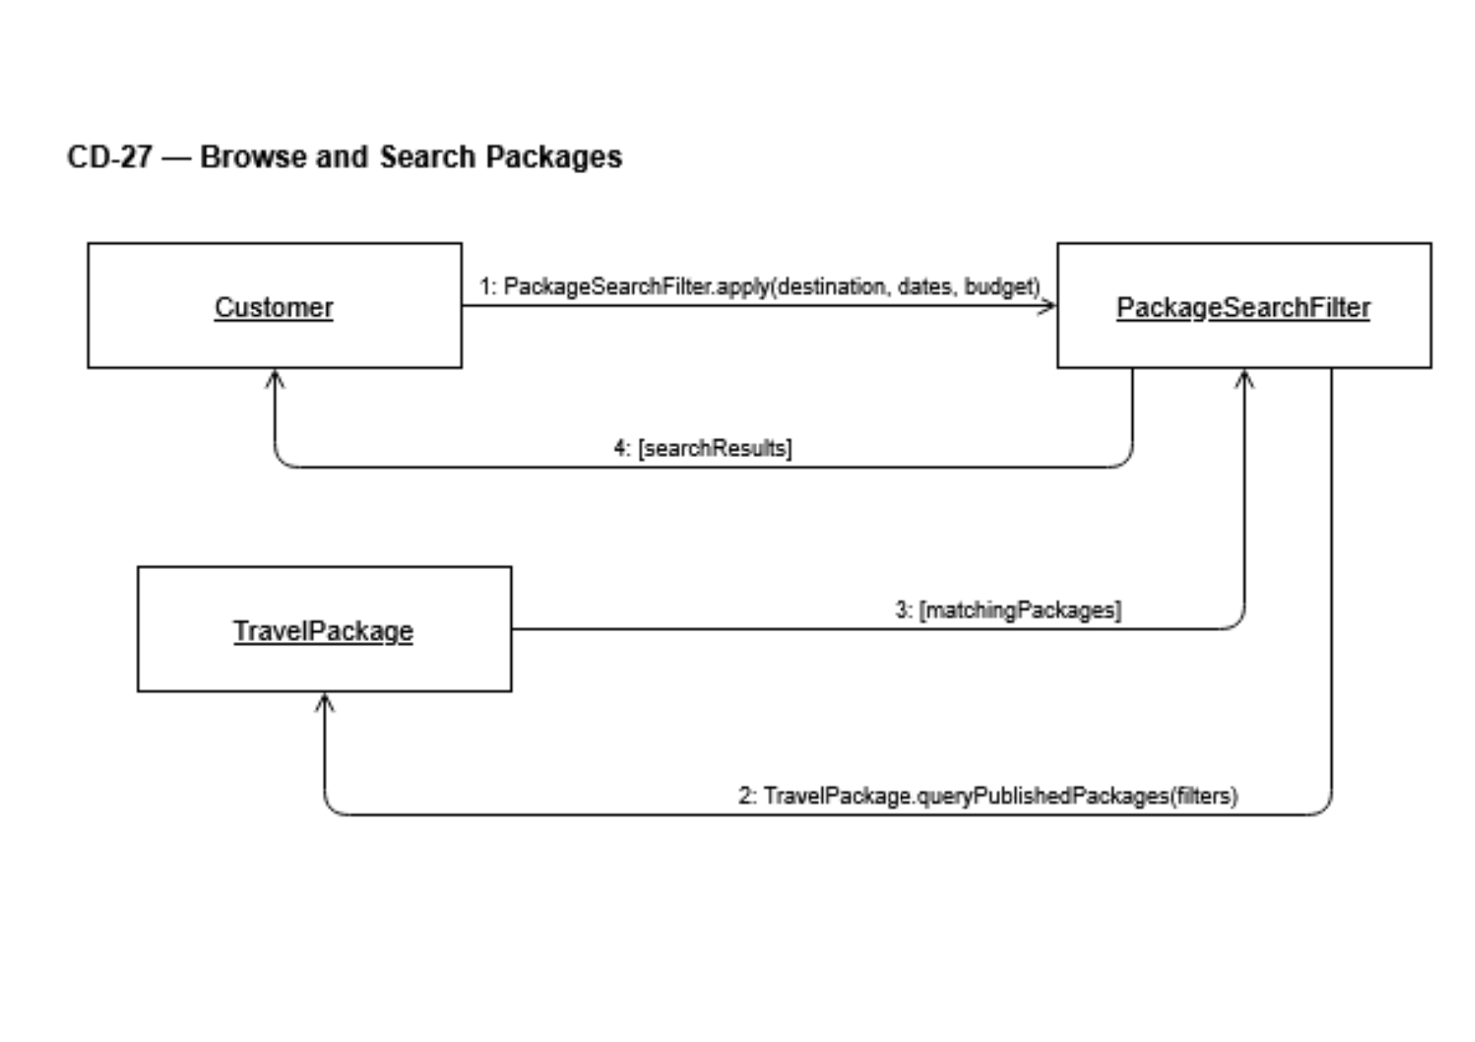
Prepared by: Gledis Ruci

CC-28: Track Trip Lifecycle Status
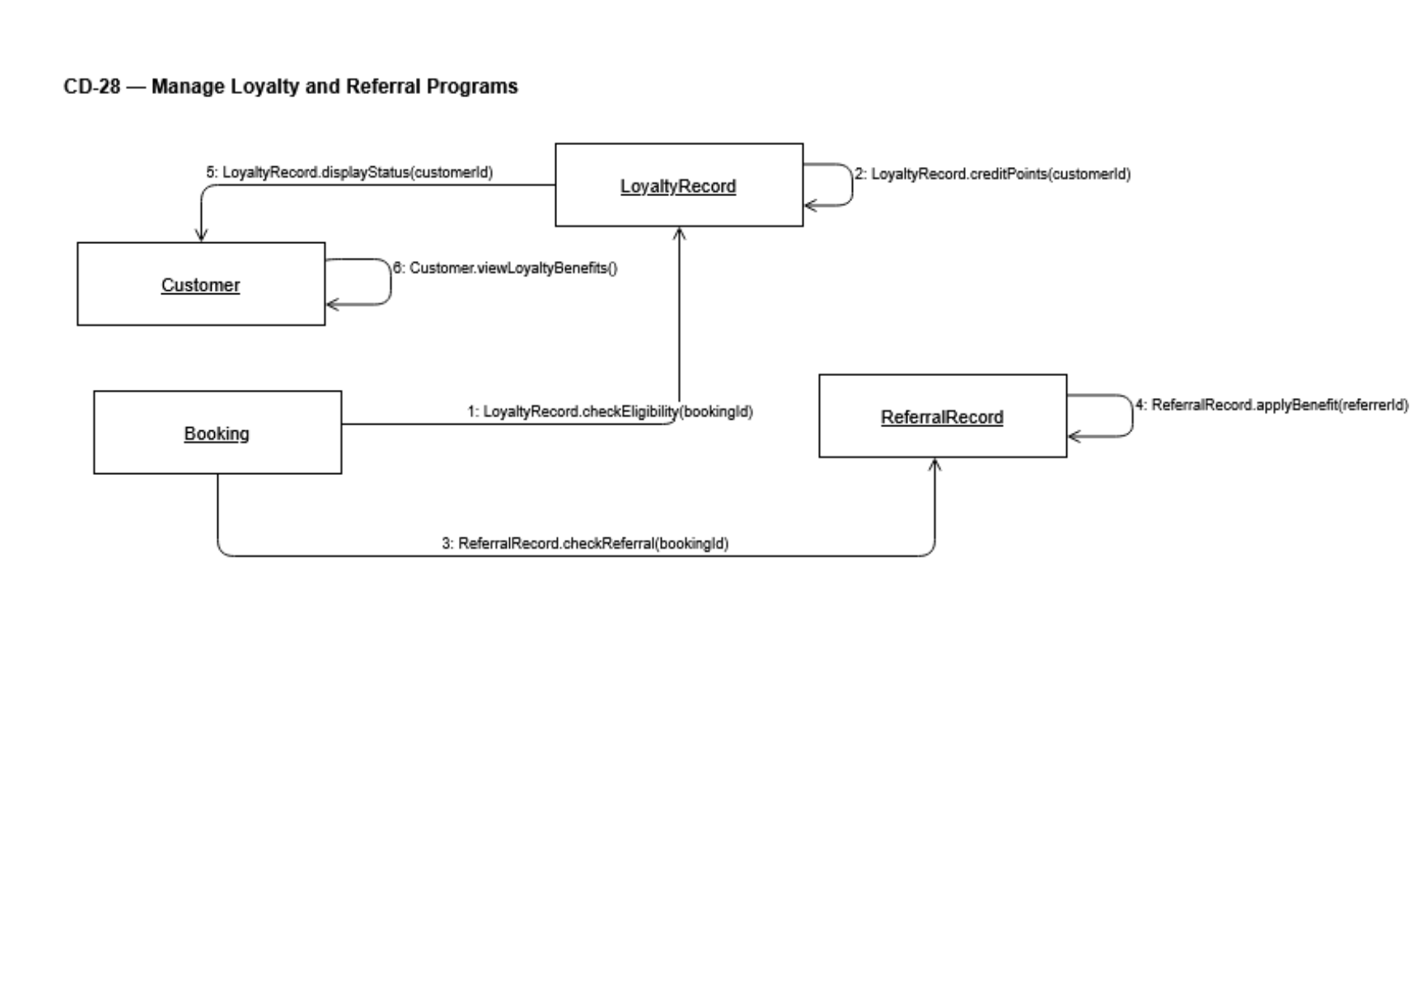
Prepared by: Gledis Ruci

CC-29: Manage Business Partner Records
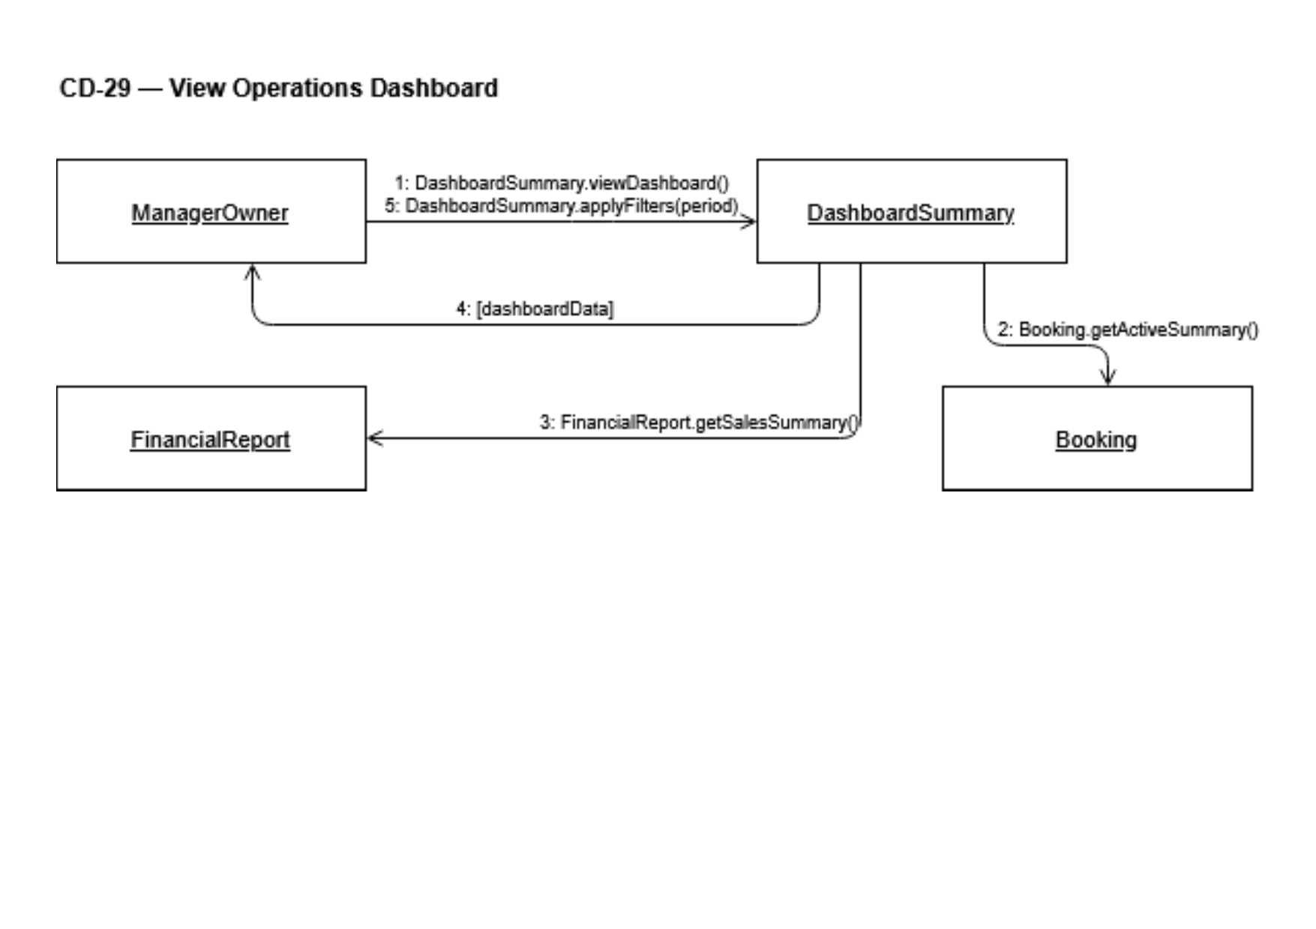
Prepared by: Henri Aliaj

CC-30: Link Partners to Travel Package
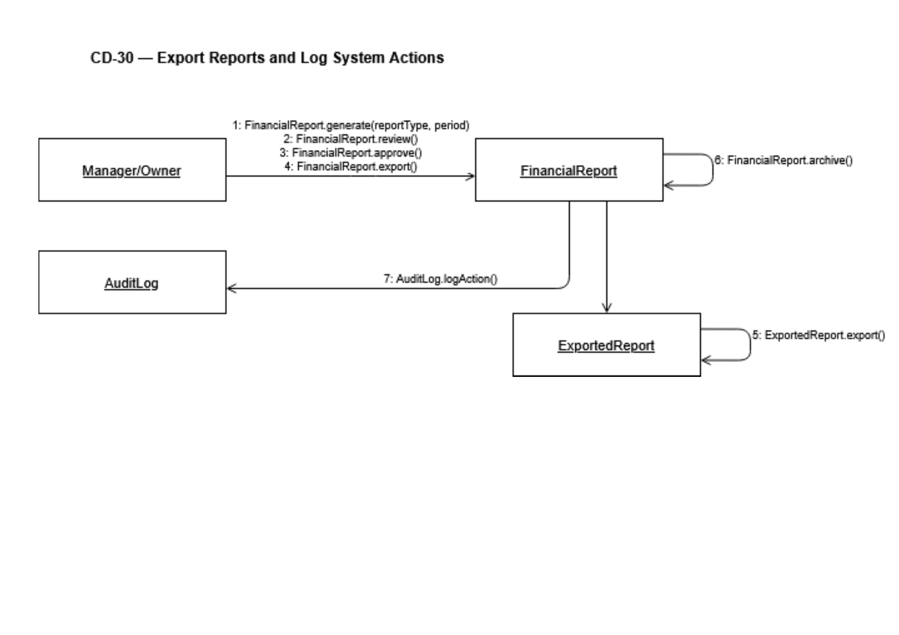
Prepared by: Henri Aliaj

5.8 Interaction Overview Diagrams (IOD-01 – IOD-03)
Interaction Overview Diagrams combine activity diagram structure with UML ref frames that reference existing sequence diagrams by name. Each ref frame (marked with the 'ref' tab) points to one of the project's 30 sequence diagrams, showing how interactions chain together at a workflow level. Decision diamonds, merge nodes, fork/join bars, flow final nodes, and activity final nodes follow standard UML notation.

IOD-01: Customer Booking Journey
End-to-end flow from account access through booking submission, staff review, and itinerary issuance. References: SD-01, SD-02, SD-15, SD-16, SD-17, SD-18, SD-20, SD-22.
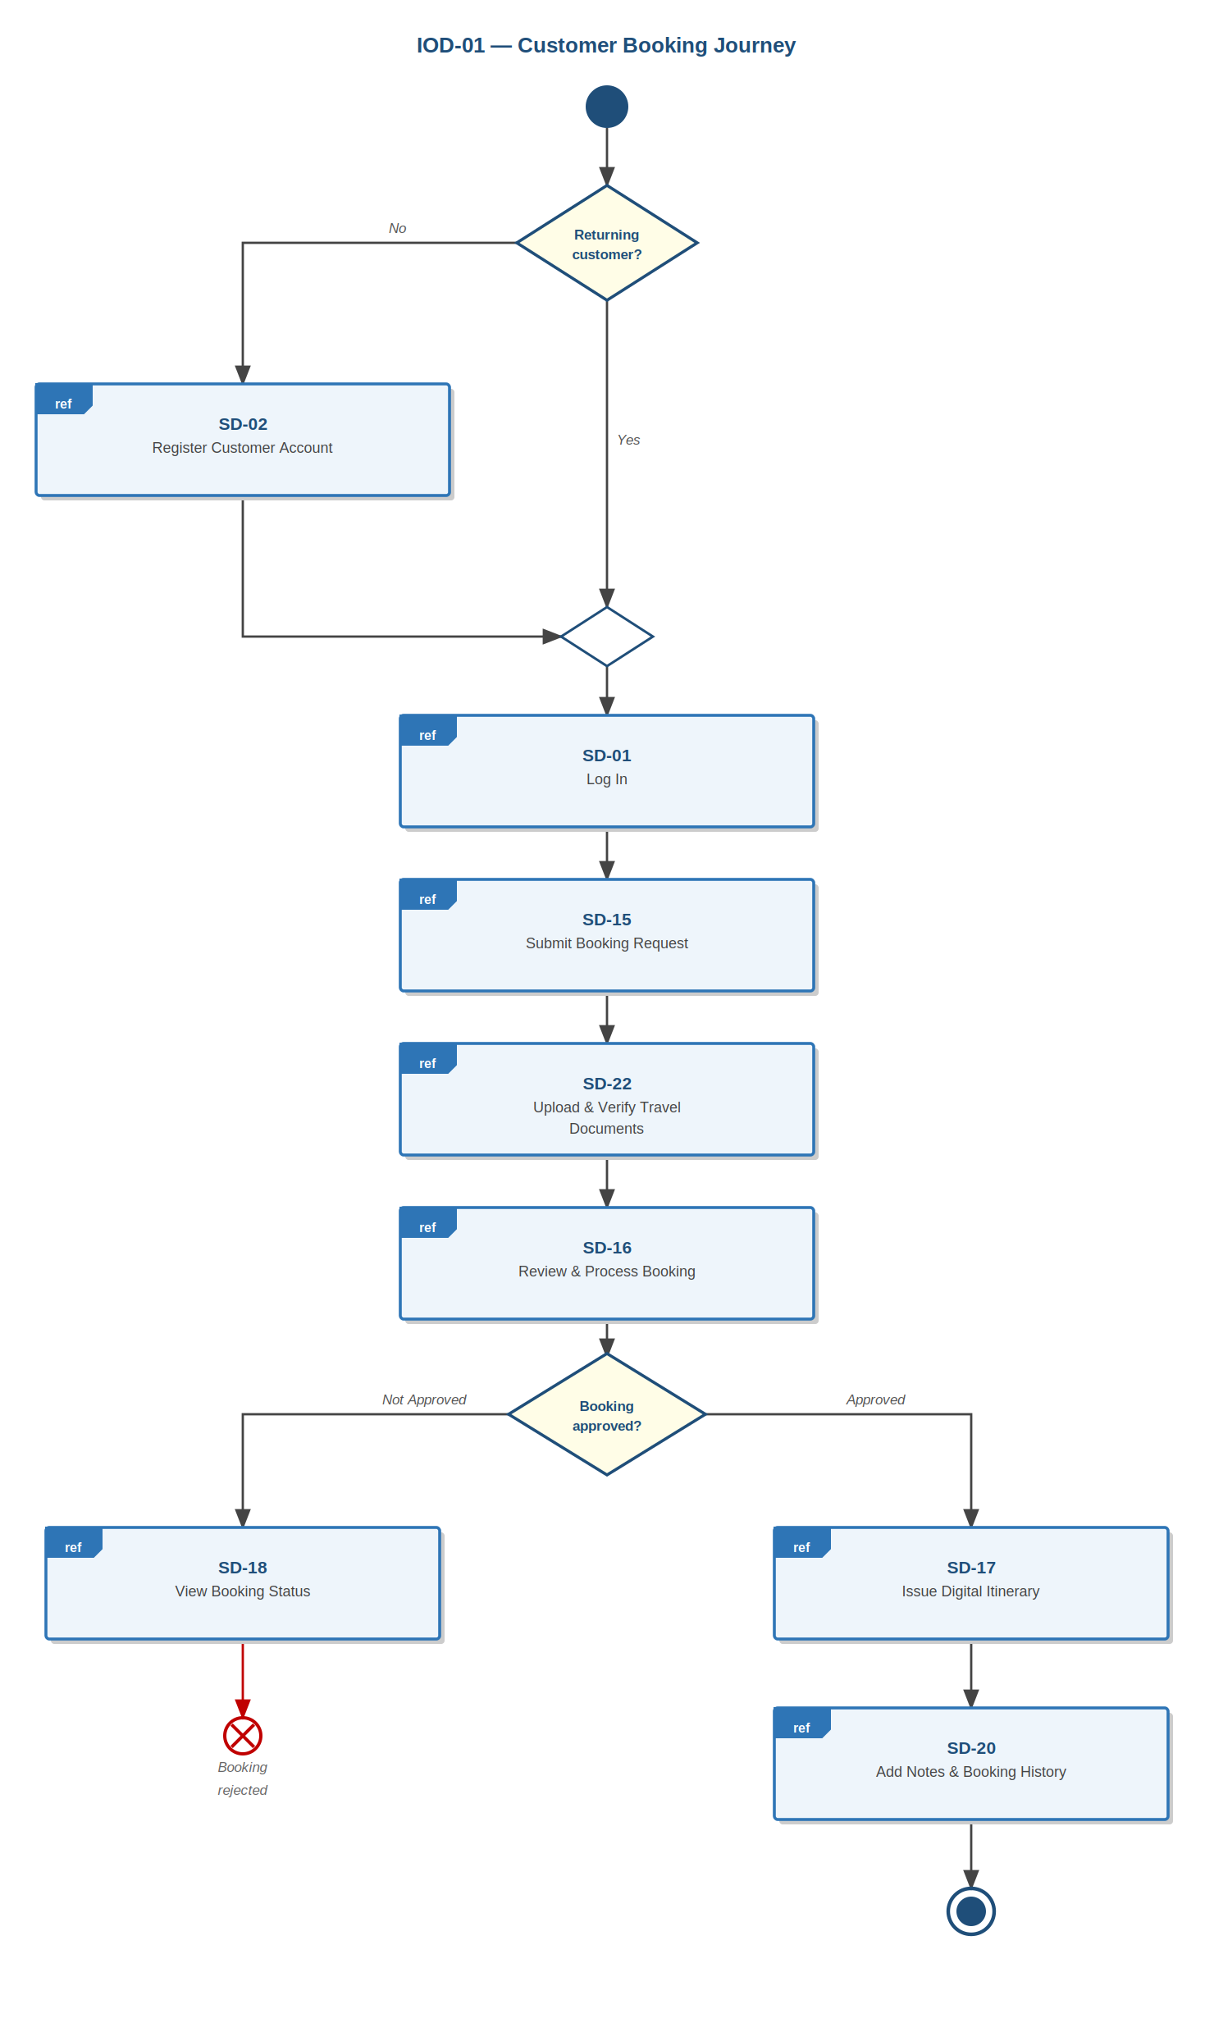
Prepared by: Alba Gjergji & Ana Gjergji

IOD-02: Cancellation & Refund Flow
Flow from booking status review through cancellation processing, policy evaluation, optional refund recording, and audit note creation. References: SD-01, SD-18, SD-19, SD-20, SD-36.
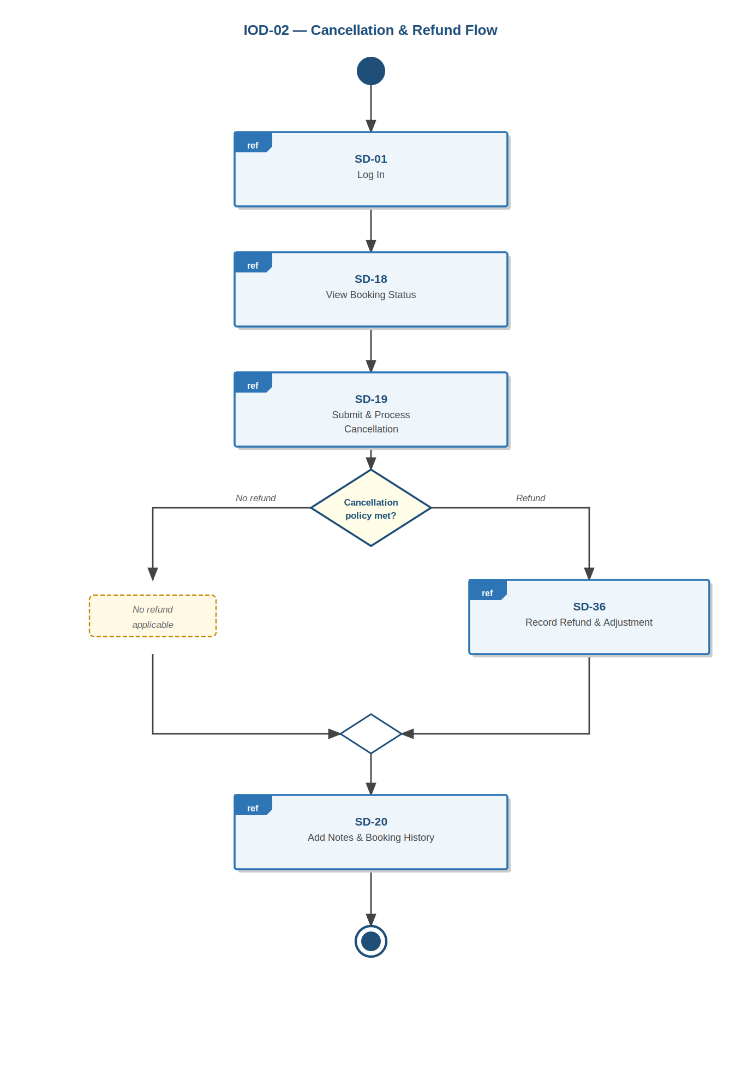
Prepared by: Alba Gjergji & Ana Gjergji

IOD-03: Package Setup & Trip Operations
Operations staff workflow covering package creation, parallel configuration and partner setup (fork/join), schedule creation, guide assignment, document distribution, and trip archival. References: SD-01, SD-08, SD-10, SD-12, SD-24, SD-25, SD-26, SD-27, SD-29, SD-30.
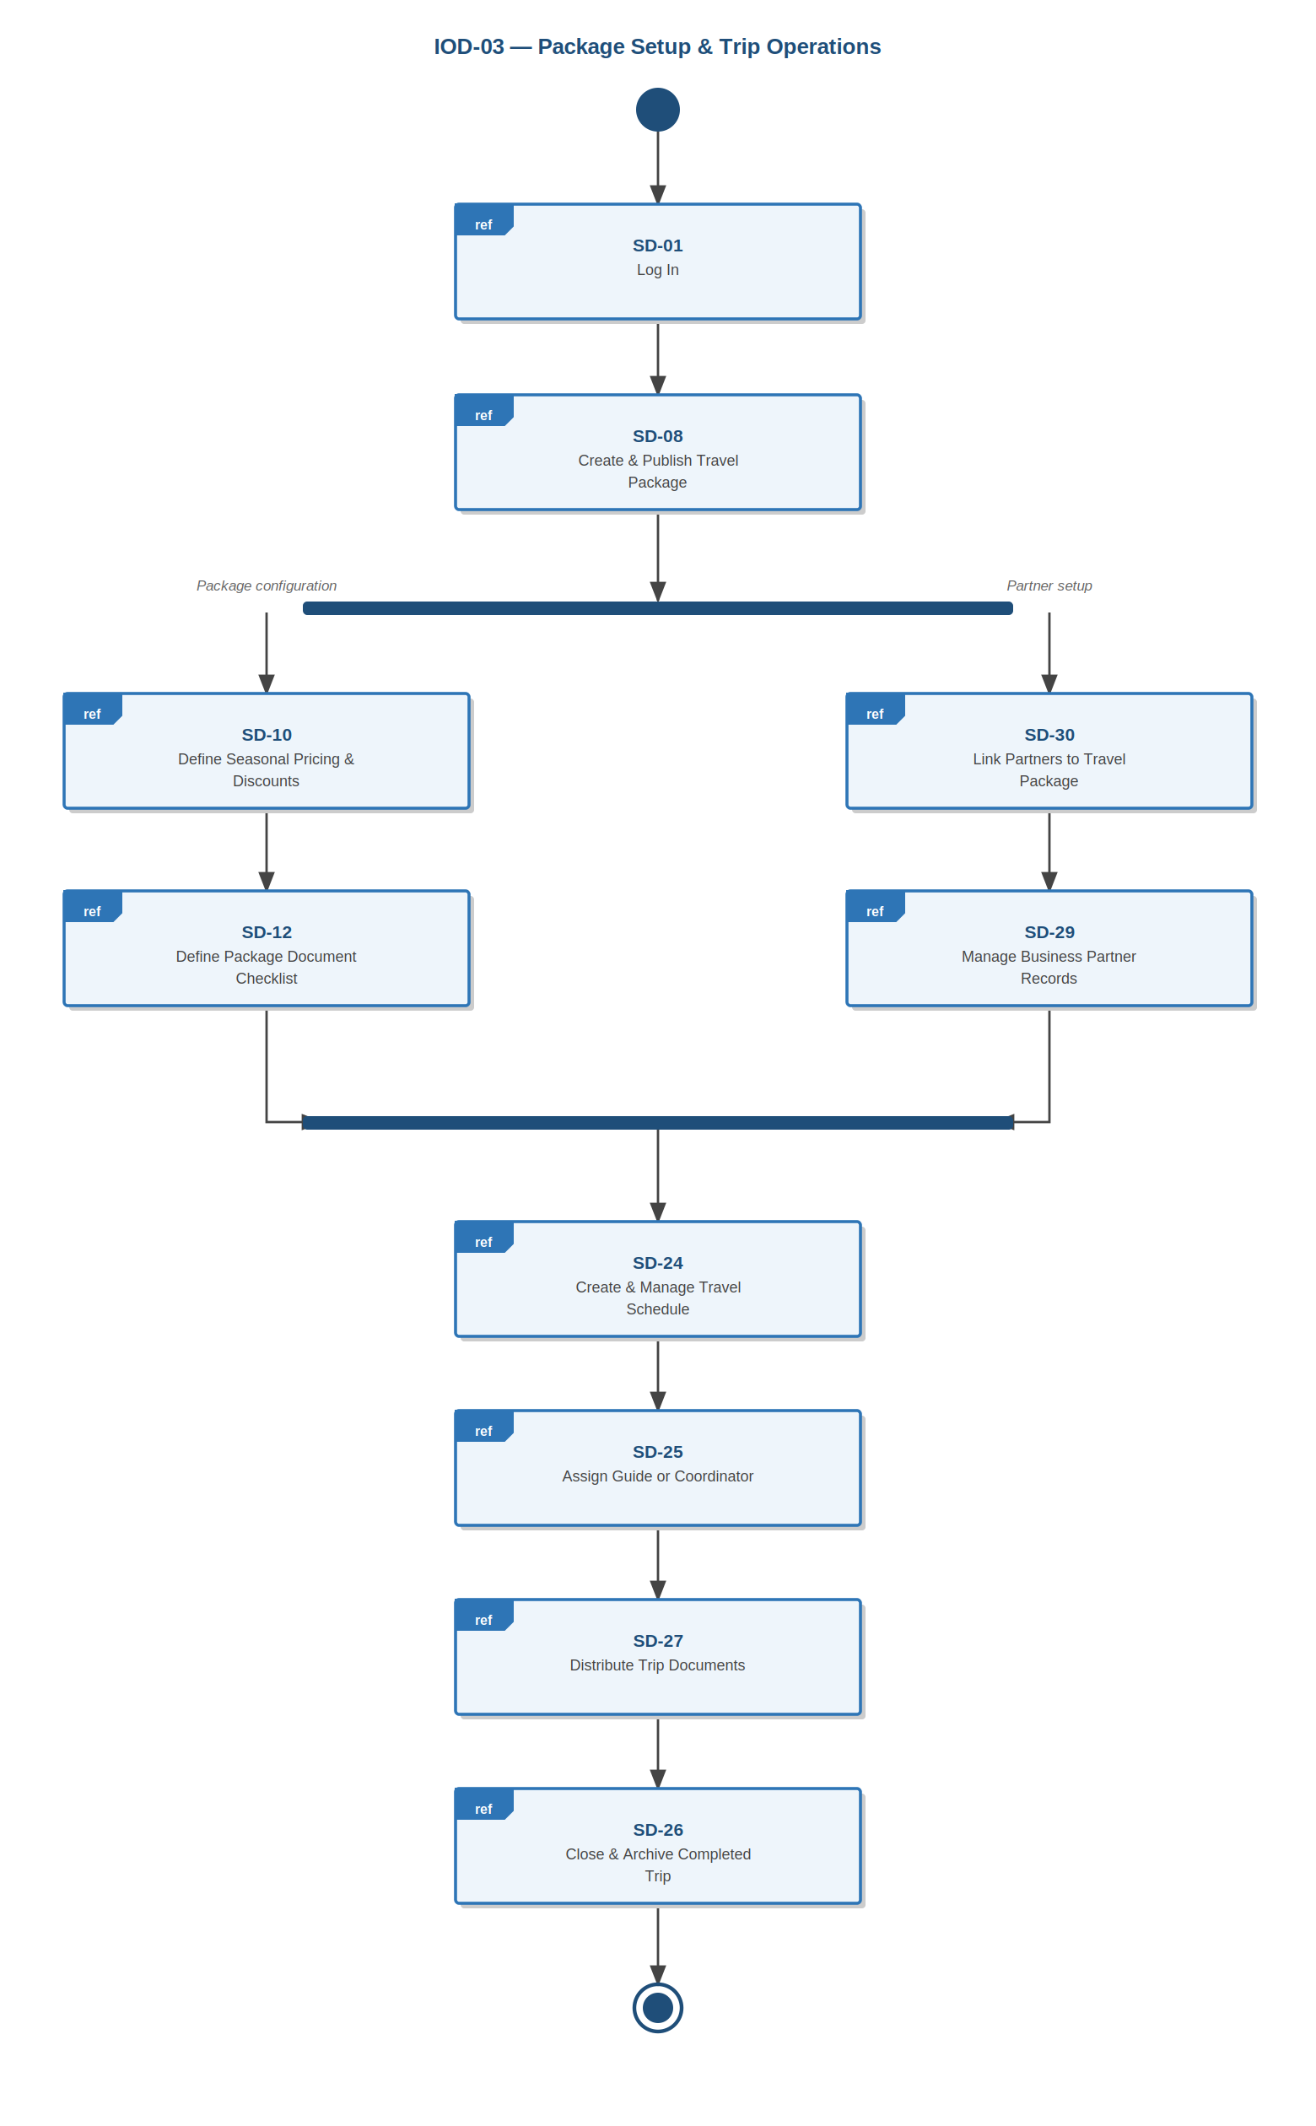
Prepared by: Amanda Shirka & Gledis Ruci

5.9 BPMN Process Diagrams (BPMN-01 – BPMN-03)
Three BPMN 2.0 process diagrams model key end-to-end business workflows using swimlane notation. These provide a business-process-level view supplementing the UML diagrams. Each diagram uses exclusive (XOR) gateways shown as diamonds with an X marker; the decision question is labelled above each gateway and the branch conditions are labelled on the outgoing sequence flows. The diagrams are wide horizontal swimlane processes, best viewed zoomed in the digital document.
BPMN-01: Package to Booking
End-to-end flow from package browsing to confirmed booking. Participants: Customer, Travel Agent, Operations Staff, Finance Staff.
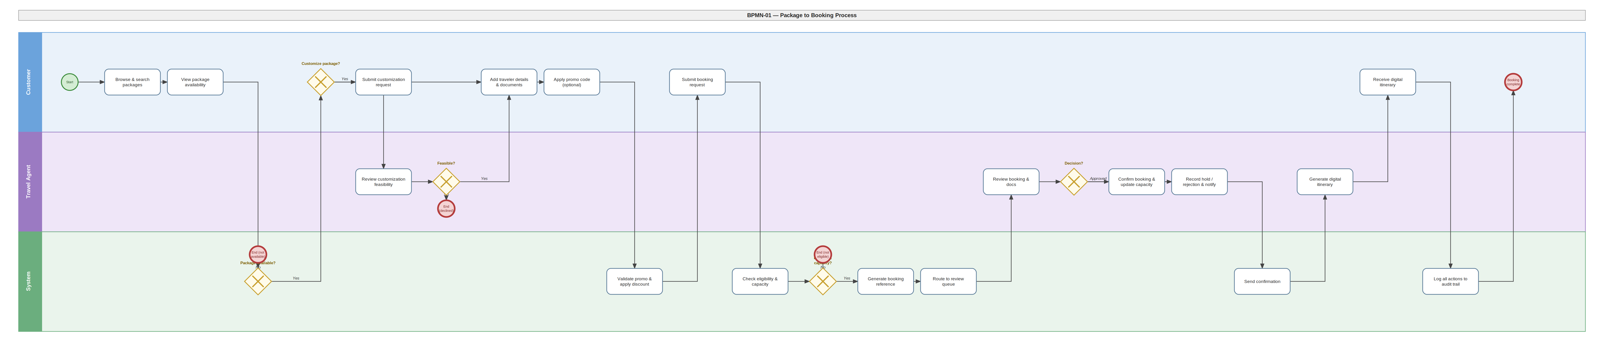
Prepared by: Amanda Shirka and Isuf

BPMN-02: Cancellation and Refund
Customer cancellation through to refund completion. Participants: Customer, Travel Agent, Finance Staff.
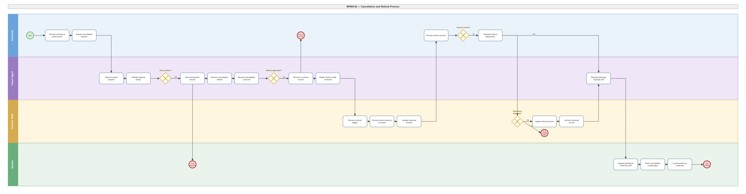
Prepared by: Alba Gjergji & Ana Gjergji, Henri Aliaj

BPMN-03: Financial Settlement
Payment tracking, reconciliation, and reporting cycle. Participants: Finance Staff, Manager/Owner, Administrator.
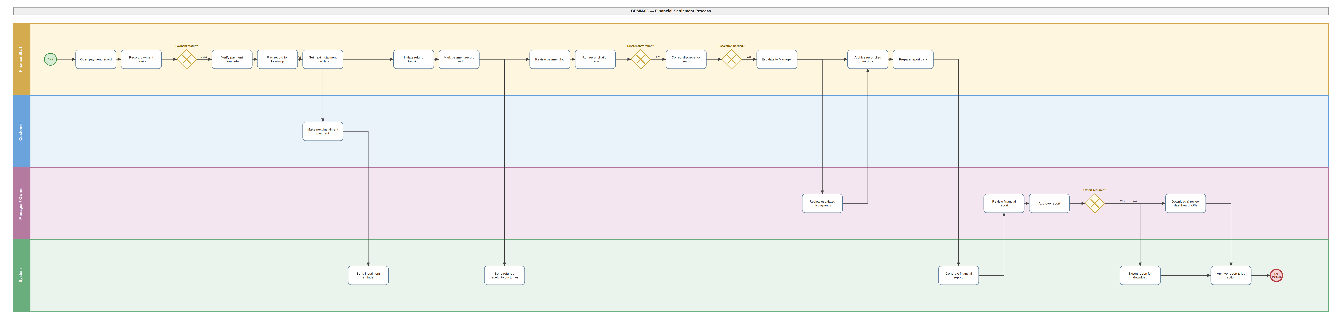
Prepared by: Henri Aliaj & Dion Hasanbashaj

6. Design Patterns

Five design patterns have been identified and documented for the system. Each entry below includes the full written justification and its class diagram. Patterns were selected based on structural evidence already present in the class specification.

# | Pattern | Category | Key Classes
1 | Factory Method | Creational | Quotation, Booking
2 | Observer | Behavioral | Booking, BookingObserver, AuditLog, Notification, PaymentRecord
3 | Strategy | Behavioral | TravelPackage, EligibilityRule, AgeBasedRule, DocumentBasedRule, NationalityBasedRule
4 | Facade | Structural | BookingEngine, CatalogService, PolicyEngine, BookingRepository, NotificationService
5 | Template Method | Behavioral | Employee (abstract), TravelAgent, FinanceStaff, HRStaff, OperationsStaff, Manager

Pattern 1: Factory Method
Category: Creational
The Factory Method pattern is explicitly present in the class specification through the Quotation.accept(): Booking method. A Booking is a complex entity whose attributes must be initialized consistently from the originating Quotation, including the quoted price, traveler details, package reference, and the unique booking reference. Rather than allowing Booking objects to be constructed arbitrarily from anywhere in the system, all creation is channelled through this factory method on Quotation.

This ensures every Booking is properly initialized, validated against the originating quotation's terms, and traceable back to its source. The pattern fits naturally because the agency operates with a formal quotation workflow, where customers receive a written estimate before committing, and a Booking can only emerge from an accepted Quotation. The Factory Method enforces this business rule structurally rather than relying on developer discipline.

Class Diagram
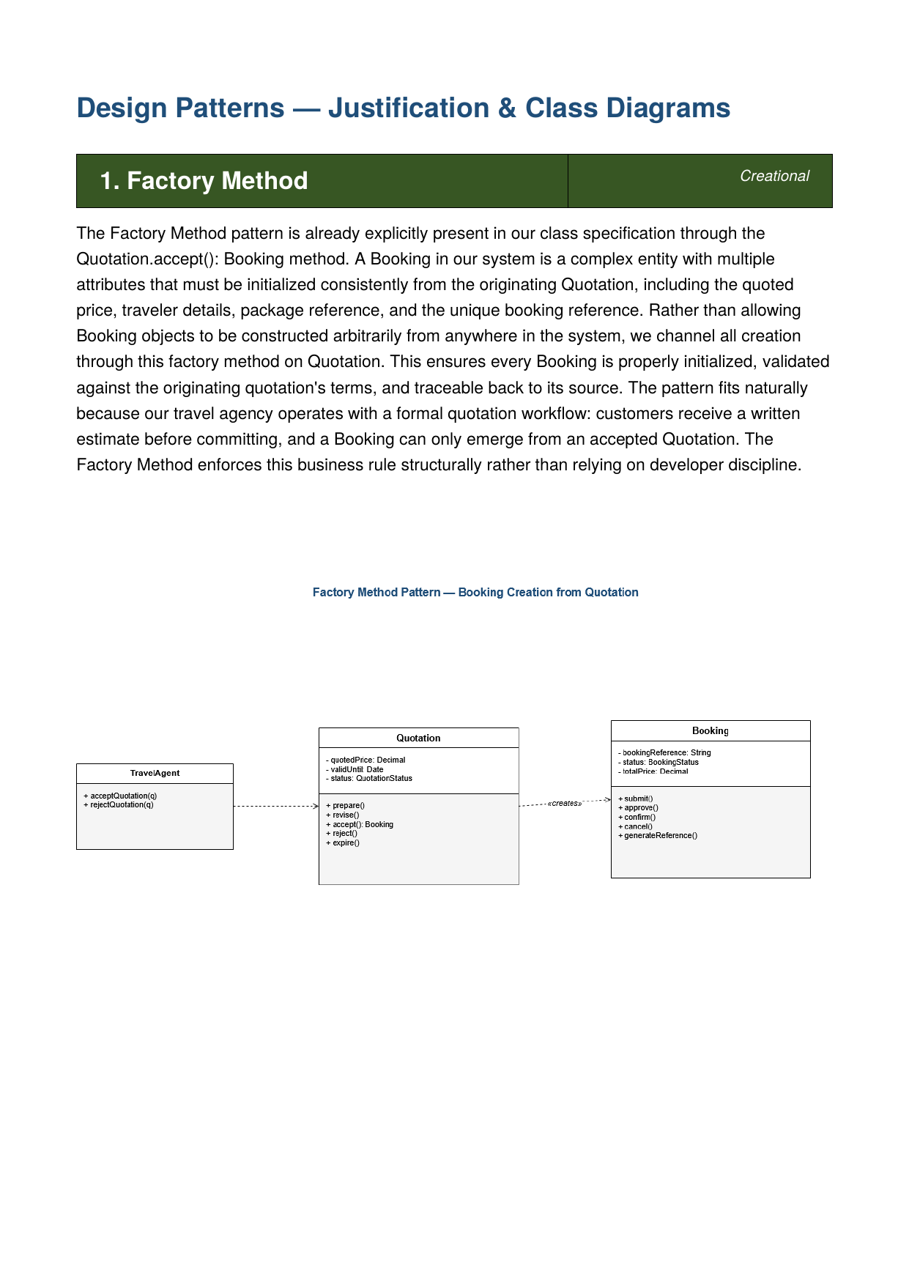
Prepared by: Isuf Celhaka & Dion Hasanbashaj

Pattern 2: Observer
Category: Behavioral
The Observer pattern formalizes a behavior already implicit in the class structure: whenever a Booking changes status, several other classes must react in a coordinated way. The AuditLog records the action for compliance and traceability, the Notification class generates and sends communications to the customer, and the PaymentRecord updates its status to trigger receipts or refund flagging.

Without the pattern, the Booking class would need direct references to all three classes and call them explicitly on every status change, creating tight coupling and fragile code. By introducing a BookingObserver interface that AuditLog, Notification, and PaymentRecord implement, the Booking simply notifies its registered observers when its state changes. This decoupling makes it trivial to add new reactions to booking events (such as waitlist notifications) without modifying the Booking class itself.

Class Diagram
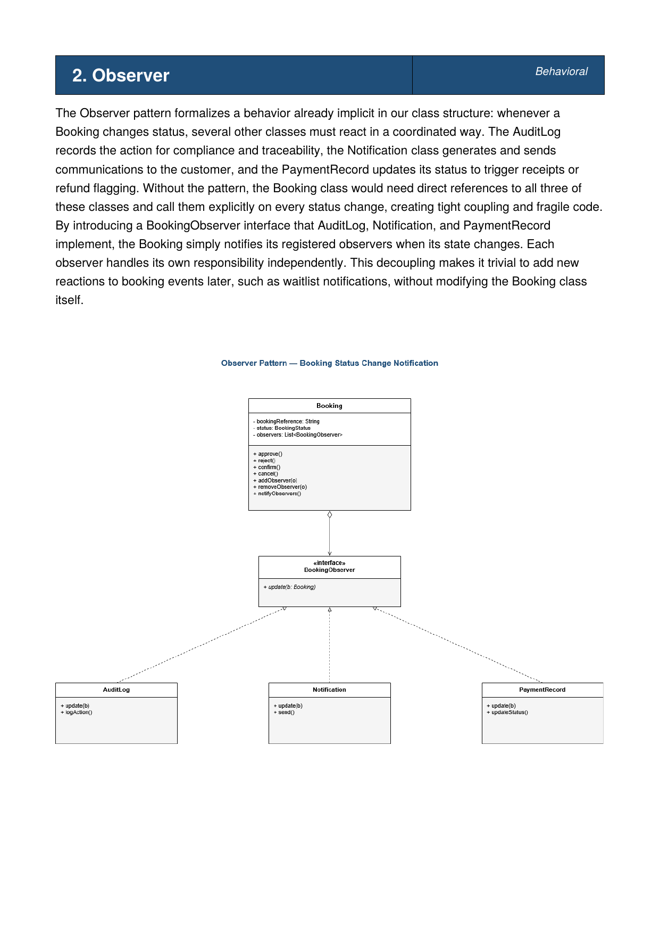
Prepared by: Amanda Shirka & Dion Hasanbashaj

Pattern 3: Strategy
Category: Behavioral
The Strategy pattern fits the TravelPackage class because different packages require different eligibility validation logic. A family-oriented package checks for accompanying adults, a senior tour validates age ranges, an international package verifies passport and visa documents, and some standard packages have no restrictions at all. The class specification already includes an EligibilityRule class with an EligibilityRuleType enum, hinting at multiple rule variants.

The Strategy pattern formalizes this by defining an EligibilityRule interface with concrete implementations such as AgeBasedRule, DocumentBasedRule, and NationalityBasedRule. The TravelPackage holds a reference to whichever rule applies and delegates eligibility checks to it. Adding a new rule type, for example a VaccinationBasedRule for destinations with health requirements, requires no changes to the TravelPackage class. The eligibility logic stays isolated and pluggable.

Class Diagram

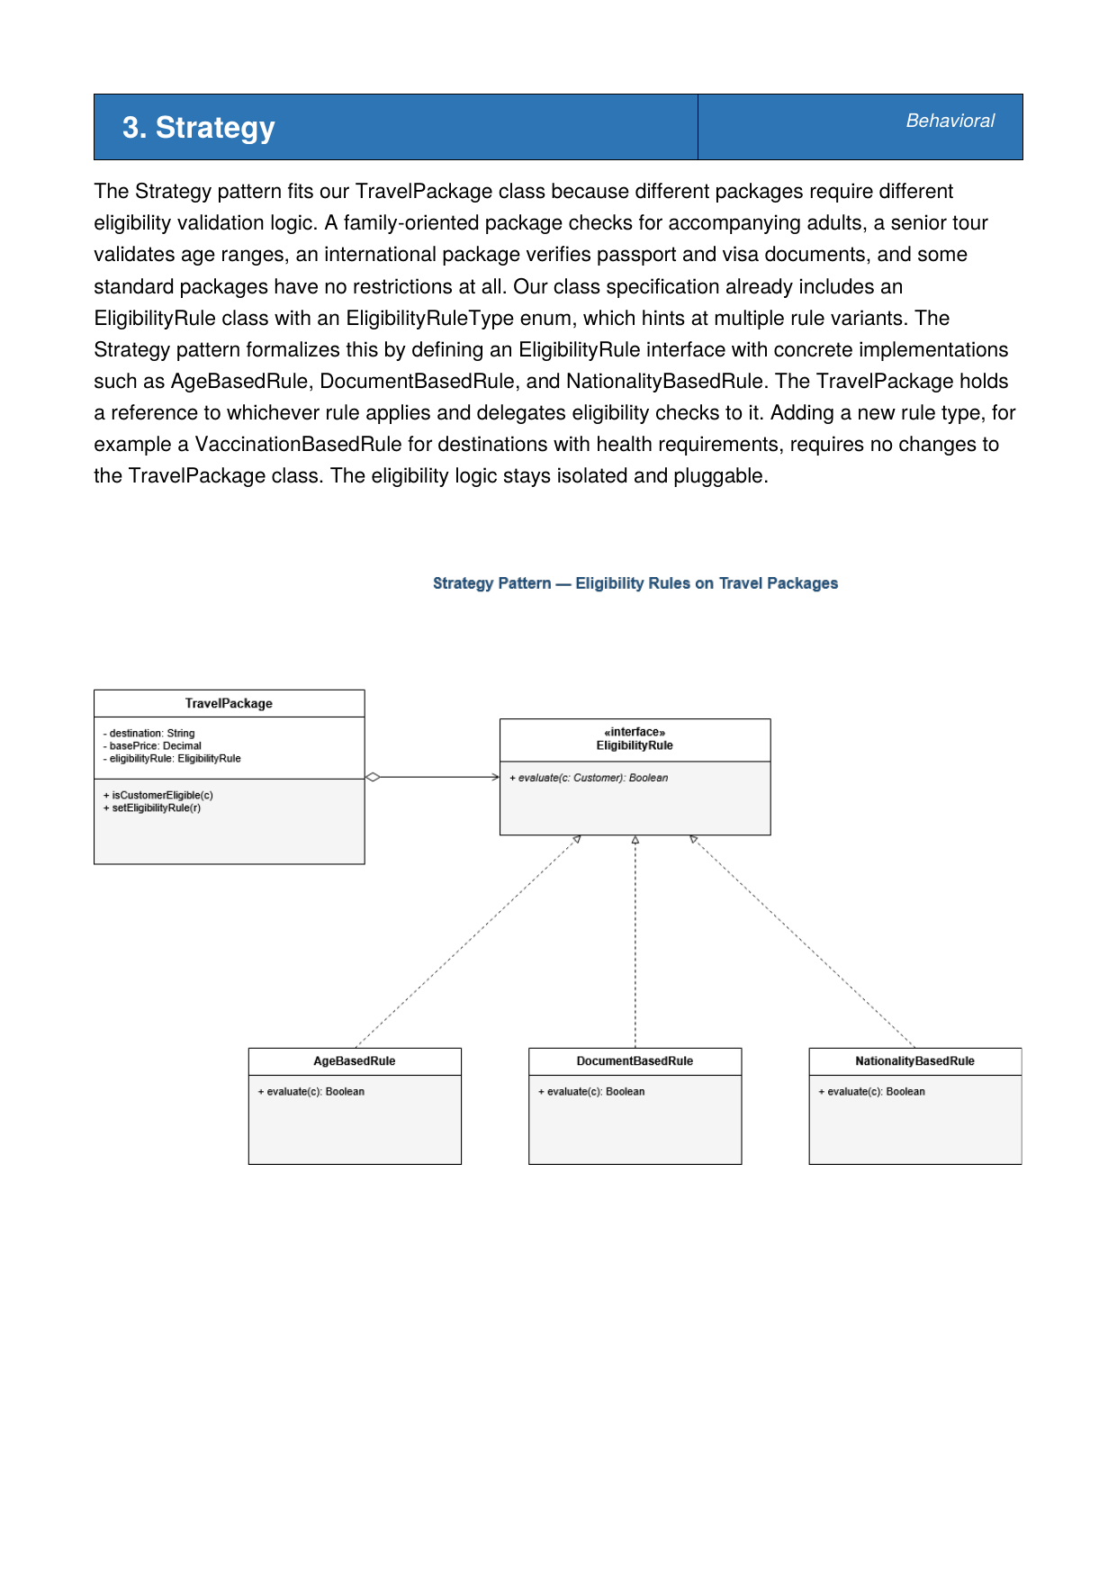
Prepared by: Gledis Ruci & Dion Hasanbashaj

Pattern 4: Facade
Category: Structural
The Facade pattern is reflected in the BookingEngine, one of the named system components identified throughout the project. Submitting a booking is a multi-step operation that touches several subsystems: the CatalogService for package availability and capacity, the PolicyEngine for eligibility validation, the BookingRepository for persistence and queue routing, and the NotificationService for customer communication.

Exposing all four subsystems directly to the Customer or Travel Agent would force them to coordinate operations across multiple classes for every booking action. Instead, the BookingEngine acts as a Facade: it provides simple, business-meaningful methods such as submitBookingRequest() and cancelBooking() that internally coordinate the subsystem calls in the correct sequence. The client interacts only with the Facade and never needs to know about the underlying complexity, reducing coupling and making the booking workflow easier to maintain as individual subsystems evolve.

Class Diagram
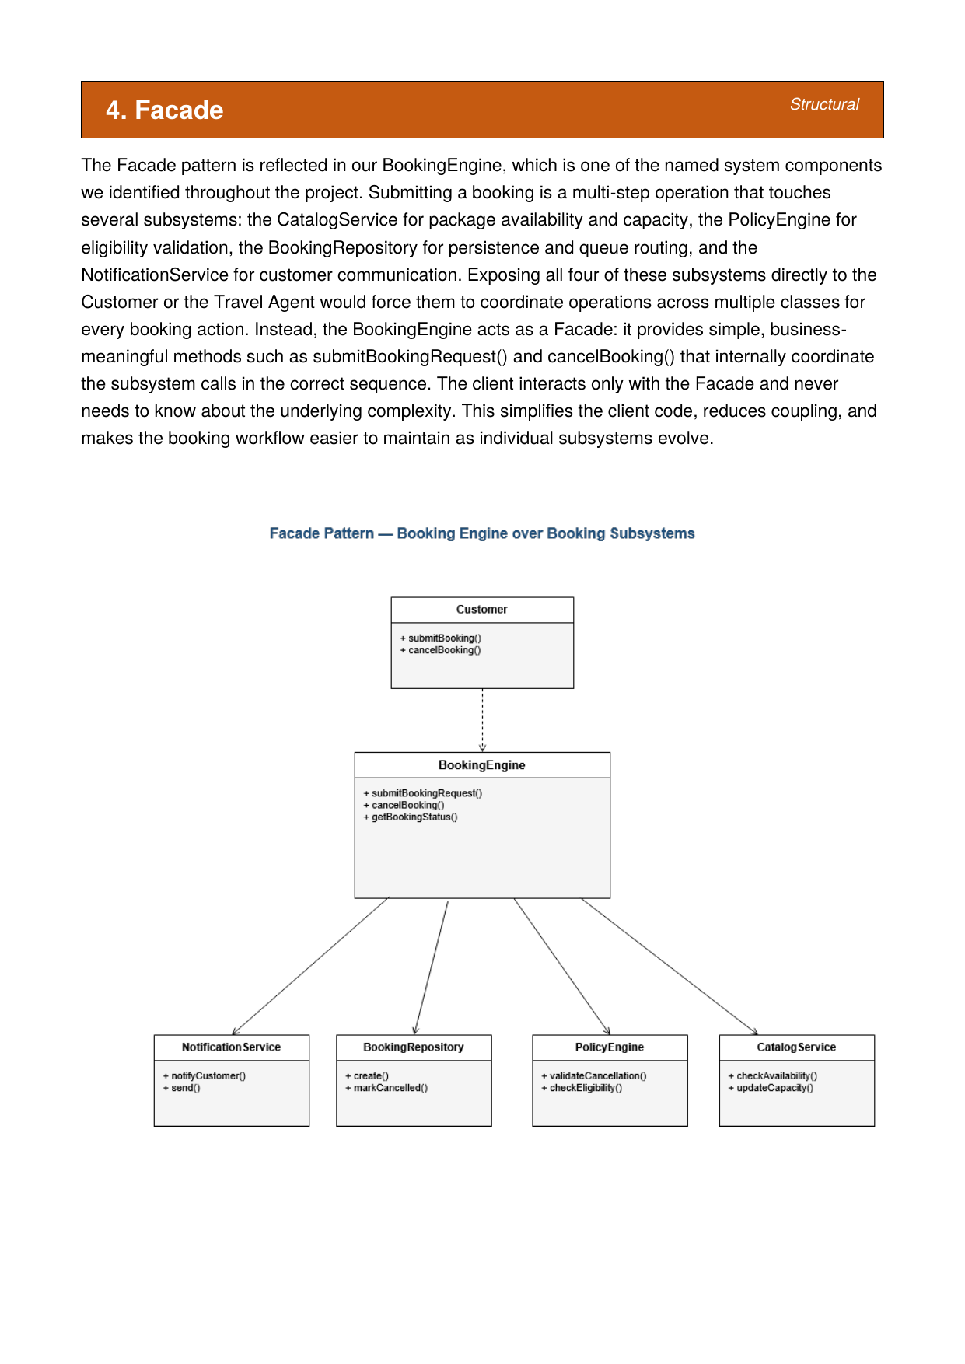
Prepared by: Henri Aliaj & Dion Hasanbashaj

Pattern 5: Template Method
Category: Behavioral
The Template Method pattern fits the Employee class hierarchy naturally. Every employee follows the same daily shift structure: log in, load their dashboard, perform their role-specific tasks, log activity, and log out. The first, fourth, and fifth steps are identical for every employee regardless of role. The second and third steps are completely different depending on whether the employee is a Travel Agent reviewing bookings, Finance Staff processing payments, HR Staff managing leave requests, Operations Staff coordinating schedules, or a Manager reviewing financial reports.

The abstract Employee class defines the template method performDailyShift() that orchestrates the sequence, with login(), logout(), and logActivity() as concrete shared methods, while loadDashboard() and performRoleTasks() are abstract and overridden by each concrete subclass. This keeps the workflow consistent across all roles, prevents duplicate code in subclasses, and makes it straightforward to onboard a new employee type by simply implementing the two abstract methods.

Class Diagram
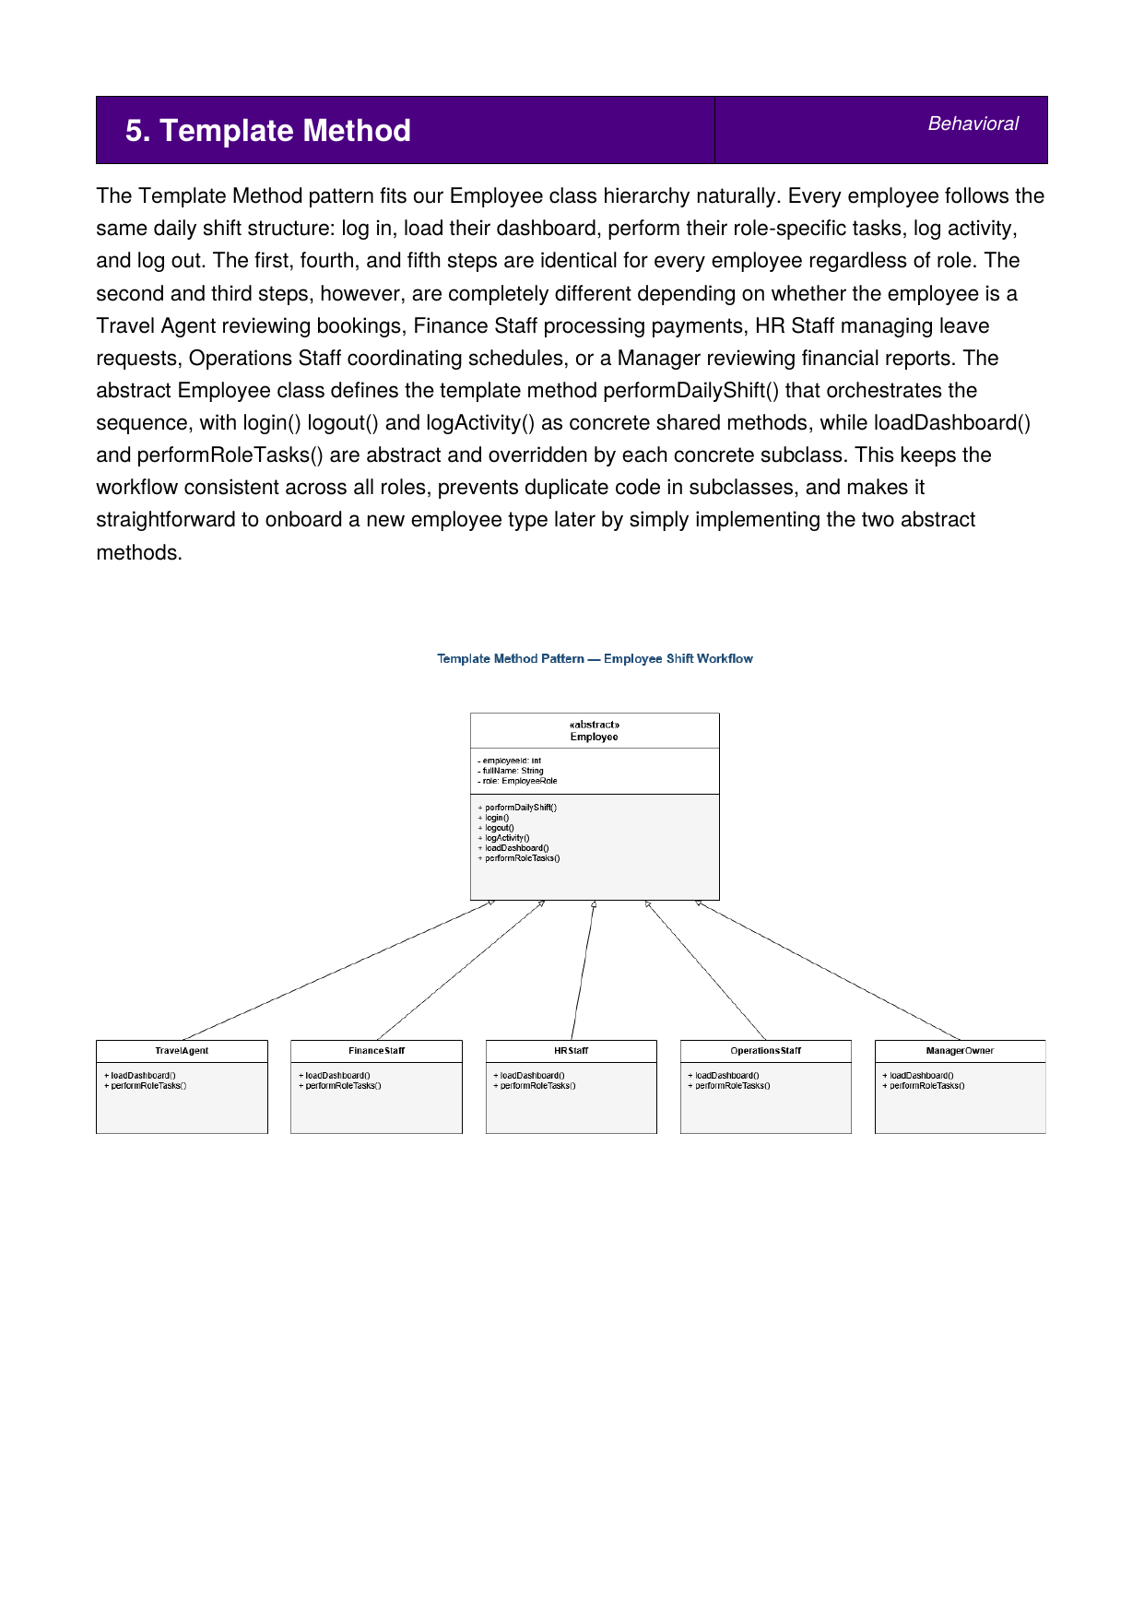
Prepared by: Alba Gjergji & Ana Gjergji

