Tour and Travel Agency Operations System
Individual Presentation Chains
Presentation Review — Complete Reference Document
This document contains the full presentation chain for each team member including the Functional Requirement, Use Case Table, Activity Diagram, Sequence Diagram, Collaboration Diagram, and State Machine Diagram.
Chains included:
Isuf Celhaka — FR-01 — Log In
Amanda Shirka — FR-08 — Manage Travel Packages
Alba Gjergji — FR-15 — Submit Booking Request
Ana Gjergji — FR-20 — Submit and Process Cancellation Request
Gledis Ruci — FR-26 — Maintain Travel Schedules
Henri Aliaj — FR-35 — Record Payment Status
Dion — FR-45 — Manage Loyalty Program

Isuf Celhaka — Domain 1 — User & Access Management

Functional Requirement

FR ID | Priority | Requirement
FR-01 | High | The system shall allow all user types to log in securely using their credentials, with role-based routing to the appropriate system area upon authentication.

Use Case Table

Use Case ID | UC-01
Use Case Name | Log In
Primary Actor | Any User (Customer, Travel Agent, Operations Staff, HR Staff, Finance Staff, Administrator, Manager/Owner)
Secondary Actors | Administrator — notified when an account is locked; can reactivate the account via UC-05.
Trigger | User navigates to the login screen and submits credentials.
Preconditions | A user account exists and is not currently authenticated.
Main Success Scenario | 1. User enters username and password. 2. System validates credentials against stored records. 3. System determines the user role. 4. System creates a session and routes user to their role-specific area. 5. System logs the access event in the audit log.
Alternative Flows | • Credentials invalid — error returned, failure counter incremented. • Three consecutive failures — account locked, user notified, Administrator alerted. • Account already locked — user directed to reset password or contact Administrator.
Postconditions | A valid session is opened with correct role permissions, or the account is locked after repeated failures.
Related FRs | FR-01, FR-02, FR-07

Activity Diagram
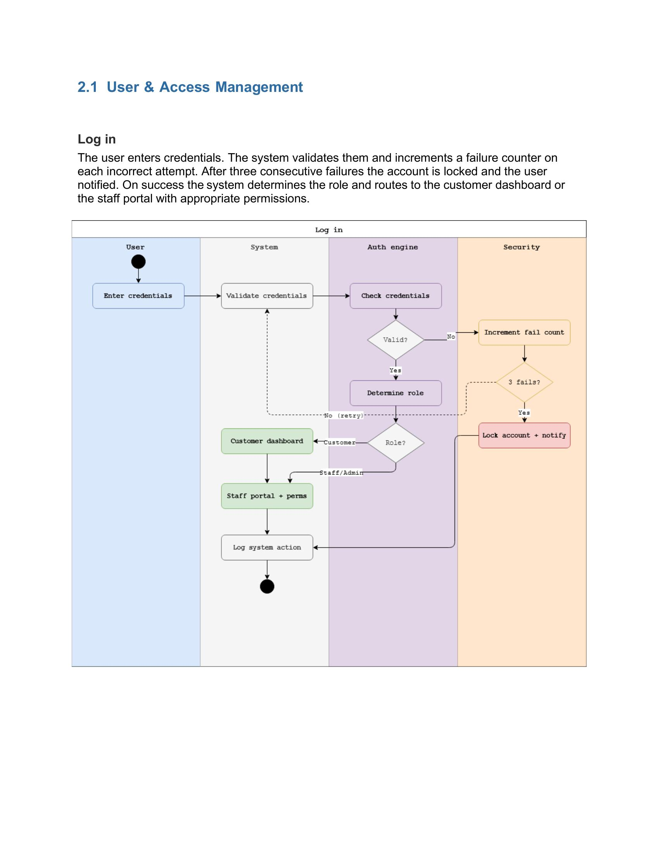
Activity Diagram — Log In

Sequence Diagram
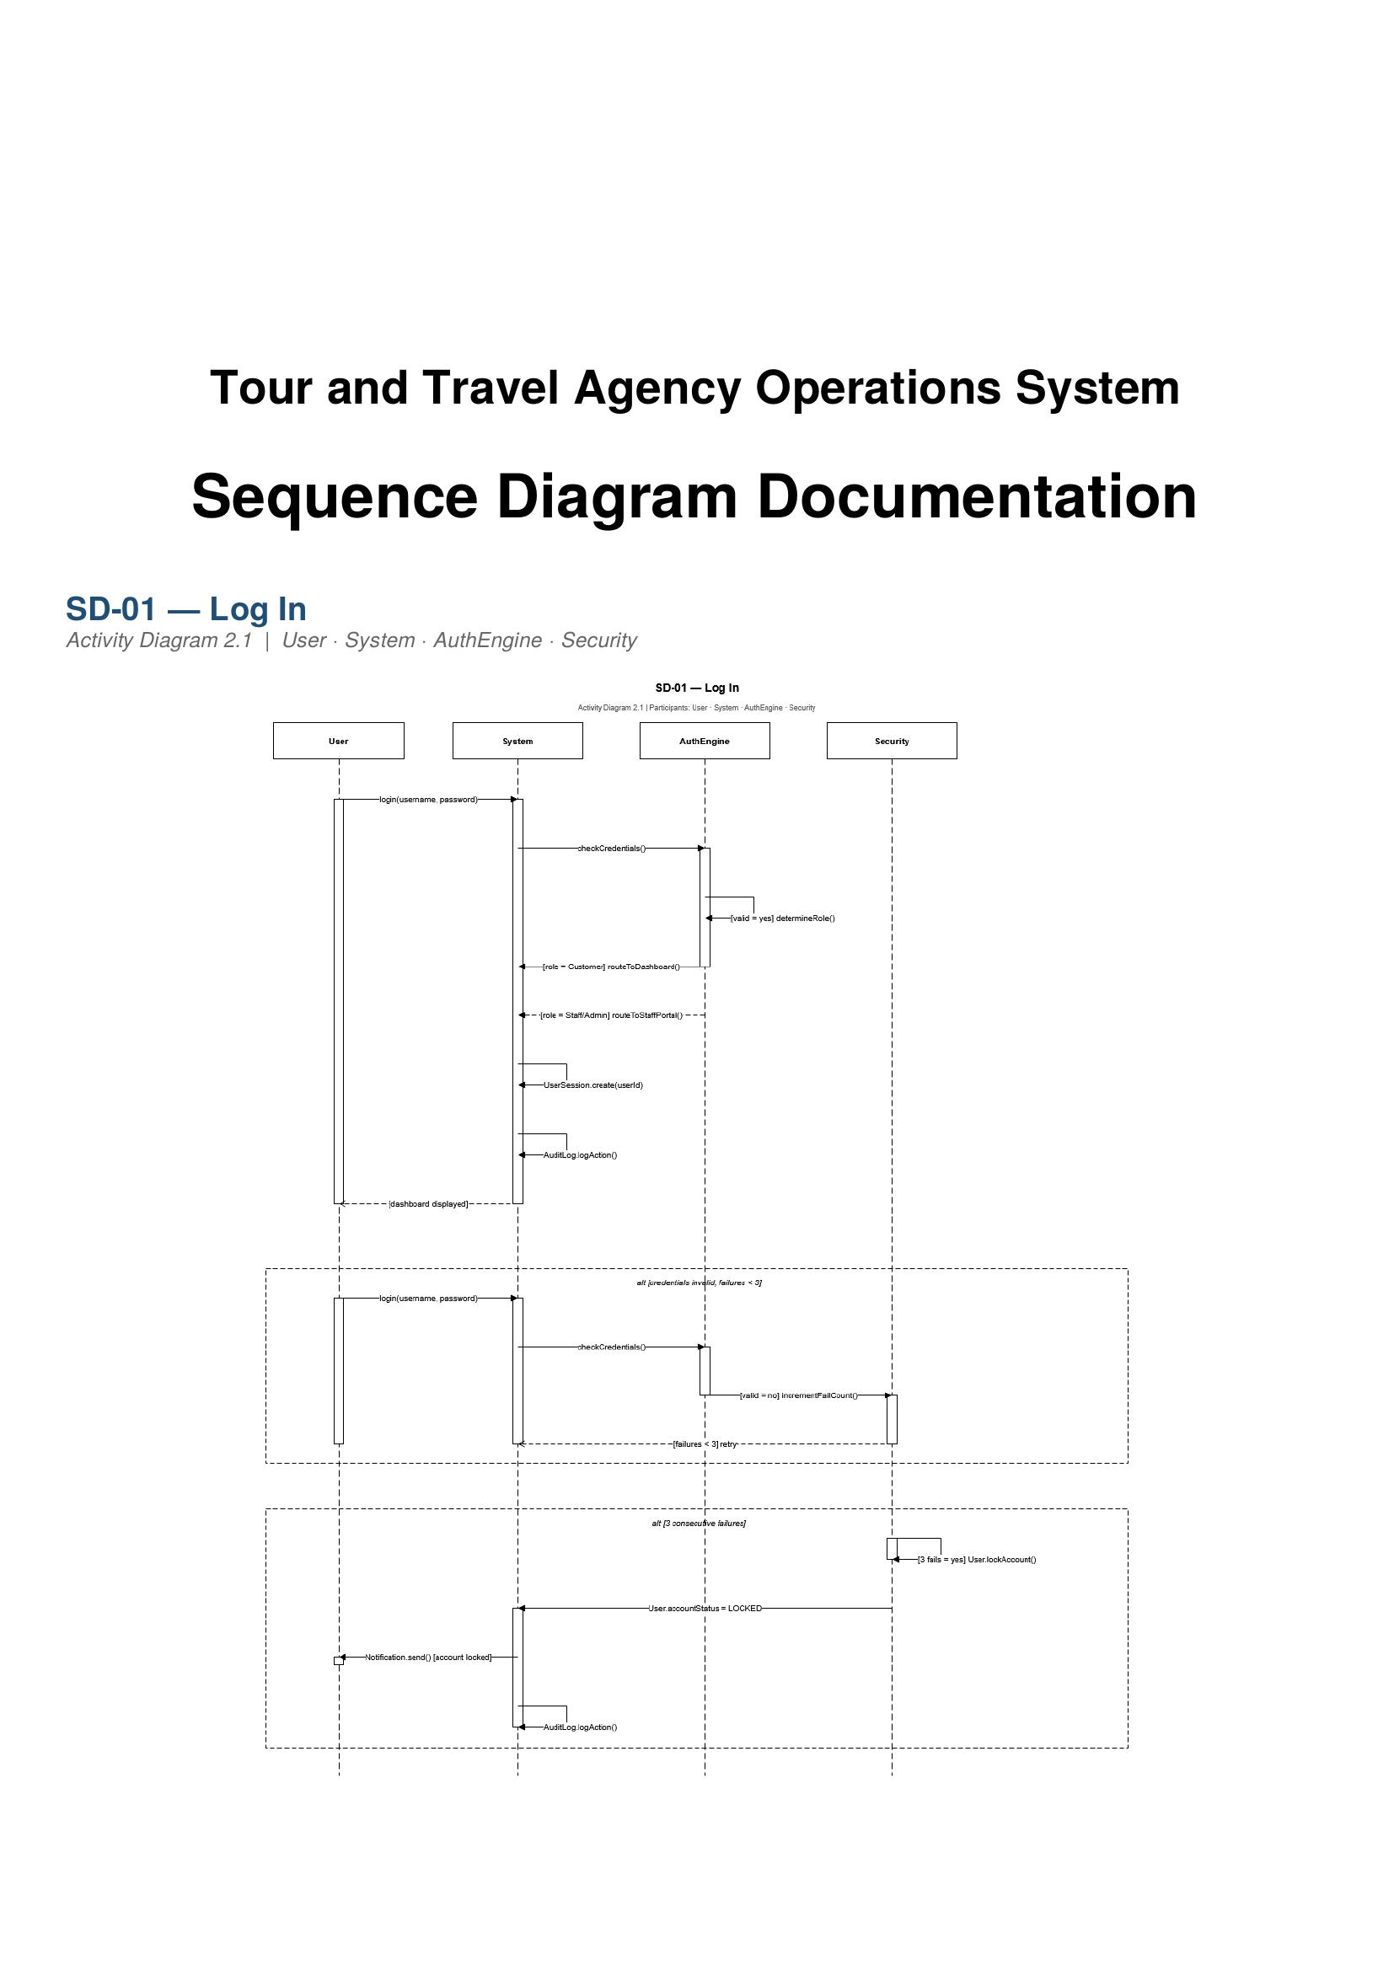
SD-01 — Log In

Collaboration Diagram
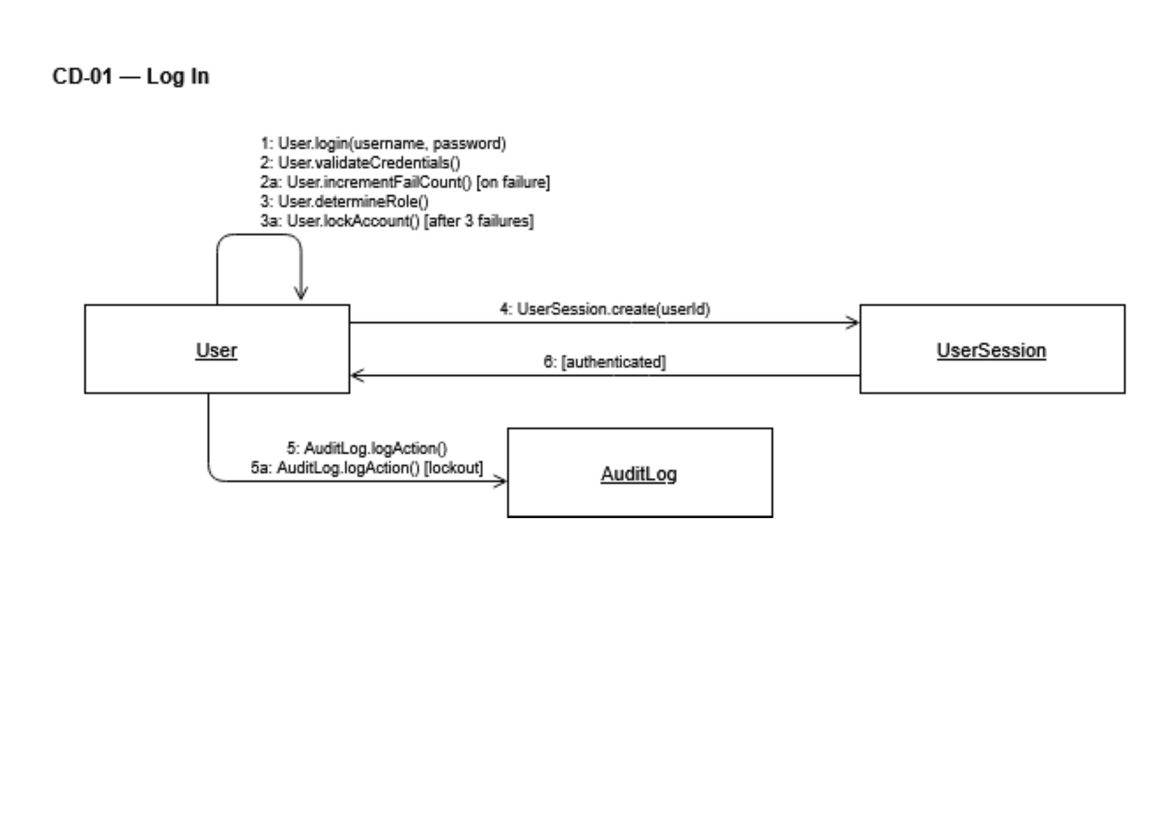
CD-01 — Log In

State Machine Diagram

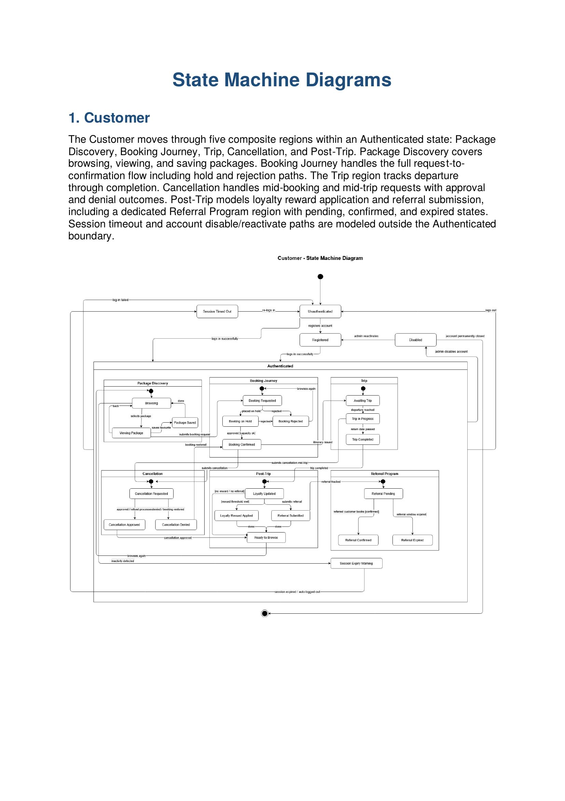
State Machine — Customer (Login and Account States)

Amanda Shirka — Domain 2 — Travel Package Management

Functional Requirement

FR ID | Priority | Requirement
FR-08 | High | The system shall allow staff to create, update, archive, and publish travel packages, storing details such as destination, duration, itinerary, capacity, price, and inclusions.

Use Case Table

Use Case ID | UC-07
Use Case Name | Manage Travel Packages
Primary Actor | Operations Staff
Secondary Actors | Manager/Owner — can view packages in any lifecycle state for oversight purposes.
Trigger | Operations Staff opens the package management module.
Preconditions | Operations Staff is logged in with package management permissions.
Main Success Scenario | 1. Staff selects create, update, archive, publish, or duplicate. 2. Staff enters or updates package details. 3. System validates required fields. 4. System applies the selected action and updates the package catalog state. 5. System logs the action in the audit log. 6. Published packages become visible to customers.
Alternative Flows | • Required fields missing — validation error returned, package not saved. • Attempt to publish package with no linked schedule — rejected until a schedule is created. • Staff duplicates existing package — new draft created with copied details.
Postconditions | Package lifecycle state is updated in the catalog and reflected across the system.
Related FRs | FR-08, FR-13, FR-14

Activity Diagram
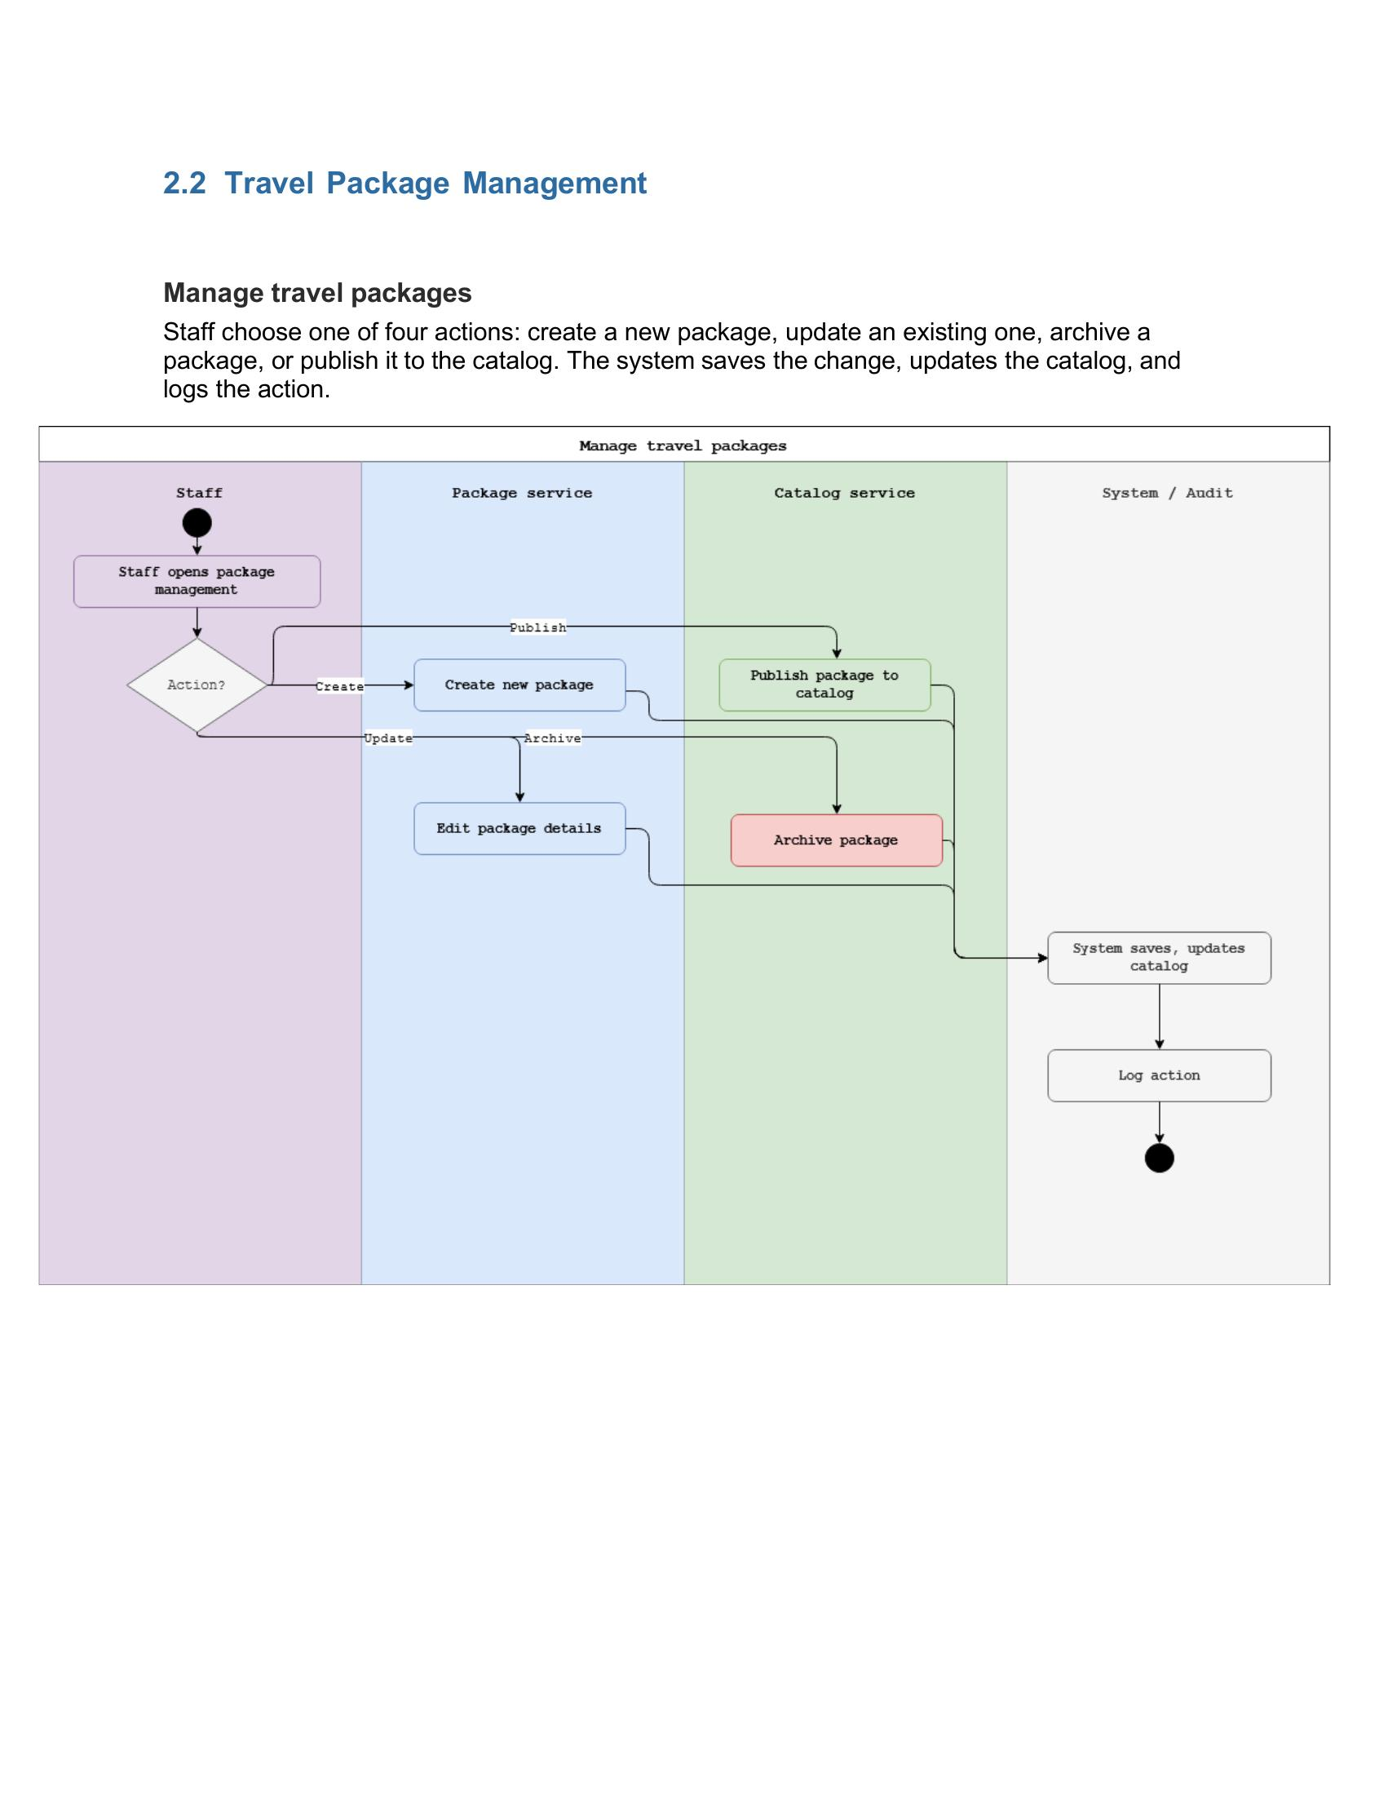
Activity Diagram — Manage Travel Packages

Sequence Diagram
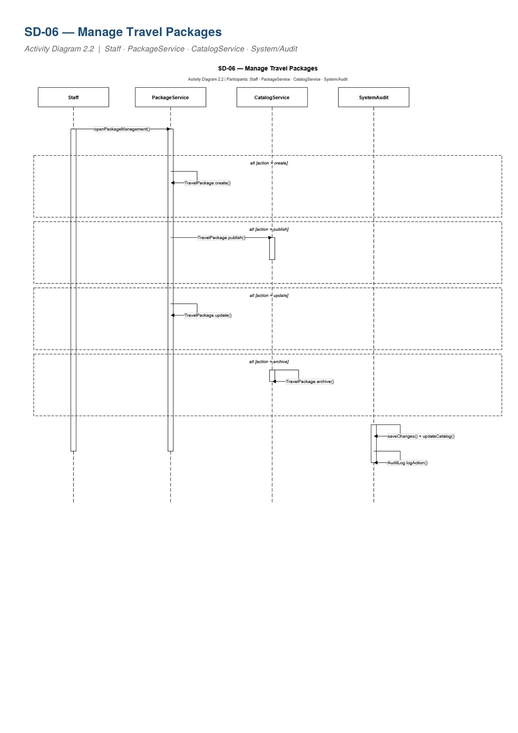
SD-06 — Manage Travel Packages

Collaboration Diagram
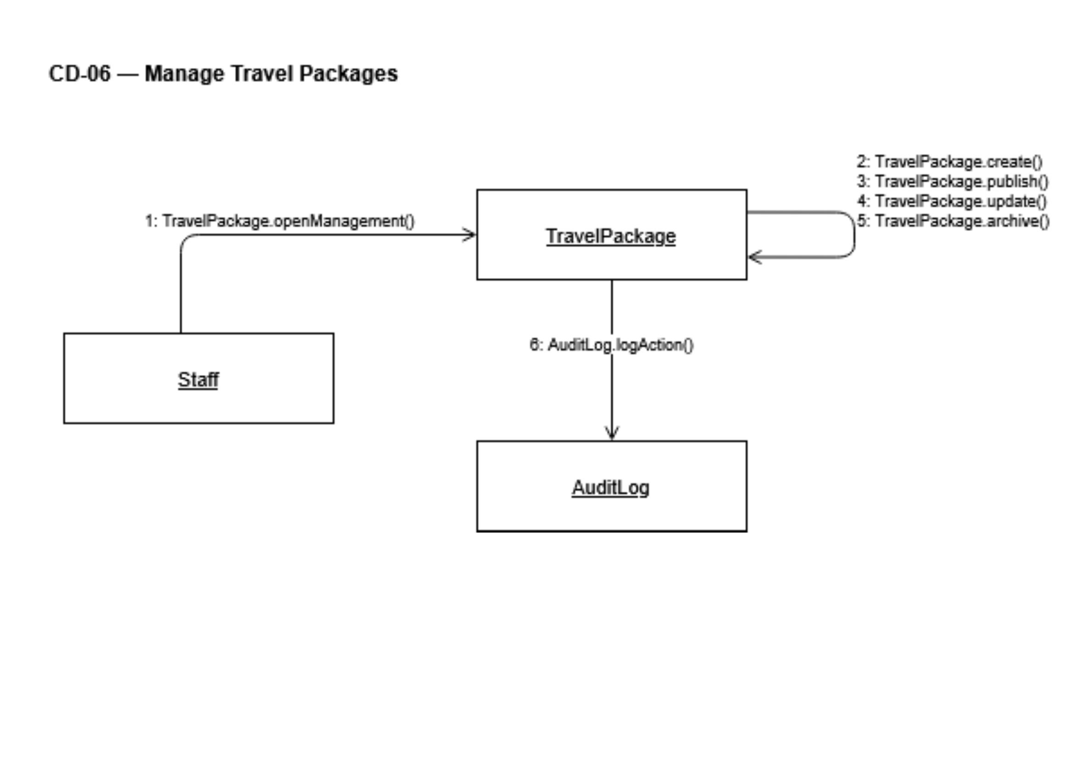
CD-06 — Manage Travel Packages

State Machine Diagram
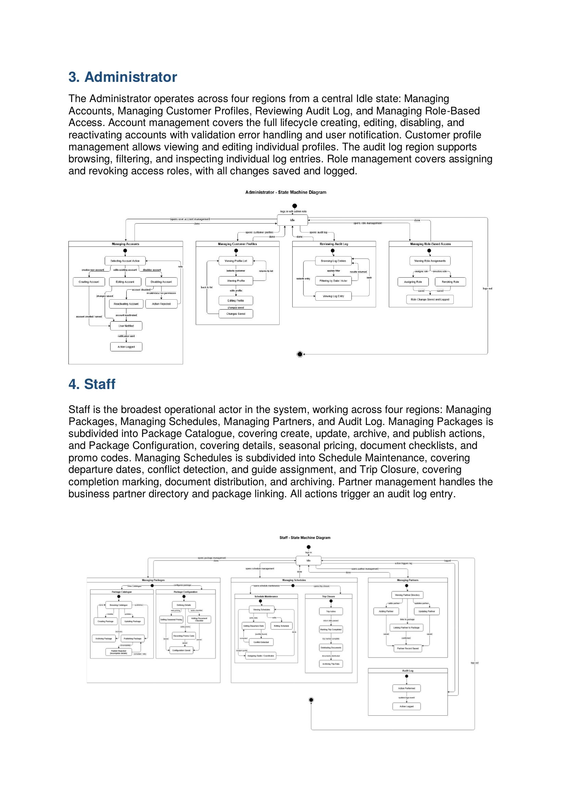
State Machine — Administrator (Operations Staff state machine pending)

Alba Gjergji — Domain 3 — Booking & Reservation

Functional Requirement

FR ID | Priority | Requirement
FR-15 | High | The system shall allow customers to submit a booking request for a selected package, including traveler details, and shall validate customer travel eligibility before submission is accepted.

Use Case Table

Use Case ID | UC-12
Use Case Name | Submit Booking Request
Primary Actor | Customer
Secondary Actors | Travel Agent — reviews and approves, rejects, or places booking on hold. Finance Staff — payment status updated following booking confirmation.
Trigger | Customer selects the book option on an available package.
Preconditions | Customer is logged in, the package is published and has available capacity.
Main Success Scenario | 1. Customer selects a package and enters traveler details. 2. System validates customer travel eligibility. 3. Customer submits the booking request. 4. System generates a unique booking reference. 5. System routes the request to the booking review queue. 6. Travel Agent reviews and approves the booking. 7. System updates remaining package capacity. 8. System notifies customer of booking confirmation.
Alternative Flows | • Eligibility check fails — booking rejected, customer informed. • Package at full capacity — customer offered waitlist option. • Travel Agent places booking on hold — customer notified. • Travel Agent rejects booking — customer notified with reason.
Postconditions | Booking request is created with a reference number and assigned status reflecting the agent review outcome.
Related FRs | FR-15, FR-16, FR-17, FR-23

Activity Diagram
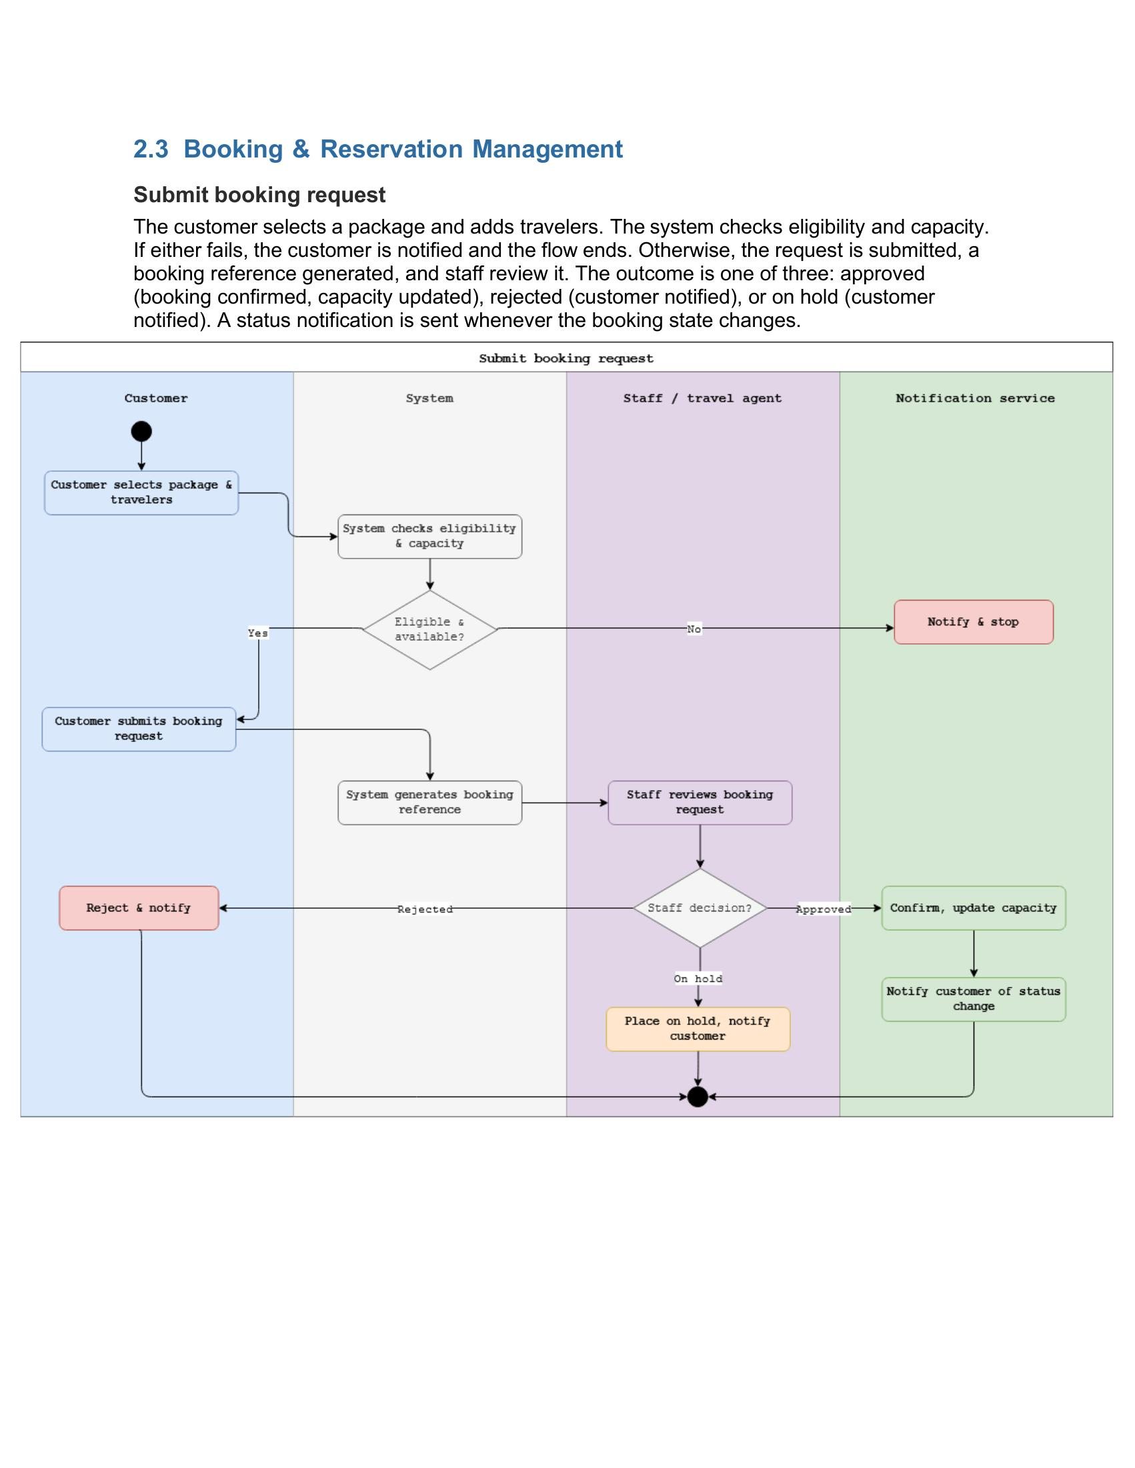
Activity Diagram — Submit Booking Request

Sequence Diagram
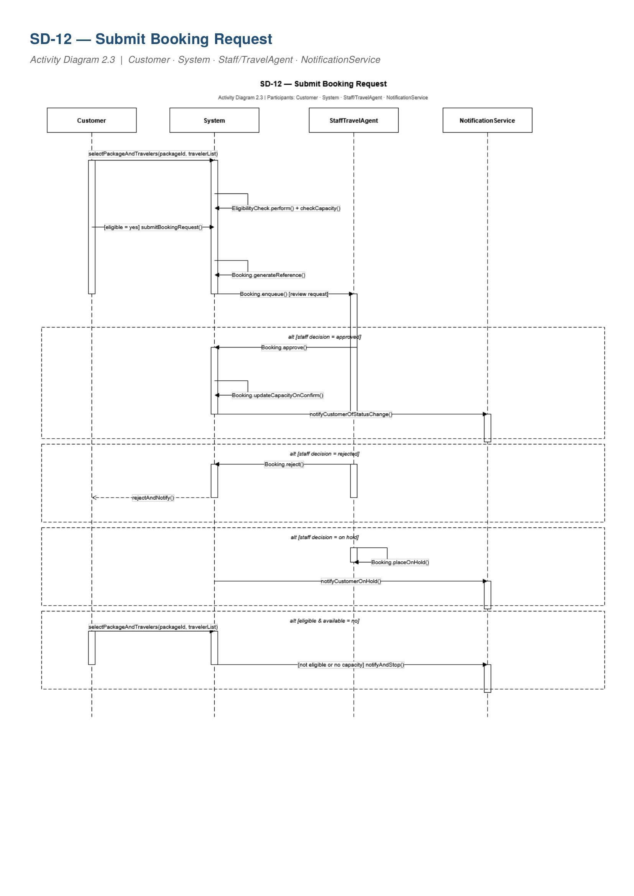
SD-12 — Submit Booking Request

Collaboration Diagram
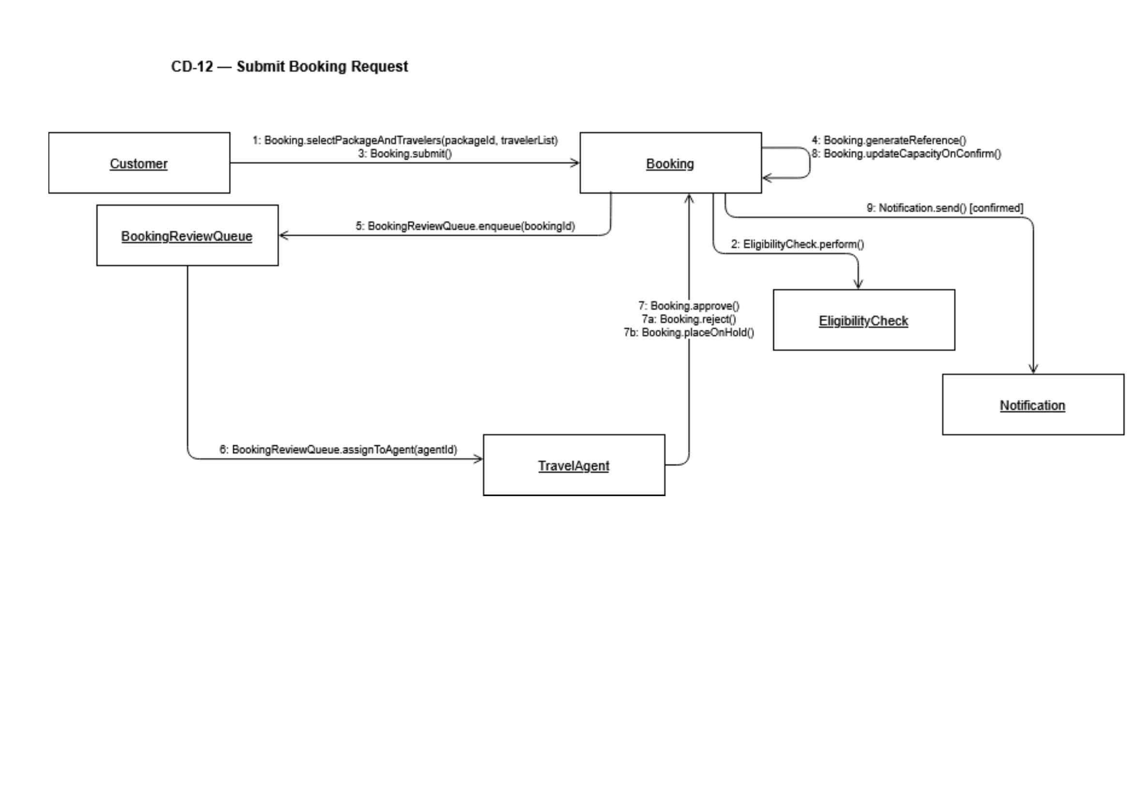
CD-12 — Submit Booking Request

State Machine Diagram

State Machine — Customer (Booking States)

Ana Gjergji — Domain 3 — Booking & Reservation

Functional Requirement

FR ID | Priority | Requirement
FR-20 | Medium | The system shall allow customers to submit cancellation requests subject to policy rules, and require staff to record the cancellation outcome and any associated refund status.

Use Case Table

Use Case ID | UC-20
Use Case Name | Submit and Process Cancellation Request
Primary Actor | Customer
Secondary Actors | Travel Agent — reviews and processes the cancellation request. Finance Staff — handles refund if applicable.
Trigger | Customer selects the cancel option on an active booking.
Preconditions | Customer is logged in and has a booking eligible for cancellation.
Main Success Scenario | 1. Customer submits a cancellation request with reason. 2. System validates the request against the cancellation policy. 3. Travel Agent reviews and approves or rejects the cancellation. 4. System records the cancellation outcome. 5. System cancels the booking and releases the package capacity slot. 6. System notifies Finance Staff if a refund applies. 7. System notifies the customer of the outcome.
Alternative Flows | • Cancellation policy prohibits cancellation — agent records outcome, customer informed. • Agent rejects cancellation — booking remains active, customer notified. • Trip already completed — cancellation blocked.
Postconditions | Cancellation is resolved and reflected in booking, capacity, and refund records.
Related FRs | FR-20

Activity Diagram
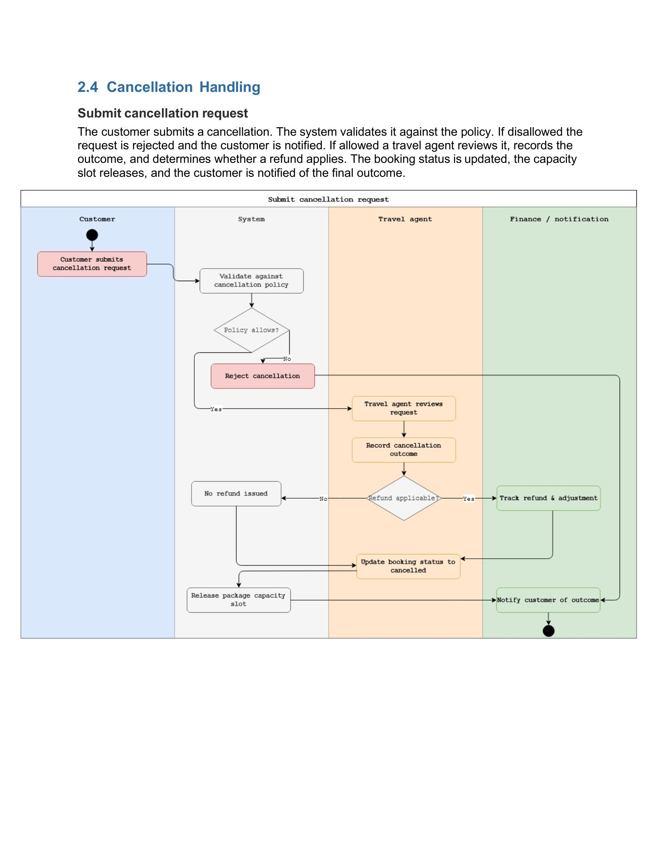
Activity Diagram — Submit Cancellation Request

Sequence Diagram

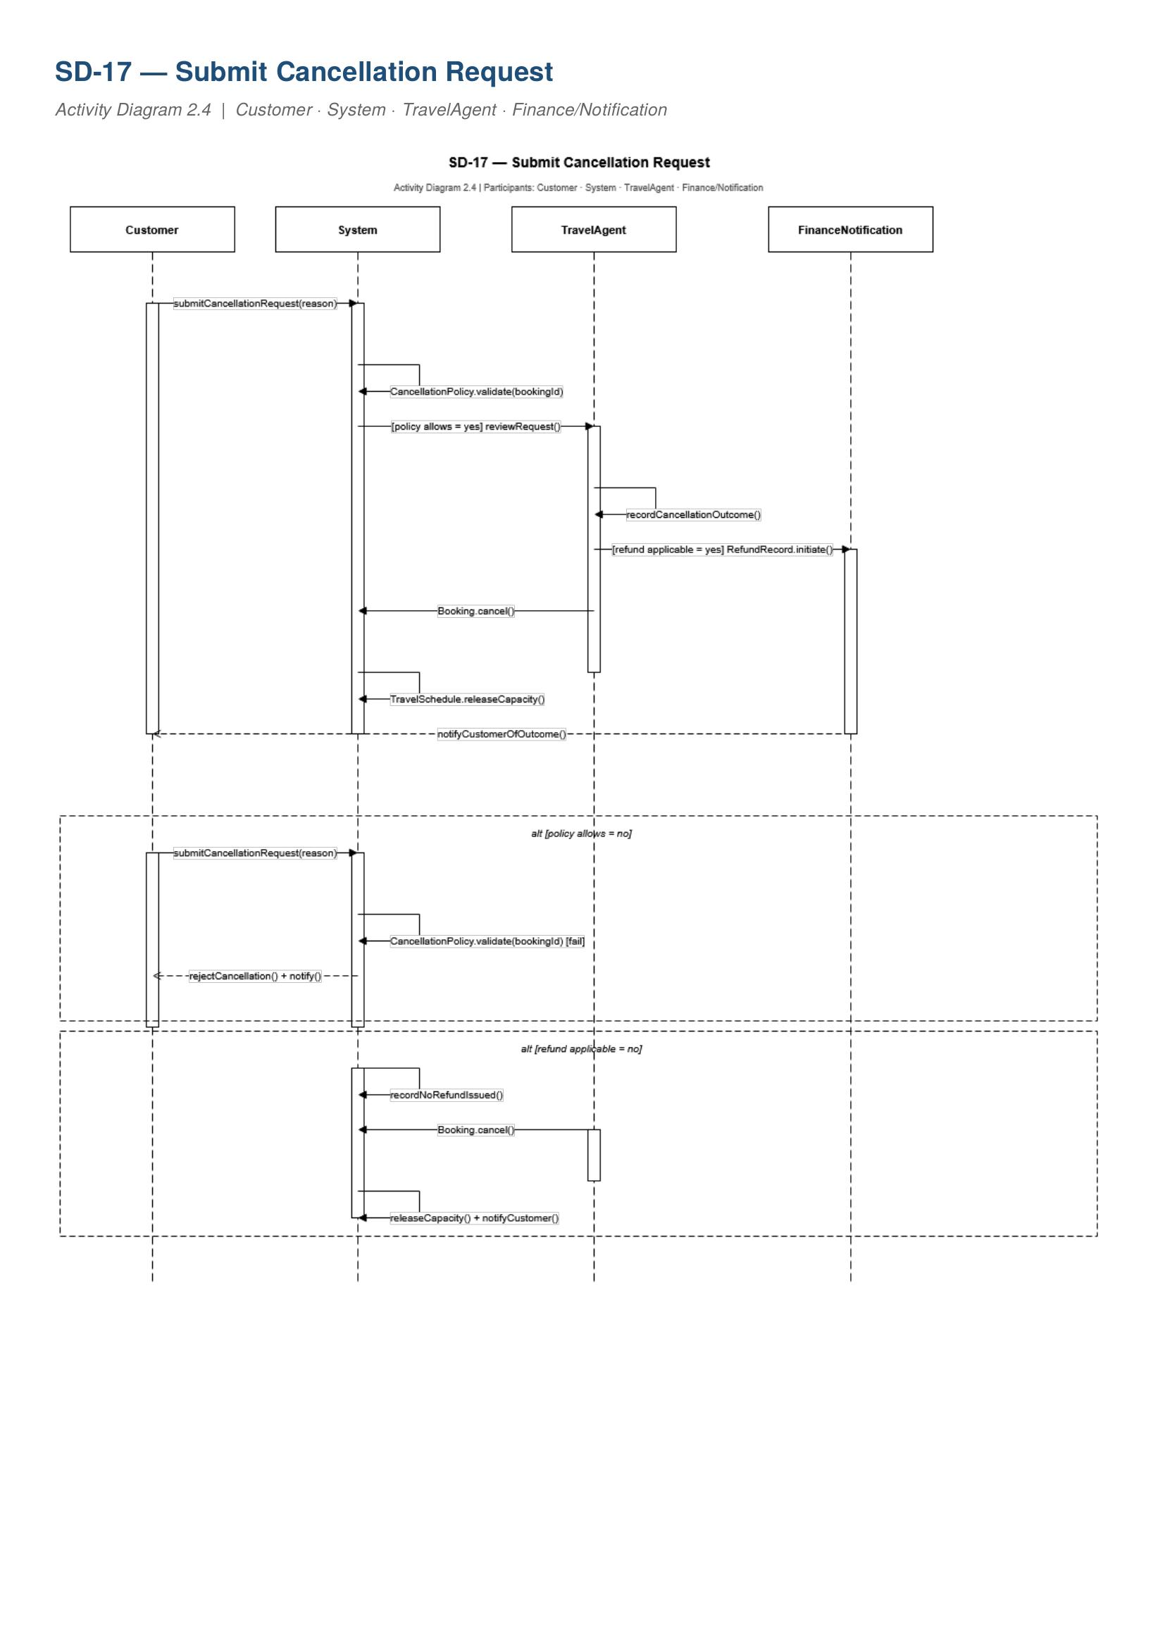
SD-17 — Submit Cancellation Request

Collaboration Diagram
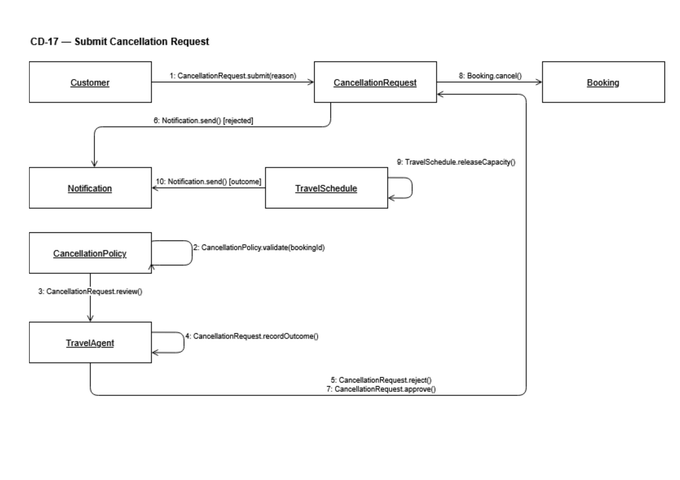
CD-17 — Submit Cancellation Request

State Machine Diagram
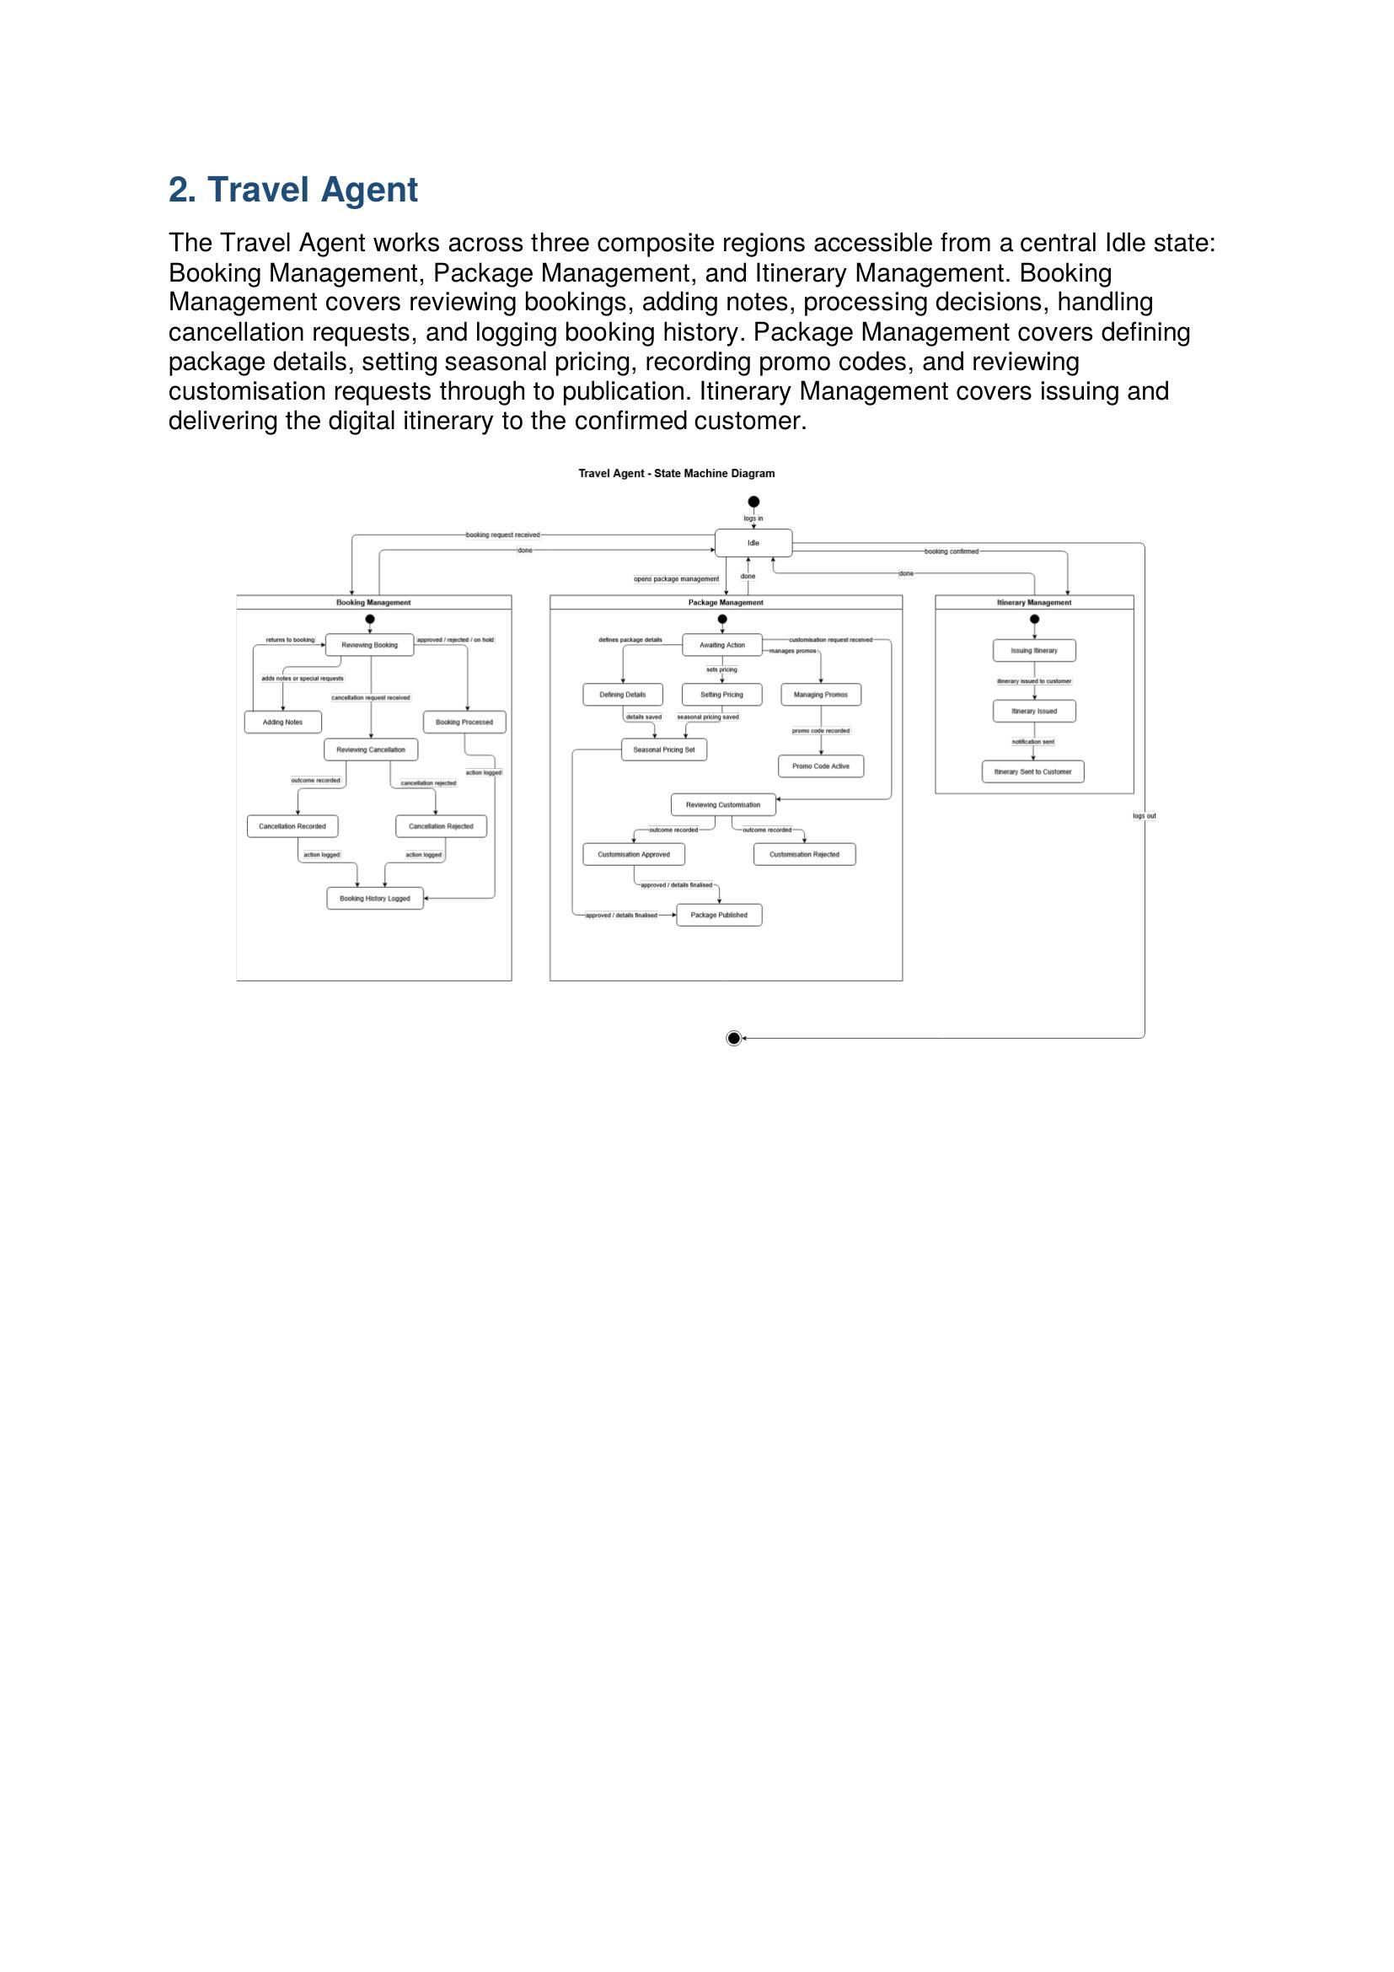
State Machine — Travel Agent (Booking Review States)

Gledis Ruci — Domain 4 — Scheduling & Operations

Functional Requirement

FR ID | Priority | Requirement
FR-26 | High | The system shall allow staff to create and maintain travel schedules including departure dates, return dates, and trip status, linked to their corresponding packages.

Use Case Table

Use Case ID | UC-21
Use Case Name | Maintain Travel Schedules
Primary Actor | Operations Staff
Secondary Actors | Manager/Owner — can view schedules for oversight. Travel Agent — references schedules when handling booking queries.
Trigger | Operations Staff opens the schedule management module for a package.
Preconditions | Operations Staff is logged in and the related package exists.
Main Success Scenario | 1. Staff opens the schedule module for a selected package. 2. Staff creates or updates a schedule entry with departure date, return date, and capacity. 3. System links the schedule to the package and updates available capacity. 4. System logs the action. 5. Schedule becomes available for customer availability checks and bookings.
Alternative Flows | • Schedule dates conflict with existing schedule — conflict flagged, not saved until resolved. • Package not yet published — schedule created but not visible to customers until published. • Schedule removed — linked bookings flagged for staff review.
Postconditions | Travel schedule is updated and linked to the package, available for booking and availability checks.
Related FRs | FR-26, FR-30

Activity Diagram
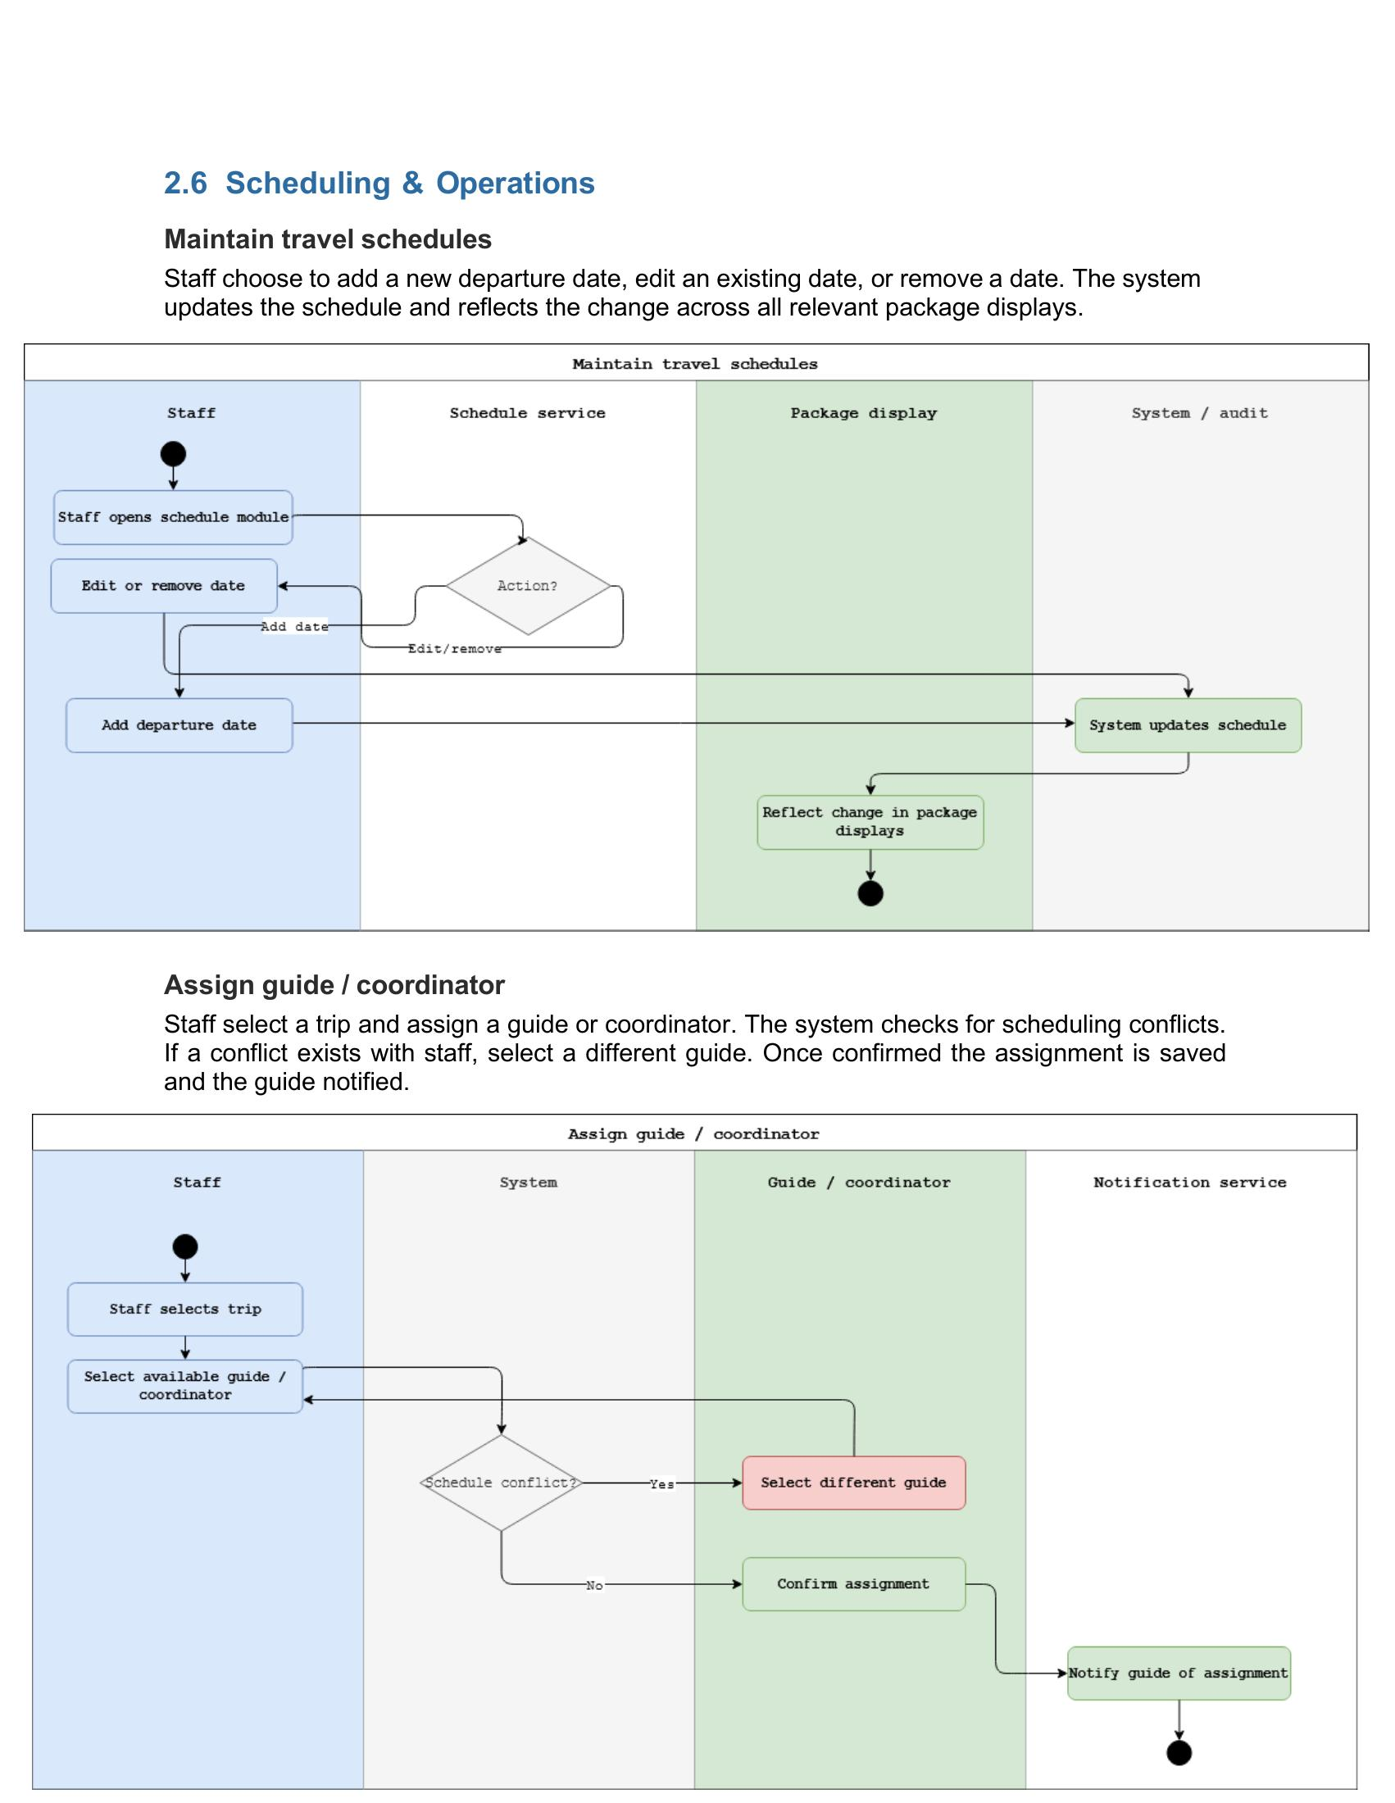

Sequence Diagram
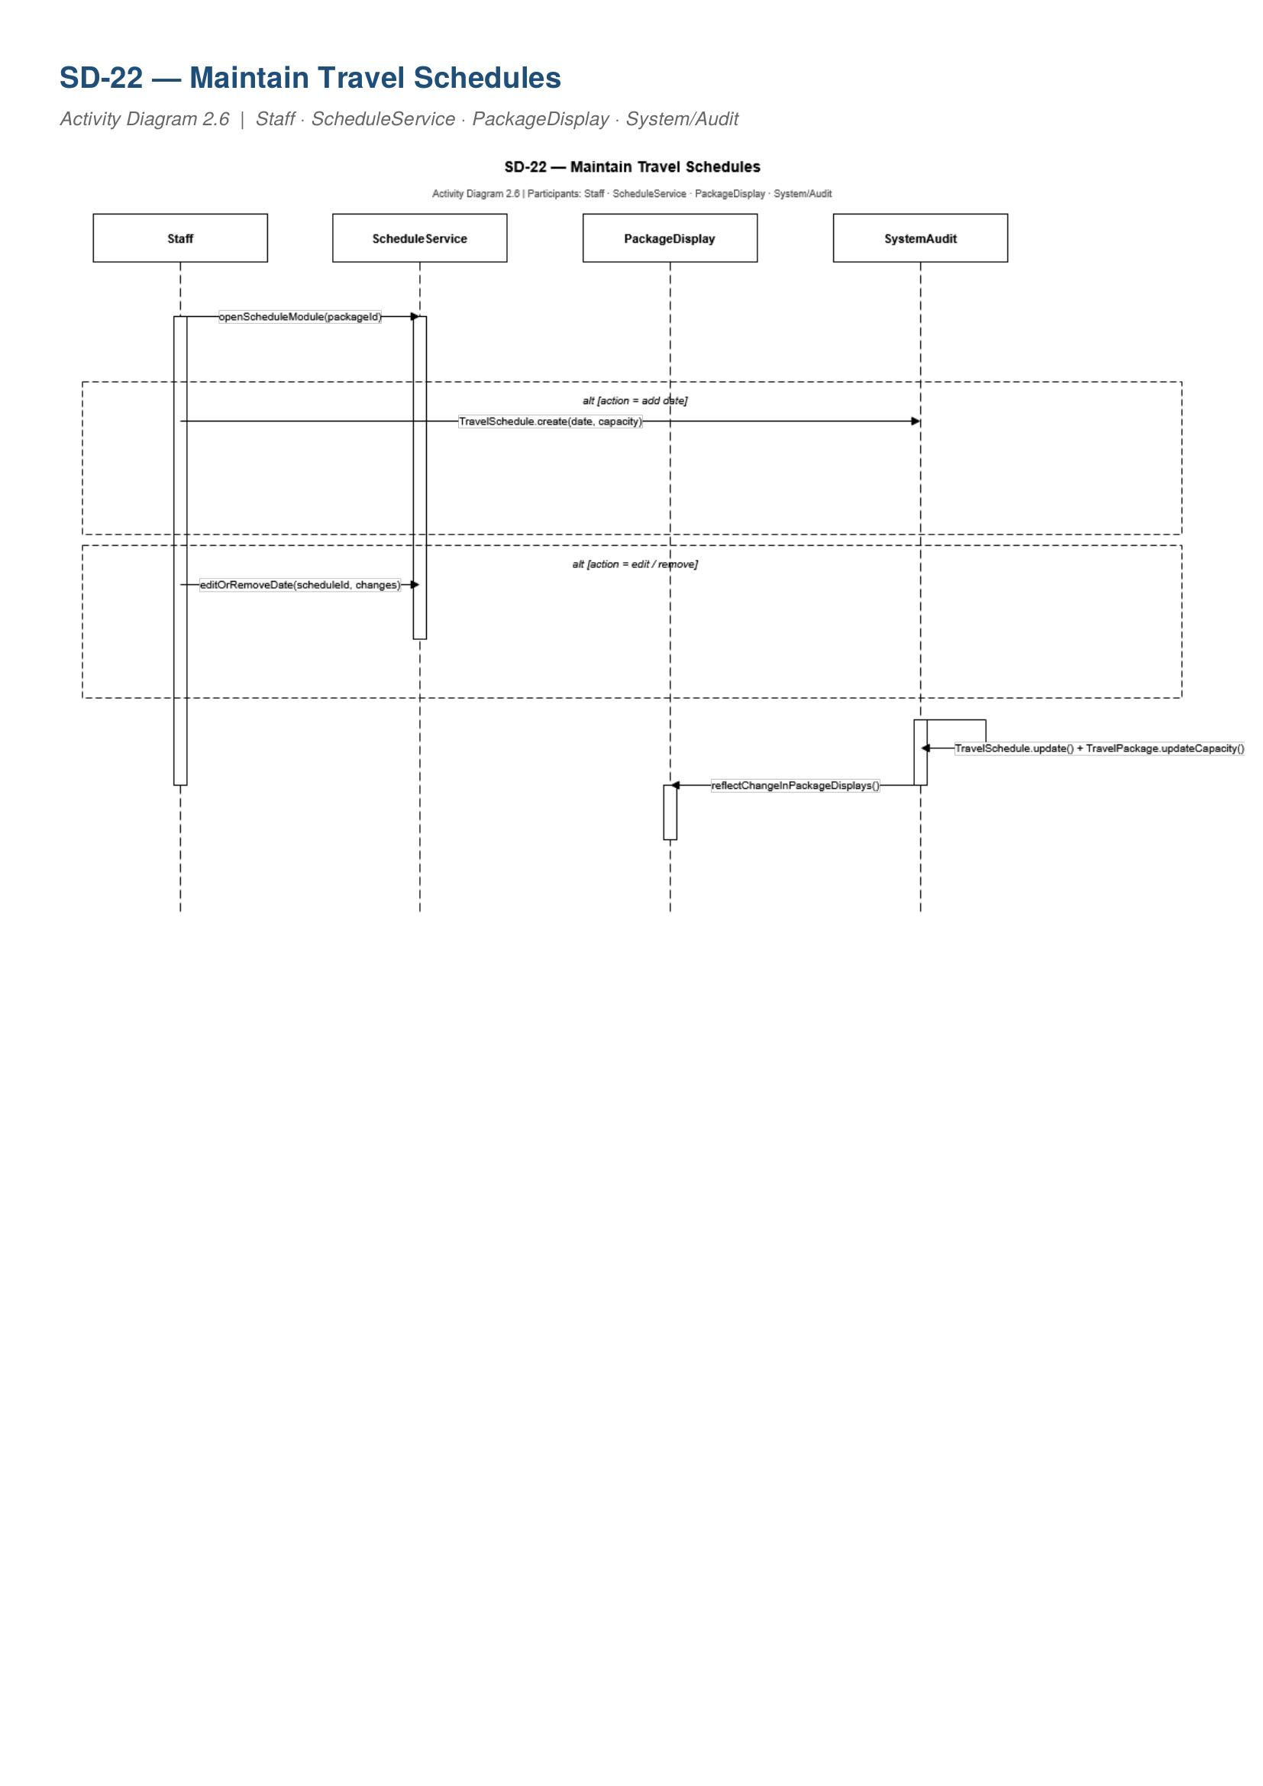
SD-22 — Maintain Travel Schedules

Collaboration Diagram
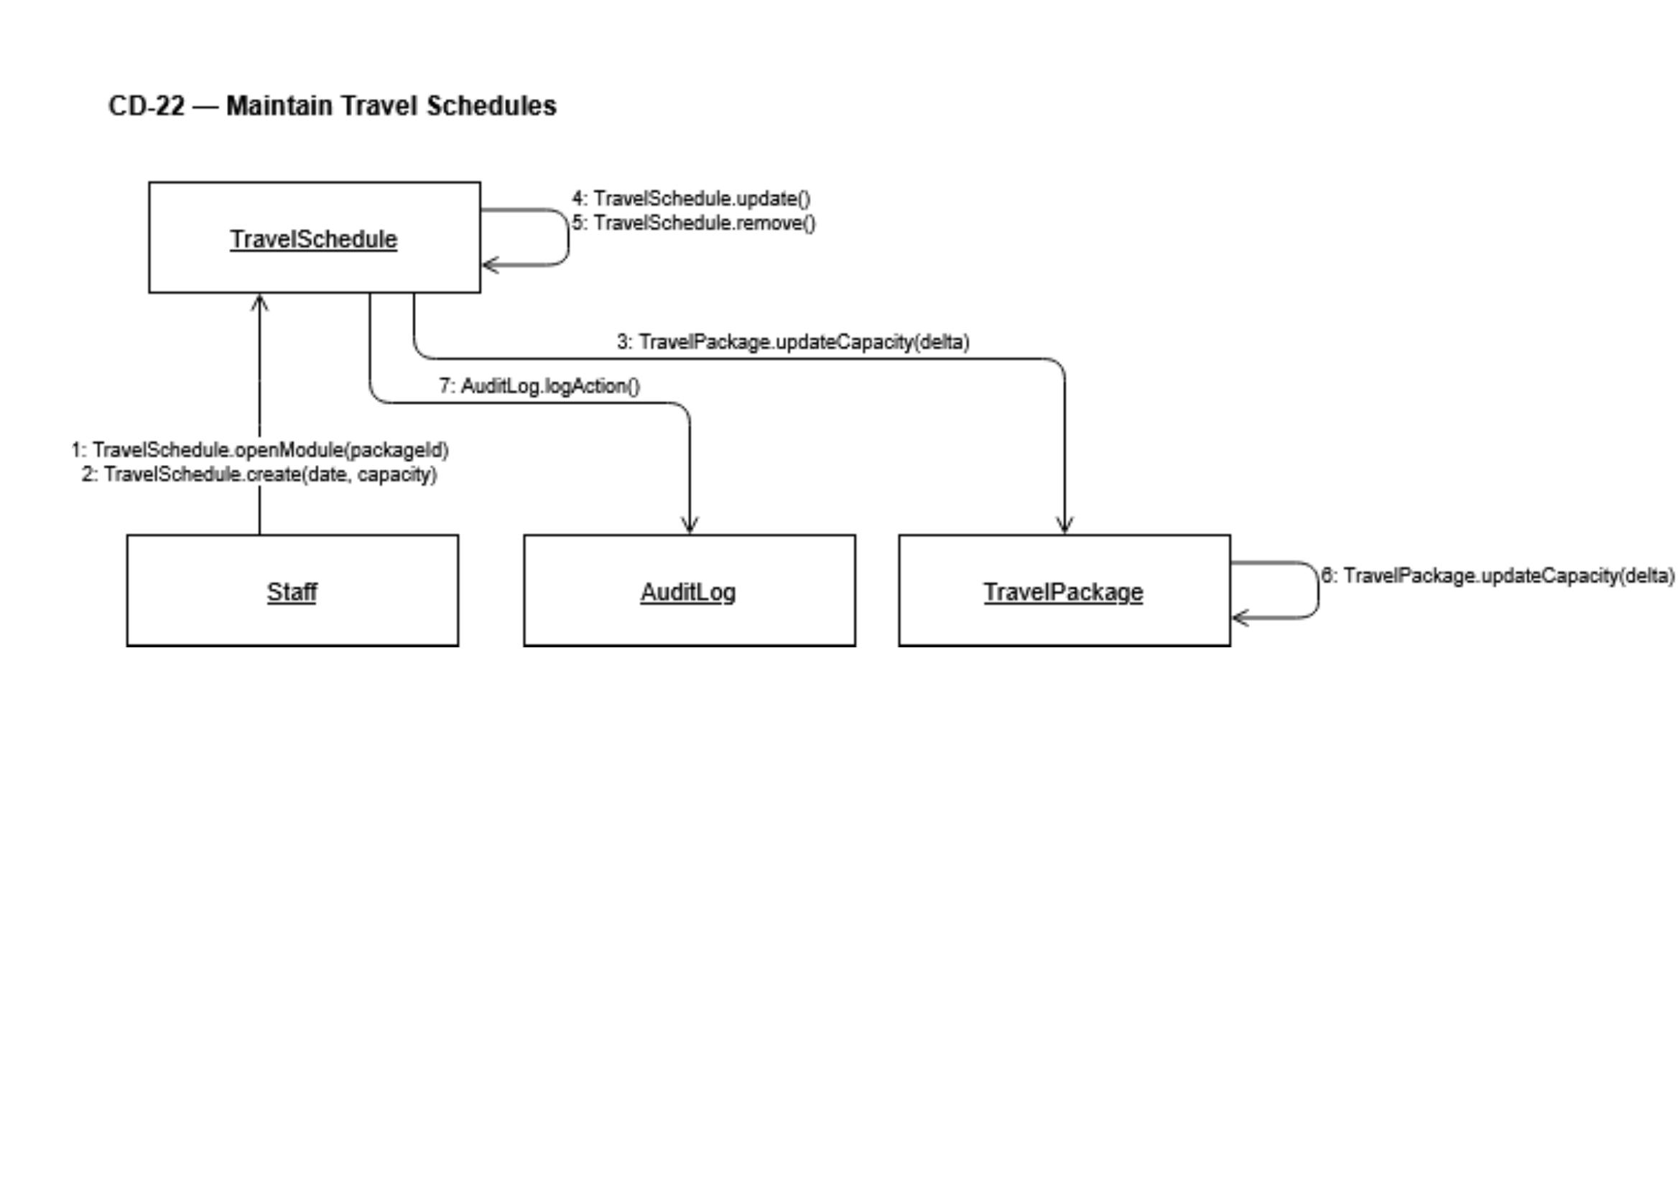
CD-22 — Maintain Travel Schedules

State Machine Diagram

State Machine — Administrator (Operations Staff state machine pending)

Henri Aliaj — Domain 6 — Financial Management

Functional Requirement
FR ID | Priority | Requirement
FR-35 | High | The system shall allow finance staff to record incoming and outgoing payments and update payment status as unpaid, partial, paid, refunded, or cancelled.

Use Case Table
Use Case ID | UC-29
Use Case Name | Record Payment Status
Primary Actor | Finance Staff
Secondary Actors | Travel Agent — notified when payment status affects booking. Customer — notified of payment updates. Manager/Owner — monitors payment statuses via dashboard.
Trigger | Finance Staff opens a booking payment record to record or update payment.
Preconditions | Finance Staff is logged in and a booking payment record exists.
Main Success Scenario | 1. Finance Staff opens the payment record for a selected booking. 2. Finance Staff records payment amount, type, and date. 3. Finance Staff updates the payment status. 4. System updates the booking record to reflect the new payment status. 5. System flags the payment as overdue if applicable. 6. System notifies the customer and Travel Agent of the status update.
Alternative Flows | • Payment recorded exceeds expected amount — discrepancy flagged for reconciliation. • Booking already cancelled — payment recording blocked, directed to refund workflow. • Payment marked partial — system checks due date and flags if overdue.
Postconditions | Payment status is recorded and reflected across booking and financial records.
Related FRs | FR-35, FR-40

Activity Diagram
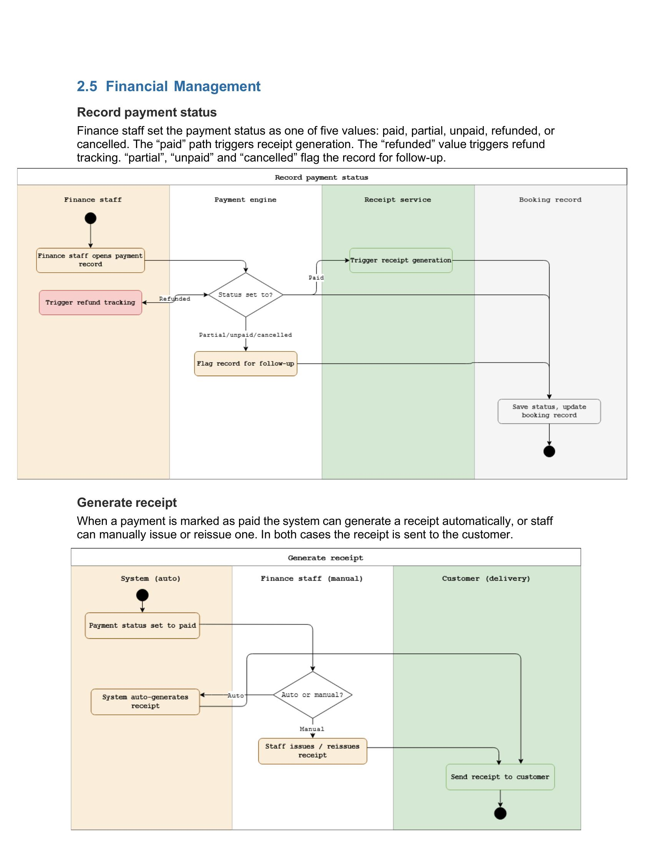
Activity Diagram — Record Payment Status

Sequence Diagram
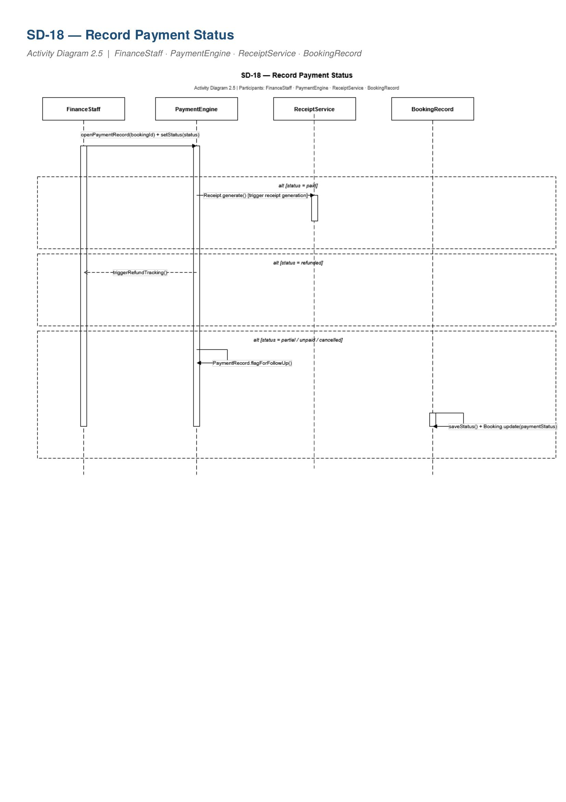
SD-18 — Record Payment Status

Collaboration Diagram
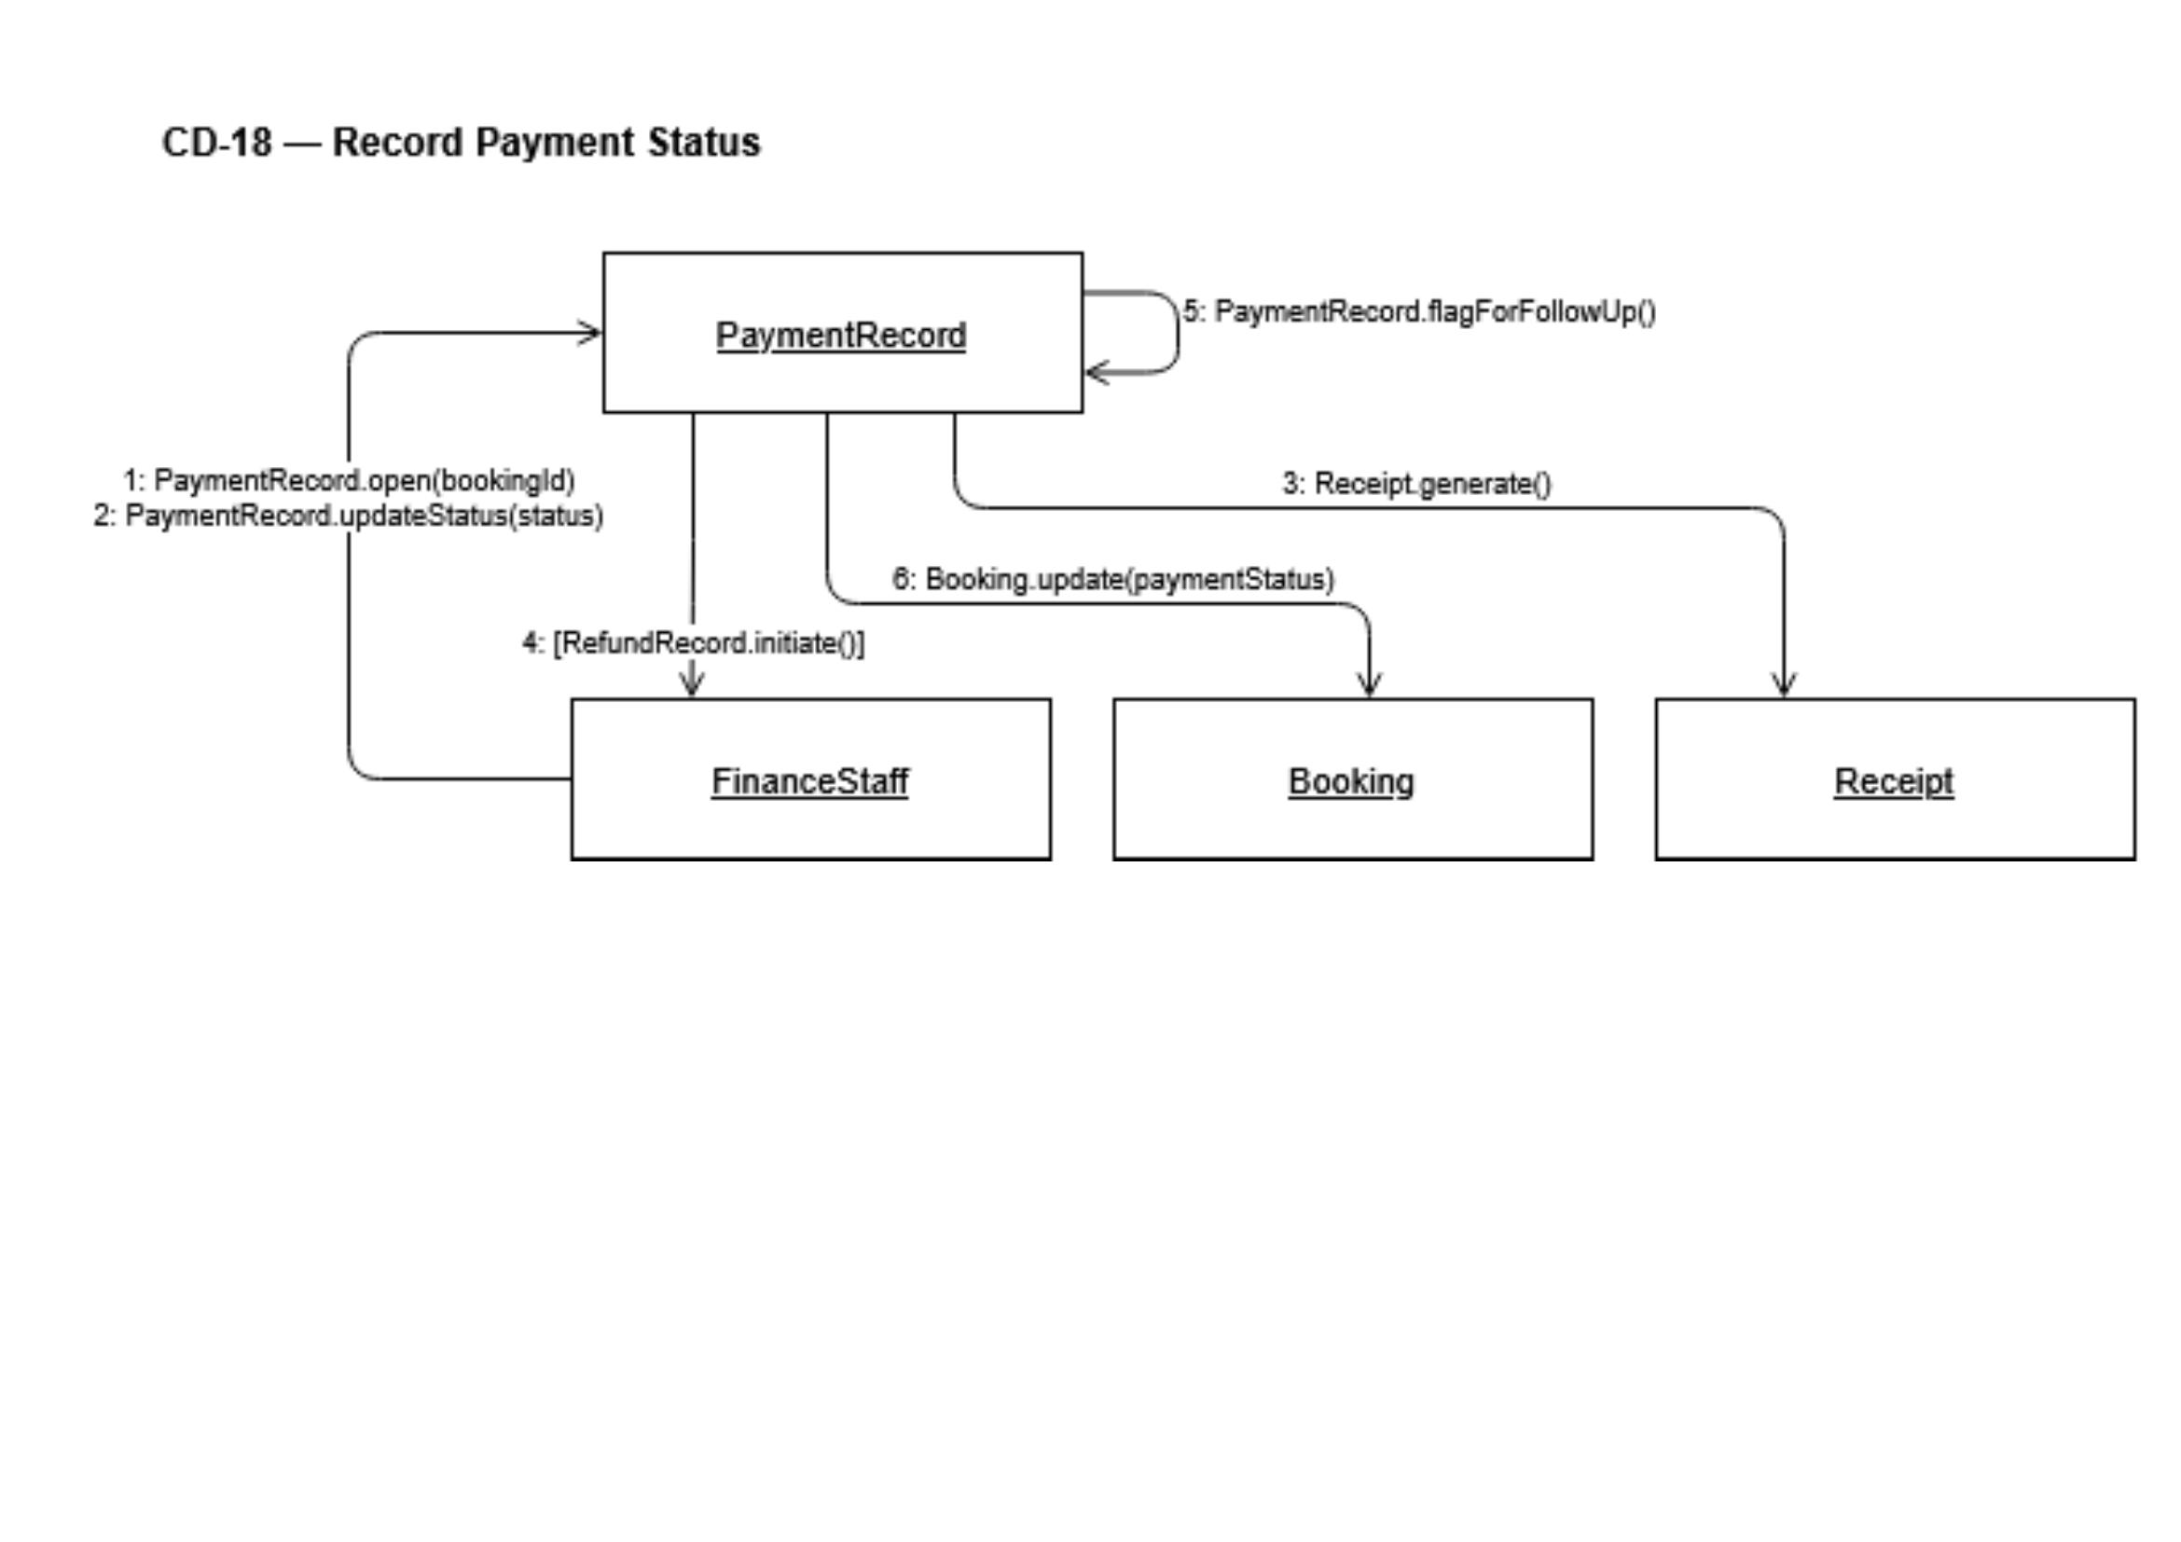
CD-18 — Record Payment Status

State Machine Diagram
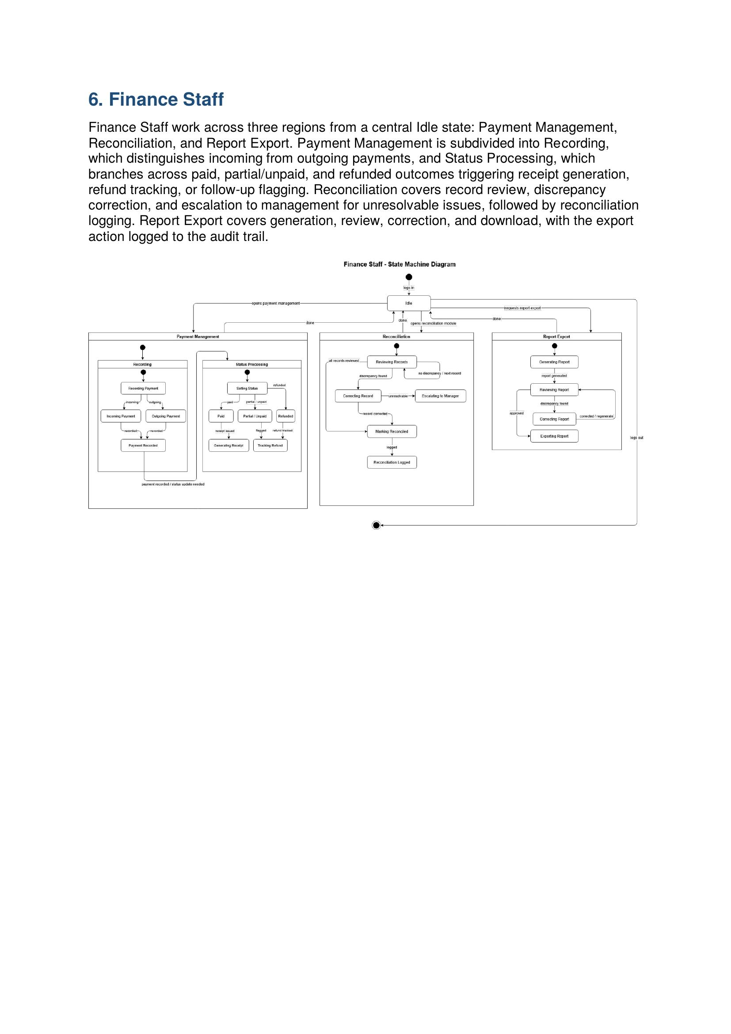
State Machine — Finance Staff (Payment States)

Dion — Domain 7 — Customer Experience & Loyalty

Functional Requirement
FR ID | Priority | Requirement
FR-45 | Low | The system shall record loyalty points earned per booking and allow customers to view and apply available rewards at the time of booking.

Use Case Table
Use Case ID | UC-37
Use Case Name | Manage Loyalty Program
Primary Actor | Customer
Secondary Actors | Finance Staff — loyalty points linked to payment completion. Travel Agent — references loyalty status when handling bookings.
Trigger | Booking is confirmed and payment completed, triggering loyalty point crediting. Or customer opens the loyalty section to view or apply rewards.
Preconditions | Customer is logged in and has at least one completed booking.
Main Success Scenario | 1. Booking is confirmed and payment completed. 2. System checks customer eligibility for loyalty points. 3. System credits loyalty points to the customer account. 4. Customer opens loyalty section and views current points balance. 5. Customer applies available rewards when submitting a new booking. 6. System validates eligibility and applies the reward at booking.
Alternative Flows | • Customer attempts to apply rewards with insufficient points — application blocked. • Booking cancelled after points credited — points reversed or held subject to policy. • Points expired — balance updated, customer notified.
Postconditions | Loyalty points are credited, visible to the customer, and applicable to future bookings.
Related FRs | FR-45

Activity Diagram
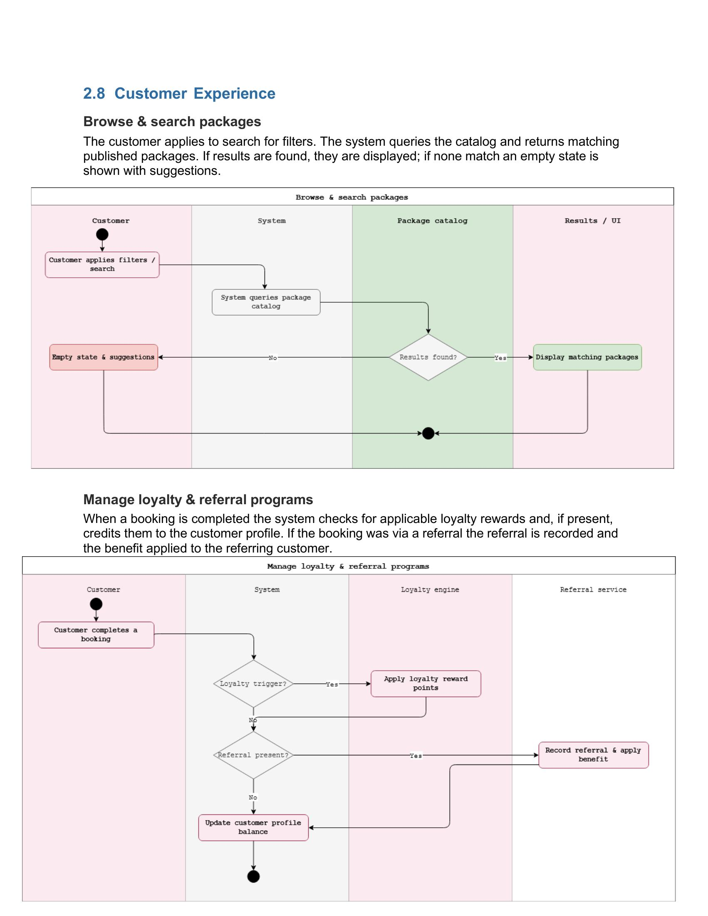

Sequence Diagram
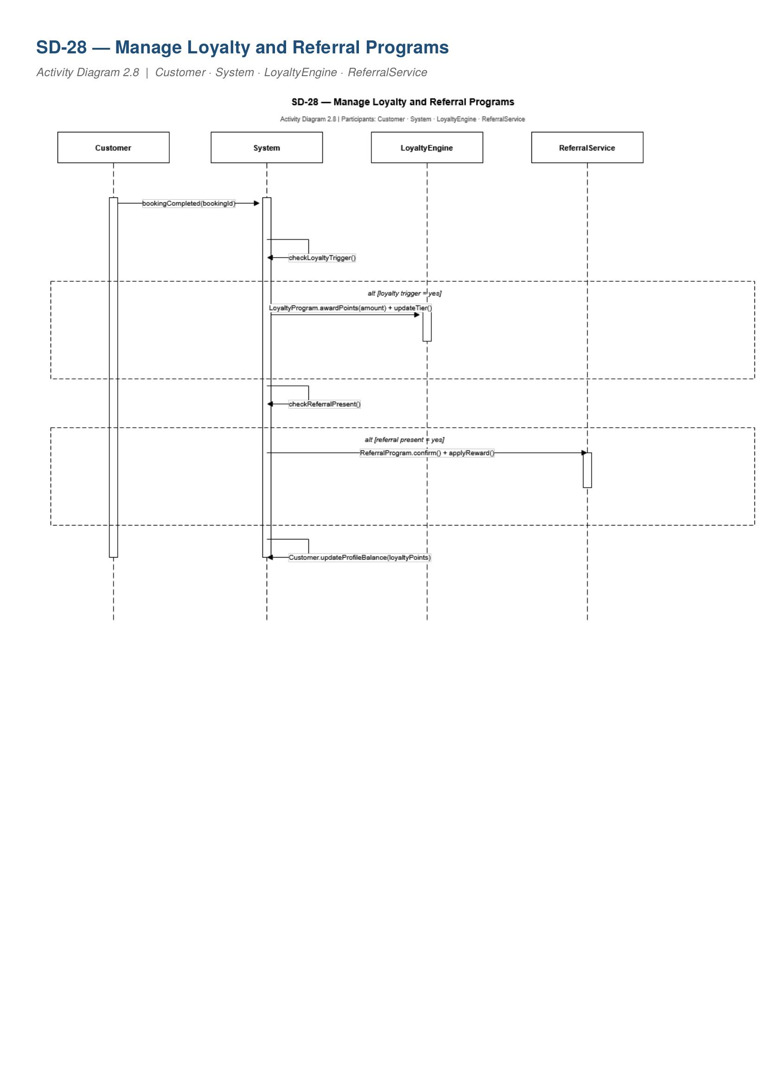
SD-28 — Manage Loyalty and Referral Programs

Collaboration Diagram
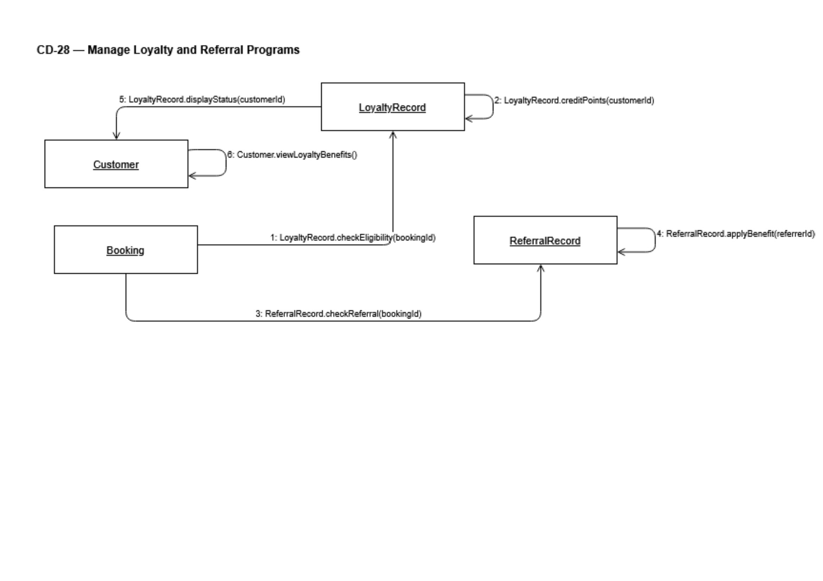
CD-28 — Manage Loyalty and Referral Programs

State Machine Diagram

State Machine — Customer (Loyalty and Post-Trip States)

