BPMN Process Diagrams
Tour and Travel Agency Operations System
Three core business processes modelled in BPMN 2.0

BPMN-01 — Package to Booking Process

Lanes: Customer · Travel Agent · System
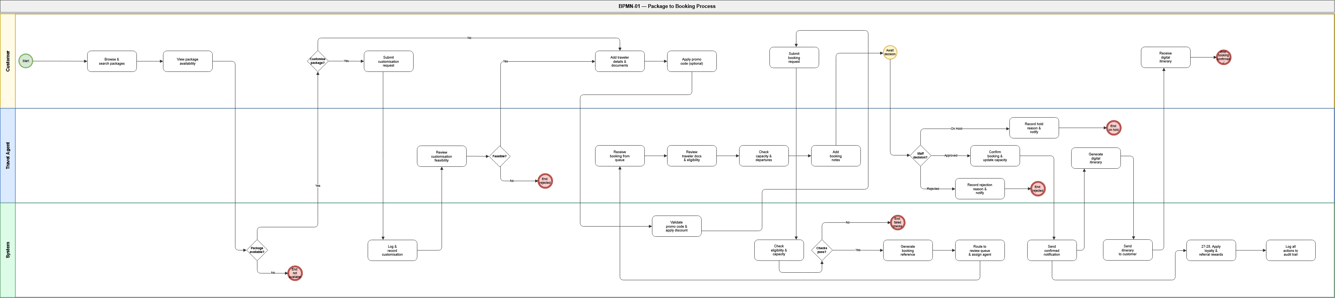
Description
This diagram models the agency's primary revenue-generating process — from the moment a customer first browses available packages through to a confirmed booking with a digital itinerary in hand.
The process begins in the Customer lane where the customer browses packages, views availability, and optionally submits a customisation request. If customisation is requested, the Travel Agent reviews feasibility and the System logs the outcome. The customer then adds traveler details, applies a promo code if available, and submits the booking request.
The System lane handles all automated steps: eligibility and capacity checks, booking reference generation, and routing to the staff review queue. The Travel Agent then reviews the booking — checking traveler documents, capacity, and departure details — before making a three-way decision: Approved, Rejected, or On Hold. An approved booking triggers itinerary generation and delivery to the customer. The System automatically applies loyalty and referral rewards on confirmed bookings and logs all actions to the audit trail.

BPMN-02 — Cancellation and Refund Process

Lanes: Customer · Travel Agent · Finance Staff · System
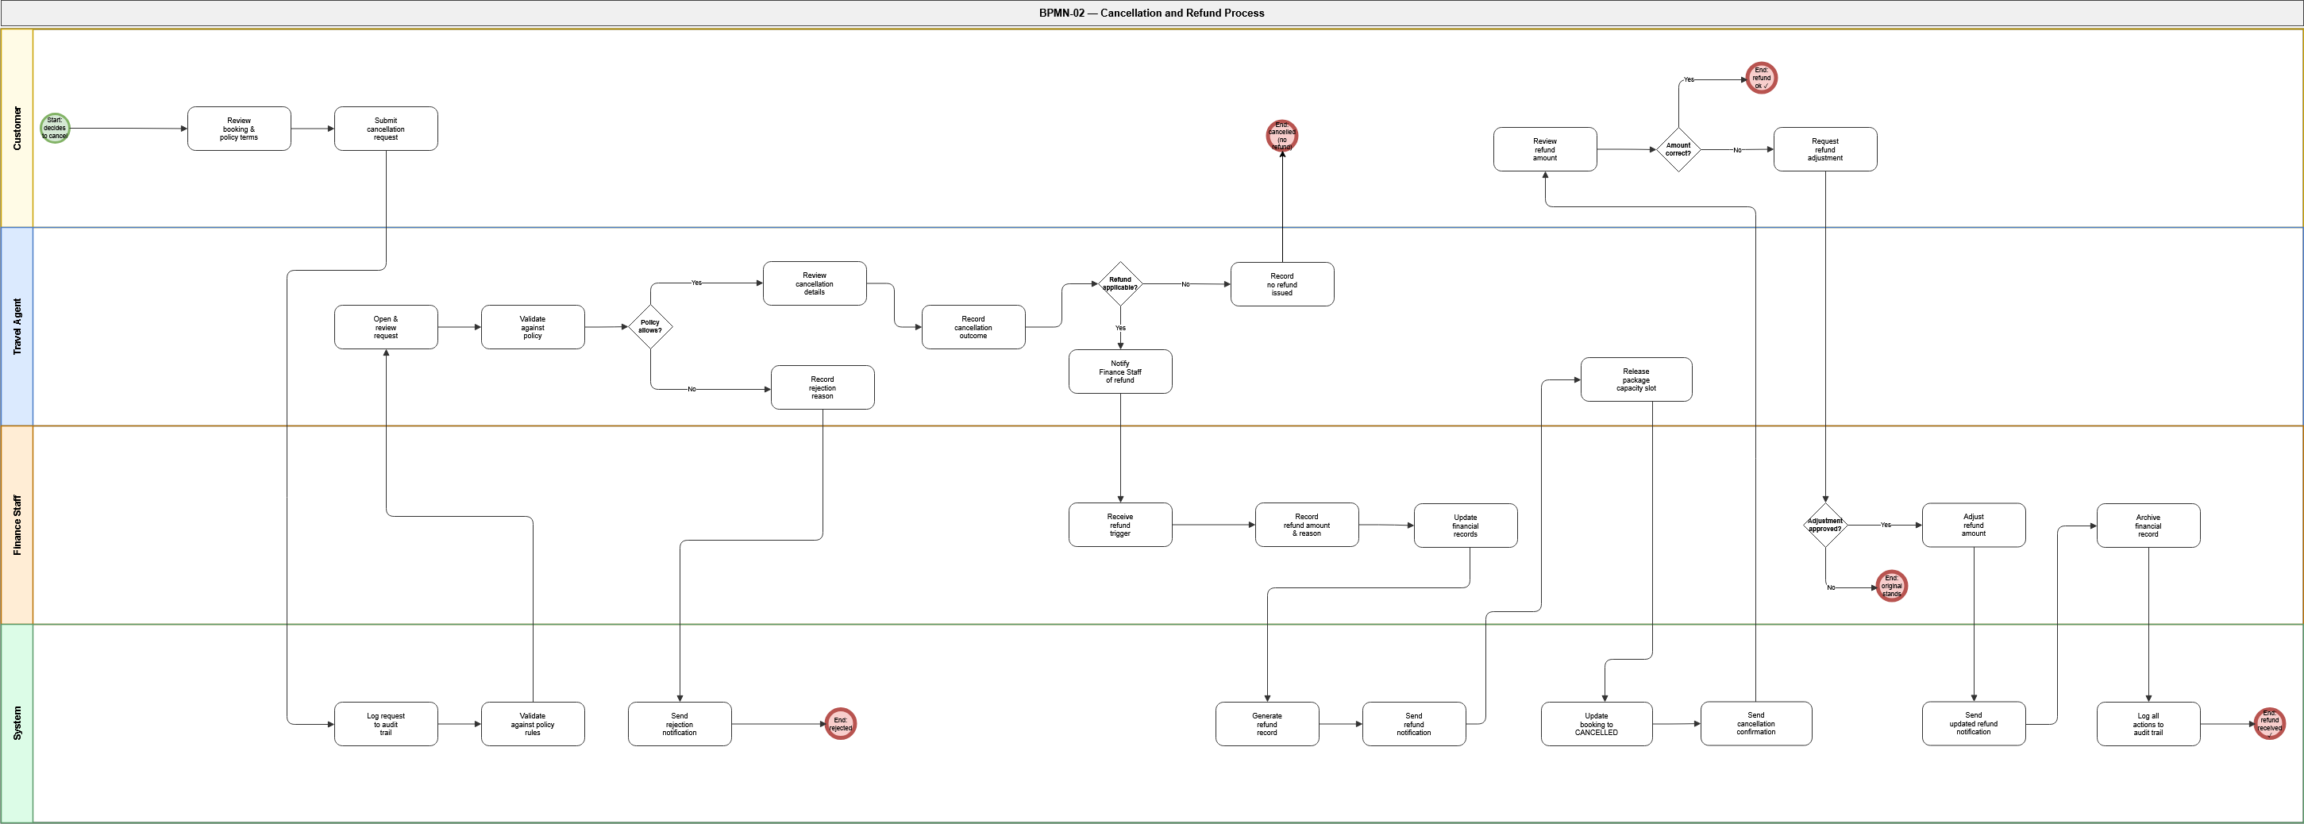
Description
This diagram models the agency's primary exception and recovery process — covering every possible outcome when a customer requests a cancellation, from policy rejection through to refund settlement.
The process starts with the customer reviewing the applicable cancellation policy and submitting a formal request. The System logs the submission and validates it against policy rules before routing to the Travel Agent. The Travel Agent checks whether the policy permits cancellation: if not, the rejection is recorded and the customer is notified immediately.
If policy allows, the Travel Agent records the outcome and decides whether a refund applies. The no-refund and refund paths both converge at a shared set of steps — releasing capacity, updating booking status, and sending confirmation — ensuring these actions happen exactly once regardless of the refund decision. Where a refund is applicable, Finance Staff record the amount, update financial records, and the System notifies the customer. A final adjustment loop allows the customer to dispute the refund amount, which Finance Staff can approve or decline before archiving the financial record.

BPMN-03 — Financial Settlement Process

Lanes: Finance Staff · Customer · Manager/Owner · System
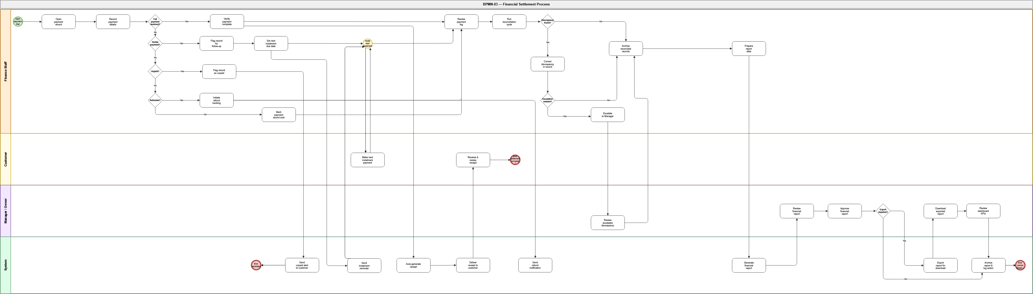
Description
This diagram models the agency's end-to-end financial management process — from recording an individual booking payment through reconciliation, report generation, and period closure.
The Finance Staff lane drives the process. After opening and recording payment details, four chained gateways determine the payment status: Full payment leads directly to receipt generation and reconciliation. Partial payment triggers a follow-up cycle where an instalment due date is set, a reminder sent, and the process waits for the customer's next payment before continuing. Unpaid records are flagged and escalated internally. Refunded records link to the cancellation process. Cancelled records are voided and flow directly to reconciliation.
All active payment paths converge at the reconciliation phase where Finance Staff review the payment log, run a reconciliation cycle, and handle any discrepancies — correcting them directly or escalating unresolvable issues to the Manager/Owner. Once reconciled, Finance Staff prepare report data which the System generates into a formal financial report. The Manager/Owner reviews and approves the report, optionally exports it, reviews the operations dashboard, and closes the financial period.

