]\[
Factory Method Pattern
Creational Design Pattern
Tour and Travel Agency Operations System

Pattern Overview
Pattern Name | Factory Method
Category | Creational
Also Known As | Virtual Constructor
Intent | Define an interface for creating an object, but let the creator decide which class to instantiate. Factory Method lets a class defer instantiation to a method.
GoF Reference | Design Patterns: Elements of Reusable Object-Oriented Software — Gamma et al., p. 107

Pattern Structure
The Factory Method pattern defines three core roles. The Creator declares the factory method that returns a Product. The Product is the type of object that the factory method creates. The Client uses the Creator to obtain a Product without knowing the details of how it is constructed.

The key principle is encapsulation of object creation. Instead of constructing a complex object directly with a constructor, the creation logic is delegated to a dedicated method. This ensures the product is always created in a consistent and valid state, and the caller does not need to know how the construction is done.

Class Diagram
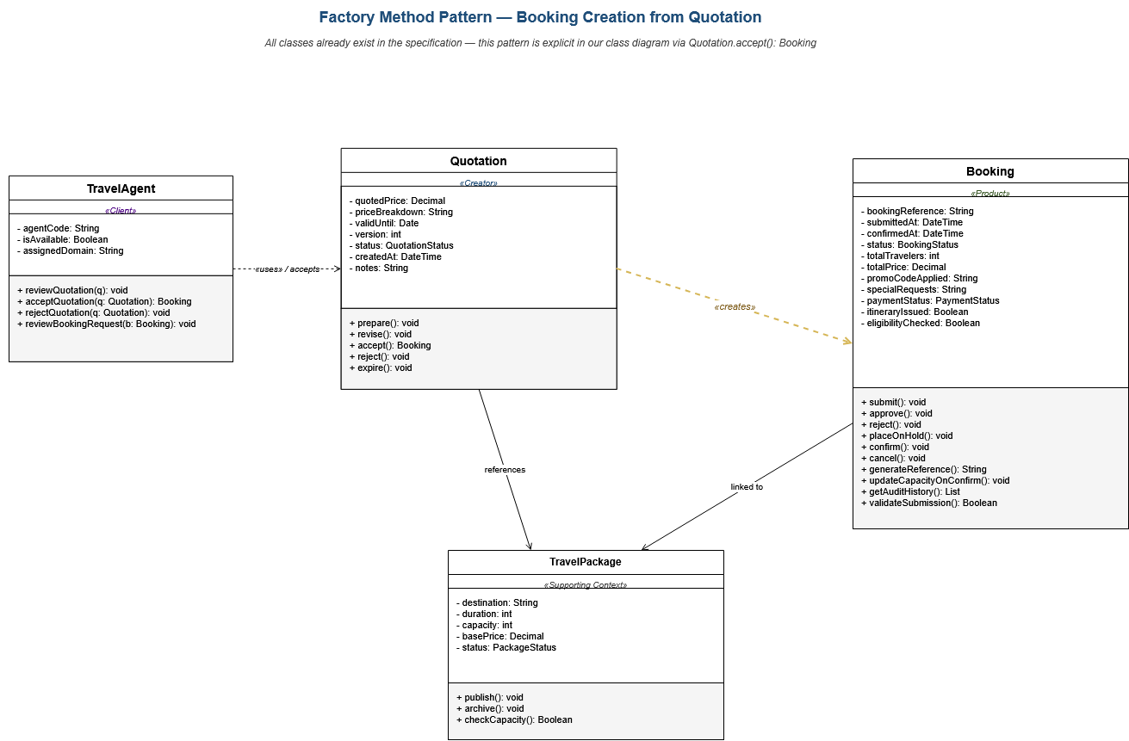
Factory Method Pattern showing Quotation.accept(): Booking as the factory method

How This Pattern Already Exists in Our System
Unlike Observer and State, the Factory Method pattern is already explicitly present in our class specification. The relationship is not implied by behavior or structure — it is literally documented as a method signature.

On page 26 of the Class Diagram Specification, the Quotation class is defined with the following method:

+ accept() : Booking

This is the textbook definition of a Factory Method. A method on one class that constructs and returns an instance of another class. The specification also documents the relationship explicitly: Quotation has an Association with Booking, a Dependency from TravelAgent (used by the agent), and an Association with TravelPackage. All three pattern participants (Creator, Product, Client) are already in place.

The remaining work is not to introduce the pattern but to recognize that it exists and explain its role in our system.

How the Pattern Operates in This System
Creator: Quotation
The Quotation class is a formal price estimate prepared by a Travel Agent in response to an inquiry. It holds the quoted price, price breakdown, validity date, version number, and notes — all the information needed to construct a corresponding Booking. The Quotation also has its own lifecycle methods: prepare(), revise(), reject(), and expire(). Only when accept() is called does it produce a Booking.

Factory Method: accept(): Booking
The accept() method on Quotation is the factory method. When called, it does several things:
- Validates that the quotation is still valid (not expired, not already accepted, in an acceptable status).
- Constructs a new Booking with the quoted price as totalPrice, the linked package as the booking's package reference, and the traveler details from the originating inquiry.
- Invokes Booking.generateReference() to produce the unique booking reference.
- Sets the initial booking status to Requested (or its equivalent state object).
- Links the new booking back to the originating quotation for traceability.
- Returns the fully formed Booking object ready to enter the review workflow.

None of this complexity is visible to the caller. The Travel Agent simply calls quotation.accept() and receives a properly initialized Booking. This is the essence of the Factory Method pattern.

Product: Booking
Booking is the Product. It is a complex object with eleven attributes that must all be initialized consistently. Its own methods generateReference() and validateSubmission() exist precisely to support consistent creation. The factory method on Quotation calls these methods as part of the creation sequence.

Client: TravelAgent
TravelAgent is documented in the specification as having a Dependency relationship with Quotation, described as 'Used by TravelAgent (prepares)'. The Travel Agent is the typical caller of accept() once the customer has agreed to the quoted terms. The agent does not construct Bookings directly — the agent works through quotations.

Justification
A Booking in this system is not a simple object. It must be initialized with eleven attributes including bookingReference, status, totalPrice, paymentStatus, eligibilityChecked, and traveler counts. Construction must be consistent because any Booking entering the review workflow with missing or inconsistent attributes would cascade errors through downstream classes — PaymentRecord, AuditLog, BookingNote, and the travel agent's review queue all depend on a correctly initialized Booking.

Three concrete benefits result from this pattern being present:

- Consistency — every Booking produced from a Quotation has the same initialization sequence. There is no scattered Booking construction code across the system creating bookings in slightly different ways.
- Validity — the quotation is validated before a booking is produced. An expired quotation, an already-accepted quotation, or a quotation referencing a now-archived package cannot produce a booking. The factory method enforces these business rules at the moment of creation.
- Traceability — every booking produced through this path can be traced back to its originating quotation. This is critical for audit, dispute resolution, and reporting — and it would be lost if bookings could be constructed arbitrarily from anywhere in the system.

This pattern fits the agency's business model naturally. A travel agency operates with a formal quotation workflow — customers receive a written estimate before committing. The Factory Method models this business rule structurally rather than procedurally. A Booking cannot come from nowhere — it must come from an accepted Quotation. The pattern enforces what would otherwise be a documented but unenforced business rule.

Participants in This System
Creator | Quotation (existing in specification)
Factory Method | accept(): Booking (existing in specification, page 26)
Product | Booking (existing in specification)
Client | TravelAgent (existing dependency on Quotation in specification)
Supporting Context | TravelPackage and Inquiry are both linked to Quotation and inherited by the produced Booking
Booking Construction Methods Used | generateReference(), validateSubmission()

Why This Pattern Was Designed Into the System
Of the three patterns presented (Observer, State, Factory Method), this is the only one that was explicitly designed into the class specification rather than emerging implicitly from class relationships. The Quotation.accept() : Booking signature shows that the design intent was always to channel booking creation through the quotation workflow. This makes Factory Method the strongest of our three pattern presentations — we are not proposing it as an improvement, we are identifying it as part of the system's original architecture.

