Observer Pattern
Behavioral Design Pattern
Tour and Travel Agency Operations System

Pattern Overview
Pattern Name | Observer
Category | Behavioral
Also Known As | Publish-Subscribe, Event Listener, Dependents
Intent | Define a one-to-many dependency between objects so that when one object changes state, all its dependents are notified and updated automatically.
GoF Reference | Design Patterns: Elements of Reusable Object-Oriented Software — Gamma et al., p. 293

Pattern Structure
The Observer pattern defines two core roles. The Subject holds state and maintains a list of observers. It notifies all registered observers whenever its state changes. The Observer is an interface that all concrete observers implement, defining the update() method that the subject calls when notifying dependents. Concrete Observers implement the Observer interface and define their specific reaction to state changes in the subject.

The key principle is decoupling. The Subject does not need to know what its observers do with the notification. It simply broadcasts the change. Each observer handles its own responsibility independently.

Class Diagram
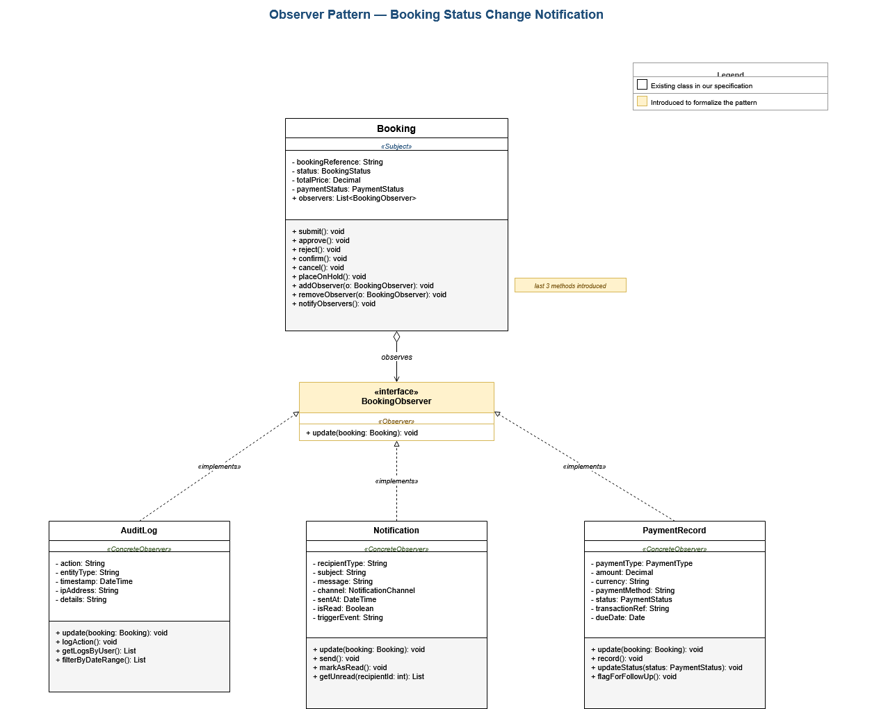
Observer Pattern applied to Booking and its dependent classes

How This Pattern Emerges in Our System
The Observer pattern is not labeled explicitly in our class specification, but the structural relationships and behaviors required for it are already present. The pattern emerges naturally from how Booking interacts with several other classes whenever its status changes.

Three observations from the existing class specification support this:
- The Booking class has six state-changing methods (submit, approve, reject, placeOnHold, confirm, cancel) and a method getAuditHistory() that explicitly returns a list of audit entries linked to the booking. This shows that booking actions are recorded as audit events in AuditLog.
- The Notification class has a triggerEvent attribute whose description in the specification reads, in part: 'triggered by a system event such as booking confirmation or status change.' This confirms that Notification reacts to booking state changes.
- PaymentRecord is composed by Booking and has updateStatus() and flagForFollowUp() methods. A booking confirmation triggers payment record updates, and a cancellation triggers refund-related flagging.

These three relationships demonstrate the same underlying behavior: a single state change on Booking causes coordinated reactions in AuditLog, Notification, and PaymentRecord. This is precisely the behavior that the Observer pattern formalizes.

Applying the Pattern Explicitly
To make this pattern explicit in our class design, we introduce one new interface and three observer relationships:

Subject: Booking
Booking takes on the Subject role. It maintains a list of registered observers and exposes the methods needed to manage subscriptions (addObserver, removeObserver, notifyObservers). The existing lifecycle methods (approve, reject, confirm, cancel, placeOnHold) each invoke notifyObservers() at the end of their execution. This requires no changes to method signatures already in the specification — only the addition of the notification call inside each method.

Observer Interface: BookingObserver
We introduce a BookingObserver interface that defines a single update(booking: Booking) method. This is the only new abstraction required. All three observer classes already exist in the specification and already perform the reactions we want — we simply have them implement the new interface.

Concrete Observers
AuditLog | Already exists in the specification with logAction(), getLogsByUser(), and filterByDateRange(). Its existing role of recording significant system actions maps directly to reacting to booking state changes.
Notification | Already exists in the specification with send() and a triggerEvent attribute that explicitly references booking state changes. The class is already designed to be triggered by booking events.
PaymentRecord | Already exists in the specification, composed by Booking, with updateStatus() and flagForFollowUp(). Its tight coupling to Booking via composition makes it a natural observer of booking state changes.

Justification
The behavioral relationships required by Observer are already implicit in the specification. Booking, AuditLog, Notification, and PaymentRecord all exist with the right responsibilities. The pattern simply formalizes how they coordinate. Three concrete benefits result:

- Decoupling — Booking no longer needs direct references to AuditLog, Notification, and PaymentRecord. It only knows the BookingObserver interface. This breaks what would otherwise be tight, hard-coded dependencies between Booking and three other classes.
- Extensibility — Adding a new reaction to booking state changes (for example a WaitlistNotifier for the waitlist feature in UC-17) requires no modification to the Booking class. The new observer simply implements BookingObserver and registers itself. This aligns with the Open-Closed Principle.
- Consistency — Centralizing notification logic in notifyObservers() ensures every state change reaches every interested observer. There is no risk of forgetting to call the audit log in one branch of a method but remembering it in another.

This pattern fits this system particularly well because booking lifecycle events have many downstream consequences that span different functional domains — auditing in the User & Access domain, communication in the Customer Experience domain, and finance in the Financial Management domain. Observer keeps these domains independent while ensuring they all stay synchronized with the booking lifecycle.

Participants in This System
Subject | Booking (existing in specification)
Observer Interface | BookingObserver (introduced to formalize the pattern)
Concrete Observer 1 | AuditLog (existing in specification)
Concrete Observer 2 | Notification (existing in specification)
Concrete Observer 3 | PaymentRecord (existing in specification)
New Methods on Booking | addObserver(), removeObserver(), notifyObservers()
Existing Methods Used | logAction() on AuditLog, send() on Notification, updateStatus() on PaymentRecord

