State Pattern
Behavioral Design Pattern
Tour and Travel Agency Operations System

Pattern Overview
Pattern Name | State
Category | Behavioral
Also Known As | Objects for States
Intent | Allow an object to alter its behavior when its internal state changes. The object will appear to change its class.
GoF Reference | Design Patterns: Elements of Reusable Object-Oriented Software — Gamma et al., p. 305

Pattern Structure
The State pattern defines three core roles. The Context holds a reference to its current State object and delegates state-dependent behavior to it. The State interface declares the methods whose behavior varies by state. The Concrete States implement the State interface, each encapsulating the behavior appropriate to one specific state of the Context.

The key principle is that each valid state becomes a class instead of being represented by conditional logic on a status field. The Context simply delegates to whatever State object it currently holds, and the State object enforces what is and is not valid in that state.

Class Diagram
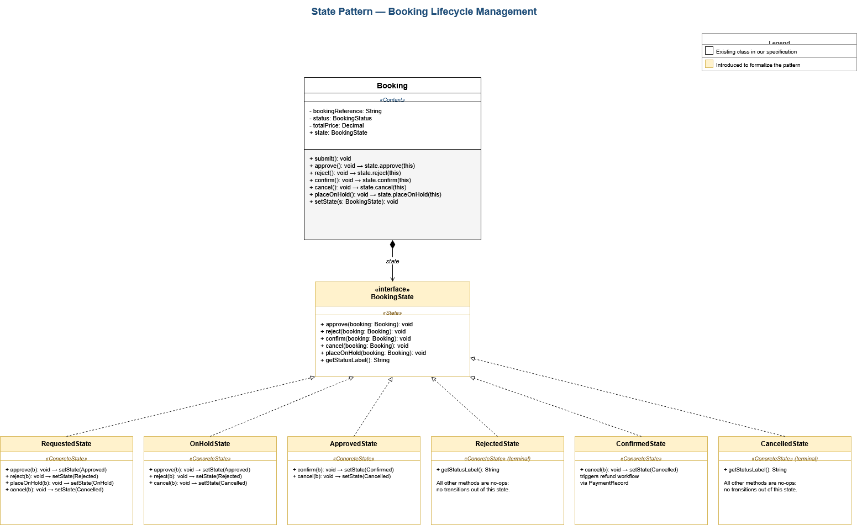
State Pattern applied to Booking lifecycle with six concrete states

How This Pattern Emerges in Our System
The State pattern is not explicitly modeled in our class specification, but the lifecycle it formalizes is already documented in detail. The Booking class has an explicit status attribute of type BookingStatus and six methods that change its lifecycle position: submit, approve, reject, placeOnHold, confirm, and cancel.

Several observations from the specification support introducing State here:
- BookingStatus is defined as a typed attribute with discrete values — Requested, OnHold, Approved, Rejected, Confirmed, Cancelled — rather than a free-form string. This implies a finite, well-defined state space.
- The lifecycle methods on Booking only make sense in certain states. cancel() on a Confirmed booking triggers a refund. cancel() on a Requested booking simply removes it. cancel() on an already Cancelled booking should do nothing. The same method name implies different behavior depending on current state.
- The state machine diagram for Customer (in the existing State Machine Diagrams documentation) already shows the Booking Journey region with explicit transitions: Booking Requested → On Hold, Approved, or Rejected; Approved → Confirmed; Confirmed → Cancelled. The state model is already designed.

Currently this lifecycle is enforced through implicit checks inside each lifecycle method. The State pattern moves this enforcement into the type system itself, where it cannot be bypassed.

Applying the Pattern Explicitly
To make this pattern explicit we introduce a BookingState interface and six concrete state classes corresponding to the BookingStatus enum values. The Booking class continues to expose its lifecycle methods, but each method now delegates to its current state object.

Context: Booking
Booking takes on the Context role. The existing status: BookingStatus attribute is supplemented with a state: BookingState attribute that holds the current state object. The existing lifecycle methods (approve, reject, confirm, cancel, placeOnHold) remain on Booking but delegate to the state object: this.state.approve(this). This preserves the existing public interface while moving behavior into the state classes.

State Interface: BookingState
BookingState is the new interface declaring the lifecycle methods that vary by state. Each method takes the Booking as a parameter so it can transition the booking by calling setState() on it.

Concrete States
RequestedState | Initial state after submission. Valid transitions: approve → ApprovedState, reject → RejectedState, placeOnHold → OnHoldState, cancel → CancelledState.
OnHoldState | Booking paused for review. Valid transitions: approve → ApprovedState, reject → RejectedState, cancel → CancelledState.
ApprovedState | Agent has approved. Valid transitions: confirm → ConfirmedState, cancel → CancelledState.
RejectedState | Terminal state. No further transitions permitted. All lifecycle methods are no-ops or throw exceptions.
ConfirmedState | Booking is active. Valid transition: cancel → CancelledState (triggers refund workflow via PaymentRecord).
CancelledState | Terminal state. No further transitions permitted.

Justification
The Booking lifecycle in this system is business-critical. An illegal state transition — confirming a rejected booking, cancelling a trip that has already completed, approving a booking that was never submitted — could cause inconsistency across the Booking, PaymentRecord, PackageSchedule, and AuditLog classes. Currently the only protection against this is conditional logic inside each method, which is error-prone:

if (status == REQUESTED) { ... } else if (status == ON_HOLD) { ... } else if (status == CONFIRMED) { ... } else { throw ... }

This kind of code grows in proportion to the number of states multiplied by the number of methods. Each new state requires modifying every method, and each new method requires considering every state. The State pattern eliminates this entirely. Three concrete benefits result:

- Illegal transitions become impossible — RejectedState simply does not implement methods like confirm() with any behavior, so calling confirm() on a rejected booking has no effect or raises an explicit error. The constraint is enforced structurally, not by remembering to write the right if-check.
- Each state class encapsulates only the behavior relevant to that state — RequestedState only knows how to handle approve, reject, placeOnHold, and cancel. It does not need to know anything about ConfirmedState's behavior.
- Adding a new state — for example a PendingDocumentsState between Approved and Confirmed — is localized. We add one class and update the transition logic in the surrounding states. No conditional logic anywhere else needs to change.

The pattern aligns perfectly with the state machine diagrams we have already documented for this system. The diagrams describe the transitions; the State pattern implements them at the class level.

Participants in This System
Context | Booking (existing in specification, gains state attribute)
State Interface | BookingState (introduced to formalize the pattern)
Concrete State 1 | RequestedState
Concrete State 2 | OnHoldState
Concrete State 3 | ApprovedState
Concrete State 4 | RejectedState (terminal)
Concrete State 5 | ConfirmedState
Concrete State 6 | CancelledState (terminal)
Mapping to Existing Spec | BookingStatus enum values map one-to-one to concrete state classes

