23CS11E - WEBFRAMEWORK USING PYTHON
Micro Project
Report On
MediLens – AI-Powered Medicine Information and Pharmacy Finder
Submitted by
INFHANT JOSEPH T 2403957620521052
In partial fulfillment for the award of the degree
of
BACHELOR OF TECHNOLOGY
in
INFORMATION TECHNOLOGY

NATIONAL ENGINEERING COLLEGE
(An Autonomous Institution affiliated to Anna University, Chennai)
K.R.NAGAR, KOVILPATTI - 628503
OCTOBER – 2026
NATIONAL ENGINEERING COLLEGE
K.R.NAGAR, KOVILPATTI – 628503
BONAFIDE CERTIFICATE
This is to certify that this project report is a Bonafide record of INFHANT JOSEPH T (2403957620521052) work done for the course 23CS11E - WEBFRAMEWORK USING PYTHON at the NATIONAL ENGINEERING COLLEGE, K.R. NAGAR, during the academic year 2026 – 2027 who carried out the project work under my supervision.

Course Instructor/Guide
TABLE OF CONTENTS
CHAPTER NO. | TITLE | PAGE NO
1 | INTRODUCTION | 5
2 | IMPLEMENTATION | 8
3 | IMPLEMENTATION RESULTS | 79
4 | CONCLUSION | 90
ABSTRACT
MediLens is a web application that helps people understand the medicines they use and find which nearby pharmacy has them in stock. It brings customers, pharmacies and an administrator together on one platform, with a separate login and dashboard for each of the three roles.
Customers can search for a medicine by brand or salt name, or upload a photo of the medicine strip or box. Text in the photo is read with the EasyOCR library and fuzzy-matched against the medicine database. For each medicine, the portal shows its uses, side effects, warnings and prescription status, together with cheaper alternatives that contain the same salt and strength. Customers can then check, city by city, which pharmacies currently stock the medicine and at what price, filter for pharmacies that are open now, and ask the MediLens AI assistant questions about the medicine in English, Tamil or Hindi, by typing or by voice. The assistant is instructed never to diagnose, prescribe or suggest dosage changes, and it can search the platform database on request through function calling.
Pharmacies register with their license number and location, wait for administrator approval, and then maintain their own stock and prices. The administrator approves or blocks pharmacies, manages the master medicine database and customer accounts, and publishes multilingual health tips with images stored in MongoDB GridFS. The system is built with Flask and PyMongo on a MongoDB database, Jinja2 templates with HTML, CSS and JavaScript on the front end, EasyOCR for text recognition and the Groq API for the language model. Passwords are stored as hashes, access is controlled by role-based decorators, every form post is protected by a CSRF token, and uploads are limited to 5 MB.
CHAPTER 1
INTRODUCTION
1.1 INTRODUCTION
Medicines are bought every day by people who often have little reliable information about them. The packaging is crowded with technical terms, the same salt is sold under many brand names at very different prices, and it is not obvious which nearby shop has a particular medicine in stock. Asking a search engine or a general chatbot can return advice that is incomplete, unsafe or not written in a language the person is comfortable with.
MediLens has been developed to address this with a single, centralized platform. A customer can scan or search for a medicine, read plain-language information about it, compare it with equivalent medicines, locate pharmacies that stock it, and ask an AI assistant follow-up questions. Pharmacies keep their own stock and prices up to date, and an administrator verifies pharmacies and maintains the medicine data that every other part of the system relies on.
The application is implemented in Python with the Flask web framework and a MongoDB database accessed through PyMongo. Pages are rendered on the server with Jinja2 templates, the photo-scan feature uses EasyOCR, and the chat assistant uses a large language model served by Groq. The assistant is grounded in the medicine data stored in the platform and is bound by explicit safety rules.
1.2 PROBLEM STATEMENT
Finding the right information about a medicine and the right place to buy it is difficult and error-prone. Printed leaflets are small and technical, and many people cannot tell whether two differently branded tablets contain the same active ingredient. As a result they may pay more than necessary for a medicine when an equivalent with the same salt and strength is available at a lower price.
Availability is a second problem. There is usually no way to know, before travelling, whether a particular pharmacy has a medicine in stock or whether it is open. Pharmacies themselves have no simple channel to publish their stock and prices to the people searching nearby. Language is a third barrier, because most medicine information is available only in English, and the general-purpose AI tools that people turn to are not designed to avoid giving diagnoses or dosage advice. There is therefore a clear need for a structured, role-based system that provides trustworthy medicine information, shows live pharmacy availability, supports local languages, and keeps AI answers within safe limits.
1.3 OBJECTIVES
The primary objective of MediLens is to provide one platform on which customers, pharmacies and an administrator can work with consistent, verified medicine data. Customers should be able to register, search for medicines by name or salt, scan a photo of a medicine, read its uses, side effects and warnings, see its prescription status, and review their own search history.
The system should help customers save money and find stock by listing cheaper same-salt alternatives and by showing, for a chosen city, the pharmacies that currently hold a medicine along with price, quantity, opening hours and an open-now indicator. Pharmacies should be able to register with their license and location, be approved by the administrator, and manage their inventory and profile. The administrator should be able to approve or block pharmacies, manage the master medicine database and customer accounts, and publish health tips in English, Tamil and Hindi.
A further objective is to offer an AI assistant that answers questions about a selected medicine in the customer's chosen language, accepts voice input, can search the platform database, and follows safety rules that forbid diagnosis, prescribing and dosage advice. Finally, the application must follow basic web-security practice through password hashing, role-based access control, CSRF protection and restrictions on uploaded files.
1.4 SYSTEM MODULES AND TECHNOLOGIES
Table 1.1: Modules of MediLens
Module | Description
Authentication and roles | Registration and login for customer, pharmacy and admin roles; pharmacy accounts stay pending until approved; blocked accounts cannot log in.
Medicine search and scan | Search by brand or salt; photo upload read with EasyOCR and matched to the database; same-salt alternatives; per-user search history.
Pharmacy finder | City and medicine filters, open-now filter based on pharmacy hours, results sorted by price, pharmacy detail page with its stock.
MediLens AI assistant | Chat grounded in medicine data, safety rules, database search through function calling, English/Tamil/Hindi replies, voice input.
Pharmacy management | Inventory with price and quantity per medicine, low-stock summary, editable shop profile (address, phone, hours, delivery).
Admin management | Pharmacy approval and blocking, master medicine database, customer accounts and multilingual health tips with images.

Table 1.2: Technologies used
Layer | Technology
Back end | Python 3, Flask (blueprints, sessions), Werkzeug password hashing
Database | MongoDB through PyMongo; GridFS for health-tip images
Front end | Jinja2 templates, HTML, CSS, JavaScript, Lucide icons, marked.js for chat formatting, browser speech recognition
Text recognition | EasyOCR with difflib similarity matching
AI assistant | Groq API (chat completions with function calling)
Configuration | python-dotenv with a .env file
CHAPTER 2
IMPLEMENTATION
2.1 PROJECT STRUCTURE
medilens/
|-- app.py application factory, CSRF check, translations
|-- config.py settings read from the .env file
|-- db.py MongoDB connection and indexes
|-- auth.py register, login, logout, role decorators
|-- user.py customer routes: scan, search, history, pharmacies
|-- shop.py pharmacy routes: inventory and profile
|-- admin.py admin routes: pharmacies, medicines, users, health tips
|-- chat.py MediLens AI assistant and language switch
|-- ocr.py EasyOCR text extraction and fuzzy matching
|-- geo.py distance and opening-hours helpers
|-- seed_admin.py creates the admin account
|-- seed_medicines.py loads sample medicines
|-- seed_pharmacies.py loads sample pharmacies and stock
|-- seed_health_tips.py loads sample health tips into GridFS
|-- requirements.txt
|-- .env.example
|-- static/
| |-- style.css
| `-- images/ medicine and health-tip pictures
|-- templates/
| |-- base.html shared layout and sidebar
| |-- login.html, register.html, error.html
| |-- user_home.html, search.html, medicine.html, scan_result.html
| |-- history.html, shops.html, pharmacy_details.html, chat_page.html
| |-- user_orders.html, order_form.html, shop_orders.html, _chat.html, home.html
| |-- shop_home.html, shop_stock.html, shop_profile.html
| `-- admin_home.html, admin_shops.html, admin_medicines.html,
| admin_medicine_form.html, admin_users.html,
| admin_health_tips.html, admin_health_tip_form.html
`-- uploads/ photos uploaded for scanning
2.2 DATABASE DESIGN
MediLens stores its data in a MongoDB database named medilens. Indexes enforce unique email addresses, one shop per owner account and one inventory record per pharmacy and medicine pair, and a geospatial index is kept on the pharmacy location.
Table 2.1: MongoDB collections
Collection | Main fields | Purpose
users | name, email (unique), password_hash, role, status, lang, created_at | All accounts; role is user, shop or admin; status is approved, pending or blocked
shops | user_id (unique), name, address, city, license_no, phone, hours, delivery, location (GeoJSON point) | Pharmacy details linked to the owner account
medicines | brand, salt, strength, mrp, uses, side_effects, warnings, rx_required, image, i18n | Master medicine database
inventory | shop_id, medicine_id (unique pair), price, qty, updated_at | Stock and price of each medicine at each pharmacy
search_history | user_id, medicine_id, source, photo, created_at | Medicines a customer searched or scanned
chat_sessions | user_id, title, medicine_id, messages, created_at, updated_at | Saved conversations with MediLens AI
health_tips | category, content (en, ta, hi), media (GridFS file), status, created_at | Multilingual health tips shown on the dashboard
2.3 PROJECT CODE
medilens/app.py:
The Tamil and Hindi dictionaries are shortened here; they use the same keys as the English one.
import os
import secrets

from flask import Flask, abort, redirect, render_template, request, session, url_for

from auth import HOME, bp as auth_bp
from chat import LANGS, bp as chat_bp
from config import Config
from db import init_db
from admin import bp as admin_bp
from shop import bp as shop_bp
from user import bp as user_bp

TRANSLATIONS = {
"en": {
"Dashboard": "Dashboard",
"Search Medicines": "Search Medicines",
"Orders": "Orders",
"History": "History",
"MediLens AI": "MediLens AI",
"New Chat": "New Chat",
"Language": "Language",
"Log out": "Log out",
"Loading...": "Loading...",
"No recent chats": "No recent chats",
"Unable to load conversations": "Unable to load conversations",
"Medicine not found": "Medicine not found",
"No results found": "No results found",
"View Full Details": "View Full Details",
"Find Nearby": "Find Nearby",
"Prescription Required": "Prescription Required",
"OTC Available": "OTC Available",
"Recent Orders": "Recent Orders",
"Recent Medicines": "Recent Medicines",
"Pharmacies": "Pharmacies",
"Medicines": "Medicines",
"Customers": "Customers",
},
"ta": { ... }, # Tamil strings for the same keys as "en"
"hi": { ... } # Hindi strings for the same keys as "en"
}

# Health tips are now stored in MongoDB

def create_app():
app = Flask(__name__)
app.config.from_object(Config)
os.makedirs(app.config["UPLOAD_FOLDER"], exist_ok=True)
init_db(app)
for bp in (auth_bp, user_bp, shop_bp, admin_bp, chat_bp):
app.register_blueprint(bp)

@app.before_request
def csrf_protect():
if "csrf" not in session:
session["csrf"] = secrets.token_hex(16)
if request.method == "POST":
sent = request.form.get("csrf") or request.headers.get("X-CSRF") or ""
if not secrets.compare_digest(sent, session["csrf"]):
abort(400)

@app.errorhandler(400)
@app.errorhandler(404)
@app.errorhandler(413)
def friendly_error(e):
msg = {400: "That request couldn't be verified. Go back, refresh the page, and try again.",
404: "We couldn't find that page.",
413: "That file is too large. Photos must be under 5 MB."}[e.code]
return render_template("error.html", msg=msg), e.code

@app.context_processor
def inject_langs():
def _(text):
lang = session.get("lang", "en")
if lang not in TRANSLATIONS:
lang = "en"
return TRANSLATIONS[lang].get(text, text)

import datetime
from db import get_db
db = get_db()
active_tips = list(db.health_tips.find({"status": "active"}))
lang = session.get("lang", "en")
if lang not in ["en", "ta", "hi"]: lang = "en"

all_tips = []
for raw_tip in active_tips:
content = raw_tip.get("content", {}).get(lang, {})
if not content.get("title"):
content = raw_tip.get("content", {}).get("en", {})
media = raw_tip.get("media")
image_url = ""
if media and media.get("file_id"):
image_url = url_for("health_tip_media", file_id=str(media["file_id"]))

all_tips.append({
"category": raw_tip.get("category", ""),
"image": image_url,
"title": content.get("title", ""),
"text": content.get("description", "")
})

return {"LANGS": LANGS, "csrf": session.get("csrf", ""), "_": _, "all_tips": all_tips}

@app.route("/")
def index():
role = session.get("role")
return redirect(url_for(HOME[role]) if role else url_for("auth.login"))

@app.route("/api/health-tips/media/<file_id>")
def health_tip_media(file_id):
import gridfs
from bson import ObjectId, errors
from flask import send_file
from io import BytesIO
from db import get_db
db = get_db()
fs = gridfs.GridFS(db)
try:
file_data = fs.get(ObjectId(file_id))
return send_file(BytesIO(file_data.read()), mimetype=file_data.content_type)
except (errors.InvalidId, gridfs.errors.NoFile):
abort(404)

return app

if __name__ == "__main__":
create_app().run(debug=True)
medilens/config.py:
import os
from dotenv import load_dotenv

load_dotenv()

class Config:
SECRET_KEY = os.getenv("SECRET_KEY", "dev-only-change-me")
MONGO_URI = os.getenv("MONGO_URI", "mongodb://localhost:27017")
DB_NAME = os.getenv("DB_NAME", "medilens")
GROQ_API_KEY = os.getenv("GROQ_API_KEY", "")
CHAT_MODEL = os.getenv("GROQ_MODEL", "openai/gpt-oss-120b")
TIMEZONE = os.getenv("TIMEZONE", "Asia/Kolkata")
SESSION_COOKIE_SAMESITE = "Lax"
UPLOAD_FOLDER = os.path.join(os.path.dirname(__file__), "uploads")
MAX_CONTENT_LENGTH = 5 * 1024 * 1024 # 5 MB per image
medilens/db.py:
from pymongo import MongoClient, ASCENDING, DESCENDING, GEOSPHERE

_db = None

def init_db(app):
global _db
client = MongoClient(app.config["MONGO_URI"])
_db = client[app.config["DB_NAME"]]
_db.users.create_index("email", unique=True)
_db.shops.create_index([("location", GEOSPHERE)])
_db.shops.create_index("user_id", unique=True)
_db.medicines.create_index([("brand", ASCENDING)])
_db.medicines.create_index([("salt", ASCENDING)])
_db.inventory.create_index(
[("shop_id", ASCENDING), ("medicine_id", ASCENDING)], unique=True
)
_db.search_history.create_index([("user_id", ASCENDING), ("created_at", DESCENDING)])

def get_db():
return _db
medilens/requirements.txt:
flask
pymongo
werkzeug
python-dotenv
groq
easyocr
Pillow
tzdata
medilens/.env.example:
SECRET_KEY=change-this-to-a-long-random-string
MONGO_URI=mongodb://localhost:27017
DB_NAME=medilens
# Paste your AI API key here later (used in batch 4 for the chatbot)
GROQ_API_KEY=
GROQ_MODEL=llama-3.3-70b-versatile
ADMIN_EMAIL=admin@medilens.local
ADMIN_PASSWORD=ChangeMe123
# Used for the 'Open now' filter
TIMEZONE=Asia/Kolkata
medilens/auth.py:
from datetime import datetime, timezone
from functools import wraps

from bson import ObjectId
from flask import (Blueprint, flash, redirect, render_template, request,
session, url_for)
from werkzeug.security import check_password_hash, generate_password_hash

from db import get_db

bp = Blueprint("auth", __name__)
HOME = {"user": "user.home", "shop": "shop.home", "admin": "admin.home"}

def login_required(f):
@wraps(f)
def wrapper(*a, **kw):
if "user_id" not in session:
flash("Please log in to continue.", "error")
return redirect(url_for("auth.login"))
return f(*a, **kw)
return wrapper

def role_required(*roles):
def deco(f):
@wraps(f)
@login_required
def wrapper(*a, **kw):
if session.get("role") not in roles:
flash("You don't have access to that page.", "error")
return redirect(url_for("index"))
return f(*a, **kw)
return wrapper
return deco

def _now():
return datetime.now(timezone.utc)

@bp.route("/register", methods=["GET", "POST"])
def register():
if request.method == "GET":
return render_template("register.html")

db = get_db()
f = request.form
name, email = f.get("name", "").strip(), f.get("email", "").strip().lower()
password, role = f.get("password", ""), f.get("role", "user")

if role not in ("user", "shop"): # admin can never self-register
role = "user"
if not name or not email or len(password) < 8:
flash("Enter your name, email, and a password of at least 8 characters.", "error")
return render_template("register.html"), 400
if db.users.find_one({"email": email}):
flash("That email is already registered. Log in instead.", "error")
return render_template("register.html"), 400

shop_data = None
if role == "shop":
try:
lat, lng = float(f["lat"]), float(f["lng"])
assert -90 <= lat <= 90 and -180 <= lng <= 180
except (KeyError, ValueError, AssertionError):
flash("Pin your shop location using the 'Use my location' button.", "error")
return render_template("register.html"), 400
shop_data = {
"name": f.get("shop_name", "").strip(),
"address": f.get("address", "").strip(),
"city": f.get("city", "").strip(),
"license_no": f.get("license_no", "").strip(),
"phone": f.get("phone", "").strip(),
"hours": f.get("hours", "").strip(),
"location": {"type": "Point", "coordinates": [lng, lat]},
}
if not all([shop_data["name"], shop_data["address"], shop_data["license_no"]]):
flash("Shop name, address, and license number are required.", "error")
return render_template("register.html"), 400

uid = db.users.insert_one({
"name": name, "email": email,
"password_hash": generate_password_hash(password),
"role": role,
"status": "pending" if role == "shop" else "approved",
"created_at": _now(),
}).inserted_id
if shop_data:
db.shops.insert_one({**shop_data, "user_id": uid, "created_at": _now()})
flash("Shop registered. You can log in once an admin approves it.", "success")
else:
flash("Account created. Log in to start.", "success")
return redirect(url_for("auth.login"))

@bp.route("/login", methods=["GET", "POST"])
def login():
if request.method == "GET":
return render_template("login.html")

email = request.form.get("email", "").strip().lower()
user = get_db().users.find_one({"email": email})

if not user:
flash("Email or password is incorrect.", "error")
return render_template("login.html"), 401

if user.get("auth_provider") == "google":
flash("This account uses Google Sign-In. Please continue with Google.", "error")
return render_template("login.html"), 401

password_hash = user.get("password_hash")
if not password_hash:
flash("Your account does not have a password configured. Please use password reset.", "error")
return render_template("login.html"), 401

if not check_password_hash(password_hash, request.form.get("password", "")):
flash("Email or password is incorrect.", "error")
return render_template("login.html"), 401
if user["status"] == "pending":
flash("Your shop is waiting for admin approval.", "error")
return render_template("login.html"), 403
if user["status"] == "blocked":
flash("This account has been blocked. Contact the admin.", "error")
return render_template("login.html"), 403

session.clear()
session.update(user_id=str(user["_id"]), role=user["role"], name=user["name"],
lang=user.get("lang", "en"))
return redirect(url_for(HOME[user["role"]]))

@bp.route("/logout")
def logout():
session.clear()
flash("You're logged out.", "success")
return redirect(url_for("auth.login"))
medilens/user.py:
import os
import re
import uuid
from datetime import datetime, timedelta, timezone
from zoneinfo import ZoneInfo

from bson import ObjectId
from bson.errors import InvalidId
from flask import (Blueprint, abort, jsonify, current_app, flash, redirect,
render_template, request, send_from_directory, session, url_for)

from auth import role_required
from db import get_db
from geo import haversine_km, is_open
from ocr import extract_text, match_medicines

bp = Blueprint("user", __name__, url_prefix="/user")
ALLOWED = {"jpg", "jpeg", "png", "webp"}

def _oid(value):
try:
return ObjectId(value)
except (InvalidId, TypeError):
abort(404)

def _log(medicine_id, source, photo=None):
"""Save to search history (skips a repeat within 60 seconds)."""
db, uid = get_db(), ObjectId(session["user_id"])
since = datetime.now(timezone.utc) - timedelta(seconds=60)
if db.search_history.find_one({"user_id": uid, "medicine_id": medicine_id,
"created_at": {"$gt": since}}):
return
db.search_history.insert_one({"user_id": uid, "medicine_id": medicine_id,
"source": source, "photo": photo,
"created_at": datetime.now(timezone.utc)})

def _history(limit):
db, rows = get_db(), []
for h in db.search_history.find({"user_id": ObjectId(session["user_id"])}) \
.sort("created_at", -1).limit(limit):
med = db.medicines.find_one({"_id": h["medicine_id"]})
if med:
rows.append({"med": med, **h})
return rows

@bp.route("/")
@role_required("user")
def home():
return render_template("user_home.html", recent=_history(5))

@bp.route("/scan", methods=["POST"])
@role_required("user")
def scan():
file = request.files.get("photo")
ext = (file.filename.rsplit(".", 1)[-1].lower() if file and "." in file.filename else "")
if ext not in ALLOWED:
flash("Upload a photo in JPG, PNG, or WEBP format.", "error")
return redirect(url_for("user.home"))

name = f"{uuid.uuid4().hex}.{ext}"
path = os.path.join(current_app.config["UPLOAD_FOLDER"], name)
file.save(path)

text = extract_text(path)
if not text.strip():
flash("We couldn't read any text. Retake the photo in good light, or search by name.", "error")
return redirect(url_for("user.home"))

found = match_medicines(list(get_db().medicines.find()), text)
strong = [m for s, m in found if s >= 0.9]
if len(strong) == 1: # one clear match: go straight to it
return redirect(url_for("user.medicine", mid=strong[0]["_id"], src="scan", photo=name))
return render_template("scan_result.html", found=found, photo=name)

@bp.route("/search")
@role_required("user")
def search():
q = request.args.get("q", "").strip()
results = []
is_random = False

if q:
rx = {"$regex": re.escape(q), "$options": "i"}
results = list(get_db().medicines.find({"$or": [{"brand": rx}, {"salt": rx}]}).limit(20))
else:
results = list(get_db().medicines.aggregate([{"$sample": {"size": 8}}]))
is_random = True

return render_template("search.html", q=q, results=results, is_random=is_random)

def view_fields(med, lang):
"""Medicine text in the chosen language, falling back to English."""
tr = (med.get("i18n") or {}).get(lang) or {}
return {k: tr.get(k) or med.get(k, "") for k in ("uses", "side_effects", "warnings")}, bool(tr)

@bp.route("/medicine/<mid>")
@role_required("user")
def medicine(mid):
db, oid = get_db(), _oid(mid)
med = db.medicines.find_one({"_id": oid})
if not med:
abort(404)
alts = list(db.medicines.find({"salt": med["salt"], "strength": med["strength"],
"_id": {"$ne": oid}}).sort("mrp", 1))
for a in alts:
a["saving"] = round((med["mrp"] - a["mrp"]) / med["mrp"] * 100) if med["mrp"] else 0
src = request.args.get("src")
if src in ("scan", "search"):
_log(oid, src, request.args.get("photo"))
view, translated = view_fields(med, session.get("lang", "en"))
return render_template("medicine.html", med=med, alts=alts, offers=_offers(db, oid),
view=view, translated=translated)

@bp.route("/history")
@role_required("user")
def history():
return render_template("history.html", rows=_history(100))

@bp.route("/photo/<name>")
@role_required("user")
def photo(name):
owned = get_db().search_history.find_one(
{"user_id": ObjectId(session["user_id"]), "photo": name})
if not owned:
abort(404)
return send_from_directory(current_app.config["UPLOAD_FOLDER"], name)

def _offers(db, med_id):
out = []
for inv in db.inventory.find({"medicine_id": med_id, "qty": {"$gt": 0}}).sort("price", 1):
shop = db.shops.find_one({"_id": inv["shop_id"]})
owner = db.users.find_one({"_id": shop["user_id"]}) if shop else None
if owner and owner["status"] == "approved":
out.append({"shop": shop, "inv": inv})
return out

@bp.route("/shops")
@role_required("user")
def shops():
db = get_db()
mid = request.args.get("mid")
med = db.medicines.find_one({"_id": _oid(mid)}) if mid else None

# Get all medicines for dropdown (sorted by brand)
all_medicines = list(db.medicines.find({}, {"brand": 1, "strength": 1, "salt": 1}).sort("brand", 1))

cities = db.shops.distinct("city")
cities = [c for c in cities if c and c not in ["1", "2", "3", "Unknown"]]
cities = sorted(cities)
return render_template("shops.html", med=med, cities=cities, all_medicines=all_medicines)

@bp.route("/shops/data")
@role_required("user")
def shops_data():
db = get_db()
a = request.args
mid = _oid(a.get("mid"))

now = datetime.now(ZoneInfo(current_app.config["TIMEZONE"]))
rows = []

city_filter = a.get("city", "")
shop_query = {}

if city_filter and city_filter != "All Cities":
shop_query["city"] = city_filter

shops = db.shops.find(shop_query)

for s in shops:
inv = db.inventory.find_one({"shop_id": s["_id"], "medicine_id": mid, "qty": {"$gt": 0}})
owner = db.users.find_one({"_id": s["user_id"]})
if not inv or not owner or owner["status"] != "approved":
continue

opn = is_open(s.get("hours"), now)
if a.get("open_now") == "1" and opn is False:
continue

rows.append({
"id": str(s["_id"]),
"name": s["name"],
"address": s["address"],
"phone": s.get("phone", ""),
"hours": s.get("hours", ""),
"delivery": bool(s.get("delivery")),
"open": opn,
"price": inv["price"],
"qty": inv["qty"]
})

# Sort by price primarily since distance is removed
rows.sort(key=lambda r: r["price"])
return jsonify(shops=rows)

@bp.route("/pharmacy/<shop_id>")
@role_required("user")
def pharmacy_details(shop_id):
db = get_db()
shop = db.shops.find_one({"_id": _oid(shop_id)})
if not shop:
flash("Pharmacy not found.", "error")
return redirect(url_for("user.shops"))

inventory_cursor = db.inventory.find({"shop_id": shop["_id"], "qty": {"$gt": 0}})
inventory_items = []
for inv in inventory_cursor:
med = db.medicines.find_one({"_id": inv["medicine_id"]})
if med:
inventory_items.append({"med": med, "inv": inv})

back_city = request.args.get("city", "")
back_mid = request.args.get("mid", "")

return render_template("pharmacy_details.html", shop=shop, inventory=inventory_items, back_city=back_city, back_mid=back_mid)
medilens/ocr.py:
import re
from difflib import SequenceMatcher

try:
import easyocr
reader = easyocr.Reader(['en'], gpu=False)
except ImportError:
reader = None

def extract_text(path):
"""Read printed text from a medicine photo. Returns '' if OCR is unavailable."""
if reader is None:
return ""
try:
result = reader.readtext(path, detail=0)
return " ".join(result)
except Exception:
return ""

def match_medicines(meds, text, min_score=0.7, limit=6):
"""Fuzzy-match OCR text against brand and salt names.
Returns [(score, medicine), ...] best first."""
words = set(re.findall(r"[a-z]{4,}", text.lower()))
scored = []
for m in meds:
brand = max((SequenceMatcher(None, m["brand"].lower(), w).ratio() for w in words), default=0)
salt = max((SequenceMatcher(None, m["salt"].lower(), w).ratio() for w in words), default=0)
# A printed brand name decides the match; a salt name alone only suggests candidates.
best = max(brand, min(salt, 0.85))
if best >= min_score:
scored.append((round(best, 2), m))
scored.sort(key=lambda t: -t[0])
return scored[:limit]
medilens/geo.py:
import math
import re

_RANGE = re.compile(r"(\d{1,2})(?::(\d{2}))?\s*(am|pm)?\s*(?:-|–|to)\s*(\d{1,2})(?::(\d{2}))?\s*(am|pm)?", re.I)

def haversine_km(lat1, lng1, lat2, lng2):
p1, p2 = math.radians(lat1), math.radians(lat2)
a = (math.sin((p2 - p1) / 2) ** 2
+ math.cos(p1) * math.cos(p2) * math.sin(math.radians(lng2 - lng1) / 2) ** 2)
return 6371 * 2 * math.asin(math.sqrt(a))

def _mins(h, m, ap):
h, m = int(h), int(m or 0)
if ap:
if not 1 <= h <= 12:
return None
h = h % 12 + (12 if ap.lower() == "pm" else 0)
elif h > 23:
return None
return h * 60 + m

def is_open(hours, now):
"""True/False from text like '9:00 AM - 9:00 PM' or '24 hours'; None if unclear."""
text = hours or ""
if re.search(r"24\s*(h|hr|hrs|hours)\b|24\s*[x*/]\s*7", text, re.I):
return True
m = _RANGE.search(text)
if not m:
return None
h1, m1, a1, h2, m2, a2 = m.groups()
if not (a1 and a2) and not (int(h1) > 12 or int(h2) > 12):
return None # "9-9" is ambiguous
s, e = _mins(h1, m1, a1), _mins(h2, m2, a2)
if s is None or e is None:
return None
t = now.hour * 60 + now.minute
return s <= t < e if s < e else (t >= s or t < e)
medilens/shop.py:
from datetime import datetime, timezone

from bson import ObjectId
from bson.errors import InvalidId
from flask import (Blueprint, abort, current_app, flash, redirect, render_template,
request, send_from_directory, session, url_for)

from auth import role_required
from db import get_db

bp = Blueprint("shop", __name__, url_prefix="/shop")
FLOW = {"accept": ("placed", "accepted"), "reject": ("placed", "rejected"),
"ready": ("accepted", "ready"), "complete": ("ready", "completed")}

def _oid(v):
try:
return ObjectId(v)
except (InvalidId, TypeError):
abort(404)

def _shop():
s = get_db().shops.find_one({"user_id": ObjectId(session["user_id"])})
if not s:
abort(404)
return s

@bp.route("/")
@role_required("shop")
def home():
db, s = get_db(), _shop()
stats = {"Medicines in stock": db.inventory.count_documents({"shop_id": s["_id"], "qty": {"$gt": 0}}),
"Low stock (5 or fewer)": db.inventory.count_documents({"shop_id": s["_id"], "qty": {"$lte": 5}}),
"New orders": db.orders.count_documents({"shop_id": s["_id"], "status": "placed"})}
return render_template("shop_home.html", shop=s, stats=stats)

@bp.route("/stock")
@role_required("shop")
def stock():
db, s = get_db(), _shop()
items = []
for inv in db.inventory.find({"shop_id": s["_id"]}):
med = db.medicines.find_one({"_id": inv["medicine_id"]})
if med:
items.append({"inv": inv, "med": med})
items.sort(key=lambda i: i["med"]["brand"])
return render_template("shop_stock.html", items=items,
meds=db.medicines.find().sort("brand", 1))

def _price_qty():
try:
price, qty = float(request.form["price"]), int(request.form["qty"])
assert price > 0 and qty >= 0
return price, qty
except (KeyError, ValueError, AssertionError):
return None

@bp.route("/stock/add", methods=["POST"])
@role_required("shop")
def stock_add():
s, pq = _shop(), _price_qty()
mid = _oid(request.form.get("medicine_id"))
if not pq or not get_db().medicines.find_one({"_id": mid}):
flash("Choose a medicine, a price above 0, and a quantity of 0 or more.", "error")
else:
get_db().inventory.update_one({"shop_id": s["_id"], "medicine_id": mid},
{"$set": {"price": pq[0], "qty": pq[1], "updated_at": datetime.now(timezone.utc)}}, upsert=True)
flash("Stock saved.", "success")
return redirect(url_for("shop.stock"))

@bp.route("/stock/<iid>/update", methods=["POST"])
@role_required("shop")
def stock_update(iid):
s, pq = _shop(), _price_qty()
if not pq:
flash("Enter a price above 0 and a quantity of 0 or more.", "error")
else:
get_db().inventory.update_one({"_id": _oid(iid), "shop_id": s["_id"]},
{"$set": {"price": pq[0], "qty": pq[1], "updated_at": datetime.now(timezone.utc)}})
flash("Stock updated.", "success")
return redirect(url_for("shop.stock"))

@bp.route("/stock/<iid>/delete", methods=["POST"])
@role_required("shop")
def stock_delete(iid):
get_db().inventory.delete_one({"_id": _oid(iid), "shop_id": _shop()["_id"]})
flash("Removed from your stock.", "success")
return redirect(url_for("shop.stock"))

@bp.route("/orders")
@role_required("shop")
def orders():
db, rows = get_db(), []
for o in db.orders.find({"shop_id": _shop()["_id"]}).sort("created_at", -1):
rows.append({**o, "med": db.medicines.find_one({"_id": o["medicine_id"]}),
"customer": db.users.find_one({"_id": o["user_id"]})})
return render_template("shop_orders.html", rows=rows)

@bp.route("/orders/<oid>/<action>", methods=["POST"])
@role_required("shop")
def order_action(oid, action):
db, s = get_db(), _shop()
o = db.orders.find_one({"_id": _oid(oid), "shop_id": s["_id"]})
if not o or action not in FLOW or o["status"] != FLOW[action][0]:
flash("That order can't be changed that way.", "error")
return redirect(url_for("shop.orders"))
if action == "accept": # reserve the stock atomically
ok = db.inventory.update_one({"shop_id": s["_id"], "medicine_id": o["medicine_id"],
"qty": {"$gte": o["qty"]}}, {"$inc": {"qty": -o["qty"]}})
if not ok.modified_count:
flash("Not enough stock to accept this order. Update your stock first.", "error")
return redirect(url_for("shop.orders"))
db.orders.update_one({"_id": o["_id"]}, {"$set": {"status": FLOW[action][1]}})
flash(f"Order marked {FLOW[action][1]}.", "success")
return redirect(url_for("shop.orders"))

@bp.route("/prescription/<name>")
@role_required("shop")
def prescription(name):
if not get_db().orders.find_one({"shop_id": _shop()["_id"], "prescription": name}):
abort(404)
return send_from_directory(current_app.config["UPLOAD_FOLDER"], name)

@bp.route("/profile", methods=["GET", "POST"])
@role_required("shop")
def profile():
s = _shop()
if request.method == "POST":
f = request.form
get_db().shops.update_one({"_id": s["_id"]}, {"$set": {
"phone": f.get("phone", "").strip(), "hours": f.get("hours", "").strip(),
"address": f.get("address", "").strip(), "delivery": f.get("delivery") == "on"}})
flash("Shop details saved.", "success")
return redirect(url_for("shop.profile"))
return render_template("shop_profile.html", shop=s)
medilens/chat.py:
import json
import re
from datetime import datetime, timedelta, timezone

from bson import ObjectId
from bson.errors import InvalidId
from flask import Blueprint, abort, current_app, jsonify, redirect, request, session, url_for, render_template

from auth import role_required, login_required
from db import get_db

bp = Blueprint("chat", __name__, url_prefix="/chat")
LANGS = {"en": "English", "ta": "Tamil", "hi": "Hindi"}
HOURLY_LIMIT = 50

SYSTEM = """You are MediLens AI, an intelligent medicine information assistant.
You provide information based primarily on the MediLens master database details provided below, supplemented by general, safe medical knowledge.

SAFETY RULES:
1. NEVER diagnose diseases.
2. NEVER prescribe medicines or recommend starting/stopping medication.
3. NEVER recommend dosage changes.
4. DO NOT provide personalized medical treatment.
5. MediLens does not support medicine purchasing or ordering. If asked to buy/order medicine, explicitly state: "MediLens does not currently support medicine purchasing or ordering. You can use Find Pharmacies to check which pharmacies in your selected city have this medicine."
6. If a medicine is not provided in the context, explicitly state "I don't have that information in the MediLens database" and offer safe general knowledge if possible, but clarify it's general.
7. Keep responses clean, well-formatted using Markdown (bullet points, bold text).
7. If you perform a search, output the results as structured cards. Use the EXACT format below, including markdown links:

--------------------------------
**[Medicine Name/Brand]**
Salt: [Salt]
Price: ₹[Price]
Status: [In Stock / Out of Stock]
Pharmacy: [Pharmacy Name]

[View Medicine](/user/medicine/[medicine_id])
--------------------------------

MEDILENS CONTEXT:
{facts}"""

def _oid(v):
if not v: return None
try:
return ObjectId(v)
except (InvalidId, TypeError):
return None

def _lang():
return session.get("lang") if session.get("lang") in LANGS else "en"

def _search_medicines(db, filters):
query = {}
if filters.get("query"):
rx = {"$regex": re.escape(filters.get("query")), "$options": "i"}
query["$or"] = [{"brand": rx}, {"salt": rx}, {"uses": rx}]

medicines_cursor = db.medicines.find(query).limit(5)
results = []
for med in medicines_cursor:
med_id = med["_id"]
inv_query = {"medicine_id": med_id}
if filters.get("in_stock_only"):
inv_query["qty"] = {"$gt": 0}

valid_invs = []
for inv in db.inventory.find(inv_query):
price = inv.get("price", 0)
if filters.get("min_price") and price < filters.get("min_price"):
continue
if filters.get("max_price") and price > filters.get("max_price"):
continue
valid_invs.append(inv)

if (filters.get("min_price") or filters.get("max_price") or filters.get("in_stock_only") or filters.get("nearest_pharmacy")) and not valid_invs:
continue

pharmacies = []
for inv in valid_invs:
shop = db.shops.find_one({"_id": inv["shop_id"]})
if shop:
pharmacies.append({
"name": shop.get("name"),
"shop_id": str(shop.get("_id")),
"price": inv.get("price"),
"stock": inv.get("qty")
})

results.append({
"medicine_id": str(med_id),
"brand": med.get("brand"),
"salt": med.get("salt"),
"mrp": med.get("mrp"),
"rx_required": med.get("rx_required"),
"pharmacies": pharmacies
})

if not results:
return "No medicines found matching these filters."
return json.dumps(results)

def _model(system, messages, max_tokens=1000, db=None):
key = current_app.config.get("GROQ_API_KEY")
if not key:
return None
import groq
try:
formatted_messages = [{"role": "system", "content": system}] + messages
client = groq.Groq(api_key=key)

tools = [
{
"type": "function",
"function": {
"name": "search_medicines",
"description": "Search the MediLens database for medicines and pharmacies based on user filters. Use this when the user asks to find a medicine, check availability, or filter by price.",
"parameters": {
"type": "object",
"properties": {
"query": {"type": "string", "description": "The medicine name, brand, salt, or condition. Empty if just filtering."},
"min_price": {"type": "number", "description": "Minimum price in rupees"},
"max_price": {"type": "number", "description": "Maximum price in rupees"},
"in_stock_only": {"type": "boolean", "description": "True if user wants only in-stock medicines"},
"nearest_pharmacy": {"type": "boolean", "description": "True if user asks for nearby pharmacies"}
}
}
}
}
]

r = client.chat.completions.create(
model=current_app.config.get("CHAT_MODEL", "openai/gpt-oss-120b"),
max_tokens=max_tokens,
messages=formatted_messages,
tools=tools,
tool_choice="auto"
)

msg = r.choices[0].message
if msg.tool_calls and db is not None:
tool_call = msg.tool_calls[0]
if tool_call.function.name == "search_medicines":
args = json.loads(tool_call.function.arguments)
search_result = _search_medicines(db, args)

formatted_messages.append({
"role": "assistant",
"content": msg.content,
"tool_calls": [{
"id": tool_call.id,
"type": "function",
"function": {"name": tool_call.function.name, "arguments": tool_call.function.arguments}
}]
})
formatted_messages.append({
"role": "tool",
"tool_call_id": tool_call.id,
"name": tool_call.function.name,
"content": search_result
})

r2 = client.chat.completions.create(
model=current_app.config.get("CHAT_MODEL", "openai/gpt-oss-120b"),
max_tokens=max_tokens,
messages=formatted_messages
)
return r2.choices[0].message.content.strip()

return msg.content.strip()
except Exception as e:
current_app.logger.exception("Groq call failed")
return None

def _facts(db, med):
if not med:
return "No specific medicine selected by the user. Answer general questions safely."
alts = [f'{a["brand"]} (MRP Rs {a["mrp"]})' for a in db.medicines.find(
{"salt": med["salt"], "strength": med["strength"], "_id": {"$ne": med["_id"]}}).limit(6)]

return (f"Medicine: {med.get('brand')} {med.get('strength')}\n"
f"Salt: {med.get('salt')}\n"
f"MRP: Rs {med.get('mrp')}\n"
f"Prescription required: {'Yes' if med.get('rx_required') else 'No'}\n"
f"Used for: {med.get('uses')}\n"
f"Common side effects: {med.get('side_effects')}\n"
f"Warnings: {med.get('warnings')}\n"
f"Alternatives: {', '.join(alts) or 'none listed'}")

@bp.route("/", methods=["GET"])
@login_required
def chat_page():
session_id = request.args.get("session_id", "")
medicine_id = request.args.get("medicine_id", "")
return render_template("chat_page.html", session_id=session_id, medicine_id=medicine_id)

@bp.route("/api/history", methods=["GET"])
@login_required
def api_history():
db = get_db()
uid = ObjectId(session["user_id"])
sessions = list(db.chat_sessions.find({"user_id": uid}).sort("updated_at", -1).limit(20))
for s in sessions:
s["_id"] = str(s["_id"])
s.pop("messages", None)
return jsonify(sessions=sessions)

@bp.route("/api/session/<session_id>", methods=["GET"])
@login_required
def api_session(session_id):
db = get_db()
uid = ObjectId(session["user_id"])
sid = _oid(session_id)
if not sid: return jsonify(error="Invalid session"), 400

sess = db.chat_sessions.find_one({"_id": sid, "user_id": uid})
if not sess: return jsonify(error="Session not found"), 404

return jsonify({
"title": sess.get("title", "MediLens AI"),
"medicine_id": str(sess.get("medicine_id")) if sess.get("medicine_id") else None,
"messages": [{"role": m["role"], "content": m["content"]} for m in sess.get("messages", [])]
})

@bp.route("/api/context/<medicine_id>", methods=["GET"])
@login_required
def api_context(medicine_id):
db = get_db()
mid = _oid(medicine_id)
med = db.medicines.find_one({"_id": mid}) if mid else None
if not med: return jsonify(error="Not found")

return jsonify({
"brand": med.get("brand"),
"strength": med.get("strength"),
"salt": med.get("salt"),
"mrp": med.get("mrp"),
"uses": med.get("uses"),
"rx_required": med.get("rx_required")
})

@bp.route("/api/ask", methods=["POST"])
@login_required
def api_ask():
if not current_app.config.get("GROQ_API_KEY"):
return jsonify(error="MediLens AI is not configured yet. Please add GROQ_API_KEY to your .env file."), 200

db = get_db()
uid = ObjectId(session["user_id"])
data = request.get_json(silent=True) or {}
text = data.get("message", "").strip()[:1000]

if not text:
return jsonify(error="Message cannot be empty."), 400

sid = _oid(data.get("session_id"))
mid = _oid(data.get("medicine_id"))

med = db.medicines.find_one({"_id": mid}) if mid else None

# Load or create session
is_new = False
if sid:
sess = db.chat_sessions.find_one({"_id": sid, "user_id": uid})
if not sess: return jsonify(error="Session not found"), 404
else:
is_new = True
# Generate title
title = (text[:30] + "...") if len(text) > 30 else text
sess = {
"user_id": uid,
"title": title,
"medicine_id": mid,
"messages": [],
"created_at": datetime.now(timezone.utc),
"updated_at": datetime.now(timezone.utc)
}
res = db.chat_sessions.insert_one(sess)
sid = res.inserted_id
sess["_id"] = sid

# Prepare Messages
turns = []
for m in sess.get("messages", [])[-10:]:
turns.append({"role": m["role"] if m["role"] in ["user", "assistant"] else "assistant", "content": m["content"]})

turns.append({"role": "user", "content": text})

# Language injection
lang_name = LANGS.get(_lang(), "English")
system_prompt = SYSTEM.format(facts=_facts(db, med))
system_prompt += f"\n\nIMPORTANT: The user has selected {lang_name} as their language. ALL your responses MUST be in {lang_name}. Do NOT answer in English unless the selected language is English."

# Disable ordering instruction
system_prompt += "\n\nCRITICAL RULE: Medicine ordering is disabled. If the user asks to buy, order, or checkout, politely state that MediLens currently provides medicine information and availability only, and ordering is not available."

# Call AI
reply = _model(system_prompt, turns, db=db)
if not reply:
return jsonify(error="Sorry, MediLens AI is temporarily unavailable. Please try again."), 200

now = datetime.now(timezone.utc)
db.chat_sessions.update_one({"_id": sid}, {
"$push": {"messages": {"$each": [
{"role": "user", "content": text, "at": now},
{"role": "assistant", "content": reply, "at": now}
]}},
"$set": {"updated_at": now}
})

return jsonify(reply=reply, session_id=str(sid))

# Keep backward compatibility for the inline UI if someone accesses it directly
@bp.route("/<mid>/ask", methods=["POST"])
@role_required("user")
def ask(mid):
return jsonify(error="Inline chat deprecated. Please use the Ask MediLens AI button."), 400

@bp.route("/<mid>/history")
@role_required("user")
def history(mid):
return jsonify(messages=[])

@bp.route("/lang/<code>", methods=["POST"])
@role_required("user")
def set_lang(code):
if code in LANGS:
session["lang"] = code
get_db().users.update_one({"_id": ObjectId(session["user_id"])}, {"$set": {"lang": code}})
return redirect(request.referrer or url_for("user.home"))

@bp.route("/<mid>/translate", methods=["POST"])
@role_required("user")
def translate(mid):
db, oid, lang = get_db(), _oid(mid), _lang()
med = db.medicines.find_one({"_id": oid}) or abort(404)
if lang == "en" or (med.get("i18n") or {}).get(lang):
return jsonify(ok=True)
prompt = (f"Translate these medicine details into {LANGS[lang]} in simple words. Keep the medical meaning exact. "
'Return ONLY JSON with keys "uses", "side_effects", "warnings".\n' +
json.dumps({k: med[k] for k in ("uses", "side_effects", "warnings")}))
raw = _model("You are a careful medical translator.", [{"role": "user", "content": prompt}], 800)
if not raw: return jsonify(error="Translation isn't available right now."), 503
try:
data = json.loads(re.search(r"\{.*\}", raw, re.S).group(0))
db.medicines.update_one({"_id": oid}, {"$set": {f"i18n.{lang}": {k: data[k] for k in ("uses", "side_effects", "warnings")}}})
return jsonify(ok=True)
except Exception:
return jsonify(error="Failed to translate"), 503
medilens/admin.py:
from bson import ObjectId
from bson.errors import InvalidId
from flask import Blueprint, abort, flash, redirect, render_template, request, url_for
import re

from auth import role_required
from db import get_db

bp = Blueprint("admin", __name__, url_prefix="/admin")

def _oid(v):
try:
return ObjectId(v)
except (InvalidId, TypeError):
abort(404)

@bp.route("/")
@role_required("admin")
def home():
db = get_db()
stats = {"Pending shops": db.users.count_documents({"role": "shop", "status": "pending"}),
"Approved shops": db.users.count_documents({"role": "shop", "status": "approved"}),
"Customers": db.users.count_documents({"role": "user"}),
"Medicines": db.medicines.count_documents({}),
"Orders": db.orders.count_documents({})}
return render_template("admin_home.html", stats=stats)

@bp.route("/shops")
@role_required("admin")
def shops():
db, rows = get_db(), []
for u in db.users.find({"role": "shop"}).sort("created_at", -1):
rows.append({"id": str(u["_id"]), "email": u["email"], "status": u["status"],
**(db.shops.find_one({"user_id": u["_id"]}) or {})})
return render_template("admin_shops.html", rows=rows)

@bp.route("/shops/<uid>/<action>", methods=["POST"])
@role_required("admin")
def shop_action(uid, action):
status = {"approve": "approved", "block": "blocked", "reject": "blocked"}.get(action)
if status:
get_db().users.update_one({"_id": _oid(uid), "role": "shop"}, {"$set": {"status": status}})
flash(f"Shop {status}.", "success")
return redirect(url_for("admin.shops"))

@bp.route("/users")
@role_required("admin")
def users():
return render_template("admin_users.html", rows=get_db().users.find({"role": "user"}).sort("created_at", -1))

@bp.route("/users/<uid>/toggle", methods=["POST"])
@role_required("admin")
def user_toggle(uid):
db, u = get_db(), get_db().users.find_one({"_id": _oid(uid), "role": "user"})
if u:
db.users.update_one({"_id": u["_id"]}, {"$set": {"status": "approved" if u["status"] == "blocked" else "blocked"}})
flash("User updated.", "success")
return redirect(url_for("admin.users"))

@bp.route("/medicines")
@role_required("admin")
def medicines():
q = request.args.get("q", "").strip()
flt = {"$or": [{"brand": {"$regex": re.escape(q), "$options": "i"}},
{"salt": {"$regex": re.escape(q), "$options": "i"}}]} if q else {}
return render_template("admin_medicines.html", meds=get_db().medicines.find(flt).sort("brand", 1), q=q)

def _med_form():
f = request.form
try:
med = {"brand": f["brand"].strip(), "salt": f["salt"].strip().lower(),
"strength": f["strength"].strip(), "mrp": float(f["mrp"]),
"uses": f["uses"].strip(), "side_effects": f["side_effects"].strip(),
"warnings": f["warnings"].strip(), "rx_required": f.get("rx_required") == "on"}
assert all([med["brand"], med["salt"], med["strength"], med["uses"]]) and med["mrp"] > 0
return med
except (KeyError, ValueError, AssertionError):
return None

@bp.route("/medicines/new", methods=["GET", "POST"])
@role_required("admin")
def medicine_new():
if request.method == "POST":
med = _med_form()
if med:
get_db().medicines.insert_one(med)
flash("Medicine added.", "success")
return redirect(url_for("admin.medicines"))
flash("Brand, salt, strength, MRP (above 0), and uses are required.", "error")
return render_template("admin_medicine_form.html", med=request.form or {})

@bp.route("/medicines/<mid>/edit", methods=["GET", "POST"])
@role_required("admin")
def medicine_edit(mid):
db, oid = get_db(), _oid(mid)
med = db.medicines.find_one({"_id": oid}) or abort(404)
if request.method == "POST":
new = _med_form()
if new:
db.medicines.update_one({"_id": oid}, {"$set": new})
flash("Medicine updated.", "success")
return redirect(url_for("admin.medicines"))
flash("Brand, salt, strength, MRP (above 0), and uses are required.", "error")
return render_template("admin_medicine_form.html", med=med, edit=True)

@bp.route("/medicines/<mid>/delete", methods=["POST"])
@role_required("admin")
def medicine_delete(mid):
db, oid = get_db(), _oid(mid)
if db.inventory.count_documents({"medicine_id": oid}) or db.orders.count_documents({"medicine_id": oid}):
flash("This medicine is in shop stock or orders, so it can't be deleted.", "error")
else:
db.medicines.delete_one({"_id": oid})
flash("Medicine deleted.", "success")
return redirect(url_for("admin.medicines"))

import gridfs
from datetime import datetime, timezone
import re
from werkzeug.utils import secure_filename

@bp.route("/health_tips")
@role_required("admin")
def health_tips():
db = get_db()
category = request.args.get("category", "")
status = request.args.get("status", "")
q = request.args.get("q", "").strip()
sort_by = request.args.get("sort", "newest")

query = {}
if category:
query["category"] = category
if status:
query["status"] = status
if q:
query["content.en.title"] = {"$regex": re.escape(q), "$options": "i"}

# Actual PyMongo Queries for Faculty Demo
# e.g., Filter active Nutrition tips: {"$and": [{"category": "Nutrition"}, {"status": "active"}]}
if category and status:
query = {"$and": [{"category": category}, {"status": status}]}

# Meaningful sorting
sort_order = [("created_at", -1)]
if sort_by == "oldest":
sort_order = [("created_at", 1)]
elif sort_by == "a-z":
sort_order = [("content.en.title", 1)]
elif sort_by == "z-a":
sort_order = [("content.en.title", -1)]

tips = list(db.health_tips.find(query).sort(sort_order))
return render_template("admin_health_tips.html", tips=tips, filters=request.args)

@bp.route("/health_tips/new", methods=["GET", "POST"])
@role_required("admin")
def health_tip_new():
db = get_db()
fs = gridfs.GridFS(db)
if request.method == "POST":
f = request.form
file = request.files.get("image")

file_id = None
filename = None
if file and file.filename:
filename = secure_filename(file.filename)
file_id = fs.put(file, filename=filename, content_type=file.content_type)

doc = {
"category": f.get("category", ""),
"content": {
"en": {"title": f.get("en_title", ""), "description": f.get("en_text", "")},
"ta": {"title": f.get("ta_title", ""), "description": f.get("ta_text", "")},
"hi": {"title": f.get("hi_title", ""), "description": f.get("hi_text", "")}
},
"status": f.get("status", "active"),
"created_at": datetime.now(timezone.utc),
"updated_at": datetime.now(timezone.utc)
}

if file_id:
doc["media"] = {
"type": "image",
"file_id": file_id,
"filename": filename,
"mime_type": file.content_type
}

db.health_tips.insert_one(doc)
flash("Health tip created successfully.", "success")
return redirect(url_for("admin.health_tips"))

return render_template("admin_health_tip_form.html", tip={})

@bp.route("/health_tips/<tid>/edit", methods=["GET", "POST"])
@role_required("admin")
def health_tip_edit(tid):
db = get_db()
fs = gridfs.GridFS(db)
oid = _oid(tid)
tip = db.health_tips.find_one({"_id": oid}) or abort(404)

if request.method == "POST":
f = request.form
file = request.files.get("image")

update_data = {
"category": f.get("category", ""),
"content": {
"en": {"title": f.get("en_title", ""), "description": f.get("en_text", "")},
"ta": {"title": f.get("ta_title", ""), "description": f.get("ta_text", "")},
"hi": {"title": f.get("hi_title", ""), "description": f.get("hi_text", "")}
},
"status": f.get("status", "active"),
"updated_at": datetime.now(timezone.utc)
}

if file and file.filename:
# Delete old image from GridFS
if tip.get("media") and tip["media"].get("file_id"):
try:
fs.delete(tip["media"]["file_id"])
except Exception:
pass

filename = secure_filename(file.filename)
file_id = fs.put(file, filename=filename, content_type=file.content_type)
update_data["media"] = {
"type": "image",
"file_id": file_id,
"filename": filename,
"mime_type": file.content_type
}

db.health_tips.update_one({"_id": oid}, {"$set": update_data})
flash("Health tip updated successfully.", "success")
return redirect(url_for("admin.health_tips"))

return render_template("admin_health_tip_form.html", tip=tip, edit=True)

@bp.route("/health_tips/<tid>/delete", methods=["POST"])
@role_required("admin")
def health_tip_delete(tid):
db = get_db()
fs = gridfs.GridFS(db)
oid = _oid(tid)
tip = db.health_tips.find_one({"_id": oid})

if tip:
if tip.get("media") and tip["media"].get("file_id"):
try:
fs.delete(tip["media"]["file_id"])
except Exception:
pass
db.health_tips.delete_one({"_id": oid})
flash("Health tip deleted.", "success")

return redirect(url_for("admin.health_tips"))
2.4 HTML TEMPLATES
The pages of MediLens are Jinja2 templates written in HTML, CSS and JavaScript. Every page extends base.html, which supplies the shared layout and sidebar. The templates are listed below in the order: shared layout and sign-in pages, customer pages, pharmacy pages and administrator pages.
medilens/templates/base.html:
<!doctype html>
<html lang="en">
<head>
<meta charset="utf-8">
<meta name="viewport" content="width=device-width, initial-scale=1">
<title>{% block title %}MediLens{% endblock %}</title>
<link href="https://fonts.googleapis.com/css2?family=Inter:wght@400;500;600;700&display=swap" rel="stylesheet">
<link rel="stylesheet" href="{{ url_for('static', filename='style.css') }}">
<script src="https://unpkg.com/lucide@latest"></script>
</head>
<body>

{% if not session.role and request.endpoint in ('auth.login', 'auth.register', 'index') %}
<!-- Auth Layout -->
<div class="auth-layout">
<div class="auth-left">
<div style="display: flex; align-items: center; gap: 0.5rem; margin-bottom: 2rem; font-weight: 700; font-size: 1.5rem;">
<i data-lucide="scan-line"></i> MediLens
</div>
<h1>Smarter medicine discovery, powered by AI.</h1>
<p class="mb-8">Your complete digital healthcare assistant for understanding, finding, and ordering medicines safely.</p>
<div class="flex-col gap-4">
<div class="flex items-center gap-2"><i data-lucide="check-circle-2" style="color:#a78bfa"></i> Scan medicines instantly</div>
<div class="flex items-center gap-2"><i data-lucide="check-circle-2" style="color:#a78bfa"></i> Ask the AI medicine assistant</div>
<div class="flex items-center gap-2"><i data-lucide="check-circle-2" style="color:#a78bfa"></i> Find nearby pharmacies</div>
<div class="flex items-center gap-2"><i data-lucide="check-circle-2" style="color:#a78bfa"></i> Order medicines safely</div>
</div>
</div>
<div class="auth-right">
<div class="auth-card">
{% block auth_content %}{% endblock %}
</div>
</div>
</div>
<!-- Flashes for auth -->
<div class="toast-container">
{% for cat, msg in get_flashed_messages(with_categories=true) %}
<div class="toast {{ cat }}"><i data-lucide="info"></i> {{ msg }}</div>
{% endfor %}
</div>

{% else %}
<!-- App Layout -->
<div class="app-container">
<aside class="sidebar" id="sidebar">
<div class="sidebar-header">
<a class="brand" href="/"><i data-lucide="scan-line"></i> <span>Medi</span>Lens</a>
</div>
<nav class="sidebar-nav">
{% if session.role == 'user' %}
<a href="{{ url_for('user.home') }}" class="nav-item {{ 'active' if request.endpoint == 'user.home' }}"><i data-lucide="layout-dashboard"></i> {{ _('Dashboard') }}</a>
<a href="{{ url_for('user.search') }}" class="nav-item {{ 'active' if request.endpoint == 'user.search' }}"><i data-lucide="search"></i> {{ _('Search Medicines') }}</a>
<a href="{{ url_for('user.history') }}" class="nav-item {{ 'active' if request.endpoint == 'user.history' }}"><i data-lucide="history"></i> {{ _('History') }}</a>

<a href="{{ url_for('chat.chat_page') }}" class="nav-item {{ 'active' if request.endpoint and 'chat_page' in request.endpoint }} mt-2" style="background: linear-gradient(135deg, rgba(124, 58, 237, 0.1), transparent); color: var(--ai-accent); border: 1px solid rgba(124, 58, 237, 0.2)">
<i data-lucide="sparkles"></i> {{ _('MediLens AI') }}
</a>

<div style="margin-top: 1rem; margin-bottom: 0.5rem; font-size: 0.75rem; font-weight: 600; color: var(--text-muted); text-transform: uppercase; padding: 0 1rem;">{{ _('Language') }}</div>
<form method="post" id="langform" class="px-4">
<select id="lang" class="w-full text-sm" onchange="this.form.action='{{ url_for('chat.set_lang', code='x') }}'.slice(0,-1)+this.value;this.form.submit()" style="padding: 0.5rem; border: none; background: var(--bg); border-radius: 4px;">
{% for code, name in LANGS.items() %}
<option value="{{ code }}" {{ 'selected' if session.lang == code }}>{{ name }}</option>
{% endfor %}
</select>
</form>
{% endif %}

{% if session.role == 'shop' %}
<a href="{{ url_for('shop.home') }}" class="nav-item {{ 'active' if request.endpoint == 'shop.home' }}"><i data-lucide="layout-dashboard"></i> {{ _('Dashboard') }}</a>
<a href="{{ url_for('shop.stock') }}" class="nav-item {{ 'active' if 'stock' in request.endpoint }}"><i data-lucide="package"></i> Inventory</a>
<a href="{{ url_for('shop.profile') }}" class="nav-item {{ 'active' if request.endpoint == 'shop.profile' }}"><i data-lucide="store"></i> Shop Profile</a>
{% endif %}

{% if session.role == 'admin' %}
<a href="{{ url_for('admin.home') }}" class="nav-item {{ 'active' if request.endpoint == 'admin.home' }}"><i data-lucide="layout-dashboard"></i> {{ _('Dashboard') }}</a>
<a href="{{ url_for('admin.shops') }}" class="nav-item {{ 'active' if 'shop' in request.endpoint }}"><i data-lucide="store"></i> {{ _('Pharmacies') }}</a>
<a href="{{ url_for('admin.medicines') }}" class="nav-item {{ 'active' if 'medicine' in request.endpoint }}"><i data-lucide="pill"></i> {{ _('Medicines') }}</a>
<a href="{{ url_for('admin.users') }}" class="nav-item {{ 'active' if 'user' in request.endpoint }}"><i data-lucide="users"></i> {{ _('Customers') }}</a>
<a href="{{ url_for('admin.health_tips') }}" class="nav-item {{ 'active' if 'health_tip' in request.endpoint }}"><i data-lucide="heart-pulse"></i> {{ _('Health Tips') }}</a>
{% endif %}
</nav>
<div class="nav-footer">
<a href="{{ url_for('auth.logout') }}" class="nav-item"><i data-lucide="log-out"></i> {{ _('Log out') }}</a>
</div>
</aside>

<div class="main-content">
<div class="topbar">
<button class="menu-btn" id="menuBtn"><i data-lucide="menu"></i></button>
<div class="flex items-center gap-2 font-semibold">
<i data-lucide="user-circle"></i> {{ session.name }} ({{ session.role|capitalize }})
</div>
</div>

<div class="toast-container">
{% for cat, msg in get_flashed_messages(with_categories=true) %}
<div class="toast {{ cat }}"><i data-lucide="info"></i> {{ msg }}</div>
{% endfor %}
</div>

<div class="mt-4">
{% block content %}{% endblock %}
</div>
</div>
</div>
{% endif %}

<script>
lucide.createIcons();
window.CSRF="{{ csrf }}";
document.querySelectorAll('form[method=post]').forEach(f=>{
if(!f.querySelector('input[name=csrf]')){
const i=document.createElement('input');i.type='hidden';i.name='csrf';i.value=window.CSRF;f.appendChild(i);
}
});
const menuBtn = document.getElementById('menuBtn');
const sidebar = document.getElementById('sidebar');
if(menuBtn && sidebar) {
menuBtn.onclick = () => sidebar.classList.toggle('open');
}
</script>
</body>
</html>
medilens/templates/login.html:
{% extends "base.html" %}
{% block title %}Log in · MediLens{% endblock %}
{% block auth_content %}
<div class="text-center mb-8">
<h2 class="text-2xl font-semibold text-deep mb-2">Welcome back</h2>
<p class="text-muted">Enter your credentials to access your account</p>
</div>
<form method="post">
<div class="form-group">
<label for="email">Email</label>
<div style="position:relative">
<i data-lucide="mail" style="position:absolute; left:12px; top:12px; width:18px; color:var(--text-muted)"></i>
<input id="email" name="email" type="email" required autocomplete="email" style="padding-left: 40px">
</div>
</div>
<div class="form-group">
<label for="password">Password</label>
<div style="position:relative">
<i data-lucide="lock" style="position:absolute; left:12px; top:12px; width:18px; color:var(--text-muted)"></i>
<input id="password" name="password" type="password" required autocomplete="current-password" style="padding-left: 40px">
</div>
</div>
<button type="submit" class="btn w-full mt-4">Sign In <i data-lucide="arrow-right" style="width:18px"></i></button>
</form>
<p class="text-center mt-6 text-sm text-muted">New to MediLens? <a href="{{ url_for('auth.register') }}" class="font-semibold">Create an account</a></p>
{% endblock %}
medilens/templates/register.html:
{% extends "base.html" %}
{% block title %}Register · MediLens{% endblock %}
{% block auth_content %}
<div class="text-center mb-6">
<h2 class="text-2xl font-semibold text-deep mb-2">Create your account</h2>
<p class="text-muted">Join the smarter healthcare platform</p>
</div>
<form method="post" id="regform">
<div class="form-group">
<label for="role">I am a</label>
<select id="role" name="role">
<option value="user">Customer</option>
<option value="shop">Pharmacy / Medical Shop</option>
</select>
</div>
<div class="form-group">
<label for="name">Full Name / Contact Name</label>
<input id="name" name="name" required placeholder="John Doe">
</div>
<div class="form-group">
<label for="email">Email Address</label>
<input id="email" name="email" type="email" required autocomplete="email" placeholder="john@example.com">
</div>
<div class="form-group">
<label for="password">Password (8+ characters)</label>
<input id="password" name="password" type="password" minlength="8" required autocomplete="new-password" placeholder="••••••••">
</div>

<div id="shopfields" hidden class="mt-6 pt-6" style="border-top: 1px solid var(--border)">
<h3 class="text-lg mb-4">Pharmacy Details</h3>
<div class="form-group">
<label for="shop_name">Shop Name</label>
<input id="shop_name" name="shop_name" placeholder="City Pharmacy">
</div>
<div class="form-group">
<label for="address">Full Address</label>
<textarea id="address" name="address" rows="2" placeholder="123 Main St..."></textarea>
</div>
<div class="form-group">
<label for="city">City</label>
<select id="city" name="city">
<option value="Tirunelveli">Tirunelveli</option>
<option value="Thoothukudi">Thoothukudi</option>
<option value="Madurai">Madurai</option>
<option value="Kovilpatti">Kovilpatti</option>
<option value="Coimbatore">Coimbatore</option>
</select>
</div>
<div class="grid-2">
<div class="form-group">
<label for="license_no">Drug License Number</label>
<input id="license_no" name="license_no" placeholder="DL-12345">
</div>
<div class="form-group">
<label for="phone">Contact Phone</label>
<input id="phone" name="phone" type="tel" placeholder="+91...">
</div>
</div>
<div class="form-group">
<label for="hours">Opening Hours</label>
<input id="hours" name="hours" placeholder="9:00 AM - 9:00 PM">
</div>

<div class="card bg-bg mt-4">
<div class="flex items-center gap-2 mb-2 font-semibold"><i data-lucide="map-pin"></i> Shop Location</div>
<p class="text-sm text-muted mb-4">Pin your exact location so customers can find you on the map.</p>
<input type="hidden" name="lat" id="lat"><input type="hidden" name="lng" id="lng">
<button type="button" class="btn btn-outline w-full" id="geo"><i data-lucide="crosshair"></i> Use My Current Location</button>
<p class="text-sm mt-2 font-semibold" id="geostatus" style="color: var(--warning)">Location not set.</p>
</div>
</div>
<button type="submit" class="btn w-full mt-6">Create Account <i data-lucide="user-plus" style="width:18px"></i></button>
</form>
<p class="text-center mt-6 text-sm text-muted">Already have an account? <a href="{{ url_for('auth.login') }}" class="font-semibold">Log in</a></p>

<script>
const role=document.getElementById('role'),box=document.getElementById('shopfields');
role.onchange=()=>{box.hidden=role.value!=='shop';};
document.getElementById('geo').onclick=()=>{
const s=document.getElementById('geostatus');
s.innerHTML = '<i data-lucide="loader-2" class="lucide-spin"></i> Finding location...';
lucide.createIcons();
if(!navigator.geolocation){s.innerHTML='<span style="color:var(--danger)">Browser does not support location.</span>';return;}
navigator.geolocation.getCurrentPosition(p=>{
document.getElementById('lat').value=p.coords.latitude;
document.getElementById('lng').value=p.coords.longitude;
s.innerHTML='<span style="color:var(--success)"><i data-lucide="check-circle"></i> Location saved successfully!</span>';
lucide.createIcons();
},()=>{s.innerHTML='<span style="color:var(--danger)">Location blocked. Allow access and try again.</span>';});
};
</script>
{% endblock %}
medilens/templates/error.html:
{% extends "base.html" %}
{% block title %}Error · MediLens{% endblock %}
{% block content %}
<div class="card text-center p-8 bg-bg max-w-lg mx-auto mt-8">
<i data-lucide="alert-triangle" style="width: 64px; height: 64px; color: var(--danger); margin-bottom: 1rem"></i>
<h1 class="text-2xl font-bold mb-2">Oops! Something went wrong</h1>
<p class="text-muted mb-6">{{ msg }}</p>
<a class="btn" href="/"><i data-lucide="home"></i> Back to Home</a>
</div>
{% endblock %}
medilens/templates/home.html:
{% extends "base.html" %}
{% block content %}
<div class="card text-center p-8 bg-bg">
<h1 class="text-2xl font-bold mb-2">{{ title }}</h1>
<p class="text-muted">{{ note }}</p>
</div>
{% endblock %}
medilens/templates/user_home.html:
{% extends "base.html" %}
{% block title %}Dashboard · MediLens{% endblock %}
{% block content %}
<style>
/* Marquee container */
.health-tips-marquee {
overflow: hidden;
white-space: nowrap;
width: 100%;
position: relative;
padding: 1rem 0;
margin-bottom: 2rem;
border-radius: var(--radius-lg);
background: #f8fafc;
border: 1px solid var(--border);
}

/* Inner scrolling track */
.marquee-track {
display: inline-flex;
gap: 1.5rem;
animation: scroll-left 30s linear infinite;
}

.marquee-track:hover {
animation-play-state: paused;
}

@keyframes scroll-left {
0% { transform: translateX(0); }
100% { transform: translateX(-50%); } /* Assuming we duplicate the content to make it seamless */
}

.health-tip-card {
display: inline-flex;
flex-direction: column;
width: 300px;
background: var(--surface);
border-radius: var(--radius-md);
border: 1px solid var(--border);
overflow: hidden;
white-space: normal; /* allow text wrapping inside the card */
box-shadow: 0 4px 6px -1px rgba(0,0,0,0.05);
transition: transform 0.2s;
}
.health-tip-card:hover {
transform: translateY(-2px);
}

.ht-image-container {
aspect-ratio: 16/9;
overflow: hidden;
background: #e2e8f0;
}

.ht-image-container img {
width: 100%;
height: 100%;
object-fit: cover;
}
</style>

<div class="mb-6">
<h1 class="text-2xl font-bold">Good morning, {{ session.name }}</h1>
<p class="text-lg text-muted">How can MediLens help you today?</p>
</div>

<!-- HEALTH TIPS SCROLLING MARQUEE -->
{% if all_tips %}
<div class="health-tips-marquee">
<div class="marquee-track">
<!-- Render twice for seamless loop -->
{% for tip in all_tips %}
<div class="health-tip-card">
<div class="ht-image-container">
<img src="{{ tip.image }}" alt="{{ tip.title }}" onerror="this.src='{{ url_for('static', filename='images/tablets.jpg') }}'">
</div>
<div class="p-4 flex-col gap-2 h-full">
<div class="flex items-center gap-2">
<i data-lucide="lightbulb" style="color:var(--warning); width:16px"></i>
<span class="badge badge-success" style="font-size:0.6rem">{{ tip.category }}</span>
</div>
<h3 class="font-bold text-md leading-tight">{{ tip.title }}</h3>
<p class="text-xs text-muted mb-0 line-clamp-3" style="display:-webkit-box; -webkit-line-clamp:3; -webkit-box-orient:vertical; overflow:hidden;">{{ tip.text }}</p>
</div>
</div>
{% endfor %}

<!-- Duplicate set for seamless scrolling -->
{% for tip in all_tips %}
<div class="health-tip-card">
<div class="ht-image-container">
<img src="{{ tip.image }}" alt="{{ tip.title }}" onerror="this.src='{{ url_for('static', filename='images/tablets.jpg') }}'">
</div>
<div class="p-4 flex-col gap-2 h-full">
<div class="flex items-center gap-2">
<i data-lucide="lightbulb" style="color:var(--warning); width:16px"></i>
<span class="badge badge-success" style="font-size:0.6rem">{{ tip.category }}</span>
</div>
<h3 class="font-bold text-md leading-tight">{{ tip.title }}</h3>
<p class="text-xs text-muted mb-0 line-clamp-3" style="display:-webkit-box; -webkit-line-clamp:3; -webkit-box-orient:vertical; overflow:hidden;">{{ tip.text }}</p>
</div>
</div>
{% endfor %}
</div>
</div>
{% endif %}

<!-- MAIN ACTIONS -->
<h2 class="text-xl font-semibold mb-4 text-deep">Main Actions</h2>
<div class="grid-3 mb-8">
<!-- Scan Card -->
<div class="card flex-col items-center text-center" style="border: 2px solid var(--border)">
<div class="p-4 mb-4" style="background: #eff6ff; border-radius: var(--radius-full)">
<i data-lucide="scan-line" style="width: 32px; height: 32px; color: var(--primary)"></i>
</div>
<h3 class="font-semibold text-lg mb-2">Scan Your Medicine</h3>
<p class="text-sm text-muted mb-6">Upload a photo of your medicine strip and let our AI identify it.</p>
<form method="post" action="{{ url_for('user.scan') }}" enctype="multipart/form-data" class="w-full mt-auto">
<label class="scan-dropzone w-full" id="dropzone" style="display:block">
<i data-lucide="upload-cloud" class="scan-icon" style="width: 24px; height: 24px"></i>
<div class="font-semibold text-primary">Click to upload</div>
<div class="text-sm text-muted mt-1">or take a photo</div>
<input id="photo" name="photo" type="file" accept="image/*" capture="environment" required onchange="this.form.submit()">
</label>
<button type="submit" class="btn btn-outline w-full mt-2" style="padding: 0.5rem; font-size: 0.875rem;">Scan Uploaded Image</button>
</form>
</div>

<!-- Search Card -->
<div class="card flex-col justify-between">
<div>
<div class="p-4 mb-4 mx-auto" style="background: #f0fdf4; border-radius: var(--radius-full); width: fit-content;">
<i data-lucide="search" style="width: 32px; height: 32px; color: #16a34a"></i>
</div>
<h3 class="font-semibold text-lg mb-2 text-center">Search Medicine</h3>
<p class="text-sm text-muted mb-6 text-center">Find medicines by brand or salt name instantly.</p>
</div>
<form method="get" action="{{ url_for('user.search') }}" class="flex gap-2 w-full mt-auto">
<input id="q" name="q" placeholder="e.g. Paracetamol" required style="flex:1">
<button type="submit" class="btn"><i data-lucide="search"></i></button>
</form>
</div>

<!-- Ask AI Card -->
<div class="card flex-col justify-between items-center text-center" style="background: linear-gradient(135deg, var(--surface), #f3e8ff); border-color: #d8b4fe">
<div>
<div class="p-4 mb-4 mx-auto" style="background: #ffffff; border-radius: var(--radius-full); width: fit-content; box-shadow: 0 4px 6px -1px rgba(0,0,0,0.1);">
<i data-lucide="sparkles" style="width: 32px; height: 32px; color: var(--ai-accent)"></i>
</div>
<h3 class="font-semibold text-lg mb-2 text-ai-accent" style="color:var(--ai-accent)">MediLens AI</h3>
<p class="text-sm text-muted mb-6">Your intelligent medicine information assistant. Ask any health-related questions safely.</p>
</div>
<a href="{{ url_for('chat.chat_page') }}" class="btn w-full text-center mt-auto" style="background: var(--ai-accent); color: white;">Ask MediLens AI</a>
</div>
</div>

{% if recent %}
<div class="flex items-center justify-between mb-4">
<h2 class="text-xl font-semibold m-0">{{ _('Recent Medicines') }}</h2>
<a href="{{ url_for('user.history') }}" class="text-sm font-semibold" style="color:var(--primary)">View all <i data-lucide="arrow-right" style="width:16px"></i></a>
</div>
<div class="grid-3">
{% for r in recent %}
<a href="{{ url_for('user.medicine', mid=r.med._id) }}" class="card" style="display:flex; flex-direction:column; gap:0.5rem">
<div class="flex items-center gap-3">
<img src="{{ url_for('static', filename=r.med.image) if r.med.image else url_for('static', filename='images/tablets.jpg') }}" onerror="this.src='{{ url_for('static', filename='images/tablets.jpg') }}'" alt="{{ r.med.brand }}" style="width: 48px; height: 48px; object-fit: cover; border-radius: var(--radius-sm)">
<div>
<div class="font-semibold text-deep">{{ r.med.brand }} {{ r.med.strength }}</div>
<div class="text-xs text-muted">{{ r.med.salt|truncate(30) }}</div>
</div>
</div>
</a>
{% endfor %}
</div>
{% endif %}

<script>
const dz = document.getElementById('dropzone');
dz.ondragover = e => { e.preventDefault(); dz.classList.add('dragging'); };
dz.ondragleave = () => dz.classList.remove('dragging');
dz.ondrop = e => { dz.classList.remove('dragging'); };
</script>
{% endblock %}
medilens/templates/search.html:
{% extends "base.html" %}
{% block title %}Search Medicines · MediLens{% endblock %}
{% block content %}
<div class="mb-6">
<h1 class="text-2xl font-bold mb-2">Search Medicines</h1>
<p class="text-muted m-0">Find medicines and check availability in nearby pharmacies.</p>
</div>

<div class="card mb-8">
<form method="get" action="{{ url_for('user.search') }}" style="display: flex; gap: 0.5rem; width: 100%;">
<div style="flex: 1; position: relative;">
<i data-lucide="search" style="position: absolute; left: 1rem; top: 50%; transform: translateY(-50%); color: var(--text-muted); width: 18px"></i>
<input id="q" name="q" value="{{ q }}" placeholder="Search by brand or salt name (e.g. Paracetamol)..." style="width: 100%; padding-left: 2.5rem; height: 48px; border-radius: var(--radius-md);">
</div>
<button type="submit" class="btn" style="height: 48px; padding: 0 2rem;">Search</button>
</form>
</div>

{% if not q and not is_random %}
<!-- Empty placeholder just in case -->
{% elif results %}
{% if not is_random %}
<div class="mb-4">
<h3 class="text-lg font-bold">Search results for "{{ q }}"</h3>
<p class="text-sm text-muted">Found {{ results|length }} matching medicines.</p>
</div>
{% endif %}

<div class="grid-4">
{% for m in results %}
<a href="{{ url_for('user.medicine', mid=m._id, src='search') }}" class="card flex-col hover:shadow-md transition-all h-full justify-between" style="padding: 0; overflow: hidden; border: 1px solid var(--border);">
<div style="aspect-ratio: 4/3; background: #f8fafc; display: flex; align-items: center; justify-content: center; padding: 1rem; border-bottom: 1px solid var(--border);">
<img src="{{ url_for('static', filename=m.image) if m.image else url_for('static', filename='images/tablets.jpg') }}" onerror="this.src='{{ url_for('static', filename='images/tablets.jpg') }}'" alt="{{ m.brand }}" style="width: 100%; height: 100%; object-fit: contain;">
</div>
<div class="p-4">
<h3 class="font-bold text-lg mb-1 line-clamp-1" style="color: var(--deep)">{{ m.brand }} {{ m.strength }}</h3>
<p class="text-sm text-muted mb-2 line-clamp-2" style="height: 2.5rem; overflow: hidden;">{{ m.salt }}</p>
<div class="flex items-center justify-between mt-3">
<span class="font-bold text-primary">₹{{ m.mrp }}</span>
<span class="btn btn-outline btn-sm" style="padding: 0.25rem 0.5rem; font-size: 0.75rem;">View Details</span>
</div>
</div>
</a>
{% endfor %}
</div>
{% else %}
<div class="card text-center py-12">
<div class="mb-4 flex justify-center">
<div style="background: #fef2f2; padding: 1rem; border-radius: 50%; display: inline-block;">
<i data-lucide="search-x" style="width: 32px; height: 32px; color: var(--danger)"></i>
</div>
</div>
<h3 class="font-bold text-lg mb-2">No medicines found</h3>
<p class="text-muted">We couldn't find any medicines matching "{{ q }}".<br>Try checking the spelling or use a different search term.</p>
</div>
{% endif %}

<style>
.grid-4 {
display: grid;
grid-template-columns: repeat(4, 1fr);
gap: 1.5rem;
}
@media (max-width: 1024px) {
.grid-4 { grid-template-columns: repeat(3, 1fr); }
}
@media (max-width: 768px) {
.grid-4 { grid-template-columns: repeat(2, 1fr); }
}
@media (max-width: 480px) {
.grid-4 { grid-template-columns: 1fr; }
}
.line-clamp-1 { display: -webkit-box; -webkit-line-clamp: 1; -webkit-box-orient: vertical; overflow: hidden; }
.line-clamp-2 { display: -webkit-box; -webkit-line-clamp: 2; -webkit-box-orient: vertical; overflow: hidden; }
</style>
{% endblock %}
medilens/templates/medicine.html:
{% extends "base.html" %}
{% block title %}{{ med.brand }} · MediLens{% endblock %}
{% block content %}
<div class="mb-4">
<a href="javascript:history.back()" class="text-sm text-muted font-semibold"><i data-lucide="arrow-left" style="width:16px"></i> Back</a>
</div>

<div class="card mb-8">
<div class="flex gap-6" style="flex-wrap: wrap;">
<div style="flex: 1; min-width: 250px; background: #f8fafc; border: 1px solid var(--border); border-radius: var(--radius-md); display: flex; align-items: center; justify-content: center; aspect-ratio: 1/1; overflow: hidden; padding: 2.5rem;">
<img src="{{ url_for('static', filename=med.image) if med.image else url_for('static', filename='images/tablets.jpg') }}" onerror="this.src='{{ url_for('static', filename='images/tablets.jpg') }}'" alt="{{ med.brand }}" style="width: 100%; height: 100%; object-fit: contain;">
</div>
<div style="flex: 2; min-width: 300px;">
<div class="flex items-center gap-2 mb-2">
<span class="badge badge-success">Available</span>
{% if med.rx_required %}<span class="badge badge-warning">Prescription Required</span>{% else %}<span class="badge badge-success">OTC</span>{% endif %}
</div>
<h1 class="text-2xl font-bold mb-1">{{ med.brand }} {{ med.strength }}</h1>
<p class="text-muted text-lg mb-2">{{ med.salt }}</p>
<div class="text-xl font-bold text-deep mb-4">MRP: ₹{{ med.mrp }}</div>

<div class="mb-4">
<div class="text-sm font-semibold text-deep uppercase tracking-wide mb-1">Uses</div>
<p class="text-muted">{{ view.uses or med.uses or 'No information available.' }}</p>
</div>

<div class="mb-6">
<div class="text-sm font-semibold text-deep uppercase tracking-wide mb-1">Side Effects</div>
<p class="text-muted">{{ view.side_effects or med.side_effects or 'No information available.' }}</p>
</div>

<div class="flex gap-2" style="flex-wrap: wrap;">
<a href="{{ url_for('user.shops', mid=med._id) }}" class="btn" style="color: white !important;"><i data-lucide="map-pin"></i> Find Pharmacies</a>
<a href="{{ url_for('chat.chat_page', medicine_id=med._id) }}" class="btn btn-ai" style="color: white !important;"><i data-lucide="sparkles"></i> Ask MediLens AI</a>
</div>
</div>
</div>
</div>

{% if alts %}
<h2 class="text-xl font-bold mb-4">Alternatives</h2>
<div class="grid-3">
{% for a in alts %}
<a href="{{ url_for('user.medicine', mid=a._id) }}" class="card flex-col justify-between hover:shadow-md">
<div class="mb-4">
<h3 class="font-bold text-lg mb-1">{{ a.brand }} {{ a.strength }}</h3>
<div class="text-muted text-sm">{{ a.manufacturer }}</div>
<div class="mt-2 font-semibold">₹{{ a.mrp }} {% if a.saving %}<span class="text-success text-sm">({{ a.saving }}% cheaper)</span>{% endif %}</div>
</div>
</a>
{% endfor %}
</div>
{% endif %}
{% endblock %}
medilens/templates/scan_result.html:
{% extends "base.html" %}
{% block title %}Confirm medicine · MediLens{% endblock %}
{% block content %}
<div class="card text-center mb-8 p-6">
<div class="inline-flex p-3 mb-4 rounded-full" style="background: #eff6ff">
<i data-lucide="check-circle" style="color: var(--primary); width: 32px; height: 32px"></i>
</div>
<h1 class="text-2xl font-bold mb-2">Identify your medicine</h1>
{% if found %}
<p class="text-muted max-w-lg mx-auto">We found multiple matches from your photo. Please select the correct medicine.</p>
{% else %}
<p class="text-danger max-w-lg mx-auto">We couldn't confidently identify any medicine from this image. Please try searching manually.</p>
{% endif %}
</div>

{% if found %}
<div class="grid-3 mb-8">
{% for score, m in found %}
<div class="card flex-col justify-between">
<div class="mb-4">
<div class="flex items-center justify-between mb-2">
<span class="badge badge-primary">{{ (score * 100)|round|int }}% Match</span>
{% if m.rx_required %}<span class="badge badge-warning">Rx</span>{% endif %}
</div>
<h3 class="font-bold text-lg m-0">{{ m.brand }} {{ m.strength }}</h3>
<p class="text-sm text-muted">{{ m.salt }}</p>
</div>
<a href="{{ url_for('user.medicine', mid=m._id, src='scan', photo=photo) }}" class="btn btn-outline w-full">View Details</a>
</div>
{% endfor %}
</div>
{% endif %}

<div class="card bg-bg">
<h3 class="font-semibold mb-2">Search Manually Instead</h3>
<form method="get" action="{{ url_for('user.search') }}" class="flex gap-2">
<input id="q" name="q" placeholder="e.g. Paracetamol" required style="flex:1; max-width: 400px">
<button type="submit" class="btn"><i data-lucide="search"></i> Search</button>
</form>
</div>
{% endblock %}
medilens/templates/history.html:
{% extends "base.html" %}
{% block title %}History · MediLens{% endblock %}
{% block content %}
<div class="mb-6">
<h1 class="text-2xl font-bold mb-2">Activity History</h1>
<p class="text-muted">Medicines you have searched or scanned recently.</p>
</div>

{% if not rows %}
<div class="card text-center p-8 bg-bg">
<i data-lucide="history" style="width: 48px; height: 48px; color: var(--text-muted); margin-bottom: 1rem"></i>
<h3 class="text-lg font-semibold mb-2">No history yet</h3>
<p class="text-muted mb-4">Start by scanning or searching for a medicine.</p>
<a href="{{ url_for('user.home') }}" class="btn">Go to Dashboard</a>
</div>
{% else %}
<div class="flex-col gap-4 max-w-lg">
{% for r in rows %}
<div class="card flex items-center justify-between p-4 hover:shadow-md transition-all">
<div class="flex items-center gap-4">
{% if r.photo %}
<img src="{{ url_for('user.photo', name=r.photo) }}" alt="Scanned" style="width: 50px; height: 50px; object-fit: cover; border-radius: var(--radius-sm); border: 1px solid var(--border)">
{% else %}
<div class="flex items-center justify-center bg-bg" style="width: 50px; height: 50px; border-radius: var(--radius-sm); border: 1px solid var(--border)">
<i data-lucide="search" style="color: var(--text-muted)"></i>
</div>
{% endif %}
<div>
<a href="{{ url_for('user.medicine', mid=r.med._id) }}" class="font-bold text-deep hover:text-primary text-lg" style="text-decoration:none">{{ r.med.brand }} {{ r.med.strength }}</a>
<div class="text-xs text-muted flex items-center gap-2 mt-1">
<span class="badge {{ 'badge-ai' if r.source == 'scan' else 'badge-primary' }}" style="font-size:0.6rem">{{ 'OCR Scan' if r.source == 'scan' else 'Search' }}</span>
<span>{{ r.created_at.strftime('%d %b %Y, %H:%M') }}</span>
</div>
</div>
</div>
<a href="{{ url_for('user.medicine', mid=r.med._id) }}" class="btn btn-outline btn-sm"><i data-lucide="chevron-right"></i></a>
</div>
{% endfor %}
</div>
{% endif %}
{% endblock %}
medilens/templates/shops.html:
{% extends "base.html" %}
{% block title %}Find Pharmacies · MediLens{% endblock %}
{% block content %}
<div class="mb-6 flex justify-between items-end flex-wrap gap-4">
<div>
<h1 class="text-2xl font-bold mb-2">Find Pharmacies</h1>
<p class="text-muted m-0">Check availability in local pharmacies.</p>
</div>
</div>

<div class="card mb-8">
<div class="flex items-center gap-4 flex-wrap">
<div class="form-group mb-0" style="flex: 1; min-width: 250px;">
<label for="city" class="font-bold text-sm">City</label>
<select id="city" class="w-full">
<option value="All Cities">All Cities</option>
{% for city in cities %}
<option value="{{ city }}">{{ city }}</option>
{% endfor %}
</select>
</div>

<div class="form-group mb-0" style="flex: 1; min-width: 250px;">
<label for="mid" class="font-bold text-sm">Medicine</label>
<select id="mid" class="w-full">
<option value="">Select a Medicine...</option>
{% for m in all_medicines %}
<option value="{{ m._id }}" {% if med and med._id == m._id %}selected{% endif %}>{{ m.brand }} {{ m.strength }}</option>
{% endfor %}
</select>
</div>

<div class="flex items-center gap-4 pt-6">
<label class="checkbox-label font-bold text-sm"><input type="checkbox" id="open"> Open Now</label>
</div>
</div>
</div>

<div id="status" class="toast info" style="display:none; margin-bottom:1rem;"><i data-lucide="info"></i> <span>Searching...</span></div>

<div class="grid-3" id="results">
<!-- Results populate here -->
</div>

<script>
(()=>{
const DATA="{{ url_for('user.shops_data') }}";
const $ = id => document.getElementById(id);
const stat = document.querySelector('#status span'), statBox = $('status');
const el = (t, cls, html) => { const e = document.createElement(t); if(cls) e.className=cls; if(html) e.innerHTML=html; return e; };

function msg(text, type='info') {
statBox.style.display='flex';
statBox.className='toast '+type;
statBox.style.position='static'; statBox.style.animation='none'; statBox.style.marginBottom='1rem';
stat.textContent=text;
lucide.createIcons();
}

function load() {
const city = $('city').value;
const mid = $('mid').value;
const open_now = $('open').checked ? 1 : 0;

if (!mid) {
$('results').innerHTML = '<div class="card text-center text-muted" style="grid-column: 1/-1;">Please select a medicine to see availability.</div>';
return;
}

const q = new URLSearchParams({mid: mid, city: city, open_now: open_now});
msg('Loading pharmacies...','info');

fetch(DATA+'?'+q).then(r=>r.json()).then(d=>{
$('results').innerHTML='';

if(d.error){ msg(d.error,'error'); return; }

if(d.shops.length === 0) {
msg('No pharmacies found for this city.','warning');
return;
}

statBox.style.display = 'none'; // Hide message on success

d.shops.forEach(s => {
const c = el('div', 'card flex-col justify-between hover:shadow-md cursor-pointer', '');
c.style.cursor = 'pointer';
c.onclick = () => window.location.href = '/user/pharmacy/' + s.id + '?city=' + encodeURIComponent(city) + '&mid=' + encodeURIComponent(mid);

let html = `<div class="mb-4">
<div class="flex justify-between items-start mb-2">
<h4 class="font-bold m-0 text-lg">${s.name}</h4>
<span class="badge badge-primary font-bold">₹${s.price}</span>
</div>
<div class="text-xs text-muted mb-3 flex items-center gap-1"><i data-lucide="map-pin" style="width:14px"></i> ${s.address}</div>
`;

let state = s.open === true ? '<span class="text-success font-bold">Open</span>' : s.open === false ? '<span class="text-danger font-bold">Closed</span>' : '';

html += `<div class="text-xs mt-1 flex gap-2 items-center flex-wrap">${state} &middot; <span class="font-bold text-deep">${s.qty} in stock</span></div>`;
html += `</div>`;
html += `<div class="mt-2 text-right text-sm font-bold text-primary">View Details &rarr;</div>`;

c.innerHTML = html;
$('results').appendChild(c);
});
lucide.createIcons();
}).catch(()=>{ msg('Could not load shops. Check your connection.','error'); });
}

$('city').addEventListener('change', load);
$('mid').addEventListener('change', load);
$('open').addEventListener('change', load);

// Initial load
load();
})();
</script>
{% endblock %}
medilens/templates/pharmacy_details.html:
{% extends "base.html" %}
{% block title %}{{ shop.name }} · Pharmacy Details{% endblock %}
{% block content %}
<div class="mb-6">
<a href="{{ url_for('user.shops', city=back_city, mid=back_mid) }}" class="btn btn-outline btn-sm mb-4">
<i data-lucide="arrow-left" style="width:16px"></i> Back to Pharmacies
</a>
<h1 class="text-2xl font-bold mb-2">{{ shop.name }}</h1>
<p class="text-muted flex items-center gap-2 m-0"><i data-lucide="map-pin" style="width:16px"></i> {{ shop.address }}</p>
</div>

<div class="card mb-8">
<h3 class="text-lg font-bold border-b pb-2 mb-4">Pharmacy Information</h3>
<div class="grid-2 gap-4">
<div>
<div class="text-sm font-bold text-muted mb-1">City</div>
<div class="font-semibold">{{ shop.city }}</div>
</div>
<div>
<div class="text-sm font-bold text-muted mb-1">Contact Phone</div>
<div class="font-semibold">{{ shop.phone }}</div>
</div>
<div>
<div class="text-sm font-bold text-muted mb-1">Opening Hours</div>
<div class="font-semibold">{{ shop.hours }}</div>
</div>
<div>
<div class="text-sm font-bold text-muted mb-1">License No.</div>
<div class="font-semibold">{{ shop.license_no }}</div>
</div>
</div>
</div>

<div class="mb-4">
<h2 class="text-xl font-bold mb-4">Available Medicines</h2>
{% if inventory %}
<div class="grid-4">
{% for item in inventory %}
<div class="card p-4 hover:shadow-md transition-shadow" style="display: flex; flex-direction: column;">
<div style="flex: 1;">
<h4 class="font-bold text-lg mb-1">{{ item.med.brand }} {{ item.med.strength }}</h4>
<p class="text-xs text-muted mb-3">{{ item.med.salt }}</p>
</div>
<div class="flex justify-between items-center border-t pt-3 mt-auto">
<span class="font-bold text-deep">₹{{ item.inv.price }}</span>
<span class="text-success font-semibold text-xs">{{ item.inv.qty }} in stock</span>
</div>
</div>
{% endfor %}
</div>
{% else %}
<p class="text-muted">No medicines available in this pharmacy currently.</p>
{% endif %}
</div>
{% endblock %}
medilens/templates/chat_page.html:
{% extends "base.html" %}
{% block title %}MediLens AI · MediLens{% endblock %}
{% block content %}
<style>
.ai-layout { display: flex; gap: 1.5rem; height: calc(100vh - 120px); min-height: 500px; }
.ai-sidebar { width: 280px; background: var(--surface); border: 1px solid var(--border); border-radius: var(--radius-lg); display: flex; flex-direction: column; overflow: hidden; }
.ai-main { flex: 1; background: var(--surface); border: 1px solid var(--border); border-radius: var(--radius-lg); display: flex; flex-direction: column; overflow: hidden; box-shadow: var(--shadow-sm); position: relative; }
.ai-context { width: 300px; background: var(--surface); border: 1px solid var(--border); border-radius: var(--radius-lg); padding: 1.5rem; display: none; flex-direction: column; overflow-y: auto; }
@media (max-width: 1024px) { .ai-context { display: none !important; } }
@media (max-width: 768px) { .ai-sidebar { display: none; } .ai-layout { height: calc(100vh - 160px); } }

.chat-list { flex: 1; overflow-y: auto; padding: 1rem; }
.chat-list-item { display: block; padding: 0.75rem 1rem; border-radius: var(--radius-md); margin-bottom: 0.5rem; color: var(--text-main); text-decoration: none; transition: background 0.2s; white-space: nowrap; overflow: hidden; text-overflow: ellipsis; font-size: 0.875rem; }
.chat-list-item:hover { background: var(--bg); }
.chat-list-item.active { background: #f3e8ff; color: var(--ai-accent); font-weight: 500; }

.ai-header { padding: 1rem 1.5rem; border-bottom: 1px solid var(--border); display: flex; justify-content: space-between; align-items: center; background: #f8fafc; }
.ai-messages { flex: 1; overflow-y: auto; padding: 1.5rem; display: flex; flex-direction: column; gap: 1.5rem; background: var(--bg); scroll-behavior: smooth; }

.msg-row { display: flex; gap: 1rem; max-width: 85%; }
.msg-row.user { align-self: flex-end; flex-direction: row-reverse; }
.msg-row.ai { align-self: flex-start; }

.avatar { width: 36px; height: 36px; border-radius: 50%; display: flex; align-items: center; justify-content: center; flex-shrink: 0; }
.avatar-ai { background: linear-gradient(135deg, var(--primary), var(--ai-accent)); color: white; }
.avatar-user { background: var(--border); color: var(--text-muted); }

.msg-bubble { padding: 1rem 1.25rem; border-radius: var(--radius-lg); line-height: 1.5; font-size: 0.95rem; }
.msg-row.user .msg-bubble { background: var(--primary); color: white; border-bottom-right-radius: 4px; }
.msg-row.ai .msg-bubble { background: white; border: 1px solid var(--border); color: var(--text-main); border-bottom-left-radius: 4px; box-shadow: var(--shadow-sm); }

.msg-bubble p { margin-bottom: 0.75rem; color: inherit; }
.msg-bubble p:last-child { margin-bottom: 0; }
.msg-bubble ul, .msg-bubble ol { margin-left: 1.5rem; margin-bottom: 0.75rem; }
.msg-bubble strong { font-weight: 600; }

.ai-input-area { padding: 1rem 1.5rem; background: var(--surface); border-top: 1px solid var(--border); }
.input-wrapper { display: flex; gap: 0.75rem; align-items: flex-end; background: var(--bg); padding: 0.5rem; border-radius: var(--radius-lg); border: 1px solid var(--border); }
.input-wrapper:focus-within { border-color: var(--ai-accent); box-shadow: 0 0 0 3px rgba(124, 58, 237, 0.1); background: white; }

.chat-input { flex: 1; border: none; background: transparent; padding: 0.5rem; max-height: 120px; overflow-y: auto; resize: none; font-family: inherit; font-size: 0.95rem; outline: none; }
.chat-input:focus { box-shadow: none; }

.quick-questions { display: flex; flex-wrap: wrap; gap: 0.5rem; margin-top: 1rem; justify-content: center; }
.quick-btn { background: white; border: 1px solid var(--border); color: var(--text-muted); padding: 0.5rem 1rem; border-radius: var(--radius-full); font-size: 0.8rem; cursor: pointer; transition: all 0.2s; white-space: nowrap; }
.quick-btn:hover { border-color: var(--ai-accent); color: var(--ai-accent); background: #f3e8ff; }

.typing-indicator { display: none; align-items: center; gap: 4px; padding: 0.5rem 1rem; }
.typing-indicator span { width: 6px; height: 6px; background: var(--text-muted); border-radius: 50%; animation: bounce 1.4s infinite ease-in-out both; }
.typing-indicator span:nth-child(1) { animation-delay: -0.32s; }
.typing-indicator span:nth-child(2) { animation-delay: -0.16s; }
@keyframes bounce { 0%, 80%, 100% { transform: scale(0); } 40% { transform: scale(1); } }

.disclaimer { font-size: 0.7rem; color: var(--text-muted); text-align: center; margin-top: 0.5rem; }
</style>

<div class="ai-layout">
<!-- Sidebar (History) -->
<div class="ai-sidebar">
<div class="p-4 border-b" style="border-color: var(--border)">
<a href="{{ url_for('chat.chat_page') }}" class="btn btn-outline w-full"><i data-lucide="plus" style="width:16px"></i> {{ _('New Chat') }}</a>
</div>
<div class="chat-list" id="historyList">
<div class="text-center text-muted text-sm mt-4"><i data-lucide="loader-2" class="lucide-spin"></i> {{ _('Loading...') }}</div>
</div>
</div>

<!-- Main Chat Area -->
<div class="ai-main">
<div class="ai-header">
<div>
<h2 class="text-lg font-bold m-0 flex items-center gap-2"><i data-lucide="sparkles" style="color:var(--ai-accent)"></i> MediLens AI</h2>
<div class="text-xs text-muted" id="chatTitle">Your intelligent medicine assistant</div>
</div>
</div>

<div class="ai-messages" id="messagesBox">
<!-- Welcome State -->
<div id="welcomeState" class="flex-col items-center justify-center text-center h-full">
<div class="avatar-ai avatar mb-4" style="width:64px; height:64px"><i data-lucide="bot" style="width:32px; height:32px"></i></div>
<h3 class="text-xl font-bold mb-2">How can I help you today?</h3>
<p class="text-muted max-w-md mx-auto mb-8">I can explain medicines, their uses, side effects, and warnings based on our master database.</p>

<div class="quick-questions max-w-2xl mx-auto">
<button class="quick-btn">What is Paracetamol used for?</button>
<button class="quick-btn">Are there side effects of Dolo 650?</button>
<button class="quick-btn">Find an alternative for Augmentin</button>
<button class="quick-btn">Is a prescription required for Pan 40?</button>
</div>
</div>

<!-- Messages will be appended here -->
<div id="msgContainer" class="flex-col gap-4" style="display:none; width: 100%;"></div>

<div class="msg-row ai typing-indicator" id="typingIndicator">
<div class="avatar avatar-ai"><i data-lucide="sparkles" style="width:18px"></i></div>
<div class="msg-bubble flex items-center" style="padding: 1rem"><span style="margin-right:2px"></span><span></span><span></span></div>
</div>
</div>

<div class="ai-input-area">
<form id="chatForm">
<div class="input-wrapper">
<textarea id="chatInput" class="chat-input" rows="1" placeholder="Ask MediLens AI about a medicine..." required></textarea>
<button type="button" class="btn btn-outline" style="border:none; padding:0.5rem; color:var(--text-muted)" id="micBtn" title="Speak"><i data-lucide="mic"></i></button>
<button type="submit" class="btn btn-ai" style="padding:0.75rem"><i data-lucide="send" style="width:18px"></i></button>
</div>
</form>
<div class="disclaimer">MediLens AI provides general medicine information and is not a substitute for professional medical advice.</div>
</div>
</div>

<!-- Medicine Context Panel (Desktop) -->
<div class="ai-context" id="contextPanel">
<h3 class="text-sm font-bold text-muted uppercase tracking-wider border-b pb-2 mb-4">Context Medicine</h3>
<div id="contextContent">
<div class="text-center text-muted mt-8">
<i data-lucide="pill" style="width:48px; height:48px; margin-bottom:1rem; opacity:0.5"></i>
<p class="text-sm">No medicine selected.</p>
<p class="text-xs mt-2">Open chat from a medicine details page to attach context automatically.</p>
</div>
</div>
</div>
</div>

<script src="https://cdn.jsdelivr.net/npm/marked/marked.min.js"></script>
<script>
(() => {
const CURRENT_SESSION_ID = "{{ session_id|default('') }}";
const MEDICINE_ID = "{{ medicine_id|default('') }}";
let activeSessionId = CURRENT_SESSION_ID;

const historyList = document.getElementById('historyList');
const msgContainer = document.getElementById('msgContainer');
const welcomeState = document.getElementById('welcomeState');
const typingIndicator = document.getElementById('typingIndicator');
const chatForm = document.getElementById('chatForm');
const chatInput = document.getElementById('chatInput');
const messagesBox = document.getElementById('messagesBox');
const contextPanel = document.getElementById('contextPanel');
const contextContent = document.getElementById('contextContent');

// Auto-resize textarea
chatInput.addEventListener('input', function() {
this.style.height = 'auto';
this.style.height = (this.scrollHeight) + 'px';
});

chatInput.addEventListener('keydown', function(e) {
if (e.key === 'Enter' && !e.shiftKey) {
e.preventDefault();
chatForm.dispatchEvent(new Event('submit'));
}
});

// Quick questions
document.querySelectorAll('.quick-btn').forEach(btn => {
btn.addEventListener('click', () => {
chatInput.value = btn.textContent;
chatForm.dispatchEvent(new Event('submit'));
});
});

function scrollToBottom() {
messagesBox.scrollTop = messagesBox.scrollHeight;
}

function addMessage(role, content) {
welcomeState.style.display = 'none';
msgContainer.style.display = 'flex';

const row = document.createElement('div');
row.className = `msg-row ${role}`;

const avatar = document.createElement('div');
avatar.className = `avatar ${role === 'ai' ? 'avatar-ai' : 'avatar-user'}`;
avatar.innerHTML = role === 'ai' ? '<i data-lucide="sparkles" style="width:18px"></i>' : '<i data-lucide="user" style="width:18px"></i>';

const bubble = document.createElement('div');
bubble.className = 'msg-bubble';

if (role === 'ai') {
bubble.innerHTML = marked.parse(content);
} else {
bubble.textContent = content; // Sanitize user input
}

row.appendChild(avatar);
row.appendChild(bubble);
msgContainer.appendChild(row);
lucide.createIcons();
scrollToBottom();
}

function loadHistoryList() {
fetch("{{ url_for('chat.api_history') }}").then(r => {
if (!r.ok) throw new Error("API Error");
return r.json();
}).then(data => {
historyList.innerHTML = '';
if (!data.sessions || data.sessions.length === 0) {
historyList.innerHTML = '<div class="text-center text-muted text-sm mt-4">{{ _("No recent chats") }}</div>';
return;
}
data.sessions.forEach(s => {
const a = document.createElement('a');
a.href = "{{ url_for('chat.chat_page') }}?session_id=" + s._id;
a.className = `chat-list-item ${s._id === activeSessionId ? 'active' : ''}`;
a.textContent = s.title || "{{ _('New Chat') }}";
historyList.appendChild(a);
});
}).catch(err => {
// Fail silently or show no recent chats
historyList.innerHTML = '<div class="text-center text-muted text-sm mt-4">{{ _("No recent chats") }}</div>';
});
}

// Load Current Session
function loadSession() {
if (!activeSessionId) {
if (MEDICINE_ID) {
// Load medicine context info without messages yet
loadContext(MEDICINE_ID);
}
return;
}

fetch(`{{ url_for('chat.api_session', session_id='') }}${activeSessionId}`).then(r => {
if (!r.ok) throw new Error("Session fetch failed");
return r.json();
}).then(data => {
if (data.error) return;
document.getElementById('chatTitle').textContent = data.title || 'MediLens AI';

if (data.messages && data.messages.length > 0) {
welcomeState.style.display = 'none';
msgContainer.style.display = 'flex';
msgContainer.innerHTML = '';
data.messages.forEach(m => addMessage(m.role, m.content));
}

if (data.medicine_id) {
loadContext(data.medicine_id);
}
}).catch(err => {
console.error(err);
addMessage('ai', '**Error:** Unable to load previous messages for this conversation.');
});
}

function loadContext(mid) {
if (window.innerWidth <= 1024) return;
contextPanel.style.display = 'flex';
fetch(`{{ url_for('chat.api_context', medicine_id='') }}${mid}`).then(r => r.json()).then(data => {
if(data.error) return;
contextContent.innerHTML = `
<div class="font-bold text-lg mb-1">${data.brand} ${data.strength}</div>
<div class="text-sm text-muted mb-4">${data.salt}</div>

<div class="text-sm mb-2"><strong class="text-deep">Uses:</strong> ${data.uses || 'Not specified'}</div>
<div class="text-sm mb-4"><strong class="text-deep">MRP:</strong> ₹${data.mrp}</div>

${data.rx_required ? '<div class="badge badge-warning mb-4">{{ _("Prescription Required") }}</div>' : '<div class="badge badge-success mb-4">{{ _("OTC Available") }}</div>'}

<a href="{{ url_for('user.medicine', mid='') }}${mid}" class="btn btn-outline w-full btn-sm mb-2">{{ _("View Full Details") }}</a>
<a href="{{ url_for('user.shops', mid='') }}${mid}" class="btn w-full btn-sm"><i data-lucide="map-pin" style="width:14px"></i> {{ _("Find Nearby") }}</a>
`;
lucide.createIcons();
});
}

// Handle Submission
chatForm.addEventListener('submit', async (e) => {
e.preventDefault();
const text = chatInput.value.trim();
if (!text) return;

chatInput.value = '';
chatInput.style.height = 'auto';
chatInput.disabled = true;

addMessage('user', text);
typingIndicator.style.display = 'flex';
scrollToBottom();

try {
const payload = { message: text };
if (activeSessionId) payload.session_id = activeSessionId;
if (MEDICINE_ID) payload.medicine_id = MEDICINE_ID;

const res = await fetch("{{ url_for('chat.api_ask') }}", {
method: 'POST',
headers: { 'Content-Type': 'application/json', 'X-CSRF': window.CSRF },
body: JSON.stringify(payload)
});
const data = await res.json();

typingIndicator.style.display = 'none';
chatInput.disabled = false;
chatInput.focus();

if (data.error) {
addMessage('ai', `**Error:** ${data.error}`);
return;
}

addMessage('ai', data.reply);

// Update session if it was new
if (data.session_id && data.session_id !== activeSessionId) {
activeSessionId = data.session_id;
window.history.replaceState({}, '', `?session_id=${activeSessionId}`);
loadHistoryList();
}

} catch (err) {
typingIndicator.style.display = 'none';
chatInput.disabled = false;
addMessage('ai', "**Error:** Cannot reach the server. Please check your connection.");
}
});

// Mic handling
const SR = window.SpeechRecognition || window.webkitSpeechRecognition;
const micBtn = document.getElementById('micBtn');
if (SR) {
const r = new SR();
r.lang = 'en-IN';
r.onresult = e => { chatInput.value = e.results[0][0].transcript; chatForm.dispatchEvent(new Event('submit')); };
r.onerror = () => alert('Microphone access denied or error occurred.');
micBtn.onclick = () => {
micBtn.innerHTML = '<i data-lucide="loader-2" class="lucide-spin text-danger"></i>';
lucide.createIcons();
r.start();
};
r.onend = () => {
micBtn.innerHTML = '<i data-lucide="mic"></i>';
lucide.createIcons();
};
} else {
micBtn.style.display = 'none';
}

loadHistoryList();
loadSession();
})();
</script>
{% endblock %}
medilens/templates/_chat.html:
<section class="chat-container">
<div class="p-4" style="background: linear-gradient(90deg, var(--deep), var(--primary)); color: white; border-bottom: 1px solid rgba(255,255,255,0.1)">
<div class="flex items-center gap-2 font-semibold"><i data-lucide="sparkles" style="color: #a78bfa"></i> MediLens AI</div>
<div class="text-xs" style="color: rgba(255,255,255,0.8)">Your medicine assistant</div>
</div>

{% if session.lang != 'en' and not translated %}
<div class="p-2 text-center" style="background: var(--bg); border-bottom: 1px solid var(--border)">
<button type="button" class="btn btn-outline btn-sm" id="tr">Translate page to {{ LANGS[session.lang] }}</button>
</div>
{% endif %}

<div id="log" class="chat-log" aria-live="polite">
<div class="bubble bot">
Hi! I'm MediLens AI. You can ask me questions about {{ med.brand }} like its side effects or precautions.
</div>
</div>

<div class="p-2 border-t" style="border-color: var(--border); background: var(--bg)">
<label class="checkbox-label text-xs ml-2"><input type="checkbox" id="speak"> Read replies aloud</label>
</div>

<div class="chat-input-area">
<input id="msg" maxlength="500" placeholder="Ask a question..." aria-label="Your question" style="border-radius: var(--radius-full)">
<button id="mic" type="button" class="btn btn-outline" style="border-radius: 50%; padding: 0.5rem; border: none; background: #f1f5f9" hidden aria-label="Speak">
<i data-lucide="mic"></i>
</button>
<button id="send" type="button" class="btn btn-ai" style="border-radius: 50%; padding: 0.5rem">
<i data-lucide="send" style="margin-left: 2px"></i>
</button>
</div>
</section>

<script>
(()=>{
const LANG="{{ session.lang or 'en' }}",VL={en:'en-IN',ta:'ta-IN',hi:'hi-IN'}[LANG]||'en-IN';
const log=document.getElementById('log'),msg=document.getElementById('msg'),speak=document.getElementById('speak');
const post=(u,b)=>fetch(u,{method:'POST',headers:{'Content-Type':'application/json','X-CSRF':window.CSRF},body:JSON.stringify(b||{})}).then(r=>r.json());
function add(role,text){
const d=document.createElement('div');
d.className='bubble '+role;
d.textContent=text;
log.appendChild(d);
log.scrollTop=log.scrollHeight;
return d;
}
fetch("{{ url_for('chat.history', mid=med._id) }}").then(r=>r.json()).then(d=>d.messages.forEach(m=>add(m.role==='user'?'user':'bot',m.content)));
function send(){
const t=msg.value.trim();if(!t)return;msg.value='';add('user',t);const w=add('bot','Thinking...');
post("{{ url_for('chat.ask', mid=med._id) }}",{message:t}).then(d=>{
w.textContent=d.reply||d.error||'Something went wrong.';
if(d.reply&&speak.checked&&window.speechSynthesis){const u=new SpeechSynthesisUtterance(d.reply);u.lang=VL;speechSynthesis.speak(u);}
}).catch(()=>{w.textContent='Could not reach the server. Check your connection.';});
}
document.getElementById('send').onclick=send;
msg.addEventListener('keydown',e=>{if(e.key==='Enter')send();});
const SR=window.SpeechRecognition||window.webkitSpeechRecognition,mic=document.getElementById('mic');
if(SR){
mic.hidden=false;
mic.onclick=()=>{
const r=new SR();r.lang=VL;
r.onresult=e=>{msg.value=e.results[0][0].transcript;send();};
r.onerror=()=>add('bot','Could not hear you. Allow microphone access and try again.');
mic.innerHTML='<i data-lucide="loader-2" class="lucide-spin" style="color:var(--danger)"></i>';
lucide.createIcons();
r.onend=()=>{
mic.innerHTML='<i data-lucide="mic"></i>';
lucide.createIcons();
};
r.start();
};
}
const tr=document.getElementById('tr');
if(tr)tr.onclick=()=>{tr.disabled=true;tr.textContent='Translating...';post("{{ url_for('chat.translate', mid=med._id) }}").then(d=>{if(d.ok)location.reload();else{tr.textContent=d.error;}});};
})();
</script>
medilens/templates/user_orders.html:
{% extends "base.html" %}
{% block title %}Your orders · MediLens{% endblock %}
{% block content %}
<div class="mb-6">
<h1 class="text-2xl font-bold mb-2">Order History</h1>
<p class="text-muted">Track and manage your medicine orders.</p>
</div>

{% if not rows %}
<div class="card text-center p-8 bg-bg">
<i data-lucide="shopping-bag" style="width: 48px; height: 48px; color: var(--text-muted); margin-bottom: 1rem"></i>
<h3 class="text-lg font-semibold mb-2">No orders yet</h3>
<p class="text-muted mb-4">Find a medicine and choose a pharmacy to place your first order.</p>
<a href="{{ url_for('user.search') }}" class="btn">Explore Medicines</a>
</div>
{% else %}
<div class="grid-2">
{% for o in rows %}
<div class="card flex-col justify-between">
<div>
<div class="flex justify-between items-start mb-4">
<div>
<h3 class="font-bold text-lg m-0">{{ o.med.brand }} {{ o.med.strength }}</h3>
<div class="text-sm text-muted">Qty: {{ o.qty }} &middot; Total: <strong class="text-deep">₹{{ o.total }}</strong></div>
</div>
<span class="badge badge-{% if o.status=='completed' %}success{% elif o.status=='cancelled' %}danger{% elif o.status=='placed' %}warning{% else %}primary{% endif %}">{{ o.status }}</span>
</div>

<div class="p-3 mb-4 rounded-md text-sm bg-bg border" style="border-color: var(--border)">
<div class="font-semibold mb-1"><i data-lucide="store" style="width:14px; margin-right:4px"></i> {{ o.shop.name }}</div>
<div class="text-muted flex justify-between">
<span><i data-lucide="package" style="width:14px"></i> {{ o.fulfilment|capitalize }}</span>
<span>{{ o.created_at.strftime('%d %b, %H:%M') }}</span>
</div>
</div>
</div>

{% if o.status == 'placed' %}
<form method="post" action="{{ url_for('user.order_cancel', oid=o._id) }}">
<button class="btn btn-outline btn-danger w-full btn-sm">Cancel Order</button>
</form>
{% else %}
<div class="w-full text-center text-xs text-muted uppercase font-semibold tracking-wider">Order locked</div>
{% endif %}
</div>
{% endfor %}
</div>
{% endif %}
{% endblock %}
medilens/templates/order_form.html:
{% extends "base.html" %}
{% block title %}Order · MediLens{% endblock %}
{% block content %}
<div class="mb-6">
<h1 class="text-2xl font-bold mb-2">Secure Checkout</h1>
<p class="text-muted">Place your order for <strong class="text-deep">{{ med.brand }}</strong></p>
</div>

<div class="grid" style="display:grid; grid-template-columns: 2fr 1fr; gap: 1.5rem">
<!-- Form -->
<div class="card">
<form method="post" action="{{ url_for('user.order_create') }}" enctype="multipart/form-data">
<input type="hidden" name="mid" value="{{ med._id }}">
<input type="hidden" name="sid" value="{{ shop._id }}">

<h3 class="border-b pb-2 mb-4" style="border-color: var(--border)">Order Details</h3>

<div class="grid-2">
<div class="form-group">
<label for="qty">Quantity</label>
<input id="qty" name="qty" type="number" min="1" max="{{ inv.qty }}" value="1" required>
<div class="text-xs text-muted mt-1">Available: {{ inv.qty }}</div>
</div>

<div class="form-group">
<label for="fulfilment">Fulfillment Method</label>
<select id="fulfilment" name="fulfilment">
<option value="pickup">Pickup from Pharmacy</option>
{% if shop.delivery %}<option value="delivery">Home Delivery</option>{% endif %}
</select>
</div>
</div>

<div class="form-group">
<label for="address">Delivery Address (if delivering)</label>
<textarea id="address" name="address" rows="2" placeholder="Enter your full address..."></textarea>
</div>

{% if med.rx_required %}
<div class="p-4 mb-4 rounded-md" style="background: #fffbeb; border: 1px solid #fef3c7">
<div class="flex items-center gap-2 text-warning font-semibold mb-2"><i data-lucide="file-text"></i> Prescription Required</div>
<p class="text-sm text-muted mb-2">This medicine requires a valid prescription to be dispensed.</p>
<div class="scan-dropzone" style="padding: 1.5rem 1rem">
<i data-lucide="upload" class="scan-icon mb-2"></i>
<div class="font-semibold text-primary text-sm">Upload Prescription</div>
<div class="text-xs text-muted">Image or PDF format</div>
<input id="prescription" name="prescription" type="file" accept="image/*,.pdf" required>
</div>
</div>
{% endif %}

<button type="submit" class="btn w-full mt-4">Place Order</button>
</form>
</div>

<!-- Summary -->
<div class="flex-col gap-4">
<div class="card bg-bg">
<h3 class="text-lg font-semibold mb-4">Summary</h3>
<div class="flex justify-between items-center mb-2 pb-2 border-b" style="border-color: var(--border)">
<div class="font-semibold">{{ med.brand }}</div>
<div>₹{{ inv.price }}</div>
</div>
<div class="text-sm text-muted mb-4">Unit Price: ₹{{ inv.price }}</div>

<div class="flex justify-between items-center font-bold text-lg">
<div>Total</div>
<div class="text-primary">₹<span id="tot">{{ inv.price }}</span></div>
</div>
</div>

<div class="card">
<h3 class="text-sm font-semibold text-muted uppercase mb-2">Pharmacy</h3>
<div class="font-bold">{{ shop.name }}</div>
<div class="text-sm text-muted mt-1">{{ shop.address }}</div>
<div class="text-sm text-muted mt-1"><i data-lucide="phone" style="width:14px"></i> {{ shop.phone }}</div>
</div>
</div>
</div>

<script>
const qty = document.getElementById('qty');
const tot = document.getElementById('tot');
const price = {{ inv.price }};
qty.oninput = () => {
let val = parseInt(qty.value) || 1;
tot.textContent = (val * price).toFixed(2);
};
</script>
{% endblock %}
medilens/templates/shop_home.html:
{% extends "base.html" %}
{% block title %}{{ shop.name }} Dashboard · MediLens{% endblock %}
{% block content %}
<div class="mb-8">
<div class="flex items-center gap-3 mb-2">
<div class="p-3 rounded-md text-white bg-primary"><i data-lucide="store" style="width:24px; height:24px"></i></div>
<div>
<h1 class="text-2xl font-bold m-0">{{ shop.name }}</h1>
<p class="text-sm text-muted m-0">{{ shop.address }}</p>
</div>
</div>
</div>

<div class="grid-3 mb-8">
{% for k, v in stats.items() %}
<div class="stat-card">
<div class="flex justify-between items-start">
<div class="stat-label">{{ k }}</div>
{% if 'New' in k %}<i data-lucide="bell" style="color:var(--primary)"></i>
{% elif 'Low' in k %}<i data-lucide="alert-circle" style="color:var(--danger)"></i>
{% else %}<i data-lucide="package" style="color:var(--success)"></i>{% endif %}
</div>
<div class="stat-value">{{ v }}</div>
</div>
{% endfor %}
</div>

<div class="grid-2">
<div class="card bg-bg border">
<h3 class="font-semibold mb-2">Inventory Management</h3>
<p class="text-sm text-muted mb-4">Add or update medicines available in your pharmacy.</p>
<a href="{{ url_for('shop.stock') }}" class="btn"><i data-lucide="package-plus"></i> Manage Stock</a>
</div>
</div>
{% endblock %}
medilens/templates/shop_stock.html:
{% extends "base.html" %}
{% block title %}Stock · MediLens{% endblock %}
{% block content %}
<div class="mb-6 flex justify-between items-center flex-wrap gap-4">
<div>
<h1 class="text-2xl font-bold mb-2">Inventory Management</h1>
<p class="text-muted m-0">Manage the medicines available in your pharmacy.</p>
</div>
</div>

<div class="card mb-8">
<h3 class="font-semibold mb-4 border-b pb-2" style="border-color: var(--border)"><i data-lucide="plus-circle" style="color:var(--primary); width:18px; display:inline-block; vertical-align:-3px"></i> Add New Stock</h3>
<form method="post" action="{{ url_for('shop.stock_add') }}" class="flex items-end gap-4 flex-wrap">
<div class="form-group mb-0" style="flex:2; min-width: 250px">
<label for="medicine_id">Select Medicine from Database</label>
<select id="medicine_id" name="medicine_id" required>
<option value="" disabled selected>Search medicine...</option>
{% for m in meds %}
<option value="{{ m._id }}">{{ m.brand }} {{ m.strength }} ({{ m.salt|truncate(20) }})</option>
{% endfor %}
</select>
</div>
<div class="form-group mb-0" style="flex:1; min-width: 120px">
<label for="price">Price (₹)</label>
<input id="price" name="price" type="number" step="0.01" min="0.01" placeholder="e.g. 50.00" required>
</div>
<div class="form-group mb-0" style="flex:1; min-width: 100px">
<label for="qty">Quantity</label>
<input id="qty" name="qty" type="number" min="0" value="10" required>
</div>
<button type="submit" class="btn" style="height: 46px">Add Stock</button>
</form>
</div>

<div class="card p-0 overflow-hidden border">
{% if items %}
<div class="table-container" style="border:none; box-shadow:none; border-radius:0">
<table>
<thead>
<tr><th>Medicine Details</th><th>Price (₹)</th><th>In Stock</th><th style="width:100px">Actions</th></tr>
</thead>
<tbody>
{% for i in items %}
<tr>
<td>
<div class="font-bold text-deep">{{ i.med.brand }} {{ i.med.strength }}</div>
<div class="text-xs text-muted">MRP ₹{{ i.med.mrp }} &middot; {{ i.med.salt|truncate(40) }}</div>
</td>
<td colspan="2">
<form method="post" action="{{ url_for('shop.stock_update', iid=i.inv._id) }}" class="flex gap-2">
<input name="price" type="number" step="0.01" min="0.01" value="{{ i.inv.price }}" aria-label="Price" style="width:100px">
<input name="qty" type="number" min="0" value="{{ i.inv.qty }}" aria-label="Quantity" style="width:80px">
<button class="btn btn-outline btn-sm">Save</button>
</form>
</td>
<td>
<form method="post" action="{{ url_for('shop.stock_delete', iid=i.inv._id) }}">
<button class="btn btn-danger btn-outline btn-sm" title="Remove Item"><i data-lucide="trash-2" style="width:16px"></i></button>
</form>
</td>
</tr>
{% endfor %}
</tbody>
</table>
</div>
{% else %}
<div class="p-8 text-center bg-bg">
<i data-lucide="package-x" style="width: 48px; height: 48px; color: var(--text-muted); margin-bottom: 1rem"></i>
<p class="text-muted m-0">Your inventory is empty. Add your first medicine above.</p>
</div>
{% endif %}
</div>
{% endblock %}
medilens/templates/shop_orders.html:
{% extends "base.html" %}
{% block title %}Orders · MediLens{% endblock %}
{% block content %}
<div class="mb-6 flex justify-between items-end flex-wrap gap-4">
<div>
<h1 class="text-2xl font-bold mb-2">Customer Orders</h1>
<p class="text-muted m-0">Process and fulfill incoming orders.</p>
</div>
</div>

{% if not rows %}
<div class="card text-center p-8 bg-bg">
<i data-lucide="shopping-cart" style="width: 48px; height: 48px; color: var(--text-muted); margin-bottom: 1rem"></i>
<h3 class="text-lg font-semibold mb-2">No orders yet</h3>
<p class="text-muted m-0">When customers place orders, they will appear here.</p>
</div>
{% else %}
<div class="grid-2">
{% for o in rows %}
<div class="card flex-col justify-between" style="{% if o.status == 'placed' %}border-left: 4px solid var(--warning){% endif %}">
<div>
<div class="flex justify-between items-start mb-4">
<div>
<h3 class="font-bold text-lg m-0">{{ o.med.brand }} {{ o.med.strength }} <span class="text-muted text-sm">&times; {{ o.qty }}</span></h3>
<div class="text-sm font-semibold text-primary">₹{{ o.total }}</div>
</div>
<span class="badge badge-{% if o.status=='completed' %}success{% elif o.status=='cancelled' or o.status=='rejected' %}danger{% elif o.status=='placed' %}warning{% else %}primary{% endif %}">{{ o.status }}</span>
</div>

<div class="p-3 mb-4 rounded-md text-sm bg-bg border" style="border-color: var(--border)">
<div class="font-semibold mb-1"><i data-lucide="user" style="width:14px; margin-right:4px"></i> {{ o.customer.name }}</div>
<div class="text-muted mb-2">
<i data-lucide="truck" style="width:14px; margin-right:4px"></i> {{ o.fulfilment|capitalize }}
{% if o.address %}<br><span class="ml-5">{{ o.address }}</span>{% endif %}
</div>
<div class="text-xs text-muted border-t pt-2 mt-2" style="border-color:var(--border)">{{ o.created_at.strftime('%d %b, %H:%M') }} UTC</div>
</div>

{% if o.prescription %}
<a href="{{ url_for('shop.prescription', name=o.prescription) }}" target="_blank" class="flex items-center gap-2 p-2 mb-4 rounded border text-sm font-semibold" style="background:#fef3c7; border-color:#fde68a; color:#b45309; text-decoration:none">
<i data-lucide="file-text" style="width:16px"></i> View Prescription
</a>
{% endif %}
</div>

<div class="flex gap-2 border-t pt-4 mt-auto" style="border-color:var(--border)">
{% for act, from, label in [('accept','placed','Accept'),('reject','placed','Reject'),('ready','accepted','Mark Ready'),('complete','ready','Complete')] %}
{% if o.status == from %}
<form method="post" action="{{ url_for('shop.order_action', oid=o._id, action=act) }}" style="flex:1">
<button class="btn {% if act == 'reject' %}btn-danger btn-outline{% elif act == 'complete' %}btn-outline{% endif %} w-full btn-sm">
{{ label }}
</button>
</form>
{% endif %}
{% endfor %}

{% if o.status not in ('placed','accepted','ready') %}
<div class="w-full text-center text-xs text-muted uppercase font-semibold tracking-wider">Order Closed</div>
{% endif %}
</div>
</div>
{% endfor %}
</div>
{% endif %}
{% endblock %}
medilens/templates/shop_profile.html:
{% extends "base.html" %}
{% block title %}Shop details · MediLens{% endblock %}
{% block content %}
<div class="mb-6">
<h1 class="text-2xl font-bold mb-2">Shop Profile</h1>
<p class="text-muted">Update your pharmacy details.</p>
</div>

<div class="card max-w-lg">
<form method="post">
<div class="form-group">
<label for="address">Full Address</label>
<textarea id="address" name="address" rows="3" required>{{ shop.address }}</textarea>
</div>
<div class="form-group">
<label for="phone">Contact Phone</label>
<input id="phone" name="phone" value="{{ shop.phone }}">
</div>
<div class="form-group">
<label for="hours">Opening Hours</label>
<input id="hours" name="hours" value="{{ shop.hours }}" placeholder="e.g. 9:00 AM - 9:00 PM">
</div>

<button type="submit" class="btn">Save Changes</button>
</form>
</div>
{% endblock %}
medilens/templates/admin_home.html:
{% extends "base.html" %}
{% block title %}Admin Dashboard · MediLens{% endblock %}
{% block content %}
<div class="mb-6">
<h1 class="text-2xl font-bold mb-2">Platform Overview</h1>
<p class="text-muted">Monitor system metrics and manage operations.</p>
</div>

<div class="grid-4 mb-8">
{% for k, v in stats.items() %}
<div class="stat-card">
<div class="flex justify-between items-start">
<div class="stat-label">{{ k }}</div>
<i data-lucide="activity" style="color:var(--primary)"></i>
</div>
<div class="stat-value">{{ v }}</div>
</div>
{% endfor %}
</div>

<div class="grid-2">
<div class="card bg-bg border">
<h3 class="font-semibold mb-2">Pharmacy Approvals</h3>
<p class="text-sm text-muted mb-4">Review pending pharmacy registrations and manage active shops.</p>
<a href="{{ url_for('admin.shops') }}" class="btn"><i data-lucide="store"></i> Review Shops</a>
</div>
<div class="card bg-bg border">
<h3 class="font-semibold mb-2">Master Medicine DB</h3>
<p class="text-sm text-muted mb-4">Add or edit the core database of medicines and salts.</p>
<a href="{{ url_for('admin.medicines') }}" class="btn btn-outline"><i data-lucide="database"></i> Medicine DB</a>
</div>
</div>
{% endblock %}
medilens/templates/admin_shops.html:
{% extends "base.html" %}
{% block title %}Manage Shops · MediLens{% endblock %}
{% block content %}
<div class="mb-6">
<h1 class="text-2xl font-bold mb-2">Pharmacy Management</h1>
<p class="text-muted">Approve, block, or review registered pharmacies.</p>
</div>

<div class="card p-0 overflow-hidden border">
{% if not rows %}
<div class="p-8 text-center bg-bg">
<p class="text-muted m-0">No pharmacies have registered yet.</p>
</div>
{% else %}
<div class="table-container" style="border:none; box-shadow:none; border-radius:0">
<table>
<thead>
<tr><th>Shop Details</th><th>License</th><th>Status</th><th>Actions</th></tr>
</thead>
<tbody>
{% for r in rows %}
<tr>
<td>
<div class="font-bold text-deep">{{ r.name }}</div>
<div class="text-xs text-muted">{{ r.address }}</div>
<div class="text-xs text-muted mt-1">{{ r.email }} &middot; {{ r.phone }}</div>
</td>
<td class="font-mono text-sm">{{ r.license_no }}</td>
<td>
<span class="badge badge-{% if r.status == 'approved' %}success{% elif r.status == 'blocked' %}danger{% else %}warning{% endif %}">{{ r.status }}</span>
</td>
<td>
<div class="flex gap-2">
{% if r.status != 'approved' %}
<form method="post" action="{{ url_for('admin.shop_action', uid=r.id, action='approve') }}">
<button class="btn btn-outline btn-sm" style="color:var(--success); border-color:var(--success)">Approve</button>
</form>
{% endif %}
{% if r.status != 'blocked' %}
<form method="post" action="{{ url_for('admin.shop_action', uid=r.id, action='block') }}">
<button class="btn btn-outline btn-danger btn-sm">Block</button>
</form>
{% endif %}
</div>
</td>
</tr>
{% endfor %}
</tbody>
</table>
</div>
{% endif %}
</div>
{% endblock %}
medilens/templates/admin_medicines.html:
{% extends "base.html" %}
{% block title %}Medicine Database · MediLens{% endblock %}
{% block content %}
<div class="mb-6 flex justify-between items-end flex-wrap gap-4">
<div>
<h1 class="text-2xl font-bold mb-2">Master Medicine DB</h1>
<p class="text-muted m-0">Central knowledge base for OCR and AI.</p>
</div>
<a href="{{ url_for('admin.medicine_new') }}" class="btn"><i data-lucide="plus"></i> Add Medicine</a>
</div>

<div class="card mb-6">
<form method="get" class="flex gap-2">
<input id="q" name="q" value="{{ q }}" placeholder="Search brand or salt..." style="flex:1; max-width: 400px">
<button type="submit" class="btn btn-outline"><i data-lucide="search"></i></button>
</form>
</div>

<div class="card p-0 overflow-hidden border">
<div class="table-container" style="border:none; box-shadow:none; border-radius:0">
<table>
<thead>
<tr><th>Medicine Details</th><th>MRP (₹)</th><th>Rx Req.</th><th style="width:150px">Actions</th></tr>
</thead>
<tbody>
{% for m in meds %}
<tr>
<td>
<div class="font-bold text-deep">{{ m.brand }} {{ m.strength }}</div>
<div class="text-xs text-muted">{{ m.salt }}</div>
</td>
<td class="font-semibold">₹{{ m.mrp }}</td>
<td>{% if m.rx_required %}<span class="badge badge-warning">Yes</span>{% else %}<span class="badge badge-success">No</span>{% endif %}</td>
<td>
<div class="flex gap-2">
<a href="{{ url_for('admin.medicine_edit', mid=m._id) }}" class="btn btn-outline btn-sm"><i data-lucide="edit-2" style="width:14px"></i> Edit</a>
<form method="post" action="{{ url_for('admin.medicine_delete', mid=m._id) }}">
<button class="btn btn-outline btn-danger btn-sm" title="Delete"><i data-lucide="trash-2" style="width:14px"></i></button>
</form>
</div>
</td>
</tr>
{% endfor %}
</tbody>
</table>
</div>
</div>
{% endblock %}
medilens/templates/admin_medicine_form.html:
{% extends "base.html" %}
{% block title %}{{ 'Edit' if edit else 'Add' }} Medicine · MediLens{% endblock %}
{% block content %}
<div class="mb-6">
<h1 class="text-2xl font-bold mb-2">{{ 'Edit' if edit else 'Add' }} Medicine</h1>
<p class="text-muted">Update the master database.</p>
</div>

<div class="card max-w-lg">
<form method="post">
<div class="form-group">
<label for="brand">Brand Name</label>
<input id="brand" name="brand" value="{{ med.brand }}" required placeholder="e.g. Dolo">
</div>

<div class="form-group">
<label for="salt">Salt (Generic Name)</label>
<input id="salt" name="salt" value="{{ med.salt }}" required placeholder="e.g. Paracetamol">
</div>

<div class="grid-2">
<div class="form-group">
<label for="strength">Strength</label>
<input id="strength" name="strength" value="{{ med.strength }}" placeholder="e.g. 500 mg" required>
</div>
<div class="form-group">
<label for="mrp">Maximum Retail Price (₹)</label>
<input id="mrp" name="mrp" type="number" step="0.01" min="0.01" value="{{ med.mrp }}" required>
</div>
</div>

<div class="form-group">
<label for="uses">Primary Uses</label>
<input id="uses" name="uses" value="{{ med.uses }}" required placeholder="Fever, mild pain...">
</div>

<div class="form-group">
<label for="side_effects">Common Side Effects</label>
<input id="side_effects" name="side_effects" value="{{ med.side_effects }}" placeholder="Nausea, skin rash...">
</div>

<div class="form-group">
<label for="warnings">Warnings / Precautions</label>
<input id="warnings" name="warnings" value="{{ med.warnings }}" placeholder="Liver issues...">
</div>

<div class="form-group mb-6 p-4 border rounded-md bg-bg">
<label class="checkbox-label" style="font-weight:600">
<input type="checkbox" name="rx_required" {{ 'checked' if med.rx_required }}>
Prescription Required (Rx)
</label>
<p class="text-xs text-muted mt-1 ml-6 mb-0">Check this if the medicine requires a doctor's prescription for dispensing.</p>
</div>

<div class="flex gap-4">
<button type="submit" class="btn"><i data-lucide="save"></i> Save Medicine</button>
<a href="{{ url_for('admin.medicines') }}" class="btn btn-outline">Cancel</a>
</div>
</form>
</div>
{% endblock %}
medilens/templates/admin_users.html:
{% extends "base.html" %}
{% block title %}Manage Users · MediLens{% endblock %}
{% block content %}
<div class="mb-6">
<h1 class="text-2xl font-bold mb-2">Customer Management</h1>
<p class="text-muted">Review and manage customer accounts.</p>
</div>

<div class="card p-0 overflow-hidden border">
<div class="table-container" style="border:none; box-shadow:none; border-radius:0">
<table>
<thead>
<tr><th>Name</th><th>Email</th><th>Status</th><th>Action</th></tr>
</thead>
<tbody>
{% for u in rows %}
<tr>
<td class="font-semibold">{{ u.name }}</td>
<td class="text-muted">{{ u.email }}</td>
<td><span class="badge badge-{% if u.status == 'active' %}success{% else %}danger{% endif %}">{{ u.status }}</span></td>
<td>
<form method="post" action="{{ url_for('admin.user_toggle', uid=u._id) }}">
<button class="btn btn-outline btn-sm {% if u.status != 'blocked' %}btn-danger{% endif %}">
{{ 'Unblock' if u.status == 'blocked' else 'Block' }}
</button>
</form>
</td>
</tr>
{% endfor %}
</tbody>
</table>
</div>
</div>
{% endblock %}
medilens/templates/admin_health_tips.html:
{% extends "base.html" %}
{% block title %}Manage Health Tips · Admin{% endblock %}
{% block content %}
<div class="flex items-center justify-between mb-6">
<div>
<h1 class="text-2xl font-bold m-0">Health Tips Management</h1>
<p class="text-sm text-muted">Manage health tips displayed on customer dashboards.</p>
</div>
<a href="{{ url_for('admin.health_tip_new') }}" class="btn btn-primary"><i data-lucide="plus"></i> Add Health Tip</a>
</div>

<div class="card mb-6">
<form method="get" action="{{ url_for('admin.health_tips') }}" class="flex gap-4 items-end" style="flex-wrap: wrap;">
<div style="flex:1; min-width: 200px;">
<label class="font-semibold text-sm">Search English Title</label>
<input name="q" value="{{ filters.q or '' }}" placeholder="Search health tips..." class="w-full">
</div>
<div>
<label class="font-semibold text-sm">Category</label>
<select name="category">
<option value="">All Categories</option>
<option value="Nutrition" {% if filters.category == 'Nutrition' %}selected{% endif %}>Nutrition</option>
<option value="Hydration" {% if filters.category == 'Hydration' %}selected{% endif %}>Hydration</option>
<option value="Sleep" {% if filters.category == 'Sleep' %}selected{% endif %}>Sleep</option>
<option value="Hygiene" {% if filters.category == 'Hygiene' %}selected{% endif %}>Hygiene</option>
<option value="Medicine Safety" {% if filters.category == 'Medicine Safety' %}selected{% endif %}>Medicine Safety</option>
<option value="Physical Activity" {% if filters.category == 'Physical Activity' %}selected{% endif %}>Physical Activity</option>
<option value="General Health" {% if filters.category == 'General Health' %}selected{% endif %}>General Health</option>
</select>
</div>
<div>
<label class="font-semibold text-sm">Status</label>
<select name="status">
<option value="">All Statuses</option>
<option value="active" {% if filters.status == 'active' %}selected{% endif %}>Active</option>
<option value="inactive" {% if filters.status == 'inactive' %}selected{% endif %}>Inactive</option>
</select>
</div>
<div>
<label class="font-semibold text-sm">Sort By</label>
<select name="sort">
<option value="newest" {% if filters.sort == 'newest' %}selected{% endif %}>Newest</option>
<option value="oldest" {% if filters.sort == 'oldest' %}selected{% endif %}>Oldest</option>
<option value="a-z" {% if filters.sort == 'a-z' %}selected{% endif %}>Title A-Z</option>
<option value="z-a" {% if filters.sort == 'z-a' %}selected{% endif %}>Title Z-A</option>
</select>
</div>
<button type="submit" class="btn">Filter</button>
<a href="{{ url_for('admin.health_tips') }}" class="btn btn-outline">Clear</a>
</form>
</div>

<div class="card p-0" style="overflow-x:auto;">
<table class="w-full text-left" style="border-collapse: collapse;">
<thead>
<tr style="border-bottom: 1px solid var(--border); background: var(--bg);">
<th class="p-3 font-semibold">Image</th>
<th class="p-3 font-semibold">Title (English)</th>
<th class="p-3 font-semibold">Category</th>
<th class="p-3 font-semibold">Status</th>
<th class="p-3 font-semibold">Created Date</th>
<th class="p-3 font-semibold text-right">Actions</th>
</tr>
</thead>
<tbody>
{% for tip in tips %}
<tr style="border-bottom: 1px solid var(--border);">
<td class="p-3">
{% if tip.media and tip.media.file_id %}
<img src="{{ url_for('health_tip_media', file_id=tip.media.file_id) }}" alt="Tip" style="width:50px; height:50px; object-fit:cover; border-radius:4px;">
{% else %}
<div style="width:50px; height:50px; background:#eee; border-radius:4px; display:flex; align-items:center; justify-content:center;">
<i data-lucide="image" style="color:#aaa;"></i>
</div>
{% endif %}
</td>
<td class="p-3 font-semibold">{{ tip.content.en.title }}</td>
<td class="p-3"><span class="badge">{{ tip.category }}</span></td>
<td class="p-3">
<span class="badge {% if tip.status == 'active' %}badge-success{% endif %}">{{ tip.status|title }}</span>
</td>
<td class="p-3 text-sm text-muted">{{ tip.created_at.strftime('%Y-%m-%d') }}</td>
<td class="p-3 text-right">
<div class="flex items-center justify-end gap-2">
<a href="{{ url_for('admin.health_tip_edit', tid=tip._id) }}" class="btn btn-outline btn-sm">Edit</a>
<form method="post" action="{{ url_for('admin.health_tip_delete', tid=tip._id) }}" onsubmit="return confirm('Are you sure you want to delete this tip?');">
<input type="hidden" name="csrf" value="{{ csrf }}">
<button type="submit" class="btn btn-sm" style="background:#fee2e2; color:#ef4444; border:1px solid #fca5a5;">Delete</button>
</form>
</div>
</td>
</tr>
{% else %}
<tr>
<td colspan="6" class="p-8 text-center text-muted">No health tips found.</td>
</tr>
{% endfor %}
</tbody>
</table>
</div>
{% endblock %}
medilens/templates/admin_health_tip_form.html:
{% extends "base.html" %}
{% block title %}{{ 'Edit' if edit else 'Add' }} Health Tip · Admin{% endblock %}
{% block content %}
<div class="mb-6">
<a href="{{ url_for('admin.health_tips') }}" class="text-sm font-semibold" style="color:var(--primary)"><i data-lucide="arrow-left" style="width:16px; display:inline"></i> Back to Health Tips</a>
<h1 class="text-2xl font-bold m-0 mt-2">{{ 'Edit' if edit else 'Add' }} Health Tip</h1>
</div>

<div class="card max-w-2xl">
<form method="post" enctype="multipart/form-data" class="flex-col gap-4">
<input type="hidden" name="csrf" value="{{ csrf }}">

<div>
<label class="font-semibold block mb-1">Category</label>
<input name="category" value="{{ tip.category or '' }}" required class="w-full" placeholder="e.g. Nutrition, Hydration, Sleep">
</div>

<div>
<label class="font-semibold block mb-1">Status</label>
<select name="status" class="w-full">
<option value="active" {% if tip.status == 'active' %}selected{% endif %}>Active</option>
<option value="inactive" {% if tip.status == 'inactive' %}selected{% endif %}>Inactive</option>
</select>
</div>

<div style="border-top: 1px solid var(--border); padding-top: 1rem; margin-top: 0.5rem;">
<h3 class="font-bold text-lg mb-2">English Content</h3>
<div class="flex-col gap-2">
<input name="en_title" value="{{ tip.content.en.title if tip.content else '' }}" required class="w-full" placeholder="English Title">
<textarea name="en_text" required class="w-full" placeholder="English Description" rows="3">{{ tip.content.en.description if tip.content else '' }}</textarea>
</div>
</div>

<div style="border-top: 1px solid var(--border); padding-top: 1rem; margin-top: 0.5rem;">
<h3 class="font-bold text-lg mb-2">Tamil Content (Optional)</h3>
<div class="flex-col gap-2">
<input name="ta_title" value="{{ tip.content.ta.title if tip.content else '' }}" class="w-full" placeholder="Tamil Title">
<textarea name="ta_text" class="w-full" placeholder="Tamil Description" rows="3">{{ tip.content.ta.description if tip.content else '' }}</textarea>
</div>
</div>

<div style="border-top: 1px solid var(--border); padding-top: 1rem; margin-top: 0.5rem;">
<h3 class="font-bold text-lg mb-2">Hindi Content (Optional)</h3>
<div class="flex-col gap-2">
<input name="hi_title" value="{{ tip.content.hi.title if tip.content else '' }}" class="w-full" placeholder="Hindi Title">
<textarea name="hi_text" class="w-full" placeholder="Hindi Description" rows="3">{{ tip.content.hi.description if tip.content else '' }}</textarea>
</div>
</div>

<div style="border-top: 1px solid var(--border); padding-top: 1rem; margin-top: 0.5rem;">
<h3 class="font-bold text-lg mb-2">Media</h3>
{% if tip.media and tip.media.file_id %}
<div class="mb-4">
<p class="text-sm font-semibold mb-2">Current Image:</p>
<img src="{{ url_for('health_tip_media', file_id=tip.media.file_id) }}" style="max-width:200px; border-radius:4px; border:1px solid var(--border);">
</div>
{% endif %}
<label class="font-semibold block mb-1">Upload New Image {% if not edit %}(Required){% endif %}</label>
<input type="file" name="image" accept="image/*" class="w-full" {% if not edit %}required{% endif %}>
</div>

<button type="submit" class="btn btn-primary w-full mt-4">{{ 'Save Changes' if edit else 'Create Health Tip' }}</button>
</form>
</div>
{% endblock %}
CHAPTER 3
IMPLEMENTATION RESULTS
The figures below show the working application, running locally on a sample data set, for each of the three roles. Medicine prices, prescription flags and pharmacy details in these screens are sample values used for demonstration.
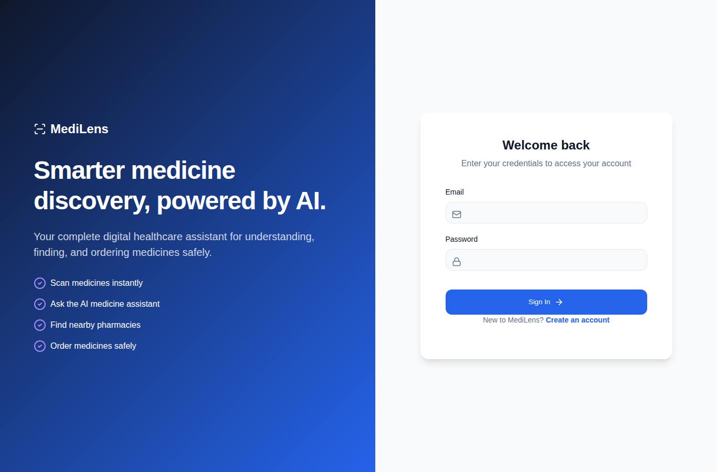
Figure 3.1: MediLens User Authentication (Login) Interface
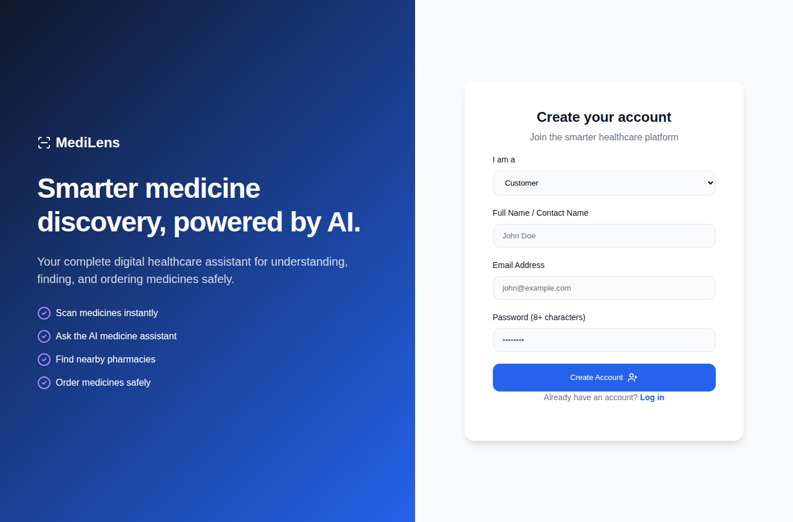
Figure 3.2: MediLens Customer Registration Interface
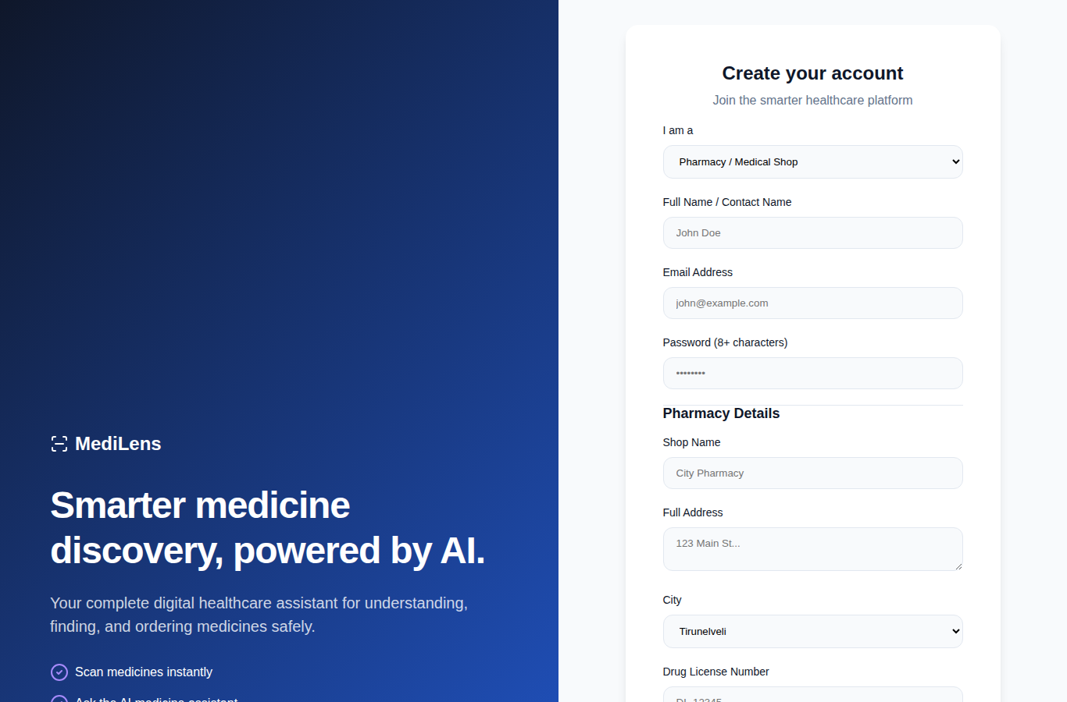
Figure 3.3: MediLens Pharmacy Registration with License and Location Details
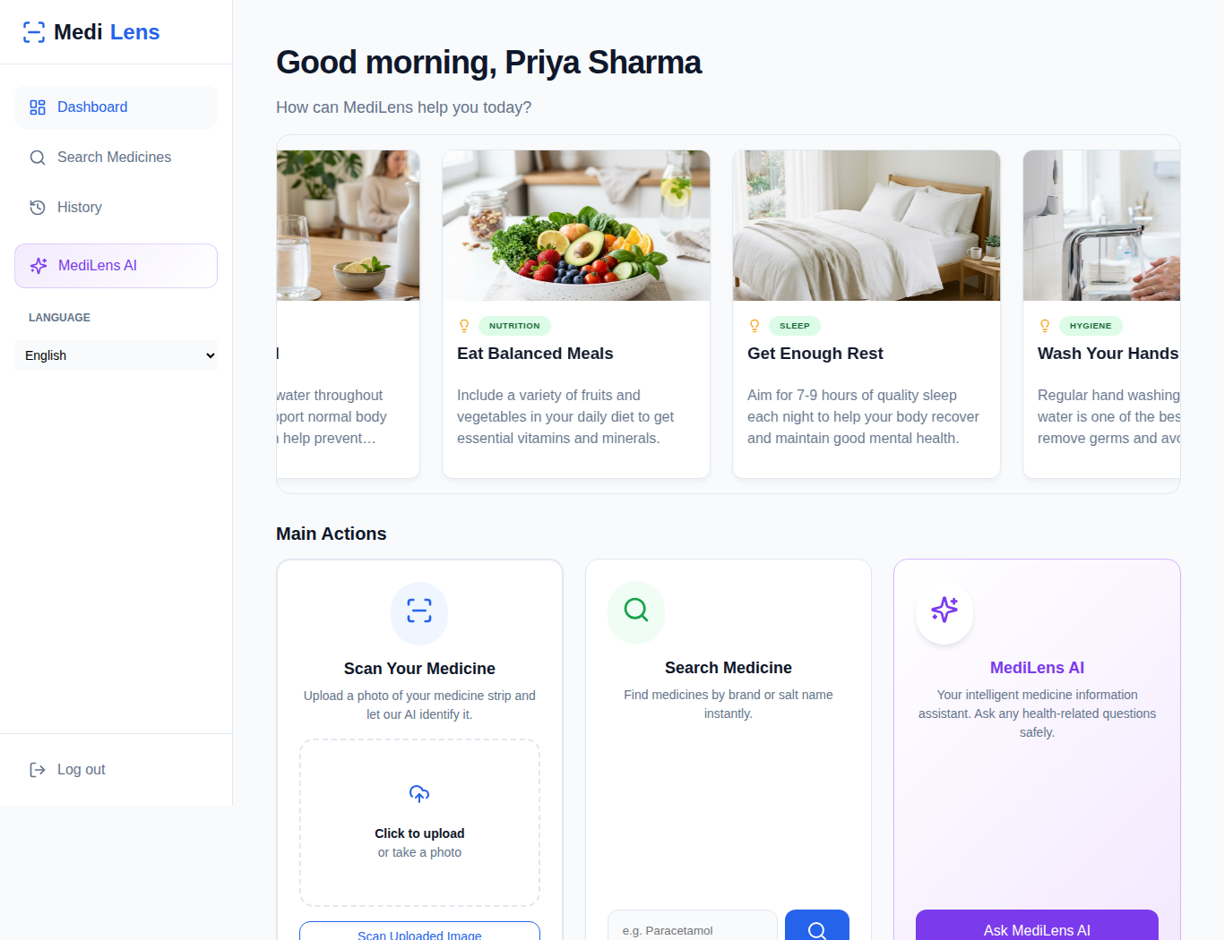
Figure 3.4: MediLens Customer Dashboard with Health Tips and Main Actions
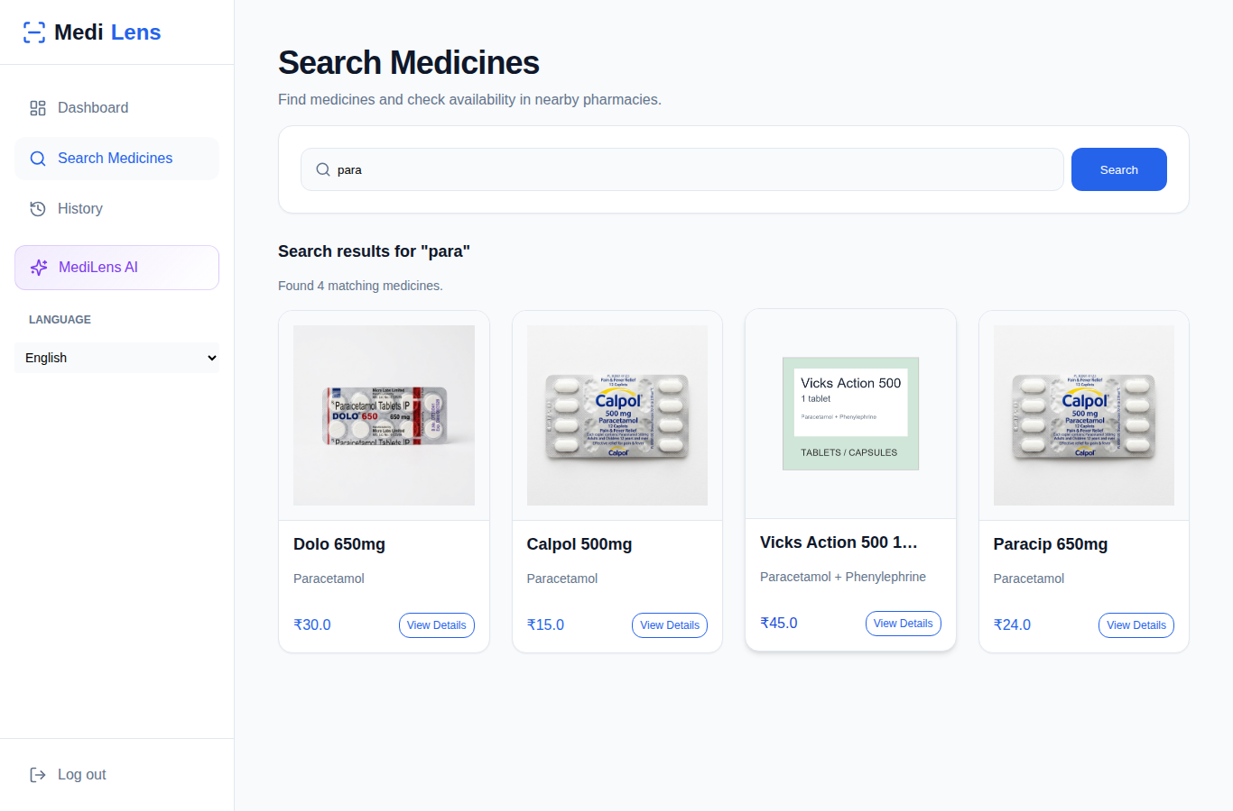
Figure 3.5: MediLens Medicine Search Results
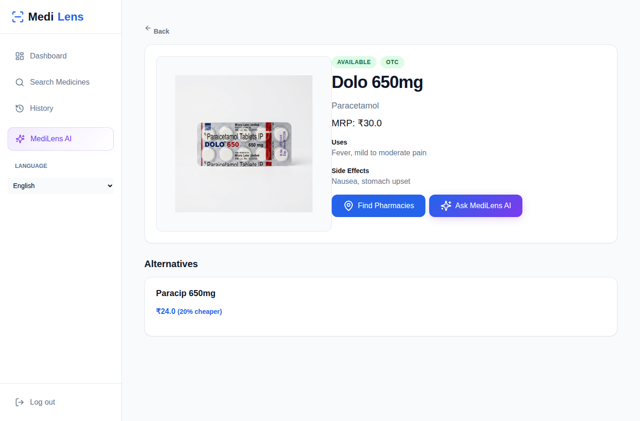
Figure 3.6: MediLens Medicine Details Page Opened After a Photo Scan
Figure 3.7: MediLens Medicine Details with Cheaper Same-Salt Alternatives
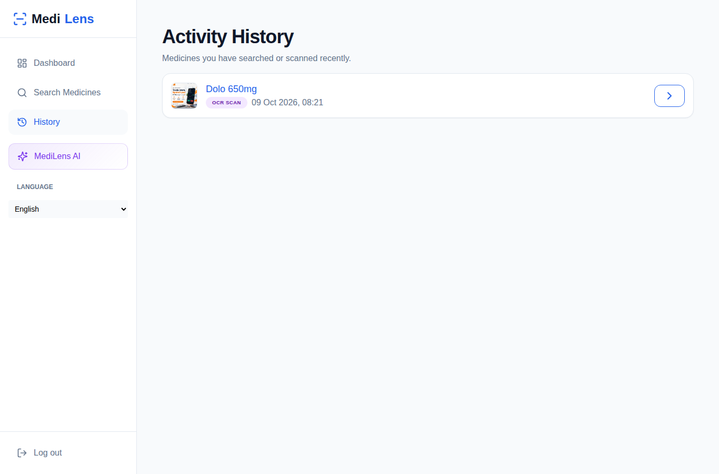
Figure 3.8: MediLens Search and Scan History
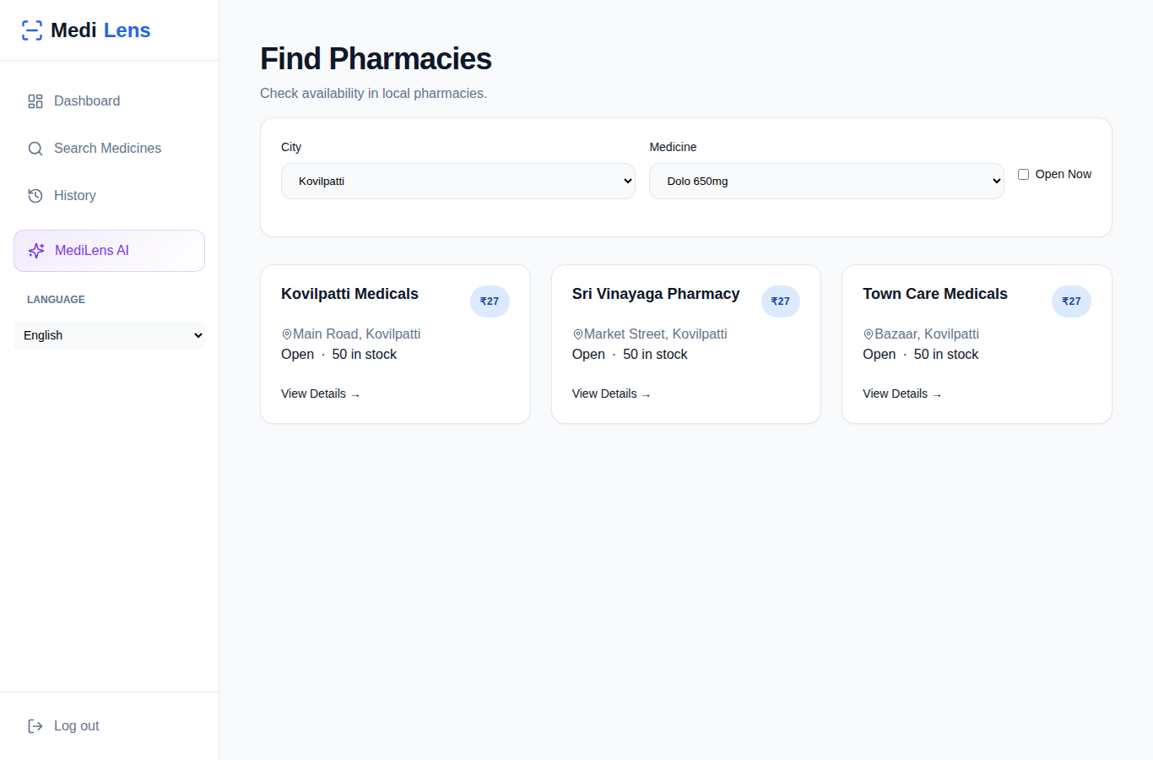
Figure 3.9: MediLens Find Pharmacies with City, Medicine and Open-Now Filters
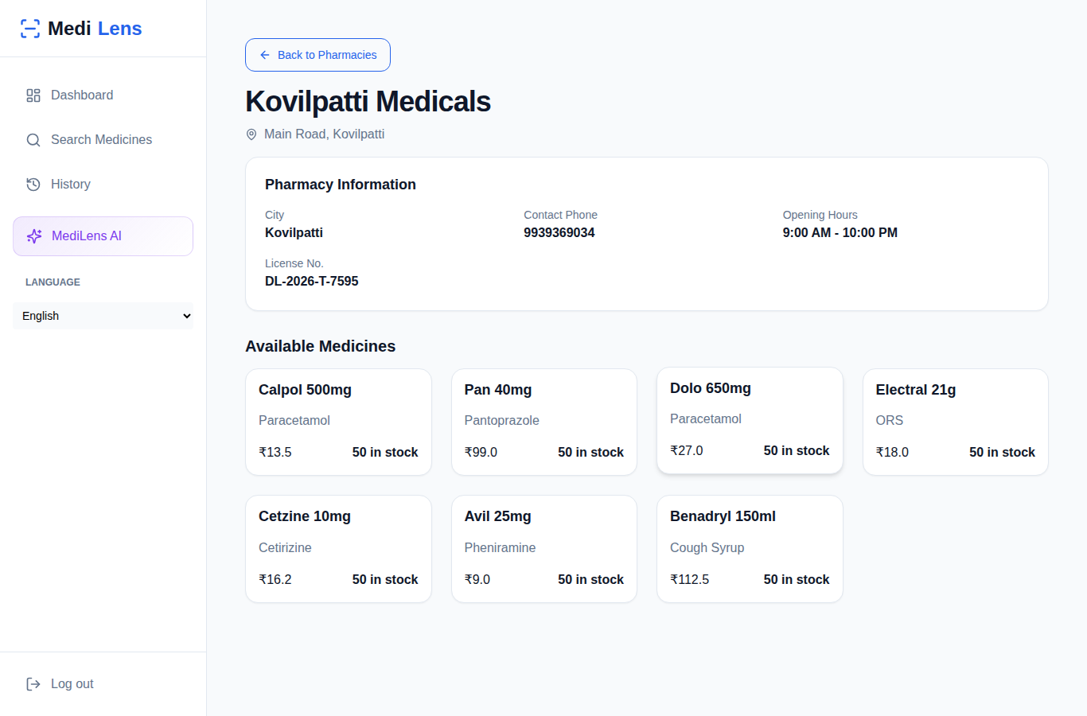
Figure 3.10: MediLens Pharmacy Details with Available Medicines and Prices
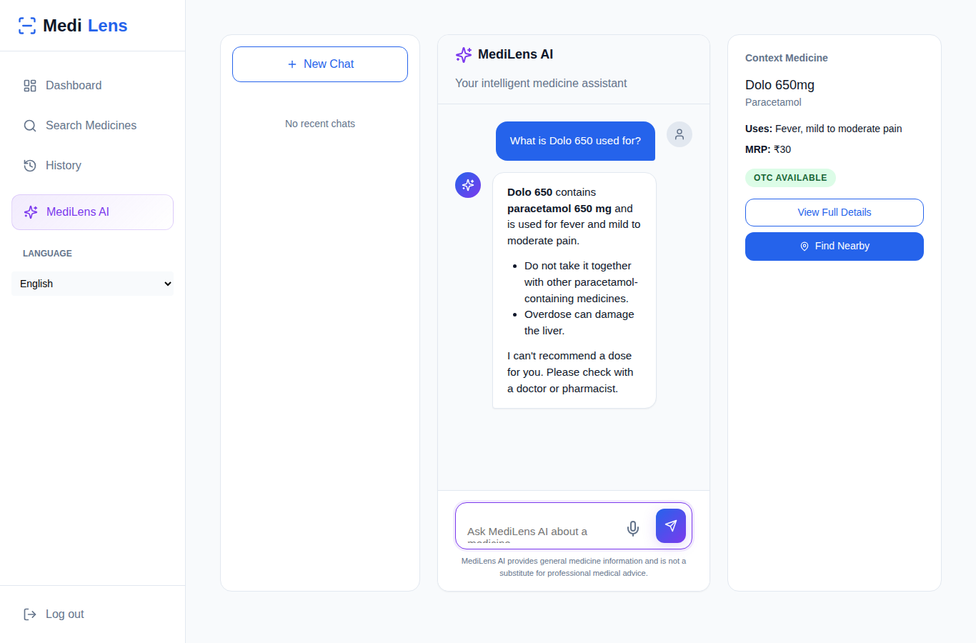
Figure 3.11: MediLens AI Chat Assistant with Medicine Context
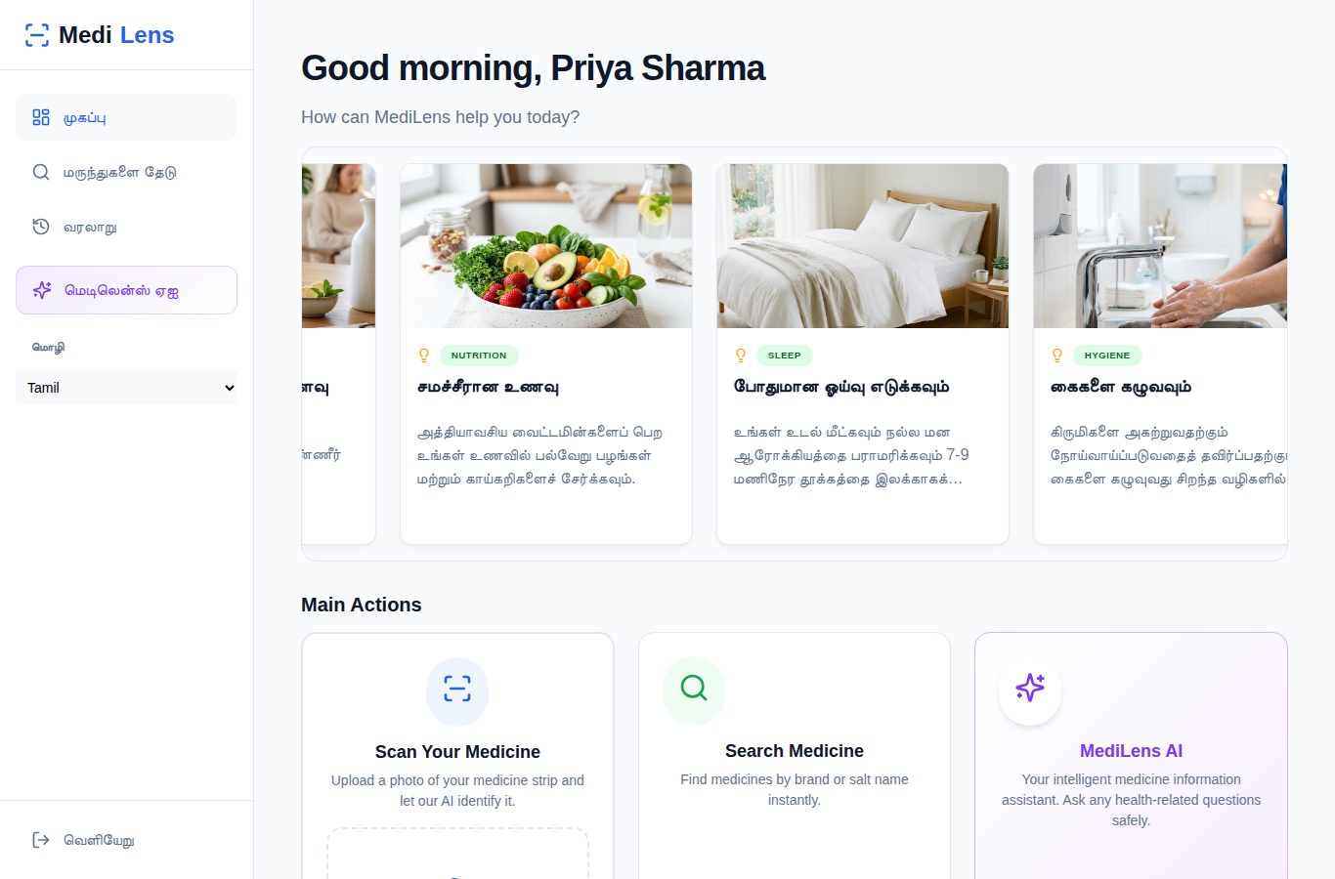
Figure 3.12: MediLens Customer Dashboard in Tamil (Multi-language Support)
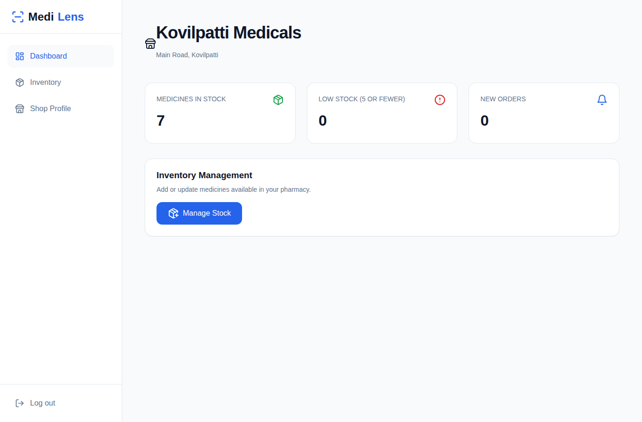
Figure 3.13: MediLens Pharmacy Dashboard with Stock Summary
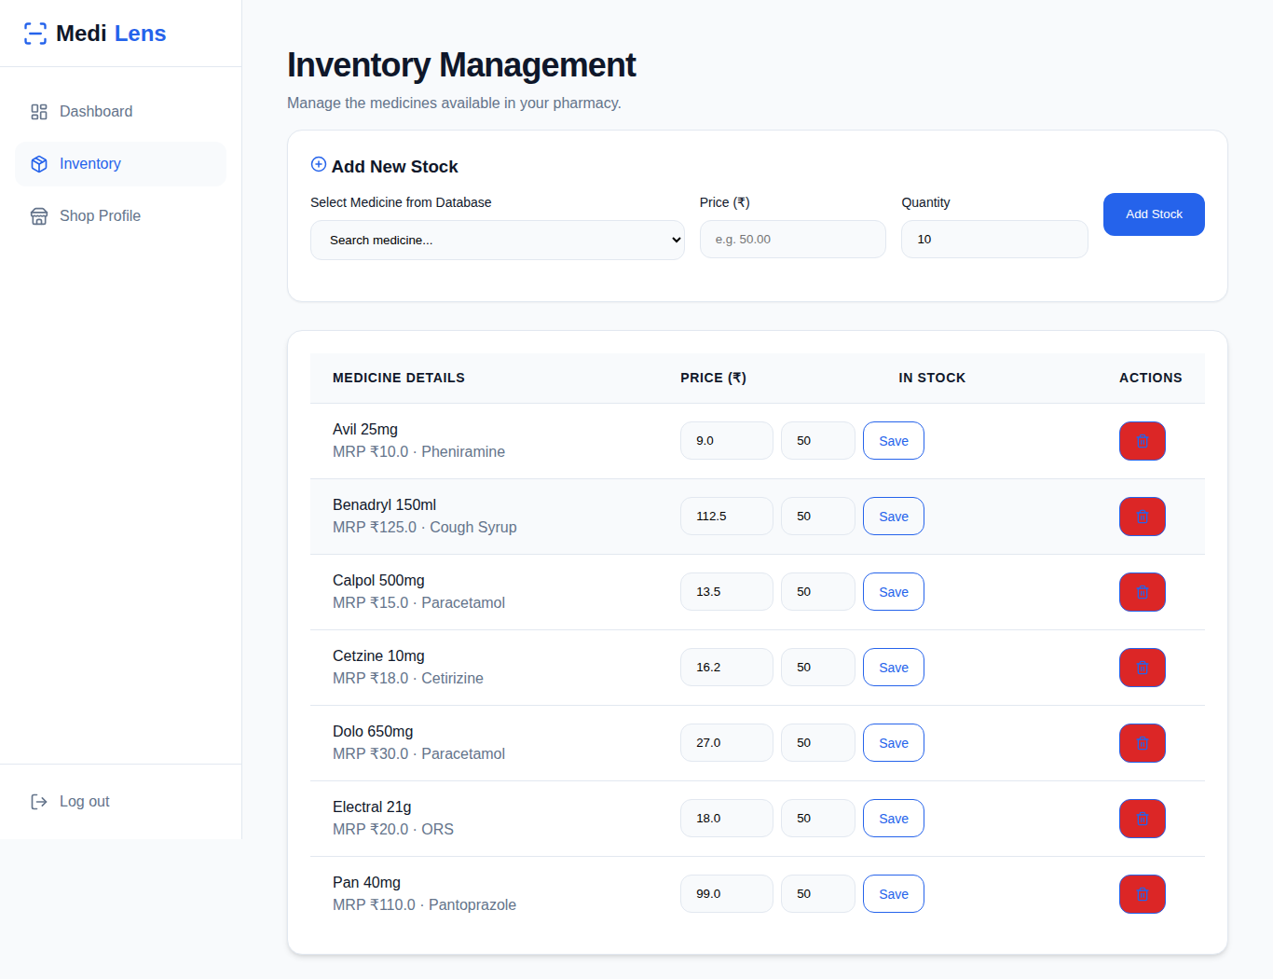
Figure 3.14: MediLens Pharmacy Inventory Management
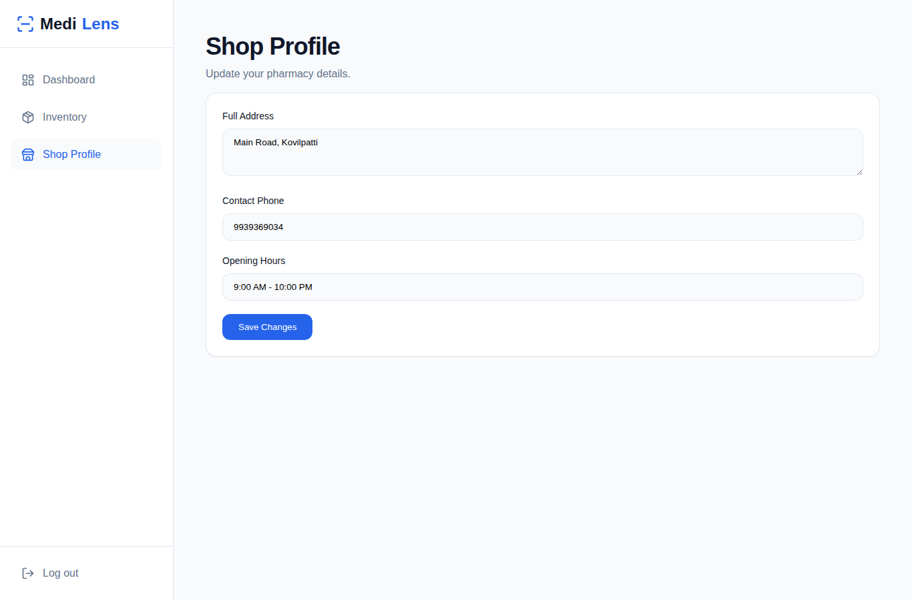
Figure 3.15: MediLens Pharmacy Profile Management
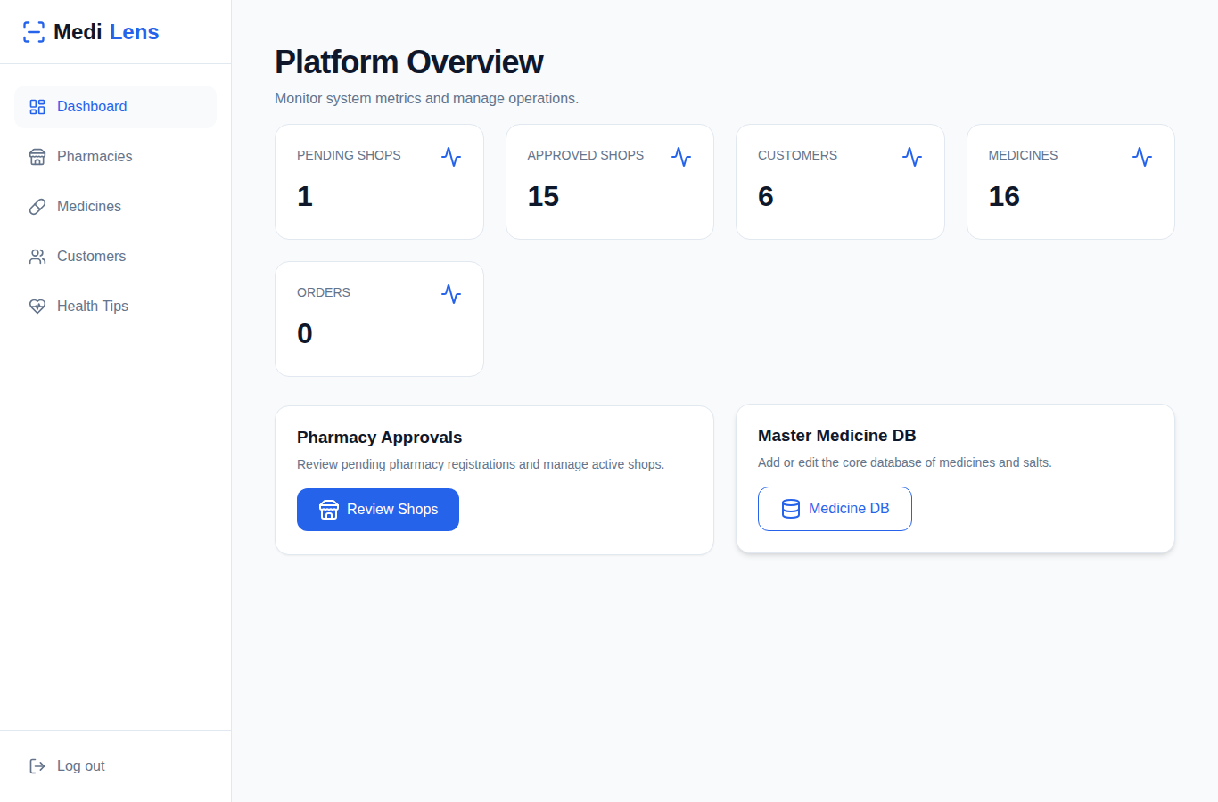
Figure 3.16: MediLens Admin Dashboard with Platform Overview
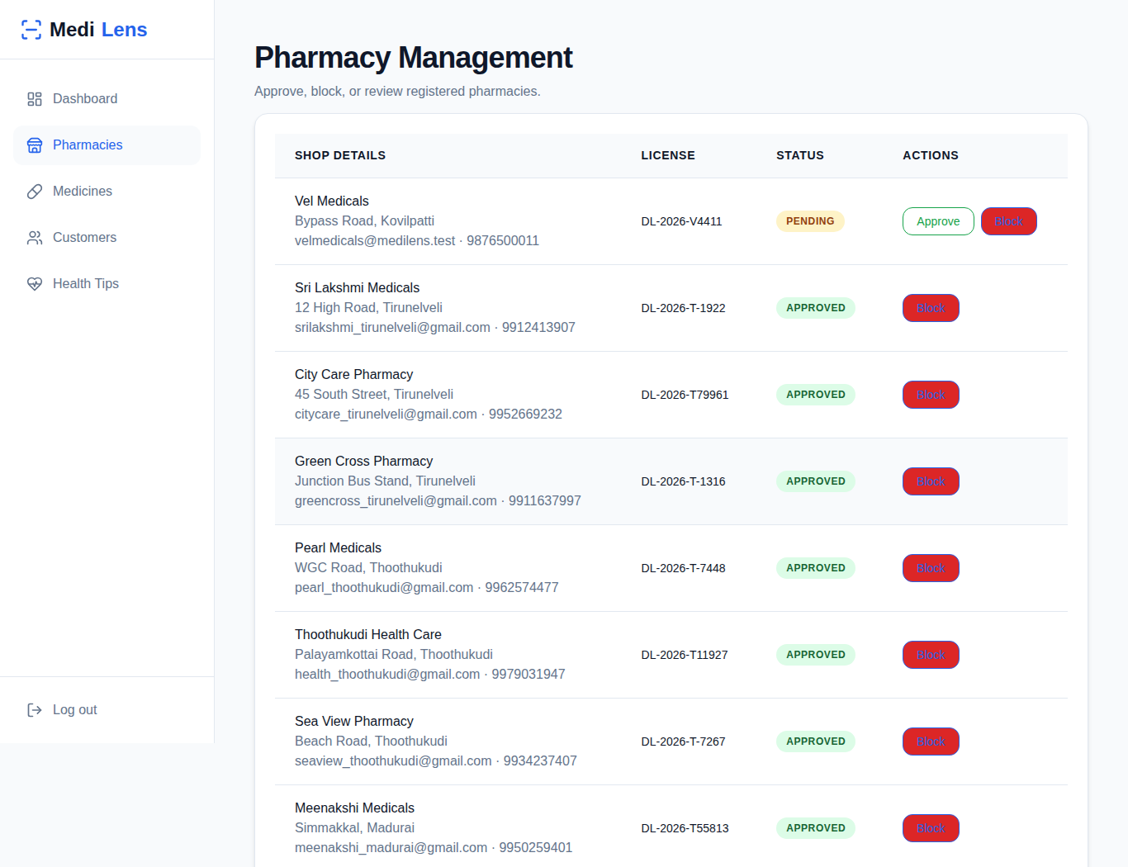
Figure 3.17: MediLens Admin Pharmacy Approval and Blocking
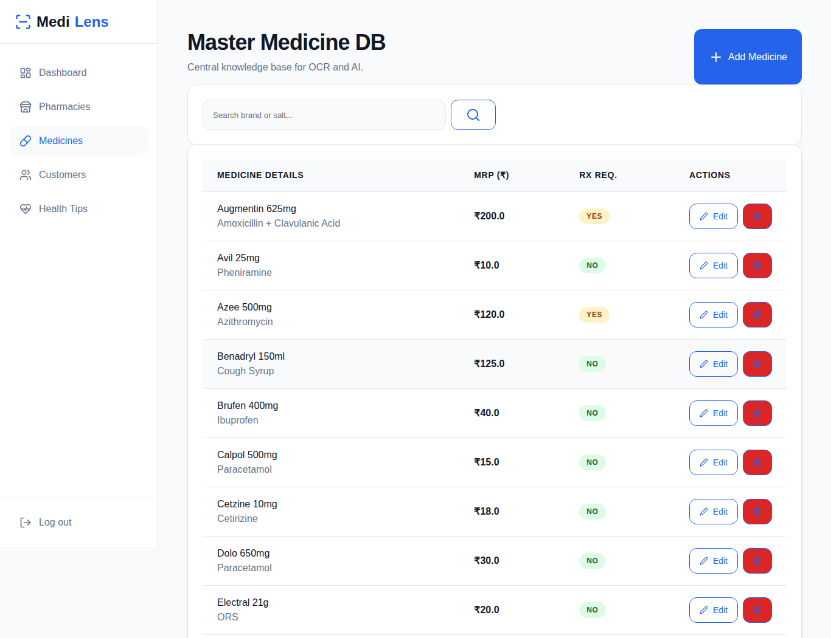
Figure 3.18: MediLens Admin Master Medicine Database
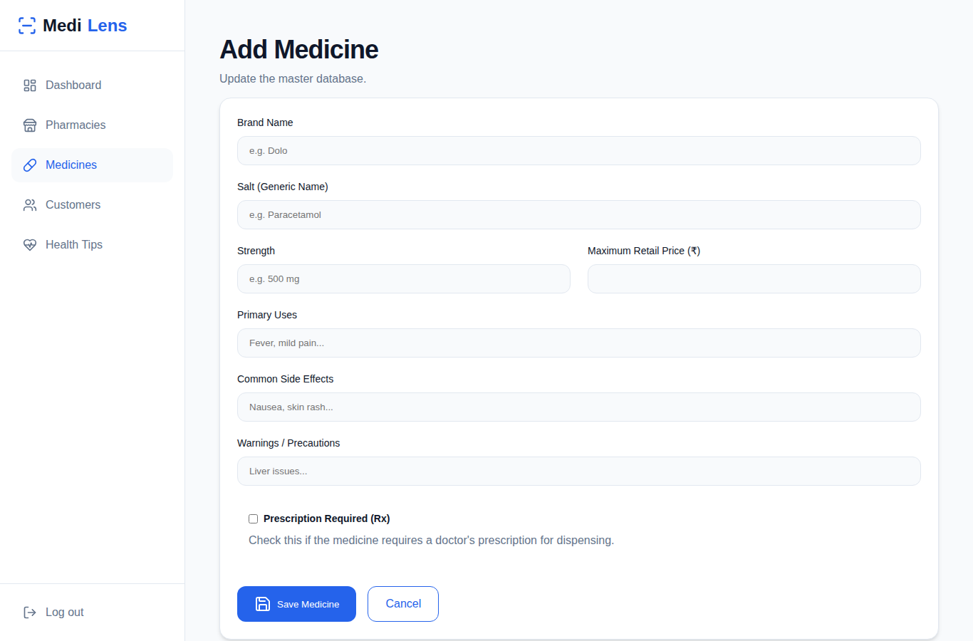
Figure 3.19: MediLens Admin Add Medicine Form
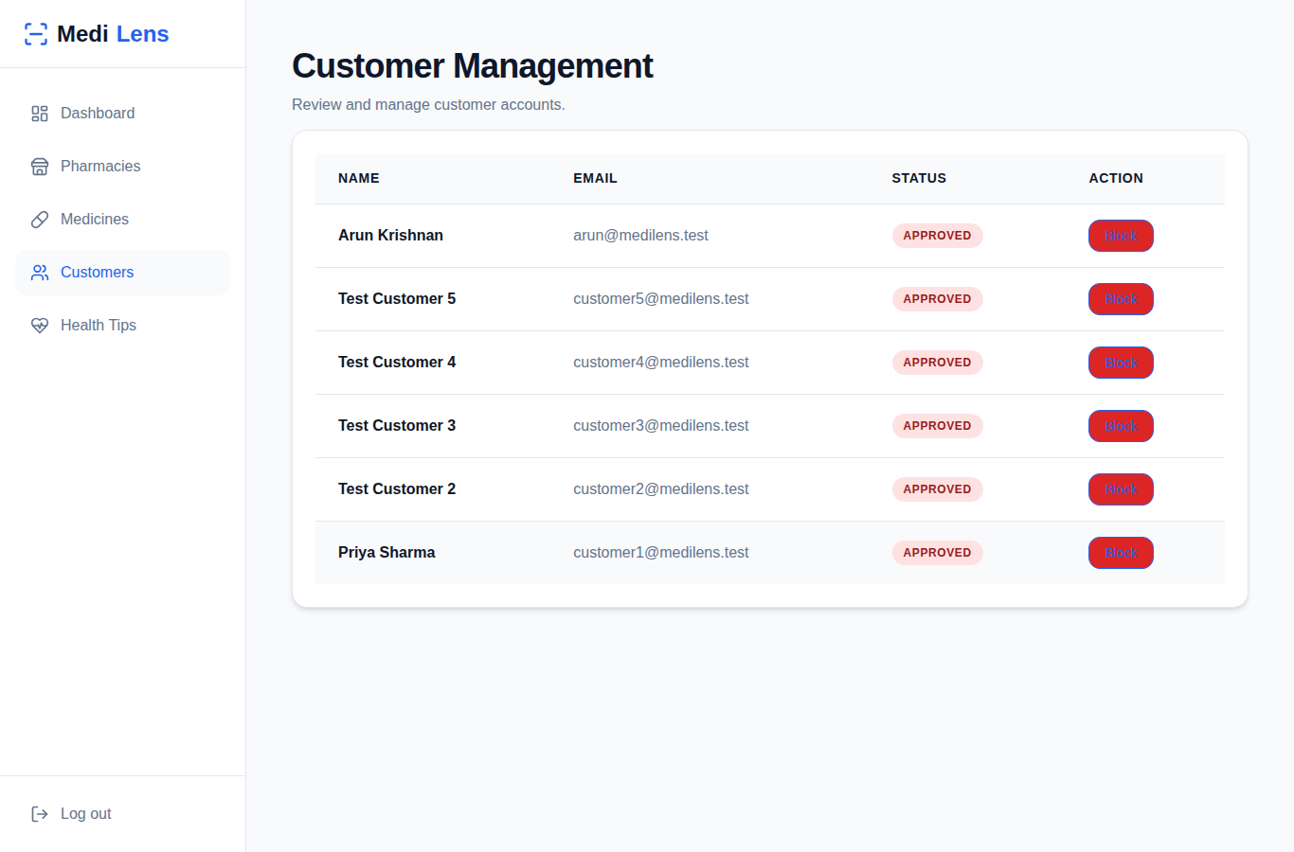
Figure 3.20: MediLens Admin Customer Management
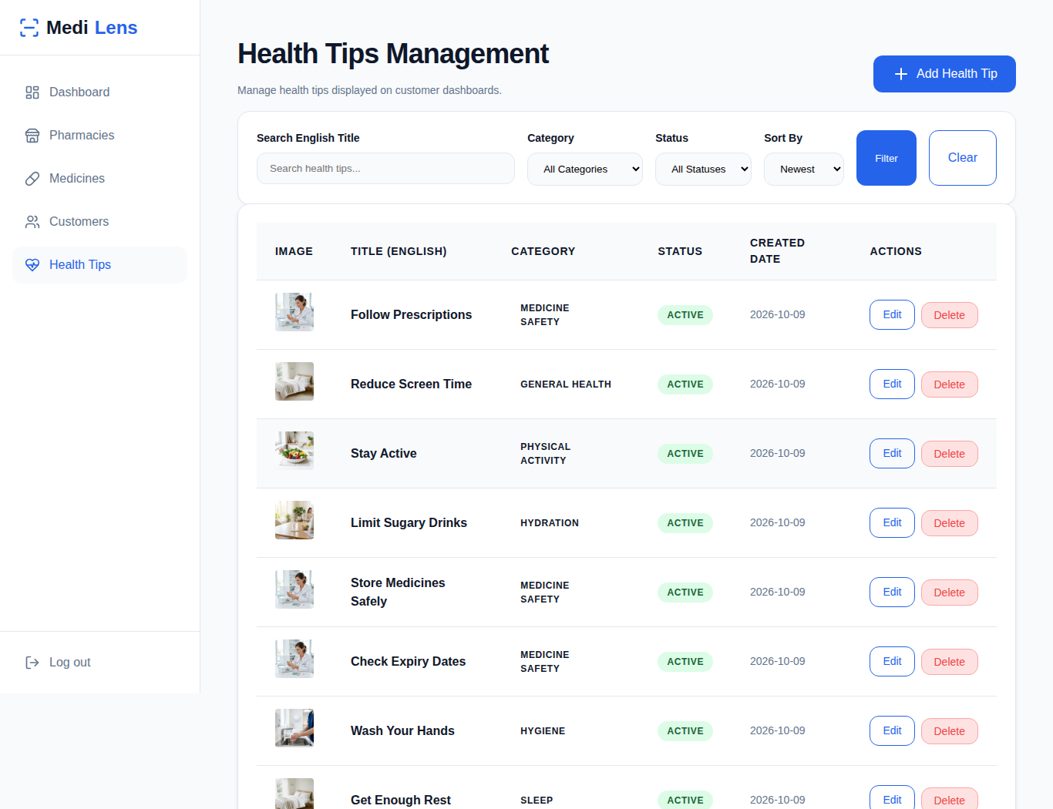
Figure 3.21: MediLens Admin Health Tips Management
CHAPTER 4
CONCLUSION
MediLens has been designed and developed as a single web platform that connects customers, pharmacies and an administrator around reliable medicine information. Built with Flask and MongoDB, it lets a customer search for a medicine or scan its photo, read its uses, side effects and warnings, compare it with cheaper alternatives of the same salt and strength, find pharmacies in a chosen city that have it in stock, and put questions to an AI assistant in English, Tamil or Hindi.
The role-based design keeps each user's tasks separate. Pharmacies register with their license and location and become visible to customers only after the administrator approves them, and they control their own stock, prices and opening hours. The administrator maintains the master medicine database, manages customer accounts and publishes multilingual health tips. Because pharmacy results are computed from live inventory records, customers see only medicines that are actually in stock.
Safety and security were treated as part of the design. The AI assistant is grounded in the platform's medicine data and carries explicit rules against diagnosing, prescribing or advising dosage changes, and the medicine data is clearly marked as sample data that must be verified by a pharmacist before real use. On the security side, passwords are hashed, routes are protected by role-based decorators, every form post carries a CSRF token, and uploaded photos are restricted by type and size.
The system can be extended in several directions: online ordering with prescription upload for prescription-only medicines, distance-based sorting of pharmacies using the stored coordinates and the distance helper already in the code, delivery tracking, and a larger medicine database verified by licensed pharmacists. Overall, the project shows how a lightweight Python web framework, a document database and a carefully constrained language model can be combined into a practical, multilingual tool that makes medicine information and local availability easier to reach.

