23IT11E – WEBFRAMEWORKS USING PYTHON
Micro Project
Report On
MediLens – AI-Powered Medicine Information and Pharmacy Finder
Submitted by
INFHANT JOSEPH T 24205052
In partial fulfillment for the award of the degree
of
BACHELOR OF ENGINEERING
in
INFORMATION TECHNOLOGY

NATIONAL ENGINEERING COLLEGE
(An Autonomous Institution affiliated to Anna University, Chennai)
K.R.NAGAR, KOVILPATTI - 628503
OCTOBER – 2026
NATIONAL ENGINEERING COLLEGE
K.R.NAGAR, KOVILPATTI – 628503
BONAFIDE CERTIFICATE
This is to certify that this project report is a Bonafide record of INFHANT JOSEPH T (24205052) work done for the course 23IT11E – WEBFRAMEWORKS USING PYTHON at the NATIONAL ENGINEERING COLLEGE, K.R. NAGAR, during the academic year 2026 who carried out the project work under my supervision.

Course Instructor/Guide
TABLE OF CONTENTS
CHAPTER NO | TITLE | PAGE NO
 | ABSTRACT | 4
1 | INTRODUCTION | 5
2 | IMPLEMENTATION | 7
3 | IMPLEMENTATION RESULTS | 30
4 | CONCLUSION | 40

ABSTRACT
MediLens is a web application that helps people understand the medicines they use and find which nearby pharmacy has them in stock. It brings customers, pharmacies and an administrator together on one platform, with a separate login and dashboard for each role.
Customers can search for a medicine by brand or salt name, or upload a photo of the medicine strip or box. The text in the photo is read using the EasyOCR library and matched with the medicine database. For each medicine, the portal shows its uses, side effects, warnings and prescription status, along with cheaper alternatives that have the same salt and strength. Customers can also check which pharmacies in a city have the medicine in stock, filter pharmacies that are open now, and ask the MediLens AI assistant questions in English, Tamil or Hindi, by typing or by voice. The assistant is instructed never to diagnose, prescribe or suggest dosage changes.
Pharmacies register with their license number and location, wait for administrator approval, and then manage their own stock and prices. The administrator approves or blocks pharmacies, manages the medicine database and customer accounts, and publishes health tips in three languages. The system is built using Flask and MongoDB, with HTML, CSS and JavaScript on the front end, EasyOCR for text recognition and the Groq API for the AI assistant. Passwords are stored as hashes, access is controlled by user roles, and every form is protected with a CSRF token.

CHAPTER 1

INTRODUCTION

1.1 INTRODUCTION
People buy medicines every day but often have very little reliable information about them. The packaging is full of technical terms, the same salt is sold under many brand names at different prices, and it is not easy to know which nearby shop has a particular medicine in stock. Searching on the internet or asking a general chatbot may give incomplete or unsafe advice, and often not in a language the person is comfortable with.
MediLens has been developed to solve this using a single platform. A customer can search or scan a medicine, read simple information about it, compare it with equivalent medicines, find pharmacies that have it, and ask an AI assistant follow-up questions. Pharmacies keep their stock and prices up to date, and an administrator verifies the pharmacies and maintains the medicine data.
The application is developed in Python using the Flask web framework and a MongoDB database. Pages are created on the server using Jinja2 templates, the photo scan feature uses EasyOCR, and the chat assistant uses a language model provided through the Groq API.

1.2 PROBLEM STATEMENT
Finding correct information about a medicine and the right place to buy it is difficult. Printed leaflets are small and technical, and many people cannot tell whether two different brands contain the same active ingredient. As a result, they may pay more than necessary when a cheaper medicine with the same salt and strength is available.
There is also no easy way to know, before travelling, whether a pharmacy has a medicine in stock or whether it is open. Pharmacies have no simple way to show their stock and prices to people nearby. Most medicine information is available only in English, and general AI tools are not designed to avoid giving diagnosis or dosage advice.
Therefore, there is a need for a simple, role-based system that gives trustworthy medicine information, shows pharmacy availability, supports local languages and keeps AI answers within safe limits. MediLens has been developed to meet this need.

1.3 OBJECTIVES
The main objective of MediLens is to provide one platform where customers, pharmacies and an administrator can work with the same verified medicine data. The specific objectives are listed below.
- To allow customers, pharmacies and an administrator to register and log in securely, with a separate dashboard for each role.
- To let customers search for medicines by brand or salt name, or scan a photo of a medicine strip or box, and read its uses, side effects, warnings and prescription status.
- To help customers save money by showing cheaper alternatives that have the same salt and strength, and to keep a history of their searches and scans.
- To show the pharmacies in a chosen city that have a medicine in stock, along with price, quantity and opening hours, with a filter for pharmacies that are open now.
- To allow pharmacies to register with their license and location, get approved by the administrator, and manage their own stock, prices and profile.
- To allow the administrator to approve or block pharmacies, manage the medicine database and customer accounts, and publish health tips in English, Tamil and Hindi.
- To provide an AI assistant that answers questions about a medicine in the customer's chosen language, accepts voice input, and follows safety rules that forbid diagnosis, prescribing and dosage advice.
- To follow basic security practices such as password hashing, role-based access, CSRF protection and limits on uploaded files.
CHAPTER 2
IMPLEMENTATION
2.1 PROJECT STRUCTURE
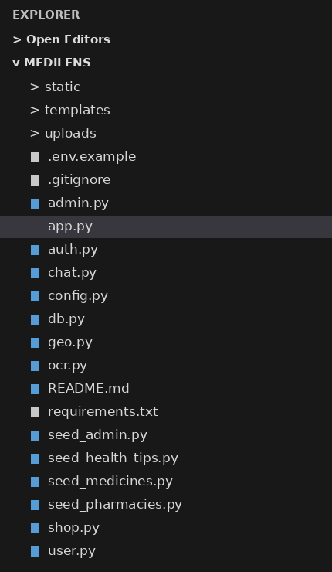
The project is organised into Python files for each part of the system, HTML templates for the pages, and a static folder for styles and images. The main application (app.py) registers the blueprints for login, customer, pharmacy, admin and chat, and handles the CSRF check and the translations. MongoDB stores the data in these collections: users, shops, medicines, inventory, search_history, chat_sessions and health_tips.
2.2 PROJECT CODE
medilens/app.py:
import os
import secrets
from flask import Flask, abort, redirect, render_template, request, session, url_for
from auth import HOME, bp as auth_bp
from chat import LANGS, bp as chat_bp
from config import Config
from db import init_db
from admin import bp as admin_bp
from shop import bp as shop_bp
from user import bp as user_bp
TRANSLATIONS = {
"en": {
"Dashboard": "Dashboard",
"Search Medicines": "Search Medicines",
"Orders": "Orders",
"History": "History",
"MediLens AI": "MediLens AI",
"New Chat": "New Chat",
"Language": "Language",
"Log out": "Log out",
"Loading...": "Loading...",
"No recent chats": "No recent chats",
"Unable to load conversations": "Unable to load conversations",
"Medicine not found": "Medicine not found",
"No results found": "No results found",
"View Full Details": "View Full Details",
"Find Nearby": "Find Nearby",
"Prescription Required": "Prescription Required",
"OTC Available": "OTC Available",
"Recent Orders": "Recent Orders",
"Recent Medicines": "Recent Medicines",
"Pharmacies": "Pharmacies",
"Medicines": "Medicines",
"Customers": "Customers",
},
"ta": {
"Dashboard": "முகப்பு",
"Search Medicines": "மருந்துகளை தேடு",
"Orders": "ஆர்டர்கள்",
"History": "வரலாறு",
"MediLens AI": "மெடிலென்ஸ் ஏஐ",
"New Chat": "புதிய உரையாடல்",
"Language": "மொழி",
"Log out": "வெளியேறு",
"Loading...": "ஏற்றுகிறது...",
"No recent chats": "சமீபத்திய உரையாடல்கள் இல்லை",
"Unable to load conversations": "உரையாடல்களை ஏற்ற முடியவில்லை",
"Medicine not found": "மருந்து கிடைக்கவில்லை",
"No results found": "முடிவுகள் கிடைக்கவில்லை",
"View Full Details": "முழு விவரங்களைப் பார்",
"Find Nearby": "அருகில் தேடு",
"Prescription Required": "பரிந்துரை சீட்டு தேவை",
"OTC Available": "சீட்டு இல்லாமல் கிடைக்கும்",
"Recent Orders": "சமீபத்திய ஆர்டர்கள்",
"Recent Medicines": "சமீபத்திய மருந்துகள்",
"Pharmacies": "மருந்தகங்கள்",
"Medicines": "மருந்துகள்",
"Customers": "வாடிக்கையாளர்கள்",
},
"hi": {
"Dashboard": "डैशबोर्ड",
"Search Medicines": "दवाइयां खोजें",
"Orders": "ऑर्डर",
"History": "इतिहास",
"MediLens AI": "मेडीलेंस एआई",
"New Chat": "नया चैट",
"Language": "भाषा",
"Log out": "लॉग आउट",
"Loading...": "लोड हो रहा है...",
"No recent chats": "कोई हालिया चैट नहीं",
"Unable to load conversations": "चैट लोड करने में असमर्थ",
"Medicine not found": "दवा नहीं मिली",
"No results found": "कोई परिणाम नहीं मिला",
"View Full Details": "पूर्ण विवरण देखें",
"Find Nearby": "आस-पास खोजें",
"Prescription Required": "पर्चे की आवश्यकता है",
"OTC Available": "पर्चे के बिना उपलब्ध",
"Recent Orders": "हाल के ऑर्डर",
"Recent Medicines": "हाल की दवाएं",
"Pharmacies": "फार्मेसियों",
"Medicines": "दवाइयां",
"Customers": "ग्राहक",
}
}
# Health tips are now stored in MongoDB
def create_app():
app = Flask(__name__)
app.config.from_object(Config)
os.makedirs(app.config["UPLOAD_FOLDER"], exist_ok=True)
init_db(app)
for bp in (auth_bp, user_bp, shop_bp, admin_bp, chat_bp):
app.register_blueprint(bp)
@app.before_request
def csrf_protect():
if "csrf" not in session:
session["csrf"] = secrets.token_hex(16)
if request.method == "POST":
sent = request.form.get("csrf") or request.headers.get("X-CSRF") or ""
if not secrets.compare_digest(sent, session["csrf"]):
abort(400)
@app.errorhandler(400)
@app.errorhandler(404)
@app.errorhandler(413)
def friendly_error(e):
msg = {400: "That request couldn't be verified. Go back, refresh the page, and try again.",
404: "We couldn't find that page.",
413: "That file is too large. Photos must be under 5 MB."}[e.code]
return render_template("error.html", msg=msg), e.code
@app.context_processor
def inject_langs():
def _(text):
lang = session.get("lang", "en")
if lang not in TRANSLATIONS:
lang = "en"
return TRANSLATIONS[lang].get(text, text)
import datetime
from db import get_db
db = get_db()
active_tips = list(db.health_tips.find({"status": "active"}))
lang = session.get("lang", "en")
if lang not in ["en", "ta", "hi"]: lang = "en"
all_tips = []
for raw_tip in active_tips:
content = raw_tip.get("content", {}).get(lang, {})
if not content.get("title"):
content = raw_tip.get("content", {}).get("en", {})
media = raw_tip.get("media")
image_url = ""
if media and media.get("file_id"):
image_url = url_for("health_tip_media", file_id=str(media["file_id"]))
all_tips.append({
"category": raw_tip.get("category", ""),
"image": image_url,
"title": content.get("title", ""),
"text": content.get("description", "")
})
return {"LANGS": LANGS, "csrf": session.get("csrf", ""), "_": _, "all_tips": all_tips}
@app.route("/")
def index():
role = session.get("role")
return redirect(url_for(HOME[role]) if role else url_for("auth.login"))
@app.route("/api/health-tips/media/<file_id>")
def health_tip_media(file_id):
import gridfs
from bson import ObjectId, errors
from flask import send_file
from io import BytesIO
from db import get_db
db = get_db()
fs = gridfs.GridFS(db)
try:
file_data = fs.get(ObjectId(file_id))
return send_file(BytesIO(file_data.read()), mimetype=file_data.content_type)
except (errors.InvalidId, gridfs.errors.NoFile):
abort(404)
return app
if __name__ == "__main__":
create_app().run(debug=True)
medilens/config.py:
import os
from dotenv import load_dotenv
load_dotenv()
class Config:
SECRET_KEY = os.getenv("SECRET_KEY", "dev-only-change-me")
MONGO_URI = os.getenv("MONGO_URI", "mongodb://localhost:27017")
DB_NAME = os.getenv("DB_NAME", "medilens")
GROQ_API_KEY = os.getenv("GROQ_API_KEY", "")
CHAT_MODEL = os.getenv("GROQ_MODEL", "openai/gpt-oss-120b")
TIMEZONE = os.getenv("TIMEZONE", "Asia/Kolkata")
SESSION_COOKIE_SAMESITE = "Lax"
UPLOAD_FOLDER = os.path.join(os.path.dirname(__file__), "uploads")
MAX_CONTENT_LENGTH = 5 * 1024 * 1024 # 5 MB per image
medilens/db.py:
from pymongo import MongoClient, ASCENDING, DESCENDING, GEOSPHERE
_db = None
def init_db(app):
global _db
client = MongoClient(app.config["MONGO_URI"])
_db = client[app.config["DB_NAME"]]
_db.users.create_index("email", unique=True)
_db.shops.create_index([("location", GEOSPHERE)])
_db.shops.create_index("user_id", unique=True)
_db.medicines.create_index([("brand", ASCENDING)])
_db.medicines.create_index([("salt", ASCENDING)])
_db.inventory.create_index(
[("shop_id", ASCENDING), ("medicine_id", ASCENDING)], unique=True
)
_db.search_history.create_index([("user_id", ASCENDING), ("created_at", DESCENDING)])
def get_db():
return _db
medilens/requirements.txt:
flask
pymongo
werkzeug
python-dotenv
groq
pytesseract
Pillow
tzdata
medilens/auth.py:
from datetime import datetime, timezone
from functools import wraps
from bson import ObjectId
from flask import (Blueprint, flash, redirect, render_template, request,
session, url_for)
from werkzeug.security import check_password_hash, generate_password_hash
from db import get_db
bp = Blueprint("auth", __name__)
HOME = {"user": "user.home", "shop": "shop.home", "admin": "admin.home"}
def login_required(f):
@wraps(f)
def wrapper(*a, **kw):
if "user_id" not in session:
flash("Please log in to continue.", "error")
return redirect(url_for("auth.login"))
return f(*a, **kw)
return wrapper
def role_required(*roles):
def deco(f):
@wraps(f)
@login_required
def wrapper(*a, **kw):
if session.get("role") not in roles:
flash("You don't have access to that page.", "error")
return redirect(url_for("index"))
return f(*a, **kw)
return wrapper
return deco
def _now():
return datetime.now(timezone.utc)
@bp.route("/register", methods=["GET", "POST"])
def register():
if request.method == "GET":
return render_template("register.html")
db = get_db()
f = request.form
name, email = f.get("name", "").strip(), f.get("email", "").strip().lower()
password, role = f.get("password", ""), f.get("role", "user")
if role not in ("user", "shop"): # admin can never self-register
role = "user"
if not name or not email or len(password) < 8:
flash("Enter your name, email, and a password of at least 8 characters.", "error")
return render_template("register.html"), 400
if db.users.find_one({"email": email}):
flash("That email is already registered. Log in instead.", "error")
return render_template("register.html"), 400
shop_data = None
if role == "shop":
try:
lat, lng = float(f["lat"]), float(f["lng"])
assert -90 <= lat <= 90 and -180 <= lng <= 180
except (KeyError, ValueError, AssertionError):
flash("Pin your shop location using the 'Use my location' button.", "error")
return render_template("register.html"), 400
shop_data = {
"name": f.get("shop_name", "").strip(),
"address": f.get("address", "").strip(),
"city": f.get("city", "").strip(),
"license_no": f.get("license_no", "").strip(),
"phone": f.get("phone", "").strip(),
"hours": f.get("hours", "").strip(),
"location": {"type": "Point", "coordinates": [lng, lat]},
}
if not all([shop_data["name"], shop_data["address"], shop_data["license_no"]]):
flash("Shop name, address, and license number are required.", "error")
return render_template("register.html"), 400
uid = db.users.insert_one({
"name": name, "email": email,
"password_hash": generate_password_hash(password),
"role": role,
"status": "pending" if role == "shop" else "approved",
"created_at": _now(),
}).inserted_id
if shop_data:
db.shops.insert_one({**shop_data, "user_id": uid, "created_at": _now()})
flash("Shop registered. You can log in once an admin approves it.", "success")
else:
flash("Account created. Log in to start.", "success")
return redirect(url_for("auth.login"))
@bp.route("/login", methods=["GET", "POST"])
def login():
if request.method == "GET":
return render_template("login.html")
email = request.form.get("email", "").strip().lower()
user = get_db().users.find_one({"email": email})
if not user:
flash("Email or password is incorrect.", "error")
return render_template("login.html"), 401
if user.get("auth_provider") == "google":
flash("This account uses Google Sign-In. Please continue with Google.", "error")
return render_template("login.html"), 401
password_hash = user.get("password_hash")
if not password_hash:
flash("Your account does not have a password configured. Please use password reset.", "error")
return render_template("login.html"), 401
if not check_password_hash(password_hash, request.form.get("password", "")):
flash("Email or password is incorrect.", "error")
return render_template("login.html"), 401
if user["status"] == "pending":
flash("Your shop is waiting for admin approval.", "error")
return render_template("login.html"), 403
if user["status"] == "blocked":
flash("This account has been blocked. Contact the admin.", "error")
return render_template("login.html"), 403
session.clear()
session.update(user_id=str(user["_id"]), role=user["role"], name=user["name"],
lang=user.get("lang", "en"))
return redirect(url_for(HOME[user["role"]]))
@bp.route("/logout")
def logout():
session.clear()
flash("You're logged out.", "success")
return redirect(url_for("auth.login"))
medilens/user.py:
import os
import re
import uuid
from datetime import datetime, timedelta, timezone
from zoneinfo import ZoneInfo
from bson import ObjectId
from bson.errors import InvalidId
from flask import (Blueprint, abort, jsonify, current_app, flash, redirect,
render_template, request, send_from_directory, session, url_for)
from auth import role_required
from db import get_db
from geo import haversine_km, is_open
from ocr import extract_text, match_medicines
bp = Blueprint("user", __name__, url_prefix="/user")
ALLOWED = {"jpg", "jpeg", "png", "webp"}
def _oid(value):
try:
return ObjectId(value)
except (InvalidId, TypeError):
abort(404)
def _log(medicine_id, source, photo=None):
"""Save to search history (skips a repeat within 60 seconds)."""
db, uid = get_db(), ObjectId(session["user_id"])
since = datetime.now(timezone.utc) - timedelta(seconds=60)
if db.search_history.find_one({"user_id": uid, "medicine_id": medicine_id,
"created_at": {"$gt": since}}):
return
db.search_history.insert_one({"user_id": uid, "medicine_id": medicine_id,
"source": source, "photo": photo,
"created_at": datetime.now(timezone.utc)})
def _history(limit):
db, rows = get_db(), []
for h in db.search_history.find({"user_id": ObjectId(session["user_id"])}) \
.sort("created_at", -1).limit(limit):
med = db.medicines.find_one({"_id": h["medicine_id"]})
if med:
rows.append({"med": med, **h})
return rows
@bp.route("/")
@role_required("user")
def home():
return render_template("user_home.html", recent=_history(5))
@bp.route("/scan", methods=["POST"])
@role_required("user")
def scan():
file = request.files.get("photo")
ext = (file.filename.rsplit(".", 1)[-1].lower() if file and "." in file.filename else "")
if ext not in ALLOWED:
flash("Upload a photo in JPG, PNG, or WEBP format.", "error")
return redirect(url_for("user.home"))
name = f"{uuid.uuid4().hex}.{ext}"
path = os.path.join(current_app.config["UPLOAD_FOLDER"], name)
file.save(path)
text = extract_text(path)
if not text.strip():
flash("We couldn't read any text. Retake the photo in good light, or search by name.", "error")
return redirect(url_for("user.home"))
found = match_medicines(list(get_db().medicines.find()), text)
strong = [m for s, m in found if s >= 0.9]
if len(strong) == 1: # one clear match: go straight to it
return redirect(url_for("user.medicine", mid=strong[0]["_id"], src="scan", photo=name))
return render_template("scan_result.html", found=found, photo=name)
@bp.route("/search")
@role_required("user")
def search():
q = request.args.get("q", "").strip()
results = []
is_random = False
if q:
rx = {"$regex": re.escape(q), "$options": "i"}
results = list(get_db().medicines.find({"$or": [{"brand": rx}, {"salt": rx}]}).limit(20))
else:
results = list(get_db().medicines.aggregate([{"$sample": {"size": 8}}]))
is_random = True
return render_template("search.html", q=q, results=results, is_random=is_random)
def view_fields(med, lang):
"""Medicine text in the chosen language, falling back to English."""
tr = (med.get("i18n") or {}).get(lang) or {}
return {k: tr.get(k) or med.get(k, "") for k in ("uses", "side_effects", "warnings")}, bool(tr)
@bp.route("/medicine/<mid>")
@role_required("user")
def medicine(mid):
db, oid = get_db(), _oid(mid)
med = db.medicines.find_one({"_id": oid})
if not med:
abort(404)
alts = list(db.medicines.find({"salt": med["salt"], "strength": med["strength"],
"_id": {"$ne": oid}}).sort("mrp", 1))
for a in alts:
a["saving"] = round((med["mrp"] - a["mrp"]) / med["mrp"] * 100) if med["mrp"] else 0
src = request.args.get("src")
if src in ("scan", "search"):
_log(oid, src, request.args.get("photo"))
view, translated = view_fields(med, session.get("lang", "en"))
return render_template("medicine.html", med=med, alts=alts, offers=_offers(db, oid),
view=view, translated=translated)
@bp.route("/history")
@role_required("user")
def history():
return render_template("history.html", rows=_history(100))
@bp.route("/photo/<name>")
@role_required("user")
def photo(name):
owned = get_db().search_history.find_one(
{"user_id": ObjectId(session["user_id"]), "photo": name})
if not owned:
abort(404)
return send_from_directory(current_app.config["UPLOAD_FOLDER"], name)
def _offers(db, med_id):
out = []
for inv in db.inventory.find({"medicine_id": med_id, "qty": {"$gt": 0}}).sort("price", 1):
shop = db.shops.find_one({"_id": inv["shop_id"]})
owner = db.users.find_one({"_id": shop["user_id"]}) if shop else None
if owner and owner["status"] == "approved":
out.append({"shop": shop, "inv": inv})
return out
@bp.route("/shops")
@role_required("user")
def shops():
db = get_db()
mid = request.args.get("mid")
med = db.medicines.find_one({"_id": _oid(mid)}) if mid else None
# Get all medicines for dropdown (sorted by brand)
all_medicines = list(db.medicines.find({}, {"brand": 1, "strength": 1, "salt": 1}).sort("brand", 1))
cities = db.shops.distinct("city")
cities = [c for c in cities if c and c not in ["1", "2", "3", "Unknown"]]
cities = sorted(cities)
return render_template("shops.html", med=med, cities=cities, all_medicines=all_medicines)
@bp.route("/shops/data")
@role_required("user")
def shops_data():
db = get_db()
a = request.args
mid = _oid(a.get("mid"))
now = datetime.now(ZoneInfo(current_app.config["TIMEZONE"]))
rows = []
city_filter = a.get("city", "")
shop_query = {}
if city_filter and city_filter != "All Cities":
shop_query["city"] = city_filter
shops = db.shops.find(shop_query)
for s in shops:
inv = db.inventory.find_one({"shop_id": s["_id"], "medicine_id": mid, "qty": {"$gt": 0}})
owner = db.users.find_one({"_id": s["user_id"]})
if not inv or not owner or owner["status"] != "approved":
continue
opn = is_open(s.get("hours"), now)
if a.get("open_now") == "1" and opn is False:
continue
rows.append({
"id": str(s["_id"]),
"name": s["name"],
"address": s["address"],
"phone": s.get("phone", ""),
"hours": s.get("hours", ""),
"delivery": bool(s.get("delivery")),
"open": opn,
"price": inv["price"],
"qty": inv["qty"]
})
# Sort by price primarily since distance is removed
rows.sort(key=lambda r: r["price"])
return jsonify(shops=rows)
@bp.route("/pharmacy/<shop_id>")
@role_required("user")
def pharmacy_details(shop_id):
db = get_db()
shop = db.shops.find_one({"_id": _oid(shop_id)})
if not shop:
flash("Pharmacy not found.", "error")
return redirect(url_for("user.shops"))
inventory_cursor = db.inventory.find({"shop_id": shop["_id"], "qty": {"$gt": 0}})
inventory_items = []
for inv in inventory_cursor:
med = db.medicines.find_one({"_id": inv["medicine_id"]})
if med:
inventory_items.append({"med": med, "inv": inv})
back_city = request.args.get("city", "")
back_mid = request.args.get("mid", "")
return render_template("pharmacy_details.html", shop=shop, inventory=inventory_items, back_city=back_city, back_mid=back_mid)
medilens/shop.py:
from datetime import datetime, timezone
from bson import ObjectId
from bson.errors import InvalidId
from flask import (Blueprint, abort, current_app, flash, redirect, render_template,
request, send_from_directory, session, url_for)
from auth import role_required
from db import get_db
bp = Blueprint("shop", __name__, url_prefix="/shop")
FLOW = {"accept": ("placed", "accepted"), "reject": ("placed", "rejected"),
"ready": ("accepted", "ready"), "complete": ("ready", "completed")}
def _oid(v):
try:
return ObjectId(v)
except (InvalidId, TypeError):
abort(404)
def _shop():
s = get_db().shops.find_one({"user_id": ObjectId(session["user_id"])})
if not s:
abort(404)
return s
@bp.route("/")
@role_required("shop")
def home():
db, s = get_db(), _shop()
stats = {"Medicines in stock": db.inventory.count_documents({"shop_id": s["_id"], "qty": {"$gt": 0}}),
"Low stock (5 or fewer)": db.inventory.count_documents({"shop_id": s["_id"], "qty": {"$lte": 5}}),
"New orders": db.orders.count_documents({"shop_id": s["_id"], "status": "placed"})}
return render_template("shop_home.html", shop=s, stats=stats)
@bp.route("/stock")
@role_required("shop")
def stock():
db, s = get_db(), _shop()
items = []
for inv in db.inventory.find({"shop_id": s["_id"]}):
med = db.medicines.find_one({"_id": inv["medicine_id"]})
if med:
items.append({"inv": inv, "med": med})
items.sort(key=lambda i: i["med"]["brand"])
return render_template("shop_stock.html", items=items,
meds=db.medicines.find().sort("brand", 1))
def _price_qty():
try:
price, qty = float(request.form["price"]), int(request.form["qty"])
assert price > 0 and qty >= 0
return price, qty
except (KeyError, ValueError, AssertionError):
return None
@bp.route("/stock/add", methods=["POST"])
@role_required("shop")
def stock_add():
s, pq = _shop(), _price_qty()
mid = _oid(request.form.get("medicine_id"))
if not pq or not get_db().medicines.find_one({"_id": mid}):
flash("Choose a medicine, a price above 0, and a quantity of 0 or more.", "error")
else:
get_db().inventory.update_one({"shop_id": s["_id"], "medicine_id": mid},
{"$set": {"price": pq[0], "qty": pq[1], "updated_at": datetime.now(timezone.utc)}}, upsert=True)
flash("Stock saved.", "success")
return redirect(url_for("shop.stock"))
@bp.route("/stock/<iid>/update", methods=["POST"])
@role_required("shop")
def stock_update(iid):
s, pq = _shop(), _price_qty()
if not pq:
flash("Enter a price above 0 and a quantity of 0 or more.", "error")
else:
get_db().inventory.update_one({"_id": _oid(iid), "shop_id": s["_id"]},
{"$set": {"price": pq[0], "qty": pq[1], "updated_at": datetime.now(timezone.utc)}})
flash("Stock updated.", "success")
return redirect(url_for("shop.stock"))
@bp.route("/stock/<iid>/delete", methods=["POST"])
@role_required("shop")
def stock_delete(iid):
get_db().inventory.delete_one({"_id": _oid(iid), "shop_id": _shop()["_id"]})
flash("Removed from your stock.", "success")
return redirect(url_for("shop.stock"))
@bp.route("/orders")
@role_required("shop")
def orders():
db, rows = get_db(), []
for o in db.orders.find({"shop_id": _shop()["_id"]}).sort("created_at", -1):
rows.append({**o, "med": db.medicines.find_one({"_id": o["medicine_id"]}),
"customer": db.users.find_one({"_id": o["user_id"]})})
return render_template("shop_orders.html", rows=rows)
@bp.route("/orders/<oid>/<action>", methods=["POST"])
@role_required("shop")
def order_action(oid, action):
db, s = get_db(), _shop()
o = db.orders.find_one({"_id": _oid(oid), "shop_id": s["_id"]})
if not o or action not in FLOW or o["status"] != FLOW[action][0]:
flash("That order can't be changed that way.", "error")
return redirect(url_for("shop.orders"))
if action == "accept": # reserve the stock atomically
ok = db.inventory.update_one({"shop_id": s["_id"], "medicine_id": o["medicine_id"],
"qty": {"$gte": o["qty"]}}, {"$inc": {"qty": -o["qty"]}})
if not ok.modified_count:
flash("Not enough stock to accept this order. Update your stock first.", "error")
return redirect(url_for("shop.orders"))
db.orders.update_one({"_id": o["_id"]}, {"$set": {"status": FLOW[action][1]}})
flash(f"Order marked {FLOW[action][1]}.", "success")
return redirect(url_for("shop.orders"))
@bp.route("/prescription/<name>")
@role_required("shop")
def prescription(name):
if not get_db().orders.find_one({"shop_id": _shop()["_id"], "prescription": name}):
abort(404)
return send_from_directory(current_app.config["UPLOAD_FOLDER"], name)
@bp.route("/profile", methods=["GET", "POST"])
@role_required("shop")
def profile():
s = _shop()
if request.method == "POST":
f = request.form
get_db().shops.update_one({"_id": s["_id"]}, {"$set": {
"phone": f.get("phone", "").strip(), "hours": f.get("hours", "").strip(),
"address": f.get("address", "").strip(), "delivery": f.get("delivery") == "on"}})
flash("Shop details saved.", "success")
return redirect(url_for("shop.profile"))
return render_template("shop_profile.html", shop=s)
medilens/admin.py:
from bson import ObjectId
from bson.errors import InvalidId
from flask import Blueprint, abort, flash, redirect, render_template, request, url_for
import re
from auth import role_required
from db import get_db
bp = Blueprint("admin", __name__, url_prefix="/admin")
def _oid(v):
try:
return ObjectId(v)
except (InvalidId, TypeError):
abort(404)
@bp.route("/")
@role_required("admin")
def home():
db = get_db()
stats = {"Pending shops": db.users.count_documents({"role": "shop", "status": "pending"}),
"Approved shops": db.users.count_documents({"role": "shop", "status": "approved"}),
"Customers": db.users.count_documents({"role": "user"}),
"Medicines": db.medicines.count_documents({}),
"Orders": db.orders.count_documents({})}
return render_template("admin_home.html", stats=stats)
@bp.route("/shops")
@role_required("admin")
def shops():
db, rows = get_db(), []
for u in db.users.find({"role": "shop"}).sort("created_at", -1):
rows.append({"id": str(u["_id"]), "email": u["email"], "status": u["status"],
**(db.shops.find_one({"user_id": u["_id"]}) or {})})
return render_template("admin_shops.html", rows=rows)
@bp.route("/shops/<uid>/<action>", methods=["POST"])
@role_required("admin")
def shop_action(uid, action):
status = {"approve": "approved", "block": "blocked", "reject": "blocked"}.get(action)
if status:
get_db().users.update_one({"_id": _oid(uid), "role": "shop"}, {"$set": {"status": status}})
flash(f"Shop {status}.", "success")
return redirect(url_for("admin.shops"))
@bp.route("/users")
@role_required("admin")
def users():
return render_template("admin_users.html", rows=get_db().users.find({"role": "user"}).sort("created_at", -1))
@bp.route("/users/<uid>/toggle", methods=["POST"])
@role_required("admin")
def user_toggle(uid):
db, u = get_db(), get_db().users.find_one({"_id": _oid(uid), "role": "user"})
if u:
db.users.update_one({"_id": u["_id"]}, {"$set": {"status": "approved" if u["status"] == "blocked" else "blocked"}})
flash("User updated.", "success")
return redirect(url_for("admin.users"))
@bp.route("/medicines")
@role_required("admin")
def medicines():
q = request.args.get("q", "").strip()
flt = {"$or": [{"brand": {"$regex": re.escape(q), "$options": "i"}},
{"salt": {"$regex": re.escape(q), "$options": "i"}}]} if q else {}
return render_template("admin_medicines.html", meds=get_db().medicines.find(flt).sort("brand", 1), q=q)
def _med_form():
f = request.form
try:
med = {"brand": f["brand"].strip(), "salt": f["salt"].strip().lower(),
"strength": f["strength"].strip(), "mrp": float(f["mrp"]),
"uses": f["uses"].strip(), "side_effects": f["side_effects"].strip(),
"warnings": f["warnings"].strip(), "rx_required": f.get("rx_required") == "on"}
assert all([med["brand"], med["salt"], med["strength"], med["uses"]]) and med["mrp"] > 0
return med
except (KeyError, ValueError, AssertionError):
return None
@bp.route("/medicines/new", methods=["GET", "POST"])
@role_required("admin")
def medicine_new():
if request.method == "POST":
med = _med_form()
if med:
get_db().medicines.insert_one(med)
flash("Medicine added.", "success")
return redirect(url_for("admin.medicines"))
flash("Brand, salt, strength, MRP (above 0), and uses are required.", "error")
return render_template("admin_medicine_form.html", med=request.form or {})
@bp.route("/medicines/<mid>/edit", methods=["GET", "POST"])
@role_required("admin")
def medicine_edit(mid):
db, oid = get_db(), _oid(mid)
med = db.medicines.find_one({"_id": oid}) or abort(404)
if request.method == "POST":
new = _med_form()
if new:
db.medicines.update_one({"_id": oid}, {"$set": new})
flash("Medicine updated.", "success")
return redirect(url_for("admin.medicines"))
flash("Brand, salt, strength, MRP (above 0), and uses are required.", "error")
return render_template("admin_medicine_form.html", med=med, edit=True)
@bp.route("/medicines/<mid>/delete", methods=["POST"])
@role_required("admin")
def medicine_delete(mid):
db, oid = get_db(), _oid(mid)
if db.inventory.count_documents({"medicine_id": oid}) or db.orders.count_documents({"medicine_id": oid}):
flash("This medicine is in shop stock or orders, so it can't be deleted.", "error")
else:
db.medicines.delete_one({"_id": oid})
flash("Medicine deleted.", "success")
return redirect(url_for("admin.medicines"))
import gridfs
from datetime import datetime, timezone
import re
from werkzeug.utils import secure_filename
@bp.route("/health_tips")
@role_required("admin")
def health_tips():
db = get_db()
category = request.args.get("category", "")
status = request.args.get("status", "")
q = request.args.get("q", "").strip()
sort_by = request.args.get("sort", "newest")
query = {}
if category:
query["category"] = category
if status:
query["status"] = status
if q:
query["content.en.title"] = {"$regex": re.escape(q), "$options": "i"}
# Actual PyMongo Queries for Faculty Demo
# e.g., Filter active Nutrition tips: {"$and": [{"category": "Nutrition"}, {"status": "active"}]}
if category and status:
query = {"$and": [{"category": category}, {"status": status}]}
# Meaningful sorting
sort_order = [("created_at", -1)]
if sort_by == "oldest":
sort_order = [("created_at", 1)]
elif sort_by == "a-z":
sort_order = [("content.en.title", 1)]
elif sort_by == "z-a":
sort_order = [("content.en.title", -1)]
tips = list(db.health_tips.find(query).sort(sort_order))
return render_template("admin_health_tips.html", tips=tips, filters=request.args)
@bp.route("/health_tips/new", methods=["GET", "POST"])
@role_required("admin")
def health_tip_new():
db = get_db()
fs = gridfs.GridFS(db)
if request.method == "POST":
f = request.form
file = request.files.get("image")
file_id = None
filename = None
if file and file.filename:
filename = secure_filename(file.filename)
file_id = fs.put(file, filename=filename, content_type=file.content_type)
doc = {
"category": f.get("category", ""),
"content": {
"en": {"title": f.get("en_title", ""), "description": f.get("en_text", "")},
"ta": {"title": f.get("ta_title", ""), "description": f.get("ta_text", "")},
"hi": {"title": f.get("hi_title", ""), "description": f.get("hi_text", "")}
},
"status": f.get("status", "active"),
"created_at": datetime.now(timezone.utc),
"updated_at": datetime.now(timezone.utc)
}
if file_id:
doc["media"] = {
"type": "image",
"file_id": file_id,
"filename": filename,
"mime_type": file.content_type
}
db.health_tips.insert_one(doc)
flash("Health tip created successfully.", "success")
return redirect(url_for("admin.health_tips"))
return render_template("admin_health_tip_form.html", tip={})
@bp.route("/health_tips/<tid>/edit", methods=["GET", "POST"])
@role_required("admin")
def health_tip_edit(tid):
db = get_db()
fs = gridfs.GridFS(db)
oid = _oid(tid)
tip = db.health_tips.find_one({"_id": oid}) or abort(404)
if request.method == "POST":
f = request.form
file = request.files.get("image")
update_data = {
"category": f.get("category", ""),
"content": {
"en": {"title": f.get("en_title", ""), "description": f.get("en_text", "")},
"ta": {"title": f.get("ta_title", ""), "description": f.get("ta_text", "")},
"hi": {"title": f.get("hi_title", ""), "description": f.get("hi_text", "")}
},
"status": f.get("status", "active"),
"updated_at": datetime.now(timezone.utc)
}
if file and file.filename:
# Delete old image from GridFS
if tip.get("media") and tip["media"].get("file_id"):
try:
fs.delete(tip["media"]["file_id"])
except Exception:
pass
filename = secure_filename(file.filename)
file_id = fs.put(file, filename=filename, content_type=file.content_type)
update_data["media"] = {
"type": "image",
"file_id": file_id,
"filename": filename,
"mime_type": file.content_type
}
db.health_tips.update_one({"_id": oid}, {"$set": update_data})
flash("Health tip updated successfully.", "success")
return redirect(url_for("admin.health_tips"))
return render_template("admin_health_tip_form.html", tip=tip, edit=True)
@bp.route("/health_tips/<tid>/delete", methods=["POST"])
@role_required("admin")
def health_tip_delete(tid):
db = get_db()
fs = gridfs.GridFS(db)
oid = _oid(tid)
tip = db.health_tips.find_one({"_id": oid})
if tip:
if tip.get("media") and tip["media"].get("file_id"):
try:
fs.delete(tip["media"]["file_id"])
except Exception:
pass
db.health_tips.delete_one({"_id": oid})
flash("Health tip deleted.", "success")
return redirect(url_for("admin.health_tips"))
medilens/chat.py:
import json
import re
from datetime import datetime, timedelta, timezone
from bson import ObjectId
from bson.errors import InvalidId
from flask import Blueprint, abort, current_app, jsonify, redirect, request, session, url_for, render_template
from auth import role_required, login_required
from db import get_db
bp = Blueprint("chat", __name__, url_prefix="/chat")
LANGS = {"en": "English", "ta": "Tamil", "hi": "Hindi"}
HOURLY_LIMIT = 50
SYSTEM = """You are MediLens AI, an intelligent medicine information assistant.
You provide information based primarily on the MediLens master database details provided below, supplemented by general, safe medical knowledge.
SAFETY RULES:
1. NEVER diagnose diseases.
2. NEVER prescribe medicines or recommend starting/stopping medication.
3. NEVER recommend dosage changes.
4. DO NOT provide personalized medical treatment.
5. MediLens does not support medicine purchasing or ordering. If asked to buy/order medicine, explicitly state: "MediLens does not currently support medicine purchasing or ordering. You can use Find Pharmacies to check which pharmacies in your selected city have this medicine."
6. If a medicine is not provided in the context, explicitly state "I don't have that information in the MediLens database" and offer safe general knowledge if possible, but clarify it's general.
7. Keep responses clean, well-formatted using Markdown (bullet points, bold text).
7. If you perform a search, output the results as structured cards. Use the EXACT format below, including markdown links:
--------------------------------
**[Medicine Name/Brand]**
Salt: [Salt]
Price: ₹[Price]
Status: [In Stock / Out of Stock]
Pharmacy: [Pharmacy Name]
[View Medicine](/user/medicine/[medicine_id])
--------------------------------
MEDILENS CONTEXT:
{facts}"""
def _oid(v):
if not v: return None
try:
return ObjectId(v)
except (InvalidId, TypeError):
return None
def _lang():
return session.get("lang") if session.get("lang") in LANGS else "en"
def _search_medicines(db, filters):
query = {}
if filters.get("query"):
rx = {"$regex": re.escape(filters.get("query")), "$options": "i"}
query["$or"] = [{"brand": rx}, {"salt": rx}, {"uses": rx}]
medicines_cursor = db.medicines.find(query).limit(5)
results = []
for med in medicines_cursor:
med_id = med["_id"]
inv_query = {"medicine_id": med_id}
if filters.get("in_stock_only"):
inv_query["qty"] = {"$gt": 0}
valid_invs = []
for inv in db.inventory.find(inv_query):
price = inv.get("price", 0)
if filters.get("min_price") and price < filters.get("min_price"):
continue
if filters.get("max_price") and price > filters.get("max_price"):
continue
valid_invs.append(inv)
if (filters.get("min_price") or filters.get("max_price") or filters.get("in_stock_only") or filters.get("nearest_pharmacy")) and not valid_invs:
continue
pharmacies = []
for inv in valid_invs:
shop = db.shops.find_one({"_id": inv["shop_id"]})
if shop:
pharmacies.append({
"name": shop.get("name"),
"shop_id": str(shop.get("_id")),
"price": inv.get("price"),
"stock": inv.get("qty")
})
results.append({
"medicine_id": str(med_id),
"brand": med.get("brand"),
"salt": med.get("salt"),
"mrp": med.get("mrp"),
"rx_required": med.get("rx_required"),
"pharmacies": pharmacies
})
if not results:
return "No medicines found matching these filters."
return json.dumps(results)
def _model(system, messages, max_tokens=1000, db=None):
key = current_app.config.get("GROQ_API_KEY")
if not key:
return None
import groq
try:
formatted_messages = [{"role": "system", "content": system}] + messages
client = groq.Groq(api_key=key)
tools = [
{
"type": "function",
"function": {
"name": "search_medicines",
"description": "Search the MediLens database for medicines and pharmacies based on user filters. Use this when the user asks to find a medicine, check availability, or filter by price.",
"parameters": {
"type": "object",
"properties": {
"query": {"type": "string", "description": "The medicine name, brand, salt, or condition. Empty if just filtering."},
"min_price": {"type": "number", "description": "Minimum price in rupees"},
"max_price": {"type": "number", "description": "Maximum price in rupees"},
"in_stock_only": {"type": "boolean", "description": "True if user wants only in-stock medicines"},
"nearest_pharmacy": {"type": "boolean", "description": "True if user asks for nearby pharmacies"}
}
}
}
}
]
r = client.chat.completions.create(
model=current_app.config.get("CHAT_MODEL", "openai/gpt-oss-120b"),
max_tokens=max_tokens,
messages=formatted_messages,
tools=tools,
tool_choice="auto"
)
msg = r.choices[0].message
if msg.tool_calls and db is not None:
tool_call = msg.tool_calls[0]
if tool_call.function.name == "search_medicines":
args = json.loads(tool_call.function.arguments)
search_result = _search_medicines(db, args)
formatted_messages.append({
"role": "assistant",
"content": msg.content,
"tool_calls": [{
"id": tool_call.id,
"type": "function",
"function": {"name": tool_call.function.name, "arguments": tool_call.function.arguments}
}]
})
formatted_messages.append({
"role": "tool",
"tool_call_id": tool_call.id,
"name": tool_call.function.name,
"content": search_result
})
r2 = client.chat.completions.create(
model=current_app.config.get("CHAT_MODEL", "openai/gpt-oss-120b"),
max_tokens=max_tokens,
messages=formatted_messages
)
return r2.choices[0].message.content.strip()
return msg.content.strip()
except Exception as e:
current_app.logger.exception("Groq call failed")
return None
def _facts(db, med):
if not med:
return "No specific medicine selected by the user. Answer general questions safely."
alts = [f'{a["brand"]} (MRP Rs {a["mrp"]})' for a in db.medicines.find(
{"salt": med["salt"], "strength": med["strength"], "_id": {"$ne": med["_id"]}}).limit(6)]
return (f"Medicine: {med.get('brand')} {med.get('strength')}\n"
f"Salt: {med.get('salt')}\n"
f"MRP: Rs {med.get('mrp')}\n"
f"Prescription required: {'Yes' if med.get('rx_required') else 'No'}\n"
f"Used for: {med.get('uses')}\n"
f"Common side effects: {med.get('side_effects')}\n"
f"Warnings: {med.get('warnings')}\n"
f"Alternatives: {', '.join(alts) or 'none listed'}")
@bp.route("/", methods=["GET"])
@login_required
def chat_page():
session_id = request.args.get("session_id", "")
medicine_id = request.args.get("medicine_id", "")
return render_template("chat_page.html", session_id=session_id, medicine_id=medicine_id)
@bp.route("/api/history", methods=["GET"])
@login_required
def api_history():
db = get_db()
uid = ObjectId(session["user_id"])
sessions = list(db.chat_sessions.find({"user_id": uid}).sort("updated_at", -1).limit(20))
for s in sessions:
s["_id"] = str(s["_id"])
s.pop("messages", None)
return jsonify(sessions=sessions)
@bp.route("/api/session/<session_id>", methods=["GET"])
@login_required
def api_session(session_id):
db = get_db()
uid = ObjectId(session["user_id"])
sid = _oid(session_id)
if not sid: return jsonify(error="Invalid session"), 400
sess = db.chat_sessions.find_one({"_id": sid, "user_id": uid})
if not sess: return jsonify(error="Session not found"), 404
return jsonify({
"title": sess.get("title", "MediLens AI"),
"medicine_id": str(sess.get("medicine_id")) if sess.get("medicine_id") else None,
"messages": [{"role": m["role"], "content": m["content"]} for m in sess.get("messages", [])]
})
@bp.route("/api/context/<medicine_id>", methods=["GET"])
@login_required
def api_context(medicine_id):
db = get_db()
mid = _oid(medicine_id)
med = db.medicines.find_one({"_id": mid}) if mid else None
if not med: return jsonify(error="Not found")
return jsonify({
"brand": med.get("brand"),
"strength": med.get("strength"),
"salt": med.get("salt"),
"mrp": med.get("mrp"),
"uses": med.get("uses"),
"rx_required": med.get("rx_required")
})
@bp.route("/api/ask", methods=["POST"])
@login_required
def api_ask():
if not current_app.config.get("GROQ_API_KEY"):
return jsonify(error="MediLens AI is not configured yet. Please add GROQ_API_KEY to your .env file."), 200
db = get_db()
uid = ObjectId(session["user_id"])
data = request.get_json(silent=True) or {}
text = data.get("message", "").strip()[:1000]
if not text:
return jsonify(error="Message cannot be empty."), 400
sid = _oid(data.get("session_id"))
mid = _oid(data.get("medicine_id"))
med = db.medicines.find_one({"_id": mid}) if mid else None
# Load or create session
is_new = False
if sid:
sess = db.chat_sessions.find_one({"_id": sid, "user_id": uid})
if not sess: return jsonify(error="Session not found"), 404
else:
is_new = True
# Generate title
title = (text[:30] + "...") if len(text) > 30 else text
sess = {
"user_id": uid,
"title": title,
"medicine_id": mid,
"messages": [],
"created_at": datetime.now(timezone.utc),
"updated_at": datetime.now(timezone.utc)
}
res = db.chat_sessions.insert_one(sess)
sid = res.inserted_id
sess["_id"] = sid
# Prepare Messages
turns = []
for m in sess.get("messages", [])[-10:]:
turns.append({"role": m["role"] if m["role"] in ["user", "assistant"] else "assistant", "content": m["content"]})
turns.append({"role": "user", "content": text})
# Language injection
lang_name = LANGS.get(_lang(), "English")
system_prompt = SYSTEM.format(facts=_facts(db, med))
system_prompt += f"\n\nIMPORTANT: The user has selected {lang_name} as their language. ALL your responses MUST be in {lang_name}. Do NOT answer in English unless the selected language is English."
# Disable ordering instruction
system_prompt += "\n\nCRITICAL RULE: Medicine ordering is disabled. If the user asks to buy, order, or checkout, politely state that MediLens currently provides medicine information and availability only, and ordering is not available."
# Call AI
reply = _model(system_prompt, turns, db=db)
if not reply:
return jsonify(error="Sorry, MediLens AI is temporarily unavailable. Please try again."), 200
now = datetime.now(timezone.utc)
db.chat_sessions.update_one({"_id": sid}, {
"$push": {"messages": {"$each": [
{"role": "user", "content": text, "at": now},
{"role": "assistant", "content": reply, "at": now}
]}},
"$set": {"updated_at": now}
})
return jsonify(reply=reply, session_id=str(sid))
# Keep backward compatibility for the inline UI if someone accesses it directly
@bp.route("/<mid>/ask", methods=["POST"])
@role_required("user")
def ask(mid):
return jsonify(error="Inline chat deprecated. Please use the Ask MediLens AI button."), 400
@bp.route("/<mid>/history")
@role_required("user")
def history(mid):
return jsonify(messages=[])
@bp.route("/lang/<code>", methods=["POST"])
@role_required("user")
def set_lang(code):
if code in LANGS:
session["lang"] = code
get_db().users.update_one({"_id": ObjectId(session["user_id"])}, {"$set": {"lang": code}})
return redirect(request.referrer or url_for("user.home"))
@bp.route("/<mid>/translate", methods=["POST"])
@role_required("user")
def translate(mid):
db, oid, lang = get_db(), _oid(mid), _lang()
med = db.medicines.find_one({"_id": oid}) or abort(404)
if lang == "en" or (med.get("i18n") or {}).get(lang):
return jsonify(ok=True)
prompt = (f"Translate these medicine details into {LANGS[lang]} in simple words. Keep the medical meaning exact. "
'Return ONLY JSON with keys "uses", "side_effects", "warnings".\n' +
json.dumps({k: med[k] for k in ("uses", "side_effects", "warnings")}))
raw = _model("You are a careful medical translator.", [{"role": "user", "content": prompt}], 800)
if not raw: return jsonify(error="Translation isn't available right now."), 503
try:
data = json.loads(re.search(r"\{.*\}", raw, re.S).group(0))
db.medicines.update_one({"_id": oid}, {"$set": {f"i18n.{lang}": {k: data[k] for k in ("uses", "side_effects", "warnings")}}})
return jsonify(ok=True)
except Exception:
return jsonify(error="Failed to translate"), 503
medilens/ocr.py:
import re
from difflib import SequenceMatcher
try:
import easyocr
reader = easyocr.Reader(['en'], gpu=False)
except ImportError:
reader = None
def extract_text(path):
"""Read printed text from a medicine photo. Returns '' if OCR is unavailable."""
if reader is None:
return ""
try:
result = reader.readtext(path, detail=0)
return " ".join(result)
except Exception:
return ""
def match_medicines(meds, text, min_score=0.7, limit=6):
"""Fuzzy-match OCR text against brand and salt names.
Returns [(score, medicine), ...] best first."""
words = set(re.findall(r"[a-z]{4,}", text.lower()))
scored = []
for m in meds:
brand = max((SequenceMatcher(None, m["brand"].lower(), w).ratio() for w in words), default=0)
salt = max((SequenceMatcher(None, m["salt"].lower(), w).ratio() for w in words), default=0)
# A printed brand name decides the match; a salt name alone only suggests candidates.
best = max(brand, min(salt, 0.85))
if best >= min_score:
scored.append((round(best, 2), m))
scored.sort(key=lambda t: -t[0])
return scored[:limit]
medilens/geo.py:
import math
import re
_RANGE = re.compile(r"(\d{1,2})(?::(\d{2}))?\s*(am|pm)?\s*(?:-|–|to)\s*(\d{1,2})(?::(\d{2}))?\s*(am|pm)?", re.I)
def haversine_km(lat1, lng1, lat2, lng2):
p1, p2 = math.radians(lat1), math.radians(lat2)
a = (math.sin((p2 - p1) / 2) ** 2
+ math.cos(p1) * math.cos(p2) * math.sin(math.radians(lng2 - lng1) / 2) ** 2)
return 6371 * 2 * math.asin(math.sqrt(a))
def _mins(h, m, ap):
h, m = int(h), int(m or 0)
if ap:
if not 1 <= h <= 12:
return None
h = h % 12 + (12 if ap.lower() == "pm" else 0)
elif h > 23:
return None
return h * 60 + m
def is_open(hours, now):
"""True/False from text like '9:00 AM - 9:00 PM' or '24 hours'; None if unclear."""
text = hours or ""
if re.search(r"24\s*(h|hr|hrs|hours)\b|24\s*[x*/]\s*7", text, re.I):
return True
m = _RANGE.search(text)
if not m:
return None
h1, m1, a1, h2, m2, a2 = m.groups()
if not (a1 and a2) and not (int(h1) > 12 or int(h2) > 12):
return None # "9-9" is ambiguous
s, e = _mins(h1, m1, a1), _mins(h2, m2, a2)
if s is None or e is None:
return None
t = now.hour * 60 + now.minute
return s <= t < e if s < e else (t >= s or t < e)
CHAPTER 3
IMPLEMENTATION RESULTS
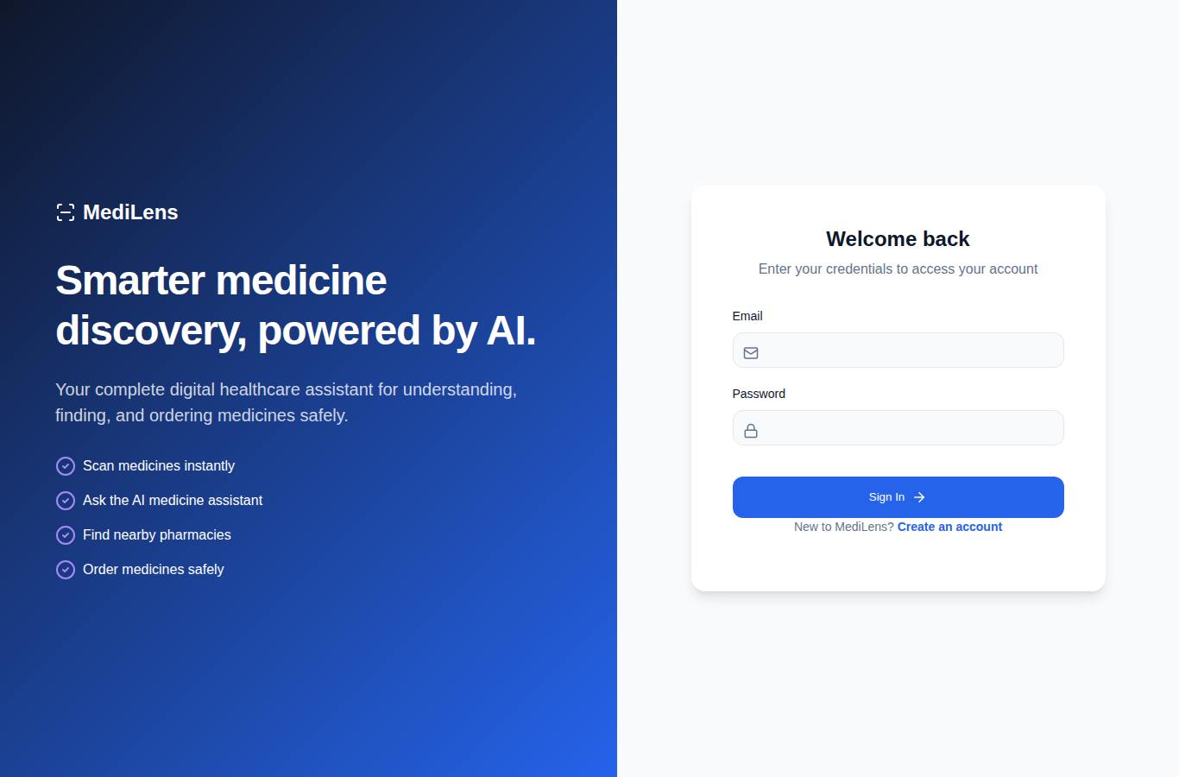
Figure 3.1: MediLens User Login Interface
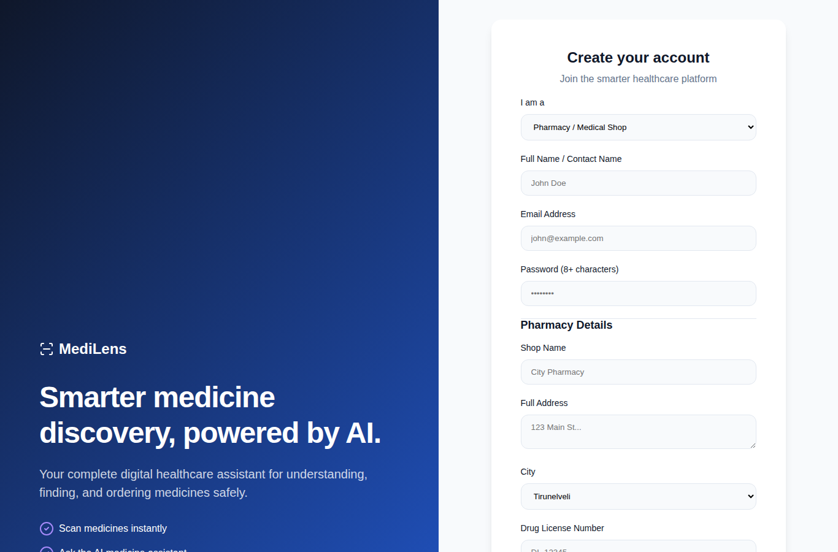
Figure 3.2: MediLens Pharmacy Registration with License and Location Details
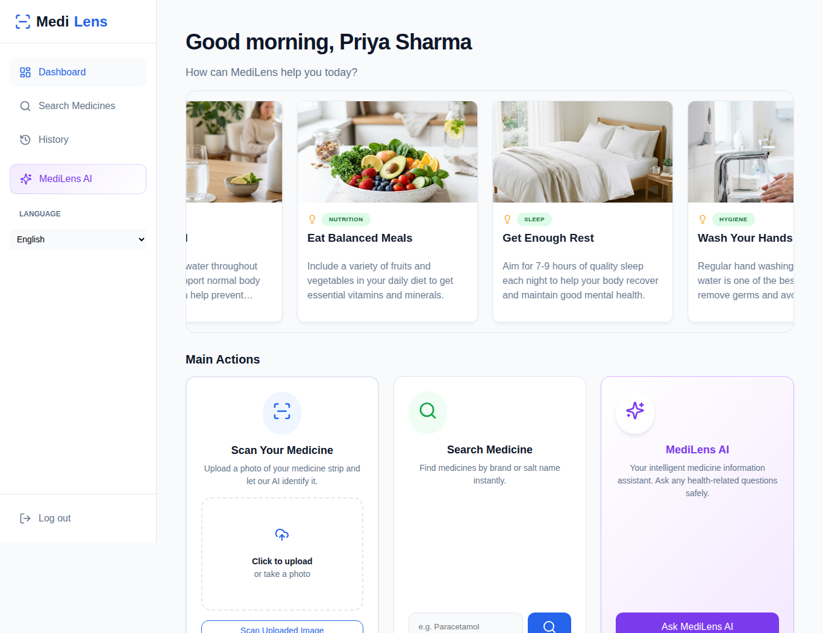
Figure 3.3: MediLens Customer Dashboard with Health Tips and Main Actions
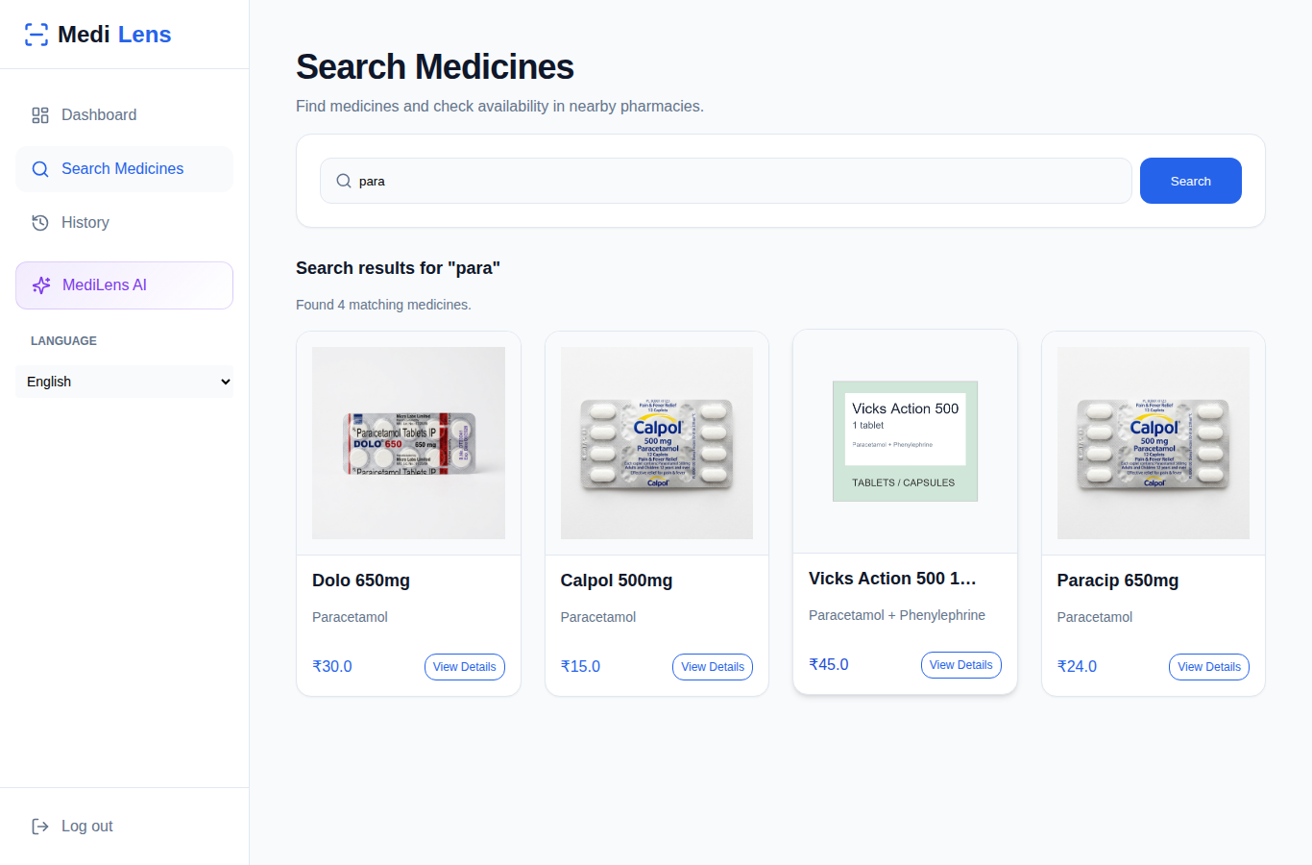
Figure 3.4: MediLens Medicine Search Results
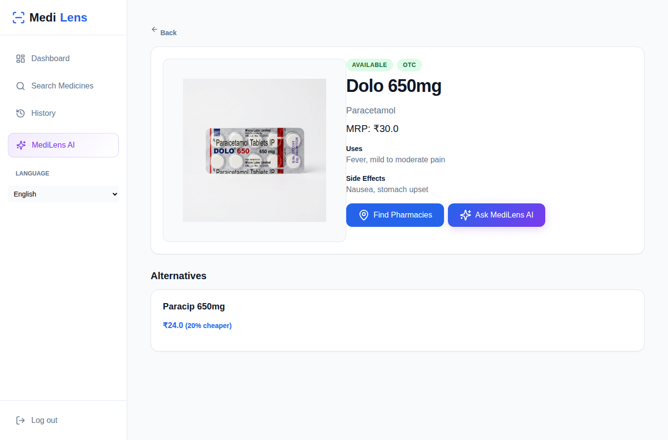
Figure 3.5: MediLens Medicine Details with Cheaper Same-Salt Alternatives
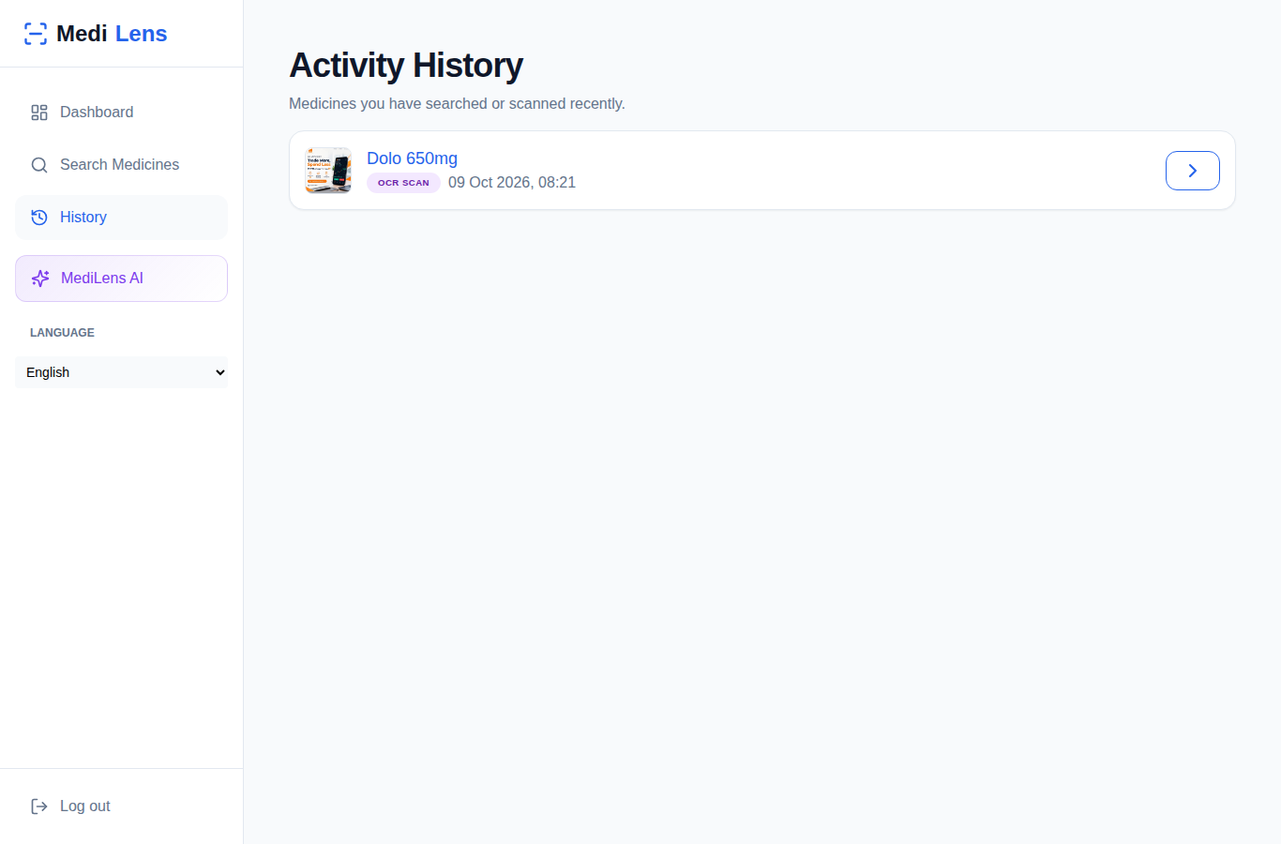
Figure 3.6: MediLens Search and Scan History
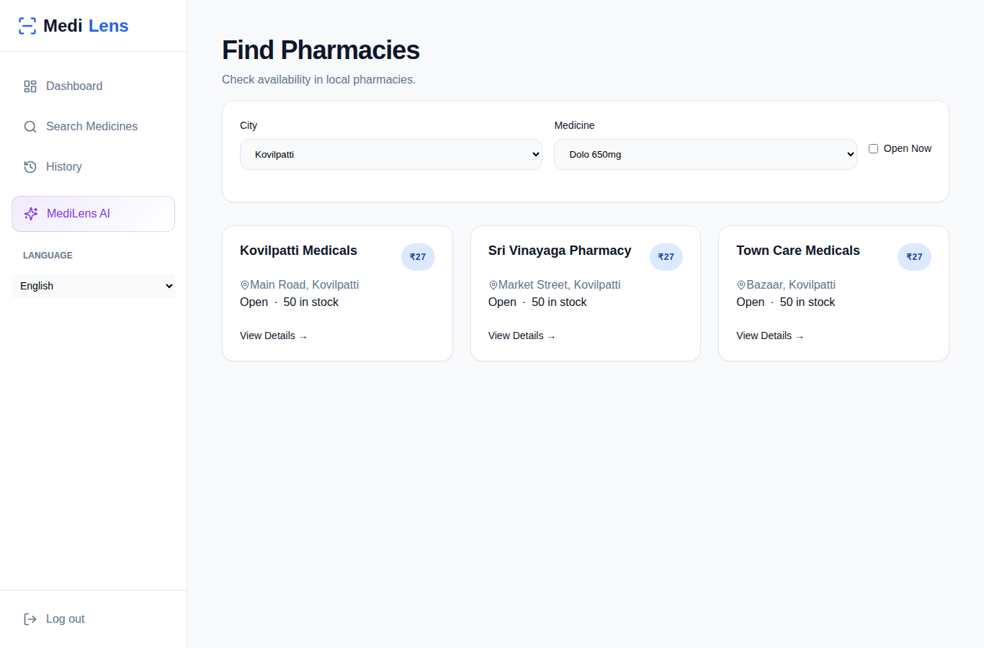
Figure 3.7: MediLens Find Pharmacies with City, Medicine and Open-Now Filters
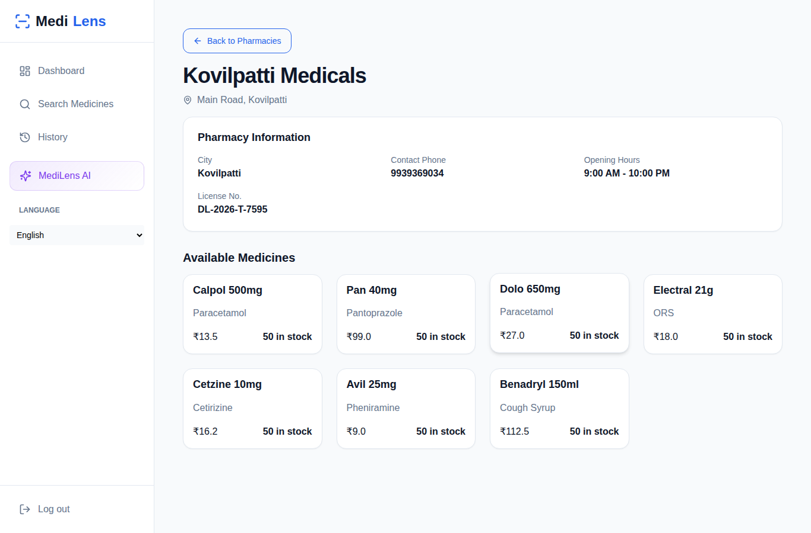
Figure 3.8: MediLens Pharmacy Details with Available Medicines and Prices
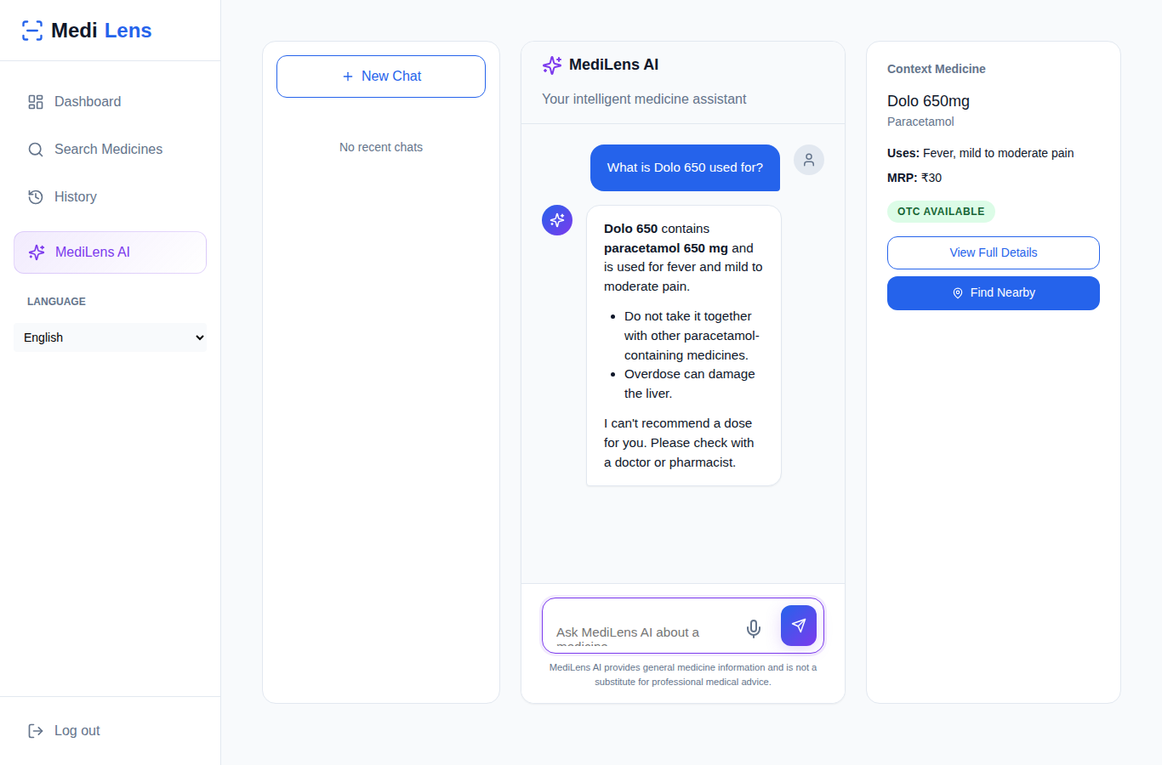
Figure 3.9: MediLens AI Chat Assistant
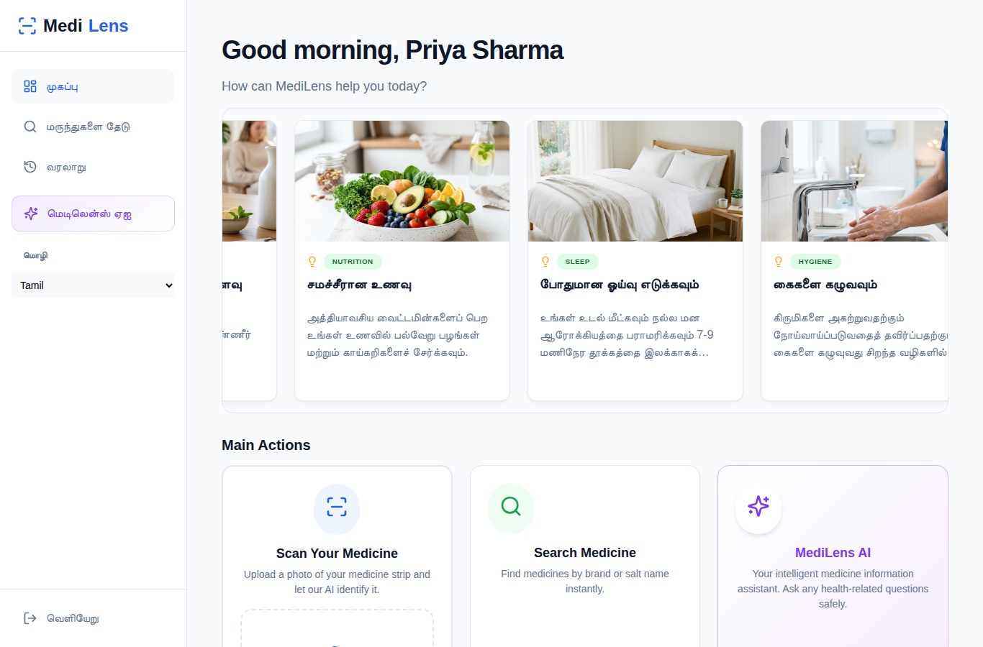
Figure 3.10: MediLens Customer Dashboard in Tamil (Multi-language Support)
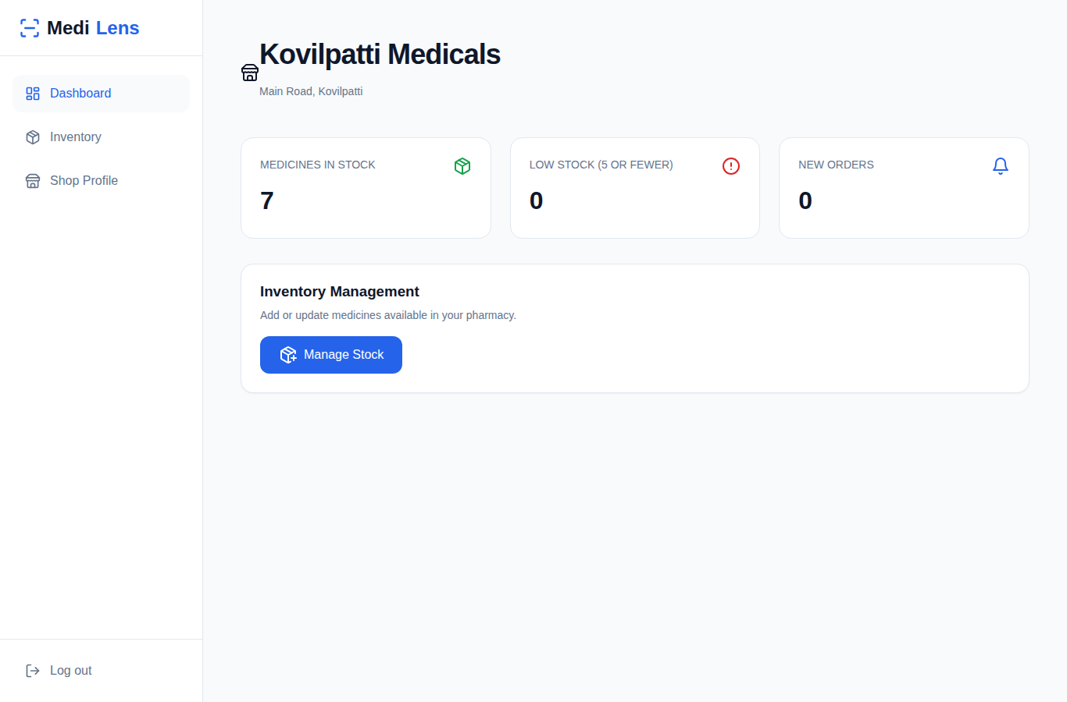
Figure 3.11: MediLens Pharmacy Dashboard with Stock Summary
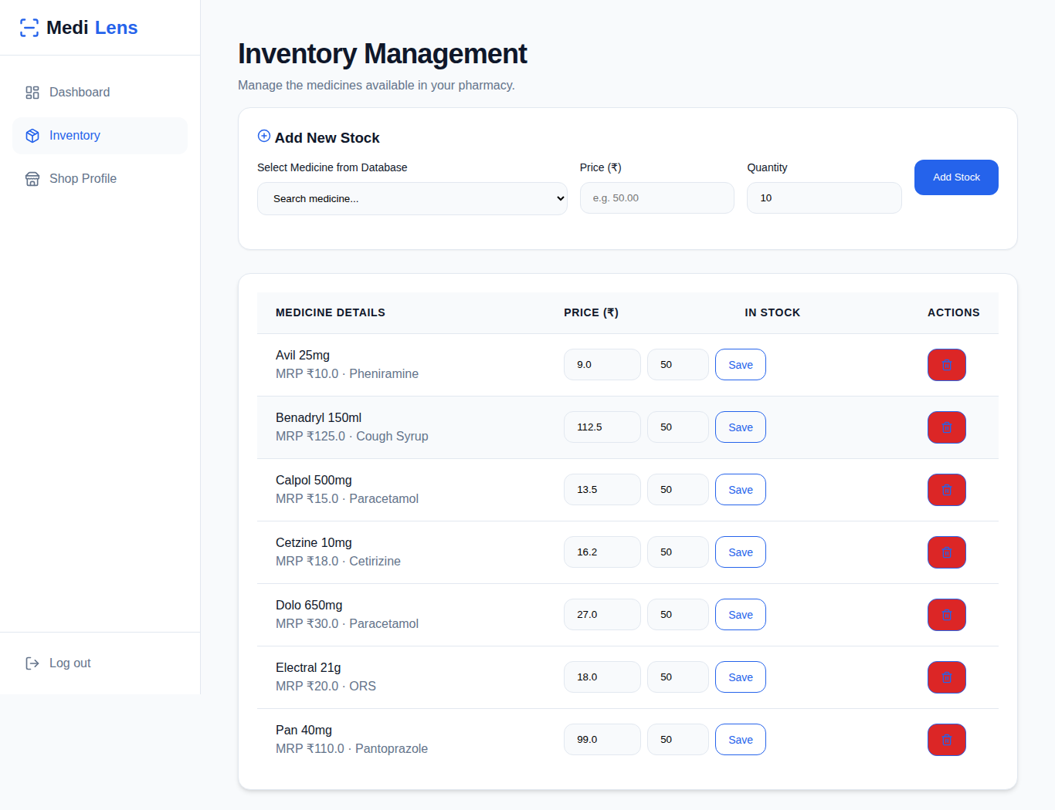
Figure 3.12: MediLens Pharmacy Inventory Management
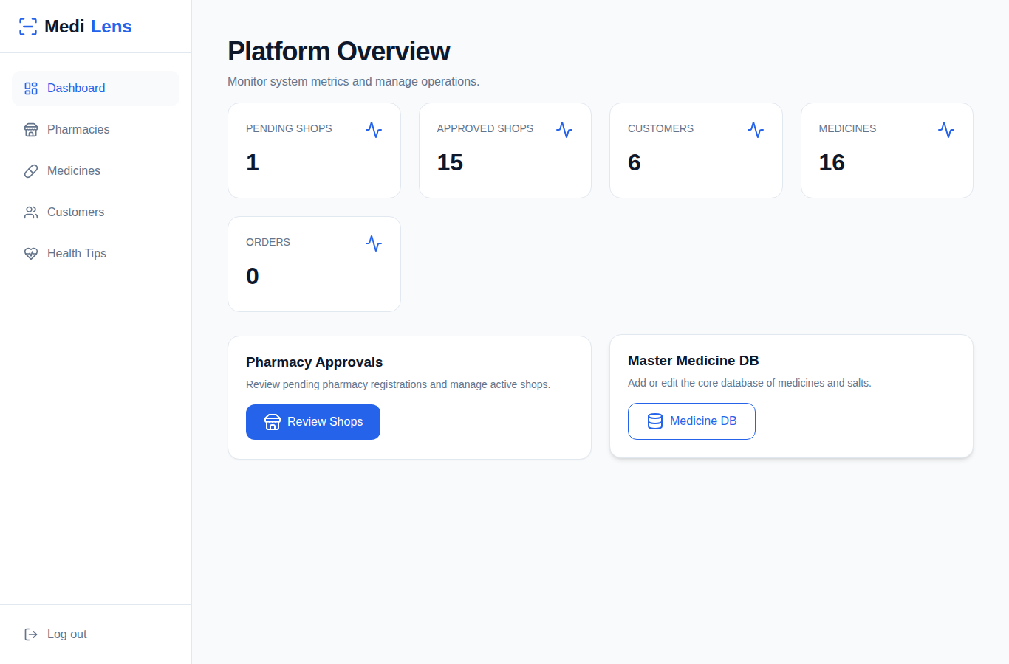
Figure 3.13: MediLens Admin Dashboard with Platform Overview
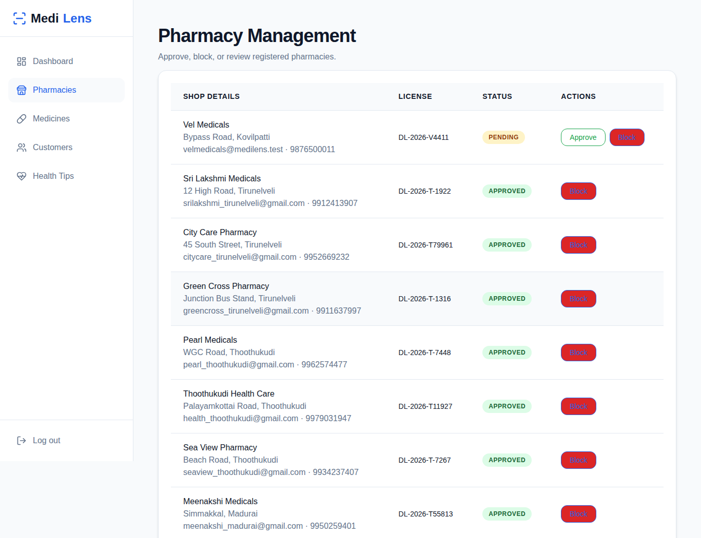
Figure 3.14: MediLens Admin Pharmacy Approval and Blocking
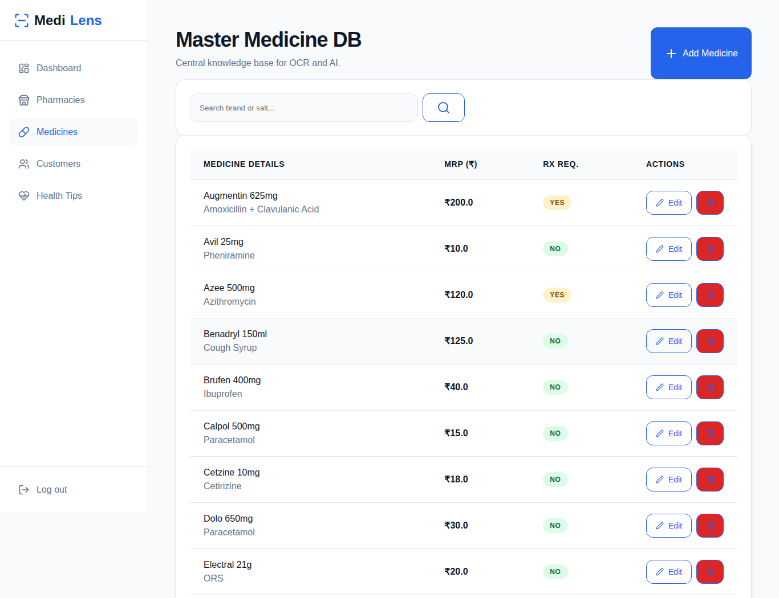
Figure 3.15: MediLens Admin Master Medicine Database
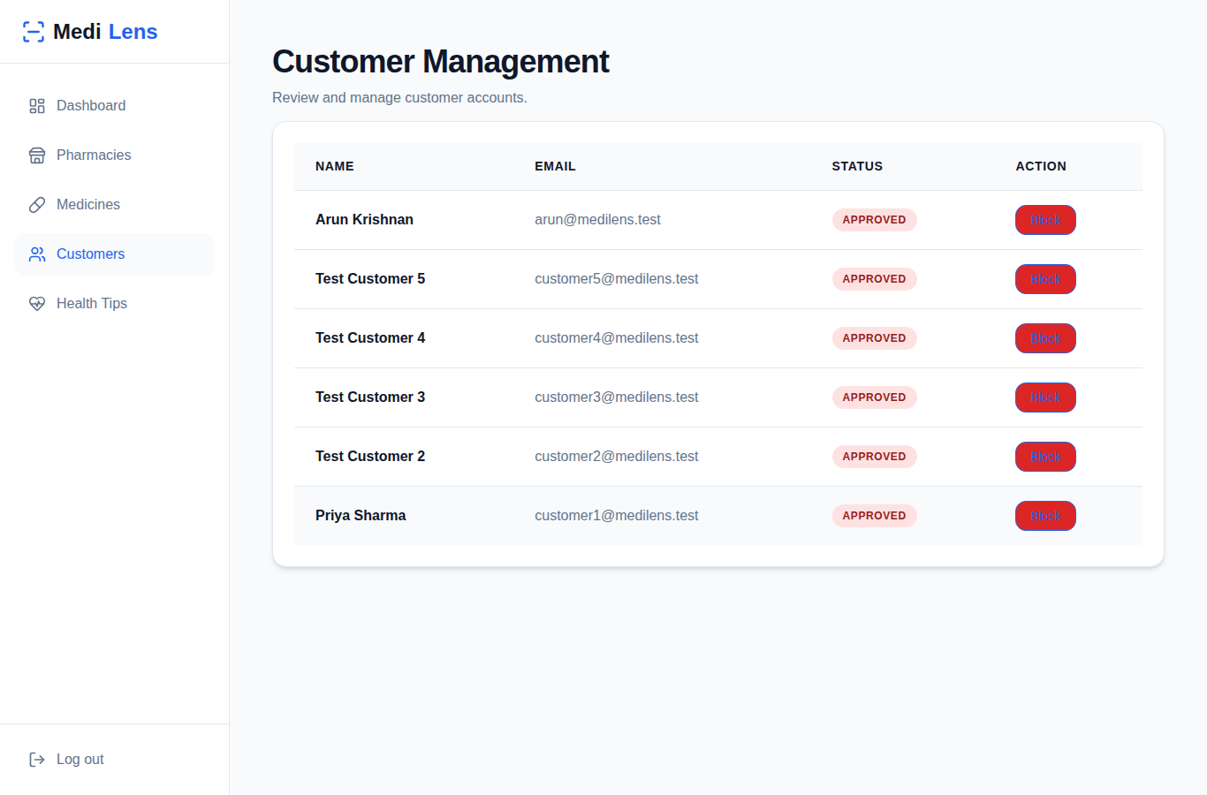
Figure 3.16: MediLens Admin Health Tips Management
CHAPTER 4
CONCLUSION
MediLens has been developed as a single web platform that connects customers, pharmacies and an administrator around reliable medicine information. Built with Flask and MongoDB, it lets a customer search for a medicine or scan its photo, read its uses, side effects and warnings, compare it with cheaper alternatives of the same salt and strength, find pharmacies in a chosen city that have it in stock, and ask an AI assistant questions in English, Tamil or Hindi.
The role-based design keeps the work of each user separate. Pharmacies register with their license and location and become visible to customers only after the administrator approves them, and they manage their own stock, prices and opening hours. The administrator maintains the medicine database, manages customer accounts and publishes health tips in three languages.
Safety and security were considered in the design. The AI assistant is given the medicine data from the platform and has clear rules against diagnosing, prescribing or advising dosage changes. Passwords are hashed, pages are protected by role-based checks, every form carries a CSRF token, and uploaded photos are limited by type and size. The medicine data used in this project is sample data and must be verified by a pharmacist before real use.
Overall, the project shows how Flask, MongoDB and a carefully limited language model can be combined into a practical and multilingual tool that makes medicine information and local availability easier to find.

