**Node.js DEMO Modifications on Huobi DM**

Huobi DM Node.js runtime uses josn package to parse int data by default. To solve the problem of failure parsing the too-long order_id digital, Huobi DM made some modifications as below:

**Details before modification.**

According to the picture below, the last two digits of the order_id was intercepted to 0;



However, when using the order_id to get information of an order, the system reported error with message “Oder doesn’t exist”.



When using the order_id to get order details, the return data is null.

**Details after modification.**

According to the screenshot below, the order_id keeps the inter string

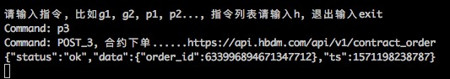

Details of Get information of an order after modified:

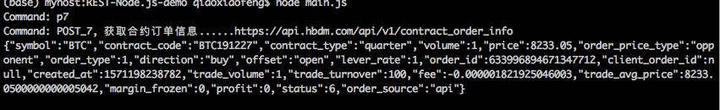

Details of Order details acquisition after modified:

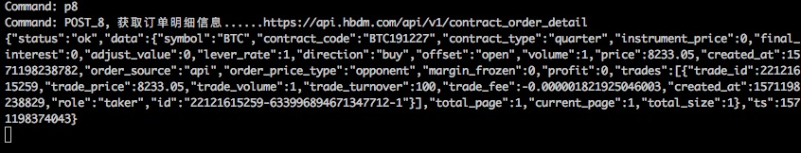

**Modifications details are listed below：**

1. Added json-bigint0.3.0 package in package.json

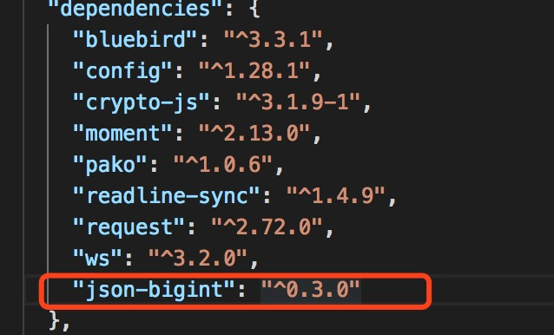

1. Changed all the JSON.parse to JSONbig.parse

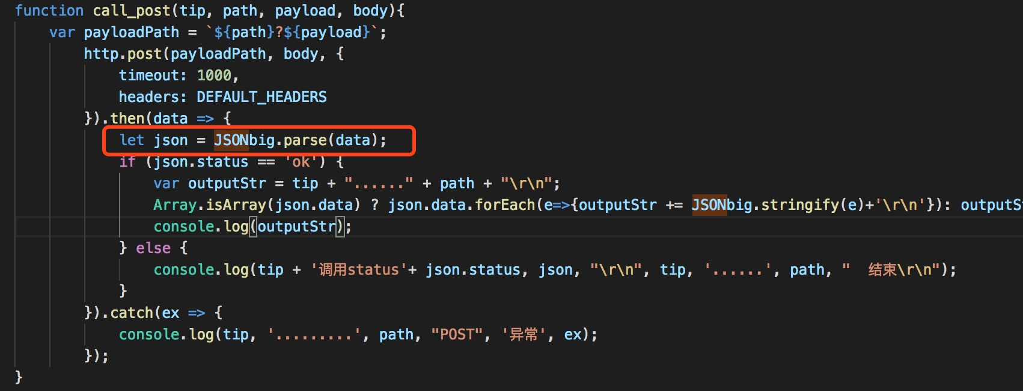

1. Parsing details on POST: Added if logic statement in Array.

