OSINT
CyberChef: CyberChef is a web application that is used for encryption, coding, zipping and data analysis.
DNSLeakTest: While using a secrecy application like a VPN, it is vital for all traffic to exit from the anonymous network. The compromise of this situation may lead to DNS leaks, Thus unwanted monitoring on our systems. DNSLeakTest allows us to check if our DNS's has been leaked or not.
Mxtoolbox.com: This tool may is used for network diagnosis. It analysis domains, blacklists, IP's and URL's. In the event of an email server blacklist, sent emails may never exit the system.
Censys: It is used for discovery, analysis and monitoring of available devices and ports. Censys claims that their unique algorithm will find"Badly managed cloud configurations", outdated certificates, available vulnerabilities and like, and report them.
Spyse: As designed for the use of reconnaissance, Spyse can find the subdomains of a domain, "A Records (The most fundamental type of DNS records. It contains the IP of given domain.)" , "DNS CNAME" TLS/SSL versions and much more. And sinse TLS and SSL versions can be prone to explotiation by some vulnerabilities, using spyse my be the initial step prior to everything. Spyse can also find different domains that are linked to the same host. This is a must-have for pentest reports since it expands the attack surface. Vulnerability discovery can be done with this tool. And it also matches the discovery of a port with CVE (Common Vulnerabilities & Exposures).

Whonix and Tails are both Operating Systems that is designed to be secure and anonymous. Both are linux based.

Creating fake accounts for OSINT recon is a good idea. Because most of the times, social media platforms need you to sign in, and not signing your legitimate account alleviates the risk of being ID’d.
1- Be consistent with your activity on your fake account.
2- Know and act the past of the fake person.
3- Generally dont attract attention, but on the off chance that you are being investigated, dont leave anything in your profile that could make your enemies sceptical.
---fakenamegenerator.com---
---Temp Mail Services---
---Temp Phone Services---
Problems that could kill your fake account
-Fake followers
-Being reported as an impersonator
-Scamming
-Copyright infringment
Google Dorking
( " " ) : Exact word search

( - ) : Exclude the written-upon word

( * ) : Auto-fill the place of the asterisk

( cache: ) : See the last time a site that's been indexed by Google

( site: ) Search things only in spesified site

( intitle: ) Search things only in places labeled as "titles"

( inurl ) Search things only in spesified URL's

( related: ) Search things that are related to the following word/s

( filetype: ) Search files that are only the filetype that has been spesified by us.

( | ) Pipe symbol: Means "OR"

( & ) Means "AND"

( () ) By using parentheses you can group words. Example usage: (youtube | twitter | facebook) & (abuse | misconduct)

Builtwith: Using this tool, we can get information about the technology that's been used to create this site like: infrastracture, server information, extensions of the site, and the font.

Netcraft: This tool provides you details like the OS of the site, kernel version, web services of the IP address or domain name that you have input. Not only that, but it also have several other services such as an extension that protects you from sites that have been known earlier for having vulnerabilities such as cross site scripting and such.

Wget: This is a command prompt tool that allows us to download files from websites. These files may be of different extensions.

Curl: Also being a command prompt tool, Curl allows us to get data from URL.
-O parameter gets us the data by its name from the far server.
-o gives us a different location.
--cookie-jar downloads the cookie information of the site.

VirusTotal.com: Is a website that uses the help of a broad database to detect malwares and untrusted files. Also it analyses URL and shares it for the use of everyone.

URLVoid: Also known as the "Website Reputation Checker" analyses if a site is mischiveous or not.

CheckShortURL: Extends the shortened URL and shows where does it belongs.
URLScan.io : Also detects harmful sites and gives us a detailed description of the URL.
Sed (linux): Allows you to process a text file in a lot of ways. It reads a file or an inpuıt made by the user and results you the way you want it.
Cut (linux): Takes the spesified part of a text file or an input.
Grep (linux): Allows you to search withing a spesified file.
Glogg: Allows you to open a big file hastily.
Sublime text regex: To find e-mail, phone, IP address we can use regex.
Regexlib: All the collections of useful pre-written codes for average regex usage.
The following tools can be used to extract metadata from a file;
-metadata2go.com
-jimpl
-exiftool
-metagoofil
Forensics Wiki may be a good site to know how to extract metadata from spesific files.
Just like it can find metadata from files, it may also be used to delete said metadata from image files.
Strings: This tool is used for showing the text parts of executable files or data files.

The practice of steganography, is a way of hiding any kind of data withing another data, physical object or a file.

The file, or the object is allowed for all eyes to see, doesnt need to be concealed. But the message inside must be hidden in a form.

Steganography can be diversified as 4;

Text steganography,
Image / video steganography,
Audio steganography and
Network steganography.

Text Steganography:
Two examples would be to hide the text in numbered words of a paragraph or numbered letters in a sentence.

The paragraph example:
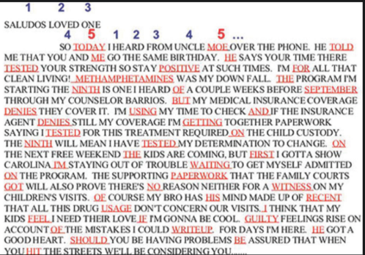

The sentence example:
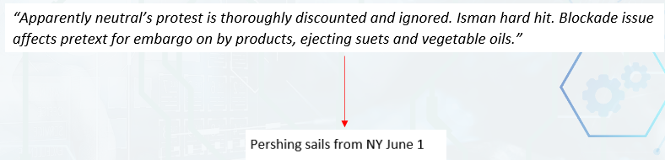
(2nd letter of every word)

Image Steganopgrahy:
Two examples would be to hide the data within RGB bits or within metadata.
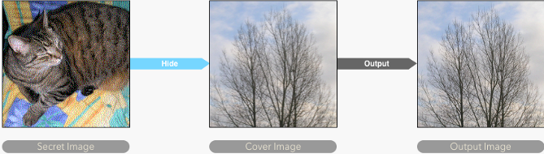

Stegsolve.jar: This tool allows us to see the different bit layers of a file.
Aperisolve.fr: Aperisolve is an online platform which performs layer analysis on an image.
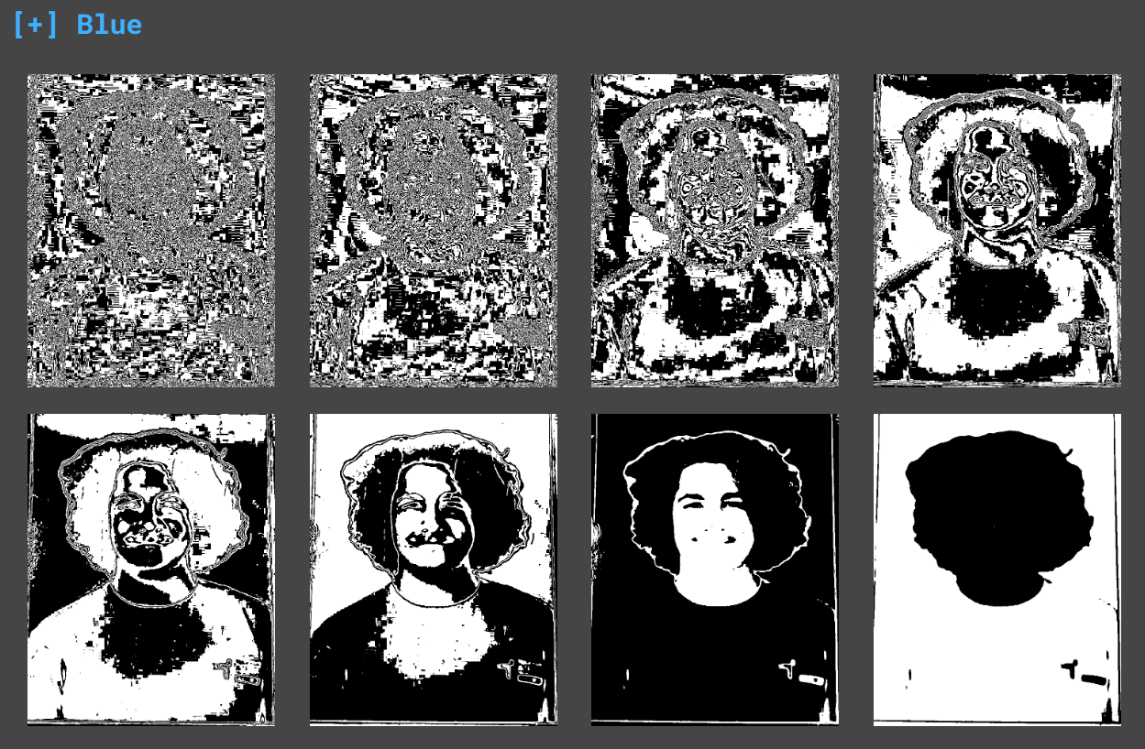
Audio Steganography:
Audio files can also be used for hiding data. It can be done by implanting frequencies which cannot be heard by humans, or draw an image (A text would be also considered as an image.) with sound.
Sonic Visualiser:
An open-source program that is used to visualise audio.
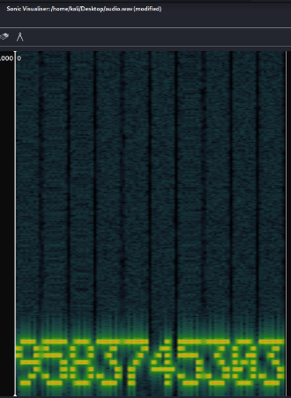

Binwalk:
Analyses the hexadecimal values inside files. This can find other files that is connected to examined file.
Foremost:
This tool allows us to recover deleted data.
Steghide:
This tool allows us to hide data within an image or an audio file without sacrificing the quality.

Stegcracker:
Exposes the hidden data within a file using bruteforce.
Howtotechies.com:
It allows us to see the original full resolution image of an social media account profile picture.
Hunter.io:
May view e-mails that are related to either the users or the employees of a spesified organisation.
Mailtester.com:
Checks if the input e-mail is valid or not.
Emailrep.io:
Checks some of the basic stats of an email such as;
Is it valid, Has It been blacklisted, Is there any data leaks?
The Harvester:
This tool finds e mail addresses, subdomains and IP addresses of the input domain name.
Whatsmyname.app:
Checks where the spesified username has been used to make an account.
Whopostedwhat.com :
Get UID from username, search posts from a specified date to a specified date
Lookup-ID.com:
Find the id of people, groups and pages.
Researchclinic.net:
A list of various OSINT tools.
Tweetdeck.twitter.com:
Real-time tracking of Trending topics (hashtags). And efficient usage of twitter by splitting main menu, notifications, messages etc. to columns.
Sleepingtime.com:
By analysing the last 1000 tweets of someone, this tool makes an educated guess about the sleep schedule of the person you are searching.
Spoonbill.io:
When you sign in, it shows the people that you follow and the changes they've made over the years to their profile such as their bio, website, location, name etc.
Twitterfall.com:
Shows you the posts that the word you specified takes place.
Onemilliontweetmap.com:
Shows you a map that shows who and where posted the word that you searched for.
Tinfoleak.com:
This tool allows us to see the twitter users device that they used to tweet with, connected accoounts and shared media.
Youtube Geofind:
Finds Youtube videos that was published in a spesified location.
Youtube Metadata:
Find the detailed metadata of a youtube video.
Watchframebyframe.com:
Allows you to watch a video frame by frame.
vk-look.com:
Gives you information such as the biography, photos, friends, personal data and ID info of a VK user.
Vkdia.com:
This tool makes a guess about the profile that it is given about who they messages with based on the online/offline status of their friends.
regvk.com:
Allows you to see when and for how long the specified profile was created in VK.
220vk.com:
This is a tool that shows the last activities and public likes and comments of a profile.

Active & Passive Recon in OSINT
Passive investigating on a target wont interact with it at all. The target wont know someone is investigating it. And passive recon is usually made by investigating open sources such as social media platforms on the web.

However, during active recon, you interact with the target, such as logging on their website, interrogating the target etc. Of course this means the target knows that you are investigating them. You leaving logs on the website would be an example of consequences of active recon.

Passive Recon ways and means:

CentralOps.net:
A general idea about an IP Adress or a domain.
Robtex.com:
Information about domain.
The Wayback Machine:
With this tool, you can see the different times where a site was indexed. This allows you to see the older versions of a website.
DNSdumpster.com:
Information about domain. See the servers that are connected to a domain, see subdomains and IP addresses that are connected to them. Also this tool shows you this information in a graphical format.
Whois:
Allows you to see who the domain belongs to, when it was taken, and IP addresses and such. It may also reach the address and phone number of a domain owner.
Ripe.net
Allows you the IP range of a IP address.
Crt.sh
Allows you to do a subdomain search both in up-to-date domains and older ones.

Active Recon ways and means:
There are some tools which bruteforce-search directories and files of a website. They leave log's on the system it was used upon. Some examples would be Gobuster and Dirb.
Other than brute-forcing directories and files, some tools allow you to search subdomains of a website. Some examples would be Sublist3r, theHarvester, subfinder and dmitry.

Whois Application:
This methodology gives us the owners of processed IP address and or domain name. It may contain sensitive information such as; Name-Surname, Phone number, E-mail address. The information that falls under the category of "Whois" may be requested by the owner for them to be confidential.
DNS Records:
When a Domain name is registered, DNS records are automatically created. Types of DNS records are:
A Records: These are the records of addresses. The IP address is connected to Domain name in this sector.

MX (Mail Exchange) Records: The E-mail servers are defined here.
AAA Records: Same as A Records but uses IPV6.
SOA (Start of Authority): SOA Records hold the information as to who is responsible for the DNS Records.
An SOA Record holds these information:
Serial Number
Retry Interval
Expires After
Time To Live (TTL)
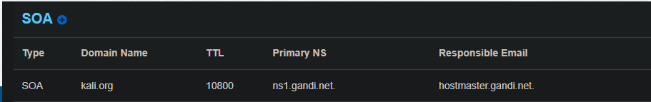

TXT Records: Holds text information. Is usually preferred for holding SPF Records which overlook authority of an E-mails IP address.
PTR Records: Finds Domain name from IP address. It serves the exact opposite task of A Records.
Ipinfo.io:
IpGeolocation.net:
IP2Location.com:
Iplocation.io:
Infosniper.net:
Shows various information a IP address can have.
These tools scan the internet for open ports and available devices:
Shodan.io
GreyNoise
ZoomEye

SSID: The name of a Wirelles connection.
BSSID: The MAC address of the device that provides the wirelles service.
WPA: WPA is a security service on wireless connections. It has succeded WEP, which was an older security service.
Wigle.net: This tool allows you to see various wirelles connection points throughout the planet.

OSINT FOR ORGANISATIONS
Not only recon is useful for people, It may be crucial for organisations during an investigation. AnnualReports.com and Corporationwiki.commay be a good start for passive organisation recon.
Password leak test: IntelX, DeepSearch, pwndb, Haveibeenpwned.

