These are supplemental instructions showing how to load the scope application onto the programmer device on an Infineon kit. For an introduction and for details on the connectors used on the kit and how to install/use the scope software, see *PSoC_5LP_Scope.docx*.

The application was created using PSoC Creator, so you must have that software installed onto your computer. It will also install PSoC Programmer and the Bootloader Host tool which are required for some of the steps below.

These instructions and the application firmware use the **CY8CKIT-043** kit as an example. If you want to use this application on the PSoC 5LP programmer device of a different kit, you may need to change the application pinout depending on the pins available on the PSoC 5LP device.

# Determine KitProg Version

The CY8CKIT-043 kit contains an onboard programmer that uses a PSoC 5LP device with KitProg hardware/firmware. Some Infineon kits have PSoC 5LP devices using KitProg2 or KitProg3 hardware/firmware. If you want to use this application on a kit that has KitProg2 or KitProg3, the steps are slightly different. The differences are covered in a separate section of this document.

To determine the KitProg version on your kit, connect the kit to the computer. Use the Windows search bar to search for and run PSoC Programmer. Once PSoC programmer starts, connect the kit and observe the log window:

If the result indicates KitProg firmware, you have firmware which supports a single application on the PSoC 5LP. Follow the KitProg instructions below to replace the programmer functionality with the scope application.



If the result indicates KitProg2 or KitProg3, you have firmware which supports dual applications. Follow the instructions in the KitProg2/KitProg3 section to load the scope firmware as a secondary application.



In either case, if you see a message that your firmware is out-of-date, you should navigate to the Utilities tab and click Update so that you are starting from the most recent version.



# Kits with KitProg (Single Application)

**These instructions are applicable for the CY8CKIT-043 kit as well as any others that have KitProg hardware/firmware.**

1. Plug in the kit while holding down button SW3 (BOOT/TARGET RST or MODE) and then release the button. The status LED should be blinking. This indicates that the kit is in Bootloader mode.
2. Open the PSoC Creator workspace KitProgScope.cywrk and build the project "Scope_KitProg"
3. From the "Tools" menu, select "Bootloader Host…"

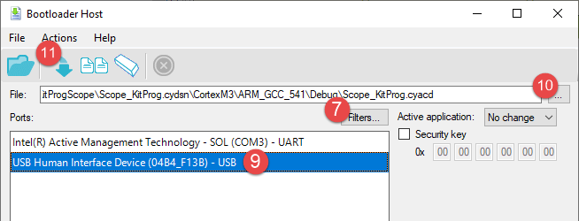

1. From the Bootloader Host tool, click the "Filters…" button.
2. Make sure "Show USB Devices" is checked. For the VID, enter "04B4". For the PID, erase the contents:

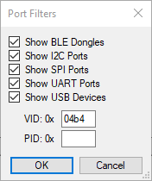

1. Select the device that says "USB Human Interface Device (04B4_xxxx) – USB"
2. Click the 3 dots next to the File name and select:

…/KitProgScope/Scope_KitProg.cydsn/CortexM3/ARM_GCC_541/Scope_KitProg.cyacd

1. Click the Download arrow. When this completes, the green status LED should be OFF. This indicates that the kit is now programmed as a scope. It will no longer function as a KitProg.
2. Optional: break the KitProg portion of the kit off from the rest of the kit.

Note: if you ever want to restore the KitProg functionality: put the kit into bootloader mode by holding down SW3 when plugging in the kit; open PSoC programmer; go to the utilities tab; and click "Update Firmware". This will remove the scope firmware from the device.

# Kits with KitProg2 or KitProg3 (Dual Application)

**These instructions are NOT applicable for the CY8CKIT-043 kit.**

If you are using a kit that has KitProg2 or KitProg3 on it, the process is a bit different. This is because those versions allow multiple applications to be programmed on the PSoC 5LP at once – one that has the programmer functionality and the other that is a secondary application such as the scope.

Bootload mechanism

1. Plug in the kit while holding down button SW3 (MODE) and then release the button. The status LED should be blinking. This indicates that the kit is in Bootloader mode.
2. Open the PSoC Creator workspace KitProgScope.cywrk.
3. In the Scope_Kitprog schematic, open up the Bootloader component and change the paths to the hex/elf files to point to the KitProg2 versions. They are in the same directory as the KitProg files:

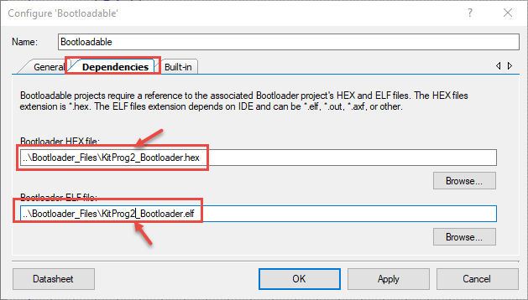

(These files also work for KitProg3).

1. Build the project "Scope_KitProg"
2. From the "Tools" menu, select "Bootloader Host…"
3. From the Bootloader Host tool, click the "Filters…" button.
4. Make sure "Show USB Devices" is checked. For the VID, enter "04B4". For the PID, erase the contents:



1. Select the device that says "USB Human Interface Device (04B4_xxxx) – USB"
2. Click the 3 dots next to the File name and select the image file for application 2:

…/KitProgScope/Scope_KitProg.cydsn/CortexM3/ARM_GCC_541/Scope_KitProg_2.cyacd

Note: the same file works for both KitProg2 and KitProg3.

1. Make sure the Active application is set to Image 2.

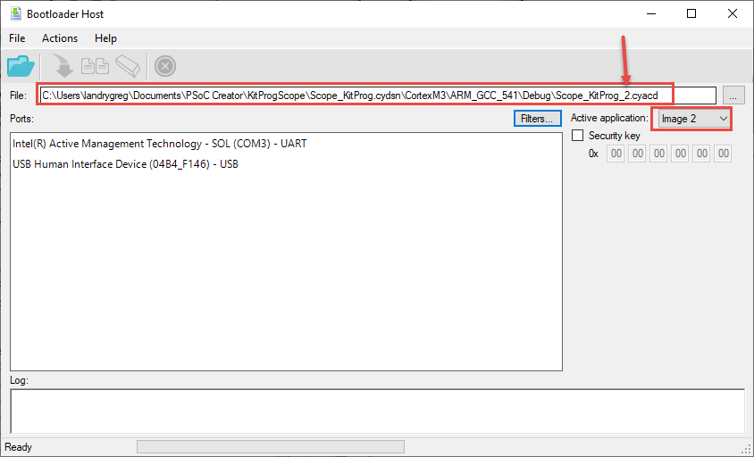

1. Click the Download arrow.
2. Once bootloading is done, the application should be in Scope mode. If the KitProg is in KitProg mode, switch to the secondary application. See the KitProg user guide for instructions on how to switch modes.
3. Optional: break the KitProg portion of the kit off from the rest of the kit.

# Pins for the CY8CKIT-043

The pins used for the CY8CKIT-043 can be found in the PSoC Creator Design Wide Resources in PSoC Creator. For reference, they are:

Scope A: P3[0]

Scope B: P3[6]

Score B ground: P3[5]

Waveform Generator: P0[1]

External Trigger Input: P12[5]

Trigger Output: P3[4]

All of these pins are available on header pins on the KitProg section of the board.

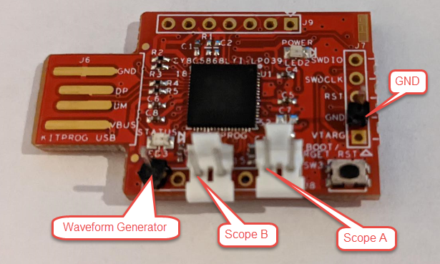

Note: The ADC used for scope channel B does not have an external decoupling capacitor on the board so it may not be as accurate, especially for fast moving signals. If desired, you can solder a 1.0 µF capacitor on C7 to solve this limitation.

Note: The ground pin next to scope channel B is not a physical ground pin on the board. Rather, it is a PSoC 5 LP GPIO pin that is driven to ground through the output buffer. Therefore, the impedance in the path of that ground signal will be higher than the physical ground pins.

If you are using a different kit, the PSoC 5LP pins available on headers may be different. See the kit documentation and modify the pins in the application appropriately for your kit's pins.

# Scope Software

The scope software can be used without modification. The digital input and digital output sections will not function since those functions are not included in the application due to lack of available pins.