**Motor Control Firmware Automation:**

*Builds and Regression Tests*

|  |  |  |
| --- | --- | --- |
| **Authors** | **Name** | **Department** |
| 01 | Hamid Behjati | IFAM PSS DCDC RD |

|  |  |  |
| --- | --- | --- |
| **Revisions** | **Date** | **Description** |
| 01 | 10-01-2023 | Initial draft |
| 02 | 12-05-2023 | Changing folder structures after making Motor Control Firmware a middleware library |

Table of Contents

1 Scope 3

2 Environmental Variables 4

3 Usage 5

4 Output Files 6

# Scope

Infineon Motor Control Library (IMCL) can be deployed using any of the following environments:

* **Modus Toolbox**: GCC compiler; microcontroller target; For application deployment.
* **IAR**: IAR compiler; microcontroller target; For application deployment.
* **Visual Studio**: Visual Studio compiler; x86 target; For regression testing on PC.
* **MATLAB/Simulink**: MinGW compiler; x86/x64 target; For Software In the Loop (SIL) testing on PC.

Therefore, the final step before merging a development branch should be checking all of these environments to ensure no build errors, build warning, or regression test failures.

There are also three different build configurations, namely

* RFO
* SFO
* TBC

The building and regression-test running process is automated using batch files and shell scripts.

This document explains how to

* Set up the system environmental variables (paths) for these batch files and shell scripts to work
* How to run the automatic builds and regression tests

# Environmental Variables

The paths for the following tools must be added to the environmental variables (as seen in the example below)

* Visual Studio: …\IDE\devenv.exe
* IAR: …\bin\iarbuild.exe
* Modus Shell: …\modus-shell\Cygwin.bat

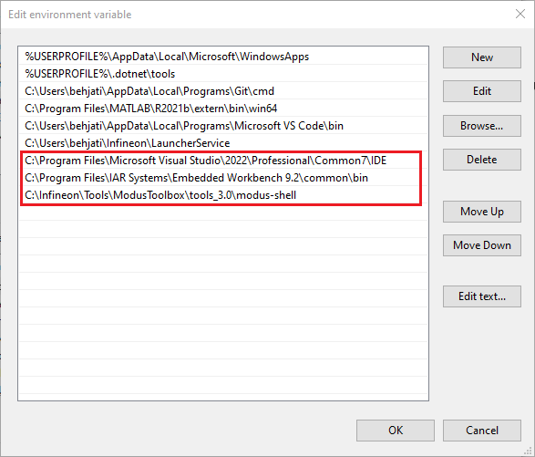

# Usage

*RUN_ALL.bat* will build IMCL in all deployment environments using all build configurations. In addition, it runs all of the regression tests on PC.

Running *RUN_ALL.bat* should open up a console and execute all builds and tests automatically. It is important to inspect the log in the end for any of the following items

* Visual Studio
  + Build errors
  + Build warnings
* IAR
  + Build errors
  + Build warnings
* GCC (Modus Shell)
  + Build errors
  + Build warnings
* Regression test failures

The generated report must be carefully inspected before merging the code.

# Output Files

The output files (.elf, .hex, .exe) and directories are as follows

* **GCC** (Modus Toolbox) .elf and .hex files
  + .\motor_ctrl_app\Build\**TARGET-GCC**\CustomRFO\
  + .\motor_ctrl_app\Build\**TARGET-GCC**\CustomSFO\
  + .\motor_ctrl_app\Build\**TARGET-GCC**\CustomTBC\
* **IAR** .elf and .hex files
  + .\motor_ctrl_app\Build\**TARGET-IAR**\RRFO\
  + .\motor_ctrl_app\Build\**TARGET-IAR**\RSFO\
  + .\motor_ctrl_app\Build\**TARGET-IAR**\RTBC\
* **Visual Studio** .lib files (**Operational Code** libraries)
  + .\mtb_shared\motor-ctrl-lib\release-vX\OperationalCode\Build\**Win32**\DebugRFO\
  + .\mtb_shared\motor-ctrl-lib\release-vX\OperationalCode\Build\**Win32**\DebugSFO\
  + .\mtb_shared\motor-ctrl-lib\release-vX\OperationalCode\Build\**Win32**\DebugTBC\
  + .\mtb_shared\motor-ctrl-lib\release-vX\OperationalCode\Build\**Win32**\ReleaseRFO\
  + .\mtb_shared\motor-ctrl-lib\release-vX\OperationalCode\Build\**Win32**\ReleaseSFO\
  + .\mtb_shared\motor-ctrl-lib\release-vX\OperationalCode\Build\**Win32**\ReleaseTBC\
* **Visual Studio** .exe files (**Regression Tests**)
  + .\mtb_shared\motor-ctrl-lib\release-vX\RegressionTests\Build\**Win32**\DebugRFO\
  + .\mtb_shared\motor-ctrl-lib\release-vX\RegressionTests\Build\**Win32**\DebugSFO\
  + .\mtb_shared\motor-ctrl-lib\release-vX\RegressionTests\Build\**Win32**\DebugTBC\
  + .\mtb_shared\motor-ctrl-lib\release-vX\RegressionTests\Build\**Win32**\ReleaseRFO\
  + .\mtb_shared\motor-ctrl-lib\release-vX\RegressionTests\Build\**Win32**\ReleaseSFO\
  + .\mtb_shared\motor-ctrl-lib\release-vX\RegressionTests\Build\**Win32**\ReleaseTBC\